Lab test 1
Flame test.

Contents
1. Introduction 3
2. Materials and methods 4
2.1 Materials 4
2.2 Experimental procedure 4
3. Results 5
4. Discussion 6
4.1 Experimental results and their significance 6
4.2 Relationship between Copper and Sodium 6
4.2.1 Copper 6
4.2.2 Sodium 6
4.3 Relevance to OME 6
4.4 Where else can this be used? 6
4.5 Limitations and sources of error 7
5. Conclusion 8
6. References 9

Introduction
The purpose of the experiment was to blind test 8 different solutions to determine the presence of a metal in a compound and to identify that metal based on the colour of the flame produced.
The hypothesis was that we could identify each metal through the flame colour it emits, this is because the colour is given off by the absorption of heat, which excites the electrons and gives them energy, as the energy wears off and the electron returns to normal, it gives off photons, which produce the colour, each colour is determined by how long or short the wavelength is.
The variables used were the different solutions containing the metal ions, and the flame from the Bunsen burner, as this was turned between the safe orange flame and working ‘blue’ flame.
The equations needed for the experiment are:
- ∆E = h x f
This is to find the change in energy (∆E) by using Plancks’ constant (h = 6.63 x 10⁻³⁴ Js) multiplied by the frequency (f) measured in Hertz (Hz). Before you can use this equation, you will need to find the frequency using this equation:
- c = f x λ
c = 3.0 x 10⁸ ms⁻¹, which is the constant speed of light.

Materials and methods

2.1 Materials
For this experiment we used the following tools:
Equipment | Purpose
Bunsen Burner | To give energy to the electrons and show the colour given off by the photons.
Heat-resistant mat | To protect the bench from the heat of the Bunsen burner.
Matches | To light the Bunsen burner.
Metal rod | To safely put the solutions in the flame.
1M solutions of unknown metal salts | To identify the metal in the solution.
Beaker with 1M of HCL | To clean the solution off the metal rod to avoid any cross-contamination.
Blue cobalt glass | To identify the solution with mixed metals.
Beaker with de-ionised water | To clean and cool the metal rod, in between solutions.
Table 1

2.2 Experimental procedure
- Set up your workstation with the required materials as outlined in table 1.
- Make sure the metal rod is clean, using the Hydrochloric Acid and Bunsen Burner, this is to avoid cross-contamination in the solutions.
- Using the metal rod, dip it in 1 of the solutions and put in to the blue flame of the Bunsen Burner, repeat as many times as necessary, using the de-ionised water in-between to clean and cool off the metal rod.
- Record the flame colour, what metal you believe is present and where it comes on the electromagnetic spectrum.
- Repeat steps 2, 3 and 4 until you have recorded colours for all solutions.

Results

Unknown metal salt | Colour of flame | Identity of metal | Wavelength (estimate)
A | Yellow | Sodium (Na) | 590nm
B | Red | Strontium (Sr) | 700nm
C | Orange | Calcium (Ca) | 610nm
D | Lavender | Potassium (K) | 400nm
E | Green | Barium (Ba) | 520nm
F | Pinky-Red | Lithium (Li) | 670nm
G | Blue/Green | Copper (Cu) | 480nm
H | Yellow/Lavender | A mix of Potassium and Sodium | Potassium at 400nm and Sodium at 590nm
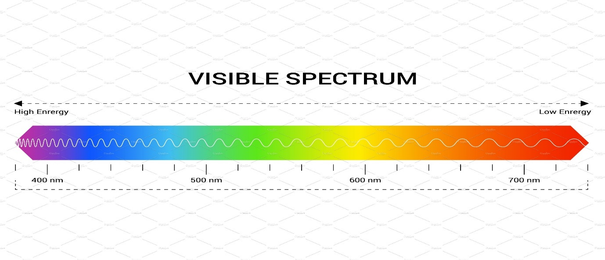
Table 2
Figure 1 Visible Spectrum [1]

Figure 1 shows the visible spectrum on which the wavelength of the metal ions is measured against. The wavelength figures in table 2 are estimated based on this.
Some key findings from the experiment are:
- The similarities between the flame colours of strontium, lithium and calcium. Each give off red colour flame, with very slight differences. Strontium and Lithium give very similar red flames, however Strontium’s’ flame is slightly more intense, and Calcium has a red flame with a tint of orange.
- The flames of Potassium (lilac), Barium (green), and Copper (blue/green) are all quite distinctive and unique to their properties, making them easier to identify.
- The flame from the mixed solution of potassium and sodium was largely dominated by the yellow flame, making the lilac quite difficult to see under normal conditions, however when using the blue cobalt glass filter, we were able to block the yellow and see the lilac more easily.

Discussion

4.1 Experimental results and their significance
The results show that, qualitatively, the metal ions giving off the red flame have some of the lowest frequencies of the solutions we tested, while potassium, with its lilac flame, had the highest and thus the largest energy gap between the ground state and excited state of the metal ion.
The ground state is where the electrons start off, closest to the nucleus, the excited state is where the electrons have ‘jumped’ while being heated, to higher energy levels, meaning they are now further away from the nucleus. The light is given when the electrons return to their normal state after being heated.
The significance of each flame colour lies in the ability to identify the presence of specific metal ions based on their unique emission spectra.

4.2 Relationship between Copper and Sodium

4.2.1 Copper
When heated, copper gives off a blue/green light. This light corresponds to a shorter wavelength on the visible spectrum. The shorter wavelength also corresponds to higher frequencies and higher energy.

4.2.2 Sodium
Sodium gives off a yellow light when heated, showing a longer wavelength to copper on the visible spectrum. The longer wavelength means Sodium has a lower frequency and lower energy level.

Relevance to OME
Forensic analysis [2]
In the case of the Boston Marathon Bombings that took place in 2013, the smoke was analysed to determine what kind of chemical composition was used within the bombs. From this, investigators can find out more about who built the bomb, if they were from a known terrorist cell, and if they were responsible for any other bombings.

Where else can this be used?
The use of coloured flames is widely used in flares. The different colours in flares have different meanings.
The most known colour is red/orange, which is known for alerting of distress or indicating a hazard. It is highly visible, especially at night.
White flares are used primarily to light up an area to enhance visibility, commonly used in search and rescue.
Green and blue flares, while not common, are mostly used by armed forces, where there is a need for a distinct colour. The green flare is more used as a signal, while blue is to illuminate areas. [3]

Limitations and sources of error
Potential limitations:
- In low concentrations some metal ions may go undetected, as the flame test may not pick them up.
- It is quite subjective, as some ions are not very far apart in the spectrum, meaning the observer could mistake its identity.
- It is not always apparent when there is a mix of colours, for example, the sodium/potassium mix, the lavender colour of the potassium wasn’t clearly visible until we used the blue cobalt glass.
Potential errors:
- Cross contamination can occur, even if thoroughly cleaned, the metal rod may still small amounts of residue left on, which could skew results.
- Unless the test is undertaken in a clean room, dust particles could enter the flame during testing.
- The flame intensity can have an affect on the test, a weaker flame, whether through poor gas rate, or a poor Bunsen burner. If the flame is not hot enough the electrons may not be able to get to the excited state they need.

Conclusion
I hypothesised that the metal ions could be identified through the flame test. While working in pairs we managed to identify the ions, and through a later group discussion we found out that some of the ions we identified in the lab were incorrect, these were mainly the ions giving off a red/orange flame.
Due to the inaccuracies, there could be ways to make flame testing more accurate.
- Use a neutral background to observe the colours and make sure the observation is done under consistent lighting.
- Ensure that the Bunsen burner and gas flow are optimised and take several temperature readings.
- Record the experiment, this could help when you have ions with similar frequencies, by being able to slow down and re-watch the flame colour, you could have more accurate results.
- While deducing the flame colour is subjective to individuals, having a discussion with multiple people could help in identifying the correct ion.

References

[1] No known author. Spectrum wavelength. Visible | Education Illustrations ~ Creative Market (accessed Mar. 13, 2024).
[2] S. Ackerman, “Smoke Color Is Key Clue to Analyzing Boston Marathon Bombs,” Wired. https://www.wired.com/2013/04/boston-bomb-smoke/ (accessed Mar. 13, 2024).
[3] Chris Woodford, “How do flares and flare guns work?,” Explain that Stuff, Jan. 24, 2010, updated Aug. 13, 2022 https://www.explainthatstuff.com/flares.html#colors (accessed Mar. 13, 2024).
‌

