Content page
AI acknowledgment - pages 1-2
Part 1: Study timetable - pages 3-4
Part 2: Using Microsoft 365 Copilot to Explore Study Techniques - pages 5-11
Part 3: PowerPoint poster- page 12
Part 4: Voice over presentation – page 13
Reference list – page 14-15

Basic Acknowledgement format of AI tool use
I acknowledge the use of Microsoft 365 Copilot (m365.cloud.microsoft) on 9 September 2026 to research study skills techniques. I used the
prompt(s):
1. Provide me with information about effective study techniques.
2. Using simple language and credible sources, provide me with information about effective study techniques to support a university student with time management.
3. Using simple language and credible sources, provide me with information about effective study techniques to support a neurodivergent university student with time management.
4. Find an academic journal on the pomodoro study technique from between 2016- 2026.
5. Find me an author with a conflicting opinion on the pomodoro technique.
6. Find me books that discuss time chunking as a study technique for a neurodivergent BA (Hons) university student.
7. Where did you find the information that you provided about the pomodoro technique? Is it peer reviewed and sourced through academic data recorded between 2016- 2026?
I acknowledge the use of Google on 10th September to research effective ways to type prompts into Copilot, I used the prompt(s):
- Academic prompting techniques.
- Who is DR Andy Stapleton? Provide a reliable source.
I acknowledge the use of Google on 19th September to research an image on time circles, I used the prompt(s):
1. Find me an image that shows an example of using a time circle, to promote use of time for a university student. I would like images with clear sources, so that I am able to reference the image Harvard style.
I confirm that I have not presented any AI generated text as my own work. I confirm I have copies of my drafts, notes, and other resources I used before, and after the use of AI tools which I may be asked to provide in evidence.

Part 1: Study Timetable/Study schedule
Amser/  Time | Llun  Monday | Mawrth  Tuesday | Mercher Wednesday | Iau  Thursday | Gwener  Friday | Sadwrn  Saturday | Sul  Sunday
00:00 - | Sleep | Sleep | Sleep | Sleep | Sleep | Sleep | Sleep
01:00 - | Sleep | Sleep | Sleep | Sleep | Sleep | Sleep | Sleep
02:00 - | Sleep | Sleep | Sleep | Sleep | Sleep | Sleep | Sleep
03:00 - | Sleep | Sleep | Sleep | Sleep | Sleep | Sleep | Sleep
04:00 - | Sleep | Sleep | Sleep | Sleep | Sleep | Sleep | Sleep
05:00 - | Exercise |  |  |  |  | Sleep | Sleep
06:00 - | Listen -Finding joy in study  Get ready for work | Watch –Panopto part 2  Get ready for work | Listen -  Finding joy in study  Get ready for work | Watch – Glenda's video on copilot  Get ready for work | Listen- Cite it right  Get ready for work
07:00 - | Family morning routine | Family morning routine | Family morning routine | Family morning routine | Family morning routine | Listen – Cite it right  Get dressed | Listen- Mindfulness before study  Get dressed
08:00 - | Work | Work | Work | Work | Work | Plan and write discussion of the two techniques | Plan and write refection on using Microsoft 365 Copilot
09:00 - |  |  |  |  |  |  | Module
10:00 - |  |  |  |  |  |  | Module
11:00 - |  |  |  |  |  |  | Module
12:00 - |  |  |  |  |  | Referencing checks and proof reading | Referencing checks and proof reading
13:00 - |  |  |  |  |  | Clean | Family
14:00 - |  |  |  |  |  | Clean | Family
15:00 - |  |  |  |  |  | Clean | Family
16:00 - | Discuss module with EMMA |  |  |  |  | Family and home | Family
17:00 - | Lecture | Staff meeting | Research 2 Study skills using copilot | Research A refined prompt | Research Where does  Copilot source the information from my prompts? | Family | Family  Lunches x3
18:00 - | Lecture | Volunteer Beavers | Family lunches x2 | Family and home
19:00 - | Lecture | Beavers
20:00 - | Lecture
21:00 - | Read -  Study skills pages, 41, 248-9,25-27 | Read -  Finding joy in studying, section 4 | Read- Essential study skills 5th edition, pages 12-18 | Read - Cite them right 13th edition, section A | Read - Cite them right 13th edition, Section D | Listen to part 3 of the Panopto to prepare for next lecture | Read- Finding joy in studying
22:00 - | Sleep | Sleep | Sleep | Sleep | Sleep | Sleep | Sleep
23:00 - | Sleep | Sleep | Sleep | Sleep | Sleep | Sleep | Sleep

Yellow | Family and home commitments
Purple | Sleep
Pink | Work
Light Blue | Study
Green | Exercise and personal care
Dark Blue | Voluntary
Grey | Chores

Part 2: Using Microsoft 365 Copilot to explore study techniques (1000 words)
2.1 Initial prompts -
1. Provide me with information about effective study techniques.
2. Using simple language and credible sources, provide me with information about effective study techniques to support a university student with time management.
3. Using simple language and credible sources, provide me with information about effective study techniques to support a neurodivergent university student with time management.
2.2 Initial Copilot response
Initial output -
Effective study techniques are methods that improve long-term learning, understanding, and recall, rather than simply helping you remember information for a short period before a test.
1. Retrieval Practice (Active Recall)
Instead of rereading notes, try to recall information from memory.
Examples:
- Use flashcards.
- Answer practice questions.
- Cover your notes and explain concepts aloud.
- Write down everything you remember about a topic.
Research shows that actively retrieving information strengthens learning and memory more effectively than passive review. [nature.com], [profiles.wustl.edu]
2. Spaced Repetition
Review material over increasing intervals rather than cramming.
Example schedule:
- Day 1: Learn content
- Day 2: Review
- Day 5: Review again
- Day 10: Review again
- Day 20: Final review
Spacing study sessions improves long-term retention compared with studying everything at once. [nature.com], [learningsc...ntists.org]
3. Interleaving
Mix different topics or problem types during a study session.
Instead of:
- Maths for 2 hours
Try:
- Algebra (30 min)
- Geometry (30 min)
- Statistics (30 min)
- Algebra review (30 min)
Interleaving helps your brain learn when and how to apply different strategies. [cognitiontoday.com]
4. Elaborative Questioning
Ask yourself:
- Why is this true?
- How does this connect to what I already know?
- What is a real-world example?
Creating meaningful connections makes information easier to understand and remember.
5. Teaching Others (Feynman Technique)
Pretend you're teaching the topic to someone with no prior knowledge.
Steps:
- Choose a concept.
- Explain it in simple language.
- Identify gaps in your understanding.
- Review and simplify again.
If you can teach it clearly, you likely understand it well.
6. Practice Testing
Complete:
- Past papers
- Quizzes
- Mock exams
- Practice problems
This develops both knowledge and exam skills while identifying weak areas.
7. Use Effective Note-Taking
Popular methods include:
- Cornell Notes
- Mind maps
- Structured outlines
Focus on summarising ideas in your own words rather than copying everything the lecturer or textbook says.
8. Manage Your Study Time
Try techniques such as:
- Pomodoro Method: 25 minutes study + 5 minutes break.
- Time blocking: Schedule specific subjects at specific times.
Regular breaks help maintain concentration and reduce mental fatigue.
9. Sleep and Exercise
Good study habits include:
- 7 to 9 hours of sleep.
- Regular physical activity.
- Adequate hydration and nutrition.
Memory consolidation occurs during sleep, making it a critical part of learning. [nature.com]
Techniques to Avoid
These feel productive but are often less effective alone:
- Re-reading notes repeatedly
- Highlighting large sections of text
- Cramming the night before an exam
- Passive reviewing without testing yourself
Recommended Study Formula
A highly effective routine is:
- Learn new material.
- Create flashcards or questions.
- Use active recall.
- Review with spaced repetition.
- Complete practice questions.
- Teach the topic to someone else or explain it aloud.
This combines the two most strongly supported strategies, retrieval practice and spaced repetition, with application and understanding. [nature.com], [profiles.wustl.edu]
As a student, focusing on active recall + spaced repetition + practice questions will usually provide the greatest improvement in grades for the time invested.
2.3 Refined prompts
1. Find an academic journal on the pomodoro study technique from between 2016- 2026.
2. Find me an author with a conflicting opinion on the pomodoro technique.
3. Find me books that discuss time chunking as a study technique for a neurodivergent BA (Hons) university student.
2.4 Prompts used to identify sources
Initial input -
Where did you find the information that you provided about the pomodoro technique? Is it peer reviewed and sourced through academic data recorded between 2016- 2026?
Initial output -
Yes. The information I provided came directly from academic journal articles published within your requested date range (2016–2026), not from general websites or blogs.

2.5 Discussion of the two techniques (300 words)
Two techniques that can support time management.
Firstly, when researching the pomodoro technique I found an article by (Biwer et el., 2021). The journal briefly explained how the technique works; the technique consists of breaking up a study period into chunks of 25 minutes of focused study. The student will then engage in 5 minutes of rest. The cycle repeats 4 times, then the student will take a longer break.
The Open university (2025). States that the technique was developed by Francesco Cirillo who struggled with time management himself, and that the pomodoro approach is thought to provide boundaries for breaks, counteracting poor self-discipline and promoting promptness and direction when returning to study. Cirillo acknowledges the common difficulties when studying, these include, worry, wasting time, poor scheduling and prioritization. (Cirillo, 2018) here
While looking at books about study skills, there were few direct mentions of the pomodoro technique, but most authors did promote taking regular breaks and structuring time. Here it is suggested that 15-minute blocks of study, is a realistic amount of time for the best concentration efforts, before taking the time out to revive the brain (Burns and Sinfield, 2022, p.37). Cirello (2018, 04:34)
Secondly, I researched time blocking (The Open University, 2025) describes time blocking as an organisational skill, designed to support students with managing different aspects of their study, by planning different tasks into chunks of time. This is a similar method to the Pomodoro.
Cottrell (2024) introduced a similar method in the form of a circle. Cottrell advises, to break down time into a 24-hour clock, in hour segments, and observe what takes up the day. Analyse how effectively time is used. Then, use this information to reorganise time into a final time circle. Cottrell encourages students to eliminate daily tasks that no longer align with them, and to replace that time with output that heightens productiveness.
2.6. Cite them rite Harvard referencing guide check

2.7. Reflection on using Microsoft 365 Copilot (400 words)
Using Microsoft Copilot was a new experience. I have used similar AI tools like Chat GPT and Google AI in my personal life and my workplace, for example, I have asked personal health questions and created posters. Copilot is very similar to Google’s AI tool.
I found copilot straightforward to use but, I am still working very closely with the guidance to support me with my prompts, and how to decipher the output. I was able to access Copilot seamlessly through my student Hwb account by clicking on the Microsoft 365 tile. I clicked on ‘new chat’ and was able to type in my prompt into the search bar. It is useful that on the bottom of the page, to the left, Copilot saves past prompts, especially when needing to revisit the information previously generated, I used this benefit often.
I am new to using AI academically, and aware that my prompts are progressing. I have used guidance from lecture 2, the Panopto and internet searches to support me. I found a video on YouTube (Stapleton, 2025). This information helped broaden my ideas on how to structure prompts. This was before I had considered the reliability of a search, so, I have referenced it in this section, to acknowledge the importance of using reliable sources through AI. I understand that just because this content creator says he has a PHD, it doesn't make content reliable, and it is up to me to do the checks to validate his claims. I researched the creator and found he is from Australia and that could mean that some of his information may not be relatable to students in the UK. I am conscious mastering this skill this will take more guidance, research and practice.
I was initially nervous to use AI. I had insecurities about being able to differentiate between sources that are accurate or not. I know that becoming confident in this area is my responsibility.
In college, I had to physically search for information at the library. I enjoyed this research method but, at this point in my life, with a full-time job and a family, I do feel incredibly privileged to have a tool that can support me with finding information for my studies, from home. I think it has made studying accessible for me. In the future, I will use AI responsibly to source books, and information.

Part 3: PowerPoint poster
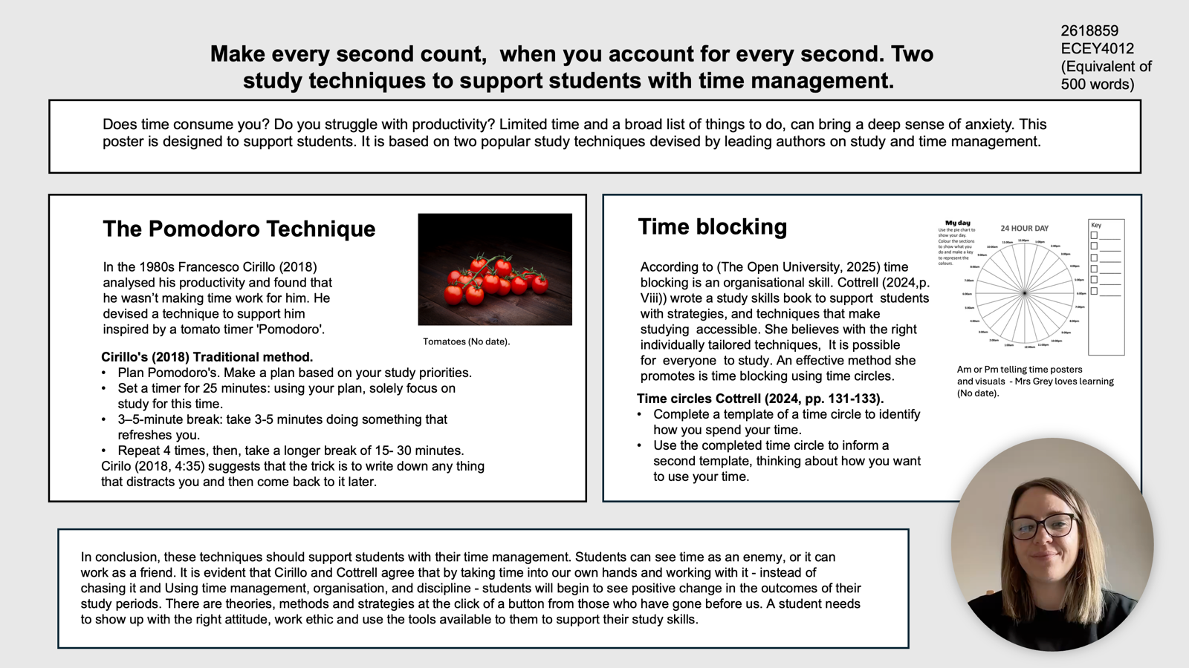
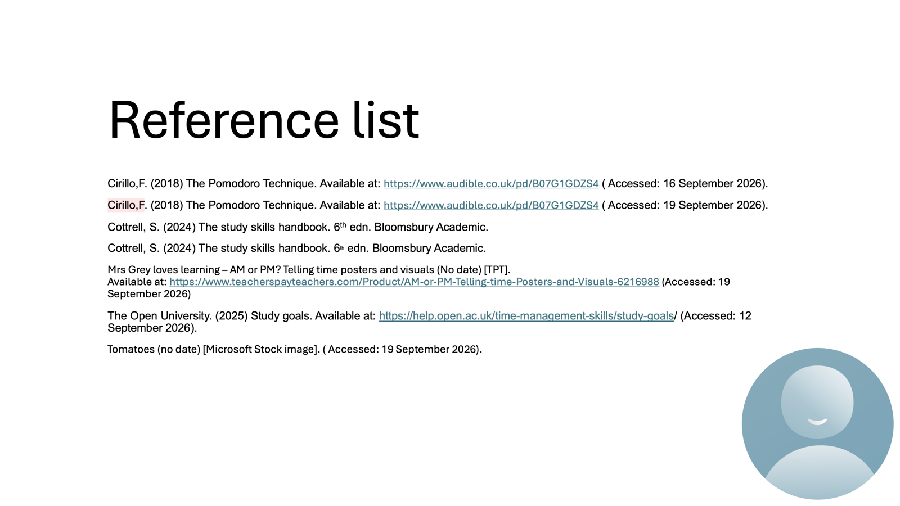

Part 4: Voice over presentation (5 minutes +/- 10 %)
https://uowtsd-my.sharepoint.com/:p:/r/personal/2618859_student_uwtsd_ac_uk/Documents/Presentation.pptx?d=w757c9396d3a343e29d8ac9b10f5e33dd&csf=1&web=1&e=2zCwUs

Reference list page
Biwer, F., Wiradhany, W., Oude Egbrink, M.G.A., De Bruin, A.B.H. (2023) ‘Understanding effort regulation: comparing ‘Pomodoro’ breaks and self-regulated breaks’, British journal of educational psychology, Volume 93 (Issue 2), pp. 353-367. Available at: https://doi-org.uwtsd.idm.oclc.org/10.1111/bjep.12593Digital Object Identifier (DOI)
Burns, T. and Sinfield, S. (2022) Essential Study Skills. 5th edn. SAGE.
Cirillo, F. (2018) The Pomodoro Technique. Available at: https://www.audible.co.uk/pd/B07G1GDZS4 (Accessed: 16 September 2026).
Cottrell, S. (2024) The study skills handbook. 6th edn. Bloomsbury Academic.
Stapleton, A. (2025) Stop prompting like a beginner. Available at: https://youtu.be/PlGAMk_l5vg?si=HpvtzxGgtD5csGQ8 (Accessed: 9th September 2026).


The Open University. (2025) Distractions and procrastination. Available at: Helpful tips for time management/ (Accessed: 9 September 2026).
The Open University. (2025) Study goals. Available at: https://help.open.ac.uk/time-management-skills/study-goals/ (Accessed: 12/9/2026).

