Module Title: Digital Skills for Personal and Professional Growth
Module Code: BMSW4008
Student Name: Khalil Ullah
Student ID: 2508657

Table of Contents
TASK 1: Assessment of Digital Skills 3
Task 2: LinkedIn Learning Certificates 8
Task 3: Essay on the Relevance and Importance of Microsoft Excel 10
3.1. Introduction 10
3.2. Main Body 10
3.3. Conclusion 13
Task 4: Essay on the Relevance and Importance of Microsoft Excel 15

TASK 1: Assessment of Digital Skills

1.1. Summary of JISC Digital Capability Results
The JISC Digital Capability self-evaluation revealed some strengths and weaknesses in my digital skills profile. It has been pointed out that my proficiency is "Capable" when it comes to the use of digital technologies, digital learning management, digital needs and preferences, and being digital. My proficiency in finding resources and information, in digital communications and collaborations, and in digital creativity and problem solving has been rated as "Developing." As can be seen from the analysis provided on the radar chart, my better results are associated with practical skills of working with digital technologies and management of digital learning, while my weaker skills relate to information seeking and digital communications.
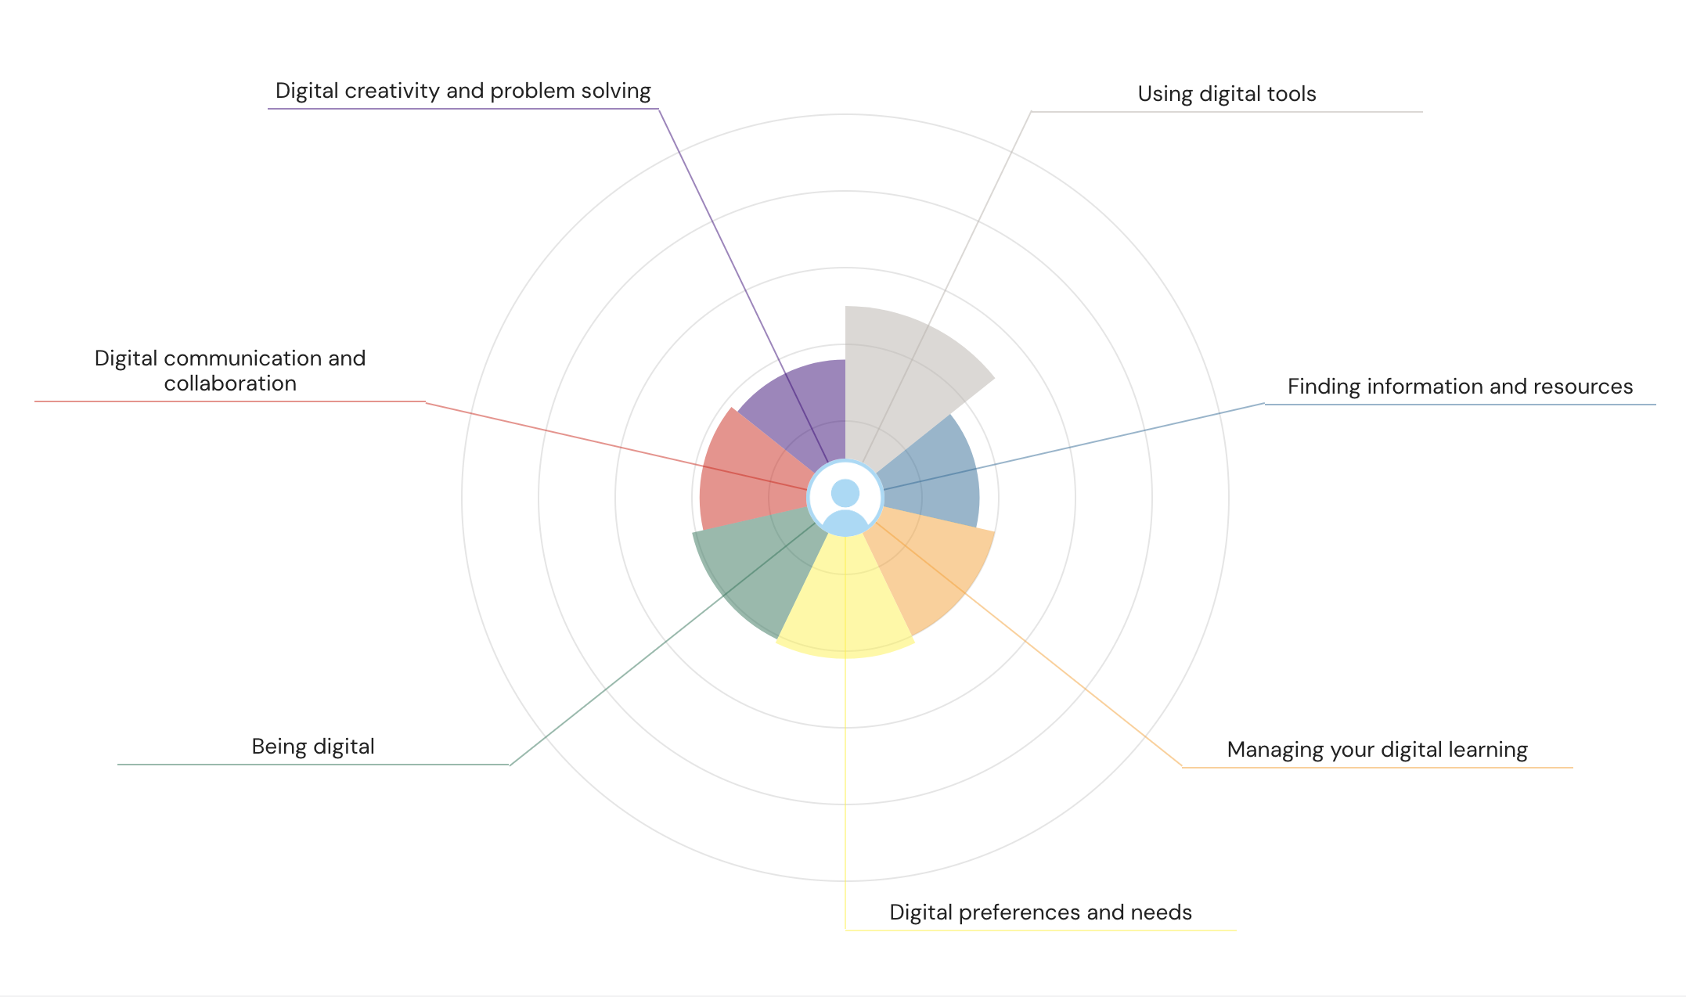 Figure 1: JISC Digital Capability Results Summary; Source: https://uwtsd.potential.ly/playlists/question-bank-for-students/assessments/new-students/report
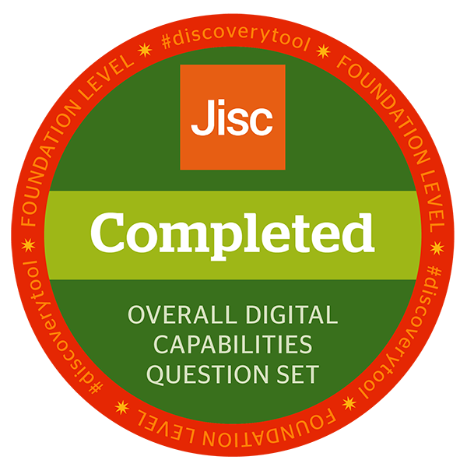
Figure 2: JISC Digital Capability Badge

1.2. Two Identified Strengths

1.2.1 Using Digital Tools
One of my strongest areas is using digital tools. The report categorised my confidence level in this area as “Capable,” indicating that I can effectively use digital devices, applications, and online systems for learning and productivity. I regularly use platforms such as Microsoft Teams, Zoom, PowerPoint, Google Drive, and learning management systems to complete assignments and communicate academically.
This trait becomes crucial since contemporary higher education is based on technologies which enable both individual and collaborative learning. According to Beetham and Sharpe (2019), capable students become adaptable to new technologies and able to build effective learning environments. The fact that I am able to organize files, store materials in the cloud, and operate learning-related software is evidence of such capability.
Additionally, it is stated that capable learners customize digital technologies in accordance with their individual needs. I already use calendars, reminder functions, and note-taking applications to organize academic assignments effectively.

1.2.2 Managing Digital Learning
Another key strength noted in the JISC report is the management of digital learning. The assessment by JISC highlights that I am able to organise and prepare effectively for all kinds of digital learning tasks. This involves the organisation of online resources, engagement with learning platforms, and maintaining efficient study habits.
Online lectures, digital libraries, and electronic databases are all sources which I use to support my work. Additionally, I develop schedules and plans via the use of digital calendars and task management software. As outlined by Fuchs (2026), digital self-management skills play a critical role in the success of students in higher education since they help to organise students, making them independent and flexible in their learning process.
These skills become crucial in light of the shift towards blended learning models in higher education institutions.
1.3. Two Identified Weaknesses

1.3.1 Finding Information and Resources
One area in which I need improvement according to the JISC report is information and resource searching, where my confidence level was rated as "Developing". While I have some experience in searching for information on the internet, at times, I am not sure how to assess the credibility, reliability, and academic value of information found on the internet.
Information about referencing, plagiarism, copyright, and credibility of information is very significant to higher education, according to the JISC report. At times, I use general internet searchers rather than utilizing scholarly search engines. According to Tee et al. (2024), poor information literacy can have adverse effects on academic achievement since they tend to depend on questionable information sources.
Another aspect in which I need to improve is using advanced search techniques and managing information through reference management tools such as Zotero and Mendeley.

1.3.2 Digital Communication and Collaboration
Digital communication and collaboration represent another weakness. According to the report, my skill in this domain is defined as “Developing.” While I feel at ease with the use of social media platforms and messaging applications in a leisure setting, there might be situations where I feel uneasy in communicating professionally online.
For instance, I may find myself reluctant to participate actively in online discussions or collaborate with other people because I may fear misunderstanding the instructions or failing to communicate clearly. For example, according to Reddy, Chaudhary and Hussein (2023), digital collaboration involves such skills as confidence and communication, among others. Similarly, Grissinger (2019) maintains that poor digital communication leads to ineffective teamwork and misunderstandings.
There is no doubt that this aspect should be developed further since it becomes critical in the current professional world where teamwork takes place online.

1.4. SMART Action Plan
To address my two areas of weakness, I have developed the following SMART goals:
SMART Goal | Specific | Measurable | Achievable | Relevant | Time-Bound
SMART Goal 1: Improve Information Literacy Skills | Improve ability to search for reliable academic information and use reference-management tools such as Zotero or Mendeley. | Complete at least 2 online tutorials and use a minimum of 5 peer-reviewed journal articles in each assignment. | Access to university library resources, online tutorials, and academic databases makes this realistic. | Supports academic research quality, referencing accuracy, and critical evaluation skills. | Achieve within 3 months.
SMART Goal 2: Improve Digital Communication and Collaboration Skills | Increase confidence in professional online communication and teamwork using platforms such as Microsoft Teams. | Participate in online discussions and collaborative activities at least twice per week. | Regular university group activities provide opportunities to practise communication skills. | Important for academic collaboration, presentations, and future workplace employability (Liu and Chen, 2026).. | Achieve within 8 weeks.

Reference list
Beetham, H. and Sharpe, R. (2019) Rethinking Pedagogy for a Digital Age. Routledge. Available at: https://doi.org/10.4324/9781351252805.
Fuchs, O. (2026) ‘Advantages and drawbacks of digital communication in remote and hybrid work settings. A sectoral case study in professional services’, Frontiers in Organizational Psychology, 4. Available at: https://doi.org/10.3389/forgp.2026.1810760.
Grissinger, M. (2019) ‘Understanding Human Over-Reliance On Technology’, Pharmacy and Therapeutics, 44(6), p. 320. Available at: https://pmc.ncbi.nlm.nih.gov/articles/PMC6534180/.
Jisc (2025) Individual digital capabilities, JISC. Available at: https://digitalcapability.jisc.ac.uk/what-is-digital-capability/individual-digital-capabilities/.
Liu, J. and Chen, Y. (2026) ‘Socioeconomic status and educational inequality: digital competency pathways to creative problem-solving and academic performance’, Frontiers in Psychology, 16. Available at: https://doi.org/10.3389/fpsyg.2025.1690989.
Reddy, P., Chaudhary, K. and Hussein, S. (2023) ‘A digital literacy model to narrow the digital literacy skills gap’, Heliyon, 9(4), p. e14878. Available at : https://doi.org/10.1016/j.heliyon.2023.e14878.
Tee, P.K., Wong, L.C., Dada, M., Song, B.L. and Ng, C.P. (2024) ‘Demand for digital skills, skill gaps and graduate employability: Evidence from employers in Malaysia’, F1000Research, 13, pp. 389–389. Available at: https://doi.org/10.12688/f1000research.148514.1.

Task 2: LinkedIn Learning Certificates
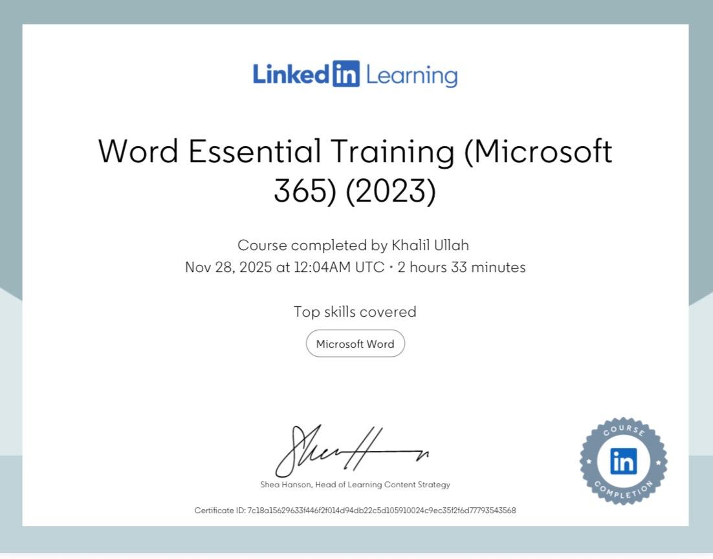

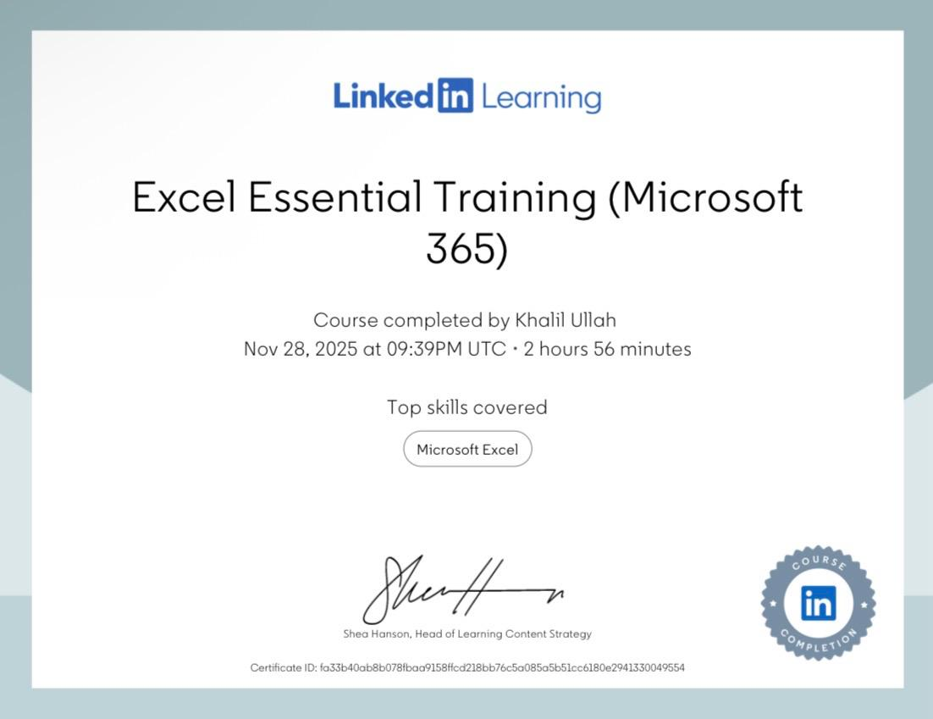
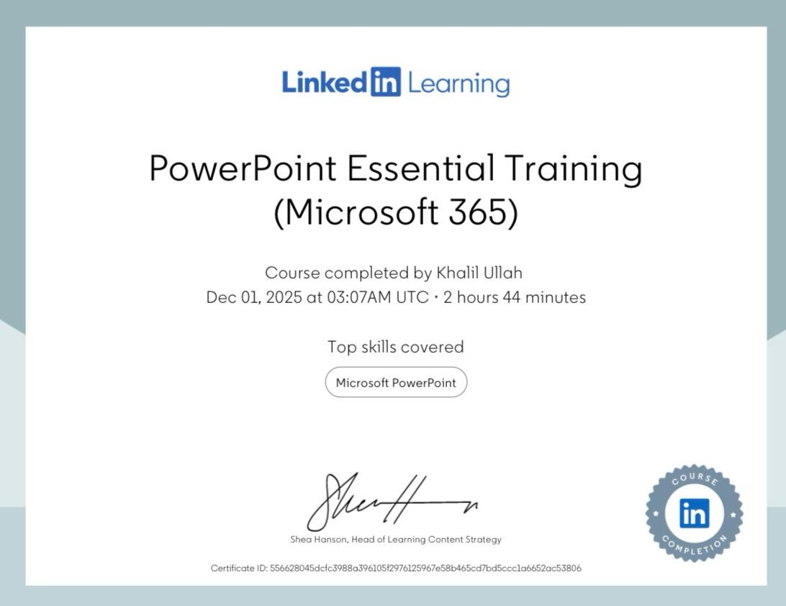

Task 3: Essay on the Relevance and Importance of Microsoft Excel

3.1. Introduction
One of the most powerful and versatile software applications ever developed is Microsoft Excel. Originating in 1985 as simply an electronic spreadsheet. Cited by Rebman et al. (2023), Excel is believed to be used by an estimated 750 million people worldwide and is now a highly powerful tool for data management and analysis. Whether it's a small business owner keeping track of their expenses or a large multinational company engaging in complex financial modelling, Excel plays a pivotal role in the digital toolbox of today's businesses. The competence with a spreadsheet is one of the most transferable digital skills that can be acquired by graduates, precisely because it is expected in so many industries and job roles (Đorđević, Sandra and Radosavljević, 2025). The essay looks at the applications of using Microsoft Excel in data analysis, budgeting, reporting and decision making with real-life examples and makes it relevant and important. It comes with an incorporated household income and expenditure worksheet capable of illustrating the practical skills of the software.

3.2. Main Body
Excel for Data Analysis
Excel is an important application used in data analysis since it features functions that allow one to organise and analyse big data sets conveniently. Descriptive statistics functions include AVERAGE, MEDIAN, and STDEV, while logical functions include IF and AND. For instance, a company engaged in retailing can use the SUMIF function to determine total sales per product category. PivotTables is another important function in Excel that makes data summarisation possible without changing the original data set (Halder, 2023). Human resources personnel can employ a PivotTable to analyse employees' absenteeism trends. Excel can also be used to conduct regression analysis through the Data Analysis ToolPak. Kumar (2023) asserts that Excel fills the gap between spreadsheets and statistical applications.
Excel for Budgeting and Financial Planning
Excel is extensively used for budgeting and financial planning by both individuals and organizations. An individual can make use of Excel for budgeting purposes such as tracking their income and expenses, maintaining balances, and warning about any overspending through the use of IF functions. Organizations, on the other hand, have finance departments that make use of named ranges, linked sheets, and scenario managers to come up with budgets across various scenarios. Regan and Brown (2021) estimates that more than 80% of finance professionals rely on Excel for budgeting.
Excel for Reporting and Data Visualisation
Excel provides a rich collection of tools for data analysis through its charts, which include bar graphs, pie graphs, and scatter graphs. These tools assist in representing complicated data in easy-to-understand ways. Using conditional formatting, cells can change colors according to data, helping managers easily spot poorly performing items. According to Ghaffar (2020), Excel dashboards are forms of business intelligence that can be achieved without any additional software. For example, a simple pie graph within a domestic budget can make data visually comprehensible.
Excel for Decision-Making
Beyond analysis and reporting, Excel is a critical tool for supporting organisational decision-making. Its what-if analysis features, including Goal Seek, Scenario Manager, and Data Tables, allow decision-makers to model the potential outcomes of different choices before committing to a course of action. A retailer considering whether to open a new store, for example, could build a break-even model in Excel, adjusting assumptions about footfall, average transaction value, and operating costs to determine under what conditions the store would become profitable.
Excel also supports decision-making through its capacity to handle large volumes of structured data using tools such as VLOOKUP, INDEX-MATCH, and Power Query, enabling organisations to merge datasets from multiple sources and derive insights that inform strategy. Frye (2022) emphasises that the ability to use Excel effectively for decision support has become a fundamental expectation for business analysts, financial planners, and operations managers. The graduates who can demonstrate this proficiency have a significant competitive advantage in the labour market. The relevance of Excel to decision-making is therefore not merely technical but strategic, enabling organisations to move from intuition-based to evidence-based decisions (Sylvestre, 2024).
Embedded Spreadsheet: Household Income and Expenditure Analysis
The following spreadsheet is an example of the real-world use of the Microsoft Excel skills that have been learned during the LinkedIn Learning Excel Essential Training (Microsoft 365) training program. This spreadsheet provides a monthly analysis of the income and expenses of a particular family, using SUM and IF functions, along with a pie chart.
Table 3: Household Income and Expenditure Summary
Category | Amount (£)
Monthly Income | 2400
Rent | 900
Utilities | 180
Groceries | 350
Transport | 150
Entertainment | 120
Savings | 300
Miscellaneous | 200
Total Expenditure | 2200
Balance | 200
Formulas Used in Excel
• Total Expenditure: =SUM(B3:B9)
• Balance (Income – Expenditure): =B2-B10
• IF Overspending Statement: =IF(B11<0,"Overspending","Within Budget")
A pie chart showing the breakdown of household expenses has been incorporated into the original Excel spreadsheet. It can be easily seen from the chart that the biggest expense incurred is Rent (41%), followed by Groceries (16%), Savings (14%), Utilities (8%), Miscellaneous (9%), Transport (7%), and Entertainment (5%). This graphical representation helps us to quickly identify the biggest expenses and take decisions for cutting down the expenses accordingly.
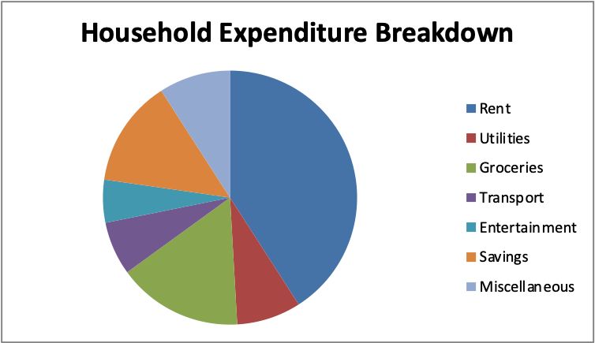
Figure 1: Household Expenditure Chart

3.3. Conclusion
Excel by Microsoft is an indispensable program in today’s digital world. Excel can be applied in data analysis, budgeting, report creation, and decision making. Thus is useful in almost any industry and profession. From the examples provided in this essay, it is clear that Excel is more than just a place where numbers are stored; Excel can help make sense of data through various formulas, functions, graphs, and interactive options. The household expenditure spreadsheet provided in section 4 serves as a good example of Excel’s abilities in these regards. It is thus imperative that students of today hone their Excel skills to become professionals of tomorrow. Through my completion of the LinkedIn Learning Excel Essential Training program and further application of those skills in this portfolio, I have greatly enhanced my data literacy and Excel proficiency.

Reference list
Đorđević, B., Sandra, M.Z. and Radosavljević, M. (2025) ‘Impact of the Digital Skills on Employability: Cross-Sectional Analysis’, Economies, 13(7), p. 196. Available at: https://doi.org/10.3390/economies13070196.
Ghaffar, A. (2020) Integration of Business Intelligence Dashboard for Enhanced Data Analytics Capabilities, Uwasa.fi. Available at: https://osuva.uwasa.fi/items/26e7b3f8-b592-41d7-b358-cd8175ae4ccd.
Halder, A. (2023) How to Use Excel Pivot Tables for Summarizing and Presenting Data. SAGE Publications Ltd. Available at: https://doi.org/10.4135/9781529670332.
Kumar, D.M.D. (2023) ‘A Study On Importance of Microsoft Excel Data Analysis Statistical Tools in Research Works’, Journal of Management & Educational Research Innovation, 1(3), pp. 25–33. Available at: https://doi.org/10.5281/zenodo.10449150.
Rebman, C., Booker, Q., Wimmer, H., Levkoff, S., Mcmurtrey, M. and Powell, L. (2023) ‘An Industry Survey of Analytics Spreadsheet Tools Adoption: Microsoft Excel Vs Google Sheets’, Information Systems Education Journal (ISEDJ), 21(5). Available at: https://files.eric.ed.gov/fulltext/EJ1409034.pdf.
Regan, T.H. and Brown, M.T. (2021) ‘Budgeting’, Financial Management in the Sport Industry, pp. 186–219. Available at: https://doi.org/10.4324/9780429316746-8.
Sylvestre, C.E. (2024) ‘The Role of Data-Driven Decision Making in Business Strategy’, The Role of Data-Driven Decision Making in Business Strategy, 3(3), pp. 80–84. Available at: https://www.researchgate.net/publication/383552085_The_Role_of_Data-Driven_Decision_Making_in_Business_Strategy.

Task 4: Essay on the Relevance and Importance of Microsoft Excel


