Justin Cretu
LCHS4002
Digital Skills and Research Methods
The use of technology in the modern healthcare workplace –
Mental Health Hospital

Contents
Introduction
Different technologies used in Modern Health Care Workplace
Research Interest
Problem Statement
Research Idea
Methodology
Sources
Conclusion
References

Introduction
The usage of technology in healthcare is a very important topic as we continue to expand and elaborate on it because technology and digitalization of the health sector, in this case, all the providers of care must try and keep up with the evolution is very important in modern healthcare not only for members of staff and also for the health and comfort of our patients. We can say that a good number of revolutions and innovations are used in our days in the healthcare sector as a result of technology and digitalization.
In my project, I will talk mostly about the usage of technologies and digitalization in my previous workplace, a Mental Health Hospital. It’s important to notice that new technology can make a huge change to any healthcare provider, and these days, hospitals and care providers everywhere are making technology a big part of their progressions, so all hospitals need to follow and keep up with the times to make sure that they are being up to date with technologies and information.

Different technologies used in Modern Health Care Workplace
Technology in health and social care can come in different forms and have many resolutions. I think that technology is any IT tool or software created to improve health and social care systems, and organizational productivity or to provide new understandings of patient care, medicines, and treatments.
As a hospital become more and more automatic with record keeping and information sharing between patients, doctors, and providers, the role of Information Technology (IT) in healthcare has become very important to patient care. “Technology helps to reduce as many as possible errors, avoid adverse medication reactions, protect patient privacy and confidentiality, and improve overall care. And while the demand for IT experts, in general, is expected to grow faster than average through 2030, the healthcare sector can provide people with a career, a mission, and a goal.” (national.edu, 2021).
Nowadays we need technology that makes life easier for staff and those using health and care providers and their families. I used to work as a support worker in a Low Secure Unit in a Mental Health Hospital in Haslemere and I can tell that using modern technologies starting from medical devices like hoists, standing aid hoists, sensory mattresses, and other medical equipment, to the latest digital software, where very helpful not just for staff in offering better support to the patients, but also for their families.
One of the digital software that is used in my workplace is the Care Notes System which allows all relevant persons to add and access new relevant information regarding the evolution and the health of the patients. In this program, you can see if there are any alerts regarding reactions or any health changes that can occur every hour or day, depending on events.
Other technologies used in the hospital were ECG monitors to monitor their health, smart thermometers very important, especially during Covid-19, blood pressure machines, smart beds, and electronic health records.

Research Interest (Motivation)
Technology has transformed the way specialists approach the idea of healthcare. Although many of these new technologies and invocations are positive regarding patient care and ensuring all the treatments are more effective, they also have some disadvantages and issues in using and applying this new technology in the best interest of people.

Problem statement
From my point of view, one of the main problems in our health and care department is the lack of information, training, and up-to-date devices.
I think that despite all of these technological advances, many health and social care providers are still using out-of-date information and technology. “Old-fashioned software creates security issues like the one that allowed hackers to take down the NHS's system in 2017. Windows 7 computers are about to be on the same page, with the company ending support in 2020.”( Kayla Matthews, Productivity Bytes,2019)
I chose this topic regarding the out-of-date system from some of our healthcare providers because we all might become a victim of this system as most of us have files and records stored in the healthcare system.
I think that is very important that Hospitals and other healthcare providers must nonstop check for updates and avoid new types of medical errors.

Research idea
I think that the application of technology in health care can bring a lot of benefits not only for practitioners but also for patients. Healthcare Information Technology (HIT) results in increased productivity and cost savings in health organizations (Naylor et al., 2011). It helps in minimizing the wastage of resources and time, thus enhancing efficiency in hospitals.
The use of modern and up-to-date medical technology certifies patient safety. First, there are alerts on medication, flags and reminders, consultation and diagnosis reports, and the easier availability of patient data. Mostly, alerts can help a patient that follows specific treatments and schedules of treatment (impactmybiz.com).
Smart technology in the healthcare sector is changing the way patients are treated with telehealth, remote care, and health monitoring technology connecting patients with their doctors like at no time before. (impactmybiz.com)
Monitoring of patients’ healthcare is a rising tendency that goes beyond old-style healthcare and into the ordinary culture. Smartwatches and fitness trackers now have become normal for so many people, monitoring health factors like heart rate, blood oxygen, irregular heartbeat monitoring, and more. I think that a big percentage of people own at least one device that is monitoring their health.
In healthcare, providers are turning to devices to help patients by continuously monitoring their health issues and making good care choices based on data trends and predictions from these devices.
For example, connected inhalers are a smart technology in healthcare that saves lives by helping patients track usage and by reminding them when to take a dosage to maintain a healthy timetable.
“66% of asthma deaths could have been prevented with smart technology monitoring like connected inhalers”
There are several different wearable items or devices that people can keep on their person to help improve their healthcare, like:
- Biosensors
- Smart thermometers
- ECG monitors
- Blood pressure monitors
- Connected inhalers
- Smartwatches
- Fitness trackers (FitBits)
An additional key revolution in healthcare devices has been the portable biosensors used by providers across the world to monitor patients and administer proactive care. These sensors are worn on the body and monitor vital health signs like temperature and heart rate to give their healthcare providers more information and insights on the progression of diseases, illnesses, and overall health.
A lot of us are now aware of telehealth, which became a very used choice for healthcare providers (mainly GPs) and patients during the Covid pandemic. With the help of video calls, doctors could virtually treat patients over video call and I can say that I’ve been using this method a lot during the pandemic every time I was in need to contact my GP.
Part of this virtual care was the use of medical portal technology to build secure online healthcare portals to help providers and patients track treatment, store health records, and collect and access data from wearable devices or clinic visits, for example, my surgery is giving me the option to contact them thru the online system and in this way, I’m able to access my patient file as well.

Methodology
These days with this quick explosion of data and technology the healthcare system accomplishes far below satisfactory levels for certifying patient safety and needs, healthcare professionals need to make sure that they follow the basics of quality improvement methodologies and terminology. The most important goals are to deliver to the healthcare workers enough information to understand the basics of quality improvement, provide a beginning point for development and inspire further inquiry into the quality development methodologies currently being used in the healthcare sector.
Innovative technology in healthcare is changing the situation and helps us all in more ways than one. With more monitoring treatment options available to more and more patients, doctors can use data, and other advanced tools to make a more practical, data-driven approach to healthcare. In this way, we all can benefit from better treatment and less waiting time.
The main goal of digital technology use in health and social care is to improve quality, productivity, and patient experience as well as support more joined care and improve the health of people.
An important change in connecting digital technology, such as adopting electronic patient records and shared care records, is complex and necessitates attention to particular aspects of the change. The main obstacles to successful digital change include the limitations of care organizations’ workforce and small budgets. Most of the barriers can be mitigated through time and effort and by treating digital projects as change. For example, I had an appointment with Southampton Hospital and they were unable to access my record from Portsmouth Hospital from this reason I need to repeat some tests, which caused extra costs from NHS, costs that could be avoided by using new technology to link the data between hospitals.
I think that if all the healthcare providers and patients as well, should adopt and try to be up to date with new technologies (especially the hospitals), the patients can benefit from better and quicker treatment and fewer waiting times.

Sources
Using more credible sources and studies can sustain the fact that the technology and digitalization of the healthcare sector are to the advantage of everybody, doctors, patients, or other parties involved in the care sector.
I think collecting information only from credible sources is very important when you conduct research. In our days we can find a lot of internet information but is vital to be able to see the difference between credible one and fake articles. A good source to find information is the NHS and gov. UK website.
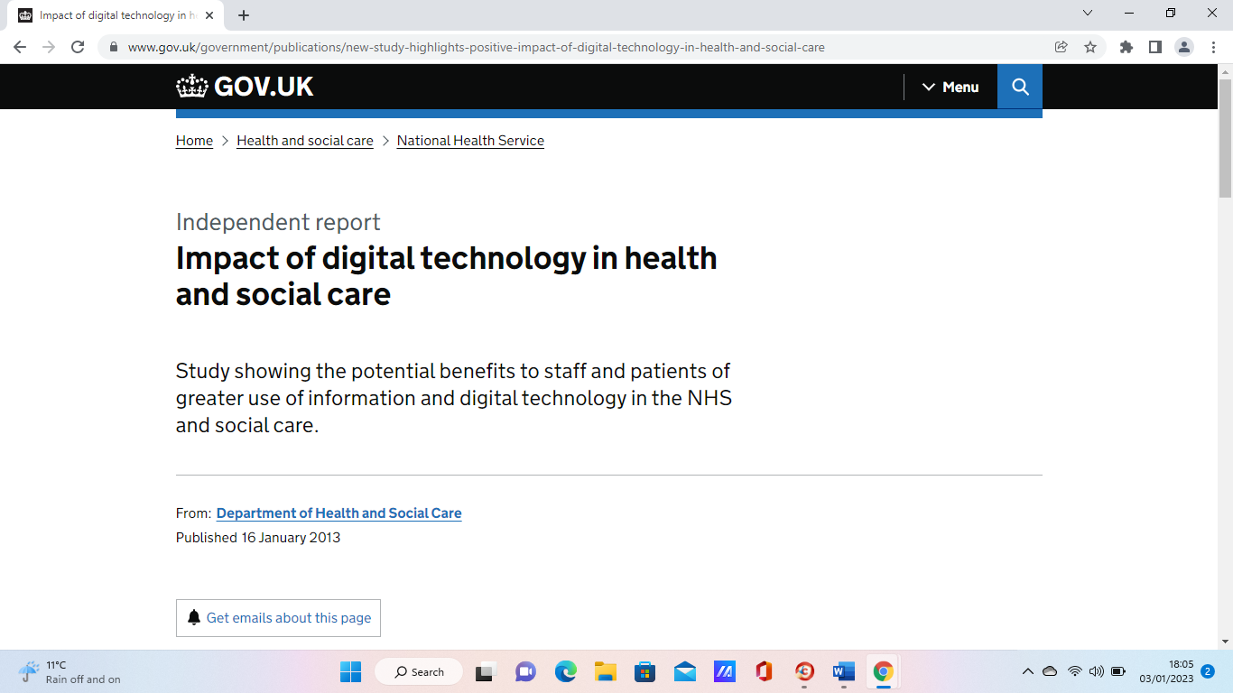
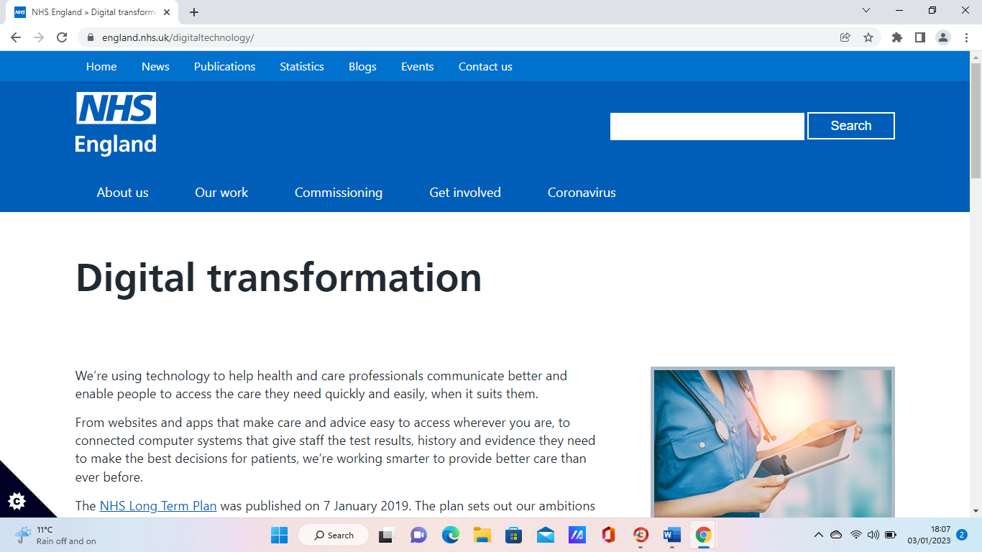
Books as well are good and credible sources of information in any study or research.

Conclusion
In conclusion, I think that the use of technology and digital information in the healthcare sector is expanding very quickly. These days there are a lot of issues being experienced by healthcare providers as they need to implement new information technology. For example, the quality accomplished as a result of investment in information technology is not often recognized. Instead of rewarding upgraded service delivery, a big majority of service providers put stress on the volume of services that they need to offer. Another issue is that healthcare delivery is split segment which makes it harder for healthcare organizations to adopt information technology. Nevertheless, of these challenges, hospitals are investing in improving digital technology because it improves information access by patients and healthcare providers which in turn increases the quality of care provided to patients. The use of data technology also improves communication between healthcare providers and subsequently decreases missed care.

References:
- https://www.oxfordhealth.nhs.uk (2017). Using technology to deliver better mental health services. [online] Oxford Health NHS Foundation Trust. Available at: http://www.oxfordhealth.nhs.uk/news/using-technology-to-deliver-better-mental-health-services [Accessed 3 Jan. 2023].
- National. (2021). Why Information Technology Is Important in Healthcare. [online] Available at: https://www.national.edu/2021/11/03/information-technology-important-healthcare/.
- Social Care Institute for Excellence (SCIE). (n.d.). Challenges and solutions: commissioning social care during COVID-19. [online] Available at: https://www.scie.org.uk/care-providers/coronavirus-covid-19/commissioning/challenges-and-solutions.
- Matthews, K. (2019). 6 Challenges Tech Has Brought To Healthcare (And How To Avoid Them). [online] www.healthitoutcomes.com. Available at: https://www.healthitoutcomes.com/doc/challenges-tech-has-brought-to-healthcare-and-how-to-avoid-them-0001.
- Graham, N.O. (1995). Quality in health care: theory, application, and evolution. Gaithersburg, Md.: Aspen Publishers.
- Harrington, C., Estes, C.L. and Crawford, C. (2004). Health policy: crisis and reform in the U.S. health care delivery system. Sudbury, Mass.: Jones And Bartlett Publishers.
- Ferriss, A.L. and SpringerLink (Online Service (2010). Approaches to Improving the Quality of Life: How to Enhance the Quality of Life. Dordrecht: Springer Netherlands
- Dunlap, S. (2022). 5 Examples of Smart Technology in Healthcare. [online] Impact Networking. Available at: https://www.impactmybiz.com/blog/smart-technology-in-healthcare/.
- GOV.UK. (n.d.). Impact of digital technology in health and social care. [online] Available at: https://www.gov.uk/government/publications/new-study-highlights-positive-impact-of-digital-technology-in-health-and-social-care.
- Maguire, D. (2018). Digital Change In Health And Social Care.
- NHS England (2019). NHS England» Digital transformation. England. NHS.uk. Available at: https://www.england.nhs.uk/digitaltechnology/.
- Coursehero.com. (2023). Available at: https://www.coursehero.com/file/p4mj1pd/In-conclusion-the-use-of-information-technology-in-the-healthcare-sector-is/ [Accessed 3 Jan. 2023].

