Abstract
With the rapid development of information technology and the increasing complexity of the network environment, global enterprises are facing unprecedented challenges in information security. This paper explores how to strengthen the information system security, governance, and compliance of NatureGarden (NG) company, in light of its actual situation. By analyzing the security risks faced by NG in allowing employees and customers to use personal devices to access company network resources, this study first conducts an in-depth exploration of existing security frameworks and models, including the Information Technology Infrastructure Library (ITIL) and the International Organization for Standardization's ISO 27000 series standards. Based on these frameworks and standards, this paper proposes a comprehensive solution aimed at enhancing the information system security of NG company, covering key areas such as compliance strategy, risk management, and security policy formulation. Additionally, this paper emphasizes the importance of continually updating regulations and standards to adapt to emerging technologies and threats, discussing how these updates can help better protect customer data and corporate assets. The purpose of this research is to provide NG and similar enterprises with a clear guidance on information security, governance, and compliance to address the challenges of the modern cyber security domain.

Key Words: Information Security, Governance, Compliance, ITIL, ISO 27000, Data Protection, Corporate Security

Directory
Abstract 1
1.Introduction 1
2. Overview of Security Frameworks and Models 3
2.1 ITIL Framework 3
2.2 ISO 27000 Series Standards 4
2.3 Comprehensive Information Security Management 6
3. Analysis of NatureGarden's Information System Security Requirements 7
3.1 Security Risks in a BYOD Environment 7
3.2 Protecting Data and Intellectual Property 7
3.3 Compliance with International Data Protection Regulations 8
3.4 Addressing Emerging Cybersecurity Threats 8
3.5 Conclusion 8
4. Solution design for security, governance and compliance 10
4.1 Security policy 10
4.1.1 Data protection policy 11
4.1.2 Cybersecurity Policy 11
4.1.3 Device Management Policy 11
4.1.4 Ensure the effectiveness of your strategy 12
4.2 Risk Management Process 12
4.2.1 Industry-Specific Risk Identification 12
4.2.2 Customized Risk Assessment 13
4.2.3 Risk Mitigation Strategies 13
4.2.4 Monitoring and Continuous Improvement 13
4.2.5 Expected Outcomes 13
4.3 Emergency Planning and Business Continuity 13
4.3.1 Customized Emergency Response Plans 13
4.3.2 Disaster Recovery Strategies 14
4.3.3 Business Continuity Planning 14
4.3.4 Employee Training and Emergency Drills 14
4.3.5 Expected Outcomes 14
4.4 Security Governance 15
4.4.1 Governance Structure Establishment 15
4.4.2 Policy and Procedure Development 15
4.4.3 Monitoring and Auditing 15
4.4.4 Expected Outcomes 15
4.5 Compliance and Technology and Human Resource Investment 16
4.5.1 Compliance Management 16
4.5.2 Technology Investment 16
4.5.3 Human Resource Development 16
4.5.4 Expected Outcomes 16
5. The Importance of New or Updated Rules and Regulations 18
5.1 Impact of emerging technologies and threats on existing security frameworks 18
5.2 The role of international cooperation and standardization 19
5.3 The Importance of Continuous Regulatory Updates 19
6.Conclusion 20
Reference 21

1.Introduction
With the rapid development of global digitalization, cybersecurity has become a crucial area in corporate management. NatureGarden (hereinafter referred to as NG), as a leading global company in selling health and wellness products, operates across multiple countries and relies on advanced information technology and extensive network systems for its daily operations. However, with the advancement of technology and the widespread use of networks, NG is facing an increasing number of cybersecurity challenges. In particular, a major issue the company has recently encountered is allowing employees and customers to use personal devices to access corporate network resources, which not only increases the risk of data breaches but also poses potential threats to the company's intellectual property and the privacy of customer information.

Against this backdrop, this paper aims to explore and propose a comprehensive set of strategies for information system security, governance, and compliance to help NG cope with the increasingly complex cybersecurity environment. Through an in-depth analysis of existing security frameworks and models, such as the Information Technology Infrastructure Library (ITIL)[1] and the International Organization for Standardization's ISO 27000 series, this paper will design a solution for NG that meets international standards and addresses its specific needs. We will focus on discussing how to strengthen the company's information system security and data protection through compliance strategies, risk management, and the formulation of security policies.

Furthermore, considering the constant evolution of emerging technologies and threats, this paper will also discuss the importance of continuously updating regulations and standards, and how these updates can help businesses better protect customer data and corporate assets. Through these comprehensive discussions and strategy formulations, this paper aims to provide NG and similar enterprises with a clear guideline to address the challenges in the modern field of information security.

2. Overview of Security Frameworks and Models

2.1 ITIL Framework
The Information Technology Infrastructure Library (ITIL)[2] is a globally recognized framework for IT service management. It offers a comprehensive set of best practices for delivering high-quality IT services that align with the needs of businesses. ITIL's structured approach covers various aspects of service management, including strategy, design, transition, operation, and continuous improvement, as shown in Figure 2.1.
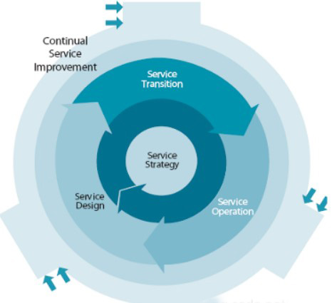
Figure 2.1 Five stages of ITIL service management
Service Strategy: This component focuses on understanding organizational goals and customer needs. It involves designing IT services and processes that align with the broader business strategy.
Service Design: Ensuring that the planned services meet current and future business requirements. This stage involves designing new services or changing existing services.
Service Transition: Managing changes effectively, ensuring that new or modified services meet customer expectations and are delivered without disrupting existing services.
Service Operation: Overseeing the day-to-day operation of services, ensuring that IT services are delivered effectively and efficiently.
Continual Service Improvement: This component emphasizes the ongoing improvement of services and processes, based on operational feedback and changing business requirements.

2.2 ISO 27000 Series Standards
The ISO 27000 series, particularly ISO 27001 and ISO 27002, provide a comprehensive set of standards for establishing, maintaining, and improving an Information Security Management System (ISMS). These standards offer guidelines and best practices for systematically managing an organization's sensitive information, ensuring its confidentiality, integrity, and availability.
ISO 27001: This standard outlines the requirements for establishing, implementing, maintaining, and continually improving an ISMS. It provides a risk-based approach to information security, requiring organizations to identify, assess, and manage information security risks[3].
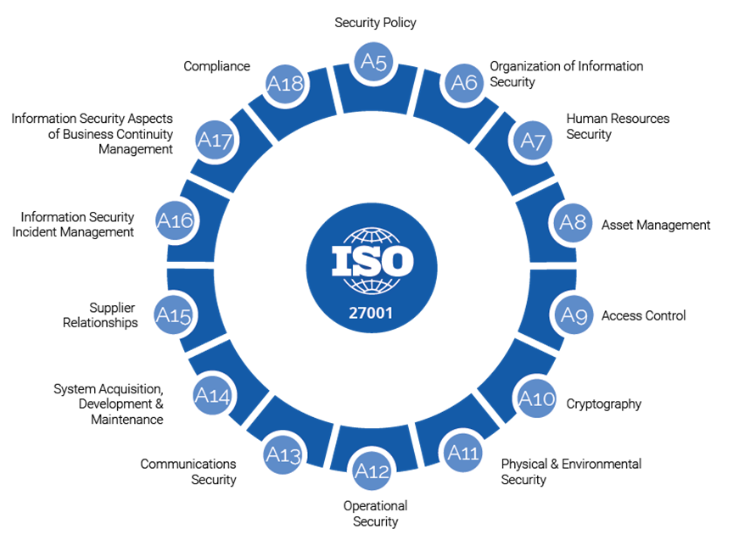
Figure 2.2 ISO 27001

ISO 27002: It provides best practice recommendations on information security management, detailing controls and guidelines for implementing an effective ISMS. It covers various aspects of information security such as user access management, incident management, and compliance[4]. The difference between ISO 27001 and ISO 27002 is shown in Figure 2.3 below.
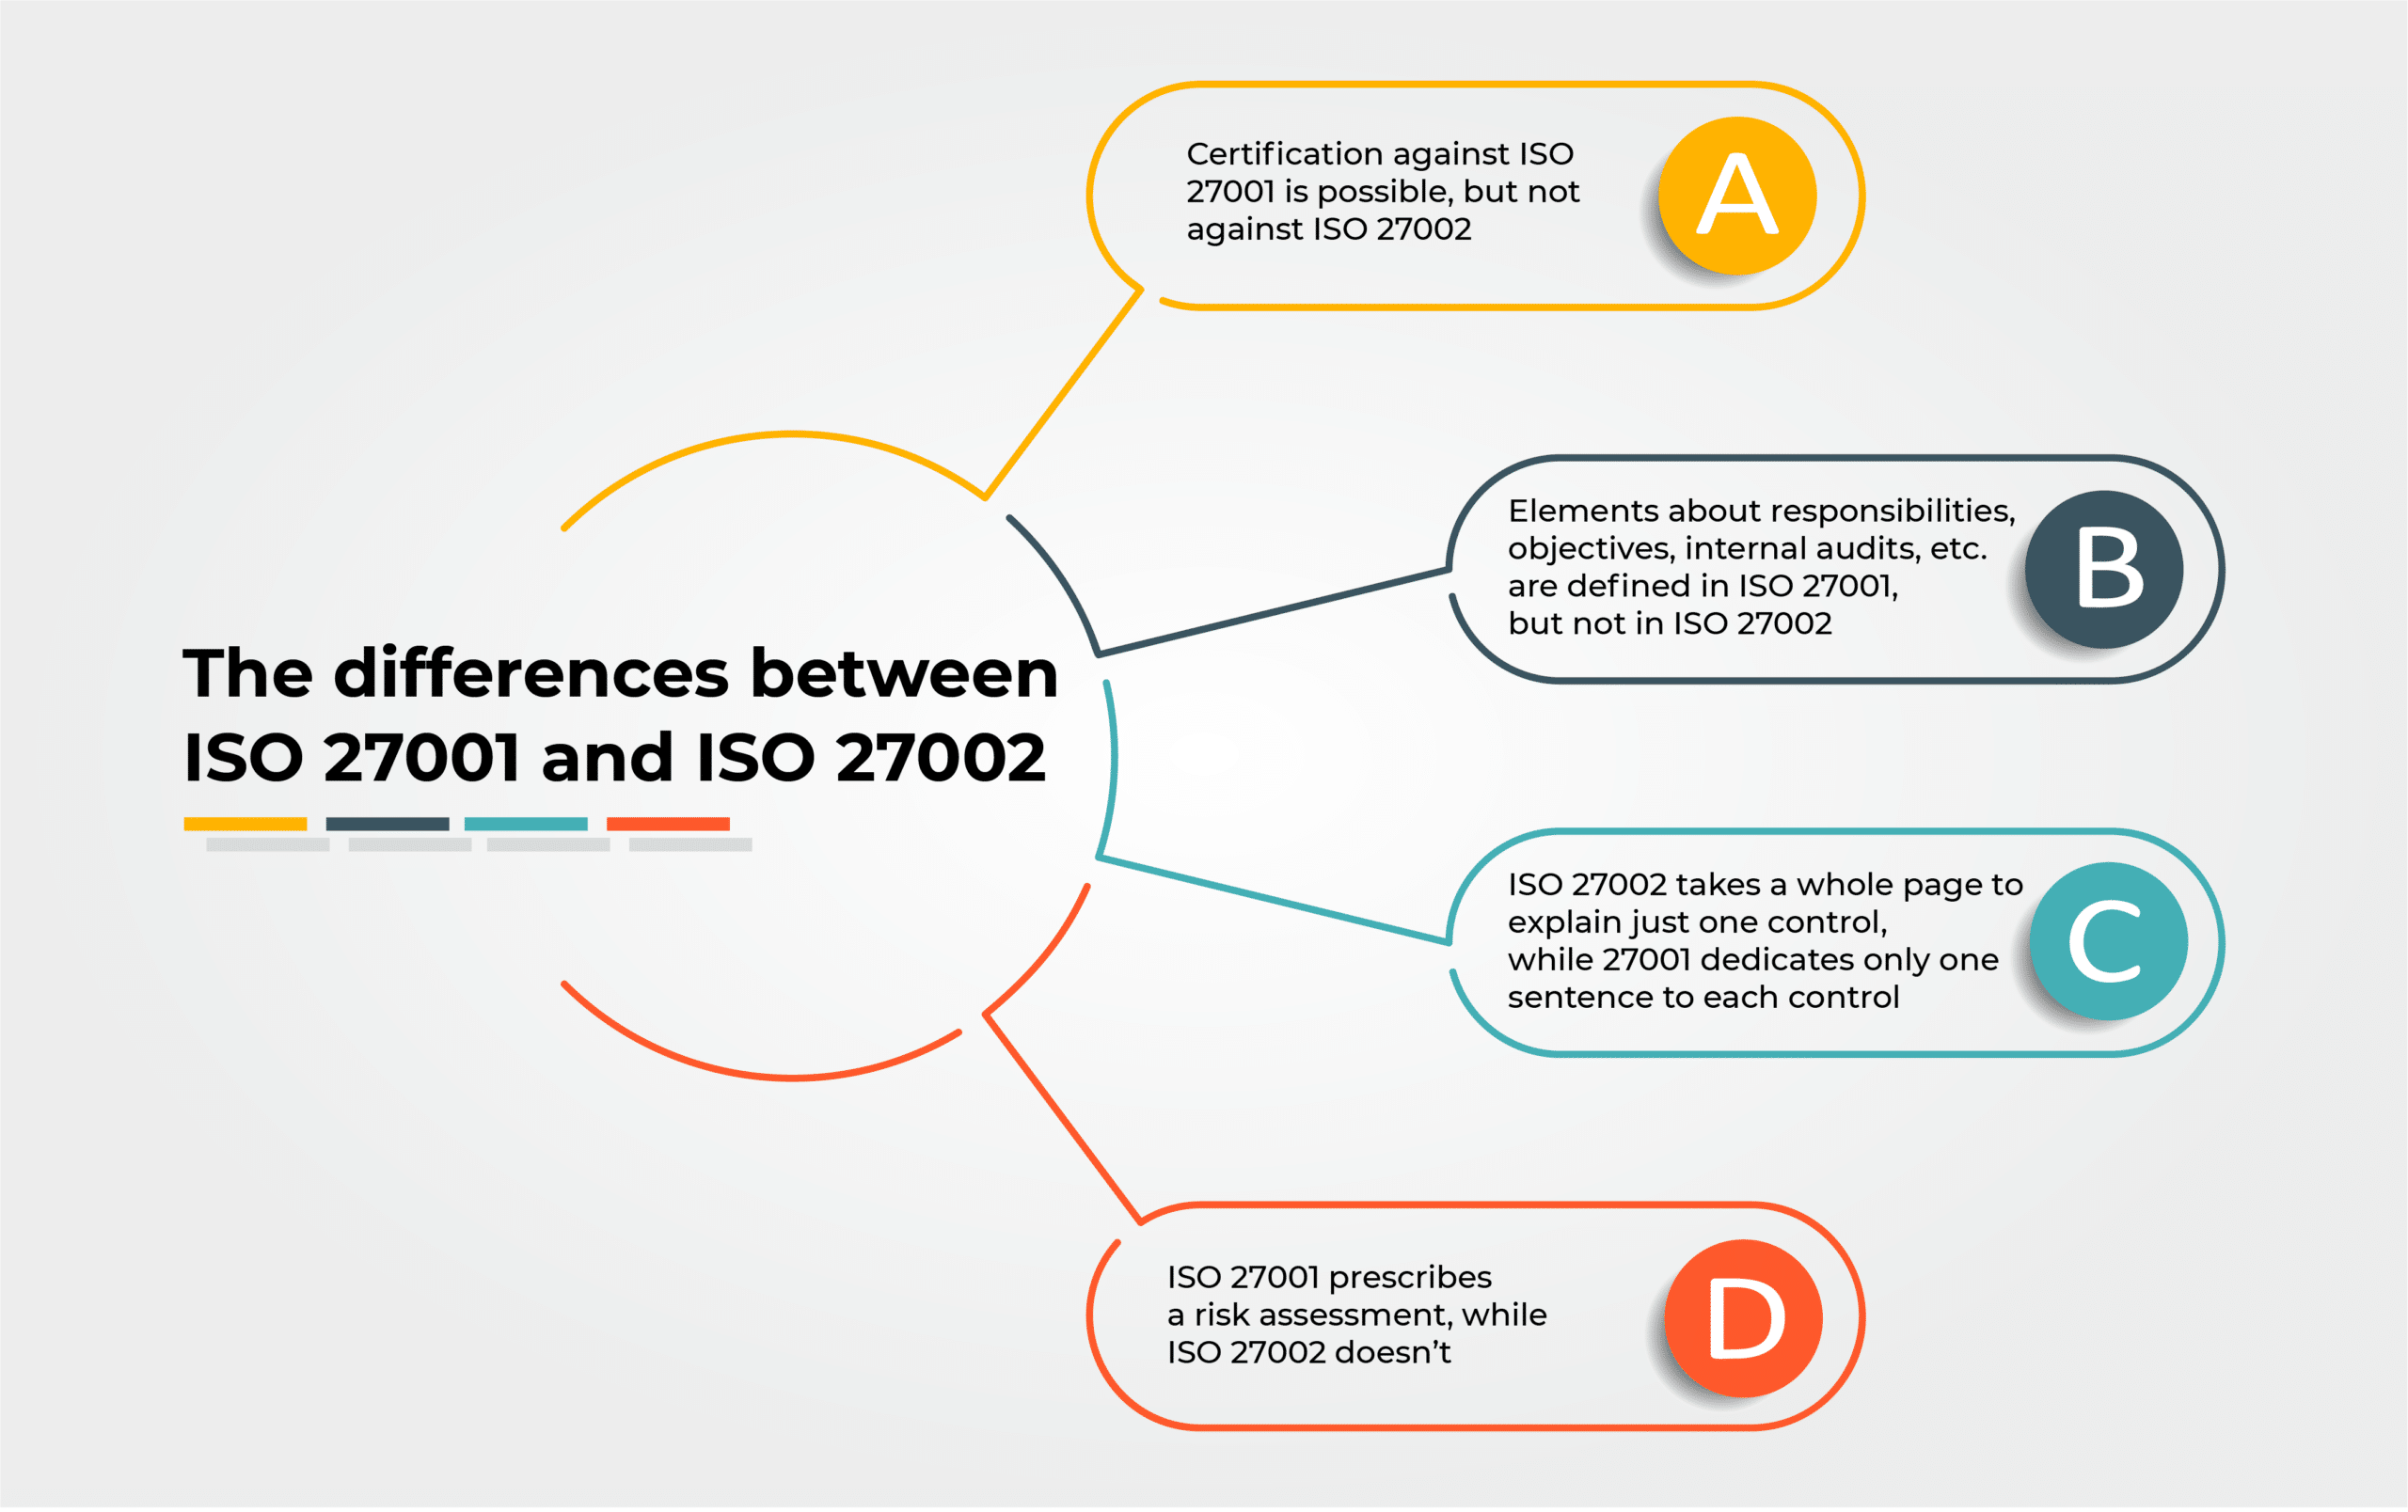
Figure 2.3 The differences between ISO 27001 and ISO 27002

2.3 Comprehensive Information Security Management
Both ITIL and ISO 27000 series standards emphasize a structured and strategic approach to managing information security risks, which is crucial for organizations like NatureGarden. By integrating these frameworks, NatureGarden can ensure the protection of its information assets and intellectual property while maintaining compliance with global data protection standards. Additionally, these frameworks facilitate internal risk management, policy formulation, and continuous improvement of security practices, keeping the company resilient in the face of evolving cyber threats.

The implementation of these frameworks involves a holistic approach, ensuring that all aspects of information security are addressed comprehensively. From policy development and risk assessment to incident management and continuous monitoring, these frameworks provide a roadmap for establishing a robust and responsive information security posture. For NatureGarden, this means not only safeguarding its business operations and customer data but also strengthening its reputation and trustworthiness in the global market.

3. Analysis of NatureGarden's Information System Security Requirements
In today’s interconnected and digitally driven business landscape, NatureGarden confronts a spectrum of information security challenges. These challenges are multifaceted, stemming from the rapid evolution of technology, the complexity of cyber threats, and the diverse nature of global operations. For NatureGarden, a comprehensive analysis of its information system security requirements is crucial to safeguard its business and customer data[5].

3.1 Security Risks in a BYOD Environment
NatureGarden’s adoption of Bring Your Own Device (BYOD) policies, while enhancing flexibility and employee satisfaction, introduces significant security vulnerabilities. Personal devices used by employees and customers to access corporate networks may lack standardized security protocols, making them susceptible to malware and cyber-attacks[6]. This increases the risk of data breaches, loss of sensitive information, and unauthorized access to the company’s network. Establishing robust security policies and employing advanced security solutions for device management and network access control are imperative to mitigate these risks.

3.2 Protecting Data and Intellectual Property
As a global leader in health and wellness products, NatureGarden handles a vast amount of sensitive data, including customer personal information, financial records, and proprietary research data. Protecting this data is not just about safeguarding the company's reputation; it’s also a matter of legal compliance and business continuity. Ensuring data integrity and security requires a holistic approach, encompassing strong encryption methods, regular security audits, and employee training programs focused on data protection best practices[7].

3.3 Compliance with International Data Protection Regulations
The global scope of NatureGarden’s operations mandates compliance with a myriad of international data protection regulations, such as the European Union’s General Data Protection Regulation (GDPR) and other regional laws. Navigating these complex legal requirements necessitates a proactive and informed approach to data governance. NatureGarden must establish a comprehensive data protection strategy, encompassing policy development, implementation of data protection measures, and ongoing monitoring and reporting to ensure compliance with these diverse regulations.

3.4 Addressing Emerging Cybersecurity Threats
The cybersecurity landscape is continuously evolving, with new threats emerging at an alarming rate. NatureGarden must stay ahead of these developments by implementing a dynamic and responsive cybersecurity strategy. This involves continuous monitoring of the IT infrastructure, regular updates to security protocols, and adopting advanced technologies like artificial intelligence and machine learning for threat detection and response.

3.5 Conclusion
To provide a clearer understanding of these security challenges and their associated risk levels, Figure 3.1 shows the identified risks on site.

Figure 3.1 Security Challenge and Risk Assessment Map
This chart categorizes various security risks such as BYOD vulnerabilities, data protection issues, compliance challenges, and emerging cyber threats, illustrating their respective risk levels based on our current security posture.
In essence, NatureGarden's approach to information system security must be multifaceted and adaptive. It requires not only the deployment of advanced technological defenses but also a strong organizational culture of security awareness, regulatory compliance, and proactive risk management. By addressing these key areas, NatureGarden can create a robust security framework that protects its business operations and builds trust with customers and stakeholders in the global market.

4. Solution design for security, governance and compliance
When addressing NatureGarden's information security challenges, a comprehensive security, governance and compliance program is critical. The plan covers everything from data protection to risk management to emergency response[8].

4.1 Security policy
Effective security governance is key to ensuring that all security measures are properly managed and enforced. Our proposed security governance framework includes the allocation of responsibilities, decision-making processes, and oversight mechanisms, as shown in Figure 4.1.
Figure 4.1 Security Challenge and Risk Assessment Map
This figure illustrates the organizational structure of security governance, including key positions such as the chief information security officer (CISO), the security team, and the roles of each business unit. Additionally, the diagram illustrates the decision-making process and how security policies are communicated within the organization.

4.1.1 Data protection policy
Implementation steps: Data classification: Classify all NG enterprise data to identify which data is sensitive and which is non-sensitive.
Encryption and storage: Implement end-to-end encryption for all sensitive data. Ensure data is stored on secure, certified servers, or cloud platforms.
Access control: Implement role-based access control to ensure that only authorized employees can access sensitive data.
Expected outcomes: Reduce the risk of data breaches and ensure compliance with data protection regulations, such as GDPR.

4.1.2 Cybersecurity Policy
Implementation steps: Firewall and Intrusion Detection: Install and configure enterprise-grade firewalls and intrusion detection systems to monitor and block suspicious activities.
Regular Security Audits: Conduct regular network security audits to identify potential security vulnerabilities.
Employee Cybersecurity Education: Provide cybersecurity awareness training to employees to teach secure internet usage habits.
Expected outcomes: Enhance network defense and reduce the success rate of cyberattacks.

4.1.3 Device Management Policy
Implementation steps: Device Security Configuration: Ensure that all company devices are equipped with the latest security software and undergo regular updates.
Remote Device Management: Implement additional security measures for devices used in remote work, such as VPN and two-factor authentication.
Device Usage Monitoring: Monitor device usage to identify unauthorized or suspicious activities.
Expected outcomes: Control device security risks, especially in a BYOD environment and enhance defense against security threats related to remote work.

4.1.4 Ensure the effectiveness of your strategy
In addition, to ensure that these policies remain effective in a rapidly changing business and technological environment, NatureGarden needs to:
- Continuous Assessment and Updates: Regularly assess the effectiveness of security policies and update them based on the latest business requirements, technological developments, and external threats.
- Technological Adaptability: Adopt flexible and scalable security technologies to adapt to emerging security threats and business changes.
- Employee Training and Development: Enhance employee awareness and adaptability to the latest cybersecurity trends through ongoing employee training and education.

4.2 Risk Management Process

4.2.1 Industry-Specific Risk Identification
Identify risks related to supply chain management, product safety, and customer data protection specific to the health and wellness products industry.
Utilize big data analytics to monitor market trends and consumer behavior, predicting potential business risks.

4.2.2 Customized Risk Assessment
Quantify the impact and likelihood of various risks (e.g., product recalls, market fluctuations, cybersecurity incidents) tailored to NatureGarden's business model.
Conduct in-depth analysis of high-risk areas, especially those involving customer data and intellectual property.

4.2.3 Risk Mitigation Strategies
Develop alternative supply chain strategies for critical suppliers' risks.
Implement advanced technological defense measures against risks like cyberattacks and data breaches[9].

4.2.4 Monitoring and Continuous Improvement
Continuously assess the effectiveness of risk management strategies through ongoing monitoring of market and technological trends.
Regularly report the risk status to the senior management team, driving necessary strategy adjustments.

4.2.5 Expected Outcomes
gain a clear understanding of key business risks that NatureGarden faces and adjust strategies promptly to respond to market and technological changes.
Enhance adaptability to supply chain disruptions and cybersecurity incidents.

4.3 Emergency Planning and Business Continuity

4.3.1 Customized Emergency Response Plans
Develop targeted emergency response plans based on NatureGarden's business characteristics and critical operational regions, such as backup strategies for warehouses in high-frequency natural disaster areas.
Prepare rapid response mechanisms for server failures or cyberattacks on online sales platforms.

4.3.2 Disaster Recovery Strategies
Ensure effective backups for e-commerce platforms and customer data.
Customize disaster recovery steps, particularly for online order processing and customer support systems.

4.3.3 Business Continuity Planning
Identify critical business processes essential to NatureGarden, such as product manufacturing, logistics, and online sales.
Create detailed plans for maintaining the operation of these critical processes under various emergency situations.

4.3.4 Employee Training and Emergency Drills
Regularly train all employees in emergency response, with a focus on front-line staff and the management team.
Conduct simulated drills to test and improve emergency response and disaster recovery plans.

4.3.5 Expected Outcomes
Enable NatureGarden to respond quickly and effectively to unexpected events such as natural disasters, technical failures, or market crises, minimizing the impact on business.
Ensure the stable operation of critical business processes, safeguarding customer service and market reputation even in the most challenging circumstances.

4.4 Security Governance
For NatureGarden, the key to security governance lies in establishing a clear framework to ensure the proper management of all aspects of information security.

4.4.1 Governance Structure Establishment
Establish an Information Security Committee composed of senior management personnel responsible for formulating security policies and overseeing their implementation.
Appoint a Chief Information Security Officer (CISO) to oversee day-to-day security operations and coordinate security matters across different departments.

4.4.2 Policy and Procedure Development
Develop comprehensive information security policies covering various aspects, from data protection to network security to employee behavioral guidelines.
Establish clear processes for handling security incidents, including incident reporting, investigation, and response.

4.4.3 Monitoring and Auditing
Regularly audit information security measures to ensure compliance and assess their effectiveness.
Supervise through internal and external resources, such as periodically hiring third parties for security assessments.

4.4.4 Expected Outcomes
Establish a comprehensive and efficient information security governance framework.
Ensure alignment of security strategies with business objectives and changes in the external environment through continuous monitoring and improvement.

4.5 Compliance and Technology and Human Resource Investment
In NatureGarden, compliance management and investment in technology and human resources are key factors in ensuring long-term security and success.

4.5.1 Compliance Management
Monitor changes in domestic and international data protection regulations, such as GDPR and other privacy laws in different regions, to ensure comprehensive compliance of company policies and operations.
Conduct regular compliance training to enhance employee awareness and understanding of critical regulations.

4.5.2 Technology Investment
Invest in state-of-the-art information security technologies, such as advanced encryption technologies, firewalls, intrusion detection systems, and security event management tools.
Regularly update IT infrastructure to adapt to emerging technological challenges and threats.

4.5.3 Human Resource Development
Provide regular security training and awareness enhancement for employees, especially in critical positions.
Establish a dedicated security team responsible for daily security monitoring, incident response, and risk management.

4.5.4 Expected Outcomes
Establish a robust security defense system through continuous investment in technology and human resources.
Maintain adaptability to the latest compliance requirements, reduce legal risks, and enhance trust with customers and the market.

The implementation of these strategies will enable NatureGarden to establish a strong competitive advantage in the field of information security. It will not only protect the company from current security threats but also prepare it to tackle future challenges. Through continuous improvement and adaptation, NatureGarden will be able to maintain stable business growth while safeguarding its assets and reputation.

5. The Importance of New or Updated Rules and Regulations
In the ever-changing digital age, emerging technologies and threats continually evolve, posing challenges to existing security frameworks and emphasizing the necessity of updating regulations. For NatureGarden, understanding and adapting to these changes is crucial to safeguarding customer data and company assets. Figure 5.1 illustrates the threats posed by some emerging technologies and the related development of international cooperation and standardization
Figure 5.1 Emerging Technologies and Threats Timeline

5.1 Impact of emerging technologies and threats on existing security frameworks
1.Security Challenges of Cloud Computing and Data Storage
Impact Analysis: With the widespread adoption of cloud technology, NatureGarden is migrating a significant amount of data to cloud platforms, including sensitive customer health data and internal business information. This shift increases the risks of data leaks and unauthorized access, especially during cross-border data transmission[10].
2.Security Considerations for the Internet of Things (IoT)
Impact Analysis: While IoT technology enhances operational efficiency, it also brings new security risks. With an increasing number of devices connected to the company's network, attackers have more entry points[11].
3. Social Engineering and APT Attacks
Impact Analysis: Attackers are increasingly inclined to use social engineering and Advanced Persistent Threat (APT) attacks to target specific individuals or departments, placing higher demands on the security awareness of NatureGarden's employees.
4.Challenges of Regulations and Compliance
Impact Analysis: The constant changes in global data protection regulations pose challenges for NatureGarden's international business. The company needs to continually adjust its compliance strategies to adapt to regulatory requirements in different regions.

Evolution of Threats: Cyber attackers continually develop new technologies and strategies, such as Advanced Persistent Threats (APTs), ransomware, and social engineering attacks. Existing security frameworks need to evolve continually to address these new threats.

5.2 The role of international cooperation and standardization
Cross-Border Security Cooperation: Faced with global cybersecurity threats, NatureGarden needs to strengthen its cooperation with other countries and international organizations, sharing security intelligence and defense strategies.
Adherence to International Standards: Implement internationally recognized security standards, such as ISO 27001, to ensure the company's security compliance on a global scale.

5.3 The Importance of Continuous Regulatory Updates
Adapting to New Threats: With the rapidly changing cyber landscape, continuous regulatory updates help NatureGarden stay ahead in addressing new security threats and challenges.

Protecting Customers and Company Assets: By updating security policies and practices, the company can more effectively protect customer data and corporate assets, maintaining the company's reputation and customer trust.

6.Conclusion
The article presents a series of solutions aimed at enhancing NatureGarden's capabilities in information security, governance, and compliance. By implementing these strategies, the company expects to significantly enhance its defense against emerging technologies and cyber threats while ensuring regulatory compliance on a global scale. These measures include updating security policies, enhancing risk management processes, establishing emergency plans and business continuity, and increasing investments in security governance and human resources.
The anticipated impacts include higher levels of customer data protection, improved defense against cyberattacks, and enhanced trust and competitiveness in the market. These measures will help NatureGarden maintain the stability and growth of its business in an increasingly complex cyber environment.
However, implementing these strategies may face some challenges, including the rapid pace of technological change, the need for employee training and awareness, and the complexity of maintaining cross-border compliance. In the future, NatureGarden should continue to monitor developments in the field of information security to make timely adjustments and updates to its security policies. The company should consider investing in advanced security technologies such as artificial intelligence and machine learning to improve threat detection and response efficiency. Additionally, fostering a culture of continuous learning within the organization, encouraging employees to continually improve their security knowledge and skills, will be crucial to ensuring long-term security success.
Through these measures, NatureGarden can not only address current security challenges but also prepare for future technological and market changes, ensuring its leadership position in the field of information security.
Reference
- Y. Al-Ashmoery, H. Haider, A. Haider, N. Nasser, and M. Al-Sarem, “Impact of IT Service Management and ITIL Framework on the Businesses,” 2021 International Conference of Modern Trends in Information and Communication Technology Industry (MTICTI), Dec. 2021, doi: https://doi.org/10.1109/mticti53925.2021.9664763.
- R. Dayal, V. Vijayakumar, R. C. Kushwaha, A. Kumar, V. D. Ambeth Kumar, and A. Kumar, “A cognitive model for adopting ITIL framework to improve IT services in Indian IT industries,” Journal of Intelligent & Fuzzy Systems, vol. 39, no. 6, pp. 8091–8102, Dec. 2020, doi: https://doi.org/10.3233/jifs-189131.
- M. Malatji, “Management of enterprise cyber security: A review of ISO/IEC 27001:2022,” IEEE Xplore, Jan. 01, 2023. https://ieeexplore.ieee.org/abstract/document/10051114.
- V. Viegas and O. Kuyucu, “International Security Standards,” IT Security Controls, pp. 17–65, 2022, doi: https://doi.org/10.1007/978-1-4842-7799-7_2.
- I. Lee, “Cybersecurity: Risk management framework and investment cost analysis,” Business Horizons, vol. 64, no. 5, Feb. 2021, doi: https://doi.org/10.1016/j.bushor.2021.02.022.
- R. Palanisamy, A. A. Norman, and L. Mat Kiah, “BYOD Security Risks and Mitigation Strategies: Insights from IT Security Experts,” Journal of Organizational Computing and Electronic Commerce, pp. 1–23, Feb. 2022, doi: https://doi.org/10.1080/10919392.2022.2028530.
- J. D. Jr and S. M. McJohn, Intellectual Property Law: Commercial, Creative and Industrial Property. Law Journal Press, 2023. Accessed: Jan. 09, 2024. [Online]. Available: https://books.google.com/books?hl=zh-CN&lr=&id=-gLuY2rBU9oC&oi=fnd&pg=PR29&dq=Data+protection+and+intellectual+property+protection&ots=qV8VD01iyo&sig=1pJhjg5tACrOZKLOqxIFfSO7bcQ.
- S. AlGhamdi, A/Prof. K. T. Win, and Dr. E. Vlahu-Gjorgievska, “Information Security Governance Challenges and Critical Success Factors: Systematic Review,” Computers & Security, vol. 99, p. 102030, Sep. 2020, doi: https://doi.org/10.1016/j.cose.2020.102030..
- Q. T. Dang, P. Jasovska, and H. G. Rammal, “International business-government relations: The risk management strategies of MNEs in emerging economies,” Journal of World Business, vol. 55, no. 1, p. 101042, Jan. 2020, doi: https://doi.org/10.1016/j.jwb.2019.101042.
- P. Yang, N. Xiong, and J. Ren, “Data Security and Privacy Protection for Cloud Storage: A Survey,” IEEE Access, vol. 8, pp. 131723–131740, 2020, doi: https://doi.org/10.1109/access.2020.3009876.
- R. Gupta, S. Tanwar, F. Al-Turjman, P. Italiya, A. Nauman, and S. W. Kim, “Smart Contract Privacy Protection Using AI in Cyber-Physical Systems: Tools, Techniques and Challenges,” IEEE Access, vol. 8, pp. 24746–24772, 2020, doi: https://doi.org/10.1109/access.2020.2970576.

