Question 1 a
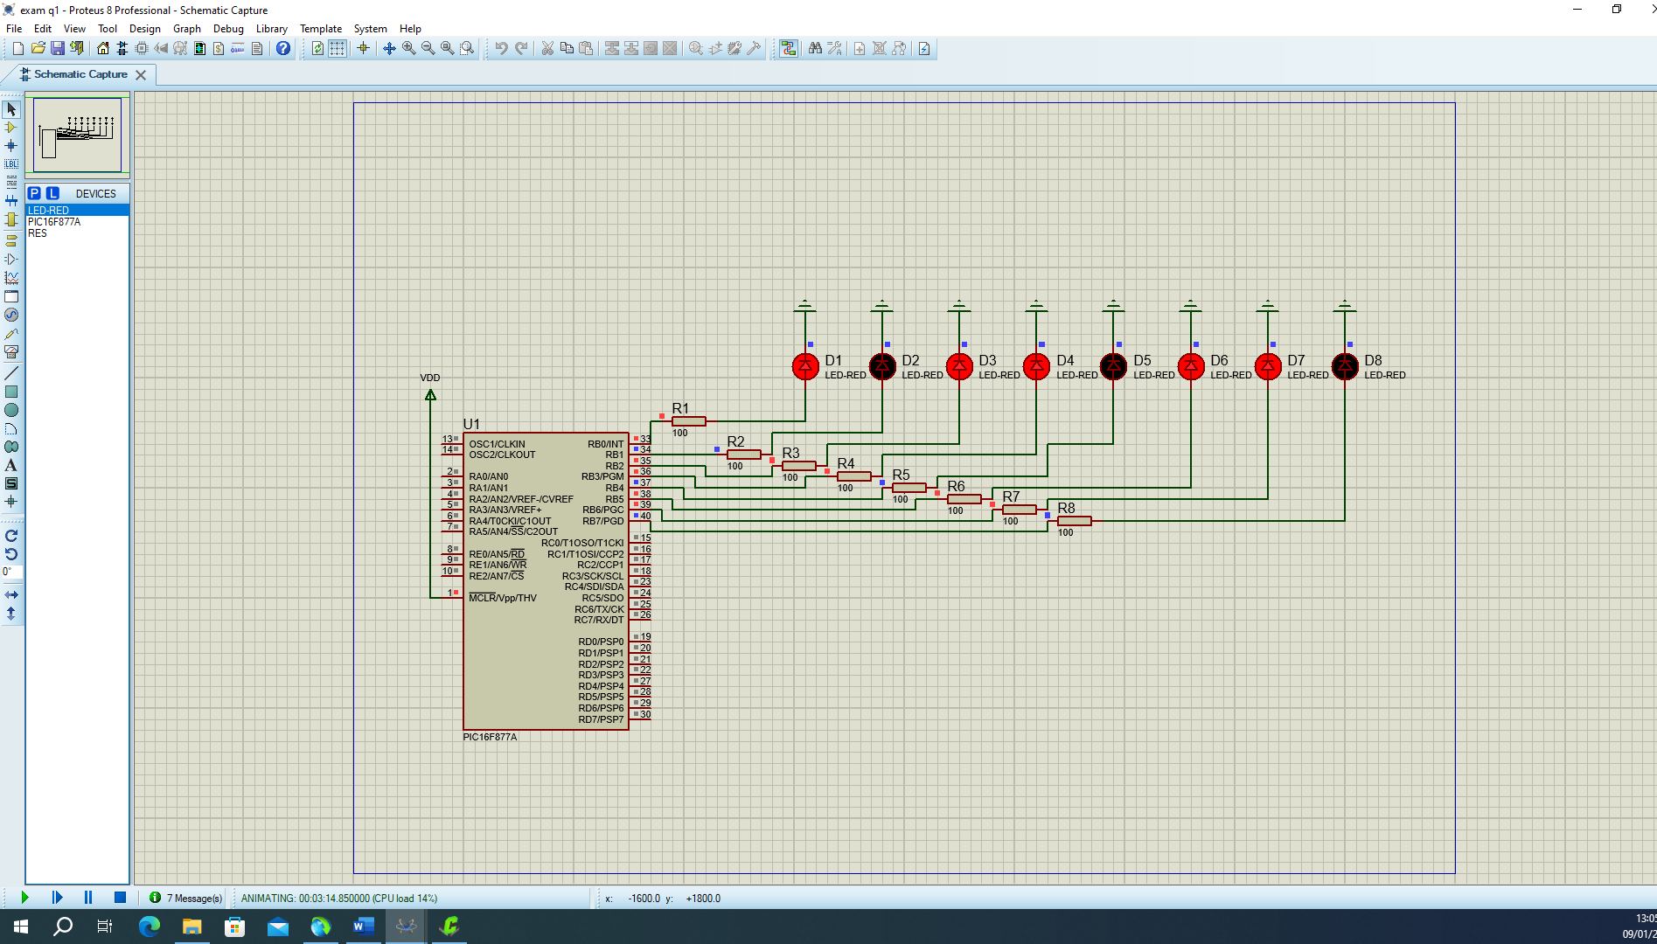
Question 1 b
#include <16F877A.h>
#fuses HS,NOWDT,NOLVP
#use delay(clock=20000000)
#define LED1 pin_B0
#define LED2 pin_B1
#define LED3 pin_B2
#define LED4 pin_B3
#define LED5 pin_B4
#define LED6 pin_B5
#define LED7 pin_B6
#define LED8 pin_B7

void main() {

set_tris_b (0x00);

while(TRUE);
{
{
output_high(LED1);
delay_ms(500);}
{
output_high(LED2);
delay_ms(500);}
{
output_high(LED3);
delay_ms(500);}
{
output_high(LED4);
delay_ms(500);}
{
output_high(LED5);
delay_ms(500);}
{
output_high(LED6);
delay_ms(500);}
{
output_high(LED7);
delay_ms(500);}
{
output_high(LED8);
delay_ms(500);}
}
}
Question 1 c)
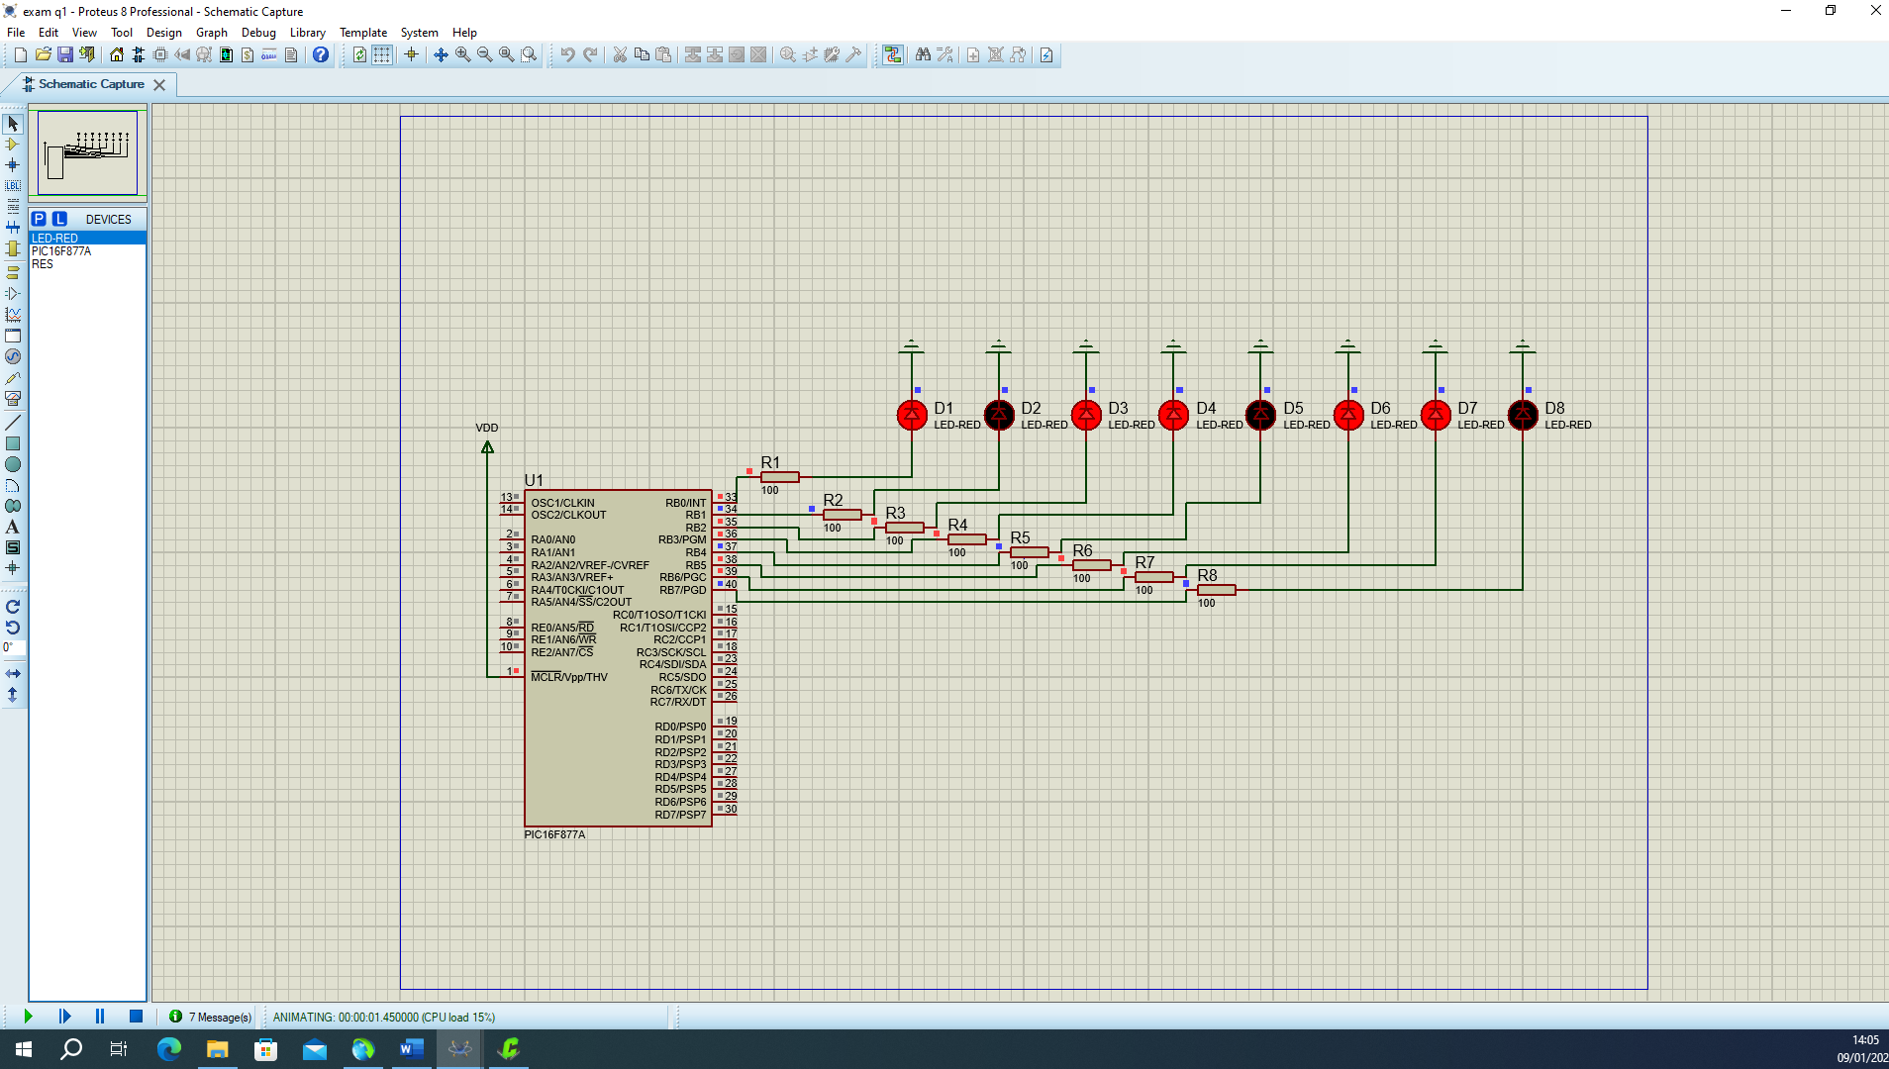
Question 2
A)
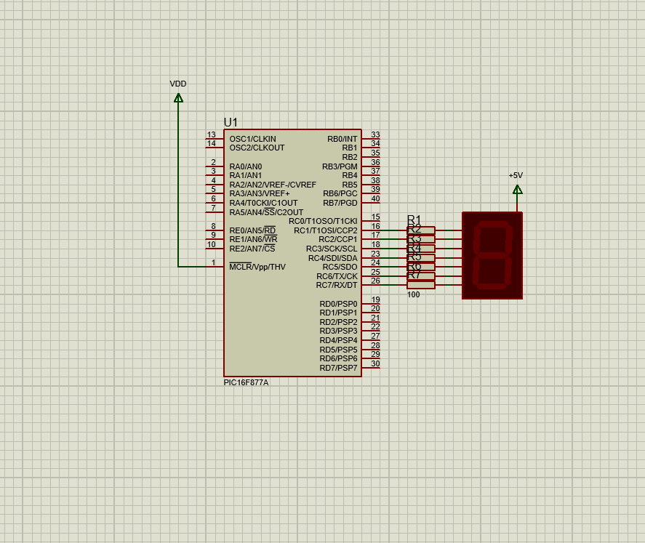
B)
#include <16F877A.h>
#fuses NOWDT, HS, NOPROTECT, NOLVP
#use delay(clock=20000000)

unsigned int8 seg_display[] = { 0xC0, 0xF9, 0xA4, 0xB0, 0x99, 0x92, 0x82, 0xF8, 0x80, 0x90 };

void main()
{
set_tris_c(0x00);

output_c(0x00);

int i;

while(TRUE)
{

if(input(PIN_C1))
{

for(i = 9; i < 1; i--)
{
output_b(seg_display[i]);
delay_ms(100);
}
}

output_b(0xFF);
}

Question 3 c


