

Assessment 1 – Reading Task Template GEORGIANA OPRESCU
Upload your photo of your A3 in-class notes here:
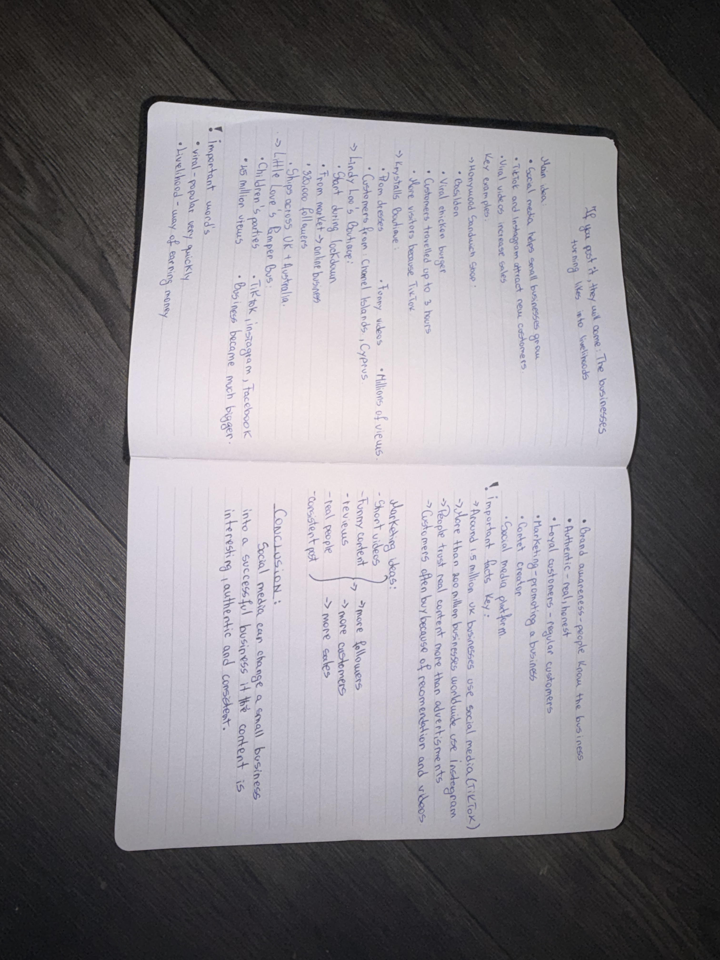

a. What is the main idea of the text?
The main idea of ​​the text is that social media helps businesses grow and evolve. to bring in more customers.

b. What are two key points?
One key point is that certain businesses, such as Honywood Sandwich Shop, have seen a dramatic increase in customers traveling long distances following viral posts by satisfied customers.
Another key point is that the popularity of businesses can be significantly influenced by user opinions on social media, as seen in the case of shops like Binley Mega Chippy and Krystalls Boutique.

c. What part of the text did you find most important? Why?
The most important part is the statement from the owner of Honywood Sandwich Shop, who expressed genuine astonishment and surprise that customers travel up to three hours for a sandwich, demonstrating the real impact of viral marketing on small businesses.

d. Was anything unclear or difficult to understand?
I was not sure about the promotional methods businesses use on platforms like TikTok to create content that goes viral and attracts customers.

e. How did your group help you understand the text better?
My group helped me because we discussed the various examples provided in the text and shared our opinions on how social media affects consumer behaviour.

2. One sentence reflection
Question: What did you find challenging about this task?
The hardest part was analyzing the text deeply enough to identify the main ideas and key points amidst the various examples presented.

