Reflective Project Report

ACMA5009

James Wybron

Table of Contents
Project Abstract. 3
Introduction. 4
Project aim. 5
Project methodologies. 5
Primavera P6 Professional for time management. 8
Scoping the project. 10
Analysis of the project. 13
Clear and concise scope definition. 15
• Material Certificate (En 10204: 2004 3.1) 18
• NDT Reports 18
• NDT Operator’s Qualifications 18
• Welders Qualifications 18
18
Evaluation of communication. 20
Conclusion. 24
Bibliography………………………………………………………………………………………….25
Table of figures………………………………………………………………………………………………26

Project Abstract.

This project involves the design, construction, and repair of a structural steel effluent platform situated over an effluent sump in an open water environment. The platform is critical for supporting industrial operations that involve the safe management and discharge of treated effluents and removal of solid particulates. Given the platform's exposure to corrosive environments and continuous contact with water, the project focuses on ensuring structural integrity, durability, and compliance with environmental regulations.

Key considerations include the selection of marine-grade materials to resist corrosion, strategic placement of support structures to accommodate dynamic water conditions, and the integration of protective coatings or cathodic protection systems to extend the platform's service life. The project also involves the safe access and installation over open water, addressing challenges such as confined space access. The scope of the project encompasses site assessment material selection, structural analysis, risk management, and safety planning, ensuring that the platform meets operational and safety requirements while maintaining environmental sustainability. Ongoing maintenance protocols will be established to mitigate future risks, with periodic inspections and repair schedules to ensure long-term functionality and safe access for the future of employees at Vale.

Introduction.

Vale Ltd is a nickel refinery which is situated in Swansea South Wales and was founded in 1902 by a gentlemen Ludwig Mond. Ludwig was a chemist from Germany who was the individual for discovered the carbonyl process of extraction known as the “Mond” process. This process is still used today to create pellets, powders and flats at a purity of 99.97%. (ltd, 2022)

The materials made and sent all around the world t global customers that produce products ranging from kitchen sinks to carry batteries (ltd, 2022).
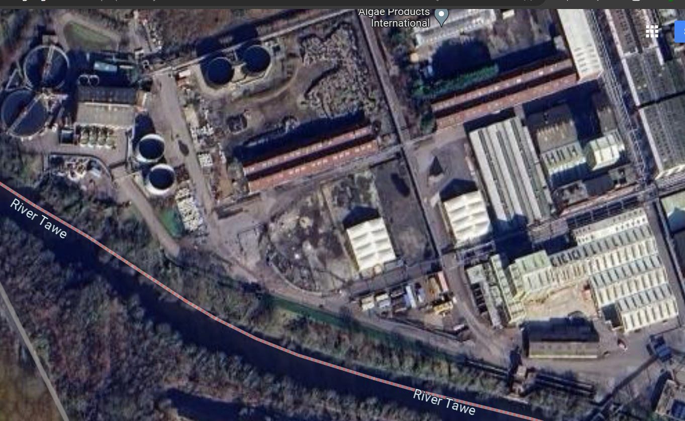
Figure 1 - Aerial photo of Vale Clydach works. The far left hand side closest to the river Tawe is the effluent plant
The Vale Clydach site is split into four main areas that are broken down into further subdivision. The project that commenced was that of the effluent, specifically the effluent sump platform. The effluent plant treats refinery wastewater up to a rate of 200,000 gallon/hour, however the nominal plant flow is around 70,000 gallons/hour.
The soluble materials in the cooling water are filtered, precipitated, and allowed to settle in holding tanks before undertaking an array of chemical treatment to ensure the water quality is returned to original spec of better. The refined settled material is collected and sent back to be refined further to remove any precious metals. The effluent sump itself has two infeed’s a process returns input of cooling water and overflow tank return. The platform itself supports access to three vega probes which are used as part of the process to alarm at low level analogue input alarm, high level analogue level and a digital level alarm. The platform also has access to an old obsolete system that was left as redundancy and an air actuated valve to close and open dependent upon tank flow process.
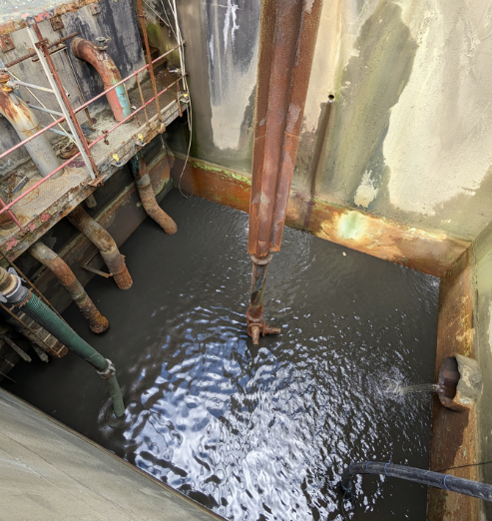Figure 2- Inside the effluent sump while running with return water held for material slurry
Structural compliance NDT (non destructive testing) is carried out periodically and they report highlighted that the structure had considerable amounts of delamination to walkways and structure. This was the catalyst to scope plan and change the platform while incorporating the removal of redundant equipment and modernise lighting.
The access to the platform was barriered of to prevent anyone inadvertently walking into the area.

Project aim.

The main aim of the project is to remove and install the new effluent sump platform at the effluent plant at Vale Clydach. The whole plant relies on the effluent sump to hold process water and remove contaminants and solids. The tank is a holding tank to allow slurry to drop to the bottom before passing through the bobby filters. The aim of the project is to turn the removal install and reinstating of all electrical equipment within the six day shutdown window.
The priority is to ensure that the work is carried out with no accidents and safety at the highest priority. Due to the work being carried out over open water it brings its own unique dangers, these challenges will be removed and reduce the possible chance of injury.
The sump will be isolated electrically, and process related to ensure that all hazards are removed this will involve further cleaning and gas testing. Due to there being one entrance in and by definition becomes a low risk confined space.
G7 multigas monitoring will be in place at all times with personal monitoring to ensure that there is no reduction in air or atmospheric quality.
The motivation for the change model is another part of the planning stage, the Mulins model here is simplified and shows the fulfilment model (JLMulins, 2002).
As can be seen the need and expectation was set, the installation of the new platform. The drive force was the installation to allow for a safe and reliable daily inspection of process critical equipment.
Desired outcome was a safe and completed project with the fulfilment of positive feedback from initial stakeholders.
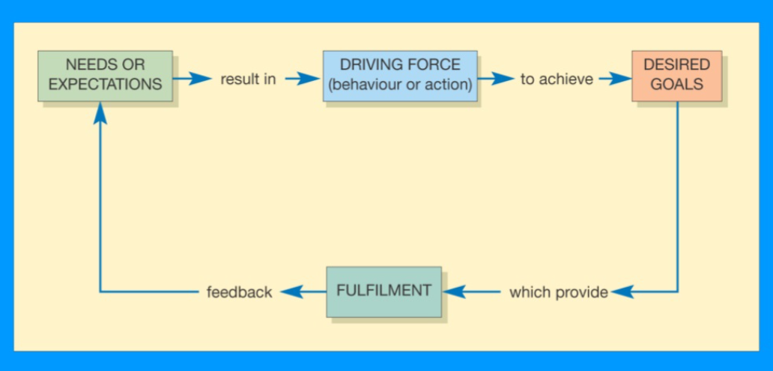
Figure 3- Mullins simplified model of change

Project methodologies.

Project planning is a field, and it involves various theories and methodologies that guide the process from conception to completion. They are used to ensure that the project comes in on its desired timescale and within the budget allocated. Below is not a definitive list but an example of the most common and popular.

The waterfall method is a sequential approach where each phase needs to be completed for the next stage to be able to start. It’s best used in a project where everything is well defined and known. Typically, not the best for a structural or improvement project, with the most meticulous planning it is sometimes difficult to determine the unknown variable. An example of this would be identify that steel work associated to the project is worse than anticipated (Pedersen, 2013).
Agile Methodology
An iterative approach that promotes flexibility and customer collaboration, focusing on delivering small, functional pieces of the project incrementally. Commonly used in software development and projects with rapidly changing requirements (Rasnacis, 2017).
Critical Path Method
A project management technique that identifies the longest sequence of dependent tasks and determines the shortest time to complete the project. Useful for scheduling complex projects with interdependent tasks (Carruthers, Carruthers, J.A.1966).
Program Evaluation and Review Technique
A statistical tool used to analyze the tasks involved in completing a project, focusing on uncertainty and variability in time estimates. Ideal for projects with uncertain activity times.
Lean Project Management
Focuses on minimizing waste and maximizing value, emphasizing continuous improvement and efficiency.
Used in manufacturing and service industries to streamline processes.
Six Sigma
A data-driven approach aimed at improving quality by identifying and removing the causes of defects and minimizing variability. Applicable in quality control and improvement projects.
Theory of Constraints
Focuses on identifying the most significant limiting factor (constraint) that hinders performance and systematically improving it. Useful in complex projects where resource allocation is critical.
Project Life Cycle Theory
Defines the stages of a project from initiation, planning, execution, monitoring, to closure. Provides a structured approach to manage projects through their entire lifespan.
Stakeholder Theory
Emphasises the importance of identifying and considering the needs and expectations of all stakeholders involved in a project. Useful for ensuring stakeholder engagement and satisfaction throughout the project.
Risk Management Theory
Focuses on identifying, assessing, and mitigating risks that could impact project success. Essential in high-stakes projects where uncertainty is a significant factor.
SWOT Analysis
A strategic planning tool that assesses Strengths, Weaknesses, Opportunities, and Threats related to a project. Helps in decision-making and identifying areas for improvement (Sammut‐Bonnici, 2015).
Decision on methodology to be used.
Each of these theories and methodologies can be adapted based on the specific needs and context of the project. Successful project planning often involves combining elements from different theories to create a tailored approach.

Gant chart and project plan.
The first stage of the plan implementation was to photograph, document and create a general specification document. All asset owners were brought together to ensure that the new specification incorporated their new requirements. The platform from its original installation had been installed with new modern equipment due to the original equipment now being obsolete. The specification and load bearing requirements were referenced from the original installation drawing. The general specification sheet allows for multiple contractors to fairly quote for the work knowing the requirements of the intended process with desired outcome.
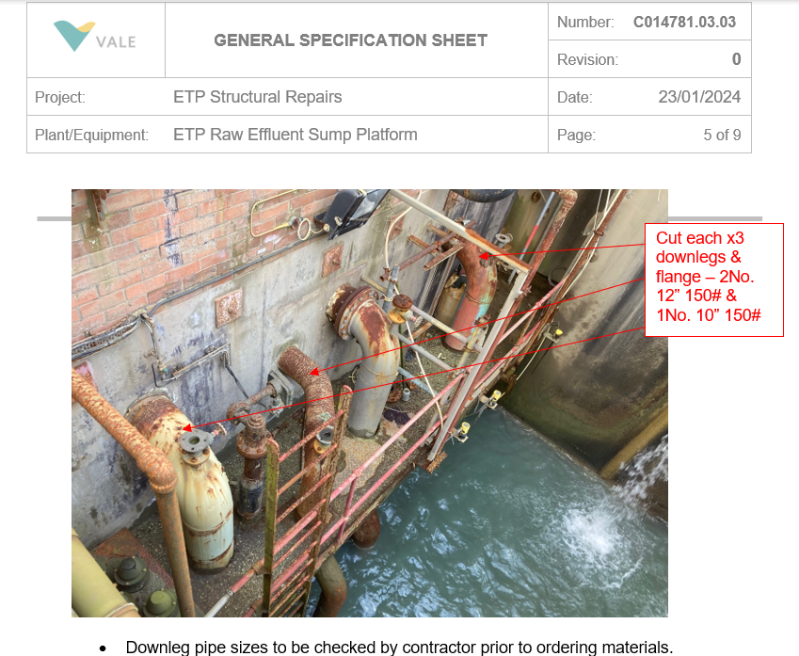
Figure 4 - Aerial phot of effluent sump with annotation on official specification sheet
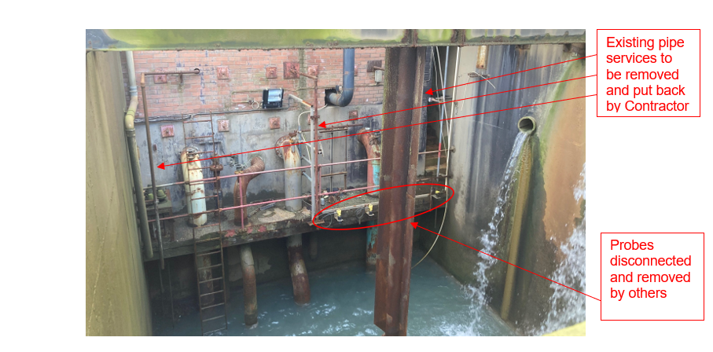
Figure 5- Specification sheet continued to give as much detail as possible to contractors
The specification is created and emailed to procurement who will start the process of fair tendering, the specification build and confirmation will be shown further on in the report. To allow fairness and impartial procurement member will send out and arrange the time for quoting the repair. All quotes received within the time frame are assessed and not purely on the lowest cost of completion. The priority is to ensure that the highest quality product is given to the customer who are the effluent plant team.
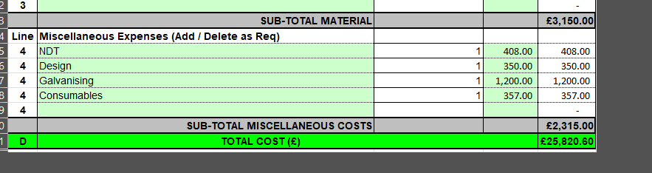
Figure 6- Cost matrix for the build of platform and installation

Primavera P6 Professional for time management.

Primavera P6 is a project management software widely used for planning, scheduling, managing, and controlling complex projects. Developed by Oracle, it is particularly popular in industries such as construction, engineering, energy, aerospace, and defense, where large-scale and resource-intensive projects need to be managed effectively. Primavera P6 is known for its powerful features that help project managers ensure that projects are completed on time and within budget.
Here’s a detailed breakdown of Primavera P6 and its Core Features of Primavera P6
Project Scheduling: Primavera P6 enables the creation of detailed project schedules with thousands of activities, tasks, and milestones. Users can set start and finish dates, task durations, dependencies (relationships between tasks), and constraints.
Critical Path Method (CPM): The software uses the Critical Path Method (CPM) to calculate the longest path of activities that must be completed on time to ensure that the project finishes on schedule.
Resource Management: Primavera P6 allows users to assign and manage various resources like labor, equipment, and materials. It helps identify resource constraints, such as over-allocation, and optimize resource usage across projects.
Risk Management: The tool has built-in functionality for identifying, analyzing, and mitigating risks associated with project activities. This helps project managers plan for contingencies and make informed decisions in the face of uncertainty.
Cost Management: Primavera P6 supports budgeting and cost control, allowing project managers to track the cost of each activity and compare the actual cost to the planned budget. It integrates with other financial systems to provide accurate cost forecasts.
Multiple Project Management: The software enables users to manage multiple projects simultaneously, making it ideal for companies handling several projects in parallel. Primavera P6 can create global resource pools and maintain interdependencies between different projects.
Baseline Comparison: Primavera P6 allows project managers to create baselines (frozen copies of the original schedule and budget) and compare them with current project progress. This helps track deviations from the original plan.
Reporting and Dashboards: The software offers customizable reports and real-time dashboards that provide insights into project performance, including key metrics like schedule variance, earned value, and resource utilization. These reports can be shared with stakeholders for better communication and transparency.
Collaboration: Primavera P6 provides collaboration tools, allowing teams to work together in real-time, update progress, share documents, and communicate project-related information efficiently.
- projects.
3. Advantages of Primavera P6
- Scalability: Suitable for both small and large projects, Primavera P6 can handle up to 100,000 activities in a single project, making it ideal for complex undertakings.
- Improved Planning: Primavera P6 helps project managers create accurate and detailed plans, ensuring the timely execution of every project phase.
- Risk Mitigation: With its powerful risk management tools, it helps in identifying potential delays and bottlenecks, allowing proactive responses to challenges.
- Resource Optimisation: The ability to manage and optimize resources across multiple projects helps in preventing resource overallocation or underutilization, ensuring efficient project execution.
- Enhanced Communication: Primavera P6 improves communication between project team members and stakeholders by offering shared dashboards, real-time data, and customizable reports.
- Compliance: Many large industries, particularly in construction and energy, are required to adhere to strict regulatory and contractual obligations. Primavera P6 helps maintain compliance by keeping projects on track and within scope.
4. Challenges and Learning Curve
- Complexity: While Primavera P6 is a very powerful tool, it can be complex for beginners. Its comprehensive feature set can make it overwhelming for small projects or users without significant project management experience.
- Cost: Primavera P6 is considered a high-end enterprise tool, and its licensing fees can be expensive, making it more suitable for large organizations with extensive project management needs.
- Training Required: Due to the complexity of the software, users often need extensive training to fully utilize its features and capabilities.
5. Primavera P6 vs. Other Tools (e.g., Microsoft Project)
- Scalability: Primavera P6 is more scalable and better suited for large, multi-phase projects compared to Microsoft Project, which is commonly used for smaller, less complex projects.
- Resource Management: Primavera P6 offers more advanced and detailed resource management features than Microsoft Project.
- Collaboration: Primavera P6 provides a more collaborative, enterprise-level platform for large teams, whereas Microsoft Project tends to be more individual or small team-focused.
6. Deployment Options
- Primavera P6 Professional (Desktop): A standalone version installed locally on individual computers, typically used by smaller teams or project managers.
- Primavera P6 Enterprise Project Portfolio Management (EPPM): A web-based version that allows large teams to collaborate across multiple locations and projects.

Below is the brake down of primavera P6 for the effluent sump project with all contractors inputted. The first column shows the related work order number. Every task must have a dedicated work order with an operation, specific risk assessment and permit request. No work by core employee or contactors will take place without a green SAP card.

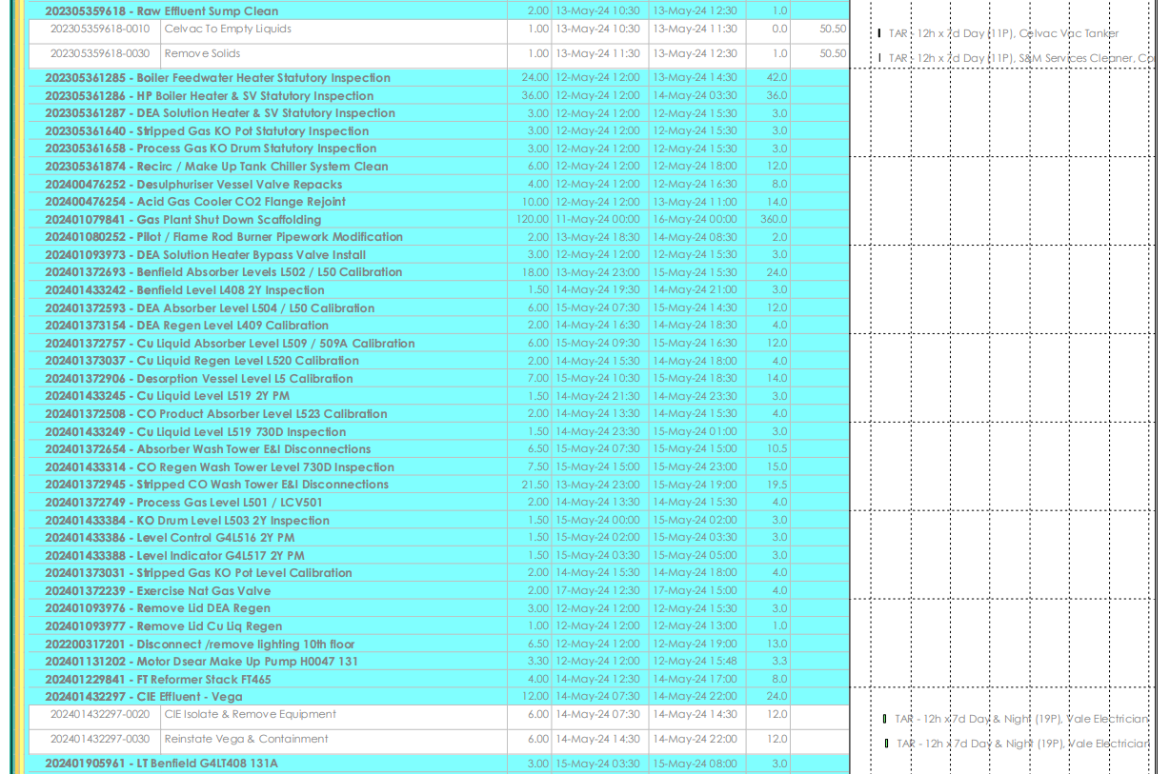
Figure 7- Screen shot of primavera layout for scheduler to mark completion status of daily tasks

Scoping the project.
Scoping the repair of structural steel work over open water is a complex project that involves detailed planning, risk assessment, specialised equipment, and adherence to regulatory and safety standards. Here’s an outline of the key considerations and steps involved in scoping such a project:
1. Site Assessment
- Initial Inspection: Perform a comprehensive inspection to assess the condition of the steel structure. Look for signs of corrosion, cracks, deformation, or other structural damage. Time was spent also reviewing the lifting operation due to supply pipe work being overhead.
- Environmental Factors: Understand the surrounding water environment process feeds and critical isolations needed to make the area safe.
- Access: Assess accessibility for workers, equipment, and materials. In cases of remote or difficult access, temporary platforms or barges might be necessary. Temporary scaffold was erected for load spreading to gain access into areas and a mobile scaffold would be dropped into the sump to allow access to the underside of the platform.
2. Structural Evaluation
- Load-Bearing Capacity: Determine the current load-bearing capacity of the steel structure and whether temporary supports or scaffolding will be needed during the repair.
- Damage Extent: Identify the extent and type of damage (corrosion, fatigue, impact damage, etc.) and prioritize critical areas for repair. We were unable to determine the damage on the concrete wall until all supporting beams were removed to increase visibility.
- Material Compatibility: Ensure that the replacement steel or repair materials are compatible with the existing structure, particularly in terms of corrosion resistance in a marine environment (use of corrosion-resistant steel or protective coatings).
3. Repair Methods
- Welding vs. Bolting: Choose the appropriate repair method. Welding might be difficult in wet environments that’s why the focus was placed upon surface preparation and isolation with adequate times for moisture dispersion to allow safe welding..
- Surface Preparation: Prepare surfaces by removing corrosion, marine growth, or old coatings. This may involve abrasive blasting, grinding, or hydro jetting.
- Corrosion Protection: Apply appropriate protective coatings, such as marine-grade paint, galvanizing, or cathodic protection systems to prevent future corrosion.
- Replacement: In cases where steel members are severely corroded or damaged, they may need to be replaced entirely. This requires careful planning to ensure structural integrity during the replacement.
4. Safety Considerations
- Worker Safety: Ensure all workers have appropriate safety gear (PPE), including harnesses, life jackets, and fall protection systems. Workers must be trained in working at heights, over water, and on marine structures.
- Environmental Hazards: Consider potential environmental hazards such as rough weather, which could affect worker safety and project timing.
- Emergency Preparedness: Prepare a detailed emergency plan in case of accidents, including evacuation procedures and rescue equipment like boats or safety rafts.
5. Regulatory Compliance
- Permits and Approvals: Obtain necessary permits from environmental, maritime, and structural engineering authorities. Compliance with local, national, and international regulations is crucial, especially regarding environmental impact on marine life.
- Environmental Impact Assessment (EIA): Conduct an EIA to evaluate how the repair work will affect the aquatic environment, including water quality and marine ecosystems. Mitigation strategies must be planned.
- Logistics and Resource Planning
- Access Equipment: Determine the equipment needed, such as barges, floating platforms, cranes, scaffolding, and specialized boats for worker and material transport.
- Material Transport: Plan for how materials will be safely transported to the site over water. This may require barges or boats designed for carrying construction materials.
- Schedule and Timing: Consider the tides, weather conditions, and daylight availability when scheduling work. Some repairs may only be possible during calm weather or low-tide periods.
- Waste Management: Implement a plan for the disposal of debris and old materials to prevent contamination of the water.
7. Cost Estimation
- Labor and Equipment: Calculate the cost of labor, equipment rental, and any special tools required for over-water repairs.
- Materials: Estimate the cost of steel, protective coatings, and any other materials.
- Safety Measures: Include costs for safety equipment, environmental protection measures, and compliance with regulations.
- Contingency Budget: Allocate a contingency budget for unforeseen challenges such as adverse weather, equipment breakdown, or additional repairs.
8. Monitoring and Quality Control
- Inspection: Regular inspections during the repair process to ensure the work is proceeding according to the plan and to maintain structural integrity.
- Testing: Conduct structural integrity tests (e.g., non-destructive testing like ultrasonic testing, magnetic particle inspection) to verify the quality of repairs.
- Ongoing Maintenance: Develop a maintenance plan to prevent future damage and extend the structure’s lifespan, including periodic inspections and touch-ups to protective coatings.

Analysis of the project.

The project on the whole was completed successfully, with respect to the removal of a non safe structure and installation of new with no safety concerns or need for intervention. The safety team were involved throughout the process and I requested active engagement throughout the process. Having individuals with CDM experience and fresh eyes would bring context to potential area that I had missed during the planning stage.
There were multiple stake holders involved and large scale teams of different skills. However there were many more stages to consider to overall understand if the project from conception to completion was a success. Within the overall shutdown window, this task was considered the critical path and was identified on primavera. The result of not being able to measure water and solid volume on full scale production would mean no cooling water to plant. Simply put, no cooling water no running plant. There are multiple safety critical SIL rated equipment across site, if the sufficient flow to a critical piece of kit is not proven then the drive is inhibited. This is done through hard wiring in plant control systems there are multiple contacts in safety circuits that are effected by flow feed back, as in analogue to digital conversion and PLC input. Therefore the task was highlighted as a critical path.
The original structure had been installed around 1972 to 1974’s an exact date is hard to determine, but the initial drawing was drafted and completed on the 17th of February 1972.
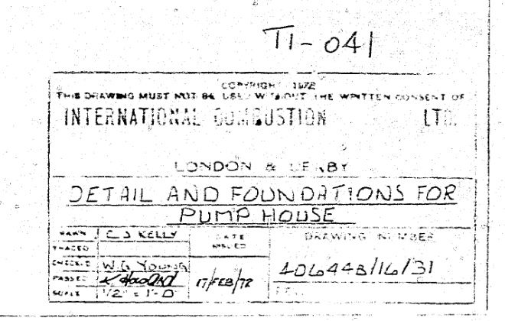
Figure 8- Image showing original date of design for current platform
It had been subjected to decades worth of maintenance, shot blasting painting and NDT reports, however it had reached a stage where it was no longer economically viable to repair.
To be able to analyse the project’s success we must not look at the project as a whole, as mentioned above on the surface the project seems successful. However detailed analysis of the project looking at fundamental key areas will highlight short comings.
Not allowing sufficient time for preparation of components made a tighter deadline than first intended. Possible from short notifications time of plant availability. There wasn’t enough time for the creation of components from the tendering stage and lead to an increase in price due to premium hour overtime working to create components on time.
Not enough time allocated for brainstorming with all team members and looking at documented plant changes. As seen from the drawings there is a section of pipe that runs through the flooring, which was installed after the initial installation of the platform. The checker floor grating was cut and the 16inch main passed through and seemed welded. The floor was now speced with Kennedy grating to prevent the accumulation of moisture and accelerating rot in level areas.
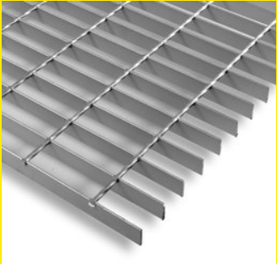
Figure 9- Grid grating improvement instead of flow forge to prevent rusting
There for a drawing and spec alteration was made to fabricate the Kennedy floor in two sections around the pipe to ensure drop in assembly without tampering with the current pipe. Disturbance or damaged to the main would have resulted in a far longer outage due to requiring repair.

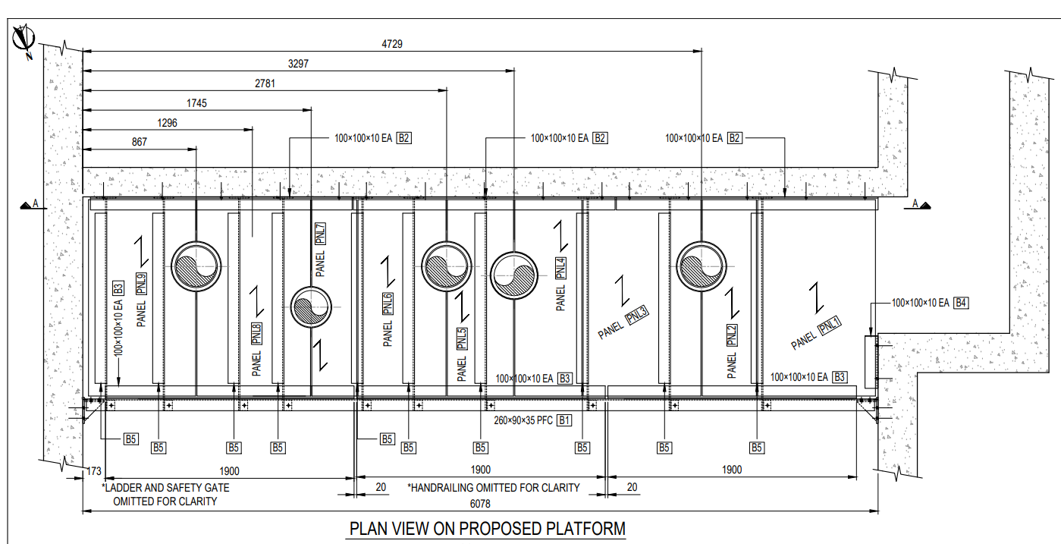
Figure 10- Segment mechanical design drawing of floor components and bracings

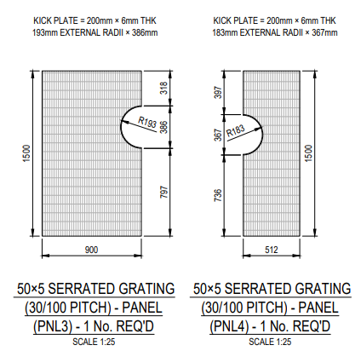
Figure 11- Modification and re-design of flooring around pipe

Clear and concise scope definition.
The scope was clearly identified and detailed with the general specification sheet, Vales standard client quotation document. Please see the documentation and project specification out setting that was used for contractors to quote against. I feel that this was a very strong part of the project that went well and ensured that the project came in on budget.
The lift.
- All lifting operations will be completed under contract lift status and will be at the contractor’s expense. Please indicate this in your quote. Contractor to supply all lift documentation, lift plan, trained and competent personnel to lifting operations.
- It is advised to investigate the use of crane/man baskets and use safety lanyards/harnesses for safe removal, preparation of new and installation of RES platforms.

Typical Sequence of Events – final tbd
Typical Sequence of Events – final tbd

- Process water re-circulation system set-up – Operations
- Over pump system tie-ins and operation
- Machine grab and silt removal from bund – external contractor tbd
- Isolate & disconnect level probes – Vale CIE
- Sump cleaning – cleaning company S&M
- Old platform disinvestment – Awarded Mechanical Contractor
- New platform installation – Awarded Mechanical Contractor
- Disconnection of over pump system

- Process water re-circulation system set-up – Operations
- Over pump system tie-ins and operation
- Machine grab and silt removal from bund – external contractor tbd
- Isolate & disconnect level probes – Vale CIE
- Sump cleaning – cleaning company S&M
- Old platform disinvestment – Awarded Mechanical Contractor
- New platform installation – Awarded Mechanical Contractor
- Disconnection of over pump system

- All other pipe services to be removed by contractor for disinvestment/installation clearances.
- The contractor will assist in transporting all scrap materials to appropriate point at site’s waste management area.
- The Contractor will assist in preparing the bund area. Fitting bungs, etc.

Timelines & Start Dates

The contractor must complete the described works within the agreed shutdown period.

Refinery Shutdown Dates
From Monday 13th May to Sunday 19th May – subject to change

Due to the sequencing of the above pre and post works the maximum allowable time to complete all mechanical works will be 3 days.
Design Changes
There may be changes to the floor panelling on one side of platform landing. This may be to incorporate an oil skimming device. If this is the case, then appropriate amendments will be made to drawings and changes covered in a variation order.
Pre-Construction Documentation
The Supplier shall provide to the Engineer an electronic copy of the following.
Quality Control Plan inc. Inspection and Test Plan.
NDT (MPI/DPI) Procedures, welding procedures and qualifications plus proof of coding
Coating & Inspection

- Inspection as specified by the design code or standard of any component.
- Contractor to provide all welding procedures and welder qualification for work carried out.
- Contractor to provide material certificates for steelwork used on job.

- Contractor shall provide written certificate of conformity to coating application of new steelwork.

- Contractor will prepare as per Vale specifications. Steelwork to be hot galv dipped.

- Vale reserves the right to check all welding, material and final thickness in-house or third party to verify workmanship and certificates provided by contractor.

Final Documentation

The Supplier shall provide to the Project Engineer within 2 weeks of the shutdown being completed.

- Weld procedure to comply to BS EN 288/3 1992 A1 1997 or BS EN ISO 15614-1 2004 or ASME Section 1X (The three standards referenced above are acceptable.)
- Material Certificate (En 10204: 2004 3.1)
- NDT Reports
- NDT Operator’s Qualifications
- Welders Qualifications

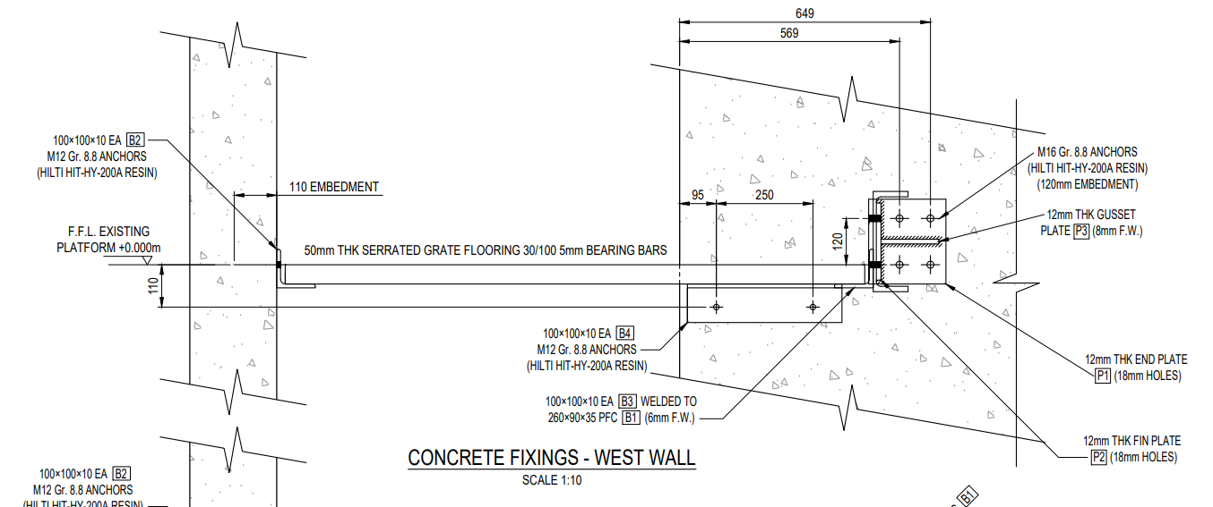
Figure 12- Side elevation drawing of specification of flooring and support
The above information is to be supplied in a technical dossier and include all items listed in the Pre-construction and Final sections above.
Guarantees

Contractors to state minimum guarantee period to cover workmanship after installation or delivery to site is complete. Access required to repair any defect from poor workmanship will be covered by the contractor for the period of guarantee stipulated in the tender.

The completed project documented in picture form.
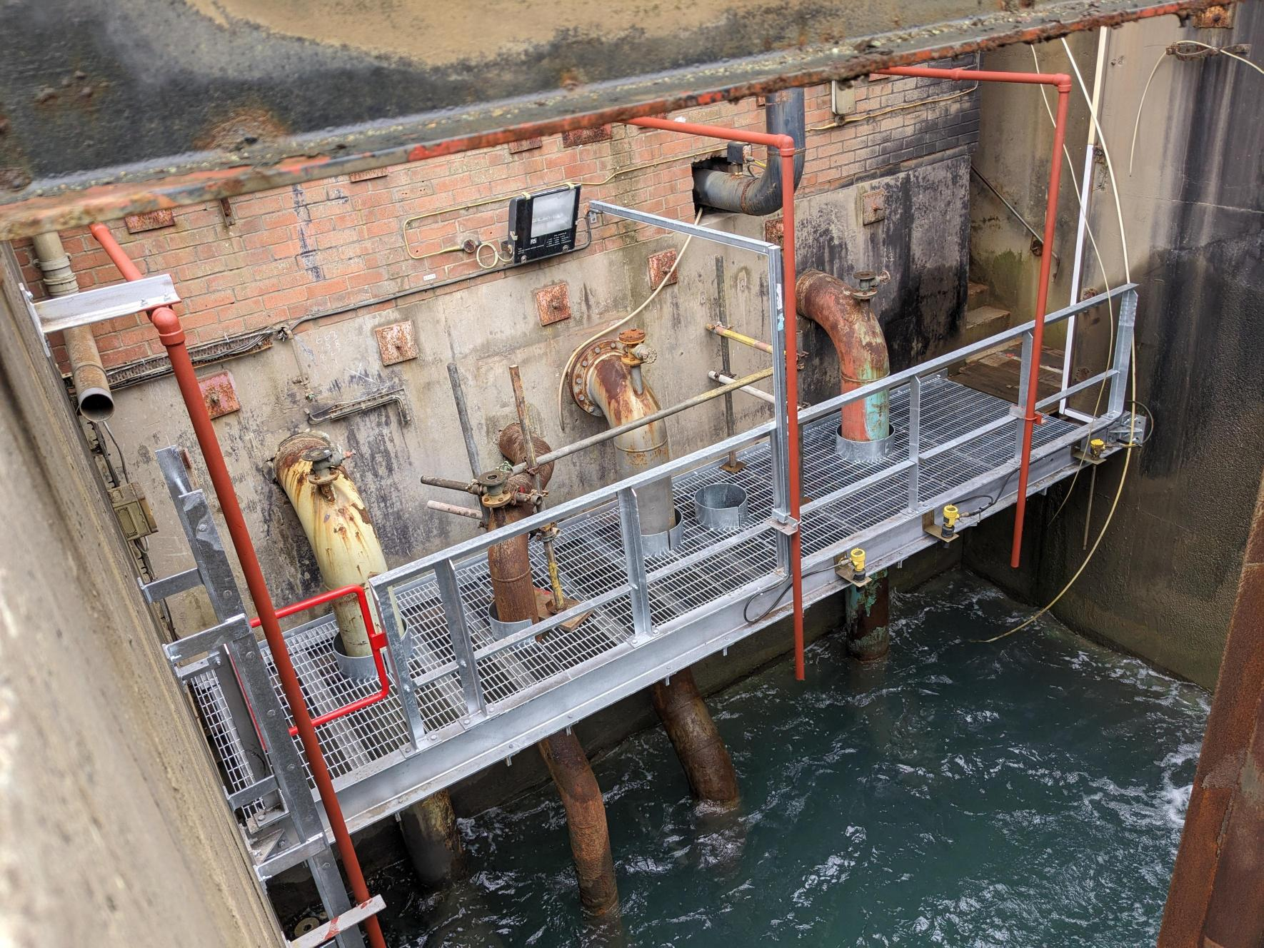
Figure 13- Completed successful project with all new Vega system installed and water back to sump.

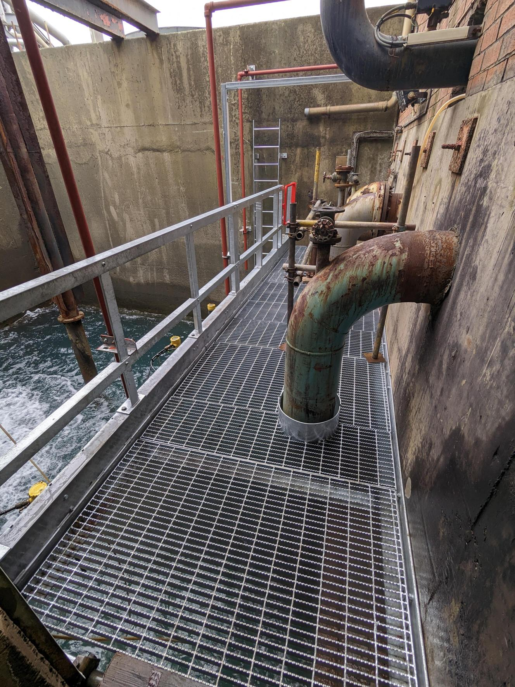
Figure 14- Close up of flooring with grating looking into sump area

Evaluation of communication.
The project communication methods were limited to the individual teams involved within the project. All stakeholders involved were onsite at the time of the project due to the complexity and knock on effect of not executing certain tasks on time everyone had to be aligned and informed at all times. If Davies cranes were not made aware of project process, then they would miss the slot for removal and installation of the new platform. Everyday an update version of primavera p6 was sent to all showing current status and next steps. Verbal and formal were the main forms off communication used within the project however there are other effective communication methods that could have been implemented to great effect as shown by Stern, G.M in his 1993 journal paper (Stern, 1993).
Verbal communication was carried out during daily progress meetings along with phone call updates. The advantages in technology allow for video calling that can show exact stages of the project without certain stake holders needing to attend site if required.
Effective communication is crucial to the success of any project, ensuring that all stakeholders are aligned, informed, and engaged throughout the project lifecycle. Project communication methods refer to the various ways in which project information is exchanged, shared, and disseminated among stakeholders. These methods can be categorized into different types based on the mode of communication, frequency, and the audience involved (Stern, 1993).
Written reports can be carried out daily as were with P6, but emails reports memos and updating of project plans is another method off communication that could have been utilised.

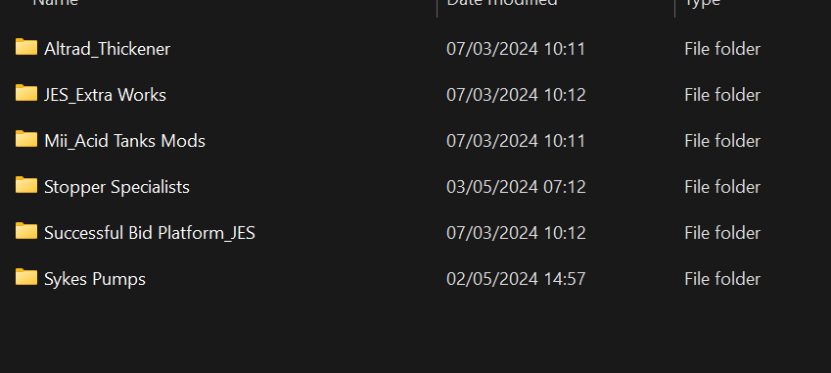
Figure 15- Screen shot showing the location and storage of project related data

Non verbal communication was unknowingly used throughout the project with the use of banks men for crane signaling operations. In some locations it is difficult to use radio communication and hand gestures to show crane drivers out of sight issues.
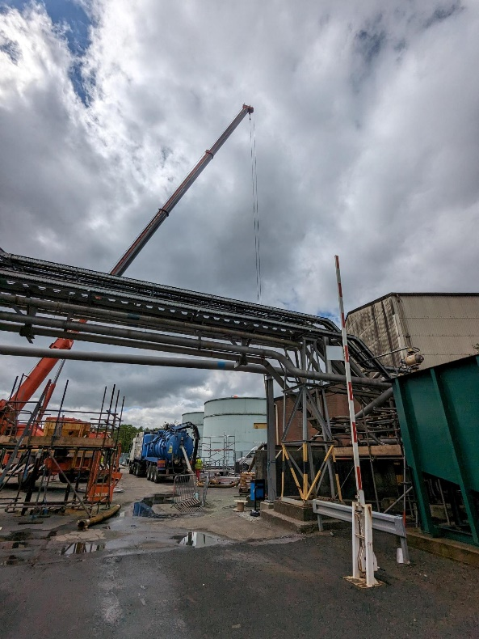
Figure 16- Phot showing lifitng operation of pump for water removal stage 1

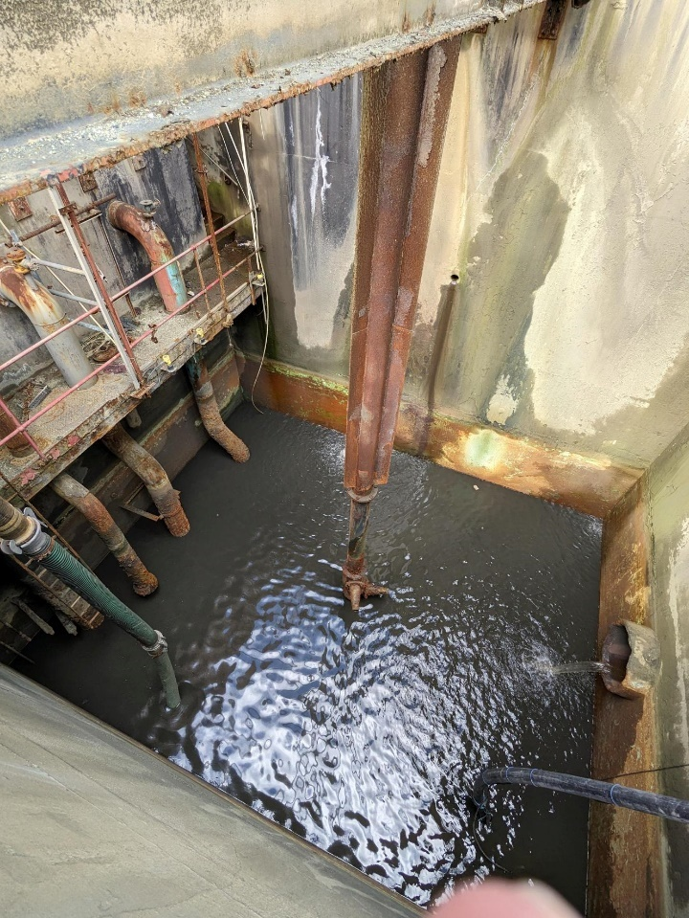
Figure 17- Picture showing immersion of two pumps and hoses

Project Communication Techniques
Push Communication In push communication, information is sent out pushed to specific recipients who need it, but receipt and response are not immediately required.
Examples: Emails, reports, newsletters, memos.
Best Use: When information needs to be documented or when sending updates to large groups.
Pull Communication In pull communication, the recipient must retrieve (pull) the information as needed.
Examples: Intranet portals, shared folders (like Google Drive, SharePoint), wikis, or dashboards.
Best Use: When making information available for stakeholders to access at their convenience.
Barriers to Effective Communication
Effective communication can sometimes be hindered by various barriers, which should be addressed proactively:
Cultural Differences: Different cultural backgrounds can lead to miscommunication due to varying interpretations of language or norms.
Language Barriers: In international projects, language differences may result in misunderstandings.
- Technology Gaps: Stakeholders may have varying levels of comfort with certain communication technologies.
- Information Overload: Too much information, especially irrelevant details, can overwhelm stakeholders and reduce the effectiveness of communication.

Conclusion.
The structural project was successfully completed, leveraging Six Sigma, the Project Life Cycle Theory, and Stakeholder Theory to ensure high-quality outcomes, effective project management, and continuous stakeholder engagement. Throughout the project life cycle, from initiation to closure, key principles of Six Sigma helped maintain process efficiency and minimise defects, while stakeholder collaboration ensured that project objectives aligned with both operational and business goals.
However a structural defect was identified in the grating floor, caused by modifications made many years after the initial installation. This defect which arose from alterations that were not accounted for in the original design, highlights the importance of considering long-term impacts when making structural changes. Although the defect did not compromise the overall success of the project, it emphasises the need for future monitoring and careful evaluation of any modifications to ensure continued structural integrity.
Going forward applying continuous quality monitoring and lifecycle asset management is essential to mitigate risks related to unforeseen alterations. Additionally, involving key stakeholders in any future modifications will ensure that safety and design standards are maintained, preserving the long-term success of the structure

Bibliography
Anon., -. Mind tools - 8 step change model. [Online]
Available at: https://www.mindtools.com/a8nu5v5/kotters-8-step-change-model
[Accessed 1st May 2024].
Carruthers, J. a. B. A., Carruthers, J.A.1966. Advances in critical path methods. Journal of the Operational Research Society, 17.( 4), pp. .359-380..
JLMulins, 2002. Management and Organisational Behaviour. - ed. -: -.
ltd, V., 2022. https://vale.com/united-kingdom. [Online]
Available at: https://vale.com/united-kingdom
[Accessed 6th May 2024].
Pedersen, M., 2013. A quantitative examination of critical success factors comparing agile and waterfall project management methodologies. Capella University., -(-), pp. -.
Rasnacis, A. a. B. S., 2017. Method for adaptation and implementation of agile project management methodology.. Procedia Computer Science,, 104(1), pp. 43-50..
Sammut‐Bonnici, T. a. G. D., 2015. SWOT analysis.. Sammut‐Bonnici, T. and Galea, D., 2015. SWOT analysis. Wiley Encyclopedia of management, pp.1-8., -(-), pp. 1-8.
Stern, G., 1993. Improving verbal communications.. Internal auditor, 50(4), pp. 49 -55.

Figure 1 - Aerial photo of Vale Clydach works. The far left hand side closest to the river Tawe is the effluent plant 4
Figure 2- Inside the effluent sump while running with return water held for material slurry 4
Figure 3- Mullins simplified model of change 5
Figure 4 - Aerial phot of effluent sump with annotation on official specification sheet 7
Figure 5- Specification sheet continued to give as much detail as possible to contractors 8
Figure 6- Cost matrix for the build of platform and installation 8
Figure 7- Screen shot of primavera layout for scheduler to mark completion status of daily tasks 11
Figure 8- Image showing original date of design for current platform 14
Figure 9- Grid grating improvement instead of flow forge to prevent rusting 14
Figure 10- Segment mechanical design drawing of floor components and bracings 15
Figure 11- Modification and re-design of flooring around pipe 15
Figure 12- Side elevation drawing of specification of flooring and support 18
Figure 13- Completed successful project with all new Vega system installed and water back to sump. 19
Figure 14- Close up of flooring with grating looking into sump area 20
Figure 15- Screen shot showing the location and storage of project related data 21
Figure 16- Phot showing lifitng operation of pump for water removal stage 1 22
Figure 17- Picture showing immersion of two pumps and hoses 22

