International Hotel Management
Component A-Report

Marketing plan written for: Moxy Hotel
Student Name: Aurelia Bogatu
Student ID number: 2231922
Marketing Essentials BMIH4005
Lecturer: Ruth Taylor

Introduction
Moxy hotel was introduced in the year 2014 in September which is a new millennial of Marriott International. The company has become successful as they are able to expand its locations to around 70 more new places over three different continents worldwide. Moxy hotel chain is an affordable and stylish hotel brand which was designed to offer its guests all the required sources to enhance their experience. This report will discuss the marketing mix of the chosen companies and an analysis of the internal environment.

Situation Analysis
“The Marketing Environment (Micro)”
Strengths | Weaknesses
- Highly qualified and specialised work personnel | - Lack of stable operational management
Opportunity | Threats
- New technology advancement | - Price related challenges
Table No. 1: SWOT analysis
(Source: Created by the learner)
Strengths- Moxy hotel engage on qualified and highly specialised work personnel’s which helps to get successful ventures over the international markets and it also helps them to come up with appropriate innovative activities. This process helps to ensure the satisfactions of its customers in the hospitality industry (Davronov et al., 2021).
Weaknesses- As Moxy hotel is a small organisation due to which it does not have a stable and strong foundation which helps to keep up with its performance.
Opportunity- The Moxy Hotel is able to get the opportunity in the new international market due to the rise of tourism activities causing their business to have higher chances to grow its profitability (Tambunan and Pardede, 2022).
Threats- Not having a proper pricing aspect with a decrease in earnings ratio are some of the threats for the company Moxy Hotel which leads to problems for them in the competitive market (Poddubnaya and Shipilov, 2019).
Segmentation and targeting
Segmentation: The hotel uses the geographical base to segment its market while it also has integrated its market as a multi-stage approach. They have tailored the name of the brands in order to cater to distinctive target markets. The hotel targets road travellers who desire a nice, clean and luxurious stay during their trip. The company mainly targets the people of the age group between 18 to 29 years of high-income group.
Targeting: The luxury brand will make effective use of social media platforms to increase the engagement of young adults who spend more of their time on Instagram, Twitter and Facebook to stay connected to their friends.
The company will mostly advertise and inform its customers through its official website so that it can analyse the number of people and the age group who shows interest in the brand.
Competition
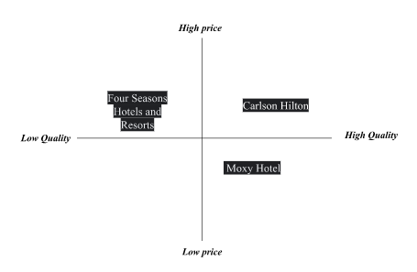
Figure No.1-Positioning of Moxy Hotel
(Source: Created by the Learner)
The competitor of Moxy is Carlston Hilton which provides its customers with high-quality services but charges high prices which can only be afforded to the high-income group of people. Four Seasons Hotels and Resorts is the other competitor of the company that provides low-quality services at low prices, here the hotel has the advantage of attracting a large number of people as they provide high-quality services at reasonably affordable prices.

BSG MATRIX
CASH COWS | STARS
high-quality foods | Time-share vacations
QUESTION MARKS | PET
Local foods | Rewards
Table No.1- BSG MATRIX
(Source: Created by the Learner)
The cash cows component of Moxy Hotel include the high-quality foods which have low growth but relatively high market share in the industry. The star component of the company is its time-share vacations which have relatively high growth as well as a huge market share in the industry. The question mark of the company is the local foods which have high growth and low share businesses.
Collaboration
The company has a real estate net worth which comprises over 6000 units in operation. Some of the brands of the company include Bulgari, Westin, Autograph Collection hotels and so on. The company manages almost all of its hotels while a very small percentage of the hotels are still owned by the parent company (Dachyar and Sahir, 2020).
“The Marketing Environment (Macro)”
Political factors: One of the major Political issues faced which is the impact of Brexit that totally imbalanced the performance and productivity of the business. Brexit helps Trade flow freely and efficiently with no additional paperwork or authority. But due to the departure of the United Kingdom, the supply chains have completely ended and cut off which has left a serious impact on the Moxy Hotel chain (Leroi-Werelds et al., 2021).
Economic Factors: One of the main economic factors which have a serious impact on Moxy Hotel and its business is the slowing of the marketing and economic growth and expansions in China and the current economic challenges and challenges in Europe. High exchange rates also act as challenging issues for the Moxy Hotel chain (Weinstein, 2022).
Social Factors: Social factors have the high capability to enhance the growth and development of the Moxy hotel organisation due to multiple people who have a keen interest and are planning for the international tour and travel which have tremendously increased (Burke et al., 2020).
Technological Factors: Technology can have the highest influence and impact on the performance of their Organisation.
Legal Factors: One of the legal factors which have a high influence on Moxy hotels the status and position of the services like Airbnb which have managed to expand their business around the world. Moxy has also faced some of the issues and challenges of an increased minimum income, which can lead to higher suppliers and labour costs.
Environmental factors: By understanding and analysing the current environment and marketing condition, the major environmental factors that can block the performances and disturb the business of Moxy are the fuel prices.
Objectives
The company will provide complementary services to its customers and aim to increase its reach to the customers by 10% within 3 months.

Strategy
Moxy hotel will offer two basic value propositions such as cost reduction and customisation. The company will be creating accessibility by providing or offering its customers a broad range of options such as flight and hotel packages, car rental services and rewards to preferred guests including the doctor on-call service.

Tactics
“The Marketing Mix”
Product– Moxy hotel in the UK offers quality accommodation with affordable price range, hotel reservations, hotel packages and room services (Khalimova, 2020). These are the product factors which operate a loyalty program to their customer that allows giving a good passenger experience to them.
Place– Moxy Hotel is able to expand its business to more than 70 new places into three different continents with 60 experiential hotels (Sikand, 2020). In order to power the network of its brand, the company will collaborate with advertising platforms such as Yahoo Maps so that people can easily get access to the hotel area.
Price– Moxy hotel uses the supply and demand pricing strategy along with that competitive pricing strategy which allows them to determine their hotel price in relation to their competitors' behaviours (Pelet et al., 2019). It allows them to gain an advantage through which the company is able to increase the chance of getting better opportunities that are useful for them to have maximum revenue.
Promotion– Moxy hotel focuses on offering its customer affordable range of room prices with excellent accommodations which helps to create a good impression of their brand towards the customer (George, 2021).The company will be using a communication mix strategy where it will make effective use of social media marketing on different social media platforms to inform customers about its unique services.

Action
“Creating Customer Value and Engagement”
Activities | Start date | End date | Duration (days)
“Market Research” | 1-03-2023 | 5-03-2023 | 5
“Segmenting customers” | 6-03-2023 | 10-03-2023 | 5
“Enhancing customer’s experiences” | 11-03-2023 | 15-03-2023 | 5
“Creating informative content through the marketing channel” | 16-03-2023 | 22-03-2023 | 7
“Developing an effective pricing system” | 23-03-2023 | 30-03-2023 | 8
“Conducting cold calls” | 31-03-2023 | 5-04-2023 | 6
Table No.3-Word Based Structure
(Source: Created by the Learner)
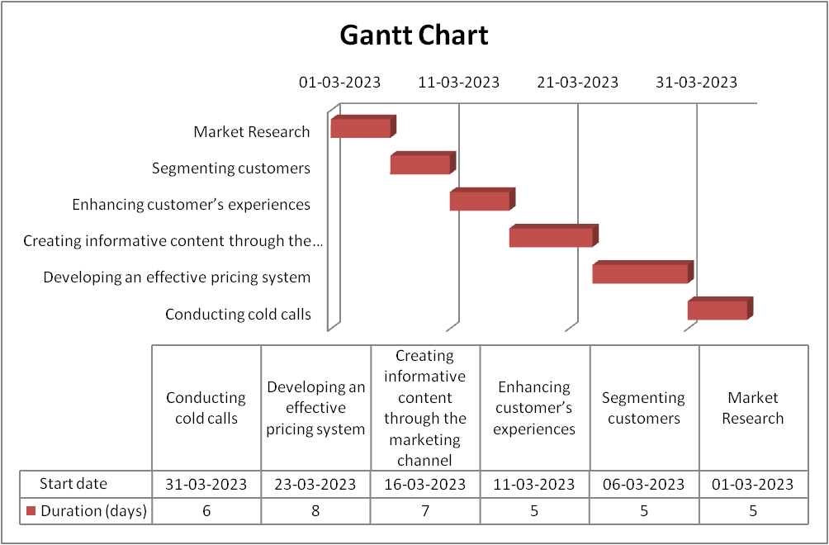
Figure No.2- “Gantt Chart of marketing activities of Moxy Hotel”
(Source: Created by the Learner)
The company will make effective use of social media platforms to reach a wider network of people and regularly inform its customers about its various upgraded services. Thus the use of social media marketing will be very beneficial for the company to understand the preferences of young adults who are also the target customers of the company (Katsikeas et al., 2020).
Moxy Hotel focuses on the step of undertaking customer expectations seriously in relation to digital interactions and personalised data-driven services. It further also uses the strategies of delivering a major range of personality development along with seamless experience in business (Tong et al., 2020). Offering loyalty customers an exclusive preview and hosting event are some of the modern methods which can be used to promote the new complimentary services.

Control
Using the KPI the company measures its performance of the marketing activities such as it will use the unique website visitor in which the company will calculate the number of people who visited the page of the company’s client by dividing the number of all the unique users during a specific period. Secondly, they will also use the traffic by the source which will show the sources of the visitors to the client’s page of the company. This will be calculated by using a reporting tool to segment the traffic by different sources with ease.
“Effective use of Digital Marketing”
Moxy hotel also links with the process of fore fronting and developing success in the hospitality industry under which the developed range of processes gets linked with the range of marketing strategies in business. It also involves the process of involving various ranges of marketing strategies which further includes the elements of the marketing mix which includes price, product, place and promotion (Al-Surmi et al., 2020).

Conclusion
In conclusion to the context above, Moxy Hotel will have to keep track of its competitor’s moves and strategies and constantly make ways to make appropriate changes to avoid the problem of identical products or services provided by other hotels. This will help the company to remain unique in providing services so that they can charge prices according to the quality.

References
Al-Surmi, A., Cao, G. and Duan, Y., 2020. The impact of aligning business, IT, and marketing strategies on firm performance. Industrial marketing management, 84, pp.39-49.
Burke, K., Robinson, P.E.T.E.R. and Choi, M.J., 2020. Developing meta-strategies for hospitality experiences. In Managing hospitality experiences (pp. 141-158). Wallingford UK: CABI.
Dachyar, A.S.N.S.M. and Sahir, A., 2020. Hotel revival strategy planning with SWOT-Fuzzy AHP-TOPSIS: A case study of a 4-star hotel.
Davronov, I., Radjabov, O., Nurov, Z. and Yuldashev, K., 2021. THE ROLE OF COMMUNICATIONS IN IMPROVING THE QUA
George, R., 2021. Market Segmentation, Targeting, and Positioning. In Marketing Tourism and Hospitality: Concepts and Cases (pp. 221-246). Cham: Springer International Publishing.
Katsikeas, C., Leonidou, L. and Zeriti, A., 2020. Revisiting international marketing strategy in a digital era: Opportunities, challenges, and research directions. International Marketing Review, 37(3), pp.405-424.
Khalimova, N.J., 2020. Analysis of foreign experience in hotel career enhancement programs. Central Asian Problems of Modern Science and Education, 2020(2), pp.3-14.
Leroi-Werelds, S., Verleye, K., Line, N. and Bove, L., 2021. Value proposition dynamics in response to external event triggers. Journal of Business Research, 136, pp.274-283.
Pelet, J.E., Lick, E. and Taieb, B., 2019. Internet of Things and artificial intelligence in the hotel industry: which opportunities and threats for sensory marketing?. In Advances in National Brand and Private Label Marketing: Sixth International Conference, 2019 (pp. 154-164). Springer International Publishing.
Poddubnaya, E.S. and Shipilov, N.Y., 2019. Strategic diagnosis methods of the hotel business organisations activities. Экономика и управление: теория и практика, 5(4), pp.19-26.
Sikand, H., 2020. Exploring The Importance Of Service Quality Attributes For Millennials At Boutique Budget Hotels.
Tong, S., Luo, X. and Xu, B., 2020. Personalised mobile marketing strategies. Journal of the Academy of Marketing Science, 48, pp.64-78.
Weinstein, A.T., 2022. Customer obsession–the springboard for a value creation strategy. Journal of Business Strategy, (ahead-of-print).

