
UNIVERSITY OF WALES
TRINITY SAINT DAVID

Topic: Written Report/ Business Plan
Healthy food restaurants - take away
Ivilina Atanasova Atanasova

Course: Business Management, 2028391

ENTREPRENEURSHIP (LCBB5001)

Vasilios Tavlaridis

25/02/23
Table of contents
1. Overview of the business idea and its product/service…………………………………. | 3
2. Ownership and Legal format of the startup……………………………………………… | 3
3. Company management (Owner, employees and the requirements for external professional service/ experts)………………………………………………………………... | 4
4. Explanation of the target market and the marketing strategies the company will adopt to reach their customers……………………………………………………………… | 6
5. Evaluation of the business idea by using the SWOT analysis model………………….. | 6
6. Assessment of the current external environment by using the PESTEL analysis model…………………………………………………………………………………………… | 7
7. Identify the critical marketing factors using the 4Ps of the marketing mix model… | 9
8. A cash flow forecast for the first 12 months……………………………………………… | 9
9. References………………………………………………………………………………….. | 11

1. Overview of the business idea and its product/service
Many foods and drinks now include artificial flavours, preservatives, colours, and other harmful ingredients. The fastest weight gain causes difficulties in heart, joint, bone, and mental health. Staying healthy is more important than being overweight. My business idea is for “Healthy food restaurants - take away”.
I cannot make anything with white flour, sugar, or sunflower oil. I will substitute oats, coconut flour, non-white flour, coconut sugar, stevia, sunflower oil, coconut oil, and butter. On-site juicers and citrus presses will make all fruit and vegetable juices. Freshly baked goods and beverages taste different. They were boiling, grilling, or baking the meal. Breakfast may include pancakes, muffins, omelettes, porridge, fruits, and smoothies. Oat pancakes with broccoli, chicken breast, and cottage cheese; coconut muffins with berries and almonds; turkey omelette with cottage cheese and olives; oatmeal with lactose-free milk, almond, pumpkin, chia, linseed, and spirulina; green smoothie (almond milk, spinach, avocado, cucumber, and lime); and fruit smoothie (coconut milk, banana, strawberry, quinoa, vanilla flavour). Beef, baked kingfish, roasted pig breast, or shellfish may be served. Side dishes include brown rice (pure or with vegetables), green salad, traditional Bulgarian salad (Shopska), Coleslaw, and bulgur. Green and red vegetable juices are great for breakfast and lunch. Fish and chip restaurants are plentiful, but healthy restaurants are not.
2. Legal format of the startup
The legal structure of my company is a Limited Liability Company (LLC).
A limited liability corporation (LLC) is a legal structure for doing business that shields its members from personal responsibility for the firm's debts and losses. Instead of individual partners or shareholders taking on most legal actions or financial failure, the corporation takes on that responsibility (Williams, 2020).
Profits and losses may be tax-free. LLC members pay Medicare and Social Security self-employment taxes. LLCs may minimise firm owners' tax liabilities compared to corporations. LLCs are taxed differently than companies. Like a partnership, all corporate profits and losses are "passed over" to each member. Like partnership owners, members disclose their revenues and losses under their owner's terms (Carlson, 2023). Table 1 illustrate the advantages and disadvantages of a Limited Liability Company-LLC (GUP, B.E.&BEEKARRY, N., 2009).

Table 1. The advantages and disadvantages of a Limited Liability Company (LLC).
Advantages | Disadvantages
1. Protection for company leaders and stockholders from legal responsibility; | 1. Publication of Financial Activities;
2. The property is secured from creditors; | 2. When compared to sole proprietors, owners have much less control in daily operations;
3. Security against the results of other people's irresponsibility; | 3. The growing complexity of its financial records suggests it may need the services of a certified public accountant;
4. Company model that can adapt to changing market conditions and offers several trading opportunities; | 4. To what extent profits can be kept may be controlled by limited partnerships is debated.
5. In most regions, corporate tax rates are less than the marginal rate;
6. The business is separate from its shareholders and might be transferred to new owners.

3. Company management (Owner, employees and the requirements for external professional service/ experts).
The healthy restaurant “Mrs&Mr STRONG” has the following Staff structure, shown in table 2.
Table 2. Staff structure on Healthy restaurant “Mrs&Mr STRONG.”
Manager | Mrs. Ivilina Atanasova
Accountant | Mr Jonh Leeds
Web designer | Mr Dobbo George
2 Chefs | Mr Chris Gray | Mrs Sophie Widdowson
2 Customer services | Ms Rachel Foster | Ms Zara Mulley
2 Cleaners (Part-time) | Mrs Amelia Bambury | Mr Joseph Smith

Manager - Ivilina Atanasova
Maintain control over the restaurant's day-to-day activities, such as employee scheduling, shift coverage, and supply monitoring. Guarantee happy customers by attending to their needs and resolving any issues they may have. Make plans and implement them to follow all food safety rules and regulations (Self J, 2021).
I have five years of professional experience in a bakery, butcher (meat and fish) and customer service in a food supermarket. My passion has been cooking for over 20 years, and it has become my career. I am a student in level 5 Business management. My passions include working with clients and cooking. With my colleagues, I will be pleased to provide you with a tasty breakfast, lunch, or dinner – some are shown in Figures 1, 2, 3, and 4.
Figure 1. Salted pancake cake Figure 2. Mashed potatoes
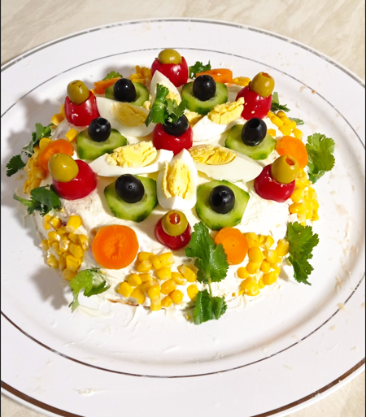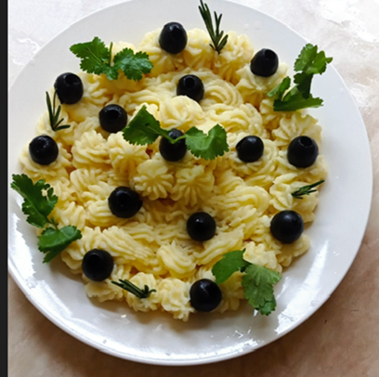

Figure 3. Beef skewers Figure 4. Beef with vegetables
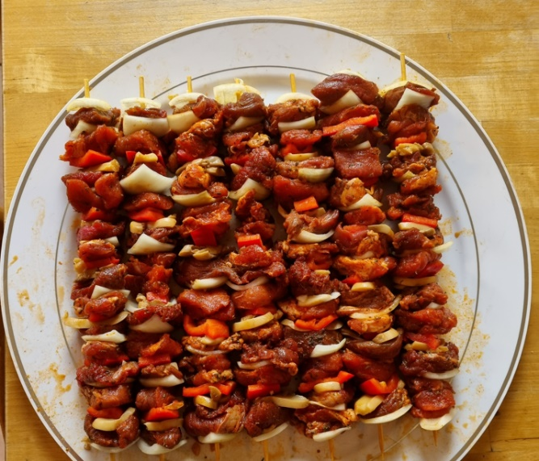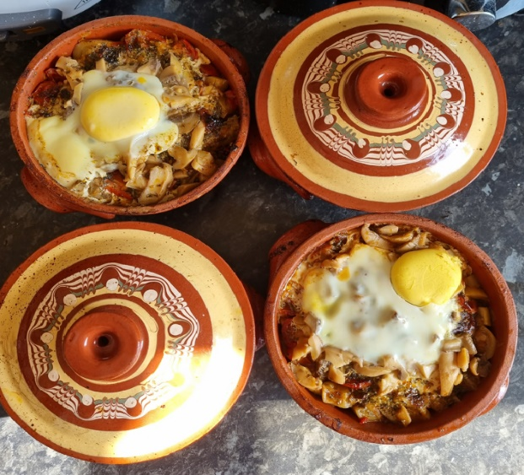

4. Explanation of the target market and the marketing strategies the company will adopt to reach their customers.
Marketing targets a specific group. These people are most likely to buy and have similar demographics and behaviours. Designing, packaging, and promoting a product requires identifying the target market. (Eckstein K, 2013).
A marketing strategy analyses customer needs and creates a competitive edge to achieve business objectives. Identifying the target audience and choosing the best distribution channels are covered. (Moutinho, Southern, G., & Southern, G Geoff, 2010).
I should pick a location near gyms (people of all ages exercise and eat healthily there); businesses providing athletic clothes, footwear, and equipment (whether as a pastime or a vocation, sports advocate healthy eating and self-discipline); parks; (people of all ages enjoy being outdoors and active).
Obesity-focused hospitals or clinics (The health condition requires a diet). There are ten gyms in Birmingham, “The gym group”.
A good place for a Healthy food restaurant is “Battery Retail Park” (B29 6SJ, Chapel Ln, Selly Oak, Birmingham area) because:
1. On this place is one of the biggest gyms: More people in the gym - more customers in the restaurant;
2. There are retailers like SPORTS DIRECT, TK MAX, HALFORDS, Mountain warehouse, and JD in the same park. These are shops for sports clothes, shoes, and equipment. The people who do sports also visit these stores – more customers for the restaurant;
3. The “Battery Retail Park” is close to the “Birmingham Weight Loss Clinic” (B30 3EE), only 2 miles and “Priory Hospital, Birmingham” 2.6 miles.
5. Evaluation of the business idea by using the SWOT analysis model
Strengths, Weaknesses, Opportunities, and Threats are referred to as SWOT, and a SWOT analysis evaluates these four facets of the company. SWOT analysis is a method that may be used to evaluate the company's current strengths and develop a winning plan for the future (Probert C, 2015).
SWOT analysis is commonly presented as a two-by-two matrix with strengths and weaknesses in the top row and opportunities and threats in the second row. Internal strengths and weaknesses contrast with external opportunities and threats. Restaurants benefit from SWOT analyses. It shows you your advantages over the competition and how you compare. SWOT analysis requires restaurant operators to analyse and prepare for issues. (Sarsby A, 2016). Table 3 illustrates Restaurant SWOT Analysis Examples:

Table 3. Restaurant SWOT Analysis Examples
Strengths | Weaknesses | Opportunities | Threats
Rated excellently online | Active competitors | Providing online ordering | Guests have less income
Focus on the Guests | High costs for suppliers | Online networking campaigns | Rising fixed costs
Nice interior design | Reduced local population | Focus on providing new menus | Loss of VIPs and high-value clients
Premium location | Limited menu options | Raise loyal visitors | Loss of suitable suppliers
Local employees | Low online relevance | Employees should be trained | Event cancellations in the area
Price impact | Access to Capital | Promote regions | Financial crisis

Customer feedback and social media research may reveal restaurant strengths — a restaurant's marketing plan's ability to capitalise on its advantages over competitors. Essent Monitoring threats that affect competitors and possibly affect you.
6. Assessment of the current external environment by using the PESTEL analysis model.
The abbreviation PESTEL stands for the Political, Economic, Social, Technical, Environmental, and Legal considerations that must be considered. Companies may better organise their budgets thanks to this business approach, which helps them to analyse these macroenvironmental elements (Dinçer & Yüksel, S, 2019).
For the healthy food restaurant, the PESTEL analysis model is shown in table 4.
Table 4. PESTEL analysis model for healthy food restaurant
POLITICAL | Government stability | Taxation policy
ECONOMIC | The Economic Growth Rate | Money supply
SOCIO-CULTURAL | Income distribution | Lifestyle changes
Technological | Government and business prioritise technology. | Speed of technology transfer
Environmental | Waste disposal | Environmental protection laws
Legal | Health and Safety | Product Safety

POLITICAL
Government stability – Healthy food companies support politicians who will assist them in influencing industry issues, including nutritional labelling, obesity prevention, minimum wage increases, accessible health care, and immigration reform.
Taxation policy - Catering, alcohol, confectionery, crisps, savoury snacks, hot meals, sports drinks, takeaway, ice cream, soft drinks, and mineral water are standard-rated. Is cold takeout VAT 5%?
VAT-free cold takStandard-radiated (including crisps, sweets, bottled water etc.). Water!
ECONOMIC
The Economic Growth Rate – was 5% between July 15, 2020, and September 30, 2021. 12.5% between October 1, 2021, and March 31, 2022;
Money supply - As of April 2022, the typical UK takeout costs £7.93, up 50p from 2021's £7.43. Food inflation is 6.7%;
SOCIO-CULTURAL
Income distribution - UK healthy food and takeout markets varied throughout the previous decade. The market dropped from 21 billion British pounds to 18.9 billion in 2021. 20.61 billion is expected in 2022.
Lifestyle changes - Fasting increases blood sugar, blood pressure, inflammation, and nutritional loss. Healthy eating may harm the stomaimmunologyical, allergies, health, obesity, and time.
Technological
Government and industry focus on technological effort - In its June 2022 Food Strategy, the UK Government pledged to publish a Land Use Framework in 2023 "to ensure we fulfil our net zero and biodiversity commitments, and assist our farmers in adapting to a changing climate while continuing to provide high quality, cheap food that promotes a better diet;
Speed of technology transfer - Restaurants that switched to online ordering, drive-throughs, and takeout kept their customers. Mobile ordering speeds up real the food.
Environmental
Waste disposal Private bin companies offer brown food trash bins. Unla ess local bin shop has brown food waste and can put food waste in your trash bag.
Environmental protection laws - Environment Act strengthens UK environmental legislation. The government may set air, water, biodiversity, and waste reduction goals.
Legal
Health and safety - Clean, prepare, cook, and chill food for safety. Cleaning, separating, cooking, and chilling at home prevents food contamination.
Product safety - The Food Safety Act 1990 and its provisions prohibit selling or processing unhealthy food. Businesses must also maintain hygiene.
7. Identification of the critical theoretical factors by using the 4Ps of the marketing mix model
Businesses may monitor and maximise the 4 Ps of Marketing. The product, price, location, and marketing build up the model (how you get customers) (Håkansson & Waluszewski, A. 2005). Table 5 are shown the 4Ps elements of a Healthy food restaurant:

Table 5. 4Ps elements for Healthy food restaurants:
Price | List | Discount | Payment
Product | Packaging | Service | Warranty
Promotions | Advertising
Place | Where people sell the item

Price
List
Muffins £1.5–2 depending on ingredients and size;
pancakes £1 to £1.5 depending on ingredients and quantity; egg dishes £2 to £3; fish and meat dishes £4 to £5; fruit and vegetable juice £3 to £4; hot drinks £2 to £3;
Discount: hot drinks with some juice 4,5,6 £; some muffins or pancakes with juice 4,5 £; main menu (fish, meat) with juice 6,7,8 £.
Payment: Card, cash.
Product
Packaging – take away ;
Service - Catering services based on advance notice; Warranty - everything is fresh and prepared same day;
Promotions:
Advertising: social media, flyers, newspapers, daily magazines;
Place - “Battery Retail Park” is a good place for a restaurant.
8. A cash flow forecast for the first 12 months- startup costs cannot exceed £25,000
I will look for Financing from:
1) National or local government department (low-interest rate) safeguards individual rights and makes government decisions with input from various sources (Beatriz, Coffinet, J., & Nicolas, T, 2022).
2) Business loans (Commercial Banks) - Big financing and reasonable terms (high-interest rate) (Schammo, 2019).
Table 6 illustrates the startup’s costs and sales figures for the next 12 months.

Table 6. Costs and sale figures for the startup healthy food restaurant
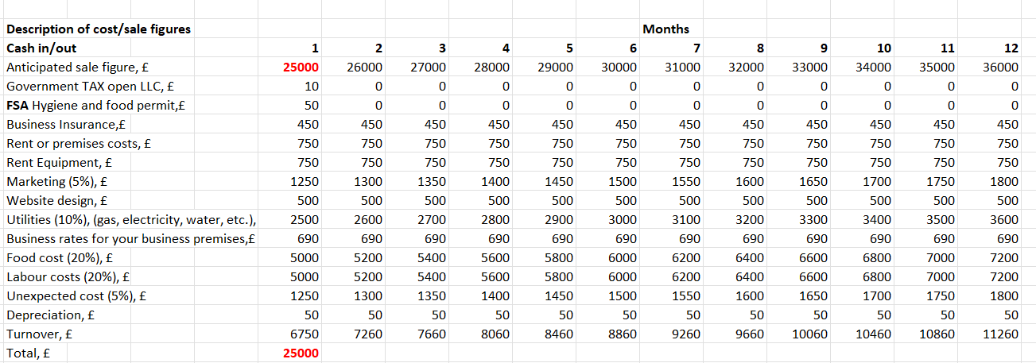

The startup cost is £25,000.
Government TAX open LLC is £10 – ItA one-time fee required when opening a company.
FSA Hygiene and food permit - Authorization to maintain sanitary conditions and handle raw foods. It is paid every year.
Business Insurance - It is paid every month.
The Rent or premises costs and Equipment (oven, grill, juice maker etc.) e paid monthly.
Marketing is (5%) of the revenue – Increasing monthly income results from increased marketing spending and a growing client base.
Website design - Monthly upkeep and updates to the WEB site.
Utilities - (10%) (gas, electricity, water, phone, internet etc.) - When revenue grows, so does the utilities’ monthly cost.
Business rates for your premises – This is a government or Bank loan.
Food cost – The expenses for food and raw materials. Increasing monthly income results from increased food spending and a growing client base.
Labour costs - The expenses for the salaries of staff.
Unexpected cost (5%) – Financial equipment repair and maintenance resources.
Depreciation - Depreciation of machinery and equipment.
Turnover - The part of revenue, or the total amount they use to do business each month.
The projected revenue rises in tandem with time.

9. References

Beatriz, Coffinet, J., & Nicolas, T. (2022). Relationship lending and SMEs’ funding costs over the cycle: Why diversification of borrowing matters. Journal of Banking & Finance, p. 138, 105471–. https://doi.org/10.1016/j.jbankfin.2018.12.007;
Carly Probert (2015). The SWOT Analysis: A vital tool for developing your business strategy;
Dinçer, & Yüksel, S. (2019). The Importance of PESTEL Analysis for Environmental Scanning Process. In Handbook of Research on Decision-Making Techniques in Financial Marketing (pp. 336–357). IGI Global. https://doi.org/10.4018/978-1-7998-2559-3.ch016;
GUP, B.E. and BEEKARRY, N., 2009. Limited liability companies (LLCs) and financial crimes. Journal of Money Laundering Control, 12(1), pp. 7-18;
Håkansson, & Waluszewski, A. (2005). Developing a new understanding of markets: reinterpreting the 4Ps. The Journal of Business & Industrial Marketing, 20(3), 110–117. https://doi.org/10.1108/08858620510592722
Hugh Williams (2020). How to Run a Limited Company;
John Self (2021). The New Restaurant Manager: How to get ahead, avoid rookie mistakes, and still have a life;
Kristen Eckstein (2013). Author's Quick Guide to Finding Your Target Market;
Sarsby A. (2016). Swot analysis : a guide to SWOT for students of business studies. Leadership Library, an imprint of Spectaris Limited. Moutinho, Southern, G., & Southern, G. (Geoff). (2010). Strategic marketing management : a business process approach. Cengage Learning EMEA.
Schammo. (2019). “Undisruption” in the SME Funding Market: Information Sharing, Finance Platforms and the UK Bank Referral Scheme. European Business Organization Law Review, 20(1), 29–53. https://doi.org/10.1007/s40804-019-00139-x;
Steven Carlson (2023). LLC Beginner's Guide, Updated Edition: The Most Complete and Easy-to-Follow Handbook on How to Form, Manage and Maintain Your Limited Liability Company (Start A Business).

