

Student Name: DIPENKUMAR KAMLESHBHAI PATEL

Student ID:2503885

Module Name: Marketing Management

Module Code: LCMB7024

Marketing Environmental Analysis for Pioneers and Followers

Lecturer’s Name: DR JAYALAKSHMI GOPALKRISHNAN

Word Count: 2689

Term 1

Executive summary
This report is aimed at analysing the response of organisations that are in the UK beverage industry to the macro-environmental forces that are external to the organisations in terms of strategy. The following report is aimed at two tasks. Task 1 critically analyses the macro marketing environment, and looks at how both the technology and the environment present both opportunities and threats. Task 2 measures the responsiveness of these organisations in a strategic manner, applying the Matrix and the Generic Strategies developed by Ansoff and Porter, respectively. The report ends with the recommendation of the value of environmental scanning and responsive strategic actions.
The strategic responses of pioneer companies show how the first movers established the standards in the industry through becoming proactive in incorporating technology and sustainability within the long-term growth models. On the contrary, the followers will be seeking a pragmatic integration of sustainability, which is in line with economic constraints and the needs of the regulatory and consumers.
Table of Contents
1. Introduction 4
2. Task 1: Critical Analysis of the Macro Marketing Environment 4
2.1 Overview of the Macro Marketing Environment 4
2.2 Selection of Two External Macro Marketing Actors 5
2.3 Critical Analysis of Each Actor 6
3. Task 2: Strategic Responses of Pioneering and Follower Organisations 11
3.1 Pioneering Organisations’ Strategic Responses 11
3.2 Follower Organisations’ Strategic Responses 13
4. Conclusion 15
5. References 16

1. Introduction
Strategic marketing management demands that firms know the broader environment in which they are operating because external forces are influential in market opportunities, competition behaviour and the potential for future growth. Through the examination of these macro-level forces, organisations can develop informed marketing plans to help them increase their competitiveness and react better to the changes in the industry. The macro-environmental analysis is important since it identifies factors that include technology, sustainability requirements, regulatory change, and shifting consumer expectations that directly affect product innovation, pricing decisions, supply chain structures, and positioning of the brands. Success for both pioneer and follower organisations is determined by how they can make sense of these forces and match their internal capabilities with external realities. A critical analysis of opportunities and threats to pioneer companies like Coca-Cola and Red Bull and follower companies like PepsiCo and Monster has been done.

2. Task 1: Critical Analysis of the Macro Marketing Environment

2.1 Overview of the Macro Marketing Environment
PESTEL is a fundamental model of analysing the macro marketing environment since it assists organisations to interpret the effect of political, economic, social, technological, environmental, and legal pressures on strategic decisions (Ahmed, 2025). Product innovation, pricing, and positioning over the long run are influenced by macro-environmental forces, which define the opportunities and limitations companies need to enter. These forces hit the beverage sector in the UK, since it is a fast-growing business with a valuation of more than USD 25.32bn as in 2024 (Expert Market Research, 2025). As shown in figure 1, the CAGR between 2025 and 2034 is estimated to be @4.88%, which is likely to reach USD 40.77 Billion by 2034. Competitive behaviour is influenced by the macro environment that is changing consumer expectations, new technologies and sustainability policies.
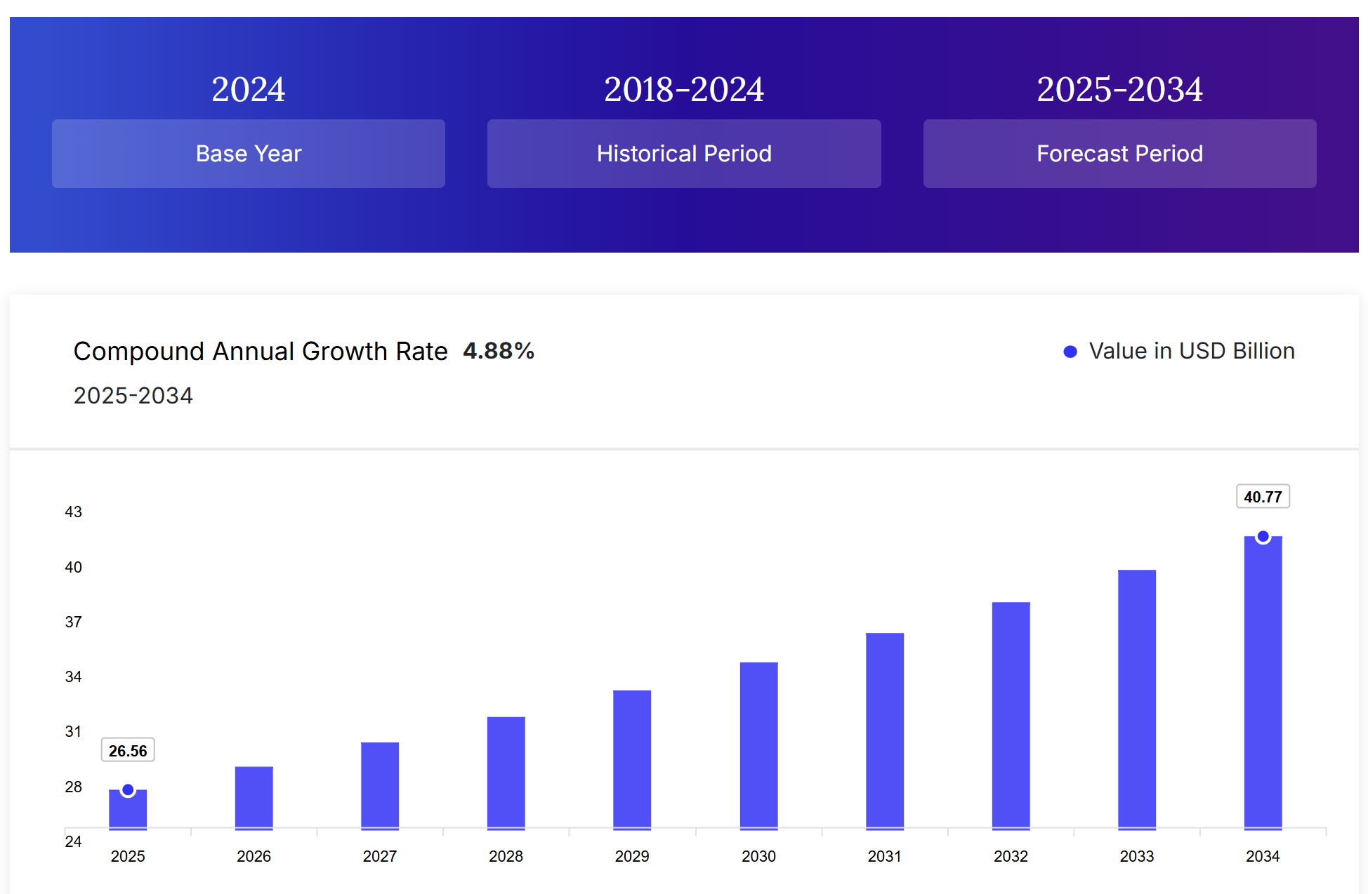
Figure 1: Growth analysis of the UK soft drinks market
(Source: Expert Market Research, 2025)
As an example, the low-sugar and zero-sugar drinks have been reformulated at a rapid rate in the UK, with now over 67% of the carbonated drinks sold (Report Linker, 2025). Another essential impact is the shift to digital technologies, which means that AI-based analytics and personalised marketing are dramatically changing how consumers make their decisions (Prabhuraj, 2025). Paiva (2025) added that competitive forces are influenced by sustainability pressures as the number of environmentally conscious consumers to whom sustainable brands and recyclable packages become a reward grows. With the current sustainability and digitalisation levels on the rise, companies have no choice but to keep on changing their strategic marketing strategies to stay competitive.

2.2 Selection of Two External Macro Marketing Actors
The selection of both technological and environmental aspects is informed by the fact that they immensely influence the beverage industry of drinks in the UK. Advocacy of technology is transforming production, marketing, and distribution channels, more so as more beverage companies continue adopting AI, automation, and digital supply chain applications to make them effective. The digital transformation in the UK is accelerating among the beverage companies, and online beverage sales are growing at a rate of over 25% between 2022 and 2024 (IMR, 2025). It illustrates the direct effects of the activities of technology to the market behaviour and positioning. The environmental forces are also crucial because the sustainability expectations and weather-related problems are critical towards defining consumer behaviour, and the regulatory frameworks.
The beverage industry applies a lot of pressure on the environment particularly due to the fact that it is reliant on water, sugar and packaging. The consumers of the UK have one of the highest sustainability orientations in the European region, with more than 70% of them claiming that they would rather use eco brand drinks (Mordor Intelligence, 2025). This makes environmental performance one of the determinants of competition. These two dimensions are therefore of great relevance since they offer unique challenges and opportunities to the innovative companies like Coca-Cola and Red Bull, and copycat companies like PepsiCo and Monster.

2.3 Critical Analysis of Each Actor
A. Technological Factors
Different strategic results emerge for innovators and imitators because of technological development. An example is Coca-Cola, which has been heavily investing in AI-powered marketing and digital vending technology. As shown in figure 2, partnering with Microsoft and investing $1.14bn in AI cloud and AI-optimised supply chain are now able to scale consumer experience (Hale, 2025). This kind of early adoption gives Coca-Cola a consumer engagement and market responsiveness edge.
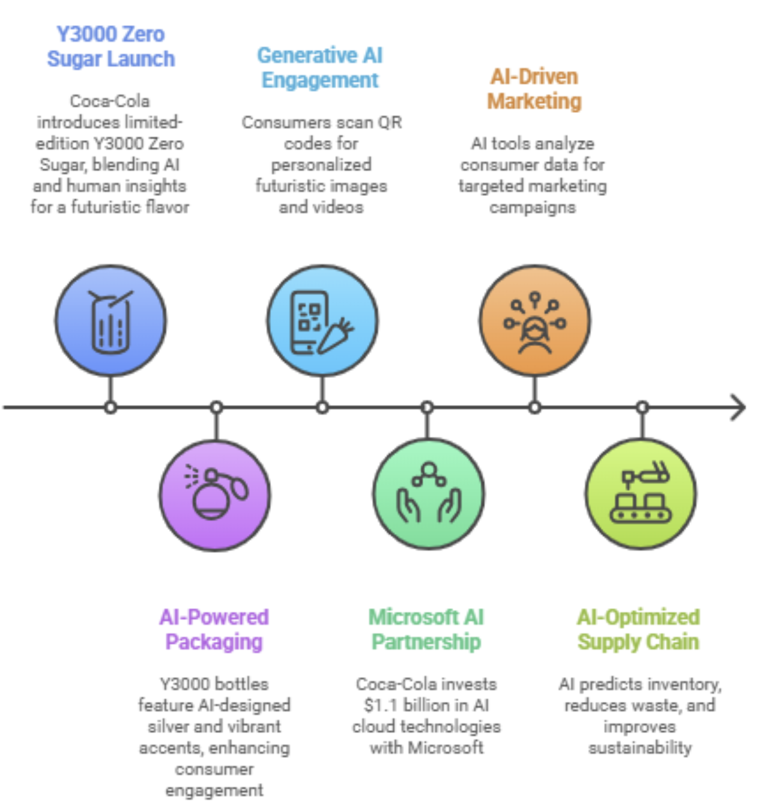
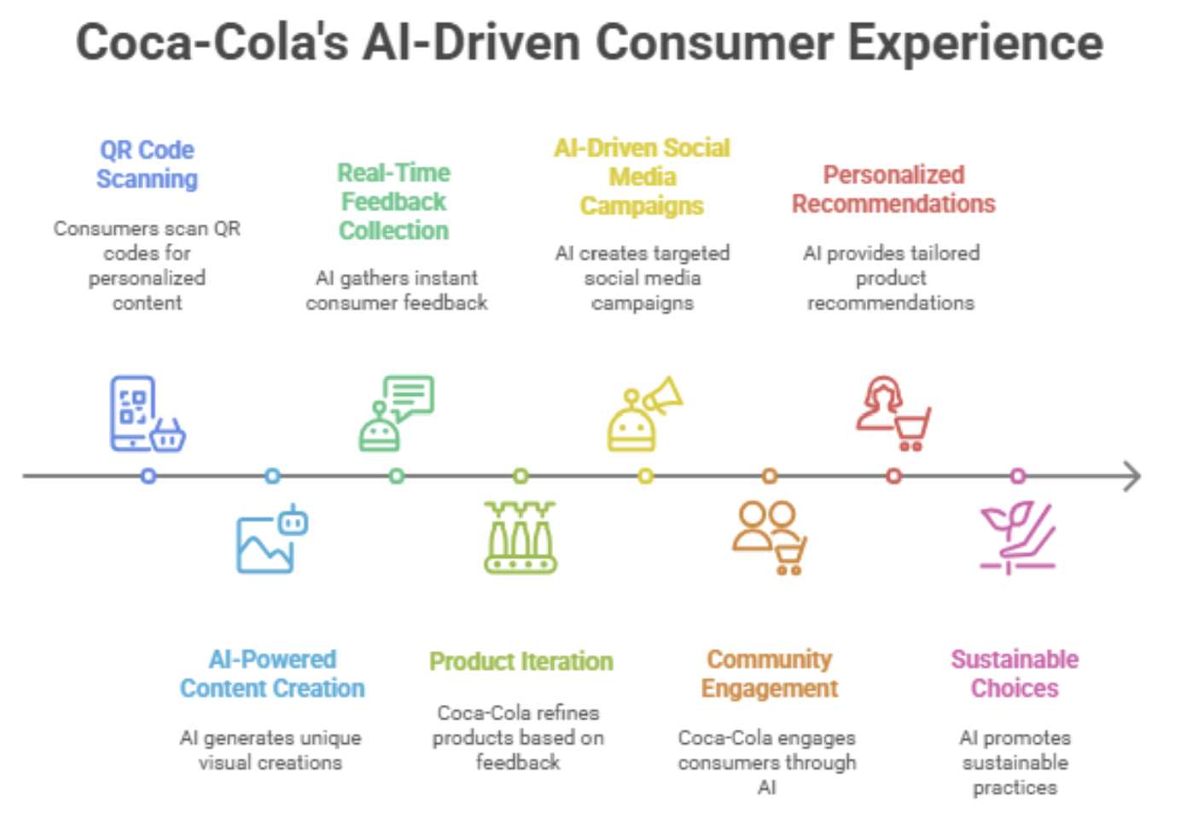
Figure 2: Investment of Coca-Cola in AI
(Source: Hale, 2025)
Red Bull also uses digital content ecosystems and data-driven sports media to maintain its premium position, and is thus a first-mover in brand-owned digital marketing strategies (Paiva, 2025). The dynamics are different to the followers. PepsiCo is more and more implementing such tools, including AI-powered personalised Pepsi Max promotions and more distribution via e-commerce. As per Ahmed (2024), this is reactive in relation to the proactive innovation of Coca-Cola.
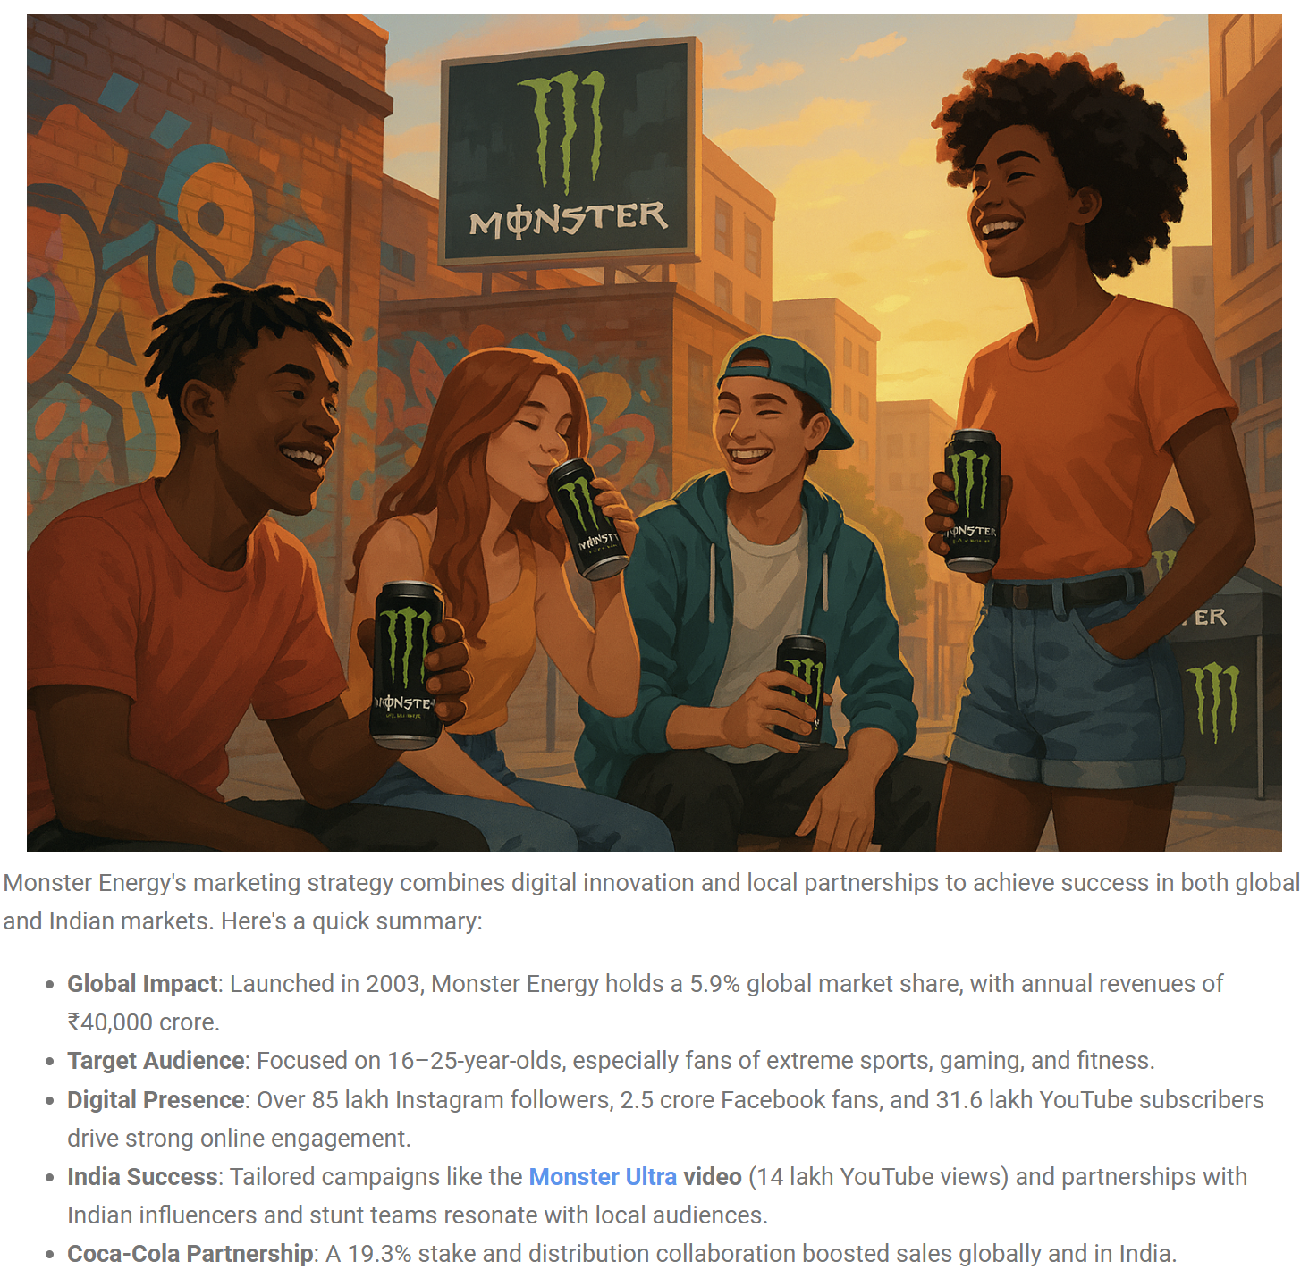
Figure 3: influencer-based marketing used by Monster
(Source: Trackandtactic, 2025)
Monster, on the other hand, uses social media analytics and influencer-based online interaction to target the niche youth hours. This is affordable, but less grand and technologically profound than the pioneer organisations (Trackandtactic, 2025). Technology also has the potential to produce threats. The cost of investment is very high, hence increasing competitive disparity between early adopters and late adopters, since the transformation brought by digital requires constant capital injection. The UK beverage companies are estimated to boost their expenditure on digital infrastructure by more than 14% every year until 2026 (Report Linker, 2025). Lower capital intensity followers might not be able to keep up, at which point, market share growth may be at a disadvantage. The technological pressure also reduces the duration of the product innovation cycle and forces the companies to constantly improve the accuracy of supply chain forecasting and segmentation, which adds strategic pressure to the followers. All in all, technological forces enable the pioneers to uphold the differentiation and the followers to concentrate on the imitation or incremental innovation.
B. Environmental Factors
The beverage industry is being redefined by environmental pressures as greenness stands out as a major buying requirement. The programme of Coca-Cola called World Without Waste and the creation of plant-based bottles are examples of how innovators employ sustainability to support brand leadership (Peattie et al., 2025). The sustainability initiative of Red Bull, spending on full recycling of aluminium cans and carbon-neutral events, can also make the company appear a sustainability innovator (Tian et al., 2025). Respondents are also retaliating, though on a different level. The PepsiCo sustainability agenda, Pep +, is among the most powerful corporate environmental initiatives in the industry, incorporating a transition to regenerative farming and decreasing the quantity of plastic (PepsiCo, 2021). As shown in figure 4, it has made value chain more circular.
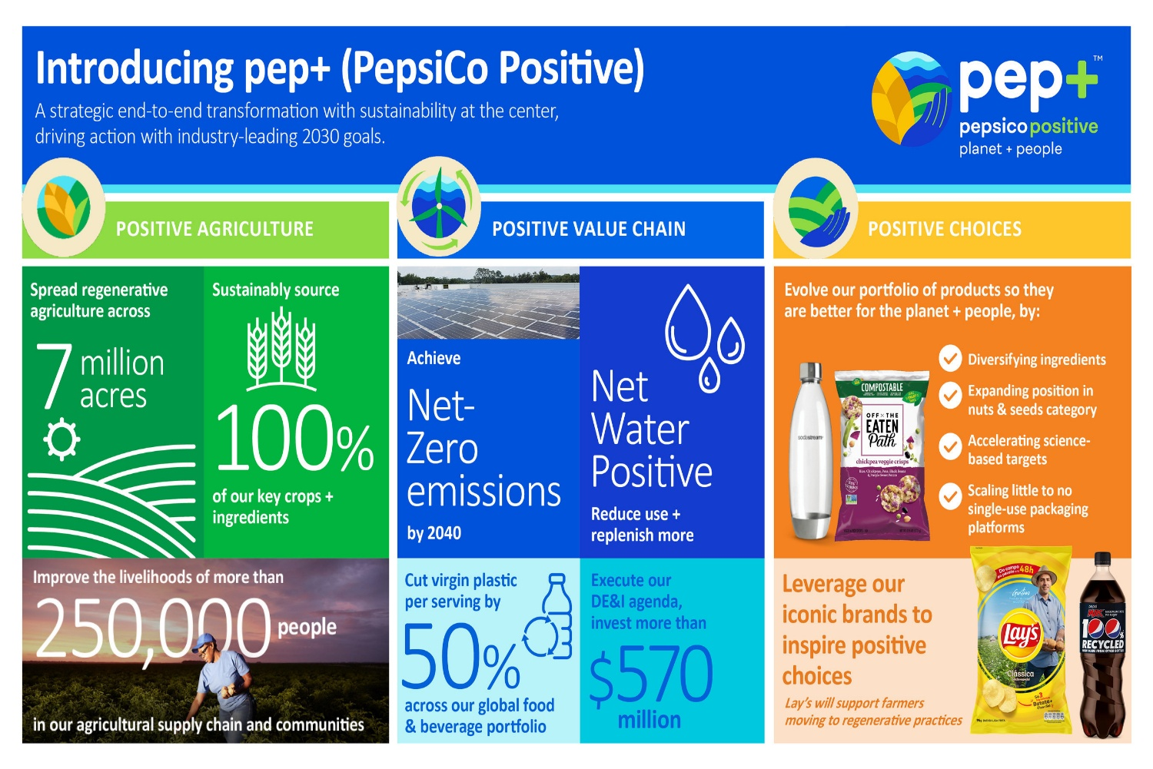
Figure 4: Pep+ approach of PepsiCo to showcase sustainable packaging efforts
(Source: PepsiCo, 2021)
Monster is progressively enhancing recyclable packages to fulfil the environmental requirements of the UK and the EU, but its actions are not as wholesome as those of innovators (Mordor Intelligence, 2025). There are serious environmental threats. Sugar-reduction requirements that made companies reformulate products raised the cost of operation of the UK Soft Drinks Industry Levy (Expert Market Research, 2025). The water shortage due to climate change and the unstable agricultural production also raise the cost of production in the beverage industry (IMR, 2025). Moreover, the tightening of UK packaging, such as taxes on plastics, puts pressure on companies to invest in new materials and solutions of the circular economy. Such pressures increase the cost of R&D and necessitate strategic change, especially in the case of the less resourceful followers. Environmental forces, therefore, formulate strategic requirements for reformulation that are eco-friendly, innovative at zero sugar percentage and packaging differentiation with innovators in a better position to lead and followers forced to change fast.

3. Task 2: Strategic Responses of Pioneering and Follower Organisations

3.1 Pioneering Organisations’ Strategic Responses
The proactive and innovation-driven strategies of leading organisations like Coca-Cola and Red Bull are usually a reaction to macro-environmental pressures based on a firm's market leadership. Putri et al. (2025) state that pioneers also use the mechanism of constant scanning of the environment in order to predict the external changes and implement them into long-term strategic planning. The Growth Matrix, explained by Ansoff, can be used to evaluate the reaction of Coca-Cola to the technological and environmental forces. Market penetration involves personalised promotional and marketing campaigns like the Share a Coke one, where data-driven segmentation is used to engage a larger number of consumers (Dholakia et al., 2025). As shown in figure 5, Red Bull has a comparable penetration with sports event marketing across the globe, employing Formula 1 and Red Bull Air Race as the means of maintaining the air of a premium brand that cuts across the markets (Aryal, 2025).
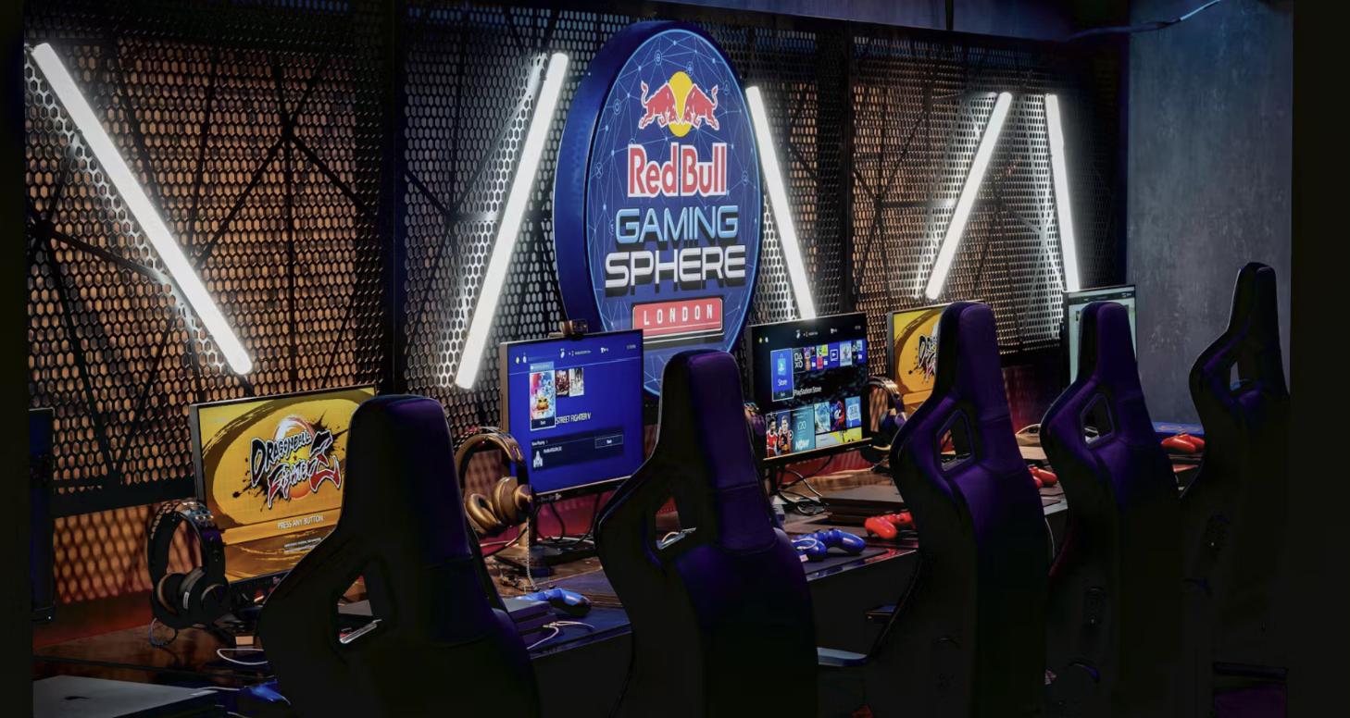
Figure 5: Red Bull increasing its popularity by organising Formula 1 racing sphere
(Source: Aryal, 2025)
Under the product development dimension, Coca-Cola speeds up reformulation with its Coca-Cola Zero Sugar, as a reaction to customer obesity and sugar-related regulation pressures. Red Bull does the same by launching new products under its Red Bull Editions, which are sugar-free and flavour-based alternatives as a response to changing lifestyle requirements (Kotovs et al., 2025). These dockets enable innovators to be technologically pertinent and handle viability requirements.
Market development is also very important to pioneers. Coca-Cola has diversified in the emerging markets by developing branding programs that are locally adapted to the local culture. It has allowed this pioneer brand to expand in regions where there is an increase in the consumption of beverages. Red Bull has implemented a lifestyle-based growth strategy and has ventured into Africa and South Asia by supporting extreme sports personalities that are highly attractive to young people (Reppel and Beninger, 2025). Diversity also enhances pioneer resistance. The acquisition of Costa Coffee is a strategic move in the global hot beverages industry by Coca-Cola, which is in line with the long-term portfolio diversification. Red Bull has gone into media and entertainment activities, relying on Red Bull Media House to strengthen brand values and introduce new sources of income (Ananthian and Rajasekaran, 2025).
Pioneer behaviour can also be explained with the help of Porter's Generic Strategies. The leadership approach of Coca-Cola is the differentiation one, which is justified by brand heritage, global distribution, and significant investment in digital marketing abilities. As seen from the findings of Toyoshima (2022), Red Bull employs focused differentiation in which lifestyle identity, involvement with extreme sports, and media ownership support its distinctiveness. These are some of the strategies that can assist pioneers in overcoming environmental difficulties. Sustainability-oriented strategic reactions are also motivated by environmental pressures. The food and drink industry in the UK is estimated at more than one hundred and twenty-five billion pounds every year, and environmental compliance is a significant competitive factor (FDF, 2025). The recyclable aluminium cans of Red Bull and events that are carbon neutral resemble its environmental trends, whereas Coca-Cola shows that its investments in sustainable packaging are in line with the sustainability trends. Sustainability-led innovation is becoming the characteristic of competitive advantage as described by Verma and Diwan (2025), which prompts the pioneers to invest in the models of the circular economy. The efforts of technology are also very powerful. The non-alcoholic drinks market in the UK is steadily increasing, and is expected to rise to in excess of GBP 28 billion by 2030, which is increasing digital-first marketing pressures (Grand View Research, 2025). The first movers embrace the use of AI-based personalisation, digital vending solutions, and logistics forecasting in order to stay at the forefront of this growing market.

3.2 Follower Organisations’ Strategic Responses
The response of organisations like PepsiCo and Monster is different because of their market positioning. Competitive imitation, progressive development of innovation and cost-effective adaptation influence their strategic behaviour. Strategies that followers tend to adopt to the changes in the macro-environment are usually fast-reactive strategies, which are based on efficiency and competitive pricing. By 2033, the UK food and beverage market will grow to exceed GBP 122 billion, and competitive positioning will be more vital to the follower brands (IMRC, 2025). Under market penetration, PepsiCo uses pricing, mass promotions, and retail alliances to promote Pepsi Max aggressively to confront the market dominance of Coca-Cola. By enlisting the services of Coca-Cola bottlers globally, Monster can easily enter the UK convenience stores and supermarkets (Manturov, 2024). Such strategies help the followers to compete by being visible and accessible as opposed to being innovative. Product development is also important to the followers. PepsiCo is proactively developing its low-sugar product line to match the health-conscious consumer behaviour and legal requirements. Monster presents new functional drinks and flavoured ones to remain relevant among younger audiences. As per the ideas of Kotovs et al., (2025), this type of incremental innovation enables the followers to be competitive without having to take the burden of R&D that was taken by the pioneers.
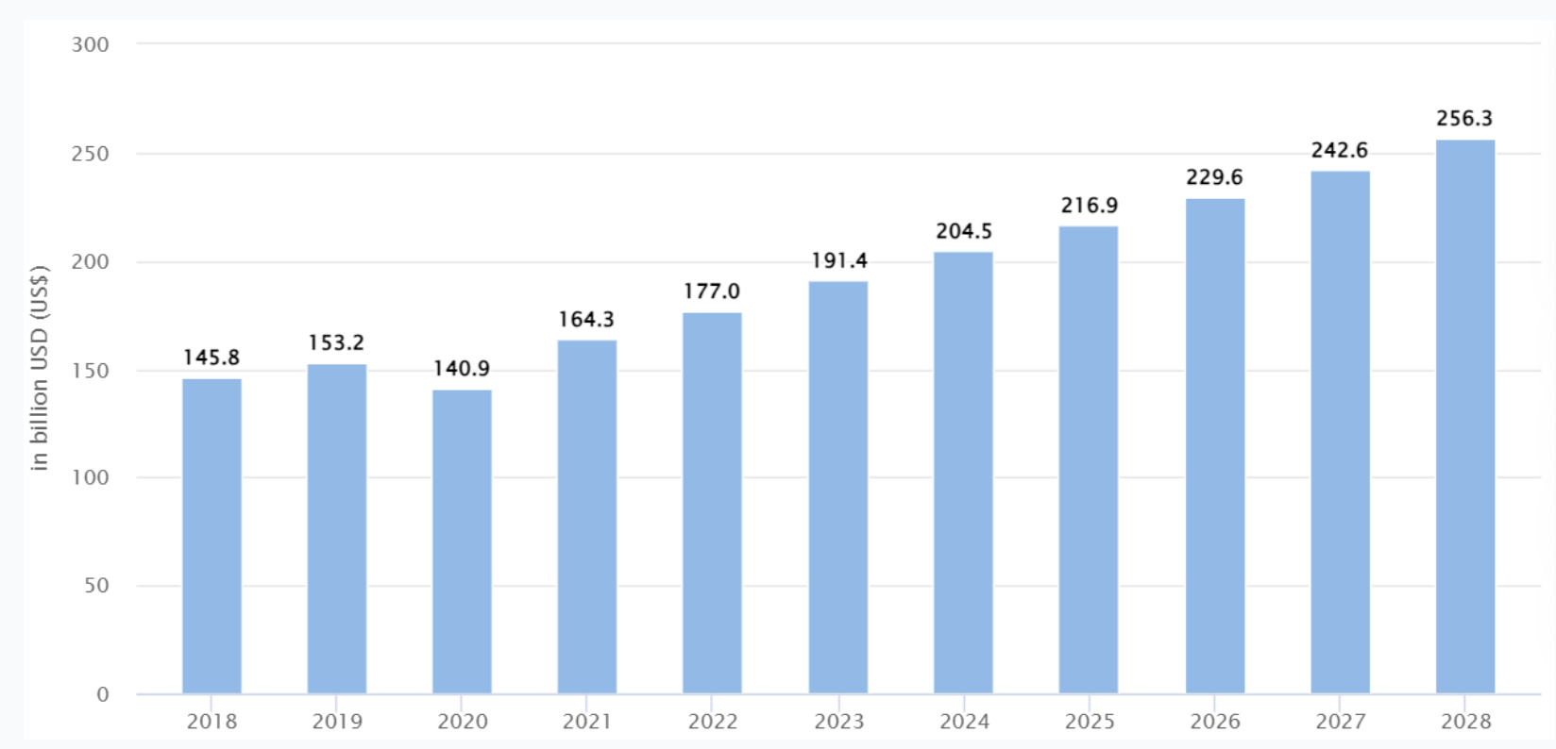
Figure 6: Global energy and sports drinks market size
(Source: Manturov, 2024)
Regarding the market development, PepsiCo uses digital media to access more customers by collaborating with online shopping platforms and food delivery services. Monster is still expanding its presence in the UK by venturing into new retail formats, especially in the convenience and petrol station markets, where the consumption of energy drinks is greatest (Haase, 2025). Follower strategy is also associated with diversification. The acquisition of Walkers snacks by PepsiCo makes service-to cross-category marketing and bundle promotion more competitive against Coca-Cola. Monster also has a range of alcoholic energy drinks, including The Beast Unleashed, which indicates a shift into the related drinks (Ananthian and Rajasekaran, 2025). Such choices are in line with the follower strategies to capitalise on the new revenue streams and still capitalise on new brand equity. The market of the global energy and sports drinks is estimated to grow to $256.3bn in next 3 years (Manturov, 2024). Positioning of followers is explained in the Generic Strategies by Porter. PepsiCo is a hybrid company that is investing in differentiation in the form of product innovation, yet cost leadership in terms of scale efficiencies. Monster applies cost focus and brand-based differentiation. As per the ideas of Reppel and Beninger (2025), these are based on its high recognition in extreme sports and youth culture. With such approaches, followers can compete with each other by being adaptive and efficient, but not pioneering. Following the redesign of the industry due to the application of new technologies, there is a rise in the uptake of AI-advanced promotion tools and more efficient supply chain systems by the followers to stay relevant. The follower behaviour is also influenced by sustainability expectations. The UK consumers are highly attracted to environmentally friendly brands that encourage followers to enhance the sustainability of their packaging and minimise the environmental impact (Grand View Research, 2025).

4. Conclusion
It is seen in the analysis that the macro-environment factors play a crucial role in the competition and development of organisations in the UK beverage industry. Two of the strongest external players that were identified to shape strategic behaviour were technological improvements and environmental pressures. Innovations in the form of innovation-led approaches, heavy investment in digital capabilities, sustainable packaging, and product diversification are proactive measures that pioneering organisations like Coca-Cola and Red Bull implement. Differentiation and focus differentiation help them to establish the industry standards and build the brand leadership over the long term.
PepsiCo and Monster are examples of follower organisations that apply more responsive but flexible approaches to stay competitive. Followers use the opportunities generated by pioneers by exploiting the same environmental conditions through selective diversification, aggressive entry into the market and cost-focused innovation. The strategic instruments employed, the Matrix of Ansoff and the Generic Strategies of Porter, show the difference in the magnitude, velocity, and concentration of the reaction of pioneers and followers. Generally, the results support the need to do permanent environmental scanning in strategic marketing management. Those organisations that are successful in decoding technological changes, sustainability concerns, and changing consumerism expectations are in a better position to develop resilience, remain competitive, and experience sustainable growth in an industry landscape that is dynamics.

5. References
Ahmed, O.A., (2024). Strategic Overview of Macro-Environment of Business: Insight from Pestl Analysis. FUTA Journal of Logistics and Innovation Technology, 3(1), pp. 241-246. https://www.researchgate.net/profile/Samuel-Majekodunmi/publication/391521493_FUTA_Journal_of_Logistics_and_Innovation_Technology_Strategic_Overview_of_Macro-Environment_of_Business_Insight_from_Pestl_Analysis_Strategic_Overview_of_Macro-Environment_of_Business_Insight_from_Pes/links/681b5d04df0e3f544f527fc4/FUTA-Journal-of-Logistics-and-Innovation-Technology-Strategic-Overview-of-Macro-Environment-of-Business-Insight-from-Pestl-Analysis-Strategic-Overview-of-Macro-Environment-of-Business-Insight-from-Pes.pdf
Ananthian, R.S.A. and Rajasekaran, S.R.C., (2025). Development of social marketing in tourism: A bibliometric approach. Multidisciplinary Science Journal, 7(4), pp.2025211-2025211. https://malque.pub/ojs/index.php/msj/article/view/5808
Aryal, A. (2025). Red Bull’s Marketing Strategy: How It Built a Global Lifestyle Brand. Available at: https://www.blankboard.studio/originals/blog/red-bull-marketing-strategy-brand-lifestyle#:~:text=energy%20drink%20company.-,Influencer%20&%20Digital%20Strategy:%20YouTube%2C%20Esports%20&%20Social%20Engagement,fueled%20moments%20on%20social%20media (Accessed: 15 November 2025).
Dholakia, N., Repo, P., Fırat, A.F., Campos, I. and Timonen, P., (2025). Artiﬁcial Intelligence, Structure of Knowledge, and the Future Directions for Macromarketing. Journal of Macromarketing, 45(2), pp.337-344. https://journals.sagepub.com/doi/abs/10.1177/02761467251323840
Expert Market Research, (2025). UK Soft Drinks Market Size & Share, YoY Growth | 2034. Available at: https://www.expertmarketresearch.com/reports/united-kingdom-soft-drinks-market (Accessed: 15 November 2025).
FDF, (2025). Food and drink industry - Facts and stats. Available at: https://www.fdf.org.uk/fdf/business-insights-and-economics/facts-and-stats/ (Accessed: 20 November 2025).
Grand View Research, (2025). UK Non-alcoholic Beverages Market Size & Outlook, 2030. Available at: https://www.grandviewresearch.com/horizon/outlook/non-alcoholic-beverages-market/uk (Accessed: 18 November 2025).
Haase, M., (2025). The nexus of knowledge, action, and values, and the philosophical, social, and normative foundations of marketing. Journal of Macromarketing, 45(1), pp.130-145. https://journals.sagepub.com/doi/abs/10.1177/02761467241256027
Hale, M. (2025) Next Gen AI in Action: Coca-Cola’s Futuristic AI-Powered Flavor Experience. Available at: https://www.gsdcouncil.org/blogs/next-gen-ai-in-action-coca-cola-s-futuristic-ai-powered-flavor-experience (Accessed: 10 November 2025).
IMR, (2025). UK Food And Drink Market Analysis and Industry Trends. Available at: https://introspectivemarketresearch.com/reports/uk-food-and-drink-market/ (Accessed: 10 November 2025).
IMRC, (2025). UK Food and Beverage Market Size, Share & Forecast 2033. Available at: https://www.imarcgroup.com/uk-food-beverage-market (Accessed: 12 November 2025).
Kotovs, D., Krievina, A. and Zacepins, A., (2025). Enhancing Precision Beekeeping by the Macro-Level Environmental Analysis of Crowdsourced Spatial Data. ISPRS International Journal of Geo-Information, 14(2), p.47. https://www.mdpi.com/2220-9964/14/2/47
Manturov, M. (2024) Top 2 stocks with strong prospects in the energy drinks market. Monster: major beverage company with 31.3% upside potential. Available at: https://freedom24.com/ideas/details/15097 (Accessed: 20 November 2025).
Mordor Intelligence, (2025). United Kingdom Beverages Research. Available at: https://www.mordorintelligence.com/market-analysis/beverage/uk (Accessed: 20 November 2025).
Paiva, T., (2025). A Systematic Review of Driving Sustainability Through Circular Economy Marketing: Insights and Strategies for Green Marketing Innovation. Encyclopedia, 5(2), p.61. https://www.mdpi.com/2673-8392/5/2/61
Peattie, K., De Angelis, R., Koenig-Lewis, N. and Strong, C., (2025). Introduction: marketing and sustainability. In The Routledge Companion to Marketing and Sustainability (pp. 1-13). Routledge. https://www.taylorfrancis.com/chapters/edit/10.4324/9781003412397-1/introduction-ken-peattie-roberta-de-angelis-nicole-koenig-lewis-carolyn-strong
PepsiCo. (2021) PepsiCo Announces Strategic End-To-End Transformation: pep+ (PepsiCo Positive). Available at: https://www.prnewswire.com/news-releases/pepsico-announces-strategic-end-to-end-transformation-pep-pepsico-positive-301377032.html (Accessed: 10 November 2025).
Prabhuraj, J., (2025, April). A STUDY ON THE INFLUENCE OF EXTERNAL FACTORS ON CONSUMER DECISION MAKING FACTORS IN DIGITAL ERA WITH REFERENCE TO MACRO ENVIRONMENT. In The International Conference on Invogue Branding (INIB 2025) (Vol. 12, No. 4SE, pp. 48-55). https://www.researchgate.net/profile/Prabhuraj-Jayaraj/publication/393146552_A_Study_on_the_Influence_of_External_Factors_on_Consumer_Decision_Making_Factors_in_Digital_Era_with_Reference_to_Macro_Environment/links/6861df4b92697d42903bd163/A-Study-on-the-Influence-of-External-Factors-on-Consumer-Decision-Making-Factors-in-Digital-Era-with-Reference-to-Macro-Environment.pdf
Putri, D.W.M., Alvionita, M., Harly, M.R. and Syaifuddin, M., (2025). Business Environment Analysis in Strategic Management. Journal of Practice Learning and Educational Development, 5(1), pp.164-170. https://digitalpress.gaes-edu.com/index.php/jpled/article/view/392
Report Linker, (2025). The United Kingdom Beverage Industry Outlook 2022 – 2026. Available at: https://www.reportlinker.com/clp/country/14/726373 (Accessed: 15 November 2025).
Reppel, A. and Beninger, S., (2025). Reflections on Holixec Education: A Macromarketing Response to Contemporary Educational Challenges?. Journal of Macromarketing, p.02761467251315113. https://journals.sagepub.com/doi/abs/10.1177/02761467251315113
Tian, Y., Kamran, Q. and Henseler, J., (2025). Sustainability in marketing: a review using multiple correspondence analysis. Cogent Business & Management, 12(1), p.2493389. https://www.tandfonline.com/doi/abs/10.1080/23311975.2025.2493389
Toyoshima, S., (2022). The Extremes in Traditional Sports: A Case Study of Red Bull TV. The International Journal of Sport and Society, 13(2), p.97. https://search.proquest.com/openview/e80b0330abec04baf0e08f5281f84b3e/1?pq-origsite=gscholar&cbl=5529389
Trackandtactic. (2025) Marketing Strategy of Monster Drink: A Success Story. Available at: https://www.trackandtactic.com/2025/04/marketing-strategy-of-monster-drink.html (Accessed: 15 November 2025).
Verma, S. and Diwan, H., (2025). Marketing innovation for sustainability: Review, trends, and way forward. Business Ethics, the Environment & Responsibility, 34(3), pp.912-935. https://onlinelibrary.wiley.com/doi/abs/10.1111/beer.12686

