Applied Programmable Logic Controllers

Applied Programmable Logic Controllers
ACDA6000

Spanswick, Adam S2218236
Contents
Table of Content Tables 4
Table of Content Figures 5
Introduction 7
1.0 Program Logic Controllers 0
1.1 Advantages/Disadvantages of PLC’S 2
1.2 Types of PLC’s 3
1.3 Siemens 7
1.4 Rockwell Automation / Allen Bradley 8
1.5 Mitsubishi Electric 9
1.6 Omron 10
1.7 ABB 11
1.8 Delta 12
1.9 Schneider Electric 13
2.0 Ladder Logic 14
2.1 Network 1 14
2.2 Network 2 14
2.3 Network 3 14
2.4 Network 4 15
2.5 Network 5 17
2.6 Network 6 18
2.7 Network 7 18
2.8 Network 8 18
2.9 Network 9 19
2.10 Network 10 20
2.11 Network 11 21
2.12 Network 12 21
2.13 Network 13 22
2.14 Network 14 23
2.15 Network 15 24
2.16 Network 16 26
2.17 Network 17 26
2.18 Network 18 27
2.19 Network 19 28
3 PLC Tags 29
4 HMI Tags 31
5 Operation Flowchart 32
6 Factory I/0 33
7 Root Screen 35
8 Alarm Screen 37
9 Engineer Screen 39
10 Factory I/O Images 41
11 Conclusion/Improvements 45
12 References 46

Table of Content Tables
Table 1 Parts of a PLC 5
Table 2 Advanatages/ Disadvantages of a PLC 6
Table 3 Advantages/Disadvantages of Compact PLC 7
Table 4 Advantages/ Disadvantages of Modular PLC 8
Table 5 Top 20 Manufactures of PLC'S [20] 10
Table 6 Siemens Advantages/Disadvantages 11
Table 7 Advantages/Disadvantages of Rockwell Automation 12
Table 8 Mitsubishi Electric Advantages/Disadvantages 13
Table 9 Omron Advanatges/Disadvantages 14
Table 10 ABB Advantages/Disadvantages 15
Table 11 Delta Advanatges/ Disadvantages 16
Table 12 Schneider Electric Advantages/Disadvantages 17

Table of Content Figures
Figure 1 Siemens PLC System overview 3
Figure 2 Block Diagram of PLC [4] 4
Figure 3 PLC OVERVIEW 5
Figure 4 Compact PLC 6
Figure 5 Modular PLC 7
Figure 7 Different PLC'S [21] 9
Figure 6 PLC Manufactures [20] 9
Figure 8 Siemens Logo [24] 10
Figure 9 Siemens PLC [28] 10
Figure 10 Rockwell Automation Logo [29] 11
Figure 11 Rockwell Automation PLC [32] 11
Figure 12 Mitsubishi Electric Logo [33] 12
Figure 13 Mitsubishi Electric PLC [37] 12
Figure 14 Omron Logo [38] 13
Figure 15 Omron PLC [42] 13
Figure 16 ABB Logo [43] 14
Figure 17 ABB PLC [47] 14
Figure 18 Delta Logo [48] 15
Figure 19 Delta PLC [51] 15
Figure 20 Schneider Electric Logo [52] 16
Figure 21 Schneider Electric PLC [56] 16
Figure 22 Network 1 17
Figure 23 Network 2 17
Figure 24 Network 3 17
Figure 25 Network 4 18
Figure 26 Network 5 20
Figure 27 Network 6 21
Figure 28 Network 7 21
Figure 29 Network 8 21
Figure 30 Network 9 22
Figure 31 Network 10 23
Figure 32 Network 11 24
Figure 33 Network 12 24
Figure 34 Network 13 25
Figure 35 Network 14 26
Figure 36 Network 15 27
Figure 37 Network 15 28
Figure 38 Network 16 29
Figure 39 Network 17 29
Figure 40 Network 18 30
Figure 41 Network 19 31
Figure 42 PLC Tags 32
Figure 43 PLC Tags 32
Figure 44 PLC Tags 33
Figure 45 HMI Tags 34
Figure 46 Operational Flowchart 35
Figure 47 Siemens Download to Factory I/O 36
Figure 48 Siemens PLC Run 36
Figure 49 Siemens Simulation 36
Figure 50 No errors on downloading 37
Figure 51 Factory I/O Driver 37
Figure 52 Configuration of Driver Factory I/O 37
Figure 53 Root Screen 38
Figure 54 Root screen warning Light 39
Figure 55 Root Screen Alarm Light 39
Figure 56 Alarm Screen 40
Figure 57 Scale Conveyor Weighing Alarm 41
Figure 58 Engineer Screen 42
Figure 59 Engineer Screen warning /alarm engineer checks 43
Figure 60 Alarm screen showing engineer checks 43
Figure 61 Factory I/O Overall 44
Figure 62 Factory I/O Overall 44
Figure 63 Factory I/O Safety Gate 45
Figure 64 Scale Conveyor Weighing 45
Figure 65 Large Box/ Pusher 1 System 46
Figure 66 Pallet Box Pusher 2 System 46
Figure 67 Overall Image of Factory I/O working 47

Introduction

The report will contain a Design and control of a Factory System which sorts 4 different packages based on size and weight. The factory is to be designed in Factory I/O and must contain and control the following as a minimum:-
4 conveyor belts
2 pushers
- conveyor scale
- Diffuse sensors
- Emergency Stop
- Buttons
- Siren.
1 Warning light
- Stack lights

To limit the current draw at start up, each conveyor should be started in sequence. A manual reset of
alarm signals once the alarm issue is corrected.

The system will require a HMI for operator interaction. The HMI must have the following controls and displays available on the root screen:-

- Buttons for starting and stopping the system
- An emergency stop button
- A button to reset all counters
- counters
- A replication of the stack lights
- Fault and warning indicators

A fault and warning screen which displays alarm and warnings.
Warning and alarm must include:-
- Counter warning number exceeded for each counter

An engineering screen which has data entry points for:
- Pre-setting counter Warning numbers

The factory must also have the following which may be manually controlled
- 1 package Emitter
- package Removers

A formal report detailing your factory I/O operation.

1.0 Program Logic Controllers

“A Programmable Logic Controller is “a small industrial computer originally designed to perform the logic functions executed by electrical hardware (relays, switches, and mechanical timer/counters)” [1]

“Program Logic Controllers (PLCs) are regarded as an industry's key element. It is categorized as a computer device that contributed to the industrial revolution. Prior to influencing other industries, they were leaders in the automobile business. Relays, panels, and contactors, which were at the forefront of all sectors before to the introduction of PLCs, are much smaller than PLCs. Relays demand far more maintenance and electricity than PLCs do. Downtime is also significantly less with relays.
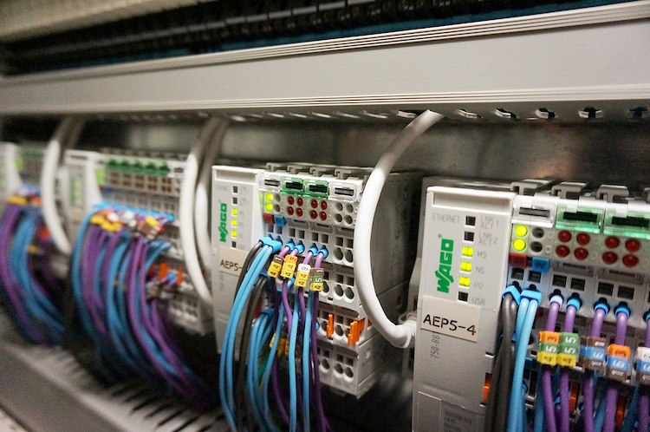
The PLC serves as the automation system's brain. Here is a list of the top automation applications where PLC is used: Steel, Glass, Paper, Textile, Cement, Food, Oil and Gas Plant, Wind Turbine System, Robotic Automation System, Chemical, Refrigeration Process, Pharmaceutical Industry.” [2]
Figure 1 Siemens PLC System overview

[3]

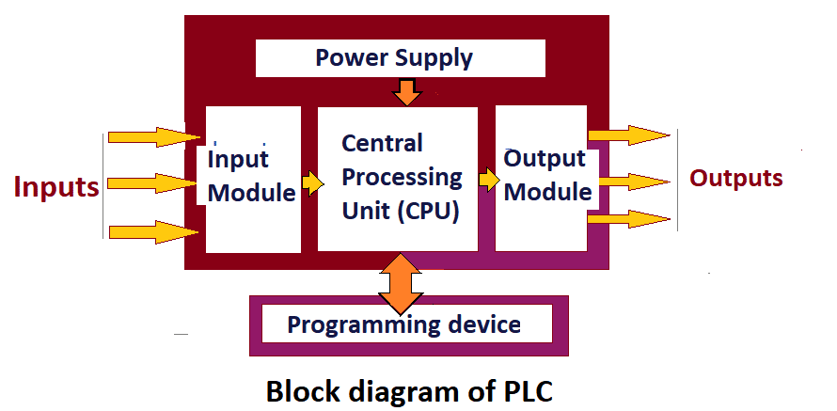
Figure 2 Block Diagram of PLC [4]

A typical PLC consists of five main parts:
Table 1 Parts of a PLC
Rack or chassis | “on which modules are mounted.” [5]
Power module | “supply power to CPU and input, and output modules in the rack.” [6]
Central Processing Unit (CPU) | “It performs logic, arithmetic, and sequencing operations” [7]
Input and output module | “It receives inputs from the field and also outputs to the field devices. It has wiring for input and output devices.” [8]
Communication interface module | “I/O modules in one or more racks are connected with the interface module.” [9]

1.1 Advantages/Disadvantages of PLC’S
Advantages | Disadvantages
- “Flexible in programming and one PLC can operate a number of machines” [10] | - “The cost of PLC for small applications is high” [10]
- “Quickly reprogrammed for any change” [10] | - “There are limitations of working PLCs under high temperature, vibration conditions.” [10]
- “Offer easy troubleshooting and correcting any errors” [10] | - “When a problem occurs, hold-up time is indefinite, usually long” [10]
- “A large number of contact available” [10] | - “Some PLCs turns on when power is restored and may cause an accident” [10]
- “Number of software timers, counters, relays are available” [10]

- “Operation of PLC can be observed on display” [10]

- “PLC is more reliable than relay logic” [10]

- “Maintenance cost and downtime is less as compared to relay logic” [10]

- “Security for ladder programming” [10]
- “PLC is a hardness industrial computer” [10]
Table 2 Advanatages/ Disadvantages of a PLC
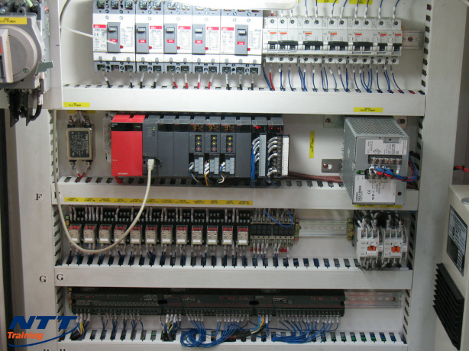

[11]
Figure 3 PLC OVERVIEW

1.2 Types of PLC’s
PLCs are modular or individually integrated programmable logic controllers.
- Compact/Monolithic PLC
“A compact or monolithic PLC has several modules housed in a single enclosure. Therefore, the manufacturer, not the user, decides on I/O capabilities. You may add more I/Os to certain onboard PLCs to make them more modular.” [12]
Advantages | “Disadvantages”
“Low cost” [12] | “Fixed number of I/O” [12]
“Already fitted I/O with CPU” [12] | “Cannot be easily repaired” [13]
“Integrated / Fixed PLC” [12] | “Small in size” [13]
“Already fitted I/O with CPU” [13]
Table 3 Advantages/Disadvantages of Compact PLC
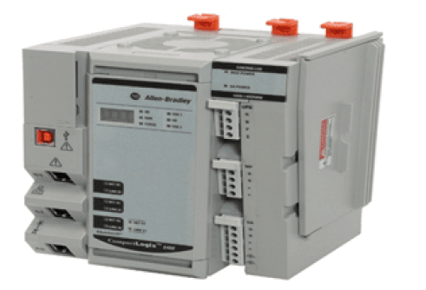 [14]
Figure 4 Compact PLC

- Modular PLCS
“A modular PLC consists of a large number of parts connected to an expandable I/O bus or common rack. This includes power supplies, CPUs, and other I/O modules from the same manufacturer or from different manufacturers connected together in the same rack. These modular PLCs are available in a variety of sizes with flexible power, processing power, I/O connectivity, and other features.
Modular PLCs are further classified into small, medium, and large PLCs based on the number of I/O functions and amount of program memory.” [13]
Advantages | Disadvantages
“Easy to maintain compared to the compact plc.” [12, 15] | “High cost compared to compact PLC.” [16]
“Inputs and outputs can be added to the modular PLC systems by the user.” [17] | “Larger in size, which includes power supply and other additional capabilities.” [18]
“Several parts are fitted with separate slots on chassis or rack or bus in this PLC.” [19] | “More complex to program due to flexibility” [20]
“Memory” [21]
“Room for Expansion” [22]
“Greater Number of Available I/O Modules” [23]
“Mix and Match” [24]
Table 4 Advantages/ Disadvantages of Modular PLC
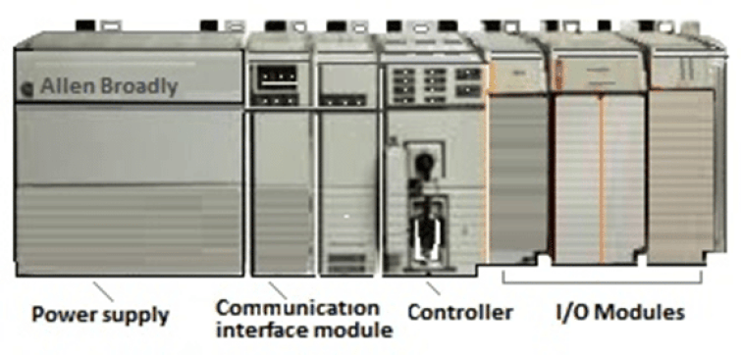
Figure 5 Modular PLC

[25]
- Miniature PLCS
“Miniature PLCs are miniature PLCs that are mounted on or near devices designed to manage them. Hardwired relay logic, counters, timers and other devices are replaced by this type of his PLC. The scalability of this PLC I/O module is limited to one or two modules and the programming language is either Relay Ladder Language or Logic Statement List.” [26]
- Medium PLCS
“Medium-sized PLCs are often used in the industry to support a large number of plug-in modules installed on the system backplane. Add hundreds of I/O points by adding I/O cards. In addition, this PLC also offers communication module functionality.” [27]
- Large PLCS
“Large PLCs are used where advanced process control capabilities are required. These PLCs have significantly more memory, programming languages, I/O points, communication modules, and other features than medium-sized PLCs. These PLCs are widely used in distributed control systems, large factories, supervisory control and data acquisition (SCADA) systems, etc.” [28]

1 | Siemens
2 | RockWell/Automation/Allen Bradley
3 | Mitsubishi Electric
4 | Schneider Electric
5 | ABB
6 | Honeywell Process
7 | Omron
8 | Hitachi Industrial Equipment Systems
9 | IDEC
10 | B&R Industrial Automation
11 | Bosch Rexroth
12 | Koyo Electronics Industries
13 | Delta
14 | Eaton
15 | Keyence
16 | LS Electric
17 | Panasonic
18 | Phoenix Contact
19 | Pilz
20 | WAGO Kontakttechnik
“There a many PLC Manufactures. The market for Program Logic Controllers is estimated to be worth Billion’s Pound’s each year. Below in the table shows the amount available to the industry sectors out there to choose from. These are the Top 20 Available.” [29]
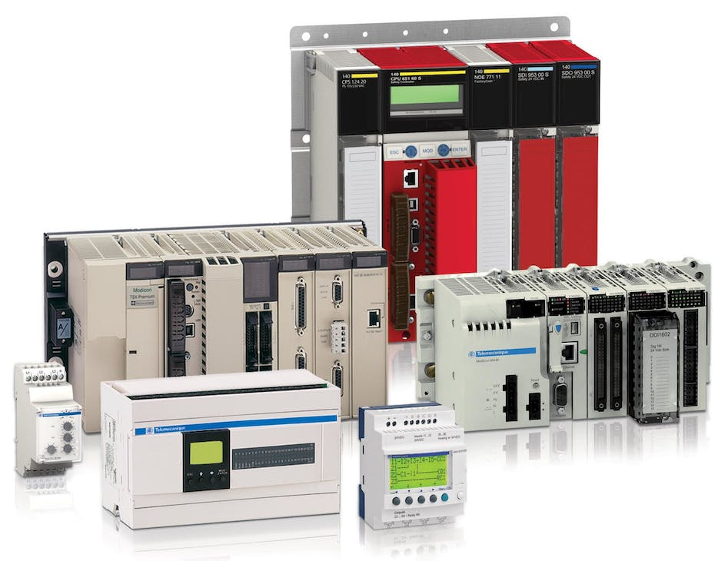

Figure 7 Different PLC'S [51]
Figure 6 PLC Manufactures [50]

Table 5 Top 20 Manufactures of PLC'S [30]


1.3 Siemens
Figure 8 Siemens Logo [52]
“German-based Siemens was founded in Munich, Germany, on October 1, 1847. Siemens is the largest industrial manufacturing corporation in Europe, with locations in more than a hundred nations.
Depending on whose report you believe, Siemens is thought to have a 30 to 40% market share, making it the undisputed leader in PLCs. However, these numbers are based on averaging the top 10 or so companies, who collectively are reported to sell a lot more PLCs than the rest put together.
The largest engineering business in Europe, Siemens, claims their SIMATIC range includes a controller "for any application" and has a market capitalization of about $124 billion and annual revenues of $60 billion.” [31] [32] [33]

Advantages | Disadvantages
Flexible logic that is simple to update | Cable connections are simply too labor-intensive.
Very Quick | It's challenging to replace or modify things.
Available Diagnostic and Fault-Finding Features | It's never easy to find mistakes. A trained crew is also necessary.
Low Power Consumption | Some operating systems are hard to locate.
Efficient | Some operating systems are prohibitively pricey.
Reliable | When a problem occurs, the delay is unpredictable and usually prolonged.
Ability to do out complicated logic calculations
Table 6 Siemens Advantages/Disadvantages
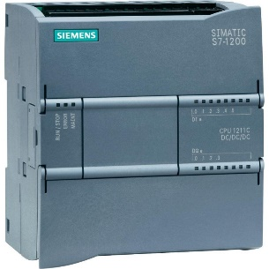

Figure 9 Siemens PLC [54]


1.4 Rockwell Automation / Allen Bradley
Figure 10 Rockwell Automation Logo [55]
“A international firm specializing in industrial automation and information technology, Rockwell Automation was established in the United States in 1903. For nearly $1.6 billion, Rockwell Automation bought Allen Bradley in 1985. Another is the well-known PLC manufacturer Rockwell Automation/Allen Bradley. There are big, small, and microcontrollers available. Allen Bradley offers the CompactLogix and MicroLogix PLC systems in addition to ControlLogix, their main flagship platform. Sizes of its PLC products range from enormous "nano" systems to tiny "micro" systems. It sells for around $7 billion annually and has a market value of $25 billion. Rockwell holds one of the top five places in the global PLC market share, giving them good insight into trends in manufacturing. However, in comparison to other companies, their equipment might be a little pricey.” [34] [35]
Advantages | Disadvantages
Resourcefulness and ease of usage | More costly in terms of market share compared to other PLC providers (top 5)
There are several input and output points on this PLC. | AB uses a yearly support contract to collect payment for its programming software.
Simple controls and inexpensive upkeep | The source code for AB is classified as confidential information. Required AB approval to modify any code
Small, medium, and large controlling applications can employ this PLC. | Potential compatibility difficulties with the more frequently used MODBUS communication protocol
It features a straightforward design and a longer lifespan. | AB only provides a manufacturer's guarantee for one year.
Cheap for the large operation
High maintainability, compatibility with older systems, and dependability
It's a great idea to use Ethernet I/P with AB automation devices.
Tools for online troubleshooting
Table 7 Advantages/Disadvantages of Rockwell Automation
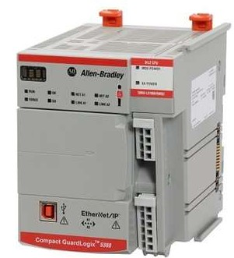

Figure 11 Rockwell Automation PLC [56]


1.5 Mitsubishi Electric
Figure 12 Mitsubishi Electric Logo [57]
“Mitsubishi Electric Corporation was founded on January 15, 1921. Japanese multinational consumer electronics manufacturer headquartered in Tokyo, Japan. It is one of Mitsubishi's core companies.
With a market capitalization of approximately US$28 billion, Mitsubishi Electric is one of the main business units of the Mitsubishi Group, a giant conglomerate with 350,000 employees. Tokyo-based Mitsubishi Electric is another popular PLC brand that offers a wide range of products. The MELSEC series includes PLCs such as high speed, security and compact. Devices are readily available and have a good reputation in the industry.
However, the company is arguably one of the largest He PLC manufacturers with the widest range, and its Japan headquarters are located in a region where rapid growth is expected.” [36] [37] [38]

Advantages | Disadvantages
Profitable input and output modules are abundant in modular PLC. | little exposure to the worldwide market. mostly accessible in Asia
Simple operating system, simple controls, and simple troubleshooting | Limited availability of its products outside of its own market
Affordable for all sizes and types of industrial control applications
Tools for online troubleshooting
Table 8 Mitsubishi Electric Advantages/Disadvantages
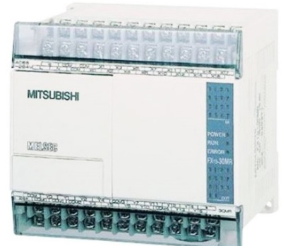

Figure 13 Mitsubishi Electric PLC [58]


1.6 Omron
Figure 14 Omron Logo [59]

“Omron is a Japanese manufacturer based in Kyoto. Omron was founded in 1933. Often launching hundreds of products at a time, the PLC specialist Japanese company offers a fairly wide range of products, including industrial robots and sensors. Omron PLCs are known for their durability and accuracy. In addition, we have a wide variety of models, from entry-level to high-end models. In addition to user-friendly support software, Omron's range of PLCs includes both micro and modular versions, with probably the largest number of individual devices overall, according to Omron. Founded in 1933, the company employs approximately 40,000 people, has a market capitalization of approximately $14 billion, and annual sales exceeding his $8 billion. Omron's primary business is the manufacture and sale of automation components, devices and systems, but it is best known for its medical devices such as digital thermometers, blood pressure monitors and nebulizers.” [39] [40] [41] [42]

Advantages | Disadvantages
In comparison to a similar Allen Bradley PLC, it would cost around 1/10 as much. | Omron might not offer such high-caliber service support.
It takes a decent length of time to find replacement components. | unable to handle complex issues such are the substantial volumes of data required for intricate processes.
Costs of licensing and upkeep are cheap, | Setting up takes more time and is less effective than other plc brands.
It is quite flexible and performs well.
It is basic and straightforward to use.
Install updates without cost
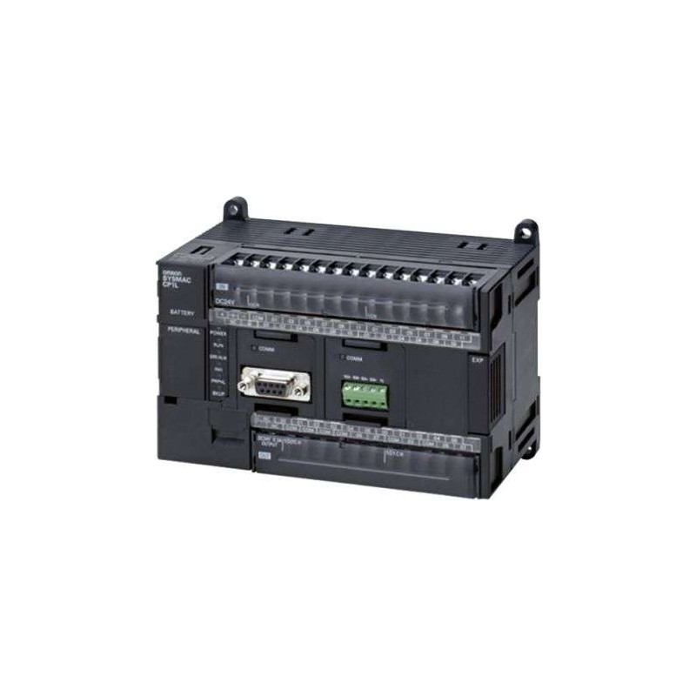
Table 9 Omron Advanatges/Disadvantages
Figure 15 Omron PLC [60]


1.7 ABB
Figure 16 ABB Logo [61]

“Swedish-Swiss multinational corporation ABB, formerly known as Asia Brown Bower, is based in Zurich, Switzerland. Another one of his well-known SPS trademarks is ABB. The scalable AC500 family of programmable logic controllers is available from ABB. ABB could have a solution, depending on the application. Since its founding in 1988, ABB has been well-known in the field of industrial automation. There is a lot of substance behind the style, as seen by the company's $50 billion market worth, $28 billion in yearly revenue, and 144,000 workers. ABB makes a variety of PLCs and is one of the biggest producers of industrial robots in the world. Robotics, data centers, energy efficiency, food and beverage, OEMs, panel builders, and oil and gas are the main activities.” [43] [42] [44]

Advantages | Disadvantages
reputable and well-established | PLC range options are few.
Any module in any CPU
Simple setup
Affordable
Finding replacement components is simple
Flexibility
Simple to program and commission
Strong Memory
Table 10 ABB Advantages/Disadvantages
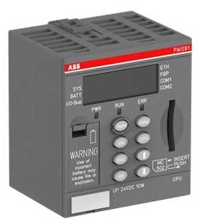

Figure 17 ABB PLC [62]


1.8 Delta
Figure 18 Delta Logo [63]

“Global Leader in Power Electronics: Delta Group .The headquarters of Delta Electronics Inc. are in Taipei, Taiwan, where it was established in 1971. The largest manufacturer of switching power supply and brushless fans is Delta. Power management is one of Delta's seven product categories.
This Taiwanese corporation engages in a wide range of operations, from smart buildings to industrial robots, all of which require a PLC to function properly.
The PLCs available are various, including modular systems and "hot-swappable" ones, to accommodate their varying operations. This indicates that it may be changed without affecting how things are done in general. Today, it has a market value of over $16 billion, and its 83,000+ employees bring in almost $9 billion annually.” [45] [46]

Advantages | Disadvantages
high-performance | Poor technical support and representation in the Southern Hemisphere
high-speed
Low running costs/less expensive
High-control systems
built-in simple commands providing quick access to operations and communication capabilities.
The DVP series PLC's modular type unit offers exceptional space savings and easy, clip-on expansion options.
Table 11 Delta Advanatges/ Disadvantages

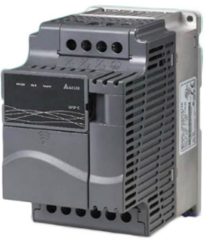

Figure 19 Delta PLC [64]


1.9 Schneider Electric
Figure 20 Schneider Electric Logo [65]

“The international corporation Schneider Electric, which offers both software and hardware, was established in France and focuses on energy management and automation solutions.
French firm Schneider Electric has 135,000 workers, a market value of over US$55 billion, and yearly sales that are greater than €27 billion.
It is thought that Modicon, one of his brands for Schneider Electric, produced the first PLC in the country as early as 1968. In 1999, Schneider Electric was established as the result of many mergers and acquisitions.
Schneider Electric is still a prominent supplier of his PLCs even if it might not be as well recognized outside the industrial sector as other companies on this list, in part because of the absence of noteworthy consumer goods.” [47] [33] [48]

Advantages | Disadvantages
Reliable | Expensive
Memory | Vulnerability been detected in some systems
Quick installation.
High quality
Table 12 Schneider Electric Advantages/Disadvantages

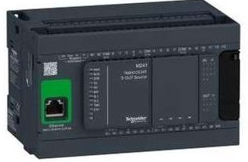

Figure 21 Schneider Electric PLC [66]

2.0 Ladder Logic


2.1 Network 1
Figure 22 Network 1
Link between plc and factory I/O

2.2 Network 2

Figure 23 Network 2
This network demonstrates how we start the program. Additionally, there is a stop button that deactivates the operate coil, which is kept energized. The security door, master alarm, alarm, and warning tags must all function properly to retain the Operate.

2.3 Network 3

Figure 24 Network 3
This Network will reset the Scale Conveyor when the operation has stopped or gone into Fault.

2.4 Network 4
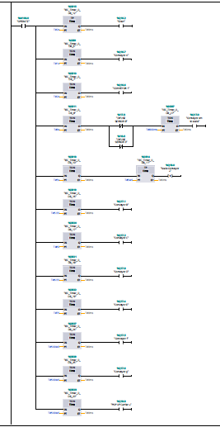
Figure 25 Network 4

On This Network when the operate coil is energised this starts the siren coil through a Time Pulse to sound for 2 seconds then goes off. The following Conveyors are started in a sequence to limit the current drawn on start up.
In this sequence they start up
Conveyor A ---- 1 Second
Conveyor 1 ----- 2 seconds
Conveyor 4m to scale ---- 3 Seconds The DIFUSE Sensors 3 & 8 Help stop the conveyor if a parcel is already on the scale weigher this helps manage the speed of parcels. The TON FOR 800MS helps the scale conveyor to clear before the conveyor 4m to scale restarts.
Scale Conveyor + starts after 5 seconds and the request stops after 5MS this is due to not requiring to be energised constantly.
Conveyor B ---- 5.5 Seconds
Conveyor C ---- 6 Seconds
Conveyor D ---- 6.5 Seconds
Conveyor E ----7 Seconds
Conveyor F ---- 500MS
Conveyor G ---- 500MS

Conveyor F &G both start at 500MS incase a parcel is on scale conveyor at the time of restart.
Pop Up carrier + --- 500MS

2.5 Network 5

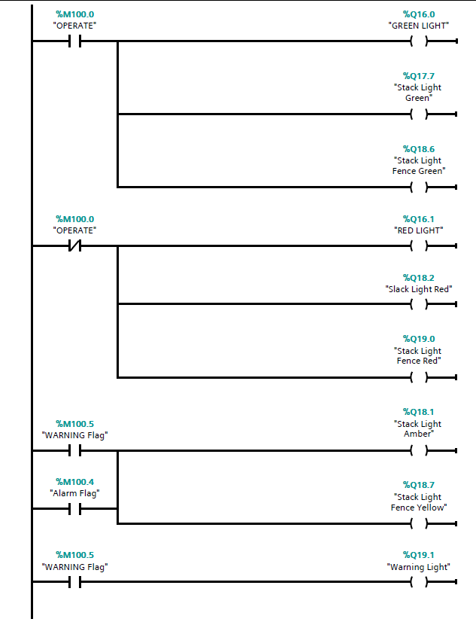
Figure 26 Network 5
This Network is around the Operating Lights and Stack Lights.
When Operate coil energises the green Lights will energise. When Operate goes off the Red Lights energise.
The Amber lights energise when the alarm and warning Flag are activated.
The warning Flag energises the warning Light located by the access gate.

2.6 Network 6
Figure 27 Network 6
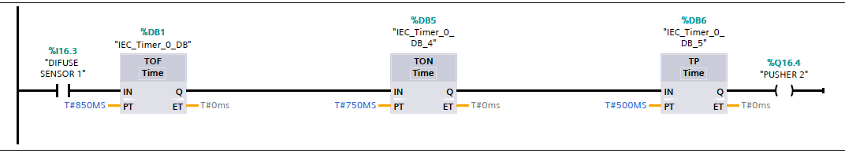
This Network is for Pusher 2 . When Diffuse Sensor 1 is broken this starts the sequence of operation for the pusher 2.

2.7 Network 7
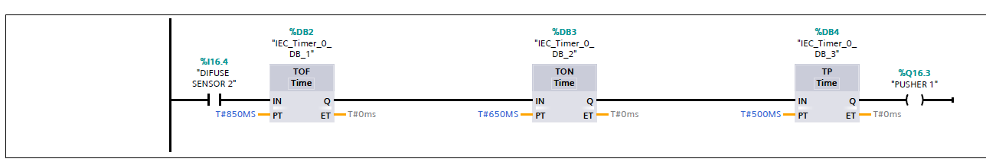
Figure 28 Network 7
This Network is for Pusher 1 . When Diffuse Sensor 1 is broken this starts the sequence of operation for the pusher 2.

2.8 Network 8
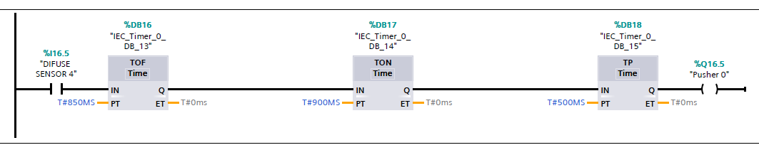
Figure 29 Network 8

This Network is for Pusher 0 . When Diffuse Sensor 1 is broken this starts the sequence of operation for the pusher 2.

2.9 Network 9
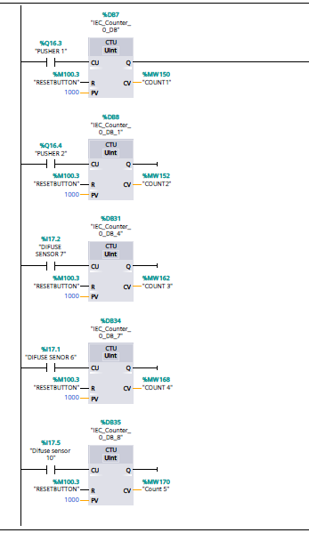
Figure 30 Network 9

This network consist of the counters.
Pusher 1 and pusher 2 will count large and small parcels. These will go to COUNT 1 & COUNT 2.
Diffuse sensor 7 will count up Pallet Boxes in count 3
Diffuse sensor 6 will count up Medium Boxes in count 4
Diffuse Sensor 10 will count up global counter of all boxes in counter 5.

2.10 Network 10
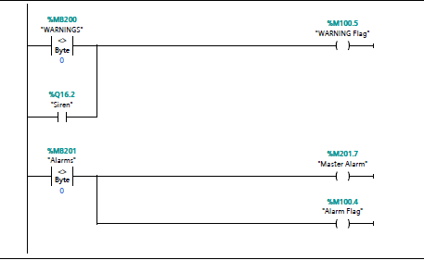
Figure 31 Network 10

On this network this is were any warning generated will trigger the warning flag.
Also any Alarms will trigger the Master Alarm and Alarm Flag to be generated.

2.11 Network 11
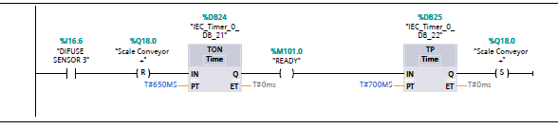
Figure 32 Network 11

On this Network when Diffuse Sensor 3 is broken the scale Conveyor Resets for 650Ms to allow a weight to be read from scales before restarting 700Ms Later.

2.12 Network 12
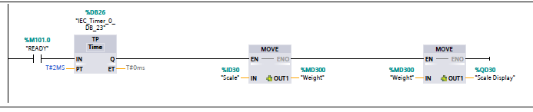
Figure 33 Network 12
This Network when the Ready is activated from Network 11 when scale conveyor is stopped this takes a weight reading from the scale conveyors before going to pop up process depending on weight.

2.13 Network 13
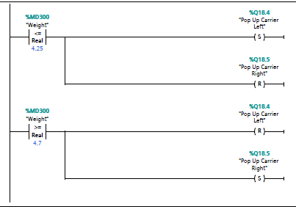
Figure 34 Network 13
On this network when the scale conveyor is stopped the weight is taken when the scale is stopped as if moving the weight will be inaccurate .If the weight is less than 4.25Kg it will make pop up carrier go left. If the weight is greater than 4.7 Kg it will go Right. This also resets the Left and right on carrier accordingly.

2.14 Network 14
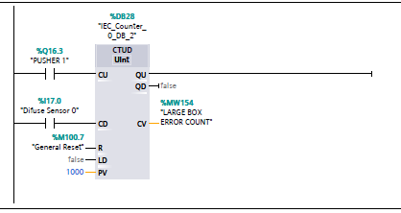
Figure 35 Network 14
This network counts the Large Box Error Counter . The Pusher 1 will count the large boxes and the Diffuse Sensor 0 will count them off the scale. If a large boxes falls off then this will register the count in MW154.

2.15 Network 15
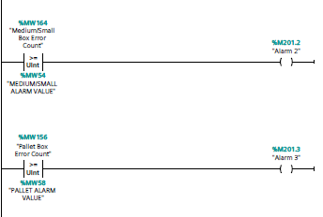
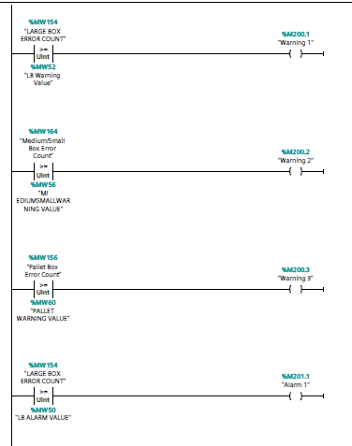
Figure 36 Network 15

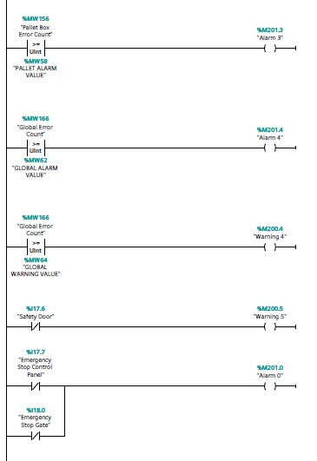
Figure 37 Network 15

On Network 15 This network generates all the warning’s and alarms.
Such as Emergency Stops/Security Gate/Scale conveyor weight and counter errors etc.

2.16 Network 16
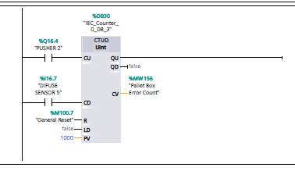
Figure 38 Network 16
This network counts the Pallet Box Error Counter . The Pusher 2 will count the Pallet boxes and the Diffuse Sensor 5 will count them off the scale. If a Pallet box falls off then this will register the count in MW156.

2.17 Network 17
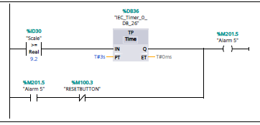
Figure 39 Network 17
On this Network if the Scale weight exceeds 9.2kg this is to represent more than one parcel on scale. Then an Alarm 5 will be generated. The TP timer was put in for 3 seconds to allow the parcels to go off the scales before the weight starts going erratic due to the parcel moving.

2.18 Network 18
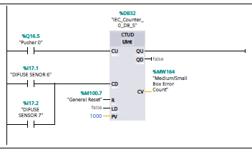
Figure 40 Network 18
This network counts the Medium/Small Box Error Counter . The Pusher 0 will count the Medium/Small boxes and the Diffuse Sensor 6 & 7 will count them off the scale on relevant conveyors. If a Medium/Small box falls off then this will register the count in MW164.

2.19 Network 19
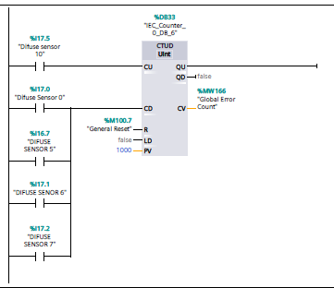
Figure 41 Network 19
This network counts the Global Box Error Counter . The Diffuse Sensor 10 will count all the boxes which come onto the system and then Diffuse Sensor 0,5,6 7 will count them off the conveyors when the go to the removers. If any boxes fall off or go missing this will create a alarm in the Global Error Count and register in MW166.

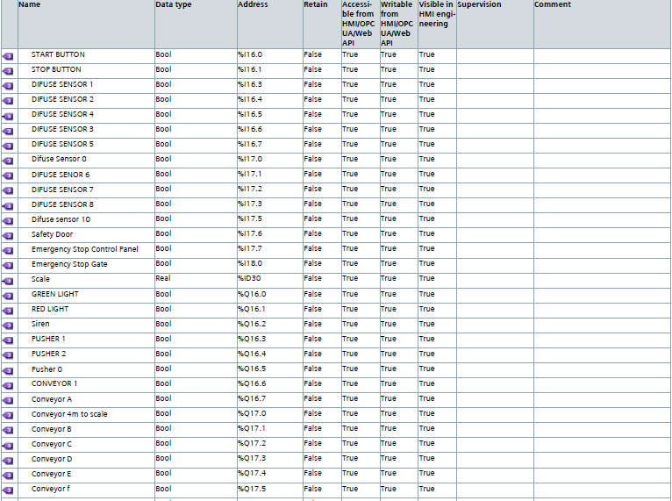
3 PLC Tags
Figure 42 PLC Tags
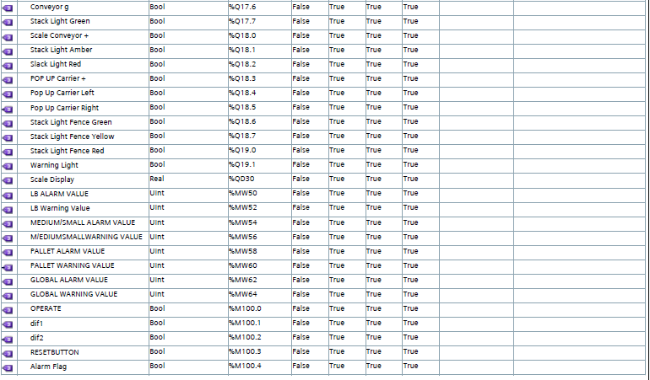
Figure 43 PLC Tags
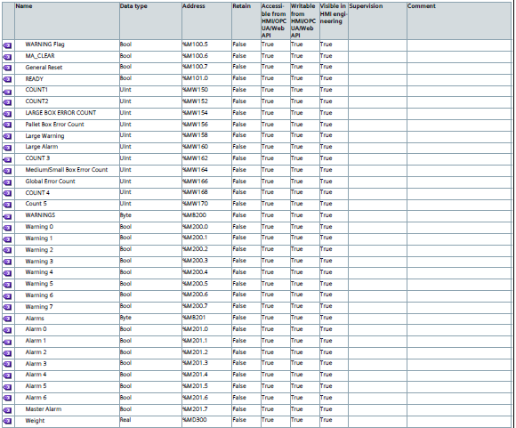
Figure 44 PLC Tags

These are all the PLC Tags which are used within the package sorting system on the Ladder Logic.

4 HMI Tags
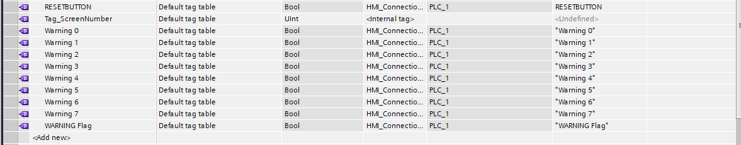
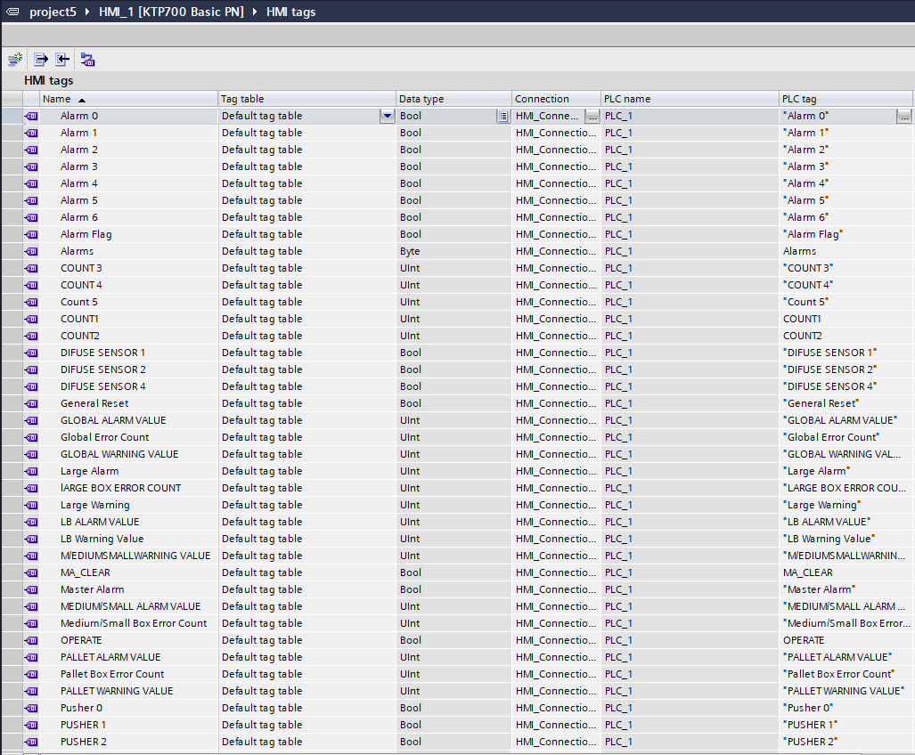
Figure 45 HMI Tags

These are all the HMI Tags which are used within the package sorting system on the Ladder Logic.

5 Operation Flowchart
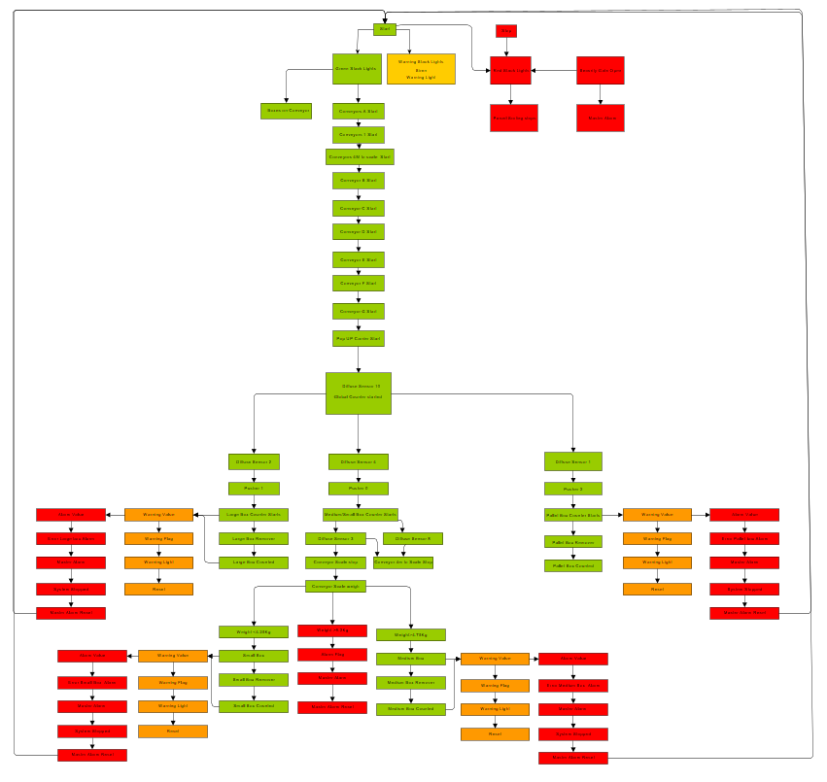
As shown below is a step by step flow chart of the process of the ladder logic.
Figure 46 Operational Flowchart

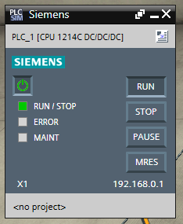
6 Factory I/0
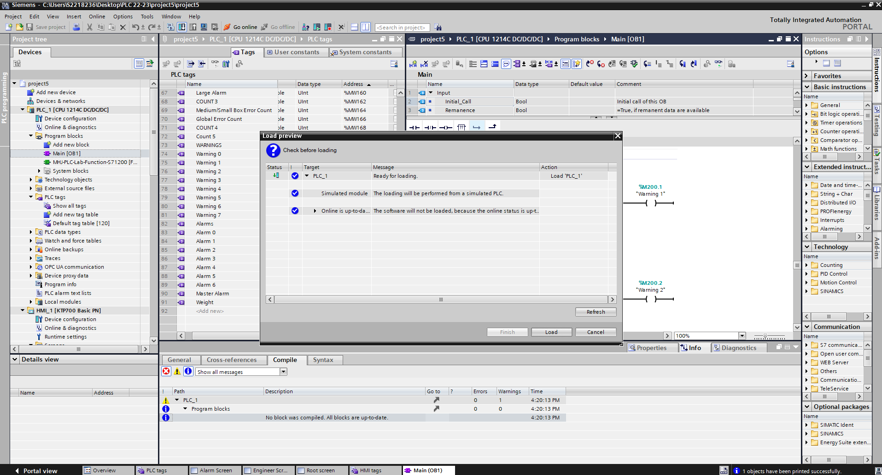
The images here show of the you download your ladder logic program and HMI screens to factory I/O. This allows you to test out your system and logic to see if operate correctly.
Figure 47 Siemens Download to Factory I/O
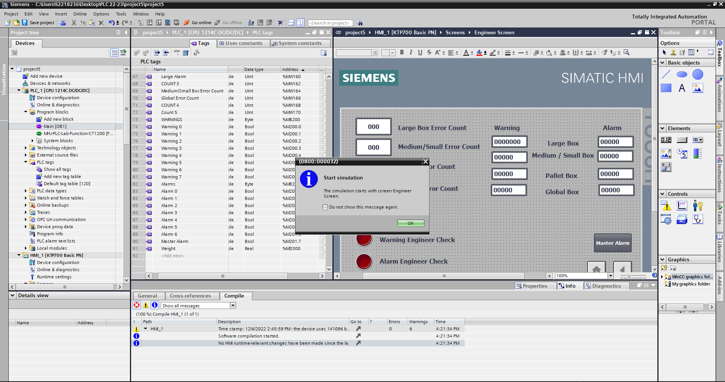
Figure 48 Siemens PLC Run
Figure 49 Siemens Simulation
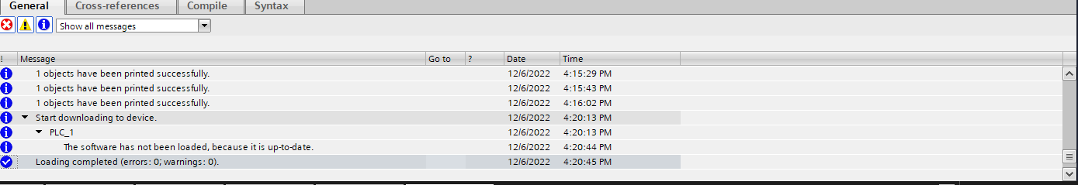
Figure 50 No errors on downloading
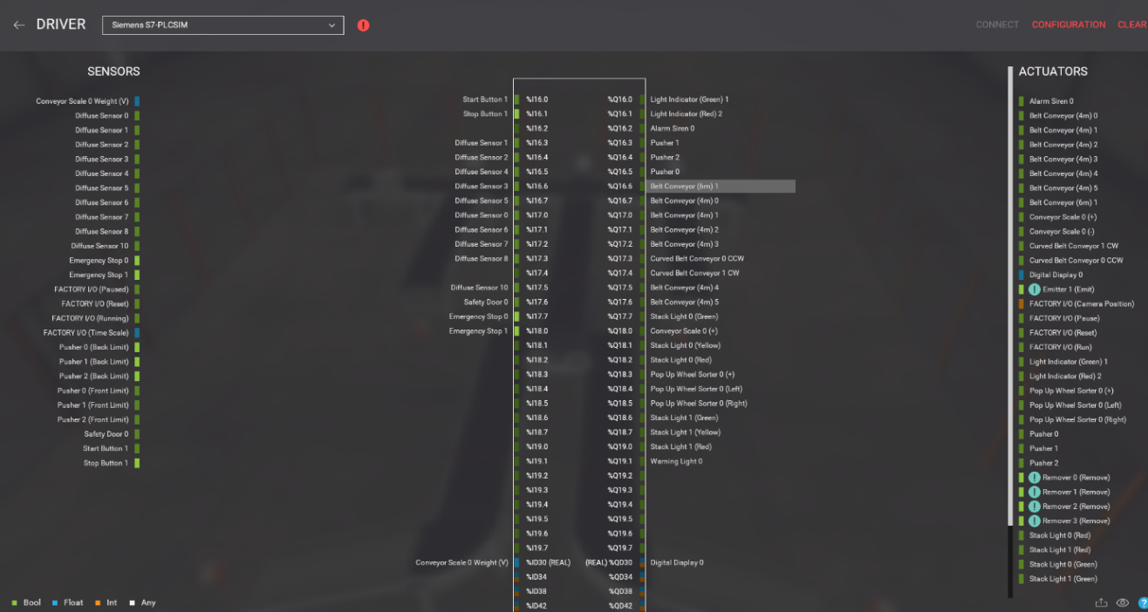
This shows it was successfully downloaded with now errors or warnings.
Figure 51 Factory I/O Driver
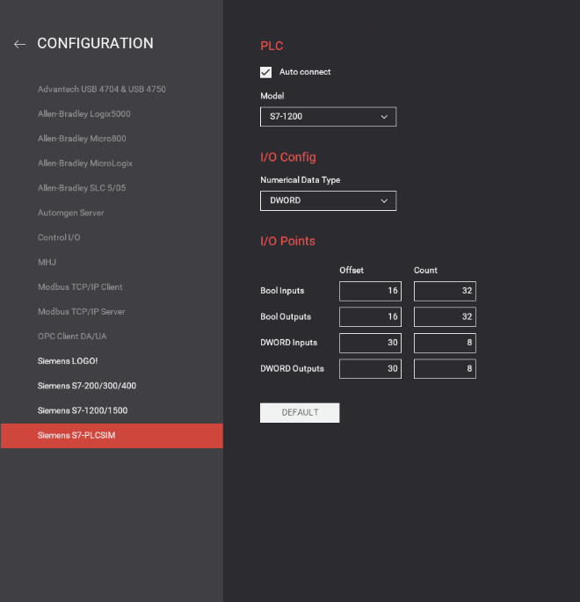
Figure 52 Configuration of Driver Factory I/O

When selecting components on Factory i/o SUCH AS Diffuse sensors you have to place them on input and outputs on the driver for siemens. If not enough input or outputs you can change this be selecting configuration like on left hand side image.

7 Root Screen
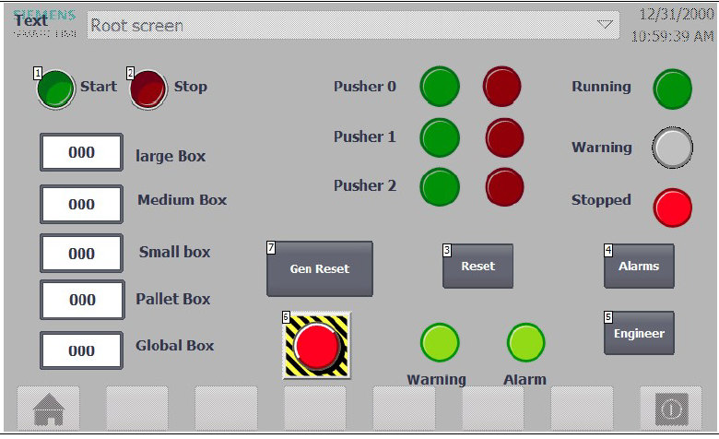
Figure 53 Root Screen
The Root screen will be the main screen for the operator . It has start and stop buttons. Counters for all the boxes individually and a global counter . The Pushers have also got green and red indication lights to show when operated. There also an emergency stop which will stop the system. The stack lights are also represented to show what state the system is when in and out of operation. There are also buttons for gen reset and reset which reset the counters and reset warnings. The warning and alarms pilot lights will change red if any alarms or warnings are present. The alarms and engineer buttons take you to them screens.

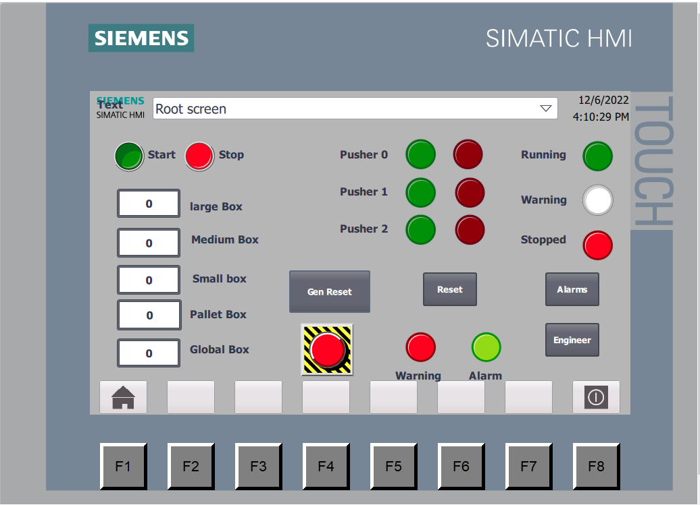
Figure 54 Root screen warning Light
On This engineer screen it shows the warning Light.
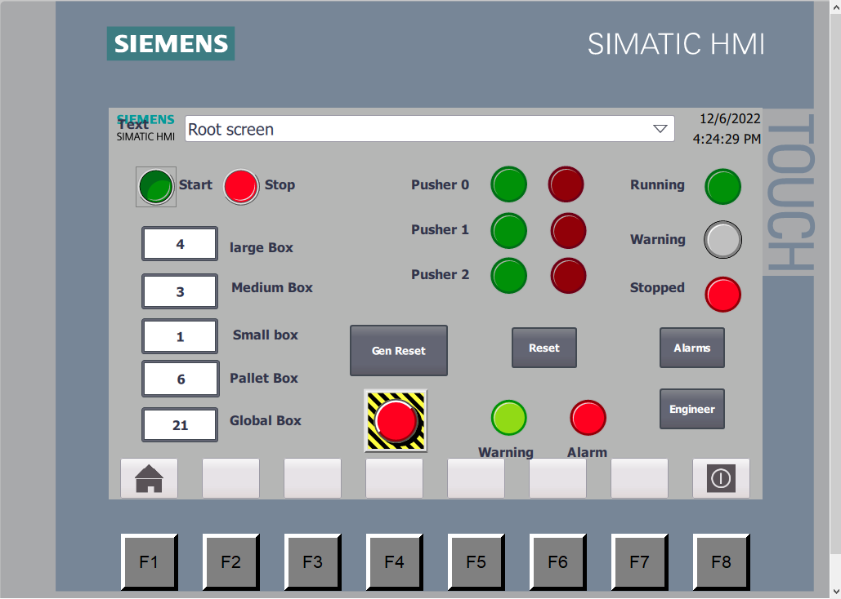

Figure 55 Root Screen Alarm Light

On This engineer screen it shows the Alarm Light.

8 Alarm Screen
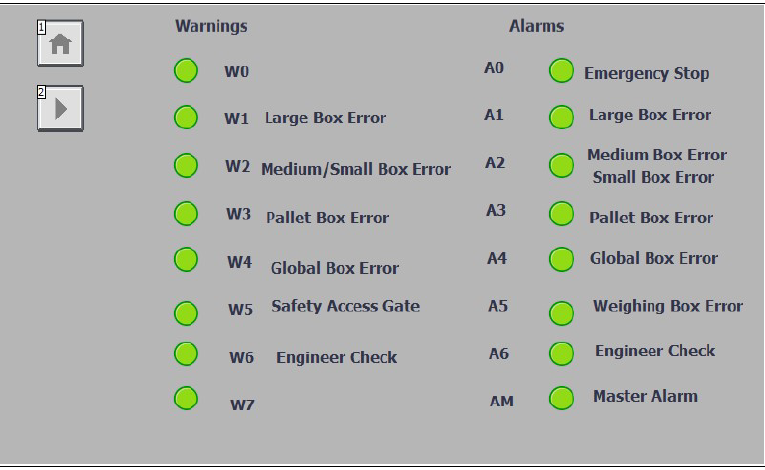
Figure 56 Alarm Screen

Alarm Screen shows all the Warnings and Alarms which are present on the System. The warnings will make the operator aware that an error has occurred but not stop the system. The only one which will stop system is safety access gate as it in logic for the operate as a safety feature. All the alarms will stop the whole process if activated. This allows the engineer to rectify an issues. The warning may be two parcels missing but the alarm will be 5 parcels for example. Only the engineer can reset alarms by engineer screen. Operators can do warnings.

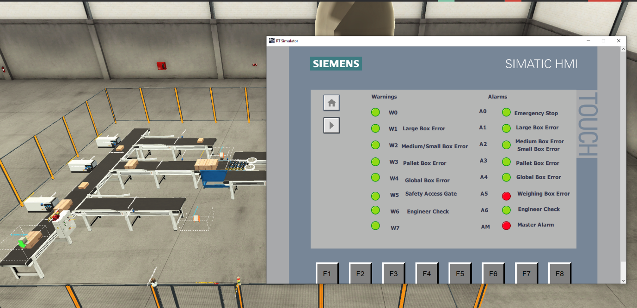
Figure 57 Scale Conveyor Weighing Alarm

As can see from above the factory I/O three parcels on the weighing scale caused the weighing scale alarm to be activated.

9 Engineer Screen
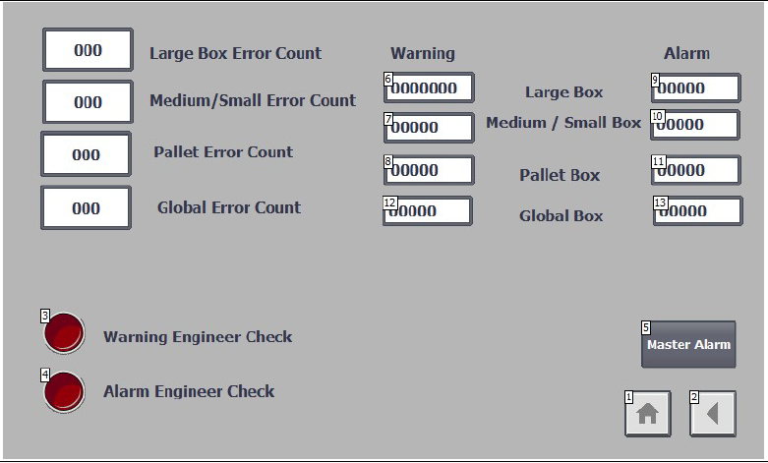
Figure 58 Engineer Screen

The Engineer screen has the error box counters present to shows the engineer if any boxes are missing or if any system isn’t operating correctly. The engineer screen also allows the engineer to enter warnings figures and alarms figure from this screen. The Master alarm button is main button which will reset all alarms when the issues are resolved. The warning and alarm red buttons are there for engineer to generate his own warnings and alarms to allow him to check the system. As shown below.
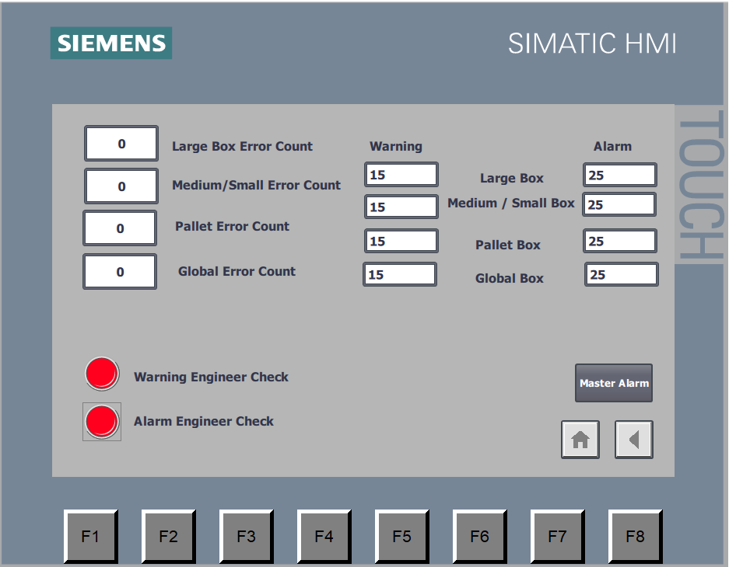
When pressing the engineers warning & alarm check buttons this generates the following alarms below on alarms screen.
Figure 59 Engineer Screen warning /alarm engineer checks
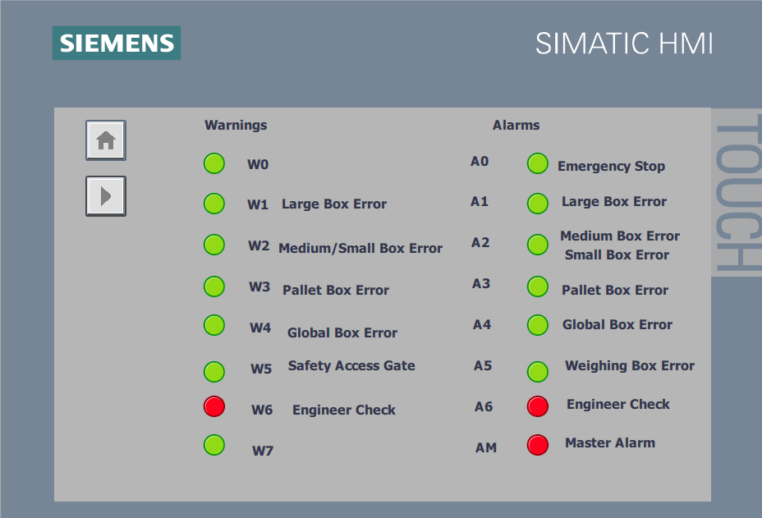
Figure 60 Alarm screen showing engineer checks

10 Factory I/O Images

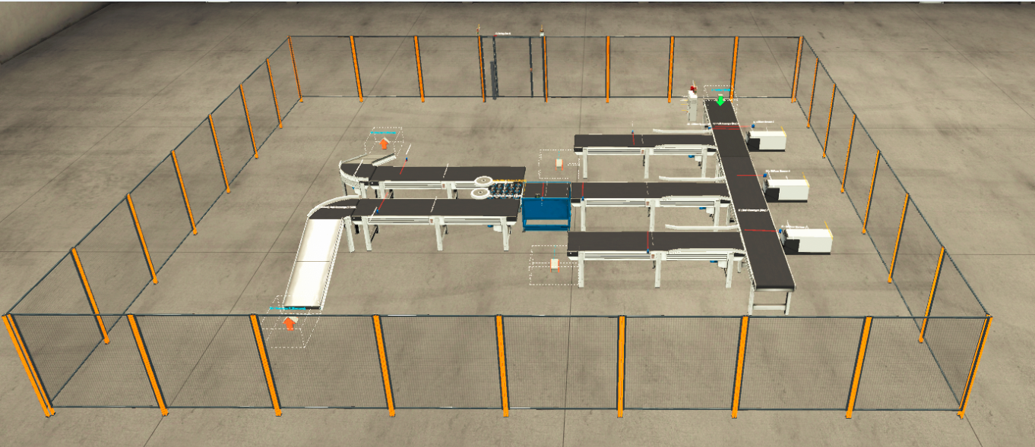
Figure 61 Factory I/O Overall
This is overall image of my Factory I/O for the package Conveyor system.
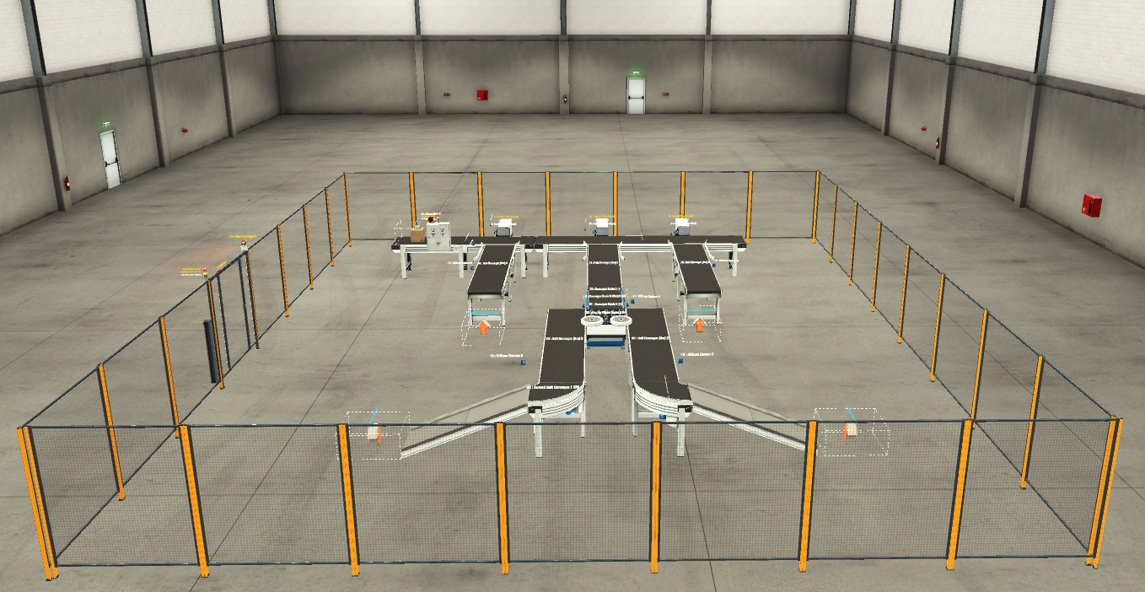
Figure 62 Factory I/O Overall

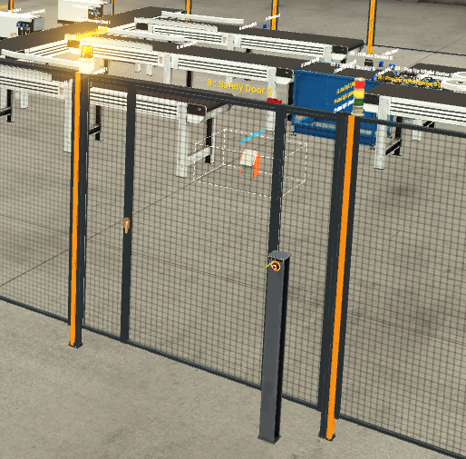
Figure 63 Factory I/O Safety Gate

Factory I/O Safety Gate and warning Klaxon with emergency stop.

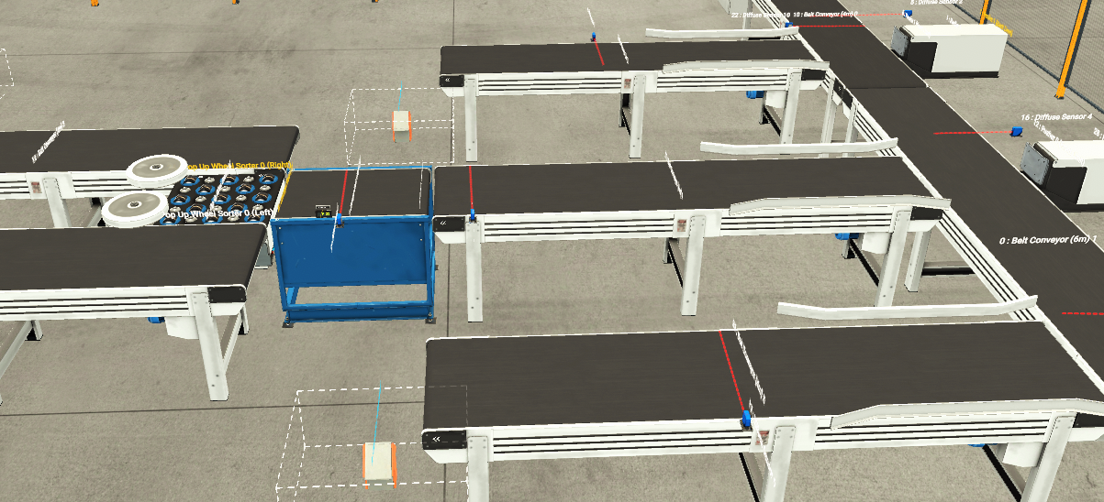
Figure 64 Scale Conveyor Weighing
Scale Conveyor weighing .

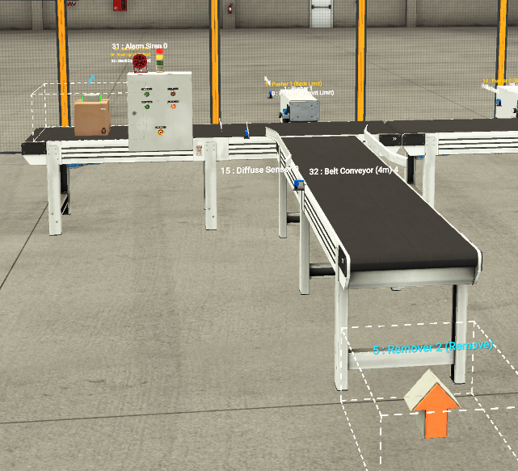
Figure 65 Large Box/ Pusher 1 System

Large Box conveyor on Pusher 1 System.
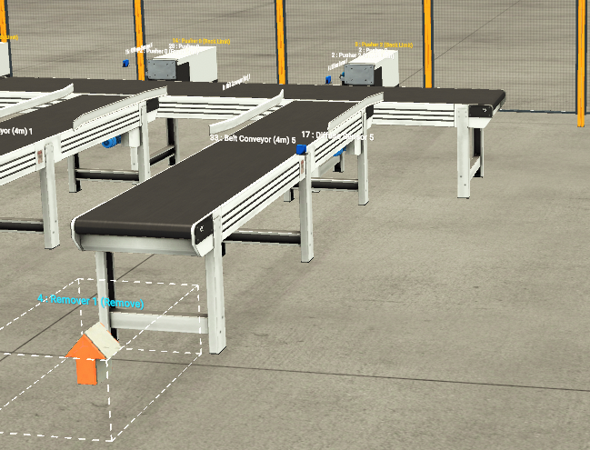

Figure 66 Pallet Box Pusher 2 System
Small Box conveyor on Pusher 2 System.

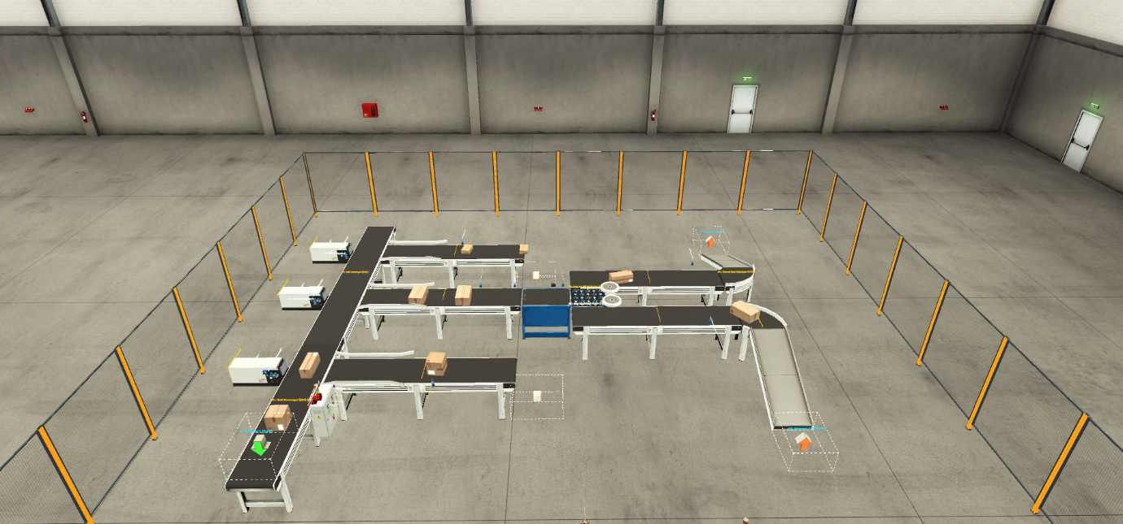
Figure 67 Overall Image of Factory I/O working

Overall image of factory I/O system running with boxes.

11 Conclusion/Improvements
Overall the project went well. A few things which could have improved the System are a Pre-set button for the counters so operators didn’t have input every time system was rebooted. Also the scale conveyor weighing system could have been more precise in holding the weight and processing. A longer conveyor to the weighing system would have allowed the parcels slow down before build up occurred. On some occasions the small parcels would spin from the pusher causing it catch up with parcel Infront so a damping system would work also .
Also to be more accurate when sorting parcels a scale conveyor could have been used to weigh all parcels and count them. This would be more accurate that a wrong parcel hasn’t managed to go down the wrong conveyor.

12 References

[1] | “What is a Programmable Logic Controller (PLC)? | Water & Wastes Digest (wwdmag.com),” [Online].
[2] | “Top 20 programmable logic controller manufacturers (roboticsandautomationnews.com),” [Online].
[3] | “Siemens PLC System Overview | Instrumentation and Control Engineering (automationforum.co),” [Online].
[4] | “Difference between Compact PLC and Modular PLC (electricalvolt.com),” [Online].
[5] | “Difference between Compact PLC and Modular PLC (electricalvolt.com),” [Online].
[6] | “Difference between Compact PLC and Modular PLC (electricalvolt.com),” [Online].
[7] | “Difference between Compact PLC and Modular PLC (electricalvolt.com),” [Online].
[8] | “Difference between Compact PLC and Modular PLC (electricalvolt.com),” [Online].
[9] | “Difference between Compact PLC and Modular PLC (electricalvolt.com),” [Online].
[10] | “Advantages and Disadvantages of the programmable logic circuit (PLC) - Semiconductor for You (semiconductorforu.com),” [Online].
[11] | “Programmable Logic Controller Basics - NTT Training (nttinc.com),” [Online].
[12] | “Difference between Modular PLC & Compact PLC Malaysia - PLC Training Centre Malaysia (asasmy.com),” [Online].
[13] | “Difference between Modular PLC & Compact PLC Malaysia - PLC Training Centre Malaysia (asasmy.com),” [Online].
[14] | “Difference between Compact PLC and Modular PLC (electricalvolt.com),” [Online].
[15] | “https://www.asasmy.com/modular-plc-vs-compact-plc-malaysia.html,” [Online].
[16] | “https://www.asasmy.com/modular-plc-vs-compact-plc-malaysia.html,” [Online].
[17] | “https://www.asasmy.com/modular-plc-vs-compact-plc-malaysia.html,” [Online].
[18] | “https://www.asasmy.com/modular-plc-vs-compact-plc-malaysia.html,” [Online].
[19] | “https://www.asasmy.com/modular-plc-vs-compact-plc-malaysia.html,” [Online].
[20] | “https://www.asasmy.com/modular-plc-vs-compact-plc-malaysia.html,” [Online].
[21] | “https://www.asasmy.com/modular-plc-vs-compact-plc-malaysia.html,” [Online].
[22] | “https://www.asasmy.com/modular-plc-vs-compact-plc-malaysia.html,” [Online].
[23] | “https://www.asasmy.com/modular-plc-vs-compact-plc-malaysia.html,” [Online].
[24] | “https://www.asasmy.com/modular-plc-vs-compact-plc-malaysia.html,” [Online].
[25] | “Difference between Compact PLC and Modular PLC (electricalvolt.com),” [Online].
[26] | “What are the types of PLCs and their Application (learnmech.com),” [Online].
[27] | “What are the types of PLCs and their Application (learnmech.com),” [Online].
[28] | “What are the types of PLCs and their Application (learnmech.com),” [Online].
[29] | “Top 20 programmable logic controller manufacturers (roboticsandautomationnews.com),” [Online].
[30] | “Top 20 programmable logic controller manufacturers (roboticsandautomationnews.com),” [Online].
[31] | “Top 20 programmable logic controller manufacturers (roboticsandautomationnews.com),” [Online].
[32] | “PLC Programming, scada & Pid Control System (forumautomation.com),” [Online].
[33] | “Top 10 Automation Companies in the World - Industrial Automation - Industrial Automation, PLC Programming, scada & Pid Control System (forumautomation.com),” [Online].
[34] | “The 7 Most Popular PLC Brands & Companies – PEKO Precision,” [Online].
[35] | “Automation IT - Choosing a PLC: Things to consider,” [Online].
[36] | “Top 10 Automation Companies in the World - Industrial Automation - Industrial Automation, PLC Programming, scada & Pid Control System (forumautomation.com),” [Online].
[37] | “The 7 Most Popular PLC Brands & Companies – PEKO Precision,” [Online].
[38] | “Top 20 programmable logic controller manufacturers (roboticsandautomationnews.com),” [Online].
[39] | “Top 10 Automation Companies in the World - Industrial Automation - Industrial Automation, PLC Programming, scada & Pid Control System (forumautomation.com),” [Online].
[40] | “The 7 Most Popular PLC Brands & Companies – PEKO Precision,” [Online].
[41] | “Top 20 programmable logic controller manufacturers (roboticsandautomationnews.com),” [Online].
[42] | “Top 10 Automation Companies in the World - Industrial Automation - Industrial Automation, PLC Programming, scada & Pid Control System (forumautomation.com),” [Online].
[43] | “The 7 Most Popular PLC Brands & Companies – PEKO Precision,” [Online].
[44] | “Top 20 programmable logic controller manufacturers (roboticsandautomationnews.com),” [Online].
[45] | “About Delta Group - DELTA (deltapowersolutions.com),” [Online].
[46] | “Top 20 programmable logic controller manufacturers (roboticsandautomationnews.com),” [Online].
[47] | “The 7 Most Popular PLC Brands & Companies – PEKO Precision,” [Online].
[48] | “Top 20 programmable logic controller manufacturers (roboti,” [Online].
[49] | “What is a Programmable Logic Controller (PLC)? | Water & Wastes Digest (wwdmag.com),” [Online].
[50] | “Top 10 Automation Companies in the World - Industrial Automation - Industrial Automation, PLC Programming, scada & Pid Control System (forumautomation.com),” [Online].
[51] | “Engineering Essentials: What Is a Programmable Logic Controller? | Machine Design,” [Online].
[52] | “File:Siemens AG logo.svg - Wikimedia Commons,” [Online].
[53] | “Top 20 programmable logic controller manufacturers (roboticsandautomationnews.com),” [Online].
[54] | “6ES7211-1AE31-0XB0 | Siemens | WIAutomation,” [Online].
[55] | “Allen-Bradley Products | Allen-Bradley (rockwellautomation.com),” [Online].
[56] | “5069-L3100ERMS2 Allen-Bradley (wiautomation.com),” [Online].
[57] | “MITSUBISHI ELECTRIC UNITED KINGDOM,” [Online].
[58] | “FX1S-30MR-001 Mitsubishi Electric (wiautomation.com),” [Online].
[59] | “Industrial Automation | OMRON, UK,” [Online].
[60] | “CP1L-L10DT-D | Omron | WIAutomation,” [Online].
[61] | “ABB Logo and symbol, meaning, history, PNG, brand (1000logos.net),” [Online].
[62] | “ABB PM591-ETH A CPU Module | ABB | WIAutomation,” [Online].
[63] | “Delta Power Solutions Logo Vector - (.SVG + .PNG) - FindLogoVector.Com,” [Online].
[64] | “VFD110E23A Delta (wiautomation.com),” [Online].
[65] | “Schneider Electric logo (.jpg) | Schneider Electric Global (se.com),” [Online].
[66] | “TM241CE24T Schneider Electric (wiautomation.com),” [Online].
[67] | A. Brief. [Online].

