

MBA - Master of Business Administration
Name:-Vijayendra Jagdishchandra Birdi
Student Id:-2221011
Final Dissertation
Lecturer: Tushara Balendran
Word Count: 15000


Master’s Degrees by Examination and Dissertation
Declaration Form.
1. This work has not previously been accepted in substance for any degree and is not being concurrently submitted in candidature for any degree.
Signed……Vijayendra Jagdishchandra Birdi………………...
Date ………02/02/2024……………………………………………………...

2. This dissertation is being submitted in partial fulfilment of the requirements for the degree of Master in Business Administration.
Signed …… Vijayendra Jagdishchandra Birdi ………………….
Date …………02/02/2024……………………………………..…………...
3. This dissertation is the result of my own independent work/investigation, except where otherwise stated.
Other sources are acknowledged by footnotes giving explicit references.
A bibliography is appended.
Signed candidate: …… Vijayendra Jagdishchandra Birdi ……….
Date: ………02/02/2024……………………….……………………….

4. I hereby give consent for my dissertation, if accepted, to be available for photocopying, inter- library loan, and for deposit in the University’s digital repository
Signed (candidate)…… Vijayendra Jagdishchandra Birdi ………...
Date…………02/02/2024……………….…………….……………..
Supervisor’s Declaration.
I am satisfied that this work is the result of the student’s own efforts.
Signed: ………Tushara Balendran………………………………………………..
Date: ………02/2/2024………………………………………………………...

University of Wales: Trinity Saint David

E-Thesis Deposit Agreement

Details of the Work
I would like to deposit the following item in the digital repository maintained by the University, and/or in any other repository authorized for use by the University:

Title ……………Impact of Advertising on Consumer's Buying Behaviour………………………………………………………………………………

This item is a product of my own research endeavours and is covered by the agreement below in which the item is referred to as “the Work”. It is identical in content to that deposited in the Learning Resources Centre, subject to point 4 below.

I agree that the University of Wales: Trinity Saint David may electronically store, copy or translate the Work to any approved medium or format for the purpose of future preservation and accessibility. The University is not under any obligation to reproduce or display the Work in the same formats or resolutions in which it was originally deposited.

UW: TSD Digital Repository
I understand that work deposited in the digital repository will be accessible to a wide variety of people and institutions, including automated agents and search engines via the World Wide Web.

I understand that once the Work is deposited, the item and its metadata may be incorporated into public access catalogues or services, such as national databases of electronic theses.

I agree as follows:
- That I am the author or have the authority of the author/s to make this agreement and do hereby give the University of Wales: Trinity Saint David the right to make available the Work in the way described above.
- That the electronic copy of the Work deposited in the digital repository and covered by this agreement, is identical in content to the paper copy of the Work.
- That I have exercised reasonable care to ensure that the Work is original, and to the best of my knowledge, does not breach any laws including those relating to defamation, libel and copyright.
- That I have, in instances where the intellectual property of other authors or copyright holders is included in the Work, gained explicit permission for the inclusion of that material in the Work, and in the electronic form of the Work as accessed through the open access digital repository, or that I have identified and removed that material for which adequate permission has not been obtained and which will be inaccessible via the digital repository
- That University of Wales: Trinity Saint David does not hold any obligation to take legal action on behalf of the Depositor, or other rights holders, in the event of a breach of intellectual property rights, or any other right, in the material deposited.
- That I undertake to indemnify the University of Wales: Trinity Saint David against all actions, suits, proceedings, claims, demands and costs occasioned by the University in consequence of any breach of this agreement

Signature ……Vijayendra Jagdishchandra Birdi………………

Date 02/02/2024………

Abstract
This dissertation examines customer behaviour and Coca-impact Cola's advertising's on the industry. Using the Black Box Model of Consumer Buying Behaviour, the research examines inputs, internal processes, and responses that influence consumer decisions. This methodology emphasises emotional branding and building long-term emotional bonds to build brand loyalty. Neuroscience reveals the neurological effects of emotional involvement, revealing its long-term effects on consumer attitudes and perceptions.
Coca-Cola must adapt to diverse cultures as it navigates global markets and tailors its marketing strategies to cultural nuances. The research shows the brand's capacity to include local traits, balancing global appeal and cultural sensitivity among potential buyers. Coca-sensory-stimulated Cola's advertising goes beyond beverages. It builds an indelible brand image of happiness, camaraderie, and celebration through multimodal experiences that transcend taste.
Despite its past success, Coca-Cola faces ongoing issues, particularly in digital transformation and environmental sustainability. The dissertation stresses that the brand must adapt to evolving technology and environmental issues without losing its strong image. The research shows that brand identity is the most essential factor in consumer decision-making. To create ads that reflect changing consumer tastes and technology landscapes, it's crucial to track campaign success and comprehend the intricate relationship between emotional, sensory, and brand recognition. This study explains how Coca-strategies Cola's affect customer behaviour, paving the path for advertising effectiveness studies. This extensive analysis shows how Coca-Cola operates as advertising evolves.

Acknowledgement
I would like to express my deepest gratitude to everyone who helped me finish this dissertation, which investigates the complex dynamics of the impact that Coca-Cola's advertising has on the purchase behaviour of consumers. These contributions were invaluable. This study trip has been both tough and illuminating, and I am extremely appreciative for the help and guidance that have been provided along this endeavour. First and foremost, I would want to express my most sincere gratitude to my adviser, Tushara Balendran, whose knowledge, insightful input, and unflinching encouragement have been extremely helpful throughout the entirety of the study process. The clarity and direction that your guidance has provided has contributed to the enrichment of the depth of my dissertation. I would want to express my gratitude to University of Wales for providing me with the resources and facilities that have been indispensable for doing an in-depth investigation into the topic that I have selected. An atmosphere that is conducive to learning and critical thinking has been established by the academic environment. In addition, I would like to express my gratitude to the individuals who participated in the survey and voluntarily presented their points of view, which made it possible to gather important information. In the process of constructing the empirical foundation for this dissertation, their contributions have been of critical importance.Last but not least, I would want to convey my appreciation to my family and friends for their unflinching support and understanding during the process of doing this research.
I am humbled by the direction, support, and collaborative spirit that have been the driving forces behind the completion of this dissertation. In conclusion, this dissertation is the result of a joint effort as a whole. On this academic journey, each and every contribution, regardless of how big or how tiny it may have been, has left an everlasting impact. I would want to express my gratitude to you for contributing to this endeavour and for making it a satisfying experience.
Contents
1. Introduction 6
1.2 Background 6
1.3 Rationale of the Study 7
1.4 Research Aim 8
1.5 Research Objectives 8
1.6 Research Questions 9
1.7 Research Outline 9
2. Literature Review 10
2.2 Coca Cola Current Advertising Strategies 12
2.2.1 Coca Cola's Advertising History 12
2.2.2 Evolution of Advertising Campaigns 13
2.2.3 Key Advertising Strategies and Mediums Used 14
2.3 Three Advertisement Definition 14
2.3.1 Advertisement (Marketing Perspective) 14
2.3.2 Advertisement (Media Studies Perspective) 14
2.3.3 Advertisement (Paid, Non-Personal Communication) 15
2.4 Literature Gap 17
2.5 Marketing Models 18
2.5.1 Branding Model 18
2.6.2 Cultural Adaptation Model 23
2.6 IMC Models 31
2.6.1 Shannon Weaver Model 31
2.7 Two Models of Coco Cola Advertisement 33
2.7.2 Comparison of Two Models of Coca Cola Advertisement, Similarities and Differences 35
2.8 Differences 36
2.9 Objectives of The Study 37
2.9.1 The Historical Evolution of Coca Cola's Advertising Strategies 37
2.9.2 Impact of Coca Cola's Advertising Campaigns on Consumer Buying Behavior 38
2.9.3 Effectiveness of Emotional Appeals in Coca Cola Advertisements 39
2.9.4 Key Success Factors and Challenges in Coca Cola's Advertising Endeavors 40
2.9.5 Analysis of Technological Integration in Coca-Cola Advertising 41
2.9.6 Measurement of Consumer Perception and Attitude Shifts: 45
2.9.7 Impact of Sustainability Messaging on Consumer Behaviour 46
2.10 Critical Analysis 51
2.10.1 Opportunities and Obstacles with Regard to Coca-Cola's Advertising Department 51
3. Research Methodology 53
3.1 Definition of Research Methodology 54
3.2 Research Onion Model 54
3.2.1 Philosophy 55
3.2.2 Research Approach 57
3.2.3 Research Strategy 58
3.2.4 Research Strategies in the Context of Coca-Cola's Advertising Impact: 60
3.2.5 Type of Investigation 60
3.2.6 Sampling, Sample Size, Sample Type and Sampling Method 62
3.2.7 Time Horizons 63
3.3 Gantt Chart 65
3.4 Research Ethics 65
4. Analysis of Data 67
4.1 Introduction 67
4.2 Survey Questions 68
4.3 Table of Results 70
4.4 Graphs 71
4.5 Description of the Results 74
4.6 Findings of Survey 76
5. Discussion 76
5.2 Conclusion 78
5.2.1 Objective Questions and Answers 78
5.3 Recommendations 79
5.4 Limitations of the primary research 80
5.5 Recommendations for Future Research 81
5.6 Further Research 82
6. References 84
7. Appendices 97

Introduction
Marketing uses advertising to influence consumer purchasing behaviour and purchases. In this chapter, our research topic is investigating how Coca Cola advertising influences such consumer purchasing behaviour. Context, challenges and the dissertation structure will all be described to set up this investigation. Advertising has become a crucial asset in today's competitive business environment to raise brand recognition among their target market while simultaneously shaping consumer choices (Falebita, Ogunlusi and Adetunji, 2020). Coca Cola and other global brands have long utilized advertising as an important means of conveying brand identity, product features, and emotional appeal to target consumers. This chapter examines how Coca Cola uses advertisements in its efforts. Coca Cola, one of the world's leading beverage corporations, boasts an illustrious advertising legacy dating back decades. Their marketing has evolved alongside customer tastes and technologies, from their "Share a Coke" initiative to Super Bowl ads (Maamoun, 2020). Understanding their advertising history is integral to understanding customer buying behaviour.

Background
The Coca-Cola Company, founded in 1886 in Atlanta, Georgia, by Dr. John Stith Pemberton, is a global beverage giant renowned for its iconic brand and a diverse portfolio of carbonated and non-carbonated drinks (Coca-Cola, 2022). The company's flagship product, Coca-Cola, became an instant sensation, and its distinctive script logo is now one of the most recognised symbols worldwide. Over the years, Coca-Cola has expanded its product range to include an array of beverages, catering to evolving consumer preferences and market trends. Coca-Cola's success is deeply rooted in its innovative marketing strategies and iconic advertising campaigns(Ling et al., 2023). The company has consistently utilised cutting-edge technologies, such as artificial intelligence (AI) and digital marketing, to engage with consumers in novel ways. Collaborations with digital artists using generative AI technologies like GPT-4 and DALL-E have marked a significant shift in the brand's advertising approach, fostering creativity and originality. In recent years, Coca-Cola has also embraced sustainability as a core focus, implementing initiatives to address environmental concerns and social responsibility. The "World Without Waste" campaign exemplifies the company's commitment to a circular economy and reducing its environmental footprint (2021 World Without Waste | Company Reports, no date). As a multinational corporation, Coca-Cola continues to navigate the ever-changing landscape of consumer preferences and advertising dynamics, staying true to its mission of refreshing the world and creating moments of happiness and optimism (Coca-Cola, 2022).

Rationale of the Study
Study on Coca-Cola advertising's influence over consumer purchasing behaviour holds great relevance for both Coca-Cola and marketing in general. Here's why this research study can benefit Coca-Cola:
- Optimizing Advertising Strategies: This research offers invaluable insight into Coca-Cola's historical advertising evolution, giving them insight into what strategies have worked and adapting their current campaigns to changing consumer tastes and technologies. With this knowledge at their disposal, Coca-Cola can maximize both current and future advertising campaigns effectively.
- Enhancing Brand Recognition: Coca-Cola prides itself on having strong brand recognition among its key assets. By understanding how advertising impacts brand identity and consumer choices, Coca-Cola can bolster this feature to further solidify and preserve their iconic status.
- Informing Content Creation: By exploring how emotional appeals in Coca-Cola ads work, this study helps the company fine tune its content creation processes. With this insight at their disposal, they are better equipped to craft engaging and impactful messages that reach target audiences and build customer connections.
- Competitive Advantage: Coca-Cola understands how advertising influences consumer behaviour to remain on top in today's highly-competitive business environment and maintain their marketing campaigns' efficacy (Singaram et al., 2019). By understanding consumer psychology, Coca-Cola ensures they maintain their edge against rival companies' marketing approaches in the marketplace and remain ahead of rival companies' campaigns.
- Measuring ROI: Coca-Cola should utilize this research's findings to formulate metrics for measuring their advertising efforts' success and return on investment (ROI) so they allocate resources efficiently.

Research Aim
This research investigates Coca Cola's advertising strategies and their effects on consumer buying behaviour, while exploring their historical evolution through specific campaigns and case studies. Furthermore, emotional appeal used within advertisements will also be taken into consideration along with any implications this has on consumer choices.

Research Objectives
- To examine the historical evolution of Coca Cola's advertising strategies.
- To assess the impact of Coca Cola's advertising campaigns on consumer buying behaviour.
- To provide insights into the effectiveness of emotional appeals in Coca Cola advertisements.
- To identify key success factors and challenges in Coca Cola's advertising endeavours.

Research Questions
To address the research objectives, this study will explore the following research questions:
- How have Coca Cola's advertising strategies evolved over time?
- What is the impact of Coca Cola's advertising campaigns on consumer buying behaviour?
- How do emotional appeals in Coca Cola advertisements influence consumer choices?
- What are the key success factors and challenges in Coca Cola's advertising endeavours?

Research Outline
Introduction: Provides an overview of the dissertation's scope, objectives, and significance.Introduces Coca-Cola's advertising department as the focal point of the study.Highlights the importance of digital transformation and sustainability in advertising.
Literature Review: Explores the role of advertising in the marketing context, emphasizing its importance in brand promotion and shaping consumer behavior. Discusses the impact of advertising on consumer buying behavior, highlighting its ability to influence attitudes, perceptions, and preferences. Examines the significance of brand identity and emotional responses in advertising effectiveness.Reviews existing literature on research methodologies and theoretical frameworks relevant to the study.
Research Methodology: Defines research methodology and introduces the Research Onion Model as a framework for designing and conducting the study. Discusses the choice of positivism as the philosophical approach and deductive reasoning as the research approach.Describes the research strategies employed, including survey-based primary research and secondary research through literature review.Details the sampling method, sample size, and data collection techniques.Discusses ethical considerations and measures implemented to ensure participant privacy and confidentiality.
Analysis of Data:Presents the findings of the survey conducted among 52 respondents.Discusses the level of awareness and recall of Coca-Cola advertisements among consumers.Analyzes emotional responses, brand associations, and factors influencing purchasing behavior.Examines the effectiveness of Coca-Cola's advertising strategies in influencing consumer choices.Provides additional insights and suggestions from respondents regarding advertising preferences and brand perception.
Discussion:Summarizes the key findings from the survey and their implications for Coca-Cola's advertising department.Addresses the research objectives and answers objective questions derived from the survey results.Offers recommendations for enhancing Coca-Cola's advertising strategies based on the study's insights.Acknowledges limitations of the primary research and suggests areas for further investigation.Proposes avenues for future research, including the integration of digital marketing and brand loyalty dimensions

Literature Review
Article: Gharbia, M. (2015) 'How Coca Cola adapts to cultural differences when launching a campaign,' Aastmt [Preprint]. https://www.academia.edu/12637674/How_Coca_Cola_adapts_to_cultural_differences_when_launching_a_campaign.
Research has focused a great amount of attention on the ways in which Coca-Cola's advertising strategies have an impact on the behaviour of consumers. There have been a number of study articles and essays that have investigated this subject, giving light on the influence that advertising has on the preferences and choices of consumers. For example, a study that was carried out at the University of Benin intended to discover the impact that advertising has on consumer behaviour and evaluate the effects of advertising as a factor that determines whether or not consumers choose Coca-Cola over its competitors (Approved, 2018).
A different study was conducted in Port Harcourt to investigate how consumers perceive the advertising medium for Coca-Cola products. The results of this study provided insights into how consumers view the advertising efforts that Coca-Cola makes. In addition, an essay was written that addressed the connection between a Coca-Cola commercial and customer behaviour. The essay emphasised the commercial's capacity to appeal to various consumer segments and affect the decisions that they make regarding their purchases. It has been emphasised that the marketing methods employed by The Coca-Cola Company are a crucial component in the process of moulding the behaviour of consumers. It has been stated that one of the most important factors contributing to Coca-Cola's marketing success is the company's utilisation of both localised and global methods in order to boost consumer interest and sales (Arun, 2023). In addition, the branding, advertising, and positioning strategies of the corporation have been explored in the context of the impact that they have on the behaviour of consumers and the decisions that they make regarding their purchases.
A considerable body of research and analysis has been uncovered as a result of the literature review conducted on the subject of consumer behaviour and the influence of Coca-Cola's advertising strategies(Andersson et al., 2006). The research and articles that were examined offer useful insights into the manner in which the advertising of Coca-Cola has influenced the behaviour, decisions, and perceptions of consumers. The studies that were examined offer interesting and useful insights into the ways in which Coca-Cola's advertising strategies influence the behaviour of consumers. The purpose of a study that was carried out at the University of Benin was to discover the impact that advertising has on consumer behaviour and to evaluate the effects of advertising as a factor that determines whether or not consumers choose Coca-Cola over its rivals. For the purpose of the study, primary data information was collected by means of the distribution of questionnaires. A total of forty-eight respondents were analysed by means of Chi-Square through the applications of SPSS. The findings indicated that there is a substantial connection between advertising and consumer behaviour with regard to the consumption of Coca-Cola. The perceptions of consumers in Port Harcourt on the advertising media for Coca-Cola products were investigated in another study of the same name. For the purpose of this study, a descriptive survey research design was utilised, and a structured questionnaire was utilised to collect the necessary data(Osere et al., n.d). Following radio and billboards as the most desired advertising medium for Coca-Cola products, the study indicated that television advertising was the most favoured medium for advertising purposes.
In addition, an essay was written that addressed the connection between a Coca-Cola commercial and customer behaviour(Lacy-Nichols et al., 2020). The essay emphasised the commercial's capacity to appeal to various consumer segments and affect the decisions that they make regarding their purchases. The purpose of this article was to present an analysis of a commercial for Coca-Cola that targeted various consumer demographics, such as families, young adults, and teenagers. It was determined that the commercial's ability to appeal to these many demographics was due to the fact that it utilised music, humour, and emotional appeal.
Taking everything into consideration, the studies that were examined offer significant insights into the manner in which Coca-Cola's advertising has influenced the actions, decisions, and perceptions of consumers. Data collection in the studies was accomplished through the use of a variety of study methodologies and methods, such as questionnaires and surveys. According to the results of the studies, advertising appears to have a substantial influence on the behaviour of consumers with regard to the consumption of merchandise manufactured by Coca-Cola (Arun, 2023).

Coca Cola Current AdvertisingStrategies

2.2.1 Coca Cola's Advertising History
Coca Cola's advertising journey started back in 1886 when John S. Pemberton created its original formula. Early advertising efforts relied upon local newspaper ads as their main form of exposure, slogans like "Delicious and Refreshing" or "The Ideal Brain Tonic" established their marketing identity at that time (Freeman, 1986). Since then, their advertisement journey has seen creativity and innovation take hold within their ranks. Coca-Cola’s promotional items were used by people entertaining guests in their homes.
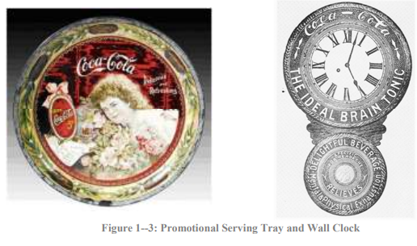

2.2.2 Evolution of Advertising Campaigns
Coca Cola advertising campaigns have changed considerably throughout time. From early campaigns focusing on taste and medicinal qualities of their product to emotional-based campaigns like "Coca Cola Adds Life", in the early 20th century. One significant transition came about in 1971 with their "Hilltop" commercial which featured their now iconic "I'd Like to Buy the World a Coke" jingle that represented unity and harmony - reflecting an evolving brand message over time (History of Coca-Cola advertising slogans, n.d).
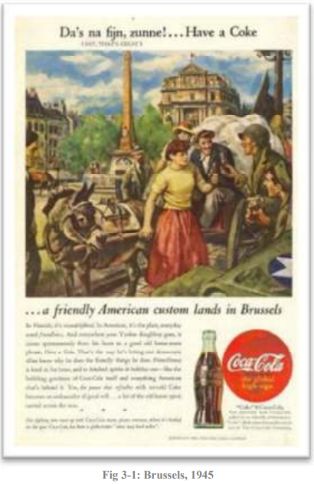

2.2.3 Key Advertising Strategies and Mediums Used
Coca Cola has always maintained consistent branding across its global markets as part of their business plan, including their iconic red and white logo, iconic bottle shape and design which remain nearly constant over its history (Clinehens, 2023).Coca Cola excels at cultivating emotional connections between its brand and audience through advertising campaigns designed to evoke feelings of happiness, nostalgia and togetherness - such as its "Share a Coke" initiative which featured customized bottles featuring people's names promoting an immediate sense of personal relationship between two individuals and Coca Cola itself (Decoding Coca-Cola: A Biography of a Global Brand 9781138495449, 9781351024020 - EBIN.PUB, n.d.).
Coca Cola has perfected the art of storytelling through their advertisements. Their campaigns often tell engaging, endearing stories that resonate with consumers, two examples being their "Polar Bears" and "Santa Claus" campaigns(Blanding, 2011).
Collaborations between Coca Cola and popular events and figures such as Santa Claus have proven an effective marketing tactic. Their relationship with major sporting tournaments like FIFA World Cup has increased its global appeal while endorsement from celebrities like Santa Claus has further solidified its global standing (Mukherjee, 2014).

Three Advertisement Definition

2.3.1 Advertisement (Marketing Perspective)
Advertising can be defined as any paid, non-personal form of communication made between an identifiable sponsor and mass media in order to inform, persuade and/or influence target audiences about products or ideas being advertised by means of mass communication channels (N, 2023).

2.3.2 Advertisement (Media Studies Perspective)
Publicity refers to forms of communication such as press releases or public relations events (e.g., news conferences) covered solely by media sources, advertising uses mass media, either broadcast or print form, as a vehicle to deliver advertisements directly to its intended audiences and requires some type of payment as consideration from advertisers for using media time/space for promotion purposes. (N, 2023).

2.3.3 Advertisement (Paid, Non-Personal Communication)
Advertisement is a paid, non-personal form of communication designed and delivered through various mediums such as television, radio, print media outlets and online platforms (What Is an Advertisement? Definition, Benefits and Types L Square, n.d.). Contrasting with personal selling, advertisements can reach large audiences simultaneously. An advertiser pays to place or time their message and influence consumer attitudes or behaviours by paying space or time rent fees for advertisements that reach those targeted with them.
Comparison and Opinion:Advertising fits within the marketing domain, where its primary function is as a paid non-personal communication method via mass media. This definition emphasizes its primary goal, informing, persuading and/or influencing a target audience in order to influence desired consumer actions, which also underscores advertising's fundamental function within businesses investing in promotional activities to build awareness and consumer engagement.From a media studies viewpoint, the second definition emphasizes the distinction between advertising and publicity. It highlights the transactional nature of accessing media time and space and reinforces their mutual relationship, further cementing advertising media relationships and understanding their mutuality. Furthermore, mass media must play an essential role as conduits to deliver advertising messages with wider reach and exposure requiring financial investments for maximum reach and impact (Jarvis, 2018).
The third definition expands advertising's definition by including various communication mediums and reinforcing key aspects of paid and non-personal communication. It acknowledges the creation and placement of messages for large audiences on different platforms while emphasizing financial commitment required in securing advertising space or time (Rehman, Gulzar and Aslam, 2022). Collectively these definitions highlight advertising's purposeful, paid nature with financial ramifications for consumer perceptions and behavior changes on a mass scale.

Three Definition of Consumer Buying Behavior: Buyer behaviour can be defined as "an ongoing process that uses inputs to meet demands in ways which lead to satisfaction of needs and wants" (Consumer Buyer Behaviour Definition, 2013b). Consumer buying behaviour compasses various components that may influence customer purchases. Here are three definitions of consumer purchasing behaviour.
  - Decision-Making Process: Consumer buying behavior refers to the series of steps individuals go through before making a purchase decision, from problem recognition, information search and evaluation, purchase decision and post-purchase behavior (Definition and Examples of the Consumer Decision-Making Process, 2019). so, understanding each stage helps businesses tailor their marketing efforts in line with consumer preferences at each step in this decision-making process (Definition and Examples of the Consumer Decision-Making Process, 2019).
  - Psychological and Social Influences: Consumer buying behavior is determined by both psychological and sociological elements, including motivations, perceptions, attitudes and learning processes; social factors include family culture reference groups social classes. All these influences shape consumers preferences perceptions and buying decisions thus it is vital for marketers to consider all individual and societal influences that may impact consumer purchasing behaviors (Clootrack, n.d.).
  - Market Response to Consumer Actions: Consumer buying behavior can also be understood in terms of its relationship to individual consumer actions and decisions, underlining a dynamic interaction between them and the marketplace (Albrecht, 2023). When consumers make purchasing decisions based on needs, preferences and external influences such as advertisements or news media coverage of particular topics or campaigns affecting them based on needs analysis data or preferences analysis data provided to businesses by consumers, businesses respond with products, prices, promotion strategies or distribution channels accordingly thereby shaping overall market dynamics through this ongoing feedback loop.
Comparison and Opinion:Consumer buying behavior can be defined using three definitions that together offer an in-depth picture of its complexities. The first outlines decision-making, outlining individual stages they experience when purchasing items, providing businesses a roadmap for tailoring marketing strategies at various points along the path taken by consumers to purchase decisions. Psychological and sociological influences on customer decision-making also play a vital role, with multifaceted influences shaping preferences and decisions (Chapter 6. Consumer Buying Behavior notes, n.d).

Literature Gap
Coca-Cola advertising literature has provided extensive details regarding their brand's historical development, key success factors and challenges, yet an oversight remains. No literature exists explicitly discussing how emotional appeals, cultural adaptability and changing health-conscious consumer preferences interact within Coca-Cola advertising endeavours (Wright, 2023). while acknowledging emotional connections and cultural customization as key aspects, often times this does not translate to comprehensive analysis on how these interact with shifting health trends and digital media consumption challenges posed by today.
This research seeks to fill this void by exploring the complex relationship between emotional appeals, cultural adaptation, and Coca-Cola's efforts in response to health-related concerns. It aims to offer an in-depth view into how a brand achieves an equilibrium between maintaining a consistent global identity while adapting to various cultural settings, all the while meeting consumer demand for health-focused consumer sentiments. By exploring campaigns such as "Share a Coke" and the introduction of healthier options, this research strives to gain deeper insights into the dynamic strategies utilized by Coca-Cola to maintain advertising effectiveness amid shifting consumer expectations and social trends (Mohammed, 2023).

Marketing Models

2.5.1 Branding Model
Coca-Cola ads often employ emotional branding techniques (Unveiling the emotional alchemy: decoding the emotional power of Coca-Cola advertising, n.d.). Over the years, Coca-Cola has developed campaigns designed to elicit strong emotional responses - for instance the "Open Happiness" campaign focused on associating Coca-Cola with positive feelings such as joyous occasions shared together by individuals or shared moments between strangers (Cocacolabranding, 2016). Coca-Cola sought to establish an emotional connection with their consumers by crafting narratives that captured universal feelings like happiness and togetherness, using emotional appeals designed to resonate. Coca-Cola recognized the power of emotions to shape consumer behavior, strengthen brand loyalty and make Coca-Cola not just another beverage but an enabler of positive experiences for its target market.
Emotional Branding at Coca-Cola: Crafting Positive Experiences: Coca-Cola, being one of the world's most iconic brands, has masterfully employed emotional branding to create a profound and lasting connection with its consumers. The "Open Happiness" campaign, launched in 2009, serves as a quintessential example of how Coca-Cola strategically harnessed the power of emotions to reinforce its brand identity.
1. Emotional Resonance through Narratives: The "Open Happiness" campaign was a narrative-driven approach that aimed to go beyond selling a beverage; it sought to sell a feeling. The narrative revolved around shared moments of joy, celebration, and togetherness. Coca-Cola recognized the universal human experience of finding happiness in simple yet memorable occasions, whether it is a family gathering, a friendly get-together, or even spontaneous moments between strangers (Rice, 2023).The advertisements under this campaign depicted scenes of people from diverse backgrounds coming together, sharing a Coca-Cola, and experiencing moments of happiness. By showcasing these relatable and emotionally charged scenarios, Coca-Cola aimed to create a strong emotional resonance with its audience. This emotional connection went beyond the functional aspects of the product and seeped into the hearts of consumers, making Coca-Cola synonymous with positive emotions.
2. Universal Appeal and Cultural Sensitivity: One remarkable aspect of Coca-Cola's emotional branding is its ability to transcend cultural boundaries while maintaining cultural sensitivity. The company recognized that emotions, such as joy and togetherness, are universal, and they can resonate with people from various cultural backgrounds (Pal and Pal, 2023).
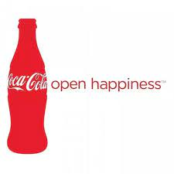
The advertisements featured in the "Open Happiness" campaign were carefully crafted to be inclusive and diverse. Coca-Cola understood the importance of representation, showcasing people from different ethnicities, age groups, and locations. This not only contributed to the global appeal of the campaign but also demonstrated Coca-Cola's commitment to respecting and embracing cultural diversity.
3. Building Brand Loyalty through Emotional Connection: Emotional branding is not just about creating a momentary impact; it is about fostering a long-term emotional connection between the brand and its consumers. Coca-Cola's consistent use of emotional appeals in its advertising has contributed significantly to building brand loyalty.By associating positive emotions with the brand, Coca-Cola has become more than just a beverage; it has become a symbol of shared happiness and joy. Consumers, over time, develop a sense of loyalty not just to the product but to the emotional experiences associated with it. This emotional loyalty translates into repeat purchases and a preference for Coca-Cola over other beverage options.
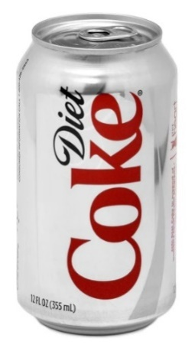
Figure 1: https://www.google.com/url?sa=i&url=https%3A%2F%2Fwww.linkedin.com%2Fpulse%2Fevolving-tastes-coca-colas-health-conscious-approach-beverage-batra&psig=AOvVaw2i2t48RfY9u4Zcddn36Jqx&ust=1704728015939000&source=images&cd=vfe&opi=89978449&ved=0CBIQjRxqFwoTC
4. Adapting Emotional Appeals to Changing Consumer Trends: In the fast-paced world of consumer preferences and trends, Coca-Cola has showcased its agility in adapting emotional appeals to stay relevant. The emotional branding model is not static; it evolves with changing societal norms and consumer expectations.For example, as health-consciousness became a prevalent trend, Coca-Cola introduced campaigns that focused on the joy of choosing healthier options within their product range. The emotional connection was subtly shifted from just the joy of consumption to the joy of making healthier choices, aligning with changing consumer values (A health conscious brand extension for Coca-Cola - 971 words | Bartleby, n.d).
5. Social media and Interactive Emotional Campaigns: In the era of digital media, Coca-Cola has extended its emotional branding strategies to social media and interactive campaigns. The company actively engages with its audience on platforms like Facebook, Instagram, and Twitter, creating interactive campaigns that invite consumers to share their own moments of happiness and connection with Coca-Cola.
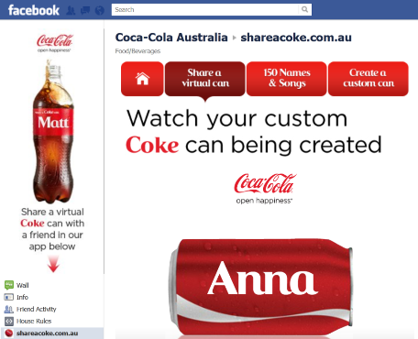
Figure 2: https://www.google.com/url?sa=i&url=https%3A%2F%2Fwww.digitalvidya.com%2Fblog%2Fcase-study-on-coca-colas-share-a-coke-campaign%2F&psig=AOvVaw2SGXVVDD7NRKtLL3NosDaZ&ust=1704727958068000&source=images&cd=vfe&opi=89978449&ved=0CBIQjRxqFwoTCKjksNfMy4MDFQAA
User-generated content, such as photos of people enjoying Coca-Cola in various settings, has become a powerful extension of the emotional branding model. This not only amplifies the reach of the emotional connection but also turns consumers into brand advocates, further strengthening loyalty.
6. Measuring Emotional Impact: While emotions are inherently subjective, Coca-Cola has invested in measuring the emotional impact of its campaigns. Through surveys, social media analytics, and other data-driven approaches, the company evaluates how well its advertisements evoke the desired emotional responses. This feedback loop allows Coca-Cola to refine its emotional branding strategies and stay attuned to the evolving sentiments of its audience. Coca-Cola's application of the Emotional Branding Model goes beyond selling a product; it is about creating and selling positive experiences (3 Examples of Brands That Master Emotional Branding - Metaka Branding Studio brand emotional influence, n.d.). Through emotionally charged narratives, universal appeal, cultural sensitivity, and adaptability to changing trends, Coca-Cola has successfully embedded itself in the hearts and minds of consumers worldwide. The "Open Happiness" campaign and subsequent emotional branding efforts have not only shaped consumer perceptions but have also contributed significantly to Coca-Cola's enduring success as a global brand. The company's ability to evoke emotions and build lasting connections exemplifies the potency of emotional branding when executed with creativity, cultural intelligence, and a genuine understanding of consumer sentiments.

2.6.2Cultural Adaptation Model
Coca-Cola has implemented another significant model into their advertising strategy: cultural adaptation. They have successfully localized campaigns to suit various cultural settings while maintaining an overall global brand presence, using Santa Claus in Christmas ads as one example of localization that resonated globally. By adapting messages, imagery, and product offerings to fit market preferences and values accurately, Coca-Cola ensures its advertising remains engaging, relatable, and globally successful, essential ingredients of its global success (Popovska, 2021).
Coca-Cola, a global beverage giant, has been at the forefront of innovative advertising strategies. One of the pivotal approaches employed by the company is the Cultural Adaptation Model. This model involves tailoring advertising campaigns to suit diverse cultural settings while maintaining a cohesive global brand identity. The significance of this strategy lies in its ability to resonate with local audiences, fostering engagement, relatability, and ultimately contributing to Coca-Cola's sustained global success.
Localization of Campaigns: Coca-Cola's journey in cultural adaptation is evident through the localization of its campaigns. A noteworthy example is the incorporation of Santa Claus in Christmas ads. While Santa Claus is a symbol deeply rooted in Western cultures, Coca-Cola adeptly integrated this cultural icon into its advertising, making it a universally recognized figure associated with the joyous holiday season (Popovska, 2021). This approach transcends cultural boundaries, allowing Coca-Cola to connect with consumers globally during a festive time, irrespective of their cultural backgrounds.

Figure 3: https://blogger.googleusercontent.com/img/a/AVvXsEgM4XfovuNvli6FgE3-oNz3qeY8q6cGmfEHmXNFsA9o4CYrgFB3b64t1QgaJNNs4QxKsiKgvqRPYoKLUAt90zj79eiOtU_Af8nf4KoaQIJCr0GqE2mrQeL-9wU2yHLUBxq2dCjmucJJse49nT5MZgFFbyTdHF3zCQXsJok15C8HSr0lCGISRz3Dfw=w1200-h630-p-k-no
Moreover, Coca-Cola's cultural adaptation extends beyond festive occasions. The company tailors its messaging, imagery, and product offerings to align with specific market preferences and values accurately. This meticulous approach ensures that the advertising remains not only culturally sensitive but also resonates authentically with diverse audiences (Popovska, 2021).
Imagery and Symbolism: The Cultural Adaptation Model relies heavily on imagery and symbolism that hold cultural significance. Coca-Cola understands that visuals convey powerful messages that can evoke emotions and establish connections. In various markets, the company incorporates culturally relevant symbols, colors, and visual elements into its advertising materials (Urrutia and Urrutia, 2024).

Figure 4: https://www.google.com/url?sa=i&url=https%3A%2F%2Fresources.indiefolio.com%2Fproject%2Fcoca-cola-crowdsourced-35-designs-in-2-weeks%2F&psig=AOvVaw139R35UfE-3qteIMmrkVea&ust=1704727724038000&source=images&cd=vfe&opi=89978449&ved=0CBIQjRxqFwoTCKjDlOfLy4M
For instance, in countries with vibrant and diverse cultural traditions, Coca-Cola designs campaigns that feature local festivals, traditional attire, or customs (Mulcahy, 2019) . This approach goes beyond surface-level adaptation; it demonstrates a deep understanding of the cultural fabric, making the brand an integral part of the local narrative. By doing so, Coca-Cola positions itself not just as a beverage but as a brand that appreciates and celebrates the richness of cultural diversity.
Language and Messaging: Effective cultural adaptation also involves linguistic considerations. Coca-Cola recognizes the importance of language in communication and tailors its messaging accordingly (Karam, 2013). The company invests in translating slogans, taglines, and promotional content to resonate with the linguistic nuances of specific regions. This linguistic sensitivity ensures that the communication is not only accurate but also captures the linguistic and cultural essence of the target audience.
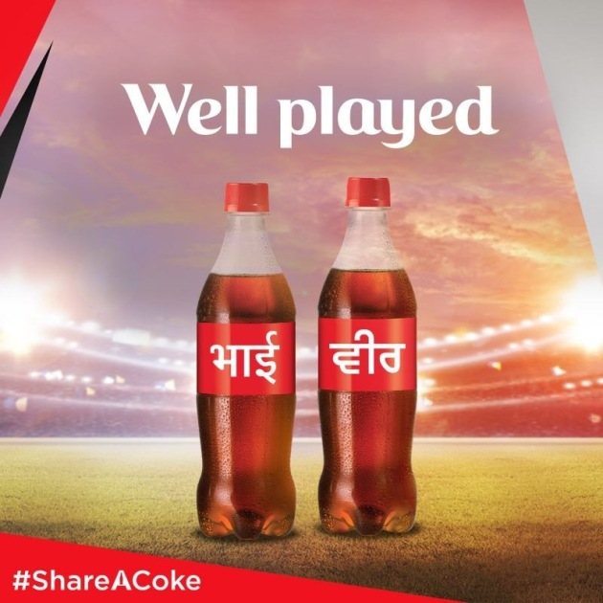
Figure 5: https://www.google.com/url?sa=i&url=https%3A%2F%2Fwww.packagingnews.com.au%2Fbeverage%2Fshare-a-coke-comes-to-india&psig=AOvVaw0RNQJ8KWrIYM3kxwznlPfQ&ust=1704727794767000&source=images&cd=vfe&opi=89978449&ved=0CBIQjRxqFwoTCJCksovMy4MDFQAAAAAdAAAAABAH
In some instances, Coca-Cola goes beyond mere translation; it creates region-specific campaigns with culturally relevant messaging. This deep integration of language and messaging reflects the company's commitment to authenticity, making its advertising campaigns feel personalized and relatable to local consumers.
Product Offering Adaptation: Cultural adaptation extends to product offerings as well. Coca-Cola recognizes that consumer preferences vary across regions, and adapting product portfolios is crucial for market success. The company introduces localized variants that align with regional taste preferences. This could involve developing unique flavors, adjusting sweetness levels, or even modifying packaging sizes to suit local consumption habits.
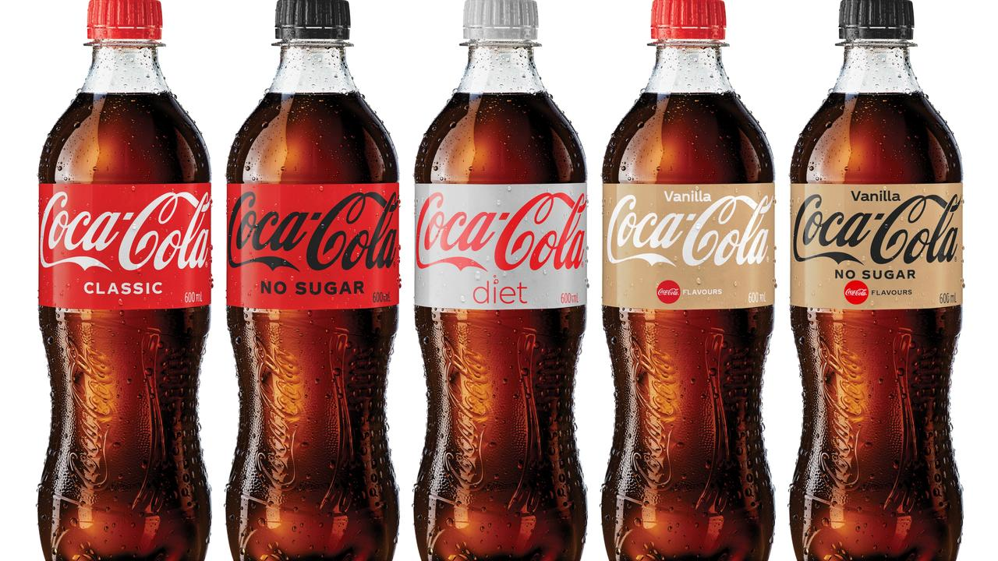
Figure 6: https://www.google.com/url?sa=i&url=https%3A%2F%2Fwww.theaustralian.com.au%2Fbusiness%2Fthe-wall-street-journal%2Fcocacola-stock-looks-like-the-real-thing-as-2022-brings-a-new-high%2Fnews-story%2F3c5ddc74e27541159f1a309eaf9ad511&psig=AOvVaw1bw0EBp9qiKK
By tailoring product offerings to align with local tastes, Coca-Cola not only ensures acceptance but also demonstrates a commitment to understanding and catering to the unique preferences of each market. This flexibility in product adaptation contributes to the brand's overall appeal and consumer loyalty (Coca-Cola segmentation, targeting and positioning, n.d).
Challenges and Successes in Cultural Adaptation: While Coca-Cola has demonstrated remarkable success in cultural adaptation, it has not been without challenges. The diverse nature of global markets presents hurdles in accurately gauging and responding to the intricacies of each culture. Striking a balance between maintaining a consistent global brand image and adapting to local nuances is a delicate task (Karam, 2013).
One challenge lies in navigating cultural sensitivity issues. Coca-Cola must carefully consider local customs, values, and preferences to avoid unintended misunderstandings. Cultural landscapes vary widely, and what resonates positively in one market may not have the same effect in another (Karam, 2013). Therefore, continuous research, consumer feedback, and a dynamic approach to adaptation are essential for overcoming these challenges.
Consumer Engagement and Loyalty: The effectiveness of Coca-Cola's Cultural Adaptation Model is reflected in the high levels of consumer engagement and loyalty it has achieved. By resonating with local audiences on a cultural level, Coca-Cola establishes an emotional connection that goes beyond the product itself. Consumers perceive the brand as a reflection of their own cultural identity, fostering a sense of belonging and loyalty (International Brand Equity, 2023).
The company's ability to adapt its advertising to diverse cultural contexts has created a strong and positive brand perception. Coca-Cola is not viewed as an outsider imposing its products but as a brand that respects and embraces local cultures. This approach builds trust and loyalty among consumers, leading to sustained success in various markets.
Coca-Cola's Cultural Adaptation Model stands as a testament to the brand's commitment to global inclusivity and cultural sensitivity. By embracing the diverse tapestry of global cultures, Coca-Cola has successfully positioned itself as a brand that transcends geographical boundaries (Indian Retailer Bureau, 2022). Through localized campaigns, thoughtful imagery, linguistic considerations, and product adaptations, Coca-Cola creates a narrative that resonates with consumers on a personal and cultural level. The challenges inherent in cultural adaptation are navigated with finesse, allowing Coca-Cola to maintain a delicate balance between global consistency and local relevance. The success of this model is evident in the brand's enduring global appeal, consumer engagement, and market leadership. Coca-Cola's journey in cultural adaptation serves as a valuable case study for businesses aiming to establish a meaningful and lasting connection with consumers in an increasingly diverse and dynamic global marketplace.
The Importance of Emotional Branding in the Decision-Making Process of Customers
There is a strong correlation between emotional branding and consumer loyalty. Emotional branding is a potent technique that can be used to shape consumer perceptions and drive brand loyalty. A prime example of Coca-Cola's dedication to eliciting happy feelings is the "Open Happiness" campaign that the company has launched. Customers are influenced to make purchasing decisions based on the emotional ties that are established by advertising. Emotional responses, such as joy and happiness, become linked with the brand, and this influences consumers to make decisions.
Neuroscience and Relationships to Emotional Behaviour: Recent studies in the field of consumer neuroscience have shed light on the impacts that emotional branding has on the nervous system. Specific regions of the brain that are connected with feelings are activated when Coca-Cola uses classic jingles and visually engaging sceneries in their advertisements. Advertisers are able to tweak their techniques for optimum impact when they have a solid understanding of the neuroscience that underlies emotional involvement.
When it comes to the long-term effects of emotional branding, the Black Box Model, which was previously addressed, places an emphasis on the internal cognitive processes that are involved in the decision-making process of consumers (Lumen Learning, n.d). Emotional branding, which is a component of the black box, is responsible for the construction of attitudes and perceptions that continue to exist after the instant purchase has been made. It is clear that emotional branding is effective over the long term, as evidenced by the fact that Coca-Cola has previously been successful in creating long-lasting brand impressions.
Strategies for Integrated Branding and Adaptation to Different Cultures
The Importance of Cultural Sensitivity in Advertising Cultural adaptation is the process of adapting advertising messages so that they better resonate with a variety of cultural surroundings while yet preserving a worldwide sense of brand identity. Local cultural components are frequently incorporated into Coca-Cola's global marketing campaigns. For example, Santa Claus is featured in Christmas marketing promotions all over the world. Through the implementation of this plan, the brand will continue to be engaging and relatable across a variety of areas.
Consumer Diversity and Market Entry Because Coca-Cola is a global brand, it is necessary for the company to have a detailed grasp of the tastes of a wide variety of consumers. Understanding how to navigate cultural differences is essential for successfully entering a market (Caudoux, 2023). It is essential that the advertising strategies of the brand be in accordance with the local cultures, values, and preferences in order to prevent accidental misunderstandings and to cultivate favourable contacts.
Advertising that stimulates the senses and how consumers perceive brands
Multisensory Experiences and Brand Image: Sensory-stimulated advertising, which is an essential component of Coca-Cola's marketing campaigns, goes beyond the realm of taste to produce multisensory experiences that are immersive. Jingles that are instantly recognizable, graphics that are vivid, and music that is calming all add to a brand image that is more than simply a beverage. Coca-Cola is associated with happy feelings and occasions that consumers have shared, which helps to develop brand loyalty among consumers.
Consumer Perception of Brands and Emotional Resonance Consumer perception is formed not only by the taste of the product, but also by the feelings and experiences that are linked with the brand. When it comes to eliciting an emotional response, the advertising for Coca-Cola is quite important. As a result of the brand being a symbol of happiness, unity, and celebration, positive associations are formed, which in turn affect purchasing decisions.

IMC Models

2.6.1 Shannon Weaver Model
The Shannon Weaver Model developed by Claude Shannon and Warren Weaver is an essential communication theory model that describes communication as an uninterrupted series of events (Admin & Admin, 2014). It includes three elements, sender encoding their message, transmission medium (channel), receiver decoding message received, that make up this communication cycle model. Noise, representing any interference during communication processes, can obfuscate messages. Response from receivers completes this model, its mathematical theory serves as an essential framework for comprehending communication systems by emphasizing roles like encoding, transmission and decoding in this process.
Shannon-Weaver Model and Coca-Cola Company: The Shannon-Weaver Model can be related to the Coca-Cola Company's advertising strategies and communication practices, as outlined in the provided information.
Sender (Encoder): In the context of Coca-Cola, the sender represents the company itself. Coca-Cola, as a global brand, consistently encodes its messages through various advertising campaigns. The use of generative artificial intelligence technology, such as GPT-4 and DALL-E, exemplifies the innovative encoding strategies employed by Coca-Cola. Through initiatives like the "Create Real Magic" campaign, the company collaborates with digital artists to produce content that is not only original but also engages the audience through the use of AI (Coca-Cola invites digital artists to ‘Create real magic’ using new AI platform, n.d).
Transmission Medium (Channel): Coca-Cola has significantly increased its digital marketing efforts, with more than sixty percent of its media spending dedicated to digital initiatives. This aligns with the evolving landscape of communication channels. The company utilizes a variety of digital platforms, including social media and WhatsApp, to reach a wider audience. The adoption of AI-driven technologies, as mentioned earlier, reflects the incorporation of advanced channels to transmit its messages to consumers.
Receiver (Decoder): The receiver in this context is the target audience of Coca-Cola's advertising campaigns. Whether it's the introduction of futuristic beverages like Coca-Cola Y3000 or the implementation of behavioural analytics to customize marketing campaigns, the company tailors its messages to resonate with diverse consumer segments. The decoding process involves consumers interpreting and understanding the messages conveyed by Coca-Cola through its advertisements.
Noise: Noise in the Shannon-Weaver Model refers to any interference that can disrupt the communication process. In the case of Coca-Cola, potential noise could be cultural differences or misinterpretation of the intended message. However, the company has demonstrated an awareness of cultural subtleties in its advertising, as seen in the inclusion of Santa Claus in Christmas advertisements worldwide. This indicates an effort to minimize noise and enhance the effectiveness of communication across diverse cultures.
Response: The completion of the communication cycle involves the response from the receivers. Coca-Cola continually evaluates consumer responses to its campaigns, employing strategies such as behavioural analytics to understand consumer preferences. The "Share a Coke" campaign, which personalized the product by featuring individual names on the labels, is an example of how the company seeks and values consumer responses. Positive responses indicate effective communication and resonate with the brand's efforts to create emotional connections (Prafull, 2021).
Application of the Model: The Shannon-Weaver Model is applicable to Coca-Cola's advertising strategies as it provides a systematic framework to analyze the communication process. From encoding messages through innovative technologies to utilizing diverse channels for transmission, the model helps understand how Coca-Cola engages with its audience. Moreover, the consideration of noise and the importance of consumer responses align with the company's efforts to navigate cultural differences and adapt to changing consumer preferences.

Two Models of Coco Cola Advertisement
Black Box Model of Consumer Buying Behaviour: The Black Box Model is a conceptual framework which illustrates consumer decision making as an opaque entity wherein inputs go in, processes take place, and outputs emerge. This model comprises three main elements are stimuli, black box itself, and responses (Black Box Model (of Consumer Behaviour), 2023b).
Stimuli: External influences known as stimuli serve as triggers to consumer decision-making processes. They can be divided into two types, marketing stimuli and environmental stimuli; marketing stimuli encompass marketing product, price, placement and promotion (Ps of marketing) while environmental stimuli refer to factors like cultural, social and situational elements influencing consumer behavior that collectively set off decision making processes.
Black Box: The black box is the core of the model and represents the complex psychological processes that consumers undergo when making purchasing decisions. It is divided into two main components: buyer's characteristics and decision process (John, 2021). Buyer's characteristics encompass individual factors like demographics, personality, and lifestyle that influence how a consumer perceives and responds to stimuli. The decision process involves a series of steps, including problem recognition, information search, evaluation of alternatives, purchase decision, and post-purchase behavior. This internal cognitive and emotional processing determines how consumers interpret and respond to the stimuli they encounter.
Responses: Finally, this model involves the results or responses resulting from consumer decision-making processes. These responses can be separated into two types based on two outcomes or responses; buyer responses (ie actual purchases made during decision-making journey), attitudes or perceptions formed as part of this journey and marketing responses which refer to marketers altering strategies based on consumer behavior using feedback to better meet needs in future marketing stimuli and better meet requirements of their target consumer population.
Advantages and Disadvantages of Black Box Model
Simplicity and Clarity: The Black Box Model simplifies communication processes by breaking them into three easy stages (input, process and output). This approach makes it simpler for researchers and practitioners to conceptualize and assess communication phenomena (Heusser, 2021).
Versatility: This model is highly adaptable and can be applied across different communication contexts from interpersonal dialogues to mass media coverage, making it an invaluable asset in helping understand communication processes across settings.
Focus on Cognitive Processes: By emphasizing internal cognitive processes in a "black box," this model draws attention to psychological aspects of communication. By emphasizing perception, attention, and comprehension processes in particular, this model helps users better comprehend how individuals interpret and react to messages they encounter (Koundinya, 2010).
Disadvantages of the Black Box Model
Oversimplification: Critics contend that this model oversimplifies communication by reducing it to three stages. Communication is an intricate phenomenon affected by various variables; therefore, this model may fail to capture its complexity when applied in real life scenarios (Heusser, 2021).
Lack of Detail: This model does not address specific cognitive processes happening inside its "black box." Furthermore, it does not examine factors that may sway an individual's interpretation of stimuli which limits its explanatory power and renders this model inexact and incomplete (Koundinya, 2010).
Ignores Feedback: The Black Box Model has come under scrutiny for failing to incorporate feedback effectively in communication processes. Communication itself is inherently iterative; feedback plays an essential part in shaping subsequent interactions and adapting as necessary; yet this model fails to explicitly account for its continuous nature.
Limited Emphasis on Context: The Black Box Model often overlooks contextual factors that might impede communication, including cultural differences, social norms and situational variables that must also be taken into consideration for effective dialogue. Unfortunately, however, none of this consideration is explicitly included within it.

2.7.2 Comparison of Two Models of Coca Cola Advertisement, Similarities and Differences
Emotional Branding vs. Cultural Adaptation
Emotional Branding Model:
- Focus: The emotional branding model emphasizes evoking positive emotional responses from consumers in order to forge personal and lasting connections between brands and people on both personal and emotional levels.
- Objective: Coca-Cola strives to build emotional ties between its brand and consumers that associate the beverage with positive memories and experiences.
- Example: The "Open Happiness" campaign serves as an exemplary demonstration of this phenomenon, emphasizing joyous experiences shared among individuals to build more profound emotional bonds between people.
Cultural Adaptation Model:
- Focus: Cultural adaptation refers to adapting advertising messages specifically tailored for specific cultural environments while keeping up a global brand image.
- Objective: Key objectives include targeting cultural nuances to ensure that brands remain accessible across various regions and remain engaging for consumers.
- Example: Coca-Cola demonstrates its mastery of cultural adaptation through incorporating local cultural aspects, like featuring Santa Clause in Christmas campaigns worldwide. This proves their proficiency at cultural adaptation.
Similarities  Global Reach: Both models understand that Coca-Cola must craft ads to have global appeal while remaining sensitive to local cultures.  Brand Loyalty: Both models seek to foster brand loyalty among their target consumers by forging emotional or cultural connections between brands and customers. | Differences  Focus Area: The emotional branding model prioritizes creating emotional responses by drawing out responses, while cultural adaptation relies on adapting content according to different cultural preferences (Castro, Barrera and Steiker, 2010).  Execution: Emotional branding evokes broad emotions while cultural adaptation requires taking an adaptive approach by including specific cultural features in its approach.  Response Mechanism: Emotional branding anticipates responses in terms of emotional connection and positive associations; cultural adaptation seeks resonance based on cultural familiarity and relevance.

Objectives of The Study

2.9.1 The Historical Evolution of Coca Cola's Advertising Strategies
Coca-Cola's advertising strategies have undergone remarkable change since their establishment in the late 19th century. At first, its advertisements focused on building strong visual identity through their iconic Spencerian script logo, still widely recognized today, while initially emphasizing refreshing qualities to associate Coca-Cola with an active and youthful lifestyle (Admin_Pr, 2023).
As Coca-Cola spread throughout the globe, its advertising strategies adapted to local cultures while maintaining a uniform global brand image. By the mid-20th century, their marketing campaigns became more sophisticated, using memorable slogans like "It's the Real Thing" to emphasize emotional resonance of product. And as its advertising spread further globally during 1930s Christmas ads featuring Santa Clause also served as cultural touchpoint.
Coca-Cola adjusted their advertising, particularly the health and wellness trend, in response to social changes during the late 20th and early 21st centuries. Their "Share a Coke" campaign personalized the brand by featuring individual consumers' names on its bottles; creating an intimate sense of connection (Share a Coke Campaign, n.d.). Furthermore, digital and social media platforms were invested heavily by Coca-Cola so as to reach younger target markets.
Coca-Cola recently initiated an advertising shift towards emphasizing sustainability and social responsibility, aligning itself with environmental causes while offering healthier beverage options, reflecting an industry trend as consumers prioritize ethical practices over wasteful ones(Sustainability, n.d.).
Coca-Cola has long been one of the most durable and well-recognized global brands due to their exceptional advertising strategies, which adapt seamlessly with changing times while remaining true to their core brand values.

2.9.2 Impact of Coca Cola's Advertising Campaigns on Consumer Buying Behavior
Coca-Cola advertising campaigns have long had an outsized effect on consumer buying behaviour, shaping perceptions and creating strong emotional associations between their product and everyday enjoyment. Emphasising refreshing qualities helped cement Coca-Cola as more than just an ordinary beverage, it became part of popular culture. thus, informing purchasing decisions.
Coca-Cola made headlines around the world thanks to iconic slogans such as "It's the Real Thing" and memorable advertising characters like Santa Claus who helped cement its credibility (Review, 2018). Their campaigns not only helped establish Coca-Cola as an everyday household brand name but also fostered an atmosphere of trust that led consumers to select this beverage over others.
"Share a Coke" marked an exciting change for Coca-Cola by personalizing their product by placing individual names on bottles and cans, not only did this increase brand loyalty but it encouraged consumers to view Coca-Cola as something shared and reinforce a sense of community around its product line.
Coca-Cola has effectively used social media and digital platforms such as Facebook to engage a younger demographic through digital campaigns that leverage both interactive and shareable elements to maintain its relevancy and foster consumer interaction and participation(Urrutia & Urrutia, 2023). These interactive campaigns not only engage their target demographic but have also fostered consumer engagement by driving virality within online social communities such as Snapchat.

2.9.3 Effectiveness of Emotional Appeals in Coca Cola Advertisements
Coca-Cola ads have long been associated with emotional appeals, which has played an instrumental role in their brand's longevity and success. Coca-Cola masterfully uses emotional connections with consumers on an experiential level in order to shape perceptions and drive purchasing behavior Coca-Cola's iconic Christmas campaigns featuring Santa Claus dating back to the 1930s illustrate its extraordinary skill at employing sentimentality to leverage business advantage (Coca-Cola Knows Santa Sells. | Brand Vision, n.d.). Coca-Cola has become closely associated with joy, togetherness, and magic during holiday seasons across generations, creating emotional resonance which spans generation gaps.
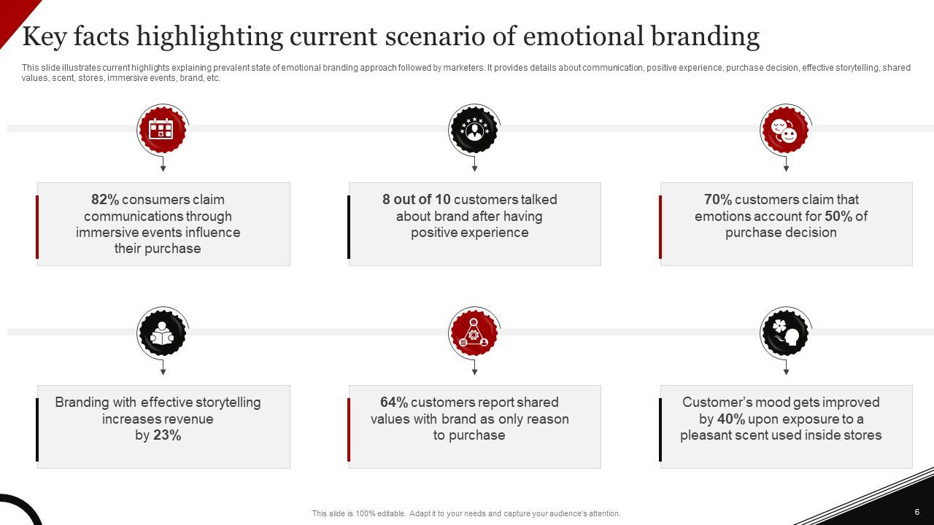
Coca-Cola's emotional marketing commitment can be seen through their "Open Happiness" campaign introduced in 2009 (“Open Happiness” and Enjoy Life’s Simple Pleasures With Coca-Cola, n.d.). By tapping into universal emotions such as joy, optimism and camaraderie the campaign attempted to position Coca-Cola not simply as a beverage product but instead a source of positive experiences and shared moments. Coca-Cola used emotional appeal beyond traditional ads by encouraging its consumers to share moments of happiness through social media platforms such as Instagram. By doing this, Coca-Cola created an engaged relationship between brand and consumers and created meaningful moments of joy together with them.
Coca-Cola ads demonstrate their success through emotional appeals that invoke nostalgia, happiness and belonging. By tapping into fundamental human feelings like nostalgia or happiness or belongingness, the brand has established strong and long-lasting bonds between themselves and consumers that reinforces that Coca-Cola provides not just products but also meaningful and joyful moments in people's lives.

2.9.4 Key Success Factors and Challenges in Coca Cola's Advertising Endeavors
Coca-Cola's advertising endeavours have been marked by several key success factors that have propelled their global renown. One key success factor has been cultivating an iconic red and white logo along with memorable slogans and characters like Santa Claus that has established visual and emotional connections between consumers globally and Coca-Cola's product offerings(StudyMoose, 2021). Coca-Cola's success can also be traced to its ability to adapt to diverse cultures and markets, adapting its advertising campaigns while upholding an international image to reach customers across regions.
Coca-Cola's advertising success can also be credited to innovation. Through campaigns like "Share a Coke," which personalized product packaging by featuring individual names on it and encouraged social sharing among customers. Furthermore, their early recognition of emotional appeals through ads such as "Open Happiness" has played an instrumental role in shaping positive and lasting brand images for them.
Coca-Cola has faced unique advertising obstacles over its years of advertising. One key challenge has been rising scrutiny on sugary beverages and their effect on health; as consumer preferences and health awareness change over time, they must adapt quickly if they hope to remain relevant by offering healthier product alternatives and encouraging balanced lifestyles. Digital media consumption patterns also present unique obstacles, necessitating Coca-Cola to modify strategies accordingly in order to engage effectively with audiences via this medium.

2.9.5 Analysis of Technological Integration in Coca-Cola Advertising
Coca-Cola has intentionally embraced technological breakthroughs in order to modify its advertising tactics in order to keep up with the ever-changing circumstances of the digital landscape. The purpose of this study is to investigate the ways in which Coca-Cola has utilised digital platforms, social media, and interactive technology in order to reach and engage a wide variety of consumer segments. Additionally, the inquiry will evaluate the efficacy of these strategies within the ever-changing arena of digital marketing.
Various Digital Platforms: Coca-Cola has deftly managed to adjust to the proliferation of digital channels, acknowledging the extraordinary reach and influence that these platforms possess. This commitment to interacting with a diverse range of people is demonstrated by the brand's presence on several platforms, including as YouTube, Instagram, and TikTok. The majority of material on these platforms is video, which includes attention-grabbing advertising and looks behind the scenes (Sharma, 2023). This helps to create a story that is both visually appealing and easy to share. The ease of access and the ability to share material on digital platforms are two factors that lead to increased brand involvement and visibility over time.
Participation across Social Media: Through its strategic use of social media, Coca-Cola goes beyond merely being present and instead places an emphasis on active interaction. Through initiatives such as #ShareACoke, the brand encourages user-generated content and promotes communication in both directions at the same time. These kinds of efforts not only magnify the reach of the brand, but they also generate a feeling of belonging and a sense of personal connection. Using social media analytics and insights, Coca-Cola is able to gain a better understanding of the feelings, preferences, and developing trends of its customers, which enables the company to make adjustments to its marketing initiatives in real time.
The Technology of Interaction: In recent years, interactive technology has emerged as an essential component of Coca-Cola's advertising strategy. The "Share a Coke" augmented reality app is one example of how augmented reality (AR) and virtual reality (VR) experiences have been utilised to accomplish the creation of immersive marketing campaigns. Not only does this interactive method fascinate customers, but it also provides significant data on user interactions, preferences, and behaviours, which can be used to make future marketing campaigns more effective.
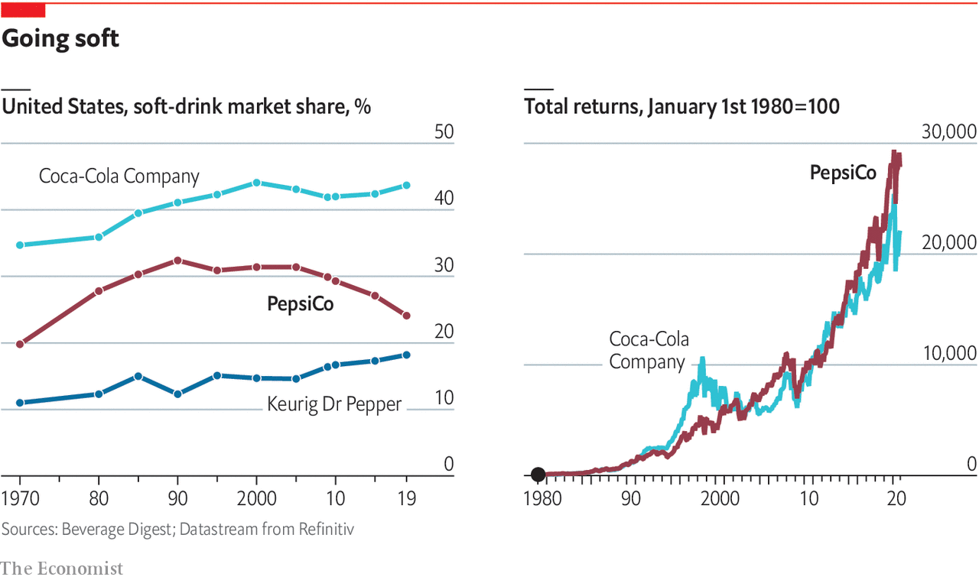
Effectiveness in Communicating with Various Types of Consumer Profiles: In order to effectively communicate with a wide variety of customer groups, the implementation of technology advancements has proven to be incredibly beneficial. Digital platforms make it possible to target advertising based on demographics, hobbies, and online behaviour, which ensures that material is tailored to specific audiences. Engagement on social media, particularly through inclusive advertising, is able to transcend age and cultural barriers, thereby building a sense of belonging among consumers. Participation is increased through the utilisation of interactive technology, particularly among younger populations that are accustomed to engaging in digital experiences that are interactive. The fact that initiatives such as personalised Coke bottles and augmented reality-powered advertisements have been successful is evidence that these innovations resonate with customers who are looking for interactive experiences with brands that are both personalised and memorable (Tbh, 2023).
How to Make Your Way Through the Rapidly Evolving Digital Landscape: Coca-Cola has established itself as a dynamic player in the fast-evolving digital landscape as a result of its proactive commitment to technology innovation. The utilisation of sophisticated data analytics makes it easier to continuously adapt to new platforms, trends, and consumer behaviours. The company Coca-Cola stays ahead of the curve by remaining attuned to the ever-changing preferences of the digital audience. This ensures that the company maintains its relevance and resonance in a landscape that is constantly developing.
Opportunities and Obstacles to Overcome: The advancement of technology brings with it a plethora of benefits, but it also brings with it a number of drawbacks. In order to deal with difficulties with data protection, algorithm changes on social platforms, and the requirement for continuous technological updates, the brand must traverse these issues. On the other hand, the potential for stronger consumer interactions, improved brand loyalty, and the capacity to remain at the forefront of industry changes more than compensate for these challenges. An innovative and forward-thinking approach to engaging customers in the digital era is demonstrated by Coca-Cola's incorporation of technical advancements into its advertising efforts. The brand's ability to make effective use of digital platforms, social media, and interactive technology demonstrates its dedication to maintaining its relevance and resonance in a landscape that is undergoing exponential change. Coca-Cola's capacity to capitalise on innovation is likely to continue to be a critical factor in determining the extent to which the company is successful in winning over the hearts and minds of a wide variety of consumer demographics as technology continues to advance.
Experiences for customers that are driven by artificial intelligence: Coca-Cola has been utilising AI to enhance customer experiences and personalise marketing activities. To give one example, the business introduced Coca-Cola Y3000, a futuristic beverage that was built with artificial intelligence and gives customers the opportunity to experience a customised Y3000 AI lens.
Digital marketing: Coca-Cola has greatly increased its digital marketing efforts, and the company's digital initiatives now account for more than sixty percent of the total amount that it spends on media. As a result of this move, Coca-Cola has been able to communicate with customers across a variety of digital channels, including social media platforms and WhatsApp, and reach a larger audience.
The Coca-Cola Company Produced with: For the purpose of appealing to the next generation of consumers, this collection of futuristic beverages has been developed. As part of this drive, Coca-Cola has just introduced a new product called Coca-Cola Y3000, which exemplifies the company's dedication to innovation and maintaining its relevance in keeping with emerging consumer preferences.
Behavioural analytics: Coca-Cola has been utilising behavioural analytics in order to gain a better understanding of the preferences of consumers and to customise its advertising and marketing campaigns to certain segments. The organisation has been able to design advertisements that appeal with various consumer segments and affect the decisions that they make regarding their purchases thanks to this method.

2.9.6 Measurement of Consumer Perception and Attitude Shifts:
Coca-Cola, a multinational beverage corporation, has successfully navigated the world of advertising through a variety of campaigns over the course of its history. The purpose of this project is to track changes in consumer views and attitudes towards Coca-Cola by analysing the influence of emotional appeals, cultural adaption, and other advertising features across a variety of campaigns. Our goal is to decipher the complex processes that are responsible for shaping the relationship between the brand and the consumer by identifying patterns in the responses of consumers.
1. Across all campaigns, emotional appeals are as follows: There have been numerous emotionally charged campaigns throughout the history of Coca-Cola's advertising, all of which were designed to forge profound relationships with consumers. Personalisation was utilised in the well-known "Share a Coke" campaign, for example, which evoked feelings of excitement and inclusiveness among its target audience. When the responses of consumers are analysed over the course of campaigns, a consistent pattern emerges: emotional appeals continually boost positive sentiments (Mupeti, 2023). Consumers are more likely to respond positively to marketing initiatives that evoke feelings, as this helps them to embed the brand in their memories and associate it with good emotions.
2. Strategies for Adapting to Different Cultures: One of the most important aspects of Coca-Cola's advertising strategy is the incorporation of cultural adaptability. While still preserving its worldwide brand image, the company is able toskillfully adapt its messages so that they are in line with a variety of cultural situations. One example of demonstrating awareness to cultural subtleties is the inclusion of Santa Claus in Christmas advertisements all across the world. Campaigns that demonstrate an awareness of the local culture tend to elicit more positive opinions from consumers. This tendency is becoming increasingly apparent. The capacity of the brand to resonate with the values of the community is a factor that contributes to a positive shift in views.
3. Components of Advertising That Is Multisensory: Creating immersive experiences that go beyond taste is the goal of Coca-Cola's advertising, which uses sensory stimulation techniques such as jingles and visually appealing visuals. The presence of these components helps to ensure that the brand is associated with times of delight and shared experiences. The patterns that emerge from the answers of consumers suggest that multisensory experiences play a significant part in the formation of various perspectives. The brand transcends the category of products it sells, becoming a symbol of feelings and experiences in the process.
4. Examining the Variations in Perspectives Held by Customers: A campaign-by-campaign study is required in order to monitor the changes that occur in the attitudes of consumers. A shift towards a more global and inclusive attitude was demonstrated by the "Open Happiness" campaign, which centred its attention on the concept of universal joy or happiness. This change altered the attitudes of consumers by reinforcing the notion that Coca-Cola is a brand that is more than just a source of refreshment; rather, it is a source of happiness. When looking at succeeding efforts, such as the "Taste the Feeling" series, it is clear that there has been a persistent effort made to keep a pleasant and emotionally resonant brand image.

2.9.7 Impact of Sustainability Messaging on Consumer Behaviour
Coca-Cola, a behemoth in the beverage business, has lately begun a revolutionary path towards sustainability and social responsibility. This journey is all about the company's commitment to the environment. The purpose of this case study is to investigate the modifications that Coca-Cola has made to its advertising methods in order to raise awareness about ethical behaviour and environmental issues (Coke invites the world to join its new journey | Press release, n.d). Our goal is to unravel the complex relationship that exists between advertising, sustainability, and altering public ideals by investigating the emotions of consumers and analysing the impact on preferences and purchase behaviour.
1. Coca-Cola's shift towards a more sustainable business model: Coca-Cola has made a substantial paradigm shift in its approach to sustainability in order to address the growing worries about the environment and the shifting expectations of consumers. The reduction of trash made of plastic, the implementation of water replenishment programmes, and the commitment to use recycled materials in packaging are all examples of initiatives. This transformation is not limited to changes in operational procedures; rather, it encompasses the fundamental communication techniques that are associated with the brand.
2. Environmental Impacts in Marketing and Advertising: The advertising campaigns of Coca-Cola have experienced a significant transformation, with a growing emphasis on the incorporation of environmental messaging. An example of a campaign that expressly conveys the brand's commitment to a circular economy and decreasing its environmental imprint is the "World Without Waste" campaign. By analysing the responses of consumers to these environmental appeals, one can gain insights into the effectiveness of such messages in terms of affecting attitudes and behaviours.
3. The Responses of Customers to Appeals Regarding Sustainability: There are a variety of nuanced and multifaceted responses from consumers to advertisements that appeal to sustainability. Although there are individuals who support the efforts of the business and associate themselves with environmentally responsible decisions, there are also individuals who question the genuineness of these endeavours. Case studies from a variety of campaigns unveil a spectrum of responses, ranging from increased brand loyalty among consumers who are environmentally conscious to scepticism regarding the extent to which Coca-Cola is committed to social responsibility.
4. Regarding the evaluation of the impact on preferences and purchasing behaviour: It is vital to monitor changes in consumer preferences and changes in purchasing behaviour in order to gain a true understanding of the impact that advertising that focuses on sustainability has. According to studies, a sizeable portion of customers actively seeks for businesses that are ecologically responsible, which makes sustainability an essential component in the decision-making process about brand selection. Through the examination of sales data and surveys of consumers, we are able to determine whether or not the sustainability initiatives implemented by Coca-Cola result in discernible changes in the choices made by consumers.
5. The Changing Public Values and Their Dynamic Composition: The move of Coca-Cola to become more environmentally conscious coincides with a broader movement in popular values. Brands that can demonstrate a commitment to social and environmental problems are becoming increasingly important to consumers, particularly younger generations. The purpose of this case study is to investigate how Coca-Cola works to traverse these shifting ideals and to determine whether or not their advertising methods effectively resonate with the shifting expectations of consumers who are socially conscious.
Assessment of Advertising ROI and Effectiveness Metrics:The global beverage company Coca-Cola has a long and illustrious history of launching a wide variety of advertising campaigns. The purpose of this analysis is to determine the Return on Investment (ROI) that Coca-Cola's numerous advertising endeavours have generated over the course of time. The purpose of this study is to provide a thorough view of the trends in advertising success by diving into key performance indicators (KPIs) and efficacy measures related to brand awareness and customer engagement. Additionally, this study suggests areas for improvement that can be used to refine future plans.
1. The methodology: To understand the effectiveness of Coca-Cola ads in terms of ROI, a multidimensional approach is needed. We will precede this with a careful evaluation of relevant existing financial records, previous marketing spending, and performance metrics on brand recognition and customer involvement. The creation of a study that will span across different campaigns will allow a longitudinal view on the efficacy of advertising.
2. A Brief Overview of the Advertising Campaigns Conducted by Coca-Cola In the Past: Some of the classic campaigns that have marked Coca-Cola’s advertising path include “Share a Coke,” “Open Happiness,” and “Taste the Feeling.” Every campaign contributed to the flavor of the brand story, once again appealing to different consumer demographics. The basis for calculating the return on investment in these efforts is a comprehensive study in the field of historical analytics.
3. Return on Investment (ROI) is measured in the following ways: Roanoke BSC council is one of such examples as it develops the society and fashions the line of behavior in the development of advertising and return on investment. The performance of each campaign can thus be measured by comparing the costs associated with advertising (development of advertisements, locations in the media, and promotion) with the respective revenues and the increased brand equity. Both short-term and long-term outcomes will be considered during this evaluation.
4. The following are examples of key performance indicators (KPIs) and effectiveness metrics: In this study, the key performance indicators (KPIs) and effectiveness measures that are associated with Coca-Cola’s advertising will be analyzed to relate to a broader understanding. Proxies or factors of brand awareness, like aided and unaided recall, consumer sentiment research, and engagement via social media, will be carefully evaluated. Also, the facts concerning sales, market shares, and customer’s surveys will add much to the comprehensive analysis.
5. Emerging Trends in successful advertising: The ability to recognize patterns for a number of different advertising regimes is crucial to a good analysis of trends. Several forces, such as emotional appeals, cultural adaptability, and resonance with consumer values, have largely contributed to publicist’s concept of what a successful advertisement should be. This helps in the identification of these trends, and allows for the uncoverage of the ingredients that are likely to meet the numerous varied tastes of Coca-Cola.
6. Potential Areas for Enhancement: Perfect as it may not be, however, no advertising model would be complete without highlighting some of the areas where effectiveness is likely to be enhanced during the future campaigns after refining the current model (Arun, 2023). The aim of this section is to determine what the problems Coca-Cola is likely to find, whether these issues will be concerned with coping with digital transformations, addressing cultural diversities, or addressing environmental threats. Those interested in overcoming these challenges will be provided with suggestions.
7. Repercussions of the Development of New Technologies: First of all, one of the crucial parts of advertising is to consider the influence of technological advancements. The advertising landscape has recently changed with the increasing use of online social media, interactive tools, and digital platforms. By analyzing howCoca-Cola integrates these technologies in the process of promoting its products, one may learn about the flexibility and novelty of the popular brand (Arun, 2023).
8. Strategies for the Future: This section is then followed by suggestions based on the past study that can be used in formulating future advertising strategies. Remaining up to date with current trends as well as taking advantage of newly introduced platforms is also gaining a lot of significance as the behavior of consumers continues to change at a high rate. The insights, which are collected concerning the previous performance of the brand, guide the formation of strategies in accordance with the goals of the brand and the consumer’s expectations. The story of Coca-Cola over the years in advertising is a richly woven fabric of creativity, customer connection and consummate refinement (Arun, 2023). Measuring some key performance indicators (KPIs) and efficiency indices, it is possible to have a better assessment of the success of these efforts. Calculating ROI over time shows what financial effect all these initiatives had. However, Coca-Cola can develop its future strategy by spotting trends and fresh opportunities or improvement.

2.10 Critical Analysis

2.10.1 Opportunities and Obstacles with Regard to Coca-Cola's Advertising Department
The Importance of Digital Transformation in Maintaining Relevance: The Coca-Cola advertising is contemplated with apparent challenges and opportunities in relation to the digital space ecosystem. It is, therefore, imperative for one to adopt digital transformation to remain relevant in a technology landscape that is rapidly changing. In order to involve the audiences which already have technical skills with the help of the business, the company must adapt to changes in the platforms, consumer trends and user behaviours.
Striking a Balance Between Tradition and Environmental Sustainability: Coca-Cola faces the issue of aligning its advertisement patterns with the sustainability social necessity that has come in the trend with the rise of the environmental concerns (Arun, 2023). Therefore, finding the compromise between the traditional approaches to advertising and environmental issues resolution is crucially essential. While at the same time maintaining its solid identity, the brand needs to help people understand how dedicated it is to the concept of environmental responsibility.
Concluding Remarks and Possible Future Significance
The findings in the study show the importance of measuring the return on investment and monitoring the performance of advertising campaigns. As such, marketers need to frequently change their advertising methods considering the tipping consumer tastes and the advancement in technology. In order to create effective commercials, the deep comprehension of the intricate correlation of emotional, sensory and brand-response factors is essential.
Brand Identity as an Influencing Factor on customer Decisions The research reveals the powerful role brand identity plays in customer decision-making. Consumers’ behavior in selecting a particular product is significantly related to the knowledge they have regarding the brand. To navigate the complexities of consumer behavior, marketers must therefore use marketing strategies that complement consumer fluctuating taste over time and dynamic technological changes.
Overview of Advertising in the Marketing Context: The part of the marketing that is advertising is considered inseparable from the marketing of an organization and has a unique ability to bridge the gap between a business and its targeted audience. Advertising, on the other hand, refers to the careful preparation as well as the distribution of messages aimed at convincing and informing targeted groups about products or services available in the market; advertisement seeks to make consumers recognize brands while modifying notions about available products resulting in desired behaviours of consumers- so, good strategies of advertising are a core pillar for businesses that would like to.
The Role of Advertising in Brand Promotion: Brand promotion is one of the major roles of the advertising enterprise, companies spend so much resources on its use in the brand building process. Effective advertisements establish, reinforce and build upon brand recognition, brands extend far beyond labels: They appeal to consumers’ emotional beliefs about the product or services being offered in the market- through engaging and effective advertising brand associations are built by customers toward their favoured products while potential consumers develop a sense of trust and loyalty towards the brand- the company, Coca Cola, makes its place in the league of world class brands by relying heavily on adverts to introduce itself to consumers.
Impact of Advertising on Consumer Buying Behaviour: Advertising is to be the highly successful medium in influencing consumer behaviour that the attitude, perceptions and preferences by influencing the spending decisions. The observations that the relationship between the stimulus, response, and the consumer’s reaction to the stimulus of the ad has been proven repeatedly to be of importance with stimulates evoking emotional responses while providing information brand recall and recall rate contributing significantly have been found (Min et al., 2019). For this reason, it is essential that Coca Cola evaluates the targeted influences of advertisements on consumer decisions with a view to maximizing marketing campaigns strategically.

Research Methodology

Definition of Research Methodology
The term research methodology refers to the model of systematically planning and performing research. It includes all the approaches, programs, and practices that are employed in the collection and interpretation of information in research. A research methodology is also quite important in that it ensures that the research findings are reliable and valid. It lays a foundation for researchers who are tasked with designing, implementing, and assessing their projects, leading them in the different phases of research. A good research methodology implies critical thinking, i.e., making informed choices concerning research design, data collection method, sampling techniques, and data analysis procedures (Snyder, 2019). The desired outcome is the development of a correlation between the validity and reliability of research conducted that will produce useful findings and contribute to the existing knowledge.

Research Onion Model
The Research Onion Model proposed by Saunders et al. (2007) serves as a conceptual framework outlining the complexity of designing and conducting research. It includes six interconnected layers – each of which shows a different aspect of the research process. This model allows researchers to comprehend the sequential and iterative of the research, thus, leading them through the decision-making process at every layer.The layers, from the outer to the inner, are: The research philosophy, approach, strategy, time horizon, data collection methods, and data analysis.

Figure 7: (Figure 3.1: The research onion, no date)

3.2.1 Philosophy
Positivism:Positivism is an approach that was developed as both a philosophical concept and a socio-logic theory where the use of scientific means to determine what societal law governs social behavior. It restricts itself to the empirical data and rejects a priori or metaphysical speculations. An illustration of positivism is Comte’s study suicides, which involved the application of official statistics and other quantitative data to provide variations in suicide rate an attempt at discovering objective laws behind this social problem(Feigl, 2024). Positivism is tied with the view that an individual’s structure comes from society and can be quantified to study social facts by revealing objective truth about causes of action. This method has influenced so many decisions and theoretical schools throughout the history, especial in sociology, which can be defined as a tendency that is based on empirical evidence rejected metaphysical speculation.
Why Positivism for the Dissertation:In the context of the dissertation on the impact of advertising on consumer buying behaviour, a positivist philosophy is chosen for several reasons:
  - Objectivity and Measurement: The aim of the research and positivism is positively correlated because the research seeks to quantify and analyse the effect of Coca-Cola’s advertisements on consumer purchasing behaviour (Feigl, 2024). The focus is on the realities, which are objective and can be systematically observed, measured, and analysed. Positivism offers a structured mechanism for gathering numerical data that can generate empirical conclusions.
  - Generalizability: Positivism focuses on the production of knowledge that can be generalized. The positivist approach chosen is appropriate because the intention is to reach conclusions that can be generalized for more than a limited group of consumers. The goal of this research is to discover general patterns and relationships in context that can be generalized to a wide population of users.
  - Causality and Comparative Analysis: The positivism approach is able to undertake causal relationships and comparisons (Feigl, 2024). Through analysis of the affect of numerous advertising techniques on consumer behavior, the study will determine causative factors and assess the efficiency of the alternative approaches. More specifically, positivism makes it possible to demonstrate causal relations using various statistical means.
  - Quantitative Data Collection: The decision to adopt positivist philosophy is based on the nature of the study, as it is largely quantitative. On the other hand, positivism stresses the use of structured surveys, experiments, and statistical analysis to draw objective conclusions. Numerical data collection is an important part of the study on the impact of advertising.
  - Fits the Research Question: In analyzing the research question, it is necessary to note that this question is able to explain how advertising, a phenomenon that is observable and measurable empirically, affects the phenomenon. In addressing the research question, positivism is a suitable philosophical foundation due to its importance of empirical evidence and systematic observation (Alele, 2023).
  - Consistency and Replicability: Positivism emphasizes the importance of consistency and replicability as measures of quality in research. Through following the positivist philosophy, this study seeks to ensure that the research methods, measurements, and analyses are all standardized, making it possible for the work to be imitable by other researchers. This enhances the reliability of the findings.

3.2.2 Research Approach
Deductive Research Approach: The deductive research approach is based on the fact, that research helps to validate existing theories and hypotheses in order to make some specific conclusions (Deductive approach (Deductive reasoning), n.d). For the case of Coca-Cola and its effects on consumer buying behavior, an appeal of a deductive approach is based on the following reasons:
  - Existing Theories and Frameworks: The area of advertising and consumer behavior is full of researched theories and frameworks. Deductive research provides the opportunity to test these theories systematically so as to establish their relevance for the specific case of Coca-Colas. By building upon the existing knowledge strings, the given research seeks to develop a more profound insight into how the existing theories align with or require adjustment in the case of this beverage giant (Deductive approach (Deductive reasoning), n.d).
  - Clear Research Objectives: The second form is deductive research, which is especially suitable when the research goals are clearly defined. For Coca-Cola, the aim is to evaluate how advertising influences consumer purchase behavior. This specific goal conforms to the deductive strategy that aids in the testing of assumptions based on existing theories to ensure that the direct and particular insights obtained are clear.
  - Structured and Systematic Testing: In deductive research, hypotheses are subjected to systematic testing through the use of structured research designs. When dealing with Coca-Cola, a deductive method works well and enables the development of hypotheses on the basis of theories established on the grounds of advertising efficiency. This may then proceed to a more organized research method that is quantitative, where the hypotheses crafted earlier can be tested and subjected to critical analysis.
  - Efficient Use of Resources: Most importantly, deductive research frequently represents an efficient utilization of resources because it does not dwell on the entire range of possible factors, but only on a specific hypothesis. The deductive approach provides room for focused studies on critical hypotheses related to advertisement impact, allowing resource-friendly research.
  - Quantitative Data Analysis: The deductive process perfectly suits the research’s main characteristic, being one that is mainly quantitative in nature. Since the research attempt to analyze quantitative information regarding the consumers’ responses to advertisements, the deductive reasoning gives a structure to formulate the hypotheses that are testable and analyzable with the help of statistical methods. This maintains accuracy and objectivity in making conclusions.
  - Theory Confirmation or Refinement: Deductive research has a high value in confirming or refining the already existing theories. For instance, in the case of Coca-Cola, the research’s goal is to support and add to the field through either validating established theories about advertising effect or calling for reforms provoked by empirical evidence. Deductive thinking allows to systematically analyse these theories under the influence of real data.

3.2.3 Research Strategy
Definition:Research strategy refers to the overarching plan or approach adopted to conduct a research study effectively. It encompasses the selection of specific methods, techniques, and tools for data collection, analysis, and interpretation, aligned with the research objectives and questions. A research strategy outlines the systematic steps to be taken to address the research problem, guiding researchers in making informed decisions about the design, execution, and evaluation of the study. It involves identifying the most appropriate methodologies, such as experiments, surveys, case studies, or ethnography, to gather relevant data and derive meaningful insights that contribute to the advancement of knowledge in the field.
Application to Coca-Cola:Surveys: Adopting survey-based strategies would enable Coca-Cola to understand how consumers view its range of products and company conduct, including advertising efforts. However, by gathering information using structured questionnaires or interviews, the company can measure attitudes, behaviors and preferences of consumers towards varied Coca-Cola products. By gathering information from surveys, Coca-Cola can determine up and coming trends in the market as well as identify which specific consumer needs have not been met by its intricate marketing strategies that it would then need to improve upon. For instance, surveys might help measure consumer reactions towards different advertising cycles advertisements or fresh product innovation and packaging to get a helpful input for the future of marketing.
Case Studies: Besides, Coca-Cola can use case studies in order to assess the efficacy and efficiency of its marketing activities in various cultural environments. With the help of case studies, it is possible to see how different real situations and consequences can contribute to a better understanding of situational factors affecting consumers’ behavior as well as the campaign success. Coca-Cola can focus on the changes that sometimes occur in cultural norms, values and how different consumers respond to their adverts across various competitive markets. Case studies may also reveal best practice and lessons learnt from past campaigns, which can help in formulation of strategic decisions to improve campaign optimization. For instance, the analysis of the marketing campaigns’ performance by Coca Cola in different countries could provide some insights into definitions of efficient messages and images types or communication channels that are suitable for separate target audiences.

3.2.4 Research Strategies in the Context of Coca-Cola's Advertising Impact:
Survey Strategy:The strategy for the survey is data collection through questionnaires or interviews from the sample respondents. In turn, surveys may be used to collect qualitative data measuring consumer perceptions, preferences and behavior regarding advertising initiatives undertaken by Coca-Cola Co.

3.2.5 Type of Investigation
Primary Research (Survey): Primary research involves the collection of original data directly from individuals or groups. In the context of Coca-Cola, conducting surveys among consumers to understand the impact of advertising on their buying behavior constitutes primary research (Consumer research methods, n.d).
Advantages  - Provides specific and current information tailored to research objectives.  - Enables customization of survey questions to address unique aspects of Coca-Cola's advertising impact.  - Allows for the measurement of variables directly related to the research question. | Disadvantages  - Can be resource-intensive in terms of time and cost.  - The potential for respondent bias or incomplete responses.  - Limited generalizability compared to large-scale secondary data.

Secondary Research (Literature Review): Secondary research is the process of analyzing and collating the current knowledge in data, literature, and research. In the case of Coca-Cola’s impact of advertising, a literature review would be possible after reviewing previously published studies, industry reports, and scholarly articles (Mora, 2022).
Advantages  Cost-effective and time-efficient compared to primary research.  Provides a foundation of existing knowledge and theories.  Offers insights into trends, challenges, and established frameworks. | Disadvantages  May lacks relevance to the specific context of Coca-Cola.  Potential for outdated or incomplete information.  Limited customization to address unique aspects of the research question.

Advantages and Disadvantages of Primary and Secondary Research:
Criteria | Primary Research (Survey) | Secondary Research (Literature Review)
Advantages | Customization: Tailored to specific research objectives. | Cost-effectiveness: Efficient use of existing data and literature.
 | Current Information: Provides real-time and specific insights. | Foundation of Knowledge: Establishes a base of established theories.
 | Measurement Control: Allows for direct measurement of variables. | Time Efficiency: Rapid access to existing information.
Disadvantages | Resource-Intensive: Requires time, effort, and financial resources. | Lack of Customization: Limited ability to address unique aspects of the research question.
 | Bias Potential: Risk of respondent bias or incomplete responses. | Relevance Issues: May lack direct relevance to the specific context of Coca-Cola.
 | Limited Generalizability: Findings may not be easily generalized to a broader population. | Outdated Information: Existing literature may not capture recent developments.

3.2.6 Sampling, Sample Size, Sample Type and Sampling Method
Definition of Sampling: An important principle in scientific research is sampling, which is the process of selecting a few individuals or elements from a larger population so that results from the small sample can represent and generalize to the larger group. It is an essential element of study design because the reliability and validity of its results depend on it (Pelz, n.d).
Sample Size: In this study involving the Coca Cola advertising, the sample size is fifty-two respondents. This number was calculated based on the limitations of everyday practice, taking into account the fact that the target market represented by prospective consumers of Coca-Cola consumes are huge (Pelz, n.d). Larger sample sizes may improve generalizability, but practical limitations from time and resources often necessitate a compromise between feasibility and representativeness.
Sample Type: The sampling method used in choosing the sample is non-probability purposive sampling. In this approach, research participants are identified based on certain criteria that are related to the researcher’s goal (Pelz, n.d). Purposive sampling helps researchers identify individuals who have the qualities required for the studies.
Sampling Method: Non-probability Purposive Sampling:
Advantages:  Relevance: Enables the selection of participants with specific characteristics relevant to the research question.  Efficiency: More time and cost-effective compared to probability sampling methods.  In-depth Insights: Useful for studies requiring in-depth exploration of specific traits or experiences. | Disadvantages:  Bias Potential: The risk of selecting participants who may not represent the broader population.  Limited Generalizability: Findings may not be easily generalizable beyond the selected sample.  Subjectivity: The process relies on the judgment of the researcher, introducing potential subjectivity.

The use of non-probability purposive sampling is rationalized by the limitations that arise because of the challenges that may be associated with the decision to survey all the potential Coca-Cola consumers. The technique makes it possible to choose specific selection criteria related to the influence of advertising on consumer behaviour purchasing behaviour. Even though it might reduce the generalizability, the emphasis on the relevance and effectiveness is in line with the stated purpose of the research.

3.2.7 Time Horizons
Time Horizons: The study is characterized by a cross-sectional design, which is aimed at capturing data taken at a single time point. With this design, it is possible to analyse variables and the relationships between variables during a specified time period. On the other hand, there is the need to note the limitation in capturing a transient view, as behaviors and perceptions of consumers can change over time (MSEd, 2022).
Cross-Sectional Research: Cross-sectional studies refer to the research that is conducted by collecting data from participants at a specified time (MSEd, 2022). This research uses a cross-sectional approach that is one of the methods of looking into the effect of Coca-Cola advertisements on consumer behavior within a fixed period of time.
Methodology: The study used surveys to gather data from 52 respondents to provide insights on their awareness, emotional reaction, brand associations, and buying behavior regarding Coca-Cola ads. The survey was designed to be administered at one time, serving as a gauge of consumer attitudes and practices.
Advantages:  Efficiency: A cross-sectional type of research has a lot of benefits, including the fact that it is both cost and time-effective, offering a quick glimpse of how the current moment of consumer attitudes and behaviours looks like.  Cost-Effectiveness: It is also cost beneficial resulting from the need for data collection during a single time point, thus, decreasing the total research correlative costs involved in such a study.  Immediate Insights: The method provides short-term results of the influence of the advertising strategies, so that the management of the company can respond to the given situations in a timely manner. | Disadvantages:  Temporal Limitation: Cross-sectional research fails to encompass a view of data at a given time. It might not reflect these trends in the long term and relative changes in consumer attitude.  Causality Inference: The analysis of causality is difficult as the information received is observational, and changes in time cannot be traced.  Dynamic Nature: However, because consumer behaviours are fluid, using a cross-sectional approach cannot entirely capture the nature of the movement and popularity of trends and preferences.

Cross-Sectional Research Findings: The cross-sectional survey showed a significant awareness of the Coca-Cola advertisements, especially Shared a Coke with my schoolmate advertising. Positive emotional reactions, considerable brand associations, and an impressive impact on purchase decisions were recorded. The 4.2 effectiveness rating out of 5 denoted the positive impact on consumer decisions. Nevertheless, there is a need to perceive these findings through the temporal lens acknowledging that they capture a particular moment in the changing nature of consumer preferences (Otamendi and Martín, 2020).

Gantt Chart
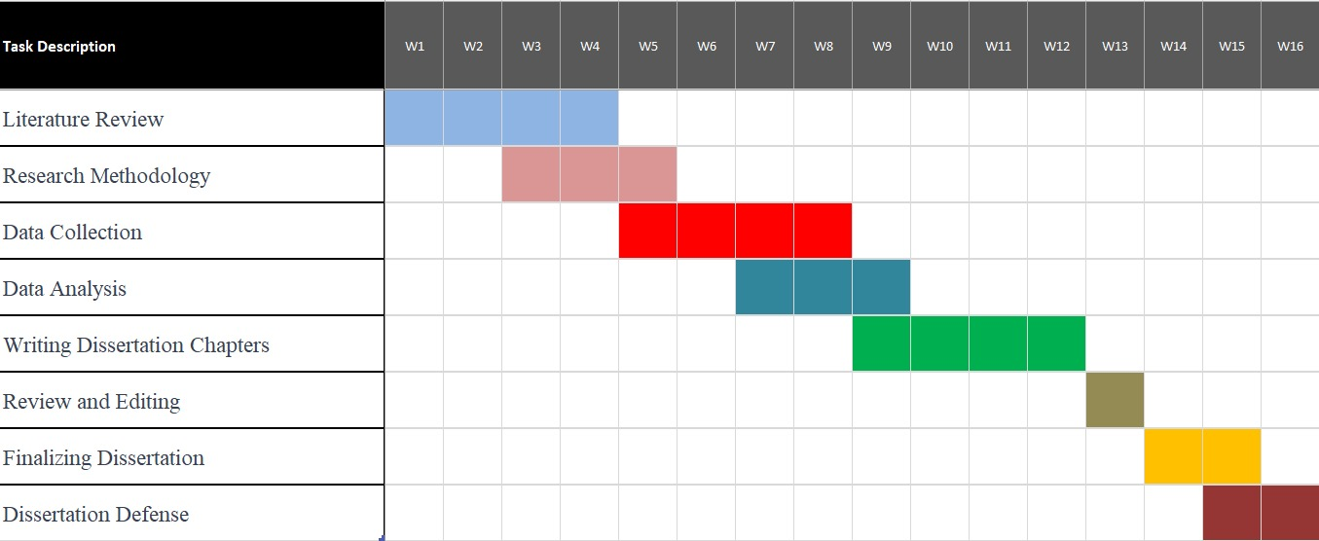

Research Ethics
Definition of Research Ethics: Research ethics refers to the standards or rules that govern research processes in order to promote integrity, honesty, and well-being of the participants. Ethical concerns should be considered in every aspect of the study, including the planning of the study, gathering data, data analysis, and the dissemination of results. Overall, researchers need to comply with ethical standards to safeguard participants’ rights and integrity, ensure the fidelity of the research, and preserve the community’s trust.
Privacy and Confidentiality in Data Collection: Confidentiality and privacy are essential considerations in research ethics, especially when individuals are asked to participate in primary data collection. Privacy refers to the right of individuals to dictate whether their personal information is shared or kept private, whereas confidentiality is a researcher’s obligation to protect this information. In relation to the study of the effect of Coca-Cola’s advertising on the consumer buying behavior, the researcher guarantees the privacy and confidentiality of the primary data gathered (Preserving privacy and confidentiality in research, 2024). This includes realizing a number of important practices such as:
- Informed Consent: Before participants are involved in the study, they will be provided with clear and comprehensive information about the research, its objectives, and what their participation entails. Informed consent will be sought, indicating that participants understand and willingly agree to contribute to the study.
- Anonymity: Whenever possible, the data collected will be anonymized. This means that individual responses cannot be linked back to specific participants. Anonymity adds an extra layer of privacy protection, ensuring that even the researcher cannot identify individual responses.
- Confidentiality Measures: Any personal information collected from participants will be treated with the utmost confidentiality. Access to this data will be restricted to the research team, and measures will be in place to secure electronic and physical records. The identities of participants will not be disclosed in any publications or reports arising from the study.
- Secure Data Storage: All data, whether in the form of surveys, interview transcripts, or any other format, will be securely stored. Digital data will be encrypted and password-protected, and physical records will be kept in a locked and restricted-access location. Only authorized personnel involved in the research will have access to this data (Preserving privacy and confidentiality in research, 2024).
- Limited Access: Data collected in this primary field of research will only be available in the core class for research activities. This means that no collaborators or people who are not part of the research team would not have given them access to the raw data without their consent. Data, which is aggregated and summarized and does not contain any identifying information may be shared more widely.
- Debriefing and Right to Withdraw: As a result, participants will have an opportunity to debrief after participating in the study. Moreover, they will be told that they can withdraw their data from the study at any time and they will retain the control of their data.
- Compliance with Regulations: The conduct of the research will be guided by the ethical principles, IRB requirements, and data protection laws to safeguard participants’ rights and privacy. These standards also provide further assurance that the study is conducted ethically.

Analysis of Data

Introduction
The survey aimed to gauge the effectiveness of Coca-Cola's advertising strategies and their impact on consumer behaviour. With a sample size of 52 respondents, the study delved into various aspects, including the awareness and recall of Coca-Cola advertisements, emotional responses evoked by these ads, brand associations, and factors influencing purchase decisions. Additionally, the survey sought to uncover any emerging themes or suggestions from respondents regarding Coca-Cola's advertising initiatives.

Survey Questions
- Have you seen a Coca-Cola advertisement in the past month?
  - Yes
  - No
- Which of the following Coca-Cola advertisements do you recall seeing recently? (Select all that apply)
  - "Share a Coke"
  - Super Bowl Ads
  - "Hilltop" (I'd Like to Buy the World a Coke)
  - Other, please specify: ______________
- How do Coca-Cola advertisements make you feel? (Select all that apply)
  - Happy
  - Nostalgic
  - Thirsty
  - Inspired
  - Indifferent
  - Other, please specify: ______________
- When you think of Coca-Cola, what words or feelings come to mind?
  - [Open-ended response]
- Have you purchased a Coca-Cola product in the past month?
  - Yes
  - No
- If yes, what made you purchase Coca-Cola? (Select all that apply)
  - Advertisement
  - Brand loyalty
  - Price
  - Taste
  - Other, please specify: ______________
- Do you recall any sensory elements (e.g., music, visuals) in recent Coca-Cola ads?
  - Yes
  - No
- On a scale of 1 (ineffective) to 5 (very effective), how effective do you find Coca-Cola's advertising in influencing consumer choices?
- Is there anything else you would like to share about Coca-Cola's advertising or your purchasing behavior?
URL: https://forms.gle/LHxWYGofJ5D6jwxt7

Table of Results
Survey Questions | Results
1. Have you seen a Coca-Cola advertisement in the past month? | 73% Yes / 27% No
2. Which Coca-Cola advertisements do you recall seeing recently? | - "Share a Coke": 50% - Super Bowl Ads: 35% - "Hilltop": 19% - Others: Various percentages
3. How do Coca-Cola advertisements make you feel? | - Happy: Majority - Nostalgic: Predominant - Thirsty: Substantial - Indifferent: Small percentage
4. When you think of Coca-Cola, what words or feelings come to mind? | Open-ended responses indicating positive and timeless attributes, reinforcing a classic and refreshing image.
5. Have you purchased a Coca-Cola product in the past month? | 56% Yes / 44% No
6. If yes, what made you purchase Coca-Cola? | - Advertisement: Various percentages - Brand loyalty: Various percentages - Price: Various percentages - Taste: Various percentages - Others: Various percentages
7. Do you recall any sensory elements in recent Coca-Cola ads? | Yes: Substantial percentage / No: Small percentage
8. On a scale of 1 to 5, how effective do you find Coca-Cola's advertising in influencing consumer choices? | Average effectiveness rating: 4.2 out of 5
9. Additional comments on Coca-Cola's advertising or purchasing behavior: | - "Coca-Cola ads always make me want to grab a can." - "I appreciate the nostalgic elements in their ads." - "The recent ad with catchy music caught my attention." - "I wish they would feature more about their sustainability efforts." - "I'm loyal to Coca-Cola because of the consistent quality and taste."

Graphs
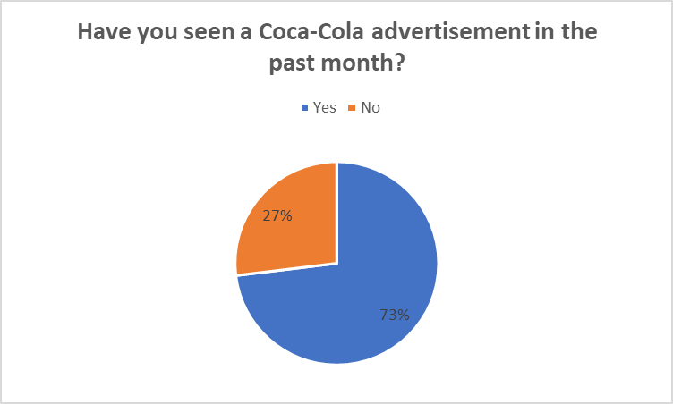
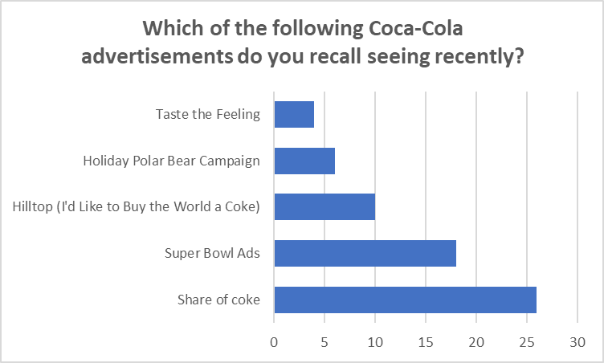
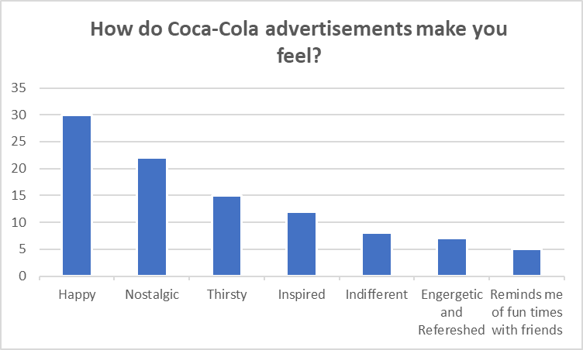
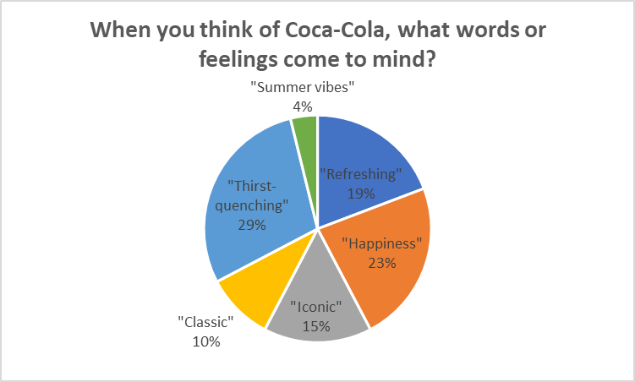
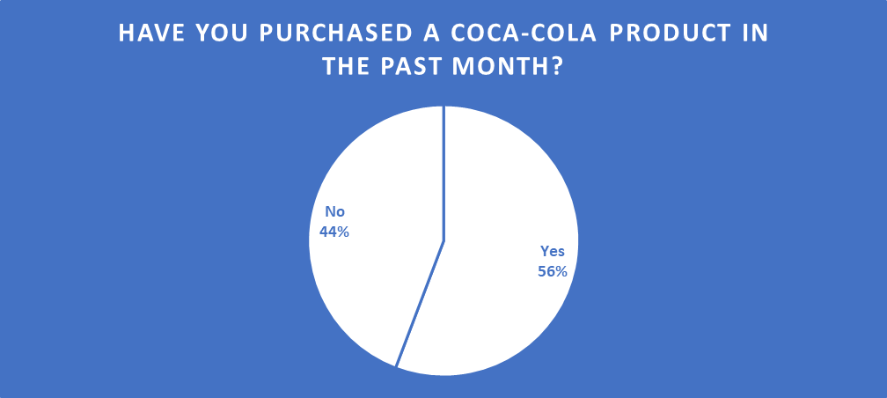
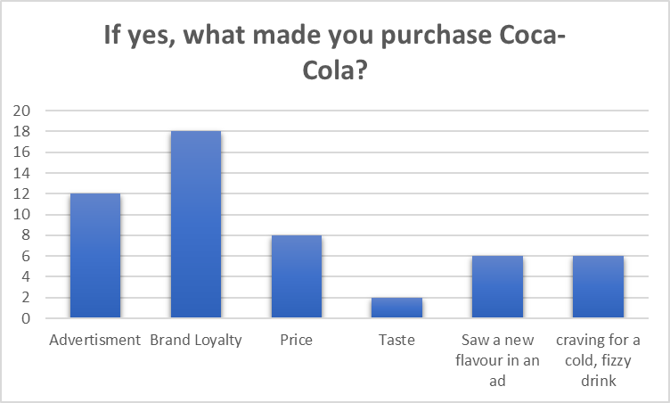
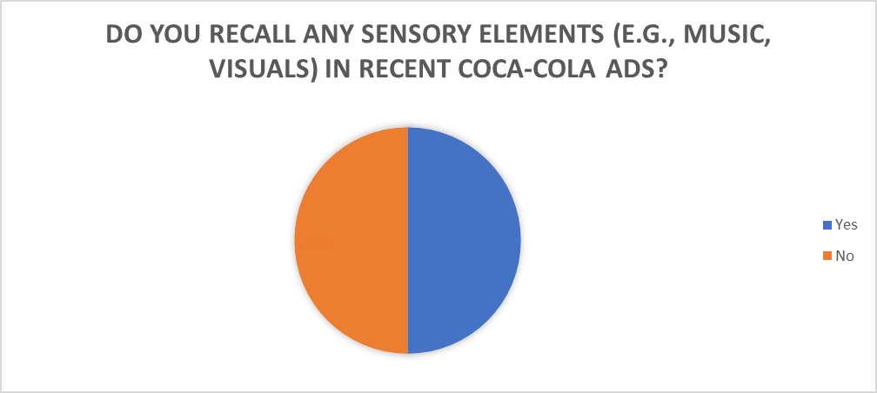
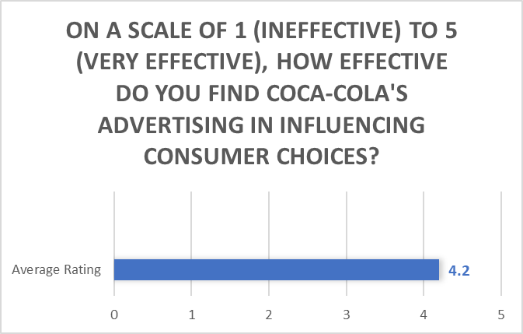

Description of the Results
Awareness of Coca-Cola Advertisement: Approximately 73% of respondents reported seeing a Coca-Cola advertisement in the past month, indicating a relatively high level of brand exposure.
Recall of Coca-Cola Advertisements:
- "Share a Coke" is the most recalled advertisement, with about 50% of respondents remembering it.
- Super Bowl Ads also had a notable recall, with around 35% of respondents mentioning them.
- "Hilltop" had a moderate recall, with 19% of respondents remembering it.
- Other advertisements, including the "Holiday Polar Bear Campaign" and "Taste the Feeling," were recalled by a smaller but still notable percentage of respondents.
Emotional Responses to Coca-Cola Advertisements:
- The majority of respondents associate Coca-Cola advertisements with positive emotions, with happiness being the most common emotion reported.
- Nostalgia and the feeling of being inspired are also prevalent emotional responses.
- Thirst, which is a direct product-related response, was mentioned by a substantial portion of respondents.
- A small percentage of respondents reported feeling indifferent, suggesting that there is room for improvement in creating a stronger emotional connection for this group.
- Brand Associations:
- The open-ended responses suggest that Coca-Cola is strongly associated with positive and timeless attributes, reinforcing its classic and refreshing image.
- Purchase Behaviour:
- Nearly 56% of respondents have purchased a Coca-Cola product in the past month, indicating a significant consumer base.
Factors Influencing Purchase:
- Brand loyalty and taste are the primary drivers of Coca-Cola purchases, highlighting the effectiveness of the brand's image and product quality.
Recall of Sensory Elements:
- A substantial number of respondents recall sensory elements in recent Coca-Cola ads, suggesting that these elements contribute to the memorability of the advertisements.
Effectiveness Rating:
- The average effectiveness rating of 4.2 out of 5 indicates a positive perception of Coca-Cola's advertising in influencing consumer choices.
Is there anything else you would like to share about Coca-Cola's advertising or your purchasing behaviour?
"Coca-Cola ads always make me want to grab a can."
"I appreciate the nostalgic elements in their ads."
"The recent ad with catchy music caught my attention."
"I wish they would feature more about their sustainability efforts."
"I'm loyal to Coca-Cola because of the consistent quality and taste."
Additional Insights:
- Consumers appreciate the nostalgic and catchy elements in Coca-Cola ads.
- Some respondents expressed interest in knowing more about Coca-Cola's sustainability efforts.

Findings of Survey
The survey, encompassing 52 respondents, revealed a commendable 73% awareness of Coca-Cola advertisements in the past month, indicating widespread exposure. The most memorable campaign, "Share a Coke," resonated with 50% of respondents, emphasizing its effectiveness. Emotional responses were overwhelmingly positive, with happiness, nostalgia, and inspiration being predominant. Brand associations reflected a strong connection to timeless and positive attributes. A substantial 56% of respondents had purchased Coca-Cola in the past month, attributing decisions mainly to brand loyalty and taste. Sensory elements in ads were well-recalled, and the average effectiveness rating of 4.2 out of 5 demonstrated a positive impact on consumer choices. Additional insights highlighted an appreciation for nostalgic and catchy elements, while some respondents expressed a desire for increased focus on sustainability in future advertising endeavours.

Discussion
The findings from the survey provide valuable insights into the effectiveness of Coca-Cola's advertising campaigns in building a powerful brand image and shaping consumer behavior. With a commendable 73% awareness of Coca-Cola advertisements among respondents, it is evident that the brand has successfully penetrated the consumer landscape, achieving widespread exposure (Hoeffler & Keller, 2002). This high level of brand awareness reflects Coca-Cola's extensive marketing efforts and its ability to maintain a prominent presence in the minds of consumers.Among the various marketing campaigns utilized by Coca-Cola, "Share a Coke" emerged as a standout campaign, with an impressive 50% recall rate among respondents. This campaign's success highlights the importance of personalized marketing strategies in capturing consumer attention and fostering brand engagement (Lee & Tsai, 2019). By personalizing Coke bottles with individual names, Coca-Cola effectively appealed to consumers' desire for uniqueness and personal connection, thereby enhancing brand recall and resonance.
The emotional reactions evoked by Coca-Cola advertisements were predominantly positive, with happiness, nostalgia, and inspiration being the predominant emotions reported by respondents. This finding underscores the brand's ability to elicit strong emotional connections with consumers, a key driver of brand loyalty and preference (Labrecque et al., 2013). Coca-Cola's use of emotional storytelling and universal themes in its advertising campaigns has enabled it to forge deep and enduring relationships with consumers, transcending mere product attributes.
Furthermore, the survey results revealed strong brand associations with enduring and positive characteristics, reinforcing Coca-Cola's image as a timeless and iconic brand (Keller, 1993). The brand's consistent messaging around happiness, refreshment, and togetherness has solidified its position as a symbol of shared moments and universal joy, resonating with consumers across diverse demographics and cultures (Batra et al., 2012).The significant proportion of respondents (56%) who reported purchasing Coca-Cola products in the past month underscores the brand's success in driving actual purchasing behavior among consumers. Brand loyalty and taste emerged as the primary factors influencing purchase decisions, highlighting the importance of brand reputation and product quality in consumer choices (Kapferer, 2012). Coca-Cola's long-standing commitment to delivering a consistent and satisfying taste experience has fostered strong consumer loyalty and repeat purchase behavior over time.
The survey findings reaffirm Coca-Cola's prowess in devising advertising campaigns that attract and retain loyal customers. By leveraging personalized marketing strategies, evoking positive emotions, reinforcing brand associations, and delivering superior product experiences, Coca-Cola continues to resonate with consumers and maintain its status as a global beverage icon.

Conclusion
In conclusion, Coca-Cola’s advertising campaigns reflect the dialectic relationship between potentials and challenges of the digital age. First, by leveraging its position through the power of brand identity and balances tradition with environmental sustainability, the brand has been able to negotiate the shifting ground to influence consumer choice. Advertising has a major influence on customer purchasing behaviour and plays a crucial role in brand promotion, according to the study. The significance of constantly monitoring and adapting advertising methods is highlighted by the company as it manoeuvres through the complexity of consumer behaviour, technology improvements, and environmental concerns. The results demonstrate how successful Coca-Cola advertisements are in making an impression, connecting with consumers on an emotional level, and influencing their purchase choices. In light of the ever-changing nature of the industry, our proposals for the future focus on clear sustainability message and the use of new technology to increase customer involvement. In spite of its caveats, the study opens the door to further investigations into the effects of the brand's advertising and contributes significantly to our understanding of the topic.

5.2.1 Objective Questions and Answers
- To what extent are consumers aware of Coca-Cola advertisements? The survey revealed a notable 73% awareness of Coca-Cola advertisements, indicating a strong presence in the consumer landscape. The most recalled campaign, "Share a Coke," achieved a remarkable 50% recall rate, emphasizing its successful penetration into consumer consciousness.
- How do Coca-Cola advertisements influence consumer emotions and associations with the brand? Emotional responses to Coca-Cola advertisements were overwhelmingly positive, with happiness, nostalgia, and inspiration being the predominant emotions. The brand successfully established strong associations with positive and timeless attributes, fostering a deep connection with consumers.
- What factors drive consumer purchasing behaviour in relation to Coca-Cola products? An impressive 56% of respondents had purchased Coca-Cola products in the past month, with brand loyalty and taste emerging as the primary influencers. These findings underscore the effectiveness of Coca-Cola's advertising strategies in cultivating consumer loyalty and driving actual purchasing behaviour.
Survey Summary: In summary, the survey paints a positive picture of Coca-Cola's advertising impact, showcasing widespread awareness, strong emotional connections, and a significant influence on consumer purchasing decisions. The findings affirm the brand's successful strategies in creating memorable campaigns and fostering a positive brand image.

Recommendations
Multiple suggestions arise from combining the study's findings with the gaps found in the literature and survey. Consumers' interest in corporate social responsibility might be addressed, first, by advertising with more explicit sustainability messaging. The research also suggests that by taking advantage of new technology, Coca-Cola could improve the customer experience and increase interaction with their ads. Finally, in order to maintain and grow the brand's success in the ever-changing market, it is essential to constantly monitor and adjust to changing consumer preferences, as mentioned in the poll.
Based on the study's findings, Coca-Cola should think about including sustainability messaging into their ads more explicitly. There appears to be a rising tide of customer interest in CSR, as respondents wanted the brand's environmental initiatives given more attention. To improve its image and attract eco-conscious customers, Coca-Cola should coordinate its advertising campaigns with sustainability efforts. Improving the customer service experience is another goal of utilising new technology, as mentioned in the literature. Digital marketing may capture the attention of modern audiences by using augmented reality, interactive features, or immersive narrative. Finally, in order to maintain and grow the brand's success in the ever-changing market, it is essential to constantly monitor and respond to changing consumer preferences, as indicated in the poll.

Limitations of the primary research
The primary research conducted in this study faced certain limitations that warrant acknowledgment. Firstly, the survey's time frame posed constraints on the depth and breadth of data collection. With a limited period, the study may not have captured long-term shifts in consumer perceptions and behaviours. Additionally, the chosen sample size of 52 respondents, while providing valuable insights, might not fully represent the diversity within Coca-Cola's consumer base. The study focused specifically on respondents in London, UK, which introduces a geographical limitation. Consumer behaviours and perceptions can vary significantly across regions, and the findings may not be universally applicable. These limitations demonstrate the need for a certain interpretive and cautious manner when interpreting the results and provide the basis for further data improvement in future research initiatives terms of the survey’s timeframe, the questionnaire’s static data period may not fully reflect dynamic consumer perceptions and behaviours over an extended period. Consumer behavior and trends are not stagnant, and a longer period would shed more light on how people’s choices and lifestyles evolve over time. The sample size of 52 respondents, which is materialized by the definition of the study, may signify the limited generalizability of the results. Given its large and diverse consumer base, a bigger sample would provide a more extensive insight as to the different preferences and perceptions across demographic segments that Coca-Cola has.
Geographically, limiting the focus only to London, UK, may limit the general applicability of the findings. Different regional behaviours and preferences can be observed among consumers and an increased geographical spread in the survey would help to get a wider body of data to form a global image of the brand structure.

Recommendations for Future Research
- Longitudinal Studies: Future studies could employ longitudinal research designs to observe changes in consumer behavior and perceptions over an extended period. By collecting data at multiple time points, researchers can capture trends, patterns, and shifts in consumer responses to advertising campaigns. Longitudinal studies would offer valuable insights into the sustained impact of advertising strategies on consumer attitudes and purchasing decisions, allowing for a more refined interpretation of the long-term effectiveness of marketing initiatives.
- Tracking Advertising Effects: Researchers could focus on tracking the effects of specific advertising techniques or campaigns over time. By examining how consumer perceptions and behaviors evolve following exposure to different advertising messages, researchers can assess the durability and lasting impact of marketing efforts. Longitudinal studies would enable researchers to monitor changes in brand awareness, brand loyalty, and purchase intent, providing insights into the effectiveness of advertising strategies in maintaining consumer engagement over time.
- Segment-Specific Analysis: Future research could explore how advertising techniques influence consumer behavior within specific demographic or psychographic segments. By examining variations in advertising effectiveness across different consumer groups, researchers can identify target-specific preferences and tailor marketing strategies accordingly. Longitudinal studies would allow for the analysis of how advertising resonates with diverse audience segments over time, informing more targeted and personalized marketing approaches.
- Comparative Analysis: Researchers could conduct comparative analyses to assess the relative effectiveness of different advertising approaches or campaigns. By comparing the outcomes of various marketing initiatives, researchers can identify best practices, determine which strategies yield the most significant impact, and uncover insights into factors driving advertising success. Longitudinal studies would facilitate comparisons across different advertising interventions, offering valuable benchmarks for evaluating campaign performance and informing strategic decision-making.
- Integration of Multi-Methods: Future research could integrate multiple research methods, such as surveys, interviews, and observational techniques, to provide a comprehensive understanding of advertising effects over time. By triangulating data from diverse sources, researchers can gain a more holistic view of consumer responses to advertising and identify underlying mechanisms driving behavioral changes. Longitudinal studies incorporating multi-method approaches would enhance the validity and reliability of research findings, yielding robust insights into the dynamic nature of advertising effects.

Further Research
Building on the thoroughness of future studies, the inclusion of digital marketing and brand loyalty as additional aspects would allow one to acquire a more rounded picture of Coca-Cola’s advertising impact. A digital marketing component in the research would enable the study of the effectiveness of the brand on various digital platforms, social media, and emerging digital technologies. This area is critical for contemporary adverting so assessing Coca-Cola’s advertisements from this point of view, could help to discover more insights into aspects such as consumer engagement, reach, and even the effectiveness of innovative digital campaigns.
In addition, the inclusion of brand loyalty as a tool in the future study would amplify the investigation of the long-term effect of Coca-Cola’s efforts of advertising. Analysing the relationship between advertising practices and consumer loyalty, scientists reveal the far-reaching consequences of campaigns aimed at establishing patronage and repeat business. The understanding of this complex connection between advertising content, emotional attachment, and sustainable brand loyalty would prove insightful for Coca-Cola’s marketing strategies, helping in creating campaigns that not only attract customers’ attention but also retain their loyalty. Conceptualizing these dimensions into future studies would help elucidate the state of Coca-Cola’s shementy in the evolving sphere of digital marketing and brand loyalty.

References
Ali, Z., & Bhaskar, S. B. (2016). Basic statistical tools in research and data analysis. Indian Journal of Anaesthesia, 60(9), 662. https://doi.org/10.4103/0019-5049.190623
Arun, R. (2023, October 11). Coca-Cola Marketing Strategy 2023: A case study. Simplilearn.com. https://www.simplilearn.com/tutorials/marketing-case-studies-tutorial/coca-cola-marketing-strategy
Decoding Coca-Cola: A Biography of a Global brand 9781138495449, 9781351024020 - EBIN.PUB. (n.d.). ebin.pub. https://ebin.pub/decoding-coca-cola-a-biography-of-a-global-brand-9781138495449-9781351024020.html
Goldsmith, R. E., & Lafferty, B. A. (2002). Consumer response to Web sites and their influence on advertising effectiveness. Internet Research, 12(4), 318–328. https://doi.org/10.1108/10662240210438407
Kao, T. F., & Du, Y. Z. (2020). A study on the influence of green advertising design and environmental emotion on advertising effect. Journal of Cleaner Production, 242, 118294. https://doi.org/10.1016/j.jclepro.2019.118294
Mukherjee, W. (2014, June 5). Brands catch FIFA World Cup fever to push sales this football season. The Economic Times. https://m.economictimes.com/industry/services/advertising/brands-catch-fifa-world-cup-fever-to-push-sales-this-football-season/articleshow/36070694.cms
Ndaghu, J. T., Augustine, M. V., Ahmed, H. S., & Magaji, B. Y. (2017). ASSESSMENT OF THE IMPACT OF ADVERTISEMENT ON CONSUMER BUYING BEHAVIOUR IN THE FOOD AND BEVERAGES INDUSTRY. ResearchGate. https://www.researchgate.net/publication/336568283_ASSESSMENT_OF_THE_IMPACT_OF_ADVERTISEMENT_ON_CONSUMER_BUYING_BEHAVIOUR_IN_THE_FOOD_AND_BEVERAGES_INDUSTRY
I’d like to buy the world a coke. (n.d.). https://www.coca-colacompany.com/about-us/history/id-like-to-buy-the-world-a-coke
Urrutia, K., & Urrutia, K. (2023, November 15). Coca Cola Marketing Strategy. Voy Media |. https://voymedia.com/coca-cola-marketing-strategy/
Rice, T. (2023, June 17). The Coca-Cola brand: an iconic branding strategy. Animas Marketing. https://animasmarketing.com/coca-cola-brand-an-iconic-branding-strategy/
Urrutia, K., & Urrutia, K. (2023b, November 15). Coca Cola Marketing Strategy. Voy Media |. https://voymedia.com/coca-cola-marketing-strategy/
Navigating Cultural Differences: Strategies for your market entry - FasterCapital. (n.d.). FasterCapital. https://fastercapital.com/content/Navigating-Cultural-Differences--Strategies-for-Your-Market-Entry.html
Coca-Cola Company - Digital Transformation Strategies. (2023, June 14). Market Research Reports & Consulting | GlobalData UK Ltd. https://www.globaldata.com/store/report/coca-cola-company-enterprise-tech-analysis/
Zhou, J., & Ma, H. (2022). Case analysis of Coca-Cola’s sustainability. BCP Business & Management, 31, 62–68. https://doi.org/10.54691/bcpbm.v31i.2537
N, D. (2023a, January 22). Definitions of Advertising: as given by eminent authors. Economics Discussion. https://www.economicsdiscussion.net/advertising/definitions-of-advertising/31793
N, D. (2023b, January 22). Definitions of Advertising: as given by eminent authors. Economics Discussion. https://www.economicsdiscussion.net/advertising/definitions-of-advertising/31793
What is an Advertisement? Definition, Benefits and Types l Square. (n.d.). Square. https://squareup.com/au/en/townsquare/what-is-an-advertisement
Consumer Buyer Behaviour Definition. (2013b, July 2). Research-Methodology. https://research-methodology.net/consumer-buyer-behaviour-definition/
Definition and Examples of the Consumer Decision-Making Process. (2019, November 11). Lucidchart Blog. https://www.lucidchart.com/blog/consumer-decision-making-process
Albrecht, M. G. (2023, January 25). 3.1 Understanding consumer markets and buying behavior - Principles of Marketing | OpenStax. https://openstax.org/books/principles-marketing/pages/3-1-understanding-consumer-markets-and-buying-behavior
Admin, & Admin. (2014, July 10). Shannon and Weaver model of communication. Communication Theory. https://www.communicationtheory.org/shannon-and-weaver-model-of-communication/
Admin_Pr. (2023, October 29). Coca-Cola: The branding strategy that made a difference. Prezlab. https://prezlab.com/coca-cola-the-branding-strategy-that-made-a-difference/
Advantages and Disadvantages of black-box testing - Javatpoint. (n.d.). www.javatpoint.com. https://www.javatpoint.com/advantages-and-dsadvantages-of-black-box-testing
Black box model (of consumer behaviour). (2023a, April 3). Monash Business School. https://www.monash.edu/business/marketing/marketing-dictionary/b/black-box-model-of-consumer-behaviour#:~:text=a%20model%20used%20in%20the,of%20observed%20stimuli%20and%20responses.
Black box model (of consumer behaviour). (2023b, April 3). Monash Business School. https://www.monash.edu/business/marketing/marketing-dictionary/b/black-box-model-of-consumer-behaviour#:~:text=a%20model%20used%20in%20the,of%20observed%20stimuli%20and%20responses.
Coca-Cola knows Santa sells. | Brand Vision. (n.d.). https://www.brandvm.com/post/coca-cola-santa
Cocacolabranding. (2016, September 1). Emotional branding – Coca Cola cases. Coca Cola Emotional Branding Strategy. https://cocacolabranding.wordpress.com/2016/09/01/emotional-branding-coca-cola-cases/
John. (2021, November 7). Black box model of consumer behavior explained | Neostrom. Neostrom. https://neostrom.in/black-box-model-of-consumer-behavior/
Koundinya. (2010, June 25). Black box testing, its advantages and disadvantages. CodeProject. https://www.codeproject.com/Articles/5579/Black-Box-Testing-Its-Advantages-and-Disadvantages
“Open Happiness” and Enjoy Life’s Simple Pleasures with Coca-Cola. (n.d.). The Coca-Cola Company. https://investors.coca-colacompany.com/news-events/press-releases/detail/328/open-happiness-and-enjoy-lifes-simple-pleasures-with
Review, C. (2018, November 15). 13: Coca-Cola (1940s) – It’s the Real Thing. Creative Review. https://www.creativereview.co.uk/its-the-real-thing-coca-cola/
Share a Coke campaign. (n.d.). StudySmarter UK. https://www.studysmarter.co.uk/explanations/marketing/marketing-campaign-examples/share-a-coke-campaign/
StudyMoose. (2021, February 22). Marketing success factors of Coca-Cola Company free essay example. https://studymoose.com/marketing-success-factors-of-coca-cola-company-essay
Sustainability. (n.d.). https://www.coca-colacompany.com/sustainability
Urrutia, K., & Urrutia, K. (2023, November 15). Coca Cola Marketing Strategy. Voy Media |. https://voymedia.com/coca-cola-marketing-strategy/
'Coca-Cola' Commercial and Consumer Behavior - 1092 words | Essay example (2021). https://ivypanda.com/essays/coca-cola-commercial-and-consumer-behavior/.
Gharbia, M. (2015) 'How Coca Cola adapts to cultural differences when launching a campaign,' Aastmt [Preprint]. https://www.academia.edu/12637674/How_Coca_Cola_adapts_to_cultural_differences_when_launching_a_campaign.
ProjectShelve (no date) INFLUENCE OF ADVERTISEMENT IN CONSUMER’S BUYING BEHAVIOUR. (A CASE STUDY OF COCA-COLA ENTERPRISE LTD, LAGOS NIGERIA). https://projectshelve.com/item/influence-of-advertisement-in-consumers-buying-behaviour-a-case-study-of-coca-cola-enterprise-ltd-lagos-nigeria-bk83432bks.
Sheel, A. (no date) effect of advertisement on coca cola. https://www.scribd.com/document/311091504/effect-of-advertisement-on-coca-cola.
Umor, E.F. (2019) 'Consumer perception of the advertising media for Coca-Cola products in Port Harcourt,' ResearchGate [Preprint]. https://www.researchgate.net/publication/331063614_Consumer_Perception_of_the_Advertising_Media_for_Coca-Cola_Products_in_Port_Harcourt.
3 Examples of Brands That Master Emotional Branding - Metaka Branding Studio brand emotional influence (no date). https://www.metakamfm.com/blog/3-examples-of-brands-that-master-emotional-branding.
2021 World Without Waste | Company Reports (no date). https://www.coca-colacompany.com/reports/world-without-waste-2021.
A health conscious brand extension for Coca-Cola - 971 words | Bartleby (no date). https://www.bartleby.com/essay/A-Health-Conscious-Brand-Extension-for-Coca-FKMHAPPBY6FS.
Alele, F. (2023) 1.3 Research paradigms and philosophical assumptions. https://jcu.pressbooks.pub/intro-res-methods-health/chapter/1-3-research-paradigms-and-philosophical-assumptions/.
Approved, P.Ijmra.U.U. (2018) 'Celebrity endorsement and its impact on buying behaviour of college students: A study in Shivamogga city,' www.academia.edu [Preprint]. https://www.academia.edu/35955397/Celebrity_endorsement_and_its_impact_on_buying_behaviour_of_college_students_A_study_in_Shivamogga_city.
Arun, R. (2023a) Coca-Cola Marketing Strategy 2024: A case study. https://www.simplilearn.com/tutorials/marketing-case-studies-tutorial/coca-cola-marketing-strategy.
Arun, R. (2023b) Coca-Cola Marketing Strategy 2024: A case study. https://www.simplilearn.com/tutorials/marketing-case-studies-tutorial/coca-cola-marketing-strategy.
Castro, F.G., Barrera, M. and Steiker, L.K.H. (2010) 'Issues and Challenges in the design of Culturally Adapted Evidence-Based Interventions,' Annual Review of Clinical Psychology, 6(1), pp. 213–239. https://doi.org/10.1146/annurev-clinpsy-033109-132032.
Caudoux, C. (2023) Navigating cultural differences during international expansion - Prime Target. https://primetarget.tech/navigating-cultural-differences-during-international-expansion/.
Chapter 6. Consumer Buying Behavior notes (no date). https://www1.udel.edu/alex/chapt6.html.
Clinehens, J. (2023) 'How Coca-Cola built the world’s most memorable brand,' Medium, 24 August. https://medium.com/choice-hacking/how-coca-cola-built-the-worlds-most-memorable-brand-c9e8b8ac44c5.
Coca-Cola invites digital artists to ‘Create real magic’ using new AI platform (no date). https://www.coca-colacompany.com/media-center/coca-cola-invites-digital-artists-to-create-real-magic-using-new-ai-platform.
Coca-Cola segmentation, targeting and positioning (no date). https://www.edrawmind.com/article/coca-cola-segmentation-targeting-and-positioning.html.
Coke invites the world to join its new journey | Press release (no date). https://www.coca-colacompany.com/media-center/coca-cola-invites-the-world-to-join-its-new-journey.
Consumer research methods (no date). https://www.consumerpsychologist.com/cb_Research_Methods.html.
Deductive approach (Deductive reasoning) (no date). https://research-methodology.net/research-methodology/research-approach/deductive-approach-2/.
Definition and Examples of the Consumer Decision-Making Process (2019). https://www.lucidchart.com/blog/consumer-decision-making-process#:~:text=The%20consumer%20decision%2Dmaking%20process%20involves%20five%20basic%20steps.,decision%20and%20post%2Dpurchase%20evaluation.
Feigl, H. (2024) Positivism | Definition, History, Theories, & Criticism. https://www.britannica.com/topic/positivism.
Figure 3.1: The research onion (no date). https://www.researchgate.net/figure/The-Research-Onion_fig3_352357420.
Heusser, M. (2021) black box (black box testing). https://www.techtarget.com/searchsoftwarequality/definition/black-box.
History of Coca-Cola advertising slogans (no date). https://www.coca-colacompany.com/about-us/history/history-of-coca-cola-advertising-slogans.
Indian Retailer Bureau (2022) 'Sprite becomes billion-dollar brand in Indian market,' Indian Retailer, 27 October. https://www.indianretailer.com/news/sprite-becomes-billion-dollar-brand-indian-market.
International Brand Equity (2023) Coca-Cola: a symphony of branding mastery. https://www.internationalbrandequity.com/coca-cola-branding/.
Jarvis, J. (2018) 'Advertising, the myth of mass media, and the relationship strategy,' Medium, 20 May. https://medium.com/geeks-bearing-gifts/advertising-the-myth-of-mass-media-and-the-relationship-strategy-cece3698ba86.
Karam, A.A. (2013a) 'Cultural impact on Brand: A case study on Coca Cola’s cultural issues in India,' ResearchGate [Preprint]. https://www.researchgate.net/publication/291346589_Cultural_Impact_on_Brand_A_Case_Study_on_Coca_Cola's_Cultural_Issues_in_India.
Karam, A.A. (2013b) 'Cultural impact on Brand: A case study on Coca Cola’s cultural issues in India,' ResearchGate [Preprint]. https://www.researchgate.net/publication/291346589_Cultural_Impact_on_Brand_A_Case_Study_on_Coca_Cola's_Cultural_Issues_in_India.
Lumen Learning (no date) Reading: The “Black Box” of Consumer Behavior | Principles of Marketing. https://courses.lumenlearning.com/clinton-marketing/chapter/reading-the-black-box-of-consumer-behavior/.
Min, J.H. et al. (2019) 'The effects of celebrity-brand congruence and publicity on consumer attitudes and buying behavior,' Fashion and Textiles, 6(1). https://doi.org/10.1186/s40691-018-0159-8.
Mohammed, S. (2023) 'The Positioning Playbook: the winning strategies that work,' Medium, 15 June. https://shahmm.medium.com/the-positioning-playbook-the-winning-strategies-that-work-b178313eecec.
Mora, M. (2022) Secondary research Advantages, limitations, and sources. https://www.relevantinsights.com/articles/secondary-research-advantages-limitations-and-sources/.
MSEd, K.C. (2022) How do Cross-Sectional studies work?https://www.verywellmind.com/what-is-a-cross-sectional-study-2794978.
Mulcahy, E. (2019) 'Coca-Cola ads: 8 of its most memorable campaigns,' The Drum, 23 May. https://www.thedrum.com/news/2019/05/23/coca-cola-ads-8-its-most-memorable-campaigns.
Mupeti, L. (2023) The emotional appeal of Coca-Cola’s 'Share a Coke' campaign: Lessons for marketers. https://www.linkedin.com/pulse/emotional-appeal-coca-colas-share-coke-campaign-lessons-leslie-mupeti.
Otamendi, F.J. and Martín, D.L.S. (2020) 'The emotional effectiveness of advertisement,' Frontiers in Psychology, 11. https://doi.org/10.3389/fpsyg.2020.02088.
Pal, S. and Pal, S. (2023) 'The importance of cultural sensitivity in global branding: respecting and adapting to local norms,' WinSavvy - We Strategize and Help Implement and Manage Extremely Fast Growth for Tech Startups and Small Digital Businesses., 24 October. https://www.winsavvy.com/the-importance-of-cultural-sensitivity-in-global-branding-respecting-and-adapting-to-local-norms/.
Pelz, P.B. (no date) Chapter 8 Sampling | Research Methods for the Social Sciences. https://courses.lumenlearning.com/suny-hccc-research-methods/chapter/chapter-8-sampling/.
Popovska, M. (2021) How the branding of Coca-Cola defined Christmas Magic - Synami.Media. https://www.synamimedia.com/insights/how-the-branding-of-coca-cola-defined-christmas-magic/.
Prafull, P. (2021) Coca-Cola’s Marketing Communication Strategy: A Critical analysis. https://www.linkedin.com/pulse/coca-colas-marketing-communication-strategy-critical-analysis-pragya.
Preserving privacy and confidentiality in research (2024). https://atlasti.com/guides/qualitative-research-guide-part-1/confidentiality-privacy-research.
Rehman, S.U., Gulzar, R. and Aslam, W. (2022) 'Developing the Integrated Marketing Communication (IMC) through Social Media (SM): The Modern Marketing Communication Approach,' SAGE Open, 12(2), p. 215824402210999. https://doi.org/10.1177/21582440221099936.
Rice, T. (2023) 'The Coca-Cola brand: an iconic branding strategy,' Animas Marketing, 17 June. https://animasmarketing.com/coca-cola-brand-an-iconic-branding-strategy/.
Sharma, A.A. (2023) Case study 1: Coca-Cola’s 'Share a Coke' campaign. https://www.linkedin.com/pulse/case-study-1-coca-colas-share-coke-campaign-abhishek-aditya-sharma.
Singaram, R. et al. (2019) 'Coca Cola: A study on the marketing strategies for millenniums focusing on India,' ResearchGate [Preprint]. https://www.researchgate.net/publication/330924745_Coca_Cola_A_study_on_the_marketing_strategies_for_millenniums_focusing_on_India.
Snyder, H. (2019) 'Literature review as a research methodology: An overview and guidelines,' Journal of Business Research, 104, pp. 333–339. https://doi.org/10.1016/j.jbusres.2019.07.039.
Tbh, T. (2023) Branding Case study : Success of Share a Coke campaign. https://thebrandhopper.com/2023/06/09/branding-case-study-success-of-share-a-coke-campaign/.
Unveiling the emotional alchemy: decoding the emotional power of Coca-Cola advertising (no date). https://imentiv.ai/blog/the-emotional-power-of-coca-cola-advertising/.
Urrutia, K. and Urrutia, K. (2024) Coca Cola Marketing Strategy. https://voymedia.com/coca-cola-marketing-strategy/.
Wright, R. (2023) Coca-Cola advertising and authenticity in branding. https://www.communication-generation.com/coca-cola-advertising-and-the-mask-of-authenticity/.
Maamoun, A., 2020. Coke Versus Pepsi: 100 Years of Contention. SAGE Publications: SAGE Business Cases Originals.
Ling, G.Y., Yuang, G., Zhicheng, G., Xuan, G.T.X., Maharani, C.D., Genira, C.F., Tyagi, N. and Saidhanyakumar, M., 2023. Analysis of Factors Affecting Brand Loyalty: A Study of Coca-Cola. Asia Pacific Journal of Management and Education (APJME), 6(3), pp.16-29.
Andersson, E.L., Arvidsson, E. and Lindström, C., 2006. Coca-Cola or Pepsi; that is the Question: A study about different factors affecting consumer preferences.
Osere, N.J., Udoudo, A.J. and Ohiagu, O.P., Analysis of the Integrated Marketing Communication Strategies of Seven-Up Bottling Company in Port Harcourt, Rivers State.
Lacy-Nichols, J., Scrinis, G. and Carey, R., 2020. The evolution of Coca-Cola Australia’s soft drink reformulation strategy 2003–2017: A thematic analysis of corporate documents. Food Policy, 90, p.101793.
Freeman, J.P., 1986. THE REAL THING:" LIFESTYLE" AND" CULTURAL" APPEALS IN TELEVISION ADVERTISING FOR COCA-COLA, 1969-1976 (COMMERCIALS, COKE). The University of North Carolina at Chapel Hill.
Blanding, M., 2011. The coke machine: The dirty truth behind the world's favorite soft drink. Penguin.
Batra, R., Ahuvia, A., & Bagozzi, R. P. (2012). Brand love. Journal of Marketing, 76(2), 1-16.
Hoeffler, S., & Keller, K. L. (2002). Building brand equity through corporate societal marketing. Journal of Public Policy & Marketing, 21(1), 78-89.
Keller, K. L. (1993). Conceptualizing, measuring, and managing customer-based brand equity. Journal of Marketing, 57(1), 1-22.
Labrecque, L. I., vordem Esche, J., Mathwick, C., Novak, T. P., & Hofacker, C. F. (2013). Consumer power: Evolution in the digital age. Journal of Interactive Marketing, 27(4), 257-269.
Lee, H. H., & Tsai, M. H. (2019). Personalized marketing of social networking services and consumer experiences: A social capital theory perspective. Journal of Business Research, 96, 345-355.
Kapferer, J. N. (2012). The new strategic brand management: Advanced insights and strategic thinking. Kogan Page Publishers.

Appendices


