MODULE CODE: Digital Skills for Personal Development and Business Growth BMSW4008

ASSESSMENT COMPONENT: PORTFOLIO

STUDENT NAME: MUTALE KENT NDEKE

STUDENT NUMBER: 2426088

LECTURER: PHILIPPA FITZGERALD

DATE:27/02/2026

Task 1 Assessment of Digital Skills

Introduction
In the modern digital world, it is essential to learn and enhance digital skills in order to transform both personally and professionally. The JISC report provides an in-depth instrument in determining competence in different digital skills. With the help of the analysis of the digital skills framework described in the report, the areas of main strength and weakness has been discussed. The analysis shows these critical areas and gives specific recommendations that would help in improving digital capabilities (Livingstone, Mascheroni and Stoilova, 2021). The practice will allow people to fill the gaps in their expertise and develop the current strengths to manage the world that becomes more technologically driven.

Digital Analysis of Existing Skills
Digital skills refer to a group of skills that are necessary in order to effectively manipulate digital technologies in various processes like, communication, collaboration, data management, problem-solving and creativity. Such competencies are the capacity to use the digital tools, find and evaluate the Internet information, and manage the online learning and use technology in order to increase the productivity. Digital Communication, Information literacy and digital problem-solving has become a key success factor in digital life both at a personal and professional level (Astuti Muh. Amin, Romi Adiansyah and Noor Hujjatusnaini, 2023).
The JISC report has shown the use of Digital Tools and Digital Communication and Collaboration proficiency. Academic activities like data analysis, report writing, and good communication have been done with the use of digital mechanisms like Microsoft office and Google Suite (Maksym Bezpartochnyi, 2022). These are the essential skills towards academic and professional achievements used with conviction.

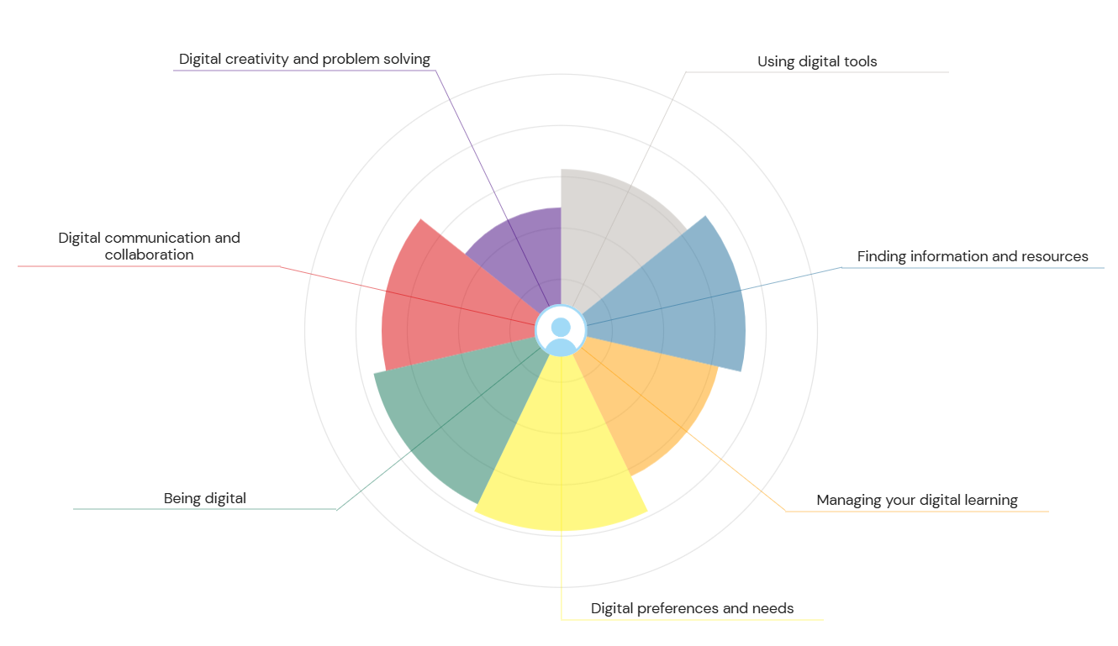
Figure 1 Screen shot of JISC report

Nonetheless, there are such areas like Digital Creativity and Problem Solving and Finding Information and Resources that have been named as the areas to be improved. Although simple problem solving with digital tools is already reached, more work on creative problem-solving methods and advanced digital tools to solve problems in the field of innovations should be conducted. Also, as it has been proved that the capability of locating information online does exist, more attention should be paid to the evaluation and choice of credible and high-quality sources, especially when working with a complicated dataset.
Digital Preferences, Needs, and Managing Digital Learning are also discussed as the areas of development (Yadav, 2024). Adaptation to new learning technologies is also indicated to be improved and there is a possibility of streamlining the digital learning strategies to suit particular needs.

Strengths as part of JISC Report
- Use of Digital Tools: Adequacy in the use of standard digital tools in communication, collaboration and information management has been proven.
- Digital Communication: Digital communication (email, virtual meetings) has proved to be effective and has sustained professionalism in them.

Areas for Improvement
- Digital Creativity and Problem Solving: Digital tools have been applied to solve simple problems but more needs to be done as far as the more complex digital creativity tools, like Adobe Creative Suite or design and innovation specific software are considered.
- Locating Information and Resources: The ability to search trustworthy information, especially in academic and professional research, will have to be enhanced.
- Digital Learning Management: It is necessary to improve the management of digital learning, in particular, the use of such platforms as online academic databases or collaborative tools in virtual teams.

Improvement Recommendations
- Interaction with Digital Innovation Tools: It is necessary to take time to study digital innovation platforms, and online courses to be more informed about the tools that facilitate creativity and highly developed problem resolution.
- Construction of Critical Information Literacy: It is necessary to develop the skill of distinguishing credible and quality sources of information especially by the way of academic training on information literacy and data validation.
- Digital Learning Strategies Improvement: Trying out new digital learning strategies, including active note-taking applications (e.g., Evernote), educational YouTube channels, online learning platforms (LinkedIn Learning or Coursera), etc., will improve the engagement and flexibility in the digital space (Zou et al., 2025).

Conclusion
The digital skills assessment has brought out my strengths and weaknesses. The JISC report has played a key role in the establishment of key gaps in the digital capabilities, especially the digital creativity, problem-solving, and information management. The linked recommendations will be used as a guideline in improving these competencies, to make things more clear for me to understand in an already digitalized world.

References
Astuti Muh. Amin, Romi Adiansyah and Noor Hujjatusnaini (2023). The Contribution of Communication and Digital Literacy Skills to Critical Thinking. Jurnal pendidikan sains Indonesia, [online] 11(3), pp.697–712. doi: https://doi.org/10.24815/jpsi.v11i3.30838
Livingstone, S., Mascheroni, G. and Stoilova, M. (2021). The outcomes of gaining digital skills for young people’s lives and wellbeing: A systematic evidence review. New Media & Society, [online] 25(5), p.146144482110431. doi: https://doi.org/10.1177/14614448211043189
Maksym Bezpartochnyi (2022). Strategy of Digital Competence Formation Using a Hybrid Learning Environment Based on Microsoft 365 Services. [online] Philarchive.org. Available at: https://philarchive.org/rec/BEZSOD [Accessed 16 Feb. 2026].
Yadav, N. (2024). The Impact of Digital Learning on Education. International Journal of Multidisciplinary Research in Arts Science and Technology, 2(1), pp.24–34. doi: https://doi.org/10.61778/ijmrast.v2i1.34
Zou, Y., Kuek, F., Feng, W. and Cheng, X. (2025). Digital learning in the 21st century: Trends, challenges, and innovations in technology integration. Frontiers in Education, 10(10). doi: https://doi.org/10.3389/feduc.2025.1562391

Task 2 LinkedIn Learning Certificates for Office365
Links for certificates-
https://www.linkedin.com/learning/certificates/e41e6560c39d43e28ed129f1b513d2692b08ebb2c84f6b63dbeccb4dd814c96b?trk=share_certificate
https://www.linkedin.com/learning/certificates/260c56779c90a3fdd6cf2eb23443b3572640e602556bb0cc24bd7debff84cdb862?trk=share_certificate

Task 3 Relevance of Excel in professional and personal life

Introduction
Microsoft Excel is a spreadsheet platform, which is a very important tool in both professional and personal activities. Excel allows one to gather, handle, and study and report data in a systematic way. It is now a necessary requirement in most industries especially when it comes to processes that require complex computation, data visualization and financial management. In addition to professional use, Excel is also very important in personal finances management, daily organization and monitoring of activities in life (Tanvir Mustafy and Ur, 2024). The essay will discuss the applicability of Excel both in the professional and personal life where its functions will be demonstrated through the application of formulas, charts and data management features.

Master Excel in the Workplace
Excel is popular in professional settings where data management, financial analysis and reporting are the common uses. It is a tool of choice by various businesses due to its capacity to store and organize huge amounts of data in an efficient manner. Examples of financial analysts, accountants and project managers, use Excel to develop financial reports, monitor performance indicators and budgets. The versatility of Excel enables it to be implemented in a broad industry, be it finance and marketing, healthcare and education (Kumar, 2025).
Among the main reasons why Excel is such a popular tool in the working place is its capability to make complex calculations in a short period. It provides a comprehensive set of in-built formulas and functions, e.g. SUM, AVERAGE, VLOOKUP, and IF that enable users to carry out mathematical operations without the necessity of another software or manual calculation. E.g., one can easily use the SUM formula to add a list of numbers, e.g., the total number of expenses or sales of a specific period. The AVERAGE can be used to find the average values in a massive dataset.
Excel is also essential in developing visual representation of data that are essential in conveying insights. Excel can be used to display data in the form of charts, graphs, and pivot tables. An example of this would be the use of pie charts to demonstrate how the various types of expenses lead up to the total budget and the use of bar charts to compare revenues in the various quarters.

Excel in Personal Life
Excel has great benefits beyond the work environment and it can be used to your personal life where it is very useful in financial management, planning your personal objectives and keeping track of valuable information. One of the ways in which excel proves to be very useful is in personal financial management where a person can easily track incomes, expenses, savings, and investments (Lindquist and Sulewski, 2024). With preparation of a budget spreadsheet, one is able to distribute money to other expenses including rent, groceries, transportation and entertainment. Excel allows tracking of monthly revenues and expenditures, savings, and cost planning of future financial purposes.
As an example, a common family of four that uses Excel to manage their money. They could easily track their finances by developing a spreadsheet with sources of income and expenditure categories. In the given sample, the sources of income are two wages, trust funds, and universal credit, and the costs include rent, utilities, food, car insurance, and others. Excel can be used to add formulas that can be used by the family to calculate the total income and expenditures on a month-to-month basis. It is then possible to calculate the total savings by subtracting total expenses by total income, which assists the family to monitor their meeting the savings objectives.
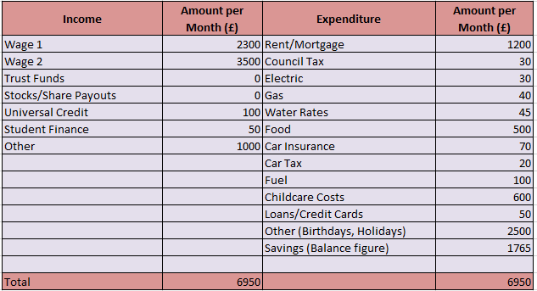
Figure 2 Household Budget
The fact that excel can make totals and averages can also be used to monitor the spending habits per month. As an example, the family finds it very easy to know how much they use to spend on buying food each month using the SUM formula to add the food costs. They can use the AVERAGE command to estimate their average spending on utilities such as electricity and water annually so that they can evaluate whether they can reduce some of the areas.
The other strength of Excel is that it can be used to generate charts and graphs that will visually represent the data.

The family may also develop pie charts to indicate how they are using their income in various ways, including child care, food and housing. Monthly expenses can be compared with the help of bar chart, which will allow them to identify those months in which they spent more than they had budgeted to spend (Kumar, 2023).
The Excel can also be employed to establish self-goals and monitor the progress as time goes by. It can be applied when saving money to go on vacation, planning to buy a big item or simply monitoring health and fitness, the functionality of Excel ensures that one is able to keep organized and goal-oriented. Indicatively, using the example of establishing a savings plan in Excel the family can set aside a part of their income to be spent on savings monthly and monitor their progress throughout the year.
Excel has numerous formulas that simplify the process of data processing, thus a useful tool to both professionals and individuals. One of the important formulas is SUM that sums the values of a selected range of cells. As an illustration, =SUM(B2:B12) would add the numbers in B2 to B12 making it necessary in computing costs or sales totals. AVERAGE is another formula which is useful, calculating the average of a given range of numbers (Abbas, Mahmoud Tarek Hefnawy and Negida, 2024).

Conclusion
The importance of Excel in professional and personal life is hard to overestimate. It allows any professional or person to use it not only because of its ability to perform complex calculations, but also because of its capability to produce visual representations of data. In business or project management, personal finances, or any other area, the capabilities of Excel make it easier, faster, and allow one to make informed decisions. The skill of using Excel efficiently gives the power to manage the data, organize the personal finances, and follow the objectives so that the persons have been able to control the state of their personal and financial lives.

References
Abbas, A., Mahmoud Tarek Hefnawy and Negida, A. (2024). Meta-analysis accelerator: a comprehensive tool for statistical data conversion in systematic reviews with meta-analysis. BMC Medical Research Methodology, 24(1). doi: https://doi.org/10.1186/s12874-024-02356-6
Kumar, D.M.D. (2023). A Study On Importance of Microsoft Excel Data Analysis Statistical Tools in Research Works. Journal of Management & Educational Research Innovation, [online] 1(3), pp.25–33. doi: https://doi.org/10.5281/zenodo.10449150
Kumar, R. (2025). Bibliometric Analysis: Comprehensive Insights into Tools, Techniques, Applications, and Solutions for Research Excellence. Spectrum of Engineering and Management Sciences, 3(1), pp.45–62. doi: https://doi.org/10.31181/sems31202535k
Lindquist, J.M. and Sulewski, C.A. (2024). Microsoft Excel. Handbook of Military and Defense Operations Research, pp.21–72. doi: https://doi.org/10.1201/9781003396307-3
Tanvir Mustafy and Ur, T. (2024). Excel. Statistics and Data Analysis for Engineers and Scientists, pp.81–134. doi: https://doi.org/10.1007/978-981-99-4661-7_3

