This is an example of a blog that looks at a skill identified as essential in the future of work. Please note, it is not one of the skills addressed in the Unit and does not specifically address the question you have been set, it only serves as an example of the potential structure and tone of a good blog post.
Use a creative title and appropriate header image.

Colouring Outside the Lines

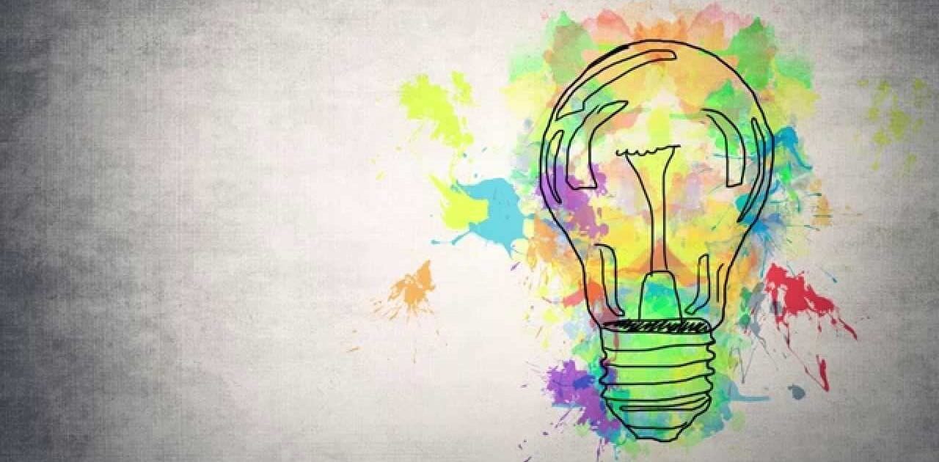
Start with an anecdote/story to capture the readers interest.
Yesterday, I watched a friend’s 8-year-old daughter as she sat on my sofa and meticulously copied the colours from a picture of two birds, into their reflected outline on the opposite page of her colouring book. The colour of each feather painstakingly assessed and a matching pencil chosen to apply the exact strokes required to replicate the picture.
On the rug at her feet, her 4-year-old brother lay, gleefully scratching an orange crayon over the outline of a dinosaur.
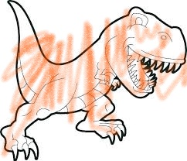
Include images, charts and diagrams relevant to your discussion.
Though I admired the fastidiousness of the copier, I could not help thinking that, unlike for the joyous scribbler, the process did not allow for any creativity it was simply an exercise in conformity. I remembered as a child of about the same age, I too had learned you should only colour inside the lines with colours carefully selected to reflect reality, I had learned to conform.
The copiers aim was perfectionism in the eyes of the person she sought to please, anything less would fail to get her the admiration she so desired. Selecting a new colour for the feathers would be considered a mistake! Her interpretation of the picture was not important, creativity was surplus to requirements.
Include a definition.
Creativity is the act of turning new and imaginative ideas into reality. Creativity is characterised by the ability to perceive the world in new ways, to find hidden patterns, to make connections between seemingly unrelated phenomena, and to generate solutions (Naiman,20180.
However, according to Ken Robinson (2007), in his TED talk Do Schools Kill Creativity, we are educating people out of their creative capacities. Land (1963), was the first to acknowledge this phenomenon when his studies revealed that creativity diminishes with age. He found 98% of children age 3-5 scored highly on his creativity test, as opposed to only 2% of adults.

Include evidence.
So what? I hear you ask.
I often come across people who consider creativity to be the exclusive remit of artists, musicians, designers, florists and the like. I am here to tell you, this is categorically not the case and if you continue to think this way you WILL be left behind in the future of work. Creative thinking is for EVERYONE and that is why it appears on all of the WEF, Future of Jobs reports since 2015, including 3rd place on the most recent (WEF, 2020). Deloitte (2020) and McKinsey (2019) also list creativity in the top 3 most sought-after skills needed to survive the 4th Industrial Revolution, as it is a cognitive skill that simply cannot be automated.
It is innovation, not replication that will give us competitive edge, making individuals indispensable and organisations sustainable. There is no innovation without creativity. Creativity drives innovation, as by looking at things from a different perspective without the restrictions of rules and norms, new and unique ideas are produced.
Furthermore, the need for creativity is essential for solving the complex problems that beset organisations more and more as the world around them increases in complexity (Puccio, 2017).
Include 1 or 2 relevant quotes
“As lives are affected by any number of looming challenges – climate crisis, automation in the workplace – humans are going to need creative thinking more than ever.”
(The Guardian, 2019).
If I have managed to convince you of the importance of creativity, but you too have had yours educated out of you, then do not fear, it can be retrieved with a little effort and a few blushes. Here are a few tips for regaining your creativity:
- Get over yourself – be prepared to be wrong and look a little bit of an idiot, or you will never come up with anything new. Creative people know perfection doesn’t exist, they aren’t afraid to make mistakes or get rejected (Chong, 2018).
- Be a rebel – try something new and unexpected (for more on this read Gino’s (2018) Rebel Talent and join the red shoe brigade).
- Stop telling yourself you can’t – I can’t draw, I can’t sing, I can’t cook, these are self-limiting beliefs (Oppland 2020)! Until recently I believed I didn’t have a musical bone in my body but after one of Moira Morgan’s Cuban Samba sessions I now know differently – I am a master with a tambourine!
- Play! – tap into your inner child and run like Phoebe. Being in a state of play allows you to explore beyond the limitations of your conforming adult brain (Brown, 2010).
Why not start today – go wild, colour outside the lines.
End with a call to action

