Netflix Change & Stability Management – Password sharing crackdown
(Initiated in 2020 and deployed in 2023)

Name: Nayani Gayathrika Gamage
Student ID: 2222070
Module: BMMB7000

Executive Summary
Every organisation has a strategy that can be either short- or long-term. However, change management may be a component of those strategies or change management that can be implemented quickly based on urgency and necessity. Change Management is a philosophy that was developed by Kurt Lewin in the early 1930s. Recently, there have been numerous alterations and value additions. Most modern scholars argue that John Kotter's 8-step model is more practical than Lewin's 3-step model because it addresses the majority of elements.
The objective of change management is to satisfy the organization's most pressing need. Leadership and every employee must be on the same page and working towards the same goal throughout the change management process.
However, academics have criticised Kotter's 8-stage model because it focuses on altering human behaviour towards the objectives, rather than system or strategy changes (Sarayreh et al., 2013).
This document discusses Netflix's most recent change management initiatives, "password crackdown" and "transfer of account." Netflix began researching password crackdown and transfer of account in 2020 and began implementing the measures in 2022. the These changes could be detrimental to Netflix's business model and have long-term repercussions. However, Netflix's new Co-CEO (Greg Peters) was eager to expedite these adjustments in light of Netflix's 2020 revenue decline.
Regardless of the cause, Netflix's competitors have not altered their subscription fees or password sharing procedures. Therefore, "password Crackdown" and "Transfer of Account" by Netflix will be detested. Change Management always evaluates a risk factor. In every change management process, the third stage, integrating the alterations into the existing system and normalising it, is crucial. This document examines in depth the Netflix change management process, its application, and its theoretical framework.

Table of contents

Table of figures

Table of Tables

- Introduction
Change Management is not an uncommon term in the emerging global community. The majority of companies are attempting to remain competitive by introducing and implementing new organisational strategies. Netflix has undergone numerous transformations since it was founded in order to become the market leader in streaming. Netflix's most recent change management initiative is the "Password crackdown" implementation at the end of 2022. This document covers in depth the change management implementation strategy for the "Password crackdown" campaign in Netflix and evaluates the change management process using a theoretical framework and applications.
Netflix is an American company that launched operations in California in 1997 (Safian, 2018). The initial business objective was to sell and rent DVDs through the mail (Sarolli and Venkatesan, 2020). Netflix has implemented a payment gateway system that allows consumers to pay for their purchases (Bajaj, 2020).
Today, Netflix is the most recognisable multinational corporation in the world. In 2022, Netflix generated 32 billion in revenue, yielding 5 billion in net income (netflix.net). These organisational advancements and stability demonstrate that Netflix has implemented a change management strategy that enables the company to accomplish its goals.
According to Netflix's 2022 Annual Report, the company has approximately 15,000 employees (netflix.net). In 2022, according to "The Times of New York" magazine, Greg Peters is one of the world's most influential individuals (Chatterji and Toffel, 2018). Greg Peters has developed numerous strategies and theories over the years to accomplish a successful "Password crackdown" change management system (Safian, 2018).
In the following sections, the change management process for "Password crackdown" will be discussed in depth with backing from a literature review. The document contains 5 core chapters. In the first section, the topic and organisation are introduced. The second section will discuss the change management and definitions. In the third section, strategies for the "Password crackdown" process. Based on the literature and the findings of the report, the fourth section will provide recommendations, followed by a conclusion.
- What is Change Management
Before discussing theories and applications, it is essential to define the topic and provide definitions. There are numerous methods to define Change Management, and numerous definitions have been provided by academics. However, the most reasonable and appropriate definitions of Change Management are;
“The overarching approach taken in an organisation to move from the current to a future desirable state using a coordinated and structured approach in collaboration with stakeholders.”
Association of project Management (UK-Chapter, 2023)

“The process of guiding organizational change to fruition, from the earliest stages of conception and preparation, through implementation and, finally, to resolution.”
Harvard Business School (Website, 2023)

It is necessary to explore why companies must undergo the change management process and how management determines when it will be implemented. When management is interested in process consistency and it needs to be streamlined, management will consider a change management process (Chatterji and Toffel, 2018; Stouten et al., 2018). It is essential to implement change management to add diversity to businesses in order to elaborate more challenges and expand the business's scope. When an organisation, for instance, wishes to implement centralised policies for its subsidiary and primary companies, the management will make adjustments to the current mode of operation (Kumar et al., 2018). Therefore, these adjustments will have both positive and negative effects on the organization's future. Consequently, these changes should be implemented with caution after developing a strategy. Most of the time, change management must be implemented to improve the organization's future (Cameron and Green, 2019). In addition, change management has been implemented to strengthen the organization's internal controls (Hayes, 2022).
2.1 Significance of Change Management in an Organisation
Every market contains rivalry. To survive in the emerging market, businesses must improve their current policies and methods of conducting business. Over the past two decades, technology has permeated the entire globe and the business sector. Technology has largely determined the expansion of the organisation (Tabrizi et al., 2019). The majority of the time, change management will result in modifications to job responsibilities and procedures. As a consequence of change management, the majority of Middle Eastern businesses have adopted digitalisation in order to remain competitive on the market (Spicer, 2020). Listed below are a few real-world examples demonstrating the significance of change management in the current era.
Financial Transformation – Majid Al Futtaim (Dubai) : 2019 will be the year of Financial Transformation for Majid Al Futtaim, a strategic decision made by the company (Pînzaru, Zbuchea and Viţelar, 2019). The procedure of change management began in 2019 and was concluded in 2021. Prior to implementation, the company has crafted a distinct vision and project plan. Company has appointed IBM Consultancy to lead the Financial Transformation initiative as a third-party service provider. The objective of Majid Al Futtaim was to have centralised financial services across the board. Prior to the financial transformation, Majid Al Futtaim had a decentralised finance department whose inconsistency of process had caused the organisation to experience numerous drawbacks (Ayyagari and Parahoo, 2022).
Digitalisation – Softlogic Ltd (Sri Lanka) : Softlogic maintains its operations in Sri Lanka. Softlogic is involved in insurance, auto financing, retail, and a variety of other enterprises in Sri Lanka and throughout South Asia. Softlogic adopted Digitalization in 2014 after acquiring the merchants Odel and Cotton Collection (Lye, 2022). Softlogic systems has converted from analogue to digital (Wijesinghe and PWG, 2021). With the acquisition of retailers, Softlogic expanded into the textile industry. The company has undergone a massive transformation that has resulted in its becoming Sri Lanka's retail and supermarket market leader (Wijesinghe and PWG, 2021).
Expanding the businesses to South Asia having a centralised leadership – Bharti Airtel Limited (India) - The organisation has adopted John P. Kotter's eight-model change management strategy (Anand, 2011). The management team identifies crucial organisational areas where a change in strategy is required (Muema, 2013).
Change the scope of the services being provided to the customers - KPMG(UK) - KPMG has undergone a massive digital transformation, which required extensive change management throughout the firm's global network. The company has expanded its services and implemented a digital platform for every aspect (Salijeni et al., 2019).

- What is “Password Crackdown Process” in Netflix
Netflix's Password Crackdown procedure uses IP address to determine whether or not devices are being used in the same household. And Netflix has implemented the verification of the User ID and password when the IP address is not the same (Thomas, 2021).
They carried out the trial run for the Password Crackdown procedure in the year 2022, and it was put into effect at the beginning of 2023 (Rodríguez Ortega, 2023). Netflix has shared the FAQ with its users to better understand of Transfer Account policy (Netflix, 2023). One of the primary objectives for Netflix's decision to implement a password clamping system is their desire to prevent members of various homes from sharing their Netflix login information (Netflix, 2023; Tang and Wei, 2023). Netflix has indicated that this had an effect on their profits in the year 2020, and additionally, during the lockdown time, many viewers shared the password, which ultimately led to the cancellation of the subscriptions (Netflix, 2023; Tang and Wei, 2023).
Figure 1 – Password sharing within one household, connected different devices
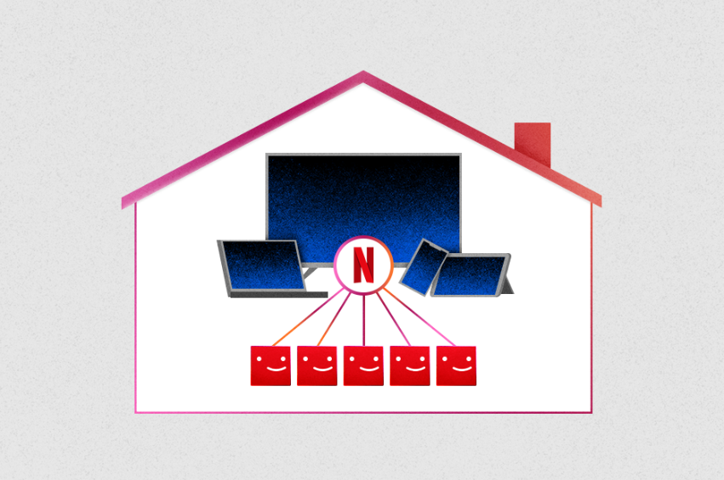
Source – Internet (Netflix, website)
According to a documentary released by Forbes, the loss of 200,000 Netflix subscribers between 2021 and 2022 stunned Netflix's investors (Forbes.com; Rodríguez Ortega, 2023; Netflix, 2023). This was the primary cause for the decline in Netflix's share price during the 2021-2022 fiscal year compared to 2020-2021. Late in 2022, Netflix started rolling out in Canada, New Zealand, Portugal, and Spain, prompting customers to disclose their primary location for the account (Forbes.com; Rodríguez Ortega, 2023).
3.1 How could change described in Netflix
Change Management is a 1960s-era philosophical concept (Creasey, T., 2007). By implementing Organisational Change Management (OCM), an organisation can expect to accomplish four primary goals, such as process changes or implementation, system changes or implementation, organisational changes or internal structure changes, and job role and hierarchy changes (Creasey, 2007; Lauer, 2010). Netflix has implemented Password Crackdown and transfer account policies to accomplish two objectives from the above which are as process implementation, system changes (Forbes, 2023; Creasey, 2007; Rodríguez Ortega, 2023). As described before, Netflix's revenue and market share were affected by password sharing beyond the household; therefore, Netflix's change management could be characterised as a strategic change to the business model that Netflix had practised since its launch (Forbes, 2023; Creasey, 2007).
Figure 2 – Forbes Article published in 2022
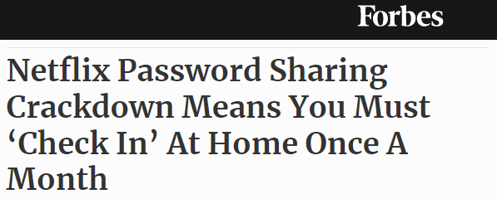
Source – Internet (Forbes, website)
Change management at Netflix focuses primarily on achieving the internal objectives and best interests of internal stakeholders (Rodríguez Ortega, 2023). Change Management always addresses a particular issue or implementation that can be carried out to resolve external or internal problems (By, 2005). Change Management will aid organisations in transitioning from their current state to their desired state (Creasey, 2007; Rodríguez Ortega, 2023). During the change management process, Netflix analysed what the addition of the password enforcement and transfer account to the customer portfolio could bring and devised a plan to manage the change without significantly altering their business model (Rodríguez Ortega, 2023).
3.2 PESTLE Analysis for “Password Crackdown Process” in Netflix
P |  | Political :  Change Management is implementing restrictions on password sharing and account transfers with external households.  Even if the same password is used in different countries, certain content is geographically restricted and cannot be viewed.
E |  | Economic :  As the password cannot be shared with peers outside of the household, it would incur additional costs for consumers.  Certain consumers are not viewing all Netflix content, which is a loss for them.
S |  | Social :  This change could make Netflix less popular. As customers may be unwilling to pay extra to share their credits with a loved one.  In addition, Netflix has original content that is not available through other online streaming services. Thus, Netflix is diplomatically urging its customers to pay an additional fee if they wish to remain Netflix subscribers and share their credentials with extended households.
T |  | Technological :  Netflix will verify the customer's IP address during the registration process and password request to ensure that the password has not been shared with a third party.  In addition, Netflix will record the subscriber's location when they sign up for the service and will verify the subscriber's location via IP address upon each login.
L |  | Legal :  Netflix has implemented additional fees for password sharing due to the loss of profit in 2020 and the cancellation of over 200,000 subscriptions.  Netflix Originals have copyright issues and contain content that a third party cannot distribute.
E |  | Environment :  Netflix has invested in renewable energy and is promoting awareness of global warming.  To demonstrate their social responsibility, Netflix has added more documentaries on animal welfare and children's programming.
Table 01 – Pestle assessment
Source: Netflix (Website,2023); Forbes (2023); Burnes (2020)
3.3 Theoretical framework in Change Management in Netflix
Change is a crucial and essential aspect of every enterprise in the globe. If the "Change" decision is not made in a timely manner, the entire business and what the organisation has accomplished up to that point will fail (Cummings, Bridgman and Brown, 2016). Scholar, Cummings, Bridgman and Brown (2016) argued that the main objectives of change management are to “The main objective of the Change management process is to ensure change’s record, evaluation, authorization, prioritization, planning, testing, implementation, and reviewing in a controlled manner” - (Cummings, Bridgman and Brown, 2016). However, Kurt Lewin who was intent on resolving social conflict, devised a Three-Steps, change management model (Burnes, 2020).
Figure 3 – Change Management Framework
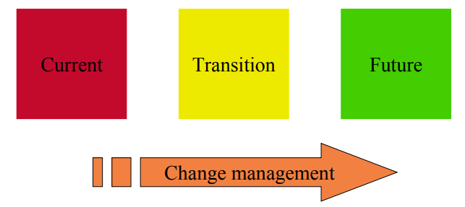
Source – Creasey (2007)

Lewin's Three-Step Model explains that every effective change management model consists of three stages;
Step 01 : Unfreezing – At this point, the organisation must be cleansed with the determination of organisational modifications. Organisations should have a discrete team responsible for implementing changes with a distinct strategy and leadership guidance. Organisations should be able to abandon outmoded practises and be encouraged to adopt new ones. Netflix should give their consumers more information about the adjustments so they can embrace them positively (Sarayreh et al., 2013; Cummings, Bridgman and Brown, 2016).
Step 02 : Moving – The second stage of Lewin's three-step paradigm refers to the adjustments that are intended. At this point, Netflix had a timeline implementation plan. Netflix had intended to implement "Password crackdown and account transfer" in early 2020, but only did so in 2023. Consequently, during the second stage of Lewin's change management model, a plan that is achievable within a reasonable timeframe must be in place (Sarayreh et al., 2013; Cummings, Bridgman and Brown, 2016).
Step 03 : Refreezing – The third stage of Lewin's three-step model is Refreeze. The majority of companies employ a three-step model for the employee induction procedure. As most new employees come from a distinct culture and working environment, most companies conduct freezing and unfreezing sessions to aid in their adaptation. During the Netflix refreezing period, the company and its consumers were informed of the changes and accepted them (Netflix, 2023; Forbes, 2023). Changes made to the principal Netflix accounts were reinforced and stabilised by the change management department. Netflix had implemented alterations to make business operations standard. According to Lewin, it is normal for employees and stakeholders to feel uneasy about adopting the changes at this stage of the change management process (Sarayreh et al., 2013; Cummings, Bridgman and Brown, 2016).
Figure 4 – Lewin’s 3-Step Model
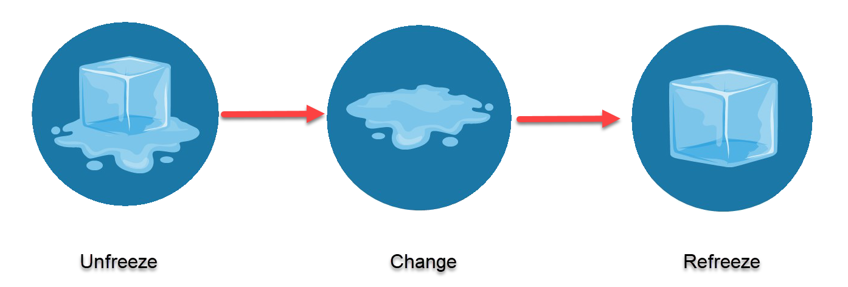
Source –Cummings, Bridgman and Brown (2016)
Scholars have critiqued Lewin's three-step model because it is effective only when a group is involved and does not apply to the individual behaviour process (Sarayreh et al., 2013; Cummings, Bridgman and Brown, 2016).
The majority of academicians argued that change management cannot be confined to a 3-Step model, so John Kotter's 8-Step Model is more applicable to any change management (Sarayreh et al., 2013).
Figure 5 – Kotter’s 8-Step Model
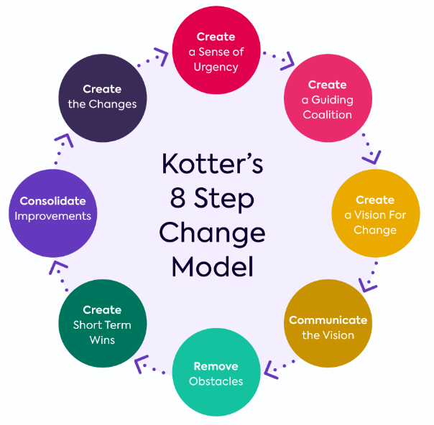
Source –Cummings, Bridgman and Brown (2016)

Step 01 – There should be a sense of urgency to implement change management. Which is crucial and essential. Netflix was constantly forced to implement changes in response to declining revenue and subscription cancellations (Sarayreh et al., 2013; Cummings, Bridgman and Brown, 2016).
Step 02 – The leadership should be in place to facilitate changes to the strategic plan. Since 2020, Netflix was prepared to modify the customer's primary account. And after the new Co-CEO was appointed, the process was accelerated even further (Sarayreh et al., 2013; Cummings, Bridgman and Brown, 2016).
Step 03 and Step 04 – Is to develop a new method for change management and bring everyone on board with the concepts and communication (Sarayreh et al., 2013; Cummings, Bridgman and Brown, 2016; Kitchen and Daly, 2002).
Step 05 – Changes in administration can be implemented when everyone is present, and one of the success factors is the group. Once everyone is on board, leadership should give each person the authority to act in accordance with the vision (Sarayreh et al., 2013; Cummings, Bridgman and Brown, 2016).
Step 06 – When a group achieves a short-term success, it will always generate motivation and positive feelings. Kotter explains in his eight-step model that during the change management process, an organisation should implement a short-term, attainable goal (Sarayreh et al., 2013; Cummings, Bridgman and Brown, 2016).
Step 07 – The urgency and significance discussed in step-1 should be maintained throughout the entire implementation process (Sarayreh et al., 2013; Cummings, Bridgman and Brown, 2016).
Step 08 – Accept and implement the changes brought about by change management. Alternatively, normalise the variations (Sarayreh et al., 2013; Cummings, Bridgman and Brown, 2016).
3.4 Evaluation of “Password Crackdown Process” changes in Netflix
Refer to the feedback from Netflix's leadership team and management. Transfer of account procedure and the password enforcement process have already been implemented in numerous nations (Ten Have et al., 2016; James and Frank, 2015; Anderson and Anderson, 2010).
However, every change management involves a risk that must be mitigated. Netflix had taken a significant risk by instituting the password enforcement procedure, as Amazon Prime Video and Disney had never done so (Lotz, 2022; Sadq, 2013). This could be a deal-breaker for Netflix and may result in the loss of customers and an increase in subscription cancellations in the future. To mitigate this risk, Netflix has added new movie series and provided automatic language translation for all recent films (Lotz, 2022; Adhikari et al., 2012). Netflix has introduced more adventure series and thriller films in the past year compared to the previous year (Eg: The last kingdom all series, You all series, Barbarians two series, etc). The majority of media personalities are debating Netflix's change management with respect to, account transfer procedure, and password enforcement process because it violates the individual fundamentals because these devices are constantly being moved from one location to another, so this type of macro control may not be successful in the online streaming business (Wang, 2023; Lotz, 2022).
Below is the customer feedback after implementation of the “Password Crackdown Process” and Transfer account.
Figure 6 – Customer reaction over password crackdown implemented by Netflix
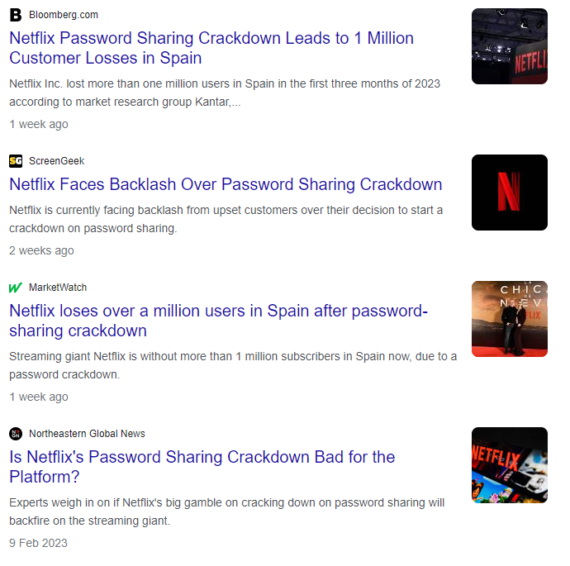
Source – Internet

4. Recommendation
Netflix has implemented the plan after analysing the strategies and analysing the market. However, Netflix faces intense competition from numerous online streaming services. It is a well-known fact that Netflix has few environmentally favourable and animal-related documentaries. Netflix has therefore taken a calculated risk by instituting the "Password Crackdown Process" and Transfer account at this time.
- Netflix should reduce subscription fees to accommodate the "Password Crackdown Process" and account transfer.
- Netflix should add more languages to the online streaming to cover the world.
- Netflix should add more musical related documentaries to the platform.
- Netflix should add "Discrimination" and have similar features in every country in order to retain customers.
- Netflix should solicit positive customer feedback once more by launching a campaign that offers financial incentives to long-term customers. (Eg: Annual Fee, Lifetime Fee, etc..)

5. Conclusion
Netflix is well within its rights to implement the modifications to the password requirement and the process of transferring accounts. However, in accordance with Lewin's model for the management of organisational change, Netflix has focused its emphasis on a single goal, which is the maximisation of profits. The three-step approach developed by Lewin is, however, more applicable to the field of human resources or internal change management. Netflix has implemented a number of important structural changes to its business model.
Everyone is letting their loved ones in on their Netflix, Amazon, and Disney passwords, which they keep secret from themselves. Netflix had the option of either increasing the monthly membership costs or coming up with an annual charge; however, the company opted to make adjustments to its business model instead. If not, Netflix might have created a distinct window for clients that needed greater access or more people to utilise their service. Netflix has not made any sacrifices to their profit share as a result of the cancellation of subscriptions. If just Netflix were to come up with such rules, it would put Netflix's market share at danger over the long term, as the competitors are not currently adopting such practises.

References
Adhikari, V.K., Guo, Y., Hao, F., Varvello, M., Hilt, V., Steiner, M. and Zhang, Z.L., 2012, March. Unreeling netflix: Understanding and improving multi-cdn movie delivery. In 2012 Proceedings IEEE INFOCOM (pp. 1620-1628). IEEE.
Anand, P., 2011. Talent development and strategy at telecom major Bharti Airtel. Strategic HR Review.
Anderson, D. and Anderson, L.A., 2010. Beyond change management: How to achieve breakthrough results through conscious change leadership (Vol. 36). John Wiley & Sons.
Ayyagari, M. and Parahoo, S., 2022. Insights-Based Market Segmentation for Competitive Advantage: Majid Al Futtaim’Malls. In SAGE Business Cases. El Khazindar Business Research and Case Center, The American University in Cairo School of Business.
Bajaj, D., 2020. Netflix Strategies for Marketing. Issue 2 Int'l JL Mgmt. & Human., 3, p.405.
Burnes, B., 2020. The origins of Lewin’s three-step model of change. The Journal of Applied Behavioral Science, 56(1), pp.32-59.
Burroughs, B., 2019. House of Netflix: Streaming media and digital lore. Popular Communication, 17(1), pp.1-17.
By, R.T., 2005. Organisational change management: A critical review. Journal of change management, 5(4), pp.369-380.
Cameron, E. and Green, M., 2019. Making sense of change management: A complete guide to the models, tools and techniques of organizational change. Kogan Page Publishers.
Chatterji, A.K. and Toffel, M.W., 2018. The new CEO activists. HBR’S 10 MUST, 47.
Creasey, T., 2007. Defining change management. Prosci and the Change Management Learning Center, pp.1-6.
Cummings, S., Bridgman, T. and Brown, K.G., 2016. Unfreezing change as three steps: Rethinking Kurt Lewin’s legacy for change management. Human relations, 69(1), pp.33-60.
DSM, D., Wijesinghe, M.R.P. and PWG, M., 2021. Initial Return of Initial Public Offerings (IPOs) and IPOs Underpricing: Evidence from Sri Lanka. Available at SSRN 4117058.
H. James, H. and Frank, V., 2015. Cultural change management. International Journal of Innovation Science, 7(1), pp.55-74.
Hayes, J., 2022. The theory and practice of change management. Bloomsbury Publishing.
Kitchen, P.J. and Daly, F., 2002. Internal communication during change management. Corporate Communications: an international journal, 7(1), pp.46-53.
Kumar, M., Jauhari, H., Rastogi, A. and Sivakumar, S., 2018. Managerial support for development and turnover intention: Roles of organizational support, work engagement and job satisfaction. Journal of organizational change management.
Lauer, T., 2010. Change management. Springer Berlin Heidelberg.
Lotz, A.D., 2022. Netflix and streaming video: The business of subscriber-funded video on demand. John Wiley & Sons.
Lye, R.M., 2022. Review of Mergers & Acquisition Cases in Sri Lanka. Sri Lanka Journal of Marketing, 8.
Muema, P.N., 2013. Strategic change management practices and challenges at Safaricom limited, Kenya (Doctoral dissertation, University Of Nairobi).
Pînzaru, F., Zbuchea, A. and Viţelar, A., 2019. Digital transformation trends reshaping companies. In Proceedings of the International Conference on Business Excellence (Vol. 13, No. 1, pp. 635-646).
Rodríguez Ortega, V., 2023. ‘We Pay to Buy Ourselves’: Netflix, Spectators & Streaming. Journal of Communication Inquiry, 47(2), pp.126-144.
Sadq, Z.M., 2013. Analysising Netflix‟ s Strategy. International Journal of Science and Research (IJSR)–Режим доступа: https://www. ijsr. net/archive/v4i3/22031503. pdf.
Safian, R., 2018. Exclusive: Spotify CEO Daniel Ek on Apple, Facebook, Netflix–and the future. Fast Company.
Salijeni, G., Samsonova-Taddei, A. and Turley, S., 2019. Big Data and changes in audit technology: contemplating a research agenda. Accounting and business research, 49(1), pp.95-119.
Sarayreh, B.H., Khudair, H. and Barakat, E.A., 2013. Comparative study: The Kurt Lewin of change management. International Journal of Computer and Information Technology, 2(4), pp.626-629.
Sarolli, G.D. and Venkatesan, R., 2020. Netflix, Inc.: DVD Wars.
Spicer, A., 2020. Organizational culture and COVID-19. Journal of Management Studies, 57(8), pp.1737-1740.
Stouten, J., Rousseau, D.M. and De Cremer, D., 2018. Successful organizational change: Integrating the management practice and scholarly literatures. Academy of Management Annals, 12(2), pp.752-788.
Tabrizi, B., Lam, E., Girard, K. and Irvin, V., 2019. Digital transformation is not about technology. Harvard business review, 13(March), pp.1-6.
Tang, W. and Wei, M., 2023. Streaming media business strategies and audience-centered practices: a comparative study of Netflix and Tencent Video. Online Media and Global Communication, 2(1), pp.3-24.
Ten Have, S., Ten Have, W., Huijsmans, A.B. and Otto, M., 2016. Reconsidering change management: Applying evidence-based insights in change management practice. Routledge.
Thomas, R., 2021. Password Sharing and Online Dispute Resolution Systems. Bus. Entrepreneurship & Tax L. Rev., 5, p.147.
Wang, Y., 2023, February. Research on the Competitive Analysis and Competitive Strategy Optimization of Netflix. In 2022 4th International Conference on Literature, Art and Human Development (ICLAHD 2022) (pp. 373-381). Atlantis Press.
https://ir.netflix.net/governance/Leadership-and-directors/person-details/default.aspx?ItemId=f23c3a43-5633-46e9-a77f-a58e28893a50
https://online.hbs.edu/blog/post/change-management-process
https://www.apm.org.uk/resources/what-is-project-management/what-is-change-management/
https://www.forbes.com/advisor/au/internet/netflix-password-sharing-rules-explained/

