

Marketing Essentials
BMIH4005

Student Name: Elena Boboc Student ID: 2206217
Lecturer Name: Dale Clarke



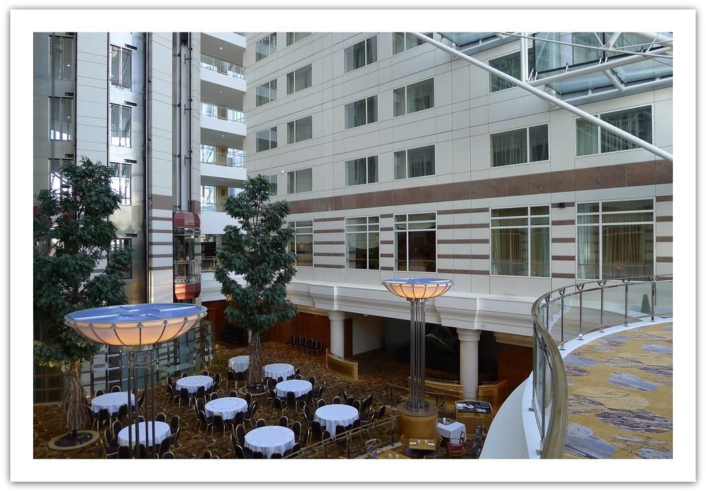

Introduction

- - The Hilton Paris Opera is a prestigious, luxurious hotel located in
the heart of Paris, France.
- - Housed in a historic building from 1889, the hotel features Belle Époque architecture that has been meticulously preserved.
- - With 267 rooms, the hotel caters to both sophisticated business travelers and leisure guests seeking a premium experience.
- - Its central location provides easy access to popular tourist destinations like Opera Garnier, Louvre Museum, and Champs- Élysées.
- - Acquired by the Hilton brand, the hotel has been strategically positioned to broaden its appeal and cultivate loyalty among existing clientele, resulting in increased reputation within the hospitality industry.
This Photo by Unknown Author is licensed under CC BY

SWOT Analysis of Hilton Paris Opera
- - The hotel has strengths such as beautiful historic architecture, central location, Hilton brand recognition, luxurious amenities, and existing customer loyalty.
- - One weakness is the high pricing compared to neighboring hotels, and limited number of rooms may impact potential revenue.
- - Opportunities lie in the growing tourism sector, targeting high- spending travelers, enhancing services, and collaborating with complementary businesses.
- - Threats include intense competition, economic fluctuations, political instability, terrorism, and COVID-19 pandemic impacts.

Segmentation & Targeting
- - Market segmentation involves dividing the hotel industry into smaller markets based on demographics, geography, psychographics, and consumer behavior.
- - The hotel can attract affluent business and vacation travelers seeking a luxurious French- themed retreat.
- - International tourists interested in French culture and famous attractions such as Opera Garnier and Louvre Museum are a target audience the hotel can cater to.
- - Domestic and international business travelers looking for luxury and efficiency can benefit
from the hotel's modern conveniences such as meeting rooms, offices, and technology.
- - The hotel can improve its consumer targeting tactics with social media, influencer marketing, and regional promotions to enhance branding, reputation, revenue, and customer satisfaction.

Competition
- - Four Seasons Hotel George V
- - The Ritz Paris
- - Hotel de Crillon
- - Mandarin Oriental Paris
- - Park Hyatt Paris-Vendome
- - Shangri-ala Hotel Paris
- - Le Bristol Paris

Collaborators
- Local restaurants
- Entertainment businesses
- Transportation services
- Tourist attractions
- Event planners

PESTLE Analysis
- - Political factors, including international relations, taxation policies, and regulations, may affect the hotel's operations and revenue, and it is essential to stay up-to-date on these changes.
- - Economic factors, such as inflation rates and consumer purchasing power, impact the hotel industry's profitability, especially for high-end luxury services.
- - Social factors, such as cultural trends and lifestyle preferences, shape guests' decisions about accommodation, and it is necessary to monitor these trends to cater to potential guests' needs.
- - Technological factors, such as new online reservation platforms or mobile applications, impact the hospitality industry, and Hilton Paris Opera must maintain up-to-date technology to remain competitive.
- - Legal factors, including labor laws, environmental protection, and licensing regulations, are essential
for Hilton Paris Opera to operate safely and obtain a good reputation.
- - Environmental factors, such as the climate crisis and sustainability, may influence guests' decisions to choose eco-friendly hotels. Sustainable hotel management strategies can improve Hilton Paris Opera's image and attract eco-conscious guests.

SMART OBJECTIVES
- - Increase revenue from high-end luxury travelers by 10%
- - Improve customer satisfaction ratings by 15%
- - Achieve an average occupancy rate of 75% during the peak summer months
- - Reduce energy consumption by 15%
- - Improve guest loyalty rates by 20%

Ansoff Matrix

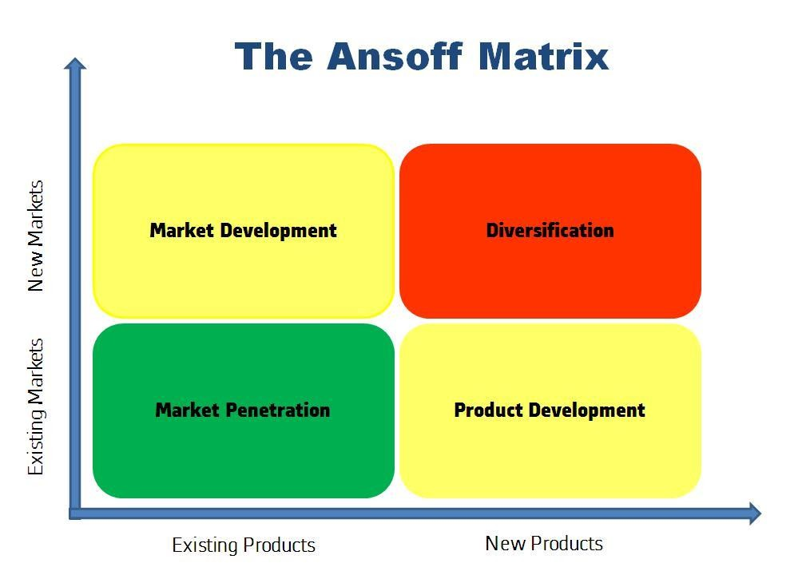
This Photo by Unknown Author is licensed under CC BY-SA

Tactics
- - Establish confidential communication methods for both personnel and guests to ensure effective and rapid communication.
- - Incorporate digital communication technologies such as email and social media platforms to facilitate communication between hotel guests and employees.
- - Hold frequent training sessions to enhance communication abilities among hotel employees.
- - Consider introducing multilingual services in tourist destinations like Paris to cater to guests' language requirements.




Actions & Control

Gantt Chart

- ------------------------------------------------------------------------------------
- | Task Description | Start Date | End Date |
- ------------------------------------------------------------------------------------
- | Project Initiation | 2023-01-01 | 2023-01-07 |

- | Task 1: Establish Confidential Communication Methods | 2023-01-08 | 2023-01-21 |
- | - Define communication protocols and security | | |
- | - Procure necessary equipment and software | | |
- | - Train personnel on confidentiality measures | | |
- | Task 3: Employee Training Sessions | 2023-02-08 | 2023-03-08 |
- | - Plan and schedule training sessions | | |
- | - Conduct training sessions | | |
- | - Evaluate and update training as needed | | |

- | Task 4: Multilingual Services | 2023-03-09 | 2023-03-31 |
- | - Research language needs and preferences | | |
- | - Hire multilingual staff | | |
- | - Implement multilingual service options | | |

• | •
• | | Task 2: Incorporate Digital Communication | | 2023-01-22 | | 2023-02-07 | | • | | Project Closure | | 2023-04-01 | | 2023-04-07 |
| |
- | - Implement email and social media platforms |  |  |  |  |  |  | | | - | - Final review and documentation | | |  |  | | |  |  | |
- | - Integrate communication tools with systems | | |  |  | | |  |  | | | - | - Handover project to operations | | |  | | |  |  | |
- | - Test and ensure system reliability | |  |  | | |  |  | | |  | - | - Celebrate successful project completion |  | | |  |  | | |  | |

References
- 1. Vallen, G. K., & Vallen, J. J. (2016). Marketing plan for the Sheraton Hotel Jiuzhaigou Resort. Tourism Management Perspectives, 19, 105-112.
- 2. Grossman, M. C., & Stinerock, R. (2015). Developing a successful hotel marketing plan. Journal of Hospitality and Tourism Insights, 1(4), 245-251.
- 3. Kim, J. B., & Lee, T. J. (2019). The effect of hotel marketing mix on brand equity and loyalty: A case of luxury hotels in Korea. International Journal of Tourism Sciences, 19(1), 1-17.
- 4. Verma, R., & Wu, L. (2020). Social media marketing and hotel performance: Evidence from the United States. Journal of Travel Research, 59(5), 905-918.
- 5. Niu, J., Liang, X., & Cai, L. A. (2015). Determinants of hotel customer loyalty in China: A snapshot of guests from Shanghai. Journal of Destination Marketing & Management, 4(4), 225-233.
- 6. Chen, C. H., & Chen, Z. S. (2019). Hotel guests' evaluation of brand reputation: Evidence from Taiwan's five-star hotels. Journal of Hospitality and Tourism Management, 41, 78-85.
- 7. Wang, D., Bi, Y., & Hu, G. (2015). A comparative study of hotel marketing communications strategy in China and the United States. Journal of Destination Marketing & Management, 4(1), 49-57.
- 8. Deng, Z., Li, X., & He, Q. (2015). Guest experience, brand image, and customer loyalty in the hotel industry: An empirical study from China. International Journal of Hospitality Management, 46, 130-140.
- 9. Li, T., Qu, H., Wang, D., & Liang, S. (2020). Social media marketing and tourist shopping intention: A study of Chinese outbound tourists visiting Singapore. Journal of Vacation Marketing, 26(2), 204-215.
- 10. Gong, H., Zhang, D., Zhang, H., & Zhang, Q. (2021). The effects of information overload on hotel booking intention: The moderating role of decision-making style. Journal of Hospitality Marketing & Management, 30(2), 185-201.
- 11. Jang, S. S., Liu, D., & Namkung, Y. (2016). Effects of restaurant green practices on brand equity formation: do green practices really matter? International Journal of Hospitality Management, 52, 131-140.
- 12. Kurtulus, K., & Incekara, A. (2019). The relationship between the hedonic value and hotel guest loyalty: The role of the emotion regulation strategy. Journal of Destination Marketing & Management, 12, 67-73.
- 13. Buhalis, D., & Schertler, W. (2018). Creative destruction in hospitality: Exploring the effects of crowdfunding on hotel entrepreneurship. Journal of Tourism and Hospitality Management, 6(2), 26-32.
- 14. Hopkins, C. D. (2017). Promoting luxury hotel brands online: A framework for social media management. Journal of Hospitality and Tourism Technology, 8(1), 2-12.
- 15. Kim, H. D., Agrusa, J., & Oh, J. C. (2015). The effects of customer satisfaction and switching barrier on customer loyalty in Korean mobile telecommunication services. Asia Pacific Journal of Tourism Research, 20(9), 1027-1047.
- 16. Lee, C. K., & Back, K. J. (2020). Do the Chinese care about hotel green practices? The moderating role of perceived eco-friendly destination image and place attachment. Journal of Sustainable Tourism, 28(10), 1489-1507.
17. Kwon, K. N., & Lee, H. H. (2016). An analysis of the impact of the hotel's in-room amenities on guest satisfaction: Focused on the non-metropolitan area. Journal of Tourism and Leisure Research, 28(3), 67-85.

Slide 2
The Hilton Paris Opera is a famous luxury hotel in Paris, France. The inn is in a historic 1889 structure. Its Belle Époque architecture has been meticulously conserved. It includes 267 spacious rooms with exquisite design. These rooms are for sophisticated business and leisure travelers seeking a top-notch experience.

Slide 3:
The hotel has many strengths, including Belle Époque architecture and historical value. Hilton is well-known in the industry.
- The house is in a prime central Parisian location near several tourist attractions. The rooms include luxurious furnishings and conveniences. Customer loyalty and patronage are high at the establishment.

Budget-conscious tourists may avoid the hotel due to its high price compared to nearby hotels.
The limited 267 rooms may cause overpopulation during high tourist seasons, reducing profitability.
Maintaining the ancient building and providing top-notch facilities are expensive.

Paris' tourist sector growth presents an opportunity to boost revenue by providing more services to corporate and recreational travelers. Enhancing our approach to targeting affluent business and leisure tourists to increase income.

Increasing service and facility quality to attract and retain customers. Creating strategic alliances with complementary businesses like adjacent restaurants and entertainment venues to increase client base and revenue.

Competition from luxury hotels, boutique hotels, and vacation rental sites in Paris is a major concern. Tourism and travel are affected by economic swings, both favorable and negative.

Slide 4

The target demographic is international tourists with disposable income who want to experience French culture and visit Paris's top attractions. The hotel's proximity to the Opera Garnier, Louvre Museum, and Champs-Élysées will appeal to culture-lovers. For luxury travelers seeking individualized service, the hotel can customize its offers.

Another target demographic is domestic and international business travelers who value convenience, luxury, and productivity. Meeting facilities, corporate offices, and cutting-edge technology may draw such guests to the hotel..

Social media, influencer marketing, and targeted promotions for specific demographics and regions can help the hotel target consumers. By targeting these categories, Hilton Paris Opera may boost its brand's image, income, and customer happiness.

Slide 5

Hilton Paris Opera Hotel has many competitors in the luxury hotel industry in Paris, including:

1. Four Seasons Hotel George V: A luxury hotel with magnificent architecture and interior design, offering limousine services, a spa, and fine dining.

2. The Ritz Paris: A world-renowned, historic hotel with luxurious suites and a spa, offering fine dining and a bar.

3. Hotel de Crillon: Another historic palace hotel in Paris, featuring grand interiors, a spa, Michelin-starred restaurants, and private event spaces.

4. Mandarin Oriental, Paris: A 5-star hotel in a prime location near the Louvre and Champs-Élysées, with opulent rooms and suites, a spa, and gastronomic dining options.

Slide 6:

Hilton Paris Opera may partner with several companies to improve customer service and grow their consumer base. Potential collaborators include:

1. Local restaurants: The hotel can partner with adjacent restaurants to give visitors discounts, packages, or collaborations. This lets travelers try Paris' best local cuisine.

2. Entertainment businesses: Teaming up to offer concert, theatre, and event tickets and unique tours of Paris' nightlife and culture.

3. Transportation services: Working with local limousine and automobile rental companies to make visitor travel easier.

4. Tourist attractions: Working with museums, galleries, and theme parks can give travelers discounts and exclusive access while promoting Paris.

5. Event planners and wedding organizers: Working with local event planners and wedding organizers to aid guests with special occasions or business events can build lasting ties and reduce stress.

Slide 7

PESTLE analysis is a tool that helps identify the political, economic, social, technological, legal, and environmental factors that affect an organization. In the case of Hilton Paris Opera, the following are the factors of the PESTLE analysis.

1. Political: Paris's hospitality and tourism economy depends on political stability. Changes in international relations, government taxation, and tax incentives may affect hotel operations and revenue. Political developments that affect travel, immigration, or lodging restrictions must be monitored.

2. Economic: Inflation, currency exchange rates, and recessions can affect hotel profitability. In addition, consumer spending power can affect hotel revenue, especially for luxury services.

3. Social: Cultural, social, and lifestyle trends influence travellers' accommodation selections. Hilton Paris Opera tailors services and facilities to consumer preferences and lifestyles by monitoring them.

4. Technological: New online reservation platforms and guest service mobile apps can affect the hospitality business. The hotel must keep up with technology to satisfy guests and stay competitive.

5. Legal: Hospitality laws include labour, environmental, contractual, and operating licence rules. To maintain its reputation and function legally, the hotel must follow certain requirements.

6. Environmental: The climate catastrophe and industry pressures to reduce carbon footprint, waste, and pollution. Sustainable hotel management can boost the property's image and attract eco-conscious customers.

Slide 8:

SMART objectives are specific, measurable, achievable, relevant, and time-bound. For Hilton Paris Opera, some SMART objectives could be:

1. Increase high-end luxury traveller income by 10% in 12 months through focused marketing and promotions.

2. Increase customer satisfaction by 15% in 6 months by implementing new customer service training modules and providing personalized hospitality services.

3. Increase room options and price flexibility for Hilton website customers in the next 18 months to reach 75% occupancy during peak summer months.

4. Reduce hotel energy usage by 15% in the following year by introducing energy-efficient measures including recycling and eco-friendly practices.

5. In 18 months, increase guest loyalty by 20% by offering exclusive benefits, personalized services, and reward programs.

Slide 9:

Hilton Paris Opera can employ Ansoff Matrix Market Penetration to boost market share and revenue. To improve market share and revenue, the Hilton Paris Opera can provide loyalty programs, exclusive bonuses for repeat clients, and bespoke services. By using its position, history, and culture to attract and retain travelers, Hilton Paris Opera can increase customer satisfaction, loyalty, and revenue. Provide more services and flexible pricing to retain and repeat customers.

Slide 10
Hotel management should provide confidential communication methods for staff and visitors. This technique informs all parties of the multiple communication channels available, resulting in fast and effective communication.

Digital communication technology like email, SMS, and social media can help hotels. The installation of such a system is expected to make it easier for hotel guests and staff to communicate about visitors' needs and concerns, especially when guests are not present.
.
The hotel should organize periodic training sessions to improve staff communication with guests and each other as such practices may improve communication. The paper's authors researched a certain topic.

Since Paris is a popular tourist destination, the city should consider offering multilingual services to meet tourists' diverse language needs such as serving customers conversant in languages other than the regional vernacular would be profitable.

Slide 11:

To improve online visibility and guest access, hotels should optimize their websites for search engines. To ensure user accessibility, the website must be mobile-optimized.
The Hilton Paris Opera uses social media marketing to reach potential and current guests. Social media material must be instructive, visually appealing, and engaging to captivate audiences.
The hotel can use email marketing to provide newsletters and promotions to subscribers.

Revenue growth, occupancy rates, customer happiness, and marketing campaign ROI will be used to evaluate the Hilton Paris Opera's operational efficiency. These measurements evaluate the hotel management's strategies and streamline any necessary changes.

Slide 12:
GANTT Chart

This Gantt chart outlines the tasks and their respective start and end dates for the project related to Hilton Paris Opera Hotel. Task 1 focuses on establishing confidential communication methods, Task 2 on incorporating digital communication technologies, Task 3 on employee training sessions, and Task 4 on introducing multilingual services. The project is expected to take approximately four months from initiation to closure. Please note that the durations and dates are just placeholders and can be adjusted based on the actual project timeline and resource availability.

