  Component One: Student Journal (learning log) 750 words +/- 10%  Contribution to Overall Module Assessment: 25% | Student No: | 2209539
 | Module Title: | Hotel  Administration and Front Office
 | Module Code: | BMIH4004
 | Lecturer: | Natalie Brailsford  Dan Payne  Nail Dyer  Muhammed Cassamo  Scott James
It takes a diverse set of skills to work at a hotel's front desk and successfully assist guests. In this journal entry, I will apply the Gibbs model to an analysis of my own talents and experiences, finding links between abstract principles and practical applications. Engagement with literature, understanding and comprehension, cognitive and intellectual, feasible, and transferrable for life and professional practise are all crucial for a career in a hotel front desk job.

Engagement with Literature Skills
To be successful at the front desk of a hotel, one must actively engage with the literature to stay current on industry trends and best practises. Professionally, I've benefited from reading academic papers, industry studies, and hotel management literature. For instance, I've studied the marketing strategies utilised by the hospitality business by reading the writings of well-known hotel management specialists like Peter Jones and Philip Kotler. The more I read, the more I not only learned but also realised what the most critical problems were in my industry.

Knowledge and Understanding Skills
The front desk staff of every hotel has to have a firm grasp of the foundations of hospitality administration (Hong et al., 2023). Although I had a firm understanding of the principals involved because of my formal education, it was applying them in practise at Oulton Hall that provided the most insightful learning experience. I've learned a lot about revenue management by seeing it in action at the hotel, such as via the use of dynamic pricing strategies and occupancy forecasting.

Cognitive and Intellectual Skills
Intelligence, especially in the areas of problem-solving and critical thinking, is also required for employment at hotel front desks. When dealing with guest complaints or handling other unanticipated events, I've had to think quickly on my feet. By putting into practise what I've learned in workshops on service recovery and customer satisfaction, I've become adept at diffusing tense situations and coming up with novel approaches to ensuring that every client leaves with a positive image of my business.

Practical Skills
Front desk staff at hotels must be well-rounded in order to succeed. Working at Oulton Hall has prepared me to handle reservations, check guests in and out, and run property management systems with ease and confidence (Mariani and Wirtz, 2023). I am also skilled at multitasking because of the hectic nature of check-in and check-out times. Successfully completing these responsibilities depends on having both the theoretical background and hands-on experience necessary to do so.

Transferable Skills for Life and Professional Practice
Working at a hotel's front desk is a great way to get transferable skills that may be used in any field (Mariani and Baggio, 2022). Effective communication, time management, and collaboration are just a few of the many transferable abilities I developed at Oulton Hall. For instance, I've learned directly from the current pandemic how important it is to be adaptable and inventive while facing hardship. The lessons I learned at Oulton Hall have helped me become more adaptable and proactive in every facet of my life and career.

Gibbs reflective model

Description
Working at Oulton Hall Hotel Spa & Golf Resort has given me the chance to get experience in many areas of the hospitality business, as described by Gibbs.

Feelings
My journey within the hospitality industry has elicited a wide spectrum of feelings, from elation to anxiety (Sigala et al., 2021). This conflicted emotion stems from the dual forces of exciting new opportunities and the weight of visitors' high expectations.

Evaluation
Proficiency in literary interaction is crucial for a career in hospitality. I've studied independently, consuming things like academic journals and books on hotel management. As a result of my commitment to learning throughout my life, I am constantly aware of the most recent advancements in my area. Reading the works of hotel marketing experts like Peter Jones and Philip Kotler has equipped me to implement novel ideas at Oulton Hall.

Analysis
There is a certain set of abilities needed to work at a hotel's front desk. My formal training gave me a firm grounding in the theoretical aspects of hospitality management, and my on-the-job experience at Oulton Hall has added to this knowledge (Wut et al., 2021). By putting into exercise what I've learned in the classroom, I've been able to polish my judgement in areas like pricing and demand strategy.

Conclusion
It is clear that intelligence and wit are a must for success in the hospitality sector. In order to maintain Oulton Hall's excellent service reputation, I have developed my problem-solving and critical-thinking abilities via repeated exercise.

Action plan
I wish to continue receiving practical experience at Oulton Hall in order to strengthen my practical talents. In addition, I want to improve what are called "transferable skills," which may be used in many different situations.

Component Two
Contribution to Overall Module Assessment: 25%
Trip Advisor Review Response 150 words +/-10%
Thank you so much for the fantastic TripAdvisor review of our hotel. We are pleased that you had a wonderful visit, and we appreciate your praise very much.
Our number one priority is making sure that all of our guests have a wonderful time while they are with us. Your feedback affirms that you are getting first-rate service from us and motivates us to keep improving.
We're glad to hear that you appreciate utilising [this feature/service of ours]. What really sets us different is the tireless efforts of our staff and their commitment to giving our clients with an amazing experience.
We look forward to your return and the opportunity to exceed your expectations. If you have any further thoughts or comments, please don't hesitate to get in contact. Your thoughts and feedback are crucial to us.
Thank you for visiting, and we hope to have you back again soon!

Screen shot of referenced Trip Advisor review used:
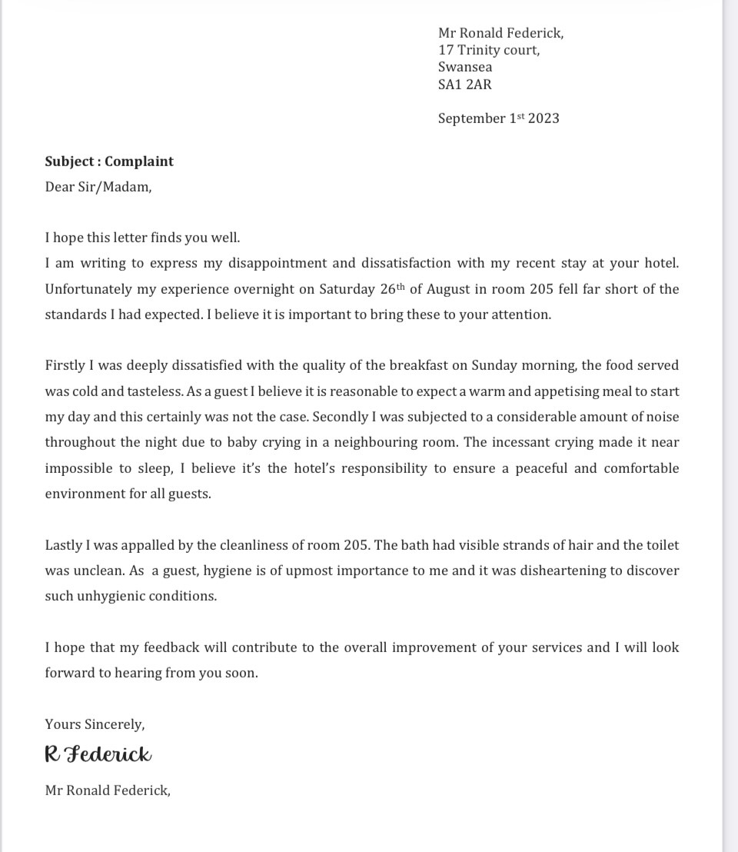

Letter of complaint response 500 words +/- 10-%
Mrs Tany Gue Ferreira Amaro
Supervisor
Oulton Hall Hotel Spa & Golf resort
Rothwell Ln, Oulton
Leeds
LS26 8HN
7th of November 2023

Dear Mr. Federick,

Subject: Response to Your Complaint
I appreciate you taking the time to read this letter. I hope this message finds you in good health and having fun. Permit me to begin by expressing my sincere regret for any problems that may have arisen during your stay at our hotel. I am grateful that you have given me the opportunity to react to the input that you provided. This information is really useful to us.
I am sorry to hear that your experience at room 205 on the 26th of August (Saturday) was not a positive one. I am sorry that we were unable to provide a pleasant and peaceful experience for our visitors throughout their stay.
It is my deepest regret that the quality of the breakfast we served on Sunday morning was not up to standards. When it comes to the quality of our customer service, I can assure you that this is not the standard we strive to achieve. Our chefs and wait staff will investigate the situation to ensure that each and every patron receives the piping hot, satisfying meal that they have earned.
I sincerely ask your forgiveness if the sound of the infant wailing in the adjacent room made you feel uncomfortable. We shall make adjustments immediately away to ensure that the tranquilly of your sleep throughout the night will not be disturbed in the future. Hold on for a second as we try to work this out.
After hearing everything you've mentioned, I can't help but feel concerned about the state of cleanliness in room 205. It is my deepest regret that the care that we took to clean and sanitise did not satisfy your requirements. I guarantee that we will thoroughly search and clean each and every room in order to remove any evidence of this gathering.
During the process of enhancing the quality of our offerings, we will keep your feedback in mind. Believe that we are working hard to find solutions to these issues and to prevent them from occurring again in the future.
We are grateful for your patronage and would want the opportunity to win back your confidence. I really apologise about this, and I do hope that you would consider giving us another opportunity to be your hosts in the future. I give you my word that we will significantly improve the quality of service and comfort that you get.
Get in touch with me at Email Address or Your Phone Number if you need more information or want to set up a visit for later. We will do everything we can to make sure you have a great time when you come back.
Please accept my sincere apologies for the trouble this has caused, and know that your comments will be used to make our services better in the future.

Yours faithfully,
Mrs Tanya

Component Three:
Contribution to Overall Module Assessment: 50% (1000 words +/- 10%)
Writing in essay format
Introduction
The Hotel Visitor Cycle is a crucial framework for analysing and controlling guests' experiences before, during, and after their stays. Guest satisfaction and loyalty depend critically on the quality of management at all levels of the hotel (Gürlek and Koseoglu, 2021). In order to describe and assess the main components required to manage the hotel visitor cycle, this article will rely on current and relevant research.
Element 1 – Pre-Arrival

The experience of a guest starts before they ever arrive, and the mood they establish at this point will carry through their whole stay. Leadership that is both timely and effective is more important than it has ever been. It is very necessary to have a trustworthy booking and reservation system in place. Ye et al., (2022) feel that a reservation system that is free of problems is absolutely necessary for repeat customers. Hotels such as the Marriott have created user-friendly online booking systems, which enable visitors to choose their desired lodging and extra amenities prior to ever checking into the hotel.
Conversations between individuals are also very valuable to have. According to law et al., (2020), a more positive pre-arrival experience might be accomplished via the use of individualised emails or messages that welcome the visitor and give help. In the pre-arrival letters that guests of The Ritz-Carlton receive, the hotel inquires about any dietary restrictions or other requests that the guests may have.

Element 2 – Arrival

Since this is the first time a guest has direct physical contact with the hotel, it is a watershed point in the stay. Here, visitors' initial impressions of the company are formed, thus the check-in process is crucial. found that including modern conveniences like smartphone check-in and keyless access devices might significantly streamline the Arrival phase (Elkhwesky et al., 2022). The Hilton Honours app, for instance, is ahead of the curve since it enables guests to check in and access their rooms from their cell phones. This strategy not only improves the customer's overall experience but also reduces wait times.
A warm welcome is just as important as speedy check-in procedures. Greeting guests by name and rewarding repeat customers are two ways to show visitors they are respected and appreciated, as emphasised by (Kim and So, 2022). The employees at Four Seasons Hotels & Resorts have a well-deserved reputation for providing exceptional service. They make a good first impression by remembering guests' names and offering refreshments. These seemingly little gestures go a long way towards making the guest feel at home right away.

Element 3 – Duration of stay

The success of a hotel depends on its capacity to keep its guests happy and comfortable throughout the duration of their stay. Now more than ever, it's crucial that rooms be cleaned and maintained on a consistent basis (Cheng et al., 2023). All lodgings must be immaculate, well-kept, and sanitary. Hotels of the Hyatt chain are among the most progressive in this regard, having implemented policies like "green" housekeeping. This scheme does more than just save the world by allowing eco-conscious guests to reduce the number of cleanings they get throughout their stay.
Also crucial is the quality of service offered to guests throughout their stay. According to Torres et al. (2021), hotels need to consistently go above and beyond for guests to remember their stay. When it comes to encouraging and supporting employees to go above and beyond to satisfy visitors, The Ritz-Carlton serves as an example. The hotel's proactive service and individualised attention make guests feel valued and cared for during their stay, increasing their sense of satisfaction and increasing the likelihood that they will return. Maintaining and, if possible, improving service quality during a guest's stay is essential if they are to leave with a positive impression.

Element 4 – Departure

The Departure phase has a significant impact on a guest's last impression of the hotel. For most tourists, this is the highlight of their whole journey. For the Departure stage to be effective, the check-out process must be simple and speedy. Nusair et al., (2020) underline the necessity of eliminating possible difficulties during checkout. Following this pattern, several establishments now provide visitors with the option of an expedited checkout. For instance, AccorHotels' express check-out, which enables guests to check out without visiting the front desk, greatly simplifies and expedites the Departure phase.
In addition, feedback from guests must be gathered prior to their departure during the Departure phase. Emphasized the significance of leveraging feedback from customers to promote service quality improvements (Zha et al., 2023). InterContinental Hotels Group (IHG) is one such hotel group that has decided to handle this situation independently. Visitors may fill out a survey at the front desk or later on at the website. Visitors may share their joys, sorrows, hopes, and fears here. It is vital for hotels to have mechanisms in place to track guest feedback and quickly address any issues that are brought to light. Departure impressions are especially potent, so hotels that actively solicit guest feedback and act on it may amaze guests long after they've checked out.

Conclusion
In conclusion, creating a remarkable and memorable guest experience requires expert management of the four critical stages of the hotel visitor cycle: pre-arrival, arrival, length of stay, and departure. This article examines each stage, drawing on the most current research in the subject, and illustrates its key elements using real-world business situations. The pre-arrival portion of a guest's experience involves customised communication and expedited reservation procedures, and it sets the tone for the entire stay. Hotels like Hilton have used mobile check-in and keyless access technology, while the Four Seasons have made customised emails and messages popular.
During the Arrival stage, visitors are reminded of the importance of a prompt check-in and a kind, personalised welcome. Guests at the Four Seasons benefit from a number of firsts that have been introduced by the hotel chain. Maintaining immaculate cleanliness, doing routine room maintenance, and providing outstanding service all contribute to guests' sense of well-being and enjoyment during their stay. Hyatt's "green" cleaning programme and The Ritz-Carlton's proactive approach to service are examples of these ideas in action.

References
Cheng, X., Xue, T., Yang, B. and Ma, B., 2023. A digital transformation approach in hospitality and tourism research. International Journal of Contemporary Hospitality Management, (ahead-of-print).
Elkhwesky, Z., El Manzani, Y. and Elbayoumi Salem, I., 2022. Driving hospitality and tourism to foster sustainable innovation: A systematic review of COVID-19-related studies and practical implications in the digital era. Tourism and Hospitality Research, p.14673584221126792.
Gürlek, M. and Koseoglu, M.A., 2021. Green innovation research in the field of hospitality and tourism: The construct, antecedents, consequences, and future outlook. The Service Industries Journal, 41(11-12), pp.734-766.
Hong, C., Soifer, I., Lee, H., Choi, E.K.C. and Ruetzler, T., 2023. Hospitality and tourism management student satisfaction with their majors and career readiness amid the COVID-19 pandemic. Journal of Hospitality, Leisure, Sport & Tourism Education, 32, p.100434.
Kim, H. and So, K.K.F., 2022. Two decades of customer experience research in hospitality and tourism: A bibliometric analysis and thematic content analysis. International Journal of Hospitality Management, 100, p.103082.
Law, R., Leung, D. and Chan, I.C.C., 2020. Progression and development of information and communication technology research in hospitality and tourism: A state-of-the-art review. International Journal of Contemporary Hospitality Management, 32(2), pp.511-534.
Mariani, M. and Baggio, R., 2022. Big data and analytics in hospitality and tourism: a systematic literature review. International Journal of Contemporary Hospitality Management, 34(1), pp.231-278.
Mariani, M. and Wirtz, J., 2023. A critical reflection on analytics and artificial intelligence-based analytics in hospitality and tourism management research. International Journal of Contemporary Hospitality Management.
Nusair, K., 2020. Developing a comprehensive life cycle framework for social media research in hospitality and tourism: a bibliometric method 2002-2018. International Journal of Contemporary Hospitality Management, 32(3), pp.1041-1066.
Sigala, M., Kumar, S., Donthu, N., Sureka, R. and Joshi, Y., 2021. A bibliometric overview of the Journal of Hospitality and Tourism Management: Research contributions and influence. Journal of Hospitality and Tourism Management, 47, pp.273-288.
Torres, E.N., Ridderstaat, J. and Wei, W., 2021. Negative affectivity and people's return intentions to hospitality and tourism activities: The early stages of COVID-19. Journal of Hospitality and Tourism Management, 49, pp.89-100.
Wut, T.M., Xu, J.B. and Wong, S.M., 2021. Crisis management research (1985–2020) in the hospitality and tourism industry: A review and research agenda. Tourism Management, 85, p.104307.
Ye, H., Sun, S. and Law, R., 2022. A Review of Robotic Applications in Hospitality and Tourism Research. Sustainability, 14(17), p.10827.
Yu, Y., Xu, S., Li, G. and Kong, H., 2020. A systematic review of research on abusive supervision in hospitality and tourism. International Journal of Contemporary Hospitality Management, 32(7), pp.2473-2496.

