Student: Sergiu-VIOREL Chiran
STUDENT ID:2121857
Report about Effective Teamwork and Communication
Module code: BMSW4002
Module coordinator: Soban sadiq
2022
Introduction
In this report, I would like to talk about communication and about how it affects our place of work and how it can build stronger teams, or the lack of communication can be an important factor in making a team ineffective.
I would like to start with a definition of communication. According to Griffith and Dunham, it is simply the exchange of thoughts between a minimum of 2 people. It means sharing ideas with the condition that these ideas are understood by the receiver. We will need to have a sender, a receiver, a message, and a medium to transmit this message. Everything starts with an idea inside the sender’s mind. The sender then chooses how he encrypts the idea in meaningful symbols (words, gestures, images) and then he chooses how to send this message either by face-to-face communication, by leaving a message, or by any electronic transmission media. It sounds simple but communication can be influenced by so many things that make it so complex: from the medium that is chosen to transmit, to the cultural background and educational background, communication can be really complex.
In the workplace, the level of communication can define a company’s success or failure because it defines the very relationships between team members. Effective communication between team members can make a company productive and can help every member of the team develop and grow on professional and personal levels. Of course, during the process of building an effective team, we may encounter different communication barriers that can come from each team member’s educational background, cultural background, and social environment. Also, noise can be a barrier to effective dialogue. A strong team normally can overcome these barriers and challenges and actually every passed challenge contributes to the success of the team, building trust and better reports between the team members. On the other side, it is so easy to fail as a team because of barriers that can create a toxic work environment and concludes in a less effective team.

Models of Communication
I will present 3 different models of communication that were developed during the last century, and I will show the advantages and disadvantages of each one of them.

Shannon and Weaver Model of Communication
This model of communication was developed in 1948 by Shannon who was a mathematician and by Weaver who was a scientist. It is a linear model and was created to explain technical communication. It consists of 6 elements: the sender, the person that is initiating the communication and he chooses the transmitter that encodes the message. The next stage is the encoded message from the transmitter that goes to a channel, which is often referred to as the medium of communication. Shannon and Weaver described that the channel is influenced by the noise which creates problems in sending the correct information. The receiver is decoding the message and he receives the information. Initially, this model of communication was missing the feedback element which was a big disadvantage for this communication to be categorized as effective. (JMC Study Team, 2019)

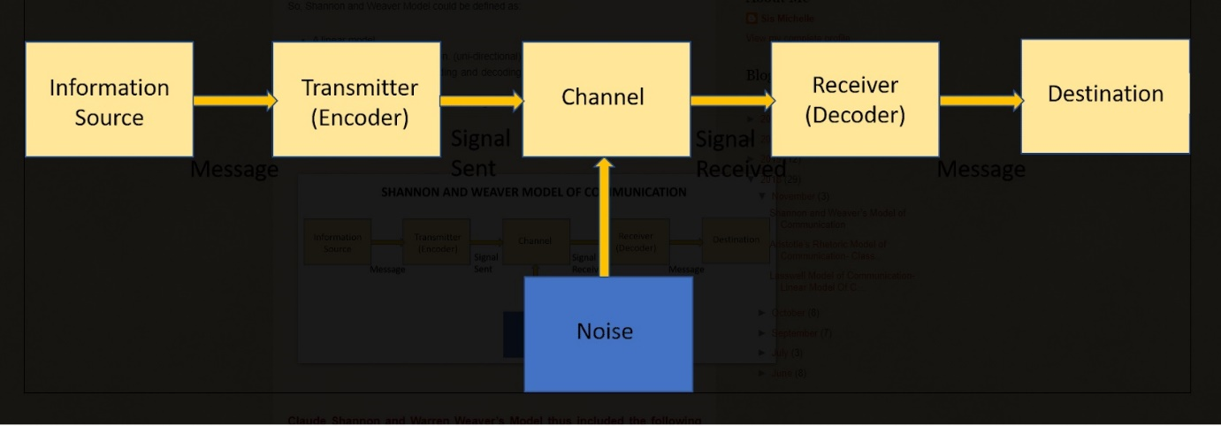(Michelle, 2018)
A relevant example was the case study that was presented during one of the lectures which had as main characters, Maria and Pedro. Maria (the sender) calls on the mobile phone (encoder and channel) Pedro (the receiver) to ask him if he can buy a chicken on his way back home. Because of the noise surrounding him, Pedro didn’t understand the message very well and doesn’t give any feedback regarding the received message. He arrives home and he goes in the kitchen (he understood kitchen instead of chicken) and Maria understands that the message that she intended to send to Pedro was not received properly. The misunderstanding could have been avoided if Pedro was offering feedback to Maria, telling her that he understands that he must buy a chicken.
At my place of work, I can relate to this miss communication sometimes, for example, one of my colleagues was trying to tell me that he placed a parcel in a specific location but because our customers were around us and interrupting with questions I didn’t understand where he stored the parcel exactly and he left thinking that I understood where the parcel was without me providing feedback. When the owner of the parcel came to collect it, I was looking for the parcel for more than half an hour in a different location because I miss understood my colleague.
Schramm’s Model of Communication
Wilber Schramm developed this cyclical model of communication in 1964. He thinks that coding and decoding the message are the most important parts of the communication process. He says that if the decoding doesn’t happen that makes the message useless. He states also that providing feedback is the main responsibility of the receiver for the communication to be effective. The existence of feedback on this model of communication is the main difference from the S&W model (Juneja, 2015)

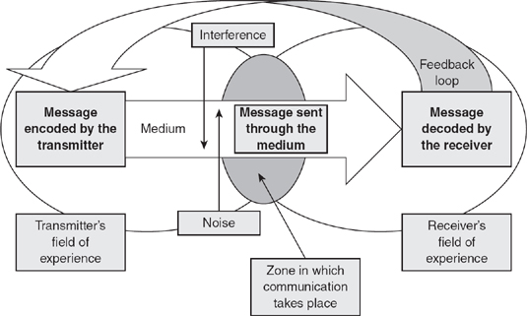
(Blythe, n.d.)
The feedback would have made a big difference in the Maria and Pedro study case. If Pedro was giving appropriate feedback the communication was effective and didn’t allow space for miss understanding.
Also, after the miss communication with my colleague, I learned my lesson and when that situation arose again, I make sure to write the information on a piece of paper and also give feedback to my colleague by just asking if I understood correctly where the parcel is located and also the apartment number for whom that parcel is. That helps our team to be more effective and avoids situations of blaming the other team member thus avoiding a toxic work environment.

Berlo’s Model of Communication
This model of communication has 4 elements: Sender, Message, Channel, and Receiver (SMCR). It is a linear model of communication and Berlo says that each component is influenced by different elements. The Sender is influenced by his communication skills, attitude, knowledge, social system, and culture. The message is influenced by: Content, Elements, Treatment, Structure, and Code. The channel is affected by Hearing, Seeing, Touching, Smelling, and Tasting, and finally, the receiver component is under the direct effect of the same elements as the sender. Berlo mentions also external noise as a factor of disruption inside the communication process, but the main disadvantage of this model is the same as in the Shannon & Weaver model that it doesn’t have a feedback component of the communication (Bhasin, 2021).

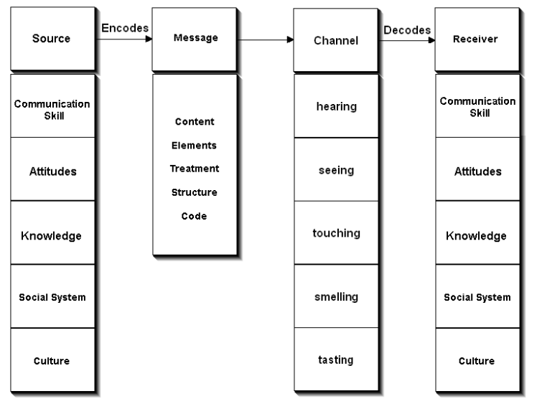
(businesstopia in Communication, 2018)
As a case study for this model we have the case of a professor that is living in a remote village and one night there is a fire that initiates in his house and because he could not contain it by himself he goes to the village and he was trying to get help from the villagers but he is using an elevated vocabulary to raise the alarm and unfortunately due to the educational differences between him(the sender) and the rest of the villagers(receivers) he is not understood and nobody reacts. This case study confirms Berlo’s theory that the educational background differences between the sender and the receiver influence the communication process in a major way and sometimes the intended information that was meant to be sent is totally different from the one received.
I confronted myself with such differences in communication in my place of work. When I recently arrived in the United Kingdom, working in a hotel one of my managers was an Irish citizen and I was not able to understand very well the Irish accent so all the time when he was asking me to do something it was really difficult to understand but because I was ashamed of my English language skills I was not giving him a feedback about the fact that I was not understanding what he was saying and also his attitude was not the best when he was communicating with me.

Communication Skills
One of the most important and most desired skills in a workplace is communication skills. But why employers are looking more and more for people with strong communication skills? To resume it: according to recent studies, for example, Woods (2010) in an article published about the communication between the employees and the managers it shows that 61% of the workers think that because of low communication they experience low morale at the job. 60% of them think that low communication is the main factor in creating confusion for the company’s clients or customers, and also 30% of the interviewed thought that low communication leads to loss of business. I will say that effective communication inside the team is the foundation of that team because it creates relationships between the colleagues that go far deeper than just the workplace which will create empathy and understanding inside the team. That will result in a more productive and stronger team.

Verbal communication
It refers to the verbal messages that are created through language. The main condition is that the receiver interprets correctly the intended sent information otherwise is useless. Verbal communication is in direct relation to your language skills, and these will help you to better express yourself and to better understand the messages received from others, thus developing your communication skills (Quintanilla, 2020, pp 20-60).
Certain communication rules come into place when we talk about verbal communication. We have to take into consideration the environment that we find ourselves in the moment of verbal communication because some ideas are appropriate to express in a specific environment some not.
Non-verbal communication
It is all the other forms of communication without using words. It is known that almost 90% of the total communication is nonverbal. When we talk about non-verbal communication we talk about body language, gestures, and facial expressions, everything that is not verbal.
In a case study to reveal the importance of nonverbal communication, we were presented the case of an employee (Mark) that is invited by the CEO of the company (Mrs. Brown) to congratulate him for his big achievements on the job. Mrs. Brown is asking him easy questions in order for him to relax and to make him feel confident. Her strategy works and he begins to loosen up his tie, crosses his legs, and feels too comfortable also he criticizes his boss and the way he is doing his job. Mrs. Brown decides that she heard enough, and she tells him that the secretary will show him out. This is an example of verbal and non-verbal communication and what we should not do when we are talking with our boss. As we can see everything that we say and express is really important and can have an immediate impact on us.
Active Listening
Active Listening is an important part of the communication process because is not only to hear the words of the person talking is also to understand and interpret what the communicator is trying to transmit and also to interpret their body language.
A case study about Max the event planner was presented in class to underline the importance of active listening. Max was trying to organize Tamara’s parent’s wedding anniversary and because of the high volume of calls he was receiving to organize other events, he forgot to change the date as Tamara wanted, and when Tamara and her 300 guests went to the agreed venue for the event she realized that Max didn’t change the date like he supposed to because he was not listening to her when she asked for the change in date. The same kind of situation happened to me at work me being a Max and didn’t really listen to one of my customers asking to reserve a private BBQ area for a certain time of the day, and I made the reservation for 4 PM instead of 2 PM. Of course, the customer got upset and he lost his trust in me.
Technology in Communication
Technology has a great influence on communication. Technology makes communication instant, creates communication channels in seconds from all over the world and that makes long distances disappear. Some of the disadvantages are: invasion of privacy, social isolation, and addiction.

Conclusion
For me, it was the most interesting Module until right now, because it talks about the most human act of all: communication. We realized how important is the act of communication in our lives and even though it seems such an easy concept, it is in fact really complex and depends on so many factors.

References
- Bhasin, H. (2021) Berlo’s Model of Communication Explained. Available at: https://www.marketing91.com/berlos-model-of-communication/ Accessed: 15 August 20222
- JMC Study Team (2019) Shannon and Weaver Model of Communication. Available at: https://jmcstudyhub.com/shannon-and-weaver-model-of-communication-mass-communication/ (Accessed: 15 August 2022)
- Juneja, P. (2015) Schramm’s Model of Communication. Available at https://www.managementstudyguide.com/schramm-model-of-communication.html (Accessed: 15 August 2022)
- Quintanilla, Kelly M. (2020) Business and professional communication: keys for workplace excellence SAGE Publications, Inc.
- Woods, D. (2010) Poor communication between managers and employees wastes time and impacts productivity, Available at: https://www.hrmagazine.co.uk/content/news/poor-communication-between-managers-and-employees-wastes-time-and-impacts-productivity
(Accessed: 15 August 2022)

Images References
- Blythe, J. (n.d.) The Schramm Model of Communication. Available at: https://sk.sagepub.com/books/key-concepts-in-marketing/n46.xml (Accessed: 15 August 2022)
- Businesstopia in Communication (2018) Berlo’s SMCR Model of Communication. Available at: https://www.businesstopia.net/communication/berlo-model-communication (Accessed: 15 August 2022)

- Michelle, S. (2018) Shannon and Weaver’s Model of Communication. Available at: https://michellemathiasfsp.blogspot.com/2018/11/shannon-and-weavers-model-of.html (Accessed: 15 August 2022)

