jQueryMobile Panels and Collapsibles

Panels

Panels can be used to allow the opening of an extra area on the screen:



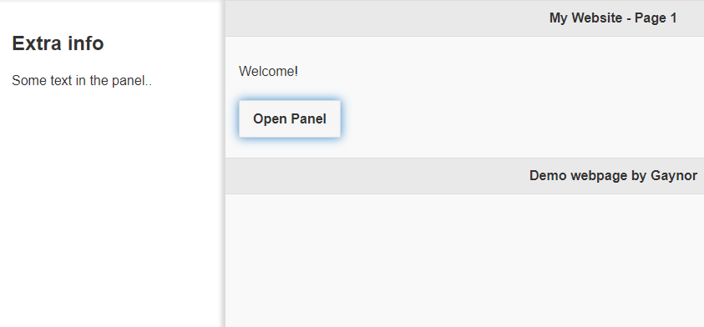

<html>
<head>

<script src="jquery-3.6.0.js"></script>
<script src="http://code.jquery.com/jquery-migrate-3.0.0.js"></script>
<link rel="stylesheet" href="jquery.mobile-1.4.5/jquery.mobile-1.4.5.css">
<script src="jquery.mobile-1.4.5/jquery.mobile-1.4.5.js"></script>

</head>

<body>

<div data-role="page" id="pageone">
<div data-role="header">
<h1>My Website - Page 1</h1>
</div>

<div data-role="main" class="ui-content">
<p>Welcome!</p>
<a href="#leftpanel" class="ui-btn ui-btn-inline">Open Panel</a>
</div>

<div data-role="panel" id="leftpanel">
<h2>Extra info</h2>
<p>Some text in the panel..</p>
</div>

<div data-role="footer">
<h1>Demo webpage by Gaynor</h1>

</div>
</div>

</body>
</html>

By adding to the panel div, we can decide if/how we want the panel to close

data-dismissible="true" (by clicking outside the panel)
data-swipe-close="true"

Or, put a button inside the panel itself to close it:

<div data-role="panel" id="leftpanel">
<h2>Extra info</h2>
<p>Some text in the panel..</p>
<a href="#pageone" data-rel="close" class="ui-btn ui-btn-inline">Close Panel</a>

</div>

You can also change the method of reveal: (add this to your panel div tag

eg <div data-role="panel" id="leftpanel" data-display="overlay">

data-display="overlay"
data-display="reveal"
data-display="push"

…and the position of panel (top and bottom not available!)
data-position="right"

Collapsibles

Within the main div, we can include collapsibles. These act as a set – when one is open, the others automatically close

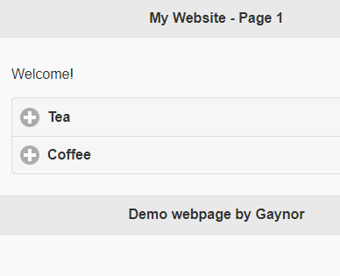

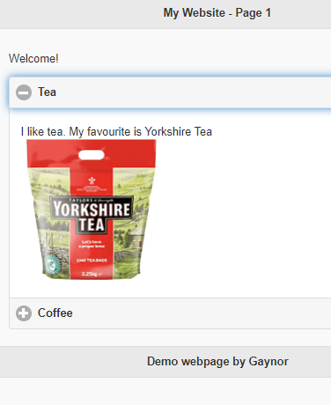

<div data-role="main" class="ui-content">
<p>Welcome!</p>
<div data-role="collapsibleset"> MAKE SET

<div data-role="collapsible"> add individual
<h1>Tea</h1>
<p>I like tea. My favourite is Yorkshire Tea<br>
<img src="yorkshire.jpg" width="200">
</p>
</div>
<div data-role="collapsible"> add individual
<h1>Coffee</h1>
<p>I don't really like coffee. But if I did, this is my local one:<br>
<img src="gowercoffee.jpg" width="200">
</p>
</div>
</div>
</div>

You can also keep a collapsed area open by default

<div data-role="collapsibleset">

<div data-role="collapsible" data-collapsed="false">
<h1>Tea</h1>
<p>I like tea. My favourite is Yorkshire Tea<br>
<img src="yorkshire.jpg" width="200">
</p>
</div>
<div data-role="collapsible">
<h1>Coffee</h1>
<p>I don't really like coffee. But if I did, this is my local one:<br>
<img src="gowercoffee.jpg" width="200">
</p>
</div>

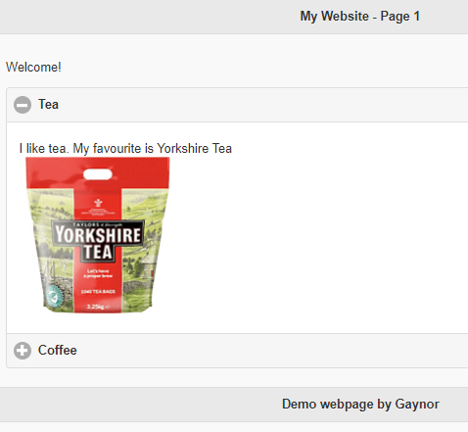

The tea section is open by default (you can only force one open at a time due to the nature of collapsibles!)

