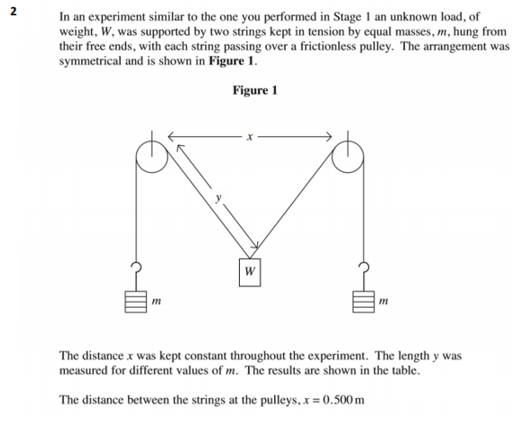
0.250 | 0.736 | 0.462 | 0.532
0.275 | 0.484 | 1.067 | 0.584
0.300 | 0.400 | 1.563 | 0.641
0.325 | 0.360 | 1.929 | 0.695
0.350 | 0.339 | 2.175 | 0.740
0.375 | 0.322 | 2.411 | 0.793
0.400 | 0.308 | 2.635 | 0.856

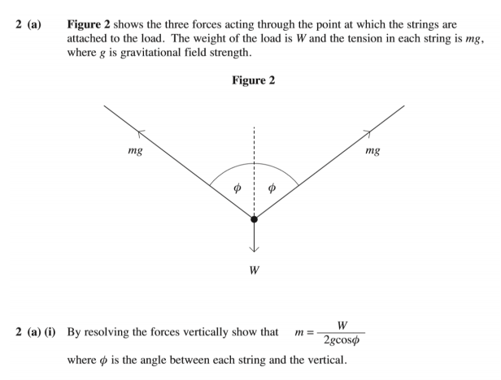

m = W/2gCosθ 2m = W/gCosθ 2mg = W/Cosθ
2mg/W = Cosθ
mgCosθ + mgCosθ = W



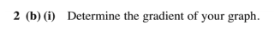
Y = mx + c m = 2.13 x = 0.5 c = 0.0003
Y = (2.13)(0.5) + 0.0003 = 1.0653
Y = 1.07
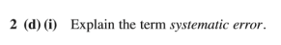
The term systematic error involves errors that are brought in by the system’s inaccuracy instead of by chance.

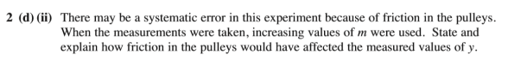
Friction in the pulleys would cause small inaccuracies for the measurements, as friction acts in the opposite direction of motion and therefore that force would affect the motion.

