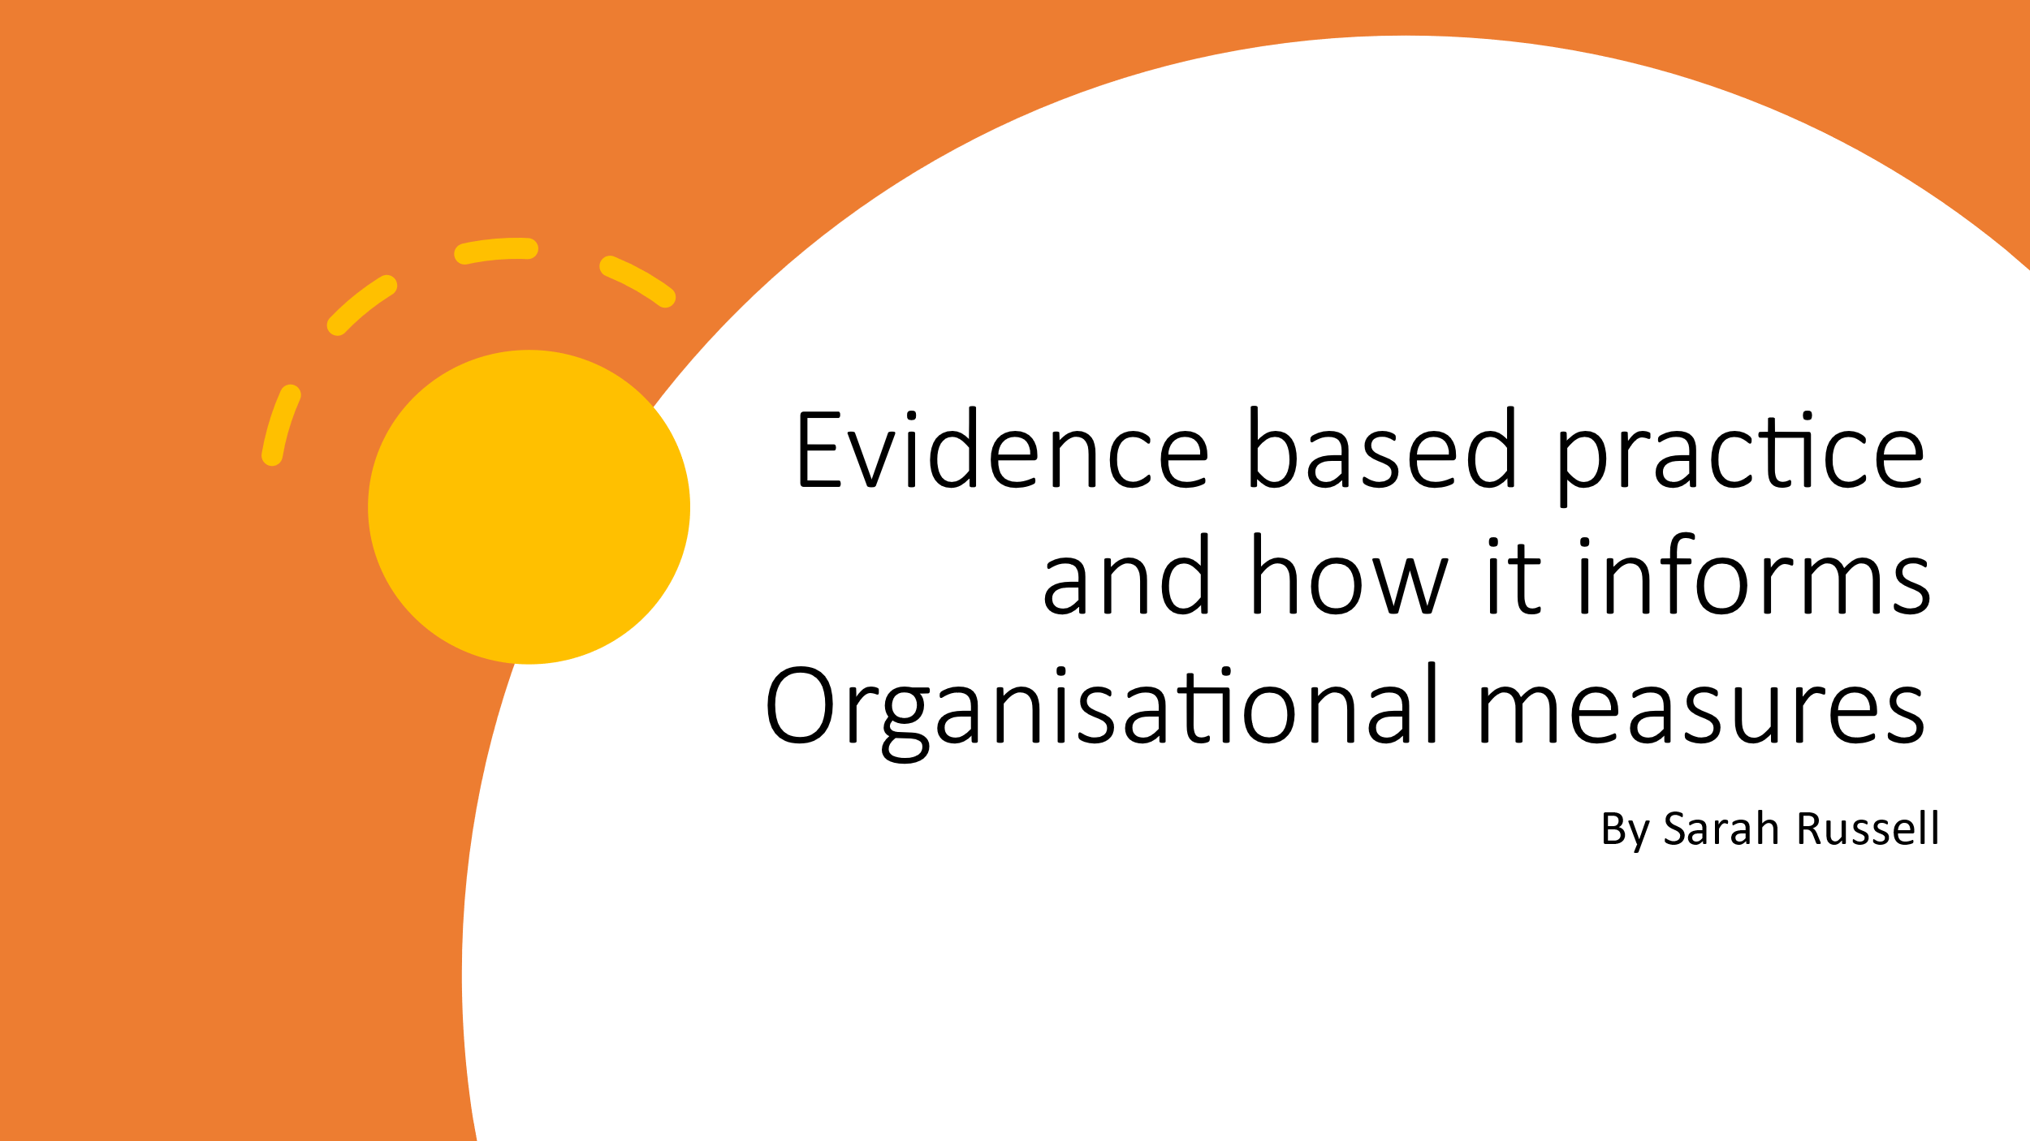

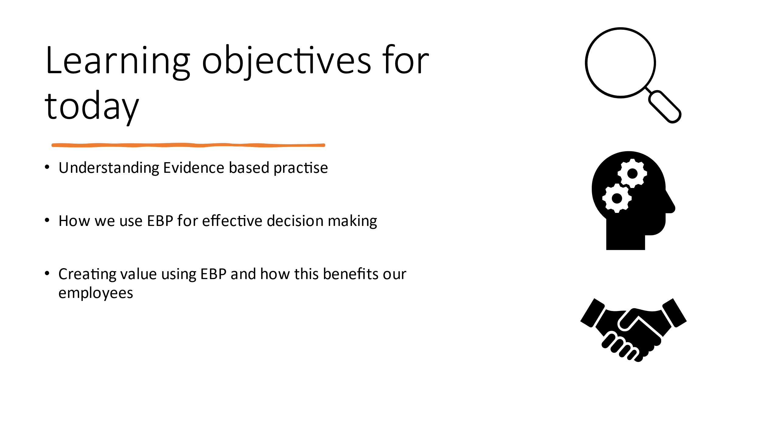
Brief introduction here – summary of learning objectives

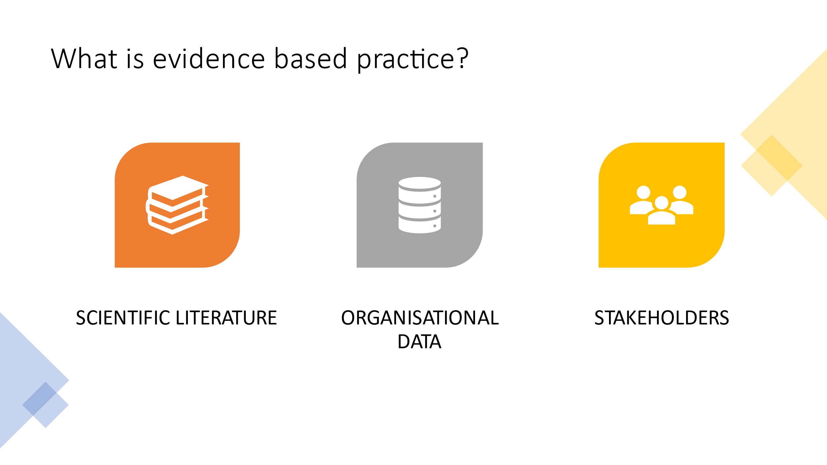
According to (Barends, Rousseau and Briner, 2014) “Evidence-based practice is about making decisions through the conscientious, explicit and judicious use of the best available evidence from multiple sources”. Put simply, this is about us using specific and reliable sources of evidence to develop knowledge and understanding to inform practice before decision making. For example, within Hywel Dda we have the Values and Behaviours Framework (HDUHB, 2015, a) , which outlines our core values and behaviours set out for every employee. Prior to the inception of the Framework we gathered evidence from various sources such as textbooks and scientific research to help support staff engagement and understand human behaviours, we used internal Organisational data such as exit interviews, staff turn over reports, sickness absence data and reasons for leaving the organisation to identify common themes or patterns of behaviours. And we used our stakeholder opinions and values to shape and underpin what we felt was important as an organisation going forward. As an NHS Organisation there are a number of benefits to using EPB, care is clinically and cost effective, it ensures high standards are maintained, care is provided on the base of evidence to ensure the best possible outcomes are achieved. (Department of Health, 2013)

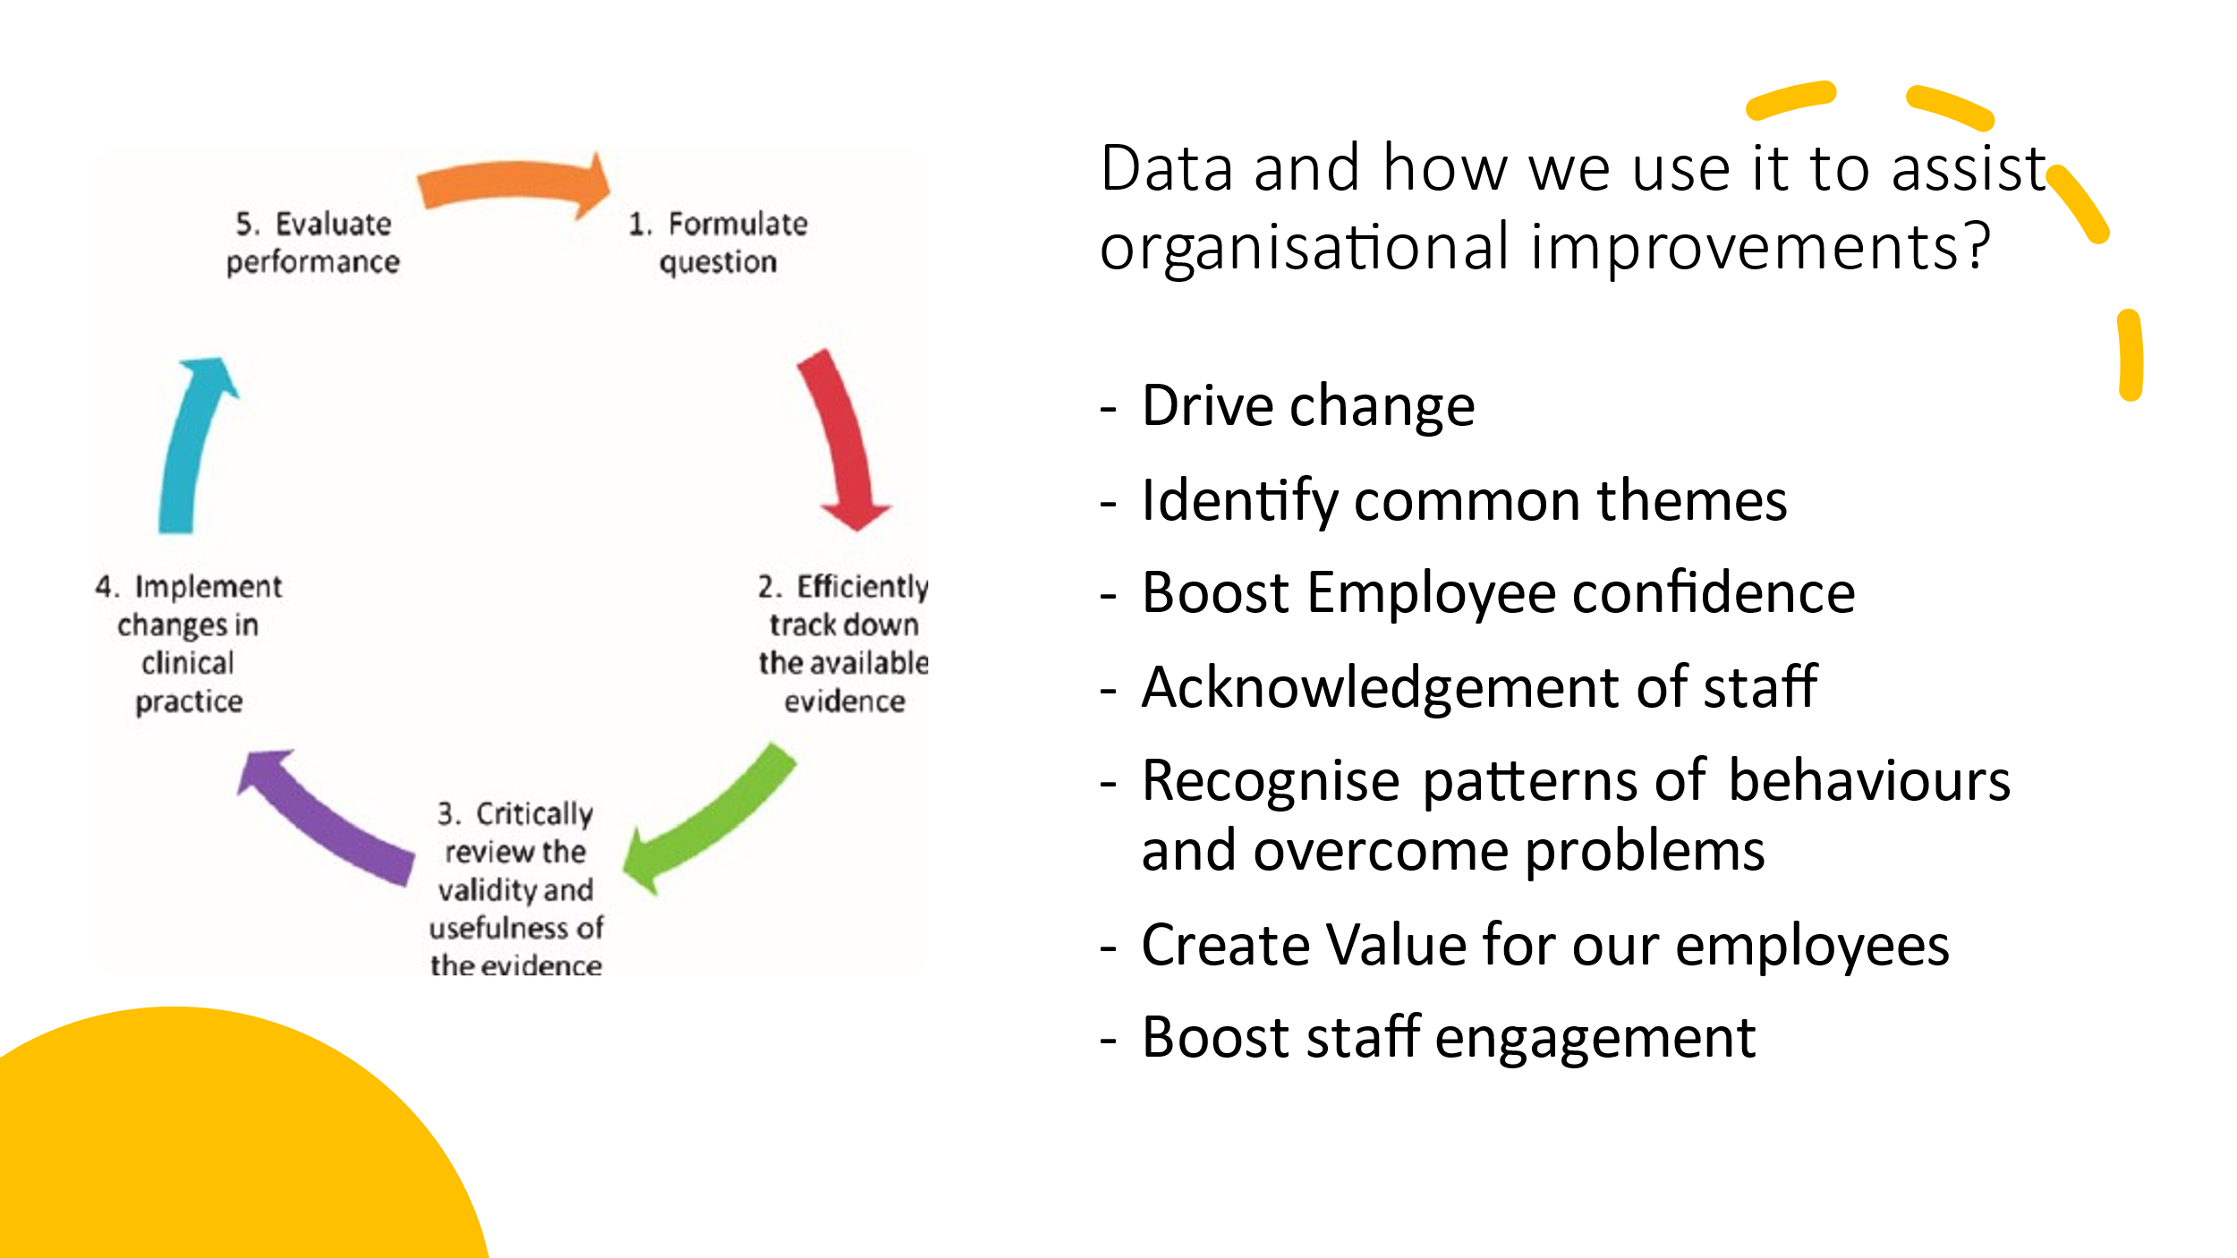
As HR professionals we rely on data to inform evidence based decision making and to contribute towards Organisational strategy. Previously we looked at why various different types of data we analysed and used to help us understand why employees were leaving the Organisation and the reasons for them feeling undervalued, we used this information to create our Value and Behaviours Framework (HDUHB, 2015, b). (Briner, 2019, p.6) gives us a useful 6 step approach to assist us through the decision making process to ensure the data we are using is relevant and reliable.
In order for us to successfully implement the Framework we had 3 key areas to focus on –
Time - Put simply we needed to allow ourselves enough time to review our evidence, decide on a course of action and then plan on how we implement the change.
Ethical - When gathering and analysing our data (Exit interviews/ staff turn over data/ staff survey outcomes) it was imperative that it was gathered, analysed and stored appropriately, it was only used for its indented purpose and we ensured that legal standards were met (Data Protection Act, 2018)
Accuracy – to ensure our data was accurate and reliable we issued our 11,000 staff with a survey centred around wellbeing and feeling values, all employees were asked the same set of questions which then enabled us to look at common themes or trends throughout the health board. The results from the survey helped us understand the areas we needed to improve on and how to make our employees feel more valued which then allowed us to shape and create our Values and Behaviour Framework.(HDUHB, 2015, c)

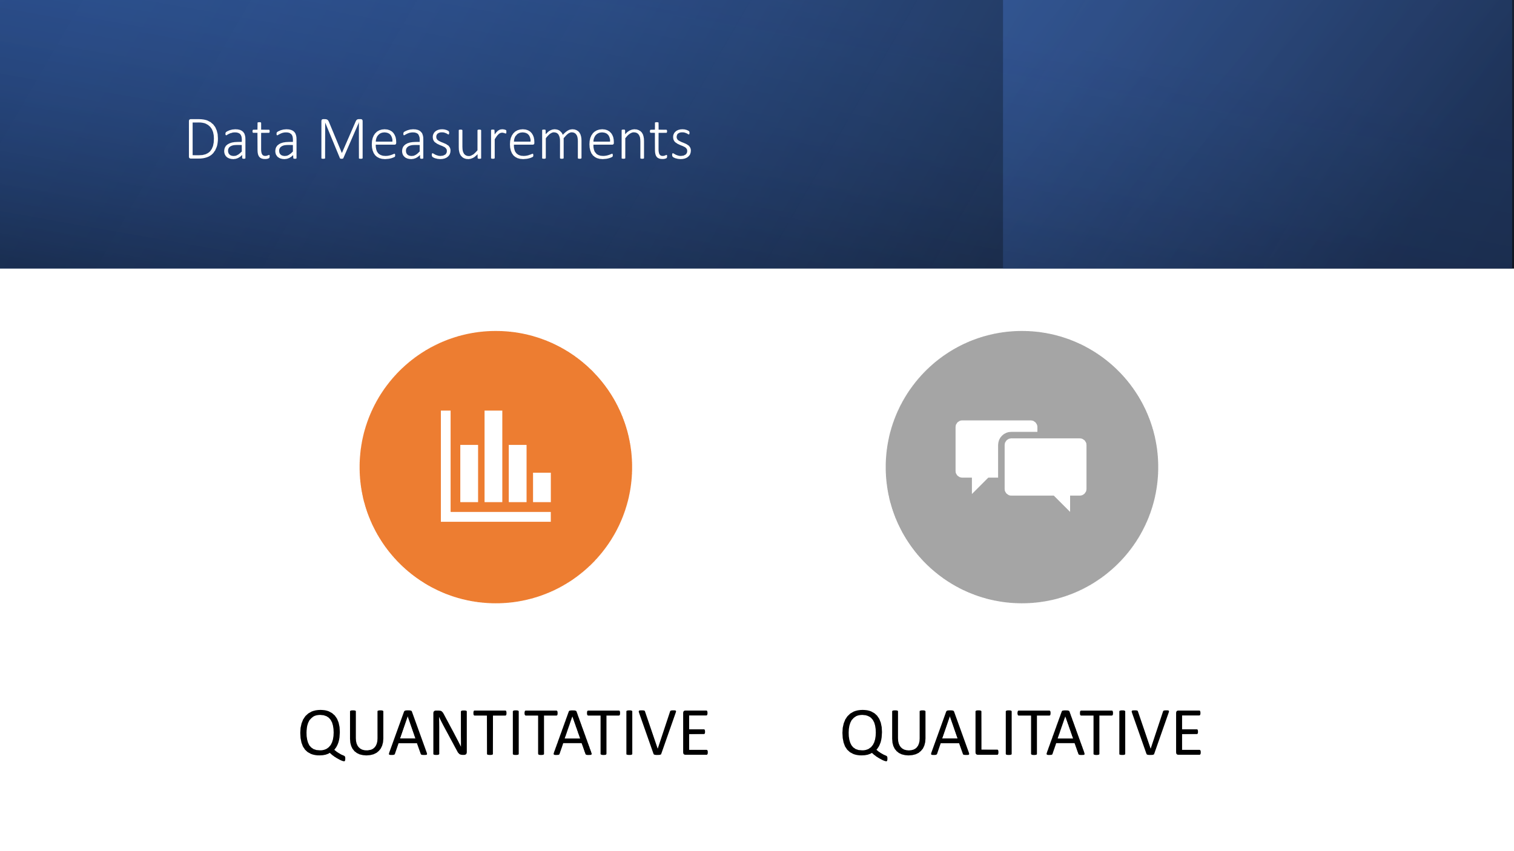
It is important to use both quantitative and qualitative sources when gathering evidence as the quantitative data refers to information that can be measured or counted and given a numerical value, However qualitative data provides us with the context behind the numbers and valuable opinions or the ‘why’ behind the numbers, It is hard to conduct a successful data analysis without using both Qualitative and Quantitative data (CIPD,2021). Before implementation of the Values and Behaviour Framework (HDUHB, 2015, d) we used both data sets to understand and collate how our staff were really feeling, we collated and analysed Staff Survey Response rates, Staff Turnover rates, Recruitment success rates, diversity and inclusion data and sickness absence rates as our Quantitative data. We then looked at and collated Exit interview comments, Evidence from PADRs and Feedback from Staff Focus groups to understand our staff voice. Ultimately, we could not have successfully created and implemented the Framework without the supporting Qualitative and Quantitative data as both provided us with valuable insight into Organisational trends and patterns and re-occurring themes and feelings throughout the Organisation. We used both data sets to minimise the risk of bias (conscious or unconscious) to ensure fairness and equality. Research suggests that most of us cannot identify when our judgement is biased (Koch ,D’mello and Sackett, 2015).

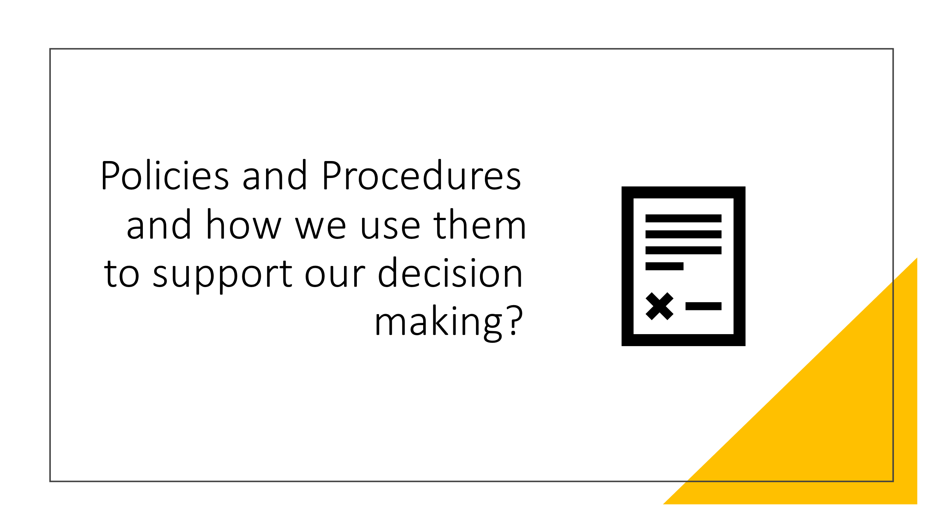
Next we are going to look at how we use our policies and procedures to support our decisions. Within any organisation but particularly within the NHS we need policies and procedures to help support our vision. Policies help us outline what is tolerated within the organisation and what procedures we then need to follow if we breach these. Alongside our Values and Behaviour framework (HDUHB, 2015, e) We also refer to our standards of behaviour policy “The Standards of Behaviour Policy enables Hywel Dda University Health Board to ensure that its employees and Independent Members practice the highest standards of conduct and behaviour. “This policy sets out the expectations required and provides supporting guidance so that all employees and Independent Members are supported in delivering that requirement.”(HDUHB ,2020) The aim of the policy is to ensure all employees and Independent members practice the highest standards of conduct and behaviour, based on the recognition that our patients always come first. Interlinked within the policy are also our Disciplinary Policy, Confidentiality Policy and a procedure for staff to raise concerns, these procedures are in place to assist us in deciding the best course of action to take if an employee fails to meet the standard of behaviours set out within the policy. This is just one example of how policies help support us in the decision making process.

Internal stakeholders – Patients, staff, Independent board members
External – Customers, suppliers
How we influence – promote and guide a positive culture, motivate staff. Raise awareness around using ethically sourced material/ supplies. Address staff wellbeing and highlight resources = better patient care
Common goal unites us – excellent patient care.
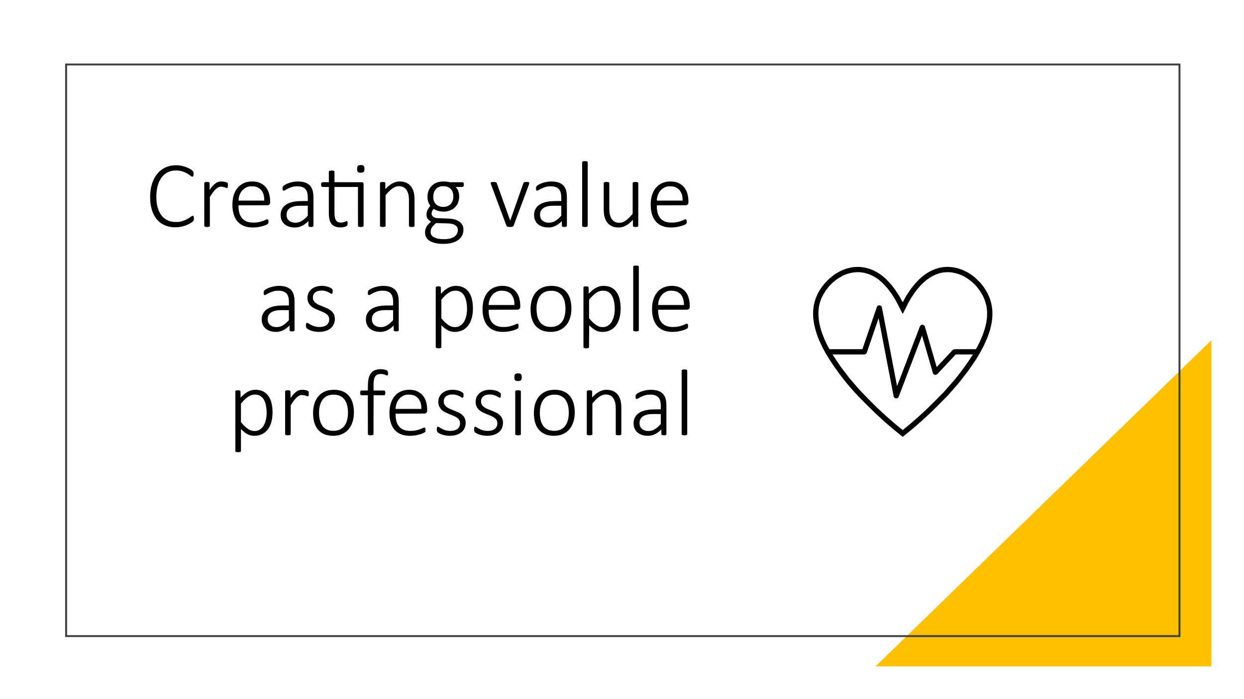
HR role – Motivate staff, empower, positive culture, training and development opportunities, performance management
creating-value-through-hr.pdf (deloitte.com)
Creating value – meeting needs of patients and staff – CIPD Profession map, look at human capital, recruitment selection, listening to staff voice.
Benefits – Employees feel valued, empowered, happy, which in turn improves patient care and experience.

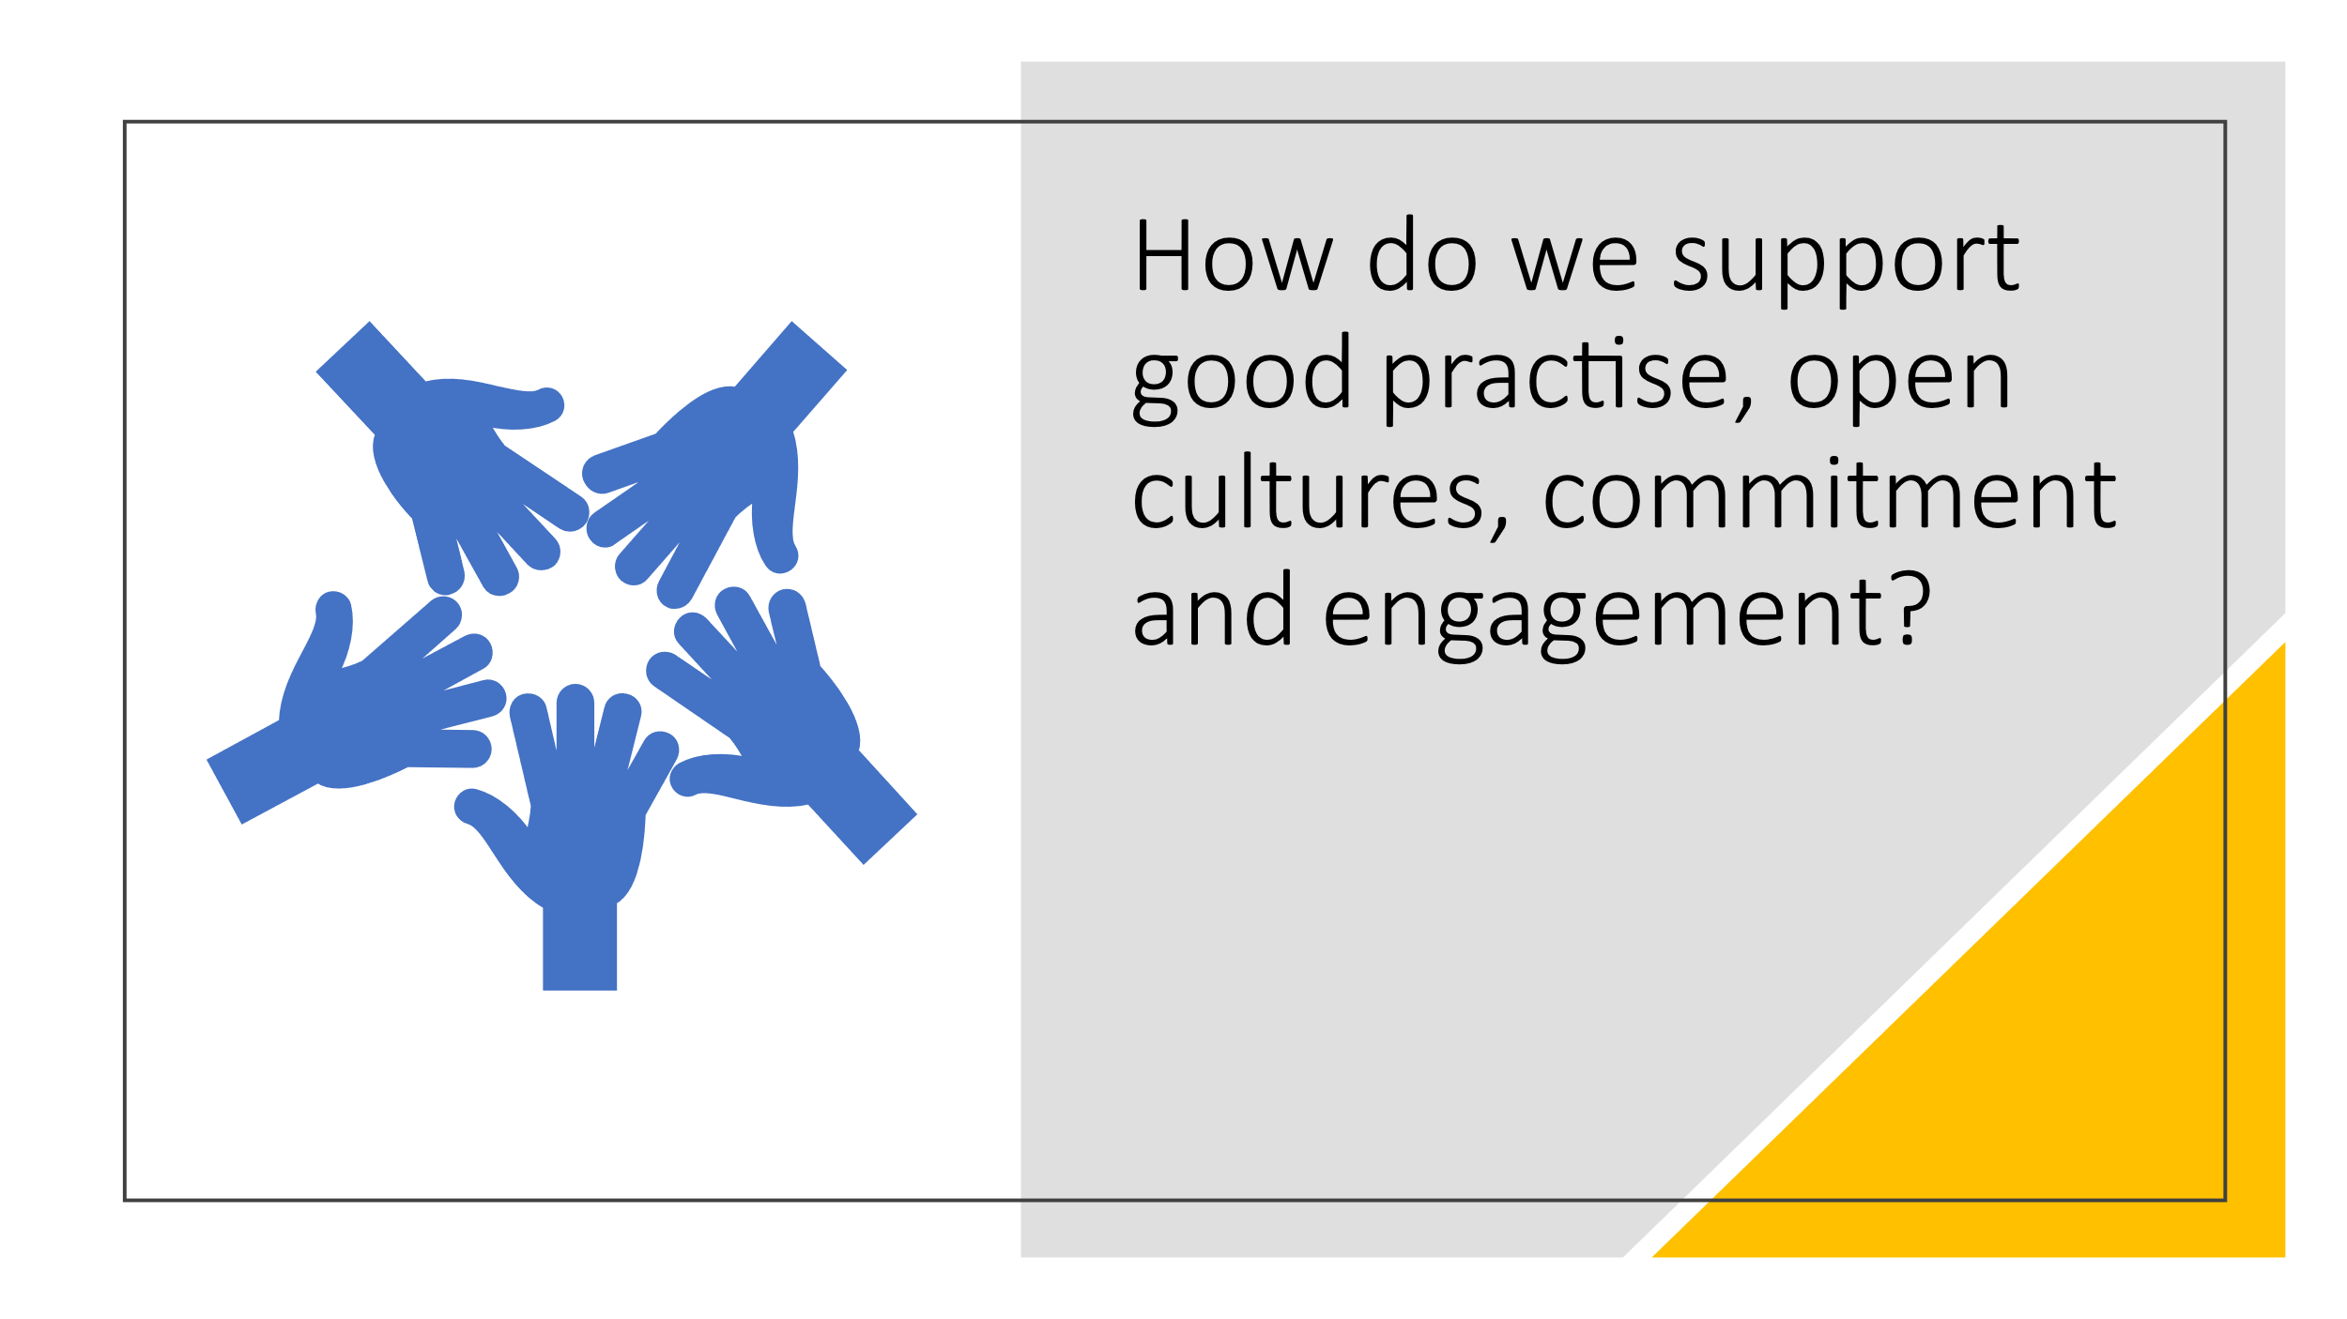
Embedded values into Organisation, demonstrate and lead by example.
Motivate and support
Staff Psychological wellbeing service – Offer staff support, let their voice be heard. Especially following pandemic. Burnout.
Patient experience team – listening to our customers voice and using good practise examples
Inclusion, equality and diversity – supporting a diverse and inclusive workforce
Induction – expectation and values made clear
Recruitment – fair interview process
Look at case studies on CIPD website, NHS wales.

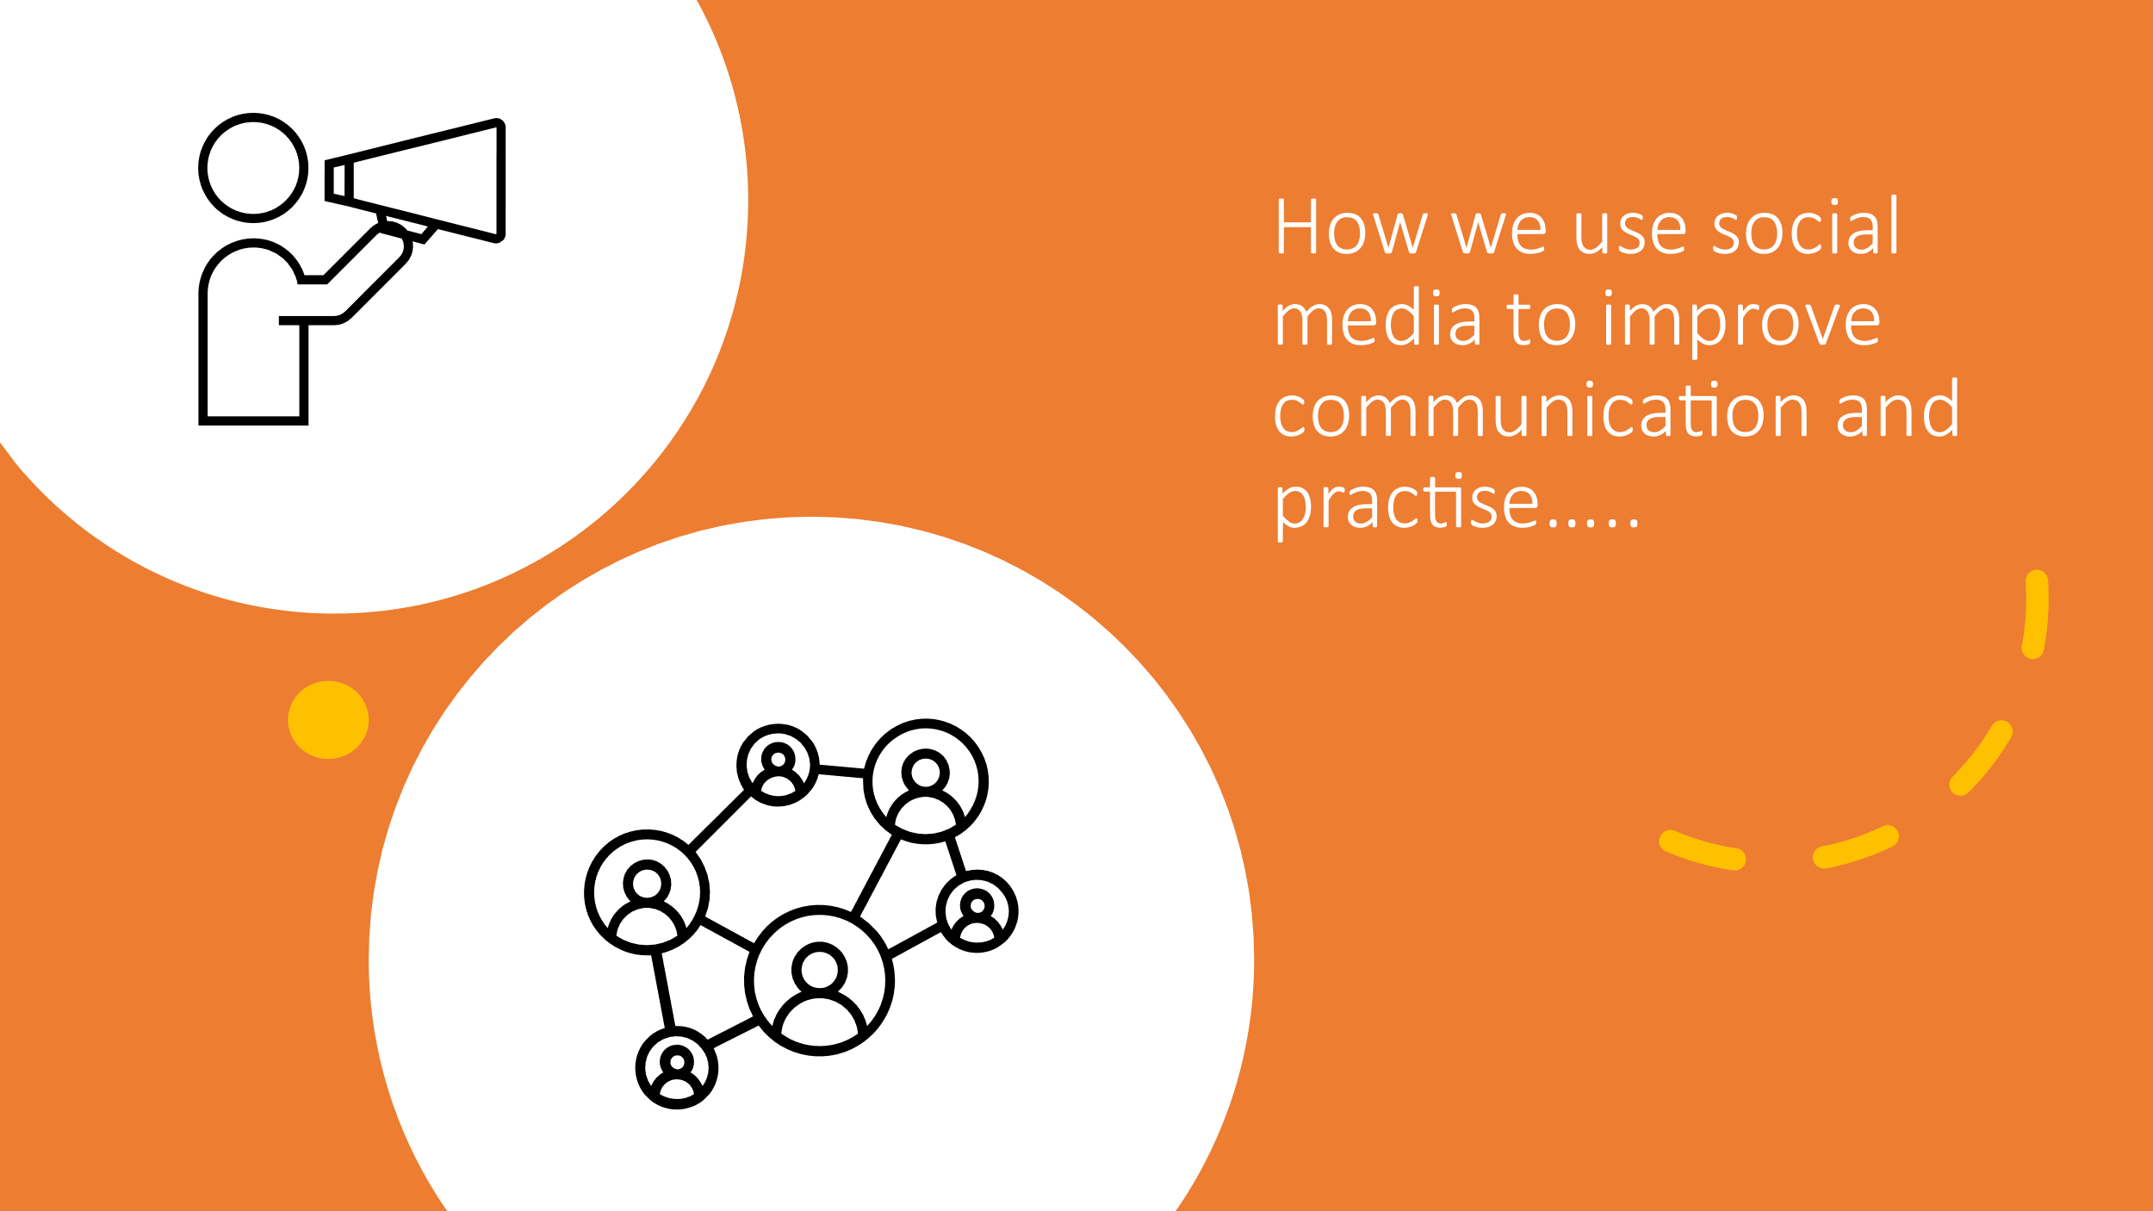
Share ideas and information on a wider platform and usually more easily accessible. Reaching different audiences, supporting diversity and inclusion. Hashtags to highlight important events, improve employee engagement.

- Corporate information can be shared to prevent rumours
- Recruitment Opportunities
- Promote organisation and image
- Share values and vision – creating appeal - Advantages
- Learning and development opportunities
- Employee voice
- Communicate change

- Spread false information
- Bullying, intimidation, stalking - Disadvantages
- Risk to security of data
- Mental health effects
- Work/life balance implications
Social media policy, Human rights act, DPA,

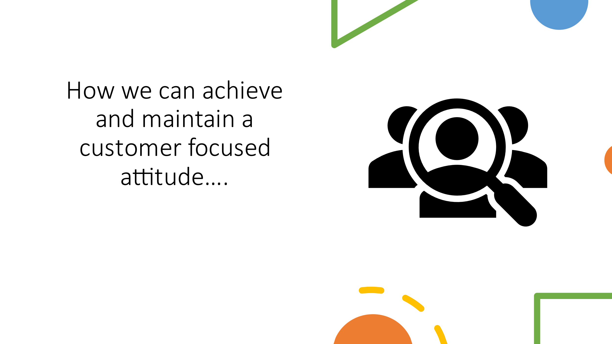
Ensuring we demonstrate and promote values – “PUTTING PEOPLE AT THE HEART OF EVERYTHING WE DO”
Use good practice examples to inform practice in other areas, shared learning. CPD.
Staff morale boosts patient care.

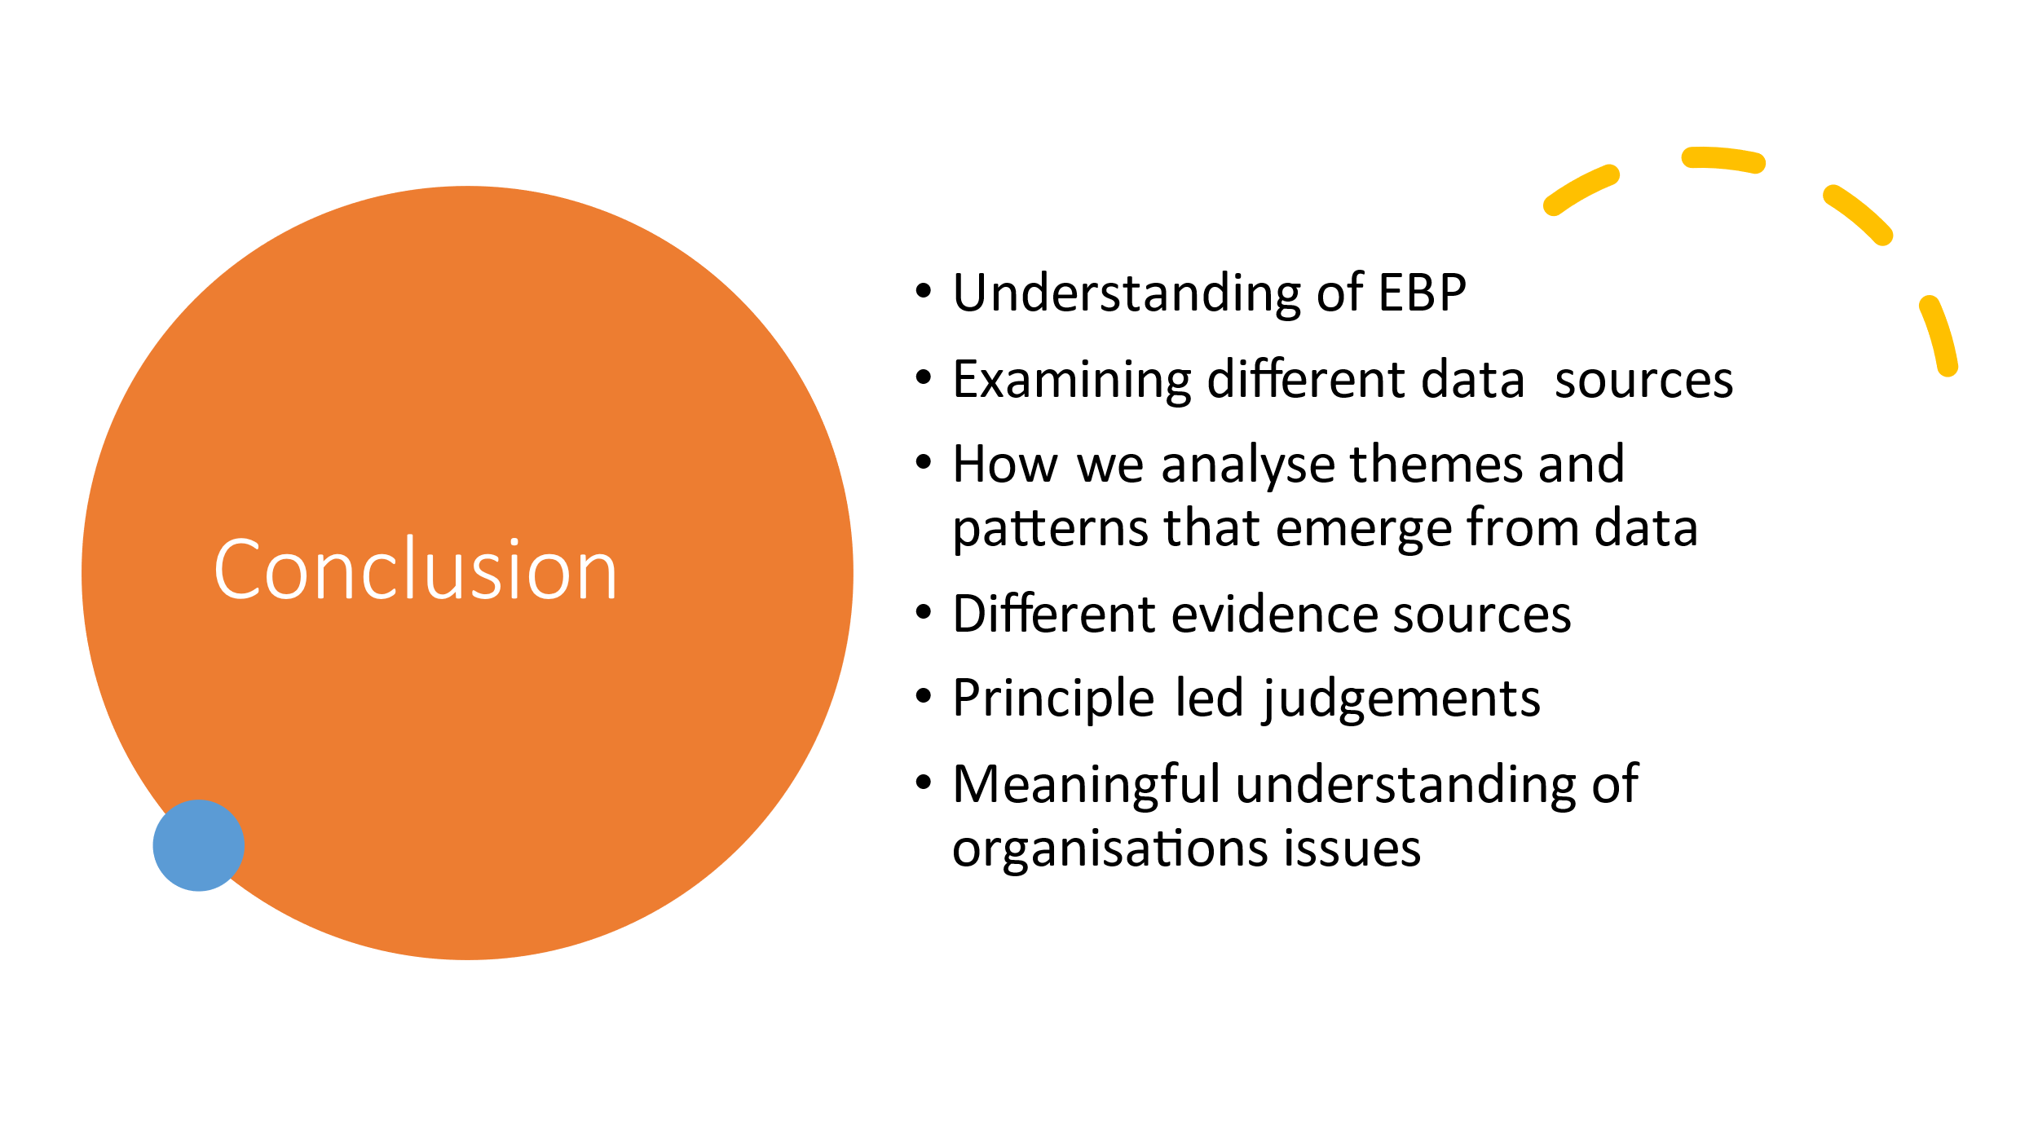
Thank you for taking the time to listen today, my hope is that you now have a fundamental understanding of EBP, and how you can examine different data sources to make sense of patterns and themes that emerge from different forms. I hope you are now able to make objective principle led judgements on a wide range of organisational issues and have the confidence to present solutions.

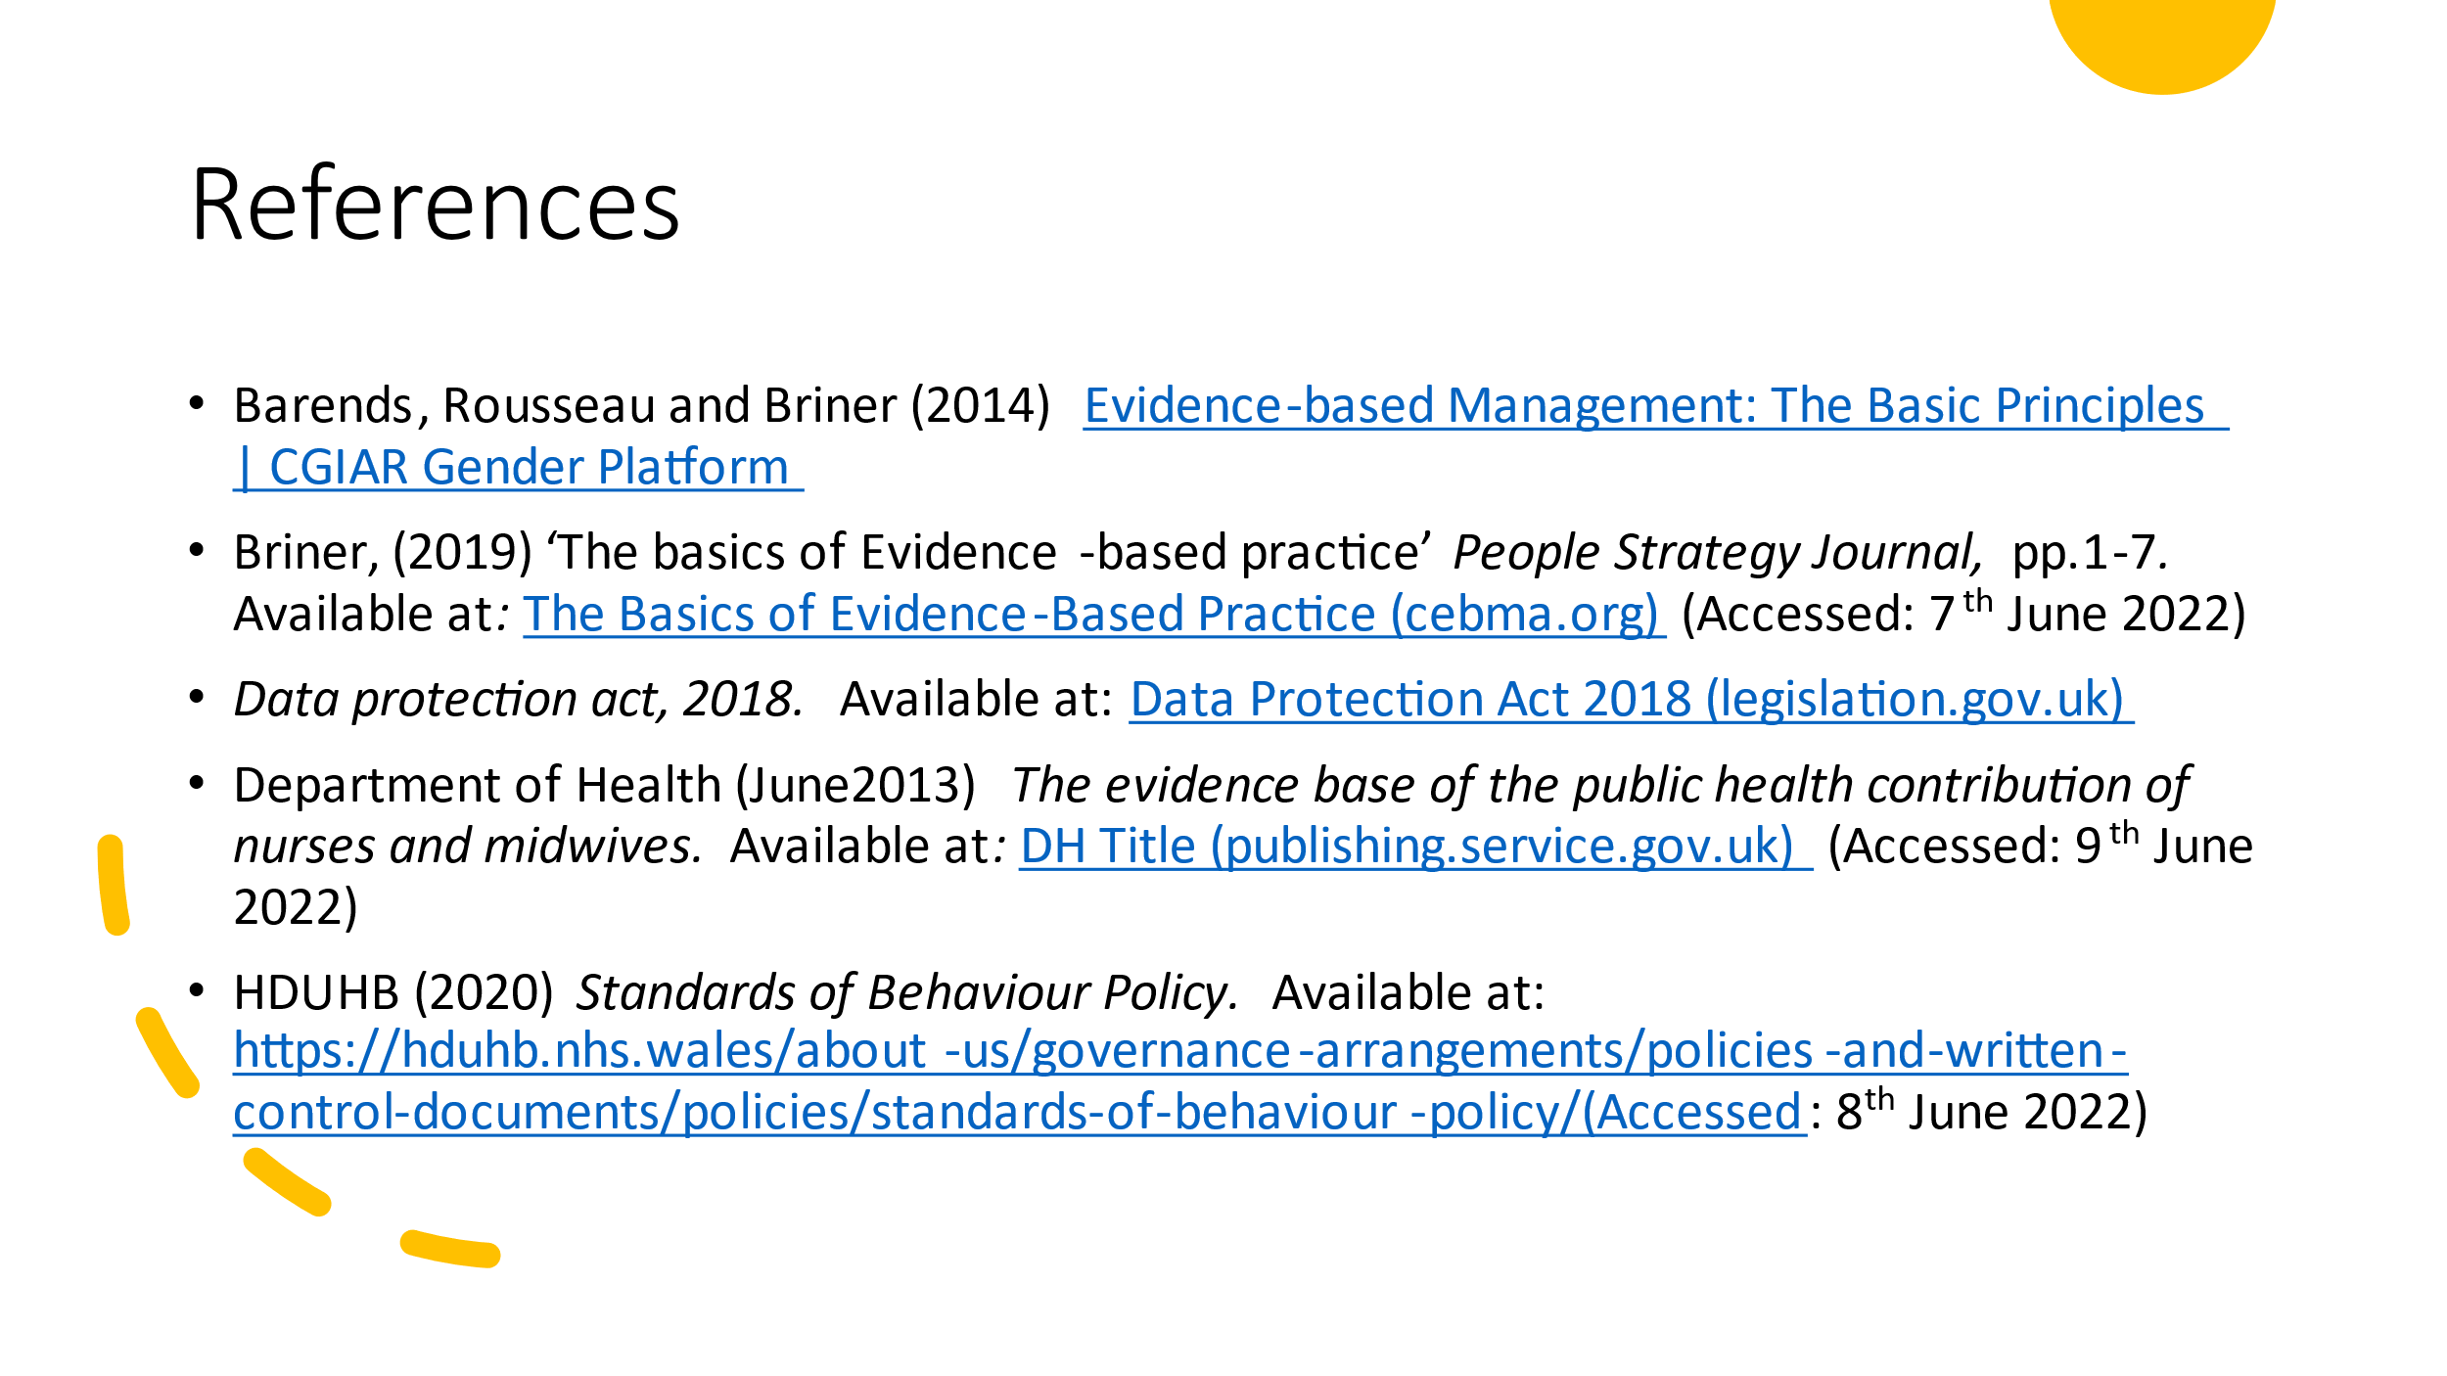
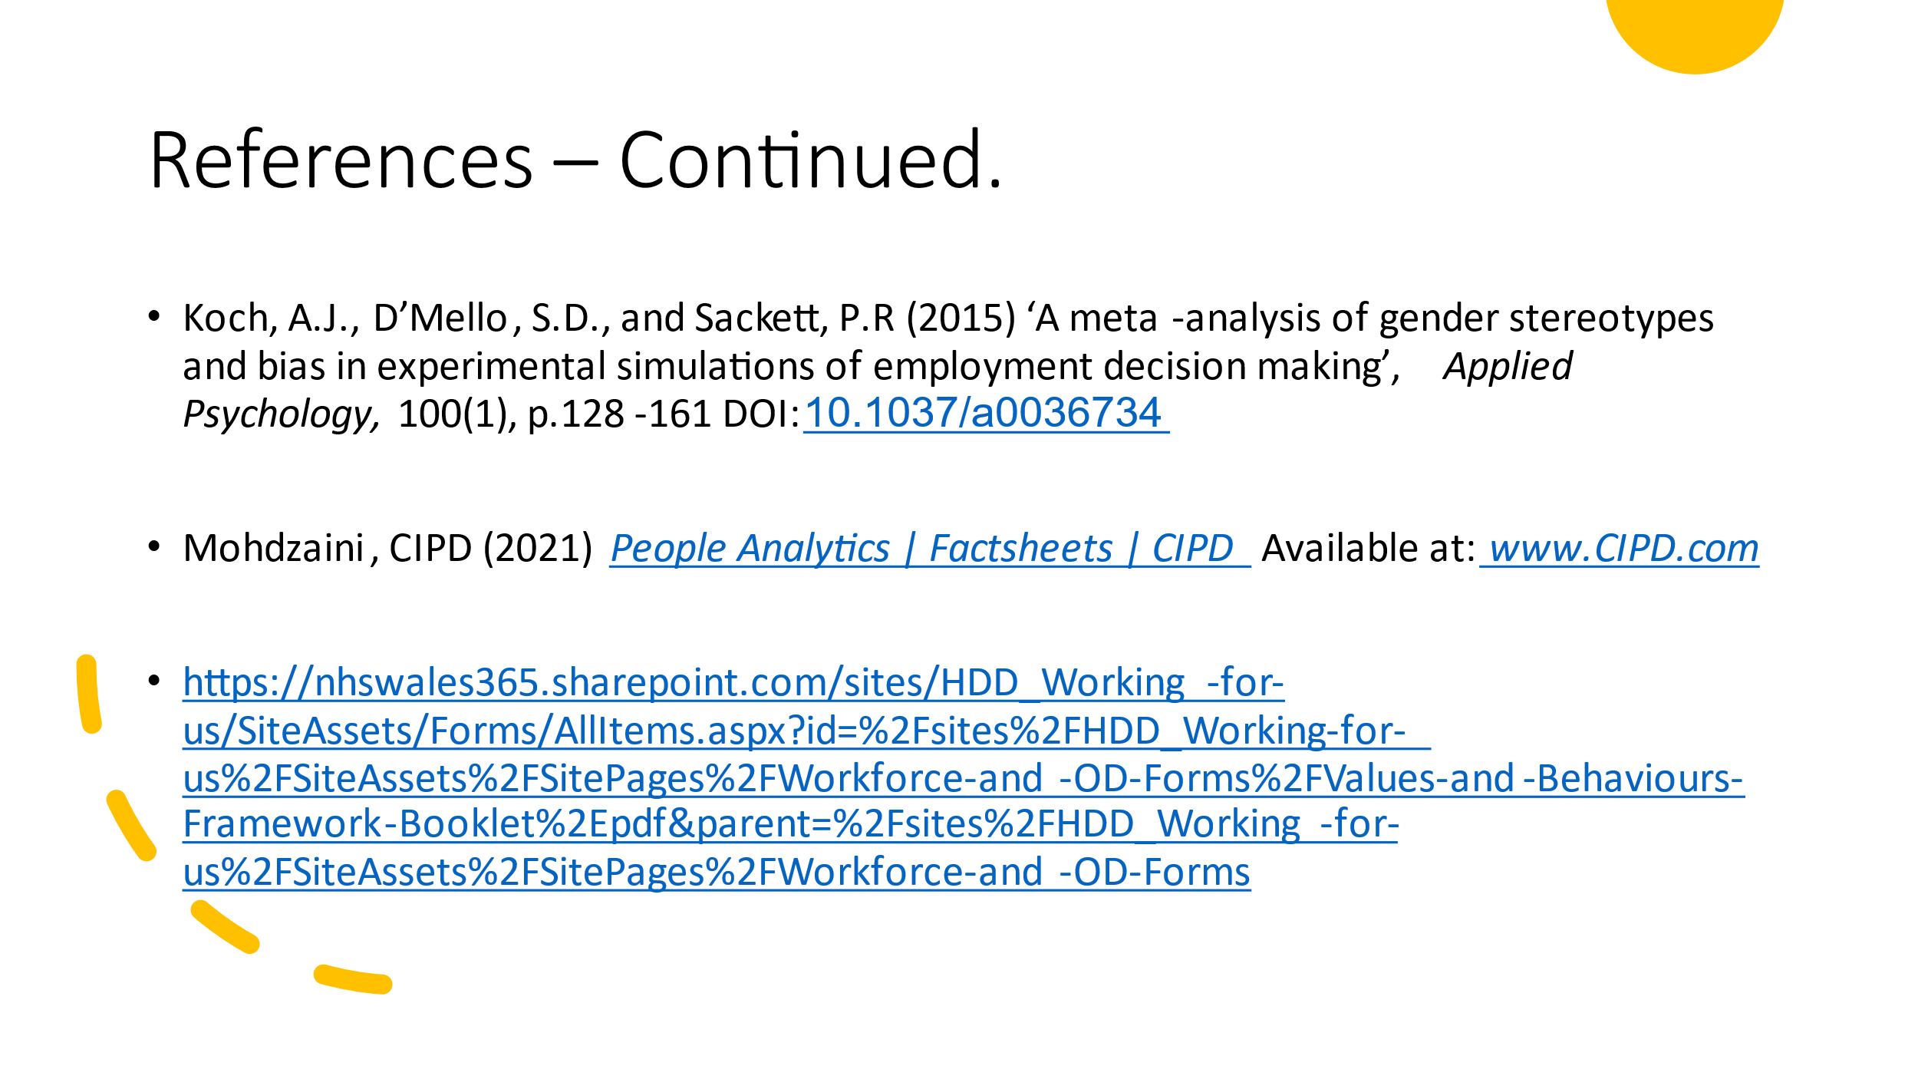

Task 2
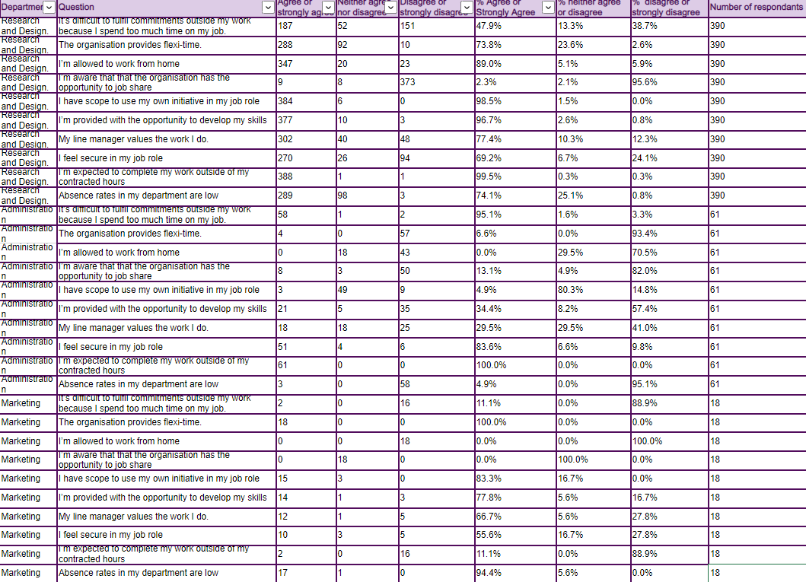
We see here that we have analysed the data a represented it as a percentage of staff instead of number of staff. We can tell from the responses that Research and Design had a 95% response rate, with 22 employees not responding to the survey. Administration had a 94% response rate with only 4 employees not completing the survey and Marketing has a 100% response rate with all employees choosing to participate in the survey. It is worth noting that staff numbers within Marketing are significantly lower than in the other 2 departments. Overall a fantastic average completion rate of 96%.

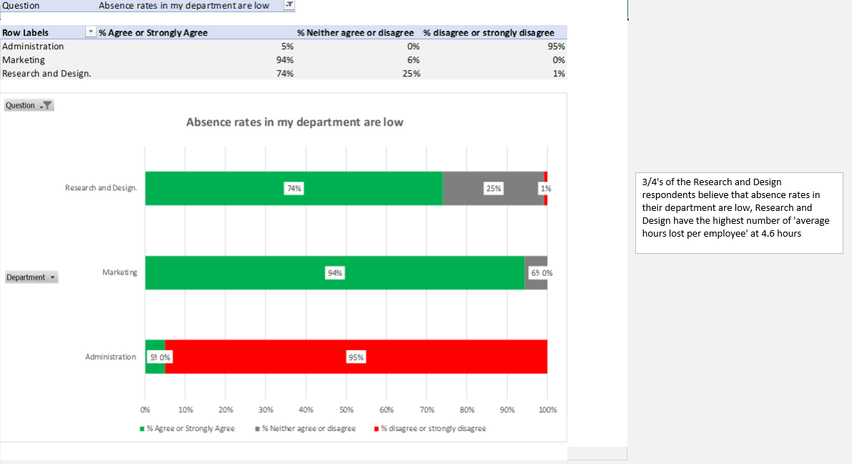
There appears here to be some misconception here, we know from the data further down that R&D have lost the most number of hours lost through absence, and have the highest cost implications of staff sickness. Whilst Administration seem to agree they have staffing issues.

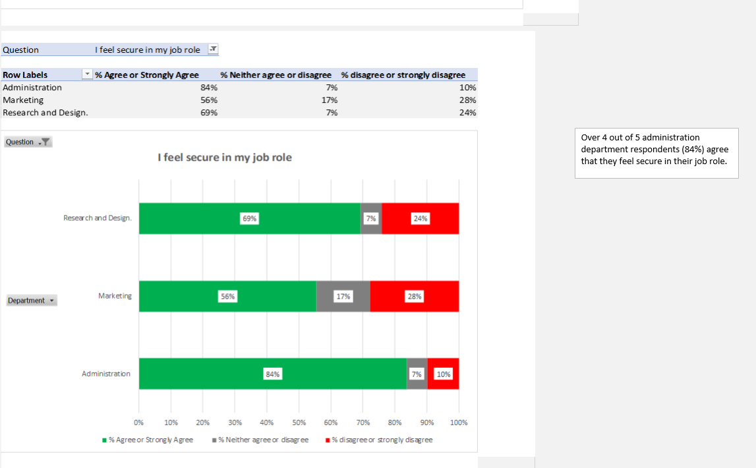

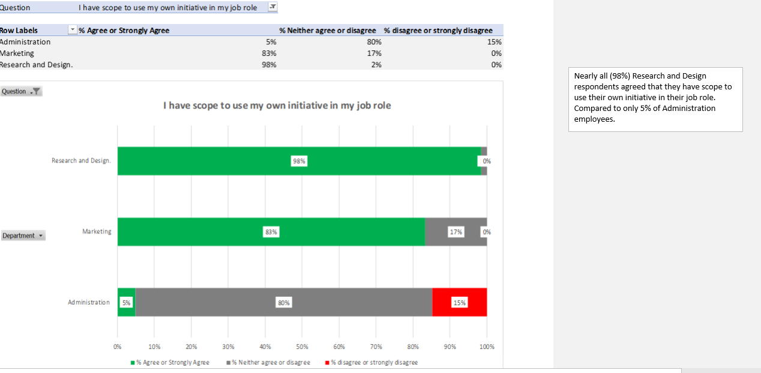

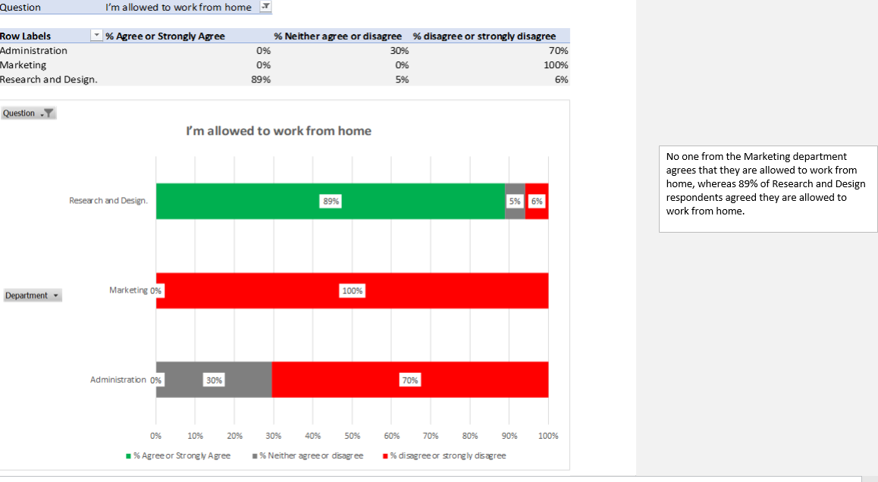

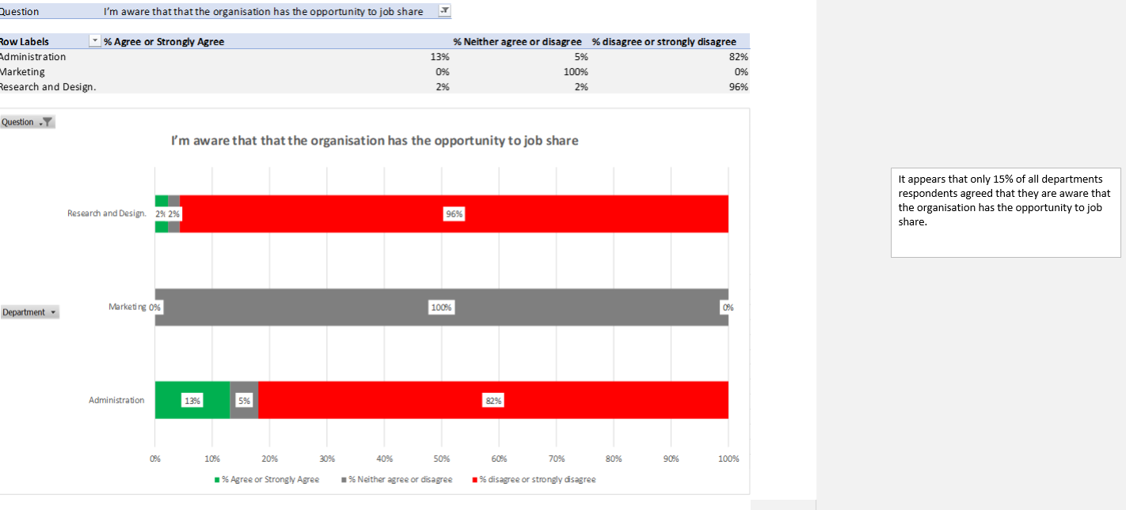

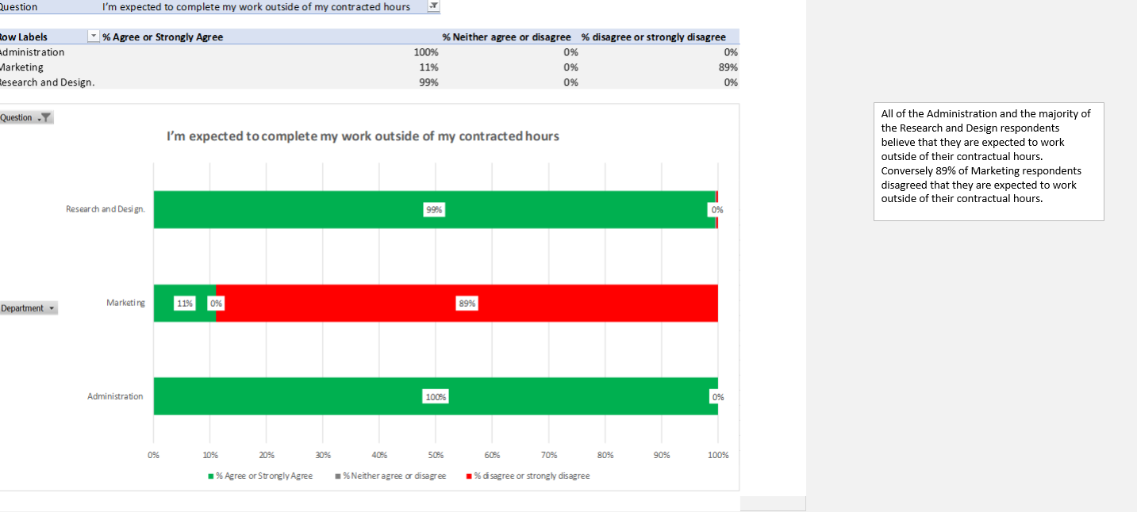

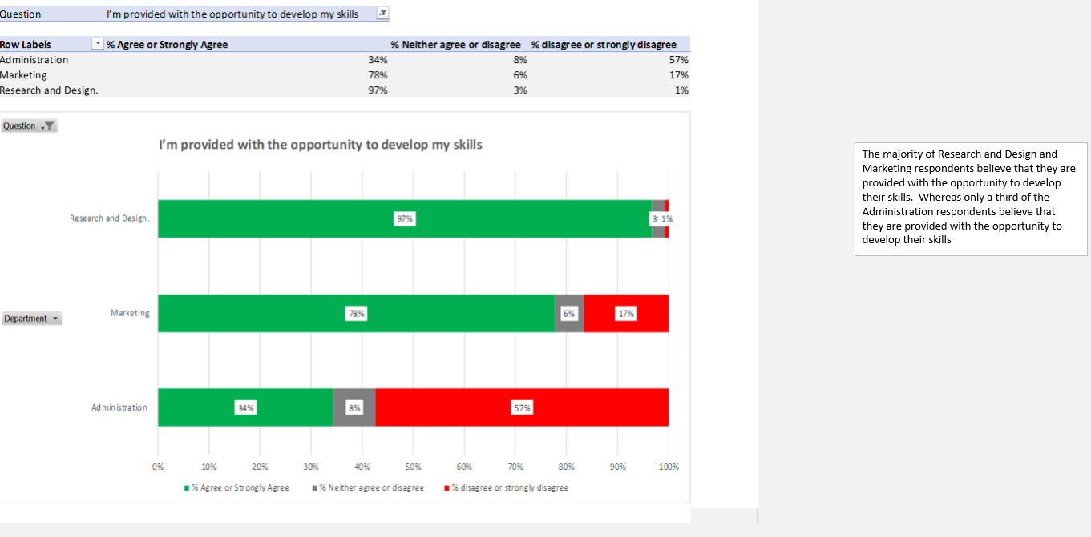

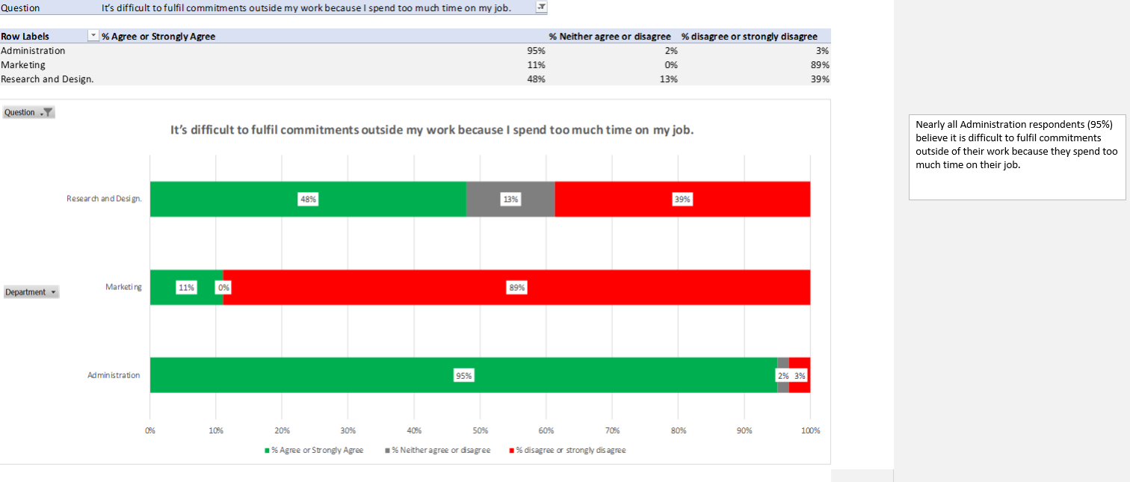

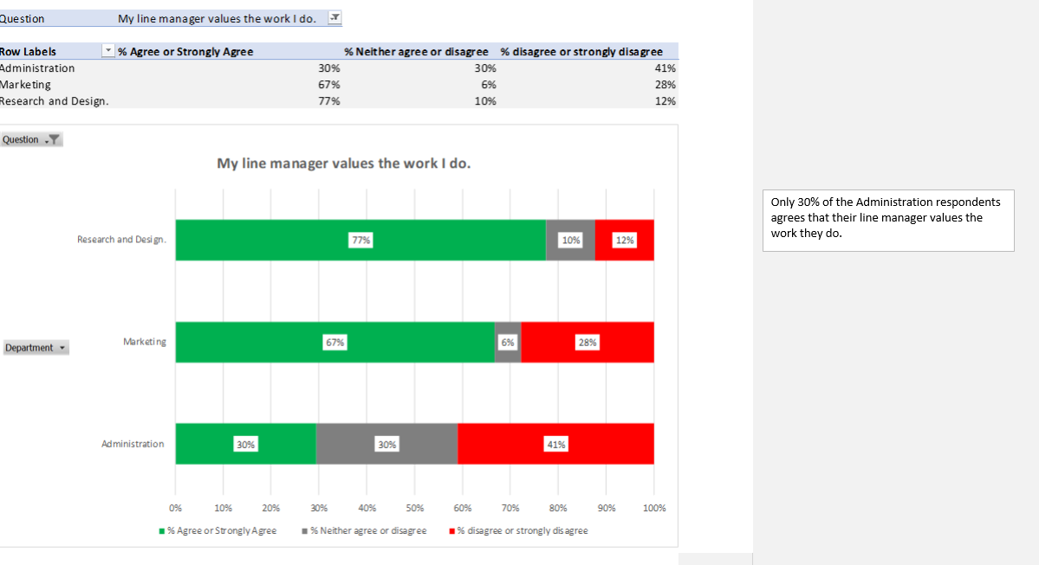

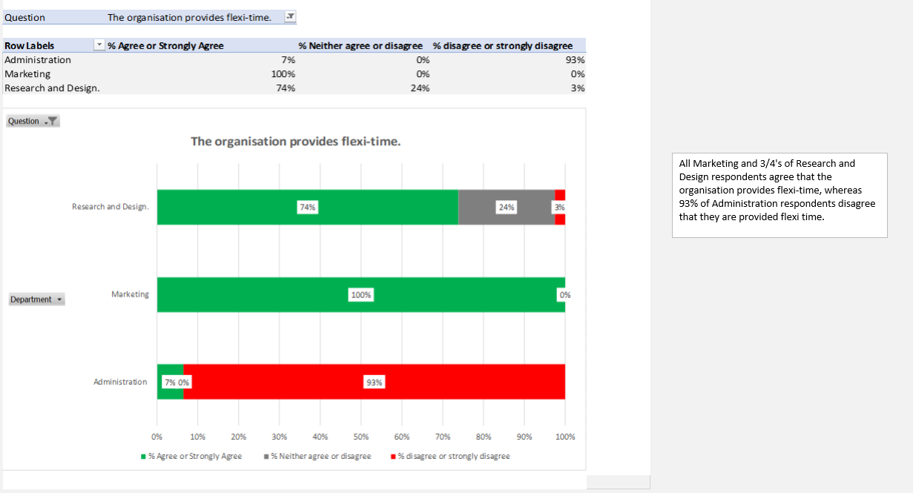

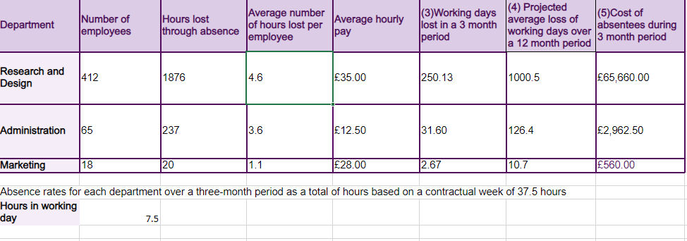

How many days lost due to Absenteeism over 3 month period?
Marketing – 2.5
Administration – 31.5
R & D – 250
Projected average loss of working days over 12 months?
Marketing – 10.5
Administration - 126
R&D – 1000
Costs of absenteeism over 3 month period?
Marketing – £560
Administration - £2962.50
R&D – £560.00

