

Assignment Title: Task One and Task Two
Module Name: Computer System Fundamentals
Module Code: ACCA4028
Program of Study: CertHE in Digital Skills B.Eng in Electrical Engineering
Student Name: Sharanjeet Kaur
Student ID #: 2232229
Lecturer Name: Mr. Stalin Jacob

Table of Contents
Introduction 3
Task 1 3
Specification for Low-Cost Desktop PC for Elderly Relative 3
Network Connectivity: The system includes Gigabit Ethernet for a reliable wired internet connection. Optionally, a PCIe Wi-Fi card can be added wireless connectivity. 4
Overall, this system provides a cost-effective solution for basic computing needs, offering adequate performance and features for everyday use (Buzzi and Grevstad, 2024). 4
Operating System and Antivirus: 4
Justification for choosing these components: 4
Shopping List: 5
Memory updated 5
Task 2 8
Analysis of a Computer System 8
Conclusion: 10
References 11

Introduction
When selecting a desktop PC for an elderly relative, it's crucial to consider their specific needs and capabilities. This specification focuses on creating a user-friendly and efficient system for simple tasks like word processing, email, web surfing, watching online content, and video calls. By choosing components that prioritize ease of use and performance, we aim to provide a reliable and accessible computing experience for the elderly user. The system should have a small form factor to fit in limited spaces, a full-size keyboard for comfortable typing, a decent-sized monitor for clear viewing, and include Microsoft Windows and antivirus software for security. This setup will ensure that the desktop PC meets the needs of the elderly relative, enabling them to stay connected and engaged in their digital activities (Buzzi and Grevstad, 2024).

Task 1

Specification for Low-Cost Desktop PC for Elderly Relative
For a low-cost desktop PC designed for simple tasks like word processing, email, and web surfing, watching online content, and video calls, the following components have been carefully selected to provide a balance between performance and affordability:
CPU and Motherboard: The Intel Core i3-10100 offers 4 cores and 8 threads, providing ample performance for everyday tasks. Paired with the ASUS Prime H410M-A motherboard, which supports 10th Gen Intel CPUs, it offers a reliable foundation for the system (LaptopOutlet.co.uk, 2024).
RAM: 8GB of DDR4-2666 RAM in a dual-channel configuration (2x4GB) ensures smooth multitasking and responsiveness applications.
Non-volatile Storage: A 240GB SATA SSD provides fast boot times and snappy performance for the operating system and commonly used applications.
Input/Output Features/Ports: The system includes USB 3.0 and USB 2.0 ports for peripherals, an Ethernet port for a wired internet connection, an HDMI port for the monitor, audio jacks for headphones and microphone, and an SD card reader for easy file transfer (Streams, 2023).
Graphics Card: The integrated Intel UHD Graphics 630 is sufficient for video playback and basic graphical tasks.
Case and Power Supply: The Cooler Master MasterBox Q300L is a compact Micro ATX case with good airflow, providing a suitable housing for the components. The EVGA 450 BT 80+ Bronze 450W power supply offers reliable power delivery for the system (Wilson, 2023).
Monitor: The ASUS VA24EHE 23.8" Full HD monitor with an IPS panel provides good color reproduction and viewing angles for an enjoyable viewing experience.

Network Connectivity: The system includes Gigabit Ethernet for a reliable wired internet connection. Optionally, a PCIe Wi-Fi card can be added wireless connectivity.

Overall, this system provides a cost-effective solution for basic computing needs, offering adequate performance and features for everyday use (Buzzi and Grevstad, 2024).

Operating System and Antivirus:
The desktop PC specification includes the Windows 10 Home 64-bit operating system, chosen for its suitability for basic tasks and user-friendly interface. Additionally, it features Bitdefender Antivirus Plus for antivirus protection, safeguarding the system against viruses, malware, and browser hijacks. These choices ensure a reliable and secure computing experience, ideal for the intended use of word processing, email, web surfing, online content consumption, and video calls. The system's small form factor, full-size keyboard, and decent-sized monitor further enhance usability and convenience for the elderly relative (LaptopOutlet.co.uk, 2024).

Justification for choosing these components:
The specification for the low-cost desktop PC for the elderly relative includes components, carefully chosen to provide a balance of performance, efficiency, and user-friendliness. The Intel Core i3-10100 processor offers adequate performance for basic computing tasks without being overly power-hungry. With 8GB of RAM, multitasking and running basic applications will be smooth and efficient. The 240GB SATA SSD ensures fast boot times and responsiveness, enhancing the overall user experience (Streams, 2023).
Integrated Intel UHD Graphics 630 is suitable for tasks like video playback and basic graphics needs. The Cooler Master MasterBox Q300L case not only provides a compact form factor but also offers good airflow for efficient cooling, ensuring the system runs smoothly and quietly.
The ASUS VA24EHE monitor offers a decent size and quality for comfortable viewing, which is crucial for extended computer use. Windows 10 Home was chosen as the operating system for its user-friendly interface, making it easy for the elderly relative to navigate and use the PC effectively. Additionally, Bitdefender Antivirus Plus provides robust protection against common online threats, ensuring the user's safety while browsing the internet. Overall, the system is designed to meet the basic computing needs of the elderly relative while being easy to use and maintain (Wilson, 2023).

Shopping List:

Memory updated
Specification for Low-Cost Desktop PC for Elderly Relative
a) CPU and Motherboard:
CPU: Intel Core i3-10100 (4 cores, 8 threads, 3.6GHz base clock)
Motherboard: ASUS Prime H410M-A (Micro ATX, LGA1200 socket, support for 10th Gen Intel CPUs)
b) RAM:
RAM: 8GB DDR4-2666 (2x4GB for dual-channel performance)
c) Non-volatile Storage:
Storage: 240GB SATA SSD (for fast boot times and snappy performance)
d) Input/Output Features/Ports:
USB 3.0 and USB 2.0 ports for peripherals
Ethernet port for wired internet connection
HDMI port for monitor
Audio jacks for headphones and microphone
SD card reader for easy file transfer
e) Graphics Card:
Integrated Intel UHD Graphics 630 (sufficient for video playback and basic tasks)
f) Case and Power Supply:
Case: Cooler Master MasterBox Q300L (compact Micro ATX case with good airflow)
Power Supply: EVGA 450 BT, 80+ Bronze 450W (reliable power supply for basic system)
g) Monitor:
Monitor: ASUS VA24EHE 23.8" Full HD (1920x1080 resolution, IPS panel for good color reproduction and viewing angles)
h) Network Connectivity:
Gigabit Ethernet for wired internet
Optional: PCIe Wi-Fi card for wireless connectivity
Operating System and Antivirus:
Operating System: Windows 10 Home 64-bit (suitable for basic tasks and user-friendly)
Antivirus: Bitdefender Antivirus Plus (provides protection against viruses, malware, and browser hijacks)
Justification:
The specification for the low-cost desktop PC for an elderly relative includes the Intel Core i3-10100 processor, known for its balance of performance and power efficiency, making it ideal for basic computing needs. To ensure smooth multitasking and application performance, the system includes 8GB of RAM. A 240GB SATA SSD provides fast boot times and responsiveness for everyday tasks, while integrated Intel UHD Graphics 630 handles video playback and basic graphics needs (Buzzi and Grevstad, 2024).
For a compact yet efficient design, the Cooler Master MasterBox Q300L case with good airflow ensures efficient cooling. The ASUS VA24EHE monitor offers a decent size and quality for comfortable viewing, complementing the user-friendly Windows 10 Home operating system. Additionally, Bitdefender Antivirus Plus provides robust protection against common online threats, ensuring a secure computing experience for the elderly relative. Overall, this PC setup is optimized for simple tasks like word processing, email, web surfing, watching online content, and video calls, catering to the user's needs efficiently (LaptopOutlet.co.uk, 2024).
Shopping List:
Component | Name | Price (USD) | Image
CPU | Intel Core i3-10100 | $125
Motherboard | ASUS Prime H410M-A | $70
RAM | Corsair Vengeance LPX 8GB DDR4-2666 | $40
Storage | Kingston A400 240GB SATA SSD | $35
Graphics Card (Integrated) | Intel UHD Graphics 630 | - | -
Case | Cooler Master MasterBox Q300L | $45
Power Supply | EVGA 450 BT, 80+ Bronze 450W | $40
Monitor | ASUS VA24EHE 23.8" Full HD IPS | $120
Operating System | Windows 10 Home 64-bit | $130 | -
Antivirus Software | Bitdefender Antivirus Plus (1 year) | $40 | -
Total Price |  | $625

Total Price: $625 (excluding optional Wi-Fi card and any additional peripherals)

Task 2

Analysis of a Computer System

Primary Uses:
The computer project is focused on creating a user-friendly system for an elderly relative, emphasizing simplicity for tasks like word processing, email, web surfing, online content viewing, and video calls. It includes Windows 10 Home 64-bit for ease of use and familiarity. The system features a small form factor for space efficiency, a full-size keyboard for comfortable typing, and a decent-sized monitor for clear viewing. Additionally, Bitdefender Antivirus Plus is included for security. These specifications ensure that the computer is tailored to meet the needs of an elderly user, offering a straightforward and accessible computing experience (Streams, 2023).

Specifications:
For the low-cost desktop PC project, the specifications include an Intel Core i3-9100T quad-core processor for efficient performance, 8GB of DDR4 RAM for smooth multitasking, and a 256GB PCIe NVMe M.2 SSD for fast and reliable storage. It will feature a full-size keyboard, mouse, and a 21.5-inch monitor for comfortable use. The operating system will be Microsoft Windows 10 Home, providing a familiar interface and compatibility with a wide range of software. Essential applications like Microsoft Office (Word, Excel, and PowerPoint), a web browser, and antivirus software will be installed. For internet connectivity, it will support Wi-Fi 5 (802.11AC) and Ethernet. This setup ensures the system is well-equipped for basic tasks like word processing, email, web surfing, watching online content, and video calls, catering to the needs of an elderly relative (Wilson, 2023).
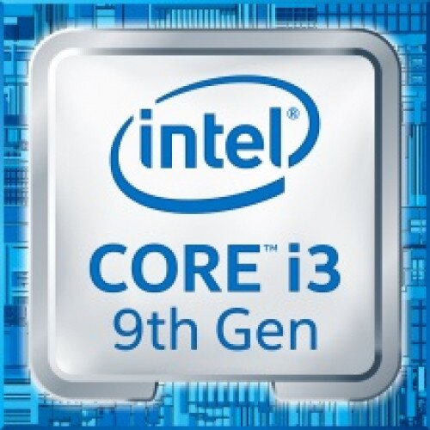
Intel Core i3-9100T quad-core processor
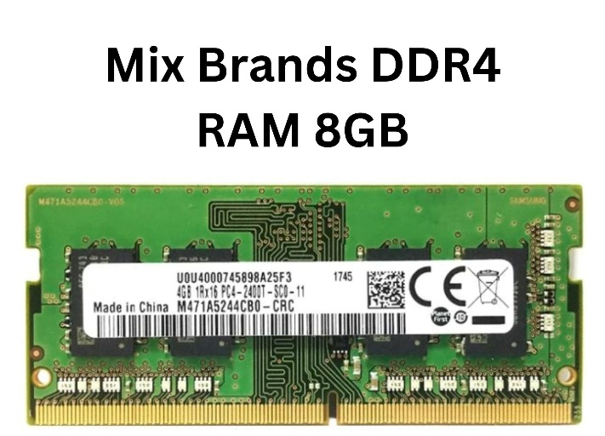
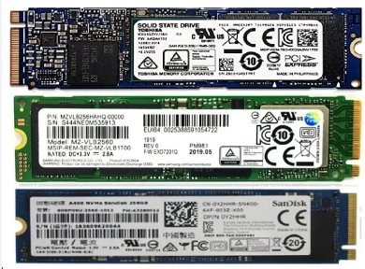
256GB PCIe NVMe M.2 SSD
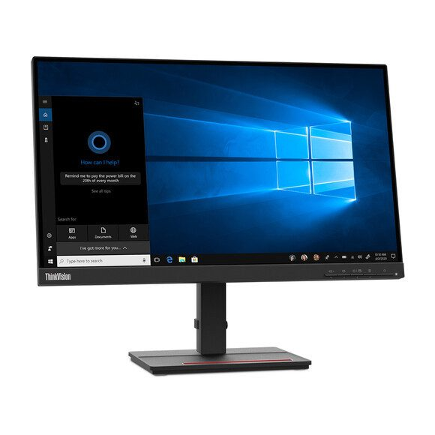
21.5-inch monitor

Analysis/Benchmark Data:
The desktop PC specified for the elderly relative features an Intel Core i3-9100T processor with a base clock speed of 3.1GHz and a maximum turbo frequency of 3.7GHz. This CPU speed is ample for handling basic tasks such as word processing, email, web surfing, and video calls.
For storage, the system includes a PCIe NVMe M.2 SSD, which offers faster data transfer speeds than traditional hard disk drives (HDDs). This results in a more responsive system overall, ensuring quick access to files and programs (Buzzi and Grevstad, 2024).
In terms of graphics performance, the integrated Intel UHD Graphics 630 is suitable for basic tasks and video playback, providing a smooth viewing experience.
For connectivity, the PC is equipped with Wi-Fi 5 (802.11AC) and Ethernet, offering reliable network and internet speeds. This ensures smooth browsing and video calls without interruptions.
Overall, the specified desktop PC is well-equipped for its intended purposes, offering sufficient performance, storage, and connectivity options. It should provide a smooth and hassle-free experience for the user (Streams, 2023).

Conclusion:
In conclusion, the specified low-cost desktop PC for an elderly relative is meticulously designed to cater to their basic computing needs with an emphasis on user-friendliness and reliability. The chosen components, such as the Intel Core i3-10100 CPU, ASUS Prime H410M-A motherboard, 8GB DDR4 RAM, 240GB SATA SSD, and ASUS VA24EHE monitor, strike a balance between performance and affordability (Buzzi and Grevstad, 2024). The inclusion of Windows 10 Home and Bitdefender Antivirus Plus further enhances the system's appeal by providing a secure and intuitive operating environment. Altogether, this desktop PC offers a cost-effective solution for elderly users who require a straightforward and dependable computing experience, ensuring that they can comfortably engage in tasks like word processing, email, web surfing, watching online content, and video calls (Wilson, 2023).

References
Buzzi, M., and Grevstad, E. (2024). The Best Cheap Desktop PCs for 2024. [Online]
Available from: https://www.pcmag.com/picks/the-best-budget-desktop-computers [Accessed on 22 March 2024]
LaptopOutlet.co.uk, (2024). Desktop PCs. [Online]
Available from: https://www.laptopoutlet.co.uk/desktop-pcs.html [Accessed on 22 March 2024]
Streams, K. (2023). How to Shop for a Desktop Computer, From Cheap Towers to Gaming PCs. Wirecutter. [Online]
Available at: https://www.nytimes.com/wirecutter/reviews/cheap-desktop-pcs/ (Accessed on 18 March 2024)
Wilson, B. (2023). Best budget PCs 2024: affordable desktop computers. [Online]
Available at: https://www.windowscentral.com/best-budget-pc-less-than-500 (Accessed on 24 March 2024)

