The snake as a symbol and why it is associated with both the Minoan House Goddess and Classical Athena.
Chapter 1: Introduction, Theory and Methodology: (1500 words)
Section a: Introduction
- Criticism of scholars who compare two images of goddesses and declare them similar.
- Snake as a symbol of earth, therefore a protector.
- Continued use of the symbol from Minoan to Classical Greek times.
Section b: Methodology
- Literature and scholarly debates on the topic, e.g. Black Athena, and the debate over the origins of Greek Civilisation.
- Comparison of iconographic representation of the Minoan snake goddess and Athena.
- Chronological: Minoan/Mycenaean influence on Classical Greek culture. Other points of influence?
- Theoretical Methodology: Classical Greeks and their cultural memory.
- Comparison with other cultures: Lithuania, Latvia, Egypt.
Section c: Cultural Memory Theory
- How this theory will be used in my dissertation: culture as memory, (Halbwachs ‘Collective Memory’; Warburg’s social memory).
- Societies preserve the ancient rites and beliefs into its current religious organisation, connect this with the argument that the Classical Greek Goddesses represent a collective memory of the previous civilisations.
- The importance of external symbols, “making” memories through monuments. Link with continued use of shrines.
- Cultural Memory is of the absolute past, include traditions of the origins of the world, but the traditions are formalised in narratives, such as epic poems.

Chapter 2: Snake as a symbol of the earth and a protector (2000 words)
- Henderson & Oakes/Morgan/Mundkur significance of snake symbolism.
- The snake as a Jungian archetype.
- Charlesworth/Babejova meanings of snake images in Near Eastern iconography.
- Discussions surrounding the snake in Aristotle’s History of Animals:
  - The idea of a sacred snake, specifically a small snake that grows to a cubit, is hairy, and whatever it bites in putrefied (7.20.30).
  - Snakes as healers: the putrefactive drug made from an Asp, and the silphium? (7.29.20).
  - Discussions on what snakes eat, how snakes will take whatever they are offered, but can also live for a long time without food (7.37.5)
  - Details on the shredding of snakeskin, how it is done from the head to the tail. Also, the naming of the procedure as casting the “old age” (8.17.15-30).
Section a: Snakes protecting shrines and religious sites.
- Snake of Athens in Herodotus
  - In Athens “they have a great snake which guards the acropolis” when the Persians invade the snake refused to eat the offering so the Athenians deserted the city because the Goddess had deserted the acropolis.
- Other examples of religious/sacred snakes?
Section b: Snakes as the symbol of the home.
- Minoan House Goddess, a statuette of the woman holding snakes.
- Athena’s Palladium in Troy provides safety. Similar to the cult of the Minoan house goddess who had a sanctuary within the palace.
Section c: Transference across religions, including the Bible.
- Existence of snake symbol before their introduction by the Minoans, seen at the Neolithic shrine in Achilleion, Thessaly.
- Reasons for its symbolic significance: movement without legs, living in holes, born from eggs.
- Medical purposes: skin, poisonous bite and venom.
- Snakes symbolise: chthonic being, an adversary of man, protector of sacred precincts and the underworld, an animal with the soul of human, sexual symbol both masculine and feminine, and symbol of constant renewal.
- The snake symbol is prevalent in many cultures: Africa, Central American, China and India.
- Greek mythological association between cows and snakes (Hera), reaches Latvia and Lithuania, where milk is left out in the home for snakes, who are seen as protectors of the house
Section d: The snake itself as an animal
- Was it significant because snakes in the home helped to kill vermin?
- Does a snake being poisonous or venomous make a difference?

Chapter 3: Minoan Snake Goddess (2000 words)
Section a: Minoan goddess and her importance
- Her attributes and different forms.
Archaeological evidence and how this is interpreted.
- Debates surrounding the importance of the Minoan Snake Goddess:
  - Axel Persson: ‘Great Minoan Nature Goddess’, linked with tree and stone cults.
  - Jacquetta Hawkes: ‘in the lands and islands of the Aegean the goddess and her worship were introduced with the earliest farming’.
  - Peter Warren argues for the importance of female divinity.
  - Evans said goddess represented “the same Great Mother with her Child or Consort whose worship under various names and titles extended over a large part of Asia Minor and the Syrian regions beyond”.
Section b: Archaeological evidence surrounding snakes
- The Mycenaean female statuette, one hand is missing but it is suggested she was holding a snake, due to the two coils beneath her left hand. Other heads of snakes and coils of snakes found in the cache.
- Seventeen snake figurines, perhaps associated with idols unknown which one. Snake as a chthonic character, Taylour argues for a connection between the snakes and the natural rock from which the temple was built.

Section c: Mycenae’s snake imagery
This section will have a discussion on the large amounts of snake imagery found at Mycenae and why this is significant.
- During excavations in 1921 at Mycenae two ‘intaglios’ showing the Great Mother holding snakes, with a lion and the double axe symbol.
- ‘Room of the idols’ where a large number of snake symbols were found at Mycenae.

Chapter 4: Snake Images in Classical Greece (2000 words)
Section a: Athena’s association with a snake.
- A list of examples is given in Nilsson.
  - Boeotian cup, which shows a snake behind Athena (See Appendix 1).
  - The Parthenon statue made by Phidias shows a snake behind Athena’s shield.
  - Image of Athena being drawn by a chariot with two large snakes on a Pyxis.
- Further examples can be found in the Lexicon Iconographica and from the Beazley archive.
- When appearing with a snake Athena is associated with Heracles, often the snake is on her shield (See Appendix 1 and 2).
- Discussion on Athena’s Aegis: whether this is the shield or her armour. Are the tassels snakes?
- Athena’s role in the transformation of Medusa into a Gorgon?
  - The version from the Ovid has Medusa being raped by Poseidon in the temple of Athena (Metamorphoses 4.770).
  - Medusa’s face later ends up on Athena’s shield as a present from Perseus.
Section b: Erichthonius, the mythical founder of Athens who was half-snake.
- Athena’s snake associated with her ‘son’ Erichtonios. He was either: born of the earth after Hephaestus attempted to rape Athena or was given to Athena by the earth.
- Erichthonios is associated with Cecrops, the apparent first king of Athens who had a serpent’s tail.
- Cecrops’ daughters were Erichthonios nurses when asked by Athena.
- The myth of the Agraulides: Athena gave Cecrops’ daughters a chest with Erechthonius inside and told them not to open it, however, they disobeyed and opened the chest; two snakes emerged from the chest and scared the daughters to death.
- Various versions in: Pausanias, Euripides Ion, Aristophanes Wasps, Apollodorus, Diodorus Siculus, Hyginus Astonomica and Fabulae, Philostratus Vita Apollonii, Hesychius, and Sophocles frag.643.

Section c: Other representations of snakes in Classical Greece
- Asclepius
  - God of healing – links with the healing that snakes symbolise
- Apollo and the Python
  - Python used to be in the cave of the oracle in Delphi – the idea of a snake protecting a shrine
- Hermes and his caduceus
  - The entwined snakes

Chapter 5: Discussion (2000 words)
- Transference of snake images across cultures.
- Are they remembrances of the previous culture?
- Has the association with the snake continued: Christianity, Bulgarian lizards in the fireplace, Lithuanian pet lizards, etc.
- There is an alternative argument of Hera being associated with the Minoan snake goddess.

- Possible links between Minoan-Mycenaean goddess and Athena:
  - Present in palaces and temples - link is tenuous, does not necessarily mean continuity of culture/occupation.
  - Link is the association of Athena and Erechtheus - why Athena enters the ‘strong house of Erechtheus’ when she comes to Athens.
- The Mycenaean palace shrine or chapel was a significant feature, the classical temple of Athena overlaps the remains of the Mycenaean palace in Mycenae.
- The possible overlap between the Mycenaean and Classical structures on the Athenian acropolis. Between the Parthenon and ‘Erechtheion’ are the ‘Doerpfeld Foundation’, a complex of wall foundations, among which is a column, suspected to be the last remnant of a palace structure having been on the acropolis, possibly the strong house of Erechtheus.

Conclusion (500 words)
Religious continuation from Minoan to Mycenaean to Classical Greece, especially of the image of a snake being associated with the goddesses.
Snake as a continued image associated with the home across multiple cultures, although in Christianity the snake has a negative association.

Appendix

1: Possibly Boetian Cup, shows a snake behind Athena.
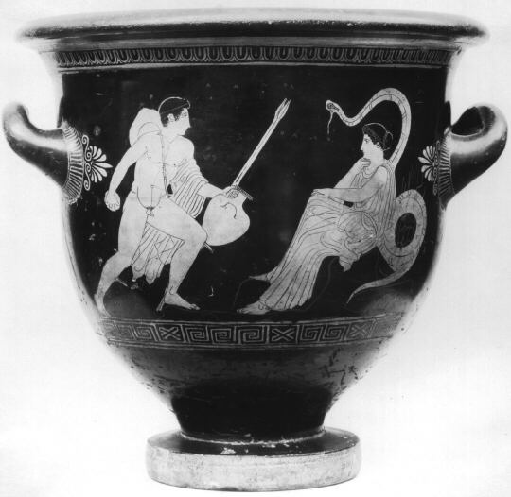
Figure 1 Beazley 214545: Athenian. From: New York, Metropolitan Museum (22.139.11).

2: Vessel showing Athena with Heracles. (1)
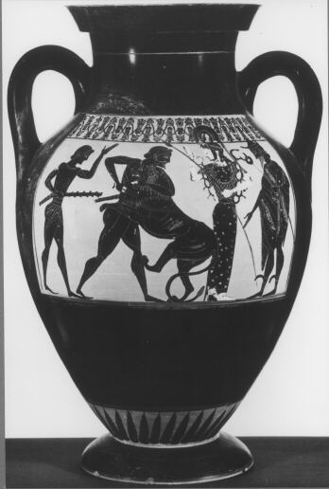
Figure 2 Beazley 6228: Athenian. New York from the market, Royal Athena; and Beverley Hills CA from the market, Summa Galleries.

3: Vessel showing Athena with Heracles. (2)
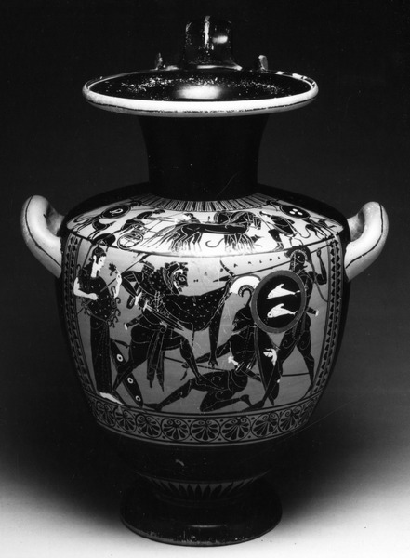
Figure 3 Beazley 9050: Athenian. From New York and London Sotheby's (154).

Bibliography
Ancient Sources:
Aristophanes., The Wasps/The Poet and the Women/The Frogs., David Barrett (trans.), 1964, London: Penguin Books.
Aristotle., History of Animals, Volume 3: Books 7-10., A.L. Peck (trans.), 1965, Cambridge MA: Loeb Classic; Harvard University Press.
Apollodorus., The Library of Greek Mythology., Robin Hard (trans.), 1997, Oxford: Oxford University Press.
Euripides., The Bacchae and Other Plays., Philip Vellacott (trans.), 1972, London: Penguin Books.
Pausanias., Guide to Greece. Vol.1: Central Greece., Peter Levi (trans.), 1971, Harmondsworth: Penguin Books.
Ovid., Metamorphoses., Brookes More (trans.), 1922, Boston: Cornhill Publishing Co.
Modern Scholarship
Assmann, J., 2008. Communicative and Cultural Memory. In: A. Erll & A. Nunning, eds. Cultural Memory Studies: An International and Interdisciplinary Handbook. Berlin; New York: s.n., pp. 109-118.
Assmann, J. & Czaplicka, J., 1995. Collective Memory and Cultural Identity. New German Critique, Volume 65, pp. 125-133.
Babejova, E., 2011. She Will Wind Herself Around You. Jung Journal: Culture & Psyche, 5(3), pp. 94-115.
Baring, A. & Cashford, J., 1991. The Myth of the Goddess: Evolution of an Image. London; New York; Victoria; Toronto; Auckland: Arkana, Penguin Books.
Becker, U., 2005. The Continuum Encyclopedia of Symbols. London; New York: Continuum.
Bernal, M., 1987. Black Athena: The Afroasiatic Roots of Classical Civilization. Vol 1, The Fabrication of Ancient Greece 1785-1985. London: Vintage.
Bernal, M., 1991. Black Athena: The Afroasiatic Roots of Classical Civilization. Vol 2 The Archaeological and Documentary Evidence. London: Free Association Books.
Bernal, M., 2001. Black Athena Writes Back: Martin Bernal Responds to his Critics. Durham; London: Duke University Press.
Blakolmer, F., 2010. A Pantheon without attributes? Goddesses and Gods in Minoan and Mycenaean Iconography. In: J. Mylonopoulos, ed. Divine Images and Human Imaginations in Ancient Greece and Rome. Leiden; Boston: Brill, pp. 21-62.
Bonney, E. M., 2011. Disarming the Snake Goddess: A Reconsideration of the Faience Figurines from the Temple Repositories at Knossos. Journal of Mediterranean Archaeology, 24(2), pp. 171-190.
Buchanan, B., 1971. A Snake Goddess and Her Companions a Problem in the Iconography of the Early Second Millennium BC. Iraq, 33(1), pp. 1-18.
Charlesworth, J., 2010. The good and evil serpent: how a universal symbol became Christianised. New Haven CT: Yale University Press.
Deacy, S. & Villing, A., 2009. What was the colour of Athena's Aegis?. Journal of Hellenic Studies, Volume 129, pp. 111-129.
Deane, S. N., 1922. Archaeological News. American Journal of Archaeology, 26(1), pp. 89-130.
Eller, C., 2012. Two Knights and a Goddess: Sir Arthur Evans, Sir James George Frazer, and the Invention of Minoan Religion. Journal of Mediterranean Archaeology, 25(1), pp. 75-98.
Evans, S. A., 1930. The Palace of Minos, 6 Vols. London: Macmillan.
Gimbutas, M., 1989. The Language of the Goddess. London: Thames & Hudson.
Goodison, L. & Morris, C., 1998. Beyond the 'Great Mother': The Sacred World of the Minoans. In: L. Goodison & C. Morris, eds. Ancient Goddesses: The Myths and the Evidence. London: British Museum Press, pp. 113-132.
Goodison, L. & Morris, C., 1998. Introduction: Exploring Female Divinity: From Modern Myths to Ancient Evidence. In: L. Goodison & C. Morris, eds. Ancient Goddesses: The Myths and the Evidence. London: British Museum Press, pp. 6-21.
Halbwachs, M., 1941; 1992. On Collective Memory. Paris; London; Chicago: Presses Universities de France; The University of Chicago Press.
Hawkes, J., 1968. Dawn of the Gods: Minoan and Mycenaean Origins of Greece. New York: Random House.
Henderson, J. L. & Oakes, M., 1990. The Wisdom of the Serpent: The Myths of Death, Rebirth, and Ressurection. New York: Princeton University Press.
Hopper, R. J., 1963. Athena and the Early Acropolis. Greece & Rome, Volume 10, pp. 1-16.
Jones, B. R., 2016. The Three Minoan "Snake Goddesses". In: R. B. Koehl, ed. Studies in Aegean Art and Culture. Philadelphia PA: INSTAP Academic Press, pp. 93-112.
Lefkowitz, M. R. & Rogers, G. M., 1996. Black Athena: Revisited. Chapel Hill; London: The University of North Carolina Press.
Lupack, S., 2010. Mycenaean Religion. In: E. H. Cline, ed. The Oxford Handbook of the Bronze Age Aegean. Oxford: Oxford University Press, pp. 263-276.
Luyster, R., 1965. Symbolic Elements in the Cult of Athena. History of Religions, 5(1), pp. 133-163.
Morgan, D., 2008. Snakes in Myth, Magic, and History: The Story of Human Obsession. Westport CT: Praeger.
Morgan, L., 2005. The Cult Centre at Mycenae and the duality of life and death. British School at Athens Studies, Volume 13, pp. 159-171.
Mundkur, B., 1983. The Cult of the Serpent: An Interdisciplinary Survey of its Manifestations and Origins. New York: State University of New York Press.
Nilsson, M. P., 1927. The Minoan-Mycenaean Religion and its survival in Greek Religion. London: Oxford University Press.
Nilsson, M. P., 1932. The Mycenaean Origin of Greek Mythology. Berkeley CA: University of California Press.
Persson, A. W., 1942. The Religion of Greece in Prehistoric Times. Berkeley; Los Angeles: University of California Press.
Stassinopoulos, A. & Beny, R., 1983. The Gods of Greece. London: Weidenfeld & Nicolson.
Taylour, L. W., 1970. New Light on Mycenaean Religion. Antiquity, Volume XLIV, pp. 270-280.
Warren, P., 1981. Minoan Crete and ecstatic religion. In: R. Hagg & N. Marinatos, eds. Sanctuaries and Cults in the Aegean Bronze Age. Stockholm: Paul Astroms Forlag, pp. 155-67.
Warren, P., 1988. Minoan Religion as Ritual Action. Goteborg: Gothenburg University.

Bernal, 2001; Bernal, 1987; Bernal, 1991; Lefkowitz & Rogers, 1996.
Assmann, 2008, p. 111.
Halbwachs, 1941; 1992.
Warburg within Assmann & Czaplicka, 1995, p. 125.
Halbwachs, 1941; 1992, p. 85.
Assmann, 2008, p. 111.
Assmann, 2008, p. 112.
Henderson & Oakes, 1990; Morgan, 2008; Mundkur, 1983.
Babejova, 2011, p. 98.
Babejova, 2011, pp. 98-99; Charlesworth, 2010.
Hdt 8.41; Nilsson, 1927, p. 428.
Hdt 8.41.
Hdt 8.41; Nilsson, 1927, p. 428.
Nilsson, 1927, p. 428.
Nilsson, 1927, pp. 429-30.
Gimbutas, 1989, p. 132.
Becker, 2005, pp. 263-5.
Becker, 2005, pp. 263-5.
Becker, 2005, p. 264.
Gimbutas, 1989, p. 134.
Babejova, 2011, p. 97.
Bonney, 2011; Eller, 2012; Jones, 2016.
Goodison & Morris, 1998, p. 113.
Persson, 1942.
Hawkes, 1968, pp. 26-7.
Warren, 1981; Warren, 1988.
Baring & Cashford, 1991, p. 110; Evans, 1930, p. 277.
Taylour, 1970, p. 272.
Taylour, 1970, p. 278.
Taylour, 1970, p. 278.
Blakolmer, 2010; Lupack, 2010; Taylour, 1970; Morgan, 2005.
Deane, 1922, p. 101.
Morgan, 2005, p. 166.
Hawkes, 1968.
Nilsson, 1927, p. 426.
Deacy & Villing, 2009.
Luyster, 1965, p. 146.
Luyster, 1965, p. 145.
Pausanias. 1.18.2.
Nilsson, 1927, p. 427.
Stassinopoulos & Beny, 1983.
Stassinopoulos & Beny, 1983.
Stassinopoulos & Beny, 1983.
Buchanan, 1971.
Gimbutas, 1989, p. 134.
Hopper, 1963, p. 7.
Hopper, 1963, p. 6.
Hopper, 1963, p. 7.

