Lecturer: Chris Felices
Module code: BMSK4003
Name: Rahima Akther Khanom
Student number: 1806290

Digital Skills and Research



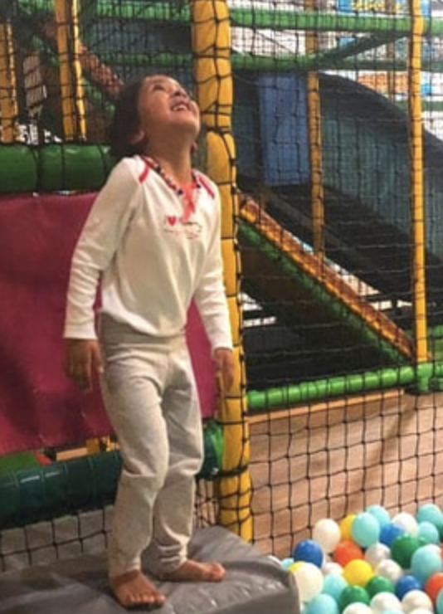

Weebly Website

Our website Wonderland was created on Weebly with me taking Marketing and creating the front page to a website.

Creating the front page was interesting to say the least, it had to be clear, concise, and easy to read, with not too much information as I felt people would lose interest and would just like to have the facts and details such as: -

- Welcoming customers to our site
- Where it is
- Who it caters for?
- What services we provide
- What are opening times are
- And where else on social media they can contact and review us.

I feel the information I have given is relevant and easy to read for everyone.
With a picture of colourful small balls and Wonderland written across it in Bold white writing it shows who we are, then in yellow smaller words Laugh, Escape, and Enjoy, these words show us what you do when you are in Wonderland.

We have a line of key words that can take us straight to any other services required such as Home, what is Wonderland, Parties, Café, Activities and Events, and a Contact us.

Below this, is a picture I have chosen of my daughter that has a smile on her face, this shows a content and happy child, enjoying where she is, with the background behind her showing other equipment, the picture is colourful and therefore the rest of the page remains white, so my writing stands out to the audience.
Rahima Khanom (1806290)

At the bottom of this web page is a polite notice that mentions “Please visit the pages you require and follow us” with the social media icons of Facebook, Twitter, Instagram and Email.

When clicked on “pages” and “about” and underneath heading type, clicking on visibility shows the page is open to public.

Clicking on “SEO Settings” (Search Engine Optimisation) and on page description shows a detailed description of what our site is regarding, this will appear in search engine results such as Google.

Below this is META KEYWORDS, I have used keywords such as Wonderland, Indoor play centre, Newport Gwent.

Meta Keywords are specific type of meta tag that appears in HTML code of any web pages and tells the search engines what the web page is about, however they are different compared to regular keywords as it appears “behind the scenes,” in the source code of the page, rather than being visible.

Below is a link that shows My page on Wonderland.

https://www.weebly.com/editor/main.php

My Google account details are as follows:

1806290uwtsd@gmail.com

And the password is:
Dob03.04.86

