Name: Nurjahan Begum

Student number: 1912210

Module code: BMSW6103

Module: Leading and implementing workplace change

Assignment title: Change management portfolio

Lecturer: Professor Dennis Pepple

Figure-1 change management image
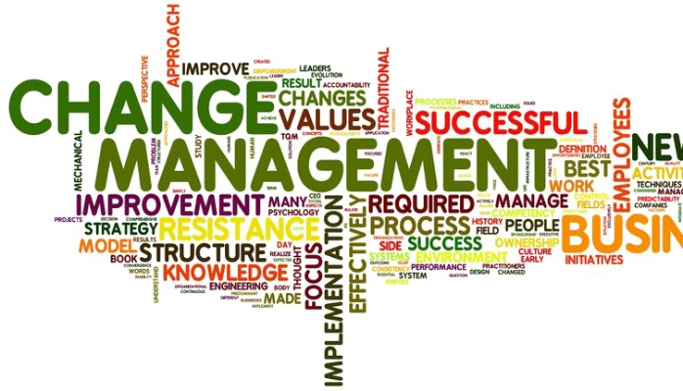
Source: Carrtegra (2022)

Contents

1.0 Introduction..............................................................................................................................................4

2.0 How the working world is evolving........................................................................................................5,6

2.1 Drivers of change.....................................................................................................................................6

2.2 Emerging themes emerging from the drivers of change..........................................................................6

2.3 Tesco’s customers reaction to change..................................................................................................6,7

2.4 The positive and negative impact of Tesco's automation Go-Get technology..........................................7
.
3.0 Process in Tesco's that can be automated....….......................................................................................7
.
3.1 Evaluating Levins change management model on Tesco’s process ....................................................8,
.
3.2 Levin’s models limitations..............................................

3.3 The driving and restraining forces that may affect the change

4.0 Tesco's organisational structure....................................................

4.1 Tesco's structures affecting the change management process.............
.
5.0 Conclusion..........................................................................................

6.0 Recommendations...........................................................................

7.0 References......................................................................................................

8.0 Appendix..............................................................................................................

1.0 Introduction

The fundamental conclusion of this portfolio is to analyse the significance of the evolving nature of the world of work and the forces driving change comprehending the function of automation. In a recent analysis, a global research and consultancy firm predicted a bleak future for the labour market in India and other five largest economies in Asia pacific by 2040, (Rao, A, 2022). The working population in these five economies, India, China, South Korea, Australia, and Japan are more likely to be in danger of automation than in north America and Europe. To evaluate and analyse how the change affects the world of work
I will be using an organisational example like Tesco PLC, established by Jack Cohen in 1919 and well known to be Britain's largest retailer of foods and other goods. According to E, Bedford, (2022) Tesco employs 354,000 employees worldwide with 5,000 locations across the globe.

My discussion will be based around how processes in Tesco that can be automated through Levins change management model as well as the shortcomings and benefits, furthermore the organisational structure of Tesco’s will be researched to understand how structure influences the change management process. My end conclusion will be based on the key factors of the evolving nature of the world of work and the impact of Levins change management model has on Tesco PLC’s organisation.
226

2.0 How the working world is evolving

Since the 1980s, the nature of labour has undergone significant, fundamental changes in a relatively brief period of time. The way the economy operates has altered because of technology. The world of work has transformed as a result of this. (Vettori, s, 2016). While technical innovation has been a major factor in the form and speed of change, other market, and social influences, such as rising worker diversity, heightened competitiveness and increased global integration have also contributed. Organisations have altered how work is organised in response to these changes. Economic constraints, and the desire to remain environmentally conscious. According to Awadari & Kanwal (2020). Organizational change is necessary and typical in a world that is changing. Whether in smaller or larger firms, change occurs at numerous levels to maintain their competitiveness. Therefore, it is believed that change is necessary for companies to survive. Any company that does not evolve throughout time will not last or be around in the long run. (Storey, 2007; Burnes, 2000). Additionally, there have been changes in the product markets with a rise in the desire for authenticity and improvement of the customer experience, both of which have an impact on how work is structured and carried out. Employees have simultaneously asked for modifications to their working conditions in an effort to improve the harmony between their personal and professional life. (Kelliher & Richardson, 2018). According to Forrester's most recent analysis, “The future of jobs forecast, 2020 to 2040,” the working populations of these five economies- Japan, Australia, south Korea, China, and India, face a greater danger of automation by 2040, (Rao, A,2022) than those in North America and Europe
Over 247 million jobs are anticipated to be at risk (Rao, A,2022) in the five economies, according to the report, “across industries more susceptible to automation.” Despite the fact that automation would threaten 69% of Indian jobs, (Rao, A,2022) the report states that the country's top goal will be to create jobs in order to handle the influx of new Workers. According to Rao, A, (2022), India will add 16 crore new workers in the next 20 years, but Japan, south Korea and China will see their workforces decline by 19%, 23% and 11%, (Rao, A,2022) respectively, primarily owing to an ageing population. The Indian government has set its focus on employment creating, according to Ashutosh Sharma, research director and vice president at Forrester, to combat the rise of automation.an effort in that regards made through, “make in India” and numerous incentive programs called “skilled India” to train rural kids to work meaningful jobs, (Rao, A, 2022) in developing industries is his claim. He also claims that automation will increase a sector's overall productivity rather than negatively impact India's ability to create jobs. For India to become a manufacturing centre, automation is essential. Largeproduction scales are used in highly productive environments to offset the decreased number of jobs per unit of production "Mr. Sharma notes, Automation can actually improve the capacity for job creation in India, according to Professor Krishna Nandivada of the Department of Computer Science and Engineering at IIT Madras,

He also proposes a two-pronged strategy to revitalise the labour force in the face of growing automation. Proactively identifying the existing workforce that could be affected by automation and upskilling them in a deliberate but forward-looking manner. Locating the employment chances in a society that is becoming more and more automated and preparing the younger workforce in that way," he claims.
The emphasis on upskilling is crucial for the future of employment, not just in India but also globally. Upskilling workers to manage automation will benefit major firms' finances as more businesses look to automation to boost efficiency and optimise manufacturing processes.

A case in point A 50,000person organisation can save $278 million over three years, (Rao, A, 2022), by upskilling its workforce, according to a 2018 Capgemini Research Institute analysis. "In order to fully utilise automation, we need people to create, maintain, and enhance the tools as well as use them. These elements provide a sizable market for occupations, particularly in India "Mr. Nandivada makes a suggestion that in the future, people will need to have higher-order cognitive abilities. Higher order cognitive abilities, to put it simply, are the capacity for critical thought and analysis to address any problem. Mr. Sharma emphasises the need for a closer match between the current training options and the talents that will be in demand in the near future." Blue collar jobs typically become white collar jobs as a result of automation. Workers in a fully automated future will need to learn the proper technical skills as well as the proper behaviours, such as professionalism, safety, and quality consciousness.”A further comment is made by him. According to the Forrester analysis, the green economy is becoming increasingly significant and could even partially offset job losses have brought on by automation. The analysis predicts that by 2040, the five

economies of the Asia Pacific region will add 28.5 million, ( Rao,S, 2022) new employment related green infrastructure smart cities, and renewable energy. 812

2.1 Drivers of change

According to Davies, J, (2022) The pace of change in society and the workplace is being accelerated by eight key forces such as technology, demographics, social trends, role of the state, covid-19. sustainability, globalisation, and migration. Covid-19 was unanticipated (for the majority of people) and is serving as a catalyst for quick and dramatic change. Change is fast due to technological advancements and environmental concerns. In the meantime, other longer-term factors including demography, the role of the state, globalisation, migration, and social trends are still causing significant changes in the future of the workplace. In the early 1960s workplaces were considerably different from what they are today. White men were employed in factories from 9 a.m. to 5 p.m., five days a week (Davies, j,2022) and the workplace was based on gender stereotypical occupations and a lack of diversity. Since then, the number of economically active women has more than doubled, the percentage of workers employed in manufacturing and construction has decreased from 40% to 15% (Davies, J, 2022) and the proportion of self-employed people in the workforce has roughly doubled. Only in the intervening years were individual employment rights, such as discrimination laws, enacted. While technological advancements are already changing many parts of life and will continue to do so, the climate emergency will likely be the main force for change. Climate change may soon begin to play a larger role in addition to present efforts to reduce carbon dioxide and methane emissions.

As farming regions shift, businesses relocate to areas less at risk from extreme weather or increasing sea levels, and individuals flee the economic repercussions of climate change, rising sea levels and changing weather will cause change in the "where" of labour. To keep up with these developments, employers, employees, as well as lawmakers and policymakers, will need to innovate and adapting a period when employing gender-neutral language was less significant, former UK Prime Minister Harold Wilson once said: "He who refuses change is the architect of destruction, the cemetery is the only human institution that opposes progress. The eight drivers of change will affect the what, who, when, where, how, and why of labour as well as the how much, what, where, and who.” (Davies, J, 2022).361

2.2 Emerging themes emerging from the drivers of change

Eight Themes emerged from the drivers of change are labour markets, regulation and enforcement models, flexibility and resilience, social interaction and sense of belonging, inequality and division, diversity and discrimination and innovation having an affect around the world and are more likely to be related to the government creating employment, legalisation and policy, employers responding to the changing nature of work, people pursuing professions in the landscape, as well as the influence of changing jobs. Labor markets are experiencing disruptions all across the world. The flaws of regulatory and enforcement mechanisms that have developed to match the needs of an industry that is swiftly, transforming into oblivion are brought into stark attention by the constantly changing nature of work. Flexibility and resilience are crucial for both individuals and organisations in a fragmented and uncertain work environment (Davies, J,2022), Fragmentation and ambiguity will also highlight how important work is in satisfying employees' needs for social connection and a sense of belonging. The forces driving change are likely to lead to more inequality and divisiveness in the years to come. Inequality, a lack of diversity,

and prejudice are all receiving more attention and are being tolerated with increasing fervour. Governments, people, and their employers must put an emphasis on innovation if they are to meet the demands of a changing workplace (Davies, 2022).215

2.3 Tesco's automation Get-Go technology and people's reactions to this change

Tesco launched its first checkout free store in central London on October 19 Tuesday 2019, according to
(Tesco PLC, 2022). Allowing consumers to shop and pay without scanning an item or using a checkout. Customers could purchase the same Tesco goods from this new retail trial, Get-Go, with a smooth shopping experience. Customers using the Tesco.com app are able to check in to their shop, pick up the groceries they need, and walk right out again without stopping at a checkout, thanks to their cutting-edge technology When customers left the store, they would be charged for the products they had bought when they left the store straight through the app using a combination of cameras and weight sensors to determine what they had picked up. Age restricted products had their own section in the store, with a

separate exit where employees personally verify Identification. The purpose of this modern technology is to make shopping even more convenient for consumers at Tesco's first Get-Go store, saving time for those who want to stop in quickly to pick up lunch or dinner on their way home. 176

2.4 The positive and negative impact of Tesco's automation Go-Get technology

Tesco's focus and target was aimed at millennial parents who are busy or wanting to get in and get out, and do not want to waste time, according to Saunter a senior retail analysist at the consumer trends analysist firm WSGN, (The Guardian, 2022) and the younger generation, known as generation Z. Three London School of Economics students who visited the Tesco GetGo after viewing a video of it on TikTok support Saunter's claim, The 19-year-old Thea Hines, who is majoring in geography and Spanish, says, "It's definitely more convenient." "If you only need to quickly grab something, you don't want to stand in line, and you don't want to converse with the cashier. The app setup did take a while, but it will go more quickly the next time. Hines worries that because a receipt has not yet reached her phone, she is unsure of how much money she has spent. She was curious to know if people spent more money here than they would in a typical store where the costs are displayed on the screen." Not everybody is happy about the modern technology. The 45-year-old Melanie Casey, who works for a neighbouring animation studio, makes a point of stopping to explain to a Tesco employee why she will not be doing her shopping there. "I used to go this store frequently, but I won't be entering now. It is sad that they are robbing people of their jobs by replacing them with technology, she argues. "I have strong feelings about this. When you entered, you would greet people and ask them how they were. I do to want to go about obtaining my things like a robot without speaking to people.
.
According to the Office for National Statistics (ONS), 65% of checkout operator jobs, including supermarket cashier occupations, are at risk of being automated out of existence, (The Guardian, 2022).308

3.0 Process in Tesco's that can be automated is an establishment of a digitally enhanced in-store experience.

Tesco made investments in digital in-store initiatives in order to increase the effectiveness of its operational strategy. Along with the standard employee-staffed check-out stations, "scan as you shop" mobile devices and self-checkout terminals were installed to provide customers the technology to check out independently without assistance from Tesco workers. As a result, manual checkout requires less labour, which lowers expenses from the standpoint of the company and operating model. The lack of employee monitoring has resulted in considerable levels of fraud for Tesco estimating around £8M per year, according to (CC, Alumni, 2016). Thus, checkout is not without its drawbacks. Tesco uses specialised cameras at self-checkout terminals-to alert workers in real-time about irregular consumer scanning activities in a n effort to curb this theft. Additionally, instore- video cameras like the broccoli cameras, alert shop floor staff when fruit and vegetable trays in the fresh food aisles are running low and urge prompt replenishing. Tesco personnel no longer have to change 5-10 million paper shelf- edge labels each month thanks to electronic-shelf edge labels, freeing up important staff time for customer services. Additionally, Tesco is able to immediately apply promotional prices thanks to the instantaneous price changes made possible by electronic shelf-edges throughout the course of a given day.

Last but not least, staff members are provided with portable smart badges that, upon scanning an item
provide information on stock levels and further product details, enabling shop floor employees to directly respond to client inquiries. Tesco needs to use smartphone technology to digitally innovate the in-store customer experience by giving customers information and customization. For example, the current Tesco App could be improved to include features that help customers find specific items within the store and to

replace the handheld devices used for "scan as you shop" for a seamless digital experience using digital wallets. This can offer an operating model opportunity by further lowering in-store head counts and costs.CC Alumni, (2018) conveys that Tesco may deploy cutting-edge Toshiba technology that does not require barcodes to solve the problems people have scanning them in self-checkout machines. 357

3.1 Evaluating how Lewin’s change management model can be implemented in the process of Tesco’s organization

Organizational change capacity is a combination of management and organisational capabilities that enables an organisation to develop and implement suitable changes to continuously adapt to environmental and
organisational evolutions, according to Klarner et al. 72 and Judge and Douglas 73. Resilience is one of the most crucial traits needed to deal with change, though it enables individuals and organisations to improve their capacity to carry out more changes in a more effective and efficient manner. (Errida & Lofti, 2021).

According to Lewin, resistance to change is identical to this resistance, but group factors (the field) hinder people from accepting this change. In order to initiate a behaviour that is open to modification, we therefore need to disturb the equilibrium state. Lewin contends that an emotional upheaval could disrupt the powers of self-righteousness and social dynamics. among the various group participants. There are undoubtedly many methods to challenge the status quo, and leaders should think about whether the change needs to be in an individual or as in a firm or among a group of individuals.

C, Matthew, (2021) states that Kurt Lewin created a framework for understanding organisational change in the 1940s, which is now considered a foundational work, a pioneer in the study of group dynamics and organisational growth, he compared this three-step procedure, which he perceived as a similar to melting a block of ice and refreezing it in a different shape, to doing so.The three phases are called "Unfreeze,"Change” and "Refreeze.” Below is a model of Lewins change model followed by a brief explanation on how Tesco’s
leaders and managers can implement the model to recognise change allowing them to plan and carry out the necessary changes to better prepare teams and boost productivity at work and maintain company goals.283

Figure: 2 Lewins change model
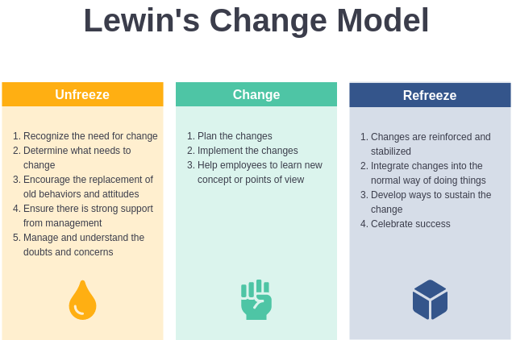
Source: Visual Paradigm, (2022)

Phase one: unfreeze

In terms of change, Lewin claims that human behaviour is in a continuous equilibrium state. This mind-set, which is almost likely attainable, is originally set up to let the mind grow without enabling that capability. (M, Raza, 2019).

Effective organisational transformation ultimately comes down to how effectively Tesco's organization's
employees comprehend: The changes that are being made, how they are being made, and what is expected of them, after the changes have been made. According to C., Matthew, (2021).

This phase of the change management process is perhaps the most crucial. The objective is to get the
Company ready for the upcoming transition. Only when there is a strong motivation to undergo change,

in Lewin's view, can that change occur. People inside the organisation of Tesco will need to be convinced of its necessity because they are acclimated to the status quo and will need convincing. They must be open to change and accept that it is necessary for advancement. They must be ready for a new way of doing thingsand the team should be told why the situation is changing by management.
To lessen the chance of failure and error, management should provide training on a trial basis. The vision needs to be communicated by management to avoid employee resistance.

Phase two: change

Two crucial criteria, including those listed below, have an impact on the success and long-term effectiveness of the change implementation process. Information flow is the coordination of problem-solving across the entire organisation, the availability of a variety of skills and knowledge, and the exchange of information among multiple organisational levels. The capacity of one or more group members Is to influence others to cooperate in achieving a common goal is referred to as leadership. the act of establishing a vision and motivation, essential to a well-thought-out change process (R, Muhammad,2019).

Once the existing scenario has been defrosted, Tesco's should begin implementing their adjustment. Due to the famously challenging nature of managing organisational change, implementing a well-planned change process does not guarantee predictable outcomes. Tesco must therefore be equipped with a variety of change options, such as the planned change process and trial and error,continious feedback at each stage and study what works, what doesn’t work, what places are resistive, etc, so that change goes smoothly. 148

Phase three: Refreeze

At phase three Tesco's organisation need to establish the changes as the new standard now that they have been implemented. The refreezing procedure efficiently cements the modifications, incorporating them into
the new state of affairs. It is an important step that should not be skipped because it can be extremely easy for employees to go back to their old habits, for this reason, the refreezing process focuses on breaking old,
destructive habits and replacing them with new, beneficial ones. Therefore, Tesco should focus on establishing if there is any employee resistance, address any problems that arose during the modification process. For change to last Tesco should provide continuous training, conduct customer surveys for feedback and stay engaged continuously for overall success. Scherer (2022), believes, these are crucial inquiries to make when the process is refreezing additionally, organisations should openly applaud any apparent accomplishments with their staff and recognise their dedication to keeping the improvements in place. 133

3.2 Lewin’s models limitation

According to admin, (2021) Lewin’s approach to change management is a little to straightforward. There are various ways to interpret each phase's steps. Using a different change management paradigm is frequently required to "fill in the gaps. The change management model established by Kurt Lewin is overly restrictive and does not take into consideration contemporary circumstances. Admin, (2021) suggests that the Freeze stage of Kurt Lewin's model occasionally receives criticism for being overly rigid because it "freezes" behaviours that eventually need to be unfrozen again due to how quickly technology advances. Businesses must constantly change in order to keep up. They think the last stage must be more flexible. The Kurt Lewin change theory is regarded by some as being a little dated. It was developed in 1947, a decade before technology played such a large part in contemporary workplaces, in contrast to Max Weber.
(Admin, 2021) describes The Change Model of Kurt Lewin to be combative instead of nurturing, given how heavily it emphasises "changing things up" and disturbing stability during the Unfreezing phase, Lewin’s three-step paradigm may be interpreted as aggressive. Some contend that Lewin's change model
overemphasises the two opposing forces fighting for dominance rather than fostering a change-friendly environment. 213

3.3 Driving and restraining forces that may affect the change?

A powerful tactical technique for figuring out what needs to change in both public and private settings is Kurt Lewin's Force Field Analysis. 2020 (Mark Connelly) widely utilised force field analysis (Lewin 1951) can be used to better understand the majority of organisational change processes.

H, Basin (2019) believes that Analysis and assessment of the forces that can affect business are the focus of force field analysis. By being aware of the factors that could affect our industry, we can better articulate the need for change and provide persuasive arguments for its implementation. Two primary forces are in play while examining the forces driving a change which are driving force and restraining force. Below is an illustration of the force field analysis and explanation on how the forces might affect change.

Figure: 3 Force field analysis

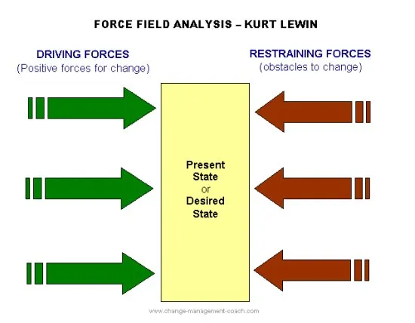

Source: Change management coach, (M,Connelly 2022).

Restraining forces are those that are preventing change, whereas driving forces are those that are sustaining it. Therefore, if a customer wants a new product, the corporation will be motivated by that demand. On the other hand, if your business cannot handle the technology required for new futures, this acts as a restraint. Which forces are strong can be determined using the force field analysis (driving or restraining). And after the stronger factor has been determined, the business may make an effective transformation decision. (H, Basin 2019).

It can be claimed that performing a Force Field Analysis is quite simple, yet it may also require a lot of labour. The initial step would be to identify the issues for which a change is necessary. You may approach the force field analysis with more organisation if you set goals for these issues or pinpoint the precise adjustment that needs to be made by completing a Force Field Analysis, one would be able to be more clear in communicating choices and be able to use the analysis as a tool for making decisions (H, Basin, 2019).Therefore Tesco leaders and management can make choices to assist those forces by determining the factors that are accelerating the transformation. The restraint forces are no different. Once recognised, various management techniques can be considered and taken on. Examples of forces that can be taken into account by Tesco when doing this analysis would be the available resources, traditions, organisational structures, rules, connections, institutional policies, and norms, etc.355

Driving forces

Driving forces are the encouraging or influencing aspects that the change initiative runs into, according to Umar Tahir (2019). These are the real reasons behind change in an organisation. Some driving forces are stated below:
- market potential,
- new leader

- competition in new technology
- pressure on fashion
- demand from management
- incentives
- political structures
- laws and regulations governing
- Public sentiment 57

Restraining forces

Restraining forces are the harmful factors that are hostile to the change initiative. The application of novel ideas or change is frequently hindered by these causes (Umar, Tahir 2019). Examples of restraints include the following:

- worry about the future.
- Earlier attempts at transformation have failed.
- outmoded employee practises.
- living in a cosy environment.
- a hostile work environment.
- unions for workers
- strictly regulated bureaucratic procedures.
- a company's culture. (Umar, Tahir, 2019).64

To make changes in equilibrium The following actions must be completed for a successful shift toward change.

- Tesco’s should increase the driving forces
- Tesco’s should Reduce restraining pressure
- Or make use of both

Lewin asserts that three phases are necessary to accomplish the desired target or goal.

- Tesco’s should Dissolve the underlying forces that are responsible for the current situation.

- Applying the three procedures listed above will tip the balance in favour of change for Tesco's.

- Upon achieving the goal, Tesco’s should reintegrate the motivating and restraint forces.49

4.0 Tesco's organisational structure

Dudovskiy, J (2016) points out that the Tesco Board of Directors is composed of ten individuals and that significant changes to the Board occurred during the 2014–2015 fiscal year. These changes also include the hiring of Dave Lewis as CEO, Alan Steward as Chief Financial Officer, and John Allan as Chairman of the Board in addition to the resignation of four non-executive directors and the appointment of three new non-executive directors Mr. Lewis forecasted a 30% cost decrease for head office services in 2015.

(Dudovskiy, J, 2016) with immediate effects on the management structure. The Tesco governance structure is shown in Figure 4 below, and it consists of five committees that answer to the Tesco PLC board. The Tesco Executive Committee is made up of 11 people and is led by Group Chief Executive Dave Lewis. 136

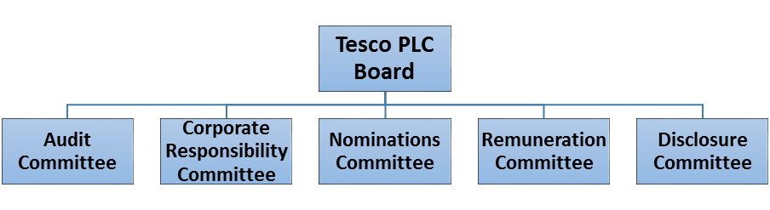

Figure: 4 Tesco Corporate Governance Structure

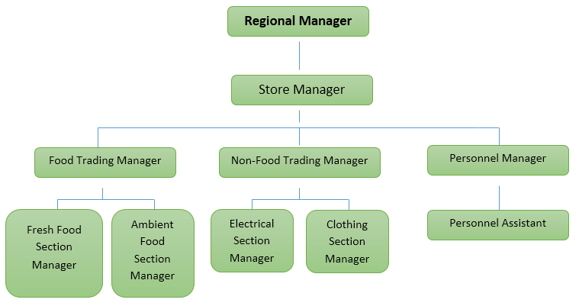
Figure 5 Tesco organizational structure at store level

Dudovskiy, J, (2016) suggests that there is a case to be made for having three or four management layers in a single organisation because doing so would increase unnecessary red tape and impede the flow of information between the layers. Therefore, high level management must consider chances for delayering, such as improving the adaptability of operations and changes within stores and accelerating the flow of information through the elimination of unnecessary management layers. Therefore, high level management must consider chances for delayering, such as improving the adaptability of operations and changes within stores and accelerating the flow of information through the elimination of unnecessary management layers.
Tesco also has a unique hierarchical management structure that has guaranteed its efficiency and seamless operation all the way down to the base root level. 125

Figure: 6- Hierarchy structure
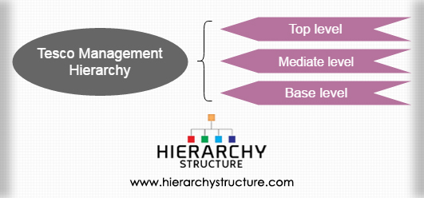
Source:Hierachy structure (2022).

Tesco is organised in a very hierarchical manner visible in the diagram above, figure six, with most of the power being concentrated at the top level and the functions being discreetly divided into a long chain of instructions. Even though it has a traditional feel, this type of organisation makes it possible for everyone to have clearly defined roles, which avoids confusion and turmoil. Furthermore, it utilises a functional establishment structure as opposed to the geographical one used by the majority of other international retail stores. (Hierarchy, 2017). 72

Top tier

All decision-making power rests with the executive board, which is presided over by the company's president (CEO), who acts as the senior administrative official. The board also includes the chairman, chief executive officer, chief financial officer, and other nonexecutive directors. There is also a nine-member executive committee, each of whom is in charge of a different department. Members at this level exclusively do supervisory tasks and make all other key decisions that have a significant impact on how
the firm runs. They represent the corporation as a whole on the international stage and act as its public face.103

Middle range

In addition, there is some level of mediation between the ground staff and the board of directors. These are made up of managers and assistants who answer to various vice presidents. They also perform duties in the areas of money, interacting with others, marketing, advertising, and human resource management. Additionally, they oversee how the other two levels are run. (Hierarchy, 2017). 61

Lower level

The highest management job at the entry level is that of a regional manager (coach). He or she is in charge of significant decisions for the stores in the region that he or she controls and directly reports to the executive at the mediatory level. Store managers, each of whom is in charge of a certain store, also assist him. Each store is then divided into three separate departments: a personal section, a non-food trading section, and a food trading section. In each of these departments, assistants are employed under different team leads and assistant-managers. Those in this level of management interact with average citizens on a daily basis. The degree of vertical power separation that exists in the modern world makes it possible for a corporation with such a diverse business to perform so effectively in the market. This type of hierarchical management has contributed to its current state as well as being a significant factor in its growth and expansion. Hierarchy, (2017). 162

4.1 Tesco's organisational structure affecting the change management process:

Islam et al, (2022) believes that employee experiences worry, fear and uncertainty leads to employee
cynicism, resistance, and unsupportive behaviour. The degree to which employees support or participate in the change process behaviourally determines how successfully an organisation manages change.

Sansyzbayevna et al, (2017) emphasises that in regard to the shift, leaders should show by example what is expected of them. The social learning theory and the idea that people learn by seeing others are both supported by this. There should be continual support that takes into account the stages that the transition from resistance to acceptance goes through. Commonly, shock and a desperate want for precise knowledge are the initial reactions. People experience a variety of emotions later in life, such as rage, grief, and despair, and they require a different kind of support. Once they have reached the change acceptance stage, they must decide how to make the required changes on their own and may require assistance.

The goal, the planned changes, and the benefits that the change would bring should be clearly communicated at every level, according to Sansyzbayevna et al. (2017). To plan, implement, materialise, control, and stabilise change processes at both the corporate and individual levels is to manage change, according to Anyieni, BCom, and Campus (2013). According to Nickolas (2006), managing change requires considering how it will affect people, which many managers find challenging. Various issues, such as

strategic direction or staff personal development programmes, may be addressed through change. Competitiveness and viability are the goals of all strategic, technological, and structural changes, as well as changes in attitudes and behaviours.

Due to the necessity of managing change, organisational structure has an impact on the process of Tesco’s organisation's structure, such as communication, negotiation, and span of control, stated below with a brief explanation, and can be affected by the way, those in positions of power at Tesco’s carry out their decisions, which can either leave a negative or positive impact, affecting the organizations change management process.320

Communication

According to the technical-rational view of change management, its mission is to lessen conflict, establish
order, manage chaos, and simplify all environmental complexity. Potential consequences are foreseen, alternatives to the current course of action are developed, and these are disseminated across the organisation. (Chinoperekweyi, J, 2020).

Tesco is a huge organisation and needs tall hierarchies because they employ a large number of people,
each with a variety of tasks or specialties inside the company. However, because Tesco has many distinct levels of management that needs notifying before any decisions can be made, communication is delayed and takes time to process.Awadari & Kanwal, (2019), held the opinion that Stanleigh (2008) was correct when she stated that "the majority of change implementation techniques fail because the organization's management does not engage people in the development process and does not allow adequate time for change to set." The success of the process and plan depends on the participation and engagement of employees as well as all other parties. Failure to define the objectives of the need for the change, inexperience with the scope and complexity, technical problems, and project management concerns are some of the causes of the failure of the change strategy.

Negotiation

The adjustments must be the subject of negotiations at all organisational levels. Regular meetings with all managers and leaders should take place. Leaders and managers should constantly discuss issues, ideas, and
solutions in the process mapping or connected to the reorganisation. 41
(Bohm et al, 2016).

Span of control

Tesco's manager's immediate reports are referred to as their span of control. The number of employees that
managers efficiently manage in a corporation is between five and six subordinates under each executive's supervision. supervisors who have more than six subordinates quickly lose sight of what is happening in the
organisation is crucial to remember. As a result, the number of direct reports Tesco's manager can manage
varies on the type of work being overseen, the visibility of subordinates' performance, and the degree of
decentralisation present within Tesco's organisation. If a subordinate's task is routine, their performance is
evident and simple to evaluate. Because employees are more in control, the corporation has a limited range of control. Since the manager only has a small number of workers to oversee due to the high span of
control, Tesco employees are required to follow all rules and regulations as well Tesco’s Chief executive
Officer's instructions. As a result, it is decided that decisions are made at the highest level of management and is communicated clearly for overall success. The corporation has a limited range of control since employees have more power. Tesco employees are obligated to abide by all rules and regulations as well as the directives of Tesco's Chief Executive Officer because the manager only has a small number of employees to supervise due to the high span of control. As a result, it is agreed that the highest level of

management makes choices. It is imperative to stress that management has set up a matrix team through
out its levels due to the towering structure. However, because the towering structure is located inside the business, it misses out on the various market prospects as opposed to a flat. More information. Tesco's narrower span and higher-level count make it more expensive for Tesco to exercise and control over its environment than Wal-Mart does with its wider span. This is because Tesco has a larger number of
superiors, which causes more communication issues between management levels.260

5.0 Conclusion

Following a thorough examination of the relevance of the changing nature of the world of work, the research and studying bought me to the conclusion and understanding that it was crucial to examine the relevance of how the nature of labour is changing and the forces that are generating change in order to comprehend how automation plays its part for change. There is no question about the significance of change in organisations, and it must be implemented because organisations require change. I have identified organisational change as a feature for Tesco’s implementing Lewins change model which I explored through Lewins change model figure 3 and through the study of (R, Muhammad 2019) phase one “unfreeze”. To unfreeze the company, leadership would need to act as a change agent at every stage of the study according to Kurt Lewin's model. The organisational change process is impacted by the transformational leadership style.

In numerous tasks throughout the last century, machines have taken the place of workers. Overall, technology has produced more employment than it has eliminated. technology has increased labour productivity in many industries by decreasing the need for humans to do basic tasks according to the studies of the world bank (2019).

6.0 Recommendation

Automation will present new challenges for workers, to maintain automated systems and to ensure that workers are adjusting to the future of change, Tesco’s should adopt the following areas such as education, reskilling, and upskilling, provide high quality training, and place sensible policies. This will allow workers to share in the advantages of the higher productivity that new technologies will create. Tesco's leaders and management should increase their knowledge of organisational phases and transition. As we can see, knowledge exchange is a crucial catalyst for the process's unfreezing and progression which was understood from the study (M, Raza, 2019) phase one “unfreeze” stage. Employee involvement is the primary driver of an organization's transition from one phase to the next, so all these factors are interconnected for the ongoing change process. Changes in rewards and recognitions are one of the main factors that can spur Tesco’s organisational change. These changes have important social repercussions that can help the change process.

References

Admin, (2021), Advantages and disadvantages of Lewin's change model [internet] Available at:
https://www.zambianguardian.com/advantages-and-disadvantages-of-lewins-change-model/
(Accessed:)

Awadari, A. C., & Kanwal, S. (2019). Employee participation in organizational change: A case of Tesco PLC. International Journal of Financial, Accounting, and Management, 1(2), 91-99. [Google scholar] Available at: View of Employee participation in organizational change: A case of Tesco PLC (goodwoodpub.com):(Accessed: 5th November 2022)

Carrtegra, LLC (2022) Effective Change Management – Change Definition [Internet image] Available at:
Effective Change Management - Change Definition - Houston, The Woodlands, Sugar Land | Carrtegra, LLC (Accessed: 26th September 2022).

Cc.Alumni, (2016) Tesco: A digital transformation technology and operations. [internet] Available at:https://d3.harvard.edu/platform-rctom/submission/tesco-a-digital-transformation/
(Accessed:)

Cc.Alumni, (2016) Tesco: A digital transformation technology and operations. [internet] Available at:https://d3.harvard.edu/platform-rctom/submission/tesco-a-digital-transformation/
(Accessed:)

Chinoperekweyi, J, (2020). Exploring philosophical proclivity of change management articles: Technical-rational perspective versus other change philosophies. Organization Development Journal, 38(2), pp.15-26. [Google scholar] Available at:Exploring-Philosophical-Proclivity-of-Change-Management-Articles-Technical-rational-Perspective-versus-Other-Change-Philosophies.pdf (researchgate.net)
(Accessed: 12th 0ctober 2022).

Davies, (2022) The future of work, eight drivers of change, [Internet] Available at: https://eightdrivers.lewissilkin.com/ (Accessed: 29th September 2022).

Davies, J, (2022) The future of work, eight drivers of change, [Internet] Available at:https://eightdrivers.lewissilkin.com/emerging-themes (Accessed: 30th September 2022).

Davies, J, (2022) The future of work, eight drivers of change, [Internet] Available at:https://eightdrivers.lewissilkin.com/predictions(Accessed: 1st November 2022).

Emma, Bedford (2022) Statista, Tesco group: number of employees in the United Kingdom (UK) 2012-2022 [Internet] Available at: https://www.statista.com/statistics/490882/tesco-group-united-kingdom-uk-number-of-employees/ (Accessed: 26th September 2022).

Errida, A. and Lotfi, B., (2021). The determinants of organizational change management success: Literature review and case study. International Journal of Engineering Business Management, 13, p.18479790211016273.The determinants of organizational change management success: literature review and case study [Google scholar] Available at:The determinants of organizational change management success: Literature review and case study (sagepub.com) (Accessed:).

Hierarchy structure, (). Tesco management hierarchy [internet] Available at:Tesco Management Hierarchy | Tesco Organizational Structure (hierarchystructure.com)
(Accessed:).

Hierarchy structure, (). Tesco management hierarchy [internet] Available at:
Tesco Management Hierarchy | Tesco Organizational Structure (hierarchystructure.com)
(Accessed:).

Hierarchy structure, (). Tesco management hierarchy [internet] Available at:Tesco Management Hierarchy | Tesco Organizational Structure (hierarchystructure.com) (Accessed:).

Hitesh, Bhasin, (2019), Force field analysis [Internet] Available at: Force field analysis - Restraining and driving forces (marketing91.com) (Accessed:).

Islam, M.N., Furuoka, F. and Idris, A., (2020). Employee championing behaviour in the context of organizational change: a proposed framework for the business organizations in Bangladesh. Journal of Asia Business Studies. [google scholar]. Available at:EM-JABS200020 1..23 (researchgate.net)
(Accessed:).

John Dudovskiy, J (2016) Tesco organizational structure [internet] Available at: Tesco Organizational Structure - Research-Methodology (Accessed: 18th October 2022)

Kelliher & Richardson (2018) Work, working and work relationships in a changing world. [Internet] Available at:https://www.google.co.uk/books/edition/Work_Working_and_Work_Relationships_in_a/Y_0rvAEACAAJ?hl=en (Accessed: 26th September 2022).Packaging and plastic - Tesco PLC

Mark Conelly, (2020), Force field analysis-Kurt Lewin [internet] Available at:https://www.change-management-coach.com/force-field-analysis.html.
(Accessed).

Mark Conelly, (2020), Force field analysis-Kurt Lewin [internet image] Available at:https://www.change-management-coach.com/force-field-analysis.html.
(Accessed).

Matthew Channell, (2021) Lewin's change management model: how to implement organisational change [internet] Available at:https://www.tsw.co.uk/blog/leadership-and-management/lewis-change-model/
(Accessed: 2nd November 2022).

Matthew Scherer (2022) An Overview of Lewin’s Change Management model[internet] Available at: https://www.businessmanagementdaily.com/68228/an-overview-of-lewins-change-management-model/ (Accessed:

Muhammad Raza (2019) Bmc Blogs, Lewins three stage model of change explained [Internet] Available at:
https://www.bmc.com/blogs/lewin-three-stage-model-change/ (Accessed:

Muhammad Raza (2019) Lewins three stage model explained [internet] Available at:
https://www.bmc.com/blogs/lewin-three-stage-model-change/ (Accessed:)

OJIN, (2016). A Case Review: Integrating Lewin’s Theory with Lean’s System Approach for Change [internet] Available at:
https://ojin.nursingworld.org/MainMenuCategories/ANAMarketplace/ANAPeriodicals/OJIN/TableofContents/Vol-21-2016/No2-May-2016/Integrating-Lewins-Theory-with-Leans-System-Approach.html
(Accessed:).

Rao A, (2022) Automation raises risk of job loss, Upskill, say experts, [Internet] Available at:Experts Stress On Upskilling Workforce To Offset Automation-Driven Job Loss (ndtv.com)(Accessed: 26th September 2022).

Rao A, (2022) Automation raises risk of job loss, Upskill, say experts, [Internet] Available at:Experts Stress On Upskilling Workforce To Offset Automation-Driven Job Loss (ndtv.com)(Accessed: 26th September 2022).

Rao A, (2022) Automation raises risk of job loss, Upskill, say experts, [Internet] Available at:Experts Stress On Upskilling Workforce To Offset Automation-Driven Job Loss (ndtv.com)(Accessed: 26th September 2022).

Sansyzbayevna Bespayeva, R. and Olzhabayevna Bugubayeva, R., (2017). Approaches and models for change management. Jagiellonian Journal of Management, 3(3). [Google scholar] Available at:
Approaches and models for change management (uj.edu.pl)
(Accessed: 17th November 2022).

Satu, Bohm et al (2016) Negotiating change [internet] Available at:
https://www.google.co.uk/url?sa=t&source=web&rct=j&url=https://uu.diva-portal.org/smash/get/diva2:1162817/FULLTEXT01.pdf&ved=2ahUKEwjAt_PN-5f7AhVBoVwKHRWDDyEQFnoECB0QAQ&usg=AOvVaw0HNjR-Cs885cf6ry1KAMgZ
(Accessed:

Tesco PLC (2021) Tesco opens new checkout-free store, ‘GetGo’[internet] Available at:https://www.tescoplc.com/news/2021/tesco-opens-new-checkout-free-store-getgo/ (Accessed: November 15th, 2022).

The guardian, (2022) End of the checkout queue? Stores rush to deploy till free technology, [Internet] Available at:https://www.google.co.uk/amp/s/amp.theguardian.com/business/2021/oct/23/end-of-the-checkout-queue-stores-rush-to-deploy-till-free-technology (Accessed: 15th November 2022)..

The guardian, (2022) End of the checkout queue? Stores rush to deploy till free technology, [Internet] Available at:https://www.google.co.uk/amp/s/amp.theguardian.com/business/2021/oct/23/end-of-the-checkout-queue-stores-rush-to-deploy-till-free-technology (Accessed: 15th November 2022).

Umar Tahir, (2019), Lewin’s Force Field Analysis (Change Management) [Internet] Available at: Lewin’s Force Field Analysis (Change Management) | CMI (changemanagementinsight.com)
(Accessed:).

Umar Tahir, (2019), Lewin’s Force Field Analysis (Change Management) [Internet] Available at: Lewin’s Force Field Analysis (Change Management) | CMI (changemanagementinsight.com)
(Accessed:).

Vettori, s, (2016) The employment contract and the changed world of work. [Internet] Available at:https://www.google.co.uk/books/edition/The_Employment_Contract_and_the_Changed/sMPOCwAAQBAJ?hl=en&gbpv=1&dq=how+the+world+of+work+is+changing&printsec=frontcover (Accessed: 26th September 2022).

Visual paradigm, (2022) Lewins change model template, [internet] Available at:
https://online.visual-paradigm.com/diagrams/templates/lewins-change-model/lewin-change-model-template (Accessed:

World Bank, (2019). World Development Report 2019: The Changing Nature of Work. Washington, DC: World Bank. doi:10.1596/978-1-4648-1328-3. License: Creative Commons Attribution CC BY 3.0 IGO [Internet] Available at:https://documents1.worldbank.org/curated/en/816281518818814423/pdf/2019-WDR-Report.pdf (Accessed: 10 November 2022).

