ECAD6011 Assignment Draft
“Utilising the Entrecomp Framework, critically evaluate your own creativity and enterprise and consider how you might be able to develop the creative and enterprising skills of primary learners through your own pedagogy”.
In the following assignment, I will be considering and evaluating how creative and enterprising I am, as both an individual and a teacher and in turn how I can develop and transfer these skills to improve the creativity skills of learners within a classroom.
According to Hodder Education (2014) and Education Scotland (2013) creativity is the combination of a series of characteristics to see things differently, which allow new ideas to emerge through making connections. Similarly, Torrance (1966) and (1974) discusses creativity being the ability to generate a large number and variety of ideas that are unique. The writer is under the opinion that creativity is in fact a combination of the previous descriptions as creativity allows people to develop a variety of new ideas whilst using connections to overcome problems whilst creating something of value. Being creative allows innovative approaches to overcome existing and new challenges (Bacigalupo et al., 2016).
Enterprising Oxford (2019) believes that being creative and being enterprising are two things that are interconnected and that for somebody to become creative they must develop some form of enterprise skills. Being innovative, making decisions to solve problems, strategic thinking and working both independently and communicating in a team are all considered key enterprise skills (Bridgewater UK, 2017). Interestingly, these skills clearly lend themselves to an individual being creative. The writer therefore feels that for somebody to develop creativity skills they must first learn to be enterprising as many skills overlap.
Both creativity and enterprise have many benefits to people living within the modern world. According to Vanlint (2017) creativity is one of the best ways for individuals to express themselves clearly and helps with building confidence. However, Christensen (2014) and Lehane (2018) are under the impression that many people lack the required confidence to act upon the ideas they may have, as they fear failure. Furthermore, Clark (2019) feels that a lack of confidence is directly linked to people fearing they “are not creative”. This leads to a heightened “fear of failure” and dismissing creative ideas that they may come up with. It is of the writer’s opinion that due to the amount of ridicule people come under for ideas during adolescence, they naturally begin to decrease creatively. Even though the best way to learn is by doing, we are told off for getting things wrong (Clark, 2019). Thorne (2007) discusses the need to recognise people who come up with different ideas and encourage them as the world needs idea generating people who can adapt things we know, recognise faults without losing confidence and improve them. It is also important to consider that in schools where good practice creative teaching is taking place in Wales, pupils thoroughly enjoy the experience and skills in oracy as well as attendance and behaviour have improved (Welsh Government (WG), 2019). The adaptation of the curriculum to become more creative across different disciplines in one school led to attainment, ambition and well-being level improvements from different pupils (Estyn, 2019).
Vanlint (2017) and Chopra and Sehgal (2017) also feels that being creative has meditative advantages as people relieve stress whilst having fun, in turn improving quality of life. The writer feels as though this is a further reason to want to encourage creativity due to the current mental health crisis with at least one in ten children struggling to cope with a lack of support from available health services (BBC Panorama, 2018). The ability to assist health services through encouraging creativity in day-to-day life is a cheap alternative to many who struggle to cope on a day-to-day basis.
Soffel (2016) believes that students are currently not learning the skills and knowledge they require to thrive. World Economic Forum (2015), Fadel (2008) and AES (2019) identify creativity and problem solving/critical thinking and collaboration as three competences that are vital skills required to live in the twenty first century. According to Lehane (2018) people who try to be more creative become better at overcoming problems and communicating and working with others, therefore, becoming competent at being creative can have a knock-on effect on the development of further skills required. Furthermore, it is recognised people who are creative and have enterprise skills generally go onto higher earning jobs (Lehane, 2018 and Badion, 2019). I believe that there are many reasons that creative and enterprise skills need to be encouraged more around the world because it delivers so many clear benefits to those that use them, most importantly the fact that having suitable enterprise and creativity skills best prepares people for employment (QAA, 2012). It is important to recognise that we need to best prepare youngsters for what is going to face them in the future be it employment or self-employment and to be able to do that, creativity and enterprise skills are a fantastic way of improving your chance of reaching your goals in life. I further believe that enterprise skills are a core foundation to being a creative individual and therefore are essential in the process of improving an individual’s creativity.
To evaluate the standard of creativity possessed by the writer, the “Entrecomp Framework” will be used where applicable. It is important to consider that “EntreComp” is the merging of the words entrepreneurial and competence and that this resource is a way of reviewing and developing my own entrepreneurial competence. Therefore, not all areas of the framework or descriptors suitably lend themselves to the creativity required from an educator. The entrecomp framework was created in 2016 following recognition of a need for entrepreneurship competence in a new skills agenda for Europe. (Bacigalupo et al. (2016). During my review, I will use the entrecomp framework as well as further theories such as Torrance (1974) to determine the level of creativity and enterprise I possess. In comparison to the other two tests, the entrecomp framework gives a clear indication of what level you are at and what to develop to ensure you continue to develop as a creative and enterprising individual. Within the framework the entrecomp wheel contains fifteen competences that are considered to be interconnected. These competences are split over three main areas: Ideas and opportunities, resources and into action. Within the competences are sixty different threads which each include up to eight different progression levels per thread. Each level lends itself to a level of proficiency, foundation is level one and two, intermediate is level three and four, advanced is level five and six, expert is level seven and eight. Having reviewed the document, it was noticeable that many descriptors in the expert level are focused on business skills due to the entrepreneurial nature of the framework and therefore won’t be applicable to an education environment, which is what I will be reviewing myself in.
Bacigulapo et. Al. (2016) discusses how creativity is the development of creative and purposeful ideas and similarly to Torrance (1966) and (1974) and Land (2011) believes that to be creative you need to come up with several ideas through combining knowledge. The first thread within creativity is the ability to be curious and open. According to Cube (2015) and Reid (2018) being curious is vital in ensuring people who are being creative stay motivated. Currently, I think I am working at level 6 on the entrecomp framework as I have “combined my understanding of different contexts to transfer knowledge, ideas and solutions across different areas.” (Bagiculapo et. Al., 2016, p24). I have shown I am at this level during lectures in university where we have taken part in activities on metaphorical thinking. During activities undertaken as an individual I had to try and connect words from two completely different contexts to come together and create a different word. Fradera (2015) discusses how metaphorical thinking can have no amount of correct answers as people who think in metaphors use their mind in a completely different imaginative way. An example of where I have done this is where I undertook an activity based on how a train journey is similar to your life. Currently there are no higher levels for this thread on the entrecomp framework in its current draft. However, I recognise the importance of continuing to want to learn to be curious and open to allow myself to maintain the skills I feel I already have.
The next thread is being able to develop ideas. Currently, I would class myself as a higher-level foundation level with elements of lower level intermediate proficiency. I am able to develop ideas as both an individual and a team creating value for others and also come up with alternative solutions to overcome problems (Bagiculapo et. Al., 2016). Similarly, the Torrance test discusses the need for an individual’s creativity to be assessed by the fluency and originality of their ideas (Torrance, 1974). In this instance, the value would be pupils reaching learning objectives or taking part in the learning process within the classroom with more confidence. According to Wagner (2009), Wilson (2019) and Hoffman (2015) using collaboration and teamwork to overcome problems using imagination (being creative) is essential part of overcoming the gap for children to develop the skills required to succeed in life. During PTE as an entire upper key stage two staff we used a team planning strategy to develop ideas to help children reach particular goals across a range of subjects. Whilst in these planning meetings we would work together to generate solutions to problems facing us, for example, timetabling issues or lack of suitable equipment and resources. Another example of where I have developed ideas alone and part of a team was in university lectures where I firstly, came up with as many ideas as possible for a shoe using divergent thinking. Guilford (1976) states that using divergent thinking develops creativity, as people using it display the creative characteristics of fluency, flexibility, originality and elaboration. To improve my ability to generate ideas I need to develop techniques to test my ideas further (Bagiculapo et al, 2016). The best way for me to do this would be to ensure I am equipping myself with the most recent knowledge of theories of pedagogy to adapt ideas on both teaching and assessment of the children. Furthermore, I can ensure I use techniques such as Eberle (2008) “Scamper” model (see appendix 1) as a tool to help overcome functional fixedness and continue to develop my own imagination.
Following this, the framework identifies being able to define problems. According to Tracey (2016) one of the main issues facing creativity is people who are not proactive thinkers and fail to adapt or change situations at all when they face issues or problems. Currently, I feel as though I am achieving elements of level 5 within the framework as I can describe approaches to open ended problems and also how I would overcome these problems utilising the skills I know I have. To ensure, I become fully competent at this level I would need to research in depth some techniques and approaches to problem solving that would allow me to deepen my knowledge and explain them. During PTE, I overcame the problem of a lack of ICT resources available within the school by communicating with other members of staff in upper key stage two to borrow all laptops available rather than the eight usually available to my class (see appendix 2). This allowed me to cover a lesson on databases in one hour rather than across four hours with different groups and became an easier topic to cover with more consistency than being taught by different members of staff. This demonstrated clear problem solving and creativity to adapt my lesson. Both Hicks (unknown) and Skills you need (2019) agree that evaluating options to overcome problems is essential to ensuring attempts are successful. This is something else I could further adapt to ensure I continue to develop. The descriptors for the higher levels within the framework for “define problems” lend themselves more towards the business elements of entrepreneurship and therefore wouldn’t be applicable for me in a teaching environment.
The next thread in the creativity competence is design value. I currently believe myself to be competent at a higher intermediate level as I am able to, “assemble, test and progressively refine prototypes that stimulate the value I want to create” (Bagiculapo et al, 2016, p24). I am also showing elements of level 5 in the framework as my creations solve problems and suit my needs (Bagiculapo et al, 2016). Ryan (2013) discusses the importance of testing and evaluating products as this allows the inventor the opportunity to assess the designs viability. Friis Tam and Teo (2019) agree, and state that prototyping further allows any changes required to the product to be made in a non-time-consuming manner. Essentially it is important that to be creative you must be adaptable (Gerrish, 2009). Whilst in university lectures, as a group we took part in an activity where our goal was to create a tower from spaghetti that would be strong enough to hold the weight of a marshmallow using only tape (see appendix 3). Throughout the construction of the tower as a group we constantly tested prior to adding more spaghetti to ensure our tower was strong enough to withstand the weight. This was an example of us continually prototyping to ensure we could still reach our success criteria. Collie and Martin (2016), Collie, Martin and Granziera (2018) and Spalding (2019) discuss the need for teachers to be reflective and adaptable. It is of the writer’s opinion that being firstly reflective and adaptable, lend themselves directly to the description by the entrecomp of prototyping and refining. Whilst on PTE I took part in weekly end of week reviews where by, we would be reflecting on the weeks teaching experience prior to refining anything we felt wasn’t working. I also did this daily with reflections of things such as classroom management or behaviour management. In one particular instance, I reflected on how changing a seating plan would impact the behaviour and attainment of two particular pupils (see appendix 4) and refined the seating plan following this reflection. In regard to improving to meet the descriptors within the entrecomp framework it would be very hard to do this within an education environment as they lend themselves more to business. It is important however to ensure that as a professional I continue to research up to date techniques and classroom management strategies to allow me to reflect more on my practice. I will use advice available from fellow qualified professionals to assist me with improving my standard of teaching as well as researching Estyn to see best practice.
The final thread within creativity is the ability to be innovative. According to Burrus (2017) creativity is the generation of ideas, whereas innovation is the application of these ideas. Similarly, to the entrecomp, Moyles (2007) discusses how creativity allows us to be innovative and take risks. I would consider innovation to be my weakest point in regards to creativity if reviewing strictly off the descriptors from the entrecomp framework as I feel a lot of the higher levels lend themselves more towards business. In my opinion, I am working at a level 2, as I know what innovation is and how it has transformed society. (Bagiculapo et al, 2016). During my time on PTE, whilst teaching persuasive writing I planned to utilise adverts from the 1960’s. Following the amount of interest that the pupils had in the items we discussed, I decided to use this as an opportunity to plan a lesson looking at how products had innovated over time (see appendix 5). I did this, as I knew that the pupils would really engage with the work. Tes (2017), Donaldson (2015) and Goss and Sonnemann (2017) are all in agreement that allowing pupils to guide the learning within a classroom improves the learning environment in turn improving the learning process and engagement levels. To improve, I feel as though I need to deepen my knowledge of innovation looking into the different types of innovation in more detail. I feel as though this will further allow me to “judge an idea, product or process if it is innovative or just new to me.” (Bagiculapo et al, 2016 p25). I am of the opinion that if I generate enough knowledge of what innovation is I can then begin to understand the effect it has throughout society and thorough different cultures in the modern world.
Bagiculapo et al. (2016) believes that whilst putting your idea into action it is important to be able to cope with uncertainty, ambiguity and risk. The description of this competence is to be able to make decisions when you are unsure of what the outcome will be and test ideas and prototypes as a way of limiting the risk of failure. Craft, Jeffrey and Leibling (2001), Wilson (2009), Coate and Boulos (2012), Dessaily (2012), Pitaru (2015) and Sponseller (2018) all agree that one of the most important principles to being creative is the ability to take risks and push your idea to give it the best chance of succeeding. It is of the writer’s opinion that taking risks and also coping with risks is the most important feature someone needs to possess to be creative as without this, people will never begin to put their ideas into practice because of the worry of failing (Tracy, 2016). Currently, I consider myself to be a level 3 within the entrecomp framework as I am able to assess whether a risk is acceptable or unacceptable (Bagiculapo et. Al, 2016). Whilst on PTE, I would continually assess risk of whether the content of the lesson I had planned was to challenging for the pupils. At times, the work was too hard and I adapted during lessons to improve the learning experience for the children. According to Hopper (2015) children appreciate having the opportunity to celebrate clear progress they are making with their work. A technique I adapted during PTE was to allow the children to take place in a “Rio Challenge” where at the start of a unit of work they would attempt the work with no support what so ever. According to Netcher (2019) using a cold/hot task technique allows children to see what they need to work on and how much progress they are making over a unit of work. My main reason for using this assessment for learning (AfL) strategy was to allow me to set groups within the unit of work based on ability. Myatt (2017), UCL (2017) and Lopez (2019) argue that groups within schools being set in ability can be disheartening and lead to a lack of progress from the low attainers. In my defence, the groupings were not fixed and pupils would move from group to group dependent on progress towards reaching learning objectives. Using this system also allowed me to delegate support staff more efficiently to pupils who required support at that specific time. Having reviewed the entrecomp framework the next few level descriptors is specifically written with business in mind therefore isn’t applicable to me. However, I do feel as though I am achieving elements of level 7 as I can still assess risk even when conditions begin to change. I feel as though this is something I will naturally improve on and become competent at as I begin to experience this more within my teaching career.
According to Torrance (1966) you need to be able to elaborate and display originality of ideas to show you are creative. Brolin (1992) and Dacey & Lennon (2000) are under the impression that to display these skills you must be determined, resilient and be motivated to work hard. Similarly, to Torrance, Bagiculapo et. Al (2016) and Spencer, Lucas & Claxton’s (2012) five-dimensional model of creativity believes motivation and perseverance to be an element of creativity. During both PTE and whilst coaching rugby outside of education I have demonstrated that I am both motivated and hard working. I also have inspired others to work hard by being passionate and leading teams as a captain. According to Duncan (2010) it is important to continue to demonstrate these qualities as being creative means overcoming many difficult tasks and potential failure.
Khai Meng (2016) and Robinson (2006) are both under the impression that creativity and innovation are something that we are all born with and must develop throughout our lives. Cox (2013) is under the impression that some people are born naturally more creative than others following research that suggests people who are more creative have connectivity more widespread across the brain than those who are not. On the contrary, Leunig (2016) is under the impression that the ability to become creative is only available to somebody when they firstly gain the knowledge required to develop ideas. The writer feels that all individuals are born with the ability to be creative and innovative but these skills need to be further developed to ensure you retain this ability and use it in the right way rather than lose it. Similarly, Costa and Kellick (2008) believe that an individual can continue to develop their creativity skills with continuous learning.
Robinson (2006), Dalile (2012) and Chary (2019) are all under the impression that schools actually supress creativity as we begin to teach them that making mistakes is wrong and that we are educated away from being creative. Research by George Land in 1968 suggested that from a group of one thousand six hundred children at a range of abilities, ninety eight percent were considered creative geniuses at a young age. Land continued the test into adulthood and found that by the time they had matured only two percent were still considered geniuses. This fact alone suggests that children are therefore born with creativity skills. This creativity is pushed out of us throughout school due to teachers being under the pressure to produce academic results. Both Richardson (2012) and Wood (unknown) are under the impression that teachers are under severe pressure to deliver results meaning they have much less of an opportunity to improve the pupils as individuals. According to Sommer (2014) teachers lacking inspiration, curriculum intensity, standardised testing and lack of rewards for creativity all play a part in creativity being supressed within schools. On the contrary, Estyn (2016), Estyn (2017) and Astle (2018) are under the impression that schools that are motivated with high levels of organisation are able to create an environment where nurturing creativity from pupils is possible. The writer believes that although some schools display good practice in having the ability to provide a creative curriculum for pupils, from experience this is not the case everywhere. There is so much focus on delivering suitable outcomes at literacy and numeracy that the opportunity to offer creative learning opportunities within schools is currently limited. According to Robinson (2006) creativity is vitally important and should share status with literacy and numeracy.
Emphasis on creative development within schools is a way of making education more enjoyable and will better prepare individuals with the skills they need to achieve (Mindham, 2004). Within Wales, there is a need to produce “enterprising and creative contributors ready to play a full part in life and work” (Donaldson, 2015, p29).
According to NACCCE (1999), Jeffrey and Craft (2004), Pamoja (2017) and Davis (2018) teachers must engage with and display creativity within the classroom to achieve full engagement and creativity from the pupils. Sharp (2004) further believes that children should be able to recognise creative thinking by it being modelled to a high standard by the teacher. Bartel (2008) is under the impression that one barrier to teaching creatively is the fear of pupils not being happy with the outcome or fearing failure. Lenz (2015) and Success staff (2019) argue that children should become accustomed to learning through failure as this best prepares them for life experiences, as they grow older. “Failure is instructive. The person who really thinks learns quite as much from his failures as his successes” (Dewey, 1933).
Jones and Wyse (2004), Davies (2003) and OFSTED (2003) imply that the inspection process and the introduction of national testing have caused a constraint to teachers’ ability to teach creatively. Vittana (2019) recognises the impact standardised testing has on teacher performance, feeling they become more focused on teaching test preparation rather than the focus on the pupils learning. It is of the writer’s opinion that education must be reformed throughout the world to cater for more creativity to be introduced throughout the curriculum. According to Grigg (2015) creativity has a higher curriculum profile in Wales than other parts of the World and promotes Scotland’s use of creativity across the curriculum. Creativity and enterprise should be considered a process rather than a subject area (Wyse, 2013). Burgess (2007), Education Scotland (2013) and Barnes (2015) believe creativity is most effective when taught across the curriculum as this allows more opportunity for it to be accessed and broadens pupils learning experiences. Creativity and innovation are included as a wider skill in Wales’ draft curriculum for 2022. This demonstrates the importance of the teaching for creativity in Wales in the future.
Jones and Wyse (2013) believe that there is no special creativity programme needed to improve creativity in children and that, this can be done by good teaching. Sharp (2004) feels that creative teaching should include teachers asking open-ended questions. Asking this type of question allows the child to see you are genuinely interested in their answer therefore encouraging them to use imagination to think of as many possibilities as they can and better equips children for the world around them (Meantoir, 2020).
According to Lucas (2017) another fantastic tool to develop creativity amongst children is to use a problem based learning (PBL) process within your classroom. PBL is the use of real world problems within your classroom that promote student learning (ICITL, 2019). PBL allows learning to become student focused and inquiry based. According to Guido (2019), inquiry based learning makes learning rewarding, something that is traditionally an issue with teachers who are trying to teach for creativity. Furthermore, it promotes a deeper understanding of curriculum content as skills pupils have are applied and builds initiative and self-direction for pupils. Self-directed learning prepares pupils for further education and life in employment as they face problems (help teaching, 2018). According to Dewey (1938) dealing with uncertainty leads to powerful learning occurring. A key factor to PBL working successfully is creating the correct environment for learning to flourish. According to Seelig (2012), the pupil is responsible for ensuring knowledge, imagination and attitude are displayed throughout the lesson but this will only work if the school provide the correct resources, habitat and culture. Seelig (2012) is under the impression that these are the main requirements for producing creativity.
To conclude, creativity and other characteristics of creativity are currently being recognised as a vital skill to becoming employable in the twenty first century. Education Scotland (unknown a) recognises that creativity is not only something people look for in potential employees but also is a vital skill for those looking to create their own businesses. In my opinion, creativity needs to be encouraged more in schools and opportunities for creativity and enterprise should be introduced throughout the curriculum, making it accessible to everybody further encouraging creativity. Opportunities to teach for creativity are included in the new draft curriculum for Wales as a wider skill. According to Welsh Government (2020) creativity and enterprise becoming a wider skill will lead to more pupils gaining the resilience needed to achieve their goals in life. It is of the writer’s opinion that educators need to provide the correct learning environment for creativity and enterprise to be developed. According to Highland Council (2010) creating a positive classroom ethos where children don’t fear being wrong or making a mistake allows for learning and teaching to be utilised to its maximum benefit. Another technique educators need to ensure they can utilise to produce creativity is the opportunity for pupils to undertake PBL tasks using open-ended questions wherever possible to encourage divergent thinking.
There are clear benefits for pupils when given the opportunity to undertake in tasks developing creativity. They are given the opportunity to express themselves. According to UNCRC (2019) every child should have the opportunity to think and make decisions for themselves. Furthermore, it gives children the opportunity to relive stress and improves their health and well being. Wales’ introduction of the well being of future generations act describes the need for Wales to be healthier and more resilient (Welsh Government, 2015). Moreover, creativity and enterprise in an education environment goes some way to improving behaviour and attendance levels. Creativity within schools “address all areas of the curriculum, as well as issues of behaviour, engagement, attendance and motivation.” (Education Scotland, unknown, page 8b).
In general, I feel as though I currently display a good level of creativity and enterprise skills. I feel as though my biggest strength would be the ability to overcome problems by not being afraid of trying things. Furthermore, I feel I show high levels of motivation and can be resilient and show good levels of perseverance. I believe having experienced a life involved in sport and taking leadership roles throughout my entire rugby career held me in good stead to have these traits. However, I do feel as though I need to begin to understand more about innovation and need to develop much more knowledge on types of innovation to allow me to further develop my own creativity and enterprise skill levels. To allow myself to continue to improve, I know it is vitally important to ensure as much continuous professional development (CPD) as possible throughout my career as an educator.
“CPD has been shown to increase teacher motivation, confidence and commitment to teaching. Learning new skills and applying them in the classroom can lead to a more stimulating and effective teaching environment.” (BESA, 2017, p1.)

References
AES (2019) What are twenty first century skills? Website available at: https://www.aeseducation.com/career-readiness/what-are-21st-century-skills [last accessed 3.1.2020].
Astle, J. (2018) Do schools kill creativity? Website available at: https://www.thersa.org/discover/publications-and-articles/rsa-blogs/2018/04/do-schools-kill-creativity [last accessed 5.1.2020].
Bacigalupo, M., Kampylis, P., Punie, Y. and Brande, G. (2016). EntreComp. Luxembourg: Publications Office.

Badion, C. (2019) 14 High-Paying Creative Jobs for 2020. Website available at: https://www.roberthalf.com/blog/salaries-and-skills/14-high-paying-creative-jobs-for-2019 [last accessed 1.1.2020].

Barnes, J. (2015). Cross-curricular learning: 3-14. 3rd Ed. London. Sage.

Bartel, M. (2008) Stereotypes and divergent thinking. Website available at: https://people.goshen.edu/~marvinpb/11-13-01/Effects-of-Stereotypes.html [last accessed 7.1.2020].

BBC Panorama (2018) Kids in Crisis – BBC Panorama. Video available at: https://www.youtube.com/watch?v=5x_O3E1cdmw [last accessed 1.1.2019].

BERA (2017) The importance of continued professional development for teachers. Website available at: https://www.besa.org.uk/insights/importance-continued-professional-development-teachers/ [last accessed 4.1.2019].

Bridgewater UK (2017) Enterprise skills; what are they and do you have them? Website available at: https://www.eship.ox.ac.uk/what-does-it-mean-be-enterprising [last accessed 28.12.19]

Brolin, C. (1992) Creativity and critical thinking. Tools for preparedness for the future in Krut,53, 1992, pages 64-71

Burgess, T. (2007) Lifting the lid on the creative curriculum. Available at: https://dera.ioe.ac.uk/7340/1/download%3Fid=17281&filename=lifting-the-lid-on-the-creative-curriculum-full-report.pdf [last accessed 3.1.2019].

Burrus, D. (2017) Creativity and Innovation: Your keys to a Successful Organisation. Website available at: https://www.huffpost.com/entry/creativity-andinnovation_b_4149993?guccounter=1&guce_referrer=aHR0cHM6Ly93d3cuZ29vZ2xlLmNvbS8&guce_referrer_sig=AQAAAB7otQuGdUVCoGzIv2z7YeAHC44Qv4g-bw3SvpLSpvpCpi4a8W-cq6avbnBCgs5J8mUZgSpciI1vCBm8rQLd-8K_HedjJl4AYa9mkBjKZIfycrXxEeWe2vF3F8Wcu4gxeC18HK6qoyXFLP-8ud0lKA5IwboVqtWerdKmADrPCg9i [last accessed 2.1.2020].

Charry, M. (2019) We’re born natural innovators so does school kill creativity? Website available at: https://www.gaia.com/article/does-education-kill-creativity [last accessed 3.1.2020].

Chopra, D. and Sehgal, K. (2017) Science shows how creativity can reduce stress. Website available at: https://www.entrepreneur.com/article/300347 [last accessed 1.1.2020].

Christensen, T. (2014) The importance of confidence in creativity. Website available at: https://creativesomething.net/post/83406840389/the-importance-of-confidence-in-creativity [last accessed 2.12.2019].

Clark, D. (2019) 10 fears holding you back from creativity and how to beat them. Website available at: https://www.lifehack.org/articles/productivity/10-fears-holding-you-back-from-creativity-and-how-beat-them.html [last accessed 2.1.2020].

Coate, K; Boulos, A. (2012) 'Creativity in Education: challenging the assumptions'. London Review of Education, 10 (2):129-132.

Collie, R.J, & Martin A.J (2016). Adaptability: An important capacity for effective teachers. Educational Practice and Theory, 38(1), 27-39.

Collie, R.J, Martin A.J, and Granziera H. (2018) Being able to adapt in the classroom improves teacher’s well-being. Website available at: https://theconversation.com/being-able-to-adapt-in-the-classroom-improves-teachers-well-being-95788 [last accessed 3.1.2020].

Costa, A., Kallick, B. (2008) Learning and Leading with Habits of Mind, Virginia: ASCD.

Cox, D. (2013) Are some people born creative? Website available at: https://www.theguardian.com/science/blog/2013/sep/19/born-creative-study-brain-hemingway [last accessed 3.1.2020].

Craft, A., Jeffrey, B. and Leibling, M. (2001). Creativity in education. London. Continuum.

Cube (2015) The neuroscience behind curiosity and motivation. Website available at: https://www.thecubelondon.com/portfolio/the-neuroscience-behind-curiosity-and-motivation/ [last accessed 1.1.2020].

Dacey, J., & Lennon, K. (2000). Understanding creativity: the interplay of biological, psychological and social factors. Buffalo, NY: Creative Education Foundation

Dalile, L. (2012) How schools are killing creativity. Website available at: https://www.huffpost.com/entry/a-dictator-racing-to-nowh_b_1409138 [last accessed 4.1.2020].

Davies, T.(2004) . Communication: The essence of a creative approach to teaching, learning and assessment. Paper presented at British Educational Research Association Annual Conference. September 11–13, Edinburgh.

Davis, L, C. (2018) Creative teaching and teaching creativity: How to foster creativity in the classroom. Website available at: http://psychlearningcurve.org/creative-teaching-and-teaching-creativity-how-to-foster-creativity-in-the-classroom/ [last accessed 6.1.2020].

Dewey, J. (1933). How We Think: A Restatement of Reflective Thinking to the Educative Process. Boston: D. C. Heath. (Original work published in 1910)

Dewey, J. (1938). Experience & Education. NY. Macmillan Company.

Donaldson, G. (2015) Successful Futures: An independent review of curriculum and assessment arrangement in Wales. Cardiff. Crown.
Desailly, J. (2012) Creativity in the primary classroom. London. Sage.

Duncan, C. (2010). The Four Essential Drives That Every Creative Needs. Website available at: https://www.productiveflourishing.com/the-four-essential-drives-that-every-creative-needs-to-stay-motivated-and-do-genius-wor/ [last accessed 4.1.2020].

Eberle, B. (2008). Scamper: Creative Games and Activities for Imagination Development. Texas: Prufrock Press.

Education Scotland (unknown a).Why is creativity important to employers. Report available at: https://education.gov.scot/improvement/documents/creativity/cre24_infographics/cre24-why-is-creativity-important-to-employers.pdf [last accessed 5.1.2020].

Education Scotland (unknown b). Creativity and learning. What is the connection? Available at: https://education.gov.scot/nih/Documents/Creativity/CRE36-Creativity-Thought-Piece-Paul-Collard-June-2016.pdf [last accessed 4.1.2020].
Education Scotland (2013) Creativity across learning: 3-18. Available at: https://education.gov.scot/improvement/Documents/cre39-impact-report.pdf [last accessed 20.12.2019].
Enterprising Oxford (2019) What does it mean to be enterprising? Available at: https://www.eship.ox.ac.uk/what-does-it-mean-be-enterprising [last accessed 12.12.2019].
Estyn (2016) A collaborative approach to developing creative activities. Website available at: https://www.estyn.gov.wales/effective-practice/collaborative-approach-developing-creative-activities [last accessed 4.1.2020].
Estyn (2017) Creative strategies that encourage thinking and high attainment. Website available at: https://www.estyn.gov.wales/effective-practice/creative-strategies-encourage-thinking-and-high-attainment [last accessed 2.1.2020].
Estyn (2019) Improving pupil outcomes and well being through a creative curriculum. Available at: https://www.estyn.gov.wales/effective-practice/improving-pupil-outcomes-and-wellbeing-through-creative-curriculum [last accessed 2.1.2020].
Fadel, C. (2008) 21st Century Skills: How can you prepare students for the new Global Economy? Paris. OECD.
Fradera, A. (2015) Life is different for people who think in metaphors. Website available at: https://digest.bps.org.uk/2015/10/21/life-is-different-for-people-who-think-in-metaphors/ [last accessed 3.1.2020].
Friis Tam, R. and Teo Y, S. (2019) Design Thinking: Get started with prototyping. Website available at: https://www.interaction-design.org/literature/article/design-thinking-get-started-with-prototyping
Gerrish, R. (2009) Creativity (AKA adaptability). Website available at: https://www.cbsnews.com/news/creativity-aka-adaptability/ [last accessed 2.1.2020].
Goss, P. and Sonnemann, J. (2017) Engaging students: creating classrooms that improve learning. Website available at: https://pdfs.semanticscholar.org/5b89/f0296f949e270903676027fd6d9a0ef769e5.pdf [last accessed 2.1.2020].
Grigg, R. (2015) Becoming an outstanding Primary School Techer. 2nd ed. Oxon. London.
Guido, M. (2018) All about inquiry based learning: definition, benefits and strategies. Website available at: https://www.prodigygame.com/blog/inquiry-based-learning-definition-benefits-strategies/ [last accessed 3.1.2020].
Guilford, J. P. (1976). Aptitude for creative thinking: One or many? The Journal of Creative Behavior, 10(3), 165–169. https://doi.org/10.1002/j.2162-6057.1976.tb01019.x
Help Teaching (2018). The importance of self directed learning. Website available at: https://www.helpteaching.com/blog/the-importance-of-self-directed-learning.html [last accessed 5.1.2020]
Hicks, T. (unknown) Seven steps for Effective Problem Solving in the Workplace. Website available at: https://www.mediate.com/articles/thicks.cfm [last accessed 2.1.2020].
Highland Council (2010) Creating a positive classroom ethos. Website available at: http://willfoxoneducation.blogspot.com/2011/09/creating-positive-classroom-ethos.html [last accessed 5.1.2020].
Hodder Education (2014) Promote creativity and creative learning in young children: Unit CYPOP 7. Website available at: https://www.hoddereducation.co.uk/getmedia/17883c9c-3cf8-4c1a-9a58-8de37f5ed2a1/CHAPTER-22.aspx [last accessed 27.12.2019].
Hoffman, B. (2015) 7 survival skills for 21 century students. Website available at: https://mylearningspringboard.com/7-survival-skills-for-21st-century-students/ [last accessed 2.1.2020].
Hopper, A. (2015) Cold Tasks and Hot Tasks. Website available at: https://www.ambition.org.uk/blog/cold-tasks-and-hot-tasks/ [last accessed 3.1.2020].
ICITL (2019). Teaching & learning: Problem Based Learning (PBL). Website available at: https://citl.illinois.edu/citl-101/teaching-learning/resources/teaching-strategies/problem-based-learning-(pbl) [last accessed 5.1.2020].
Jeffrey, B. & Craft, A. (2004) Teaching creatively and teaching for creativity: distinctions and relationships, Educational Studies, 30:1, 77-87, DOI: 10.1080/0305569032000159750
Jones, R. and Wyse, D. 2004. “Introduction”. In Creativity in the primary curriculum, Edited by: Jones, R. and Wyse, D. 1–11. London: David Fulton Publishers
Jones, R. and Wyse, D. (2013) Creativity in the Primary Curriculum. Abingdon. Routledge.
Kampen, M. (2019) 8 essential 21st Century Skills your students need. Website available at: https://www.prodigygame.com/blog/21st-century-skills/ [last accessed 2.1.2020].
Khai Meng, T. (2016) Everyone is born creative , but it is educated out of us at school. Website available at: https://www.theguardian.com/media-network/2016/may/18/born-creative-educated-out-of-us-school-business[last accessed 3.1.2020].
Kellogg Northwestern University (2019) How creative are you? Website available at: https://www.kellogg.northwestern.edu/faculty/uzzi/ftp/page176.html [last accessed 3.1.2020].
Land, G. (2011) TedX Tucson George Land the Failure of Success. Video available at: https://www.youtube.com/watch?time_continue=14&v=ZfKMq-rYtnc&feature=emb_title [last accessed 2.1.2020].
Lehane, S. (2018) The benefits of being more creative. Website available at: https://medium.com/@samuellehane/the-benefits-of-being-more-creative-58cd6964b733 [ last accessed 2.1.2020].
Lenz, B. (2015) Failure is essential to learning. Website available at: https://www.edutopia.org/blog/failure-essential-learning-bob-lenz [last accessed 5.1.2020].
Leunig, T. (2013) Why real creativity is based on knowledge. Video available at: https://www.youtube.com/watch?time_continue=114&v=vajIsWwHEMc&feature=emb_title [last accessed 6.1.2020].
Lopez, J. (2019) Mixed ability vs Ability grouping in the Primary School Classroom: Where do you stand? Website available at: https://thirdspacelearning.com/blog/mixed-ability-grouping-vs-ability-grouping-primary-maths/ [last accessed 6.1.2020].
Lucas, B. (2017) Teaching creative thinking: Advice and examples. Website available at: http://www.sec-ed.co.uk/best-practice/teaching-creative-thinking-advice-and-examples/ [last accessed 4.1.2020].
Meantoir (2020) Using open ended questions and the benefits for the child. Available at: https://www.meantoir.ie/open-ended-questions/ [last accessed 4.1.2020].
Mindham, C. 2004. “Thinking across the curriculum”. In Creativity in the primary curriculum, Edited by: Jones, R. and Wyse, D. 126–41. London: David Fulton Publishers
Moyles, J. (2007). Beginning teaching, Beginning learning: in Primary Education. 3rd ed. Maidenhead: Open University Press.
Myatt, M. (2017). Why we should stop ability setting in schools? Website available at: https://schoolsweek.co.uk/why-we-should-stop-ability-setting-in-schools/ [last accessed 4.1.2020].
National Advisory Committee on Creative and Cultural Education (NACCCE). 1999. All our futures: Creativity, culture and education, London: DfEE.
Netcher, K. (2019) Cold Task, Hot task. Website available at: http://assessmentforlearning.co.uk/cold-task-hot-task/ [last accessed 3.1.2020]
Ofsted. (2003). Expecting the unexpected: Developing creativity in primary and secondary schools. Available at: http://www.ofsted.gov.uk ( last accessed 4.1.2020)
Pamoja (2017) Creative learners need creative teachers. Website available at: https://pamojaeducation.com/blog/creative-learners-need-creative-teachers/ [last accessed 5.1.2020].
Pitaru, D, C. (2015). Keys to Creativity: Taking Risks. Website available at: https://blogs.psychcentral.com/unleash-creativity/2015/01/taking-risks/ [last accessed 2.1.2020].
QAA (2012) Enterprise and entrepreneurship education: Guidance for UK Higher Education Providers. Gloucester. QAA Publications.
Reid, K. (2018) Why staying curious is so important for creativity. Website available at: https://www.copyblogger.com/stay-curious/ [last accessed 1.1.2020].
Richardson, H. (2012) Exam pressure undermining teachers integrity. Website available at: https://www.bbc.co.uk/news/education-17564311 [last accessed 4.1.2020].
Robinson, K. (2006) Do schools kill creativity? Video available at: https://www.ted.com/talks/sir_ken_robinson_do_schools_kill_creativity#t-1149637 [last accessed 5.1.2020].
Ryan, V. (2013) Testing and evaluating a prototype – Why? Website available at: http://www.technologystudent.com/despro_flsh/evalintegr1.html [last accessed 2.1.2020].
Seelig, T. (2012) Innovation engine. California. HarperCollins.
Skills you need (2019) Problem Solving. Website available at: https://www.skillsyouneed.com/ips/problem-solving.html [last accessed 2.1.2020].
Soffel, J. (2016) What are the 21 century skills every student needs? Website available at: https://www.weforum.org/agenda/2016/03/21st-century-skills-future-jobs-students/ [last accessed 3.1.2020].
Sommer, L. (2014) Cannes Lions 2014 workshop presentation. Available at: https://www.slideshare.net/leonardsommer3/classroomthinktankcanneslions2014 [last accessed 3.1.2020].
Spalding, A. (2019) How to encourage reflective teaching in your school. Website available at: https://blog.irisconnect.com/uk/blog/5-benefits-of-encouraging-teacher-self-reflection [last accessed 4.1.2020].
Spencer, E., Lucas, B., & Claxton, G. (2012) Progression in creativity – Developing new forms of assessment: A literature review. Newcastle. CEE.
Sponseller, S. (2018) Creativity and Innovation are all about Taking Risks. Website available at: https://medium.com/@steve_2150/creativity-and-innovation-are-all-about-taking-risks-f1ec581f1237 [last accessed 4.1.2020].
Success staff (2019) Inspiring quotes about failure. Website available at: https://www.success.com/13-inspiring-quotes-about-failure/

Tes (2017) Teaching the teacher: How student-led learning can help your pupils to become independent and responsible learners. Website available at: https://www.tes.com/blog/teaching-teacher-how-student-led-learning-can-help-your-pupils-become-independent-and [last accessed 1.1.2020]
Thorne, K. (2007) Essential Creativity in the Classroom, Abingdon: Routledge
Torrance, E, P. (1966) Torrance tests of Creative Thinking. Princeton, NJ. Personal Press
Torrance, E. P. (1974) The Torrance Tests of Creative Thinking: Norms-Technical Manual. Princeton, NJ. Personal Press.
Tracy, B. (2016) 6 obstacles to creative thinking and how to overcome them. Website available at: https://www.entrepreneur.com/article/282960 [last accessed 1.1.2020].
UCL (2017) Schools ‘teaching in ability sets’ despite evidence this may cause harm. Website available at: https://www.ucl.ac.uk/news/2017/sep/schools-teaching-ability-sets-despite-evidence-may-cause-harm [last accessed 3.1.2020].
UNCRC (2019) Know your rights: All children have the same rights. Website available at: https://www.savethechildren.org.uk/content/dam/gb/reports/humanitarian/uncrc19-child-friendly.pdf [last accessed 4.1.2020].
Vanlint, N. (2017) The positive benefits of creativity. Available at: https://lifelabs.psychologies.co.uk/users/8838-nicola-vanlint/posts/4292-the-positive-benefits-of-creativity [last accessed 2.1.2020].
Vittana(2019) 12 advantages and disadvantages of standardized testing. Available at: https://vittana.org/12-advantages-and-disadvantages-of-standardized-testing [last accessed 3.1.2020].
Wagner, T. (2009). Global Achievement Gap. New York: Basic Books.
Welsh Government (2015). Well being of future generations act: A guide for young people. Website available at: https://futuregenerations.wales/wp-content/uploads/2017/01/160401-wfg-accessible-guide-for-young-people-en.pdf [last accessed 6.1.2020].
Welsh Government (2019) Evaluation of creative learning through the arts programme. Llandudno. Crown.
Welsh Government (2020). A guide to curriculum for Wales 2022. Available at: https://hwb.gov.wales/draft-curriculum-for-wales-2022/a-guide-to-curriculum-for-wales-2022/#other-proposed-statutory-requirements [last accessed 6.1.2020]
Wilson, A. (2009) Creativity in Primary Education. 2nd ed. Exeter. Learning matters.
Wilson, R. (2019) 21st century skills. Website available at: https://www.progressiveteacher.in/21st-century-skills/ [last accessed 1.1.2020].
Wood, K. (unknown) Students, teachers and the pressure to achieve: Have we got it back to front? Website available at: https://www.unimedliving.com/education/the-future-of-education/students-teachers-and-the-pressure-to-achieve-have-we-got-it-back-to-front.html [last accessed 5.1.2020].
World Economic Forum (2015) New Vision for Education. Geneva. Unknown.
Wyse, D. (2013) ‘Creativity’ in Wyse, D., Baumfield, M., Egan, D., Gallagher, C., Hayward, L., Hulme, M., Leitch, R., Livingston, K. and Menter, I. (eds). Creating the curriculum. Abingdon. Routledge. 117-28.

Appendix 1

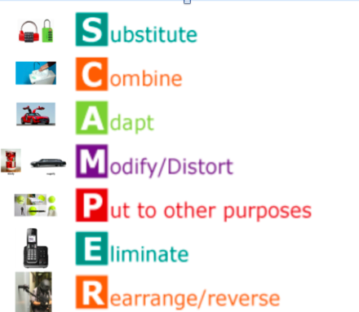

Appendix 2
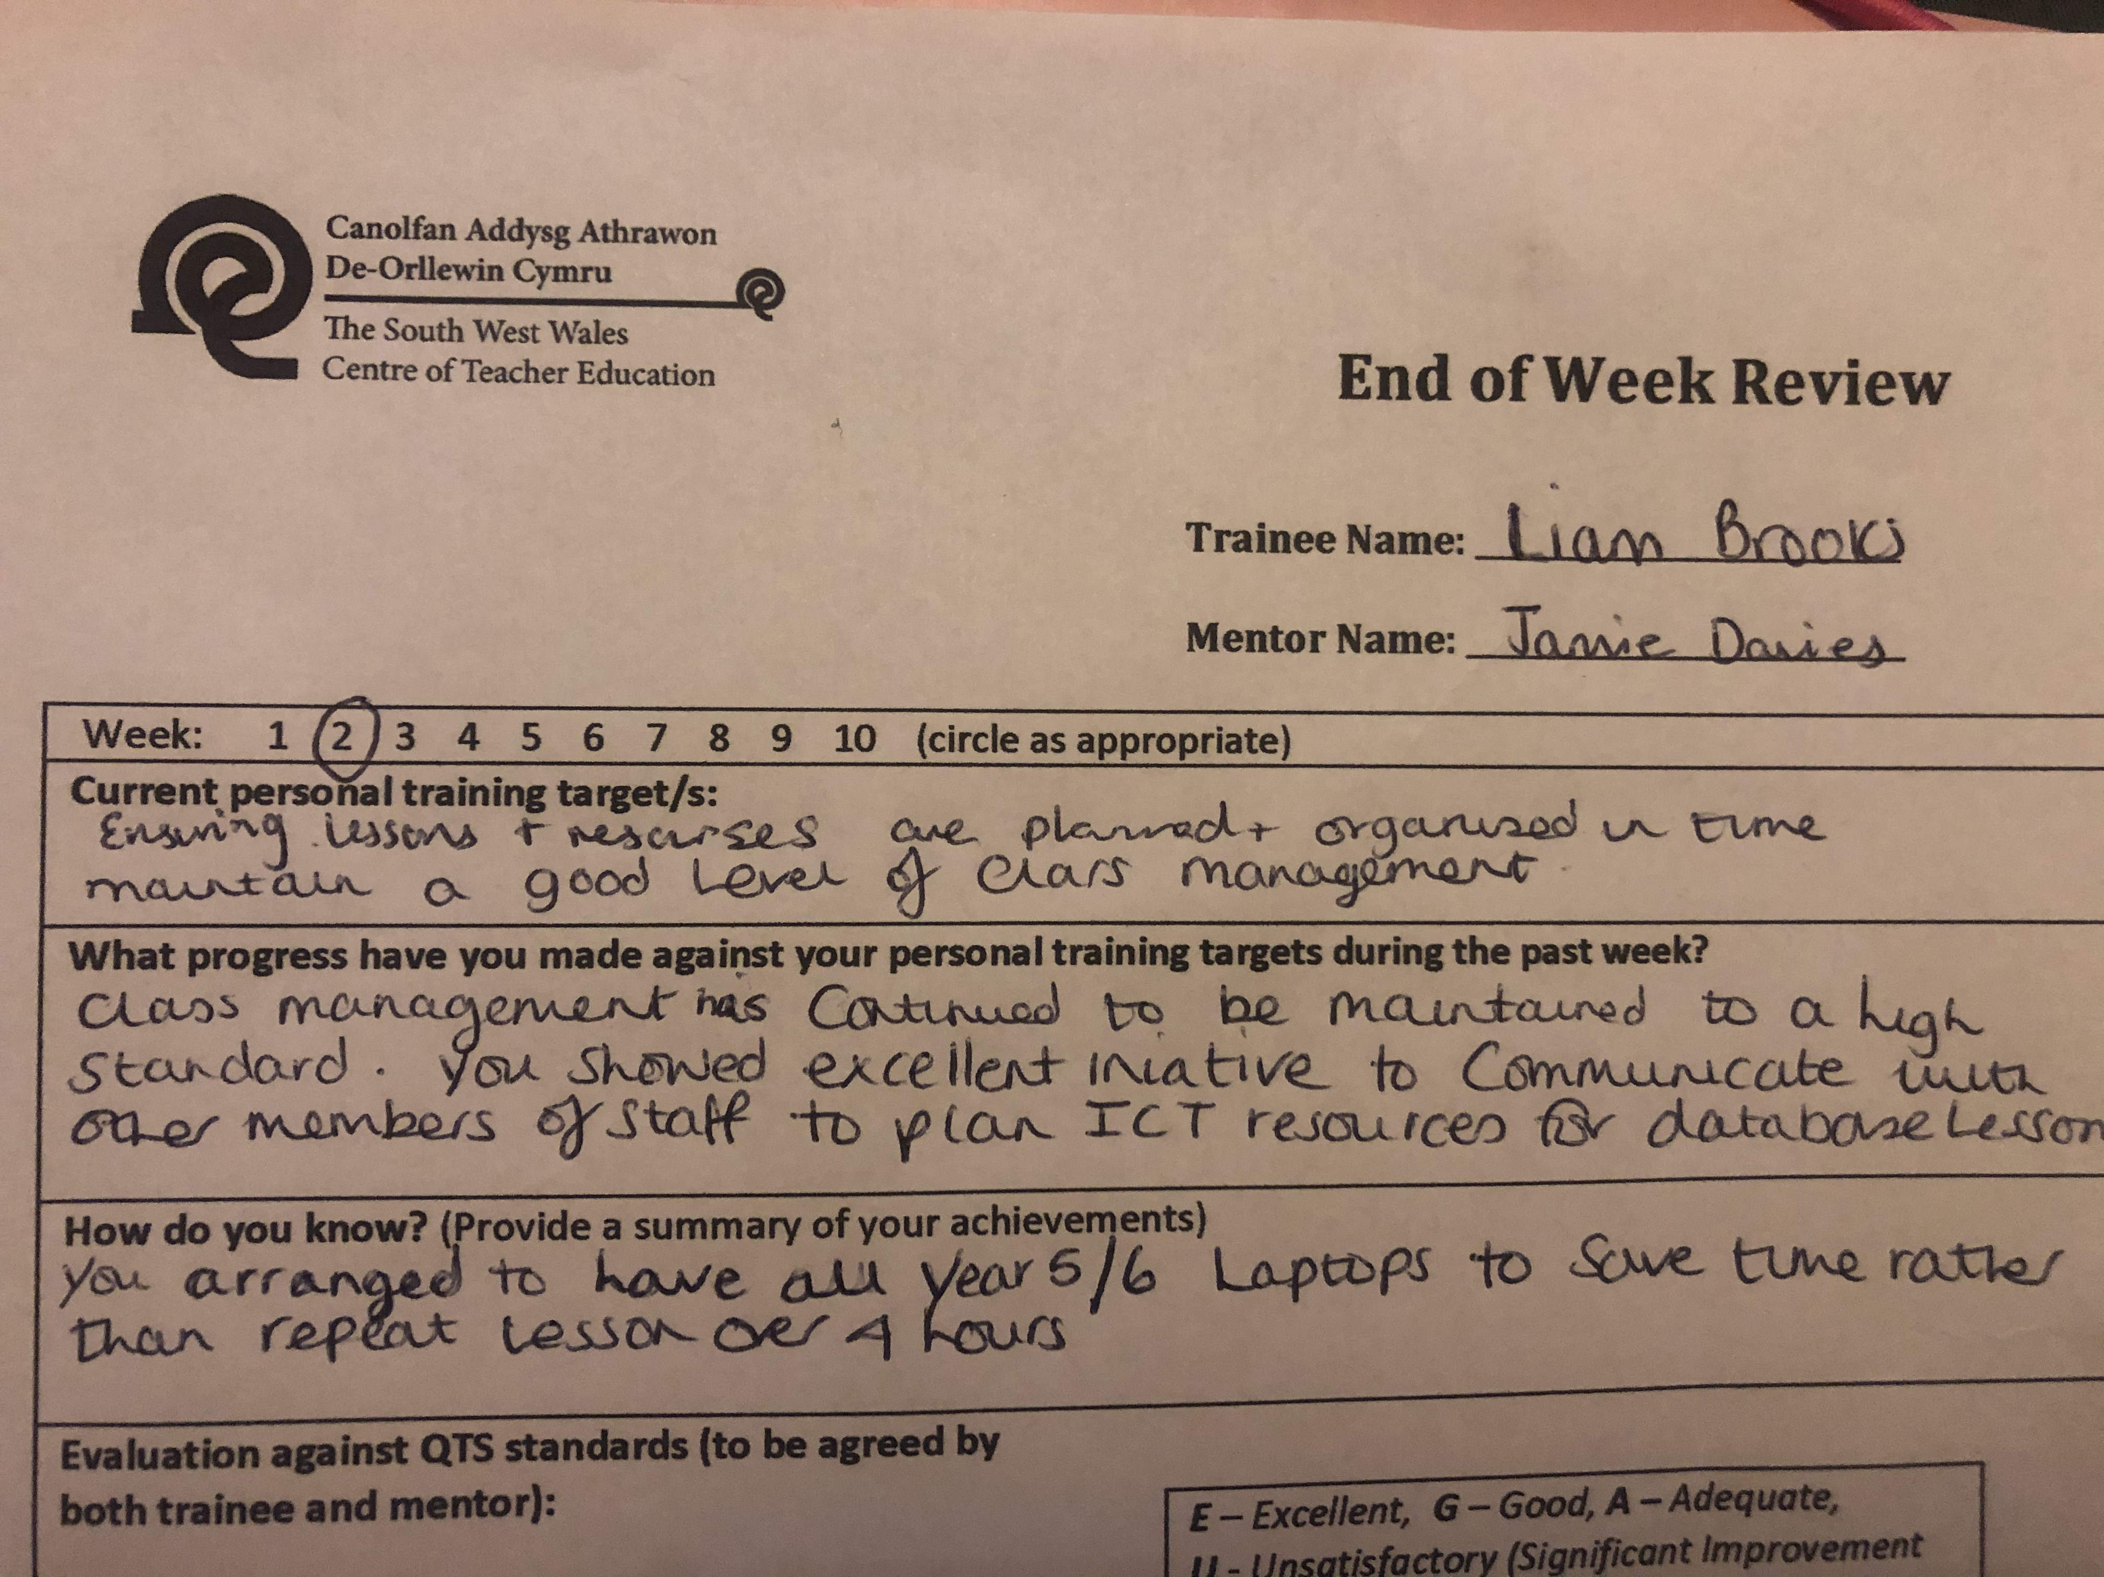

Appendix 3
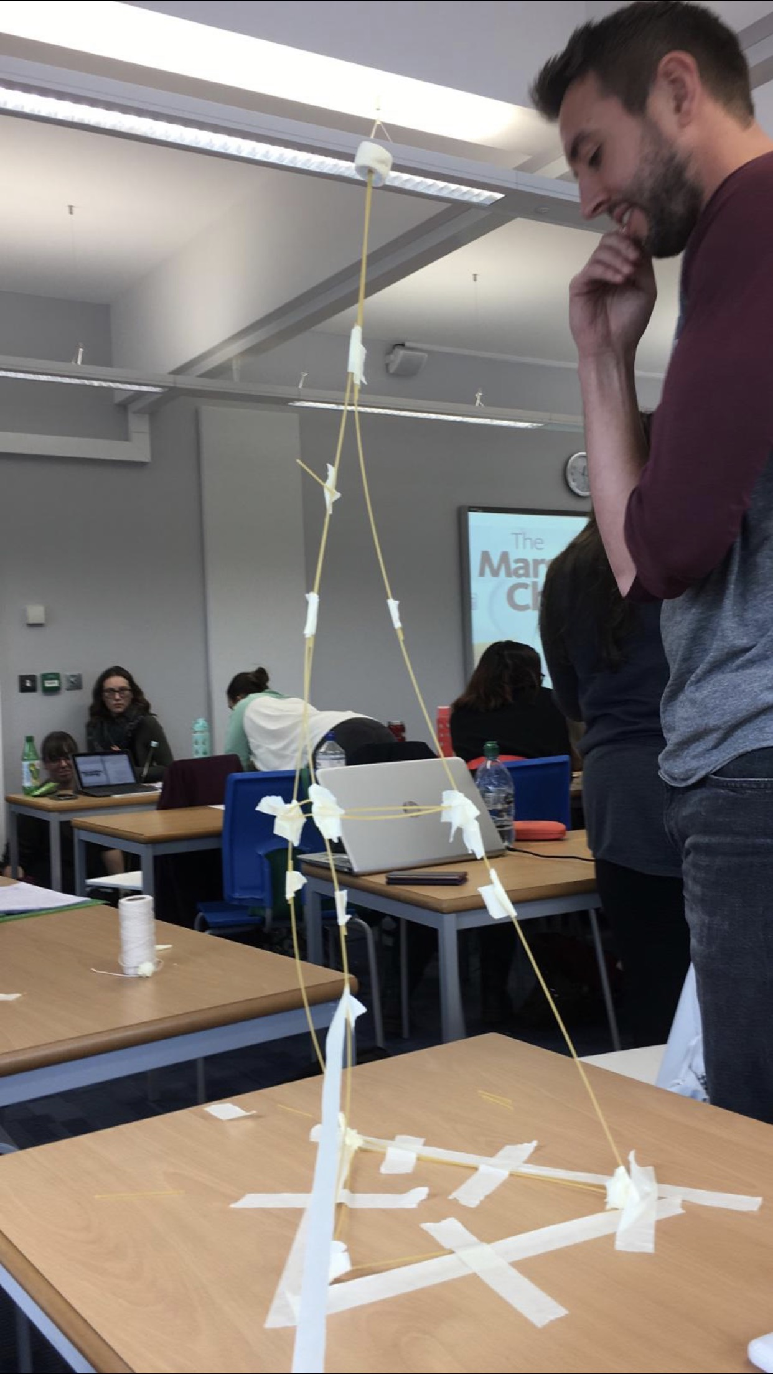

Appendix 4
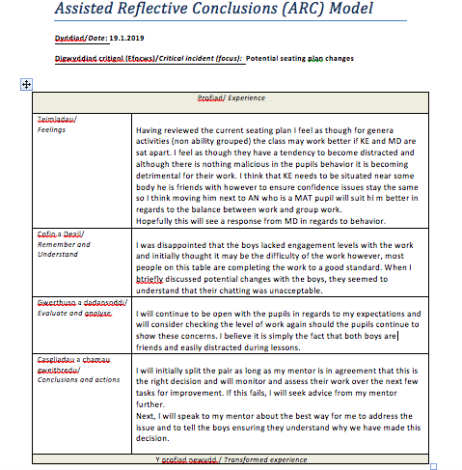

Appendix 5



