Computer Forensics – Research + Synthesize a Solution to a
Potential Real-Life Scenario
Author: Liam Aaron Jarvis (2000388)
Computer Forensics (ACCD5000)
School of Applied Computing
Wales Institute of Science and ART
Date of Submission: 16th of December

Table of Contents
Page
Introduction 3
Task 1 - Research 4
Wireshark 4
Write Blockers (Hardware) 7
FTK Forensic Toolkit 7
FAW (Forensics Acquisition of Websites) 8
Nmap (Network Mapper) 9
Tools Table/Comparison of Use Case 10
Task 2 – Case Study: Sabotage 12
Background 12
The Investigative Process 13
Preparation for the Investigation 13
Investigation Aims 14
Launching the Investigation 14
Evidence Collection/Consent for Seizure of Evidence 14
Data Recovery 17
Post Investigation 18
Invoice 20
Conclusion 21
Reference List 22

Introduction
This document covers Tasks 1 and 2 of the brief. Task 1 entails discussing some commonly used Computer Forensics tools, providing a brief description and analysis on each tool mentioned, as well as categorising all tools discussed within a table. Task 2 covers the provided case study, where a fictional company “CEC Mobile Manufacturing Company” has fallen victim of a sabotage by a former employee. This task requires documentation for the forensic methodology used to investigate and restore files specified in the brief, a sample professional forensics report, and a sample invoice.

Task 1 - Research

Wireshark
Wireshark is a network analysis tool, more specifically a packet sniffer, used by computer forensics professionals to help “understand data you capture from a network. The captured data is interpreted and presented in individual packet form for analysis, all within Wireshark” [1] Wireshark works by first capturing data from the host’s Network Interface, and then “breaks the capture into frames, segments and packets, understanding where they begin and end.” [1] Wireshark then puts this data into context of addressing, protocols, and data, and presents this to the user. These captures can also be saved for later use.
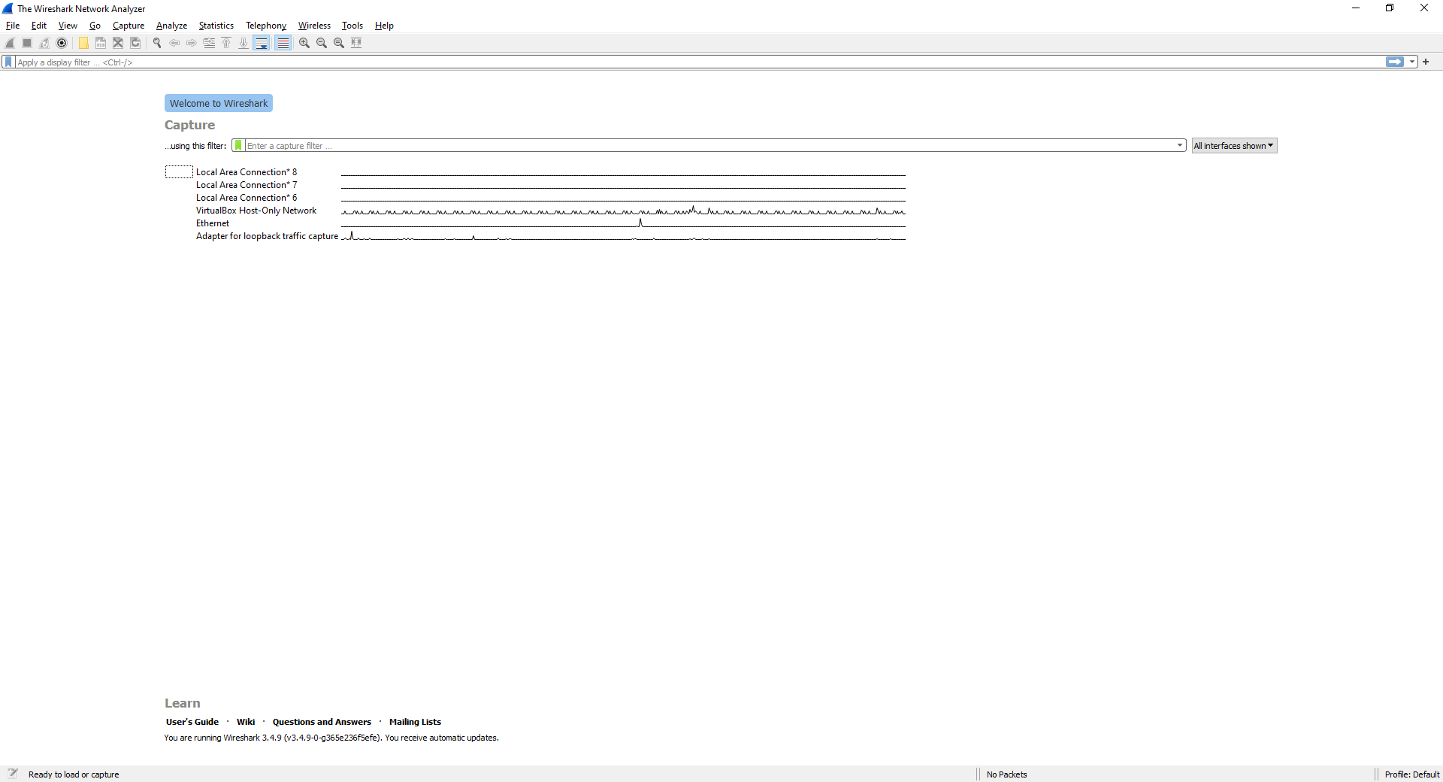
Wireshark is not a preventative tool and instead a monitoring tool that is useful if a cyberattack is spotted whilst ongoing for capturing data about the attack, like the origin of the attack. For obvious reasons it is also not useful after an attack unless the data has been saved for analysis during an attack. Wireshark is a great tool in a computer forensic professionals’ arsenal, but on its own is less useful.
When Wireshark is first loaded, you are given a list of network connections you can monitor, as well as a capture filter which allows you to filter what network traffic you want to capture, for example to only capture traffic from a specified IP address. Once one or more network connections are selected you can start capturing packets.
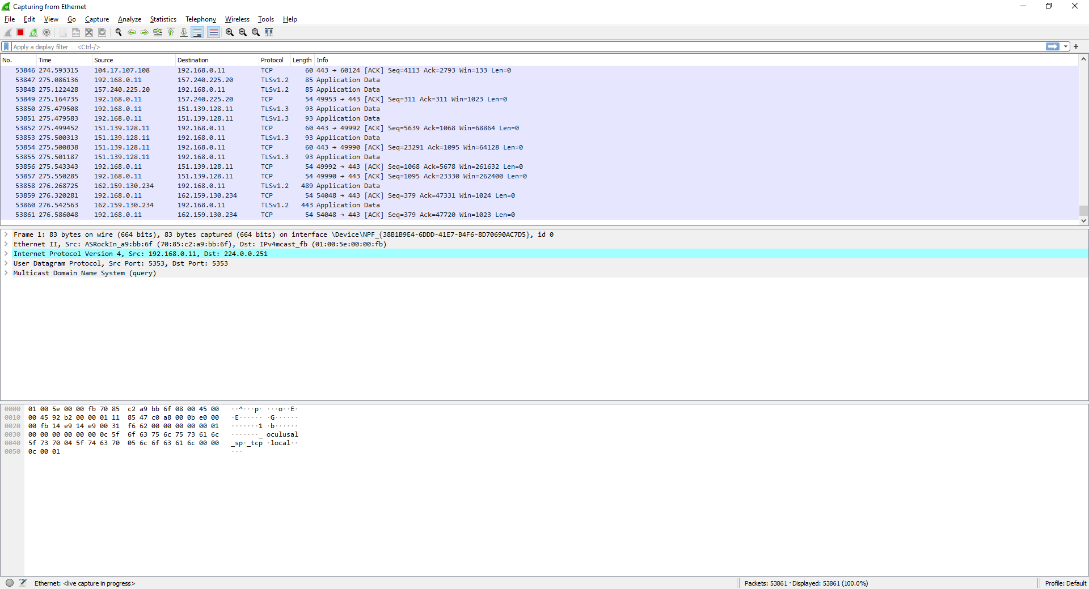
Once on the capture screen, you can see all the packets coming to and from the selected network connection. Below is an explanation of each column:
- “No.: This is the number order of the packet that got captured. The bracket indicates that this packet is part of a conversation.
- Time: This column shows you how long after you started the capture that this packet got captured. You can change this value in the Settings menu if you need something different displayed.
- Source: This is the address of the system that sent the packet.
- Destination: This is the address of the destination of that packet.
- Protocol: This is the type of packet, for example, TCP, DNS, DHCPv6, or ARP.
- Length: This column shows you the length of the packet in bytes.
- Info: This column shows you more information about the packet contents, and will vary depending on what kind of packet it is” [2]
This capture page can be quite cluttered and useless without the use of capture filters, but using them you can monitor specific IP addresses, ports, filter out DNS and ARP traffic, etc… Another way to get more use out of Wireshark is using display filters. When you stop packet capture on the capture page, display filters can be used in analysis to see only packets sent from one computer to another, traffic on a specific port, or exclude traffic from specified IP addresses. Display filters allow you to capture a wide range of packets and save them for later analysis, where specific filters can be applied, rather than applying a capture filter and losing any data that you may need.
Below is an example of using a filter to only see packets going to or from 192.168.0.1, which is the default gateway, or router of the home network.

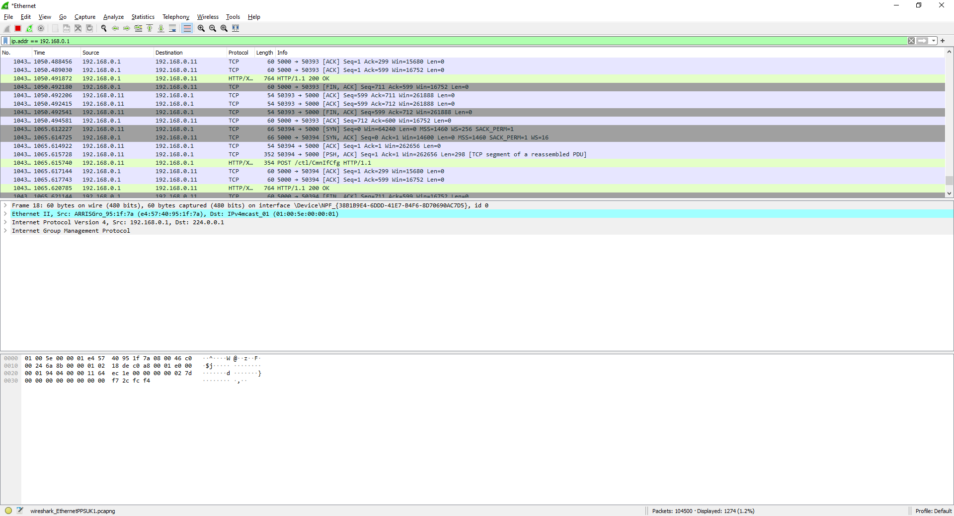
Here packets are being sent to and from the computer on the network (192.168.0.11).
Wireshark has many used in networking, such as troubleshooting performance issues within a network. For computer forensics, it can be used during an attack to monitor and capture the following information:
- “Wireshark can be used to identify who initiated the attack, as we know that in forensic how important it is to identify a culprit or an accused to get the investigation started.
- Wireshark can be used to know how exactly the attack has been implemented on a system.
- Wireshark can be used to identify what all information or Data has been compromised from a device or network.
- It is helpful in finding out if the attacker has left anything in the system like a Trojan horse or a botware which can be used later to compromise the system.
- It also tracks the amount of the data collected and what all has been analyzed and should be analyzed. In short, determines whether there is enough data to analyze the network.” [3]
The main disadvantage posed by Wireshark, is the fact that it needs to be used during an attack. If the cyberattack is completed before a computer forensics professional can clock on, either due to how quick the attack is completed, or if it is a sneaky attack that flies under the radar at first, this tool becomes useless. Businesses may not even have forensics professionals onsite, only hiring them when needed. This leaves the responsibility up to the network administrator who could easily be occupied with other tasks.

Write Blockers (Hardware)
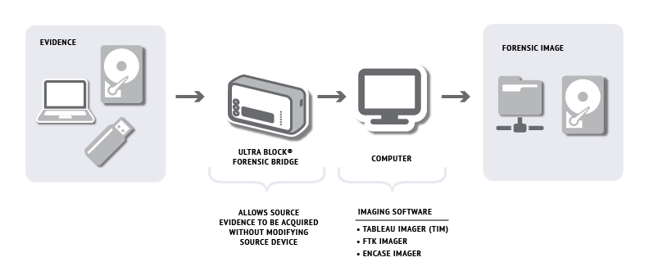
A write blocker is a computer forensics tools that blocks writes to a storage media. “Normal read access to the device is supported, but all write requests are blocked”. [4]. A write blocker is a tool meant to be used after a cyberattack takes place. It doesn’t prevent an attack, but does prevent the modification of drives, allowing you to use the drive as evidence. This can be useful in court, as when presenting evidence “you must prove that none of your analysis efforts left any trace on the evidence media” [4] as well as proving you haven’t modified any other supporting evidence in any way. Proving you have not tampered with any evidence ensures admissibility of the piece of evidence. Software write blockers have the disadvantage of still being possible to bypass. This disadvantage however is removed with hardware write blockers, as “a physical connection blocks any other paths to the disk.” [4].
[5] Diagram briefly explaining the use of a hardware write blocker

FTK Forensic Toolkit
The FTK Forensic Toolkit is a software that is used to scan storage drives for various types of information. Some of the features of the toolkit include:
“Full-Disk Forensic Images
Decrypt Files and Crack Passwords
Parse Registry Files
Locate, Manage and Filter Mobile Data
Collect, Process and Analyze Datasets Containing Apple File Systems
Visualization Technology” [5]
On top of this, the toolkit also includes some web tools, such as email analysis. The tool assists file systems from all three major desktop operating systems such as “FAT, exFAT, NTFS” [6], “Mac OS Extended (Journaled), OSXC -- Mac OS Extended (Case-sensitive, Journaled)” [6], and “Linux ext2 and ext3” [4], and “ext4” [6]. It also supports the “APFS (Apple File System).” [6].
The FTK Forensic Toolkit is the most complete tool a forensics professional can use, as it is a range of tools rather than a singular tool for a specific job. The toolkit is used during the investigative process after an attack/breach and can also be one of the only tools used depending on the attack. As stated previously, the toolkit has a range of tools that allows the user to create a forensic image (The structure and contents of a storage device or a specific disk volume) for analysis. The forensics professional can then read through the forensic image to look for any clues/evidence of the attack. Encrypted files can be decrypted, passwords can be cracked, and registry files can be parsed using tools available within the toolkit. This makes the toolkit incredibly useful if the attack was initiated within a network, by someone who has broken into the network physical or digitally, or an employee who will already have access to the network.
The toolkit is also being expanded on as time goes on, with tools such as the email analysis/parse tool. This along with constant update, has made the tools a staple of the forensics arsenal. The main disadvantage of the toolkit is in its size. The number of tools available can be daunting to new users, but with time and experience, this disadvantage is removed. Plus, the advantages it offers far outweigh this disadvantage.

FAW (Forensics Acquisition of Websites)
FAW is a forensics tool that stores “valuable information along with webpages that may be helpful to extract information for forensics investigators.” [7]. Bijalwan goes onto say:
“(FAW) captures all the evidences in a live environment. It also keeps loss of all incidents in real time that took place during the acquisition. The experts can also perform multiple tasks at a time, such as screenshots, recording, advertisement, and streaming of data. FAW is also useful to analyze the webpages if they are infected with any malicious code” [7]
Bijalwan [7] also notes that generally, an intruder will launch malicious code through a JavaScript file, which FAW can trace and save for an investigator for later analysis. This makes the use case of the tool to capture and analyse a website when it is suspected that the attack originated from the internet. Both the source code and any JavaScript files can be captured, and if malicious code can be found within the website, it can be used to further the investigation. Either the website was infected by a malicious third party, or the website is simply a phishing site created to pose as another company and trick unsuspecting users.
Included in the FAW suite is a report tool, which details “all the activities carried out with the FAW suite importing all the acquisitions references in addition to regulatory references in Digital Forensics.” [8]. It also allows the webpages to be captured in “in FTP and SFTP mode without modifying metadata of copied files.” [8]. This, like a write block, helps to prove that you have not tampered with the evidence, making said evidence admissible in court. Lastly, the tool can be integrated for use with Wireshark.
“FAW uses the capabilities of Wireshark to capture all of the traffic on all interfaces active network during the acquisition of the Web page, the investigator can then do an analysis of all the network traffic is transited to reach the Web page on both the intrinsic behavior of the same.” [9]
This for example could allow us to see if the website is communicating with another IP address, that could be owned by the computer of the hacker, or where the data that is being stolen using the website is being sent to.

Nmap (Network Mapper)
Nmap is a computer forensics tool “most often used by network administrators and IT security professionals to scan enterprise networks, looking for live hosts, specific services, or specific operating systems.” [10]. Nmap can be used via the command line, or through a GUI and can be used on the main 3 desktop operating systems: Windows, Mac OS and Linux. Nmap would be used during the investigative process, to check the network for vulnerabilities. This can help find out how an attack was initiated, and aid in finding out both the type of attack, and the origin of the attack. It also allows the network administrator to fix the vulnerability so it can’t be exploited again by attackers.
A key feature of Nmap, as explained in the “Nmap in the Enterprise” book [10] is the ability to create IP packets and send them out, to help test parts of the network, and to perform some of the scans that can be performed using Nmap. Another key feature is the varied number of scans Nmap can make use of. Some of the more prominent and useful scans include:
- Port Scans - TCP, UDP, SYN, etc…
- OS detection (along with its version),
- IDLE scan – A Scan that uses packets bounced of an eternal host to make the scan stealthier. (Can be dangerous as this scan can be made use of for malicious purposed)
Nmap is also free and open source. This comes with many advantages and disadvantages. Firstly, it means that users have been able to verify that the source code of Nmap is safe for security purposes and can continue to do so into the future. The software is also well documented. Due to both its free and open nature, as well as the support it offers for a wide range of operating systems, the software is used by many power users and organisations. This means the internet has a plethora of documents to help with the basics of Nmap, or to make use of more advanced/niche features.
A disadvantage, however, is the lack of official support that you could get with a paid software. There is lots of documentation, but this documentation does not perfectly apply each user, where some users may experience a rare bug and essentially be stuck. Official support would be able to help with this bug better as it is more tailored to each user and use case, unlike online documentation which is written around the experience that the specific user had.

Tools Table/Comparison of Use Case
A brief thought before moving onto the table – Even though these tools can be compared with one another for their use case/importance to forensics professionals, it is not a straightforward apple to apples comparison. It should be kept in mind that these tools make up an arsenal, with each tool having its own use case scenario. One example of this has already been explained - FAW integration with Wireshark. Another example however could be in the case of a sabotage within the network. The first thing to do is to find out which computer/computers or user account the attack originated from. From here, the forensics team can use a write block on any of the relevant storage drives that were in use by the suspected computers/user. After this, the FTK Forensic Toolkit could be used to create a forensic image of these drives and then start analysing the collected data.
By using a write block first, it can be proven undeniably that the device was not tampered with during the investigation/use of the FTK Forensic Toolkit. With this being said, below is the comparison table, where the name of each tool, a brief explanation, and each use case are briefly explained for a side-by-side comparison of each tool.

Name of Tool | Explanation | Use Case
Wireshark | Packet Sniffer Monitoring Tool for capturing data packets on network connections. | During a cyberattack to capture as much data as possible about the attack, e.g. Origin of attack, targeted IP/s
Write Blocker (Hardware) | Physical tool that prevents writes (But not reads) to a storage device. | Before the investigative process takes place to prove the device was not tampered during an investigation. Ensures admissibility of the evidence in court.
FTK Forensic Toolkit | A suite of tools that allow the user to create a forensic image of a storage device/disk volume, and decrypt and crack passwords, parse registry files, etc… | During the investigative process to analyse a storage device/disk volume for evidence related to the attack.
FAW | A tool that allows the user to capture web pages and their relevant information, e.g. Source Code, JavaScript Files. | During the investigative process to capture and analyse any websites that could be the suspected origin of an attack. Can also be integrated with Wireshark to monitor network traffic during the acquisition of the web page.
Nmap | Network scanning tool that allows the user to scan the network in question to find vulnerabilities. | During the investigative process to find vulnerabilities in the network. This can help to find out how an attack was initiated, as well aid in finding out the type of attack and the origin of the attack. Allows network administrator to fix vulnerabilities to stop further exploitation.

Task 2 – Case Study: Sabotage

Background
CEC Mobile Manufacturing is a Company based in Swansea. The company designs mobile phone interfaces/GUIs for popular vendors. CEC has rose to be a market leader in its market within a relatively short period of time. A worker, Rob Jengelley was working on a GUI interface that rivalled Apple’s iPhone 12 designs using Autodesk Maya. Unbeknownst to CEC however, Rob had secretly planned to sell these designs to a competitor, Samtech. A week later Rob handed in his resignation to leave CEC.
Engineers later discovered that many of the mobile designs that were stored on Rob’s computer were gone, one in particular being the Galaxy S20 Plus design. Millions of pounds were spent on these designs and rob had sabotaged them. No backups were made, due to the confidential nature of the work. To further prove that Rob was indeed behind the sabotage, was the fact that only he could access this work. The CEO Ms Dee Rod was particularly disturbed, as these designs were going to be patented and then licensed to mobile telephone manufacturers around the world. If these designs are leaked, CEC would lose both the millions in R&D, and the millions they would earn from licensing these designs.
Due to the serious nature of this attack, and the millions the company could lose, Ms Dee Rod hired Barry Lynch, a CHFI and CEH Certified professional to investigate the sabotage and provide evidence that Rob did indeed sabotage the company and its designs, and to retrieve the lost data. Ms Dee Rod has read many success stories involving computer forensics investigations around the world and is the reason she hired Mr. Lynch.

The Investigative Process

Preparation for the Investigation
Before the investigative process takes place, it is key that the necessary preparations are put in place. This is to ensure that any evidence that will be used in court will not be tampered with during the investigation, both intentionally and unintentionally. Doing so will make the evidence presented admissible within the court, as it can be proven the evidence was not tampered with in any way.
A forensics lab should also be setup. This is where the bulk of the investigation will take place. This is useful as it gives the forensics professionals somewhere to work and ensures that all evidence within the room is secure from anyone other than the forensics professionals. A forensic lab should have multiple computers (And servers if needed), any other devices such as write blockers, and fire, water, smoke, and electromagnetic suppression systems in case of an emergency, to try and protect the evidence as best as possible.
A forensics toolkit should be setup by the forensics professionals before the investigation starts. This “toolkit” should have all the necessary devices/software the forensics professionals may need throughout the investigation. Since this investigation is a Data Recovery investigation, which is an investigation which entails “the recovery of data that has been identified as required and relevant.” [11], a write blocker should be included within this toolkit.
A write blocker (as explained in part 1 of this document) prevents someone writing to a storage device. A hardware write blocker is the best choice, as although it isn’t easy to do, a software write blocker can still be bypassed. Another advantage of a physical write blocker is the fact that it is easier to understand, when compared to a software write blocker. As explained on pages 33-34 of the book “The Best Damn Cybercrime and Digital Forensics Book Period” [12], it is much easier to visually and conceptually explain and demonstrate how a hardware write block works to a jury (or anyone else), than to “explain the esoteric technical specifics of a Linux operating system forensic recompile to a jury of average (and often non-technical) citizens” [12]. Using this proves that the evidence has not been tampered with during the investigative process.
Another useful tool that will be used during the investigation is Access Data’s FTK® Forensic Toolkit, which has a range of tools available. The FTK Imager inside the toolkit can be used to first create a forensic image of Rob’s computer drive, so any investigative steps are taken on this image, rather than the original drive. Then, the imager can be used to recover any lost files, in this case, the mobile phone designs for CEC. If any files were encrypted by Rob, the toolkit can also be used to decrypt these files. Lastly, the toolkit will be used to create a report of the investigation process, outlining the evidence collected, and the methods used to go about collecting it.
Outside of software and hardware, the toolkit should have some physical tools. These could include screwdrivers for disassembling Rob’s PC and removing any hard drives, anti-static bags for storing computer components, pens and markers for notes, a camera for taking photos of evidence, blank USB drives for storing information gathered, etc.. Once the toolkit is assembled, and the forensics lab is setup, the investigation can take place.

Investigation Aims
The aims of the investigation, which was pointed out by the CEC CEO are as follows:
- Recover the lost data from Rob’s computer
- Investigate and provide evidence of Rob’s sabotage
Both of these aims can be fulfilled by recovering the lost data. Recovering this data means that CEC can be provided with the lost designs, so they do not lose all their time and money spent on them. Finding this data also proves that it existed in the first place. With this knowledge, it can be stated for sure the data was definitely removed by a user. As stated in the background, the data on Rob’s computer were never backed up as the confidential nature of his work. Due to this confidentiality, only Rob had access to these designs. This means that either Rob was unprofessional and left his PC logged in for someone else to gain access to and delete the files, or more likely, that he himself had access to and deleted the file. Either way, this evidence helps to bolster the case that Rob did indeed sabotage the company.

Launching the Investigation

Evidence Collection/Consent for Seizure of Evidence
Firstly, before touching any computers, a consent to search from should be filled in by CEO Ms Dee Rod. This form should outline exactly what is being seized during the investigation and why, along with the CEO’s full name, signature, and date of signature. An example can be seen below:
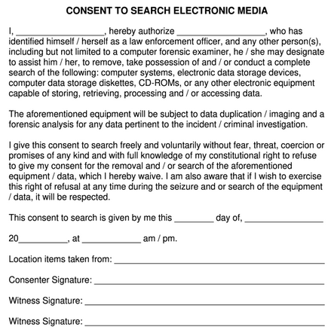

[20]

It may also be worth gather any witness statements from anyone who worked with and/or knew Rob at CEC. A witness statement documents a witness’ account of facts relating to a dispute or person. The witness statement (as per the UK government) should include the following:
- “Start with the name of the case and the claim number;
- State the full name and address of the witness;
- Set out the witness's evidence clearly in numbered paragraphs on numbered pages;
- End with this paragraph: 'I believe that the facts stated in this witness statement are true.' and
- be signed by the witness and dated.” [13]
Below is a typical layout of a witness statement:
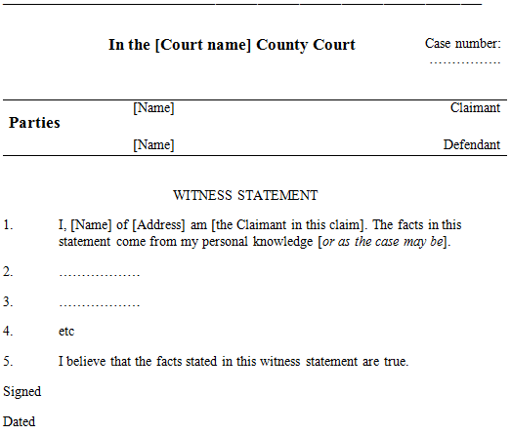

[13]

As seen above, the witness must consent at the start of the dialogue, and at the end by signing and dating the statement. Any witness account that points towards Rob acting upon malicious intent is helpful, as simply finding the lost files on Rob’s computer may not be enough to prove him guilty, or to start a legal investigation on Rob.
From here, further evidence will be seized, the main thing being Rob’s computer. If any other storage devices were used by Rob, these should also be seized for analysis. It is safe to assume that since this was likely a sabotage on Rob’s part, his computer will have been turned off, meaning that the volatile memory of his computer can’t be searched for evidence. This does make handling the computer easier though, as it can be simply moved to the forensics lab. As the files on this computer were not backed up, any network devices can likely be left alone as well.
Before handling any evidence however, a Chain of Custody document must be filled out. The Chain of Custody is “A process that tracks the movement of evidence through its collection, safeguarding, and analysis lifecycle by documenting each person who handled the evidence, the date/time it was collected or transferred, and the purpose for the transfer.” [14]. This again is another way to prove admissibility of evidence, as this document details exactly who had the evidence, the date and time, and the purpose of transferring it.
The last thing that needs to be done before the data can be recovered from Rob’s computer, is to ensure all evidence can/is stored safely and labelled appropriately with the supporting documents with it. Since storage drives will be handled, they should be stored in anti-static bags when not in use and stored in a safe environment within the forensics lab, with the proper safety controls in place from accidental damage, such as physical, electronic, magnetic, water or fire damage. This also further secures evidence and ensures it is only be handled/used when needed during the investigation.

Data Recovery
After all the evidence has been collected, the data can now be recovered from Rob’s computer. Write blockers should be installed on any storage drives of Rob’s PC to ensure it does not get written to during the data recovery process. From here, the drive/s can be installed on the forensics lab PCs, and the FTK imager within the FTK Toolkit can be used to create an identical image of the drive/s. These forensic images are made to keep the original drive intact, which allows it to be used as evidence as we have not tampered with the original drive in anyway. A problem that arises from this is proving that the forensics image is an exact copy of the original drive’s files. This can be proven however using hash reports.
“After successfully obtaining the forensic image of the digital evidence it is important to maintain the integrity of the image. To ensure such integrity a hash value is created for every forensic image using various hashing algorithms such as MD5 (Message Digest 5), SHA1(Secure Hash Algorithm), and SHA25. The hash value is generated in accordance to the contents of the data stored in the digital evidence. Any tampering with evidence will result in a different hash value, and thus the digital evidence will not be admissible in a court of law.” [15]
After the creation of the forensic image/s, a Forensic Data Recovery software can be used to find the lost data and CEC mobile phone designs.

“Forensic data recovery is an exclusive process of restoring data and files which will be utilized for legal purposes. Unlike common data recovery tools out there, forensic data recovery is more complicated. It is used to recover data and files from storage devices taken as proof or found at crime scenes.” [16]
The FTK imager within the FTK toolkit can again be used for this process. Some features included within FTK include:
- “Matchless speed and stability
- Database driven
- Faster searching
- All products unified on a single database
- Offers tailor-made services” [16]
Once the deleted files are found, another backup should be made to keep these files safe, and the drives should be logged and stored safely. Some of FTK’s web tools, such as the email analyser should be used. Using this tool, Emails “can be arranged in a timeline, giving the investigator a complete view of the entire email conversation and the ability to focus on any specific item of interest” [17]. This could help to find any emails Rob might have sent to the third party he was trying to sell the designs to, Samtech, further proving Rob’s malicious actions.

Post Investigation
Now that all evidence has been collected, a report should be made so both CEC and Barry Lynch have a document that can be referred back to, containing all documentation of evidence, and how it was collected. The FTK toolkit can once again be used to create the report, however for this document’s purposes, a sample of a FTK report will instead be used. FTK tables created within the report can be viewed using HTML, which is what the samples are based off of. These samples can be found below:

HDD of Rob’s Computer:
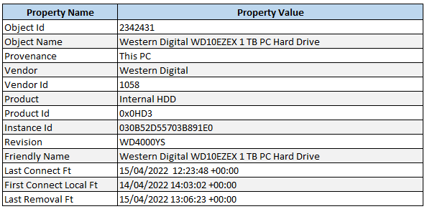
HDD of the Forensics Image created of Rob’s Computer:
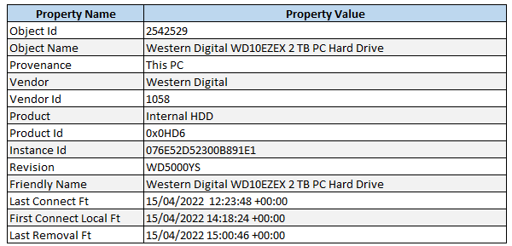
Details such as the Object Id, the name of the device and the related details, and when the device was first and last connected, and the last time it was removed. Viewing these tables using HTML makes it easier to digest and explain, and helps prove that the evidence was only accessed when stated.
On completion of the report, Ms Dee Rod should be notified that the designs have been recovered, so she can take the necessary next steps, such as getting the designs patented, and to use all the gathered evidence during the investigation to take Rob to court, and have a legal investigation against him to find further evidence of him acting upon malicious intent, using the gathered evidence to make a case that he should be further searched.
Barry Lynch will likely have to testify in court, to help explain the evidence collected, and how he can prove the evidence submitted is admissible in court, showing the efforts taken to ensure the evidence was not tampered with in any way as a result of the investigation. Explaining such things as how the hardware write blocker works, why the forensic image was taken, and how the data and emails were recovered from Rob’s computer. Necessary documents such as the witness statements, chain of custody, and written consent from CEC that he was allowed to access the premise and seize any assets, such as Rob’s computer, for the investigation.

Invoice
Barry Lynch should also supply CEC with an invoice for the investigation, which is simply “a list of things provided or work done together with their cost, for payment at a later time” [18]. As per the UK government, an invoice should include the following:
- “a unique identification number
- your company name, address and contact information
- the company name and address of the customer you’re invoicing
- a clear description of what you’re charging for
- the date the goods or service were provided (supply date)
- the date of the invoice
- the amount(s) being charged
- VAT amount if applicable
- the total amount owed” [19]
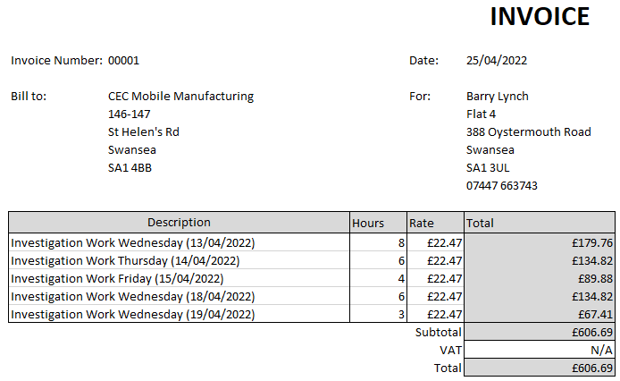
Below is an example of the type of invoice Barry Lynch could send to CEC:

Conclusion
This document has covered both tasks 1 and 2 of the assignment. For task 1, some of the more commonly used tools for computer forensics professionals were covered, by explaining what they are, and analysing their use cases within context of an attack and forensics investigation. After this, the tools were inserted into a table, where a brief overview of each of the tools were given, and each use case was described. This gives a brief comparison of each tool and when they should be deployed. For task 2, an overview of the forensics methodology was given for the steps that would be taken in response to the requirements proposed in the case scenario. After detailing the investigation process, a sample forensics report and invoice were given.

Reference List
[1] J. Bullock, and J. T. Parker, Wireshark for Security Professionals: Using Wireshark and the Metasploit Framework, Indianapolis: Wiley, 2017, ch.1, pp.2. [E-book]
[2] J. Petters, “How to Use Wireshark: Comprehensive Tutorial + Tips”, Varonis, Sep. 19, 2020. [Online] Available: https://www.varonis.com/blog/how-to-use-wireshark
[3] Forensic Yard, “Wireshark: A network Forensic tool”, Forensic Yard, Jan. 11, 2021. [Online] Available: https://forensicyard.com/wireshark-in-forensics/ [Accessed Apr. 19, 2022.]
[4] M. G. Solomon, K. Rudolph, E. Tittel, N. Broom, and D. Barrett, Computer Forensics JumpStart, 4th ed., Canada: Wiley, 2011, ch.3, pp 73, 75, 121. [E-Book]
[5] Exterro, “FTK® Forensic Toolkit”, Exterro, [Online] Available: https://www.exterro.com/forensic-toolkit [Accessed Apr. 19, 2022.] (*Maybe Remove)
[6] The Office of Law Enforcement Standards of the National Institute of Standards and Technology, Access Data Forensic Toolkit (FTK) Version 7.0.0.163, Homeland Security, 2020, pp.7. [Online] Available: https://www.dhs.gov/sites/default/files/publications/access_data_forensic_toolkit-ftk_7.0.0.163.pdf [Accessed Apr. 19, 2022.]
[7] A. Bijalwan, Network Forensics: Privacy and Security, Oxford: CRC Press, 2021, ch.7, pp.142. [E-book]
[8] Forensics Acquisition of Websites, “Forensics Acquisition of Websites”, fawproject, [Online] Available: https://en.fawproject.com/ [Accessed Apr. 19, 2022.]
[9] Forensics Acquisition of Websites, “Technical features”, fawproject, [Online] Available: https://en.fawproject.com/technical-features/ [Accessed Apr. 19, 2022.]
[10] A. Orebaugh, and B. Pinkard, Nmap in the Enterprise: Your Guide to Network Scanning, Massachusetts: Syngress Publishing, Inc. 2011, ch.2, pp.34. [E-book]
[11] A. Jones, and C. Valli, Building a Digital Forensic Laboratory: Establishing and Managing a Successful Facility, Massachusetts: Buttersworth Heinemann and Syngress Publishing Inc. 2011, ch.2 pp.25. [E-book]
[12] A. Reyes, and J. Wiles, The Best Damn Cybercrime and Digital Forensics Book Period, Massachusetts: Syngress Publishing, Inc. 2011, ch.1 pp.33-34. [E-book]
[13] Ministry of Justice, “Witness Statements”, Jan. 2017. [Online] Available: https://www.justice.gov.uk/courts/procedure-rules/civil/standard-directions/general/witness-statements [Accessed Apr. 25, 2022]
[14] W. Jansen, and R. Ayers, Guidelines on PDA Forensics: Recommendations of the National Institute of Standards and Technology, Maryland: National Institute of Standards and Technology, 2004, pp.57.
[15] N. Reddy, Practical Cyber Forensics: An Incident-Based Approach to Forensic Investigations, Maharashtra: Apress, 2019, ch.1, pp.6. [E-book]
[16] T. Lucia, “Top 8 Forensic Data Recovery Software”, Wondershare, Mar. 16, 2022. [Online] Available: https://recoverit.wondershare.com/file-recovery/forensic-data-recovery-software.html [Accessed Apr. 26, 2022.]
[17] C. Easttom, Digital Forensics, Investigation, and Response, 4th ed., Massachusetts: Jones and Bartlett Learning, 2021, pp. 80. [E-book]
[18] Cambridge Dictionary, “Invoice”, Cambridge, [Online] Available: https://dictionary.cambridge.org/dictionary/english/invoice [Accessed Apr. 26, 2022.]
[19] UK Government, “Invoicing and taking payment from customers”, [Online] Available: https://www.gov.uk/invoicing-and-taking-payment-from-customers/invoices-what-they-must-include [Accessed Apr. 26, 2022]
[20] pdfFiller, “Standard Media Release Form Template”, [Online] Available: https://www.pdffiller.com/100077359-fillable-consent-to-search-electronic-media-form-forwardedge2-usss

