Finance Report
This report will document all the financial data that we at Where’s my local have decided on, it is also a continuation from the last research completed as we have changed how we are spending our loaned money before we had chosen to have a large office and a large team working on the app however after finding out the cost of that, we found that our company wouldn’t be feasible to do anything and we would have no profit so we changed our initial idea and are now working with a small team in a smaller office so we can cut down on costs.

Break-Even Point
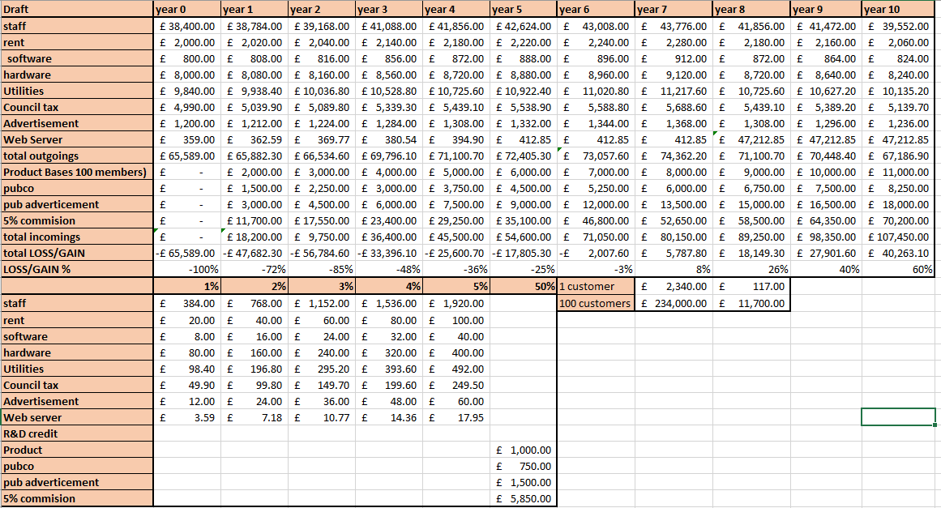
This shows our company planning on our financing, as you can see on this table after 6 years we only lose 3% of money and then by the 7th year we make 8% of our money back, so we can assume that the money will break even during the 6th year you can also see that we are planning at having up to 100 customers every year so that can easily be altered for better or for worse depending on our success on launch. You can see as well that after 10 years of our plan we make nearly double the amount of our spending in our profits. This is all worked out with having a small development team (around 10 coders and adding more every year after) and owning a small office to work in. The costing for the pubs will depend on how much they want their pub shown on our app if a customer is near their location.

- Series 1 = Outgoing costs
- Series 2 = Potential income
This chart shows that with our current spending and our current idea of our prices we will start getting our money back after 6 and a half years this shows that our project can be profitable if we make it according to this plan.

Cash Flow Chart
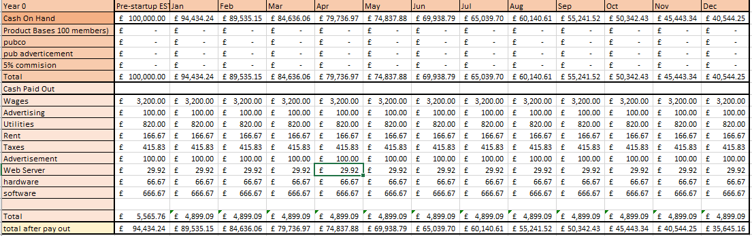
I have worked this chart on the year 0 costing her you can see from the £100,000 loan we got we will have around £35,645.16 left that means we lost £64,354.84 in that first year.
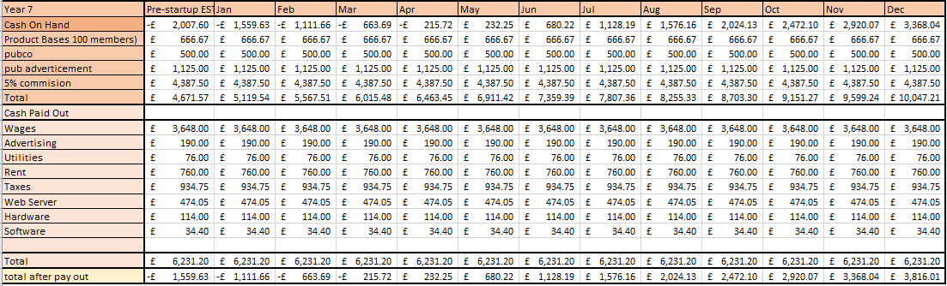
Here I have worked out what I think it will look after 7 years when we get a profit according to our breakeven point chart. Here I found we will have a profit of £8,625.72 however even with the same workings out I found I have had 2 different profit amounts not sure what went wrong but I have kept both to see the potential correct result (the 2 results are £5,787.80 and £3,816.01 not sure where the £1971.79 is but will look into it)

Cost Analysis
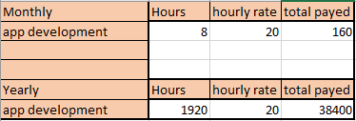
This shows that in year 0 if we pay £20 an hour and have our team work 8 hours 5 days a week they will be payed £160 a month and they will work around 1920 hours a year and get payed £38,400 a year.

Sales Forecast
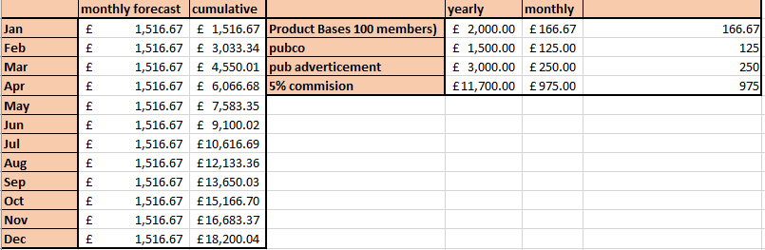
Here you can see that I have taken our incomings from what we expect year 1 to be like and we have worked out what each would be monthly and totalled to monthly total with that we expect that we ear around the same very year give or take 1%
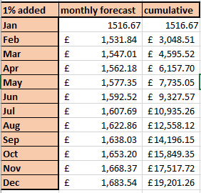
This would be our sales forecast if we had gotten 1% more every month as shown we earn up to £1000 more with just adding 1%
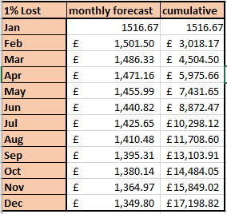
Here is what our sales forecast would be if we lost 1% again like if we had gained 1% it’s another £1000 this is if the worst happened and our advertisement doesn’t work ask expected

As you can see here if we keep the same amount every month we have a pretty good stable growth

As you can see here even with an increase of funds by 1% our monthly forecast looks similar to the one if we had the same amount every month.

Again as you can see our forecast if we lost 1% still looks pretty good and similar to our on what we hope to have witch is to make around the same every month for the first year at least.

