Name:_Christian Evans_______________________________

Student Number: 2526458________________________
__________________________________________________________

WORKSHEET 3 – TESTING (Chickens)

- Original code:
[Copy and paste your original code from Moodle into this box. Do not change it.]

from math import trunc, floor
eggsRequiredPerCake = 2
print("What sort of food?")
print("1. Normal")
print("2. Superfood")
foodChoice = input("Enter your choice from the options above (1 or 2): ")
chickenEggDays = floor(int(input("How many days has your chicken been laying? ")))
if foodChoice == "1":
howManyCakesCanBeMade = trunc(chickenEggDays / eggsRequiredPerCake)
print(f"{chickenEggDays} days, that's {chickenEggDays} eggs and {howManyCakesCanBeMade} cakes.")
else:
totalEggsSuperFood = trunc((3 / 2) * chickenEggDays)
superfoodHowManyCakes = trunc(totalEggsSuperFood / eggsRequiredPerCake)
print(f"{chickenEggDays} days, that's {totalEggsSuperFood} eggs and {superfoodHowManyCakes} cakes.")

Code Testing

For each test below, run your code and enter the values provided. Provide a screenshot of what happened when the programme ran. Did the programme behave correctly or did it do something unexpected? Fill in a box for each test below. You should present 8 separate boxes, 1 for each test. (Note: the first box is provided as a template)

Normal food
i. 4 days (should be 4 eggs = 2 cakes)
ii. 9 days (should be 9 eggs = 4 cakes)
iii. -3 days (no cakes or error handled)
iv. 10000 days (program should catch the error – many of these eggs would be bad!)

Superfood
v. 4 days (should be 6 eggs = 3 cakes)
vi. 5 days (should be 7 eggs = 3 cakes)
vii. 1 days (should be 1 egg = 0 cakes)

Test your menu
viii. What happens if you enter “3”?

Test:
Normal food i) 4 days

Screenshot(s) of output:
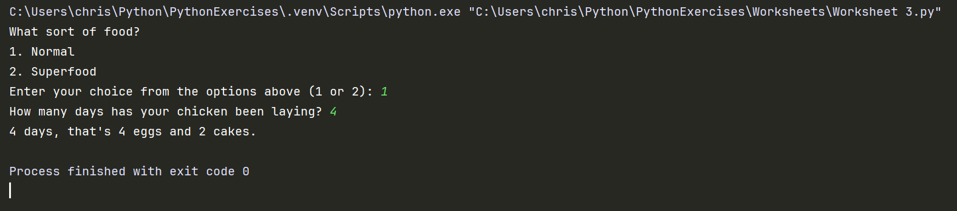
Result: Did the program behave as expected ie syntactically and logically correct?
YES/NO (delete as appropriate) - Yes

If NO, what problems were encountered and why? Suggest how things could be improved.

(Copy and paste box above for each of the rest of the tests)
Test:
Normal food ii) 9 days

Screenshot(s) of output:
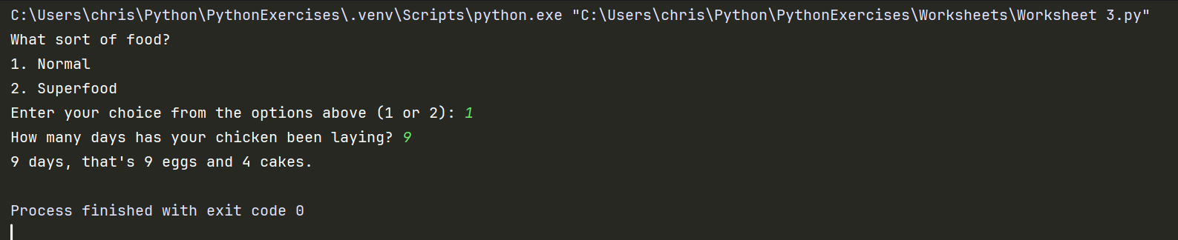
Result: Did the program behave as expected ie syntactically and logically correct?
YES/NO (delete as appropriate) - Yes

If NO, what problems were encountered and why? Suggest how things could be improved.

Test:
Normal food iii) -3 days

Screenshot(s) of output:
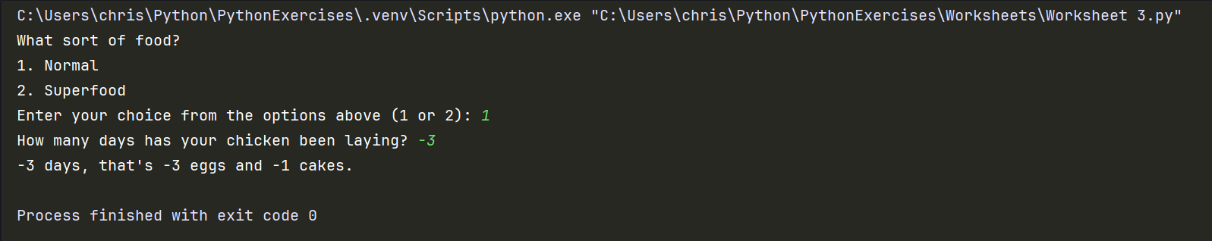
Result: Did the program behave as expected ie syntactically and logically correct?
YES/NO (delete as appropriate) – No

If NO, what problems were encountered and why? Suggest how things could be improved.
Should have validation to prevent user from inputting negative values.

Test:
Normal food iv) 10000 days

Screenshot(s) of output:
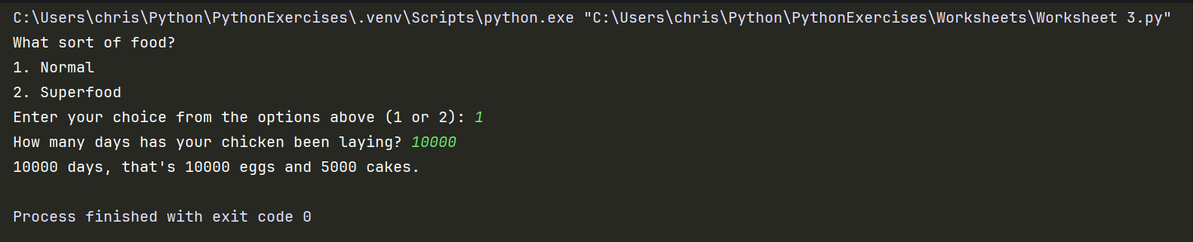
Result: Did the program behave as expected ie syntactically and logically correct?
YES/NO (delete as appropriate) - Yes

If NO, what problems were encountered and why? Suggest how things could be improved.

Test:
Super food v) 4 days

Screenshot(s) of output:
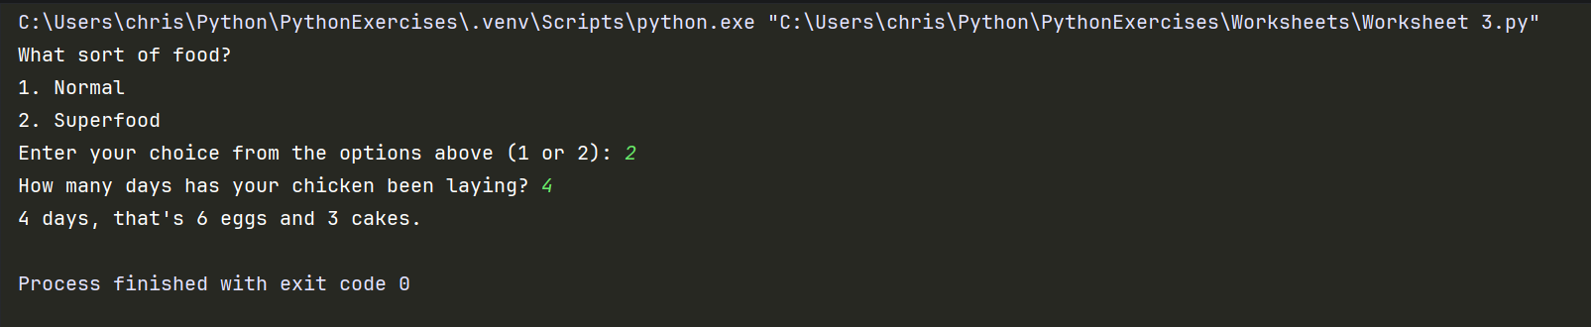
Result: Did the program behave as expected ie syntactically and logically correct?
YES/NO (delete as appropriate) - Yes

If NO, what problems were encountered and why? Suggest how things could be improved.

Test:
Super food vi) 5 days

Screenshot(s) of output:
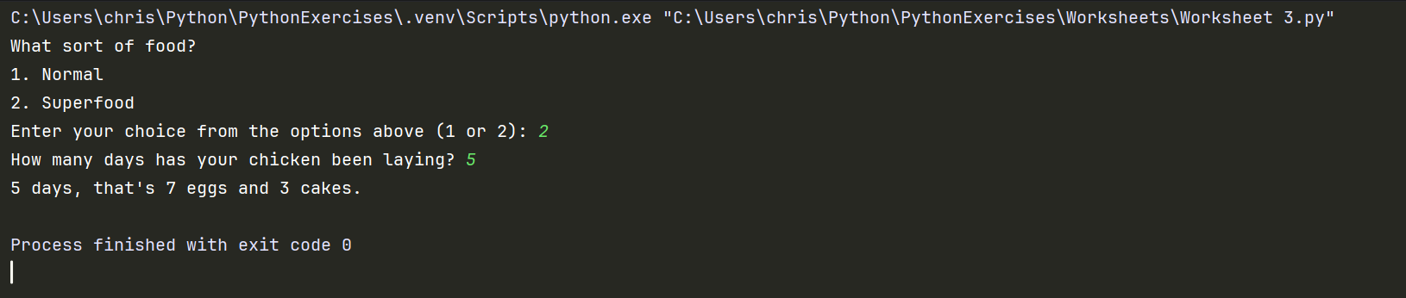
Result: Did the program behave as expected ie syntactically and logically correct?
YES/NO (delete as appropriate) - Yes

If NO, what problems were encountered and why? Suggest how things could be improved.

Test:
Super food vii) 1 days

Screenshot(s) of output:
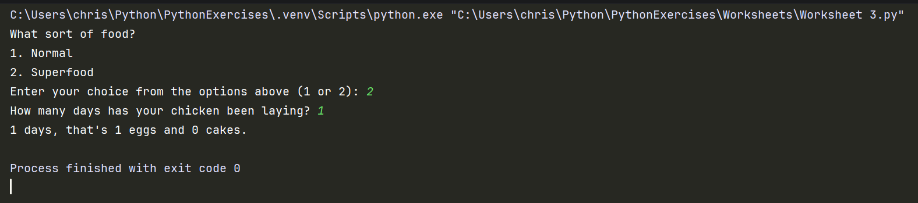
Result: Did the program behave as expected ie syntactically and logically correct?
YES/NO (delete as appropriate) - Yes

If NO, what problems were encountered and why? Suggest how things could be improved.

Test:
Test your menu viii) What happens if you enter “3”?

Screenshot(s) of output:
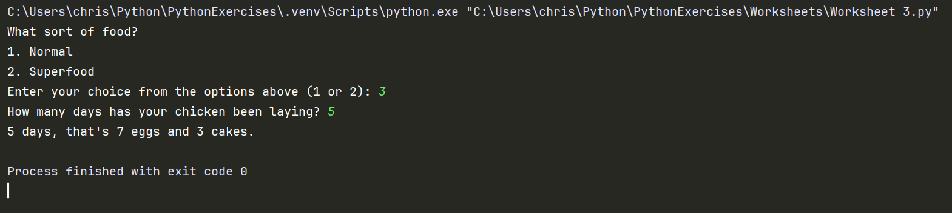
Result: Did the program behave as expected ie syntactically and logically correct?
YES/NO (delete as appropriate) - No

If NO, what problems were encountered and why? Suggest how things could be improved.
This because the option 2 was set within an else statement not an else if so it is logically following the option 2 path.

- Consider the results of the above tests and revisit your original code in order to address the tests that failed. (Note: you may not be able to solve all of the problems that were originally encountered, but solve as many as you can.)

Paste your full revised code here :

[Copy and paste your full revised code here – note, do not use a screenshot]
from math import trunc, floor
eggsRequiredPerCake = 2
print("What sort of food?")
print("1. Normal")
print("2. Superfood")
foodChoice = int(input("Enter your choice from the options above (1 or 2): "))
chickenEggDays = floor(int(input("How many days has your chicken been laying? ")))
while True:
if foodChoice == 1 and chickenEggDays > 1:
howManyCakesCanBeMade = trunc(chickenEggDays / eggsRequiredPerCake)
print(f"{chickenEggDays} days, that's {chickenEggDays} eggs and {howManyCakesCanBeMade} cakes.")
break
elif foodChoice == 2 and chickenEggDays > 1:
totalEggsSuperFood = trunc((3 / 2) * chickenEggDays)
superfoodHowManyCakes = trunc(totalEggsSuperFood / eggsRequiredPerCake)
print(f"{chickenEggDays} days, that's {totalEggsSuperFood} eggs and {superfoodHowManyCakes} cakes.")
break
else:
print("That is not a valid choice, restart the program.")
break

