Independent Study Module BMPF7013F

Lyanna Austin
Student Number: 2117164

Independent Study - Designing an Artefact

Independently study of a complex subject that has particular relevance to their workplace and their personal development. This assignment has 2 parts, a portfolio, and a written assignment.

The total word count for this assignment is 9000 words +/- 10%
Total word count excluding contents, references and appendices = 9731

A PEDAGOGICAL ANALYSIS OF GOSPEL VOCAL MELISMA FOR CONTEMPORARY VOICE STUDIOS

Table of Contents
PART ONE: PORTFOLIO 3
Introduction 3
Artefact Description 4
Context and Rationale 5
Rationale for Thematic Auditory Methodology 9
Literature review methods 9
A Planned Programme of Study 12
Gantt Chart 13
Ethical Considerations in Artefact Design 13
Critical Reflection 15
PART TWO: WRITTEN ASSIGNMENT 18
Introduction 18
Rationale 18
Research Methodology 19
Theoretical context 20
Literature Review 20
Scope Of Melisma Within Gospel Music 21
Analysis Of Gospel Melisma 21
Vocal Agility 25
Nurturing improvisation for gospel melisma 28
Discussion 29
Conclusion 31
References 32
APPENDICES 41
Appendix 1 - GLOSSARY OF TERMS 42
Appendix 2: List of Search Terms 44
Appendix 3: Ethical Consideration for Developing an Artefact 45
Appendix 4: Thematic Music Analysis of Gospel Melisma Technique 46
Appendix 5: Breath Management and Support Exercises 52
Appendix 6 – Vocal Artefact 54
Appendix 7 - Breath Management 55
Appendix 8 – Vocal Artefact – Agility 57
Appendix 9 – Vocal Artefact – Registration 60
Appendix 10 – Vocal Artefact – Improvisation 62
Appendix 11 – Vocal Artefact – Melismatic Tools 64
Appendix 12 – Vocal Artefact – Guide notes 65

PART ONE: PORTFOLIO

Introduction

Background

Contemporary music is an amalgamation of many genres and singing styles (Soto-Morettini, 2014; Le & Soon, 2023). The sound of African-American gospel music has had a significant impact on the development of Contemporary Commercial Music (CCM) (Legg & Philpott, 2015). Current research on African-American gospel music focuses mainly on sociological, historical, and stylistic aspects rather than on identifying and codifying specific techniques and characteristics as well as performance practices of the genre (Boyer, 1995; Legg & Philpott, 2015; Robinson-Martin, 2016). Consequently, it becomes increasingly difficult to provide adequate pedagogical strategies for gospel music that emphasise vocal stylistic skills specific to gospel music (Robinson-Martin, 2010).

According to Frith (1996), the concept of the voice as a musical and spiritual instrument is essential for gospel vocal performance. It is, therefore, common for gospel singers to use various expressive vocal techniques in their songs to convey profound emotions and significance (Cusic, 2011; Youssef, 2022). Among these techniques is the use of melismas. Gospel music exemplifies the technique of melismas, which requires vocal expression by incorporating multiple improvised or structured notes within a single sound or syllable (Robinson-Martin, 2014; Legg & Philpott, 2015; Youssef, 2022). Historically, the technique of melisma has not been limited to gospel music (Youssef, 2022); it has been used in other religious contexts, including Gregorian chants (Everitt, 2012) and liturgy (Crocker, 1996). The purpose of this study is to examine the application of melismas to gospel music, although this technique can be applied to a wide variety of musical styles.

During this independent study, the primary focus will be to review, design and create a vocal artefact containing a collection of vocal exercises as a guide to enhance the practice of gospel melismas in the applied studio. This study investigates the complexities of gospel melisma, evaluates prevailing research, and explores the pedagogical strategies of teaching melisma within gospel music genres using a thematic approach (Braun & Clarke, 2006). Based on the research, this assignment offers an overview of vocal physiological principles and pedagogical strategies used to help students understand the mechanics of the voice. Furthermore, this addresses the need to conduct rigorously structured research to identify evidence-based teaching tools that can be used in the vocal studio.
A thorough grasp of the principles governing vocal physiology can offer valuable insights into the mechanics of voice production. This enhances vocal control, technique, and accuracy, enabling vocal instructors and students to better understand the physiological processes underlying various expressive melismatic techniques. The focus on innovative teaching methods corresponds with the changing world of music and performance, as contemporary vocalists often face a variety of musical styles and platforms, requiring them to be highly adaptable and versatile in their skills.

Defining Melismas

This assignment aims to define gospel melismas and examine the recurring themes of the techniques used, which will be incorporated into the vocal artefact. In CCM pedagogy, a melisma is often referred to as a "vocal run" and "riffs" (Robinson-Martin, 2014), as an "ad-lib" (Everitt, 2012), or as a "lick" (Chandler, 2014), as "passing neighbour tones", "bends", "tails", and "ornamentations" (Boyer, 1978; 1995; Robinson-Martin, 2016). It is acknowledged by Galettis (2009) that there are a variety of terms used to describe melisma. In popular music genres, the term "lick," which is similar to a "guitar lick," is often preferred over melisma. Kayes (2015) notes that the usage of 'lick' is characteristic of rock, pop, and soul music. Similarly, Chandler (2014) describes melisma as a 'lick' or a 'riff' and mentions 'run' as a tool used for improvisation. Chandler (2014) also specifies that licks typically span 3 to 4 notes but may extend over an octave. Witmer (2017) characterises a lick as a brief, identifiable melodic element or phrase. Meanwhile, a riff is defined as a concise, recurring pattern used more for embellishment than improvisation (Robinson, 2017). Robinson-Martin (2014) correlates the extensive use of notes in a run with melisma, emphasising that both are vocal techniques.

Artefact Description

Due to the ever-changing challenges singers face, particularly in terms of stylistic technique, that may not be adequately addressed by conventional teaching methods. Therefore, the study aims to incorporate primary research using thematic auditory analysis (Braun & Clarke, 2006). This strategy seeks to bridge the gap between theory and practice, ensuring that vocalists are aptly equipped to navigate the varied and dynamic environments found in contemporary vocal studios. This vocal artefact is titled 'Gospel Melisma: Vocal Exercises', which provides a curated collection of vocal exercises for teaching gospel melismas, developed according to the expertise of leading pedagogues (Boyer, 1995; Wise, 1997; LeBorgne, 2019; Miller, 1996; LoVetri, 2002; 2003a; 2003b; Robinson-Martin, 2010; 2014; 2016; Anne Peckham, 2005; Estil, 1988). Within the context of gospel singing, these exercises provide a structured and practical approach to mastering the intricate art of melismatic singing. The accompanying artefact is comprised of four distinct sections: (i) Respiration: Breath Management, (ii) Vocal Agility, (iii) Vocal registration and (iv) Improvisation. The purpose of this artefact is to provide exercises that emulate melismatic movements in gospel music to support vocal training. The existing literature recommends techniques for pop riffs and runs. As a vocal teacher with expertise in gospel, soul, and R&B music, it is imperative to find research for an established pedagogy and lexicon for stylistic tools utilised in these styles. Building on the findings of my earlier literature review titled 'What is the gospel sound?' (Austin, 2023), there appears to be a noticeable gap in research concerning various stylistic techniques. Several studies have highlighted the need for a pedagogical approach specifically tailored to the needs of CCM singers (Chandler, 2014; LoVetri, 2002).

The primary research method used in this study is a thematic analysis (Braun & Clarke, 2006). This artefact contains exercises designed to address recurring themes. Breath management (Sundberg, 1993; Henderson, 1979; Fleming, 2005; Miller, 1996; LeBorgne, 2019) allows singers to achieve greater vocal power, sustain longer phrases, and maintain a controlled essential for gospel's dynamic and emotive performances (Robinson-Martin, 2010). A key component of agility (Harper, 1996; Benson, 2018) involves rapid and intricate vocal movements over a series of notes (Boyer, 1995). Singers trained in melismatic techniques for gospel music must be able to execute fast movements with enhanced precision and ease (Harper, 1996; Benson, 2018). Simultaneously, flexibility training expands the vocal range and facilitates seamless transitions between registers (Harrison, and O'Bryan, 2014; Miller, 1996; Ragan, 2020). A balance must be struck between the engagement of thicker and thinner vocal folds to ensure proper vocal registration (Thurman et al., 2004). By recognising these distinctions, gospel performers can achieve the dynamic range and expressive qualities required for the genre's style.

Context and Rationale

Professional context
My formative years were greatly influenced by my church, a predominantly black Pentecostal congregation. My exposure to African-American gospel music was shaped by this experience. In addition, this experience paved the way for a successful career in music as a professional backing vocalist, session singer, songwriter, and vocal coach.
As a CCM vocal instructor specialising in gospel music, I frequently encounter the challenges of melismatic vocal techniques in the vocal studio. This highlights the need for detailed and rigorous research within the field.

The purpose of this study is to thoroughly catalogue and examine the intricate components of melismatic singing, aiming to distil essential themes that will serve as the basis for crafting specialised exercises tailored to the performance of melismatic singing. Using a detailed thematic analysis of the various aspects of the melismatic technique, the researcher intends to uncover the subtleties that contribute to the excellence of melismatic performances. The resulting framework will guide the development of voice exercises to enhance the technical and expressive capabilities of singers. The expected outcome of this research is twofold: firstly, the refining of methodological approaches for teaching melismatic singing, and secondly, the contribution of empirical insights into a more general teaching methodology for CCM. This comprehensive approach offers to bridge identified gaps in pedagogical literature and practice, reinforcing instructional techniques with academically grounded, research-backed methodologies.

The decision to focus on melisma is primarily a result of a strong personal connection and exposure to the form, as well as my commitment to improving the quality of instruction within my studio, particularly in light of the apparent lack of specialised pedagogical materials. A melisma is a technique of singing multiple notes to a single syllable (Youssef, 2012; Robinson-Martin, 2010), and it is an essential skill for gospel singers. To effectively train gospel singers in melisma, you must demonstrate a nuanced understanding and proficient application of gospel melisma during solo performances, studio recordings, and choir sessions (Boyer, 1995; Sellers, 2009) to achieve a culturally viable performance (Robinson-Martin, 2010).

Considering the rich historical context where vocal pedagogy luminaries like García (1894) have long underscored the symbiotic relationship between technical mastery and emotional expression, this study is aligned with a tradition in which foundational skills are seen as a means to emotional expression (Coffin, 1989; Hoch, 2019). Despite the importance of these skills, vocal instructors are faced with the challenge of a limited number of resources that are specifically designed to address gospel melisma's subtleties (Jordan, 2021; Sellers, 2009; Robinson-Martin, 2010). It is often the result of this gap that gospel melisma exercises are adapted from other musical traditions like classical or pop techniques, which, while resourceful, may not fully capture the unique sound and emotional depth of gospel music (Jordan, 2021; Sellers, 2009; Robinson-Martin, 2010). Due to this reality, it is necessary to develop specialised training materials that are based on scholarly research and are built on gospel melisma technique's specific needs, thus addressing the relative lack of such materials in contemporary singing styles. To fill this gap, the upcoming artefact aims to contribute pedagogical resources for training the gospel singer. Several important areas, such as breath control, vocal agility, and registration, are addressed through this integrated approach, which is rigorously supported by scholarly research and pedagogical principles (LoVetri. 2002; Harrison, and O'Bryan, 2014; Legg & Philpott, 2015). Drawing on the expertise of authorities like Sundberg (1993), Henderson (1979), Fleming (2005), Miller, (1996) and LeBorgne (2019), the artefact presents a comprehensive guide for instructors and students alike to enhance their technical skill and emotive expression in gospel music performance. Through this rigorous pedagogical lens, the artefact is positioned to contribute meaningfully to developing effective vocal training methodologies.

Research Methodology

The guiding ontological perspective for this research recognises the existence of multiple realities, underscoring the value of qualitative data in capturing individual perspectives, thoughts, feelings, and experiences (Kawulich, 2012). Given the adaptable nature of thematic analysis, it is not tethered to any singular epistemological or theoretical doctrine. Instead, it aligns with the researcher's aims and can be moulded to fit a variety of theoretical understandings (Braun & Clarke, 2006). Its methodological flexibility is beneficial for uncovering patterns or themes within the data, whether through a deductive or inductive approach. As the epistemological foundation for thematic analysis, constructionism is chosen because it holds that humans construct knowledge and meaning while interacting with their environment. This perspective is essential in qualitative research, where the goal is often to understand complex, subjective experiences and social processes. According to this view, knowledge varies from person to person, influenced by social and cultural factors. The perspective allows for different interpretations of data, recognising that people understand and explain phenomena differently. Taking a constructionist approach to the study of gospel melisma acknowledges its cultural, emotional, and personal significance. This study provides a unique opportunity to examine how individual singers and communities construct meaning around melisma within the rich historical and spiritual context of gospel music. This approach is particularly pertinent as it respects the subjective experiences of performers and the social dynamics at play, facilitating a nuanced analysis that transcends technical aspects to reveal the lived reality of gospel melisma.

The research adopts a pragmatic paradigm focused on practical outcomes and relevance to real-world applications, employing various methods. It combines a constructionist view of reality with a flexible approach to knowledge. It aims to produce actionable insights into gospel melisma, acknowledging that diverse individual and collective experiences shape this knowledge.

Methods

Thematic Auditory Analysis
This study employs a thematic auditory analysis approach to investigate the nuances of gospel melisma from the traditional to the modern era. There will be a systematic analysis of several gospel songs spanning this period, emphasising vocal intricacies and melismatic techniques. An analysis of the primary research dataset will be carried out through careful listening, capturing variations in style, execution, and contextual usage (Braun and Clarke, 2006).

Integrative Literature Review
To complement the auditory analysis, an integrative literature review will synthesise contemporary literature with insights derived from research. This review will use 'white' and 'grey' to analyse scholarly articles, music criticisms, and historical accounts to better understand the development of gospel melisma as a pedagogical and cultural phenomenon (Lawrence et al., 2014). To support the practical results derived from auditory analyses, gaps in existing research should be identified, and knowledge should be consolidated.

Design and Creation of Vocal Artefact
A collection of vocal exercises will be developed based on the thematic auditory analysis and the literature review. Exercises are designed to cover the key thematic and technical elements of gospel melisma identified in the research. As a result of developing tools based on evidence-based research, it will be possible to bridge the theoretical understanding and practical application gap to support contemporary vocal training for gospel music.

Synthesis of Themes from Literature Review
Based on the results of the literature review, findings will be carefully classified into themes per the scholarly discourse surrounding gospel melisma. To ensure that the study is grounded in historical knowledge and contemporary understanding, these themes will be incorporated into the auditory analysis and will aid in the interpretation of data. The data will be analysed and coded to identify overarching themes characterising gospel melisma practice and pedagogy. A cross-reference with primary auditory research will validate these themes and integrate academic perspectives with real-world applications.

Rationale for Thematic Auditory Methodology

Thematic analysis in qualitative research systematically pinpoints, examines, categorises, articulates, and presents recurring motifs within a set of data (Braun & Clarke, 2006). Boyatzis (1998) characterises thematic analysis as a translator, allowing qualitative and quantitative scholars to exchange insights effectively. When executed precisely, thematic analysis delivers credible and perceptive results (Braun & Clarke, 2006). As Pistrang & Barker (2012) and Barker et al. (2002) note, thematic analysis provides a systematic means for distilling complex research data into actionable insights. Based on this methodology, it is evident that vocal training, pedagogical techniques, and performance methods must be tailored to the unique properties and requirements of gospel melisma. This analytical process, as highlighted by Wasbotten (2022), is instrumental in understanding and addressing the educational challenges intrinsic to the genre. As opposed to standard thematic analysis based on textual data, this study explores the characteristics of gospel melisma directly using thematic audit analysis. Based on the analysis of audio data, this approach aims to identify recurring patterns in gospel singing so that vocal training methods may be improved. The choice of thematic auditory analysis is deliberate; it aligns with the research objectives by concentrating on the audio characteristics of gospel melisma performances. Kobin & Tyson's (2006) research provides an instance of thematic analysis by examining the significance of hip-hop in social work and empowerment initiatives, particularly among clients from diverse ethnic and cultural backgrounds in urban environments. This method extracts key themes from the audio, supporting the study's goal to improve instruction in gospel melisma. This analysis is inductive, following Thomas (2003), to let dominant themes naturally surface from the performances without the constraints of structured methodologies. It condenses the audio data into focused summaries that connect to the research goals. It helps develop a framework representing gospel melisma in practice, recognising the relationship between inductive and deductive reasoning in the research process. Through this approach, the research intends to contribute to the pedagogical discourse and practice significantly, ensuring that gospel music's spiritual and emotive power is preserved and propagated through informed and effective vocal instruction.

Literature review methods

In fields where peer-reviewed literature may be limited, such as gospel melisma, it is essential to underscore the significance of 'grey' literature. While 'white' literature, consisting of peer-reviewed academic sources, forms the cornerstone for validated knowledge (Lawrence et al., 2014), it is crucial to recognise that gospel melisma, with its multifaceted nature, benefits from a more comprehensive approach.

Incorporating 'grey' literature into the research framework further enhances the depth and rigour of this study (Schopfel, 2010) 'Grey' literature, encompassing materials like book chapters, reports, and other non-peer-reviewed publications, plays a crucial role by offering diverse perspectives and practical experiences that can significantly enrich the understanding of gospel melisma (Schopfel, 2010; Lawrence et al., 2014). In disciplines like gospel melisma, where conventional academic discourse may not comprehensively address the nuances of practical training programs, 'grey' literature becomes particularly pertinent. In addition to academic studies, grey literature offers contemporary insights from industry practitioners with sources like Arceneaux (2008), Stoney (2021), and McKay (2020), who emphasise the significance of practical melisma exercises in pop and gospel music. However, it is essential to approach such sources thoughtfully, acknowledging their unique contributions while also recognising the potential limitations, including potential bias and a lack of peer review (Lawrence et al., 2014). Integrating both scholarly and grey literature enables a more comprehensive understanding of the gospel's melismatic artistry. By tapping into the insights and expertise of practitioners and professionals who contribute to the field's development, such inclusion serves to bridge gaps in knowledge, providing a more comprehensive and well-rounded perspective for academic inquiry and practical application (Schopfel, 2010; Lawrence et al., 2014). This interdisciplinary study will incorporate insights from vocal pedagogy, musicology, physiology, and performance studies (Kreiman & Sidtis, 2011), demonstrating a deliberate and methodical approach to research methodology.

Search Strategies: The research employed a diverse search strategy to explore gospel melismatic techniques. This strategy incorporated a set of carefully selected search terms, including "gospel melisma," "melismatic techniques," "vocal ornamentation," "gospel music pedagogy," "performance practices," "gospel music history," "cultural influences," "vocal physiology," and "contemporary gospel trends (See appendix 1 for search strategies).

Each term serves a unique purpose, from capturing the core subject of Gospel Melisma to embracing broader contexts of Melismatic Technique and practical dimensions of Performance Practices, ensuring that the search strategy covers a broad spectrum of relevant literature. The search was conducted across various academic databases, RESEARCH GATE, PROQUEST, JSTOR, GOOGLE SCHOLAR library catalogues UWTSD, and 'grey' literature sources, encompassing peer-reviewed and non-peer-reviewed materials.

Theoretical Influences

Gospel and other popular genres are subject to a significant challenge in CCM, as they lack a standardised pedagogical approach, unlike traditional classical singing (Bartlett & Naismith, 2020). As Potter (2008) points out, classical music has a systemised voice pedagogy advantage over CCM singing.

It is important to note that the theoretical influences on the study of gospel music within the context of CCM pedagogy are multidisciplinary and incorporate concepts from various research fields that inform instructional methodologies and approaches. Musicology and ethnomusicology provide insights into the evolution of gospel music and its cultural significance. The historical development of gospel music, explored through musicology, informs its pedagogy by identifying its stylistic origins and transformations over time (Darden, 2004). An ethnomusicologist examines music within the context of its culture and social group, advocating for a pedagogy that reflects the music's sociocultural significance.

Vocal health and technique form the anatomical and physiological basis for teaching gospel music safely and sustainably. Due to the demands of gospel music, which require a high level of vocal endurance and flexibility, vocal pedagogy incorporating the latest research on voice health is crucial (LoVetri & Weekly, 2003).

The performance practice theory focuses on the interpretive aspects of gospel music performance. Improvisational traits and emotional delivery are trademarks of this genre and require a teaching approach beyond technical instruction to explore expressive authenticity (Bartlett, 2014). It is imperative that educational theory be considered to shape the structure of learning experiences, curriculum development, and pedagogical strategies. Through the application of educational theories, gospel music knowledge will be transmitted in a systematic, objective-driven, and assessment-based manner, providing clear learning outcomes (LeBorgne & Rosenberg, 2019).

Practical Influences

The evolution of gospel music pedagogy within CCM is deeply rooted in practical influences that shape teaching methods. Functional Voice Training Theories by (LoVetri & Weekly, 2003) and Riggs (1998) highlight techniques tailored to the vocal demands of gospel music, blending mechanical control with stylistic expression. Research by Portia Maultsby (1992) underscores the necessity of a deep, historical, and performance-based study of gospel music, a sentiment echoed by Legg and Philpott (2015). Investigations into the expressive use of melisma by scholars such as Cusic (2002) and Johnson (2019) reveal its emotional and technical intricacies, while insights from Boyer (1985), Burnim (1985), and Wise (2002) show how cultural experiences and cross-genre influences shape melisma's practical application. Robinson-Martin (2016) further identifies melisma's role in authentic audience connection.

A Planned Programme of Study

Aims and Objectives:
This study aims to conduct a comprehensive literature review and primary research through thematic auditory analysis to present pedagogical considerations for teaching gospel melisma within the gospel context.

Objectives
· To conduct a comprehensive review and thematic auditory analysis of gospel melisma, identifying pedagogical gaps and opportunities.
· Critically analyse research findings to develop innovative teaching techniques for gospel melisma informed by literature findings and primary research.
· To create a vocal artefact that enhances gospel melisma pedagogy in contemporary vocal instruction.

Learning Outcomes

· Expand knowledge and practice of gospel melismatic technique through primary research.
· Design and create an educational vocal artefact.

Gantt Chart
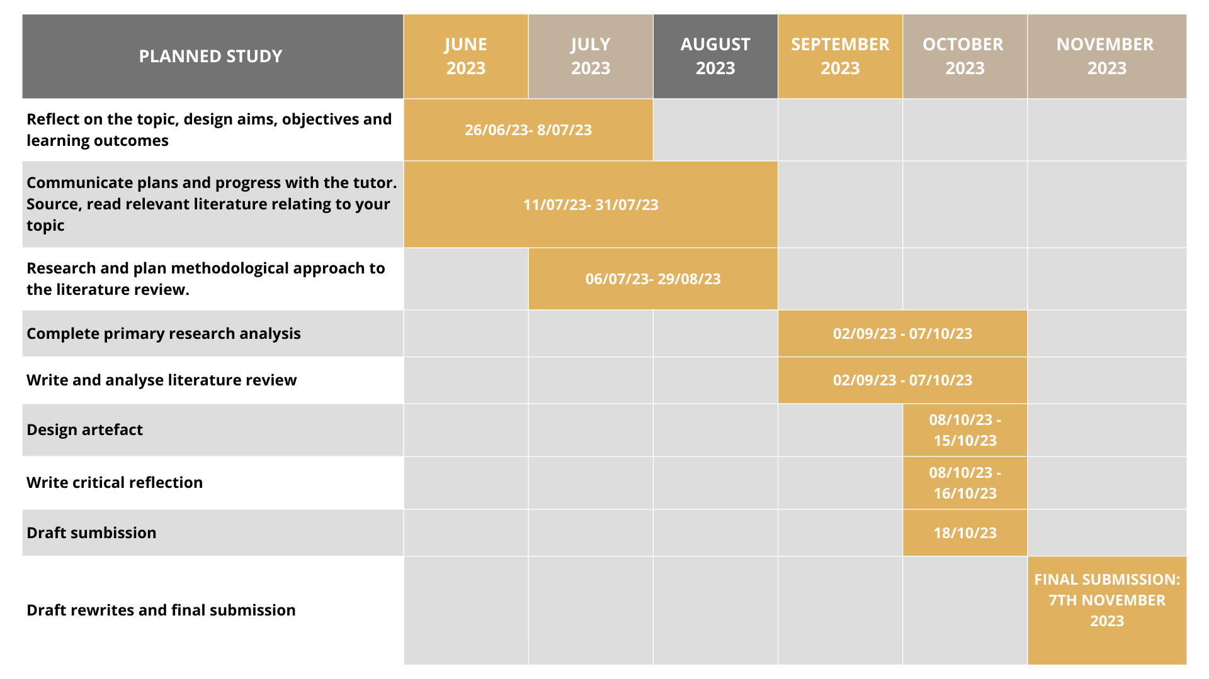

Ethical Considerations in Artefact Design

Vocal Health and Safety
An ethical approach must be followed when designing a vocal artefact for use in the studio, mainly when the artefact is created on evidence-based research (Given, 2008). Although derived from theoretical studies, a research artefact of this type will directly affect practitioners, highlighting the importance of responsible development (Given, 2008). Vocal health and safety are the cornerstones of this approach, and consequently, every exercise recommendation is supported by a deep understanding of vocal anatomy and physiology (Lovertri, 2002; Robinson-Martin, 2016).

Authentic Representation
Researchers have an ethical responsibility to advocate exercises that enhance the voice's capacity without causing undue strain or potential harm (Given, 2008). Equally vital is the researcher's commitment to authentic representation (Robinson-Martin, 2016). This commitment to authentic representation is essential because it ensures that the vocal techniques and exercises promoted are culturally sensitive and respect the integrity of the gospel genre. It prevents the appropriation or misrepresentation of gospel melisma, preserving its cultural and artistic significance in contemporary voice studios (Robinson-Martin, 2016). It is crucial that exercises, especially those rooted in specific cultural or genre conventions, are depicted authentically to avoid any appearance of cultural appropriation (Boyer, 1995).

Mitigating Confirmation Bias
The methodical approach helps mitigate the potential pitfalls of confirmation bias, as identified by Given (2008), in which researchers may solely consider supporting data. By adopting a systematic and thorough approach, this study aims to avoid such bias and instead provide a balanced and holistic examination of the subject matter, encompassing diverse perspectives and evidence, thus ensuring a comprehensive and well-rounded piece of work.

Transparency and Disclosure
Throughout the artefact, transparency is kept at the forefront, revealing the origins of any vocal exercises and crediting inspirations and sources. In addition, researchers should disclose any potential affiliations, ensuring users are aware of any factors that may have influenced adapted vocal exercise within this assignment.

Continuous Ethical Evolution
As Given (2008) suggests, ethical research practice is not static; instead, it evolves with experience. As researchers encounter various ethical dilemmas and challenges, it demands thoughtful consideration and adaptation. With each research project and ethical decision made, researchers refine their ethical compass, becoming more adept at navigating the complex terrain of research ethics. As a final point, the dynamic nature of vocal science necessitates the commitment of researchers to stay current. Staying current is advised because the field of vocal science continually evolves with discoveries and advancements (Smith, 2019). By keeping abreast of the latest research findings and technological developments, researchers can ensure that research remains relevant, accurate, and aligned with the most recent insights. As a result, each step in the design of a vocal artefact has been guided (see Appendix 2 for ethical considerations).

Continuous Ethical Evolution
As Given (2008) suggests, ethical practice in research isn't static; instead, it evolves with experience. As researchers gain more experience, they encounter various ethical dilemmas and challenges that demand thoughtful consideration and adaptation. With each research project and ethical decision made, researchers refine their ethical compass, becoming more adept at navigating the complex terrain of research ethics. As a final point, the dynamic nature of vocal science necessitates the commitment of researchers to stay current. Staying current is advise because the field of vocal science continually evolves with new discoveries and advancements (Smith, 2019). By keeping abreast of the latest research findings and technological developments, researchers can ensure that research remains relevant, accurate, and aligned with the most recent insights.

As a result, each step in the design of a vocal artefact has been guided (see appendix 2 for ethical consideration).

Critical Reflection

Reflective practice is an essential tool for educators and practitioners in vocal pedagogy, offering a profound pathway toward personal and professional growth (Moon, 2006; Bolton, 2010). Shon (1987) aptly captures the essence of reflective practice when he states that reflective practice involves looking back, analysing experiences, and using that understanding to guide future action (Moon, 2006). In creating vocal exercises for gospel melisma in a studio setting, reflective practices are crucial. They ensure ethical alignment, exercise quality, adaptation, user-centred design, and ongoing improvement in the design process.

Kolb's Experiential Learning Theory (Kolb, 1984) guided the development of gospel melismatic singing exercises because it offers a structured framework for integrating concrete experiences, reflective observations, abstract conceptualisation, and active experimentation, facilitating a well-rounded and effective learning process.

Throughout practising and refining vocal exercises, knowledge evolves through experience, reflection, and adaptation (Kolb, 1984). Based on Kolb's theories, learning can be viewed as a cyclical process involving four key phases: i) Experience, ii) reflection, iii) abstract conceptualisation, iv) and active experimentation (Kolb, 1984). When researching this project, I quickly realised that I was dealing with a module unlike any other I had encountered before, characterised by lengthy and demanding prerequisites for creating an artefact. The lack of scholarly research in this field is the most challenging aspect of my research journey. Addressing the dearth of existing literature and the significance of this research for future inquiries requires a proactive approach. While acknowledging the challenge, researchers can engage with related literature, even from adjacent fields, to draw connections, identify gaps, and propose innovative research directions (Smith, 2019).
Additionally, collaborating with experts in the field and seeking interdisciplinary perspectives can enrich the study and bridge the knowledge gap. By actively participating in scholarly discussions and conferences, researchers can contribute to the evolution of the field and foster collaboration, advancing the research study. This presented a unique dilemma for this study, as it highlighted the importance of this research for future inquiries while simultaneously presenting a challenge due to the need for more existing literature.

Concrete Experience: As my research targeted Gospel melisma, which incorporated several specific techniques such as riffs, runs, passing notes, bends, turns and tails, I was acutely aware of the lack of literature that would support my research. Balancing the limited resources of academic "white" literature with the vast but often unstructured "grey" literature available presented a unique set of challenges (Baker et al., 2002). To navigate this intricate landscape, I divided my research into two sections: the first examined "how we do it," focusing on the underlying function of the voice, while the second examined "what we do," involving exercises designed to help students comprehend this functionality better. However, as I progressed in my research, I realised that the term "melisma" was far-reaching and all-encompassing for this genre. The realisation that existing literature was limited prompted a significant refinement in my research question, making it more specific and practical. This change in approach was driven by the need to address the knowledge gap effectively. It is not uncommon for researchers to encounter such shifts during the investigation. When faced with these changes, researchers typically engage more deeply with the available literature, seeking alternative perspectives and methodological approaches to adapt their research direction and ensure its relevance (Smith, 2019). This process of evolving research questions and methodologies signifies personal growth as a researcher, demonstrating adaptability and resilience in facing challenges.

Reflective Observation: This research has deepened my appreciation for the profound impact of gospel singing, revealing its immersive influence and a bridge to diverse musical practices. As I delved into the traditions of melisma, I found a new appreciation for how the art of melisma transcends multiple genres, allowing for intriguing comparisons. I drew inspiration from the intricate subtleties of Gregorian chant (Crocker, 1995; Kelly, 2011) and the nuanced rhythms of classical Indian singing (Lavezzoli, 2006; Kuiper, 2011). These traditions illuminated the intricate web of musical practices, underscoring their significance and highlighting their interconnectedness with various musical traditions. Aside from historical and cultural revelations, my aspirations are consistently directed toward a tangible, well-researched result for my vocal studio by curating a pedagogical collection that serves the development of gospel melisma teaching techniques for vocal educators, students and choirs.

Abstract conceptualisation:

As a result of my research into vocal pedagogy, I became aware of the limitations of traditional techniques, especially those influenced by schools such as Bel Canto, which were once considered universally adaptable across various musical genres (Blades-Zeller, 2002; Miller, 1996). LoVetri (2002) advocates for genre-specific CCM vocal pedagogy in Western European classical genres because it acknowledges that each genre has unique vocal techniques and styles. This approach, supported by Bjorkner et al. (2006) and Cleveland et al. (2003), aims to support singers to develop the necessary skills and versatility to excel in their chosen musical style. For classical singing, distinct vocal parameters, such as vibrato and resonance, set the benchmark (Ekholm, Papagiannis, & Chagnon, 1998). In contrast, gospel vocal pedagogy, still emerging academically, hints at distinct parameters drawn from existing research on its cultural aesthetics and styles (Arthur, 2004; Boyer, 1978; 1979; 1988). This synthesis underscores the necessity for tailored pedagogical approaches for CCM, emphasising research's role in shaping vocal teaching methods.

Active Experimentation: After gaining insights from research on vocal pedagogy, I moved from theoretical to practical application. An artefact was created by synthesising themes found in the research with innovative ideas during this transformational phase. This milestone was more than just an assignment; it signifies a professional growth moment, promising to elevate gospel vocal instruction in my studio.

PART TWO: WRITTEN ASSIGNMENT

Introduction

'A virtuosic singer in the gospel style is one whose musical choices have the ability to tap into, and give meaning to, collective emotion, and induce an audience to a collective joy or sorrow, awe or celebration' (Wald, 2003)

The human voice, a unique and intricate musical entity, offers depth and versatility distinct from conventional instruments (Frith, 1996). All musical instruments, including the voice, have three components to sound production: the actuator or power source (respiratory system), the vibrator (vocal folds), and the resonator (vocal tract) (Doscher, 1994; McCoy, 2004). In Contemporary Commercial Music (CCM), melisma is a distinctive stylistic device requiring singers to express numerous pitches within a solitary syllable (Legg & Philpot, 2015; Youssef, 2022).

Virtuosic levels of melismatic singing became popular in the 1980s and are still commonly found in contemporary gospel artists like Karen Clark-Sheard, Daryl Coley, Vanessa Bell Armstrong, Smokie Norful, Kim Burrell, and Yolanda Adams, to name a few who are popular today (Sellers, 2009). Gospel music's distinctive qualities are often overlooked within CCM. The disparity may be attributed to the genre's diverse subgenres and stylistic subtypes. This diversity sometimes results in the oversight of unique vocal techniques within the broader academic discourse surrounding CCM (LoVetri, 2002; LoVetri & Weekly, 2013). Additionally, the need for more researchers focused on individual genres within CCM further exacerbates the challenge of giving these styles the attention they deserve. This lack of consideration contributes to the dearth of research on the gospel's distinctive stylistic contributions and historical significance within CCM (Jordan, 2021).

Rationale

In this study, scholarly inquiry is combined with hands-on application to explore the tradition of gospel melisma thoroughly. The purpose of this study is to provide a deeper understanding of this complex stylistic technique through an analysis of its auditory characteristics, which builds on a previous study of the key components of gospel sound (Austin, 2013). This study was motivated by the apparent disconnect between theoretical research and current practice in gospel music - particularly the lack of detailed, systematic studies examining the technical aspects and cultural context of gospel melisma. This research will not only address these gaps but also provide singers and music educators with practical, research-based strategies and exercises. One of the primary outcomes of this research will be an educational vocal artefact demonstrating a dedication to providing valuable, practical outcomes from scholarly research. As a practical resource, this artefact will allow vocalists to practice and refine melismatic techniques, which I will employ in my voice studio.

In this study, the following research question is raised: How can existing literature and primary research inform contemporary teaching techniques for gospel melisma? This study will discuss the implications of the findings, which will contribute to the design of the artefact and suggest avenues for future research.

Research Methodology

This research examines the complex intricacies of gospel melisma, ensuring that the methodology complies with well-established ontological and epistemological principles. This study is based on two philosophical principles. (i) The research adopts a constructionist ontology inspired by Barbour (2014), who posits that individual perceptions shape multiple realities. This perspective is ideal for exploring gospel melisma's rich and varied personal experiences. (ii) The epistemological framework is deliberately flexible, seeking to understand the breadth of knowledge, content, and processes involved in its creation. This approach echoes Lincoln and Guba's (1994) emphasis on establishing a clear philosophical stance to bolster research validity. In this research, a pragmatic paradigm is used, as proposed by Morgan (2014), which focuses on practical solutions and the applicability of findings in the real world. This approach, not bound by any single philosophical system, allows for diverse methods and techniques (Ninino, 2018). In this context, the constructionist ontology and adaptable epistemology are congruent with the pragmatic goal of generating actionable knowledge about gospel melisma. The research, therefore, approaches knowledge as both constructed and contingent upon individual and community experiences.

Methods

This study conducts a thematic auditory analysis of gospel melisma, systematically examining a selection of gospel songs across eras to highlight vocal nuances and melismatic techniques. The analysis requires meticulous listening to discern style variations, execution, and context. Complementing this analysis is an integrative literature review, which amalgamates 'white' and 'grey' literature, including scholarly articles and historical narratives to deepen understanding of gospel melisma's evolution as an educational tool and cultural expression. This review seeks to identify research gaps and consolidate knowledge, thereby supporting the practical insights gained from auditory analyses. To translate theoretical research into practice, the study will develop a set of vocal exercises informed by both auditory analysis and literature review findings. These exercises aim to address the essential aspects of gospel melisma, thereby facilitating the transition from academic theory to practical application in contemporary gospel music training. In addition, the literature review will guide the analysis of the research findings by categorising them based on academic discussions of gospel melisma. Integrating historical and contemporary perspectives into the auditory analysis will enhance data interpretation. Through cross-referencing thematic elements identified in the literature with the auditory research, the study ensures the validation of these themes, marrying scholarly views with practical application in gospel melisma.

Theoretical context
This study is grounded in a multidisciplinary examination of gospel music within CCM pedagogy. This study acknowledges that gospel music, a genre rich in improvisational and emotional nuances, lacks standardised educational approaches (Bartlett & Naismith, 2020). The framework incorporates insights from musicology and ethnomusicology to map the historical development and cultural significance of gospel music, advocating a teaching methodology that is culturally sensitive and reflects the genre's sociocultural origins (Bowen, 1996; Legg & Philpot, 2015). The framework also recognises the importance of performance practice theory (Bowen, 1996), including the interpretive skills needed to deliver Gospel music authentically. Pedagogical strategies are effective, objective-driven, and provide clear learning outcomes when backed by educational theory (LoVetri, 2002; Van den Akker et al., 2006). This comprehensive approach not only respects the complexity of gospel music but also aims to enrich CCM pedagogy with rigorous, well-rounded instructional strategies.

Literature Review

This literature review is divided into four sections, collectively elucidating the multifaceted aspects of gospel melisma: (1) it defines the scope of melisma within gospel music, (2) a detailed thematic auditory analysis, (3) explores the physiological principles underpinning melismatic singing in gospel tradition and (4) nurturing improvisation for gospel melisma.

Scope Of Melisma Within Gospel Music

According to Chandler's (2014) explanation, melisma serves as an umbrella term encompassing various techniques, such as licks, while runs are considered extensions of improvisational vocal dynamics. Gospel melisma is distinct for its technical and expressive range. It is worth noting that melisma has a long history dating back to medieval European music (Legg & Phillpott, 2015; Crocker, 2017). Melisma in gospel is strongly influenced by terms such as "runs" "lick" and "riff', which are emblematic of rock, pop, and soul music (Tagg, 2003; Galettis, 2009; Kayes, 2015). By incorporating seminal work by Boyer (1995) on melodic interpolation) his delineation of "passing neighbour notes," "bends," "turns," and "tails" offers a practical guide for gospel singers. A distinction should be drawn between a 'melismatic run' and a 'melismatic riff' to highlight the need for precision in both study and performance. While both share a common bond with melisma, they differ in their execution. Melismatic runs are extended, improvisational sequences allowing singers to express themselves freely and passionately.
In contrast, melismatic riffs are structured, repetitive vocal patterns that contribute to the unity and rhythmic vitality of gospel choirs (Chandler, 2014; Youssef, 2022; Robinson-Martin, 2016). Both techniques are essential in understanding the vocal tradition of gospel, with melismatic runs enabling individual expression and emotional depth. In contrast, melismatic riffs create collective energy and spirit within the genre (Robinson-Martin, 2016). Given the scope and focus of this study within the artefact, the vocal exercises will be presented in the form of melismatic passages characterised by "runs" and "riffs."

Analysis Of Gospel Melisma

This study conducts a thematic auditory analysis, recognised by Braun & Clarke (2006) for its precision, to explore melismatic techniques in gospel music. By analysing twenty gospel songs, it examines nuances in vocal performance—melisma complexity, agility, breath control, and vowel use—from historical to modern styles.

Adopting and modifying Robinson-Martin's (2016) framework for analysing scat singing verses vocal runs allows for a tailored investigation into gospel melisma's development. (Refer to Appendix 4 for the Thematic analysis) The subsequent sections synthesise these insights, offering a concise yet comprehensive view of melisma's role in shaping vocal technique and style in gospel music's evolving landscape.

The dynamism of gospel music is epitomised by its signature melismatic singing, a style that has evolved considerably over time. This research embarked on a thematic auditory analysis to unravel the progression of melismatic techniques in gospel music.

The study analysed 20 gospel songs, carefully chosen based on several papers that stated iconic artists throughout the history of gospel music (Legg, 2010; Sellers, 2009; Jordan, 2021) to represent both traditional and contemporary sub-genres. The auditory analysis involved listening attentively to each track identifying, and cataloguing the melismatic techniques utilised. These techniques were coded for breath management, vocal agility, variety, registration, improvisation, and use of vowels. The coding methodology focused on distilling the key elements of each performance, particularly the nuanced employment of melismatic vocalisation within the context of the selected songs.

Findings

Theme 1: Research revealed various melismatic tools gospel singers utilise, including riffs, runs, turns, bends, and tails. Often, these elements are cleverly layered within a single vocal phrase, requiring a solid understanding of scales and chord structures.

Theme 2: The ability to control breath and navigate between vocal registers is essential to achieving compelling melodic passages.

Theme 3: The selection of vowels within the melismatic phrases was influenced by the relevance of the lyrics. It was evident that melismatic phrases were sung with many vowels ending in /o/ and /e/. Diphthongs add sophistication and emotional depth.

Theme 4: Singers often create distinctive sounds using thick and thin vocal folds to express emotion and spiritual messages.

Theme 5: Gospel singers displayed impressive versatility in their use of vocal folds, contributing to the distinctive sonic quality of the genre.

Theme 6: Melismatic practices have evolved in a clear evolutionary trend, with earlier styles characterised by dense, emotive expressions, in contrast to modern gospel's more refined styles, which emphasise clarity and precision.

Theme 7: The ability to improvise was essential to artists' creative expression, enhancing their performances with personal flair and enhancing their emotional impact. The live performance of 'Calvary' by Richard Smallwood included three female soloists who used improvisation during the melismatic phrases to convey their interpretation.

Theme 8: It was noted that some artists adeptly combined multiple techniques—such as riffs with bends or runs with turns—to create complex melismatic sequences.

The thematic analysis reveals that melisma in gospel music is a dynamic technique that serves as a vessel for deep emotional expression and a platform for technical mastery. As revealed by the study, there is a discernible evolution in the practice of melisma, shifting from the raw, emotion-laden performances of the traditional era to the precise, improvisation-infused executions of modern gospel music. This progression signifies a continual expansion of vocal possibilities within the genre. By adopting the nuanced techniques of melisma into their practice, gospel vocalists can not only enhance their expressive capabilities but also partake in the ongoing evolution of the style. These findings highlight the potential of melismatic singing to constantly revitalise the gospel music experience, pushing the boundaries of vocal performance and fostering innovative approaches to conveying the genre's spiritual and emotional essence.

There are limitations to this analysis of melisma in gospel music. The song selection may not accurately represent the genre, and subjective interpretation may affect the ability to identify themes. The historical coverage is limited, focusing primarily on contrasting past and present without providing any details regarding the evolution in between. A singer's cultural background, as well as personal influences on melisma, should be taken into consideration. In addition, the influence of live performance atmospheres on melismatic techniques needs to be considered, and the lack of technological tools for precise measurement is a technical shortcoming. These factors indicate that a more comprehensive approach is needed to understand melisma's complexity in gospel music.

Respiration: Breath Management

Voice production is powered by the respiratory system (Miller, 1996). To achieve efficiency in singing, every system of the voice must be coordinated and balanced; however, breath management requires balancing the inspiratory and respiratory muscles dynamically (LeBorgne & Rosenberg, 2014; Chandler, 2014). The coordination of the muscles to control subglottal air pressure and airflow is essential for proper technique (Ragan, 2020). Breath support facilitates the regulation of air pressure beneath the vocal folds during exhalation (McCoy, 2004), while breath control governs how air is expelled (McCoy, 2004). The rate at which air is used and passes through the vocal folds is directly influenced by the interaction between breath support, laryngeal positioning, and vocal fold closure (LeBorgne & Rosenberg, 2014). The commonly recommended approach to breath management, particularly emphasising support, aligns with the "Appoggio" technique. Derived from the Italian verb "appoggiare," which signifies leaning, supporting, and sustaining, this technique promotes inhalation through diaphragmatic contraction and external intercostal relaxation (McCoy, 2004). Exhalation, in turn, is controlled through the antagonistic interaction between the diaphragm and coordinated actions of the abdominal muscles and external intercostals (McCoy, 2004). (See Appendix 5 for breath management exercises).

Considerations for breath and movement in gospel singing

Gospel singing use of movements and gestures contributes significantly to dynamic and expressive performances (Robinson-Martin, 2016)). Recent research by Ravignani and Kotz (2020) explores the relationship between breath, voice, and synchronised movement. This research shows that when individuals vocalise in harmony with rhythmic arm movements, vocalisation naturally synchronises with these movements. In turn, listeners instinctively align their movements with the vocaliser's actions. To maximise the emotional and dynamic impact of gospel music, singers must skilfully control their breath while seamlessly integrating movements, ensuring that their physical gestures harmonise with their vocal delivery. This synchronisation fosters a powerful and evocative performance that resonates deeply with the audience.

Artefact Exercise: Breath Management for Long Phrases

Aim: This helps singers improve their breath control and stamina when singing long phrases, precisely a 9-note sequence on an /o/ vowel. This encourages the use of intercostal muscles to maintain steady breath support and control throughout a prolonged melodic phrase. (Refer to Appendix 6,7 for the vocal artefact) For example, here is an exercise for sustaining a phrase. Taken from a YouTube clip of the Elevation Choir (2023).
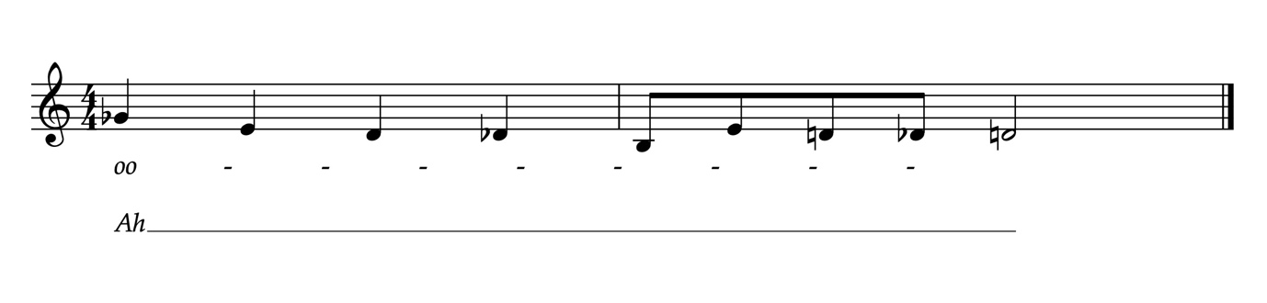
Figure 1: Phrasing exercise for sustaining breath management

Vocal Agility

Miller (1996) defines vocal agility as the innate capacity to navigate pitch transitions, reinforcing the role in vocal performance. Pitch and tonal variations, fundamental to vocal expression, are governed by the thickness and length of the vocal folds (Harrison and O'Bryan, 2014). This balance of vocal fold configuration is, in turn, controlled by the thyroarytenoid (TA) and cricothyroid (CT) muscles. When the TA muscles contract, they usher in relaxation within the vocal folds, endowing them with thickness—a hallmark of the chest voice. Conversely, the CT muscles, through stretching and thinning, yield a lighter, ethereal head voice (Davids & LaTour, 2012).

These muscular counterparts, acting in synergy, swiftly adapt the length and thickness of vocal cords according to the pitch range demanded, equipping gospel singers with the requisite precision and dexterity to execute melismatic runs gracefully. It is pertinent to acknowledge, however, that the level of adaptability varies among individual singers due to inherent physiological disparities (Davids & LaTour, 2012).

Melismatic runs often draw inspiration from scales like the major and minor pentatonic, blues scales and mixolydian scales, thereby underscoring the significance of regular scale practice for gospel vocalists (Refer to Appendix 8 for a compilation of the prevalent scales). The flexibility of vocal expression enables singers to traverse the intricacies of stylistic nuances such as melismas, glissandos and bends with finesse (Harrison and O'Bryan, 2014; Miller, 1996). Thin-fold voice types, in general, exhibit greater agility compared to their counterparts with thicker vocal folds. Consequently, vocal agility can be cultivated by incorporating exercises that utilise a thin vocal mechanism—emphasising head voice, falsetto, or a thin/thick fold/chest and mixed voice. Exercises that span ascending and descending pentatonic scales and facilitate seamless transitions between different vocal registers also contribute significantly to developing vocal agility (Robinson-Martin, 2010).

As an example, this style of conditioning exercise focuses on agility development and draws inspiration from pentatonic scales. as outlined in Robinson-Martin's (2016) work.

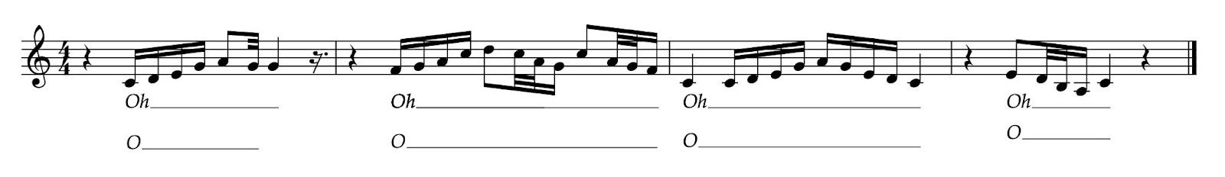

Figure 2: Style conditioning exercise - Pentatonic Scale. Taken Robinson-Martin's (2016).

The primary research highlighted that traditional gospel compositions often feature melismas with a subtler and less pronounced intonation. This is an intentional effort to preserve the spiritual and emotive essence of the music, emphasising the raw, heartfelt expression over technical precision. In contrast, contemporary gospel singers present melismatic runs characterised by greater precision, clarity, and a remarkably crisp execution.

These observations show the evolving stylistic preferences that define gospel melisma. The singers in traditional gospel, such as those featured in Richard Smallwood's "Calvary," place a strong emphasis on expressiveness and dynamism in their approach to melisma. Their melodic embellishments are delivered with an intense emotional fervour, often characterised by dramatic fluctuations in pitch and intensity. However, there were noticeable similarities of riffs and runs in all eras over a pentatonic scale.

On the other hand, modern gospel music, exemplified by artists like Kierra Sheard, places significance on accuracy and clean execution of riffs or runs.

The runs and riffs in contemporary gospel music are executed with careful attention to pitch, timing, and articulation, resulting in a polished and refined sound. This evolution is not a departure from the roots of gospel music but rather an expansion of its expressive palette. It demonstrates how gospel artists have adapted and refined their melismatic techniques, catering to evolving tastes and expectations within the genre. In essence, the research findings underscore the dynamic nature of gospel music and its enduring ability to evolve while staying true to its emotive and spiritual core.

In response to this, I have created a few vocal exercises. This stylistic conditioning exercise integrates elements of melodic "woahs" and intricate vocal "riffs" to empower singers in conveying emotion through dynamic vocal expression on a "yeah" and "woah" while refining their vocal agility. (Refer to the appendix 8 for the Vocal Artefact)

Registration

Vocal registration is central to voice studies and is necessary for producing various pitch tones by engaging specific muscular actions within the vocal structure (Harrison & O'Bryan, 2014).
Though the terminology around vocal registration is debated, experts generally agree on two main registers: thick fold/ chest and thin fold/head voice or falsetto (McCoy, 2004; LeBorgne & Rosenberg, 2014). The most prominent vocal quality found in gospel singing is a thick fold, chest or chest-dominant, speech-like quality (Robinson-Martin, 2016). This directly correlates to the black theological preaching styles in which the preacher would sing-speak their sermon, particularly during the climactic portion (Wise, 2002; Robinson-Martin, 2016). Therefore, in gospel singing, having a developed and strengthened chest register is imperative for efficient singing. Changes in vocal quality and registration are also tools of interpretation related to the melisma; purposeful changes are often used as interpretive choices by the singer. Gospel singers will sometimes employ other vocal registrations (Sellers, 2009). These include but are not limited to, thin fold, chest mix (i.e., an unpressured, light spoken quality), pure head/falsetto voice (i.e., the sound of an owl), and brassy head/falsetto mix (Robinson-Martin, 2016). The vocal quality used is often directly related to the emotional perspective of the song. According to Robinson-Martin (2016), when developing registration, there are four aspects of development to consider: (1) the identification of each register. For example, this exercise is taken from (Robinson-Martins, 2016) to identify chest register.

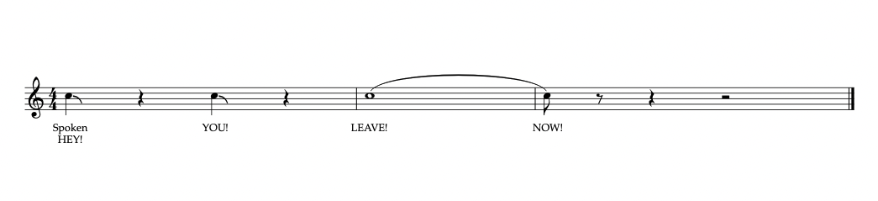
register using spoken voice and then sung. (2) the strengthening of each register; (3) the extension of each register; and (4) the combining of vocal registers (See appendix 9)
Figure 3: Taken from Robinson-Martin (2016), So you want to sing gospel?

The primary research findings on vocal registration indicate that most melismatic movements involve a combination of chest mix and belt voice. I have developed two vocal exercises to facilitate the transition between vocal registers while integrating lyrical content into a melismatic riff. The second exercise focuses on flipping between vocal registrations, transitioning from thick fold or chest voice to thin fold or head voice (Ragan, 2020; Robinson-Martin, 2016). This exercise aims to cultivate versatility in a singer's vocal range and tonal quality. (Refer to Appendix 9 for the vocal artefact)

Nurturing improvisation for gospel melisma

Improvisation in gospel melisma combines technique and creative expression (David & Latour, 2012). Melodic modifications range from subtle changes, like adding 'passing notes', to more comprehensive alterations, introducing multiple new notes or refining an existing melody (Boyer, 1996). The key to these melodic alterations is not just the introduction of new notes but the strategic placement and the emotions they convey (Robinson-Martin, 2016).
The effectiveness of these techniques often relies on mimicking the natural intonations found in speech, allowing music to emulate human emotions (Boyer, 1996). Rhythmic improvisation in gospel emphasises the feel of the rhythm more than the strict beat count. By referencing natural speech patterns, vocalists can incorporate realistic rhythm variations into their music (Robinson-Martin, 2010). For a deeper exploration into rhythmic improvisation and phrasing, students can be guided to craft a brief set of lyrics aligned with specific rhythmic patterns spanning 5 or 6 notes. (See Appendix 10)

Effective instruction requires educators to engage with the singer's personal narratives and beliefs, guiding them to explore gospel themes and draw inspiration from scripture and personal experiences. Firstly, it is essential to build a foundational understanding of scales and harmony. This can be achieved by aural skills and developing harmonic sensitivity. Secondly, vocal warm-ups should incorporate both melodic and rhythmic improvisation exercises.

As a part of my vocal artefact, I have incorporated a few exercises on the scales used in gospel music over a major and minor pentatonic scale, a blues scale and a Mixolydian scale, which was a common theme in the thematic analysis (Refer to appendix 9 for notated scales).

While this study does not primarily focus on textual interpolations like ad-libbing, the thematic analysis does highlight the relationship between textual improvisation and how melismas often append or blend with the conclusion of a textual phrase. Boyer (1979) defines textual interpolations as the infusion of additional words into a phrase. An illustrative example would be expanding "Lord, I am tired" to "Lord, (you know) I am (so) tired."

Gospel music is learned predominantly in church and is an oral tradition (Jordan, 2021). Emulation is essential during the nascent phases of melismatic learning, guiding students to dissect and assimilate the intricate facets of melismatic technique. For example, the excerpt from "Still I Say Thank You" was performed by Smokie Norfuls.
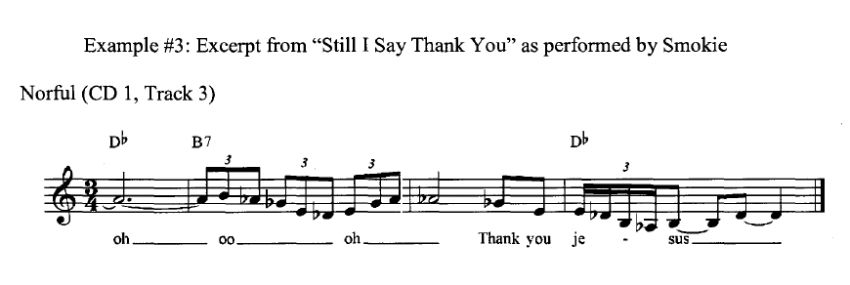
Figure 4: This excerpt provides students with a case to apply melismatic techniques in context. taken from (Robins-Martin, 2010).

As students solidify their foundational skills, emphasis on personalisation becomes increasingly essential. This aspect encourages students to create unique melismatic patterns that reflect personal and spiritual journeys, adding depth and individuality to interpretations (Legg, 2010; Legg & Philphott, 2017).

A vocal performance can be enhanced significantly by adding embellishments such as "runs" and "tails." however, these embellishments also present unique challenges due to their reliance on vocal flexibility, rhythmic precision, and a grasp of harmonic intricacies (Legg & Philpott, 2015).

In constructing a vocal artefact, instructors must have a comprehensive understanding of stylistic tools such as runs, tails, bends, and riffs. This knowledge not only underpins effective teaching but also ensures that educators can adapt their methods to the unique needs of each student. Moreover, having access to various tools allows instructors to address different vocal challenges, ensuring holistic development in their students. (Please refer to the appendix 11 for stylistic tools).

Discussion

The research study attempts to explore and dissect the varied and complex components of gospel melisma. During this independent study, several key elements of gospel melisma, such as riffs, runs, turns, bends, and passing notes, have been highlighted. These elements, as discussed by scholars (Boyer, 1996; Legg & Philphott, 2015) and (Robinson-Martin, 2010; 2016), form the foundational building blocks for the performance and execution of gospel melisma. One of the crucial observations gathered from this research is the discernible gap in existing academic discussion focusing specifically on gospel melisma. To bridge this gap, the research not only leveraged existing literature but also capitalised on primary research and adopted an interdisciplinary approach. Expanding on the theories proposed by (Legg, 2010; Barker et al., 2002; Pistrang & Barker, 2012; Wasbotten, 2022), the study establishes the pressing need for adopting and adapting innovative pedagogical methods to teach gospel melisma.

The purpose of this inquiry has been to examine the facets of gospel melisma and how it can be used to enhance the skills of vocalists. Practically, the design and creation of the vocal artefact demonstrate the need for exercises tailored to gospel melisma. The themes discussed in the findings support existing literature on the role of breath management and nuanced vowel usage in executing melismatic sequences (Themes 2 and 3), suggests that these should be central to vocalists' practice routines. Additionally, manipulating vocal fold thickness (Theme 4) conveys deeper emotional content, highlighting the importance of mastering vocal texture for compelling performances. (Themes 7 and 8) suggests integrating gospel melisma into modern vocal practice, honouring the gospel's rich heritage while promoting stylistic versatility. This integration encourages a holistic and adaptable approach to singing, ensuring technical proficiency and emotional depth.

Limitations
The study's insights are drawn from a limited set of exercises, potentially overlooking the full spectrum of gospel melisma techniques. The absence of participant input also means the research lacks empirical data from vocalists, which could impact the practical applicability of the findings. Cultural specificity is another limitation, as the pedagogical approaches may not translate across different musical traditions without adaptation. These limitations highlight areas for future research to deepen the understanding of gospel melisma's pedagogy.

Recommendations:
· Future studies could undertake a comparative analysis with melismatic techniques in other musical genres to reveal shared characteristics and distinctive practices.
· A longitudinal study could trace how vocalists develop melismatic skills over time, offering insights into long-term practice strategies.
· A diverse range of songs and performances should be analysed to solidify the research findings.
· Research that captures personal experiences from vocalists regarding their journey with gospel melisma could add depth to the understanding of its impact on vocal identity and technique.

Conclusion

The study revealed the intricate nature of gospel melisma and the urgent need for targeted teaching methods (Youssef, 2022). A thorough review of relevant literature and auditory analysis was conducted to design targeted vocal exercises addressing the identified educational gaps (Bartlett & Naismith, 2020). The study emphasised the role of breath management, vocal agility, vocal registration, and improvisation in mastering melismatic singing. The reliance on a limited set of exercises and lack of extensive empirical vocal data may constrain its more comprehensive application; nonetheless, it provides a valuable foundation for a deeper appreciation of gospel melisma within its cultural context. Future research is encouraged to build on these insights by examining melismatic techniques across different musical genres and tracing the development of these skills in vocalists over time. This study's fusion of gospel tradition with contemporary vocal practice not only advances scholarly dialogue but also offers practical guidance, enhancing vocalists' capacity to tell compelling stories through their performances.

References

Andraé Crouch-The Blood Will Never Lose Its Power (no date) www.youtube.com. Available at: https://youtu.be/eaASM4KZVzU?si=1apqcJcorwXOi7M0.

Arthur, S.K. (2004) ‘“Sound of Praise”: Reflexive Ethnopedagogy and Two Gospel Choirs in Tallahassee, Florida’, diginole.lib.fsu.edu [Preprint]. Available at: https://diginole.lib.fsu.edu/islandora/object/fsu:168076.

Austin, L.M.J. (2023) ‘Investigating the Gospel Sound: Pedagogical Approaches for Teaching Gospel Singers in the Applied Voice Studio’.

Barker, C., Pistrang, N., & Elliott, R. (eds.) (2002) Research methods in clinical psychology: An introduction for students and practitioners (2nd ed.). Chichester, England: Wiley. doi:10.1002/0470013435

Barbour, R.S. (2013) ‘Introducing Qualitative Research : A Student’s Guide’, Introducing Qualitative Research, pp. 1–392. Available at: https://www.torrossa.com/en/resources/an/5017513.

Bartlett, I. (2014) ‘Reflections on contemporary commercial singing: an insider’s perspective’, Voice and Speech Review, 8(1), pp. 27–35. Available at: https://doi.org/10.1080/23268263.2013.829711.

Bartlett, I. and Naismith, M. (2020) ‘An Investigation of Contemporary Commercial Music (CCM) Voice Pedagogy: A Class of its Own?’, Journal of Singing, 76(3), pp. 273–282. Available at: http://hdl.handle.net/10072/393265.

Benson, E.A. (2018) ‘Modern Voice Pedagogy: Functional Training For All Styles’, American Music Teacher, 67(6), pp. 10–13. Available at: https://www.jstor.org/stable/26502682.

Björkner, E. (2006) Why so different? Aspects of voice characteristics in operatic and musical theatre singing. Available at: https://www.diva-portal.org/smash/get/diva2:11182/FULLTEXT01.pdf).

Blades-Zeller, E. (2002) A spectrum of voices: Prominent American voice teachers discuss the teaching of singing. Oxford, England: Scarecrow.

Bless The Lord (Live) (no date) www.youtube.com. Available at: https://youtu.be/U4eUP674NaE?si=IdIG8vlGEGCTInDI (Accessed: 7 November 2023).
‌
Blessing Of Abraham - Donald Lawrence & the Tri-City Singers (no date) www.youtube.com. Available at: https://youtu.be/iqrMnwz0U7E?si=BhOTYIH66ZCuYrQO (Accessed: 7 November 2023).

‌Bolton, G. (2010) Reflective practice: Writing and professional development. Sage publications.

Bowen, J. (1996) ‘Performance Practice Versus Performance Analysis: Why Should Performers Study Performance’, Performance Practice Review, 9(1). Available at: https://scholarship.claremont.edu/ppr/vol9/iss1/3.

Boyatzis, R.E. (1998) Transforming Qualitative Information: Thematic Analysis and Code Development, Google Books. SAGE. Available at: https://www.google.co.uk/books/edition/Transforming_Qualitative_Information/_rfClWRhIKAC?hl=en&gbpv=0.
‌
Boyer, H. C. (1978) ‘Gospel music’, Music Educators Journal, 64(9), 34-43.

Boyer, H. C. (1979) ‘Contemporary gospel music’, The Black Perspective in Music, 7(1) 5-58.

Boyer, H. C. (1988) ‘Tracking the tradition: New Orleans sacred music’, Black Music Research Journal, 5(1), 135-147.

Boyer, H. C. (1995) How sweet the sound: The golden age of gospel. Washington, DC: Elliott & Clark.

Boyer, H. C. (eds.) (1985) A comparative analysis of traditional and contemporary gospel music. In I. Jackson (Ed.), More than dancing: Essays on Afro-American music and musicians (pp. 127-145). Westport, CT: Greenwood.

Braun, V. and Clarke, V. (2006) ‘Using thematic analysis in psychology’, Qualitative research in psychology, 3(2), pp.77-101.

Burnim, M. (1985) ‘Culture Bearer and Tradition Bearer: An Ethnomusicologist’s Research on Gospel Music’, Ethnomusicology, 29(3), pp. 432–447. Available at: https://doi.org/10.2307/851798.

Can’t Give Up Now (no date) www.youtube.com. Available at: https://youtu.be/rBXbkgLnKCQ?si=hfI-HUiGxFj6aaKw (Accessed: 7 November 2023).

Chandler, K. (eds.) (2014) ‘Teaching popular music styles’, In Teaching singing in the 21st century (Ed.) (pp. 35-52). (Landscapes: the arts, aesthetics, and education, 14).

Cleveland, T., Prokop, J., Stone, R. E., & Sundberg, P. J. (2003) ’Aerodynamic and acoustical measures of speech, operatic, and Broadway vocal styles in a professional female singer’, Journal of Voice, 17(3), 283-297.

Coffin, B. (1989) Historical vocal pedagogy classics. Scarecrow Press.

Crocker, R. L. (1995) Gregorian studies in the twenty-first century. Plainsong and Medieval Music, 4(1), 33-86.

Cusic, Don. (2011) ‘The Development of Gospel Music’, In The Cambridge Companion to Blues and Gospel Music, edited by Allan F. Moore. 44-60. Cambridge: Cambridge University Press. http://dx.doi.org/10.1017/CCOL9780521806350.

Darden, Robert. (2004) People Get Ready!: A New History of Black Gospel Music. NewYork: Continuum Press.

Davids, J. and LaTour, S. (2012) Vocal technique: A guide for conductors, teachers, and singers. Waveland Press.

Dolly Parton - I Will Always Love You (Audio) (no date) www.youtube.com. Available at: https://youtu.be/lKsQR72HY0s?si=GMwGmmgi5YB8Ivu8 (Accessed: 7 November 2023).

Donnie McClurkin Great is Your Mercy (no date) www.youtube.com. Available at: https://youtu.be/SKeTQ1ZHqgA?si=WWdjqzuEMO0SQTOD (Accessed: 7 November 2023).

Doscher, B. (eds.) (1994) The functional unity of the singing voice (2nd ed.). London: Scarecrow.

Ekholm, E., Papagiannis, G., & Chagnon, F. (1998) ‘Relating objective measurements to expert evaluation of vocal quality in Western classical singing: Critical perceptual parameters’, Journal of Voice, 12(2), 182-196.

Eric Arceneaux (2008) ‘Voice training: “riffs, runs, & control – part 1’. [Accessed: 13th October 2023].

Estill, J. (1988) ‘Belting and Classic Voice Quality: Some Physiological Differences’, Medical Problems of Performing Artists, 3(1), pp. 37–43. Available at: https://www.jstor.org/stable/45440649.

Everitt, L. (2012) ‘Whitney Houston and the art of melisma’. BBC, https://www.bbc.com/news/magazine-17039208 [Accessed: 22nd September 2023].

Fleming, R. (2005) The inner voice: The making of a singer. Penguin.

Frith, S. (1996) Performing rites: on the value of popular music. Harvard, Massachusetts: Harvard University Press.

Galettis, H. (2009) ‘Dynamics and expressive techniques. In Musical concepts: Music 1 aural skills preliminary and HSC course’ Queensland, Australia: John Wiley & Sons Australia Ltd, (pp. 47-68).

Garcia, M. (1894) Hints on Singing. New York: E. Schuberth & Co.

Given, L.M. (eds.) (2008) The Sage encyclopedia of qualitative research methods. Sage publications.

Guba, E.G. and Lincoln, Y.S. (1994) Competing Paradigms in Qualitative Research (in N.K. Denzin and Y.S. Lincoln Handbook of Qualitative Research, Thousand Oaks, Sage)

Harper, P.V. (1996) Comparative study of the bel canto teaching styles and their effects on vocal agility. University of North Texas.

Harrison, S.D. and O'Bryan, J. (eds.) (2014) Teaching singing in the 21st century (Vol. 14). Springer Netherlands.

Henderson, L.B. (1979) How to Train Singers: Featuring Illustrated" natural" Techniques and Exercises. Prentice Hall.

Hoch, M. (2019) ‘Historical landmarks in singing voice pedagogy’. Voice and Speech Review, 13(1), pp.43-6.

Holy Ghost (no date) www.youtube.com. Available at: https://youtu.be/IuVoWvIQmug?si=ssAHfwc3t_8gRxyO (Accessed: 7 November 2023).

How I Got Over (no date) www.youtube.com. Available at: https://youtu.be/eKqxzdeUMzE?si=ccnAcLMtqaNUmdXJ (Accessed: 7 November 2023).
‌
Potter. J. (1998) Vocal Authority: Singing Style and Ideology, Cambridge: Cambridge University Press.

Johnson, B. (2019) Jazz Diaspora: Music and Globalisation. Routledge.

Jordan, D.A. (2021) ‘Break Every Chain: Unleashing the Cultural Pedagogy of Black Gospel Singing’. Teachers College, Columbia University.

Justin Stoney. (2021) ‘5 Riffs & Runs Every Singer Needs To Know - Voice Lessons To The World Ep. 120’. https://www.youtube.com/watch?v=YOJTjSm7gvE&t=30s [Accessed: 8th October 2023).

Karen Clark-Sheard"Balm In Gilead!" (no date) www.youtube.com. Available at: https://youtu.be/zW0S1sowcyA?si=wbPybqFerb7rjib6 (Accessed: 7 November 2023).

Kawulich, Barbara. (2012). ‘Selecting a research approach: Paradigm, methodology and methods’.

Kayes, G. (2015) ‘How does genre shape the vocal behaviour of female singers?’ Empirical studies of professional female singing in Western Lyric and Contemporary Commercial Music genres (Doctoral dissertation).

Kelly, T. F. (2011) ‘Poetry for music: the art of the Medieval prosula’, Speculum 86, 361-386. doi: 10.1017/S0038713410004689.

Kirk Franklin - Something About the Name Jesus (no date) www.youtube.com. Available at: https://youtu.be/NxksjhN1Qv4?si=ckRHyek4Ohmw23Vg (Accessed: 7 November 2023).

Kobin, C. and Tyson, E. (2006) ‘Thematic analysis of hip-hop music: Can hip-hop in therapy facilitate empathic connections when working with clients in urban settings?’. The arts in psychotherapy, 33(4), pp.343-356.

Kreiman, J. and Sidtis, D. (2011) Foundations of voice studies: An interdisciplinary approach to voice production and perception. John Wiley & Sons.

Kuiper, K. and Hoopla Digital (2011) The Culture of India. United States: Britannica Digital Learning.
‌
Lawrence, A., Houghton, J., Thomas, J. and Weldon, P. (2014) ‘Where Is the Evidence?’ Realising the Value of Grey Literature for Public Policy & Practice, A Discussion Paper.

Lavezzoli, P. (2006) The Dawn of Indian Music in the West, Google Books. A&C Black. Available at: https://www.google.co.uk/books/edition/The_Dawn_of_Indian_Music_in_the_West/OSZKCXtx-wEC?hl=en&gbpv=1&dq=lavezzoli
‌
Le, C. and Soon, G.Y. (2023) ‘Conceptual Framework of Training Curriculum Development of Stylistic Vocal Performance of Popular Music’, International Journal of Education & Technology, 1(1), pp.20-28.

Leborgne, W.D. and Rosenberg, M.D. (2019) The vocal athlete. Plural Publishing.

Legg, A. (2010) ‘A taxonomy of musical gesture in African American gospel music’, Popular Music, 29(1), 103-129. doi:10.1017/S0261143009990407.

Legg, A. and Philpott, C. (2015) ‘An analysis of performance practices in African American gospel music: rhythm, lyric treatment and structures in improvisation and accompaniment’, Popular music, 34(2), pp.197-225.

LoVetri, J. (2002) ‘Contemporary commercial music: More than one way to use the vocal tract’, Journal of Singing, 58(3), pp.249-252.

LoVetri, J. (2003a) ‘Who's minding the store?’ Journal of Singing, 59(4), 345-346.

LoVetri, J. (2003b) ‘Voice pedagogy: Female chest voice’, Journal of Singing, 60(2), 161-164.

LoVetri, J.L. and Weekly, E.M. (2003) ‘Contemporary commercial music (CCM) survey: Who's teaching what in nonclassical music’. Journal of Voice, 17(2), pp.207-215.

Mahalia Jackson - Take My Hand, Precious Lord (Official Audio) (no date) www.youtube.com. Available at: https://youtu.be/uYUwO6_lysw?si=MvZuVGeO3xyiX9P0 (Accessed: 7 November 2023).
‌
Maultsby, P. (eds.) (1992) The impact of gospel music on the secular music industry. In B. J. Reagan (Ed.), We '11 understand it better by and by: Pioneering African American gospel composers (pp. 19-33) Washington, DC: Smithsonian Institution Press.

McCoy, S. (2004) ‘Your voice: An inside view. Princeton, NJ: Inside View Press’, (2007) A classical pedagogue explores belting. Journal of Voice, 63(5), 545- 549.

Miller, R. (1996) The structure of singing: System and art in vocal technique. Belmont, CA: Wadsworth.

Moon, J.A. (2006) Learning journals: A handbook for reflective practice and professional development. Routledge.

Morgan, D.L. (2014) ‘Pragmatism as a Paradigm for Social Research’, Qualitative Inquiry, 20(8), pp. 1045–1053. Available at: https://doi.org/10.1177/1077800413513733.

Ninio, A. (2018) Pragmatic development. Routledge.

Paul Mckay. (2020) ‘How to Sing Riffs and Runs - Vocal Expert’, https://www.youtube.com/watch?v=CK2VEoC9mPA&t=127s [Accessed: 22nd September 2023].

Peckham, A. (2005) Vocal workouts for the contemporary singer. Hal Leonard Corporation.

Pistrang, N. and Barker, C. (2012) ‘Varieties of qualitative research: A pragmatic approach to selecting methods’ https://psycnet.apa.org/record/2011-23864-001.

Psalm 150 by J moss (no date) www.youtube.com. Available at: https://youtu.be/yVzxY-kQG_A?si=Aj3kU8YPlMjDC9fg (Accessed: 7 November 2023).

Ragan, K. (2020) A systematic approach to voice: The art of studio application. Plural Publishing. Retrieved from https://www.youtube.com/watch?v=CK2VEoC9mPA&t=58s

Ravignani, A. and Kotz, S.A., 2020. ‘Breathing, voice, and synchronized movement’, Proceedings of the National Academy of Sciences, 117(38), pp.23223-23224.

Rev. James Cleveland This Too Will Pass. (no date) www.youtube.com. Available at: https://youtu.be/LaOxvfjonZY?si=3kc89k2RstWgGvJt (Accessed: 7 November 2023).
‌
Richard Smallwood & Vision - Calvary (no date) www.youtube.com. Available at: https://youtu.be/gl7kCi2MUsg?si=FfbAT7qjQ9PLFJMS (Accessed: 7 November 2023).

Riggs, S. (1998) Singing for the Stars: A Complete Program for Training Your Voice, Google Books. Alfred Music Publishing. Available at: https://www.google.co.uk/books/edition/Singing_for_the_Stars/e-pTkjxuP4kC?hl=en&gbpv=1&dq=seth+riggs+&pg=PA1&printsec=frontcover (Accessed: 7 November 2023).

Robinson-Martin, T. (2016) So you want to sing gospel: A guide for performers (Vol. 5). Rowman & Littlefield.

Robinson-Martin, T. (eds.) (2014) ‘Take my hand: Teaching the gospel singer in the applied voice studio’. Teaching singing in the 21st century, pp.335-350.

Robinson-Martin, T.M. (2010) ‘Developing a pedagogy for gospel singing: Understanding the cultural aesthetics and performance components of a vocal performance in gospel music’. Teachers College, Columbia University.

Schön, D.A. (1987) Educating the reflective practitioner: Toward a new design for teaching and learning in the professions. Jossey-Bass.

Schopfel, J. (2010) ‘Towards a Prague definition of grey literature’.

Sellers, C.Y. (2009) ‘I Sing Because I ‘m Free: Developing a Systematic Vocal Pedagogy for the Modern Gospel Singer’ (Doctoral dissertation, The Ohio State University).

Smith, J.M. (2019) ‘The ethics of material provisioning: Insiders’ views of work in the extractive industries’, The Extractive Industries and Society, 6(3), pp. 807–814. Available at: https://doi.org/10.1016/j.exis.2019.05.014.

Soto-Morettini, D. (2014) Popular singing and style. Bloomsbury Publishing.

Sundberg, J. (1993) ‘Breathing behaviour during singing’, The NATS journal, 49,49-51.

Tagg, P. (eds.) (2003) Melisma. In J. Shepherd, D. Horn, D. Laing, P. Oliver & P. Wicke (Eds.), Bloomsbury Encyclopedia of Popular Music of the World: Performance and Production (pp. 564-567). London: Continuum. University Press 2007-2008.

The Clark Sisters"Jesus Is a Love Song!" (no date) www.youtube.com. Available at: https://youtu.be/b3TBVmkVXao?si=jDSUp_DR2xCxPn7t (Accessed: 7 November 2023).

‘This little light of mine’ par Sister Rosetta Tharpe (1960) (no date) www.youtube.com. Available at: https://youtu.be/Qj3fpujjFis?si=XIf7IU5bmaGHgh4V (Accessed: 7 November 2023).

Thomas, D.R. (2003) ‘A general inductive approach for qualitative data analysis’.

Thurman, L., Welch, G., Theimer, A. and Klitzke, C. (2004) October. ‘Addressing vocal register discrepancies: an alternative, science-based theory of register phenomena’, In Proceedings of the 2nd International Conference of The Physiology and Acoustics of Singing, Denver, CO.

Van den Akker, J., Gravemeijer, K., McKenney, S., & Nieveen, N. (eds.) (2006) Educational design research. London: Routledge.

Vennard, W. (1967) Singing: The Mechanism and the Technic. New York: Carl Fischer.

Wald, G. (2003) ‘From spirituals to swing: Sister Rosetta Tharpe and gospel crossover’, American Quarterly, 55(3), pp.387-416.

Wasbotten, L. (2022) ‘Classical to Contemporary: The Evolution of Classically-Driven Vocal Pedagogy in a Contemporary Studio’ (Doctoral dissertation, Arizona State University).

Willie Mae Ford Smith - I’m Bound for Canaan Land (no date) www.youtube.com. Available at: https://youtu.be/ZhSGkFwL77k?si=GRIyiJrKptxs4uS1 (Accessed: 7 November 2023).

Witmer, R. (2017). Lick. Grove Music Online. Retrieved from Oxford Music Online: http://www.oxfordmusiconline.com/subscriber/article/grove/music/49259.

Wise, R. (1997) Vocal training for the gospel singer. Columbus, OH. Raise Publishing.

Wise, R. (2002) Defining African American gospel music by tracing its historical and musical development from 1900 to 2000. The Ohio State University.

Work On Me (no date) www.youtube.com. Available at: https://youtu.be/tEoH8xnc9Zg?si=4gzH-KVt1SQLKRqa (Accessed: 7 November 2023).

Yolanda Adams - The Battle Is The Lord’s (no date) www.youtube.com. Available at: https://youtu.be/Sur8dkPX4l4?si=BvgGCwGbRonLjfRJ (Accessed: 7 November 2023).

You Are My Daily Bread Live (no date) www.youtube.com. Available at: https://youtu.be/X7iM3LYcjGU?si=lhy26G-qPXLSiGPe (Accessed: 7 November 2023).

You Don’t Know (no date) www.youtube.com. Available at: https://youtu.be/qGLbUpsXv1M?si=7fe90wk9YEzy0CGR (Accessed: 7 November 2023).

Youssef, M. (2022) ‘Exploring melismatic singing and the effects of emotional expression in contemporary music’ (Doctoral dissertation, Macquarie University).

APPENDICES

Appendix 1 - GLOSSARY OF TERMS

Ad-lib - Spontaneous improvisation of melodies1, which can include melisma, and other forms of vocal improvisation and techniques.

Bends - The intentional alteration of a note, sung either slightly above or below its standard pitch, typically by a semitone (half step) or less, for expressive purposes.

Chest Voice - See Thyroarytenoid Dominant.

Cricothyroid Dominant - also referred to as "head voice," this is a thin fold vocal production in which the set of muscle that lengthens and thins the vocal folds are dominant. The cricothyroid muscle controls pitch and is the primary muscle used to produce high pitches.

Glissandos - A glissando, often called a "gliss," is a musical term for a smooth, continuous slide between two notes. It can be used in vocal music and on instruments to create a sliding effect between pitches, adding expressive nuances to a performance.

Lick - A short melodic idea that can be used to describe other instruments including the voice.

Melisma- Also called "coloratura." ornamentation added to a composed melody. Melismas can be improvised or pre-composed, however in gospel music they are improvised.

Melismatic Riff - A repeated sequence of notes in the melismatic phrase.

Melismatic Run - Melisma that uses many notes, is not repeated, and can be used for improvisational purposes.

Passing Tones - The insertion of one or two intermediate notes, progressing stepwise in the same direction, between two notated notes.

Tails - A sequence of approximately two to four additional notes, positioned at the conclusion of a musical phrase or just before a pause in the melody. These notes move both upward and downward in a stepwise fashion.

Thyroarytenoid Dominant - also known as "chest voice," this is a heavy vocal production in which the set of muscle that shortens and thickens the vocal folds are dominant. The thyroarytenoid muscle comprises the bulk of the vocal fold and is the primary muscle used to produce lower pitches.

Turns - Brief melodic patterns consisting of five or more notes, executed within a two-beat timeframe, in which the initial and concluding notes are identical.

Melodic Interpolations - A short, melodic insertions added to a given melody for the purpose of creating variation in the musical articulation of emotional expression

Grupettos - A rapid five note turn beginning with the main note (Baker, 1998)

Appendix 2: List of Search Terms

Search Terms | Justification | Citation
Gospel melisma | The primary focus of the study, encompassing all aspects of gospel melismatic vocal techniques. | (Robinson – Martin, 2010; Legg, 2010)
Melisma Techniques | A broader term to capture discussions on melisma within its wider musical and vocal context. | (David & LaTour, 2012;  Robinson- Martin, 2016; Youssef, 2022)
Vocal Ornamentation | Recognising melisma as a form of vocal ornamentation, including various vocal embellishments. | (Boyer, 1995; Wise, 1997)  (Robinson – Martin, 2010 ;2016)
Gospel music pedagogy | Addressing the practical and pedagogical dimension of melismatic techniques in gospel music. | (Robinson – Martin, 2010; 2016)
Performance practice | Encompassing the practical application of melismatic techniques in live gospel music performances. | (Bowen, 1996)
Gospel music history | Providing historical context for the development of melismatic techniques within gospel music. | Legg, 2010, Legg and Philpott, 2015
Cultural influences | Exploring the impact of cultural diversity on gospel melismatic styles and practices. | Robinson – Martin, 2010, 2016
Vocal Physiology | Investigating the physiological aspects of vocal production and control in melismatic singing. | (LoVetri, 2002;  LeBorgne, 2019;  Ragan. 2020; Miller, 1996)
Contemporary gospel trends | Analysing modern trends and evolutions in gospel melismatic techniques and their relevance today. | (Sellers, 2019;  Jordan, 2021;  Legg, 2010)

Appendix 3: Ethical Consideration for Developing an Artefact

Ethical Consideration | Preparatory Steps in the Design of the Vocal Artefact
- Define the Research Scope | - Ensure research objectives prioritise ethical principles.  - Define the scope to avoid potential harm or misrepresentation.  - Establish a clear ethical framework for the project.
- Review Existing Literature | - Select literature that aligns with ethical standards.  - Avoid using sources that promote harm and unethical practices.
- Design and Create Artefact | - Ensure exercises promote vocal health.  - Acknowledge cultural sensitivity and authenticity in artefact design.
- Ethical Documentation | - Properly cite and attribute inspirations and sources  - Maintain transparency in the development process.  - Ensure all contributors are credited ethically
- Ethical Reflection | - Reflect on ethical implications of artefact use.  - Address any ethical concerns or dilemmas that arise.  - Consider long-term ethical implications of the artefact.

Appendix 4: Thematic Music Analysis of Gospel Melisma Technique

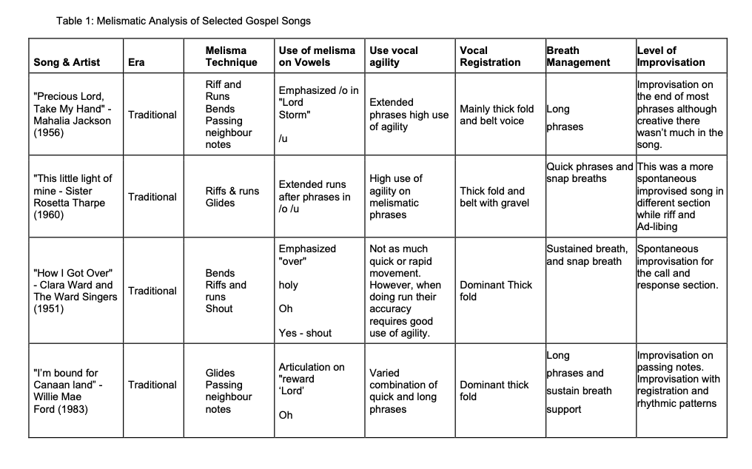

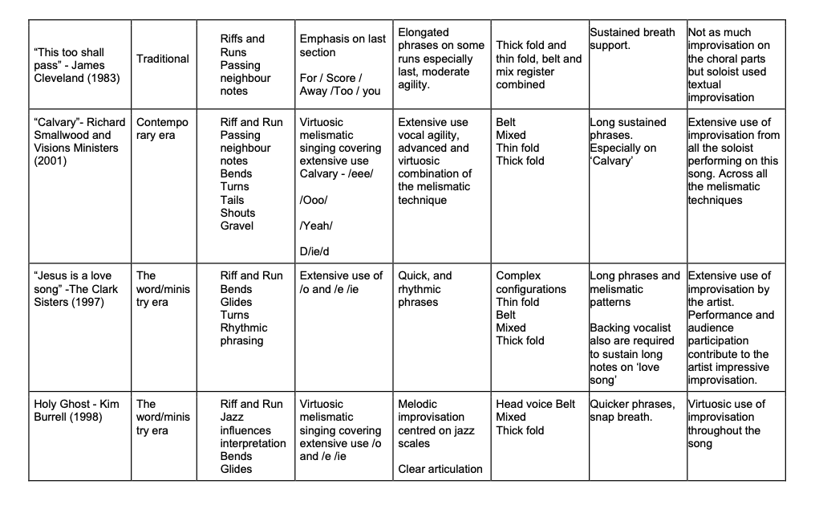

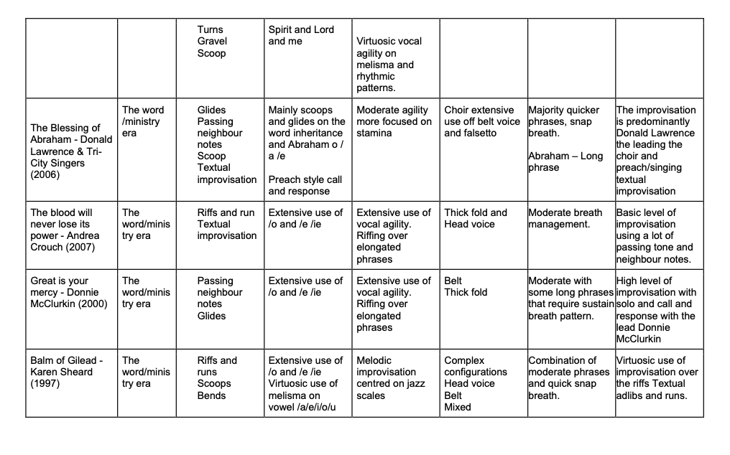

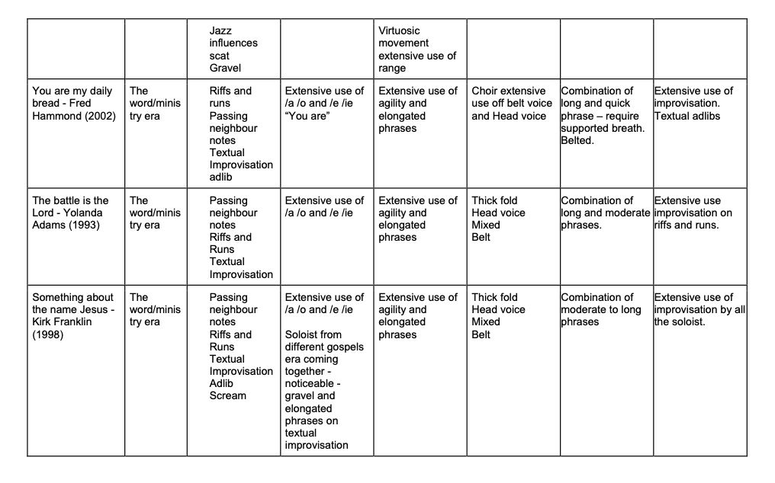

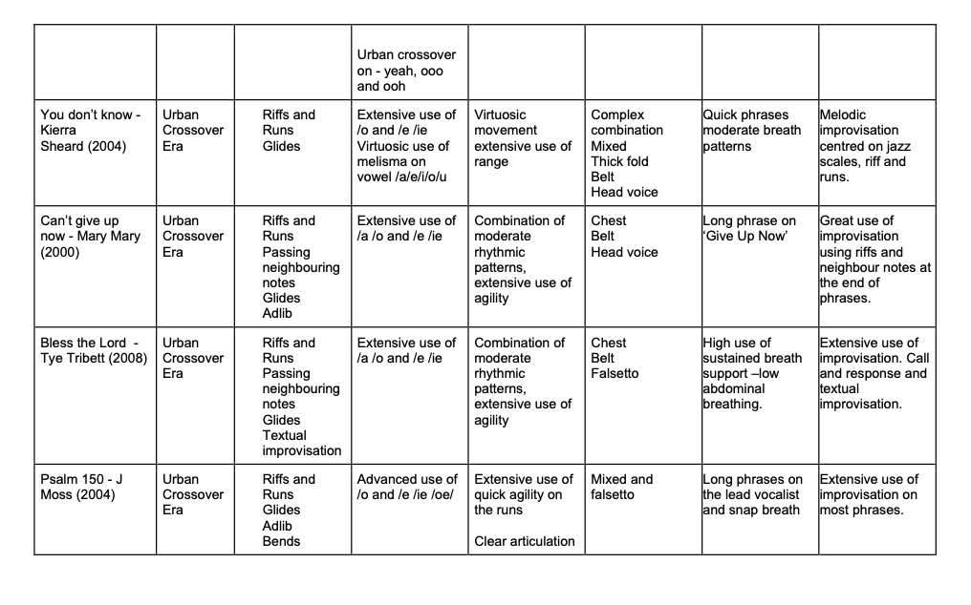

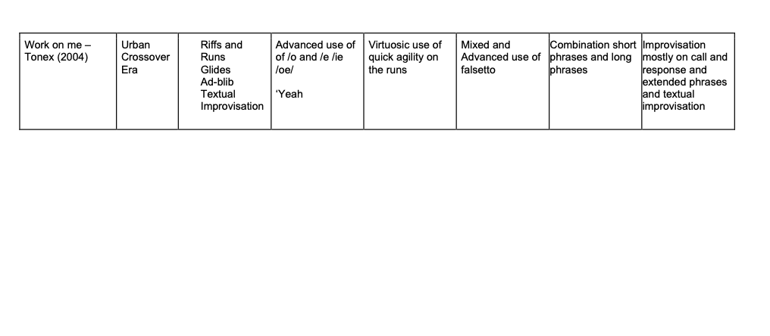

Appendix 5: Breath Management and Support Exercises

Objective: Establish a strong foundation for sustained and expressive singing.

Appoggio Exercise

Exercise 1: Using the Farnielli Appoggio technique (Miller 1996), we focus on strengthening abdominal control and breath support.
Instructions:

- Ensure that your feet are hip-width apart and your shoulders are relaxed by adopting a comfortable and upright posture.
- Place one hand on your chest and the other just below your ribcage to monitor your breath. Shift your attention to diaphragmatic breathing, imagining that you are filling your lower abdomen with air as you inhale. Keep your chest relatively still, allowing your abdomen to rise.
- Then, work on controlled exhalation, engaging your abdominal muscles gently to regulate the release of air.

Exercise 2: Extended Exhale - Quick Inhale and Prolonged Exhale
Instructions:
- Inhale through the mouth for a short count (e.g., 4 seconds).

- Exhale using an "sh" sound (e.g., "shh") evenly for an extended duration.

Practice:
Aim for an even and consistent flow of air. Start with your initial count (e.g., 15 seconds) and gradually increase it by 5-second increments.

Exercise 3: Sibilant Fricatives - Flexible Abdominal Workout
Instructions:
- Engage abdominal muscles to flex the abdominal wall.
- Use sibilant fricatives (e.g., "ssss," "shh") to activate abdominal movements.

Focus:
Monitor tension in shoulders and neck; all work should be done by abdominal muscles.

Exercise 4. Sibilant Fricatives with Connected Vowels

Instructions:
Combine sibilant fricatives (e.g., "ssss," "shh") with different vowels.

Focus on moving air freely while shaping and placing sound into the breath stream.
Revisit it after improving in the first three exercises.
These exercises are designed to improve breath management, which is crucial for enhancing singing performance, including pitch, range, and style.

Appendix 6 – Vocal Artefact

Design Vocal Artefact: Vocal Training for Gospel Melisma

The Gospel Melisma Vocal Training Guide enhances melismatic vocal abilities in gospel music. This structured resource is founded on primary research and literature review.
Aim: The primary goal is to compile tailored melismatic vocal exercises for gospel music. These exercises are divided into four sections, cover breath management, vocal agility, registration, and improvisation:

- Breath Management Exercises: Focus on sustaining phrases, enhancing stamina, and ensuring vocal health through breath control.
- Agility Exercises: Develop vocal flexibility by exploring major, minor, pentatonic, and blues scales for melismatic passages.
- Registration Exercises: Learn to identify vocal registers and achieve seamless transitions, promoting balanced and controlled vocal tones.
- Considerations for Improvisation: Explore gospel improvisation, including crafting lyrics, rhythmic improvisation, and emotive vocal performance techniques.

ACCESS TO AUDIO SAMPLES: For audio samples of the exercises within this artefact. You can access these samples by scanning the QR code below or by visiting this link: http://bit.ly/vocalartefact.



Appendix 7 - Breath Management

Exercise 1: Three-Phase Breath Management Exercise; Inhale, Suspend, Exhale
- Instructions: Inhale through the mouth for a specified count (e.g., 8 seconds).
- Suspend the breath by activating the abdominal muscles and obliques.
- Exhale using an "ssh" sound (e.g., "shh") evenly over a specified count.

Practice:
Start with an 8-second count, then progress to 10 seconds and 12 seconds. Aim to regularly practice and extend the duration over time.

Breath Management for Long Phrases

Purpose: To enhance vocal stamina, enabling singers to sustain extended passages with control and expressiveness. This skill facilitates artistic interpretation and ensures singers can deliver compelling, emotionally resonant performances.

Exercise 2: ‘Oh, Jesus’
Figure 1: ‘Oh, Jesus’ exercise. For audio example please follow this link.

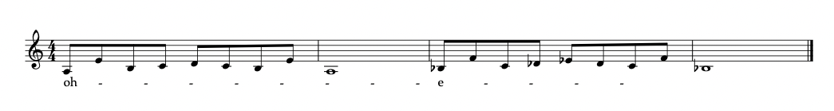
Exercise 3: ‘Oh, Jesus’ Expansion
Figure 2: Phase 2 of ‘Oh, Jesus’ exercise develops multiple notes on a long phrase. For audio example please follow this link.

Exercise 4: ‘Amen’ Long Phrases
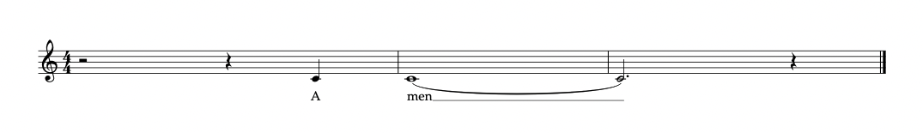
Figure 3: ‘Amen’ exercise enabling singers to sustain extended passages. In addition to develop dynamics you can start p then crescendo to mf. For audio example please follow this link.

Exercise 5: ‘Amen’ Long Phrases
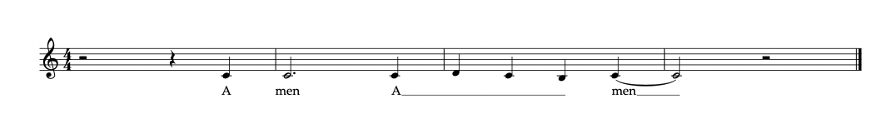
Figure 4: Phase 2 of the ‘Amen’ exercise developing multiple notes on a long phrase. For audio example please follow this link.

Appendix 8 – Vocal Artefact – Agility

The following agility exercises are centred on melismatic passages within major, minor, pentatonic, and blues scales. These exercises serve to cultivate the skill of navigating and embellishing melismatic phrases with fluency. These exercises aim to broaden singers' creative and expressive ability for gospel vocal performance, fostering versatility across a range of scales.

Pentatonic Scales
Practicing the major/minor pentatonic scale on vowels (a, e, i, o) serves to refine pitch accuracy, vowel clarity, vocal range, and breath control. This exercise enhances both vocal technique and musicality, enabling singers to convey lyrics effectively and expressively in their performances.

Exercise 6: ‘Major Pentatonic Scale – /a/e/
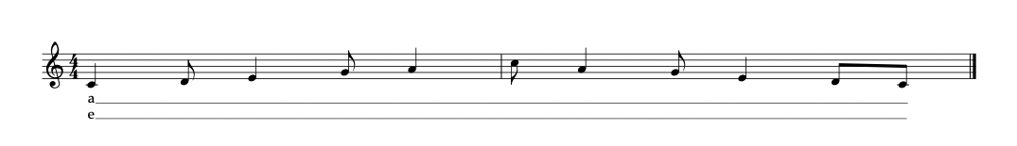

Figure 5: Developing vocal agility with major pentatonic scale and vowel variations. Begin by singing the scale comfortably, then incrementally increase the pitch by a semitone, repeating this process four times to expand your vocal range and flexibility. For audio example please follow this link.

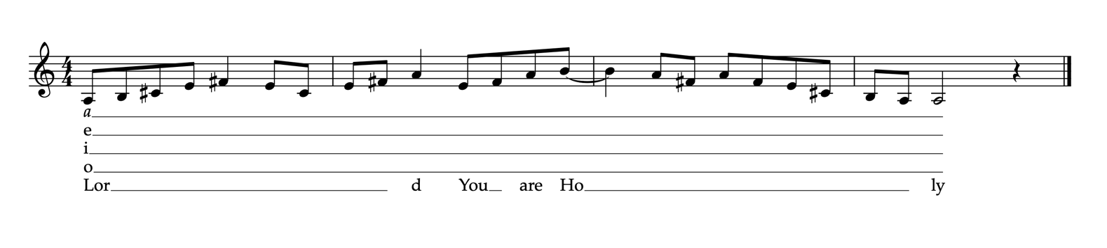
Exercise 7: ‘Lord You are Holy’
Figure 6: Enhancing vocal agility with major pentatonic patterns and vowels. This exercise utilises major pentatonic patterns with vowel sounds and text to boost your agility. Begin by singing the scale comfortably, then gradually raise the pitch by a semitone. Repeat this sequence four times to broaden your vocal range and enhance flexibility. For audio example please follow this link.

Exercise 8: ‘Minor Pentatonic Scale’
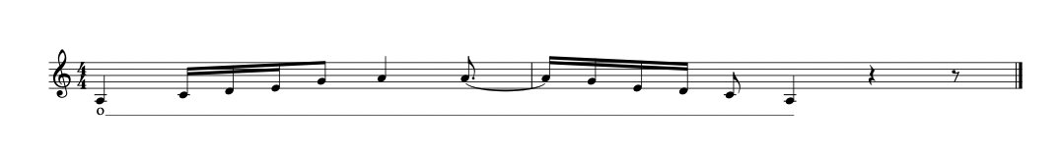
Figure 7: This exercise employs minor pentatonic patterns along with vowel sounds to refine your agility. Start by singing the scale comfortably, then incrementally raise the pitch by a semitone. Reiterate this process two times to expand your vocal range and foster greater flexibility. For audio demonstrations, please follow this link.

Exercise 9: ‘Minor Pentatonic Riff’
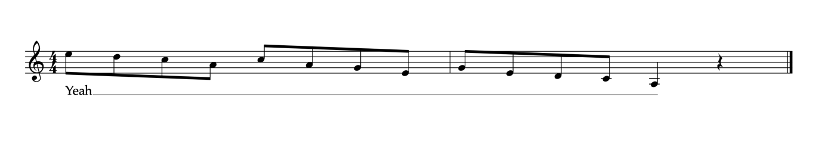
Figure 8: Minor pentatonic riff patterns exercise utilises minor pentatonic riff patterns alongside vowel sounds to strengthen vocal agility and flexibility. Commence by singing the scale comfortably, gradually elevating the pitch by a semitone. Repeat this sequence four times to extend your vocal range and bolster your flexibility. For audio examples, please access the following link.

Exercise 10: ‘Mixolydian Scale’
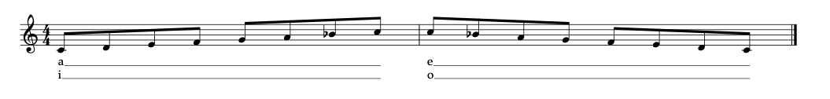
Figure 9: Mixolydian scale with vowels sounds develop vocal agility and flexibility and aural skills. Start by singing the scale comfortably, gradually increasing the pitch by a semitone. Reiterate this process four times to expand your vocal range and fortify your flexibility. For audio examples, please access the following link.

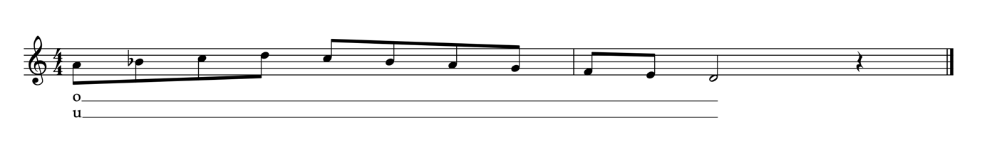
Exercise 11: ‘Mixolydian run’
Figure 10: Mixolydian run patterns with vowel sounds develop vocal agility and flexibility. Begin by comfortably singing the scale, then progressively raise the pitch by a semitone. Perform this sequence four times, distinct from previous exercises, to broaden your vocal range and enhance flexibility."

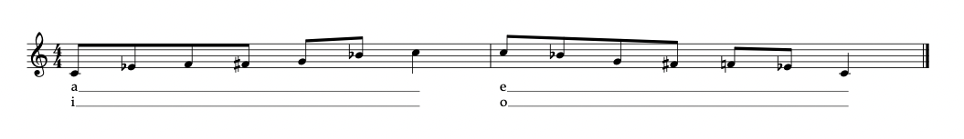
Exercise 12: ‘Blues Scale’
Figure 11: Smooth Transition from Thin/Head to Thick/Chest Registers
This exercise focuses on developing transitioning between the thin/head and thick/chest vocal registers.

Exercise 13: ‘Blues Scale Riff’
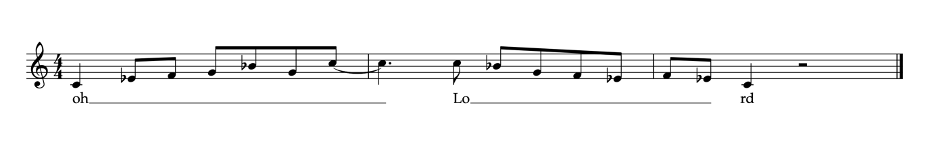
Figure 12: The "Blues Scale Riff" exercise for vocals helps singers improve their ability to sing blues scales and develop their vocal control and expression within the context of blues music.

Appendix 9 – Vocal Artefact – Registration

These exercises assist singers in developing the ability to navigate between their registers smoothly, ensuring a consistent and controlled vocal tone throughout their entire vocal range.

Exercise 14: Hey You – Taken from (Robinson Martin, 2016) So you want to Sing Gospel?

Figure: Begin with saying 'Hey! You!' with an exaggerated speaking voice. This exercise helps to identify the chest thick fold register. You can then sing Hey! You! on a note and move incrementally in pitch up a semitone 5 times.

Exercise 15: You Are Worthy Lord
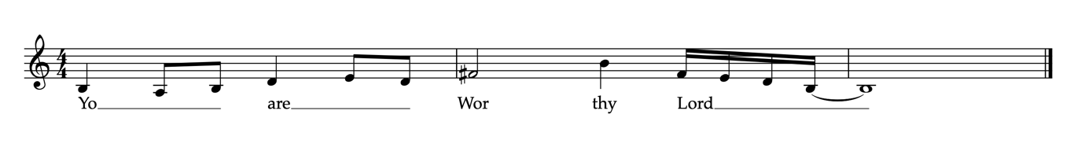
Figure 11: Registration for Thick Fold/ Chest voice. To identifying thick fold / chest register simply try speaking in a relatively loud, low-pitched voice, as if reprimanding someone in an assertive tone.

Exercise 16: You Alone
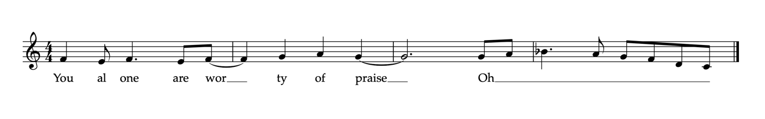
Figure 12: Identifying Falsetto/Head Voice For falsetto/head voice, start on a relatively high but easily obtainable pitch. Start with some simple owl sounds and then say "You too?" imitating a "damsel in distress" sound.

Exercise 17: Smooth transitioning from thin/head to thick/Chest

Figure 13: This exercise focuses on developing transitioning between the thin/head and thick/chest vocal registers.
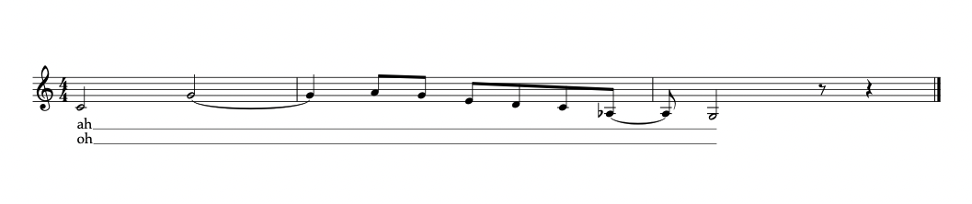
Exercise 18: Registration Flip
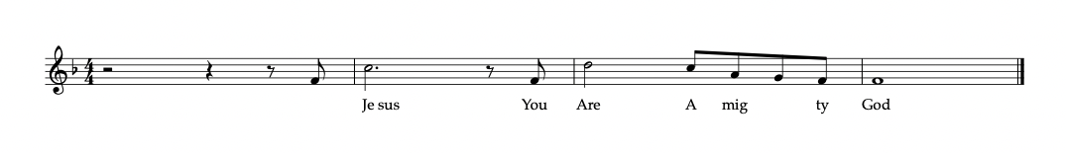
Figure 14: The registration flip exercise helps singers develop smooth and controlled transitions between their chest and head voices, improving their vocal range and eliminating noticeable breaks in their voice.

Appendix 10 – Vocal Artefact – Improvisation

Improvisation

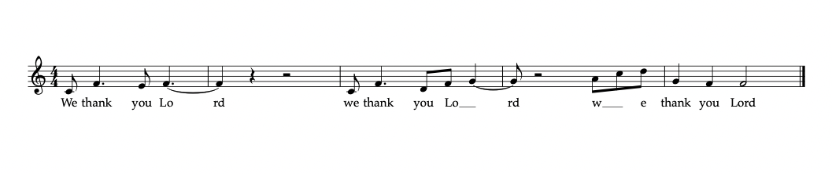
Example: Rhythmic improvisation and phrasing exercise
Figure 15: This involves cultivating rhythmic improvisation and phrasing skills by instructing students to compose a brief set of personalised lyrics adaptable to various 5 or 6-note rhythmic patterns. The sole prerequisite for these lyrics is that they hold personal significance to the student during the lesson. As an illustration, the phrase " We thank you " may be employed to harmonise with melodic patterns encompassing 5 notes.

Example: Developing Aural Skills

Developing advanced ear training and emulation skills. Students are encouraged to engage in the following steps: Listen attentively to a segment of a melismatic pattern, such as the excerpt from Smokie Norful's rendition of "Still I Say Thank You." Familiarise themselves with the passage by listening repeatedly. Practice singing the phrase slowly and gradually increase the speed for improved proficiency.
Figure 16: Taken from (Robinson-Martin, 2010)

Exercise 18: Improvision – Riffs and Runs

Improvisation over a gospel chord progression
Please listen to track 18 is a guide and then practice using instrumental on track 19.

Fmaj 7 / E7#5#9 / Am7 / Gm9 / C13
Fmaj 9 / C/E D7 / Gm11

Instructions:

Listen: Immerse yourself in the gospel chord progression to internalize its rhythm and feel.

Scale warm-up: Practice the relevant scales (major, pentatonic, blues) to get comfortable with the notes that fit the key.

Simple improvisation: Start with humming a basic melodic patten around the scale of F major Then gradually begin to try a riff and then a run, gradually increasing in complexity as you grow more confident.

Emotional connection: Use the emotive power of gospel to inject feeling into your improvisations, allowing your response to flow naturally.

Record and reflect: Capture your improvisation and critique it to identify strengths and areas for improvement.

Repeat: Keep practicing, introducing new variations and possibly lyrics as you progress.

Appendix 11 – Vocal Artefact – Melismatic Tools

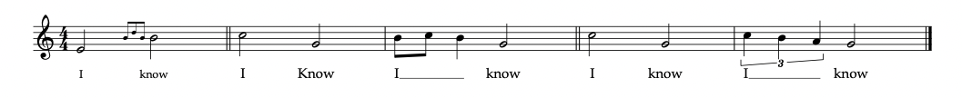
Bends Neighbour notes Passing notes
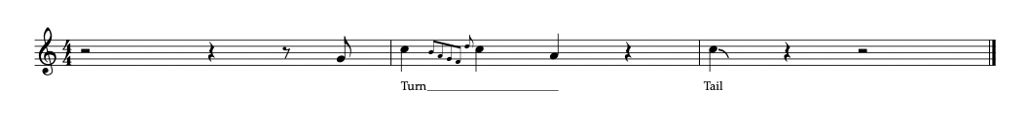
Turn Tail

Bends - refers to a musical technique where a note is deliberately sung or played slightly off-key, typically by a semitone or less, for expressive effect. Often, the sound produced is marginally higher than the intended pitch.

Neighbour Tone - is a musical term that describes a note that is placed immediately above or below the target note.

Passing Note – is a passing note involves the introduction of one or two notes in a stepwise progression in the same direction, situated between two existing notes.

Turns – is a brief melodic pattern comprising at least five notes that are played within a two-beat duration. The sequence begins and concludes with the same note.

Tail - refers to a sequence of two to four notes appended to the conclusion of a musical phrase or just before a pause in the melody. This sequence progresses stepwise in a single direction, either ascending or descending.

Appendix 12 – Vocal Artefact – Guide notes



