Managing people
assessment 1

Student name : Stanislav Dragov
Student ID : 1919084
Lecturer : Zainab Atta
Program : Business Management
Module : Managing people
Module code: LCBB5004

SLIDE 1
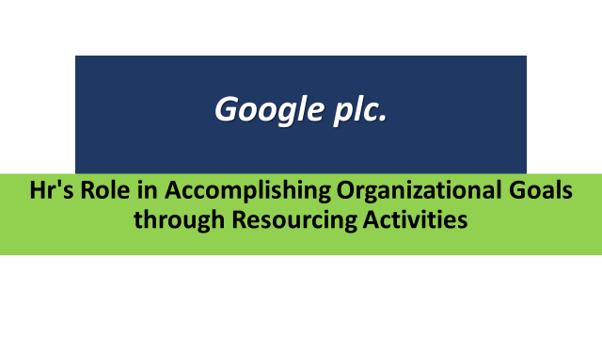
It is more important than ever in the 21st century to effectively manage and use an organization's human resources. Despite this, only a few organizations can compete with Google in terms of human resources management (parent company - Alphabet). Throughout its entire business model, Google has shown that it relies on innovation in every area of its operation. As a result, the organization has established an employee-centered culture with employee empowerment at its core.

SLIDE 2
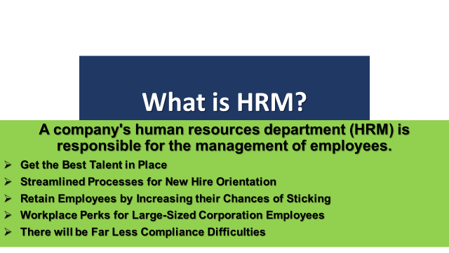
What is HRM?
A company's human resources department (HRM) is responsible for the management of employees (Zamanan, 2020). There are several facets to human resources management, including recruitment, hiring, and firing. Human Resources Management (HRM) focuses on the human aspect of management. Acquisition, development, motivation, and maintenance of human resources are all part of this.
- Get the Best Talent in Place: You don't have to waste your time searching for personnel on job boards and ads when you work with a Professional Employer Organization (PEO). Your company's values, mission, and purpose should be reflected in your corporate culture. You'll be able to make quicker decisions thanks to industry-specific information and insights.
- Streamlined Processes for New Hire Orientation: Even if you find the ideal candidate, the onboarding process may make or break their professional life. The onboarding procedure for your firm is the process through which you welcome and prepare your new hire for success.
- Retain Employees by increasing their Chances of Sticking: Strategic HR solutions promote employee engagement, productivity, and teamwork. Real-time feedback may assist you in identifying and resolving issues, as well as fostering a sense of worth and appreciation among your employees. It's possible to convert individuals into productive teams by using effective performance management practices.
- Workplace Perks for Large-Sized Corporation Employees: A company's size usually dictates the scope of its employee benefits, but not when working with an experienced professional employer organization (PEO). Employee incentives and a variety of insurance options are also available.
- There will be Far Less Compliance Difficulties: Hundreds of rules and regulations must be adhered to by HR departments. If you aren't trained in compliance, it becomes a full-time job. Compliance with any employment rules and regulations should be your first concern. Benefits, payroll and termination are all included.

Slide 3
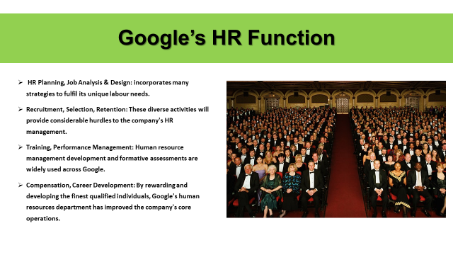
If we observe Google’s HR environment we can understand the gravity of this context,
HR Planning, Job Analysis & Design: Google's human resource planning incorporates many strategies to fulfil its unique labour needs.
Recruitment, Selection, Retention: The company's human resources management will face significant challenges as a result of his diversification.
Training, Performance Management: It is common practice with Google to use a variety of human resource management development and evaluation program in various parts of the firm.
Compensation, Career Development: Google's human resources department has focused on boosting the company's essential operations by compensation and developing the best qualified people.

Slide 4
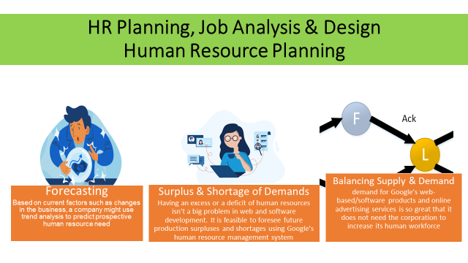
HR Planning, Job Analysis & Design
Human Resource Planning
Let’s talk about Google’s secret formula,
- Forecasting:
Based on current factors such as changes in the business, a company might use trend analysis to predict prospective human resource need (Safont Bagué, 2019).
In order to predict the demand for human resources in each future scenario, scenario analysis uses a qualitative technique to examine possible combinations of components.
- Surplus & Shortage of Employees:
Having an excess or a deficit of human resources isn't a big problem in web and software development. It is feasible to foresee future production surpluses and shortages using Google's human resource management system (HRMS).
- Balancing Supply and Demand :
However, demand for Google's web-based/software products and online advertising services is so great that it does not need the corporation to increase its human workforce (Pal, 2020).
It is also necessary for the company to manage the supply and demand for human resources when it comes to the production and distribution of Nexus and Chromecast devices.
New employees are hired by Google based on the company's projections of future human resource needs in different sectors.

Slide 5
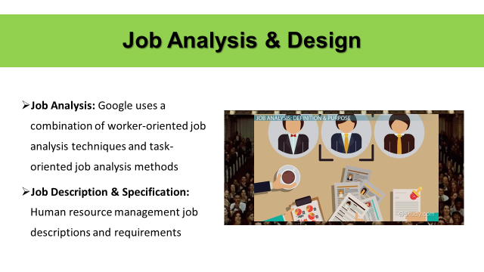
Job Analysis and Design
When it comes to human resources, Google has a flexible organizational structure. When it comes to job analysis and design, Google's many divisions use a variety of methods.
- Job Analysis: When it comes to product development, Google uses a mix of worker- and task-oriented job analysis methodologies.
- Job Description & Specification: Human resource management job descriptions and requirements, for example, are quite different from those of product development professions.

Slide 6
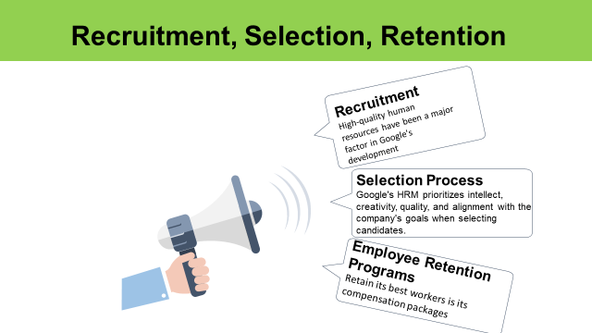
Google maintain a strong a dynamic policy to maintain employee stability in the organization and entry criteria is also world class.
Recruitment, Selection, Retention
- Recruitment: High-quality human resources have been a major factor in Google's development (Baking, 2016).
Sources:
In-house recruitment sources for the company include promotions, transfers, and internships/trainees/interns. The Power of Focused Intensity Google hires through outside sources, such as educational institutions and job seekers who respond to employment advertisements (Indirect Method).
- Selection Process: According to the corporation, the most essential traits used in the selection of applicants by Google's human resource management are intelligence, inventiveness, a drive for excellence, and alignment with the company's objectives.
When it comes to managing personnel in different departments and jobs within the organization, Google's human resource management employs a number of different procedures and activities.
- Employee Retention Programs: The most significant human resource management technique used by Google to retain its best workers is its compensation packages (Pendergraft, 2019).
Compared to the rest of the industry, the compensation packages offered by the firm are competitive and above average. The company offers its employees a variety of benefits, including free lunch.
Fun and creativity are stressed in corporate workplaces, which helps to recruit and retain inventive and creative employees.
People with leadership potential may benefit from coaching and mentorship.

Slide 7
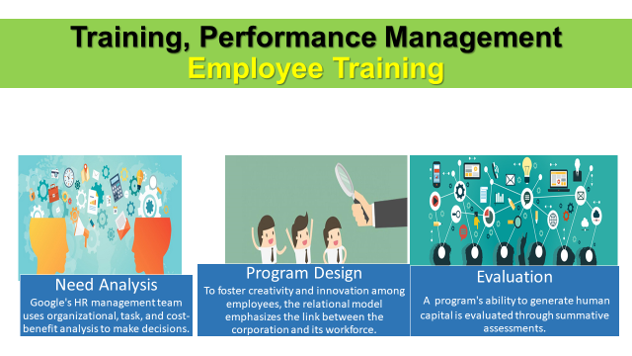
Training, Performance Management
Google places a high importance on intellect and a drive for excellence in all of its employees, regardless of their position.
Employee Training:
- Needs Analysis: Organizational analysis, task analysis, and cost-benefit analysis are some of the methods utilized by the Google human resources management team to make choices (among others).
- Program Design: To foster creativity and innovation among employees, the relational model emphasizes the link between the corporation and its workforce. The major focus of the results-oriented approach is on the training outcomes... As an example, Google uses this strategy when it launches a training program for its employees.

- Evaluation: Summative evaluations are used to determine how effective a program is in terms of producing human resources. The descriptive goal of assessment is to understand how well employees performed in order to evaluate the effect of training. Search engine giant Google assesses training programs based on a variety of factors, including how effectively students learn and how well they respond to the instruction.

Slide 8
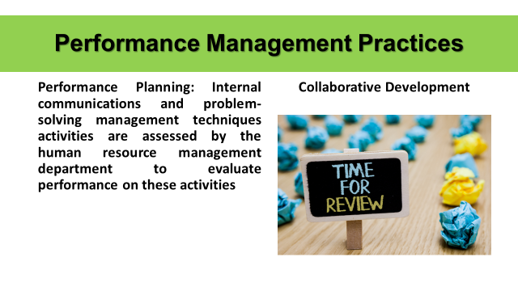
Because Google has a global clientele, the company's workforce reflects such diversity. More than 70 offices have been created in more than 40 countries.
Performance Management Practices
Performance Planning: Internal communications and problem-solving management practices are evaluated by the human resources department. Performance planning activities include customer service, communication, diversity support, and problem-solving skills.
Correlation with the aims of the company high focus on variety encourages a wide range of ideas and problem-solving abilities. Search engine giant Google's corporate objectives include a focus on innovation.

Slide 9
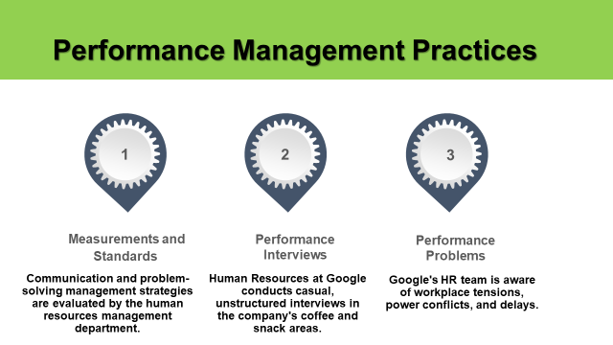
This search engine and other internet firms have made it a household name, however, thanks to its employee-friendly work environment and HR requirements. As the best employer, you must put a lot of focus on human resources management. When it comes to Google employees, they tell stories of how wonderful it is to work there.
- Measurements and Standards: Internal communications and problem-solving management practices are assessed by the department of human resources management.
- Performance Interviews: The Human Resources department at Google does informal, unstructured interviews in places where workers congregate, such as the coffee and snack areas of company headquarters.
- Performance Problems: Negativity in the workplace, power struggles, and delays are all on the minds of Google's human resources staff.

Slide 10
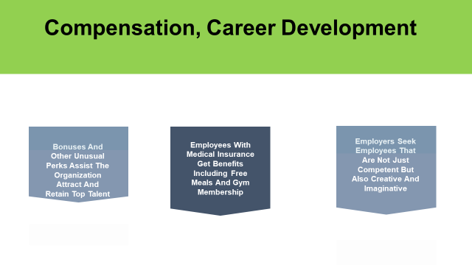
Compensation, Career Development
Efforts to get Compensations are well deserved
Incentives, bonuses, and other atypical rewards help the company recruit and retain the best employees.
With medical insurance, employees get perks like free meals and access to gym facilities.
Employers want to fill their workforce with people who are not just capable but also creative and innovative.

Slide 11
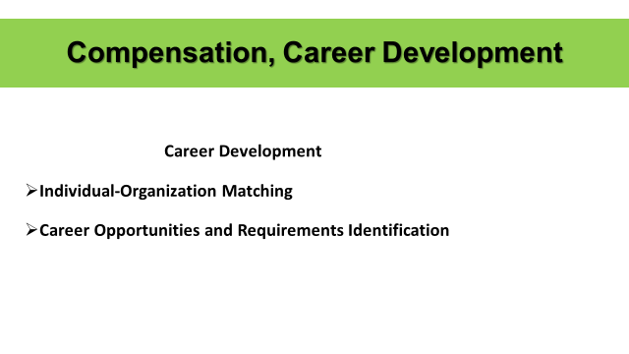
Google has risen to the top of the technology industry thanks to a well-managed and highly motivated workforce.
Career Development:
- Individual-Organization Matching: When it comes to satisfying the needs of the person as well as the needs of the organization, Google places a high priority on finding the right match between the individual and the job, company, and team.
- Career Opportunities and Requirements Identification: It is possible to identify prospective career routes for people by doing job analysis, which aids human resource managers. As a company, Google uses coaching to help employees better understand the workplace dynamics and potential career routes inside the company.

Slide 12
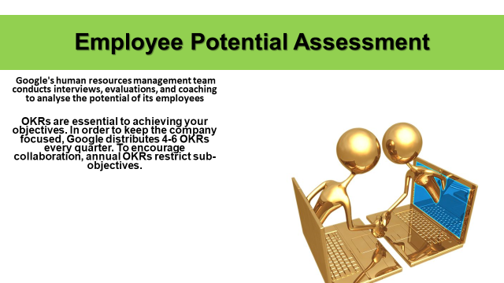
Employee Potential Assessment
Google's human resources management team conducts interviews, evaluations, and coaching to analyse the potential of its employees.
Google's new internal grading system, called Objectives and Key Results (OKRs), is a step forward in assessment. Aside from monitoring progress and successes, these OKRs are not linked to performance assessments.
Putting in Place Career Development Initiatives: During or during an evaluation, human resources management informs employees of their possible career options. A new product or company launch, for example, may need the implementation of specific career development programs.

References

Baking, C., 2016. Leading the Way for a Connected World (Doctoral dissertation, GOOGLE).
Pal, D., 2020. Future of Workplace: Collaboration of Human Resource with Artificial Intelligence. Journal of HR, Organizational Behaviour & Entrepreneurship Development, 3(3), pp.14-19.
Pendergraft, G., 2019. Controversy Over Gender Differences and Free Speech at Google. SAGE Publications: SAGE Business Cases Originals.
Safont Bagué, A., 2019. HR marketing & recruitment: an overview and proposals from Google & Zappos.
Zamanan, M., Alkhaldi, M., Almajroub, A., Alajmi, A., Alshammari, J. and Aburumman, O., 2020. The influence of HRM practices and employees’ satisfaction on intention to leave. Management Science Letters, 10(8), pp.1887-1894.

