Changemakers: Creativity and Value Creation
Assignment 1 - BMPS5011

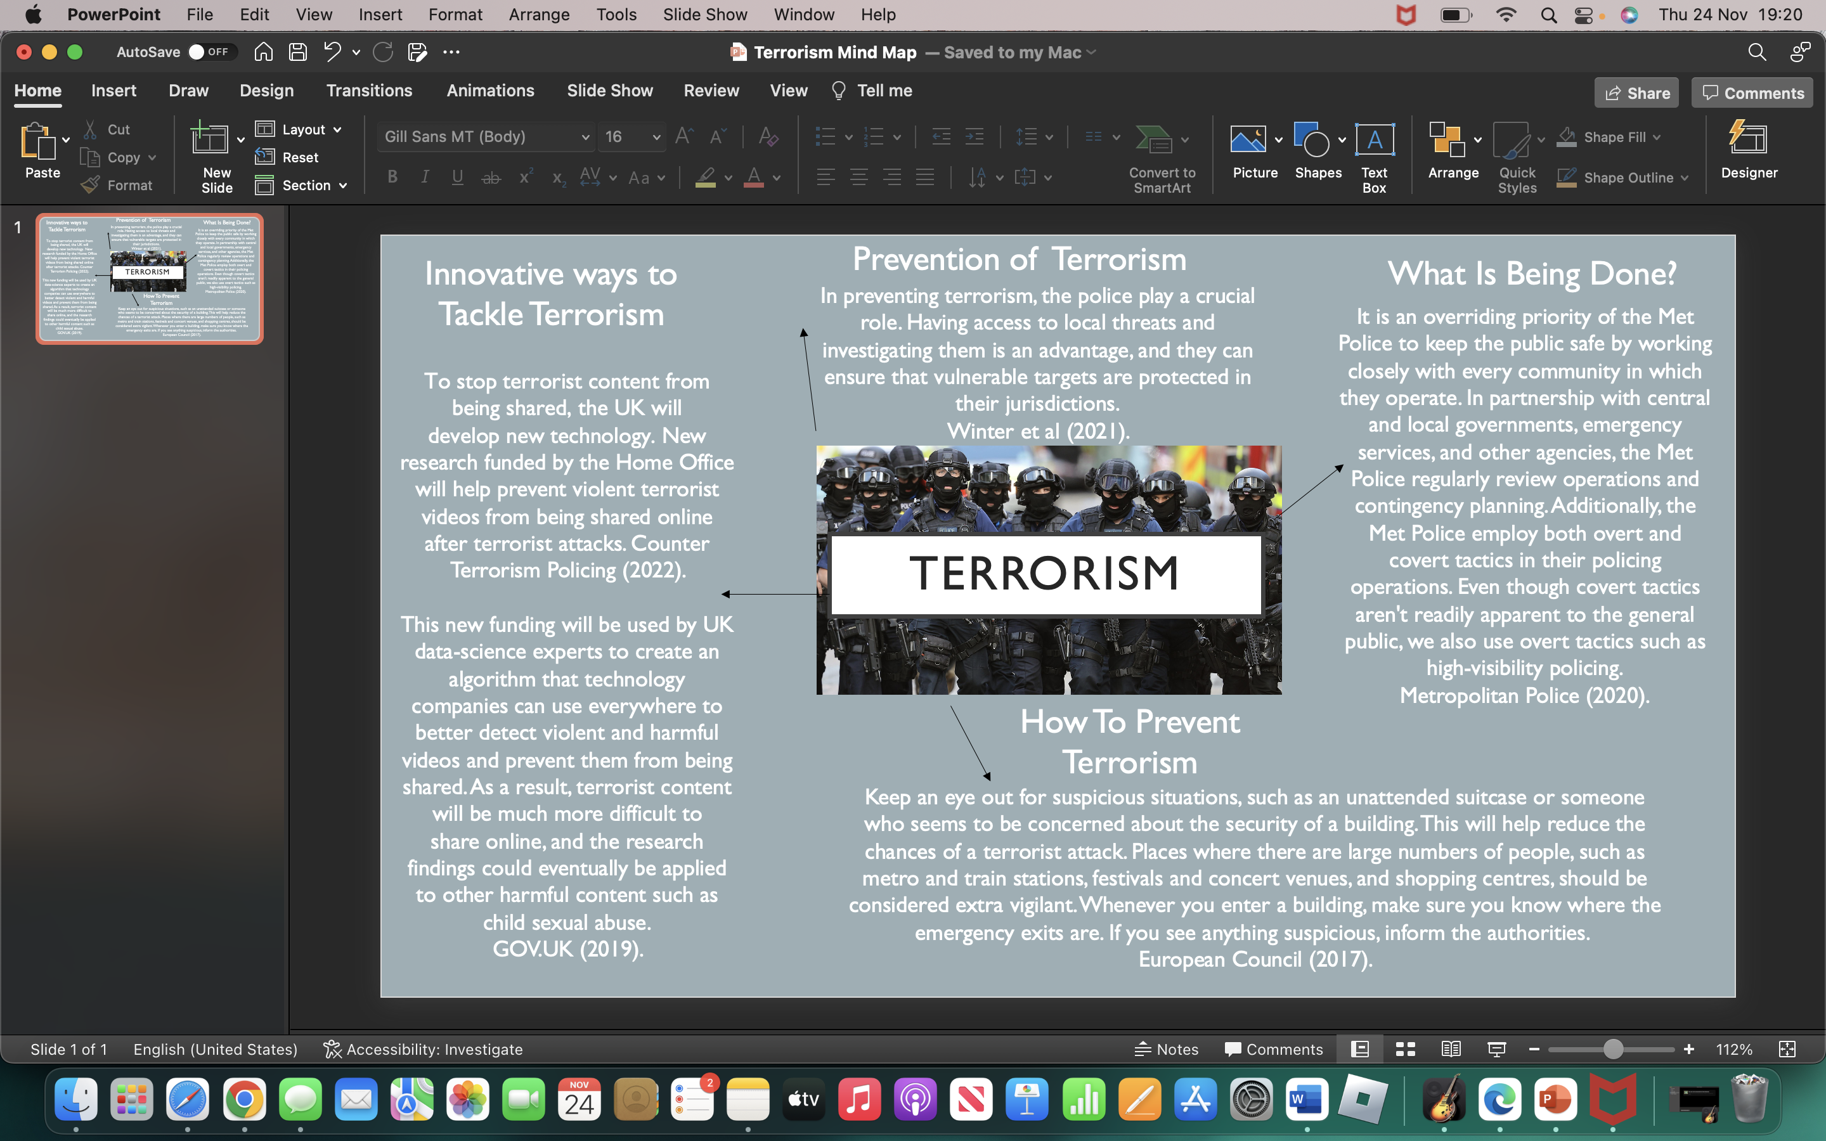
To begin choosing my approach for this assignment, I firstly decided which type of crime was suitable to research including content such as raising awareness, innovative prevention ideas and reliable information. Throughout the beginning of my research, I found that there a high amount of stop and searches, arrests and outcomes transmitted out regarding terrorism in the UK. The Operation of Police Powers Under the Terrorism Act [2000] provides statistics relating to the matter.

A total of 203 arrests have been made for terrorism-related actions during the past 12 months, an increase of 20 arrests (11%) over the same period last year. Data provided indicates there were 203 arrests related to terrorist activity at the time of data provision. There were 49 charges (24%) that resulted in charges, 44 of which were linked to terrorism. Under investigation, 94 people (46%) have been released. The release without charge of 50 individuals (25%) was the result of no charges being filed. There were 10 (5%) who were recalled to prison or given alternative punishment, such as caution or warning. GOV.UK (2022).

This is a concerning amount of activity taking place involving terrorism, which is why this topic peaked as an interest to look further. As the millennium dawned, the threat of international terrorism became a more prominent political issue, particularly after the terrorist outbreak on the Twin Towers on 11th September 2001. One year before 9/11, the UK had passed new legislation against terrorism. In the Terrorism Act 2000, the police and the Home Secretary were given improved powers to battle terrorism and reform previous counterterrorism legislation. It expanded the definition of terrorism to include domestic and international terrorism. Allen and Harding (2021).

As I indulged myself in the research and findings of terrorism over the decades, I found that terrorism can take various forms. There is no single type of terrorism. Many countries contribute to this phenomenon. Terrorists come from an extensive range of ethnic, racial, religious, political, and ethnic upbringings, as well as having a variety of views, missions, and goals. As the methods, people, or places from which terrorists operate go beyond national boundaries, international terrorism refers to terrorism outside national boundaries. Terrorism, largely defined as Islamist terrorism, has been synonymous with international terrorism since the 1990s. Several terrorist groups in Iraq ans Syria, such as Al Qaida and the Islamic State of Iraq and the Levant, have the capability and intention to attack the West. CPS (2020).
The current national threat level to the UK from terrorism is substantial which means likely. This reasoning alone is why it is vital to create awareness specifically in populated areas. As the threat to UK interests has developed since the 1960s, MI5 has countered terrorist threats both at home and abroad. It can become difficult to understand the approaches and actions that terrorist groups are going to undertake. The difficultly to gain secretive knowledge and to carry out an attack is increasing due to new technology. It is considered extremely necessary to inform others of the risks and dangers of terrorism due to the devastating nature it causes. MI5 (2019).
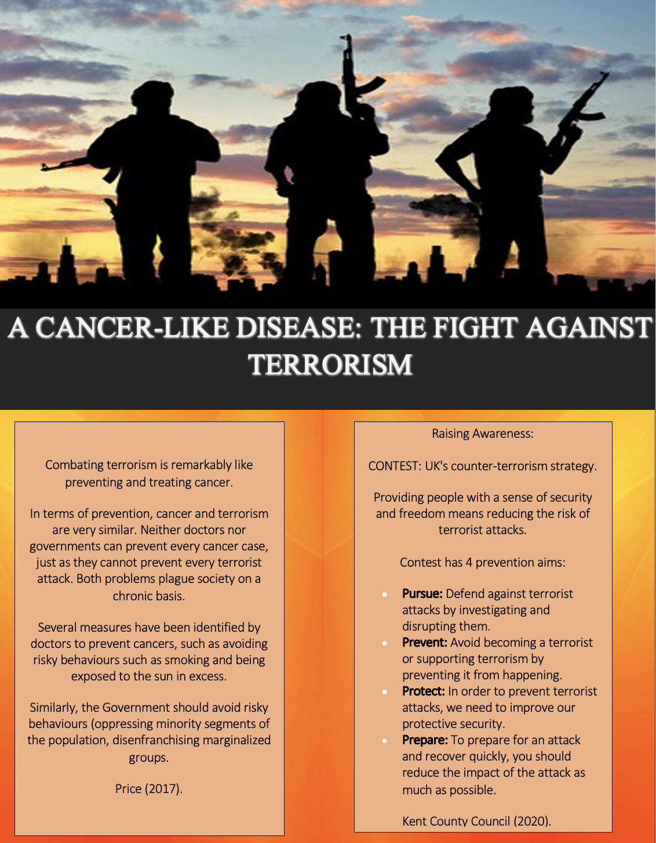
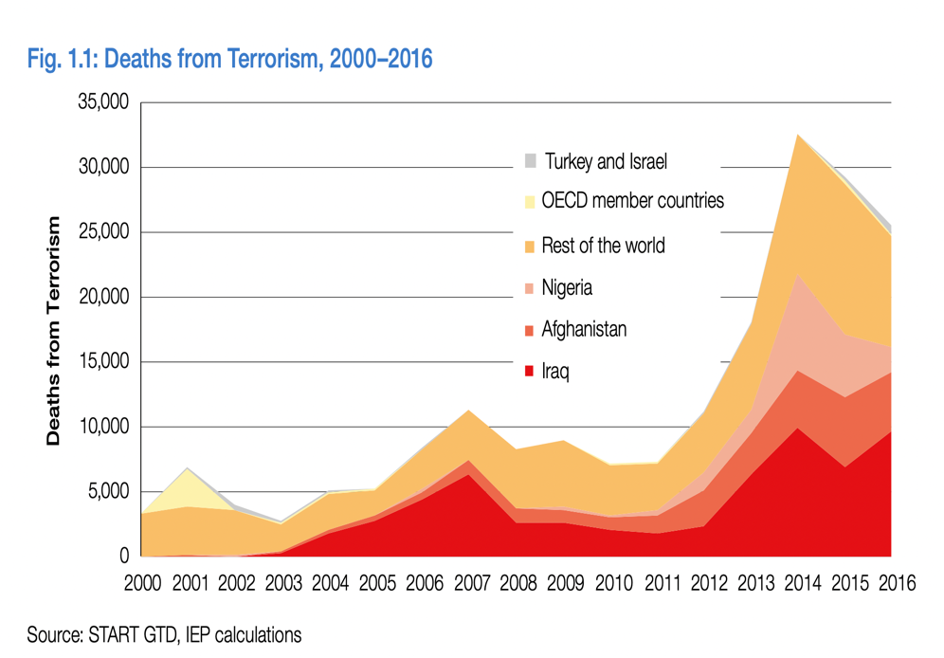
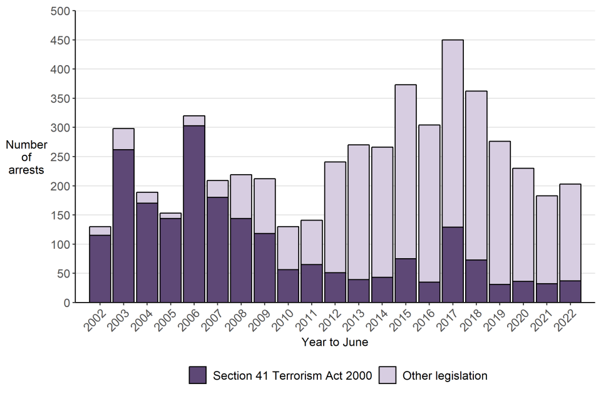

GOV.UK (2022).
HM Government (2018).

There is a wide range of ideas and narratives motivating extremist right-wing groups, including Daesh, Al Qaida, and the Islamic State. In addition to inspiring those formally affiliated with a particular group, their propaganda also inspires those without formal affiliation. Terrorist groups are also often attracted to individuals due to psychological, social, cultural, and material reasons. However, ideology continues to be a powerful motivating factor for many individuals. Janecka (2002).

In addition to the expanding number of potential terrorists, the threat has diversified as groups and individuals continue to innovate and share information about methodologies. There is a likeliness for an increase in terrorist attacks on crowded places in the UK and abroad for the upcoming years.
Ezell et al (2010).

Islamist terrorist attacks have increased in continental Europe by 49 since the beginning of 2015 - 11 in 2015, 19 in 2016, and 19 in 2017. While attacks have occurred throughout Western Europe, about half of them have targeted France. HM Government (2018).

In the 12-month period ending 30 June 2022, 203 arrests were made for terrorism-related activity, an increase of 20% over the 12-month period before (a 11% increase). GOV.UK (2022).

TERRORISM
Flyer Audio –
https://www.youtube.com/watch?v=_0TYFlXZ4cg

References:
Allen, G. and Harding, M. (2021), Terrorism in Great Britain: The Statistics. [online] Parliament.uk. Available at: https://researchbriefings.files.parliament.uk/documents/CBP-7613/CBP-7613.pdf, (Accessed: 10th November 2022).
Counter Terrorism Policing (2022). Prevent. [online] Counter Terrorism Policing. Available at: https://www.counterterrorism.police.uk/what-we-do/prevent/, (Accessed: 10th November 2022).
CPS (2020), Terrorism | The Crown Prosecution Service, [online] www.cps.gov.uk. Available at: https://www.cps.gov.uk/crime-info/terrorism, (Accessed: 11th November 2022).
European Council (2017), EU fight against terrorism - Consilium. [online] Europa.eu. Available at: https://www.consilium.europa.eu/en/policies/fight-against-terrorism/, (Accessed: 15th November 2022).
Ezell, B.C., Bennett, S.P., von Winterfeldt, D., Sokolowski, J. and Collins, A.J. (2010). Probabilistic Risk Analysis and Terrorism Risk. Risk Analysis, 30(4), pp.575–589, Available at: https://www.dhs.gov/xlibrary/assets/rma-risk-assessment-technical-publication.pdf, (Accessed: 15th November 2022).
GOV.UK (2019), UK to help develop new tech to stop sharing of terrorist content, [online] GOV.UK. Available at: https://www.gov.uk/government/news/uk-to-help-develop-new-tech-to-stop-sharing-of-terrorist-content, (Accessed: 15th November 2022).
GOV.UK. (2022), Operation of police powers under the Terrorism Act 2000 and subsequent legislation: Arrests, outcomes, and stop and search, Great Britain, quarterly update to June 2022. [online] Available at: https://www.gov.uk/government/statistics/operation-of-police-powers-under-the-terrorism-act-2000-quarterly-update-to-june-2022/operation-of-police-powers-under-the-terrorism-act-2000-and-subsequent-legislation-arrests-outcomes-and-stop-and-search-great-britain-quarterly-u, (Accessed: 10th November 2022).
HM Government (2018), The United Kingdom’s Strategy for Countering Terrorism. [online] Available at: https://assets.publishing.service.gov.uk/government/uploads/system/uploads/attachment_data/file/716907/140618_CCS207_CCS0218929798-1_CONTEST_3.0_WEB.pdf, (Accessed: 22nd November 2022).
Janecka, I.P. (2002). Terrorism and Cancer: Striking Similarities. Plastic and Reconstructive Surgery, [online] 110(2), pp.697–698. Available at: https://journals.lww.com/plasreconsurg/Citation/2002/08000/Terrorism_and_Cancer__Striking_Similarities.52.aspx, (Accessed 23 November 2022).
Kent County Council (2020), Kent.gov.uk. Counter-terrorism strategy (Contest) - [online], Available at: https://www.kent.gov.uk/about-the-council/strategies-and-policies/community-safety-and-crime-policies/contest, (Accessed: 22nd November 2022).
Metropolitan Police (2020), Current threat level in the UK | The Met. [online] Available at: https://www.met.police.uk/advice/advice-and-information/t/terrorism-in-the-uk/current-threat-level-UK/, (Accessed: 15th November 2022).
MI5 (2019), Counterterrorism | MI5 - The Security Service. [online] Mi5.gov.uk. Available at: https://www.mi5.gov.uk/counter-terrorism, (Accessed: 11th November 2022).
Price, B.C. (2017). Terrorism as Cancer: How to Combat an Incurable Disease. Terrorism and Political Violence, 31(5), pp.1–25, Available at: https://www.tandfonline.com/doi/full/10.1080/09546553.2017.1330200, (Accessed 22nd November 2022).
Winter, C., Heath-Kelly, C., Kaleem, A. and Mills, C. (2021). A moral education? British Values, colour-blindness, and preventing terrorism. Critical Social Policy, 42(1), p.026101832199892, [online], Available at: https://journals.sagepub.com/doi/full/10.1177/0261018321998926, (Accessed: 15th November 2022).

‌

‌
‌
‌

‌

‌

‌

‌

‌

