

Investigating the Key Functions of Operating Systems and Command-Line / Scripting Operations in Windows and Linux Environments
Course Code: ACCA4022
Course Name: Computer Architecture and Operating Systems
Student Name: Nabeel Zafar
Student Number: 2523172

Table of Contents
Introduction 3
1. Key Functions of General-Purpose Operating Systems 3
1.1 Process Management 3
1.2 Memory Management 4
1.3 File and Device Management 4
1.4 User Interface, Protection and Security 5
2. Using the Windows OS command line 6
2.1 Process Management 6
2.2 File and Directory Management 7
2.3 Network Testing and Monitoring 9
2.4 User Management 12
2.5 Task Scheduling 13
3. Use of Linux OS CLI Commands 14
3.1 Process Management 14
3.2 File and Directory Management 16
3.3 Network Testing and Monitoring 18
3.4 User Management 20
3.5 Task Scheduling 22
4. Use of Windows OS Scripts 23
4.1 Script 1 – Simple Calculator 23
4.2 Script 2 – File Backup Automation 24
5. Use of Linux OS Scripts 25
5.1 Script 1 – Simple Calculator 25
5.2 Script 2 – System Disk Usage Monitor 26
Conclusion 27
Reference 28

Introduction
Operating systems are the backbone of today's computing, as they are the software that controls the hardware and enable users and applications to communicate with the computer. This report explores the critical functions of general purpose operating systems and gives hands-on experience of general purpose operating system skills using two popular platforms (Microsoft Windows and Linux (Kali Linux)) control panel respectively Command Line Interface (CLI) and graphical user interface (GUI). The report has five main parts: overview of basic operating system functions, Windows CLI commands demo, Linux CLI commands demo, writing and running Batch and Bash scripts. To show that the commands and their output have been used in practice, screenshots of commands and their outputs are included throughout. In addition, a summary of the key findings from this investigation is included at the end of the report.

1. Key Functions of General-Purpose Operating Systems
There are a number of basic functions that a general-purpose OS like Microsoft Windows or Linux can carry out to make reliable computers and make it possible for multiple programs to safely share the hardware resources.

1.1 Process Management
The process management deals with the process creation, scheduling and termination of processes, and selecting which process to allow access to the CPU at any instance, using scheduling algorithms, such as Round Robin or Priority Scheduling [2]. It can also support the synchronisation of processes and the communication between processes to guarantee that concurrently running programs do not interfere with each other [2]. In Windows, tasks and what they are using can be displayed and controlled through Task Manager or a command line tool called tasklist or Get-Process (see Figure 1). On Linux, the same information is provided on the command-line via the commands ps and top.
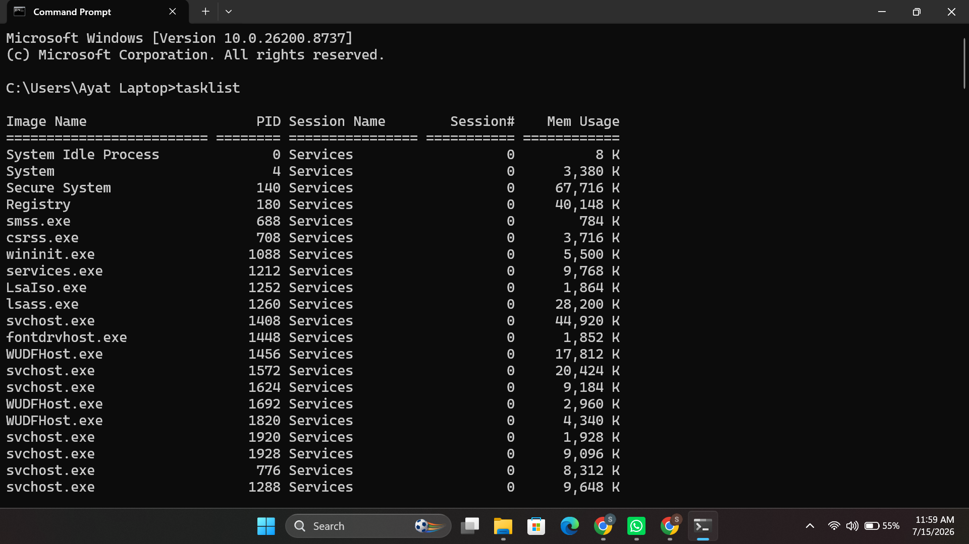
Figure 1:tasklist command showing active Windows processes (process management).

1.2 Memory Management
Memory management manages the allocation, protection and deallocation of the main memory (RAM) of each process that is currently running, so that no running process will use the memory of another process. Different methods were used in modern operating systems, such as paging, segmentation and virtual memory, where the OS is able to expand the memory it uses to memory on disk if it becomes full [3] [4]. On windows, each process has its own virtual address space of 8 terabytes, threads in a process can access its virtual address space but cannot access those of another process, thus, the system is protected from getting corrupted [1]. PowerShell's Get-Process can be used to get the live memory used by each process, as illustrated later in Section 2.

1.3 File and Device Management
File management organizes the way in which data is stored, named and accessed on storage devices such as creation, deletion, permissions and access methods to data [2]. Device management is a way to manage hardware—including disks, printers, and network adapters—and to transmit information, such as print queues, using drivers, and to store print jobs in a queue until they can be sent to a printer (spooling) [2]. The file and directory operations can be monitored from the command line directly - e.g. on Linux (Figure 2), the listing of the file and directory attributes is done by the command ls -la and on Windows (Figure 3) the network device configuration is displayed by the ipconfig /all command.
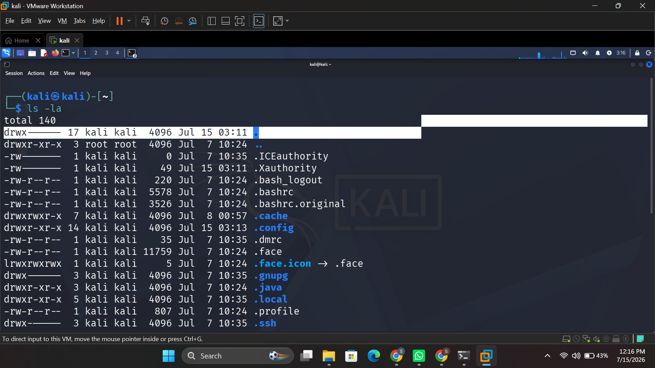
Figure 2: ls -la command showing file permissions and attributes on Kali Linux (file management).
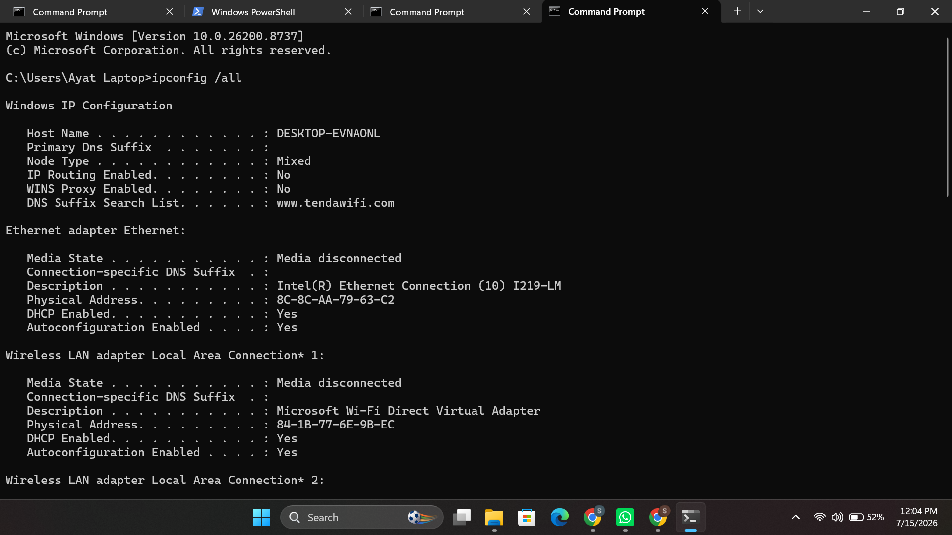
Figure 3: ipconfig /all command showing network adapter configuration (device management).

1.4 User Interface, Protection and Security
The operating system also offers the user interface that the users will use to interact with the computer, either graphical user interface (GUI) or command-line interface (CLI) [7]. Protection and security mechanisms are used to control the access to resources by users and processes; they are needed to prevent unauthorized use, the presence of malware and data theft [2]. The utility programs used to manage user accounts and permissions through the command line are available on both Windows and Linux, and are illustrated in this report, in Sections 2 and 3 respectively.

2. Using the Windows OS command line
There are five areas of administration that are covered in this section, using Batch and PowerShell command-line tools: process administration, file and directory administration, network testing and monitoring, user administration, and task scheduling. A screenshot of the execution and output of each command is displayed with it.

2.1 Process Management
The tasklist command displays all currently running processes as well as the process ID (PID) and memory usage of each process, and includes the filter switch /FI to list only processes that satisfy the filter condition (such as one based on the name of a specific image [6] (Figure 4)). The taskkill /IM notepad.exe /F command kills a process if it is currently active, by process image name (Figure 5); while the PowerShell command Get-Process | Sort-Object CPU -Descending returns objects for live processes and will send them to the Sort-Object function to sort them by CPU time [6] (Figure 6).
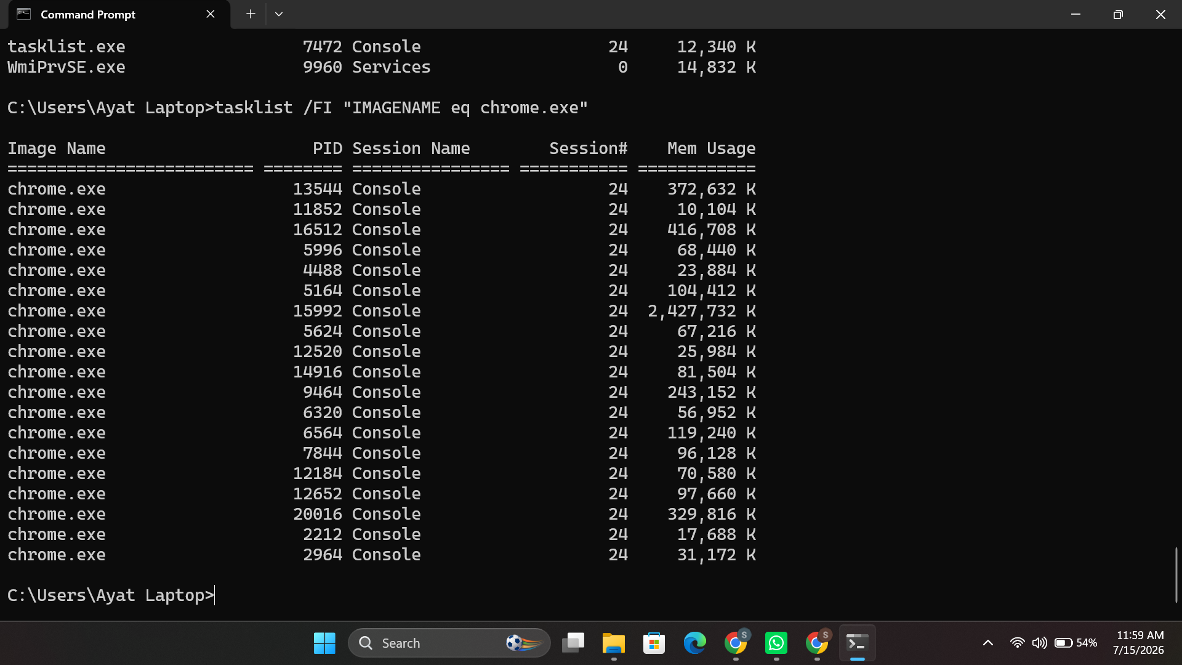
Figure 4: tasklist /FI "IMAGENAME eq chrome.exe" — filtering processes by name.
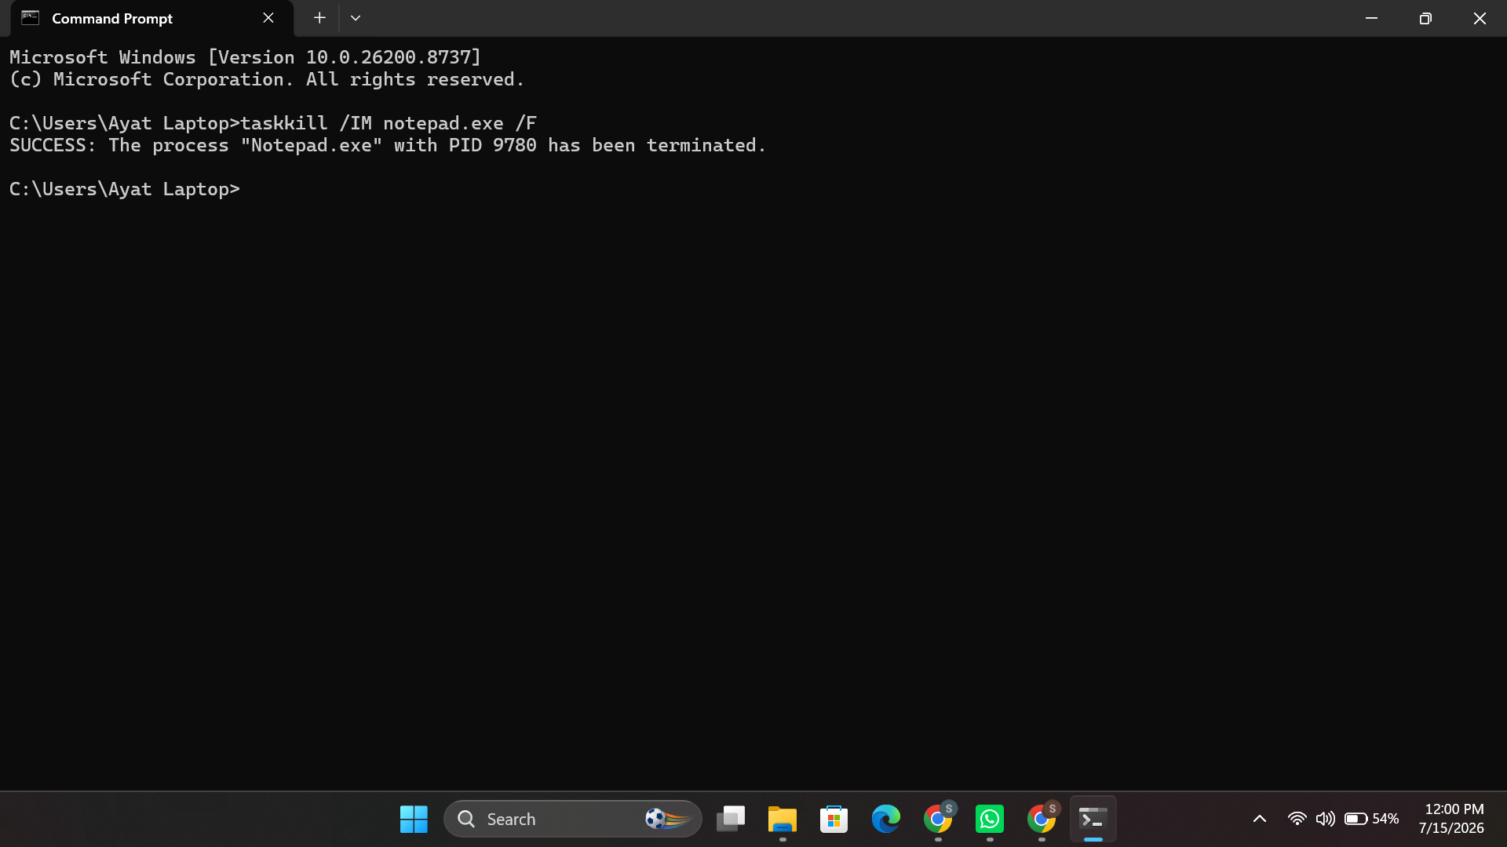
Figure 5: taskkill /IM notepad.exe /F — forcibly terminating a process.
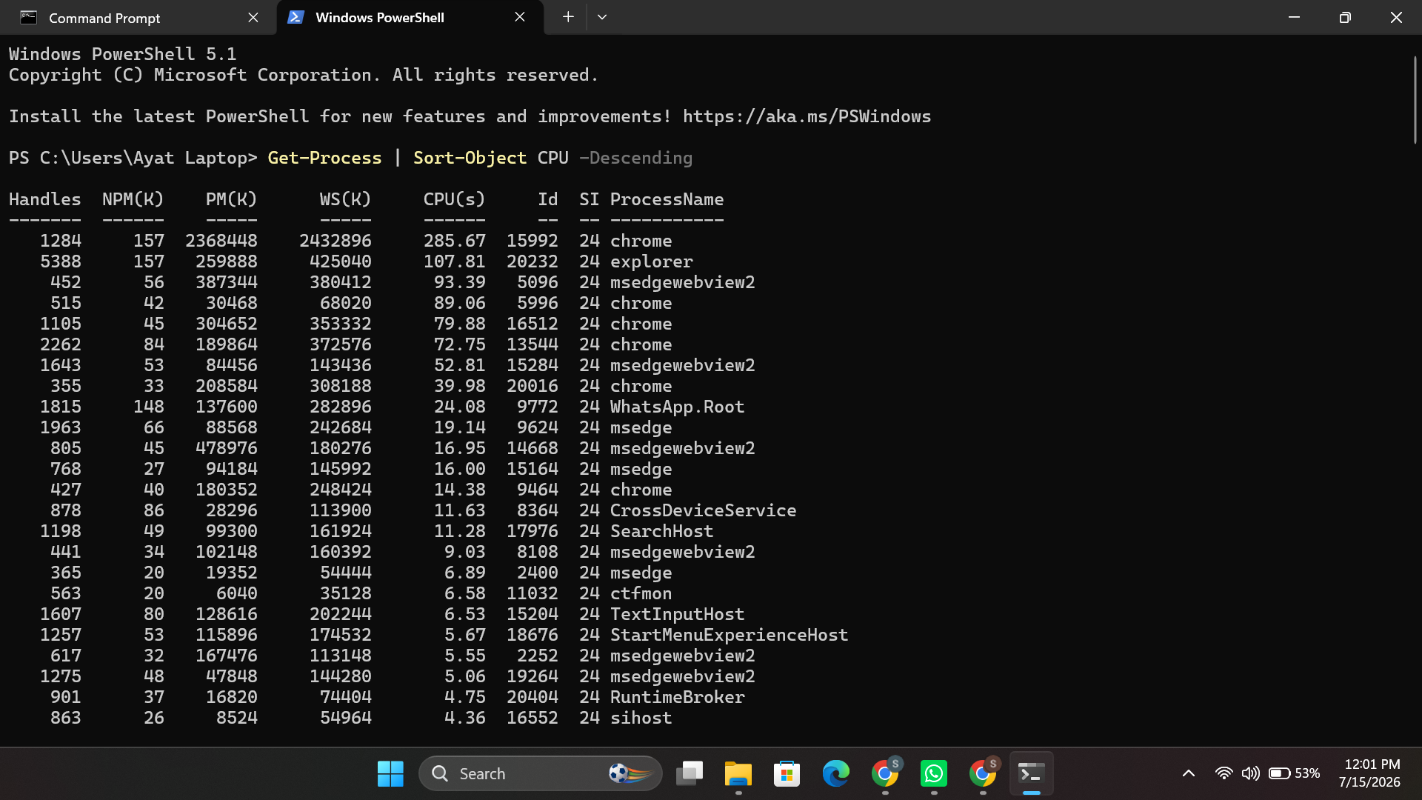
Figure 6: Get-Process | Sort-Object CPU -Descending — ranking processes by CPU usage.

2.2 File and Directory Management
The mkdir command makes a new folder; copy makes another copy of a file, prompting for confirmation before it overwrites an existing file; and del /F force-deletes a file; see Figures 7 to 9.
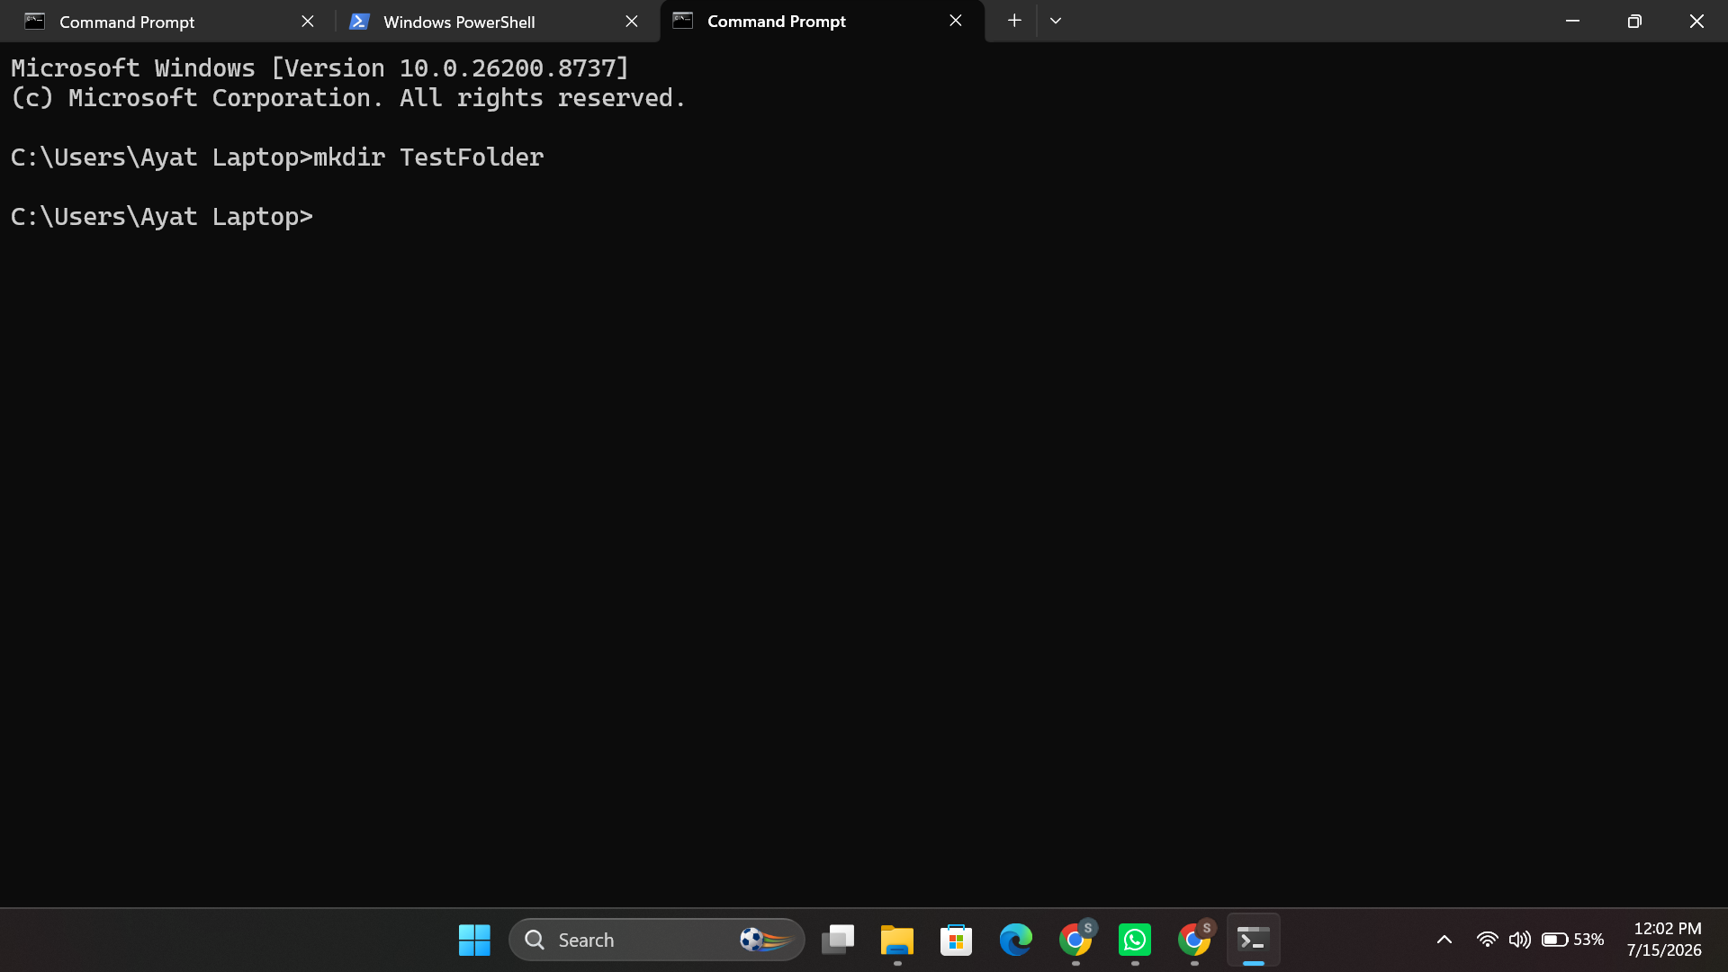
Figure 7: mkdir TestFolder — creating a new directory.
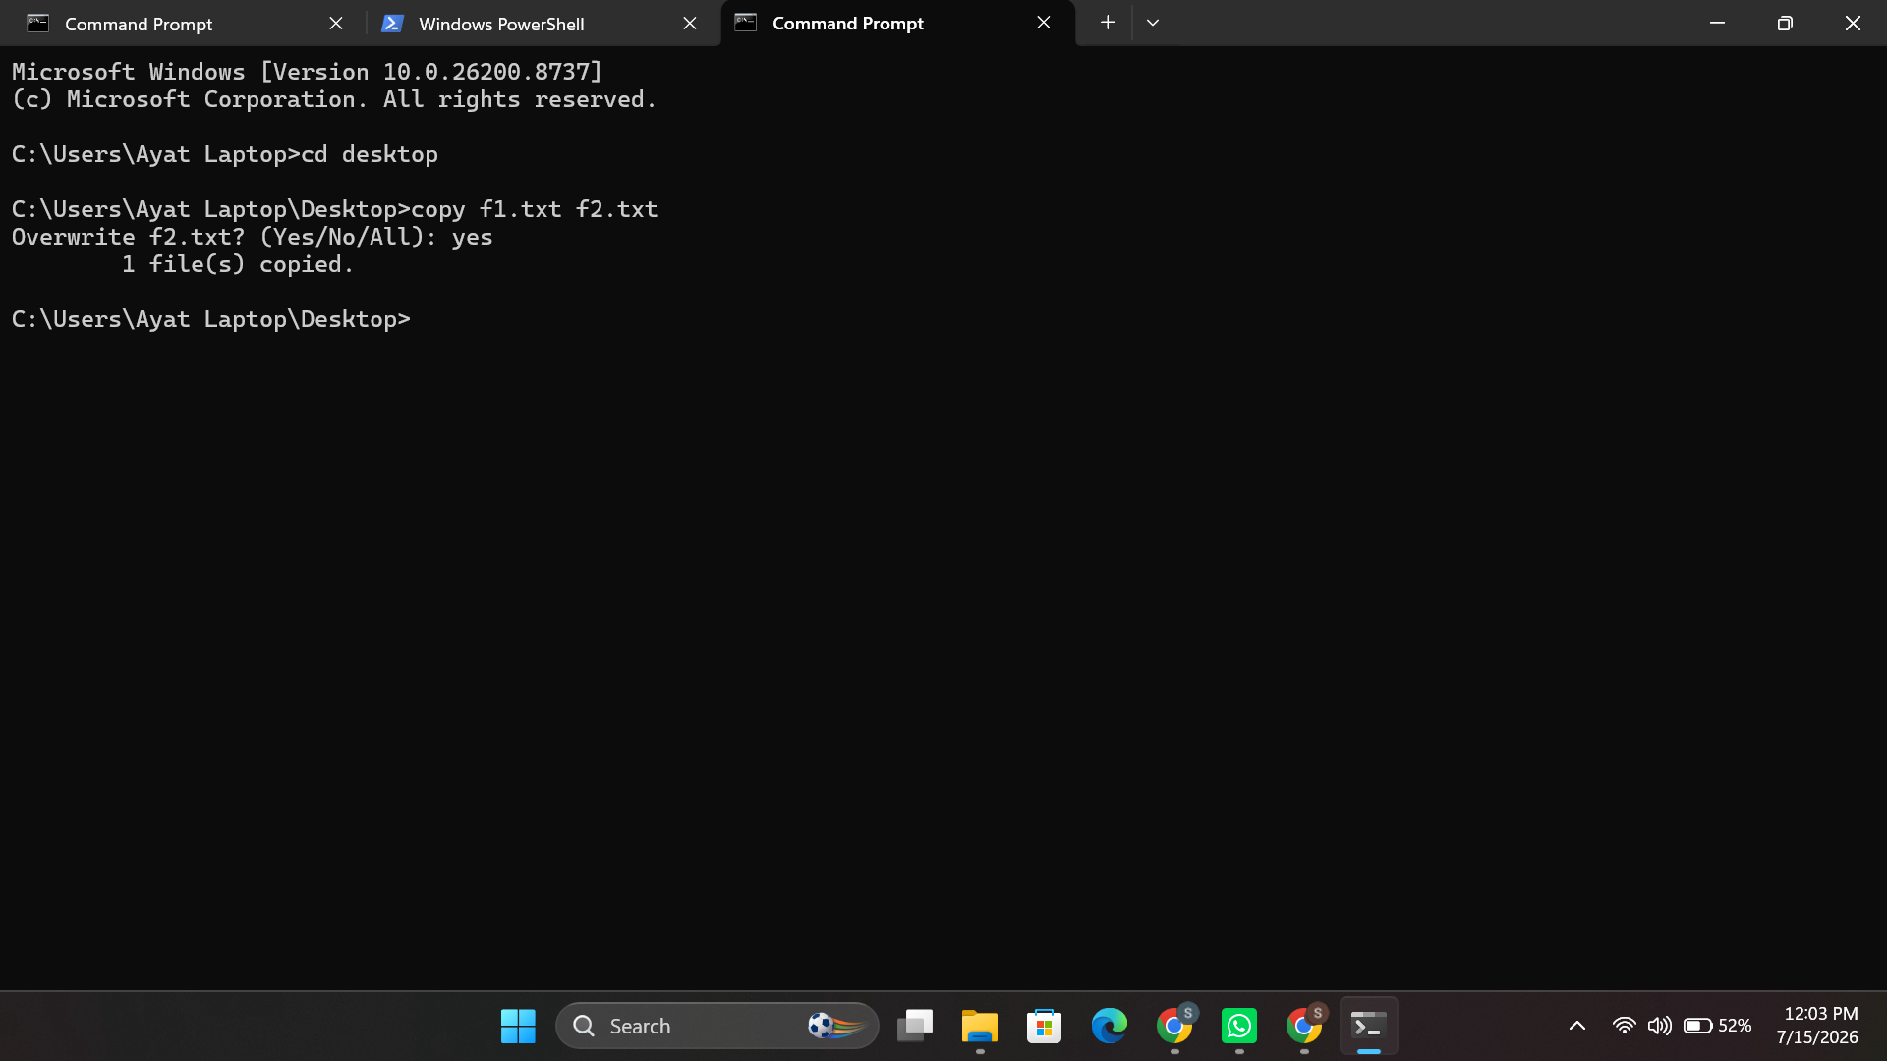
Figure 8:copy f1.txt f2.txt — copying a file with overwrite confirmation.
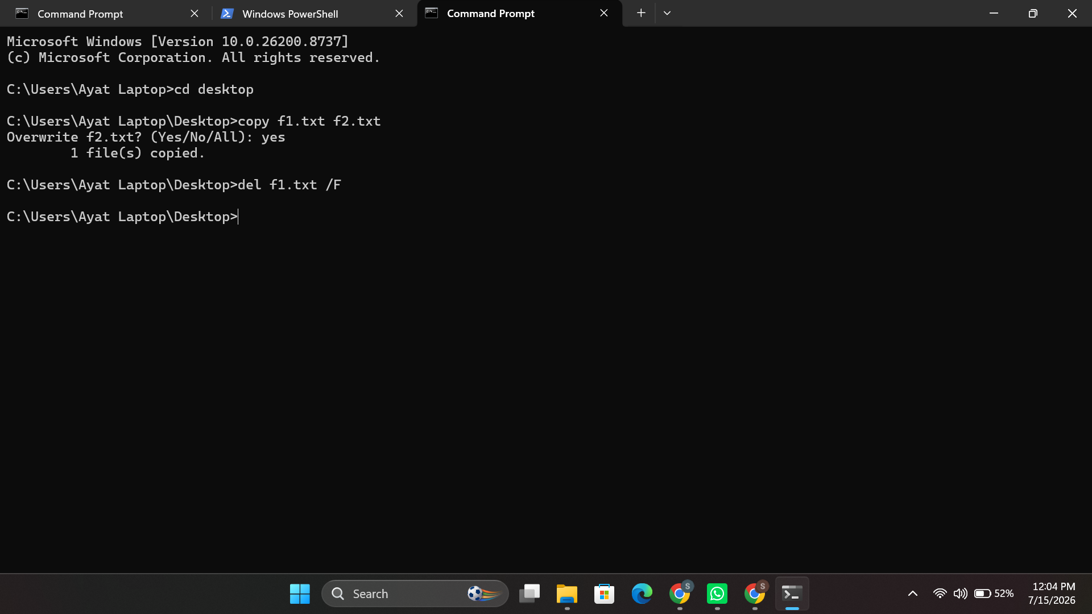
Figure 9: del f1.txt /F — force-deleting a file.

2.3 Network Testing and Monitoring
The ping -n 4 command is used to test connectivity to a destination and measure the round-trip time (RTT) between the local host and the destination, as shown in Figure 10. ipconfig /all is used to display detailed information about the configuration of each network adapter, such as the host name, DNS suffix, and physical address (MAC address), as shown in Figure 11. netstat -an is used to display a list of all active TCP connections and listening ports, as shown in Figure 12. tracert is used to report the route and latency for each hop between the local host and a destination, as shown in Figure 13. nslookup is used to resolve a domain name to an IP address using the information provided by the configured DNS server, as shown in Figure 14.
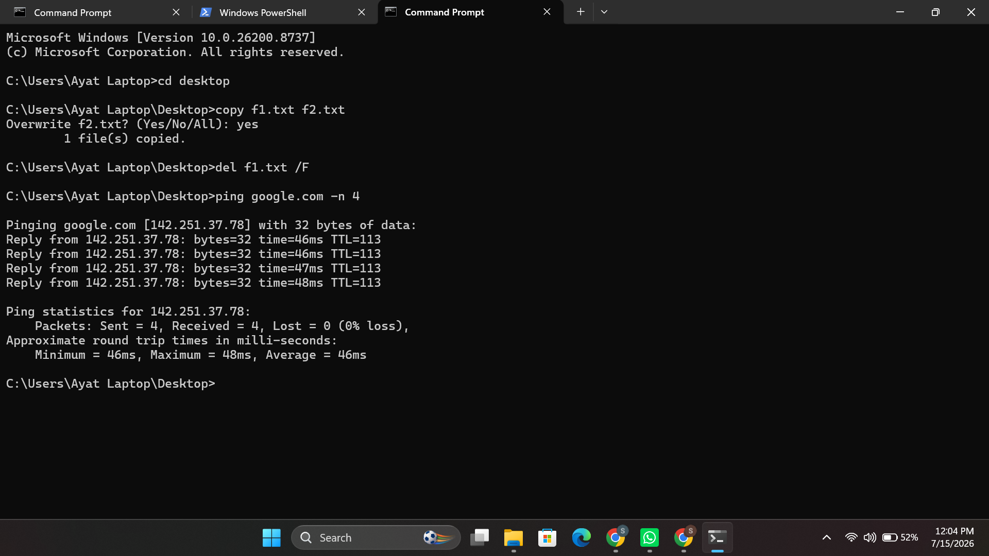
Figure 10: ping google.com -n 4 — testing network connectivity.
Figure 11:ipconfig /all — detailed network adapter configuration.
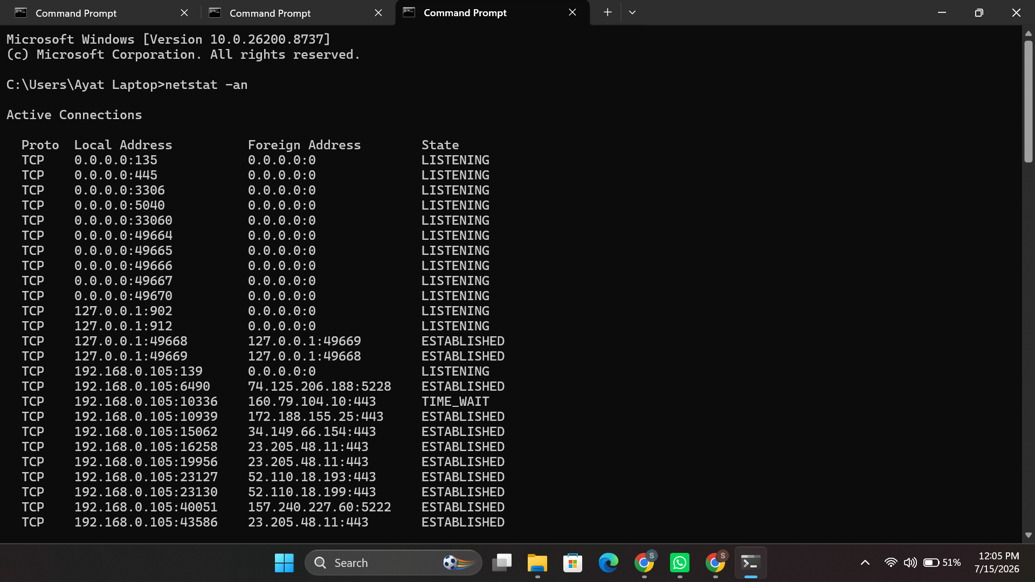
Figure 12: netstat -an — active and listening TCP connections.
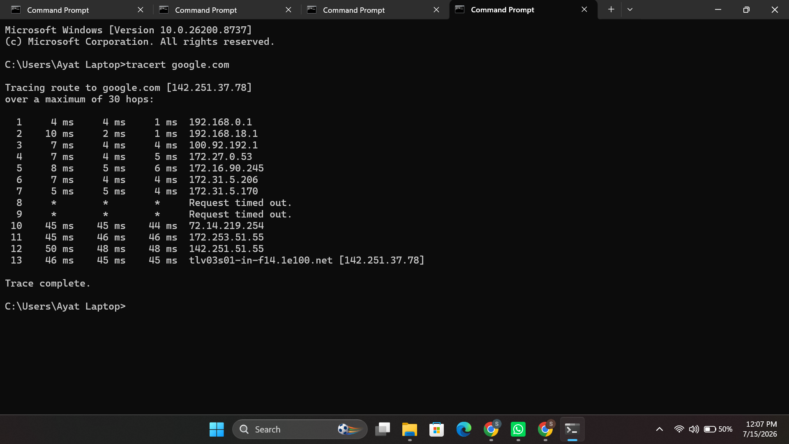
Figure 13: tracert google.com — tracing the network route to a destination.
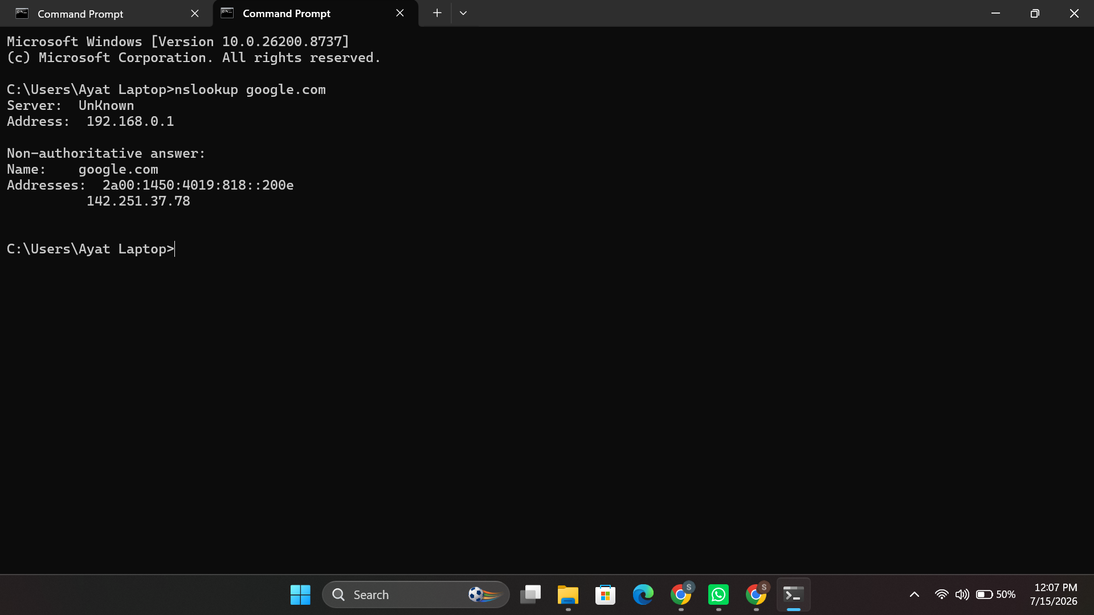
Figure 14: nslookup google.com — resolving a domain name to an IP address.

2.4 User Management
The net user command shows the list of local user accounts (Figure 15), net user TestUser Pass123 /add adds a new local user with a password, and net localgroup administrators lists the members of the local Administrators group, showing which accounts are members of this group and thus have elevated privileges (Figure 16).
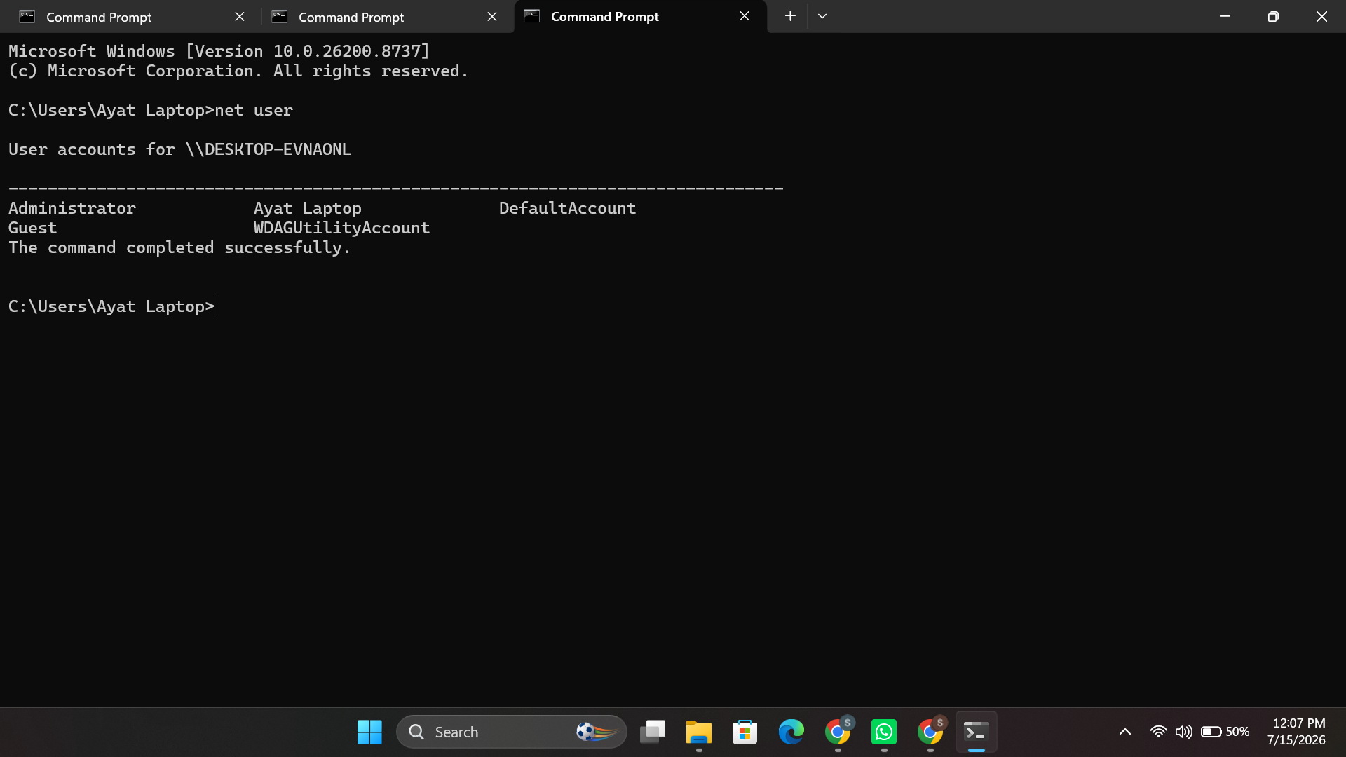
Figure 15: net user — listing local user accounts.
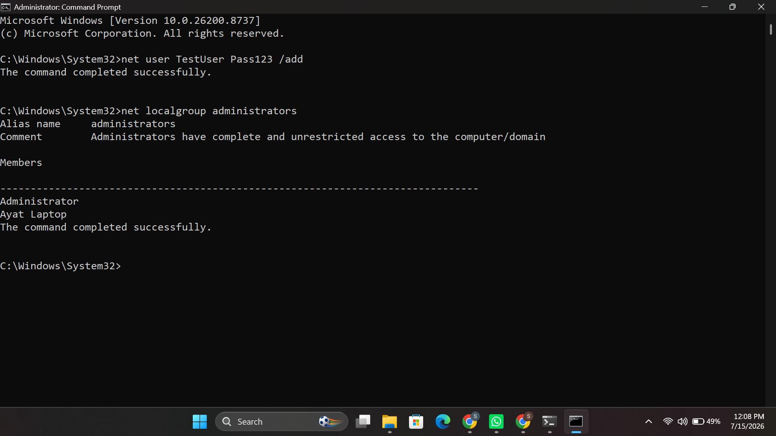
Figure 16: net user /add followed by net localgroup administrators — creating a user and viewing group membership.

2.5 Task Scheduling
schtasks /query displays all the tasks that were registered in Windows Task Scheduler, including the next time the task is run and whether it is running or not [8] (Figure 17), and schtasks /create /tn /tr /sc /st registers a new task — in this case the test task named TestTask will launch notepad.exe every day at 09:00 [9] (Figure 18).
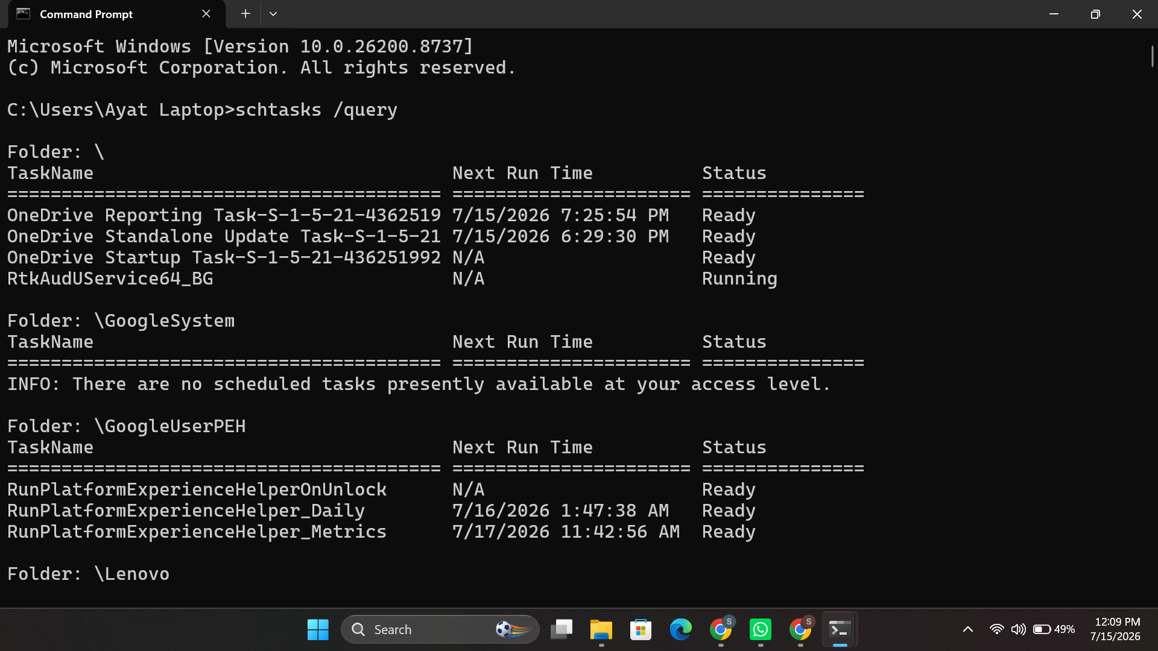
Figure 17: schtasks /query — listing scheduled tasks and their status.

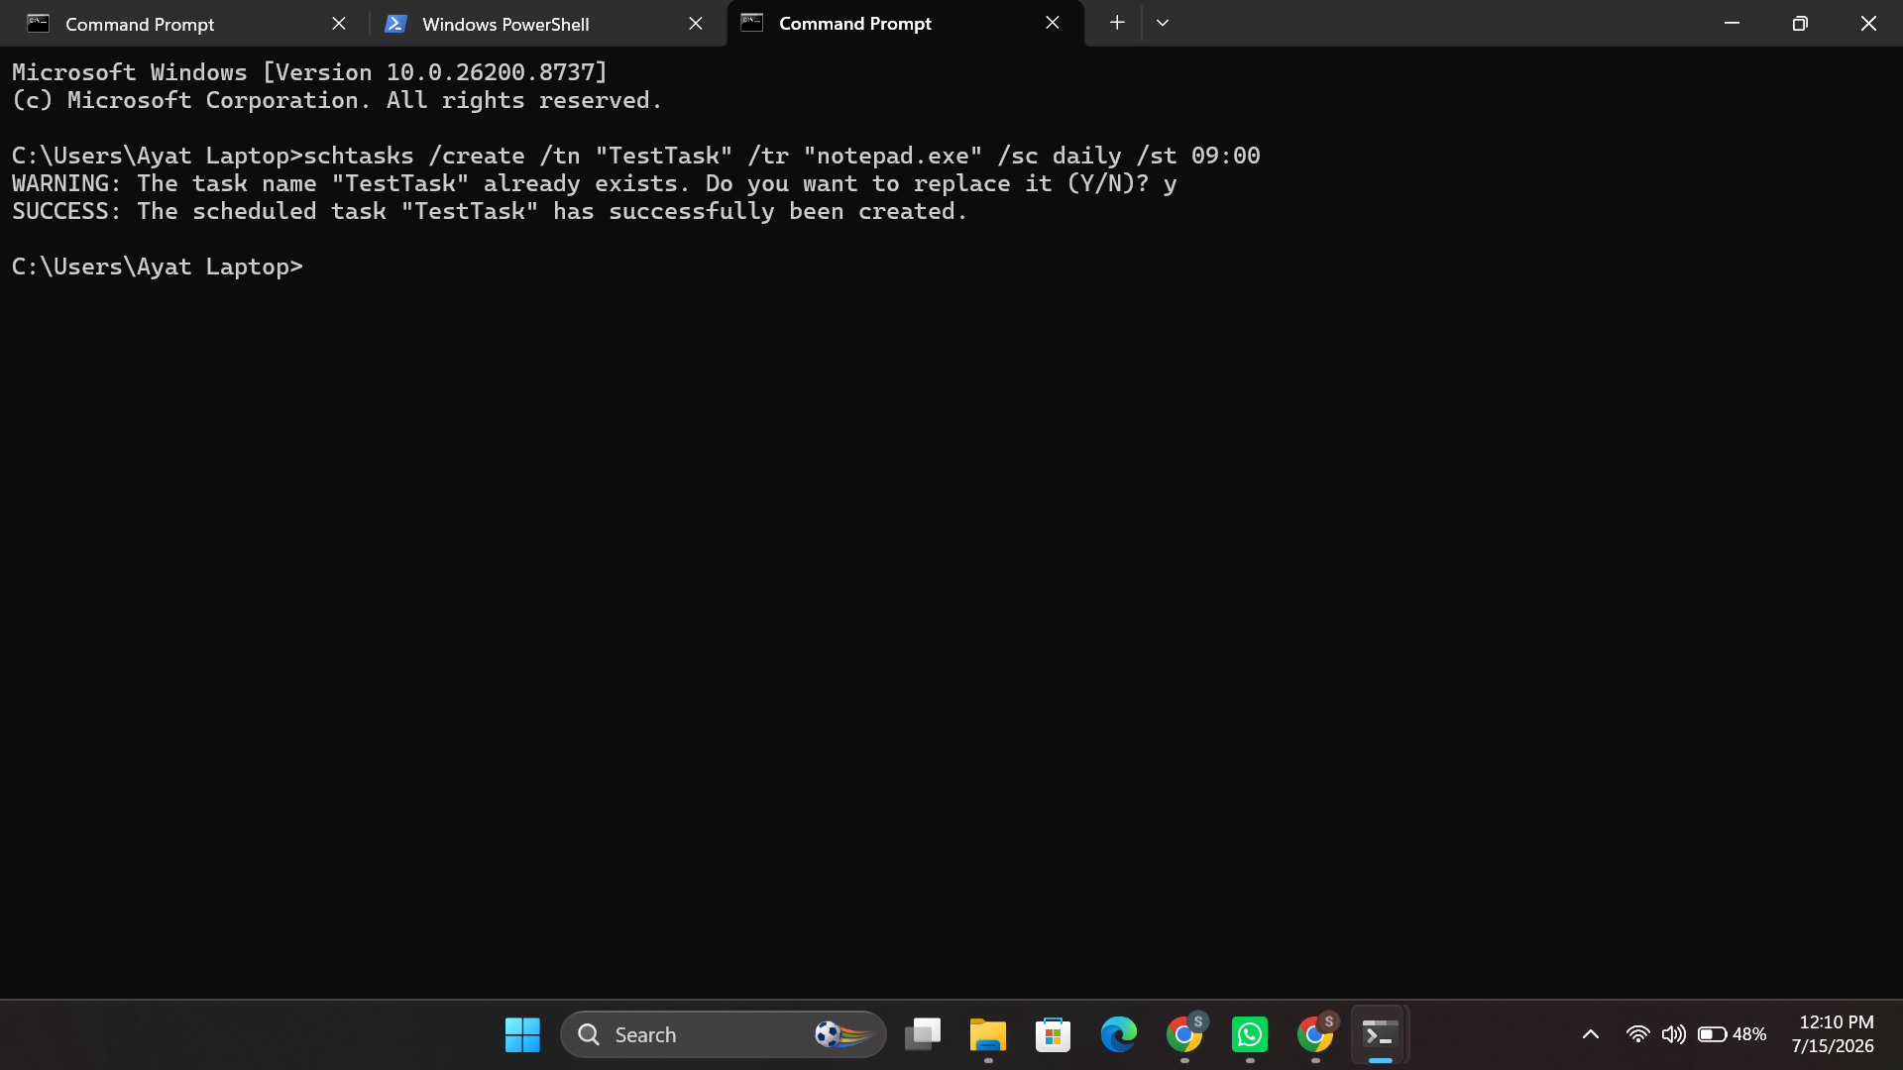
Figure 18: schtasks /create — registering a new daily scheduled task.

3. Use of Linux OS CLI Commands
It will repeat the same 5 administrative areas using Bash commands that run on Kali Linux, showing the same functionality in a Linux-based operating system.

3.1 Process Management
The ps aux command prints out all the active processes on the system and their resource consumption, including who owns them, how much CPU and memory they use, and their state (Figure 19), and the interactive top utility will show a constantly changing, ordered list of processes and their resource use [10] (Figure 20). kill -9 <PID> is used to terminate a process with signal SIGKILL by its PID [17] (Figure 21).
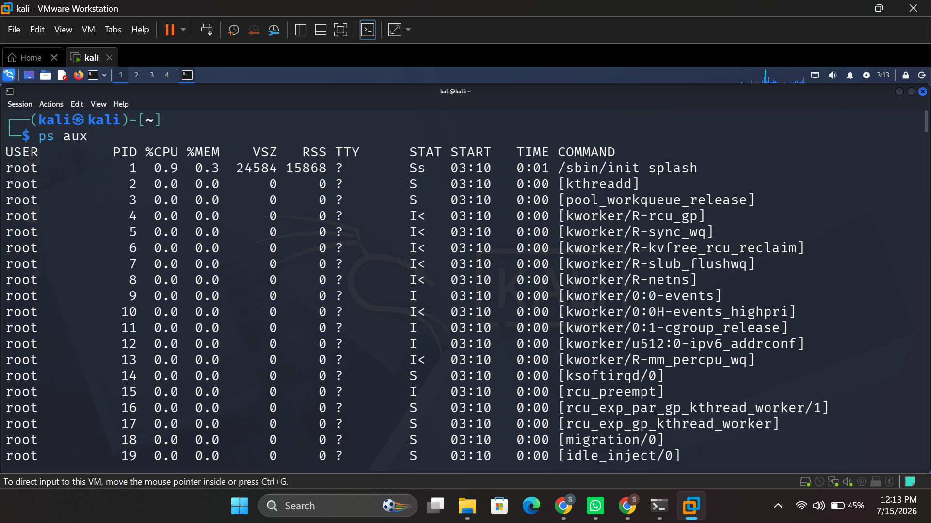
Figure 19: ps aux — listing all running processes.
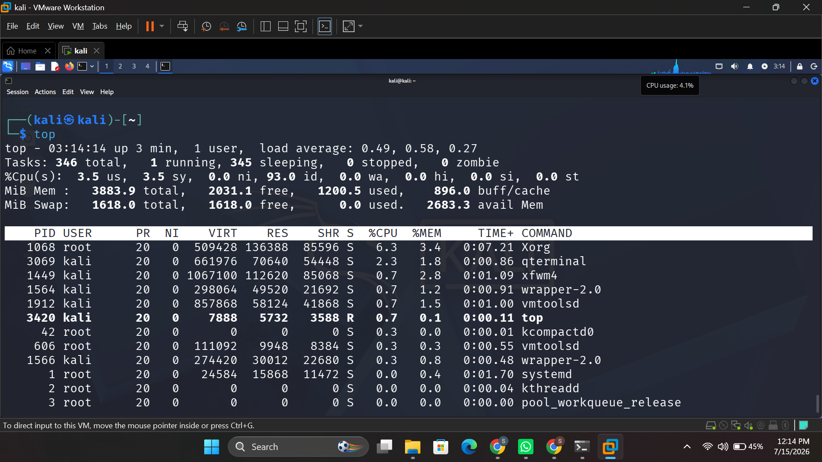
Figure 20: top — live view of system resource usage by process.
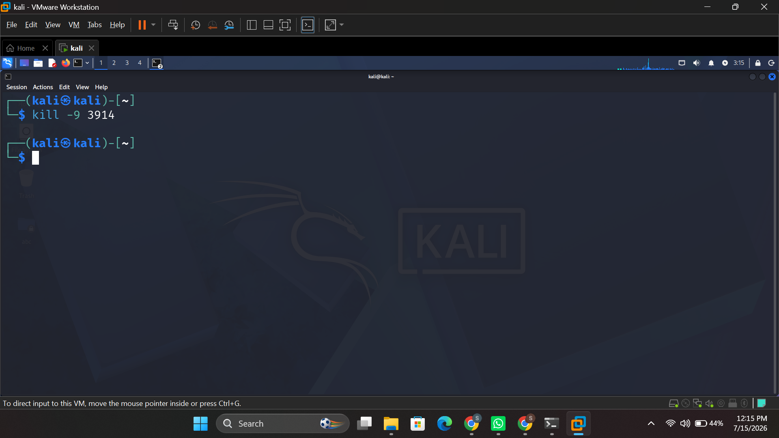
Figure 21: kill -9 3914 — forcibly terminating a process by PID.

3.2 File and Directory Management
The ls -la command lists all files and directories, including hidden files, together with permissions, ownership, and size [11] (Figure 22). mkdir makes a new directory of files (Figure 23); find recursively searches the file system and lists the names of files that match a given name pattern [10] (Figure 24); and chmod 755 changes the file permission 755, allowing the owner to read, write and execute the file, and permitting others to read and execute the file (Figure 25).

Figure 22:ls -la — listing files with permissions and ownership.
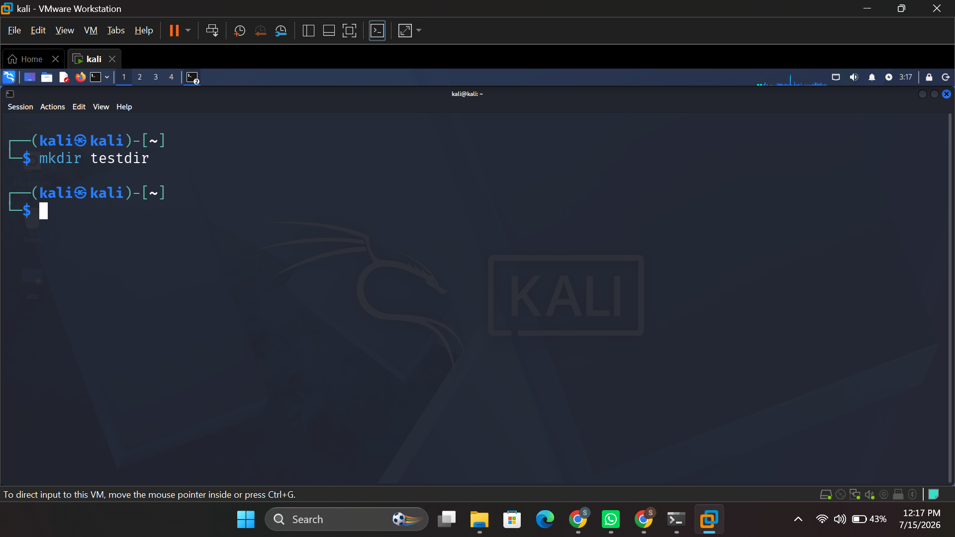
Figure 23: mkdir testdir — creating a new directory.
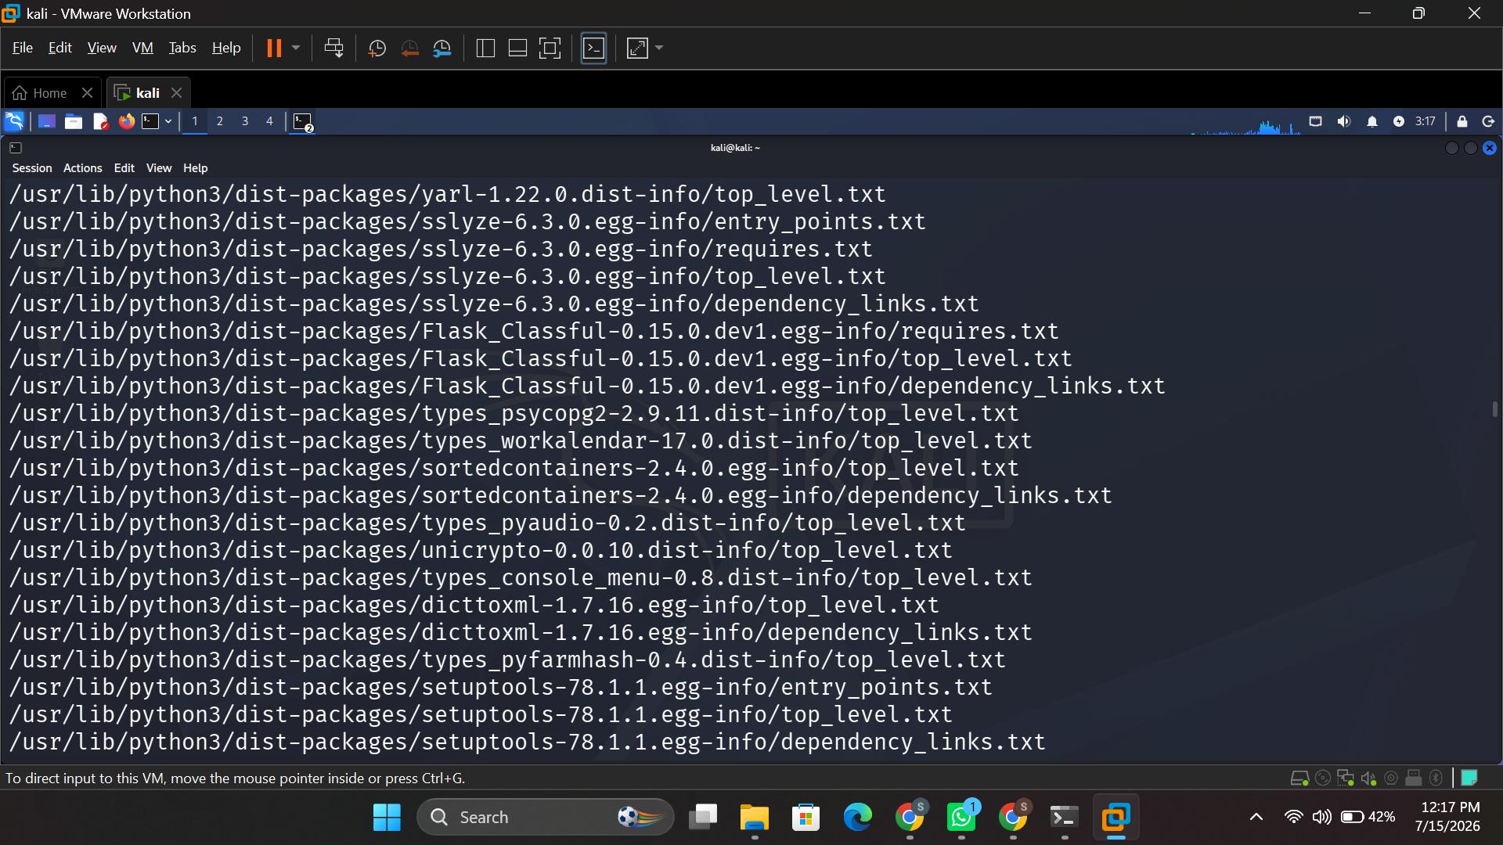
Figure 24:find / -name — searching the filesystem for files by name.
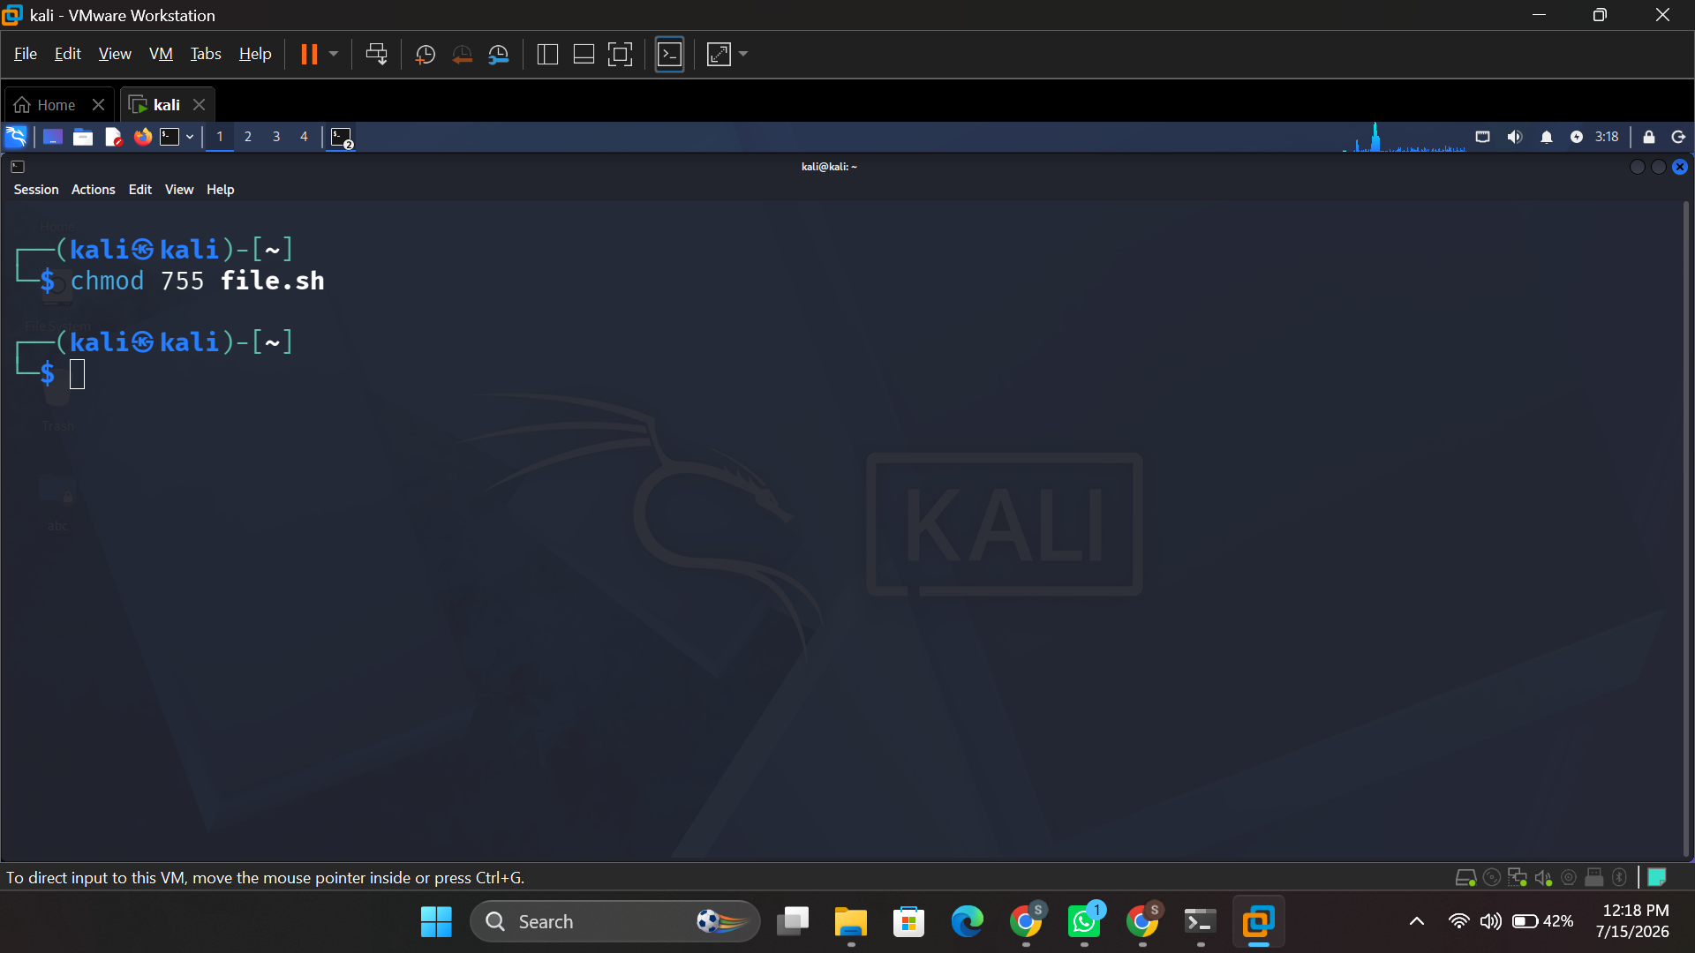
Figure 25:chmod 755 file.sh — setting read/write/execute permissions.

3.3 Network Testing and Monitoring
The ping -c 4 command sends four ICMP echo requests and prints packet loss and round trip statistics (Figure 26); the ifconfig command prints the configuration of the network interface, including an IPv4 and IPv6 address and an MAC address (Figure 27); the netstat -tulnp command prints listening TCP and UDP packets and the associated process (Figure 28); the traceroute command prints the route to a target host, hop by hop (Figure 29); and the nmap -sV command performs a port scan of a target host to detect services (Figure 30).
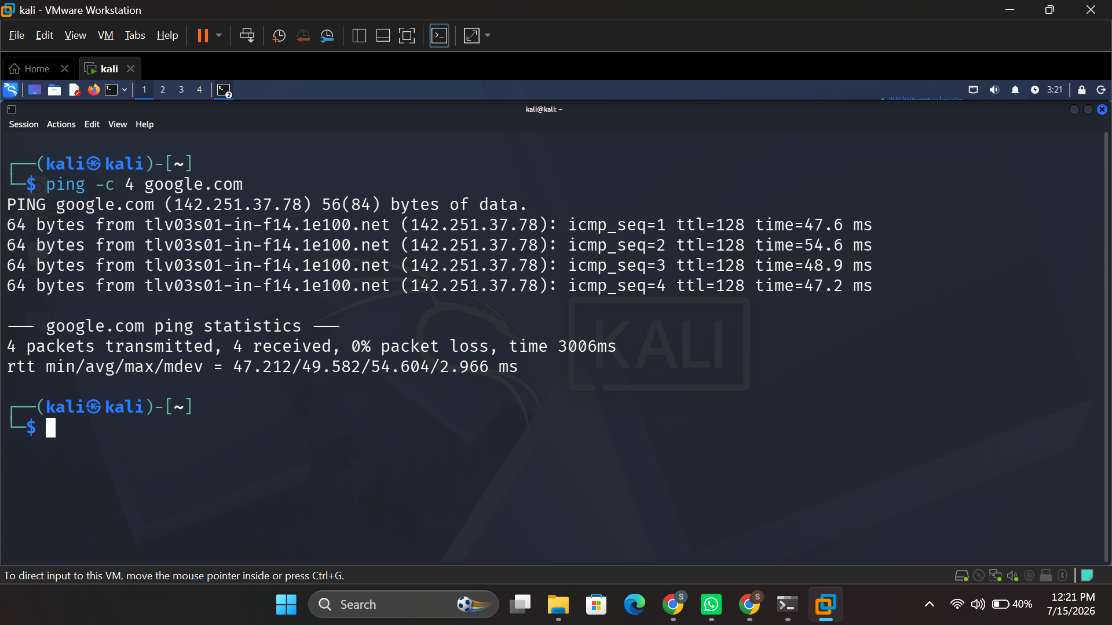
Figure 26:ping -c 4 google.com — testing connectivity and latency.
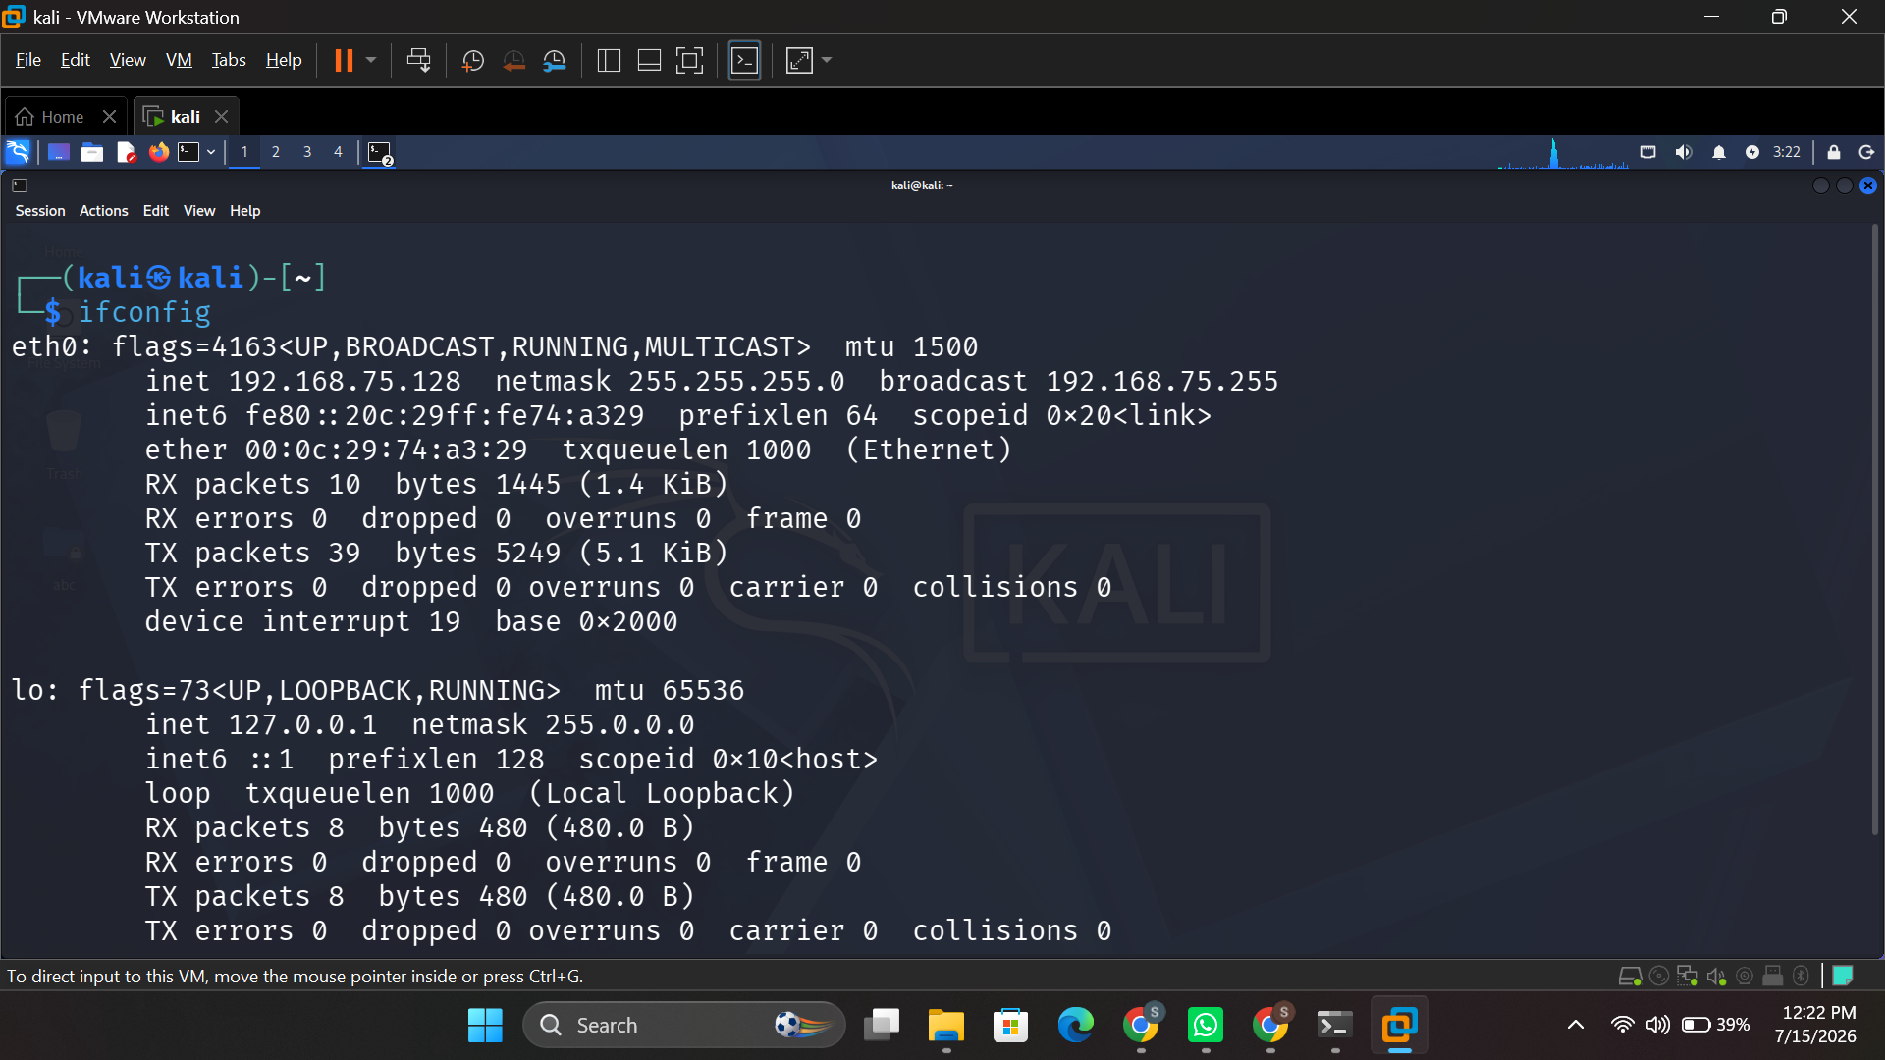
Figure 27: ifconfig — network interface configuration.
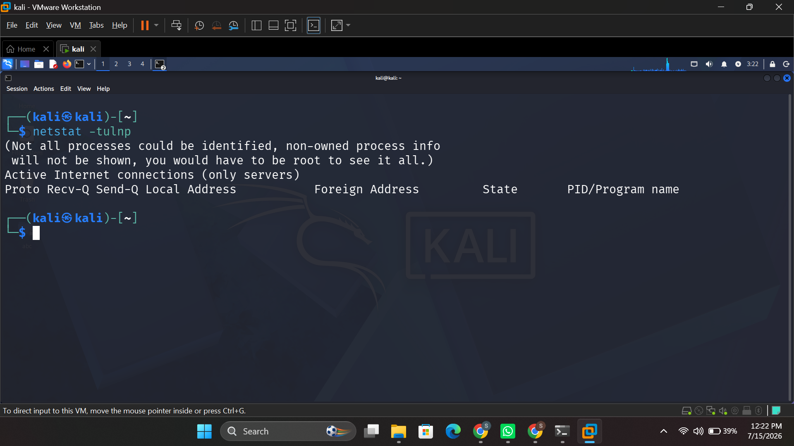
Figure 28:netstat -tulnp — listening TCP/UDP ports.
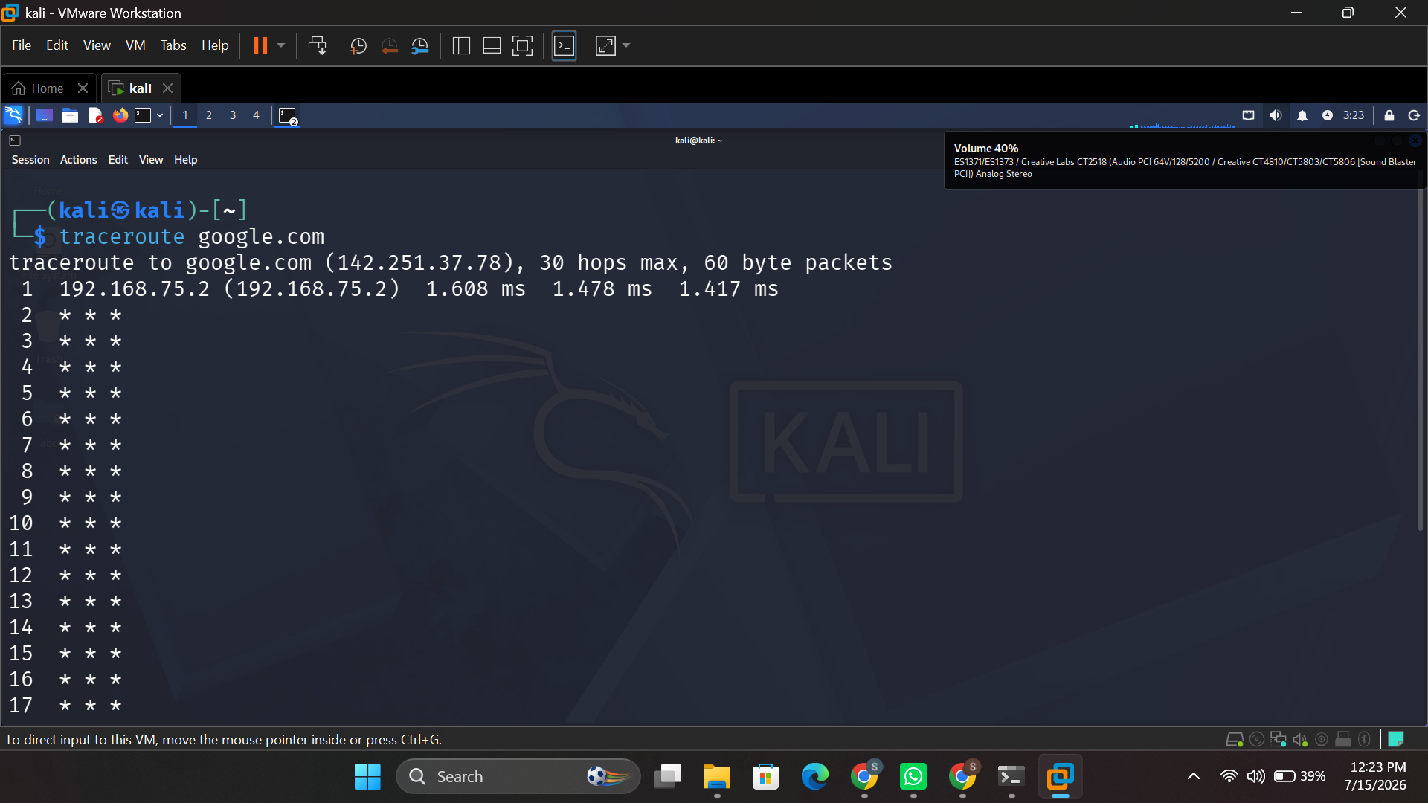
Figure 29:traceroute google.com — tracing the route to a destination host.
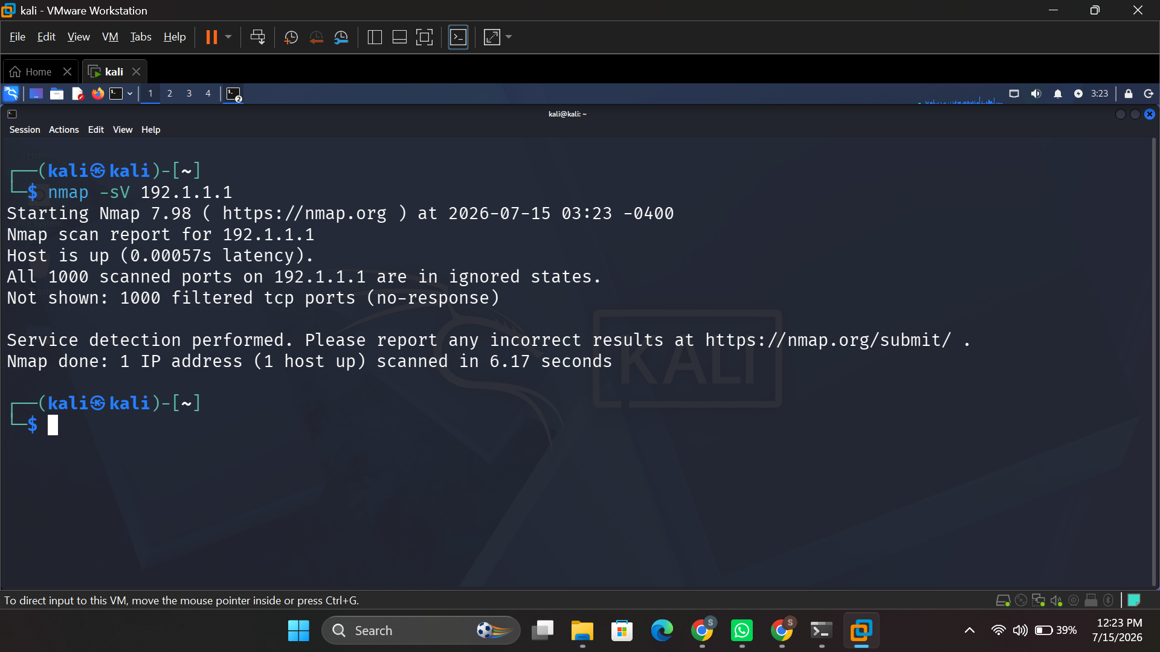
Figure 30:nmap -sV — service-detection scan of a target host.

3.4 User Management
The whoami command prints the name of the user currently logged in (Figure 31), the useradd command creates a new user account (Figure 32), the passwd command sets a user account's password, cat /etc/passwd displays all local accounts stored on the system (Figure 33) and groups <username> lists the groups to which a particular account belongs (Figure 34).
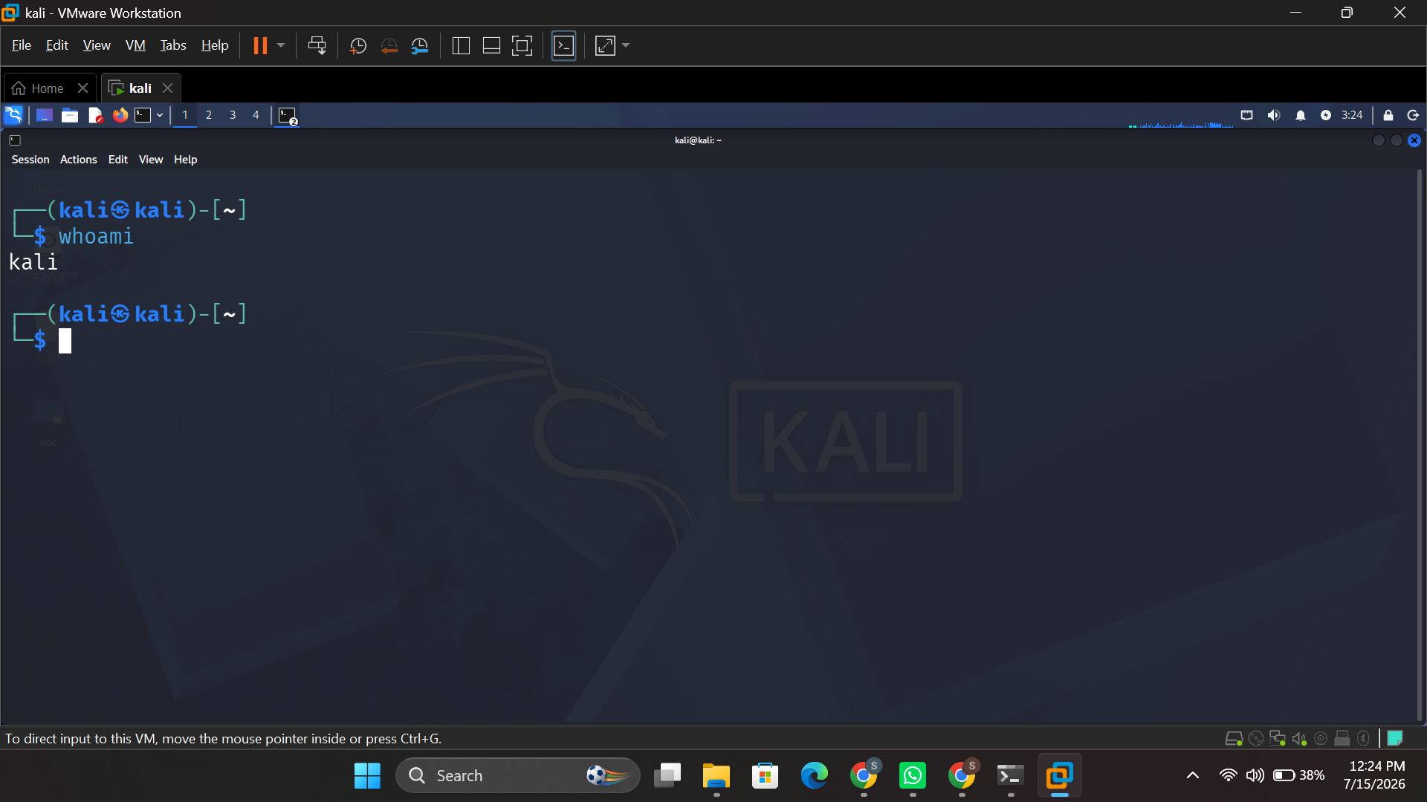
Figure 31:whoami — displaying the current logged-in user.
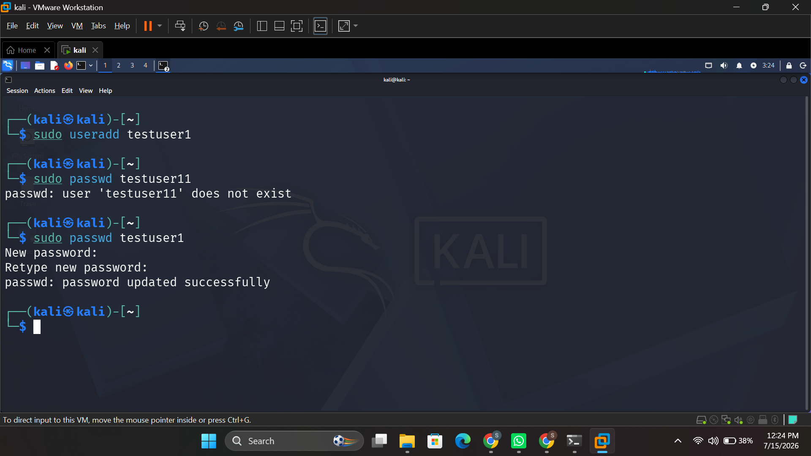
Figure 32:sudo useradd and passwd — creating a user and setting a password.
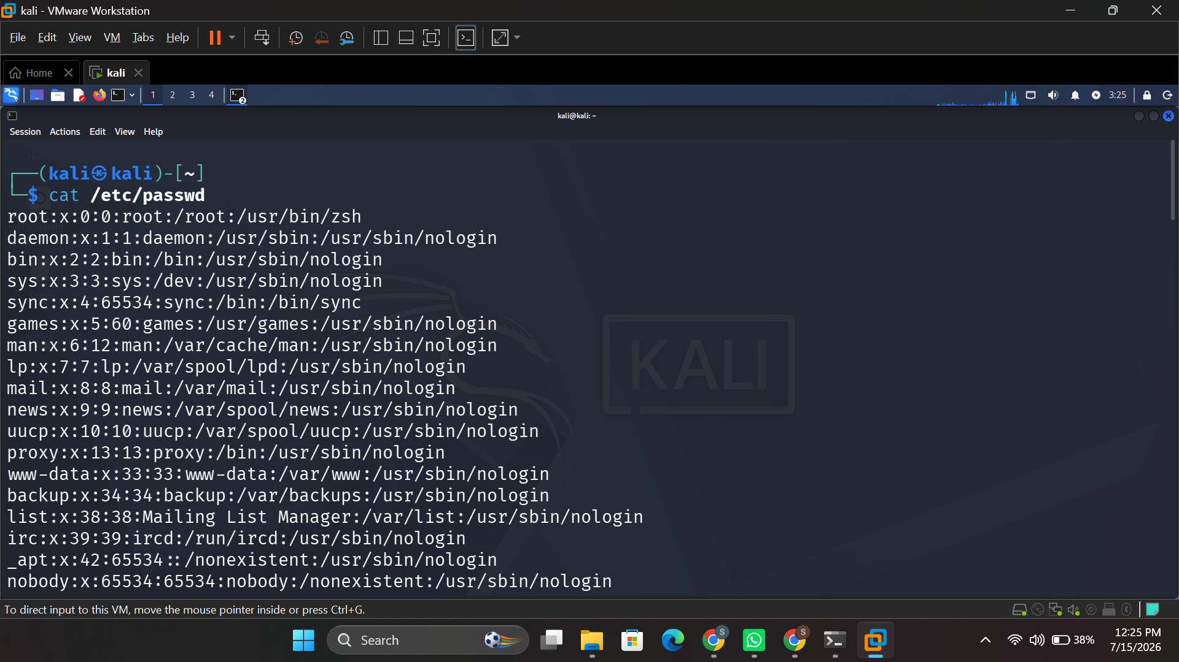
Figure 33:cat /etc/passwd — viewing all local user accounts.
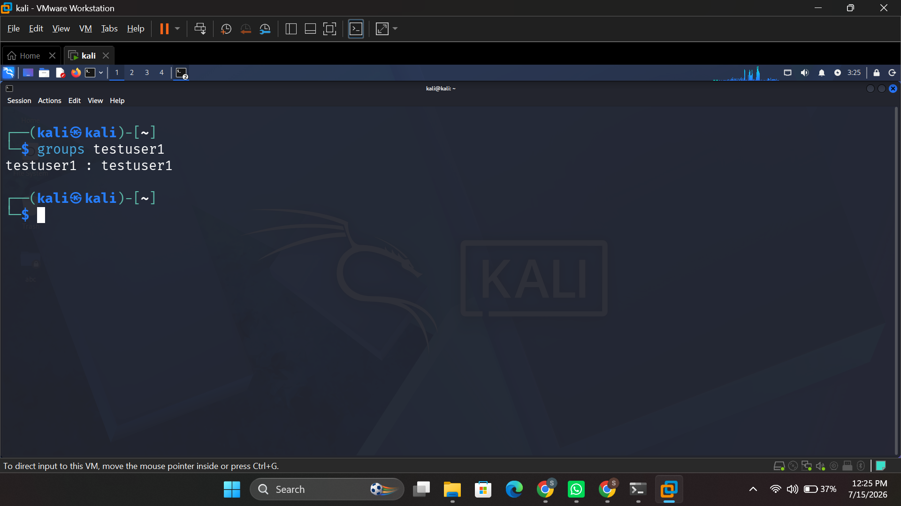
Figure 34: groups testuser1 — listing group membership for a user.

3.5 Task Scheduling
The command crontab -l will list all the cron jobs that are scheduled for the current user (Figure 35), and at 10:00 schedules a job for a single time, using /bin/sh shell (Figure 35).
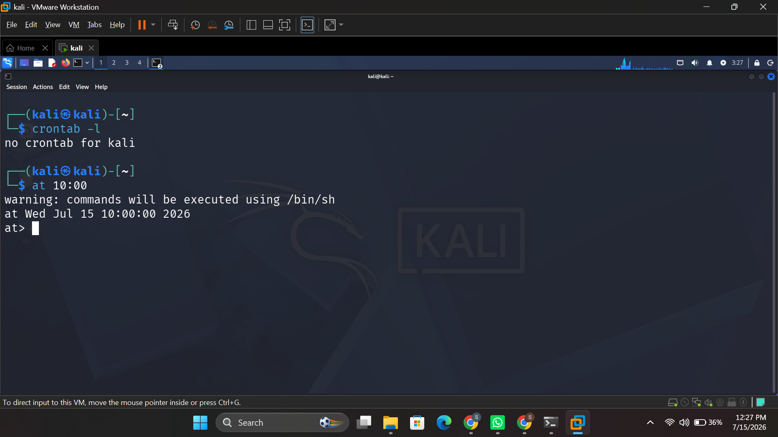
Figure 35: crontab -l and at 10:00 — viewing and scheduling one-off jobs.

4. Use of Windows OS Scripts
Two Batch scripts were written to illustrate the use of the Windows command-line automation. Each script features variables, input, a calculation and a conditional or loop to control the flow of the script.

4.1 Script 1 – Simple Calculator
This script asks the user for 2 numbers, adds them together with the set /a arithmetic operator and has the user repeat the calculation with a goto loop and an if statement.
@echo off
:menu
set /p num1="Enter first number: "
set /p num2="Enter second number: "
set /a sum=%num1%+%num2%
echo Sum = %sum%
set /p again="Run again? (y/n): "
if /i "%again%"=="y" goto menu
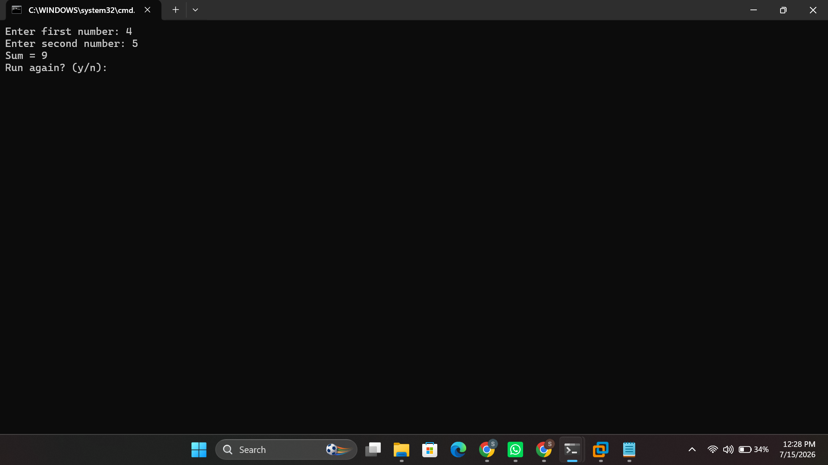
Figure 36: Execution of the Batch calculator script, showing user input, the calculated sum, and the loop prompt.

4.2 Script 2 – File Backup Automation
In this second script, the backup process is being automated to create a simple backup job. It stores the source and destination paths and then creates the backup folder only if it doesn't exist, and copies all of the text files from the source folder to the destination backup folder using a for loop.
@echo off
set src=C:\TestFolder
set dest=C:\Backup
if not exist %dest% mkdir %dest%
for %%f in (%src%\*.txt) do (
copy "%%f" "%dest%"
echo Copied %%f
)
echo Backup complete!
pause
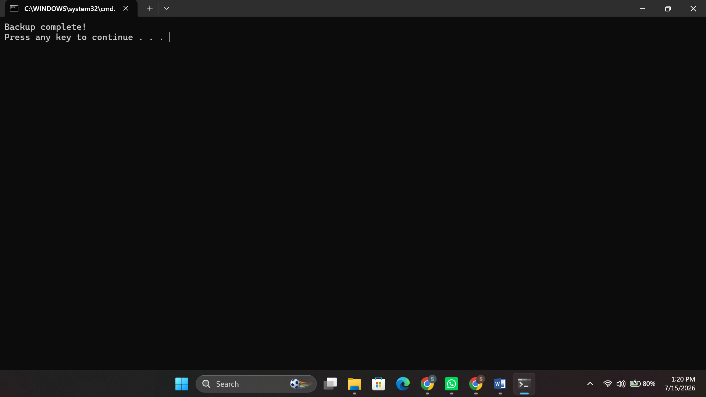
Figure 37:File Backup Automation

5. Use of Linux OS Scripts
Two bash scripts were written to show automation and control flow in the Linux terminal. All of the scripts contain a variable, an input, an arithmetic operation, and a loop or a conditional.

5.1 Script 1 – Simple Calculator
It prompts the user to enter two numbers, executes the sum using Bash arithmetic expansion $((…)), and uses a while loop with a conditional break to give the user the option to repeat the calculation any number of times he or she wants.
#!/bin/bash
while true; do
read -p "Enter number 1: " n1
read -p "Enter number 2: " n2
result=$((n1 + n2))
echo "Sum = $result"
read -p "Run again? (y/n): " ans
[[ "$ans" != "y" ]] && break
done
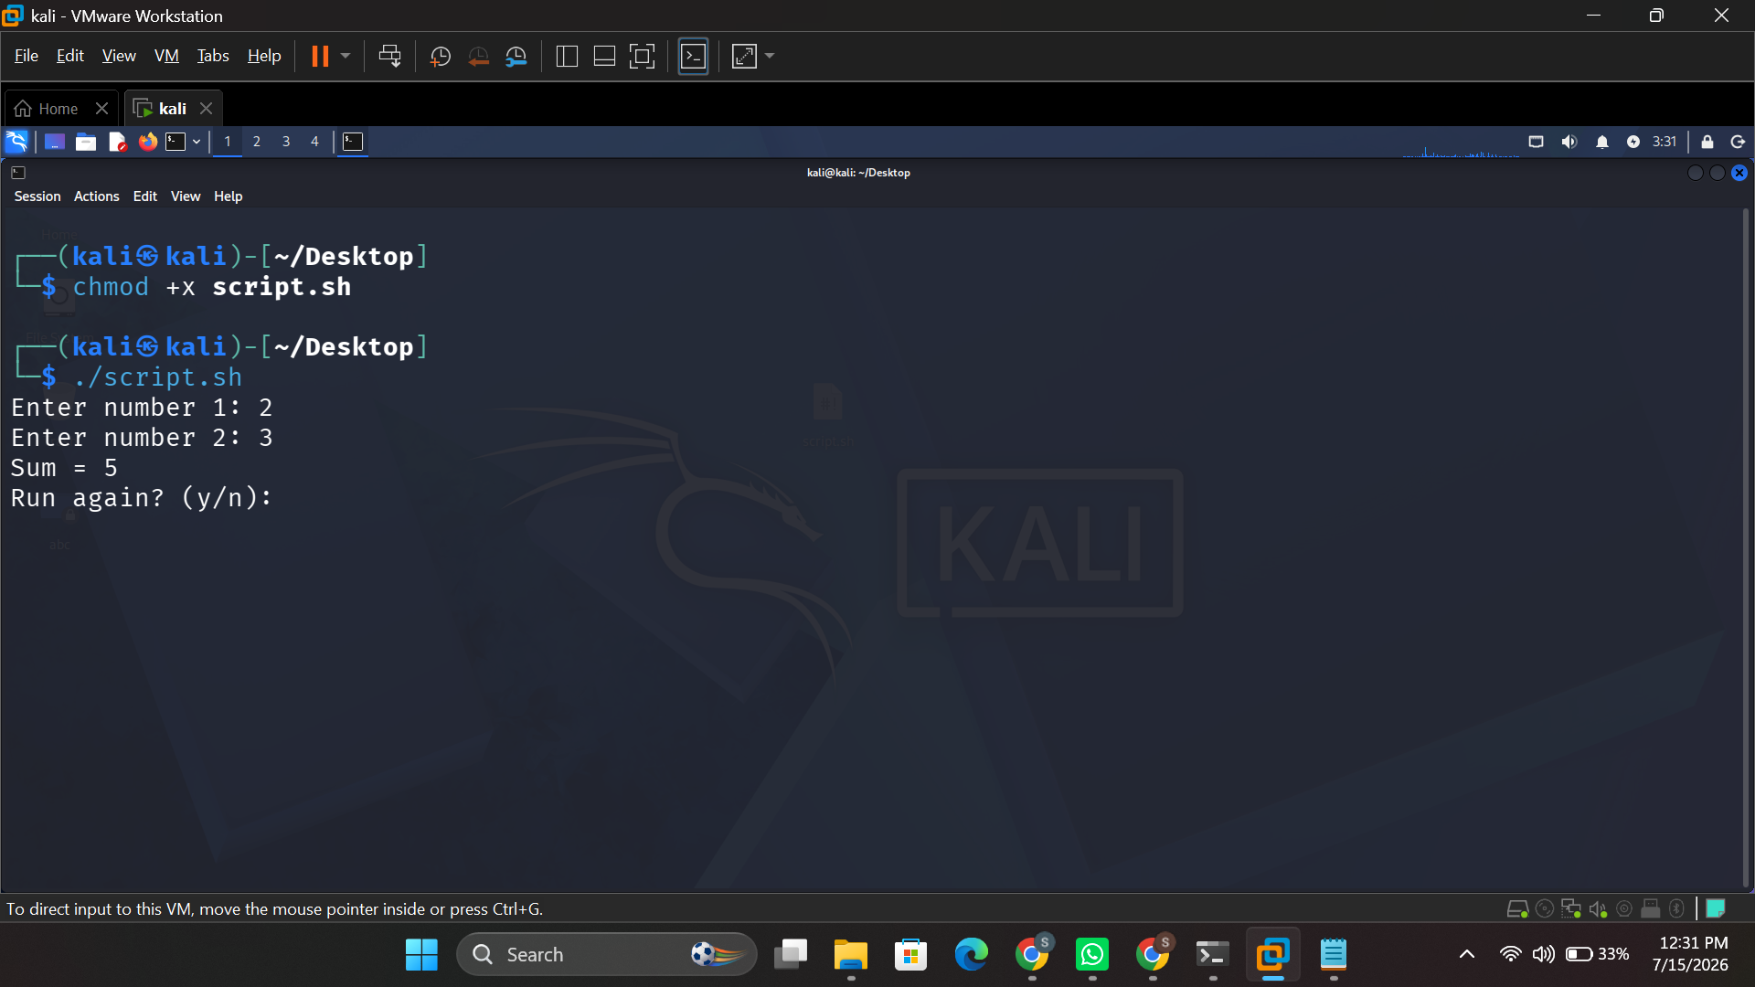
Figure 37: chmod +x script.sh followed by execution of the Bash calculator script.

5.2 Script 2 – System Disk Usage Monitor
This second script demonstrates automation with a for loop that repeats a check five times, using df to read current disk usage and an if/else conditional to warn the user when usage exceeds 80%.
#!/bin/bash
for i in {1..5}; do
echo "Check $i:"
df -h | grep "/dev/sda1"
used=$(df / | tail -1 | awk '{print $5}' | tr -d '%')
if [ "$used" -gt 80 ]; then
echo "Warning: Disk usage high!"
else
echo "Disk usage normal."
fi
sleep 2
done
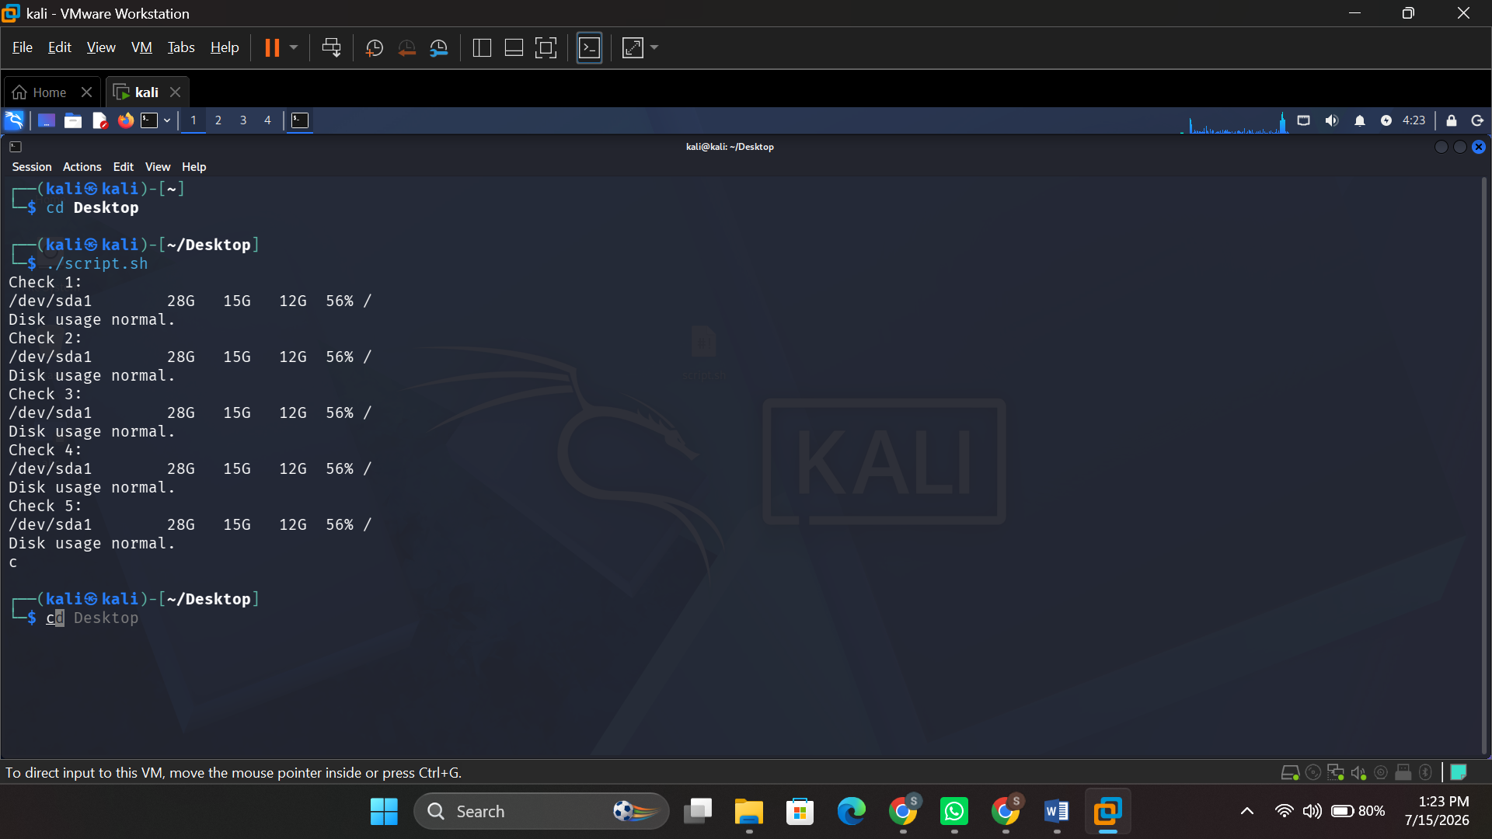
Figure 38:System Disk Usage Monitor

Conclusion
In this report, the key components of general purpose operating systems have been discussed; process management, memory management, file and device management, and user interface and security; and how each of these functions can be seen, monitored, and controlled using graphical applications as well as the command-line interface.
The commands and useful features of Windows Batch and PowerShell demonstrated the full extent of available command line tools for process control (tasklist, taskkill, Get-Process), file and directory operations (mkdir, copy, del), network diagnostics (ping, ipconfig, netstat, tracert, nslookup), user administration (net user, net localgroup) and task automation (schtasks). The same analysis was done for the Linux commands and it was found that the Kali Linux equivalent commands for each command are directly comparable, for example: ps, top, kill (process management); ls, mkdir, find, chmod (file management); ping, ifconfig, netstat, traceroute, nmap (network monitoring); useradd, passwd, groups (user management); and crontab, at (scheduling tasks).
The creation of Batch and Bash scripts solidified the concept of creating scripts that take advantage of variables, user input, arithmetic operators, and control flow structure, including loops and conditional statements, to automate repetitive administrative tasks, like performing calculations, backing up files, or monitoring disk usage. A hands-on capability that has clear application to system administration, as in reducing the amount of time and effort that has to be put in by humans.
Overall, the investigation has led to a better understanding of how operating systems are managing and securing system resources, and it has helped to build useful command-line and scripting abilities, applicable to two of the most popular operating system families in use today.

Reference
[1] Microsoft, "About Memory Management - Win32 apps," Microsoft Learn. [Online]. Available: https://learn.microsoft.com/en-us/windows/win32/memory/about-memory-management [Accessed: 15-Jul-2026].
[2] GeeksforGeeks, "Functions of Operating System," GeeksforGeeks, Oct. 2025. [Online]. Available: https://www.geeksforgeeks.org/operating-systems/functions-of-operating-system/ [Accessed: 15-Jul-2026].
[3] GeeksforGeeks, "Memory Management in Operating System," GeeksforGeeks, Jan. 2026. [Online]. Available: https://www.geeksforgeeks.org/operating-systems/memory-management-in-operating-system/ [Accessed: 15-Jul-2026].
[4] Coursera, "What Is Memory Management? How It Works, Techniques, and Uses," Coursera, Jan. 2026. [Online]. Available: https://www.coursera.org/articles/memory-management [Accessed: 15-Jul-2026].
[5] TutorialsPoint, "Operating System - Memory Management," TutorialsPoint. [Online]. Available: https://www.tutorialspoint.com/operating_system/os_memory_management.htm [Accessed: 15-Jul-2026].
[6] Microsoft, "Get-Process (Microsoft.PowerShell.Management)," Microsoft Learn. [Online]. Available: https://learn.microsoft.com/en-us/powershell/module/microsoft.powershell.management/get-process [Accessed: 15-Jul-2026].
[7] Indeed Editorial Team, "Types of Operating Systems (With OS Functions and Examples)," Indeed Career Guide. [Online]. Available: https://www.indeed.com/career-advice/career-development/types-of-operating-systems [Accessed: 15-Jul-2026].
[8] Microsoft, "schtasks query," Microsoft Learn, Feb. 2024. [Online]. Available: https://learn.microsoft.com/en-us/windows-server/administration/windows-commands/schtasks-query [Accessed: 15-Jul-2026].
[9] Microsoft, "schtasks," Microsoft Learn, Feb. 2023. [Online]. Available: https://learn.microsoft.com/en-us/windows-server/administration/windows-commands/schtasks [Accessed: 15-Jul-2026].
[10] Red Hat, "Linux commands cheat sheet," Red Hat Developer, May 2026. [Online]. Available: https://developers.redhat.com/cheat-sheets/linux-commands-cheat-sheet [Accessed: 15-Jul-2026].
[11] T. Carrigan, "Linux for beginners: 10 commands to get you started at the terminal," Red Hat, Nov. 2025. [Online]. Available: https://www.redhat.com/en/blog/10-commands-terminal [Accessed: 15-Jul-2026].
[12] T. Carrigan, "Linux for beginners: 10 more commands for manipulating files," Red Hat, Nov. 2025. [Online]. Available: https://www.redhat.com/sysadmin/10-more-commands-terminal [Accessed: 15-Jul-2026].
[13] S. Kenlon, "Managing files with the Linux terminal," Red Hat, Nov. 2025. [Online]. Available: https://www.redhat.com/sysadmin/managing-files-linux-terminal [Accessed: 15-Jul-2026].
[14] DigitalOcean, "50+ Essential Linux Commands: A Comprehensive Guide," DigitalOcean Community, Apr. 2026. [Online]. Available: https://www.digitalocean.com/community/tutorials/linux-commands [Accessed: 15-Jul-2026].
[15] Hostinger, "60 essential Linux commands with syntax & examples," Hostinger Tutorials, May 2026. [Online]. Available: https://www.hostinger.com/tutorials/linux-commands/ [Accessed: 15-Jul-2026].
[16] LinuxVox, "Mastering Red Hat Linux Commands: A Comprehensive Guide," linuxvox.com. [Online]. Available: https://linuxvox.com/blog/red-hat-linux-commands/ [Accessed: 15-Jul-2026].
[17] S. Rajack, "How to Get Scheduled Tasks in PowerShell?," SharePoint Diary, Jul. 2025. [Online]. Available: https://www.sharepointdiary.com/2022/01/get-scheduled-tasks-in-powershell.html [Accessed: 15-Jul-2026].
[18] A. Howell, "Learn to automate with PowerShell and Task Scheduler," TechTarget, Feb. 2025. [Online]. Available: https://www.techtarget.com/searchwindowsserver/tutorial/Learn-how-to-create-a-scheduled-task-with-PowerShell [Accessed: 15-Jul-2026].

