
Name: Zakariyya Imran
Student ID : 2319033
Lecture : Joanne Davies
Module: Digital transformation in the Health and Social Care Professions
Module Code: BMHP6026
Assignment Title: Component 1: Written Report

Contents Page
- Introduction ……………………………………………………………………. 3
- Impact on Workforce ……………………………………………………… 3
2.1 Role Transformation and Workflow Change
2.2 Skills, Training and Organisational Culture
2.3 Critical Workforce Evaluation
- Impact on Service Delivery ……………………………………………... 4
3.1 Access, Efficiency and Sustainability
3.2 Integration and Infrastructure Challenges
3.3 Governance and Data Protection
3.4 Critical Service Evaluation
- Impact on Patients and Service Users ……………………………...5
4.1 Empowerment and Self-Management
4.2 Digital Exclusion and Inequality
4.3 Privacy, Trust, and Ethical Considerations
4.4 Critical Patient Evaluation
- Conclusion and Recommendations ………………………………… 9
- Reference List ……………………………………………………………12

Chosen Digital Innovation: The NHS App (national rollout

July 2019)

Digital Transformation in UK Healthcare:
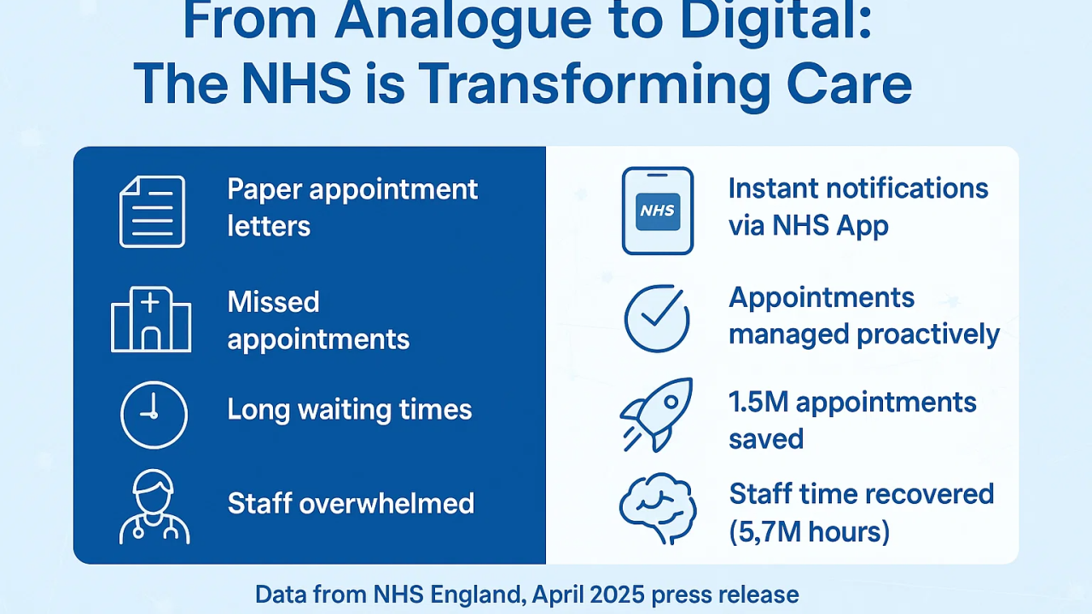
Figure 1: Screenshot of the LinkedIn homepage. Source: LinkedIn (n.d.) LinkedIn. Available at: http//www.linkedin.come _ (Accessed: 27th February).

1. Introduction
The NHS App was launched nationally in England in July 2019 and represents one of the most significant digital innovations introduced in UK healthcare within the past decade. Designed as a “digital front door” to NHS services, the application allows patients to book GP appointments, order repeat prescriptions, access elements of their primary care record, receive test results, and view vaccination status (Cave et al., 2023). Its rapid expansion during the COVID-19 pandemic highlighted its significant role in supporting remote access, digital triage, and continuity of care, embedding virtual interaction into routine primary care practice (Greenhalgh et al., 2025).
Digital transformation has become a central strategic priority within UK healthcare policy, framed as a necessary response to rising patient demand, workforce shortages, and persistent financial pressures within the National Health Service (NHS England, 2019). The NHS App aligns with key policy frameworks, including the NHS Long Term Plan (NHS England, 2019), What Good Looks Like (NHS England, 2021), and A Plan for Digital Health and Social Care (DHSC, 2022), which position digital tools as mechanisms to improve efficiency, empower patients and support long-term system sustainability. However, while policy discourse frequently presents digital innovation as inherently beneficial, evidence suggests its impact is complex and uneven (Zhou et al., 2024). Digital technologies may reshape professional roles, alter patterns of access, and risk worsening health inequalities if implementation is not carefully managed.

This report critically evaluates the impact of the NHS App on workforce roles, service delivery structures, and patient experience. It examines both positive and negative outcomes, drawing upon contemporary UK research and policy, and considers implications for equity, governance, and sustainable practice.

2. Impact on Workforce

2.1 Role Transformation and Workflow Change

The introduction of the NHS App has significantly altered administrative and clinical workflows, particularly within general practice. Reception and administrative staff increasingly manage digital appointment systems, triage electronic requests, and respond to online queries, standing for a shift from traditional face-to-face or telephone gatekeeping towards digital coordination roles (Greenhalgh et al., 2025). In some practices, this transition has reduced high volumes of telephone traffic and enabled asynchronous communication, allowing staff to process requests more flexibly (Abel et al., 2024).

However, evidence suggests that digital innovation has not necessarily reduced workload; rather, it has redistributed and reconfigured it. Abel et al. (2024) describe the emergence of “hidden digital labour”, whereby staff spend substantial time managing electronic consultations, reviewing incoming requests, and coordinating responses. Digital demand can be continuous, lacking the natural pauses associated with telephone hours or physical reception closure. Consequently, the NHS App may contribute to workload compression rather than relief.

Furthermore, triage responsibilities increasingly extend to non-clinical staff who must categorise digital requests appropriately. This shift raises concerns regarding role boundaries, accountability, and potential risk exposure. Greenhalgh et al. (2025) note that digital systems often layer onto existing processes, creating hybrid workflows rather than replacing older systems. This dual-system burden can generate complexity and inefficiency during transitional periods.

2.2 Skills, Training and Organisational Culture
The digitisation agenda requires a workforce capable of operating confidently within digital systems. O’Neill and Gladwell (2024) emphasise the importance of digital literacy within the Digital, Data and Technology (DDaT) workforce framework, highlighting the need for structured training pathways. Similarly, the What Good Looks Like framework (NHS England, 2021) underscores leadership, digital capability, and cultural transformation as prerequisites for successful innovation, arguing that digital maturity is as much about behaviours and mindset as it is about technological infrastructure.

Nevertheless, implementation challenges remain. Digital competence varies across age groups and professional backgrounds, and protected training time is often limited due to staffing pressures. Gardner et al. (2023) argue that organisational culture is critical: where digital innovation is perceived as imposed rather than co-produced, resistance and stress may increase. Zhou et al. (2024) further demonstrate that investment in digital technologies does not uniformly improve staff satisfaction, indicating that technological adoption alone is insufficient to enhance workforce experience. without parallel attention to workload, autonomy, and support structures. professional identity and meaningful engagement in change processes.

Synthesising critical insight: Ultimately, the success of workforce digital transformation is inextricably linked to broader system sustainability; without embedding robust training, fostering adaptive culture, and ensuring staff empowerment, digital innovation risks creating efficiency in theory but fragility in practice, undermining the resilience of the NHS workforce and the quality of patient care.

2.3 Critical Workforce Evaluation
Overall, the NHS App reflects a broader structural transformation within healthcare, shifting professional roles from direct gatekeeping to digital flow management. While certain efficiencies are evident, policy narratives emphasising productivity gains may understate the complexity of implementation and the risk of digital fatigue. Sustainable workforce transformation requires investment not only in technology but also in training, leadership, and cultural adaptation. Without these, digital systems risk intensifying pressure within an already stretched workforce.

3. Impact on Service Delivery

3.1 Efficiency, Access, and Sustainability
The NHS App has significantly reconfigured service delivery in primary care by enabling patients to book appointments, request prescriptions, and access parts of their medical record remotely (Cave et al., 2023). This digital mediation has reduced reliance on telephone-based systems and manual administrative processes, offering potential improvements in workflow efficiency, transparency, and patient convenience. Brown et al. (2023) note that digital outpatient solutions can also contribute to environmental sustainability by reducing travel, paper usage, and the carbon footprint associated with in-person appointments. During the COVID-19 pandemic, the App’s rapid uptake highlighted its role in supporting continuity of care, demonstrating that digital tools can provide flexible, scalable access during periods of systemic strain (Greenhalgh et al., 2025).
Nevertheless, efficiency gains are uneven and context dependent. While some practices report reduced administrative pressure and improved patient throughput, others have experienced additional demand, as lower barriers to access increase consultation volumes. This demonstrates the paradox of digital healthcare: while tools can streamline access, they can also generate unintended workload pressures and exacerbate resource limitations (Whitfield and Hamblin, 2022). Moreover, digital engagement often favours younger, technologically literate populations, which may reinforce disparities in service utilisation.

3.2 Integration and Infrastructure Challenges

Effective digital transformation relies upon robust integration across diverse IT systems within general practice. The NHS App must operate alongside various clinical management software platforms, yet interoperability remains inconsistent, resulting in potential duplication of work, delayed communication, and workflow friction (Whitfield and Hamblin, 2022). Infrastructure inequities, including uneven broadband access in rural areas and variation in regional IT capability, further compound these challenges, creating a postcode lottery for digital access.
Financial investment is also critical. Initial development costs, ongoing system maintenance, and cybersecurity measures require sustained funding commitments. Pope et al. (2024) highlight that while collaboration with digital health industries can facilitate technological implementation, centralised data systems create potential vulnerabilities that necessitate continuous monitoring and investment in staff training and technical support.

3.3 Governance and Regulatory Considerations
Governance structures and regulatory compliance are essential to maintain public trust and safeguard patient information. The NHS App must adhere to the Data Protection Act 2018 and UK GDPR, alongside NHS Digital standards for data security. Failure to comply risks not only legal consequences but also erosion of public confidence, which is critical for adoption and engagement (Information Commissioner’s Office, 2023). Transparent reporting, continuous audit, and adherence to ethical frameworks are therefore prerequisites for sustainable service delivery.

3.4 Critical Service Evaluation
The NHS App has undoubtedly expanded digital mediation within service delivery, transforming how patients access care and how administrative processes are managed. Yet digital transformation alone does not resolve underlying structural pressures, including workforce shortages, chronic funding constraints, and regional disparities in digital maturity. Its benefits are contingent upon effective system integration, equitable infrastructure investment, robust technical support, and continuous governance oversight. Without these conditions, digital innovation may produce fragmented or inconsistent service experiences, exacerbate existing inequalities, and create unintended workflow burdens, thereby limiting its potential to deliver sustainable improvements across the health system.

Critically, the NHS App illustrates a broader lesson in digital health: technological adoption does not equate to systemic improvement. For digital innovations to realise their potential, organisational readiness, policy alignment, and inclusive design must be prioritised. Systems must be adaptable to local contexts, embedding flexibility for diverse populations and varying practice capacities. Consequently, while the App provides tangible operational benefits, these are neither uniform nor automatic, highlighting the importance of ongoing evaluation, context-sensitive implementation, and integration with broader health system reform agendas (Greenhalgh et al., 2025; Brown et al., 2023).

4. Impact on Patients and Service Users

4.1 Empowerment and Self-Management
Access to personal health records through the NHS App represents a significant shift towards patient transparency. Gavin et al. (2024) report that digital self-management tools can enhance engagement among individuals with long-term conditions, supporting medication adherence and informed decision-making. The ability to access services 24/7 may improve autonomy and reduce frustration associated with telephone waiting systems (Cave et al., 2023). From a policy perspective, such empowerment aligns with person-centred care models and preventative healthcare strategies (NHS England, 2019).

4.2 Digital Exclusion and Inequality
Despite these benefits, digital exclusion remains a critical concern. Evidence indicates that older adults, individuals with lower socioeconomic status and those with limited digital literacy are less likely to use app-based services (Cave et al., 2023). Whitfield and Hamblin (2022) argue that digital-first strategies risk marginalising vulnerable populations unless alternative access routes remain available. Sinnott et al. (2026) report patient frustration where digital triage models appear to replace rather than supplement traditional access pathways. The Patient Safety in the Digital NHS review (2025) warns that digital poverty may exacerbate health disparities, particularly where access to devices or reliable internet is limited.

4.3 Privacy, Trust, and Ethical Considerations
Public trust is fundamental to digital legitimacy. Concerns regarding data sharing, cybersecurity breaches and commercial partnerships may influence willingness to engage (Pope et al., 2024). Compliance with UK GDPR and transparent governance processes are essential to maintaining confidence.

4.4 Critical Patient Evaluation
The NHS App embodies a tension between empowerment and exclusion. While digitally confident users may benefit from increased autonomy and convenience, digitally marginalised groups risk reduced access and diminished voice. Digital innovation, therefore, must be accompanied by targeted inclusion strategies to prevent the entrenchment of existing inequalities. Without initiative-taking interventions, digital-first policies may inadvertently exacerbate social and health disparities by privileging populations with greater technological access and familiarity. This is particularly significant in rural and socioeconomically disadvantaged communities, where infrastructure limitations such as poor broadband connectivity compound barriers to engagement (Whitfield and Hamblin, 2022). Furthermore, ethical concerns regarding data privacy, informed consent, and trust in NHS digital governance may deter uptake, particularly among vulnerable groups (Pope et al.,2024). To realise the App’s potential for equitable patient empowerment, implementation must integrate comprehensive digital literacy support, alternative non-digital access pathways, and ongoing evaluation of inclusivity outcomes. Digital innovation should enhance system-wide accessibility rather than reinforce structural inequalities, positioning equity, and social justice as central to sustainable healthcare transformation.

5. Conclusion and Recommendations
The NHS App, introduced in 2019, represents a significant digital innovation within UK healthcare. It has reshaped workforce roles, modernised aspects of service delivery and expanded opportunities for patient engagement. However, its impact is uneven and context dependent.

Workforce transformation requires sustained training and cultural adaptation to prevent digital fatigue. Service efficiency gains depend on infrastructure readiness and effective system integration. Patient empowerment is tempered by persistent digital exclusion and privacy concerns.

To enhance equity and sustainability, several recommendations emerge. First, structured and funded digital training pathways should be embedded within workforce development programmes, with protected learning time to mitigate implementation burden. Second, hybrid access models must be preserved to ensure that digital systems supplement rather than replace traditional routes. Third, national digital inclusion strategies should provide community-based literacy programmes and device access initiatives. Finally, continuous independent evaluation is essential to monitor equality impacts and maintain public trust.

As healthcare delivery becomes increasingly technology-mediated, critical appraisal of digital innovation remains essential to ensure that transformation enhances equity rather than deepening disparity.

6.Reference
Abel, G., Atherton, H., Sussex, J., Akter, N., Aminu, A.Q., Aminu, A., Bak, W., Bryce, C., Clark, C.E., Clark, C. and Cockcroft, E., 2024. Current experience and future potential of facilitating access to digital NHS primary care services in England: the Di-Facto mixed-methods study. Health and Social Care Delivery Research, 12(32), pp.1-197.
Atherton, H., Brant, H., Ziebland, S., Bikker, A., Campbell, J., and Gibson, A. (2022) ‘The potential of alternatives to face-to-face consultation in general practice’, British Journal of General Practice, 72(717), pp. e68–e75.
Brown, M.R., Knight, M., Peters, C.J., Maleki, S., Motavalli, A. and Nedjat-Shokouhi, B., 2023. Digital outpatient health solutions as a vehicle to improve healthcare sustainability—a United Kingdom focused policy and practice perspective. Frontiers in Digital Health, 5, p.1242896.

Cave, E., Charlesworth, A., Dacre, J., Francis, R., Pearson, D., Baker, M., Davies, C., Gordon, N., Hussain, W., Patterson, H. and Perrin, N., 2023. Evaluation of Government commitments made on the digitisation of the NHS Fourth Special Report of Session 2022–23.

Department of Health and Social Care (2022) A Plan for Digital Health and Social Care. London: DHSC. Available at: https://www.gov.uk (Accessed: 25 February 2026).

Department of Health and Social Care (2023) Data saves lives: reshaping health and social care with data. London: DHSC.

Faculty of Clinical Informatics (2023) Digital professionalism and information governance guidance. London: FCI.
Gardner, J., Herron, D., McNally, N. and Williams, B., 2023. Advancing the digital and computational capabilities of healthcare providers: A qualitative study of a hospital organisation in the NHS. Digital Health, 9, p.20552076231186513.
Greenhalgh, T., Clarke, A., Byng, R., Dakin, F., Faulkner, S., Hemmings, N., Hughes, G., Husain, L., Kalin, A., Ladds, E. and MacIver, E., 2025. After the disruptive innovation: How remote and digital services were embedded, blended, and abandoned in UK general practice–longitudinal study.
House of Commons Health and Social Care Committee (2022) Digital transformation in the NHS. London: HMSO.
Information Commissioner’s Office (2023) Guide to UK GDPR. Wilmslow: ICO.
LinkedIn (n.d.) LinkedIn. Available at: https://www.linkedin.com (Accessed: 3 November 2025).
NHS Digital (2023) NHS App dashboard data 2023. Leeds: NHS Digital.
NHS England (2019) The NHS Long Term Plan. London: NHS England.
NHS England. England, N.H.S., 2021. What good looks like framework.
England, N.H.S., 2023. Delivery plan for recovering urgent and emergency care services. NHS England
O’Neill, E. and Gladwell, V., 2024. Digital, Data and Technology (DDaT): Scoping review.
Pope, R., Zenonos, A., Bryant, W., Spiridou, A., Key, D., Patel, S., Robinson, J., Styles, A., Rockenbach, C., Bicknell, G. and Rajendran, P., 2024. Real-world learnings for digital health industry–NHS collaboration: life sciences vision in action. Future Healthcare Journal, 11(3), p.100168.
Royal College of General Practitioners (2023) The future of general practice in a digital age. London: RCGP.
Whitfield, G. and Hamblin, K., 2022. Technology in social care: spotlight on the English policy landscape, 2019-2022. Centre for Care.
World Health Organization, 2025. Global strategy on digital health 2020-2027. World Health Organization Zhou, X., Leiva-Granados, R., Yi, J., Yao, Z., Fang, J. and Skordis, J., 2024. Staff experience after investment in digital technologies: A difference-in-differences study in the English NHS. Available at SSRN 5198150.

