Theatre District Analytical Report
Introduction
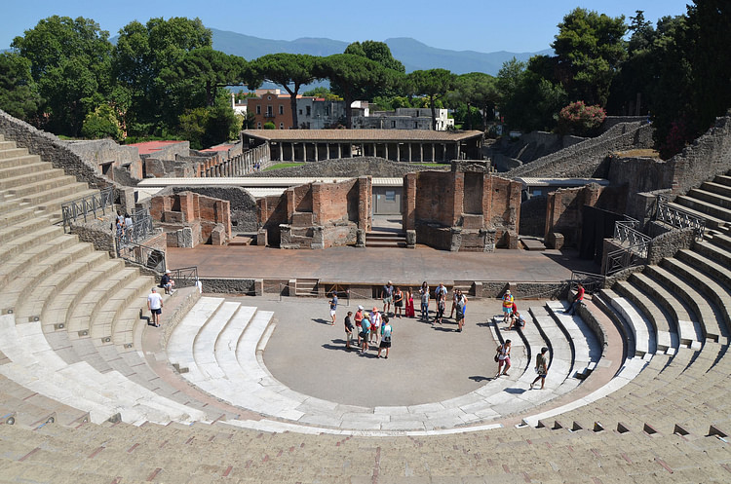
Pompeii, the Roman city located in the region of Campania that was disastrously buried by the volcanic eruption of Mount Vesuvius in 79AD, is arguably one of the greatest archaeological sites in the world. The rapid burial under lapilli and ash fashioned a singular context of preservation, almost instantly freezing the urban spaces, buildings, artefacts and organic materials that would ordinarily have been lost to time. Among the most compelling structures that have survived are the Large Theatre, the Odeon Theatre and the gladiator barracks. These spaces are able to provide insight into the architecture, urban space usage and entertainment of the Romans.

Figure 1: A photo taken from the top of the Large Theatre, showing the seating and stage with the gladiator barracks behind (Raddato, 2019).

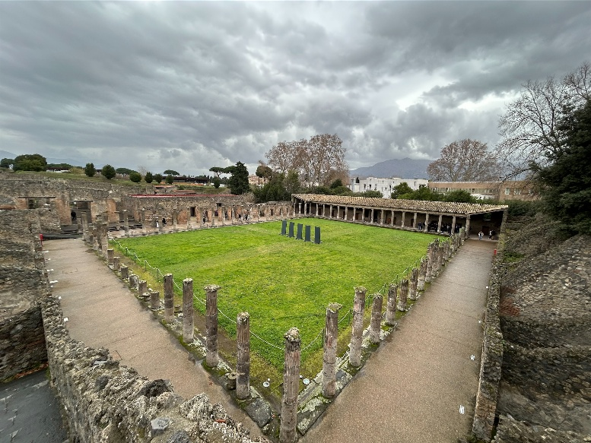
The Theatre District occupies the southwest sector of Pompeii and is comprised of several performance related buildings and areas. The largest structure in this area is the Large Theatre, an open aired amphitheatre built into a natural slope that is able to seat 5000 people and was built in the second century BC, financed by the Halconii family following the sectarian conflicts and then renovated during the rule of Augustus (Shepard, 2019). As well as this there are another two major buildings in the form of the Odeon Theatre and the gladiator barracks. The Odeon Theatre, also known as the Small Theatre, built in 80BC, is a more intimate venue holding only 1500 people and built with a roof; it was used primarily for council meetings and more cultural performances (Hines, 2003). Hadrill (1994) writes that the architecture of the Odeon reflects elite exclusivity however, Zanker (1998) is of the opinion that the grandeur is from the Augustan ideological projection. The gladiator barracks was originally an outside foyer for theatre goers but was later adapted for housing and training the gladiators in 62AD; it features a large open area in the middle, with cells and other rooms around the outside (Sheldon, 2022).
Figure 2: A photo taken by me of the gladiator barracks, showing the central training area surrounded by cells and other rooms

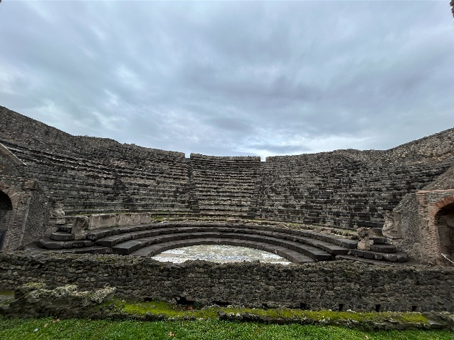
The Large Theatre was one of the very first permanent stone theatres in the Roman world and is an example of a combination of both Roman and Greek architectural style, with a semi-circular seating arrangement or Cavea, orchestra and an impressive stage, promoting Pompeii’s cultural identity. By contrast the small theatre features a rectangular plan with thin walls and likely a wooden roof; this would accentuate the contained nature and the improved acoustics, making it perfect for recitals, oratory and chamber performances. The theatres are able to tell historians more than just the performance spaces but also their importance, both socially and civically. This study aims to argue that the theatres and gladiator barracks were not simply entertainment venues but also dynamic social and political institutions that mirror patterns of hierarchy, cultural identity and urban adaptation.
Figure 3: A photo taken by me showing the Odeon Theatre from behind the stage.
Preservation: Challenges of Exposure and Conservation
Preservation at Pompeii has benefited from the volcanic entombment as the ash protected the structures and artifacts in the city from erosion and scavenging for almost 17 centuries. However, once the theatres were exposed in the 18th century, environmental and human forces have taken their toll, making conservation efforts a challenge. Early archaeologists prioritised grand discoveries over preservation, which led to the deterioration of the seating, stages and stairways, and the removal of artifacts from the site (Sheppard, 2021).
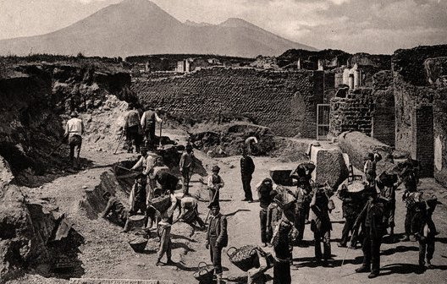
In the 19th and 20th centuries the focus had diverted more to archaeological clarity, volumes of volcanic debris were shifted and more seating and corridors were discovered. It was this period also when the conservation attempts were started, with the largest being a metal framework being constructed to support the seating. Many of the conservation attempts were unsuccessful however, as some were incompatible with the ancient materials and in some cases even accelerated the decay.
Figure 4: A photo showing the excavations in the 19th Century (Jess, 2011)
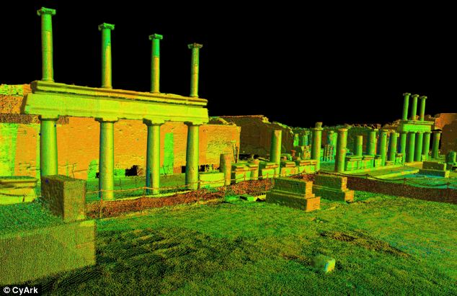
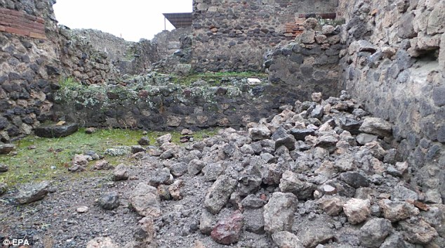
Modern archaeologists have shifted the focus for a third time to more closely examining the already excavated structures and preserving them by clearing the drainage systems beneath the seating and fixing the structural weakness. This is due to the main threat to the structures not being the burial but instead being exposure to rain, vegetation and temperature changes. More recently conservation attempts have been made in the form of adding retaining walls, new drainage systems and walkways in the areas with the greatest footfall. As well as physical preservation, new technology such as 3D scanning and acoustic reconstructions have been used to preserve the theatres digitally (Nappo, 2017). The 3D scanning records the buildings with exact precision on a computer, and the acoustic reconstructions allow historians to understand how sound travelled throughout the theatres and how performances would have been experienced (Crowley, 2024). Despite the lengths gone to by archaeologists over the years, many original elements from the theatres have been lost, such as the wooden roofing, painted decorations and organic materials. These challenges directly affected the fieldwork development and shaped the interpretations and methodology.
Figure 6: A rendition of the 3D imaging taking place at Pompeii (Griffiths, 2013)
Figure 5: A photo showing a collapsed wall in Pompeii, following weeks of rainfall (Williams, 2013)
Fieldwork: From Discovery to Methodological Revolution
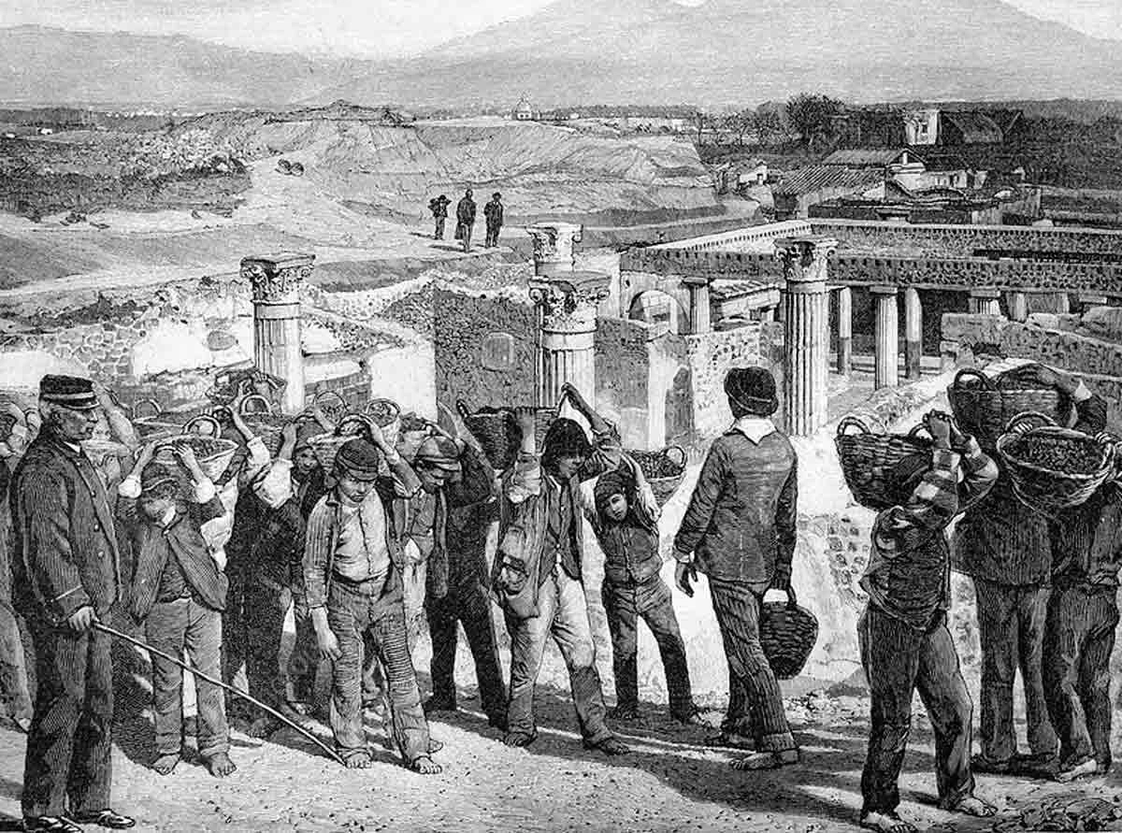
Fieldwork at Pompeii was started in 1748 when the excavations began under Bourbon rule, with the Large Theatre being excavated in the 1760’s and expanded through the next two centuries. The theatres received a lot of interest due to their grandeur, and excavations were tunnel based with the aim of retrieving statues, inscriptions and decorative elements. This then led to revealing contextual information, most importantly relating to construction sequences and later modifications, being lost. Many limitations were faced by this period including poor documentation of find spots, removal of artifacts and minimal recordings of wall inscriptions and graffiti (Parslow, 1998).
Figure 7: A drawing depicting the early excavations at Pompeii (Venner, 2024).

In 1863 Guiseppe Fiorelli became the director of excavations and work became more organised, with him implementing such measures as the region-insula numbering system, which is still used today, improved recording of graffiti and inscriptions, early efforts into understanding zoning and public space use. In this period the theatres were studied more as architectural monuments with increased attention towards seating capacity and the social hierarchy, construction techniques and the evidence for Samnite and Roman building phases. These early archaeologists laid the foundations for site mapping and stratigraphic exposure, although far less rigorously than modern day standards (Cassanelli, 2002). Early Scholars, such as A Mau, and numerous 19th century excavators documented structural layouts and artifacts in foundational work (Dunn, 2024).
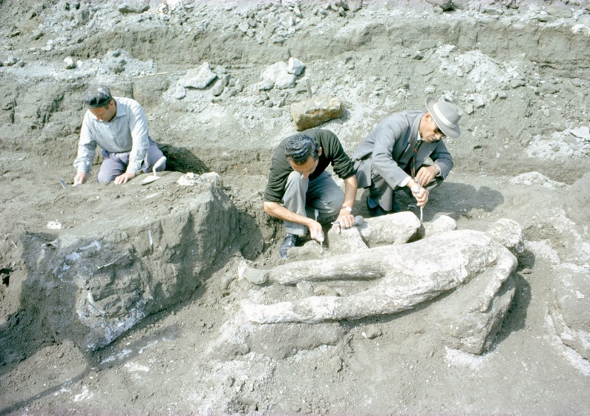
By the early 20th century, Pompeii was starting to become more important to wider debates surrounding Roman social history. Historians were increasingly examining the theatres and gladiator barracks in terms of function, patronage and social meaning. This led to the key developments being elite benefactors supporting the analysis of the theatres as civic institutions, the discovery that the Odeon was used more for specialised performances and a thorough examination of gladiatorial graffiti, which showed evidence for popularity, fan culture and individual celebrities. The excavations of this period remained primarily clearance based, removing ash from the premises, with the preservation methods being inconsistent. Problems occurred in the gladiator barracks with structural repairs and reconstructions often obscuring original features and therefore making later interpretation more complex. Despite this, the early 20th century was a crucial time in the excavation of Pompeii as the historians were able to lay the groundwork for the integration of theatres and the gladiator barracks within Pompeii’s urban plan, and understanding the relationship between entertainment, politics and social identity (Amery and Curran 2002).
Figure 8: A photo showing two archaeologists patching a plaster mold of a woman. (Battaglia, 1961)
In the 1970’s the archaeology at Pompeii went through serious methodological transformation. The large-scale clearance of ash was replaced with the contextual reanalysis of previously excavated areas, conservation led research and interdisciplinary studies. Specifically for the theatres and the gladiator barracks this meant a reassessment of the structure modifications following the earthquake of 62AD, specifically the transformation of the Quadriporticus into the gladiator barracks, a deeper examination of wear patterns, access routes and spatial organisation to reconstruct movement and activity and a study into the graffiti as primary social evidence as opposed to simple curiosity. The start of bioarchaeologists examining bodies found in the gladiator barracks allowed historians to further understand health, trauma and diet, the physical demands of gladiator training and the presence of non-combatants (Jashemki, 2026).
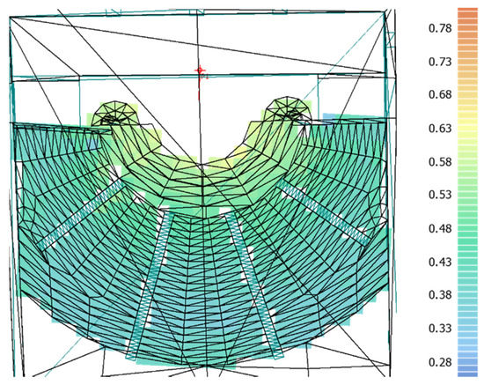
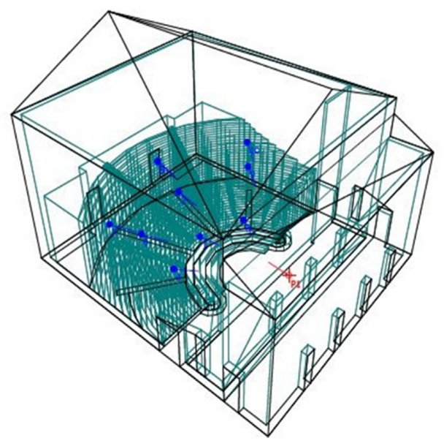
In the 21st century the research has focused more on documentation, digital reconstruction and experiential analysis rather than excavation. There are several key projects including the digital documentation and architectural analysis put on by Pompeii Quadriporticus Project. This project includes photogrammetry and laser scanning, detailed mortar and construction analysis and digital phase modelling. These techniques have allowed historians to understand how the quadriporticus morphed into the gladiator barracks and how permanent the modifications were (Crowley). Another project is the acoustic research within the theatres. Interdisciplinary teams have been using impulse response testing and digital simulation to understand further how sound would travel through these venues. They have so far demonstrated intentional acoustic optimisation, supported distinctions between performance types and reinforced interpretations of the Odeon as a space for elite performances (Vanderbilt, 2025). Research has also changed recently to understand further how the city has changed and how to preserve it better, asking questions such as how later restorations affected original layouts, how modern materials affected preservation and how to balance public access with preservation.
Figure 9: A diagram of the acoustic reconstruction of the Odeon (Ciaburro, 2020)
Figure 10: A diagram of the acoustic reconstruction of the Odeon (Ciaburro, 2020)
Material Culture: Artefacts as Evidence of Social Life
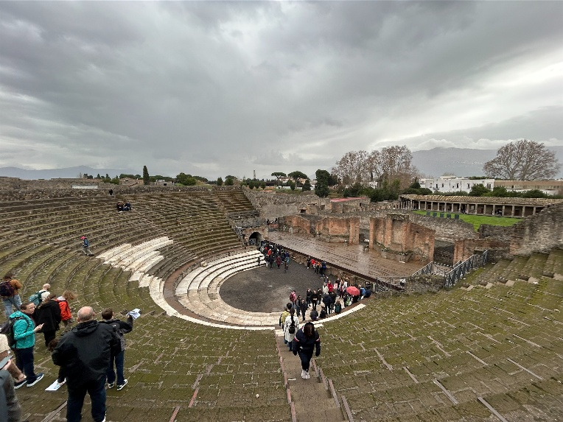
There are many architectural remains to be found in the theatres with the Large Theatre alone boasting limestone and tuff seating from the Samnite era, later Roman renovations and marble decorations added in the Augustan era. Scholars such as Sear (2006) and Coarelli (2002) write that these remains show chronological phases of construction and the Romanisation of Pompeii, as well as the elite’s investment into public entertainment. The Odeon is interesting in that although the roof was never discovered, the architecture of the building suggests that it had one. This expensive architecture suggests a space for a more elite audience (Hadrill, 1994).
Figure 11: A photo taken by me showing the seating and stage of the Large Theatre.
Despite many items going missing during the early excavations, several decorative items have been found in the theatres, such as sculptural decoration in the scanae frons, painted architectural surfaces and inscriptions naming benefactors. These decorations are linked to the Augustan cultural ideology, and these theatres would have been used for projecting Roman values, mythological narratives and imperial identity (Zanker, 1998). Losing so many decorations has made interpretation complicated but surviving fragments support the notion that the theatres were visually performative, even outside of staged events.
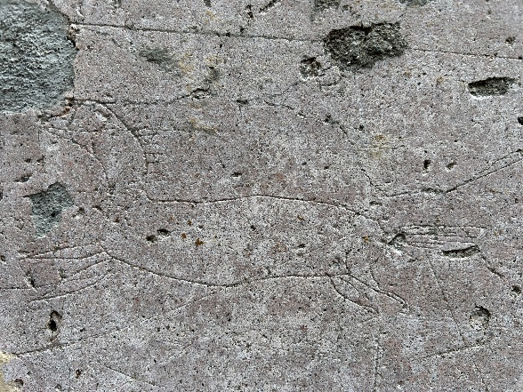
Many examples of graffiti can be found in the alleyway behind the Odeon, leading to the Large Theatre. Many of these inscriptions comment on the performances, assert the presence of the individual, relay a humorous or romantic message or in some cases bare political comments. These inscriptions are not casual acts of vandalism but more of intentional acts of communication placed in interactive social spaces (Benefial, 2010).
Figure 12: A photo taken by me of some graffiti depicting a horse, found behind the Odeon.
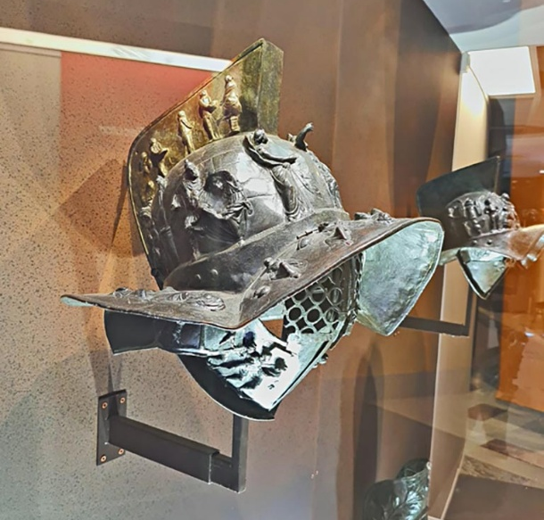
In the gladiator barracks many artifacts were discovered and many were transferred to the Archaeological Museum of Naples. Among these items there was a large number of weapons and armour, including bronze helmets, greaves and arm guards and shields and swords. These items are often highly decorated, portraying victories, mythological figures and symbolic motifs. This decoration would indicate that these were not just weapons but also ceremonial display items and markers of status and identity (Jacobelli, 2003).
Figure 13: A photo showing a highly decorated helmet from the Archaeological Museum of Naples (Dunn, 2024).
Graffiti was also found in the gladiators’ cells and on the columns surrounding the barracks, these inscriptions often depicted the names or nicknames of gladiators, recorded victories and expressions of admiration, often by female admirers. These inscriptions can tell historians that some gladiators held celebrity status, there was a strong emotional investment by the public and there was little or no barrier between the gladiatorial and civilian worlds (Futrell, 2006).
More everyday artifacts have also been found in the gladiator barracks; including pottery, lamps, storage vessels and small personal items. This is evidence that the barracks were not only a venue of violence and training but also of ordinary daily life and residence. These artifacts are particularly important as they allow historians to determine the uses for the rooms and spaces around the barracks and they support the idea that it was a multifunctional lived environment as opposed to an institutional facility (Allison, 2004).
As well as the artifacts discovered, several human remains were found. One such body was of a woman with jewellery, who has often been thought to be evidence of companions or partners to the gladiators, proving that non-combatants could be found in the barracks (Kyle, 2012). It is also evidence that the personal lives of gladiators could be socially complex and even involve families and service personnel. On the bodies of the gladiators, injuries can often be found, supporting literary description of intense physical training and repetitive injury patterns (Welch, 2007).
Interpretation: What the Evidence Reveals about Roman Space
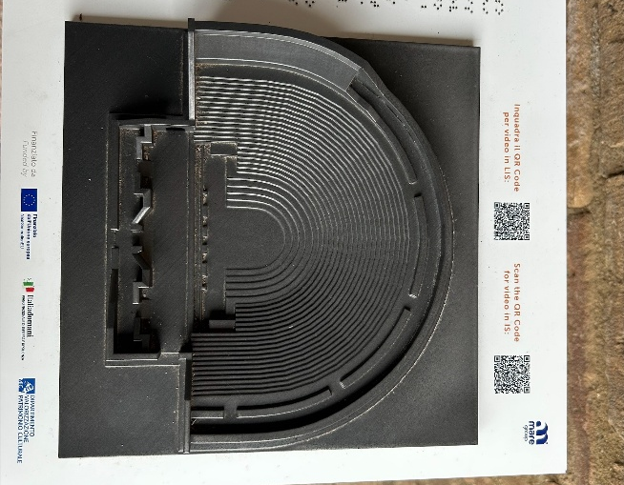
The theatres of Pompeii were not simply entertainment venues but also acted as highly structured social spaces, with archaeological evidence showing how the activities within reinforced social order. The most direct evidence we have of this is the seating area within the Large Theatre, as the seating is divided depending on status, with the elites closest to the stage and the lowest status up at the top. Divisions such as this materially enacted Roman hierarchy, turning just the attendance into a performance of social rank (Laurence, 1994). Inscriptions found naming benefactors and magistrates demonstrates that the theatrical activity was closely linked with elite patronage and political self-display; elites could increase political capital by funding refurbishments and performances (Coarelli, 2002).
Figure 14: A photo taken by me of a 3D model of the Large Theatre.
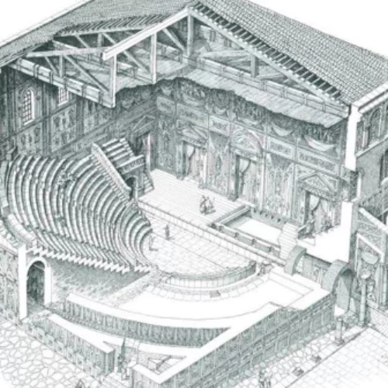
Having two theatres within Pompeii indicates a diversity of performance as opposed to a single tradition. The Odeon’s roofed design suggests more intimate performances and the architecture portrays exclusivity and elite cultural consumption (Hadrill, 1994). This point is further proved by acoustic studies that show sound clarity was preferred over capacity (Ciaburro, 2020). This tells historians that Pompeii had several performance genres and that cultural life was rather stratified, with different venues for different audiences (Tonder, 2025).
Figure 15: A drawing of how the Odeon Theatre would have looked (Pompeii Archaeological Park).
Graffiti found around the theatres is evidence of informal and unsanctioned activities connected with performances. Graffiti should be understood as an act of formal engagement and suggests the enthusiasm of the audiences, rivalry between performers and their factions and repeated visitation by individuals. This indicates that the theatres were social spaces, being occupied before and after the shows. This tells historians that theatre spaces were socially active beyond the point of performance, audiences often participated in performance culture and that reputation and memories were often constructed through writing (Benefiel, 2020).
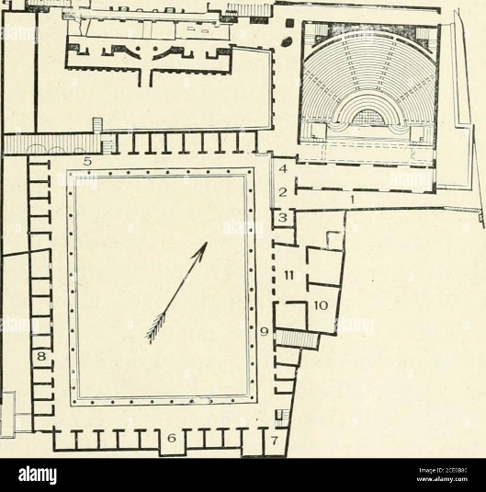
The architectural layout of the gladiator barracks, a central training area surrounded by the cells and other rooms, is evidence of a training focused occupation. Both Welch (2007) and Jacobelli (2003) interpret the central courtyard as a training area for activities such as practiced drills, sparring and conditioning, with the surrounding rooms comprising of sleeping quarters, storage for equipment and spaces for supervision and instruction. The enclosed and repetitive nature of these rooms is evidence of a controlled and institutional occupation. It tells historians that daily life was built centred around physical training; behaviour and movement were tightly regulated and it was a highly disciplined environment.
Figure 16: A map depicting the layout of the gladiator barracks and Odeon Theatre (Alamy).
The findings of many highly ornate weapons and armour are evidence that the barracks were not simply a utilitarian space. These items are heavy and ornamental, therefore being impractical in a combat environment. This indicates that they were used for activities such as ceremonial preparation, pre combat display and rehearsals of spectacle. This tells historians that gladiators performed, with high visual impact, as well as fought, putting the barracks in the performance economy (Jacobelli, 2003).
The intense concentration of graffiti in and around the barracks is strong evidence of daily occupation and social activity. The graffiti indicates repeated presence of named gladiators, pride and identity and the interaction between civilians and gladiators. The graffiti shows the paradox of the gladiator’s social position, being both marginal and celebrated (Futrell, 2006). This tells historians that the construction of identity was an ongoing activity, the gladiators would engage in self-promotion and that the barracks were a social environment (Jacobelli, 2003).
Domestic artifacts and human remains are evidence that the barracks were occupied permanently. Various assemblages found suggest food preparation, sleeping arrangements and long-term residence (Alisson, 2004). The presence of non-combatants is indicated by the findings of jewellery and skeletons, suggesting that the communities were not purely male (Kyle, 2012). This tells historians that daily domestic duties coexisted with training, there were emotional and social relationships, and the site was lived in as a community.
Conclusion
The Theatre District of Pompeii offers an archaeological dataset through which Roman entertainment, social organisation and daily life can be studied. The preservation of the city allows historians to reconstruct activity directly from physical remains. Despite the setbacks caused from early excavations, modern fieldwork has transformed these remains into key case studies for a wide array of disciplines. Ultimately these structures are evidence of how entertainment functioned as a microcosm of Roman society, continuing to enrich modern historians on the interplay between spectacles, daily life and politics in the Roman World.

Bibliography
Allison P (2004), Pompeiian Households: An Analysis of Material Culture, Los Angeles: Cotsen Institute of Archaeology
Amery C and Curran B Jr (2002), The Lost World of Pompeii, Los Angeles: J. Paul Getty Museum
Beneficial (2010), ‘Dialogues of Ancient Graffiti in the House of Maius Castricius’, American Journal of Archaeology, 114, pp59-101, Available at: https://www.jstor.org/stable/20627644
Cassanelli R (2002), Houses and Monuments of Pompeii: The Works of Fausto and Felice Niccolini. Los Angeles: J. Paul Getty Museum
Ciaburro (2020), ‘Acoustic Design of Ancient Buildings: The Odea of Pompeii and Posillipo ’, DOI: 10.3390/buildings10120224
Coarelli F (2002), Pompeii, London: Riverside Books
Crowley J (2024), Cutting-Edge Archaeology: Mapping Pompeii With the Skydio X10, Available at: https://www.skydio.com/blog/cutting-edge-archaeology-mapping-pompeii (Accessed 21 January 2026)
Dunn B (2024), Pompeii, Large Theatre, Available at: https://pompeiiinpictures.com/pompeiiinpictures/R8/8%2007%2020%20p2.htm?utm_source=chatgpt.com (Accessed 21 January 2026)
Futrell A (2006), The Roman Games, Oxford: Blackwell
Kyle D (2012), Sport and Spectacle in the Ancient World, Oxford: Oxford University Press
Hadrill A (1994), Houses and Society in Pompeii and Herculaneam, Princeton: Princeton University Press
Hines T (2003), The Ancient Theatre Archive, Available at: https://www.whitman.edu/theatre/theatretour/pompeii.odeum/pompeii.odeum.htm (Accessed 22 January 2026)
Jacobelli L (2003), Gladiators at Pompeii, Los Angeles: Getty Publications
Jashemski W (2026), History of excavations, Available at: https://www.britannica.com/place/Pompeii/History-of-excavations (Accessed 22 January 2026)
Laurence R (1994), ‘Roman Pompeii: Space and Society’, Journal of Field Archaeology, 24, pp382-385, Available at : https://www.jstor.org/stable/530696
Nappo S (2017), Pompeii: its Discovery and Preservation, Available at: https://www.bbc.co.uk/history/ancient/romans/pompeii_rediscovery_01.shtml (Accessed 21 January 2026)
Parslow C (2002), Rediscovering Antiquity: Karl Weber and the Excavation of Herculaneum, Pompeii, and Stabiae. New York: Cambridge University Press
Sear F (2006), Roman Theatres: an Architectural Study, Oxford: Oxford University Press
Sheldon N (2022), The Gladiators of Pompeii, Available at: https://historyandarchaeologyonline.com/the-gladiators-of-pompeii/ (Accessed 23 January 2026)
Sheppard J (2019), Mass Spectacles in Roman Pompeii as a system of Communication, DOI:10.7916/d8-q1sm-7e39
Sheppard J (2021), ‘Guardians of the Threshold: The Image of the Gladiator and its protective Function in Pompeii’, DOI:10.5456/issn.2050-3679/2021s06
Tonder V (2025), ‘Pompeiian Performance Soundscapes’, DOI: 10.3390/heritage8060196
Vanderbilt R (2025), The Preservation challenges of Pompeii and its lessons, Available at: https://rooseveltvanderbilt.org/the-preservation-challenges-of-pompeii-and-its-lessons/ (Accessed 23 January 2026)
Welch K (2007), ‘The Roman Arena in the Late Republic Italy’, Journal of Roman Archaeology, pp59-80, DOI: 10.1017/S1047759400012502
Zanker P (1998), The Power of Images in the Age of Augustus, Michigan: University of Michigan Press
Figures
Alamy, Figure 16, Available at: https://www.alamy.com/stock-photo/gladiators-barracks-pompeii.html?sortBy=relevant (Accessed 23 January 2026)
Battaglia L (1961), Figure 8, Photo of the Day, Available at: https://www.nationalgeographic.com/photo-of-the-day/media-spotlight/vesuvius-pompeii-italy-archaeology (Accessed 21 January 2026)
Ciaburro G (2020), Figures 9 and 10, Acoustic Design of Ancient Buildings, Available at: https://www.mdpi.com/2075-5309/10/12/224 (Accessed 22 January 2026)
Griffiths S (2013), Figure 6, Historic Repeating Itself, Available at: https://www.dailymail.co.uk/sciencetech/article-2470060/CyArk-digitally-3D-scan-500-culturally-important-sites-years.html (Accessed 21 January 2026)
Jess H (2011), Figure 4, Photographic Archaeology, Available at: https://photographicarcheology.blogspot.com/2011/11/pompeii.html (Accessed 21 January 2026)
Pompeii Archaeological Park, Figure 15, The Large Theater and Odeon of Pompeii, Available at: https://pompeiiarchaeologicalpark.com/the-large-theater-and-odeon-of-pompeii/ (Accessed 22 January 2026)
Raddato C (2019), Figure 1, The Large Theatre of Pompeii, Available at: https://www.worldhistory.org/image/11296/the-large-theatre-of-pompeii/ (Accessed 21 January 2026)
Venner J (2024), Figure 7, Why is Pompeii so Important, Available at: https://www.thecollector.com/why-is-pompeii-so-important/ (Accessed 21 January 2026)
Williams A (2013), Figure 5, Pompeii is Threatened Again, Available at: https://www.dailymail.co.uk/news/article-2517219/Pompeii-threatened--time-weather-Walls-collapse-Roman-city-preserved-volcanic-ash-weeks-rain.html (Accessed 21 January 2026)

