Hyper-Fort Security Solution
Contents
1 Abstract 2
2 Introduction 2
3 Related Work 3
3.1 Bring Your Own Device (BYOD) 3
3.1.1 VMWare Workspace One 3
3.1.2 Microsoft Enterprise Mobility + Security (EMS) 3
3.1.3 Hypori 3
3.1.4 MobileIron 3
3.2 HyperFort Network 4
3.2.1 WEP vs WPA vs WPA2 4
3.2.2 802.1x 4
3.2.3 RADIUS (Authentication server) 4
3.2.4 Wireless IPS 5
3.3 Legal Aspect 5
4 Problem Formulation (Outline the problem) 6
4.1 Bring Your Own Device (BYOD) 6
4.1.1 Personal and Business Use Overlapping 6
4.1.2 Data Leakage Potential 6
4.2 Different Devices, Operating Systems & Applications 6
4.2.1 Devices 6
4.2.2 Operating Systems 6
4.2.3 Applications 7
4.3 HyperFort Network 7
4.3.1 General Network 7
4.3.2 Viruses 7
4.3.3 Physical 7
4.4 Legal Issues 7
5 Implementation 8
5.1 DMZ 8
5.2 three layer Hierarchal Approach 9
5.3 Core Layer 9
5.4 Distribution Layer 9
5.5 Access Layer 9
5.6 Virtual Local Area networks (Vlans) 9
5.7 Wireless 9
5.7.1 SSID 10
5.7.2 Authentication 10
5.7.3 WPA2 10
6 Results/Findings & Discussions 10
6.1 BYOD SOLUTION 10
6.2 Network 11
6.2.1 WPA2-Enterprise 11
6.2.2 Authentication 11
6.2.3 Ethernet Port Access Protection 11
6.2.4 Wireless IPS 12
6.2.5 Standardisation 12
6.3 Physical 12
6.4 Legal 12
7 Conclusion, Recommendation & Future Work 12
8 References 13
9 Appendices 15
9.1.1 Definitions 15
9.1.2 BYOD Comparison Table 16

Abstract
This report details the required network infrastructure to implement Bring Your Own Device for HyperFort, a consultancy company specialising in the energy sector. Included as part of the report is the network setup ensuring security and relevant legislation is complied with. Security is ensured with wireless and general network best practise being followed and modern security protocols being used throughout.

Introduction
Bring Your Own device (BYOD) is being implemented by Companies all across the globe, for reasons such as; cost, flexibility and employee satisfaction. However for every advantage made possible by BYOD there is likely an equal amount, if not more, of potential risks or threats. For instance, security, employee owned mobile devices could be more susceptible to malware.
This report outlines potential threats, while offering suggestions as to how threats can be minimised and/or eliminated.

Related Work

Bring Your Own Device (BYOD)
To successfully implement BYOD, most sources suggest that a Mobile Device Management (MDM) Solution should be included as part of the design. Some products have also advanced past just being an MDM solution, and are now referred to an Enterprise Mobility Management (EMM). EMM is essentially a suite dedicated to the management of devices, it encapsulates the features of MDM, as well as Mobile Application Management (MAM) and Unified Endpoint Management (UEM).The most compatible products on offer that fit HyperFort’s requirements are listed below:

VMWare Workspace One
Workspace ONE is powered by AirWatch UEM Technology. VMWare Advertise being able to provide a “seamless user experience for accessing any app on any device” [1], and like other solutions has security measures in place such as “integrated per-app VPN” [1].

Microsoft Enterprise Mobility + Security (EMS)
A Microsoft solution is always a strong consideration as it would be assumed HyperFort have an infrastructure in place based upon Microsoft products. EMS has strong security measures in place allowing for ultimate control of data, such as the ability to “Control and track what happens after a file has been accessed, and prevent copying, printing, and other actions to avoid sharing with unauthorised users.” [2] As quoted on the Microsoft web site.

Hypori
Hypori is a virtual solution, as opposed to other options which require an agent to be installed. With Hypori “All the apps run on servers in the secure data centre, never leaving data or applications at rest on the physical end point” [3]. This coupled with the fact that “Hypori is the only capability that is CSfC listed and provides a fully virtualized end user device capability” [3] means Hypori is a very feasible solution for HyperFort. More information can be found on the Hypori site (https://hypori.com).

MobileIron
MobileIron is a purpose built EMM solution. MobileIron offer three EMMS bundles; silver, gold and platinum. Silver lacks many of the features that would need to be utilised by HyperFort, whereas gold and platinum offer a superior functionality that would help secure HyperFort data. For example Appconnect, which is “a secure business app container with app-specific VPNs for AppConnect-enabled apps.” As stated in the MobileIron factsheet [4]. Other features include “A layered security model that supports integrated Mobile Device Management”, to protect data in transit and at rest.
The above solutions were all chosen from the Solutions Review 2019 MDM Buyers Guide [5], along with further research from each supplier. Further comparisons are highlighted in the table in the appendices.

HyperFort Network

WEP vs WPA vs WPA2
The three different protocols all offer encryption security devices on a wireless network. Each is discussed below:
WEP – uses encryptions known at RC4, which is done by sharing a PSK with the access point. This immediately highlights a flaw in the security of the protocol. This will therefore not be used in the HyperFort network.
WPA – WPA was designed to replace WEP, and along with this the encryption cipher too. The solution being to use “a new encryption algorithm called Temporal Key Integrity Protocol (TKIP). TKIP ran on the same wireless hardware that was originally created, and it used a 128-bit encryption algorithm” [6] by using a 128 bit algorithm it doubled the possibly of encryption steps. This used the same hardware as WEP however.
WPA2 – WPA2 is named after WPA but features are not a lot alike. WPA2 uses AES encryption, which is much stronger that the previous TKIP. As well as a change in encryption, WPA2 required all new hardware. This hardware “can run in backward-compatibility mode to support the original WPA and even WEP standards” [6]. Further research indicates that the enterprise WPA2-Enterpise protocol is more secure again and will link in with a RADIUS server to provide “government-grade wireless security” [7], coupled with the 802.1x protocol discussed below.

802.1x
Where the WEP and WPA (And 2) protocols deal with the encryption of data across the network, the 802.1x protocol deals with the authentication of clients connecting to the network. Intel [8] advise if “a Wi-Fi user is authenticated via 802.1X for network access, a virtual port is opened on the access point allowing for communication. If not successfully authorized, a virtual port is not made available and communications are blocked.
Intel also state “There are three basic pieces to 802.1X authentication:
Supplicant A software client running on the Wi-Fi workstation.
Authenticator The Wi-Fi access point.
Authentication Server An authentication database, usually a radius server”

RADIUS (Authentication server)
RADIUS stands for Remote Authentication Dial-In User Service and is a protocol known as AAA (authentication, authorization and accounting). The diagram below illustrates the process of authentication:
[9]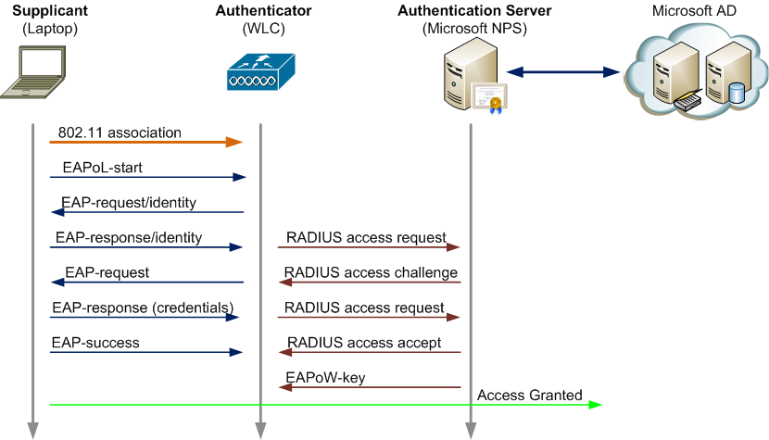
1 RADIUS Process explained
As is illustrated The EAP protocol talks to the RADIUS server (via the Wireless controller); which then responds whether the user/device is authorized to access, after confirming with the Active Directory server. This then allows access by creating the virtual port, as per the 802.1x protocol, which forwards EAP messages between the supplicants (end device), Authenticator and authentication server.

Wireless IPS
David Minutella et al [6] state “Deploying wireless IPS for your network sets up a variety of “sensors” that detect when a policy has been violated. The minute a rogue access point shows up in the network, the system can alert you, pinpointing the location of the access point”. Installing wireless IPS would mean that rogue access points are easily detected, therefore improving wireless security.

Legal Aspect
When securing a network there needs to be a focus around laws that apply to cyber security. The laws applicable to HyperFort are outlined below:
- Data Protection Act (2018) – Also referred to as DPA, the 2018 amendment to the law has been edited in line with Brexit, and this replaced the 1998 edition and lays out regulations for the UK. The Data Protection Act means that organisations must do everything to ensure data is handled responsibly and safely.
- Stored Communications Act 1986 – the Stored Communications act protects the privacy of “Wire and electronic communications while in electronic storage (for example, e-mails stored on a server).” And “Electronic information about subscribers and customers” as stated by Thomson Reuters [10]
- The Cybersecurity Disclosure Act of 2017 – “aims to promote transparency in the oversight of cybersecurity risks” [11].
- General Data Protection Regulation GDPR (2016) - Similar to DPA, GDPR protects the handling of data, specifically personal data. The law covers privacy and consent. One difference to DPA however is that fines are increased for breaches,” Organizations in breach of GDPR can be fined up to 4% of annual global turnover or £20 Million (whichever is greater).” [12]
- Computer Misuse Act 1990 – defined by the Government [13] as “An Act to make provision for securing computer material against unauthorised access or modification; and for connected purposes.”

Problem Formulation (Outline the problem)

Bring Your Own Device (BYOD)

Personal and Business Use Overlapping
A problem that could arise with the amount of personal devices being used in the office is the blending between personal and business use. Users will have access to personal applications, such as Facebook, Instagram, Twitter and other social media applications, when in the office and use of such applications during working hours will reduce productivity levels.

Data Leakage Potential
With HyperFort being under pressure to allow staff to use personal devices this means that there is a greater potential for data to be leaked, including intellectual property. This is coupled with the usual potential for data leaks in any network.

Different Devices, Operating Systems & Applications

Devices
Different device brands can cause issues with the standardization for an MDM solution, as there will be different options available for specific to certain brands. This is due to certain brands lacking in technological features when compared to better known brands.

Operating Systems
Operating systems (OS) tend to tie in with certain brands, and typically the OS is dependent upon the brand. For example Apple devices will usually run iOS. One vulnerability that can be exploited is ‘rooting’ on an android device or ‘Jailbreaking’ a device running iOS. Jailbreaking is referred to on the Apple Support site [14], the main section of the article to be considered in regards to HyperFort is below:
“Security vulnerabilities: Jailbreaking your device eliminates security layers designed to protect your personal information and your iOS device. With this security removed from your iOS device, hackers may steal your personal information, damage your device, attack your network, or introduce malware, spyware, or viruses.”
This obviously prevents risks as unauthorized apps could have malicious intentions on the device with the ‘Jailbreak’, therefore leading to a data breach.
This is similar with the ‘Rooting’ process on android, where a user gains additional permissions that the device would not normally allow.

Applications
There are two main issues with the applications on devices; firstly the access between personal and business app and the transfer of data between the two, secondly the apps which must be on the device as well as apps which must not be on the device. The first issue highlighted will be an issue, as if a personal application has too much access to business related apps, this could result in a data breach. The second issue regarding which applications should and should not be on the device relate to applications such as browsers which offer little or no protection for data in transit. However certain applications such as a virus detection should be on the device so there is another issue enforcing this.

HyperFort Network

General Network
Some problems which will need prevention measures put in place to protect against are:
- Rogue access points.
- Man in the middle attack.
- Correct protocols/standards being used to mitigate risk.
- Denial of Service attack.
- Unused Ethernet ports being exploited.
- Phishing, including spear-phishing.

Viruses
Many different viruses are developed by cyber criminals to harm businesses and potentially even steal data. Measures will need to be in place to protect against viruses mentioned in other areas of this report. Such viruses include ransomware, rootkits, and browser hijackers.

Physical
Problems can arise when unauthorized users are able to access areas of the building which house components to run the network, such as servers or switches. As well as having access to components, potential threats could use sniffing software to capture data packets if able to access certain areas of the building.

Legal Issues
There is a lot of legislation surrounding cyber security, which is ever-evolving to adapt to real time threats. Some laws that HyperFort will need to comply with are stated below, with further information regarding the legislation in the previous section (3.3):
- Data Protection Act (1998)
- Stored Communications Act 1986
- The Cybersecurity Disclosure Act of 2017
- General Data Protection Regulation GDPR (2016)
- Computer Misuse Act 1990

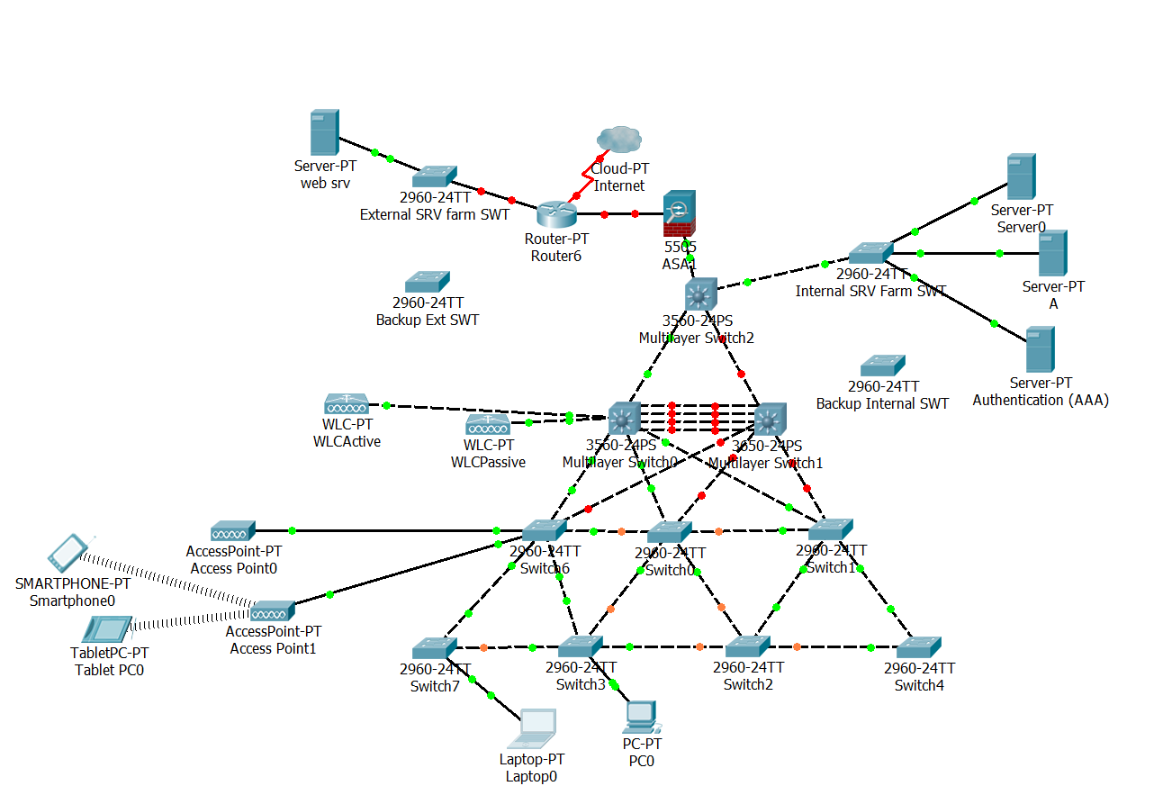
Implementation
The above diagram illustrates the proposed HyperFort Network, displaying the core, access and Distribution layers. Each Component and method of configuration is discussed below.
2HyperFort Network

DMZ
Firstly internet access is provided by the ISP via the router. This is outside of the HyperFort’s internal network, within a DMZ. The DMZ is the first layer of security in place to mitigate risk. Barracuda [15] advises that “this structure can help to protect internal devices from sophisticated attacks” and that they function “by restricting remote access to internal servers and information, which can be very damaging if breached.” Servers that external bodies require access to would also be placed in the DMZ, such as the Web and Mail servers.
Such servers are connected via a layer 2 switch, with a second switch stored with the same configuration ready to replace the original should it fail. This offers redundancy.

three layer Hierarchal Approach
Cisco [16]advise “A hierarchical network design model breaks the complex problem of network design into smaller, more manageable problems. Each level, or tier in the hierarchy addresses a different set of problems”. This applies to the HyperFort network, each layer is discussed further below.

Core Layer
Cisco [16]define the core layer as providing “an optimized and reliable transport structure by forwarding traffic at very high speeds”. The Core layer is made up of layer 3 switches, which have additional functionality compared to layer 2 switches, dealing with higher levels of the OSI network model. Essentially layer 2 hardware will only deal with mac addresses, whereas layer 3 hardware can also deal with IP addressing. The Internal server farm is connected at this level, via a layer 2 switch, to ensure high availability. The Layer 2 switch in connection servers will again have a spare with the same configuration, to be swapped out should the original fail.

Distribution Layer
The distribution layers purpose is to ensure packets of data are routed correctly, then to pass on from the access layer to the core layer. The Cisco 3 layer hierarchal approach can be simplified to a 2 layered approach, merging the Distribution and core layers as they often overlap. Cisco [16] state “this layer defines policy for the network. A policy is an approach to handling certain kinds of traffic”; which helps to control what reaches the core layer.

Access Layer
Essentially the access layer is the “front door to a network” [16]. The access layer provides entry to the network to end-devices such as desktops, laptops and also wireless devices too. Wireless devices connect via wireless access points, which would be connected at this layer and configured to communicate with the wireless controller(s) in the distribution or core layer. In the access layer, ports will need to be disabled when not in use to increase security so that potential attackers are not able to make use of this vulnerability.

Virtual Local Area networks (Vlans)
VLANs will be implemented into the network, as an extra measure to secure the network. Vlans logically divide a network in to separate, virtual, sub networks. Within HyperFort each department will have their own vlan assigned to their users, for example finance users will all be groups together in the finance vlan. Then the finance Vlan will be the only Vlan with access to the servers holding financial data. This mitigates risk, as only required users can access the servers. Other uses for Vlans in the network, will relate to the wireless network, this is discussed further below.

Wireless
The wireless network is one area where companies can be targeted by cyber criminals, security is ensured by implementing the following:

SSID
SSID or Service Set Identifier is the name of the wireless network. The HyperFort Network will have two different SSIDs, one for internal users and a second one for external users.
Both SSIDS will have their own Vlans, to separate access and keep external users from having too much access. Rules will be applied against both Vlans with the external wireless having access to more restrictions in place and no inter-vlan routing to connect to other Vlans.
The Internal SSID will not be broadcast and will be added for internal users via group policy.

Authentication
A RADIUS server will be implemented to authenticate users of the wireless network. The RADIUS server will be used in union with Active Directory and a PKI server to ensure only certified users are able to access the wireless network. This will also require the 802.1x protocol.

WPA2
The WPA2 protocol is the second version of the WPA protocol, the main difference being the method of encryption. Version two uses the extra secure AES encryption. This will be implemented in place of WPA or WEP.

Results/Findings & Discussions

BYOD SOLUTION
Out of the four BYOD solutions discussed, two were not further considered; Microsoft EMS and Hypori. Microsoft EMS was not considered further as the implementation required a lot of additional components such as Azure and Intune. This meant to manage the EMS service additional staff would potentially need to be recruited to ensure the level of expertise to support the service was met.
Hypori on the other hand was not considered as a real solution as firstly, the company is not as reputable as other options and seemed to lack support in comparison with others. Also as engaging as the virtual aspect was, it meant that data would be held in the Hypori’s Datacentre. This added an extra element where data could be compromised, if the company was targeted by a cyber-attack for example. Coupled with the fact that, as previously mentioned they were not a reputable as other possibilities, this meant they were not explored further.
The two remaining solutions were very similar, Mobile Iron and VMWare Workspace. Both offered protection against jail breaks and rooting, which was not offered in other solutions. This safeguarded against certain threats made available by modifications to the OS. Both products also have a centrally managed console to manage and track devices. Another common element of both solutions is that they offer multi-factor authentication, and single sign-on, offering both security and ease of access for users. Also a shared feature is the ability to encrypt devices, as well as remotely wipe if compromised. Lastly both options include containerization, where corporate apps are stored in their own container to separate company and personal data.
However after careful consideration VMWare emerged as the solution I would recommend to be implemented. Case studies provided by both companies outlined areas where VMWare was a more viable solution as stated below:
Implementation – a MobileIron case study into their work with Brother advises “One reason the MobileIron devices were not deployed all at once was because it took a significant amount of manual labour to move away from the previous mobile platform. The support team communicated installation methods to individuals who were proficient in using mobile devices so they could perform their own installation. However, it was necessary to temporarily collect the devices of the remaining majority of employees to perform installation work for them” [17]. Requiring a “significant amount of manual labour” for the “majority if employees” to implement is a problem for HyperFort, as it is suggested that 95% of their users are wireless based. Whereas VMWare “offers the flexibility with multiple deployment options and the scalability necessary to meet the requirements of an on-premise, enterprise-wide solution. In addition to their secure, behind-the-firewall, on-premise deployment, Siemens also smoothly migrated their solution” in 2015 as reported by VMWare [18].
Also VMWare offer better support for SaaS and other cloud applications, meaning they were a better fit for HyperFort as they use cloud based services. They can also whitelist and blacklist applications.
Finally a really important factor is cost. VMWare charge £7.81 per device and MobileIron charge £80. It is assumed that HyperFort has a relatively large user base, therefore the saving to procure all licensing would be huge. The Support tools which were on offer by MobileIron, did not merit such an increase in cost per device.

Network

WPA2-Enterprise
Following research into the most effective protocol to implement to secure network traffic connecting via Wi-Fi, it was found that WPA2 Enterprise offers the most secure solution. This is because the protocol uses AES encryption as opposed to the older encryption types; RC4 and TKIP used in WEP and WPA standards. This will prevent man-in-the-middle attacks.

Authentication
To implement a secure means of connection, a certificate will be assigned to users via a user based policy. Users will need to enter their credentials to download the certificate to a new device, provided by the PKI server. If the user is authorized to access then the 802.1x protocol will communicate with the device, authenticator and authentication server to confirm the user is certified. RADIUS can also run Health Checks for clients connecting, for example certain security patches must be on a device before allowing access. VMWare can also offer similar with their BYOD solution to ensure devices are secure before connecting.

Ethernet Port Access Protection
Ethernet port access protection would mean restricting ports within HyperFort to only allow a specific mac address to access a port. Although this would improve security within the building, it would be too difficult to implement at HyperFort as users will be using their own BYOD devices which could mean different mac addresses will be using a port day-to-day potentially.

Wireless IPS
IPS will need to be in place, to scan the network in case any rogue WAPS have been attached to the network. This will prevent user data being stolen by connecting to a false SSID that is made to look like HyperFort’s SSID.

Standardisation
Although not possible to standardise the devices that users will be using to connect to the network, networking equipment should be standardized. This is because if equipment is to fail it can be easily replaced with a like-for-like replacement. As well as this, IT staff can be trained to use Cisco equipment.

Physical
In regard to the physical aspect on site, the following should be considered:
Un-interrupted Power Supply – UPS should be in the Server room to reduce down time if power was to fail on site.
Building Access – Building access would need to be managed to ensure unauthorized people cannot access critical areas of the building. One such way of securing the premises could be to set up a card swipe system.
Wireless Access Points (WAPS) – WAPS will need to be placed strategically to ensure there is no interference between the different WAPS. WAPs will need to have the 802.1x standard too to authenticate clients.

Legal
As previously mentioned in section 2.3, there are certain laws relating to cyber security that must be complied with by HyperFort. To ensure all laws are complied with, an acceptable use policy would be drafted detailing employees responsibilities related to DPA etc. The AUP must be renewed often to be kept up to date with emerging technology.
As well as this, network switches are all configured with a banner advising potential hackers that unauthorized access is prohibited, in line with DPA and the Computer misuse act. This then makes it a legal issue and HyperFort could take legal action against such criminals.

Conclusion, Recommendation & Future Work
To conclude, it is recommended that the VMWare Workspace one is implemented as the BYOD Solution for HyperFort as the cost is reasonable for the product being offered.
The network should feature the WPA2 and 802.1x protocols to ensure data is safe when in transit and also that only authenticated users are able to access the network.
In the Future an Acceptable use policy such as the one available on the NHS digital site [19] should be put in place. This will need to be reviewed regularly, to ensure legislation is kept up-to-date with emerging technological advances.

References

[1] | VMWare, “why workspace one airwatch,” VMWare, 2019. [Online]. Available: https://www.air-watch.com/why-workspace-one-airwatch/. [Accessed 5 January 2019].
[2] | Microsoft, “Mobile Device Management,” Microsoft, [Online]. Available: https://www.microsoft.com/en-gb/cloud-platform/mobile-device-management. [Accessed 5 January 2019].
[3] | “Hypori,” Intelligent Waves LLC, 2018. [Online]. Available: https://hypori.com. [Accessed 4 January 2019].
[4] | MobileIron, “MobileIron Enterprise Mobility Management (EMM),” October 2017. [Online]. Available: https://www.mobileiron.com/sites/default/files/2017-10/MobileIron-Solution-Guide_EN_US_v1.4.pdf. [Accessed 5 January 2019].
[5] | T. Hanna, “All New 2019 MDM Buyer’s Guide,” January 2019. [Online]. Available: https://solutionsreview.com/mobile-device-management/get-your-free-2014-mobile-device-management-mdm-buyers-guide/. [Accessed 4 January 2019].
[6] | J. C. H. S. David Minutella, “Wireless Security and,” in CCNA Exam Prep (Exam 640-802), 2nd Edition , BPB Publications, 2006, p. July.
[7] | Business.com, “Wireless Security In The Enterprise: Deploying WPA2-Enterprise,” Business.com, 11 July 2018. [Online]. Available: https://www.business.com/articles/deploying-wpa2-enterprise-encryption/. [Accessed 10 January 2019].
[8] | Intel, Intel, 3 August 2018. [Online]. Available: https://www.intel.co.uk/content/www/uk/en/support/articles/000006999/network-and-i-o/wireless-networking.html. [Accessed 10 January 2019].
[9] | WiFi Nigel, “Microsoft NPS as a RADIUS Server for WiFi Networks: SSID Filtering,” WiFi Nigel, 22 March 2014. [Online]. Available: http://wifinigel.blogspot.com/2014/03/the-microsoft-network-policy-server-nps.html. [Accessed 10 January 2019].
[10] | Thomson Reuters, “Stored Communications Act,” Thomson Reuters, 2019. [Online]. Available: https://uk.practicallaw.thomsonreuters.com/8-516-9283?transitionType=Default&contextData=(sc.Default)&firstPage=true&comp=pluk&bhcp=1. [Accessed 6 January 2019].
[11] | Tara-Swaminatha, “The year ahead in cybersecurity law,” 9 January 2018. [Online]. Available: https://www.csoonline.com/article/3245743/legal/the-year-ahead-in-cybersecurity-law.html. [Accessed 6 January 2019].
[12] | Trunomi, “GDPR Key Changes,” Trunomi, May 2018. [Online]. Available: https://eugdpr.org/the-regulation/. [Accessed 7 January 2019].
[13] | UK Government, UK Government, 29 June 1990. [Online]. Available: https://www.legislation.gov.uk/ukpga/1990/18/introduction. [Accessed 7 January 2019].
[14] | Apple, “Unauthorized modification of iOS can cause security vulnerabilities, instability, shortened battery life, and other issues,” 15 June 2018. [Online]. Available: https://support.apple.com/en-gb/HT201954. [Accessed 7 January 2019].
[15] | Barracuda, “DMZ Network,” Barracuda, 2018. [Online]. Available: https://www.barracuda.com/glossary/dmz-network. [Accessed 7 January 2019].
[16] | Cisco, “The Hierarchical Network Design Model,” Cisco, [Online]. Available: https://www.cisco.com/web/learning/netacad/demos/CCNP1v30/ch1/1_1_1/index.html. [Accessed 7 January 2019].
[17] | MobileIron, “Brother Industries turns to MobileIron for solutions to work offsite while maintaining tight security,” MobileIron, [Online]. Available: https://www.mobileiron.com/en/case-studies/brother. [Accessed 2019 January 9].
[18] | VMWare, “SIEMENS,” [Online]. Available: https://media.featuredcustomers.com/CustomerCaseStudy.document/vmware-airwatch_siemens_None.pdf. [Accessed 9 January 2019].
[19] | National Health Service England, “Bring Your Own Device: example policy,” 2019. [Online]. Available: https://digital.nhs.uk/services/data-and-cyber-security-protecting-information-and-data-in-health-and-care/cyber-and-data-security-policy-and-good-practice-in-health-and-care/bring-your-own-device-byod-guidance-for-health-and-care-organisations/bring-your. [Accessed 10 January 2019].
[20] | “VMWARE WORKSPACE ONE,” [Online]. Available: https://www.vmware.com/content/dam/digitalmarketing/vmware/en/pdf/products/workspace-one/vmware-workspace-one-datasheet.pdf. [Accessed 4 January 2019].

Appendices

Definitions
Term | Definition
MDM | Mobile Device Management
BYOD | Bring Your Own Device
OS | Operating System
AUP | Acceptable Use Policy
EMM | Enterprise Mobility Management
MAM | Mobile Application Management
UEM | Unified Endpoint Management
VPN | Virtual Private Network
EMS | Enterprise Mobility + Security
SSO | Single Sign On
SaaS | Software as a Service
DLP | Data Loss Protection
DMZ | Demilitarized Zone
SSID | Service Set Identifier
PSK | Pre-Shared Key
RC4 | Rivest Cipher 4
AES | Advanced Encryption Standard
TKIP | Temporal Key Integrity Protocol
WEP | Wired Equivalency Privacy
WPA | Wi-Fi Protected Access
RADIUS | Remote Authentication Dial-in User Service
AAA | Authentication, Authorization and Accounting
IPS | Intrusion Prevention System
UPS | Uninterrupted Power Supply
WAP | Wireless Access Point
VLAN | Virtual Local Area Network

BYOD Comparison Table
Solution | Features | Supported OS’ | Cost
VMWare Workspace One | - SSO  - Encrypt and remotely wipe corporate data leaving personal info untouched  - Managed Console  - Containerization , separates work and personal data  - Deliver any apps, Legacy or Cloud  - BYOD or Corporate owned  - enterprise encryption, wipe and attachment control  - whitelist and black list apps  - Detect jailbroken or rooted devices.  - Data Loss Protection and threat detection  - Support tools users can share screen | Android  Chrome OS  iOS  macOS  Windows 10  Windows Phone | Advanced: £7.81 per device  £11.72  Per user
Microsoft Enterprise Mobility + Security | - SSO  - Freedom to work from any device  - after a file has been accessed “prevent copying, printing” [2]  - Control access to data based upon “user, location, or device state” [2]  - Can manage company data without managing device  - Multifactor authentication  - Single management console  - Threat Intelligence  - Thousands of SaaS | Android  iOS  macOS  Windows 10  Windows Phone | E3 £6.60 Per month  E5 £13.00  Per month  *E5 Includes additional security measures, not required to function.
Hypori | - All Data held Centrally in secure data centre  - Military Grade Security  - Single Virtual OS to support  - Centralized Control  - TLS 1.2 encryption  - Multi-factor authentication  - Agentless app | Android  iOS
MobileIron | - Corporate applications in secure container to prevent data leaks  - enterprise app store  - Technical support tools  - Self Service Portal  - Self-Registration  - Remote wipe  - Encryption  - Management Console  - Check Compliance  - SSO  - Jailbreak detection  - Copy/paste restrictions  - DLP polices  - Multi-factor authentication | Android  iOS  macOS  Windows 10  Windows Phone | £80 per Device

marking criteria and Student FEEDBACK

This section details the assessment criteria. The extent to which these are demonstrated by you determines your mark. The marks available for each criterion are shown. Lecturers will use the space provided to comment on the achievement of the task(s), including those areas in which you have performed well and areas that would benefit from development/improvement.

Common Assessment Criteria Applied (Assignment 1) | Marks available | Marks  awarded
1. Research-informed Literature
Extent of research and/or own reading, selection of credible sources, application of appropriate referencing conventions.
Excellent level of literature covered. Discussed, security, MDM solutions, BYOT and its legal considerations. (Grade mark: 93.33%) | 15 | 14
2. Knowledge and Understanding of Subject
Extent of knowledge and understanding of concepts and underlying principles associated with the discipline.
Author shows an excellent understanding of the subject area. Knowledge is underpinned by literature very well. (Grade mark: 93.33%) | 15 | 14
3. Analysis
Analysis, evaluation and synthesis; logic, argument and judgement; analytical reflection; organisation of ideas and evidence
A good comprehensive critical evaluation of the various solutions is presented. The chosen solution is critically evaluated against various factors before final recommendation. (Grade mark: 85.00%) | 40 | 34
4. Practical Application and Deployment
Deployment of methods, materials, tools and techniques; application of concepts; formulation of innovative and creative solutions to solve problems.
Hierarchical design is observed. Good internal redundancy. Could add more redundancy at network edge. (Grade mark: 85.00%) | 20 | 17
5. Skills for Professional Practice
Attributes in professional practice: individual and collaborative working; deployment of appropriate media; presentation and organisation.
The report is well organised overall. Some minor restructuring can improve the work (see comments embedded in document). (Grade mark: 80.00%) | 10 | 8

Assignment Mark (Assessment marks are subject to ratification at the Exam Board. These comments and marks are to give feedback on module work and are for guidance only until they are confirmed. ) | Late Submission Penalties (tick if appropriate) |  | 87%
 | Up to four weeks late |  | 87%
 | First Attempt? |  | 87%

