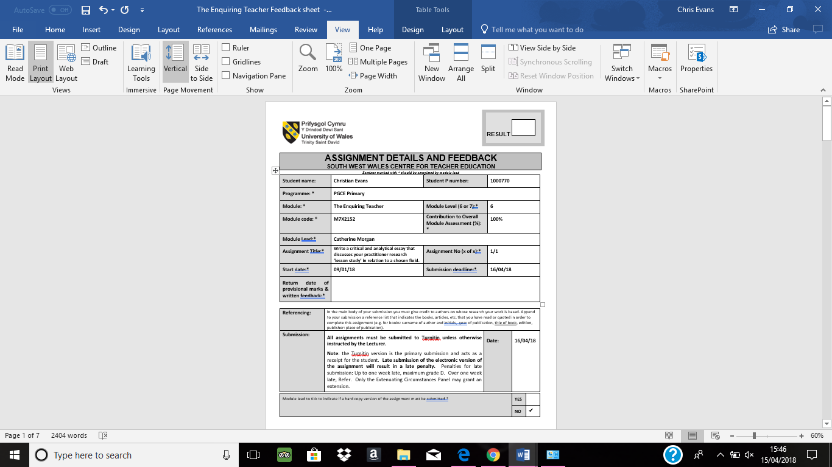

Table of Contents
1.1 - Aims, focus and purpose of Assignment | Page 3
2.1 – Research Context  2.2 – School Settings | Page 3  Page 4
3.1 – Literature Review  - - Skinners Theory of Operant Conditioning  - - Albert Bandura’s social Learning theory  - - Positivity and motivation in the classroom | Page 5  Page 5  Page 6  Page 7
4.1 – Lesson Study  4.2 - Observation Methods  4.3 – Ethical Considerations | Page 8  Page 8  Page 10
5.1 – Lesson Study 1 and Analysis  5.2 – Lesson Study 2 and Analysis | Page 10  Page 12
6.1 – Research Findings | Page 14
7.1 - Conclusions  7.2 – Recommendations | Page 15  Page 17

Appendix Content
Appendix A | Consent form (Parents) | Page 19
Appendix B | Leuven Scale, School A Observation | Page 20
Appendix C | Event Sample School A | Page 21
Appendix D | Semi- structured interview, School A | Page 22
Appendix E | Leuven Scale, School B Observation | Page 23
Appendix F | Event Sample School B | Page 24
Appendix G | Semi- structured interview, School B | Page 25

1.1- Aims, focus and purpose of Assignment
The aim of this assignment is to develop my own critical thinking skills within education and to look at a specific area of teaching that can be improved through independent research. This assignment has not only allowed me to develop my critical thinking skills but has also given me the opportunity to reflect on my own experiences from Professional teaching experience one and establish strengths and weaknesses in my teaching ability.
The issue that interested me was the use of behaviour management tools within my school, in particular the use of behaviour charts. Within my school the behaviour chart used was standard throughout the year groups and had led to me experiencing various outcomes from its use and has made me question the relativity of these charts.
Within my class the chart had been used to deter low levels of involvement and behaviour and on occasions had allowed me to control the levels of involvement given by the pupils when completing their work.
This assignment has also provided me with an opportunity to attend an unfamiliar school setting and reflect on how teaching takes place in this school compared to my own. It has also helped me to understand that all children are different and that what might work well for one class does not mean it would have the same benefits for another.
2.1 – Research Context
For this assignment I have been asked to work collaboratively with a partner to identify similarities and differences in our teaching experiences and decide upon one teaching to look at in more detail. After agreeing on this area, myself and my partner shall conduct a lesson study to identify strengths and weaknesses of this area and how we could further improve our own teaching in the future.
After discussing our experiences of teaching in the foundation phase during Professional Teaching Experience one, my partner also highlighted the use of a behaviour chart within his school. He explained that he felt this behaviour strategy was an important aspect within his respective classes, as it had played a fundamental role in his ability not only for him to teach the class but to also give the children the best possible learning environment to thrive.
We also agreed upon the notion that children’s levels of involvement fluctuated more during lessons that focused on Language, Literacy and communication than any other subject.
From our discussion we decided that the purpose of our research would be to find out “How we can improve involvement in an English focus task through the use of effective behaviour charts in a foundation phase classroom?”
We aim to do this by completing a series of lessons that focus upon levels of interaction and types of behaviours shown by the pupils during the focus task and how these levels are affected by the application of the school’s respective charts. We will also gain the thoughts and feelings of the children regarding the use of these charts within their school and seek if they fully understood how and why these charts are implemented by their teachers.
2.2 – School Settings
For confidentiality reasons the schools within this research will be labelled School A and School B. School A is a large inner-city school based in the centre of Swansea and currently has approximately over 500 pupils enrolled. The school also has a below national average amount of free school meals but also has a high percentage of English as an additional language pupil’s. The class in which the lesson study will take place in is a Year 1 class.
School B is situated in the seaside town of Porthcawl and has approximately 250 pupils enrolled in the school. It has a below national average amount of free school meals and the class in which our lesson study shall take place is of reception age.
Within our respective schools and classrooms, each has a similar behaviour chart which is used frequently to regulate the behaviour of pupils. In School A, the behaviour chart consists of a traffic light system. The three colours (Green, Yellow, Red) show the various stages of the chart and each colour has a different consequence. When a child is placed on the green traffic light the consequence is to miss 5 minutes of their play time. The next stage of the chart (Yellow) means that the child will miss a whole play time. Finally, if a child is placed on the red traffic light they are sent to the head teacher and a phone call home is made. These consequences are set as a deterrent to the children in the hope that they will behave in the appropriate manner.
The behaviour chart in School B is like that in school A but is instead made up of four clouds. The first cloud, which is the lightest of the four, indicates that the children are behaving well and have not been reprimanded in any way. This is where all children are placed at the beginning of a lesson. The other three clouds which visually appear to get darker, indicate that children have misbehaved and again consequences get gradually worse the further along the clouds you are moved.
During our discussion myself and my partner highlighted examples of when the use of these behaviour charts has had a positive effect on pupil’s engagement and standards of work but also shared negative experiences where the application of the behaviour chart has led to pupils’ behaviour worsening and their engagement in the learning experience become non-existent.
Through our lesson study we hope to witness how different children react to the use of a behaviour chart and whether there are improvements that can be made to ensure that the use of behaviour charts lead to more positive learning experiences for children.
  - - Literature review
Behaviour charts can be seen throughout schools across the United Kingdom and from my own experiences of entering new classrooms are usually one of the first things that are brought to my attention by the class teacher. Before conducting our research on the effectiveness of Behaviour charts on children’s involvement levels, I shall first look at the relevant theory behind the use of these charts.
The behaviour management within our respective classrooms focus mainly around children being rewarded for good behaviour and those showing negative or unwanted behaviours are then placed on the behaviour chart. Depending on where a pupil’s name is placed on the chart at the end of the lesson will determine what punishment or rewards they will receive.
3.2 – Skinners Theory of Operant Conditioning
The theory behind these charts can be linked to B.F. Skinner’s behaviourist theory known as Operant Conditioning. From his experiments skinner thought that “Through operant conditioning, an individual makes an association between a particular behaviour and a consequence” (Skinner, 1938). Skinner believed that behaviours could be controlled via the use of punishments and rewards believing that “the increase of something undesirable attempts to cause a decrease in the behaviour” (David, 2015).
Therefore, using Skinners theory, by placing a pupil on the behaviour chart it should result in the child understanding that the behaviour displayed is unacceptable and as a result of this punishment, shall no longer behave in that manner.
The charts also allow children to be rewarded for improving their behaviour after being placed on it. For example, if a child’s involvement and behaviour improve after being placed on the behaviour chart, then their removal from this chart can be seen as a reward. Skinner labelled this type of reward as a ‘Negative reinforcers’ and is described as “the removal of an undesired or unpleasant outcome after the desired behavior.” (David, 2015). This again places emphasis on the child’s understanding that their good behaviour has led to a positive effect and that if this behaviour is continued then no ‘undesired outcomes’ will occur.
Skinners theory of behaviour is based upon the assumption that “all behaviours are determined by past reinforcements and the contingencies in the present environment” (Deci, 1975). Implying that if the punishments for bad levels of interaction and behaviour, as well as the rewards for good levels are consistent within the classroom then good behaviour and interaction will always follow.
Skinner’s theory also focuses on ‘positive reinforcement.’ Skinner (2002) highlights that positive reinforcement should be used when a behaviour is followed by a situation that increases the likelihood of that behaviour occurring in the future.
During my time in my Professional Teaching Experience it became apparent to me that although positive reinforcement is demonstrated in each class, it is not as visible or motivational as the behaviour chart. Positive reinforcement was given to the children through general positive praise and house points.
(Cooper, et al., 2007) “Positive reinforcement is the most important and most widely applied principle of behaviour analysis"
However, the house point chart was not displayed in the same motivational way as the behaviour chart. For the positive reinforcement to be just as significant as the negative it would have been of more value if they were as one. For example, positive behaviour could mean you reach the top of the chart which means you gain a house point. (WAG, 2012) “guiding them towards positive outcomes rather than highlighting their mistakes.”
  - – Albert Bandura’s social Learning theory
Leading on from Skinner’s theory of Operant conditioning, Albert Bandura developed his own theory for explaining behaviour. He agreed with skinners thoughts but added that children also model behaviours of others that surround them. Bandura (1977) specified that “most human behavior is learned observationally through modelling”. Mcleod (2016 ) agreed with this idea by maintaining that a child will imitate another child’s behaviour if the consequences are rewarding and that the child would be more likely to continue performing this behaviour.
In retrospect of this children can also learn through observing bad behaviour. If a child witnesses someone being punished for behaving in a poor manner, then they are less likely to imitate them through fear of receiving the same outcome.

  - – Positivity and motivation in the classroom
The Welsh Government states that “It is important to focus on positive rather than the negative statements when interacting with children, guiding them towards positive outcomes rather than highlighting their mistakes.” (WAG, 2012). By drawing the attention of the pupils to good examples of involvement and behaviour it allows children to develop an understanding of desired conduct within the class.
Highlighting positives can also lead to an improvement in a child’s self esteem and motivation. “Provided that praise is perceived as sincere, it is particularly beneficial to motivation when it encourages performance attributions to controllable causes” (Henderlong & Lepper, 2002). The higher a child’s level of motivation to succeed and learn, the more likely they are to involve themselves in the learning experiences provided for them.
Motivation also plays a key role in the use of a behaviour chart. Children need to feel like they are going to gain something from their hard work.
“Intrinsic or extrinsic motivation is acknowledged as one of the most significant psychological concepts in education and can respectively, be indicated by the achievement of personal goal setting and developing an interest in the subject area; and reliance on external rewards and pressures.” (Kistnasamy , 2014)
If motivation is not present within a classroom environment and children are not encouraged to improve, succeed or be involved in the learning opportunities provided for them, then the use of a behaviour chart can be meaningless. Brophy (2010) said “the concept of student motivation is used to explain the degree to which students invest attention and effort in various pursuits, which may or may not be the ones desired by the teacher”. Based on this research, for behaviour charts to affect levels of involvement the emphasis must be place of positive aspects of behaviour.
After researching the theory behind the use of behaviour charts it has led me to realise that there are many ways in which the chart can be used to influence a child’s interaction levels and behaviour within the classroom. As I have previously stated, the charts currently within our classroom highlight children who are not interacting within the lesson and showing disruptive behaviours. The research has also shown me that the use of behaviour charts is extremely complex as it requires numerous factors to be present such as children’s understanding and motivation in order to be a success.

4.1 - Lesson Study
To find out if behaviour charts can increase levels of interaction with a foundation phase class, myself and my partner shall carry out our research using the method of ‘Lesson Study’.
Peter Dudley introduced this research method to the UK in the early 2000s. Dudley (2014) stated that “Lesson Study (LS) is a highly specified form of classroom action research focusing on the development of teacher practice knowledge.” Lesson study involves collaboratively planning and delivering a series of lessons and recording your findings, to highlight positive and negative aspects of pedagogy and teaching strategies used by teachers. As our research is based upon the use of behaviour charts we have decided that we will carry out our observations during a lesson that is based mainly on Language, literacy and communication as myself and my partner both felt that the children within our classes had shown both high and low levels of interaction during these lessons whilst on placements.
As our pupils consist of different ages, the skills and topic of our lessons in our respective classes will differ however the structure and organisation of our lessons will remain the same to ensure both classes are given the same learning opportunities and can display their natural behaviours. Our sequence of lessons will hopefully allow us to gauge whether the use of a behavioural chart has a beneficial or detrimental effect to children’s involvement and behaviours shown within the lessons.
Our lesson study will consist of two lessons, the first will involve myself teaching a lesson in School A with my partner observing the children’s behaviours and interaction levels. From this lesson we shall evaluate how the behaviour chart influences the children’s interaction levels and look at how we can improve the use of the behaviour chart for the following lesson, where my partner shall teach in School B and I shall observe the behaviours of the children.
4.2 - Observation Methods
Within our lesson study we shall be using three different observation techniques. BERA (2011) guidelines recommend that the observation techniques we use should be appropriate to the purpose of our research. Therefore, as our research involves looking at children’s involvement with and without the use of a behavioural chart we have decided to observe and assess the level of interaction during our lessons via The ‘Leuven Scale for Involvement’.
Laevers (2005) describes involvement as the levels that children are operating at during learning experiences. This scale focuses on the extent to which pupils are operating to their full capacities. It refers to whether the child is focused, engaged and interested in the activities offered to them.
The scale itself is made up of 5 stages. Stage 1 being the lowest level of involvement, where a child display’s a lack of effort throughout and there is an absence of cognitive thinking. An example of this level can be a child continually staring into space and not focusing on their work. The highest level of involvement, ‘Stage 5,’ is achieved by a child that is continuously focused throughout the activity and showing elevated levels of concentration, persistence, creativity and energy.
Before our lessons, myself and my partner looked at each of the stages in the Leuven Scale and talked about what kind of behaviours we would class as each stage, this will help to ensure that when observing the lessons our scoring would be accurate and consistent. We decided that we would mark the children’s level of involvement every five minutes and that we would choose three target pupils at random to assess at the beginning of the lesson.
Our target pupils would be chosen within one ability group to ensure that the task asked of them is relevant to their ability, as if the task set for them is too easy or difficult for them to complete then levels of interaction will deteriorate. In ensuring this, it will allow for true reflections of the children’s behaviour. By using the Leuven scale, it will allow us to see if levels of interaction of our three target pupils increases after the introduction and implementation of the behaviour chart has occurred.
The second observation method which we shall use during our lesson study is event sampling. Event sampling is a type of Frequency count that is “used where the object of the research is to compare individuals or schools in terms of certain types of behaviors” (Chesterfield, 1997). Using this type of checklist will give us the opportunity to record specific behaviours that we would expect to see show levels of interaction. This will include several behaviours both positive and negative. For example, children asking instructions to be repeated, relative answers given by pupils, providing eye contact when teacher is talking.
When these behaviours are displayed by our three target pupils it shall be marked down using a tally chart. The behaviours will be recorded before and after the use of the behaviour chart to establish if the chart has led to an increase in positive behaviours shown and a decrease in negative behaviours.
Our third observation method which we shall be applying in our lesson study will be semi-structure interviews. According to Cohen & Crabtree (2006) “Semi-structured provides a clear set of instructions for interviewers and can provide reliable, comparable qualitative data”. At the end of each lesson our three target pupils will be asked questions to gain an understanding of why they believe a behaviour chart is used. The question will also look seek to find out if the children themselves are able to recognise a difference between their own levels of involvement and behaviour and their peers after the use of the behaviour chart.
Finally, we shall also ask the children how it makes them feel when another child is placed on the behaviour chart and if applicable how they felt when placed on the behaviour chart themselves, and if they feel they worked better due to this consequence. All the answers given to us by the children will be recorded in written form and provide us with qualitive data that can be used to develop a clearer understanding on how the use of the behaviour chart affects their learning.
4.3 – Ethical Considerations
Throughout our lesson study myself and my partner will adhere to the BERA Ethical guidelines for educational research (2011) as well as UWTSD Research, Ethics and Integrity code of professional conduct and practice (2017). To ensure that we adhere to these guidelines myself and my partner will ensure that all information and details recorded will be kept confidential and anonymous. Our target pupils shall be labelled using letters and as we have already stated, the schools in which our lesson study shall take place in shall be labelled ‘School A’ and ‘School B’.
As myself and my partner’s research involves working closely with children of an early age, we have completed an ethics form which has been approved by both the University and the head teacher of the respective schools. We have also gained consent from parents/guardians of the children within our classes by the signing of consent forms (Appendix A).
We have also gained assent from the children to take part in our research project by recording responses to our explanation of our research using the commonly known ‘Thumbs up, Thumbs down’ method that is used frequently in each class.
We ensured all children that agreed to participate that they had the right to withdraw at any point during the lesson and that no punishments will occur for this decision. As well as ensuring that all children who choose to participate would not receive any rewards for taking part.
Finally, the methods of observation that have been stated in the previous section are commonly used throughout the school environment therefore reducing the intrusion and distress levels of the pupils whilst allowing qualitative data to be achieved. Any data that is collected from our lesson’s will be handled within the legal requirements and all data shall be saved via an encrypted memory stick and password protected online cloud storage.
5.1 Lesson Study 1 and Analysis
As mentioned previously, our first lesson study took place in School A with myself conducting the lesson and my partner observing the involvement and behaviour of the children using the observation methods mentioned in the previous section.
After completing the introduction of the lesson, the class split off into their four ability groups to complete the tasks set for them. The ability group that were chosen to be observed consisted of 8 children and our three target pupils were chosen by my partner as he had no previous knowledge of the children. Their scores for involvement where then recorded throughout (Appendix B) as well as the behaviours displayed during the lesson (Appendix C)
At the beginning of the focus task all children were engaged in the activity at hand and were scored at level 4 on the Leuven scale for involvement during the first ten minutes. The three children also showed signs of positive behaviour throughout this ten-minute period by asking questions and providing eye contact with myself whilst explaining the task to them.
After 15 minutes of the focus task, Child B began to disrupt other pupils in the lesson and was scored at level 2 for interaction and had begun to disrupt the rest of the children by talking to them. Child B was given two warnings about his behaviour and was asked to continue with the ‘excellent work’ that he had showed over the first part of the session.
However, the warnings did not have a positive effect on the child’s behaviour and was therefore placed on the green traffic light of the behaviour chart. After this punishment had been put in place for Child B, it proceeded to remind the other pupils in the group to continue working at the levels they were currently at and even increased the level of interaction of shown by Child C.
Retrospective to the impact made on Child C, the punishment of being placed on the behaviour chart for Child B only lead to the child becoming further disengaged with the lesson and despite being moved further down the behaviour chart later in the lesson only continued to show signs of negative behaviour and low levels of interaction. Towards the last five minutes of the lesson Child B did return to his work and showed improved levels but only after being reminded of how well he worked at the beginning of the lesson on a second occasion.
After the focus task was complete the three target pupils were asked questions about the behaviour chart which had been used within their lesson (Appendix D). When asked about why they thought teachers used the charts in their lessons, the children showed a basic level of understanding of the method behind it. Child A answered, “The teacher uses the behaviour chart when someone is being naughty”.
Child B and C nodded in acceptance with the statement made, however Child B went on to say that “sometimes I get put on the chart even if I haven’t done anything wrong”. This statement seemed to show that the child had become disillusioned with the chart and highlighted that sometimes he felt he would be placed on the chart even if he was showing ‘good behaviour’.
When Child B was questioned about how they felt being placed on the behaviour chart they responded, “It made me feel angry” and expanded further on this by saying “I had done more work than everybody else”. This shows that Child B thought they were entitled to stop working for a while as he had completed more of his work than anyone else.
For the majority of the pupils the lesson was successful as they were able to achieve the learning objectives and success criteria set for them at the beginning of the lesson, however for Child B the use of the behaviour chart had only led to the child becoming further disengaged with the activity and although choosing to continue with the task by the end of the session the work was incomplete and had not achieved the same outcome as the other pupils in the group
From the lesson myself and my colleague both agreed that the use of ‘negative reinforcement’ had an adverse effect on the behaviour of Child B during the lesson as it only furthered to decrease the child’s level of involvement within the task and an increase in the amount of negative behaviours shown.
After discussing whether the behaviour chart had improved involvement during the focus task, we agreed that it had helped to increase levels of involvement for two of our target pupils. In order to try and make our next lesson more successful, we agreed that we would focus more on praising positive behaviour and high levels of involvement instead of punishing those showing low levels of involvement.
Therefore, we decided to adapt the behaviour chart of School A for our following lesson study by adding a Golden sun component to the chart described previously. This Golden sun would be used to highlight children that are showing elevated levels of involvement and positive behaviours. We would also use the Golden sun as a motivational tool to encourage the children.
As this is a new concept to the children within School A, it was important that before the following lesson took place the children were introduce to the ‘Golden sun’ and given an explanation that good behaviour and concentrating on their work would lead to their name being placed on the golden sun and that at the end of the lesson those placed on that icon would receive two house points.
5.2 - Lesson study 2 and Analysis
Our Lesson study 2 took place in School B in which this time my colleague would conduct the lesson and I would observe the levels of involvement (Appendix E) and behaviours of the children (Appendix F). After introducing the new component of the behaviour chart to the children in School A, it was clear to see the excitement on their face with many of the children talking amongst themselves about ‘wanting to get on the golden sun’ and when told about the reward a few cheers were given by the pupils.
The lesson was run in a similar context to that of Lesson study 1, as the introduction was carried out with the whole class before the children were sent off to complete the tasks set for them. The group of children in which our lesson study took place consisted of nine pupils of which three were chosen at random by myself as target pupils.
During the first five minutes the three target pupils were all scored at level 3 using the Leuven scale of involvement and had showed positive behaviour and attitudes towards the activity given to them. Whilst completing the work set for them the children were continuing to talk amongst themselves about their wishes to be placed on the golden sun.
The levels of involvement stayed constant for a further ten minutes before Child D was rewarded for answering a question based on the activity. As a result of this, all three target pupils began to concentrate harder on their work and were later scored at level 4 for involvement. This led to Child E and F also being rewarded by being placed on the golden sun.
The children continued to score highly on the Leuven scale of involvement until the task was completed and all children had produced a good standard of work according to my partner who had a deeper understanding of the ability levels of the children.
The three target pupils were then asked the same question as the children that took part in lesson study 1 (Appendix G). Again, the children showed a basic understanding of the behaviour chart and were able to explain what the various stages of the chart meant.
As none of the children had not received any punishment and had not been placed on any of the dark clouds we asked the children how it made them feel when they had been placed on the chart previously? Child D replied, “It made me feel sad because I had been naughty”.
The children were then asked how they felt when their friends had been placed on the behaviour chart. Two of the children explained that they disliked seeing their friends being placed on the behaviour chart although admitted that it does make them “work harder”. Child D added that they felt happy when their friends were placed on the golden sun with them.
After the lesson had been concluded and a brief overview of the work completed had been viewed, it was clear to see that the children had achieved the learning objective and the lesson had been enjoyed by all the pupils. The addition of the golden sun had allowed the teacher to emphasise positive behaviour and had seemingly resulted in the children being motivated to complete the task to the best of their ability. Throughout the entire lesson the children had behaved well showing on many occasions positive behaviours which were marked using the event sampler. Due to this level of behaviour throughout the chart had no dramatic effect on the conduct of the pupils.

6.1 - Research Findings
From my research findings it became clear to me that positive reinforcement had a more constructive effect on the children than negative reinforcement. This was shown in lesson study 1 where Child B continued to behave in an inappropriate manner after he had been told off. This follows on from what I researched in my literature review, where it stated that positive reinforcement is extremely important and highlighting a child’s mistakes can have an undesirable effect on them. Skinner’s belief that negative reinforcement will lead to a decrease in the type of behaviour shown beforehand was not witnessed during this incident. Although, this had a negative impact on Child B, we also witnessed a positive effect using negative reinforcement as Child A and C showed elevated levels of interaction after this punishment was given out. This is an example of Bandura’s Social Learning Theory emphasised previously.
On reflection of the answers given during the semi-structured interview which proceeded this incident, child A and C expressed feelings of sadness when witnessing their friends being placed on the behaviour chart despite improving their interaction levels. This implies that although a punishment was aimed at one individual, it can still impact negatively on other children’s emotions. This would have an adverse effect on creating a positive learning environment which is essential for children to learn in.
This event clearly shows that responses to both positive and negative reinforcements are often child specific and dependent on many various factors such as, personality, environmental and social.
The research findings have also highlighted to me, the importance of attitude and understanding from the children. A report written by Gorard et al. (2012) states that “Individual aspirations and expectations are considered important because they might influence key choices.”
During the semi structured interview with Child B, it was clear to see from his response that he had had previous undesirable experiences when placed on the behaviour chart by reflecting on a time where he had felt being placed on the chart was unfair. This could have occurred as the child had not understood why they had been placed on the chart and has led them to become disengaged with its use.
The results of our lesson study also emphasised Brophy’s belief that motivation plays a key role within a child’s levels of involvement. This is highlighted in the change of behaviour charts from Lesson 1 to Lesson 2.
The behaviour charts in lesson two succeeded in providing motivation and a goal for the children to reach via high levels of involvement. Based on Kistnasamy’s views, the concept of the Golden sun, along with the reward of house points offered both intrinsic and extrinsic motivation for the pupils. Therefore, the chart had a positive effect on the levels of interaction. I do however recognise that the impact of rewards can lose its appeal over time and whether the addition of the golden sun will still make the same impact on the children’s involvement after a longer time is up for debate.
7.1 – Conclusion
After completing the lesson study and analysis of our research findings I believe that the project has been beneficial in finding out whether behaviour charts can influence levels of involvement in a foundation phase class. The lesson allowed me to witness several types of behaviour and reactions towards the use of these charts.
The lesson study process allowed myself and my colleague to highlight weaknesses in the use of our chart in lesson one and agree on how we could further improve this in preparation for our second lesson. After making these changes the implementation of the adapted behaviour chart allowed for further positive results.
The results that were obtained from this lesson study have not only helped to indicate how to improve the use of behaviour charts but has also made me reflect on my own teaching style. Viewing the children reacting far more positively by focusing on positive behaviour rather than negative is certainly an aspect of behaviour management that I will seek to use more frequently in the future.
The observation methods that were applied during the lessons allowed for both qualitative and quantitative data to be achieved. The Leuven scale of involvement was extremely beneficial to our research as it allowed us to record scores quickly due to the number scale given, which in turn allowed the observer to focus on the target pupils rather than recording details.
Although myself and my partner had spoke before hand about our interpretation of the levels within the scale it is still possible that on occasions our interpretations might have been differed. Because of this, if carrying out a lesson study in the future I would assign one person to complete the scoring throughout the entirety of the project. This would allow for the same interpretation of the levels for each lesson.
The use of event sampling to note down the occasions when specific behaviour occurred before and after the application of the behaviour chart was useful within the first lesson of our research. It allowed us to view the difference and similarities of the actions displayed by our target pupils.
In the second lesson the event sampling had little effect on our research findings, but this was mainly down to the good behaviour from the pupils throughout the lesson as no changes occurred throughout the entirety of the lesson. One disadvantage to using the event sample is that I found myself looking only for the behaviours mentioned within the chart and therefore could have possibly missed other behaviours that effected children’s levels of involvement as well as the pupil’s reactions and emotions to the use of the chart.
The addition of video recording our lessons would have been extremely beneficial to our research as it would have allowed us to re-evaluate our results taken from the lessons and include anything that might have gone unnoticed.
Finally, the use of semi-structured interviews at the end of our lessons gave the children the opportunity to discuss their understanding of how the behaviour charts in their classrooms are used. They also described their feelings towards the chart when they themselves or their peers are placed on it.
The answers given by the children were extremely beneficial as it highlighted in some cases the adverse effects being placed on the behaviour chart can have on pupils. It also emphasised the importance of communicating with the children who are placed on the chart for bad behaviour, to explain and help them to understand the types of behaviour that are unacceptable in the classroom as all children have a different interpretation of acceptable and unacceptable behaviour.
In my future teaching, I will endeavour to communicate with my pupils to ensure that those placed on the chart understand why. In turn this can lead to the chart being used more effectively for the whole class as they will have a clearer understanding of expected behaviour and involvement.
If using this observation method in a future lesson study research, then I would look to include voice recording equipment during these interviews, as having to write down notes whilst the children were speaking proved to be time consuming and didn’t allow for full concentration to interpret what the children were saying. By using a voice recorder, it would have allowed for these higher levels of concentration and could have led to posing more specific questions based on the children’s answers. This would have led to a deeper understanding of the pupils’ thoughts.
With regards to the generalisation of the results obtained for this study, I believe that if carried out in different classes throughout schools in different areas and different ages, the results would differ due to the complex and diverse personalities and needs in which classrooms of today contain. Our study took place in relatively similar age classes however lessons were taught by two separate teachers with different teaching styles and classroom expectations. The lessons were also taught at contrasting times with one taking place during the first session of the day and the other in the afternoon session. These factors most certainly would have had an influence on the levels of involvement and behaviour shown.
If I was to carry out a lesson study research again, not only would I adapt my observation methods spoken about previously, I would also ensure that lessons carried out would be conducted by one teacher and include more than two lessons. This would allow for more reliable and consistent results which would lead to further improvements on the use of behaviour charts for levels of involvement.
7.2 – Recommendations
In answer to our research question ‘How can we improve involvement in an English focus task through the use of behaviour charts in a foundation phase classroom?’, I believe that when used appropriately and consistently it can have a positive effect on children’s involvement. However, for this to occur there are many different factors that need to be considered.
It is vitally important that the use of the behaviour chart allows focus on positive reinforcement and only use negative punishments as a secondary response. Furthermore, the rewards and punishments must be relative to the children, they must be able to motivate the children and if possible lead them to be intrinsically motivated by their enjoyment of learning rather than the external rewards such as stickers or house points.
Another aspect that can affect the use of behaviour charts is the children’s attitudes and understanding of these charts. As mentioned in the previous section all pupil’s must be clear on what standard of behaviour is expected in the classroom and consequences and rewards for certain behaviours need to be consistent from teaching staff, to ensure that children do not become disillusioned by the concept of behaviour charts.
Finally, for the application of behaviour charts to be truly affective in supporting children’s level of involvement, the teacher must provide children with interesting and engaging learning opportunities that meet the needs and abilities of all learners. By developing relationships and understanding of how children work best, and the emotional signs displayed by the pupils in the classroom will lead to a clearer understanding of how to manage each child’s individual behaviour.

Reference List
Bandura, A., 1977. Social Learning Theory. 1st ed. New Jersey: Prentice Hall.
BERA, 2011. Ethical Guidelines for Educational Research, London: British Educational Research Association.
Brophy, J., 2010. Motivating Students to Learn. 3rd ed. New York: Routledge.
Chesterfield, R., 1997. Classroom Observation Tools, s.l.: Institute for International research.
Cohen, D. & Crabtree, B., 2006. Qualitive research guidelines project. [Online]
Available at: www.qualres.org/HomeSemi-3629.html
Cooper, J., Heron, T. & Heward, W., 2007. Applied Behaviour Analysis. 2nd ed. New Jersey: Pearson Education.
David, L., 2015. Classic and Operant Conditioning (Skinner). [Online]
Available at: https://www.learning-theories.com/operant-conditioning-skinner.html.
[Accessed 06 04 2018].
Deci, E. L., 1975. Intrinsic Motivation. 1st ed. New York: Plenum Press.
Dudley, P., 2014. Lesson Study: A Handbook, Cambridge: LSUK.
Gorard, S., See, B. H. & Davies, P., 2012. The Impact of Attitudes and Aspirations on Educational Attainment and Participation , York: Joseph Rowntree Foundation .
Henderlong, J. & Lepper, M. R., 2002. The Effects of Praise on Children’s Intrinsic Motivation: A Review and Synthesis. Psychological Bulletin, 128(5), pp. 774-795.
Kistnasamy , E. J., 2014. American Journal of Educational Research. The Power of Extrinsic Motivation in Tertiary Education,, Volume 2.6, pp. 383-388.
Laevers, F., 2005. Well-being and Involvement in Care Settings. A Process-oriented Self-evaluation Instrument., Brussels: Research Centre for Experiential Education Leuven University.
Mcleod, S., 2016. www.simplypsychology.org/bandura.html. [Online]
Available at: https://simplypsychology.org/bandura.html
[Accessed 11 April 2018].
Skinner, B. F., 1938. The Behaviour of organisms: An experimental analysis. New York: Appleton-Century.
Skinner, B. F., 2002. Beyond Freedom and Dignity. Indiana: Hackett Publishing.
WAG, 2012. Practical approaches to behaviour managment in the classroom, Cardiff: Welsh Assembly Government .

Appendix A – Consent Form (Parents)
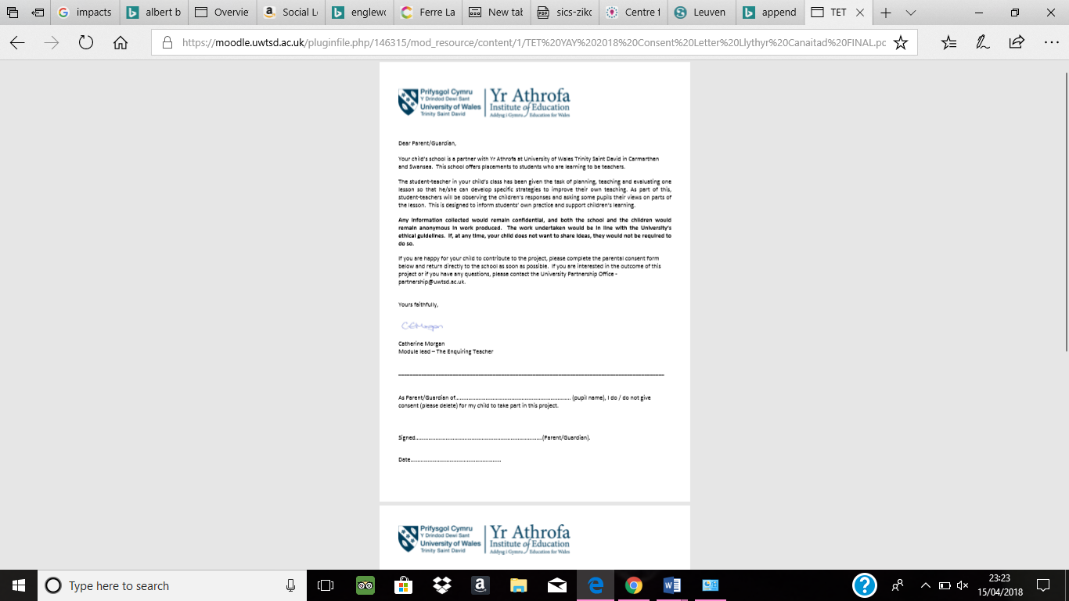
Appendix B – Leuven Scale, School A Observation
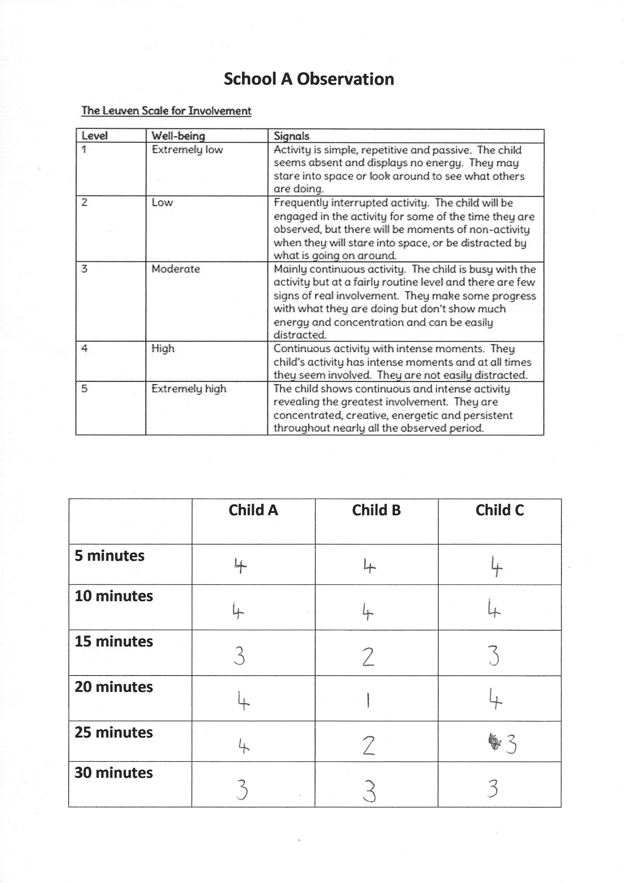
Appendix C – Event Sample School A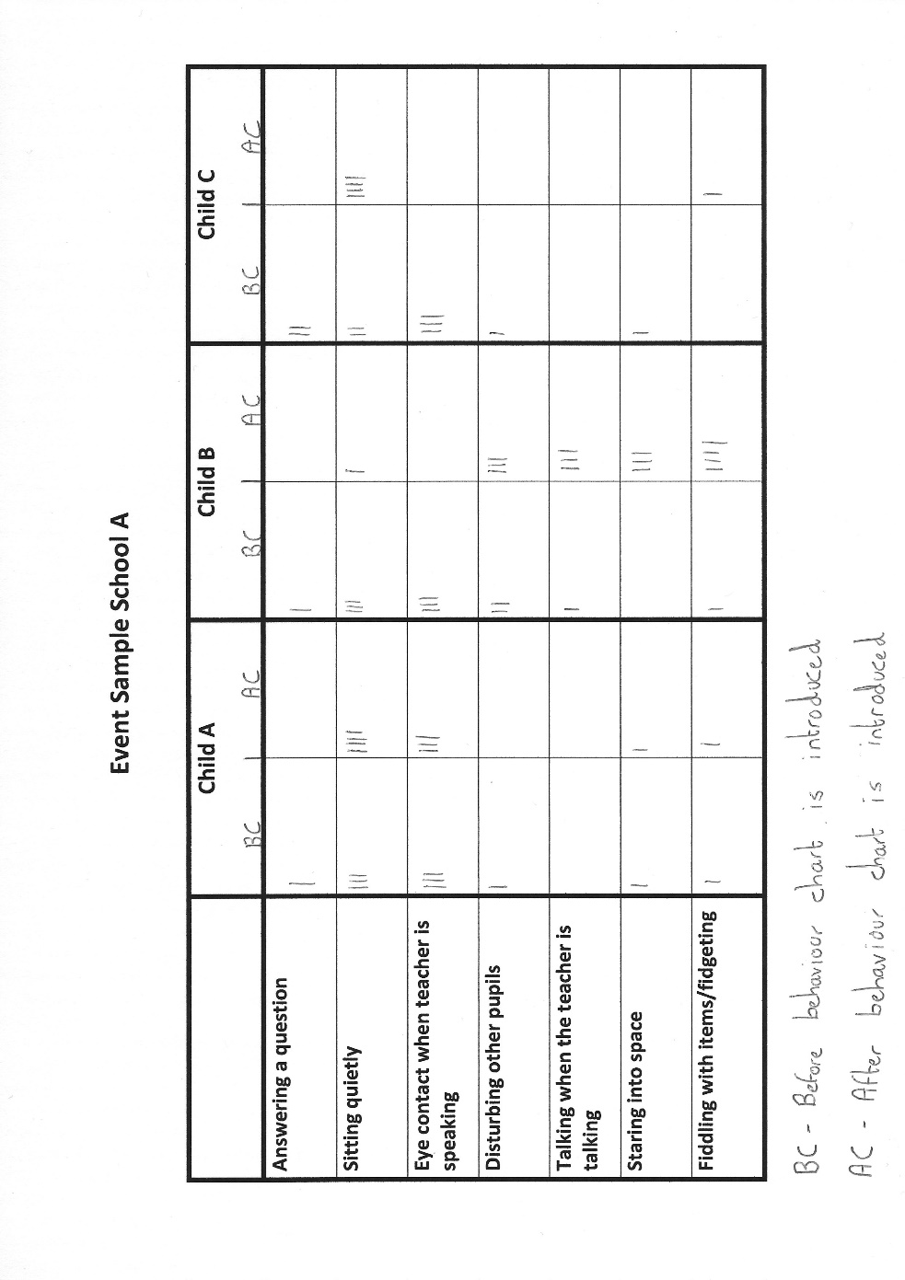

Appendix D – Semi-structured Interview School A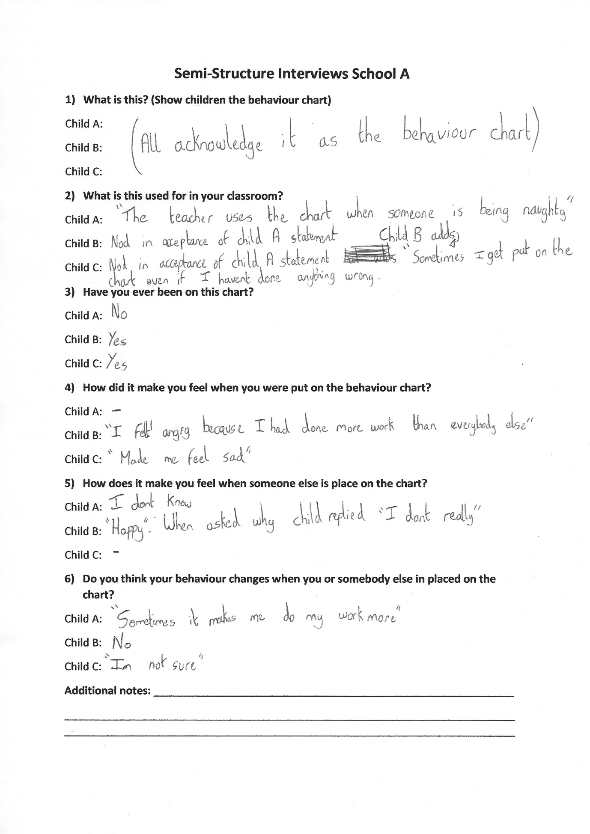

Appendix E – Leuven Scale, School B Observation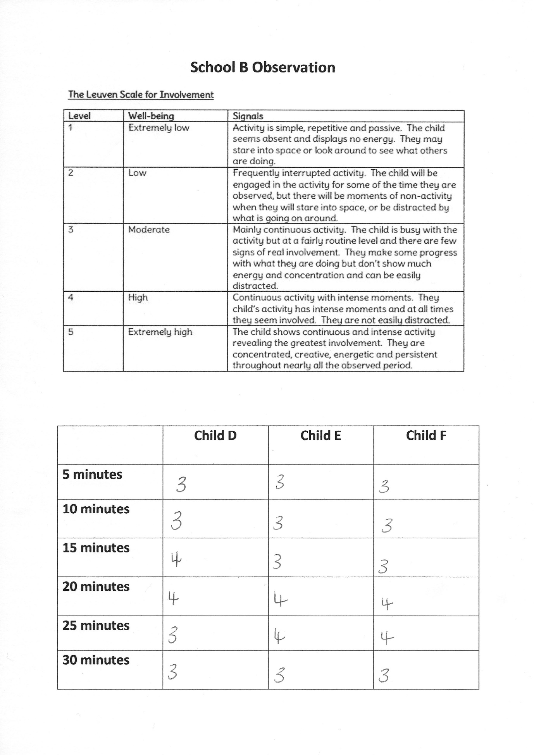

Appendix F – Event Sample School B
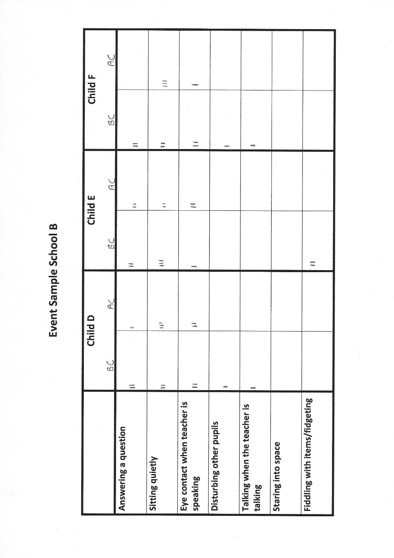

Appendix G – Semi-structure interview School B


