LCBB5000 Data Handling and Business Intelligence

Assignment 2

Student Name: Ivan Todorov Todorov
Student ID: 2023561
Table of Contents
Introduction 2
Data warehousing 3
Business Intelligence 4
Data Mining 6
Part:1 8
Pre-processing Data 8
Data Analysis & Visualization 8
Part:2 10
1. 10
2. 11
3. 12
a) Cluster Analysis 13
b) Data mining and text mining methods 15
C) Advantages and disadvantages of using SPSS and Excel 15
Conclusion 16
References 18

Introduction
Using a set of specialized methods, skills, and procedures, a company's historical and current business data is explored, iterated, and investigated in order to gain new insights that might help the company make better decisions. It is possible to use data to better understand your clients, optimize your advertising campaigns, tailor your content, and boost your bottom line by using it. You need the correct data analytics tools and procedures in order to realize the many benefits of data. The power to build your business is hidden in the raw information, but data analytics can help you find it (2022). Evaluation of current data warehousing, data mining, and business intelligence trends was conducted in the first section of the evaluation where details of those process-like advantages, stages, implication etc. has been mentioned. Data processing tools were used to examine all relevant information, and an example is supplied. In the following section, we'll focus on acquiring a thorough understanding of the subject matter through the application of analytical techniques. In this example, SPSS was used for data analysis since it allows for easy identification of trends and patterns. SPSS's advantages and disadvantages over Excel have been outlined in the following paragraphs.

Data warehousing
An organization's operational data is stored electronically in a DWH, where it may be queried on-demand or periodically for reports. On the other hand, building and implementing a data model that can quickly generate insights is required for a data warehouse. The data in the DWH is distinct from the operational data that can be found. To make daily operations, analysis, and reporting easier, it is laid out in such a way that relevant data is grouped together. This enables users to make plans based on the information they gather over time. The importance of warehouses in business is reinforced by this.
When it comes to extracting meaningful information from raw data, dimensional models are the greatest way to discover the optimal method for doing so. There are three basic styles of architecture to consider when creating a real-time data warehouse for business use.
- Architecture with a single layer
- a two-tiered design
- Three-tiered Design
A data warehouse's most important features include:
Subject orientation: This type of information is focused on a specific topic rather than the overall operation of the company. A few examples of topics include specifics about products, sales, clients, and vendors, among others.
Integration: Incorporating numerous sources of data, such as flat files and relational databases, allows for improved data analysis.
Time variation: In a DWH, the data is categorized by a specific time period because it provides information from a certain historical moment in time.
Non-volatile: If additional information is added to an existing file, it is considered "non-volatile" since it will not be lost. Modifications to a DWH aren't reflected in changes made to an operational database because they're distinct entities.
Data warehousing was first used in a somewhat low-tech manner in the early 1990s. However, with time, data warehousing became increasingly sophisticated.

As a data warehouse (DWH) user, you'll go through the following general stages:
Operational Database: Offline Data is simply copied from one server to another during this stage. So, the copying of data has no effect on the operating system's performance, loading, processing, or reporting.
Data Warehouses that are not online: The Datawarehouse receives frequent data feeds from the Operational Database. The Data warehousing information is linked and changed in order to achieve the Datawarehouse goals.
Data Warehouse in Real Time: At this point, the operational database's transactions are reflected in the data warehouses. An example of this would be a reservation system for air or rail travel.
Data Warehouse Integrated: When an operational system processes a transaction, data warehouses are automatically updated. Thereafter, the operational system receives transactions from the Data Warehouse.

Business Intelligence
As a collection of tools and techniques, business intelligence (BI) is used to turn raw data into information that can be used for economic decision - making. Transactional databases store all of a business's day-to-day data. Companies may benefit from Business Intelligence (BI) by discovering and utilizing the information they currently possess. Data may be mined from a wide range of sources to offer actionable and nearly real-time inputs for decision-making with the help of business intelligence tools (BI) (Zuhaira and Ahmad, 2020).
To make strategic and operational choices, you need to recognise patterns and develop knowledge from big data you have at your disposal. Today's top business intelligence technologies can be found in the following list:
Sisense: As a non-technical user, the SharePoint BI tool might be a good fit. Large datasets may be managed, analysed, and visualised by a broad variety of users without the involvement of IT. Google Analytics and AdWords data can be retrieved using this tool. In comparison to other BI tools, this one process data more quickly thanks to the usage of built-in technology.
SAP Business Intelligence: Sisense BI may be a good option if you're not an expert in the field. Without the need to involve the IT department, a broad variety of people may manage, analyse, and display enormous datasets.
.The Dundas BI: Browser-based and user-friendly Users of Dundas BI can connect to multiple data sources at the same time. In addition to tables, graphs, and charts, it allows for customization and viewing on both mobile and desktop devices. Reports may be readily created and performance metrics can be retrieved for further investigation. All types of businesses and industries can benefit from Dundas' services.
Using Business Intelligence Has Many Advantages
Business Intelligence Systems have many advantages, such as these:
BI programs allow firms to create reports with a single click, saving both time and money. Employees are able to do more throughout their workday as a result of this.
Improved visibility and identification of problem areas can be achieved by using business intelligence (BI).
Accountability must be improved. With the BI system assigning accountability in the organization, there must be someone responsible and accountable for the organization's performance against its stated objectives.
A bird's-eye view is provided by this method. Dashboards and scorecards, two common BI tools, give decision-makers in businesses a bird's-eye view of their data.
It makes company operations more efficient. Business Intelligence (BI) removes all of the complexity from business procedures. Predictive analysis, computer modelling, benchmarking, and other methods are all part of the package.
It makes data analysis a breeze. BI software has become more accessible to non-technical or non-analytical people, allowing them to swiftly collect and process data. The power of analytics may now be distributed to a larger group of people.

Data Mining
We live in a digital age where big data is everywhere, and that number is expected to rise by 40% every year over the next decade. The information is buried deep within. It's hard to get any value out of big data unless we have sophisticated tools and methodologies for mining it.
Technological infrastructure is required for data mining. Required: More data must be processed and kept in order for the system to have a more powerful capability. More complicated queries and a larger number of inquiries necessitate a more powerful system than simpler queries and searches. Uses: If you're conducting study on anything from mathematics to genetics, data mining can be a beneficial tool. To deliver tailored promotions based on an individual's purchase history, retailers can employ point-of-sale information and data mining. Customers' demographic information from comment or warranty cards could be used by the store to create new items and marketing targeted at specific consumer groups.
Key aspects of data mining:
Using trend and behaviour analysis, an algorithm generates forecasts about future patterns. Based on what is most likely to happen. The development of information that is useful for making decisions. Analyse vast amounts of data in databases. Clustering is focused on the discovery and visual documentation of previously unknown groups of information.
In this section, we've compiled a list of the best open-source and SaaS data mining tools.
Oracle Data Mining: A feature of Oracle Advanced Analytics, Oracle Data Mining enables analysts to build and deploy prediction models. This programme includes classifications, extrapolation, outlier detection, forecasting, and more. Using Oracle Data Mining, you can identify and target the most profitable consumers by predicting their behaviour, segmenting their profiles, and detecting fraudulent activity. Java APIs could be used by programmers to uncover new relationships and correlations in business information.
IBM SPSS Modeler: A data mining product, IBM SPSS Modeler allows data scientists to expedite and visualize the data mining process. Predictive models may be built using complicated algorithms and a simple drag-and-drop interface by anyone, regardless of programming knowledge. Large amounts of data from many sources can be imported and rearranged by data science teams using IBM's SPSS Modeler. Spreadsheets and relational databases are supported in the standard version of this program. You'll need to upgrade to the premium version if you want text analytics.
SAS Enterprise Mining: One of the main functions of Enterprise Miner is to analyse and store data. In data mining, important information can be gleaned from vast volumes of data. Users may quickly develop data mining models and utilize them to solve crucial business issues using an interactive GUI. Data preparation and exploration, as well as the creation of advanced predictive and descriptive models, may all be done with SAS's extensive collection of algorithms.

Part:1
By using crime rate dataset, this part will analysis and visualize different graph and use different Microsoft excel function to give more deeper understanding of dataset.

Pre-processing Data
Data preparation is the process of transforming raw data into something that can be read and comprehended. This is a crucial step because raw data cannot be used in data mining. Before employing machine learning or data mining, ensure that the data is of excellent quality.

Data Analysis & Visualization
The graphic depiction of data is the focus of data visualization, an interdisciplinary discipline. A time series, for example, is ideal for this type of communication since it contains a large amount of data.
Using bar graph average of crime rate and crime rate in million are both shown in following. From the bar we see that average crime rate is 102.81 and there is 1028 crime in every million.

Pivotal table of crime rate
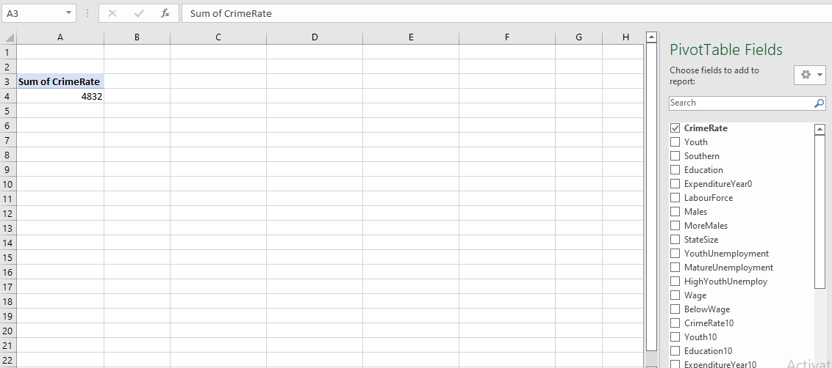

VLOOKUP function:
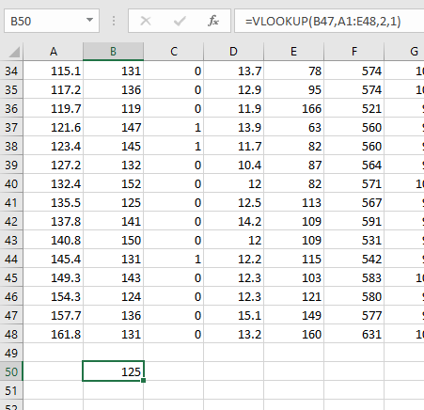

Part:2

1.
Frequency table ice-cream with its three categories. Vanilla has the highest frequency and then strawberry and chocolate has the lowest value.
Ice-cream
 |  | Frequency | Percent | Valid Percent | Cumulative Percent
Valid | Vanilla | 95 | 47.5 | 47.5 | 47.5
Valid | Chocolate | 47 | 23.5 | 23.5 | 71.0
Valid | Strawberry | 58 | 29.0 | 29.0 | 100.0
Valid | Total | 200 | 100.0 | 100.0
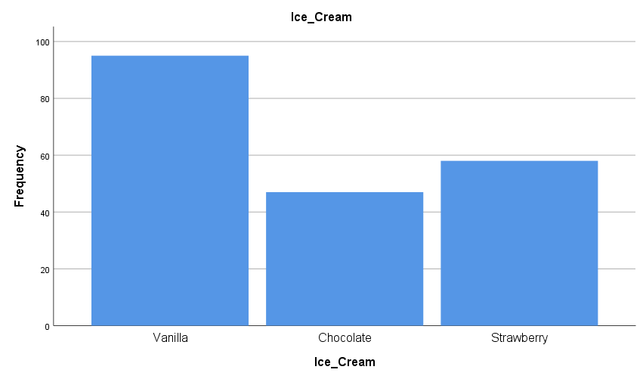
For every form of data analysis, a visual representation is essential. The frequency of each ice cream flavour is depicted in this bar graph, which follows on from the previous one.

2.

Using SPSS, frequency of male and female has been shown in the table. Female has higher percentage than male.
Gender
 |  | Frequency | Percent | Valid Percent | Cumulative Percent
Valid | Male | 91 | 45.5 | 45.5 | 45.5
Valid | Female | 109 | 54.5 | 54.5 | 100.0
Valid | Total | 200 | 100.0 | 100.0

The pie graph is a common illustrative tool. This is also useful for quickly determining which gender is dominant.
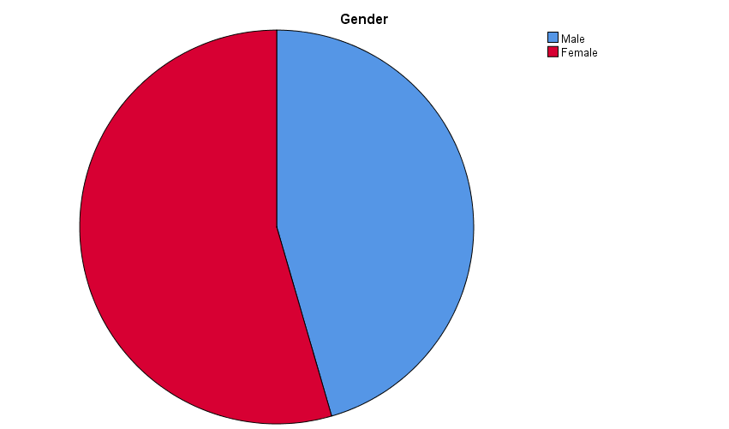

3.
According to the statistics table, participants who choose chocolate and strawberry flavour ice cream have a mean and a median of 47, respectively, in the following tables. The average and median values for strawberry ice cream are then calculated, with a mean value of 55.45 and a median value of 58.

Statistics
 |  | Video | Puzzle
N | Valid | 47 | 47
N | Missing | 0 | 0
Mean |  | 47.70 | 47.32
Median |  | 47.00 | 46.00
Ice_Cream = Chocolate

Statistics
 |  | Video | Puzzle
N | Valid | 58 | 58
N | Missing | 0 | 0
Mean |  | 55.45 | 57.14
Median |  | 58.00 | 61.00
Ice_Cream = Strawberry

a) Cluster Analysis
It is possible to organize data into groups by reducing the Euclidean distance between them using K-means. It is possible to identify unidentified categories in the data using the K-means clustering algorithm. Check assumptions about the types of groups that exist or uncover new ones in massive data sets using this method. (Pham, Dimov and Nguyen, 2004).
In SPSS using dendrogram we have taken 3 cluster.

Initial Cluster Centers
 | Cluster
 | 1 | 2 | 3
video | 29 | 55 | 72
puzzle | 26 | 71 | 31

Iteration Historyª
Iteration | Change in Cluster Centers
Iteration | 1 | 2 | 3
1 | 16.278 | 12.775 | 17.567
2 | 3.070 | 1.812 | 1.037
3 | 1.793 | .967 | .327
4 | 1.400 | .798 | .373
5 | 1.096 | .682 | .471
6 | .406 | .114 | .616
7 | .000 | .000 | .000
a. Convergence achieved due to no or small change in cluster centers. The maximum absolute coordinate change for any center is .000. The current iteration is 7. The minimum distance between initial centers is 43.290.

Final Cluster Centers
 | Cluster
 | 1 | 2 | 3
video | 41 | 58 | 56
puzzle | 46 | 61 | 39

ANOVA
 | Cluster |  | Error |  | F | Sig.
 | Mean Square | df | Mean Square | df | F | Sig.
video | 5889.952 | 2 | 39.226 | 197 | 150.153 | <.001
puzzle | 7430.226 | 2 | 40.994 | 197 | 181.253 | <.001
The F tests should be used only for descriptive purposes because the clusters have been chosen to maximize the differences among cases in different clusters. The observed significance levels are not corrected for this and thus cannot be interpreted as tests of the hypothesis that the cluster means are equal.

Number of Cases in each Cluster
Cluster | 1 | 67.000
Cluster | 2 | 101.000
Cluster | 3 | 32.000
Valid |  | 200.000
Missing |  | .000

b) Data mining and text mining methods
Information Extraction (IE): Extracting relevant information from a large volume of data is done using this method Decoding unstructured text begins with IE's tokenization, identification of named entities, segmentation, and assignment of parts of speech. An important part of the IE process is to identify the relationships among the various data elements in a document. This is followed by the accumulation of the extracted corpora into linked databases for further processing. Precision and recall processes are used to examine and analyse the relevant information/outcomes from the extracted data.
Natural language processing (NLP): Unstructured text may now be processed automatically by computers using NLP, which examines the structure and syntax of individual words and sentences (Predicting User Motivation Towards Retention of e-Services: An NLP-based Approach, 2019). NLP is a branch of artificial intelligence.
NER, summarization, and sentiment analysis are some of the methods it uses.
Summarizing a significant amount of textual data into an easy-to-understand summary of the document's most important aspects. Depending on the word's part of speech, such as "noun," "verb," "adjective," and so on, each word or token in a document is given a tag to help organize it. PoS tagging enables semantic analysis of unstructured text.
Sentiment analysis: Positive or negative sentiment can be determined through the use of both internal/external data sources and a time period. It is via the use of sentiment analysis that firms are able to engage with their customers in order to enhance their operations, user experience, and satisfaction.

C) Advantages and disadvantages of using SPSS and Excel
Advantages
- Even tiny samples may be utilised with confidence when using the SPSS Exact Tests module.
- Data missing from an analysis can be linked to other variables using SPSS' Missing Values module. Your models and outcomes can suffer if you don't have enough information. Use it to verify data collected in surveys, by social scientists, by data miners, and by market researchers.
- Analysis may be done without the requirement for a statistician because of SPSS's forecasting function.
- With excel, the best technique to store data. Calculation can be made.
- Everything you need to analyse data. It's simple to create charts for data visualizations.
- Printing reports is a breeze. There is a plethora of free templates at your disposal.
- You can write code to automate. Clean and transform data.
Disadvantages
- SPSS's inability to handle extremely large datasets is a severe flaw. When it comes to analysing clinical data, researchers in the medical and nursing fields prefer SAS to SPSS over SPSS.
- Social science software SPSS is more like a statistical software than a social science software. To make things easier for the end user, the output is condensed. This feature's main drawback is that it obscures the internal workings of the programs being run.
- Control and security are lacking. Errors in Excel can be caused by human error. Consolidating Excel is a difficult task. Agile business methods can't be carried out in Excel. We can't make quick decisions with Excel. Collaborative work isn't supported by Excel. Excel is notoriously difficult to diagnose and fix problems with.

Conclusion
Businesses of all sizes benefit from the usage of business analysis tools since they help them enhance their performance. As the needs of different businesses change, business analysis can help them achieve their goals. In some cases, customers should be the primary users of a business study, as they are the best source of information on the product's performance. Preventing incomplete or failing projects is the goal of this form of analysis (Yermish et al., 2010). Poor business analysis often results in more problems than it fixes, and it can be a complete waste of time and resources. It is therefore imperative to learn about business analytic tools so that novel solutions can be found for problems.

References
Iiba.org. 2022. [online] Available at: <https://www.iiba.org/globalassets/events/webinars/2019/files/december-30-2019-iiba-business-data-analytics-a-decision-making-paradigm.pdf> [Accessed 16 April 2022].
International Journal of Business and Administrative Studies, 2019. Predicting User Motivation Towards Retention of e-Services: An NLP-based Approach. 5(1).
Pham, D., Dimov, S. and Nguyen, C., 2004. An Incremental K-means algorithm. Proceedings of the Institution of Mechanical Engineers, Part C: Journal of Mechanical Engineering Science, 218(7), pp.783-795.
Yermish, I., Miori, V., Yi, J., Malhotra, R. and Klimberg, R., 2010. Business Plus Intelligence Plus Technology Equals Business Intelligence. International Journal of Business Intelligence Research, 1(1), pp.48-63.
Zuhaira, B. and Ahmad, N., 2020. Business process modeling, implementation, analysis, and management: the case of business process management tools. Business Process Management Journal, 27(1), pp.145-183.

