Worksheet 3 – Network Resources

Dominik Tomasz Kania
Computing (Computer Networks and Cybersecurity)
University of Wales Trinity Saint David
Swansea, Wales
1702026@student.uwtsd.ac.uk

Table of Contents
Abstract 3
Introduction 3
Worksheet 3 – Practical Tasks 4
Task 1: Understanding NTFS and Share Permissions 4
Task 2: Utilising Group Policy Management Console 13
Worksheet 3 – Observational Tasks 24
NTFS Permissions and Share Permissions 24
Group Policy Management 26
Principles of Password Security 28
Conclusion 31
References 32

Abstract
Microsoft created a hierarchical system to establish a mechanism for maintaining object details through a meticulous listing of network objects. Network technicians can establish and manage users and devices within a particular system or network with a designated destination, which necessitates proper network organisation. When a network expands, it becomes necessary to arrange a vast number of users into logical groups and subgroups while maintaining user authentication at each level, which necessitates the use of information management policies. A security policy is a systematic framework that states what distinguishes appropriate and inappropriate user behaviour when it comes to working with data resources in a trusted environment. It is a component of hierarchical information security control and a representation of the information management activities that employees can perform.

Introduction
Employees are constantly seen as a valuable commodity that must be safeguarded; nevertheless, they are also regarded as one of the most significant possible risks to a company's network security. Employees are commonly held accountable for security vulnerabilities in corporations, and it is critical that they receive the same level of scrutiny as technological concerns. According to a vast number of analysts, noncompliance with information management policies is one of the most serious issues that companies face nowadays. This is largely regarded as a human concern rather than a technical one. As a consequence, it is no wonder that one of the most common root causes of data security incidents is human error. Academic studies and reviews from information technology institutes on policies and permissions implementation are discussed in this paper. The aim is to provide an outline of the major issues that come with successfully implementing risk management. As a result, challenges that come with management and maintenance of network resources have been classified into three main groups: NTFS permissions and share permissions, Group Policy Management, and principles of password security. Subsequently, this paper states that subordinating users to persistent directed consciousness increasing and actively tracking their conformity to information security policies can enhance the compliance level.

Worksheet 3 – Practical Tasks

Task 1: Understanding NTFS and Share Permissions
To demonstrate how local/NTFS permissions operate, a basic text file inside a folder was created initially. The first step is to provide two distinct sets of rights for two distinct accounts. One user will have read-only access to the file, while the other will have administrator-level access. Figures 1 and 2 depict the creation of a file and a document.
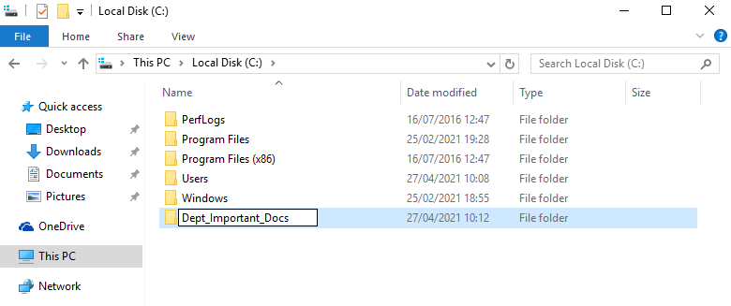
- New folder creation.
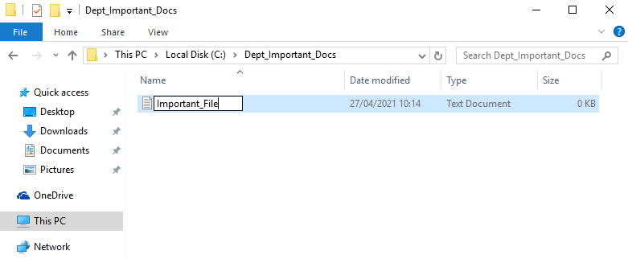
- New file creation.

Figure 3 demonstrate that removing authenticated users was not permitted; a Windows security issue dialogue appeared, stating that the privileges on this folder would be inherited as a consequence. As a result, inherited permissions on this file must be disabled. As seen in Figure 4, after disabling inherited permissions, all inherited permissions can be removed from the object.
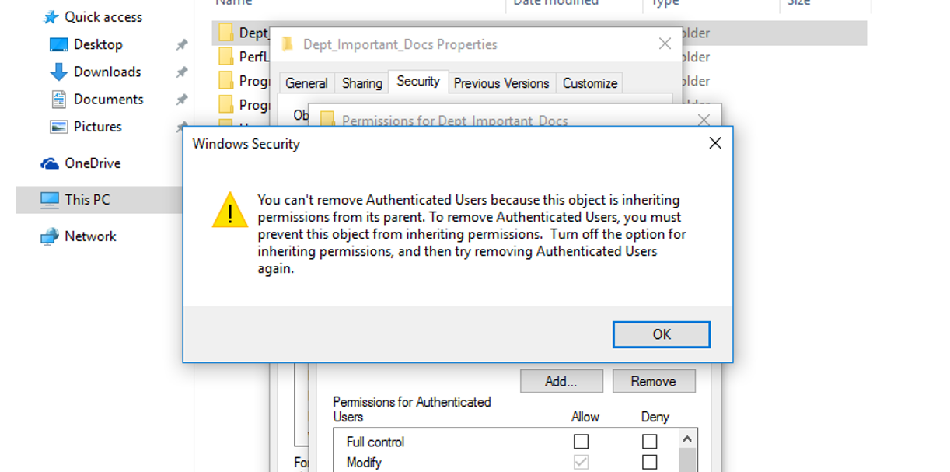
- Error message related to inhertied permissions.
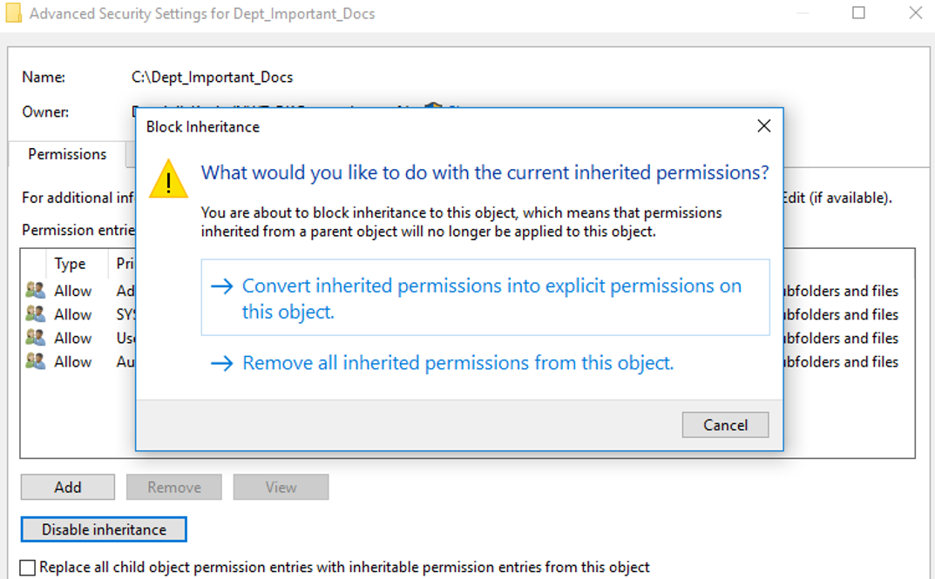
- Successful removal of inherited permissions.

After deleting all inherited permissions from the object, users can be added, as shown in Figure 5, and rights can be assigned, as shown in Figure 6. It is worth noting that documents generated in the folder will inherit the folder's permissions, as seen in Figure 7.
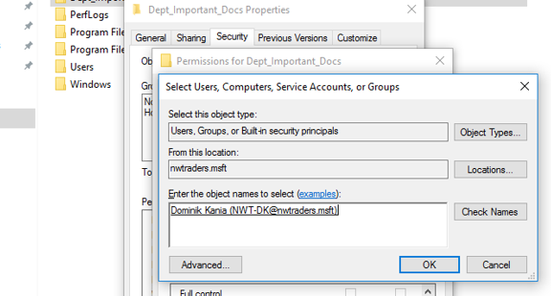
- New user with full access.
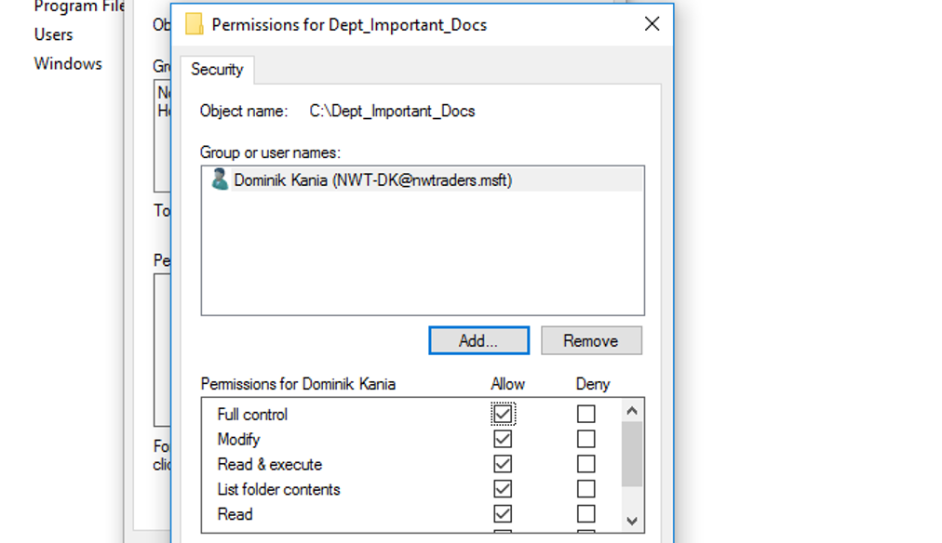
- Full access settings of the new user.

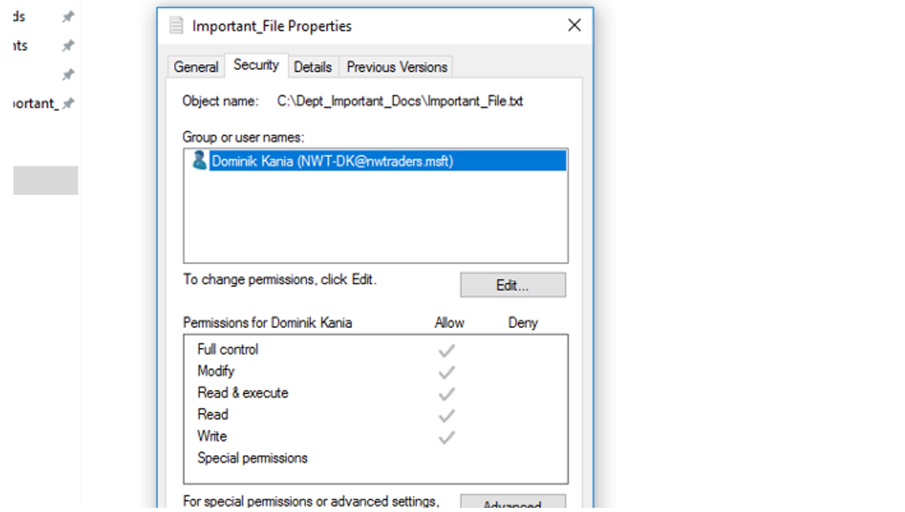
- Inherited properties from the main folder.

Figures 8 and 9 show two new users, one with full access and one with read-only access, which prevents non-administrative user from making further modifications to the text.
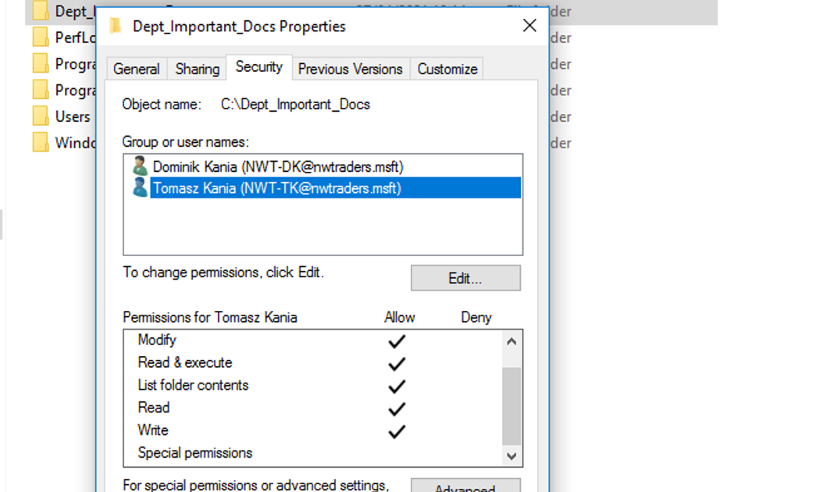
- Additional user with full access.
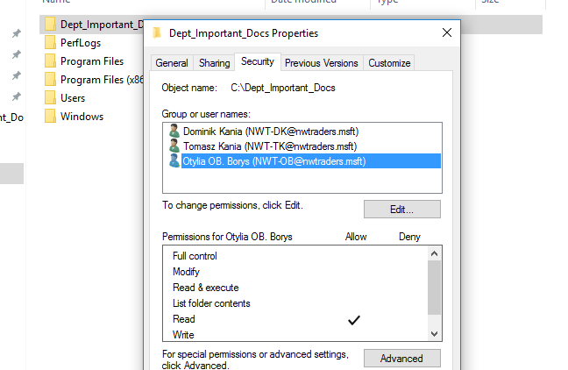
- Non administrative user with read only permission.

After assigning rights to each account, configurations can be checked by merely changing text by a user with maximum access and another with read-only access. Figure 10 shows a successful text modification by a user with complete access, while Figures 11 and 12 indicate that a non-administrative user cannot make any modifications to the text or the folder in which the text is stored. This is because read-only settings prevent this user from changing anything in this folder.
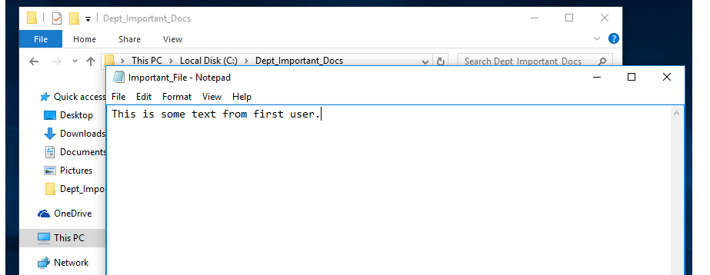
- Successful modification by user with full access.
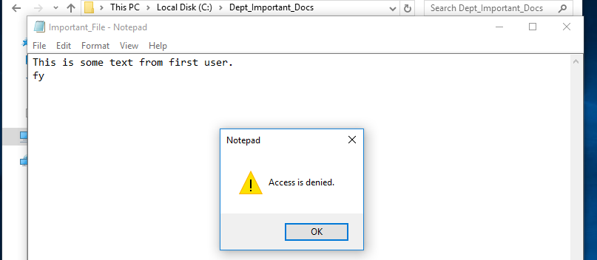
- Modification of the document denied for the user with read only access.
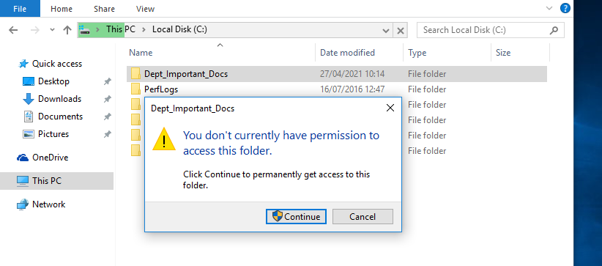
- Access to edit settings denied for the user with read only access.

Controlling resource access in a networked environment is made possible by share permissions. When a file or folder is generated on a networked server, it is not distributed by default. Unless the user has explicitly concealed the resource sharing, all files and drives that are deliberately distributed on a server can be accessed by looking for a computer on the network and extending the accessible shares that this service has established. Network shares, like NTFS permissions, must be closely handled since having a resource accessible across the network may jeopardise local infrastructure if access control is not adequately protected internally. NTFS permissions function by giving specific user profiles or groups permissions to records, files, and drives irrespective of where they interact from.
Figures 13–17 demonstrate the successful creation of the share's profile. The local path to the share was successfully generated and concealed by appending "$" to the end of the path, as seen in Figure 14. The use of the dollar sign in the share name indicates that the share is hidden for privacy and security reasons. This acts as a barrier against any potential intruders that might be investigating this network.
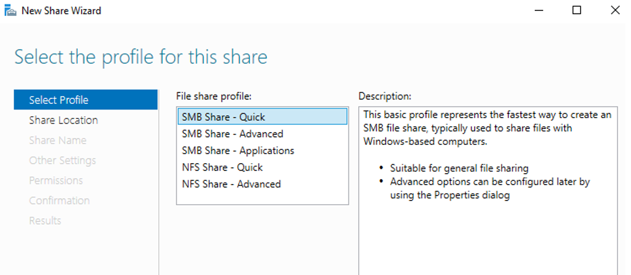
- SMB Share - Quick.
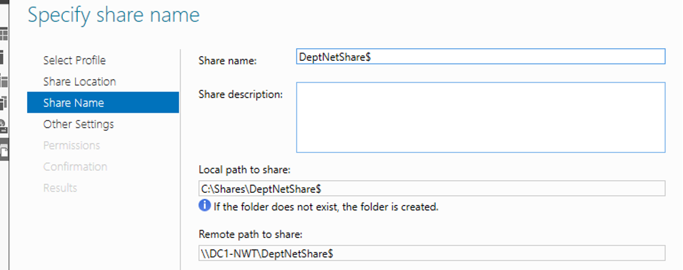
- Name of the local path to share.

Following the creation of a local path to the share, users with the appropriate permissions must be listed, as seen in Figure 15. This serves as a preventative measure to avoid unauthorised users from making modifications to critical records. Figure 16 shows the location and properties of the newly created share, while Figure 17 demonstrates that the share was successfully created.
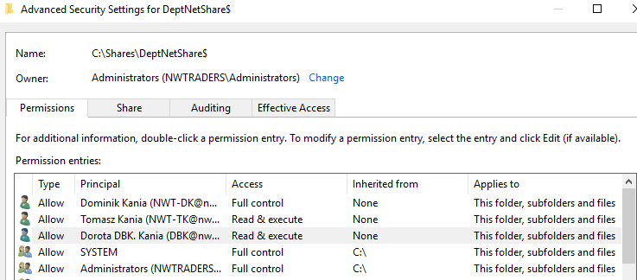
- Members with read and execute permissions and administrator users with full control.
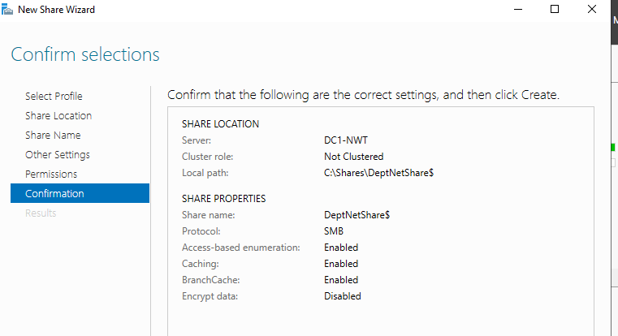
- Selection confirmation.
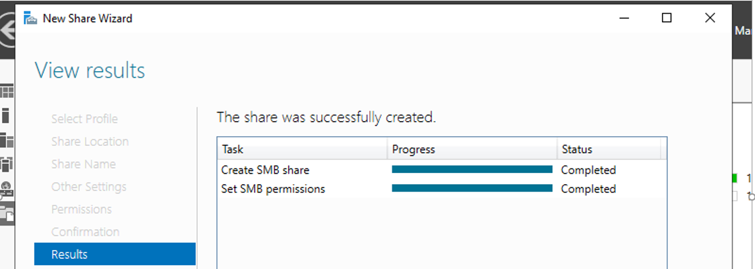
- Final results.
A network mapped drive maintains a continuous link to the share, appearing as extra local drive on the network machine attempting to reach the network share. It also eliminates the need to navigate to the share or look for it any time people want to view the information saved there. Figure 18 shows a successful mapping of the network drive, with all settings, such as drive letter or folder path, displayed. Figure 19 also shows a mapped drive that successfully appeared in the network locations.
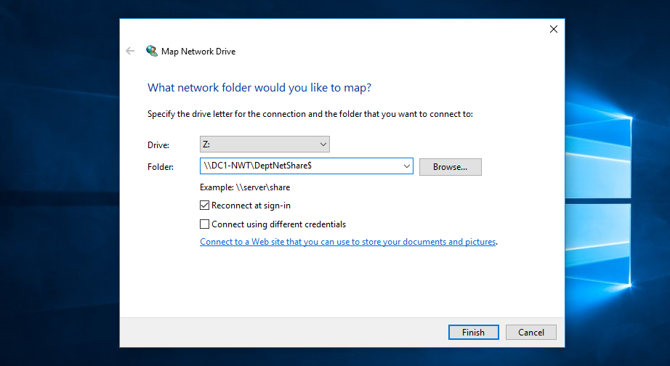
- Mapping network folder.
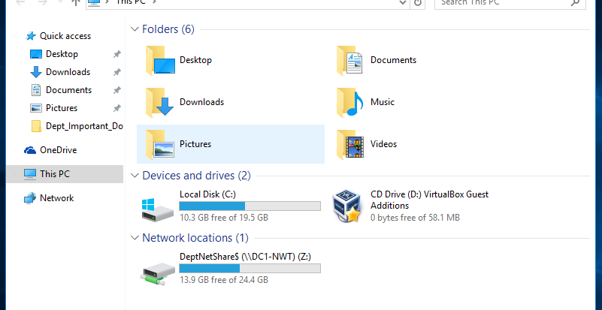
- Successful mapping of the network folder.

Task 2: Utilising Group Policy Management Console
The Group Policy Management Console (GPMC) is a built-in Windows Server admin interface that can be used to monitor Group Policies across the entire AD forest. The primary goal of Group Policy Management is to simplify the practice of carrying out, most often organisational or administrative specific configurations, to domain devices and clients. This clearly improves efficiency on manual installations, but it also offers a way to automatically control security configurations to guarantee that all appropriate devices are controlled as needed, without exclusion.
Limiting access to the Control Panel is a reasonable way to prevent users from making manual adjustments to the configurations of the network's devices. In order to do so, an organisational unit, as seen in Figure 20, must be created and a specific user assigned to it.
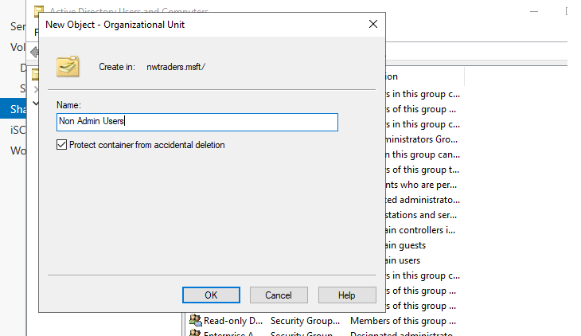
- New organizational unit.

Figure 21 depicts a specific user that was attached to this organizational unit, while Figure 22 illustrates the configurations that were implemented to prevent access to the Control Panel. System administrators may use a command to force Active Directory to examine any new configurations or rules that have been added. This is handy because it is necessary to force AD in order to validate the settings. The command "gpupdate /force" must be used in command prompt to achieve this, as seen in Figure 23.
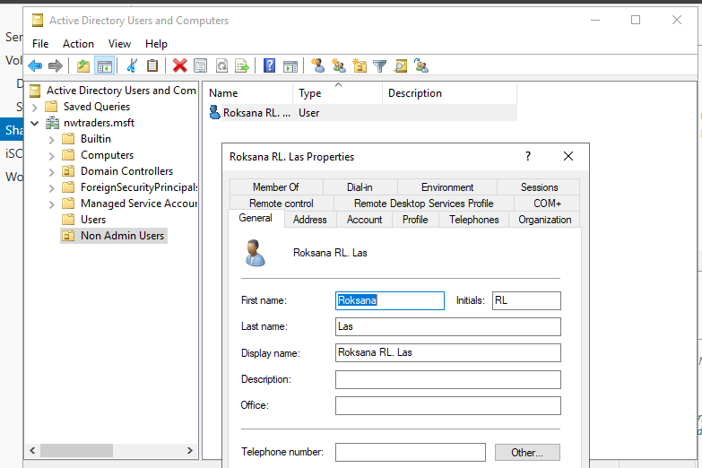
- Adding a new user.
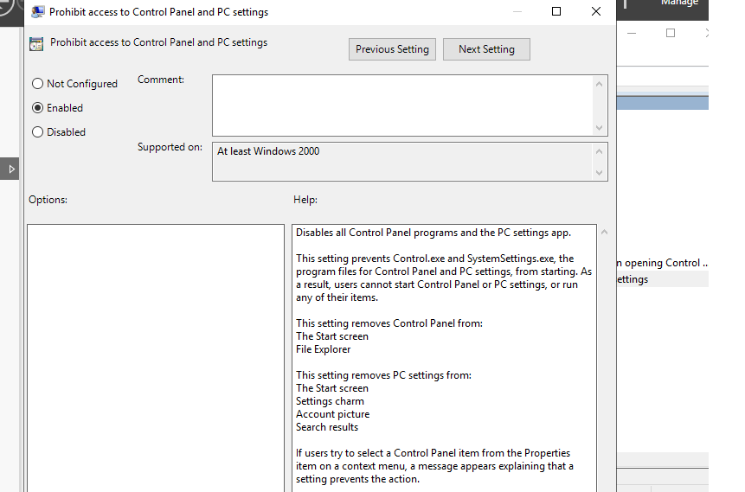
- Prohibiting access to control panel for non administrative users.

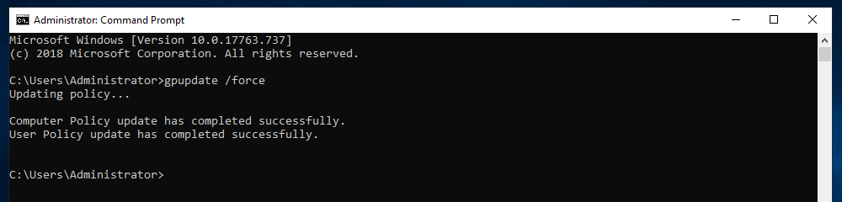
- Updating policy created for control panel.
Furthermore, configurations can be checked by signing in as the user that is not permitted to view the Control Panel, as shown in Figure 24, and attempting to access Control Panel, as shown in Figure 25. This user's configuration prevents anyone using this account from accessing Control Panel; a restriction error is shown, as seen in Figure 26.
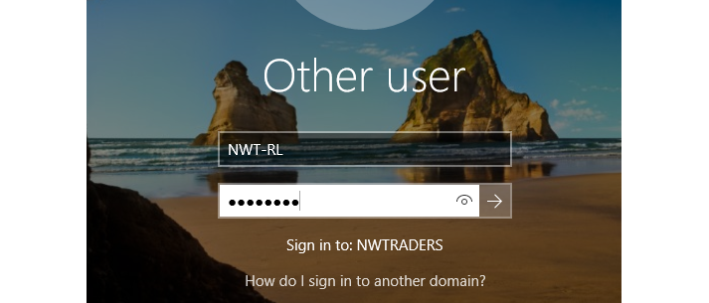
- Signing in to the new user created.
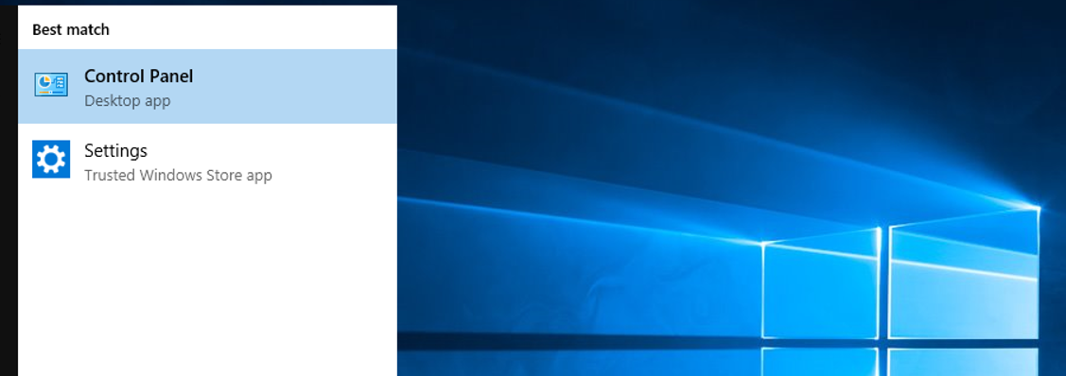
- Trying access control panel from the new user.
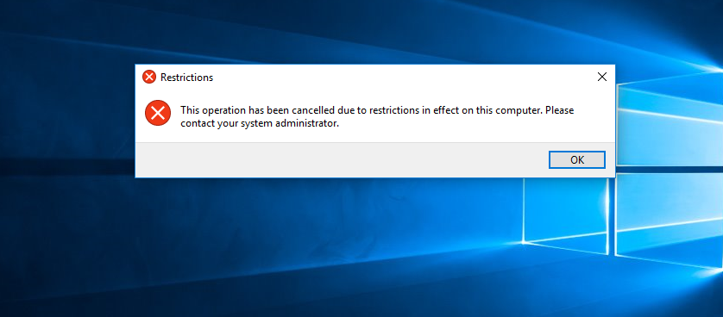
- Access denied to the control panel.

The Windows Command Prompt is a powerful tool that administrators can use to rapidly and reliably maintain a system configured and operating The Command Prompt is seldom used by the regular person. Rather than welcoming risk, often administrators restrict access to the Command Prompt to deter people from solving software glitches and messing around in places where they can jeopardise the security of a system.
A command prompt can be used to execute commands that bypass device configurations and grant users with high-level privileges to manipulate access controls. It may be a challenge in the hands of the wrong people. It is important to ensure the command prompt is turned off for users who do not require it. This can be accomplished by configuring policies to block access to the command prompt, as seen in Figure 27. As previously said, this policy must be updated in command prompt, as seen in Figure 28. Figure 29 shows the effective implementation of this policy, as well as its operation in Figures 30 and 31. The user is notified that the command prompt has been disabled by the appropriate administrator and that no commands can be executed. This improves overall security and prohibits untrained users from causing harm to the device.

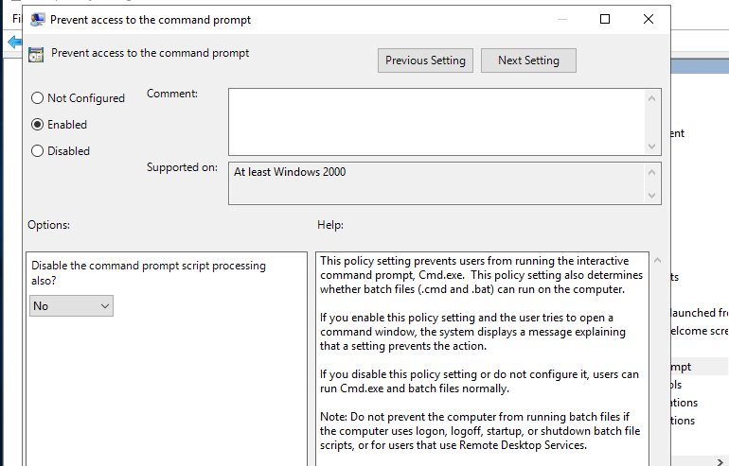
- Creating policy for command prompt.
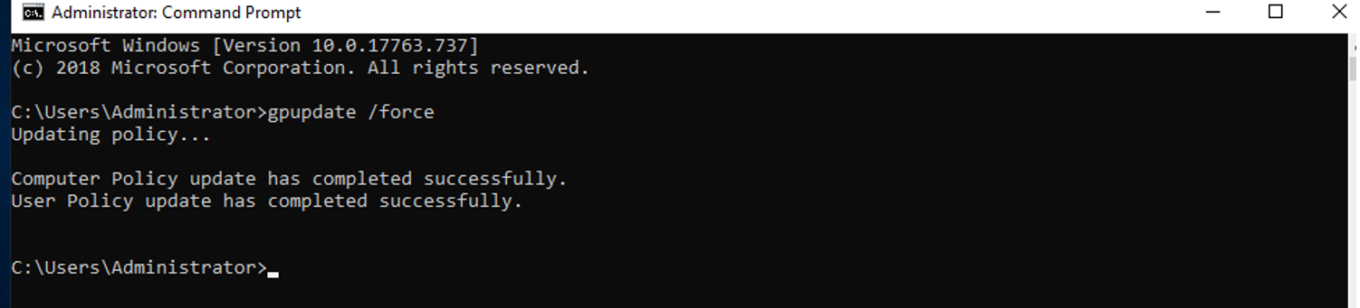
- Updating created policy for command prompt.
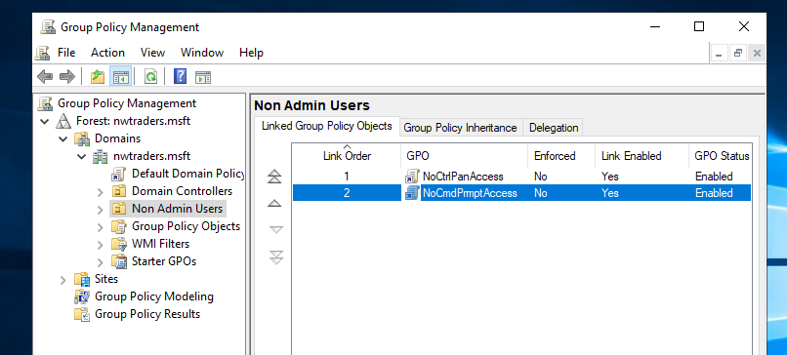
- Successfful creation of policy in non admin users.
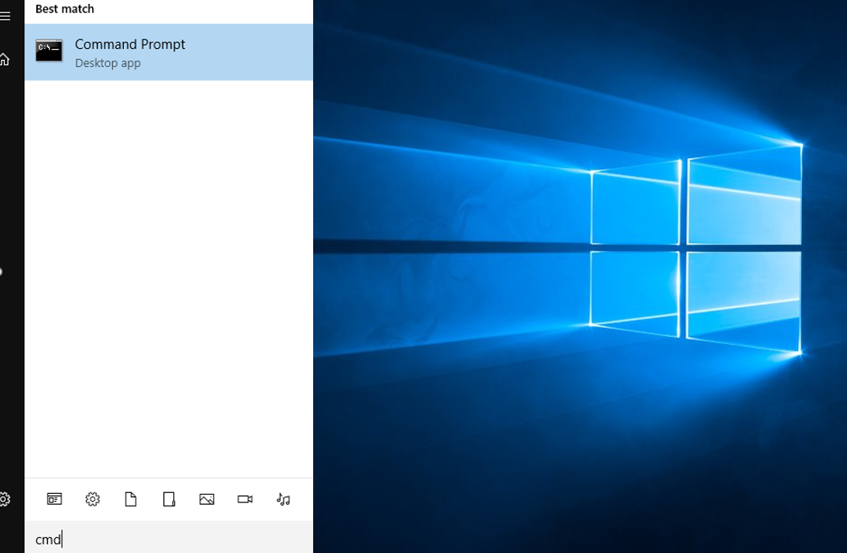
- Trying to access command prompt.
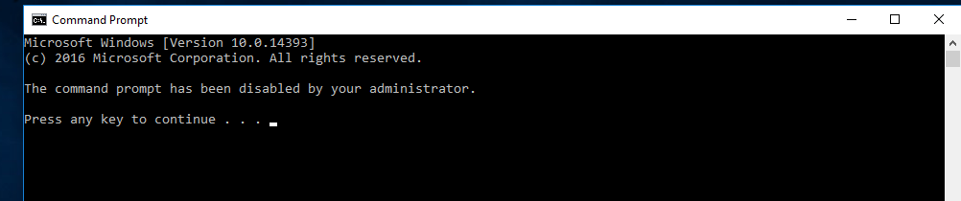
- Access denied for non administrative user.

Removable media drives are important for data handling and distribution. Portable media is often used by companies as a storage medium for confidential electronic records or to free up additional storage space on business machines. Although removable media is simple to use and has several enterprise applications it is not without risks. Using removable media drives may appear to be harmless, however they have the ability to create a slew of issues for a customer or an organisation. Such gadgets connect to the computer's USB port and could include ransomware that was unconsciously transferred or that is activated immediately by the device's Autorun function. As a result, it is proposed that all access to these be denied to all classes of users other than domain administrators.
Figures 32, 33, and 34 show how the applicable policy for these portable media was generated and updated in command prompt, as well as the policy being available in linked group policy objects. However, the policy could not be tested because this configuration was performed on Virtual Machines by using remote access technology, and there was no possibility to manually insert removable media to this machine, in order to validate this policy. Notwithstanding, since the policy can be seen available in linked group policy objects and has been successfully configured and enabled to deny all access, it is assumed that this policy is functioning properly.
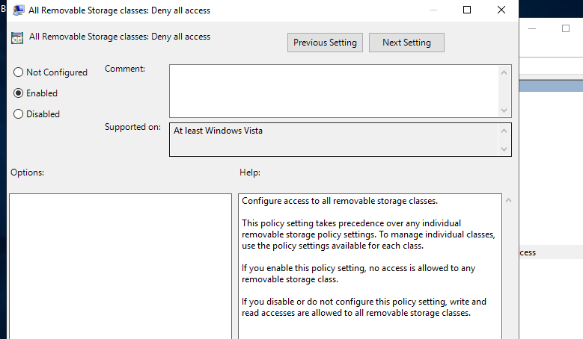
- Creating policy for removable storage.
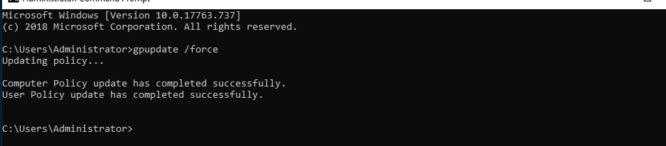
- Updating created policy.
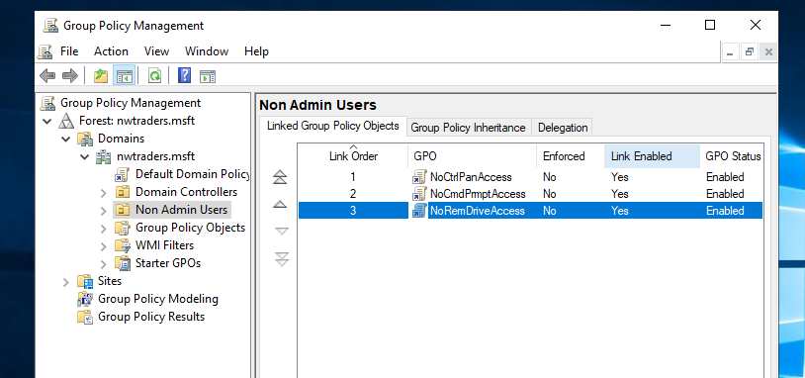
- Successfful implementation of the created policy.

Unauthorized application deployments into networks that are more available than maybe servers located in data centres are a significant source of danger within a network. Applications that can be deployed on network devices and later used to leverage network weaknesses and implement possible attacks are a major cause of harm in the network infrastructure. As a result, it is prudent to limit programme installations to approved system administrators only. This is shown in Figures 35 and 36, where a new organisational unit is added and a single computer is transferred to this unit, as well as a specific policy for user installations is enabled to prohibit them from installing any software. As previously mentioned, this policy must also be updated in command prompt, as seen in Figure 37. Furthermore, this policy for computers, unlike the previous policies for users, would have a special machine allocated to it rather than a user. Following the implementation of this policy, it can be seen in Figure 38 that it is available in linked group policy objects and is functioning properly, as seen in Figure 39, where authorization to install new software was denied.
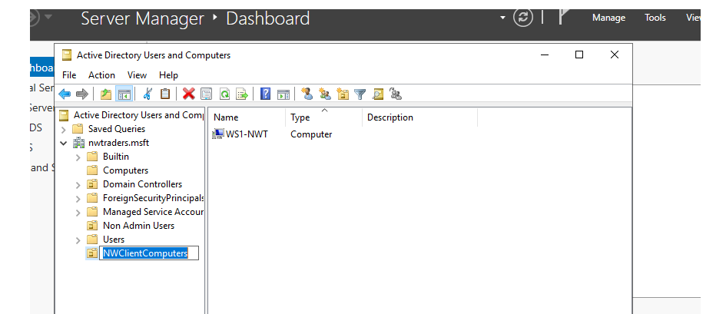
- Adding a new organizational unit.
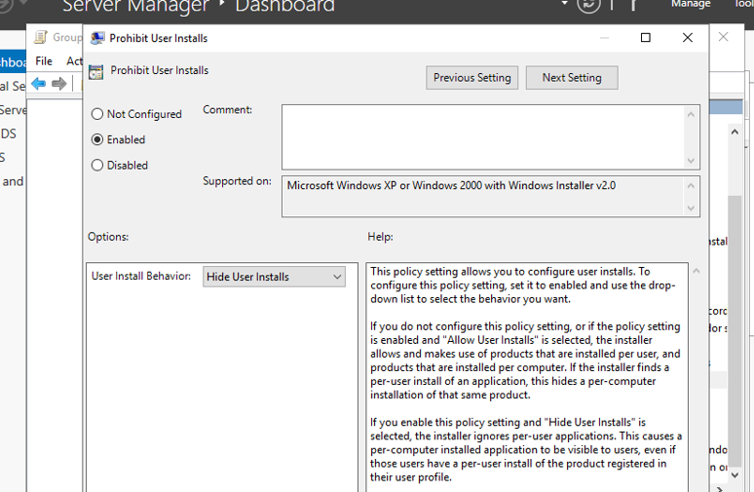
- Creating software policy.
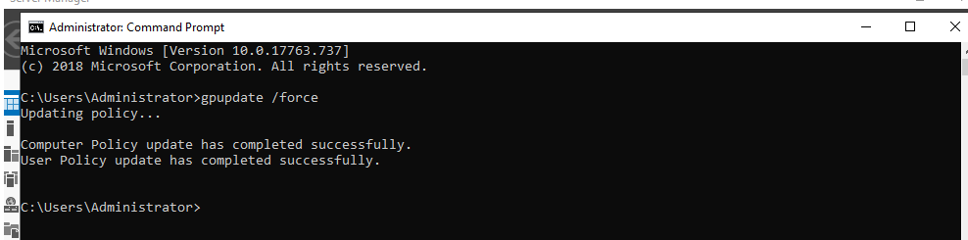
- Updating the new policy.
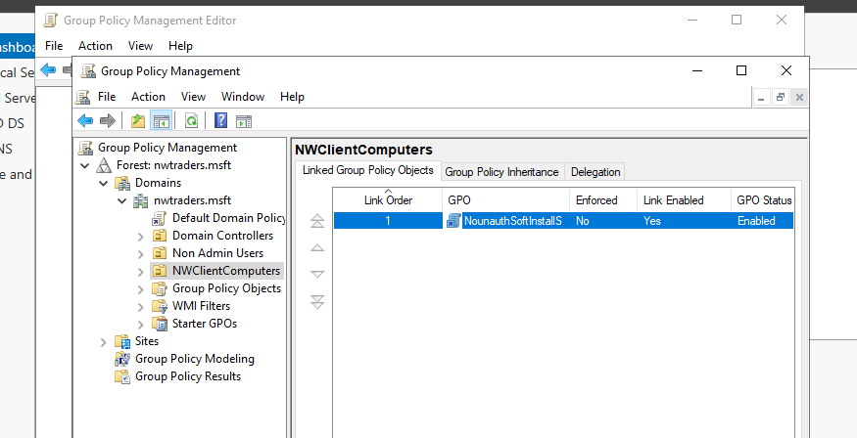
- Software policy implementation.
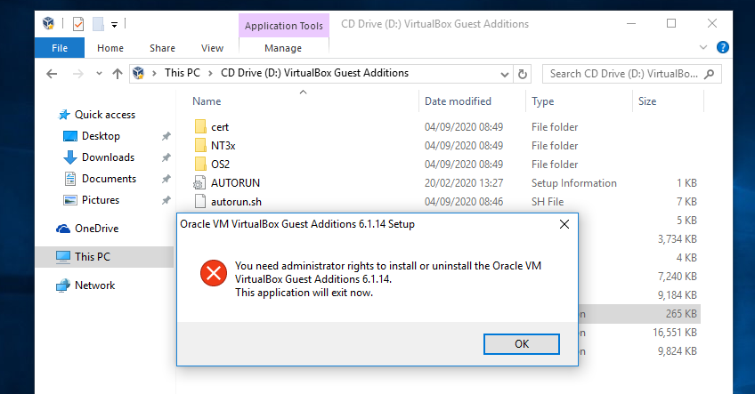
- Proof of working software policy.

Password Policy is a key necessity for improving network security. Stronger characteristics associated with standards minimise the risk of password leakage and have the ability to adhere to valid password protection guidelines, such as "passphrases". Passwords should be used in accordance with minimum difficulty criteria to implement stricter security policies by establishing a longer specified value length as a mandatory standard.
Figure 40 depicts a policy implementation with defined policy settings configured and complexity requirements enabled. Again, as seen in Figure 41, this policy must be updated via command prompt. Furthermore, to show that this policy is operating properly, an attempt was made to create a new user with a password that did not conform with the regulations, and while attempting to finalise the creation, an error occurred indicating that policy specifications were not met, as seen in Figure 42.
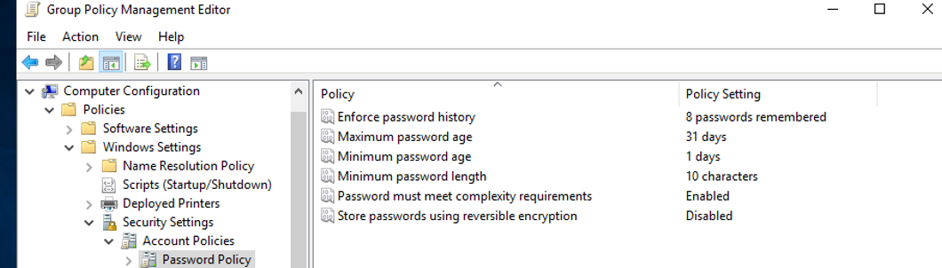
- Enforcing password policies.
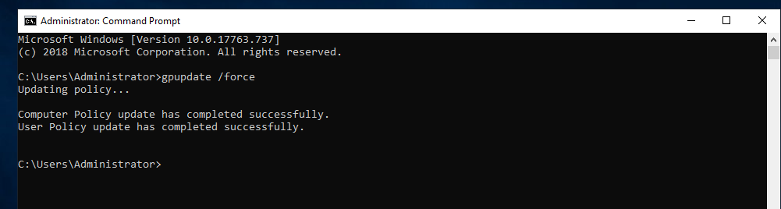
- Updating created policies.
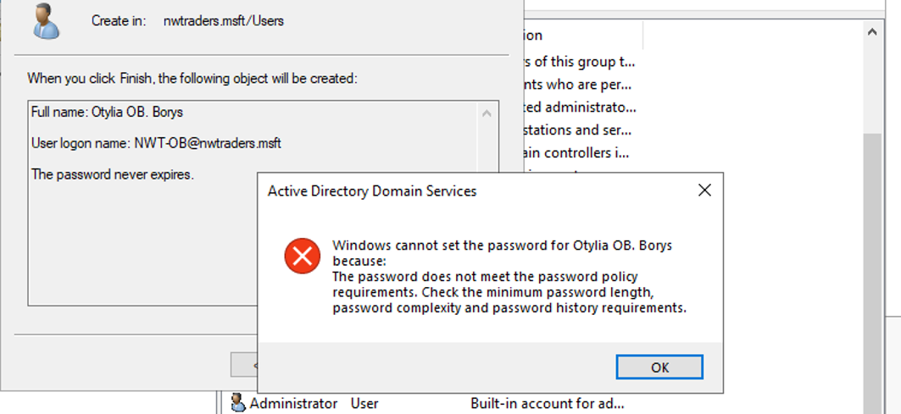
- Proof of the working password policy.

Worksheet 3 – Observational Tasks

NTFS Permissions and Share Permissions
NTFS permissions and share permissions are both commonly found in Microsoft Windows configurations. While both share and NTFS permissions have the same advantage of minimizing unauthorised entry, there are several key distinctions to be mindful of when determining how to execute a task such as document sharing. Below are the major differences between share and NTFS permissions, as well as when and how to use both [1] [2]:
- While share permissions are simple to set up and maintain, NTFS permissions allow more flexibility over a shared file and its items [2].
- While using both share and NTFS permissions at the same time, the most stringent permit always takes precedence. When the shared file permission is configured to "Read", and the NTFS permission is configured to "Modify", the share permission takes precedence since it is the most stringent; a person would not be permitted to modify the content on the shared folder [2].
- While sharing archives in the FAT and FAT32 file systems, share permissions may be utilised, whereas NTFS permissions cannot [2].
- Share permissions do not extend to those that are locally logged in to the network, while NTFS permissions do [2].
- With the exception of NTFS permissions, share permissions enable users to cap the amount of simultaneous connections to a shared archive [2].
- The “Advanced Sharing” settings in the “Permissions” properties are where users customise share permissions, whereas NTFS permissions are set in the folder attributes' security tab [2].
Share permissions are categorized as follows [2]:
- Full Control: Allows users to read, modify, and delete files as well as edit permissions and take control of content [2].
- Change: Ensures that the user can read, modify, and delete files inside the shared folder [2].
- Read: Enables people to browse the items of the archive [2].
NTFS has a few more authorization choices in addition to Full Control, Change, and Read, which can be configured for groups or individuals [1]:
- Full control: Users have complete control over their folders and subfolders, allowing them to read, write, modify, and erase them. Users can also adjust the privileges configuration for all folders [1].
- Modify: Enables users to read and write documents, as well as delete them [1].
- Read and execute: Enables users to access and activate executable files, such as programs [1].
- List folder contents: Allows browsing and listing of directories and folders, as well as file execution [1].
- Read: Enables users to search the items of the folder and subfolders [1].
- Write: Enables users to upload and write documents and files [1].

Group Policy Management
Overall organisational security is the main goal of Group Policy Management. Group policies, also known as Group Policy Objects, allow compliance professionals and security experts to implement appropriate security measures throughout their entire organisation from a single location. This enables network engineers to apply best practises to end-user machines focused on individual corporate requirements without needing to do so locally. This essentially eliminates days of computer labour that could otherwise be utilized tracking network operation for security vulnerabilities, protecting against cyberattacks, or improving network performance. In order to step into sufficient complexity, IT specialists should use Group Policy Management to implement and document corporate cybersecurity activities that are outside of the basic security configurations that come with Windows and other software solutions. Group Policy Management techniques empower security experts to impose password sophistication criteria. Companies can quickly make their entire network infrastructure safer by using Group Policy Objects to implement these requirements in a simplified, coherent manner [3] [4].
Group Policy Objects can be much more complex than password requirements, concentrating on organisational prerequisites. Cyber security experts may use them to implement the concept of least privilege by restricting which information is accessible to which users, as previously mentioned. According to these rules, only individuals who need immediate access to a company's most confidential documents are permitted to view them. This corporate security strategy reduces the ability of internal malicious actors to cause harm while simultaneously preventing computer hackers from obtaining access to an entire network system by compromising a single end-account. IT professionals can also establish file redirections to protect sensitive data and enforce sufficient upgrades. Employees, for instance, could use Group Policy Management mechanisms to transfer individual archives to the company's Network Attached Storage (NAS), ensuring that they are kept as secure as feasible in a centralised and supervised digital setting. They can also distribute security updates and other technical upgrades on a daily basis rather than on specific instance scenario, making it easy to implement security best practises across the organisation [3] [4].
The Group Policy Object structure has a fixed hierarchical order sequence. Local Group Policy Objects are the first to be implemented; these rules are the fundamental configurations that govern a single computer. In Windows XP and subsequent versions, these local policies could be subdivided into different registered users. Following that, Active Directory member rules associated with a specific place are implemented. An Active Directory service is a combination of existing machines within an enterprise that are grouped together based on their geographic location. If there are several site policies, they will be implemented in the order specified by the individual in charge of these regulations. Furthermore, Windows group rules aligned with a certain domain, the environment in which the device is currently running, are executed. If a domain is concerned with more than one regulation, the policies will be applied in the order specified by the relevant person. Ultimately, GPOs created for an Active Directory organisational unit under which the machine or client functions would be incorporated. Organizational units represent functional categories that help establish standards and handle clusters of objects and attributes ranging from people to machines. Thus, various policies in this group would be implemented in accordance with a person's orders [3] [4].

Principles of Password Security
Passwords have been used as a form of authentication since the dawn of civilization. One of the most common applications of passwords today is to secure user accounts. They are, though, not completely reliable and have vulnerabilities that can be used all too quickly. In 2009, a malware attack on RockYou.com resulted in the capture of over 32 million customer real names, physical addresses, usernames, passwords, and e-mail addresses. These records were also publicly disclosed on the Internet, enabling people to see any of the credentials used. Impreva, an organization that publicises weak login credentials and recommends best practises, then gathered these details. About 290,000 members used the phrase "123456," making it the most common choice. "Password," which was implemented by 62,000 registered users, came in fourth position. Further investigation revealed that it only requires 110 attempts for an attacker to gain ownership of an account and 17 minutes to break into 1000 accounts. On social media sites, confidential information can be easily exchanged, and the more details an individual reveals, the more relevant they become to the platform. In the other hand, security checks on social media sites are often lax. They do not, for example, facilitate the use of secure passwords or multifactor authentication [5] [6].
Passwords rarely expire, and it is well understood that individuals use the same login credentials across many platforms. As a result, there has been an uptick in the development of worms on social media websites to collect phrases from specific platforms, which are then fed into keyword engines to initiate dictionary attacks to compromise the account information on the specified platforms. It is essentially a brute force attack, with attackers usually trying to crack a password using the first 20 entries. People must also establish strong and safe login credentials that are difficult for unauthorised individuals to infer. This eliminates the possibility of anyone obtaining unwanted access to sensitive information. When selecting a password, the general safeguards of the platform must be kept in mind. Some of the most important password security principles are described below [5] [6]:
- Complex passwords: When passwords are lengthy and impossible to guess, cybercriminals find it increasingly difficult to gain access to accounts. Passwords that are more than eight characters long and contain both upper and lowercase letters, numbers, and symbols are considered complex [6].
- Password encryption: Password encryption provides another layer of security to passwords, particularly if they have been compromised by hackers. The most secure standard is non-reversible and end-to-end encryption. In this case, passwords can be secured during network transport [5].
- Two-factor authentication: It has gradually become the industry norm for controlling access to corporate services. In contrast to regular authentication methods such as username and password, users must validate their identities with one-time passcodes, phone call-backs, or security tokens. The theory is that with two-factor authentication, an intruder cannot obtain entry by guessing or breaking the password [6].
- Sophisticated authorization methods: Using non-password-based specialised solutions, such as biometric authentication, helps to protect data even more. People can use biometric verification as part of multi-factor authentication, including using a fingerprint with Touch ID to log in to an Apple device, or just looking at a Windows machine with Windows Hello face recognition software. This approach aids the machine in recognising workers by their faces, fingerprints, or voices [6].
- Dictionary words: Cybercriminals equipped with sophisticated software can comb through thousands, if not millions, of dictionary phrases. Avoiding the use of dictionary phrases is recommended to prevent the data from being a target of a dictionary attack software [5].
- Storing passwords: Passwords should not be stored online or on paper, since this information can be compromised by anyone with malevolent purposes. It is recommended that all passwords are saved using applications, such as a password manager [5].
- Password managers: They require only one password to be memorised since they save and generate credentials for several accounts, automatically logging people in when they choose an account [5].
- Various passwords: Using differentiated passwords for each account is advised. Otherwise, if one password is compromised, multiple accounts that use the same credentials are at risk [6].
- Updating passwords: This is also an important consideration. And no matter how complicated the password is, it can be broken if enough time is given. As a consequence, it is important to cultivate the practise of regularly changing passwords [6].
- Antivirus software: Passwords would be insecure if a criminal's spy programme was tracking what users typed on their computers, regardless of how secure their passwords are or how vigilant they are about the encryption. Using the most up-to-date anti-malware and vulnerability detection tools to toughen the infrastructure and avoid and eradicate vulnerabilities that might enable attackers to gain access to the network, makes it more challenging for cybercriminals to procure passwords [6].

Conclusion
The purpose of this work was to clarify and address current challenges in group policy management framework and user permissions, as well as password security, with a focus on the elements that determine individuals' behaviour patterns in this regard. The group management practises of the business owners should be understood by all employees in the company. People and companies must be educated and trained on data protection enforcement on a daily basis. Without those resources and services, the management system will have no impact on employees. It is therefore essential to follow security protocols. If this is not addressed, employees' adherence to those rules may deteriorate over time. Individuals may be compelled to follow their organization's best practices with the assistance of technology. As a result, exposing people to directed consciousness raising and continuously tracking their commitment to policies and procedures can improve their enforcement level.

References

[1] | S. Parkinson and A. Crampton, “A Novel Software Tool for Analysing NT File System Permissions,” International Journal of Advanced Computer Science and Applications, vol. 4, no. 6, pp. 266-272, July 2013.
[2] | D. Gibson, “Accessing Resources on a Network,” in Windows 7 Desktop Support and Administration: Real World Skills for MCITP Certification and Beyond, John Wiley & Sons, 2010, pp. 357-392.
[3] | William Stanek Training Solutions, “Group Policy Management,” in Active Directory Infrastructure Self-Study Training Kit, Stanek & Associates, 2016, pp. 487-501.
[4] | J. Moskowitz, “Implementing Security with Group Policy,” in Group Policy: Fundamentals, Security, and the Managed Desktop, John Wiley & Sons, 2015, pp. 465-478.
[5] | K. Curran, J. Doherty, A. McCann and G. Turkington, “Good Practice for Strong Passwords,” EDPACS: The EDP Audit, Control, and Security Journal, vol. 44, no. 5, pp. 1-13, November 2011.
[6] | Y. Apelbaum, “Account and Password Policies,” in User Authentication Principles, Theory and Practice, Fuji Technology Press, 2007, pp. 97-119.

