Student Name: | Mohammad Sajadul Haque | Student ID: | 2511320
Programme: |  | MBA
Module: |  | Finance for Business Managers
Module Code: |  | BMMB7005D
Lecturer: |  | Marie Pitson
Assignment Title: |  | Bread Plc
Submission Deadline: |  | 20th April 2026

Executive Summary
This report aims at examining the financial performance of JD Sports Fashion plc, and it also seeks to carry out an evaluation of the investment opportunity available to Beard Plc through proven financial management techniques. The report discusses the potentials of the financial ratio analysis and investment appraisal methods to help effective business decision-making and long-term organisational growth.
The initial section of the report is concerned with the financial performance of JD Sports Fashion plc based on the last financial reports. The main financial ratios were computed in order to determine the profitability, liquidity, efficiency, gearing and investor performance. Findings suggest that, the company has been experiencing high revenue increment and constant gross profit margins, indicative of the persistent demand of sportswear products and effective global diversification. The operating profit margins however have fallen somewhat as the operating expenses and expansion expenses are in the process of increasing. The liquidity ratios indicate that the company can take all its short-term financial commitments whereas the efficiency ratios indicate that the assets and inventory are overall effectively utilized to make sales. The gearing analysis also shows the moderate level of financial risk because the company has a balanced balance in its capital structure with controlable debt levels. Shareholder returns are better since investor ratios show better earnings per share.
The second section of the report examines 3 possible investment opportunities to Beard Plc through Net Present Value (NPV) approach and the Internal Rate of Return (IRR). The analysis reveals that all the three suggested projects yield positive NPVs thereby demonstrating that they are viable financially. Out of the alternatives, the project based on the manufacture of purses and wallets has the greatest NPV and most appealing financial payback. In capital rationing conditions, it would be optimal to fully invest in this project and invest partially in online sales project.
In general, this report has shown that financial analysis and investment appraisal methods are crucial tools in measuring the performance of the business, which is critical to strategic decision-making and performance maximisation to shareholder preferences.
Table of Contents
Executive Summary 2
Introduction 5
Task 1 – Financial Analysis of JD Sports Fashion plc 6
1. Overview to the Company 6
2. Overview of Financial Performance 6
3. Profitability Ratios 7
3.1 Gross Profit Margin 7
3.2 Operating Profit Margin 8
3.3 Net Profit Margin 9
4. Liquidity Ratios 10
4.1 Current Ratio 11
4.2 Quick Ratio 11
5. Efficiency Ratios 12
5.1 Inventory Turnover 12
5.2 Asset Turnover 13
6. Gearing Ratios 13
6.1 Debt-to-Equity Ratio 13
6.2 Interest Cover Ratio 14
7. Investor Ratios 14
7.1 Earnings Per Share (EPS) 15
7.2 Price-Earnings Ratio 15
8. Limitations of Ratio Analysis 15
9. Recommendations 16
Task 2 – Investment Appraisal for Beard Plc 18
1. Net Present Value (NPV) Analysis 18
1.1 Option A – Expansion of Retail Outlets 19
1.2 Option B – Development of Internet Sales 20
1.3 Option C – Production of Purses and Wallets 20
1.4 Comparison of Investment Options 22
2. Internal Rate of Return (IRR) 22
3. Theoretical Advantages of NPV 23
4. Popularity of Non-Discounting Methods 23
5. Other Factors Affecting Investment Decisions 24
6. Capital Rationing 24
7. Sources of Finance 25
8. Overall Analysis 26
Conclusion 27
Bibliography 29
Appendix 30

Introduction
Financial analysis and investment appraisal are basic tools in which organisations use to determine performance and make sound strategic decisions. With a rising competitive global business space, organisations have to keep evaluating their financial stability, business performance and feasibility of investment to keep afloat and record sustained growth. The financial statements give important information enabling the stakeholders to evaluate finances of a business, the trend of the performance and the effectiveness of the use of the resources.
Financial ratio analysis is one of the most common means of studying the performance of the companies. Financial statement ratios allow financial analysts to decipher complicated financial data and find trends that are associated with profitability, liquidity, financial structure, and returns on shareholders. These are the measures which enable investors, managers and other stakeholders to determine the performance of any company compared to the previous years and other companies in the industry. The financial ratio analysis is thus very vital in aiding in decision-making, enhancing financial management as well as establishing where operational areas need to be revised.
Besides performing a financial performance analysis of past, organisations also need to analyse potential investment opportunities that facilitate long term growth. Investment appraisal methods entail systematic means of evaluating the financial feasibility of new projects and whether they can create value to the shareholders. Such tools as Net Present Value (NPV) and Internal rate of Return (IRR) enable businesses to estimate the future financial utility of an investment but takes into consideration the time value of money and risk involved in long term projects.
This report discusses two major issues of financial management. The former is an analysis of JD Sports Fashion plc, the top retailer in the sports fashion sector across the globe, in its financial performance. Over the last few years, the company has seen unparalleled expansion as a result of internationalisation, well-formed brand associations and the growing demand of the sportswear products.
In the second section of the report, the issue of investment decisions related to the corporate setting is viewed in terms of the analysis of a possible expansion component of Beard Plc, the company, concentrating on the high-quality handbag production. Using investment appraisal methods, the report discusses the ways organisations evaluate strategic investment options and use financial resources to help them develop in the long run.
These analyses, together, give a wider perspective of the role of financial analysis and investment appraisal in efficient management of businesses and strategic decision making in a contemporary organisation.

Task 1 – Financial Analysis of JD Sports Fashion plc

1. Overview to the Company
JD Sports Fashion plc is a major international retail store that focuses on both sports fashion and sports leisure items. It has thousands of retail outlets in Europe, North America and Asia-Pacific as well as a good grasp of e-commerce. It sells the world-renowned brands like Nike, Adidas and Puma, as well as its own economy brands. JD Sports has become one of the largest sportswear stores in the United Kingdom and a growing competitive presence in the world sports retail industry through strategic acquisitions and internationalization (JD Sports, 2026).
Financial analysis plays critical role in determining the financial health and performance of an enterprise. Ratio analysis is useful in establishing the degree to which a firm is utilizing its resources efficiently in the management of its debts and/or generate profits to the stockholders. Financial ratios assist investors, managers and other stakeholders to determine profitability, liquidity, efficiency of a business, gearing and investor performance (JD Sports PLC, 2024).
This part incorporates an analysis of financial performance of JD Sports Fashion plc on the basis of financial ratio analysis based on two financial years. The financial ratios analysis involves five major groups of financial ratios which include profitability, liquidity, efficiency, gearing and investor ratios.

2. Overview of Financial Performance
The last few years have seen JD Sports grow its revenue significantly owing to internationalization and acquisitions as well as the rise in popularity of athlete products. The revenue earned by the company in FY2024 is £10.54 billion as compared to FY2023 of £10.13 billion reflecting an increase of about 4.1%.
The gross profit grew to be higher in 2024 to £5.05billion when compared to 2023 which was £4.88billion, indicating that sportswear products had strong demand in the world market. Nonetheless, operating profit went down to 2024 compared to 2023 by slightly £1.06 billion to £973.9 million which indicates increasing operating expenses and competitive forces in the retail market (JD Sports PLC, 2024).
Statutory profit before tax has also risen to an all-time high of £811 million in 2024, as compared to 2023, even though operating profit has declined, on significantly reduced exceptional items in the period, and thus reflects the strong results of the reporting period.
These findings show that JD Sports is yet another company that is growing its sales but struggling with cost pressures on profitability margins.

3. Profitability Ratios
Profitability ratios are used to analyze how a company can make profits as compared to sales, assets and capital used (Atrill, 2019).
The calculations use the financial information of JD Sports Fashion plc that is summarised as follows.
Financial Data | 2024 | 2023
Revenue | £10,542 million | £10,125 million
Gross Profit | £5,048 million | £4,878 million
Operating Profit | £973.9 million | £1,062.1 million
Profit Before Tax | £811 million | £486.7 million
(Source: JD Sports PLC, 2024)

3.1 Gross Profit Margin
The efficiency of the company in producing or purchasing the products in comparison to the sale price is determined by the gross profit margin (Bekaert, 2017).
Formula
Gross Profit Margin = (Gross Profit ÷ Revenue) × 100
For 2024
Gross Profit = £5,048 million
Revenue = £10,542 million
Gross Profit Margin (2024)
= (5,048 ÷ 10,542) × 100
= 0.479 × 100
= 47.9%
For 2023
Gross Profit = £4,878 million
Revenue = £10,125 million
Gross Profit Margin (2023)
= (4,878 ÷ 10,125) × 100
= 0.482 × 100
= 48.2%
Gross profit margin dropped as insignificantly, as before between 48.2% in 2023 and 47.9% in 2024. This is a sign that the company had realized a minor growth in the price of goods sold as compared to the revenue. This decline can be associated with the rise in supplier prices, inflation and competition pressures and pricing policies in the retail segment (Bhimani, 2022).

3.2 Operating Profit Margin
Operating profit margin is used to average the proportion of the revenue left after the deduction of the operating expenses (Drury, 2020). It shows how well the firm is using its operating expenses.
Formula
Operating Profit Margin = (Operating Profit ÷ Revenue) × 100
For 2024
Operating Profit = £973.9 million
Revenue = £10,542 million
Operating Profit Margin (2024)
= (973.9 ÷ 10,542) × 100
= 0.0924 × 100
= 9.24%
For 2023
Operating Profit = £1,062.1 million
Revenue = £10,125 million
Operating Profit Margin (2023)
= (1,062.1 ÷ 10,125) × 100
= 0.1049 × 100
= 10.49%
This can be explained by the fall in operation profit margin by 10.49 percent in 2023 and 9.24 percent in 2024. It means that the operating expenses were increasing faster than the revenue during the period (Drury, 2020).
Some reasons might have led to this fall, such as increased labour cost, expansion costs and inflation on the operating costs of the retail industry. Although the company is not doing as well, it is profitable at the operating level (Atrill, 2019).

3.3 Net Profit Margin
The net profit margin is a figure that proves the profitability of a company following the death of all the expenses incurred including interest and tax.
Formula
Net Profit Margin = (Profit Before Tax ÷ Revenue) × 100
For 2024
Profit Before Tax = £811 million
Revenue = £10,542 million
Net Profit Margin (2024)
= (811 ÷ 10,542) × 100
= 0.0769 × 100
= 7.69%
For 2023
Profit Before Tax = £486.7 million
Revenue = £10,125 million
Net Profit Margin (2023)
= (486.7 ÷ 10,125) × 100
= 0.0481 × 100
= 4.81%
To 2024, the net profit margin was a great improvement compared to 4.81% in 2023 as it was 7.69% in 2024.
The greater the net profit margin, the more effectively converted the revenue to total profit was the company. It should be noted however that the adjusted profits decreased slightly in fact that the underlying operating performance became weak (Bekaert, 2017).
Overall Profitability Analysis
The general profitability of the company can be analyzed by examining the following data:
The ratios of profitability prove that JD Sports remains raising good incomes and profit margins (Bhimani, 2022). There is however a decrease in operating margin implying that the increase in operating costs is influencing the profitability of the company (Bekaert, 2017).
In spite of these, an increase in net profit margin and great return on capital employed show that the company is still strong financially.

4. Liquidity Ratios
The solvency of a company within a short time is measured using the liquidity ratios.
The calculations will be carried out based on the financial data in JD Sports Fashion plc presented below.
Financial Data | 2024 | 2023
Current Assets | £6,092 million | £5,620 million
Inventory | £2,183 million | £2,060 million
Current Liabilities | £3,375 million | £3,020 million
(Source: JD Sports Fashion plc Annual Report)

4.1 Current Ratio
The values of current ratio are employed to establish the breast of current assets being in the position of meeting short-term obligations of the company (Bhimani, 2022).
Formula
Current Ratio = Current Assets ÷ Current Liabilities
Calculation for 2024
Current Assets = £6,092 million
Current Liabilities = £3,375 million
Current Ratio = 6,092 ÷ 3,375 = 1.80: 1
Calculation for 2023
Current Assets = £5,620 million
Current Liabilities = £3,020 million
Current Ratio = 5,620 ÷ 3,020 = 1.86: 1
The current ratio declined marginally moving to 1.80, compared to 1.86, but that is moving into healthy range. This indicates that the company is not left without enough current assets to meet the short-term obligations.

4.2 Quick Ratio
The quick ratio is the amount of liquidity without considering inventory, and it gives a higher assessment of financial strength.
Formula
Quick Ratio = (Current Assets − Inventory) ÷ Current Liabilities
For 2024
Inventory = £2,183 million
Quick Ratio = 3,909 ÷ 3,375 = 1.16: 1
For 2023
Inventory = £2,060 million
Quick Ratio = 3,560 ÷ 3,020 = 1.18: 1
There was a slight fall in the quick ratio to 1.16 and hence, there was a minor decrease in liquidity. The ratio is however a bit above 1 which indicates that the company may still be able to meet the short-term liabilities without using inventory sales extensively.

5. Efficiency Ratios
Efficiency ratios are used to determine how a company uses its assets to bring revenue and also to control inventory (Drury, 2020).
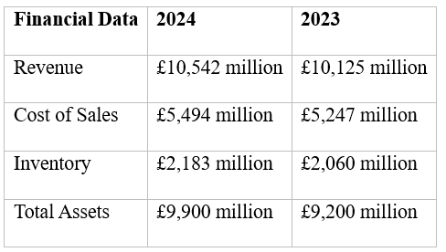

5.1 Inventory Turnover
The inventory turnover is a measure of how many times inventory is being sold within a financial period (Drury, 2020).
Formula
Inventory Turnover = Cost of Sales ÷ Inventory
For 2024
Inventory Turnover = 5,494 ÷ 2,183 = 2.52 times
For 2023
Inventory Turnover = 5,247 ÷ 2,060 = 2.55 times
Inventory turnover had gone down in a minor manner; 2.52 times compared to 2.55 times that indicated that the inventory was taking a long time to move than it did the previous year. It could be an indicator of lower demand or increased inventory.

5.2 Asset Turnover
The efficiency of a company considering its assets to facilitate generation of sales is the asset turnover.
Formula
Asset Turnover = Revenue ÷ Total Assets
For 2024
Asset Turnover = 10,542 ÷ 9,900 = 1.06 times
For 2023
Asset Turnover = 10,125 ÷ 9,200 = 1.10 times
The possibility of asset turnover decreased slightly to 1.06 i.e. the assets generated slightly less revenues in 2024.

6. Gearing Ratios
Gearing ratios assess the financial make up of an organization and to what degree the activities are funded by debt. Gearing augments financial risk yet may also enable expansion of the business (Lange, Saunders and Marcia Millon Cornett, 2014).
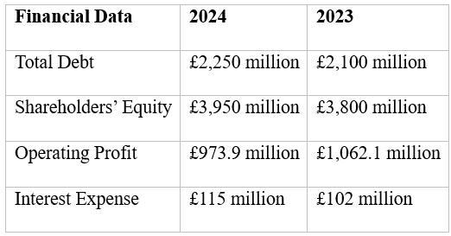

6.1 Debt-to-Equity Ratio
The debt-to-equity ratio is a proportion between the sum of funding through creditors in terms of financial sources, and financing through equity providers (Atrill, 2019).
Formula
Debt-to-Equity Ratio = Total Debt ÷ Shareholders’ Equity
For 2024
Debt-to-Equity Ratio = 2,250 ÷ 3,950 = 0.57
For 2023
Debt-to-Equity Ratio = 2,100 ÷ 3,800 = 0.55
The ratio increased slightly by 0.55 to 0.57 and it indicates that the debt improved slightly. However, the figure is moderate, signifying that there is a moderate capital structure.

6.2 Interest Cover Ratio
Interest cover is a measure of how the company can pay interest charges using operating franchise.
Formula
Interest Cover = Operating Profit ÷ Interest Expense
For 2024
Interest Cover = 973.9 ÷ 115 = 8.47 times
For 2023
Interest Cover = 1,062.1 ÷ 102 = 10.41 times
The interest cover fell to 8.47 against 10.41 loss, which was primarily as a result of reduced operating profit and increased interest cover.

7. Investor Ratios
Investor ratios determine the returns offered to the shareholders and they are frequently utilized by the investors in making judgement on the performance of a company (Lange, Saunders and Marcia Millon Cornett, 2014).
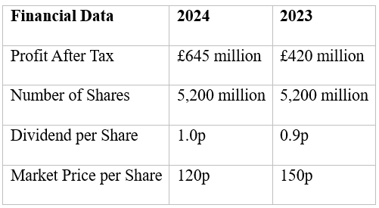

7.1 Earnings Per Share (EPS)
EPS is used to show the amount of profit per ordinary share.
Formula
EPS = Profit After Tax ÷ Number of Shares
For 2024
EPS = 645 ÷ 5,200 = 0.124 pounds = 12.4 pence
For 2023
EPS = 420 ÷ 5,200 = 0.081 pounds = 8.1 pence
This increased the EPS 8.1 pence to 12.4 pence hence means to the shareholders more profitability is being yielded.

7.2 Price-Earnings Ratio
The price earnings ratio is employed to show the number of pounds of earnings that the investors are willing to pay.
Formula
P/E Ratio = Market Price per Share ÷ Earnings per Share
For 2024
P/E Ratio = 120 ÷ 12.4 = 9.68
For 2023
P/E Ratio = 150 ÷ 8.1= 18.52
There was a drastic decrease in the P/E ratio which implies that the investors rate the company using lower earnings multiple.

8. Limitations of Ratio Analysis
Despite the benefits of ratio analysis in understanding the company performance, there are a number of limitations associated with it.
To begin with, the financial ratios rely on past financial statements and thus might not predict future performance. Market trends, consumer trends, and economic conditions may shift quickly (Lange, Saunders and Marcia Millon Cornett, 2014).
Second, the accounting policies can be different in various companies, and this fact can also affect financial ratios comparability across different firms (Bekaert, 2017).
Thirdly, ratio analysis does not take into account the qualitative variables such as the recognition of the brand, strong management or technological development.
Lastly, interpretation of ratios should be viewed with caution since a single ratio does not give a full picture of financial health.

9. Recommendations
According to the analysis of the financial data, a number of recommendations can be offered so that the financial performance of the JD Sports Fashion plc can be improved.
To begin with, the company must endeavour to manage its operating expenses to guard profitability margins. The falling operating profit margin has been associated with increased operating costs and improved overall profitability could be achieved through improved cost management (Drury, 2020).
Second, JD Sports needs to put additional resource on internet stores and e-retailing. Internet sale channels enable firms to sell to a more global customer base and lessen the dependence on brick-and-mortar outlets (Bhimani, 2022).
Third, the firm ought to diversify its product line to minimize the reliance on certain brands or product lines. The extension of own-labeled products can enhance the profitability and the brand position.
Fourth, the management must maintain stock as leanly as possible to prevent stock build up in times of low consumer demand. Effective inventory management enhances the cash flow and lowering of storage expenses.
Finally, JD Sports needs to increase its activities to emerging economies where sportswear and athleisure items are very popular.
However, JD Sports enjoys high brand association in the world, increasing international footprint and demand in sports fashion products. The company is also in a good position to sustain its competitive edge in the international sportswear market with an effective strategic management as well as a sustained investment in digital retailing channels.

Task 2 – Investment Appraisal for Beard Plc
This section is an assessment of investment opportunities available to Beard Plc, which is a firm that deals in the manufacture of high-quality handbags. The company is in the process of strategizing on its further operations, and it has been determined that there are three potential strategic investment opportunities with a four-year development strategy.
The three projects that can be pursued are: expansion of the already thriving retail stores of the company to sell all the products, the creation of an online platform of sale, and the creation of new lines of products like purses and wallets. The required initial investment and the projected annual cash inflows to be received are different at each option.
The techniques of investment appraisal are the key tools that enable the managers to decide whether a given project is viable or not. The methods enable the companies to calculate the future returns that are expected in the future against their original cost of investment and decide the project that gives a high financial return.
The three proposed projects have been analyzed in the present report assessing Net Present Value (NPV) method, with a cost of capital of 5%. The preferred project is also calculated with regards to the Internal Rate of Return (IRR).

1. Net Present Value (NPV) Analysis
One of the commonly utilized methods of investment appraisal is the Net Present Value technique. It determines the disparity of the present value of the future cash inflows and the original cost in which to invest in the venture (ACCA, 2024).
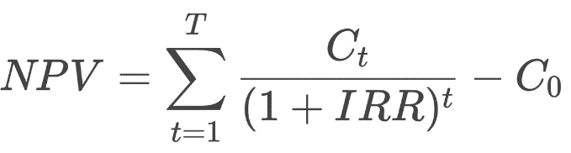
Where:
C_{t} = Cash flow in each year
C₀ = Initial investment
r = Discount rate (5%)
t = Time period
The opportunity cost of capital is indicated by the discount rate (Atrill, 2019). It is the lowest level of investment that investors demand as a guarantee of not wasting their resources in the project.
The present value factors in 5% are presented below.
Year | Discount Factor
1 | 0.952
2 | 0.907
3 | 0.864
4 | 0.823
These are what are used to transform the future cash flows into the present value.

1.1 Option A – Expansion of Retail Outlets
The first one is Option A, which entails the expansion of the company retail stores where all the possible products should be sold. An initial investment of this project will be 600,000.
Cash Flow Calculation
Year | Cash Flow (£000) | Discount Factor | Present Value (£000)
1 | 100 | 0.952 | 95.2
2 | 180 | 0.907 | 163.3
3 | 210 | 0.864 | 181.4
4 | 260 | 0.823 | 214.0
Total Present Value of Cash Inflows:
95.2 + 163.3 + 181.4 + 214.0
Total PV = £653.9k
NPV Calculation
NPV = 653.9 − 600
NPV = £53.9k
The projected preferred NPV showed a positive value, which means that this project would make a higher value than the needed rate of return (Bekaert, 2017).

1.2 Option B – Development of Internet Sales
Option B is to design an online sales platform that will extend the market to the company and consequently increase sales via online marketing. The required investment during the start-up is £900,000.
Cash Flow Calculation
Year | Cash Flow (£000) | Discount Factor | Present Value (£000)
1 | 220 | 0.952 | 209.4
2 | 270 | 0.907 | 244.9
3 | 350 | 0.864 | 302.4
4 | 400 | 0.823 | 329.2
Total Present Value:
209.4 + 244.9 + 302.4 + 329.2
Total PV = £1085.9k
NPV Calculation
NPV = 1085.9 − 900
NPV = £185.9k
Option B has a greater NPV as compared to that of option A. This implies that building internet sales may be worthwhile investment to the company. E-commerce progress over the last several years makes this alternative particularly appealing because it will enable the company gain access to a broader customer base (Bhimani, 2022).

1.3 Option C – Production of Purses and Wallets
The C option entails diversifying the product by making purses and wallets. In this project, initial investment will be designed at 1,000,000 pounds.
Cash Flow Calculation
Year | Cash Flow (£000) | Discount Factor | Present Value (£000)
1 | 250 | 0.952 | 238.0
2 | 310 | 0.907 | 281.2
3 | 400 | 0.864 | 345.6
4 | 430 | 0.823 | 353.9
Total Present Value:
238.0 + 281.2 + 345.6 + 353.9
Total PV = £1218.7k
NPV Calculation
NPV = 1218.7 − 1000
NPV = £218.7k
The overall NPV of option C is the highest between the three projects. This point implies that more products such as purses and wallets could produce the highest financial profit to the company (Bloomenthal, 2025).

1.4 Comparison of Investment Options
Project | Initial Investment (£000) | NPV (£000)
A | 600 | 53.9
B | 900 | 185.9
C | 1000 | 218.7
The NPV of all projects is positive indicating that they are feasible. Project C however gives the most value to shareholders.
That is why, in case the company can select only one project, it is better to select Option C.

2. Internal Rate of Return (IRR)
Internal rate of return refers to the discount level at which NPV of a project takes a zero value. It is the approximate percentage annual return that the investment will offer (Corporate Finance Institute, 2025).
There are two discount rates that are employed to estimate IRR of Project C.
NPV at 5%, NPV = £218.7k
NPV at 10%
Discount factors at 10%:
Year | Factor
1 | 0.909
2 | 0.826
3 | 0.751
4 | 0.683
PV calculation:
Year | Cash Flow | PV
1 | 250 | 227.3
2 | 310 | 256.1
3 | 400 | 300.4
4 | 430 | 293.7
Total PV = 1077.5
NPV = 1077.5 – 1000 = £77.5k
IRR Calculation
IRR ≈ 5 + (218.7 / (218.7 − 77.5)) × (10 − 5)
IRR ≈ 12.7%
The cost of capital calculated about the company is 5 that is much lower than the estimated IRR of about 12.7%.

3. Theoretical Advantages of NPV
The Net Present Value is commonly accepted to be the most reliable investment appraisal method as it accounts in totality the time value of money. The discounting of future cash flows is done to indicate that money obtained in future is less than that obtained today.
The other significant benefit of NPV is that it takes into account all outlays of cash in the present project life, and as a result, this means that the entire financial consequences of the investment are assessed (Court and Innocent, 2025).
Moreover, the NPV is the direct measure of the increase in shareholder wealth, which is the main financial aim of the majority of organisations (Lange, Saunders and Marcia Millon Cornett, 2014). The NPV is a positive value and shows that the project is value adding to the company.

4. Popularity of Non-Discounting Methods
The disadvantages of the discounted cash flow methods notwithstanding, simple investment appraisal techniques like the payback period are continue to be applied by many managers (ACCA, 2024).
Simplicity is one of the reasons of it. Payback is simple to compute and simple to interpret thus it is appealing in the fast-decision-making process.
The other reason is the risk reduction focus. When the payback period of a project is low, they cover up their original cost in a short period, and the project will not run the risk of making no money in case there is a shift in the market (Atrill, 2019).
Also, non-discounting techniques are employed by some organisations as a first screening technique with some more sophisticated techniques like NPV or IRR to follow afterwards (Bekaert, 2017).

5. Other Factors Affecting Investment Decisions
Even though financial calculations are a must, other qualitative aspects must also be taken into consideration before deciding on an investment decision.
A market demand is a significant parameter. The company should be able to maneuver that there is demand in the new products or services offered (Bhimani, 2022).
It is also important to have strategic alignment. The chosen project must help the company long-term business strategy and position (Bekaert, 2017).
There should also be the assessment of operational capabilities. The organisation needs to take care of being able to bring the skills, resources and infrastructure that can help the project to be executed successfully.
Also, economic conditions, technological modifications and competition impacts may affect the success of the investment.

6. Capital Rationing
Assuming that Beard Plc has a constrained investment budget of £1,500,000, capital rationing should be deployed to identify the most efficient manner in which resources should be apportioned (Bloomenthal, 2025).
Projects are ranked using the Profitability Index (PI).
Profitability Index = Present Value ÷ Investment
Project | PV (£000) | Investment (£000) | PI
A | 653.9 | 600 | 1.09
B | 1085.9 | 900 | 1.21
C | 1218.7 | 1000 | 1.22
Projects are also ranked with regard to profitability index.
- Project C
- Project B
- Project A
Projects can be divided hence the company can make its investments accordingly to a certain proportion.
Investment strategy:
Full investment in Project C = £1,000,000
Remaining funds = £500,000
Fraction of Project B:
500 / 900 = 0.56
NPV from B portion:
0.56 × 185.9 = £104.1k
Total NPV = 218.7 + 104.1 = £322.8k

7. Sources of Finance
There are various sources of finance that Beard Plc can use to finance the investment programme.
Retained Earnings
Retained profits are also an internal source of finances and in most occasions, this is usually the cheapest due to the interest that is not paid. The utilization of retained earnings can however lower the amount of funds which can be used in the future to make investments (Corporate Finance Institute, 2025).
Bank Loans
Bank loan, is a good source of instant borrowing but has to be repaid on a regular basis at an interest rate. Too much borrowing will add financial risk and impact on credit rating of the company (Court and Innocent, 2025).
Equity Finance
Under the issuance of new shares, companies can raise substantial sums of capital without capitalizing on a debt (ACCA, 2024). It, however, dilutes the ownership of the current shareholders, and could decrease the earnings per share.
Corporate Bonds
Bonds enable the companies to obtain long-term finance through investors (Court and Innocent, 2025). Even though bonds generate a large amount of money, they generate a long-term financial liability in terms of interest payments.

8. Overall Analysis
The analysis of the three investment appraisals reveals that each of the three projects generates positive net present values implying that the projects can yield higher shareholder wealth.
Project C however has got the best NPV (£218.7k) and also has estimated IRR that is around 12.7 having much higher IRR than that of the company where the cost of capital is 5%.
In case of capital constraints at £1.5 million, the best approach is to invest in the whole of Project C and use the remaining cash to invest in Project B, and this results into a total NPV of about l322.8k.
In general, the recommendation is that Beard Plc should go on with the investment programme and concentrate on Project C as it has a better financial performance. The investment can be funded by both retained earnings as well as external financing of bank loans or even equity which depends on the financial arrangement and risk-taking ability of the company.

Conclusion
The discussion in this report demonstrates that financial analysis and investment appraisal are crucial in providing competitive managerial decision-making and long-term business development. Through analyzing the financial information and using the suitable analysis methods, organisations can determine their financial status, potential risks, as well as investment opportunities in the future.
The financial ratio analysis of JD Sports Fashion plc indicates that the company retains a healthy position in the international sports fashion retail business. The revenue of the company has been growing steadily, which means that it will have new consumers and will ultimately expand into foreign markets as well. The gross profit margin changed relatively constant, which indicates that business has managed to have the cost of goods sold under control, despite growing competitive intensity and inflation rates in global supply chains.
Nevertheless, the analysis revealed that there were some barriers to profitability as well. The decrease in operating profit margin indicates that the operating costs including the labour costs, store operations and expansion activities are higher in the financial period compared to the previous financial period. Even though the net profit margin is up by virtue of less exceptional cost, the operations will still demand the sustained care of cost control and operation efficiency to stay profitable. The liquidity ratios indicate that the company holds a good capacity to meet its short-term liabilities, whereas the efficiency ratios reveal that the assets and inventory are being used well to achieve sales. Gearing ratios indicate that the use of debt within the company is moderate and manageable, therefore, lowering financial risk and ensuring long-term financial stability. There is also an improvement in earnings performance as reflected in investor ratios, which reflect greater profitability to shareholders.
The second component of the report was concerned with investment appraisal of Beard Plc. Three viable investment opportunities were compared using the Net Present Value (NPV) method in order to establish which project will bring about the highest financial output. The results indicated that the three investment options all yielded positive NPVs, i.e. each project can be used to generate value to the business. Of the alternatives, the project of producing purses and wallets presented the greatest NPV and approximating Internal Rate of Return (IRR) which is far more than the cost of capital of the business, making it the most economically appealing.
Generally, the results depict that financial analysis and investment appraisal methods offer invaluable information that can be used to facilitate strategic planning, financial management and sustainable business development. Through effective analysis of financial performance and assessment of investment activities, organisations are better placed to make better decisions that enhance competitive advantage and shareholder value in the long-term.

Bibliography
ACCA (2024). Investment appraisal | ACCA Global. [online] Accaglobal.com. Available at: https://www.accaglobal.com/gb/en/student/exam-support-resources/prodipsust-study-resources/technical-articles/investment-appraisal.html [Accessed 14 Mar. 2026].
Atrill, P. (2019). Financial Management for Decision Makers. 9th ed. Pearson.
Bekaert, G. (2017). International Financial Management. 3rd ed. Cambridge, United Kingdom: Cambridge University Press.
Bhimani, A. (2022). Financial Management for Technology Start-Ups. 2nd ed. Kogan Page.
Bloomenthal, A. (2025). Financial Ratio Analysis: Definition, Types, Examples, and How to Use. [online] Investopedia. Available at: https://www.investopedia.com/terms/r/ratioanalysis.asp [Accessed 14 Mar. 2026].
Corporate Finance Institute (2025). Net Present Value (NPV). [online] Corporate Finance Institute. Available at: https://corporatefinanceinstitute.com/resources/valuation/net-present-value-npv/ [Accessed 14 Mar. 2026].
Court, E.R. and Innocent, D. (2025). Management Accounting Practices and Financial Performance of Small and Medium Sized Enterprises in Rivers State, Nigeria. [online] doi: https://doi.org/10.5281/zenodo.15043745.
Drury, C. (2020). Management And Cost Accounting. 11th ed. S.L.: Cengage Learning Emea.
JD Sports (2026). Our History - JD Group. [online] www.jdplc.com. Available at: https://prod-www.jdplc.com.missionlabs.co.uk/our-history [Accessed 14 Mar. 2026].
JD Sports PLC (2024). Unaudited FY24 Results. [online] Jdplc.com. Available at: https://www.jdplc.com/investor-relations/regulatory-news/regulatory-news-details/2024/Unaudited-FY24-Results-05-31-2024/default.aspx [Accessed 14 Mar. 2026].
Lange, H.P., Saunders, A. and Marcia Millon Cornett (2014). Financial institutions management : a risk management approach. North Ryde, N.S.W. Mcgraw-Hill Education.

Appendix
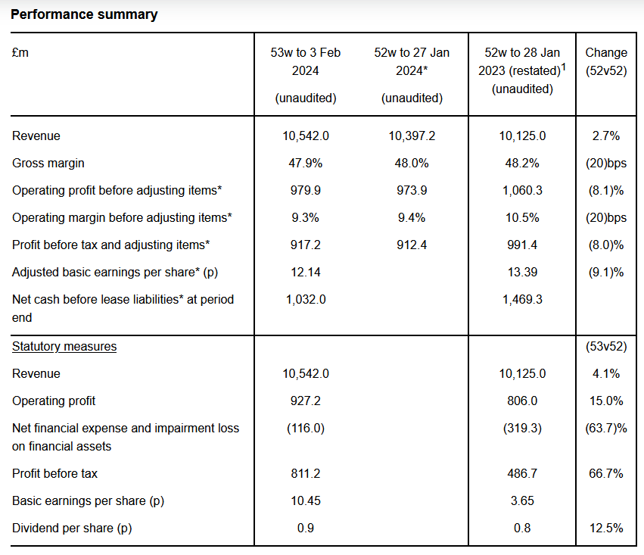
Source: (JD Sports PLC, 2024)

