

MODULE CODE: ECPT6006

ASSESSMENT COMPONENT: A Critical Evaluation of the Role of Digital Innovation in Professional Practice

STUDENT NAME: Joanne Wozencroft

STUDENT NUMBER: 0652449

AI Acknowledgement
I confirm that I have not used any AI tools in the research and creation of this assignment.
I confirm that I have not presented any AI generated materials as my own work.
I confirm that I have copies of my drafts, notes, and other resources I used, which I may be asked to provide in evidence.
Introduction
This assignment critically evaluates the role of digital innovation in professional practice within post-16 education in Wales, where digital capability is positioned as central to economic resilience, social inclusion and learner preparedness for participation in a digital society (Welsh Government, 2019; OECD, 2019). National policy, including Digital 2030, identifies digital competence as a sector priority, while professional standards emphasise inclusive pedagogy, digital literacy and reflective practice (Welsh Government, 2019; Education Workforce Council, 2019). Together, these frameworks position digital innovation as a mechanism for enhancing teaching, learning and employability outcomes.
However, the assumption that technology inherently improves learning is contested. Digital tools are shaped by social and institutional contexts, meaning their effectiveness depends on how they are pedagogically applied rather than simply adopted (Selwyn, 2016; Williamson, 2017). This highlights the importance of aligning technology with teaching strategies and learner needs (Laurillard, 2012).
Drawing on socio-cultural and cognitive perspectives, including dialogic learning and formative assessment, this assignment examines how digital tools can support meaningful learning (Vygotsky, 1978; Black and Wiliam, 1998). It evaluates the use of Mentimeter as a case study, arguing that digital innovation is most effective when underpinned by pedagogical theory, inclusive practice and professional responsibility (Mishra and Koehler, 2006; Means et al., 2014).
Literature Review: The Role of Creativity and Digital Innovation in Professional Practice
Digital innovation is widely recognised within the literature as a central feature of post-16 education, shaping both pedagogical approaches and professional expectations (Welsh Government, 2019; Jisc, 2020). Policy frameworks such as the Welsh Government’s Digital 2030 strategy position digital capability as essential to employability, inclusion and long-term sector development (Welsh Government, 2019), while implementation guidance emphasises the strategic integration of digital learning across teaching and organisational practice (Welsh Government, 2019). Similarly, Jisc identifies digital capability as a shared responsibility across post-16 providers, linking it directly to learner outcomes and institutional development (Jisc, 2020). More recent sector evidence highlights ongoing challenges in digital access, confidence and infrastructure across further education settings, reinforcing the importance of inclusive and sustainable digital practice (Jisc, 2024). These sources collectively position digital innovation as a driver for change within professional practice, requiring educators to adapt to evolving technological and pedagogical demands (Welsh Government, 2019; Jisc, 2024).
However, there is significant debate regarding the extent to which digital innovation leads to improved learning outcomes. Selwyn (2016) critiques technological determinism, arguing that digital technologies are shaped by institutional and socio-political contexts rather than acting as inherently transformative tools. Williamson (2017) extends this critique by highlighting how data-driven educational systems may prioritise measurable engagement over deeper learning. More recent research supports this perspective, demonstrating that digital technologies do not automatically enhance learning but are effective only when aligned with active pedagogical strategies (Bond et al., 2020). This indicates that digital innovation should be understood as contingent upon its implementation rather than inherently beneficial (Selwyn, 2016; Bond et al., 2020).
The literature further emphasises the relationship between digital innovation and future skills. The OECD argues that digitalisation is reshaping labour markets, requiring learners to develop not only technical competence but also collaboration, problem-solving and adaptability (OECD, 2019; OECD, 2021). Welsh Government policy reflects this emphasis, positioning digital capability as essential for preparing learners for employment and lifelong learning (Welsh Government, 2019). These sources collectively suggest that digital innovation is closely linked to workforce readiness, positioning educators as facilitators of transferable skills development (OECD, 2021; Welsh Government, 2019).
A recurring theme within the literature is the distinction between technological adoption and pedagogical transformation. Research on blended learning demonstrates that improved outcomes are associated with instructional design, interaction and feedback rather than technology alone (Means et al., 2014). Similarly, active learning research shows that student performance improves when learners engage cognitively with content (Freeman et al., 2014). However, studies of audience response systems indicate that such tools do not independently improve learning without structured explanation and feedback (Kay and LeSage, 2009). More recent reviews reinforce that digital tools are most effective when integrated with active learning and feedback processes (Bond et al., 2020). Laurillard (2012) supports this perspective, emphasising that learning occurs through iterative cycles of dialogue, feedback and adaptation. Together, these studies demonstrate that tools such as Mentimeter are pedagogically valuable only when embedded within structured teaching approaches (Laurillard, 2012; Bond et al., 2020).
Socio-cultural theory provides a foundation for understanding collaboration in digital environments. Vygotsky (1978) conceptualises learning as socially mediated, while Mercer and Littleton (2007) highlight the importance of dialogue in developing shared understanding. Digital tools can support this by enabling learners to contribute ideas and engage with peers in real time. For example, Mentimeter can make collective thinking visible, supporting inclusive participation across a cohort (Khan, 2025; Millmore, 2022). However, behavioural participation does not necessarily result in cognitive engagement, as meaningful learning requires interactive and constructive engagement rather than passive response (Chi and Wylie, 2014; Bond et al., 2020). This suggests that collaboration within digital environments must be actively structured by teachers to support deeper learning (Chi and Wylie, 2014).
Collaboration is also widely recognised as essential within the broader educational landscape. Cooperative learning has been shown to enhance both academic achievement and interpersonal skills when appropriately structured (Johnson and Johnson, 2009), while more recent research continues to emphasise the importance of collaboration for employability and problem-solving skills (OECD, 2021). Digital tools can support collaborative learning, but their effectiveness depends on task design and facilitation rather than technology alone (Johnson and Johnson, 2009).
Creativity represents an important dimension of digital innovation. Creativity involves generating ideas and exploring possibilities within learning environments (Craft, 2005), which can be supported through interactive and collaborative digital tools. However, meaningful learning requires progression beyond recall towards higher-order thinking processes such as analysis, evaluation and creation (Bloom, 1956; Anderson and Krathwohl, 2001). More recent research supports the importance of designing digital tasks that promote critical thinking and problem-solving (Bond et al., 2020). This indicates that creativity in digital learning depends on pedagogical design rather than technological features (Anderson and Krathwohl, 2001).
Cognitive theory further emphasises the importance of instructional design in digital environments (Mayer, 2009).Cognitive load theory suggests that learning is hindered when working memory is overloaded (Sweller, 1988; Kirschner, Sweller and Clark, 2006), while multimedia learning theory demonstrates that learning is most effective when information is presented clearly and coherently (Mayer, 2009). More recent research supports these findings, indicating that poorly designed digital environments can reduce learning effectiveness (Bond et al., 2020). This highlights the need for careful sequencing and integration of digital tools within post-16 teaching (Mayer, 2009).
Motivation is frequently cited as a benefit of digital innovation, yet the literature presents a more nuanced perspective (Selwyn, 2016). Intrinsic motivation is supported by autonomy, competence and relatedness (Deci and Ryan, 2000), and digital tools may enhance engagement through interactivity and anonymity. However, research indicates that gamification may not sustain motivation over time (Hanus and Fox, 2015), while more recent studies suggest that engagement is most effective when linked to meaningful learning activities (Bond et al., 2020). This suggests that digital tools should support intrinsic motivation through pedagogical design rather than novelty (Deci and Ryan, 2000).
Formative assessment represents one of the most significant contributions of digital innovation to professional practice (Wiliam, 2011). Effective assessment involves eliciting evidence of learning and adapting teaching accordingly (Black and Wiliam, 1998), while feedback plays a central role in developing learner self-regulation (Nicol and Macfarlane-Dick, 2006). Digital tools such as Mentimeter enable teachers to gather real-time evidence of learner understanding. More recent research suggests that digital assessment is most effective when combined with feedback and instructional adaptation (Henderson et al., 2019). This reinforces that assessment is a pedagogical process rather than a technological function (Nicol and Macfarlane-Dick, 2006).
Frameworks such as TPACK and SAMR are widely used to evaluate digital integration (Mishra and Koehler, 2006; Puentedura, 2010). Effective digital pedagogy requires the integration of technological, pedagogical and content knowledge (Mishra and Koehler, 2006), while models such as SAMR provide a framework for evaluating levels of technology use (Puentedura, 2014). However, these frameworks have been critiqued for oversimplifying complex teaching contexts (Hamilton, Rosenberg and Akcaoglu, 2016), suggesting that they are most effective when used to support reflective practice rather than prescribe approaches (Hamilton et al., 2016).
Professional capability and institutional context are critical to digital innovation (Selwyn, 2016; Warschauer, 2004). Effective implementation requires sustained professional development (Darling-Hammond, Hyler and Gardner, 2017), yet variability in digital confidence and access continues to be identified across post-16 settings (Jisc, 2024). Digital teaching can also increase workload and cognitive demands (MacIntyre, Gregersen and Mercer, 2020), creating a tension between innovation and sustainability within professional practice (Darling-Hammond et al., 2017).
Equity and inclusion remain central concerns within the literature (Warschauer, 2004; Selwyn, 2016). Digital innovation may reproduce inequalities when access and support are uneven (Selwyn, 2016), while Welsh legislative frameworks reinforce the need for inclusive provision. More recent research highlights disparities in digital access and participation, emphasising the importance of inclusive design within digital learning environments (Jisc, 2024). This suggests that digital innovation must be carefully implemented to avoid reinforcing existing inequalities (Selwyn, 2016).
Ethical and safeguarding considerations further shape digital practice. Legal frameworks such as the Data Protection Act 2018 and UK GDPR establish requirements for data use, while the Prevent Duty extends safeguarding responsibilities into digital environments. These frameworks reinforce that digital innovation must be implemented responsibly within professional practice (HM Government, 2015; Data Protection Act 2018).
Despite extensive research, limitations remain within the literature (Selwyn, 2016; Kirschner and De Bruyckere, 2017). Much of the evidence focuses on short-term engagement rather than long-term learning outcomes, particularly within further education contexts (Means et al., 2014; Bond et al., 2020). This highlights a gap in understanding the sustained impact of digital innovation on learner progression, indicating a need for further context-specific research (Jisc, 2024).
In synthesis, the literature consistently demonstrates that digital innovation, pedagogical theory and professional practice are interdependent (Laurillard, 2012; Mishra and Koehler, 2006). Digital tools such as Mentimeter can support participation, collaboration, creativity and formative assessment, but their effectiveness depends on pedagogical design, teacher expertise and contextual factors (Means et al., 2014; Bond et al., 2020). Digital innovation within post-16 education should therefore be understood as a form of reflective professional practice shaped by theory, policy and the realities of teaching and learning (Selwyn, 2016; Welsh Government, 2019).
Selection and Justification of appropriate teaching tool - Mentimeter
I selected Mentimeter as the digital learning tool for this portfolio based on the understanding that digital innovation in post-16 education is most effective when aligned with pedagogical purpose rather than technological novelty (Laurillard, 2012; Selwyn, 2016). Research demonstrates that while interactive technologies can increase participation, participation alone does not ensure conceptual understanding or deep learning (Kirkwood and Price, 2014; Chi and Wylie, 2014). This informed my decision to identify a tool that supports dialogic engagement, structured formative assessment, retrieval-based learning and inclusive participation within a post-16 context (Black and Wiliam, 1998; Roediger and Karpicke, 2006).
Mentimeter is a real-time audience response system that enables live polling, ranking tasks and open-ended responses, with immediate visualisation of learner input through charts and word clouds (Hill, 2020). This tool was selected as it enables whole-cohort participation, transforming questioning from individualised responses into collective, visible engagement (Kay and LeSage, 2009). This aligns with Laurillard’s (2012) conversational framework, which conceptualises learning as an iterative process shaped by dialogue and feedback. By making learner thinking visible, Mentimeter enables responses to be examined, challenged and developed through structured discussion, supporting adaptive teaching rather than passive response collection (Laurillard, 2012; Means et al., 2014).
Constructivist theory further supports this selection. Learning is understood as the restructuring of knowledge through challenge and adaptation (Piaget, 1952), supported by scaffolding that enables progression in understanding (Bruner, 1960). Mentimeter supports this process by enabling questions to be sequenced from recall to application and evaluation, aligning with Bloom’s Taxonomy and supporting higher-order thinking (Anderson and Krathwohl, 2001). Research on retrieval practice demonstrates that recalling information strengthens long-term retention when supported by feedback (Roediger and Karpicke, 2006), and Mentimeter provides a practical mechanism for embedding retrieval opportunities within lessons (Roediger and Karpicke, 2006).
Socio-cultural theory also informed this decision. Learning is socially mediated through interaction and shared tools (Vygotsky, 1978), and dialogue plays a central role in developing understanding (Mercer and Littleton, 2007). Mentimeter functions as a mediational tool, transforming individual responses into shared representations that support collaborative meaning-making (Vygotsky, 1978; Laurillard, 2012). This enables learners to engage with the ideas of others and develop their understanding through discussion. However, behavioural participation does not necessarily result in cognitive engagement, as meaningful learning requires active and constructive interaction (Chi and Wylie, 2014), reinforcing the importance of structured facilitation when using such tools.
Empirical research further supports this selection. Audience response systems have been shown to increase participation and engagement when embedded within structured teaching (Kay and LeSage, 2009; Hew and Lo, 2018), with more recent research indicating that tools such as Mentimeter can enhance attentiveness and active learning when integrated into lesson design (Khan, 2026; Lauricella, Banks and Kay, 2025). More recent research also highlights that engagement is influenced by task design and teacher facilitation rather than technology alone (Bond et al., 2020; Limbu and McKinley, 2024). Mentimeter therefore provides a platform for implementing structured, research-informed teaching strategies that support both engagement and learning (Bond et al., 2020). However, there is a risk that such tools prioritise engagement over depth, as rapid-response formats may encourage surface-level contributions unless carefully structured (Kirkwood and Price, 2014; Selwyn, 2016).
Within my post-16 teaching context, Mentimeter is integrated as part of structured lesson sequences to support both retrieval and formative assessment. At the beginning of a session, multiple-choice questions are used to activate prior knowledge and identify misconceptions, aligning with retrieval practice principles (Roediger and Karpicke, 2006). During teaching, open-ended questions and ranking tasks prompt learners to explain, compare and justify their thinking, supporting higher-order cognitive processes and engagement in digital learning environments (Anderson and Krathwohl, 2001; Lauricella, Banks and Kay, 2025). The visualisation of responses enables patterns in understanding to be identified and teaching to be adapted in real time, reflecting Black and Wiliam’s (1998) model of formative assessment as responsive instruction. In this way, Mentimeter is not used as an isolated activity, but as an integrated component of teaching that supports continuous feedback and conceptual development (Laurillard, 2012).
Inclusion was a key factor in this selection. Research indicates that anonymity can increase participation and reduce anxiety among less confident learners (Kay and LeSage, 2009; Tarazi et al., 2023). Within post-16 education, where cohorts are diverse in confidence and experience, Mentimeter enables all learners to contribute simultaneously, supporting equitable participation (Tarazi et al., 2023). This aligns with legislative expectations regarding inclusive practice under the Equality Act 2010 and the Additional Learning Needs and Education Tribunal (Wales) Act 2018.
Creativity also informed this decision. Creativity involves the generation and exploration of ideas within structured contexts (Craft, 2005), and digital tools can support this through collaborative idea generation (Cojocariu et al., 2024). Mentimeter’s open-ended responses and word cloud features allow learners to share diverse perspectives and engage in collective thinking, supporting creative engagement within structured learning environments (Craft, 2005).
The selection of Mentimeter also demonstrates alignment with the Professional Standards for Further Education Teachers in Wales, which emphasise effective assessment, inclusive practice and reflective pedagogy (Education Workforce Council, 2019). By using Mentimeter to gather real-time evidence of learner understanding, teaching can be adapted in response to learner needs, reflecting responsive and learner-centred practice (Black and Wiliam, 1998; Education Workforce Council, 2019). Its capacity to widen participation further supports inclusive teaching expectations (Tarazi et al., 2023).
In addition, the use of Mentimeter aligns with the Welsh Government Digital 2030 framework, which emphasises the development of digitally capable learners prepared for participation in a digital society (Welsh Government, 2019). By embedding Mentimeter within teaching, purposeful digital practice is modelled and learners are supported in developing digital confidence and transferable skills (OECD, 2021; Welsh Government, 2019). This demonstrates that digital innovation contributes to broader strategic priorities relating to employability and lifelong learning (Welsh Government, 2019).
To ensure meaningful integration, Mentimeter was evaluated using the TPACK framework, which emphasises the alignment of technological, pedagogical and content knowledge (Mishra and Koehler, 2006). This tool can be aligned with formative assessment strategies and curriculum objectives, supporting coherent teaching and learning. The SAMR model further supports reflection on how digital tools can enhance learning beyond substitution (Puentedura, 2014), and Mentimeter enables modification of classroom interaction through real-time feedback and collective dialogue (Hamilton et al., 2016).
Overall, Mentimeter was selected because it supports key principles identified within the literature, including dialogic teaching, formative assessment, retrieval practice, collaboration and inclusive participation (Laurillard, 2012; Black and Wiliam, 1998; Roediger and Karpicke, 2006). This demonstrates that Mentimeter is not inherently innovative; rather, its effectiveness depends on how pedagogical theory, task design and professional judgement are integrated in practice (Mishra and Koehler, 2006; Selwyn, 2016). Its selection therefore reflects a synthesis of pedagogical theory, empirical research and professional standards, demonstrating that digital innovation is most effective when technology and pedagogy are aligned within post-16 practice.
Application of chosen digital tool – Mentimeter
This cohort consisted of part-time learners with a diverse range of prior educational experiences, confidence levels and digital competencies. In addition, several learners were identified as having Additional Learning Needs (ALN), requiring inclusive and differentiated approaches to teaching (Florian and Black-Hawkins, 2011). As a result, the design and implementation of the session prioritised accessibility, flexibility and opportunities for all learners to participate meaningfully, ensuring that digital innovation supported rather than hindered inclusive practice (Selwyn, 2016). The session focused on Mental Health and Wellbeing and was delivered through a flexible evening pathway attended once weekly. Given the diversity of the cohort in terms of age, academic background and confidence levels, the design of the Mentimeter presentation was underpinned by principles of inclusion and accessibility, rather than aesthetic considerations alone, reflecting the expectation that digital tools should actively reduce barriers to participation and support equitable learning experiences (Selwyn, 2016; Education Workforce Council, 2019). Consideration was also given to potential disparities in device access and connectivity, particularly within a part-time cohort, ensuring that activities could be accessed via mobile devices and did not rely on high bandwidth, aligning with research on the digital divide in post-16 education (Selwyn, 2016).
In designing the slides, particular consideration was given to the needs of adult learners, who may present with diagnosed or undiagnosed visual impairments, visual stress or screen fatigue, particularly within an evening learning context. Consequently, each slide was deliberately designed using large, bold fonts, high-contrast colour combinations and minimal text to maximise readability and reduce visual strain, consistent with accessibility principles in digital learning design (Beetham and Sharpe, 2019; Jisc, 2024). Cluttered layouts, italics and underlining were avoided, and key terms were selectively bolded to guide attention without overwhelming the visual field, thereby supporting cognitive processing and reducing extraneous cognitive load (Mayer, 2009). Colour was not used to convey meaning independently, ensuring accessibility for learners with colour-vision differences and aligning with inclusive design principles that promote universal access to learning (Jisc, 2024).
Prior to constructing the presentation, I developed a clearly sequenced ten-slide structure aligned with the intended learning outcomes of the session. Each slide was designed with a single pedagogical function, including orientation, eliciting prior knowledge, surfacing misconceptions, encouraging reflection and embedding formative assessment. This structured approach ensured that Mentimeter was not used as an isolated engagement tool but as a mechanism to scaffold learning through iterative cycles of interaction, feedback and adaptation, consistent with Laurillard’s (2012) conversational framework. A consistent visual template was applied throughout to support predictability and reduce cognitive load, which is particularly important for learners with additional learning needs or reduced processing capacity (Kirschner, Sweller and Clark, 2006). Each slide presented one central idea in plain language, with generous spacing and limited wording to maintain clarity across devices, including mobile phones, which are frequently used within post-16 contexts (Jisc, 2024). All slides were tested in learner view to ensure accessibility and usability across different screen sizes.
Given the sensitive nature of the subject matter, an early message provided a clear trigger warning and established expectations for respectful discussion. This approach supported safeguarding responsibilities and promoted psychological safety within the learning environment, which is recognised as a prerequisite for learner engagement and participation (Maslow, 1943; UK Government, 2015). Opportunities for learners to opt out of responding to sensitive questions were also incorporated, recognising the personal nature of the topic and supporting learner autonomy. The anonymous response function was deliberately enabled to widen participation and reduce performance anxiety, particularly for learners who may be less confident in contributing verbally. Research indicates that anonymity within audience response systems can increase equitable participation and redistribute classroom voice (Kay and LeSage, 2009; Tarazi et al., 2023). Within this session, anonymity functioned as a protective mechanism, allowing learners to engage with potentially emotive themes without fear of judgement or personal exposure. However, anonymity was carefully balanced with explicit behavioural expectations and active facilitation to maintain professional accountability and ensure respectful interaction (Beetham and Sharpe, 2019).
The ten-slide sequence incorporated a range of question types, including multiple-choice polls, ranking tasks and open-ended responses, to accommodate different communication preferences and levels of confidence. Low-stakes polling was used initially to build engagement and activate prior knowledge, aligning with retrieval practice principles that support memory consolidation and long-term retention (Roediger and Karpicke, 2006). This was followed by ranking tasks designed to promote comparison and reasoning, and open-ended prompts that encouraged reflective expression and personal interpretation. This progression reflects movement through increasing cognitive complexity, supporting higher-order thinking processes as conceptualised within Bloom’s Taxonomy (Anderson and Krathwohl, 2001). Verbal instructions and modelling were provided alongside each activity to scaffold digital participation, ensuring that learners with lower digital confidence were able to engage effectively. During delivery, pacing was carefully managed to allow sufficient processing time for responses, recognising that rapid transitions between activities can increase cognitive load and disadvantage learners requiring additional processing time (Mayer, 2009). Responses were used formatively to identify patterns in understanding, address misconceptions and adapt the pace and depth of teaching in real time, aligning with Black and Wiliam’s (1998) model of formative assessment as responsive and adaptive instruction. Through this process, Mentimeter functioned not only as a participatory tool but as a mechanism for evidence-informed teaching and ongoing instructional decision-making.
This implementation demonstrates alignment with the Professional Standards for Further Education Teachers, Work-Based Learning Practitioners and Adult Learning Practitioners in Wales, particularly in relation to inclusive practice, learner wellbeing and reflective professionalism (Education Workforce Council, 2019). The use of Mentimeter to gather real-time evidence of learner understanding supports responsive teaching, while its capacity to widen participation reflects a commitment to inclusive and learner-centred practice (Black and Wiliam, 1998; Tarazi et al., 2023). This illustrates how digital tools can be used to enact professional standards in practice rather than simply support engagement. Informal observation indicated increased participation across the cohort, particularly among quieter learners, suggesting that the combination of anonymity and structured questioning supported more equitable engagement.
The approach also reflects broader Welsh policy priorities. The Welsh Government’s Digital 2030 framework emphasises the importance of developing digitally capable learners who can engage confidently and critically with technology (Welsh Government, 2019). By embedding Mentimeter within teaching, the session supported not only subject-specific learning but also the development of digital confidence and competence, contributing to learners’ readiness for participation in a digitally mediated society (OECD, 2021; Welsh Government, 2019). This demonstrates that digital innovation within post-16 education contributes to wider strategic goals relating to employability, inclusion and lifelong learning.
Ethical considerations were central throughout the design and implementation process. The use of Mentimeter was informed by responsibilities under the UK General Data Protection Regulation (UK GDPR) and the Data Protection Act 2018, ensuring that learner data was handled appropriately and that anonymity was used responsibly (UK Parliament, 2018). A contingency plan was also considered in the event of technical difficulties, ensuring that alternative questioning strategies could be implemented without disrupting the learning sequence. The inclusion of trigger warnings, structured facilitation and clear behavioural expectations also reflected safeguarding responsibilities within post-16 education (UK Government, 2015). By embedding accessibility features, supporting psychological safety and ensuring ethical digital practice, the use of Mentimeter became an enactment of inclusive and responsible pedagogy rather than simply a digital engagement strategy (Selwyn, 2016; Beetham and Sharpe, 2019).
This structured application also reflects the TPACK framework, as Mentimeter is integrated through the alignment of technological functionality, pedagogical strategy and subject content, ensuring coherence between digital innovation and learning outcomes (Mishra and Koehler, 2006). This highlights that effective digital practice is achieved through intentional integration rather than the use of technology in isolation.
Overall, the application of Mentimeter within this session demonstrates how digital tools can be purposefully integrated into teaching to support inclusive, dialogic and responsive learning environments. Its use reflects a synthesis of pedagogical theory, empirical research and professional standards, illustrating that effective digital innovation is achieved through careful design, structured implementation and ongoing professional reflection within post-16 practice (Laurillard, 2012; Mishra and Koehler, 2006).
All participants provided consent for the use of their names, initials, photographs, and student details.
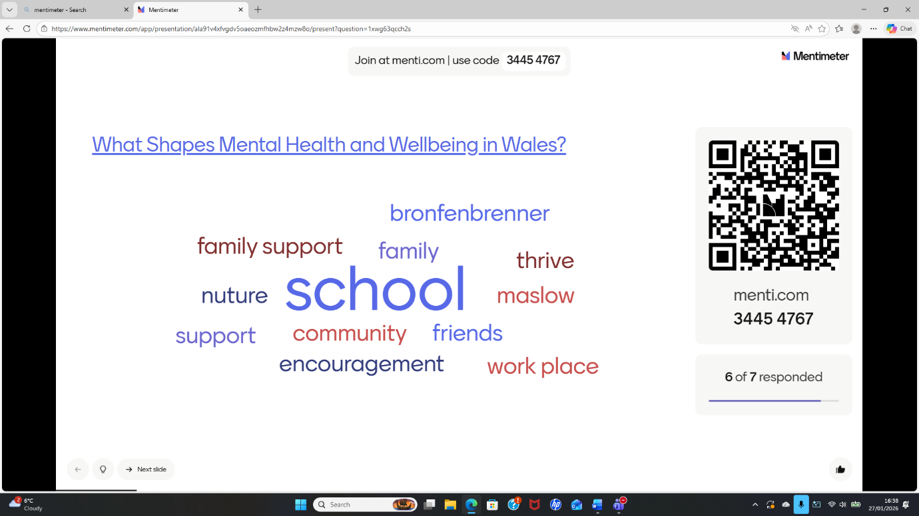

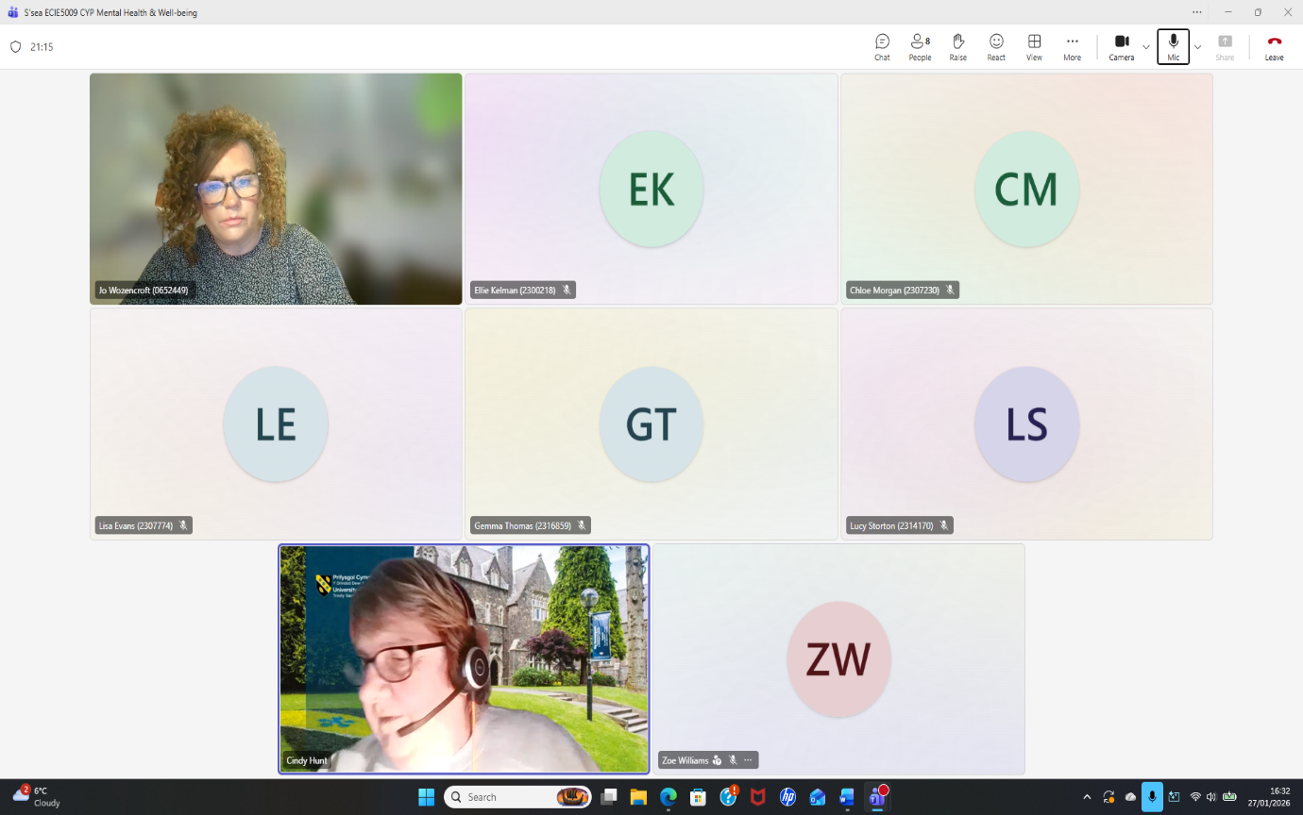
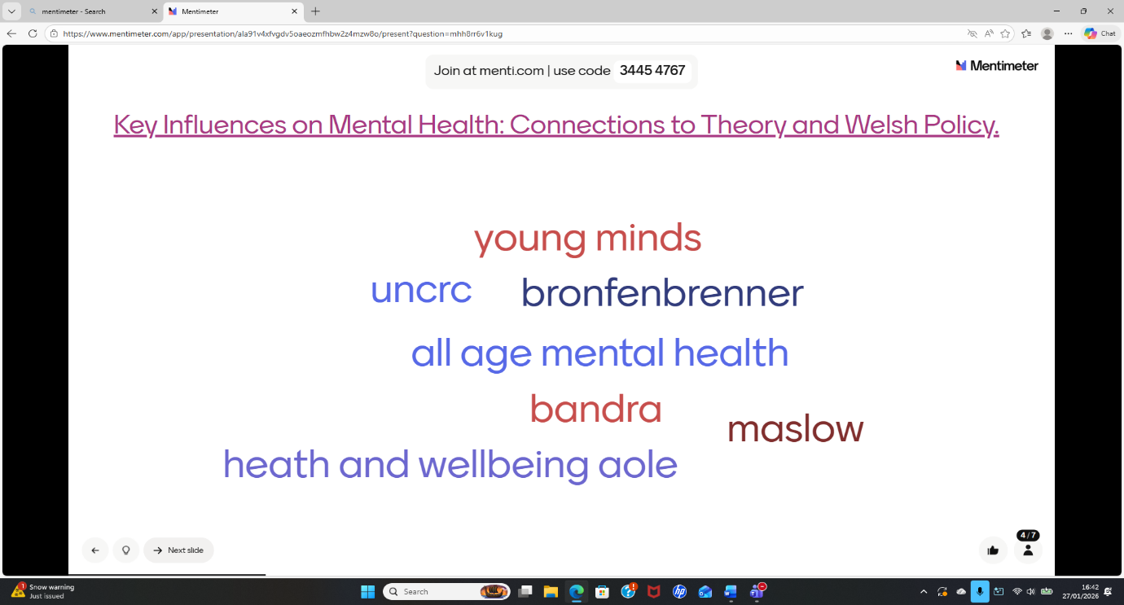

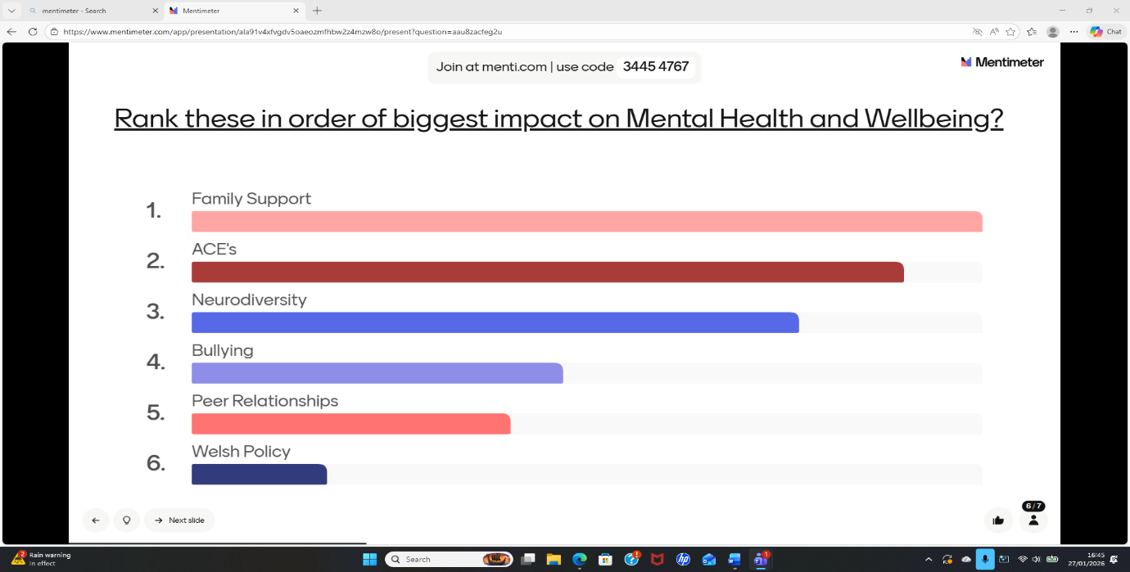
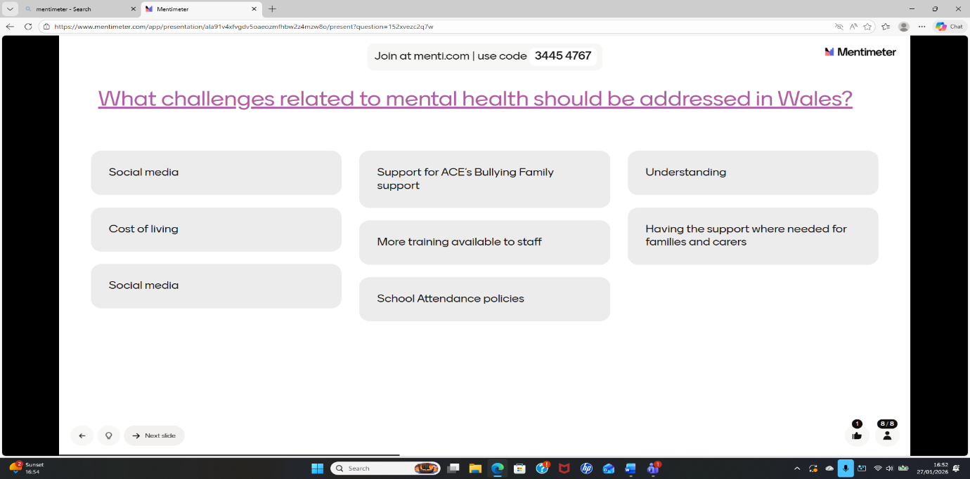

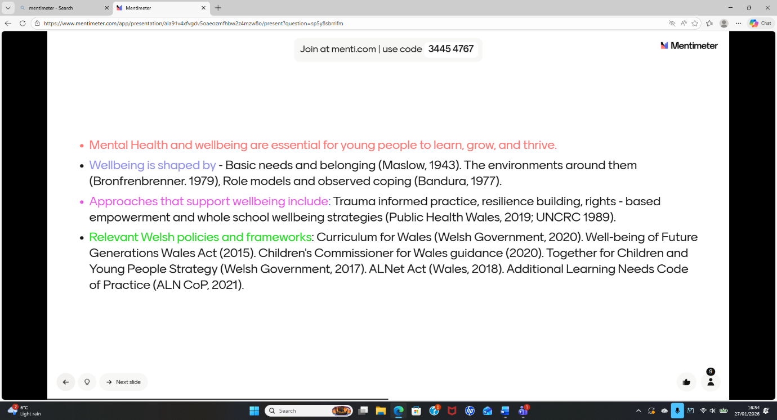

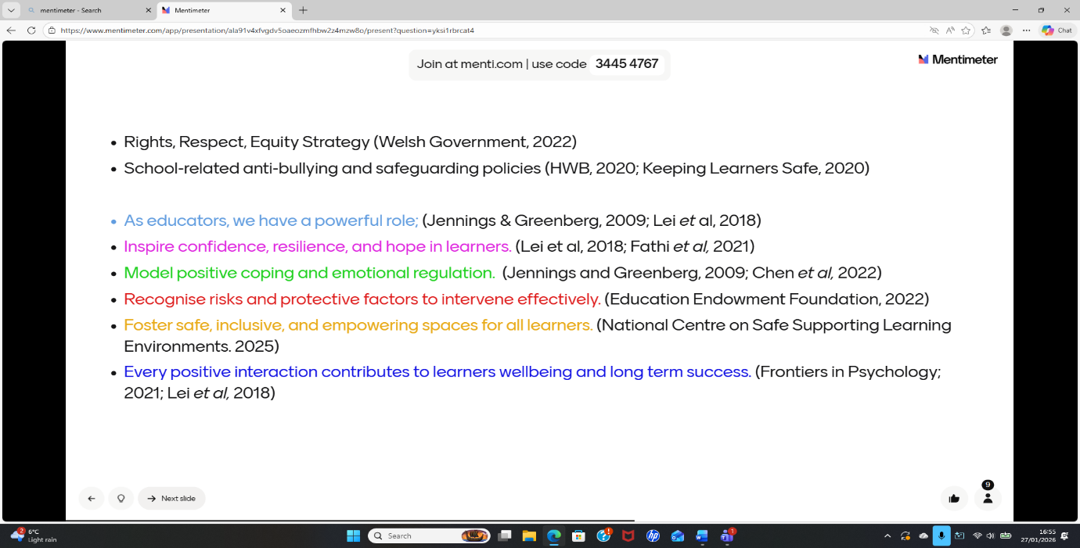
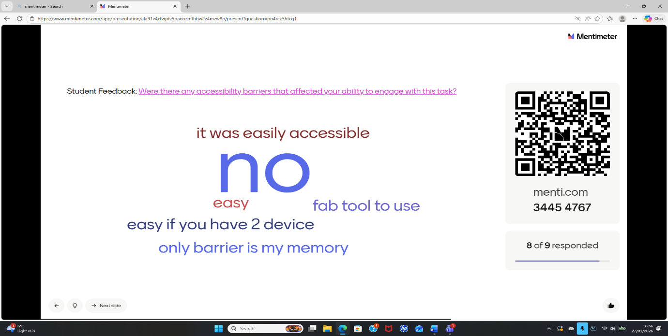

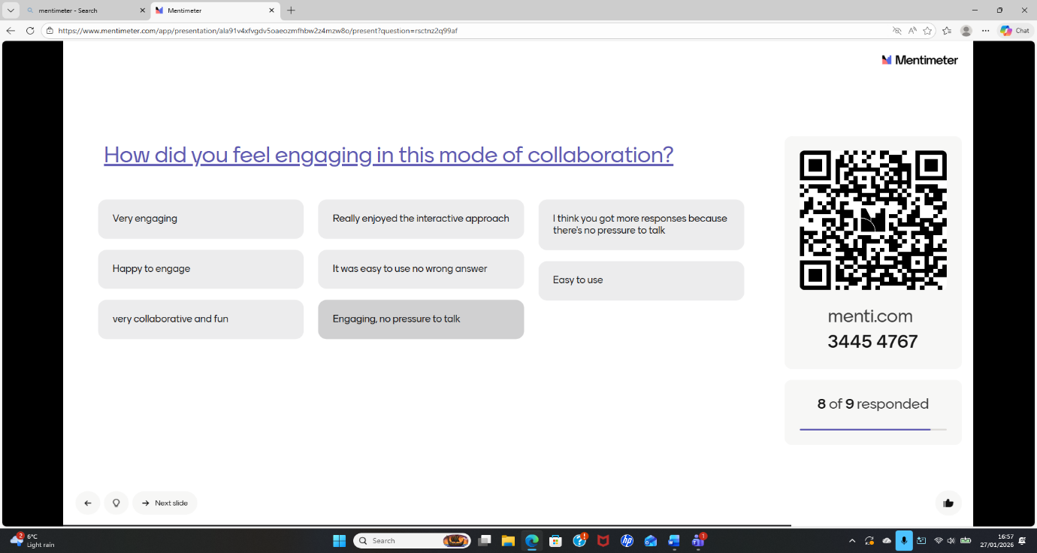

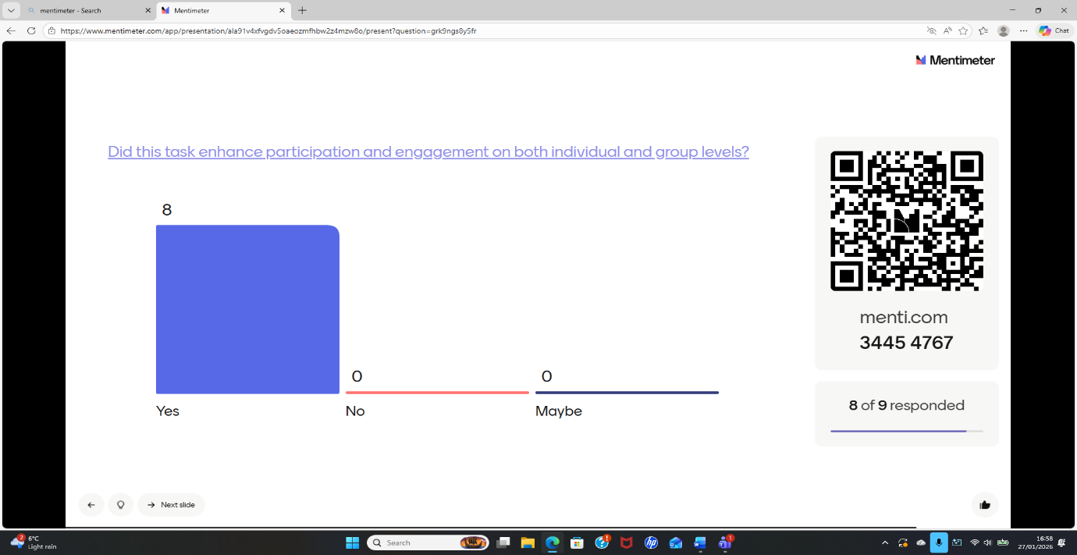

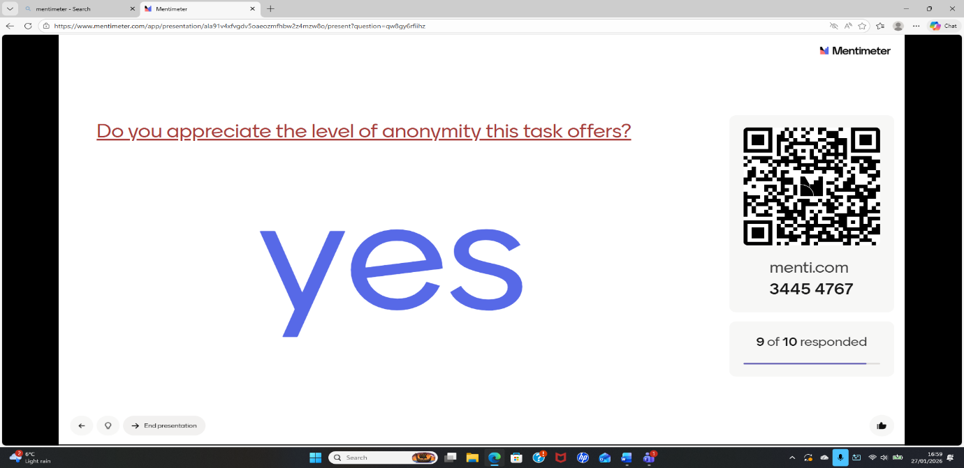



Lesson Plan

Topic: Mental Health and Wellbeing |  | Class: Level 5 - tertiary students studying Inclusive Education within the Centre of Childhood and Youth Studies. Lesson delivered through a flexible evening pathway attended once weekly.
Date: 06/02/26 | Length of lesson: 1 hr 15 mins |  | Number of students: 11
Resources required:
- Mentimeter presentation (10 slides)
- Projector / screen
- Internet access
- Student mobile devices or laptops
- Safeguarding guidance materials (if required)

Aim of Lesson
- To develop learners’ understanding of mental health and wellbeing within inclusive education contexts, while promoting reflection, discussion and application through structured digital interaction using Mentimeter.

Learning Outcomes – The Learners Should Be Able To:
- Define key concepts related to mental health and wellbeing
- Identify factors that influence mental health in educational settings
- Analyse the role of inclusive practice in supporting wellbeing
- Reflect on their own perspectives and experiences
- Apply understanding to professional contexts

Previous student knowledge required for the session:
- Basic understanding of inclusive education principles
- Awareness of diversity within educational settings
- Introductory knowledge of wellbeing concepts

Anticipated difficulties (if applicable):
- Sensitivity of topic may limit verbal participation
- Variation in confidence levels across cohort
- Potential cognitive fatigue due to evening delivery
- Digital confidence may vary
- Emotional responses to content

Professional Standards (where are these being met within the session)
Inclusive practice (V1: Respect individual learners and diverse learning communities):
The use of anonymous responses within Mentimeter supports equitable participation by reducing anxiety and enabling all learners to contribute, regardless of confidence level or prior experience
Assessment and feedback (A3: Assess and give feedback to learners):
Real-time formative assessment will be embedded through structured questioning, enabling ongoing identification of misconceptions and responsive adaptation of teaching, consistent with principles of effective formative assessment
Digital competence (K4: Use and value of appropriate learning technologies):
The purposeful integration of Mentimeter reflects an understanding of how digital tools can enhance learning when aligned with pedagogical intent, rather than used for engagement alone
Learner-centred practice (A2: Teach and support learning):
Teaching will be adapted in real time based on learner responses, supporting a dialogic and responsive approach to instruction.
Professional values and ethics (V1, V4: Respect for learners and acknowledgement of wider context):
The inclusion of trigger warnings, structured facilitation and clear behavioural expectations reflects safeguarding responsibilities and ethical engagement with sensitive content
Understand the importance of the Welsh culture and language as a bilingual nation
The session is designed to reflect the importance of Welsh culture and language within a bilingual educational context. Lesson objectives were presented in English and available in Welsh to support bilingual learners and promote inclusivity. In addition, the session aligned with the Welsh Government’s long-term vision of ‘A Wales of Vibrant Culture and Thriving Welsh Language’, by incorporating opportunities for creative expression and discussion. This ensured that digital practice not only supported learning outcomes but also reinforced cultural identity and national priorities within post-16 education.
Value and promote diversity, equality of opportunity and inclusion
The session is designed to promote inclusive participation by ensuring that all learners are encouraged and empowered to share their perspectives. The use of Mentimeter supports this by enabling all learners to contribute simultaneously, reducing barriers associated with confidence and communication. A range of assessment strategies, including polling, ranking and open-ended responses, will be implemented alongside visual and verbal explanations to support diverse learning preferences. Slide design incorporated carefully selected colour contrasts and visual elements to support learners with Additional Learning Needs (ALN), including those who may experience visual processing difficulties, ensuring accessibility and equitable engagement.
Demonstrate dignity, courtesy and respect towards others
A respectful and supportive learning environment is actively fostered through positive interactions and inclusive dialogue. Learners are addressed courteously, and their contributions are acknowledged and valued throughout the session. The use of Mentimeter further supports this by allowing learners to express their ideas without fear of judgement, promoting a culture of respect and openness. Active listening and facilitation ensured that diverse viewpoints were explored constructively, reinforcing an inclusive and collaborative learning environment.
Demonstrate commitment to learners, their learning, safety and well-being
The session demonstrates a commitment to learner wellbeing by providing clear instructions, structured activities and ongoing opportunities for clarification. Given the sensitive nature of the topic, appropriate safeguarding measures are implemented, including the use of trigger warnings and the option for anonymous participation. Collaboration is encouraged through discussion and shared responses, supporting both engagement and the development of social skills. This approach ensured that learners feel supported, confident and able to engage meaningfully with the content.
Enable learners to share responsibility for their own learning and assessment
Learners are encouraged to take an active role in their learning through opportunities to contribute ideas, reflect on responses and engage in collaborative discussion. The use of Mentimeter supports this by allowing learners to generate and share their own responses in real time, fostering a sense of ownership over the learning process. Opportunities for creative input and independent thinking are embedded within the session, enabling learners to engage more deeply with the content and take responsibility for their own development.

Lesson Detail:
Stage | Focus | Strategy | Time
Introduction  Development  Plenary/conclusion | Establish context and psychological safety  Activate prior knowledge and introduce concepts  Develop understanding and critical thinking  Apply knowledge to inclusive practice  Reflective engagement.  Consolidate learning and assess understanding | Welcome and outline session aims  - Trigger warning for sensitive content  - Mentimeter word cloud: “What does wellbeing mean to you?” (anonymous)  - Establish discussion expectations  Mentimeter multiple-choice quiz to assess prior understanding (retrieval practice)  - Tutor explanation based on responses  - Address misconceptions in real time.  Ranking activity: factors affecting mental health in education  - Group discussion informed by results  - Tutor scaffolding and questioning (dialogic teaching)  Open-ended Mentimeter question: “How can educators support wellbeing?”  - Learners analyse responses collectively  - Link to inclusive education principles.  Individual reflection prompt (anonymous submission)  - Guided discussion linking theory to practice,  Final Mentimeter poll to check understanding  - Summary of key points  - Opportunity for questions and clarification | 15 mins  10 mins  10 mins  10 mins  15 mins  15 mins

Assessment Strategies: when and how are they included within the lesson?
Diagnostic assessment: Initial Mentimeter quiz to assess prior knowledge
Formative assessment: Ongoing use of polling and open-ended responses to identify misconceptions and adapt teaching (Black and Wiliam, 1998)
Peer discussion: Learners engage with shared responses to deepen understanding
Reflective assessment: Open-ended responses to encourage self-evaluation and application
Plenary assessment: Final poll to evaluate learning outcomes
Gibbs, G. (1988) – Refective Cycle

The plenary was designed to consolidate learning, assess understanding and promote reflection. A final Mentimeter slide asked learners to identify one key idea about mental health and wellbeing they would take forward into practice. This enabled reflection and supported knowledge consolidation. Responses were displayed in real time to identify common themes and support discussion. A follow-up multiple-choice question revisited a key concept to assess understanding and address misconceptions. Anonymous responses supported inclusive participation, while a confidence rating scale encouraged self-reflection and identified areas for further support. The plenary concluded with a brief summary linking responses to the session objectives and encouraging application to future contexts.

Gibbs, G. (1988) – Refective Cycle
Informal reflection (to be completed after the session)
Description
The session was delivered online via Microsoft Teams using a structured ten-slide Mentimeter presentation to support learning on Mental Health and Wellbeing within a Level 5 Inclusive Education module. Prior to the session, learners were informed via Teams that they would require access to two devices: one to view the session and another to participate in Mentimeter using either a QR code or numerical code, supporting digital readiness (Jisc, 2024). During the session, several contextual challenges emerged. Some learners experienced technical issues with internet connectivity, resulting in delayed participation, while others joined the session late. All learners had cameras switched off, which is common in online evening provision, making it difficult to visually gauge engagement. Participation through Mentimeter was varied, with some learners actively contributing responses and engaging in discussion, while others remained quiet or did not submit responses. Additionally, some learners verbally contributed answers and engaged in discussion, demonstrating differing participation preferences. These factors highlight the complexity of managing engagement within digitally mediated post-16 environments (Bond et al., 2020).

Feelings
I felt that the session was generally successful in creating an inclusive and supportive environment, particularly given the sensitive nature of the topic. However, the lack of visual cues due to cameras being off made it challenging to interpret levels of engagement and understanding, which aligns with research indicating that digital environments can obscure learner participation (Williamson, 2017). I also recognised some uncertainty regarding whether all learners were fully engaged, particularly those who did not contribute to Mentimeter. At the same time, I felt reassured that the anonymous response function supported participation for those who may otherwise have been reluctant to contribute, which is consistent with findings that anonymity can reduce anxiety and increase engagement (Tarazi et al., 2023).

Evaluation
Learner engagement was high during anonymous Mentimeter activities, particularly in open-ended responses and word clouds, supporting research that anonymity can increase participation and redistribute classroom voice (Kay and LeSage, 2009; Tarazi et al., 2023). Mentimeter enabled real-time insight into learner understanding, allowing me to adapt explanations and address misconceptions during the session, which aligns with formative assessment principles (Black and Wiliam, 1998). However, not all learners contributed to Mentimeter activities, and some relied on verbal contributions instead, suggesting variation in digital engagement preferences. Technical issues and late arrivals also disrupted continuity, highlighting the importance of flexibility in digital teaching (Bond et al., 2020). While the session supported inclusive participation overall, engagement was uneven, reflecting the challenges of online learning environments.

Analysis
The variation in participation can be understood through socio-cultural and cognitive perspectives. Learning is socially mediated and influenced by interaction, yet digital environments can both enable and constrain participation (Vygotsky, 1978; Bond et al., 2020). The anonymity of Mentimeter supported participation for some learners, but the absence of visual cues limited my ability to interpret engagement fully, reinforcing concerns regarding data visibility in digital learning (Williamson, 2017). Some learners required additional support in interpreting ranking tasks, suggesting that clearer scaffolding would enhance understanding, which aligns with Bruner’s (1960) emphasis on structured support for learning. Furthermore, technical barriers such as connectivity issues highlight the ongoing digital divide within post-16 education (Jisc, 2024). The emotional sensitivity of the topic required careful facilitation, and the use of trigger warnings and structured discussion supported psychological safety, which is essential for engagement (Maslow, 1943).

Conclusion
Overall, the session demonstrated that Mentimeter can effectively support inclusive, dialogic and responsive learning when integrated within structured teaching. It enabled real-time formative assessment and broadened participation, aligning with key pedagogical principles (Laurillard, 2012; Black and Wiliam, 1998). However, the experience also highlighted limitations, including uneven participation, technical barriers and the challenges of interpreting engagement in online contexts. These findings reinforce that digital tools are most effective when supported by clear facilitation, scaffolding and flexible teaching approaches (Bond et al., 2020).

Action Plan
In future sessions, I would provide clearer scaffolding for more complex question types, particularly ranking tasks, to support understanding (Bruner, 1960). I would also build in additional time for discussion to deepen engagement with learner responses, supporting dialogic learning (Laurillard, 2012). To address technical barriers, I would provide alternative participation options where possible, ensuring accessibility for all learners (Jisc, 2024). Encouraging a combination of verbal and digital participation may also support varied learner preferences and increase overall engagement. Overall, I would continue to use Mentimeter as a tool for formative assessment and inclusive participation, while refining its implementation to enhance consistency of engagement and depth of learning (Mishra and Koehler, 2006).

Evaluation and Reflection
The implementation of Mentimeter within this session provided an opportunity to critically evaluate the role of digital tools in supporting teaching and learning within post-16 education. While the intended outcomes were to enhance participation, support formative assessment and promote inclusive engagement, the effectiveness of the tool was shaped by both pedagogical design and contextual factors. Research emphasises that digital tools do not inherently improve learning outcomes but instead depend on how they are implemented within teaching practice (Selwyn, 2016; Bond et al., 2020). This evaluation therefore considers both the strengths and limitations of Mentimeter in relation to learner engagement, assessment and inclusion, supported by feedback from learners and professional observation.
A key strength of Mentimeter was its capacity to support participation across the cohort. Anonymous response functions enabled learners to contribute without fear of judgement, which is particularly important within sensitive topics such as mental health and wellbeing. This was strongly reflected in learner feedback, where students described the tool as “easy to use”, “accessible” and “very engaging”, and reported that they were “happy to engage” due to the absence of pressure to speak. Several learners highlighted that they “loved that there was no wrong answer” and valued the anonymity, which increased their willingness to contribute. This aligns with research indicating that anonymity can increase equitable participation and reduce anxiety (Kay and LeSage, 2009; Tarazi et al., 2023). The feedback suggests that Mentimeter successfully supported inclusive participation and created a safe environment for engagement, consistent with socio-cultural perspectives on collaborative learning (Vygotsky, 1978).
Mentimeter also supported formative assessment by enabling real-time insight into learner understanding. The use of multiple-choice and open-ended questions allowed me to identify misconceptions and adapt teaching accordingly, which reflects Black and Wiliam’s (1998) model of formative assessment as responsive instruction. Learners reported that the tool was “easy to engage with” and enhanced their participation, suggesting that the immediate feedback and interactive structure supported their learning experience. Additionally, my mentor observed the session and described it as “dynamic, innovative, collaborative and highly engaging”, noting that it was “well planned, organised and delivered”. This external feedback reinforces the effectiveness of the tool in supporting structured and responsive teaching, aligning with Laurillard’s (2012) emphasis on feedback-driven learning.
However, while participation was enhanced, engagement remained variable across the cohort. Not all learners contributed to Mentimeter activities, and some preferred to respond verbally or remain passive. This reflects research suggesting that behavioural participation does not necessarily equate to cognitive engagement (Chi and Wylie, 2014). Although learners reported increased engagement overall, the presence of quieter participants highlights the need to interpret digital participation data cautiously. This aligns with Williamson’s (2017) argument that visible engagement metrics may not fully capture learning, reinforcing the importance of professional judgement in evaluating digital learning tools.
Technical and contextual factors also influenced the effectiveness of the session. Some learners experienced internet connectivity issues and joined the session late, which disrupted continuity and participation. These challenges reflect broader issues of digital inequality within post-16 education (Jisc, 2024). Despite prior communication regarding device requirements, these barriers impacted the consistency of engagement. This supports Selwyn’s (2016) argument that digital tools are shaped by contextual conditions rather than functioning independently of them.
The online delivery environment further influenced engagement. With all cameras switched off, it was difficult to interpret non-verbal cues such as attention and understanding. While Mentimeter provided real-time response data, it did not fully capture levels of engagement, highlighting a limitation of digital tools in representing learner participation (Williamson, 2017). However, learners reported that they valued the ability to contribute anonymously and felt that this increased participation, suggesting that digital tools may support alternative forms of engagement even when traditional cues are absent (Tarazi et al., 2023).
The design of the Mentimeter activities also influenced learning outcomes. While multiple-choice questions effectively supported retrieval practice, some learners required additional support when engaging with ranking tasks. This suggests that certain activities may increase cognitive demand if not sufficiently scaffolded, which aligns with cognitive load theory (Kirschner, Sweller and Clark, 2006). This highlights the importance of aligning task complexity with learner readiness to ensure effective engagement and understanding.
Despite these challenges, the overall evaluation of Mentimeter was highly positive. Learners described the session as “fun”, “collaborative” and “engaging”, and reported that the tool enhanced participation. This suggests that Mentimeter supported both motivation and interaction, aligning with research on active learning and engagement (Freeman et al., 2014). The mentor’s feedback further reinforced this, highlighting the effectiveness of the session design and delivery. These findings indicate that Mentimeter can enhance teaching and learning when implemented within structured and inclusive pedagogical approaches.
This evaluation has informed the development of my future practice. I would continue to use Mentimeter as a tool to support inclusive participation and formative assessment, while also incorporating additional strategies to support learners who may not engage digitally (Bond et al., 2020). I would provide clearer scaffolding for more complex tasks, particularly ranking activities, to support understanding (Bruner, 1960). I would also build in additional time for discussion to deepen engagement and support dialogic learning (Laurillard, 2012). To address technical challenges, I would consider alternative participation methods to ensure accessibility for all learners (Jisc, 2024).
Overall, the use of Mentimeter demonstrated both the potential and limitations of digital innovation within post-16 education. While it enhanced participation, supported formative assessment and created an inclusive learning environment, its effectiveness was influenced by factors such as learner preference, digital access and pedagogical design. This reinforces the view that digital tools are not inherently transformative, but must be critically integrated within teaching practice to support meaningful learning (Selwyn, 2016). Through this evaluation, it is evident that effective digital innovation requires ongoing reflection, adaptation and alignment with both theory and professional standards.

Reference List
Additional Learning Needs and Education Tribunal (Wales) Act 2018. Cardiff: National Assembly for Wales.
Advance HE (2023) Professional Standards Framework for Teaching and Supporting Learning in Higher Education. York: Advance HE. Available at: https://www.advance-he.ac.uk (Accessed: 12 February 2026).
Anderson, L.W. and Krathwohl, D.R. (eds.) (2001) A taxonomy for learning, teaching, and assessing: a revision of Bloom’s taxonomy of educational objectives. New York: Longman.
Armstrong, M., Davies, L. and Thomas, R. (2024) ‘Using Mentimeter to enhance engagement in health education revision sessions’, Journal of Further and Higher Education, 48(2), pp. 215–229.
Ayandibu, A. (2025) ‘Comparative analysis of interactive response systems in higher education: pedagogical affordances and participation patterns’, Computers & Education, 198, 104821.
Bandura, A. (1977) Social learning theory. Englewood Cliffs, NJ: Prentice Hall.
Beetham, H. and Sharpe, R. (2019) Rethinking pedagogy for a digital age: principles and practices of design. 3rd edn. London: Routledge.
Black, P. and Wiliam, D. (1998) ‘Assessment and classroom learning’, Assessment in Education: Principles, Policy & Practice, 5(1), pp. 7–74. https://doi.org/10.1080/0969595980050102
Bloom, B.S. (ed.) (1956) Taxonomy of educational objectives: the classification of educational goals. New York: Longmans.
Bond, M., Bedenlier, S., Marín, V.I. and Händel, M. (2020) ‘Emergency remote teaching in higher education: mapping the first global online semester’, International Journal of Educational Technology in Higher Education, 17(1), article 44. https://doi.org/10.1186/s41239-020-00232-0
Bronfenbrenner, U. (1979) The ecology of human development: experiments by nature and design. Cambridge, MA: Harvard University Press.
Bruner, J.S. (1960) The process of education. Cambridge, MA: Harvard University Press.
Caldwell, J.E. (2007) ‘Clickers in the large classroom: current research and best-practice tips’, CBE—Life Sciences Education, 6(1), pp. 9–20.
Carless, D. and Winstone, N. (2023) Designing effective feedback processes in higher education: a learning-focused approach. London: Routledge.
Castillo-Manzano, J.I., Castro-Nuño, M. and López-Valpuesta, L. (2024) ‘Evaluating the design of digital tools for the transition to an e-continuous assessment in higher education’, Journal of Computing in Higher Education, 36(1), pp. 45–67.
Çekiç, A. and Bakla, A. (2021) ‘A review of digital formative assessment tools: features and future directions’, International Online Journal of Education and Teaching, 8(3), pp. 1565–1585.
Chi, M.T.H. and Wylie, R. (2014) ‘The ICAP framework: linking cognitive engagement to active learning outcomes’, Educational Psychologist, 49(4), pp. 219–243. https://doi.org/10.1080/00461520.2014.965823
Cojocariu, V.-M. and Boghian, I. (2024) ‘A literature review on digital creativity in higher education—toward a conceptual model’, Education Sciences, 14(11), article 1189. https://doi.org/10.3390/educsci14111189
Counter-Terrorism and Security Act 2015. London: HMSO.
Craft, A. (2005) Creativity in schools: tensions and dilemmas. London: Routledge.
Dancsa, D., Štempeľová, I. and Takáč, O. (2023) ‘Digital tools in education’, International Journal of Emerging Technologies in Learning, 18(5), pp. 45–60. https://doi.org/10.3991/ijet.v18i05.38545
Darling-Hammond, L., Hyler, M.E. and Gardner, M. (2017) Effective teacher professional development. Palo Alto: Learning Policy Institute.
Data Protection Act 2018. London: HMSO.
Deci, E.L. and Ryan, R.M. (2000) ‘The “what” and “why” of goal pursuits: human needs and the self-determination of behavior’, Psychological Inquiry, 11(4), pp. 227–268. https://doi.org/10.1207/S15327965PLI1104_01
Dichev, C. and Dicheva, D. (2017) ‘Gamifying education: what is known, what is believed and what remains uncertain’, International Journal of Educational Technology in Higher Education, 14(9), pp. 1–36.
Draper, S.W. and Brown, M.I. (2004) ‘Increasing interactivity in lectures using an electronic voting system’, Journal of Computer Assisted Learning, 20(2), pp. 81–94.
Education Workforce Council (2019) Professional standards for further education teachers, work-based learning practitioners and adult learning practitioners in Wales. Cardiff: Education Workforce Council. Available at: https://www.ewc.wales (Accessed: 22 February 2026).
Educators Wales (2023) Professional standards for further education teachers in Wales. Cardiff: Educators Wales.
Enomoto, K., McIntyre, S. and Williams, B. (eds.) (2018) Innovative teaching and learning practices in higher education. Faringdon: Libri Publishing.
Equality Act 2010. London: HMSO.
Freeman, S., Eddy, S.L., McDonough, M., Smith, M.K., Okoroafor, N., Jordt, H. and Wenderoth, M.P. (2014) ‘Active learning increases student performance in science, engineering, and mathematics’, Proceedings of the National Academy of Sciences, 111(23), pp. 8410–8415.
Fuentes, A. and LaBad, C. (2025) ‘Digital engagement in higher education: a systematic synthesis of pedagogical integration studies’, British Journal of Educational Technology, 56(1), pp. 88–105.
Genlott, A.A. and Grönlund, Å. (2016) ‘Closing the gaps: improving literacy and mathematics by ICT-enhanced collaboration’, Computers & Education, 99, pp. 68–80.
Gibbs, G. (1988) Learning by doing: a guide to teaching and learning methods. Oxford: Oxford Further Education Unit.
Gokbulut, B. (2020) ‘The effect of Mentimeter and Kahoot applications on university students’ e-learning’, World Journal on Educational Technology: Current Issues. Available at: https://ceeol.com (Accessed: 24 April 2026).
Hamilton, E.R., Rosenberg, J.M. and Akcaoglu, M. (2016) ‘The substitution augmentation modification redefinition (SAMR) model: a critical review and suggestions for its use’, TechTrends, 60(5), pp. 433–441. https://doi.org/10.1007/s11528-016-0091-y
Hanus, M.D. and Fox, J. (2015) ‘Assessing the effects of gamification in the classroom: a longitudinal study on intrinsic motivation, social comparison, satisfaction, effort, and academic performance’, Computers & Education, 80, pp. 152–161. https://doi.org/10.1016/j.compedu.2014.08.019
Hattie, J. and Timperley, H. (2007) ‘The power of feedback’, Review of Educational Research, 77(1), pp. 81–112.
Hew, K.F. and Lo, C.K. (2018) ‘Flipped classroom improves student learning in health professions education: a meta-analysis’, BMC Medical Education, 18, pp. 1–12.
Hill, L. (2020) ‘Mentimeter: a tool for actively engaging large lecture cohorts’, Academy of Management Learning & Education, 19(2), pp. 256–258. https://doi.org/10.5465/amle.2019.0129
HM Government (2015) Prevent duty guidance: for England and Wales. London: HM Government.
Hwb (n.d.) Trauma-informed practice and schools. Available at: https://hwb.gov.wales (Accessed: 15 February 2026).
Jisc (2020) Digital 2030: a strategic framework for post-16 digital learning in Wales. Bristol: Jisc. Available at: https://www.jisc.ac.uk (Accessed: 22 February 2026).
Jisc (2024) Digital experience insights survey: further education findings. Bristol: Jisc. Available at: https://www.jisc.ac.uk (Accessed: 22 February 2026).
Jisc (2025) Digital experience insights survey 2025: further education findings. Bristol: Jisc.
Johnston, B. (2019) Conceptualising the digital university: the intersection of policy, pedagogy and practice. London: Palgrave Macmillan.
Kay, R.H. and LeSage, A. (2009) ‘Examining the benefits and challenges of using audience response systems: a review of the literature’, Computers & Education, 53(3), pp. 819–827.
Khan, M.A. (2025) ‘Mentimeter tool for enhancing student engagement and active learning: a literature review’, International Journal of Changes in Education.
Khan, S. (2025) ‘Mentimeter in higher education: engagement, inclusion and academic performance outcomes’, Computers & Education Open, 6, article 100142.
Kimmons, R. and Hall, C. (2018) ‘How useful are digital tools for learning? Examining the pedagogy of educational technology’, Educational Technology Research and Development, 66(5), pp. 1231–1249.
Kirkwood, A. and Price, L. (2014) ‘Technology-enhanced learning and teaching in higher education: what is “enhanced” and how do we know? A critical literature review’, Learning, Media and Technology, 39(1), pp. 6–36. https://doi.org/10.1080/17439884.2013.770404
Kirschner, P.A. (2017) ‘Stop propagating the learning styles myth’, Computers & Education, 106, pp. 166–171.
Kirschner, P.A. and De Bruyckere, P. (2017) ‘The myths of the digital native and the multitasker’, Teaching and Teacher Education, 67, pp. 135–142.
Kirschner, P.A., Sweller, J. and Clark, R.E. (2006) ‘Why minimal guidance during instruction does not work: an analysis of the failure of constructivist, discovery, problem-based, experiential, and inquiry-based teaching’, Educational Psychologist, 41(2), pp. 75–86. https://doi.org/10.1207/s15326985ep4102_1
Koehler, M.J. and Mishra, P. (2009) ‘What is technological pedagogical content knowledge (TPACK)?’, Contemporary Issues in Technology and Teacher Education, 9(1), pp. 60–70.
Lauricella, S., Banks, L. and Kay, R. (2025) ‘Boosting engagement and learning: how gamified quizzes via Mentimeter impact undergraduate students’ experiences’, INTED2025 Proceedings, pp. 1652–1655. https://doi.org/10.21125/inted.2025.0499
Laurillard, D. (2012) Teaching as a design science: building pedagogical patterns for learning and technology. London: Routledge.
Limbu, B. and McKinley, J. (2024) ‘Online engagement in higher education post-COVID: a systematic review’, Higher Education Research & Development, 43(4), pp. 765–782.
Loughran, J. (2014) Developing a pedagogy of teacher education: understanding teaching and learning about teaching. London: Routledge.
MacIntyre, P.D., Gregersen, T. and Mercer, S. (2020) ‘Language teachers’ coping strategies during the COVID-19 conversion to online teaching: correlations with stress, wellbeing and negative emotions’, System, 94, article 102352. https://doi.org/10.1016/j.system.2020.102352
Marshall, S. (2020) A handbook for teaching and learning in higher education. 5th edn. London: Routledge.
Martin-Key, N.A., Spadaro, B., Funnell, E.J. and Barker, E.J. (2022) ‘The current state and validity of digital assessment tools for psychiatry: a systematic review’, JMIR Mental Health, 9(4), article e32813. https://doi.org/10.2196/32813
Maslow, A.H. (1943) ‘A theory of human motivation’, Psychological Review, 50(4), pp. 370–396.
Mattar, J., Ramos, D.K. and Lucas, M.R. (2022) ‘DigComp-based digital competence assessment tools: literature review and instrument analysis’, Education and Information Technologies, 27(6), pp. 8035–8058.
Mayer, R.E. (2009) Multimedia learning. 2nd edn. Cambridge: Cambridge University Press.
Mayhew, E., Davies, M., Millmore, A., Thompson, L. and Peña Bizama, A. (2020) ‘The impact of audience response platform Mentimeter on the student and staff learning experience’, Research in Learning Technology, 28, article 2397. https://doi.org/10.25304/rlt.v28.2397
Means, B., Toyama, Y., Murphy, R. and Baki, M. (2014) ‘The effectiveness of online and blended learning: a meta-analysis of the empirical literature’, Teachers College Record, 115(3), pp. 1–47.
Meirbekov, A., Maslova, I. and Gallyamova, Z. (2022) ‘Digital education tools for critical thinking development’, Thinking Skills and Creativity, 44, article 101039. https://doi.org/10.1016/j.tsc.2022.101039
Mercer, N. and Littleton, K. (2007) Dialogue and the development of children’s thinking: a sociocultural approach. London: Routledge.
Mexhuani, B. (2025) ‘Adopting digital tools in higher education: opportunities, challenges and theoretical insights’, European Journal of Education, 60(1), pp. 1–15.
Millmore, A. (2022) Mentimeter: engaging students with an easy-to-use audience response system. Available at: https://openpress.sussex.ac.uk (Accessed: 12 February 2026).
Mishra, P. and Koehler, M.J. (2006) ‘Technological pedagogical content knowledge: a framework for teacher knowledge’, Teachers College Record, 108(6), pp. 1017–1054.
Nicol, D.J. and Macfarlane-Dick, D. (2006) ‘Formative assessment and self-regulated learning: a model and seven principles of good feedback practice’, Studies in Higher Education, 31(2), pp. 199–218. https://doi.org/10.1080/03075070600572090
OECD (2019) OECD skills outlook 2019: thriving in a digital world. Paris: OECD Publishing. https://doi.org/10.1787/df80bc12-en
OECD (2020) Education responses to COVID-19: embracing digital learning and online collaboration. Paris: OECD Publishing.
OECD (2021) OECD skills outlook 2021: learning for life. Paris: OECD Publishing. https://doi.org/10.1787/0ae365b4-en
Panero, M. and Aldon, G. (2016) ‘How teachers evolve their formative assessment practices when digital tools are involved in the classroom’, Digital Experiences in Mathematics Education, 2(1), pp. 70–86.
Parmigiani, D., Benigno, V. and Trentin, G. (2024) ‘Formative assessment and metacognitive development in higher education digital contexts’, Assessment & Evaluation in Higher Education, 49(6), pp. 912–927.
Pashler, H., McDaniel, M., Rohrer, D. and Bjork, R. (2008) ‘Learning styles: concepts and evidence’, Psychological Science in the Public Interest, 9(3), pp. 105–119.
Pechenkina, E., Laurence, D., Oates, G. and Eldridge, D. (2017) ‘Using a student response system to enhance learning experience in large classrooms’, International Journal of Educational Technology in Higher Education, 14(1), pp. 1–14.
Piaget, J. (1952) The origins of intelligence in children. New York: International Universities Press.
Pichardo Galán, J.I., López-Medina, E.F. and Mancha-Cáceres, O. (2021) ‘Students and teachers using Mentimeter: technological innovation to face the challenges of the COVID-19 pandemic and post-pandemic in higher education’, Education Sciences, 11(11), article 667. Available at: https://www.mdpi.com/2227-7102/11/11/667 (Accessed: 18 February 2026).
Pikhart, M. (2024) ‘Digital tools and creative learning: supporting language learners through technology-enhanced pedagogy’, Computer Assisted Language Learning, 37(2), pp. 145–166.
Pillay, P. (2024) ‘The evolution of online formative assessment: a systematic review’, Social Sciences and Education Research Review, 11(2), pp. 283–293.
Pillay, R. (2024) ‘Digital formative assessment in post-pandemic higher education: opportunities and tensions’, Teaching in Higher Education, 29(5), pp. 642–658.
Puentedura, R.R. (2014) SAMR and TPCK: a hands-on approach to classroom practice. Available at: http://www.hippasus.com (Accessed: 22 February 2026).
Quinn, C.N. (2014) Revolutionize learning and development: performance and innovation strategy for the information age. San Francisco: Pfeiffer.
Race, P. and Pickford, R. (2007) Making teaching work: teaching smarter in post-compulsory education. London: SAGE Publications.
Reinhold, F., Leuders, T., Loibl, K. and Nückles, M. (2024) ‘Learning mechanisms explaining learning with digital tools in educational settings: a cognitive process framework’, Educational Psychology Review, 36(1), pp. 1–29.
Roediger, H.L. and Karpicke, J.D. (2006) ‘Test-enhanced learning: taking memory tests improves long-term retention’, Psychological Science, 17(3), pp. 249–255. https://doi.org/10.1111/j.1467-9280.2006.01693.x
Rosen, L.D., Lim, A.F., Carrier, L.M. and Cheever, N.A. (2014) ‘An empirical examination of the educational impact of text message-induced task switching in the classroom’, Educational Psychology, 34(4), pp. 1–19.
Rotar, O. (2025) ‘Student engagement in digitally mediated higher education: conceptual clarity and measurement challenges’, Studies in Higher Education, 50(1), pp. 55–72.
Ryan, R.M. and Deci, E.L. (2000) ‘Intrinsic and extrinsic motivations: classic definitions and new directions’, Contemporary Educational Psychology, 25(1), pp. 54–67.
Sato, T. (2023) ‘Post-pandemic transformation of online and distance learning: a review of challenges and opportunities’, Education Sciences, 14(1), pp. 1–19.
Schön, D.A. (1983) The reflective practitioner: how professionals think in action. New York: Basic Books.
Schwab, K. (2016) The fourth industrial revolution. Geneva: World Economic Forum.
Selwyn, N. (2016) Education and technology: key issues and debates. 2nd edn. London: Bloomsbury Academic.
Serrada-Sotil, A., Hernández-Martín, A. and Sánchez-Gómez, M.C. (2025) ‘Audience response systems in higher education: a systematic review’, Computers & Education, 198, article 104769.
Siemens, G. (2005) ‘Connectivism: a learning theory for the digital age’, International Journal of Instructional Technology and Distance Learning, 2(1), pp. 3–10.
Sweller, J. (1988) ‘Cognitive load during problem solving: effects on learning’, Cognitive Science, 12(2), pp. 257–285. https://doi.org/10.1207/s15516709cog1202_4
Tai, J., Ajjawi, R., Boud, D., Dawson, P. and Panadero, E. (2018) ‘Developing evaluative judgement: enabling students to make decisions about the quality of work’, Higher Education, 76(3), pp. 467–481.
Tarazi, A. and Ortega-Martín, J.L. (2023) ‘Enhancing EFL students’ engagement in online synchronous classes: the role of the Mentimeter platform’, Frontiers in Psychology, 14, article 1127520. https://doi.org/10.3389/fpsyg.2023.1127520
Tondeur, J., van Braak, J., Siddiq, F. and Scherer, R. (2017) ‘Time for a new approach to prepare future teachers for educational technology use’, Computers & Education, 94, pp. 134–150.
UK Parliament (2015) Counter-Terrorism and Security Act 2015. Available at: https://www.legislation.gov.uk/ukpga/2015/6/contents (Accessed: 22 February 2026).
UK Parliament (2018) Data Protection Act 2018. London: HMSO.
Vallely, K.S.A. and Gibson, P. (2018) ‘Engaging students on their devices with Mentimeter’, Compass: Journal of Learning and Teaching, 11(2). https://doi.org/10.21100/compass.v11i2.843
Van Dijk, J. (2020) The digital divide. Cambridge: Polity Press.
Vygotsky, L.S. (1978) Mind in society: the development of higher psychological processes. Cambridge, MA: Harvard University Press.
Warschauer, M. (2004) Technology and social inclusion: rethinking the digital divide. Cambridge, MA: MIT Press.
Well-being of Future Generations (Wales) Act 2015. Cardiff: National Assembly for Wales.
Welsh Government (2019) Digital 2030: a strategic framework for post-16 digital learning in Wales. Cardiff: Welsh Government.
Welsh Government (2022) Keeping learners safe: statutory guidance for education settings. Cardiff: Welsh Government.
Williamson, B. (2017) Big data in education: the digital future of learning, policy and practice. London: SAGE.
World Economic Forum (2020) The future of jobs report 2020. Geneva: World Economic Forum.
Yang, M., Wang, T. and Lim, C.P. (2023) ‘E-portfolios as digital assessment tools in higher education’, Education and Information Technologies, 28(4), pp. 3457–3476.

