Project Planning and Management
in the workplace
Researching the needs of BAME or Female led Enterprises; exploring their needs, barriers and support available for them

STUDENT: Brindusa-Elena Nechita
STUDENT ID: 1905284
LECTURER: Shehla Khan
TABLE OF CONTENTS

Introduction ……………………………………………………………………………………. 3
Main findings ………………………………………………………………………………….. 4
Reflection ..……………………………………………………………………………………. 25
Recommendation …………………………………………………………………………. 26
Conclusion ……………………………………………………………………………………. 26
References ……………………………………………………………………………………. 28
Appendix ………………………………………………………………………………………. 30

INTRODUCTION
In these modern times, planning and management are required for each person to obtain specific goals. In essence, planning refers to a process that incorporated with analytical thinking and various operational activities, achieves to obtain most appropriate outcomes. Through specific applications of management, planning can be executed in a right manner. (Azhar, 2017) Both planning and management are playing a remarkable role in the development of the enterprises and provide a long-term sustainability rate.
The main concern of this report is to research the needs of BAME & Female led enterprises and to maintain all the consideration which can be helpful in monitoring & evaluating of the specific project. This report will discuss various tools and techniques which can provide best efforts in project management. For the project management, some appropriate tools considered are: Quad chart, Gantt chart, risk assessment, stakeholders’ analysis and also a survey was conducted to identify the specific findings about the BAME & female entrepreneurs.

FINDINGS
To make the project successful, the contribution of various project management tools helped to manage the project in a right manner. The main purpose of this project is to analyze the BAME & Female led enterprises and also determine if the BAME community can start their business and overall monitoring it in an effective manner. (Stern, 2020) There are many tools and techniques that are utilized for managing this research project and are discussed below:
- Gantt chart - Gantt chat is considered as the bar chart in project management and can be used to determine a project in a particular schedule. In this chart, all the research project activities are formed in a specific manner as per the timetable. With the help of this chart, all the researched activities related with BAME and Female led enterprises are comprised in a specific manner. This project analyzes various activities like the Quad chart, stakeholder’s analysis, meeting with Dylan, WBS, design survey, risk analysis, monitoring & evaluating and schedules them in a systematic way so that all the activities are completed as per the specific time period. All these activities demonstrate the dependency relationship between each other and maintain the schedule status, as this is considered as the main benefit of the Gantt chart tool. Through the Gantt chart, all the activities were performed in a right way on a given time period by all the team members. Without the Gantt chart tool, it is not possible to achieve and to maintain all the activities effectively. (Bell, 2019) The Gantt chat of this project is attached in Appendix 1.
- Survey - To complete the project successfully and get the most desirable outcomes, a questionnaire is used to identify various aspects related to this project. A well framed questionnaire answered by the 7 respondents and all the responses provide the most appropriate results which can be helpful to manage the project appropriately. There are 12 questions asked by the researcher related to the BAME & Female led enterprises. With the help of this tool, the researcher effectively determined the points of view of the people (Chreim and et. al., 2018). Without this tool, it is difficult to analyze the opinion and thinking of the BAME & female business & entrepreneurs in relation to their experience on how they started their own businesses. Questionnaire of this project given in appendix 2.
- Risk Assessment - This project management technique is helpful to determine the uncertainty of risk so that the project can be completed in an efficient way. In this research project, the researcher conducted the risk assessment process that eliminated the hazard and also controlled the risk. (Rumeser and Emsley, 2018) There are certain risks identified in this project, like the lack of engagement with the team members, the risk of entrepreneurs not completing the questionnaire, the completion of the task on time, internal, external, time & quality risks also considered by the researcher. Without the risk assessment, it is critical to analyze the risk factors and manage the risk in a right way. The risk assessment chart is attached in appendix 3.
- Stakeholder Analysis - This analysis contains the systematic process which determines the potential changes. This technique is helpful because it addresses to the interest of the stakeholders in the context of the project plan and policy with an appropriate action. It is identified that there are various stakeholders involved such as the BAME / Female entrepreneurs, the project team, the UWTSD business support, the Welsh government, and the module lecturer. This analysis is done based on the stakeholders prospective and appropriate action is determined by them. All the stakeholders provide their best contribution in project management and through this analysis, all specific prospective of the stakeholders and action is analyzed and therefore beneficial for the project outcome. (Davis, 2020) Without this technique, it is discussed to address the involvement of stakeholders in project. Stakeholder analysis table attached in appendix 4.
In order to maintain project, the project life cycle tool is used which can be helpful to demonstrate the ability to plan and also successfully implement the project. There are five phases that are involved in the project life cycle which systematically address the requirements of the project and also manage all the activities in an appropriate manner. (Robbins, 2019) The critical analysis related to all five phases as per this research project are given below -
Project Life Cycle
- Initiating Process - This is the first phase of this cycle which demonstrates the need of the project. Through the Quad chat, all the activities are divided into four categories like purpose of the project, stakeholders, desired end results and the measure of success. In purpose, the specific aims and objectives formulated helped determine the needs of BAME entrepreneurs and how to provide them support. (dos Muchangos, Tokai and Hanashima, 2017) At this initial stage of this project, all the requirements of the project addressed helped to maintain the smooth running of this project.
- Planning process - This phase is playing a prominent part in the development of the project. For specific planning process, the Stakeholders analysis tool is used to demonstrate the appropriate planning of all the stakeholders so that the project objectives are completed in an effective manner. The stakeholders prospective and their actions are discussed and involved in the planning process which are beneficial for the successful completion of this project. This planning process is beneficial to analyze the engagement of the stakeholders in the project so that all the working tasks are managed properly. Lack of planning leads to adverse outcomes which can create barriers in execution of the project.
- Executing Process - This phase demonstrates the proper execution of the project so that all the activities are performed correctly. The Gantt chart tool is being used for the executing process. Through the Gantt chart, all the diverse activities of the schedule are executed in a systematic way and it is this tool that helped to finish all the framed activities in a right time period. The Gantt Chart contained various benefits like finishing all the activities on time, maintaining the relevancy of the information and created specific dependency among all the activities. (Redlein, 2020)
Without this tool, the execution of the project would be critical because the proper coordination with all activities would not be maintained systematically and then it would be difficult to finish the project activities on time.
- Monitoring & Controlling Process - This process is essential to control the project working. The iron triangle tool is used to maintain the monitoring and controlling process of this project. This tool contains three factors: scope, schedule & resources. All these three factors helped to monitor all the activities of the project. The risk assessment tool was also utilized by the researcher to identify the uncertainty of the risk. Risk assessment also helped to eliminate the internal & external risk factors. Without these tools, the researcher cannot properly monitor and control all the project activities. (Fleming, 2020) (Galli, 2018)
As per this project, BAME / Female led enterprises are determined and it is analyzed that UK's largest enterprises are still failing to enhance their ethics diversity on the higher level. As per the BAME enterprises, their members are trying to maintain business in an ethical form. The number of BAME board members in both forms, executive or non-executive, declined from 9% in 2018 to 7.4% in the year 2019. To conduct the research on BAME and Female led enterprises, researcher used various tools and techniques which helped to manage all the research activities in a right way. (Jutlla and Raghavan, 2017) There are some specific tools and techniques that are utilized like survey techniques, Quad chat, Gantt chat & many more. For survey technique, questionnaires were distributed, and the researcher found responses from all seven respondents. All these seven respondents are Jaly Begum, Begum, Chic hair design, Sheikh Ahmed, Marian, Spice Cube etc. All these respondents shared their perspective with the researcher and also provided their participation to obtain the most appropriate outcomes for this research. This tool to conduct the research is more appropriate and beneficial to provide most appropriate outcomes of the research. As for the responses of all seven respondents, it is analyzed that BAME & Female led enterprises are running by most of the people and some people show their interest to run enterprises. With the help of a stakeholder analysis, the researcher effectively considered the involvement of all the stakeholders in this research project. The researchers created specific engagement with all the stakeholders so that they can share their perspective and take appropriate action to complete the research project in an appropriate manner. (McRobbie, Strutt and Bandinelli, 2019)
The project plan is executed with the help of proper flow of communication among all the stakeholders. There are various stakeholders involved in this BAME and Female led enterprises research project such as female entrepreneurs, the project team, UWTSD business support, the government, module lecturer. (Muriana and Vizzini, 2017) All these stakeholders communicated properly to maintain the specific implementation of the project plan. All the stakeholders considered their perspective so that they can take appropriate action in the implementation of the project plan. Stakeholders maintained a contact support line so that they can effectively inform them for the specific support system. Stakeholders distributed all the information to the team members via e-mails , online meetings, phone calls. All stakeholders communicated properly & update their team with the help of mail system and phone calls. To maintain the detailed implementation of the project plan, stakeholders implemented all the relevant information which they received from the respondents. Stakeholders like BAME and Female entrepreneurs, the team, the government and many more connected with each other and delivered all adequate details and information to each other which led to the successful implementation of this project plan. (Mijinyawa and Abdullahi, 2017) The researchers took appropriate instructions in order to get the best outcomes and funding and courses opportunities for the BAME Female entrepreneurs provided by the government so that they can effectively start their business. Communication methods adopted by the stakeholders are emails because this is the formal way to communicate and delivered the information about the project which maintain specific records.
To identify appropriate findings of the project, the questionnaire tool was used to monitor and evaluate the research project which provided successful outcomes that determined the future learning in an appropriate way. (Momeni, Yaghoubi and Aliha, 2019) There are 12 questions asked by the researcher to complete this research project which is all about BAME Female led enterprises. The interpretation of all these questions which responded by the seven people are given below:

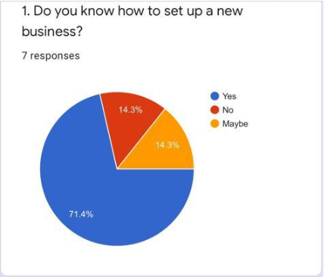
Interpretation
From this chat it can be analyzed that out of 7 respondents over all 71.4% people responded that they properly know how to set up a new business and they also have good knowledge about how to establish a business properly. 14 3% people responded that they don't know about anything, how to set up a new business and also 14.3% people provided confused response about this question because they have a rough idea about how to set up a new business.

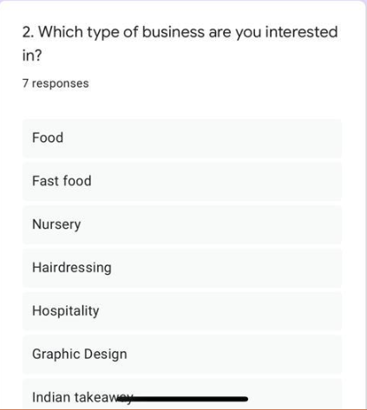
Interpretation
It can be determined that there are many types of businesses which people want to start like food, fast food, nursery, hairdressing, hospitality, graphic design and Indian takeaway. All 7 people responded to this question most appropriately as per their area of interest. Some people responded that they would like to open hospitality business, some respondents responded that the light to open food business, so all the seven people show their diversity area of interest in context of the business.

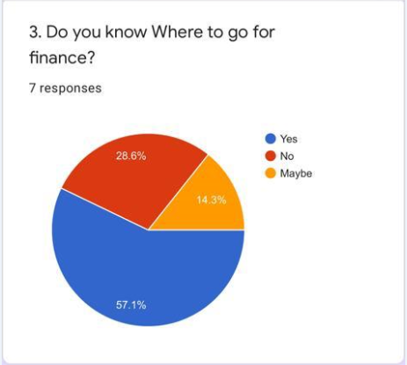
Interpretation
On the basis of this chat it can be analyzed that out of 7 respondents, 57.1% people responded that they have proper knowledge about where to go for finance of the business. 28.6% people agreed that they do not know where to go to arrange finance for the business. 14.3% people responded that they also don't have any idea about finance.

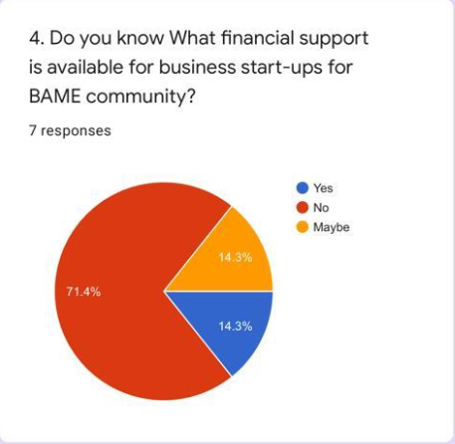
Interpretation
From this chat, it can be investigated that out of 7 respondents overall 14.3% people responded that they have knowledge about financial support which is available for business startup specifically for the BAME community. 71.4% people responded that they do not know about financial support systems which are available for the business startup for the BAME community. 14.3% people also responded that maybe they know about financial support system for the new startup related to the BAME community.
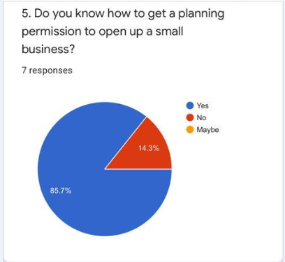
Interpretation
On the basis of this research, it can be analyzed that overall 85.7% respondents responded that they properly know how to get a planning permission to open up a small businesses. Only 14.3% people responded that they have no idea where to get a permission to open a small business at a particular location.

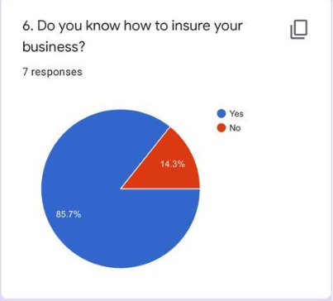
Interpretation
As per this analysis, it can be measured that out of 7 respondents, 85.7% people responded that they have knowledge about how to ensure their business and only 14.3% respondents agreed that they are not aware about how to ensure it at a specific market place.

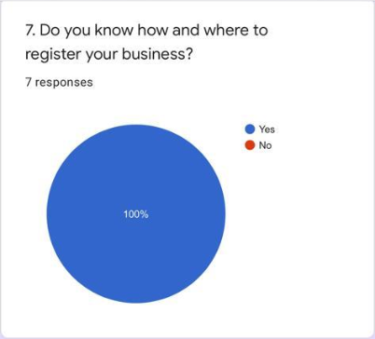
Interpretation

From this survey, it is analyzed that all 7 respondents responded that they contain proper knowledge about how and where they can effectively register business. 100% people are aware about where they can register their business.

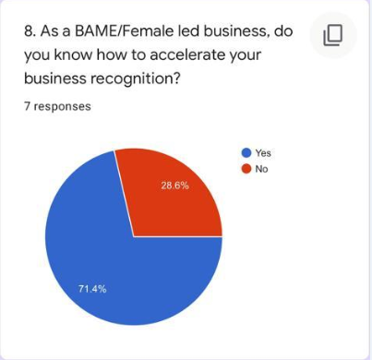
Interpretation
On the basis of this research it is measured that out of 7 respondents, overall 71.4% people responded that as a BAME / Female led business, they know how they can effectively accelerate their business recognition. Only 28.6% people responded that they do not know how to accelerate their business recognition.

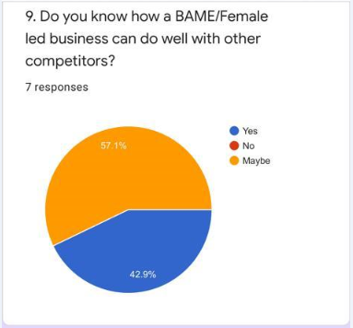
Interpretation
As per this survey it can be analyze that 42.9% people responded that BAME / Female led business can do well with other competitors and 57.1% people responded that maybe BAME / Female led business can do well with their rivals.
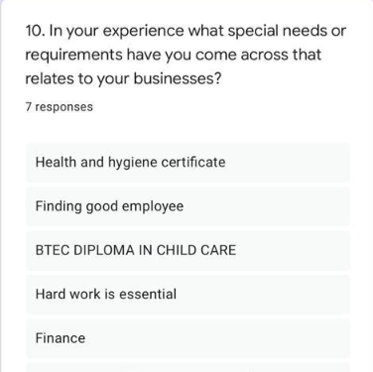
Interpretation
As per this survey it can be analyzed that there are various specific needs and requirements that people consider that are related to their business, like health and hygiene certificate, finding good employees, BTEC diploma in child care, hard work is essential and also finance. All the seven respondents provided their need related to the project and selected various options to fulfill the requirement of the business.

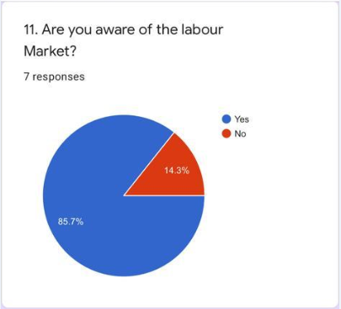
Interpretation
From the above chart, it is found that out of 7 respondents, 85.7% people responded that they are aware about the labor market & 14.3% respondents responded that they do not know aware about the labor market.
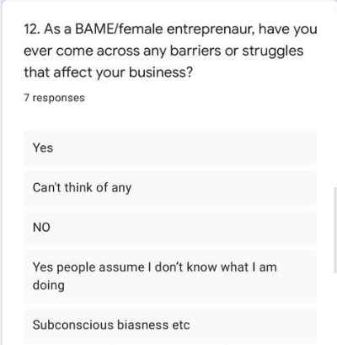
Interpretation
Based on this investigation, it can be analyzed that BAME / Female entrepreneur faced various barriers and challenging situations that directly impacted on their business. Some people responded that they face struggle in their business, but others responded that they don't think of any barriers or struggle.

Reflection

It was a good opportunity to participate in this project. It provided deep knowledge and understanding about research tools, how to achieve aims and objective successfully, how to follow specific tools and techniques, how to engage more with the project team members and collaborate effectively, and nevertheless to improve time management completion of tasks. The main concern of this project is BAME / Female led enterprises was the appropriate survey which was conducted and completed successfully that helped the team determine the most possible outcome. For this research project, various tools and techniques were used that proved very helpful to monitor and evaluate the project management plan in an effective manner. During the project implementation period, the biggest threat was the completion of the project on a specific deadline but with the help of all the team management members and their allocated tasks, the project was completed on time. There were also various risks and uncertainty experienced, like some of the respondents not responding the questionnaire on time, it was difficult to convince people, some lack of engagement with team members. In this project, personal and professional development was learned, analytical and critical problem-solving skills were also observed and improved upon.

Recommendation

For this project it can be recommended that it is necessary to conduct proper communication, provide continuous feedback system about the current performance of the team members, and use proper management techniques. (Subramanian, 2016) All these things can help to maintain proper project management planning and implementation so that the execution of the entire task can be obtained in an appropriate manner.

CONCLUSION
It is concluded from this project that to complete the project effectively it is necessary to conduct effective planning and management process so that all the monitoring and implementation activities can be done properly. This project determines various tools and techniques for the execution of project management plan successfully. There are various tools are utilized in this project like Quad chart, stakeholder analysis, risk assessment, survey method & project life cycle. All these tools and techniques are beneficial for successful completion of the project.
Drawing upon the Iron Triangle, we identified that our costs were mainly human resources, as all team members had equally important parts to play in the project.
Our scope in identifying the support available for BAME or female entrepreneurs and how much the existing ones know about Welsh Government Support in Wales was reached by examining the answers in the questionnaire and by speaking with Dylan Williams Evans at UWTSD Business Support.
Time management was closely related to the completion of each task, therefore related with the human resources and individual tasks that had to be done in a sequential order and were completed on time by each team member.
Evaluating the development of the project, we identified hard and soft outcomes as follows:
- Hard: 7 entrepreneurs completed the questionnaire
- Soft: positive feedback was given
From the project team evaluation point of view, we found that the soft outcomes were: engaging with the lecturer, how to implement different management tools and the feedback received, engagement with team members on delivering the allocated part of the project, communicating, advising and supporting each other.

REFERENCES
Azhar, S. (2017). Role of visualization technologies in safety planning and management at construction jobsites. Procedia engineering, 171, pp.215-226.
Bell, E. (2019) Workplace skills planning and the importance of investing in learning. HR Future, 2019(10). pp.35-35.
Chreim, S. and et. al. (2018) Review of female immigrant entrepreneurship research: Past findings, gaps and ways forward. European Management Journal, 36(2), pp.210-222.
Davis, K. (2020) Case Study 6-Innovation in Modules to Increase Business and Community Engagement.
dos Muchangos, L.S., Tokai, A. and Hanashima, A. (2017) Stakeholder analysis and social network analysis to evaluate the stakeholders of a MSWM system–A pilot study of Maputo City. Environmental Development, 24, pp.124-135.
Fleming, R. S. (2020) Time Management and Workplace Happiness. In The Routledge Companion to Happiness at Work (pp. 326-334). Routledge.
Galli, B.J. (2018) Risks related to lean six sigma deployment and sustainment risks: How project management can help. International Journal of Service Science, Management, Engineering, and Technology (IJSSMET). 9(3). pp.82-105.
Jutlla, K. and Raghavan, R. (2017) Improving the recruitment of Black, Asian and Minority Ethnic (BAME) communities in health and social care research: a review of literature.
McRobbie, A., Strutt, D. and Bandinelli, C. (2019) Feminism and the Politics of Creative Labour: Fashion Micro-enterprises in London, Berlin and Milan. Australian Feminist Studies, 34(100), pp.131-148.
Mijinyawa, H.M. and Abdullahi, S.E. (2017) November. Improved Group Based Time Quantum (IGBTQ) CPU scheduling algorithm. In 2017 13th International Conference on Electronics, Computer and Computation (ICECCO) (pp. 1-6). IEEE.
Momeni, M.A., Yaghoubi, S. and Aliha, M.R.M. (2019) An optimal control model for analyzing quality investment in the project management. Computers & Industrial Engineering. 129. pp.529-544.
Muriana, C. and Vizzini, G. (2017) Project risk management: A deterministic quantitative technique for assessment and mitigation. International Journal of Project Management, 35(3), pp.320-340.
Othman, N.R.B. (2019) Project management documentation for my development process.
Redlein, A. (2020) Modern Facility and Workplace Management. Springer International Publishing.
Robbins, T.R. (2019) A multipart project planning and tracking exercise. Decision Sciences Journal of Innovative Education. 17(2). pp.104-125.
Rumeser, D. and Emsley, M. (2018) A systematic review of project management serious games: Identifying gaps, trends, and directions for future research. The Journal of Modern Project Management. 6(1).
Stern, T.V. (2020) Lean and agile project management: how to make any project better, faster, and more cost effective. Productivity Press.
Subramanian, V. (2016) Towards business process management based workplace e-learning. In 2016 IEEE 16th International Conference on Advanced Learning Technologies (ICALT) (pp. 555-557). IEEE.

Appendix

Gantt chart
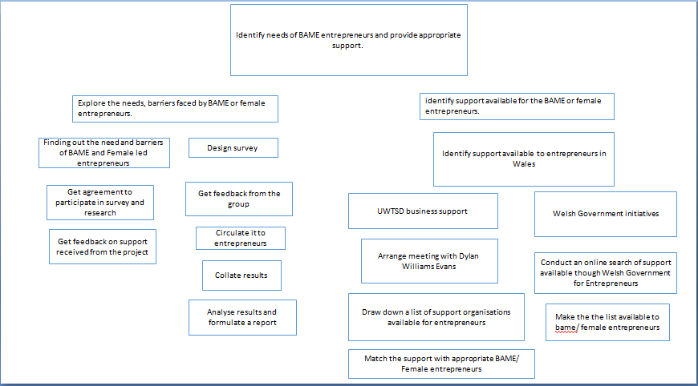

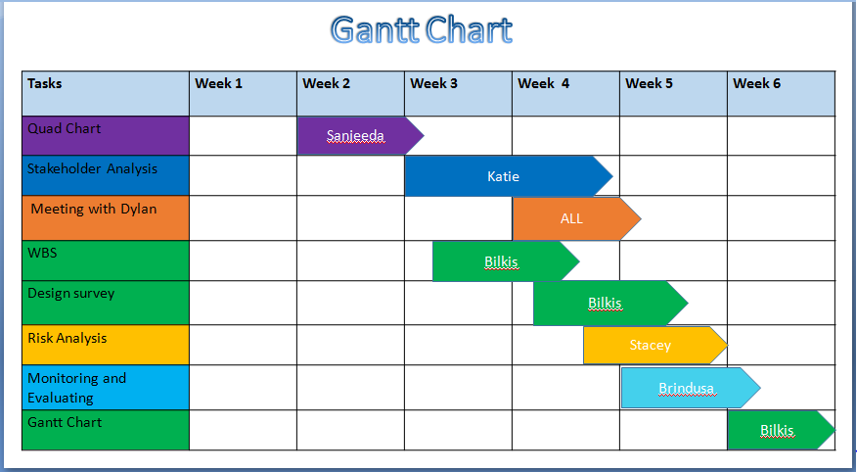
Survey (Questionnaire)
Questionnaire
Name -
Age -
1Q) Do you know how to set up a new business?
- Yes
- No
- Maybe
2 Q) Which type of business are you interested in?
- Food
- Fast Food
- Nursery
- Hairdressing
- Hospitality
- Graphic Design
- Indian Takeaway
3Q) Do you Know where to go for finance?
- Yes
- No
- Maybe
4Q) Do you know what financial support is available for business startups for the BAME Community?
- Yes
- No
- Maybe
5Q) Do you know how to get a planning permission to open up a small business?
- Yes
- No
- Maybe
6Q) Do you know how to insure your business?
- Yes
- No
7Q) Do you know how and where to register your business?
- Yes
- No
8 Q) As a BAME / Female led business, do you know how to accelerate your business recognition?
- Yes
- No
9Q) Do you know how a BAME / Female led business can do well with other competitors?
- Yes
- No
- Maybe
10Q) In your experience, what special need or requirements have you come across that relates to your business?
- Health and Hygiene Certificate
- Finding good employees
- BTEC DIPLOMA IN CHILD CARE
- Hard work is essential
- Finance
11Q) Are you aware of the labor market?
- Yes
- No
12 Q) As a BAME/ Female Entrepreneur, Have you ever come across any barriers or struggles that affect your business?
- Yes
- Can’t think of any
- No
- Yes, people assume I don’t know what I am doing
- Subconscious Biasness etc.

Risk Assessment

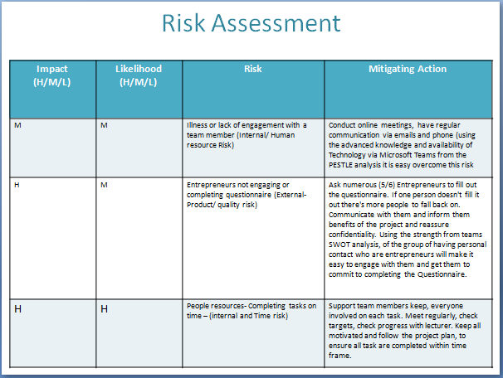

Stakeholder Analysis

Priority  H/M/L | Stakeholder | Stakeholder's  Perspective | Action
H | BAME/female Entrepreneurs | Find support and ways to help women start their business | Contacting support lines and informing them of the different support
H | Team | Collecting as much information as possible | Distributing the information to the team
H | UWTSD business support | Taking advice and instruction on how to get the best outcome for each individual | Gathering relevant information for the individuals
H | Government | Funding and providing courses and opportunities for BAME females starting or in a business | Providing information on how to apply for a loan or government grant
H | Module lecturer | Teaching and providing information to the team (researchers) to enable them to investigate relevant support | Attend lecture and acquire knowledge on how to conduct a quad chart, w.b.s., risk assessment etc

Quad Chart


