

Programme: BA (Hons) Leadership and Management Skills for the Workplace
Module: Organizational Culture
Module code: LCLM 5005
Assignment Title: Component 1
Organizational Culture: Individual Report
Student Name: Pedro Santos
Student ID:2331411
Lecturer: Amir Homayounfard
Executive Summary
Organizational culture basically replaces the attitude, values, and beliefs in an organization, which has a direct impact on decision making, business processes, organizational structure and group behavior. Considering the argument presented by Mullins and Christy (2016), the report has demonstrated the influence of organizational culture and business structure and decision-making of John Lewis Partnership. Handy’s Cultural Types and Schein’s Model of Organizational Culture have been evaluated here to identify the types of organizational culture in this company. The report has demonstrated how organizational culture helps to adapt to external environmental forces and highlighted organizational changes in John Lewis. Effectiveness and challenges of a collaborative organizational culture on business processes have also been presented here. Based on the impact of organizational culture, some recommendations have been provided at the end of this report.

Table of Contents
1. Introduction 4
2. Influence of organisational culture on the company structure and the decision-making process of John Lewis 4
3. Different types of organisational culture in John Lewis and the prevailing culture within the organisation 7
3.1 Handy’s Cultural Types 7
3.2 Schein’s Model of Organisational Culture 9
4. Application of organisational culture in John Lewis to adapt to external environmental influences 10
5. Role of organisational culture to ensure effective functioning within John Lewis 13
5.1 Organisational culture, as an enabler to effective functioning 13
5.2 Organisational culture, as a barrier to effective functioning 14
6. Impact of organisational culture on the overall performance of John Lewis and recommendations for further improvements 14
6.1 Impact of organisational culture on the overall performance 14
6.2 Recommendations 15
7. Conclusion 16
References 17

1. Introduction
Organizational culture has a direct impact on decision-making and organizational structure in a business organization. Mullins and Christy have argued that the organizational culture influences group behavior, employee motivation, managerial control and job satisfaction. Maintaining cultural diversity and understanding different cultural backgrounds of employees is important for global business organizations. There are various theoretical frameworks and models which have highlighted the impact of organizational culture, employee behavior and performance. The purpose of this report is to understand the importance of organizational culture, based on the argument of Mullins and Christy (2016). The report will discuss the company structure and decision-making process of John Lewis. John Lewis Partnership is a British department store which was founded in 1864, and it is the largest employee-owned business in the UK. Currently, it has more than 75000 employees, and all of them are business partners of John Lewis who share business profits. This is a major UK-based retailer which operates more than 330 Waitrose supermarkets and 36 John Lewis department stores. The paper will evaluate the role of the external environment on organizational culture and offer some evidence-based recommendations for John Lewis to improve its existing organizational culture.

2. Influence of organizational culture on the company structure and the decision-making process of John Lewis
According to Alves et al., (2022), organizational culture can shape employee behavior, recruitment, employee retention and staff engagement. A supportive and collaborative organizational culture helps in decision-making and also fosters innovation. There are different types of organizational culture such as market, clan, adhocracy and hierarchy culture, which have different values on organizational structures. As per the view of X, some basic types of organizational structure are functional, divisional, flat, matrix and hierarchical. Organizational culture can control hierarchical structure and reporting lines in an organization, which develops a flat or hierarchical organizational structure. Similarly, a culture of trust and empowerment develops a functional or divisional structure which promotes employee autonomy. John Lewis Partnership has a distinctive organizational culture which influences its employee-owned structure (Almerri, 2023). The influence of organizational culture in this company is critically evaluated below.
Participative decision-making and employee autonomy: The organizational culture of John Lewis Partnership follows the partner-first philosophy and is connected with employee ownership. All 75000+ employees are co-owners and partners in this company who share business profits (John Lewis & Partners, 2026). This company culture encourages employees to actively participate in decision-making and share their innovative ideas. Participative decision-making increases job satisfaction, creativity and productivity among employees as well as fosters the culture of trust. According to Mengstie et al., (2023), the organizational culture of John Lewis promotes collaboration and transparency among employees, which influences leadership style as well. The company has a clan culture that promotes employee involvement and teamwork (John Lewis & Partners, 2026). Participative decision-making may slow the decision-making process, but it promotes employee autonomy, which increases employee retention.
Customer-centric culture: organizational culture aligns internal values and employee behavior to improve the overall customer expectations. As a retail organization, John Lewis also maintains a customer-first approach and has created a customer-centric culture (John Lewis & Partners, 2026). Instead of short-term profitability, the company considers long-term customer satisfaction and tries to increase brand loyalty (Tasoulis et al., 2023). The company culture also helps managers and team leaders in operational decisions (Alves et al., 2022). The company culture has also adopted rapid digital transformation to maintain a competitive advantage.
Democratic governance: The Partnership Council of John Lewis Partnership consists of over 3,000 elected representatives who manage corporate policies and business decisions. It follows the “Sharing Power” framework, where the governance structure shares power among the Partnership Board, the Chairman and the Partnership Council (John Lewis & Partners, 2026). This company promotes the culture of fairness, which is also deeply rooted in the democratic governance structure. It values the culture of transparency and employee accountability, which also influences leadership decisions in John Lewis. However, rapid structural adjustment can create bureaucratic layers in organizational structure, which can affect business performance in the UK retail environment (Almerri, 2023).
Teamwork and collaboration: The employee ownership model of John Lewis promotes the culture of teamwork, collaboration and innovation. Employees are co-owners here, so they share business purpose and equal responsibility for the company's success. The collaborative organizational culture of mutual support for all employees ensures they are participating in teamwork (Mengstie et al., 2023). Jon Lewis also conducts cultural orientation for global employees and conducts cross-functional programs to increase departmental coordination. Communication plays a vital role in the organizational culture of John Lewis, which creates a collaborative work culture. The company has a problem-solving approach and considers diverse perspectives of employees.

3. Different types of organizational culture in John Lewis and the prevailing culture within the organization

3.1 Handy’s Cultural Types
Charles Handy’s Cultural Types was developed in 1978, which has four types of organizational culture such as role, task, power and person (Umbrex, 2025). All of these organizational cultures are linked to a Greek god that highlights how it influences organizational decision-making. Power culture (Zeus) denotes that when a central figure controls the overall organization, it can increase the decision-making process and is beneficial for entrepreneurial organizations (Umbrex, 2025). Task culture (Athena) promotes teamwork and collaboration, which highlights that flexible organizational structure can reduce complexity as well as promote problem-solving efficiency among employees (Umbrex, 2025). The role culture (Apollo) promotes bureaucracy culture, where clear and specific rules can improve process efficiency. Person culture (Dionysus) prioritises individual expertise and values which shape organizational performance.
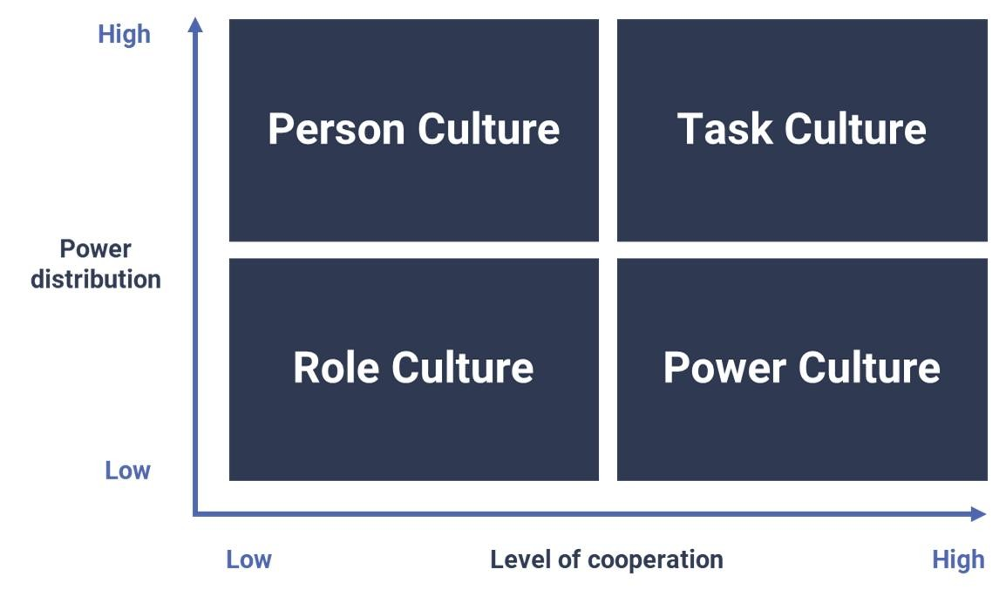
Figure 1: Handy’s Cultural Types
(Source: EXP, 2025)
Task culture: Based on this theory, John Lewis has adopted the task culture and role culture. The task culture promotes teamwork and collaboration as well as helps employees to achieve shared goals. John Lewis has adopted this culture to ensure collaborative decision-making and promote cross-functional coordination (EXP, 2025). The management encourages employees to be involved in the decision-making process to create a cooperative work environment. Cross-functional collaboration has improved retail strategies in John Lewis as it has heavily invested in digital retail transformation. Currently, 60% of overall sales come from online, which highlights the collaborative approach of technology and retail.
Role culture: John Lewis has also adopted role culture to create a formal structure and set clear responsibilities for all employees. The management has set well-defined job roles for all 30 departmental stores and online operations (Stewart, 2012). Clear operational guidelines and customer service standards help employees to maintain service quality as well as brand reputation in the competitive retail industry. The partnership structure in Jon Lewis motivates employees to share their ideas for operational improvement (EXP, 2025). The rule culture has also improved the governance system and ensured long-term sustainability for this company.

3.2 Schein’s Model of Organizational Culture
Another important theory of organizational culture is the Three Layers of Organizational Culture Theory of Edgar Schein. This theory highlights three different levels of organizational culture, including artefacts, espoused values, and underlying assumptions. Artefacts are easily observable elements such as architecture, technology, office layout, dress code and rituals in an organization which represent the organizational culture (Hogan and Coote, 2024). Espoused values are corporate philosophies, goals and strategies which need to be followed by members and state the company values. Underlying assumptions are unconscious beliefs and employee perceptions which influence employee behavior in an organization (Pedro Pinto, 2025).
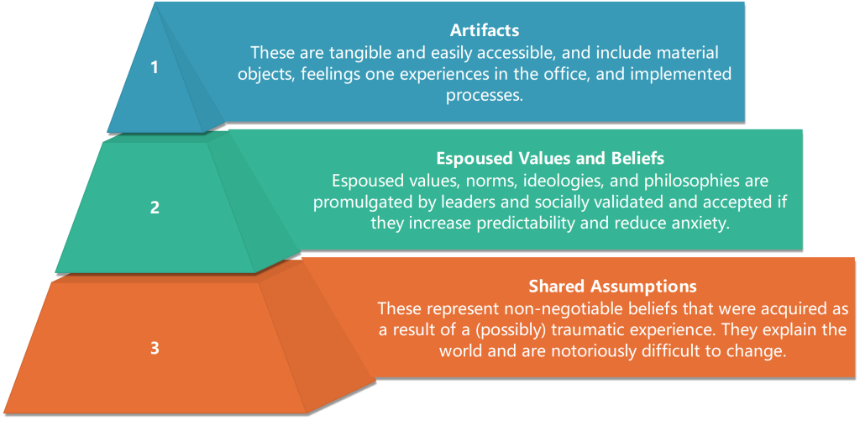
Figure 2: Schein’s Model of Organizational Culture
(Source: Hogan and Coote, 2024)
The organizational culture of John Lewis can also be demonstrated through this theory. There are nearly 75,000 employees or partners in John Lewis, and the Partnership Council demonstrates the visible cultural practices in this company. Annual partner bonus is the financial artefact in John Lewis which promotes the company's commitment to shared success. Formal principles denote the espoused values in John Lewis that promote equality, fairness and transparency among employees (Stewart, 2012). Espoused values directly influence customer satisfaction. The customer satisfaction rate is 80% in John Lewis. The company also reported a revenue of £12.4 billion in 2023 due to customer-focused approaches. According to Pedro Pinto (2025), basic underlying assumptions are deeply ingrained beliefs among employees which shape their attitude and behavior. Employees in John Lewis have shared ownership, which leads to higher commitment and engagement towards the organization. Underlying assumptions developed collaborative decision-making in the organization, where employees actively contribute to organizational changes and improvements (Stewart, 2012).

4. Application of organizational culture in John Lewis to adapt to external environmental influences
Organizational culture in a company helps to understand external forces and implement them in business policies and practices. According to Alassaf et al., (2020), the external environment creates uncertainties in business processes, such as economic downturn, technical changes, geopolitical tension, unemployment rate, inflation, legal factors and others that influence business functions. Considering these factors, global businesses shift organizational policies and make changes in their operations. A flexible and collaborative organizational culture helps employees to adapt to changes (Tasoulis et al., 2023). Similarly, supportive leadership and management approaches guide employees during change management. John Lewis also utilises its organizational culture to adapt to external forces in business practices and improve customer satisfaction.
Digital transformation: The technical advancement in the UK has created new market opportunities for UK retailers. John Lewis has taken several innovation initiatives, such as implementing chatbots and AI, to enhance customer experience (John Lewis & Partners, 2026). The company has also invested in digital platforms and omnichannel retail to offer online shopping experience for customers. The company conducts regular employee training to improve digital and technical skills for employees as well. These initiatives help this organization to remain competitive in the UK retail industry.
Developing Customer-Centric Strategies: E-commerce, digital marketing and social media have a strong impact on consumer preferences. Considering these factors, John Lewis has improved its existing customer service approaches and implemented advanced technology to increase customer satisfaction (Tasoulis et al., 2024). It operates in the highly competitive retail sector where high-quality customer service plays a vital role in brand reputation. Considering the rise of e-commerce, John Lewis also offers online shopping and has created a strong market position in the UK. Reports have identified that its revenue was £12.4 billion in 2023, which highlights how service and product improvements can deliver a personalized retail experience for customers (John Lewis & Partners, 2026).
Adopting cost challenges in the UK market: High inflation in the last few years and high interest rates have created strong economic pressure for UK companies. Rising operational costs and economic uncertainty not only disrupted the supply chain but also increased production costs. Considering the increasing cost challenge, John Lewis preferred to maintain open communication between the management and employees while making financial decisions (Tasoulis et al., 2023). The collaborative approach in this organization helps the management to create practical cost management strategies.
Managing employee engagement: Globalization has a direct impact on workforce diversity. Unemployment rate, employment opportunities and the rate of skilled graduates in the UK can influence modern organizations. Considering these factors, John Lewis has developed an inclusive partnership culture where more than 75000 employees are partners of this company (Tasoulis et al., 2024). The inclusive organizational culture not only promotes equality, diversity, and inclusivity but also encourages employees to participate in the decision-making process. Reports have highlighted that 85% of employees in John Lewis are highly satisfied with workplace arrangements and organizational benefits (John Lewis & Partners, 2026). The company has a diverse culture where employees from different cultural backgrounds feel respected as well as valued. This organizational culture helps employees to adopt changes and learn new skills.
Sustainability and ethical business practices: considering the changing consumer preference towards sustainability, climate change, and regulatory pressure in the UK, John Lewis also maintains ethical business practices. The UK government is committed to becoming net zero by 2050, reduce 81% carbon emission by 2035, implementing the 2021 Environment Act and making other sustainable initiatives to reduce the impact of climate change (Tasoulis et al., 2023). Considering this factor, John Lewis has integrated sustainable business practices and encouraged suppliers to adopt responsible supply chain management. The company is committed to becoming net zero across operations by 2035 and its entire supply chain by 2050 (John Lewis & Partners, 2026). It also sources 100% free-range dairy and uses 100% recycled raw materials for manufacturing (John Lewis & Partners, 2026). It has taken several initiatives in animal welfare, circular economy and sustainable sourcing to implement ethical business practices.

5. Role of organizational culture to ensure effective functioning within John Lewis

5.1 Organizational culture, as an enabler to effective functioning
The organizational culture of John Lewis has a strong influence and positive impact on the company's functions. It influences the employee ownership structure and increases employee engagement through active recognition (John Lewis & Partners, 2026). Employees work as partners in this company who share responsibilities and financial rewards equally. The culture fosters a sense of belonging and accountability among employees, which increases employee retention. On the other hand, profit-sharing incentives motivate employees to improve their performance and contribute towards organizational goals. According to reports, the employee turnover rate is very high in the UK returns sector due to high work pressure and longer shifts. John Lewis has set a strong example for other retailers to improve employee satisfaction while maintaining performance excellence by adapting a supportive organizational culture. As per the view of Dimitrantzou et al., (2022), the customer-centric culture in John Lewis acts as a vital enabler for company success. Considering changing customer demand, market trends and social media trends, John Lewis has improved its service quality and product reliability to develop long-term customer relationships. Instead of gaining short-term profit, long-term sustainable growth has developed a strong brand trust in the UK market. John Lewis also follows a service-oriented culture that has high service standards and omnichannel retail, which encourages repeat purchases and increases customer loyalty (Reeves, 2023). This organization and culture also promote collaborative decision-making and open communication, where employees can freely share their ideas with the management. Active participation in decision-making promotes creativity and innovation, which also helps in Change management. A collaborative effort among all departments helps to improve omnichannel retailing and online retail experience for customers.

5.2 Organizational culture, as a barrier to effective functioning
The participative culture of John Lewis also acts as a barrier to decision-making and business functions. According to Dimitrantzou et al., (2022), employees are included in decision-making and sharing their ideas can slow the overall decision-making process and create complexity. The UK Retail Industry is highly competitive, hence the active involvement of employees and the representative councils reduce organization agility. It also operates online, but a slow decision-making process can affect business performance and supply chain efficiency in John Lewis. Major organization changes in this company often face cultural resistance from employees. Employees work as partners in this company, hence they have the right to fight for their job security (Reeves, 2023). It not only creates complexity for the management but also affects the proposed restructuring processes. The UK retail industry is currently facing financial pressure; the company has decided to implement operational restructuring and store closures in some areas (Alves et al., 2022). However, this decision has created conflict among team members and affected the traditional cultural values of this company.

6. Impact of organizational culture on the overall performance of John Lewis and recommendations for further improvements

6.1 Impact of organizational culture on the overall performance
The organizational culture can improve employee engagement, organizational commitment, employee retention and overall business performance in a company. John Lewis has a collaborative and flexible organization and culture where employees share responsibility and financial rewards equally (Mengstie et al., 2023). This collaborative culture not only increases employee engagement and job satisfaction but also has improved organization and productivity by 20% in recent years. Profit-sharing bonus system motivates employees to improve their skills and performance as well as enhance customer service (Alves et al., 2022). Along with this, organizational culture also has its own impact on brand reputation. Motivated employees offer high-quality customer service, which creates long-term customer relationships and repeat purchases. Customer satisfaction level is more than 80% in John Levi's, which helps this company to maintain comparative advantages in the UK retail sector. Company culture also supports creativity, innovation and digital adoption in John Lewis (Mengstie et al., 2023). Employees can share their innovative ideas with the management and representative councils which help the company to adopt digital retail trends successfully.

6.2 Recommendations
Recommendation 1: John Lewis has to invest in Artificial Intelligence and advanced analytics for a data-driven decision-making process. It has a strong market share in online sales so analysing consumer data and purchase behavior is important to develop effective marketing strategies. Similarly, increasing flexibility is also important in decision-making for strategic projects.
Recommendation 2: As an omnichannel retailer, John Lewis needs to improve its existing skill development and employee training programs. Offering digital training programs and using digital learning platforms can improve digital skills for employees. It will help them to manage e-commerce operations and improve online customer service.
Recommendation 3: As a major retail company in the UK, John Lewis needs to improve its ESG principles and invest in sustainable business practices. Ethical Sourcing and reducing plastic packaging will position it as a responsible retailer in the competitive UK market. Implementing an energy efficient system, renewable energy sources, recycled packaging, circular economy and sustainable supply chain will increase brand reputation.

7. Conclusion
The organizational culture of John Lewis has a direct impact on the decision-making process and employee engagement. Evaluate the impact of organizational culture and company structure, and use relevant frameworks to identify different types of organizational culture in John Lewis. The company uses organizational culture to implement external environment forces in business processes such as omnichannel retailing for technical advancement and improving customer service. It has also invested in sustainability and ethical business practices, considering the government's commitment towards sustainability. The report has demonstrated organizational culture as a barrier and enabler for business functions with relevant justification. The impact of organizational culture and overall business performance, and relevant recommendations for improvement, has been included at the end of this report.

References
Alassaf, D., Dabić, M., Shifrer, D. and Daim, T., (2020). The impact of open-border organization culture and employees’ knowledge, attitudes, and rewards with regards to open innovation: an empirical study. Journal of Knowledge Management, 24(9), pp.2273-2297.
Almerri, H. S. H. (2023). Investigating the impact of organizational culture on employee retention: Moderating role of employee engagement. Journal of System and Management Sciences, 13(4), 488-507.
Alves, J.L., Nadae, J.D. and Carvalho, M.M.D., (2022). Knowledge management enablers and barriers: exploring the moderating effect of communication barriers. International Journal of Managing Projects in Business, 15(7), pp.1091-1122.
Dimitrantzou, C., Psomas, E., Bouranta, N. and Kafetzopoulos, D., (2022). The role of organizational culture in total quality management adoption and cost of quality. Total Quality Management & Business Excellence, 33(15-16), pp.1718-1736.
EXP, (2025). Culture theory - Handy. Available at: https://theexpgroup.com/blogs/knowledge-base/culture-theory-8211-handy?srsltid=AfmBOoqLpez2vds9rRpvb7r9NKvIItCJeJjkegw8oTMYvFcqB95Yu24Z [Accessed 10 March 2026]
Hogan, S.J. and Coote, L.V., (2024). Organizational culture, innovation, and performance: A test of Schein's model. Journal of business research, 67(8), pp.1609-1621.
John Lewis & Partners, (2026). About Us. Available at: https://www.johnlewis.com/customer-services/about-us [Accessed 10 March 2026]
John Lewis & Partners, (2026). Being a Partner. Available at: https://www.jlpjobs.com/about-the-partnership/being-a-partner/ [Accessed 10 March 2026]
John Lewis & Partners, (2026). Diversity and inclusion. Available at: https://www.johnlewispartnership.co.uk/ethics-sustainability/governance/diversity-and-inclusion [Accessed 10 March 2026]
John Lewis & Partners, (2026). Homepage. https://www.johnlewispartnership.co.uk/ [Accessed 10 March 2026]
Mengstie, M.M., Biks, G.A., Cherlin, E.J. and Curry, L.A., (2023). Organizational culture and barriers to change in University of Gondar Comprehensive Specialized Hospital Cardiac Unit. BMC health services research, 23(1), p.296.
Naidoo, P. and Martins, N., (2024). Investigating the relationship between organizational culture and work engagement. Problems and perspectives in Management, (12, Iss. 4 (spec. iss.)), pp.433-441. (Naidoo and Martins, 2024)
Pedro Pinto, (2025). Schein’s Model: Unpacking Organizational Culture Layers. Available at: https://coachpedropinto.com/scheins-model/ [Accessed 10 March 2026]
Reeves, M., (2023). How Organizational Culture Influences Employee Behavior. Available at: https://www.togetherplatform.com/blog/how-organizational-culture-influences-employee-behavior
Stewart, H., (2012). Make Your People Happy, Like John Lewis Does. Available at: https://www.happy.co.uk/blogs/make-your-people-happy-like-john-lewis-does/ [Accessed 10 March 2026]
Umbrex, (2025). Handy Cultural Types (Power, Role, Task, Person). Available at: https://umbrex.com/resources/frameworks/organization-frameworks/handy-cultural-types-power-role-task-person/#:~:text=1.,leadership%20style%20will%20unlock%20performance. [Accessed 10 March 2026]
Tasoulis, K., Pappas, I., Vlachos, P.A. and Oruh, E., (2023). Employee reactions to planned organizational culture change at John Lewis Partnership: A configurational perspective. Tasoulis, K., Pappas, IO, Vlachos, P., Oruh, ES (2023). Employee reactions to planned organizational culture change at John Lewis Partnership: A configurational perspective. Human Relations, in press, Forthcoming.
Tasoulis, K., Pappas, I.O., Vlachos, P. and Oruh, E.S., (2024). Employee reactions to planned organizational culture change: A configurational perspective. human relations, 77(9), pp.1272-1305.

