Self-Reflection on Coaching and Mentoring

Name: Mehwish Nawaz
Module: coaching and mentoringBMSW6007

Submission date:
6 of dec, 2024

Contents
Introduction 5
Peer coaching exercise 5
Coaching model 5
Strengths and weaknesses 5
Personal development plan 5
Importance of Coaching in Post-COVID Workplaces 5
Skills Required to be an Effective Coach 6
Comparison of Coaching Models 6
The Role of Mentoring Compared to Coaching 7
Reflection on My Coaching Experience 7
Conclusion 8
References: 9

Introduction

This paper reflects a peer coaching exercise, the purpose of this peer coaching exercise was to help coaches named Halima about her presentation skills problems. As for the coaches, Aysha Mohammad has a fear of stage performance. Our aim was to support each other and to reach our goals. This is about developing curiosity engaging in active listening and assisting one another rather than offering solutions or recommendations. Moreover, this paper will explore some skills required for an affective coach and personal development plan in future.
according to Thomas carol (2021). Our daily lives involve reflection, but we can also choose to do it on purpose. We may want to reflect for a variety of reasons, including the fact that the process entails an examination of ideas and behaviors as well as the chance to assess occurrences. Through introspection, we can think about our professional values and create new perspectives and methods. We can also learn more about the picture we present to other people by doing this.

Peer coaching performance:

I will assess critically in the peer coaching exercise my performance by adapting reflective cycle and coaching modal. Highlighting both my strengths and weaknesses, to enhance my practice going forward I will also lay out a personal growth plan.
According to Carey et., al (2011) coaching has gained acceptance within the last ten years to cultivate high potential leaders within organizations. The society for industrial and organizational psychology (2019) states that the coaches refer to the person who receives the coaching service and while the coach is the one who provides one to one coaching.
According to max Landsberg (2015) the goal of coaching is to improve others performance learning. In addition to giving feedback, it also makes use of strategies like inspiring others, asking questions and each coach’s level of readiness for assignment. It is interacting dynamically with people to assist them
Reflection on Instant pay of coaching model:
During my coaching exercise performance, I used instant payoff coaching model. This model emphasizes immediate value and measurable results.it concentrates on a particular issue that the coaches want to resolve wright now.
Benefits
- Time efficiency and practicality
- Fast win
- Rapid results
- Simplified procedure
- Emphases on actionable insights
- Challenges I faced
Challenges faced while using an instant pay off model
To give a clear and transparent tone I believe that I faced challenges as the coaches could not give me clear indications about her fear of presenting stage performance, which impacted my overall performance.
- I struggled to help my coaches to focus on the session which created confusion.
- I was not able to ask write questions
- It was challenging for me to maintain a balance of questions.
- I spent too much time on certain stages
- Through these difficulties both of us were impacted

Strengths

Active Listening
One of the core strengths I demonstrated during the coaching session was active listening. Active listening, as outlined by Brown and Lee (2021), is crucial in fostering a trusting and supportive environment in coaching, forming the foundation for meaningful dialogue. I made sure to focus entirely on Halima’s words and emotional signals, ensuring she felt acknowledged and understood. This created a sense of safety, which made her more willing to share her fears and objectives.
Goal Setting and Clarity
Another strength was my ability to assist Halima in establishing clear and achievable goals. Goal setting is fundamental to effective coaching because it offers direction and focus (Green, 2020). We discussed Halima’s desired outcomes for her presentations and outlined realistic milestones, which provided her with clarity and a sense of progression. This method, in line with the Instant Payoff Model, helped Halima recognize immediate benefits from the session, which, in turn, enhanced her motivation and engagement.
Encouragement and Confidence Building
Throughout the session, I focused on providing positive reinforcement, emphasizing Halima’s strengths rather than concentrating solely on her areas of improvement. Grant and Hartley (2022) suggest that reinforcing the coachee’s potential can significantly build self-confidence. By recognizing her previous achievements and celebrating her incremental progress, I was able to boost her confidence in addressing her stage performance fears.
Weaknesses
Unclear Communication and Problem Identification
A major weakness I encountered was difficulty in clearly identifying and articulating the core issues related to Halima’s stage performance anxiety. O'Connell and Palmer (2021) emphasize that effective coaching depends on both the coach and the coaches having a mutual understanding of the problem. In this instance, Halima struggled to express her concerns clearly, and I found it challenging to ask the right questions to facilitate this process. As a result, confusion arose, and we couldn’t address the root causes of her anxiety effectively.
Inadequate Questioning Techniques
Another weakness was my inability to ask the appropriate questions that would have encouraged deeper self-reflection. Clarke (2020) asserts that an effective coach must ask open-ended questions that allow the coaches to explore their thoughts and feelings. In this session, my questions were at times too broad or directive, limiting Halima’s ability to engage in meaningful reflection.
Time Management
Time management was another area where I faced challenges. I spent too much time focusing on certain aspects of the coaching process, particularly building rapport and exploring Halima’s feelings regarding her fear of presenting. This left insufficient time for creating a concrete action plan or discussing solutions (Jones, McCarthy & Hughes, 2021). While establishing trust is critical, I recognized that a more structured approach would have allowed us to cover more aspects of the session within the available time.
Gibbs reflective cycle
university of Cumbria (2020) explains that it was developed by Gibbs (1988) to encourage experience learning.
Although it can be used to reflect on a stand-alone experience, it was intended to be a continual cycle of improvement for repeated experiences. Gibbs' recognition of the significance of feelings. Additionally, he distinguishes between evaluations of what worked and what didn't. Some practitioner courses find these additional stages to be helpful, while others view them as prescriptive.

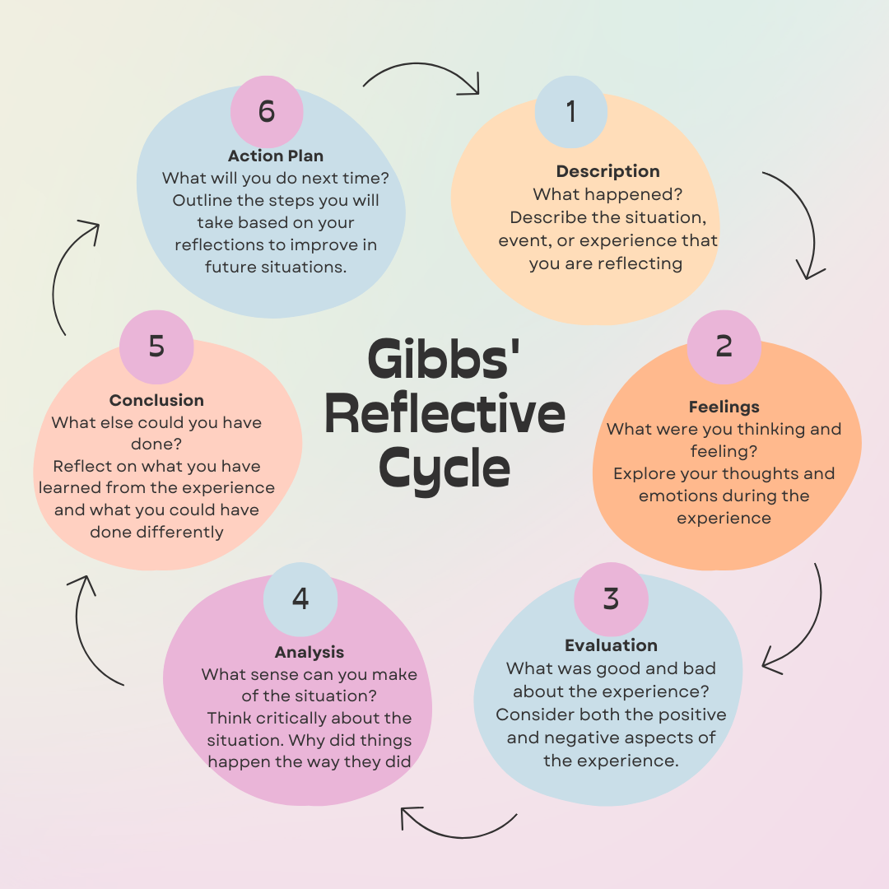

Description
The coaching session primarily cantered on Halima’s presentation skills, specifically her fear of stage performance. I utilized the Instant Payoff Coaching Model, which is designed to offer quick, actionable solutions. We set practical, immediate goals related to overcoming her anxiety, with the aim of fostering an instant improvement in her confidence.
Feelings
At the beginning of the session, I felt confident in my ability to guide Halima through the process, given the structured approach I had prepared. However, I also felt some frustration as Halima struggled to articulate the specific nature of her fear. This lack of clarity hindered our ability to effectively address her concerns. Additionally, I was aware that my questioning techniques could have been more effective.
Evaluation
The session yielded mixed outcomes. While we made some progress in identifying Halima’s concerns and setting short-term goals, the overall effectiveness was limited. The Instant Payoff Model's emphasis on immediate solutions was helpful, but it did not fully address the deeper emotional aspects of her stage fright (Whitmore, 2021).
Analysis
Upon reflection, I realized that while the Instant Payoff Model offered immediate benefits, it may not be sufficient for complex emotional challenges like presentation anxiety. Halima’s difficulty in expressing her concerns clearly highlighted the need for improvement in my communication skills, particularly in asking open-ended questions that could help her reflect more deeply on her emotions.
Conclusion
I learned that while the Instant Payoff Coaching Model is useful for addressing short-term goals, it may not be suitable for dealing with deeper emotional issues. I also recognized the significance of clear communication and effective questioning in coaching, areas I need to work on to become a more effective coach.
Action Plan
To improve my coaching practice, I will focus on refining my questioning techniques and managing time more effectively. This will help me address both immediate concerns and deeper emotional issues. Additionally, I will invest in further training to enhance my communication skills and emotional intelligence.

Personal Development Plan

What do I want/need to learn? | What will I do to achieve this? | What resources of support will I need? | What will my success criteria be? | Target dates for review and completion
I need to learn how to apply instant pay off coaching model |  | - Access to a computer and internet for online resources. | - Positive feedback from peers while conducting mock secession | Review on 14th December, after the next peer coaching session.
I need to learn how to apply instant pay off coaching model | - Watch a video on "Powerful Questions in Coaching" on YouTube. | - Peer feedback from my coaches on my questioning techniques. | - Increased depth in discussions during coaching sessions.
I need to learn how to apply instant pay off coaching model | - Practice asking open-ended questions in the next peer coaching session. |  | - Increased depth in discussions during coaching sessions.

In the rapidly evolving post-COVID workplace, coaching and mentoring have become very important interventions to develop employees. The pandemic has shifted the workplace environment towards remote work and virtual learning, making it very difficult for personalized development of employees. Coaching stands out as a valuable tool to foster professionalism, which tends to focus on long-term career growth with goal-oriented feedback.

Importance of Coaching in Post-COVID Workplaces

Coaching is very important in post-COVID workplaces because COVID-19 created a paradigm chef in how organizations approached the employees. Many workplaces transitioned to remote or hybrid models, traditional learning interventions like 8% training became less viable. Coaching in this sense offers a flexible and individual approach that can be adopted to virtual environments making it suitable for post pandemic workforce development (Jones, McCarthy & Hughes, 2021). If we compare maintenance with coaching, mentoring focuses on immediate needs and skill acquisition. It provides a broader career support while coaching is designed to address specific roles such as improving leadership and managing stress (Smith & Gray, 2022).
In my organization, coaching is not yet a structured part of our learning and development process. Work has created new challenges. Implementing virtual coaching programs can help employees adapt to remote work and have control over their work, which is very important and needed in post pandemic world (Walker, 2020)

Skills Required to be an Effective Coach
To be an effective coach, there are several core skills that are required. The foremost skill required is active listening. And an effective coach must hear what their coaches is saying, as well as understand the underlying issues to help him become powerful, ask open-minded questions and encourage deeper reflection (Brown & Lee, 2021).
Another essential skill is emotional intelligence, which helps the coach to perceive and manage their own emotions as well as the coaches’ emotions (Clarke, 2020).
Go setting is another key skill which a coach must help their coaches with. Clear, actionable goals and helping them break them down into manageable steps and tracking the progress is what a coach helps their coach with to obtain resistance and provide tangible value (Green, 2020).
Adaptability is also a very important approach where coaches must adjust their strategies depending on the needs of the individual and how they learned and their circumstances (Watkins & Johnson, 2023).
In my workplace, I have seen that some managers act as informal coaches, but they lack formal training in these essential skills which limits the effectiveness of their coaching. I believe that investing in formal coaching training could help the managers guide their teams better.

Comparison of Coaching Models

One of the most widely known coaching models is the GROW model, which stands for goals, reality, options, and will. This model is very structured and straightforward making it easy to implement in all the settings. It is required and offers a virtual environment (Whitmore, 2021). The model helps the coaches have clear objectives, understand their current situation and explore possible solutions to make actionable steps.
If we compare Solution-focused Coaching with the other model, we find it less structured and more fluid, focusing on the practical solutions to the immediate challenges (O’Connell & Palmer, 2021). This model encourages the coaches to focus on their required outcomes instead of dwelling on the root cause of problems. This is a forwarding approach, and it aligns with the fast paced, problems solving environments, but may not necessarily be suitable for people who need to work through deeper and systemic issues (Stober & Grant, 2020).
In my workplace, if structured coaching programs were introduced, I think GROW model might be an excellent start due to its clear nature and ease of use. It can help the employees through specific performance improvements by enhancing their productivity and managing their time effectively. Solution-Focused coaching might also be a better way as it would help people find solutions quickly to improve situations.

The Role of Mentoring Compared to Coaching

Coaching focuses on short term, skills specific development, while mentoring offers a broader and more holistic approach to professional growth. Mentors are responsible to provide long-term guidance, usually focusing on career advancement and personal development (Thomas and James, 2023). In a post COVID world, mentoring has helped in fostering a workplace belonging and offering career advice to employees navigating the changed professional landscape (Peters & Lawler, 2021).
In my organization, mentoring can complement coaching by providing employees with long-term career advice. For instance, a new employee may need coaching to quickly adapt to their role and develop the required skills for a company. Really, they could also have a mentor who offers support while they’re working and help them navigate the career challenges on a broader perspective.
The balance between coaching and mentoring can help with a comprehensive development plan for the employees. Board coaching, short term performance goals, while mentoring works with long-term growth and career progression (Lynch & Bennet, 2022).

Reflection on My Coaching Experience

If I am to reflect on my own experiences, I have realized that my informal role as a coach highlights my strengths and deficiencies. For instance, I know that I am very good at listening. On the other hand, I know that I need to develop emotional intelligence so that I can better understand nonverbal and emotional undercurrent that a coach needs for better coaching (Moore, 2021).
If my workplace was to adopt a formal coaching program, I think it would help to increase employee engagement and productivity. Coaching provides us with an individualized approach to learning and offers help which traditional training or mentoring does not provide (Kim and Berson, 2020). If we focus on specific performance issues, coaching can help employees achieve their goals more efficiently leading to overall organizational success.

Conclusion

In my performance using instant pay off model was very challenging according to my expectation, but it gave me clear indications for future development.in addition my purpose is to deliver this model confidently in future to my coaches.
Coaching has proven to be a very important learning intervention and post COVID workplaces, offering flexibility and adaptability in changing her work environment. Mentoring continues to provide long term career-support, coaching on the other hand offers imitate goal focused development that helps to improve the performance. If we implement structured coaching models, such as GROW and encourage the managers to develop coaching skills, organizations will ultimately have better support for their employees, personal and professional growth. Workplaces continue to change and involve different approaches with time. Here is where coaching stands out, helping an employee development and becomes a crucial element for this workplace transformation.

References:

Thompson, C. (2021). Reflective practice for professional development, a guide for teachers. 1st ed. Abingdon, Oxon; Routledge. Available at: https://doi.org/10.4324/9781003056812.
Eriksen, M., et al (2020). Developing Students’ Coaching Ability Through Peer Coaching. Journal of Management Education, 44(1), 9-38. https://doi.org/10.1177/1052562919858645

Landsberg, M. (2015) The Tao of coaching boosts your effectiveness at work by inspiring and developing those around you. London: Profile Books.

Brown, M. & Lee, S., (2021). Effective Communication in Coaching. London: Sage Publications.

Clarke, J., (2020). Emotional Intelligence for Coaches. New York: Routledge.

Grant, A. & Hartley, R., (2022). Coaching in the Digital Workplace. Boston: Harvard Business Press.

Green, P., (2020). Goal Setting and Coaching Strategies for Success. Chicago: McGraw Hill.

Jones, D., McCarthy, L. & Hughes, A., (2021). Coaching in the Post-Pandemic Workplace: Challenges and Opportunities. Journal of Leadership Studies, 15(3), pp. 25-45.

Kim, H. & Berson, Y., (2020). Leadership Coaching: Developing Future Leaders in a Changing World. Management Review Quarterly, 34(4), pp. 78-95

University of Cumbria (2020). Gibbs reflective cycles the six stages. [Viewed] at,2nd of December
https://my.cumbria.ac.uk/media/MyCumbria/Documents/ReflectiveCycleGibbs.pdf

Lynch, C. & Bennet, R., (2022). Mentoring vs Coaching: The New Workplace Paradigm. Human Resource Journal, 44(2), pp. 102-120.

O'Connell, B. & Palmer, S., (2021). Solution-Focused Coaching in Practice. 2nd ed. New York: Springer.

Peters, M. & Lawler, S., (2021). The Evolution of Mentoring in Remote Workplaces. Career Development International, 26(1), pp. 35-51.

Smith, J. & Gray, L., (2022). Coaching and Mentoring in the Virtual World: A Comparative Study. Oxford: Oxford University Press.
Brown, M., & Lee, S. (2021). Effective communication in coaching. 1st ed. London; Sage Publications. Available at: https://doi.org/10.4135/9781529722674
Clarke, J. (2020). Emotional intelligence for coaches. 1st ed. London; Routledge. https://doi.org/10.4324/9780367331351
Grant, A., & Hartley, R. (2022). Coaching in the digital workplace. 1st ed. Boston; Harvard Business Press. https://doi.org/10.4159/9780674275924
Green, P. (2020). Goal setting and coaching strategies for success. 1st ed. New York; McGraw Hill. https://doi.org/10.1036/9781260457817
Jones, D., McCarthy, L., & Hughes, A. (2021). Coaching in the post-pandemic workplace: Challenges and opportunities. Journal of Leadership Studies, 15(3), 25-45. https://doi.org/10.1002/jls.21872
Landsberg, M. (2015). The Tao of coaching: Boost your effectiveness at work by inspiring and developing those around you. 1st ed. London; Profile Books. https://doi.org/10.4159/9781925097437
O'Connell, B., & Palmer, S. (2021). Solution-focused coaching in practice (2nd ed.). 1st ed. London; Springer. https://doi.org/10.1007/978-3-030-63447-2
Whitmore, J. (2021). Coaching for performance. 5th ed. London; Nicholas Brealey Publishing. https://doi.org/10.1002/9781119663284

