Kazi Sadia Ahmed
Student number: 1806239.
Module: Project Planning and Management in work place.
Module code: BMSW5104.

Executive summary:
This report has been requested to reveal how the COVID-19 pandemic has impacted in business organisations around the globe and how the business organisations are taking it as a project and how they are adapting to the impact of the Coronavirus outbreak. The subject of the topic is Amazon.com. Amazon aim to carry on doing their business while ensuring employees safety and it is taken as their project. Various tools and techniques of project management have been mentioned to show how the project manager can tackle the unprecedented impacts of COVID-19 in the business.

Contents:
1. Introduction…………………………………………………………………………………………..pg. 1
2. Things Amazon has done since the outbreak of the pandemic……….........pg. 1
3. Tools and Techniques that Amazon can apply to manage their project for the current situation………………………………………………………………………………………pg. 2
4. Things to take into consideration………………………………………………………..pg.11
5. Conclusion…………………………………………………………………………………………..pg. 12

1. Introduction:-
The COVID-19 pandemic of 2020 has rapidly spread around the globe and infected millions of people. This pandemic has brought the economic activity nearly to a standstill as countries are having to impose strict restrictions on movement to control and contain the spread of this virus. Unprecedented measures are being taken by the Government around the world to minimise the negative impact on the people of their countries and society (The World Bank, 2020).
This COVID-19 outbreak has changed the way of operations within companies in an unprecedented manner. As measures many business had to adopt to various organisational changes in a short period of time trying to stay afloat. Many companies are shifting full-scale work from home plans and some are going for all on delivery. Even some are having to cease their trading completely (Thorbeche, 2020).
This report is based on the impacts of COVID-19 pandemic and how the origination is dealing with this unprecedented situation and taking it as a project to carry on doing the business as well as ensuring safety to its employees and others.
Amazon is nothing different to them. Amazon.com is the largest online retailer and a well-known cloud service provider in the world. Jeff Bezos is the founder of the company and he launched Amazon websites in 1995. Originally the company was a book seller and had expanded to sell a whole variety of consumer goods and digital media. They also sell their own electronic devices such as kindle e-book reader, kindle fire tablet and fire TV. Amazon has its head quarter in Seattle, Washington (Rouse, 2014).

2. Things Amazon has done since the outbreak of the pandemic:-
Since the outbreak of the COVID-19 pandemic, Amazon has been doing a roundup of actions to reduce the spread of the coronavirus to all those who are related to the company. Amazon is ensuring to support those who are directly and indirectly impacted by the pandemic. Amazon’s aim is to carry on their business while ensuring the safe environment to its employees, customers and all the others who are related to the supply chain.
1
Amazon have announced 100,000 new jobs in March and added 75,000 more to help in meeting the customer demand and to assist the existing employees who are working hard to fulfil orders for essential products (Dodds, 2020).
Amazon invested about $800 million globally on COVID-19 safety measures for the COVID-19 safety measures. Amazon increased the wage by £2 per hour on the basis of the various regions. In UK the wage increased by £2 per hour approximately and in many other EU countries. This commitment of increased wages by the end of April means an investment of over £350 million.
Amazon is working intensely to tackle price gouging and to keep price fair. Amazon is protecting the customers from the exploitation of those retailers who takes the advantage of this current crisis to make more money.
Amazon is continuing with their ongoing enhanced cleaning in their physical stores and encouraging contactless delivery to keep their customers and drivers safe. Amazon is prioritising to stock and deliver those items that are higher priority to their customers (Day One Staff, 2020).
Amazon has committed £21 million to support the mostly affected people due to this COVID-19 pandemic. Amazon is donating masks to EU public health services
Amazon is providing free content to customers such as books, music and video available on Amazon devices (Day One Staff, 2020).

3. Tools and Techniques that Amazon can apply to manage their project for the current situation:-
Amazon needed to implement various measures and options to cope with COVID-19 pandemic. It is like a whole project new project to the company to carry on doing the business successfully as well as ensuring safety to the employees and all the stakeholders.
In today’s highly competitive business global business environment, the ability to deliver project on time, on budget, and alignment with business goals is very important to become successful in business. This is where the project manager
2

is very essential, project managers have to manage an incredibly complex assignment to manage and should be able to blend with organisational skills, interpersonal skills, and should have an analytical mind (Wrike, 2020).
Project: Means a piece of planned work or an activity that needs to be completed over a given period of time and that intends to achieve a particular outcome (Dictionary Cambridge, 2020). A project has some components, such as, goals, timeline, budget, stakeholders and project manager.
Project Management: Project Management can be defined as the application of a collection of tools, techniques, knowledge and skills to lead the use of various resources towards the accomplishment of a unique and complex task on a set time. Besides the set time the task also involves cost and quality constraints (Atkinson, 1999).
The COVID-19 pandemic has impacted on every business and has impacted on Amazon as well. Amazon needed to implement many new actions and had to takes various measures to tackle this unprecedented situation of COVID-19 pandemic. Amazon aim to carry on doing their business and while ensuring safety to their employees and the others and therefore deals with the current situation as a project to overcome all the odds and to carry on with the business successfully.
At the beginning of any project the amount of work and planning can be overwhelming as there are various tasks that need to be completed at the right time with appropriate sequence. A skilled project manager knows that a project gets easier if the project is broken down into phases. By dividing the project management effort into five phases can help to structure the efforts and simplifies them into manageable steps. These five phases are also known as project life cycle which is used as a tool in project management.
The project life cycle:
There are five project management phases that a project passes through, from the time of initiation to completion. By this framework or tool project managers are able to measure their progress (Pinegar, 2019).
The phases of project life cycle are:-
3
Project Initiation: - The aim of this stage is to define the project. At this stage the projects value and feasibility are measured. At this stage Amazon defines that they aim to carry on with the business while ensuring safety to the employees, customers, and all the others who are related to the product value chain.
Planning: - Development of a roadmap to be followed by everyone. It is a written project plan to guide the team and to keep them on time and on budget. It gives the team direction for producing quality outputs and to handle risks. Amazon plans the various measures to ensure safety within the workplace and outside.
Project Execution: - This stage mostly associated with the project management. Execution involves building deliverables which satisfies customers. Managers allocates the resources and keeps the team members focused on their tasks. Amazon would need to allocates all the safety resources and the products and delegate the tasks to the team members.
Project monitoring: - Monitoring and control are often combined with execution as they often occur at the same time. While executing the project plan team must constantly monitor their own progress. Amazon would need to monitor the project time to time while the project is running.
Closing: - At this phase the project is completed and evaluated but due to the unprecedented situation of the COVID-19 pandemic the project has no definite finish time yet , so Amazon would still need to carry their project until the pandemic is over (Villanova University, 2019).
The project life cycle of Amazon has not come to its final phase yet as the COVID-19 pandemic is still present around the globe.
Iron Triangle:
The Project Triangle or the Iron Triangle indicates the three constraint of time, cost and quality or scope that requires to be managed in project delivery. Each constraint are interrelated, where the scope means the amount of work involved in delivery of the project, cost means the total resources needed to deliver the project, and time means the allotted or estimated time scale of the project. A change in one point of the triangle will impact on the other two points (Stakeholdermap, 2020).
4
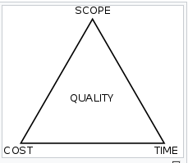
Figure: The Iron Triangle. Source: Stakeholdermap.com.
As for example when Amazon is applying the Iron Triangle for their project management the three constraint of the triangle are very relevant to their project. The time, cost and quality or scope are all present in this project. So when the time is getting stretched for the unprecedented situation and uncertainty of the COVID-19 impacts, the cost is also getting higher. No one knows when this pandemic is going to end and therefore Amazon is needing bear more cost. The project manager has to keep a balance among these three constraint.
Quad Chart:
Quad charts are the charts that are divided into four quadrants or portions. It is a good chart to use when there is a short time to explain a project. The quad chart needs to present all the information to your audience about the project. It should be presented as all in one page so that the audience can understand it without any confusion (Ahmad, 2016).The Quad Chart for Amazon is shown below:-
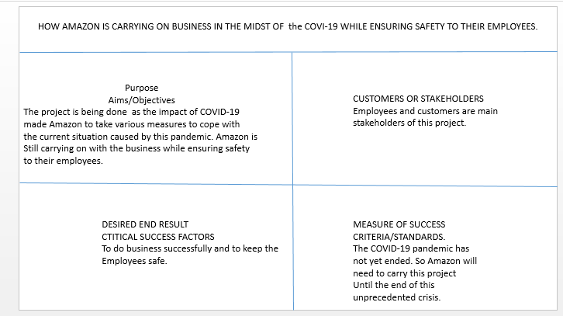
5
During the planning process of a project all the stakeholders should be brought into consideration. A stakeholder is a group or organisation or an individual who is impacted or can impact the outcome of a project (Landau, 2019).
Stakeholders’ analysis is a tool that had drawn the attention of many researchers because of its role in generating useful knowledge to perform successfully for any initiatives (Maximova, 2017).
It is important to identify the stakeholders in order to achieve a high chance of success for any project, but to ensure the use of limited resources, time and money in an efficient way can be difficult. This is where Mendelow’s Matrix can come useful.
Introducing Mendelow’s Matrix: Mendelow (1991) suggested that the stakeholder group should be analysed based on their power and interest over the organisation or project (Oxford College of Marketing, 2018).

Mendelow’s Matrix
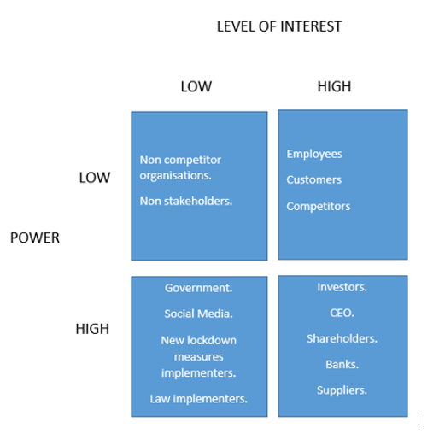
6
Amazon needs to monitor the impacts of COVID-19 to keep all their stakeholders satisfied with the performance while they are tackikng the COVID-19 pandemic.
Risk managrement:- Risk management has been defined as a range of activities that organisations need to carry out to control and reduce threats to a projects’s efficieny, profitability and success. Risks are caused due to internal and exyternal factors and they can be preditable or unpredictable (CMI,2020).
Amazon had not done a proper risk assesment for their employees’ safety to work with or without PPE in the COVID-19 pandemic situation. Amazon had not taken adequate measures to keep employees safe and the employees had contracted COVID-19 in more than 50 Amazon warehouses.
It was only because of there neglegence towards the risk management measuires which they should have dealt with and just not be in a denial strategy. Amazon did not provide enough supply of PPE for their employees and it was aslo difficult to adhere to soial distancing measures (Bain,2020).
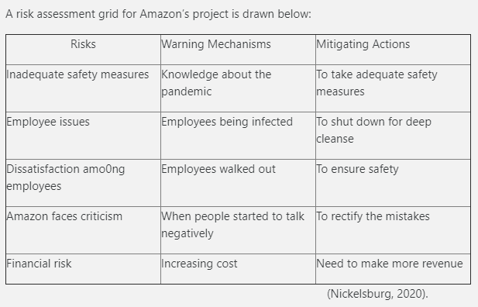
Amazon should have done a complete risk assesment to keep their employees safe before they want the employeees to work during this virus outbreak. Employees play the most important role for any organisation so to ensure their safety is crucial. 7
Work breakdown struture:- A WBS displays all the things that are organised in a multiple level and graplically displayed for a project’s accomplishment (Cohen, 2018). By breaking the work into smaller tasks the work gets more manageable and approachable. The WBS integrates scope, cost and time baselines to ensure project plans are in alignment. (Workbreakdownstructure, no date).
There are two ways to create a Work Breakdown Struture:-
- Top-down Approach:- This approach generates a complete and more accurate WBS. In this approach the overall project is decomposed into sub-projects. The dicomposition continues until the task or work reach to a level where they can be estimated and accurately defined. It is a popular approach because it is logical to define a solution of a problem and then to breakdown the solution into steps required for the task.
- Bottom-up Approach:-It is more of a brainstorming exercise where the team members are asked to list the low level tasks needed to complete a project. It can get chaotic because the task identified by the team members may not be of the same level. It takes long to ensure that all tasks of a particular level have been completely identified. The disadvantages of this approach is that almost more than a few low-level tasks can get omitted as the team members not always knowledgeable or aware of all parts (Project-Management, 2018).
The appropriate approach for Amazon would be the Top-Down Approach because the situation that the organisation is facing due to the outbreak of the COVI-19 pandemic is very new to them and therefore the top-down approach will be easier to tackle the project, which is to carry on their sevice while ensuring safety to employees and others.
The Gantt chart is a project scheduling tool developed by Henry Gantt in 1917. It gives an easy but effective visual representation of a project’s plan. It gives the details of how the work of the project is timed and monitored throughout the whole project. The important milestone of the project is marked on the Gantt chart (CMI, 2002).

8
A Gantt chart has been shown below for Amazon to display how Amazon has dealt with the COVID-19 since the breakout. From the project manager’s percpective the Gantt chart has been shown.
Starting for trom the risk assessment to the desirable goal but as the pandemic is still there, the goal has not yet been achived. Some of the task in the Gantt chart are taking place at the same time.
Fig: The Gantt Chart
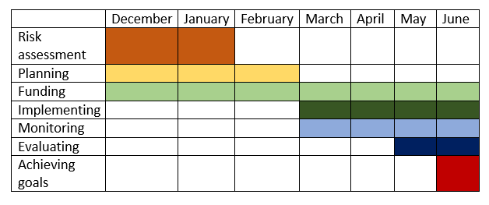

A network diagram is a graphical resresentation of of all the related responsibilities and task of a project (Wrike, 2020).
A project network diagram is a tool that helps to simplify a complex project plan and enables the project manager to give an insight to the bigger picture of the project. It is important to have an overview of the projet and know when it starts and finishes, and to take note of all the points in-between which intersect and and the way they work. It a visual representation of the workflow of a project. A network diagram is populated with boxes indicating tasks and responsibilities, and the arrows leads the schedule and the order at which the work must be done. It helps managers to track the project and allows them to see the progress of each element.
Amazon should apply the network diagram to know where they are with their project. It will allow the manager to understand the progress and to track the project’s requirement.

9
A network diagram for Amazon is shown below:-
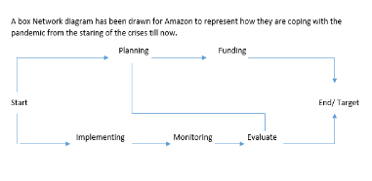
There some pros and cons of project network diagram:
The pros are that it collects all the neessary tasks that are required to complete the project successfully. Knowing the details about the project will assist to identify the critical activities. It will reveal if there is any possibilities of delays.
The cons are that there are limitations. It takes time to produce a project network diagram and costs money to produce. It can be too complex to understand depending on the type of the project. There can be mistakes in making it and may be misleading the team.
Some do not see the need to produce a network diagram as there are other tools which cover the same ground. As for example, Gantt Chart which also gives a graphical representation of the project and can represent the similar things (Malsam, 2019).
So therefore Amazon may drop this tool as they can produce a Gantt Chart which will give the team the similar knowledge of the project plan.
McKinsy 7s Model: It is a tool that analyses the organisational design of a firm by looking into 7 key internal element: strategy,struture, system, shared values, style, staff and skills, helping organisation to identify if they are effectively alligned and enable organisation to become successful. McKinsey 7s model was introduced in 1980s by McKinsey’s consultants.
10
The aim of the model was to show how the 7 elements of a company can be aligned to achieve effetiveness in a company. This model applied for various situation like to facilitate organisational change, to implement new strategy, to identify how each area may change in the futue (Jurevicius, 2013).
Amazon can apply this tool by identifying areas that are not effectively aligned and decide what changes are required and make those changes and keep reviewing the 7s.

4. Things to take into consideration:
The tools which is thought be appropriate for Amazon to face the current situation is mainly the Iron Triangle because a project will always have the three constrains to deal with so if the project manager applies the Iron Triangle in his planning than he would be able to keep track of the time, cost, scope and qulity . He would need to maintain the balance of the three contraints.
The quad chart is a visual represetation for a project and for Amazon it can be applied because it will give the team a quick understanding of the project and the stakeholders will also be aware of what is going on with in the project.
The network diagram may be avoided as the Gaantt chart is already drawn which will show the similar information.
The manager of the project for the Amazon will need to monitor and evaluate the project from time to time as he wll need to balance the tasks within the project. The manager will need to ensure safety to the employees and therefore need to adhere health and safety measure. The manager need to be motivating the team by increasing their wage in recognition of the increased risk they face by coming to the workplace in the middle of this pandemic (Newton, 2020).
What went wrong initially would need to be rectified. There had been shortage of PPE and inadequate safety measures which had led to deaths among their workers, which should not have occurred if the risk assesment were done at the beginning of this project.
The project manager should evaluate about what went wrong and what was right so that in the future the mistakes do not repeat
11
The project manager should be experienced to run the project successfully and have the right skills to run the project and enough time to manage the situation but the COVID-19 is a whole new thing for Amazon and which had led to some problems.
The manager needs to be motivated himself to motivate others. Herzberg believed that worker get more productive when they are given greater responsibility. He mentioned two factors that is, the one that motivates and the the other as satisfier. So the manager needs to gives responsibilities to the team members so that they feel the drive to work efficiently. He should also look into their hygiene factors which is to give them a safe workplace and ensure their safety.

5. Conclusion:-
The various tools and techniques have been discussed which the project manager can take into consideration for running the Amazon project which is doing their business efficiently while ensuring safety to the employees. Among the tools it is not necessary to apply every tool at the same time but rather choose the most related ones. But in this report all the tools and techique were brought into discussion and their pro and cons have been discussed. The manager will use the the most relevant ones which has neen mention in the report.

12

REFERENCES:
- Ahmad. (2016), ‘Quad Chart – Should You Use Them?’, [Online]. Available: freepowerpointtempletes.com, [01.07.2020].
- Atkinson, R. (1999). ‘Project management: cost, time and quality, two best guesses and a phenomenon, its time to accept other success criteria’, International Journal of project management 17(6), pp.337-342.
- Bain, M. (2020). ‘’Amazon faces new legal scrutiny over its employees’ health and safety’’, [Online]. Available: qz.com, [04.06.2020].
- CMI, (2020). ‘’Risk Management’’, [Online]. Available: www.managers.org, [04.06.2020].
- CMI. (2020), ‘’Managements Model Gantt chart’’, [Online]. Available: www.managers.org.uk, [20.05.2020].
- Cohen, E. (2018). ‘What is WBS (Work Breakdown Structure) in Project Management’, [Online]. Available: www.workamajig.com, [02.07.2020].
- Day One Staffs. (2020), ‘Amazon’s action to help employees, communities, and customers affected by COVID-19’, [Online]. Available: blog.aboutamazon.com, [29.06.2020].
- Dictionary Cambridge. (2020), ‘Project meaning in the Cambridge Dictionary’, [Online]. Available: dictionary.cambridge.org, [29.06.2020].
- Dodd, L. (20200, ‘Amazon hires another 75,000 staff to cope with COVID-19 demand’, [Online]. Available: www.telegraph.o.uk, [27.06.2020]
- Jerevicius, O. (2013), ‘McKinsey 7s Model’, [Online]. Available: www.strategicmanagement.com, [02.07.2020].
- Landau, P. (2017), ‘What Is A Stakeholder?’, [Online]. Available: www.projetmanager.com, [02.07.2020].
- Malsam, W. (2019), ‘3 free tools for making network diagrams’, [Online]. Available: www.projectmanager.com, [02.07.2020].
- MAXIMOVA, V., 2019. Stakeholders' Analysis. FAIMA Business & Management Journal, 7(3), pp. 26-35.
- Newton, C. ‘How Amazon is growing its power during the pandemic’, [Online]. Available: www.theverge.com, [02.07.2020].
- Nickelsburg, M. (2020). ‘’ Amazon faces unprecedented challenges as dozens of warehouses grapple with Covid-19 outbreak’’, [Online]. Available: www.geekwire.com, [04.06.2020].
- Oxford College of Marketing, {2018), ‘What is Mendelow’s Matrix and how is it useful?’, [Online]. Available: blog.oxfordcollegeofmarketimng.com, [02.07.2020]. 13
- Pinegar, G. (2019),’The Project lifecycle: Five steps to know by heart’, [Online]. Available: learn.g2.com, [30.06.2020].
- Project-Management. (2018), ‘Work Breakdown Structure (WBS): Top-down or Bottom-up?’, [Online]. Available: project-management.com, [02.07.2020].
- Rouse, M. (2014),’ What is Amazon’, [Online]. Available: whatis.techtarget.com, [29.06.2020].
- Stakeholdermap, (2020). ‘Project management, project planning, templates and services’, [Online]. Available: www.stakeholdermao.com, [01.07.2020].
- The World Bank. 2020, ‘The Global Economic Outlook during the Covid-19 Pandemic: A changed world’, [Online]. Available: www.worldbank.org, [27.06.2020].
- Thorbecke, C. (2020), ‘How businesses bare adapting to a coronavirus pandemic economy’, [Online]. Available: abcnews.go.com, [27.07.2020].
- Villanova University. (20190, ‘Five phases of the project management lifecycle’, [Online]. Available: www.villanova.com, [01.07.2020].
- Workbreakdownstructure, (no date), ‘what is Work Breakdown Structure (WBS) | Project’, [Online]. Available: www.workbreakdown.com, [02.07.2020].
- Wrike. (2020). ‘Project Management basics |Project Management Guide’, [Online]. Available: www.wrike.com, [30.06.2020].
- Wrike. 2020), ‘’ what is network diagram in project management’’, [Online]. Available: www.wrike.com, [29.05.2020].

14

