Sean Seymour – Davies
2219678

Level 4 Fieldwork - ECYW4006
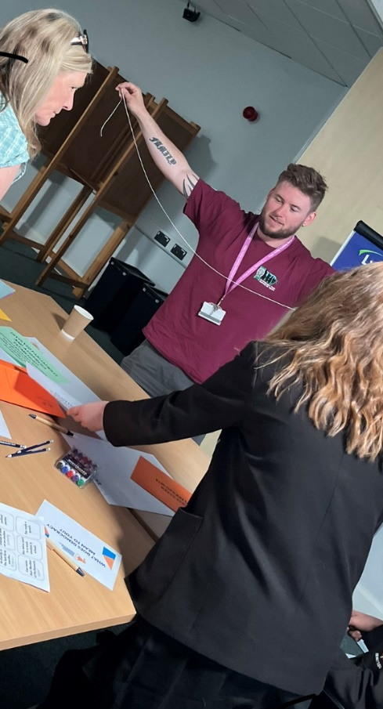
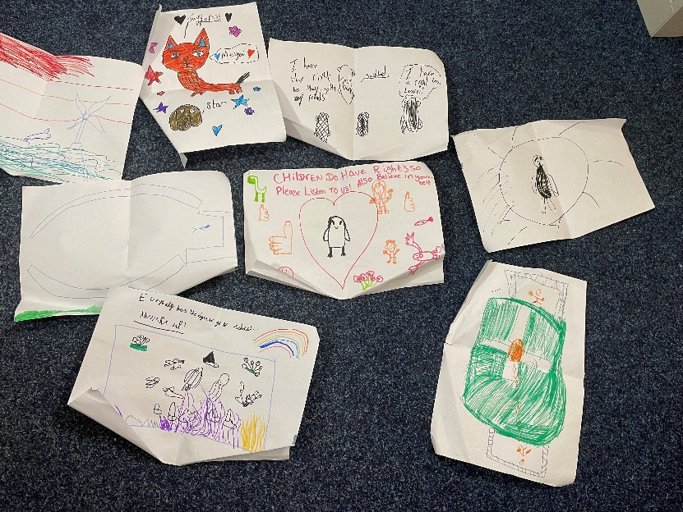

(Young people’s drawings during a UNCRC presentation I co-delivered)

(Assisting with a democracy celebration event with local school council members)

Contents

Section | Page/s | Title
1 | 3 | Acknowledgments
2 | 4 - 7 | National Occupational Standards for Youth Work checklist
3 | 8 -11 | Professional development plan
4 | 12 -14 | Field work supervision contract
5 | 15 -18 | Placement contract & fieldwork practice supervision contract
6 | 19 - 21 | Placement risk assessment
7 | 22 - 25 | Observation of the work placement
8 | 26 - 31 | Community profile
9 | 32 - 36 | Reflective summary of own learning development
10 | 37 - 42 | Supervisions Recordings
11 | 43 - 48 | Reflective Recordings
12 | 49 - 52 | Learning Mentor final Report
13 | 53 - | Fieldwork Supervisors final Report
14 |  | Placement hours recording Log

- Acknowledgments

Thank you

To those who have supported me with my portfolio: I especially want to thank:
Nadine Farmer – Placement Supervisor & Senior Youth Worker, Pembrokeshire Youth Service.
Tim Ramsey – Learning Mentor & Senior Youth worker, Pembrokeshire Youth Service.
Bethany Roberts – Children’s and Young people’s rights officer. Pembrokeshire Youth Service.
Cindy Hunt – Visiting practice tutor, Trinity St David’s.
Alana Enoch – Assessing practice tutor, Trinity St David’s
Most importantly all of the young people who have given me their time, participation and views for me to complete this module
and to the rest of the Youth Workers within in Pembrokeshire Youth for their continued support, guidance and advice especially during the times that motivation can be hard to find.

- National Occupational Standards for Youth Work checklist

Key Area A: Work with young people and others
YW01 Initiate, build and maintain purposeful relationships with young people
(pg no’s 33, 35, 43.).
YW02 Assist young people to express and to realise their goals
(pg no’s 43,44.).
YW03 Engage with communities to promote the interests and contributions of
young people
(pg no’s ).
YW04 Develop productive working relationships with colleagues and
stakeholders to support youth work
(pg. no’s).

Key Area B: Facilitate the personal, social and educational development
of young people
YW05 Enable young people to use their learning to enhance their future
development
(pg. no’s ).
YW06 Enable young people to work in groups
(pg. no’s 43,44,45).
YW07 Encourage young people to broaden their horizons to be effective
citizens
(pg. no’s 43,44,45,46 ).
YW08 Support young people to identify and achieve aims
(pg. no’s ).
YW09 Support young people in their understanding of risk and challenge
(pg. no’s 43).
YW10 Facilitate young people’s empowerment through their active
involvement in youth work
(pg. no’s ).
YW11 Plan, prepare and facilitate activities with young people
(pg. no’s ).
YW12 Work with young people to manage resources for youth work activities
(pg. no’s ).
YW13 Support young people in evaluating the impact of youth work activities
1808776
SJYW4012
pg. 4
(pg. no’s ).
YW14 Facilitate young people’s exploration of their values and beliefs
(pg. no’s ).
YW15 Advocate on behalf of young people and enable them to represent
themselves to others
(pg. no’s ).
YW16 Enable young people to access information to make decisions
(pg. no’s 43,44,45).
Key Area C: Promote inclusion, equity and young people’s interests and
wellbeing
YW17 Work with young people in promoting their rights
(pg. no’s 45,46 ).
YW18 Explore with young people their wellbeing
(pg. no’s 45 ).
YW19 Work with young people to safeguard their own welfare
(pg. no’s 45 ).
YW20 Embed organisational policy for the protection and safeguarding of
young people
(pg. no’s 45 ,46).
YW21 Develop a culture and systems that promote inclusion and value
diversity
(pg. no’s ).
YW22 Ensure that youth work activities comply with legal, regulatory and
ethical requirements
(pg. no’s 22 ).
FUNCTIONAL AREA D: Develop Youth Work Strategy and Practice
YW23 Investigate the needs of young people and the community in relation to
youth work
(pg. no’s 26,27,28,29,30 ).
YW24 Evaluate and prioritise organisational requirements for youth work
activities
(0)
YW25 Influence and develop youth work strategies
(0)
1808776
SJYW4012
pg. 5
YW26 Identify and secure funding and resources for youth work
(0)
YW27 Facilitate and engage young people in the strategic development and
delivery of youth work
(pg. no’s ).
YW28 Work in partnership with agencies to improve opportunities for young
people
(pg. no’s 45, 46, 47).
YW29 Monitor and evaluate the quality of youth work activities
(pg. no’s 32,37,38,39).
FUNCTIONAL AREA E: Develop, lead and manage self and others
YW30 Work as an effective and reflective youth work practitioner
(pg. no’s 37,38,39,40,41 ).
YW31 Provide youth work support to other workers
(pg. no’s 37, 43).
YM32 Involve, motivate and support volunteers
(0)
YW33 Promote equality of opportunity and diversity in your area of
responsibility
(0)
YW34 Develop structures, systems and procedures to support volunteering
(0)
YW35 Manage your own resources and professional development
(0)
YW36 Provide leadership for your team
(0)
YW37 Allocate and check work in your team
(0)
YW38 Recruit, select and keep colleagues
(0)
YW39 Provide learning opportunities for colleagues
(0)
YW40 Make sure your own actions reduce risks to health and safety
1808776
SJYW4012
(Pg no 43, 19,20,21)
(0)
YW41 Ensure health and safety requirements are met in your area of
Responsibility
(Pg no 43, 19,20,21)

- Professional development plan

PROFESSIONAL DEVELOPMENT PLAN
For completion by the student after consultation with the Learning Mentor and Fieldwork Supervisor at the outset of the Placement
Student | Sean Seymour-Davies
Learning Mentor | Nadine Farmer
Placement | Children and Young People’s Rights Office
Date | 18/11/22

Students will be expected to consider their placement experience to demonstrate competence in the key aspects of youth work outlined in the table below based on the National Occupational Standards for Youth Work (CLD Standards Council Scotland, 2019) and the Youth Work in Wales: Principles and Purposes Document (YWWRG, 2018).
Learning Mentor’s/mentor’s opening comments about the placement – exactly what type of work will the placement involve?
Sean will be supporting the work of the CYPRO team. Please see induction pack.

The placement will include:

- Going to deliver session on the UNCRC in secondary schools
- Supporting the work of the youth councils/forums and Pembrokeshire Youth Assembly
- Supporting any events that CYPRO is facilitating
- Supporting special interest groups
- Delivering training to young people

The placement will be held at different locations across the county. Sean will be supported by the Children and Young People’s Rights Officer and Children and Young People’s Right Officer Youth Worker.

Student initial comments about the Placement.
I am eager to further develop my skills and knowledge around children’s and young people rights. The UNCRC is a large document with many articles which can be difficult for young people to understand. I wish to learn about the creative learning methods/styles used by Youth Workers, which can help young people learn about their rights and ensure that their views and voices are heard.

PROFESSIONAL DEVELOPMENT PLAN
Please note that at Level 4 we expect students to be assisting a professional youth worker, assisting development, delivery, supporting youth work activities. Please complete the form electronically to enable the boxes to expand, ensuring you provide adequate detail.

 | 1. Work in accordance with the 5 pillars of Principles and Purposes of Youth Work in Wales (YWWRG, 2018) (Educative, Expressive, Participative, Inclusive, Empowering). | 2. Facilitate the personal, social and educational development of young people | 3. Promote inclusion, equality and young people’s interests and wellbeing | 4. Work with young people and others
What do you need to learn? | Observe  How these principles and purposes are being put into practice when delivering sessions with young people.  Observe and assist Qualified Youth work staff with running sessions in the Children’s and young people rights s team.  Develop bilingual accredited activities valuing the use of the Welsh language  Inclusive - Enabling young people to develop knowledge understanding and positive attitudes and behaviour in relation to language and the value of one’s own and other languages. | Explore and develop ideas that allow informal education sessions to take place for young people.  Assist with developing accredited opportunities for the personal, social and educational development of young people.  YW 05 Enable young people to use their learning to enhance future development. | The importance of making sure that all young people have the opportunity to take part in activities, feeling included and have the opportunity for their views/voice to be heard.  Work on a 1:1 basis with young people on a range of issues  YW 18 Explore with young people their wellbeing.  YW 22 Ensure that youth work activities comply with legal, regulatory and ethical requirements. | Learn about the different settings that a Youth Work approach can be used to engage and support young people.  YW 04 Develop productive working relationships with colleagues and stakeholders to support youth work.
Activities you will learn from (how will you learn, what will you learn from)

Student | Sean Seymour-Davies
Supervisor | Tim Ramsey
Date | 20/06/2023

- Fieldwork Practice Supervision Contract

Practicalities | - Supervision sessions to last 1hr  - Face to face supervision where possible or via Teams meeting if this is more suitable.  - No answering phones during session. Sessions should not be interrupted unless essential. If a situation occurs and either supervisor or supervisee has to leave, session to be reconvened at earliest opportunity.
For example - timing, frequency, place, what are reasonable interruptions.
Boundaries | - General catch up covering work, home/work balance, positives and any difficulties/frustrations if applicable.  - All areas discussed will remain confidential unless there is an issue that needs to be passed on.  - 10 mins at the start of each session to discuss/vent before moving on to reflections and placement discussion.
What can be discussed, what cannot, confidentiality, how will gossip be dealt with.
Working together | - Answers will not be given by supervisor instead will explore pathways where supervisee can find their own answers.  - Supervisor will challenge ideas where applicable to offer balance to the discussion and encourage supervisee to explore ideas further.  - Use supervision to unpick ideas and thoughts and explore them further relating to experiences and theory.
Sharing expectations, what the focus of the relationship will be, hopes and fears, the ethos of the supervision.
Session Format | - Supervisee to bring 2 written reflective recordings to each supervision session.  - Face to face sessions where possible.  - Tea/coffee and biscuits.
What will each session be like? Will all the time be spent on one incident; are supervisees expected to bring written recordings or verbatim accounts?
Organisational & Professional context | - Confidentially with regards to discussions unless a safeguarding matter occurs.  - Time keeping and keeping n track with discussions (avoid going off on a tangent).  - Professionally challenge each other’s views where applicable.
Expectations, fitness to practise, responsibilities on supervisor and supervisee, professional and ethical boundary discussions.

Signed (supervisee) S S-Davies Date: 11/12/22
Signed (supervisor) T Ramsey Date: 11/12/22

- Placement Contract & Fieldwork Practice Supervision Contract

FIELDWORK PLACEMENT CONTRACT
Where possible please complete this information electronically, the text boxes will expand to contain the necessary information.
STUDENT INFORMATION
Student Name | Sean Seymour-Davies
Student Address | 5 Fleming Crescent, Haverfordwest, Pembrokeshire, SA61 2SJ
Student University e mail | 2219678@student.uwtsd.ac.uk
Student DBS Status and date | 18/04/21  No convictions or records.
Additional requirements
Name of fieldwork supervisor | Tim Ramsey
Fieldwork supervisor Tel. | 07775 703602
Fieldwork supervisor e mail | Timothy.Ramsey@pembrokeshire.gov.uk

HOST ORGANISATION INFORMATION

Name of Organisation |  |  | Pembrokeshire Youth Service
Tel. |  |  | 01437 775813
Email |  |  | Youth.support.team@pembrokeshire.gov.uk
Aims/ Purpose of the Organisation |  |  | Pembrokeshire Youth provides experiences, opportunities, information and personal support for young people aged 11-25 years.
Duration of placement |  |  | Level 4 Placement: 200 hours (100 or more face to face Youth Work).
Please outline the activities expected of the student
(Use more space if necessary)

Facilities/equipment available to student
Please confirm that your organisation has in place the following procedures/policies and where the student can have access to them:
a. Equal Opportunities Policy and procedures |  |  | Yes
b. Safeguarding policy and procedures including a designated child protection officer |  |  | Yes
c. Disability Policy (please state how you will meet any special requirements noted by the student) |  |  | Yes
d. Health and Safety Policy and procedures |  |  | Yes
e. Risk assessments including significant risks identified? An example to be provided to the University. |  |  | Yes
f. Appropriate measures, informed by up to date legal requirements and public health guidance to  minimise health risks associated with COVID-19 |  |  | Yes
During induction the student will be made aware of the organization’s rules of conduct (including boundary management), practices and policies, including Safeguarding and Health and Safety (e.g. accident reporting), First Aid contact details and materials and fire procedures.

During induction the student will be made aware of the welfare facilities available during placement.
The student will be covered by your employer's liability insurance whilst on your premises and undertaking any assigned tasks.

Yes - x No
During the placement, the student will be responsible to:

Name of Learning Mentor |  | Nadine Farmer
Position |  | Children and Young People’s Rights Officer
Telephone No. |  | 07795 612917
Email |  | Nadine.farmer@pembrokeshire.gov.uk
UNIVERSITY INFORMATION

Name of visiting tutor | Cindy Hunt
Telephone Number | 01267 676767
Email address | c.hunt@uwtsd.ac.uk

Student, Learning Mentor, and Visiting Tutor to sign below:

I hereby agree to the terms and conditions outlined above

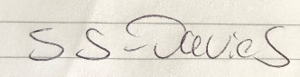
Signed (student)………………………………………………………………… Date: 18/11/22………

Signed (Learning Mentor)…N. Farmer Date 18/11/22

Signed (visiting tutor)………… Date: …18/11/22………

- Risk Assessment

Risk Assessment
Ref | Hazard / Task / Activity  Area of Concern | Person(s) at Risk | Existing Controls | RA Score  (Likelihood x Severity) | Additional Actions / Protective Measures | Actions by Whom | Actions by When | Updated RA Score  (Likelihood x Severity)
1. | Chronic lower back pain (Prolapsed L5/s1 disc) | Sean Seymour –Davies | Own standing desk and office chair with lumbar support.  Engaged with medical professionals and undertaking a strength and conditioning course.  Prescribed medication. | 5 x 2 10 | Take regular breaks from long periods of sitting to stretch and move around.  Avoid lifting any heavy items. | Sean  Sean | Ongoing  Ongoing | 5 x 1 5
2. | Minor blood clotting disorder | Sean Seymour-Davies | Under the care of hematologists in Singleton hospital. | 2 x 3 6 | Ensure he has his bleeding disorder information card on him at all times.  Make colleagues aware of the condition prior to undertaking any activities that could include physical contact (Sport, paint balling ect) | Sean  Sean | Ongoing | 2 x 3 6
3. | Taking group of Young People on a day trip to Cardiff to the Sendd then Bowling.  ( Someone falling ill on the trip).  (A young person becoming upset and absconding)  (Young people behaving inappropriately on the bus or during the activity). | Staff attending : Nadine Farmer, Sean Seymour-Davies and Bethany Roberts.  Young people attending: | All medical conditions known and consent forms signed.  Emergency contact information available for all participants attending the trip.  All young people to sit appropriately with their seat belts on.  2 x Members of staff on the bus at all times. | 2 x 4 8 | Discussion/expectations regarding behavior to be had with the group prior to leaving.  All staff members to be given copies of the Young Peoples emergency contact number and to be made aware of any pre existing medical conditions. | Nadine, Beth and Sean.  Nadine | 27/01/23  27/01/23 | 2 x 3 6
4.
5.

Risk Assessment Matrix
Likelihood | 5 | 5 | 10 | 15 | 20 | 25
Likelihood | 4 | 4 | 8 | 12 | 16 | 20
Likelihood | 3 | 3 | 6 | 9 | 12 | 15
Likelihood | 2 | 2 | 4 | 6 | 8 | 10
Likelihood | 1 | 1 | 2 | 3 | 4 | 5
 |  | 1 | 2 | 3 | 4 | 5
 |  | Severity

Likelihood
- = Rare – Highly unlikely to occur
- = Unlikely – Not likely to occur in normal circumstances
- = Possible – May occur at some point
- = Likely – Expected to occur at some point
- = Almost Certain – Expected to occur regularly throughout
Severity
- = Not Significant – Minor injuries or discomfort. No medical intervention.
- = Minor - Injuries requiring basic first aid. Temporary injury or discomfort.
- = Moderate - Injuries requiring medical intervention.
- = Major - Injury or illness resulting in serious consequence.
- = Fatality – Injury or illness resulting in death.
Score Rating
1 – 9: Low
10 – 15: Medium
16 - 25: High

- Observation of the Work Placement

Pembrokeshire Youth Service -

Is an organisation that sits within the education department of Pembrokeshire County Council. The service mainly operates from County Hall which is located within the town centre of Haverfordwest. However it also utilises a range of other buildings around the County to work with and provide opportunities to young people aged between 11-25. The service aims to provide new experiences, information, advice, non-formal and informal educational opportunities to enhance the personal, social and political development of young people based on a voluntary relationship (Pembrokeshire.gov.uk 2023).
The service employs many Youth Workers divided up into small teams delivering different forms of Youth and Community work to young people across the County, working within a multi-agency approach they link with a host of other services which include many aspects of statutory services and the voluntary sector to achieve the best outcomes for young people.
A brief over view of each Youth Work team
Community Team – offers universal access to opportunities to young people through community activities/Youth clubs. They work in partnership with members of the community and encourage young people to become active citizens and make a contribution to their local environment. This team provides 9 open access Youth clubs scattered around Pembrokeshire that offers young people an opportunity to socialize with their friends, try new activities, go on residential trips, assist with delivering accredit programmes such as Sports leadership, Senior Youth club member training and Duke of Edinburgh.
Youth Support Team – This team includes two substance misuse support workers, The Children’s and Young People’s Rights of office and the Youth Homelessness prevention workers.
The Youth homelessness service aims to raise awareness via presentations in schools, work in a preventative manner and educate young people around the skills required to live independently as they transition into adulthood. The team offers floating support to young people in a new tenancy to help sustain this or if they are presenting as homeless and need support to address the complicating factors that have led them to it. The service also offers three supported accommodation properties that can be accessed by young people as a stepping stone on their transition to full independence. Core Youth work principles can lend themselves kindly to this project by allowing us to re-build trusting relationships with young people who may feel let down by other trusting adult relationships in their lives, which has factored into relationship breakdowns. Youth work aims to empower young people to express themselves in a manner that is inclusive for all. This then enables the young people to actively participate in the support on offer, which in turn then educates the young people to learn the skills required to live independently as well as address some of the factors that had led towards them becoming homeless.

Substance misuse support workers – Work in partnership with the whole Youth service and other agencies such as the police, schools and Choices drug and alcohol misuse organisation to support young people with harm reduction strategies around their use of substances. The aim is to educate and support users and their families around risk and harm reduction.

Outreach Team – Work with a more targeted approach with young people that are no longer in any form of education, training or employment. They work towards building relationships with young people and helping them towards achieving employment or training opportunities. They also provide support to young people that have been identified by an education provider as at risk of disengaging. They undertake activities and residential trips with aim of building young people’s confidence and self-esteem which can often be seen as barrier when disengaging from education, training or employment.

Youth Justice Team – Work with a variety of multi agencies to try and prevent/reduce youth offending. Through a prevention programme they offer alternative opportunities to support young people who have been engaging in offending behaviour through a restorative justice approach. They aim to implement Youth Work values with regards to relationship building and engaging with young people, despite being a statutory service often instructed by the court to work with young people and their family.

School based Team – Each secondary school in Pembrokeshire has its own school based Youth Worker who can offer informal education opportunities within in a formal environment that can sometimes be overwhelming for some Young people. They deliver accredited programmes like the Prince’s Trust and Duke of Edinburgh award.

Since the authors time within Pembrokeshire Youth, it has granted opportunities to co-work alongside and learn from Youth Workers within the smaller subsection teams. These teams then work within different agenda’s to support young people across Pembrokeshire, but delivering the same Youth Work values, principles and purposes ensuring that their support is inclusive and built upon the basis of voluntary participation. The author was fortunate enough to be offered a placement within the Children’s and Young People’s Rights office of Pembrokeshire Youth.
The Children’s and Young People’s rights office – The aim of this team is to lead on the delivery of participation and the rights of children and young people. The team promotes the United Nations Convention on the Rights of the Child (UNCRC) to other organisations, services and professionals, to raise awareness and ensure that they are working in a way that promotes and empowers children and young people to be aware of their rights. It also develops youth projects and local Youth forums alongside youth clubs, school councils, special interest groups and Pembrokeshire Youth Assembly. The work enables young people’s voices to be heard on a local as well as a national scale, involving them in decisions that may affect young people or the community they live in.
As part of the placement the author was tasked with co-developing a new Haverfordwest Youth forum, utilising his social capital with the young people within the community from his experience working within the local Youth club.

Word count: 974

- Community Profile

Community Profile – Haverfordwest
Introduction
This community profile will consider the community of Haverfordwest. More specifically, it will look at the overall population and will find this information for the national office for statistics to look at the most recent data. It will also explore any areas of deprivation/poverty if any, and will explore any services that are available for these identified areas for Young People. Additionally it will look at the affluent areas, so an overall view of the community demo graph can be considered. It will consider the views of some young people living in the town and highlight some of the area’s that they have identified as missing within their community.
According to Haverfordwest Town Council (2021), Haverfordwest is the County town of Pembrokeshire which is rich with historic buildings, cultural heritage and boasts several riverside walks and large green areas. The town council consists of 17 councillors who are elected for a four year term in office to oversee their ward. The town has been divided into five electoral wards which are the Garth Ward, Priory Ward, Castle Ward, Prendergast Ward and Portfield Ward.
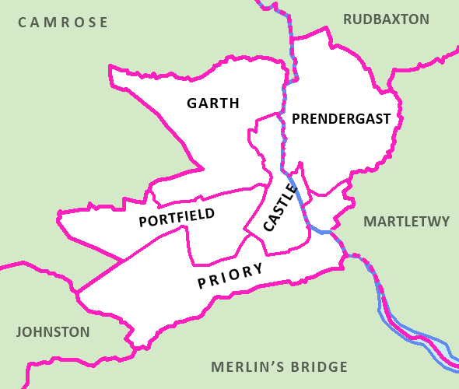 Haverfordwest Castle (Electoral ward)

The most recent population date available indicates that in 2021 there were 14,899 people living in Haverfordwest (City Population 2021 – Census).

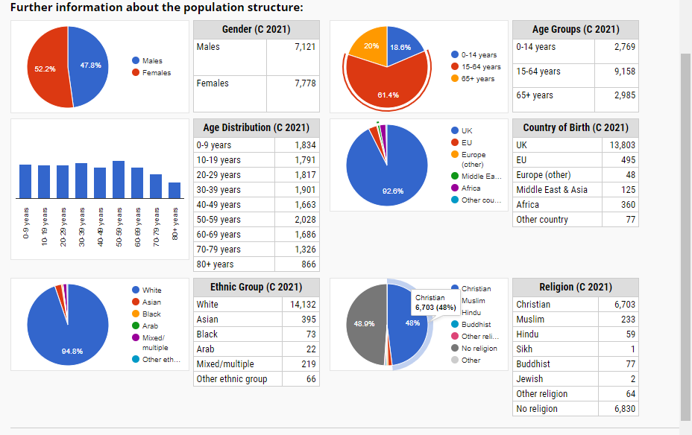

According to the Welsh Index of Multiple Deprivation (WIMD) in 2019, the Garth ward 2 is ranked number 71 out of 1,909 local areas in Wales overall which places the area amongst the 10% most deprived areas in Wales. There is little in the way of shops and services in this area of Haverfordwest. However there is a large playing park for children and Young people and a Youth Centre called the Hive run by the Garth Youth Project charity.
Alternatively in the Prendergast Ward which is ranked 1,205 out of 1,909 local areas in Wales resulting in it being placed within the 50% of least deprived areas. There is a large retail park full of shops and cafés, laundrette services, a large secondary school with a sports village complex and primary school, a butchers, hair salons, a well maintained playing park/field, vehicle repair garage, takeaway restaurants and the County hospital. Most sports clubs in Pembrokeshire utilise the training facilities in Prendergast during winter months providing everyone in the community access to sports clubs.
What resources already exist for Young People?
The Town Council oversees key areas within the community such as the Picton Community Centre which is centrally based within the centre of the town under the Castle ward. This building is a modern purpose built centre with a large hall, stage, toilets and fully equipped kitchen area. The centre has recently been leased to Pembrokeshire County Council and is now being run as a Community Youth Centre by Pembrokeshire Youth Service. The Youth Centre opens three evenings a week from 6-8pm during school term time, and week days during school holidays with a range of activities ongoing for Young People aged 11-25.
Next to the Picton Centre is a large outdoor skate park with flood lights, within a short walking distance there is a new library which has a café, art gallery, children’s area, quiet area and access to I.T/printing facilities. The town has a college offering young people an opportunity to access higher education should they wish.

Economy and Labour Market
Pembrokeshire has long been known for its reliance on tourism for employment/income due to its coastal location and scenery. Haverfordwest itself, largest employer is Pembrokeshire County Council with around 6,100 employees and its main central office/building County Hall situated within the town centre (Castle ward) provides the essential services to meet the needs of its residents and visitors (Port of Milford Haven news 2022). These services include education and schools, social services, waste and recycling, housing, leisure and Youth Services. The town also has a hospital and large supermarket chains (Morrisons, Tesco, Aldi, Lidl and Marks and Spencer) providing further opportunities for employment. The author interviewed a young person for his views on employment opportunities/prospects for young people in Haverfordwest and was given the following answer
“I have never had difficulty finding part time work within in Haverfordwest, the hospitality sector and supermarkets will often give out part time contracts to Young People, however finding a fulltime career is a far harder challenge and unless you learn a profession/trade via higher education, it’s really difficult to move on and gain full independence within the area. The cost of living is really high and the choices of affordable houses are very limited. I have found it very difficult and demoralising at times.”

The young person was then asked for his views on the town centre and a couple of the re-development projects ongoing (New multi-story car park and transportation hub currently being built).
“The town centre its self makes me sad these days as more and more shops are closing and being replaced by charity shops. Don’t get wrong I love a bargain from a charity shop but Haverfordwest town centre is now filled with them. The council is a lot to blame for this as they keep putting business rates and rent up resulting in smaller businesses having to close. Then the larger branded shops keep moving up to the retail park in Withybush. It makes me laugh that the council are spending all of this money knocking down the old multi story car park to build a new one alongside a huge new bus/transportation hub when there is nothing really much for people to see in the town centre. Also bus routes are few and far between in Pembrokeshire so what is the point in a fancy new transportation centre when they run hardly any buses.”

The author then asked the Young Person about the Areas of development they would like to see for young people within Haverfordwest?
“I was upset that the old Palace cinema closed down last year and there has long been rumours of a large new cinema being built in the town centre. Yet nothing has been happening for years, it would be nice to have a new cinema/bowling complex like the larger towns/cities tend to have. As I don’t drive myself Il be happy with the new transportation hub providing there are going to be more bus routes making the County more accessible. The main thing I would really like to see in Haverfordwest is more affordable/social housing being built so young people don’t have to face the possibility of becoming homeless I have been there and it was horrible.”

Conclusion
In recent years there has been a growing concern from community members in the Haverfordwest area, that the town has become run down, with lack of investment and little employment prospects for future generations. With Pembrokeshire having always been heavily reliant on its revenue from tourism impacted hugely over the last couple of years due to the COVID 19 pandemic. However there are positive signs of rejuvenation with some developing projects which could present new opportunities for members of its community.
The town centre is being heavily invested in, with the construction of a new multi million pound transport hub and multi-story car park hoping to make the town more accessible for all within the County who use public transport. A new library has also been built in the Town centre. There are two Youth centres running with range of activities/programmes available for Young People to access, as well as two new large Secondary schools and a College providing opportunities to learn new skills.
Word Count : 1250

References
Haverfordwest Town Council. (2021). Many voices, One Town, Heart of the Community. Available at: https://haverfordwesttown.co.uk accessed on (03/02/23)
Haverfordwest Castle (Electoral Ward). Available a at https://en.wikipedia.org/wiki/Haverfordwest_Castle_%28electoral_ward%29 accessed on (03/02/23)
City Population, Haverfordwest, Population data. Available at https://citypopulation.de/en/uk/wales/pembrokeshire/W37000361__haverfordwest/ accessed on (18/02/23)
Port of Milford Haven News. (2022). South West Wales launches free Port bid. Available at: https://www.mhpa.co.uk/news/2022/09/23/south-west-wales-launches-a-freeport-bid-consortium/#:~:text=Pembrokeshire%20County%20Council%20is%20the,housing%20and%20leisure%20and%20more. Accessed on (19/02/23)
Welsh Index of Multiple Deprivation (WIMD) 2019: results report. Available at: https://www.gov.wales/sites/default/files/statistics-and-research/2019-11/welsh-index-multiple-deprivation-2019-results-report-024.pdf accessed on (18/02/23)

- Reflective Summary of own Learning and Development

The level 4 placement with the Children’s and Young People’s rights office has been an excellent learning opportunity for me to assist and observe experienced Youth Workers within Pembrokeshire Youth service. Witnessing them and assisting with applying the core principles and values of Youth work within our practice throughout was a real highlight. The work undertaken by Nadine and the CYPRO team is incredibly inclusive and empowering for all young people that choose to engage with them via local Youth forums, Youth Assembly, Junior Safeguarding and school councils.
I observed that a massive strength of Nadine’s was being able to build trusting relationships with young people and ensuring that their voices were heard. In sessions she would regularly afford the young people the anatomy to be creative with their ideas and suggestions for community projects, safeguarding awareness raising and knowledge to enhance young people’s awareness around democracy and the United Nations Convention on the rights of a Child. Another key strength was her ability to plan sessions and events really well, something that I have identified as a weakness for myself as I tend to take too much on which impacts on my ability to manage time.
A method Nadine, Tim and I discussed, was the use of the NAOMIE (Practice resource, student Youth work online 2021) planning tool method and reflected on this as something I could utilise when developing and planning future sessions. It can then be used to critically evaluate sessions with aim of highlighting the strengths, needs of the young people, aims of the session followed by a valuation on areas that can be improved to enhance my practice. I intend to use this tool regularly moving forward.


I was able to utilise my supervisions in a positive way to reflect on sessions and experiences with young people allowing me to consider further research into theories that can help inform my practice and knowledge moving forward on my academic Journey. I utilised the Gibbs reflection tool (G.Gibbs 1970) when writing my reflective recording for supervisions which helped me unpick my feelings, any ethical dilemmas, behaviours and research further.

As part of the placement I was asked to co-develop a new Haverfordwest Youth forum, running from the local youth club. This tied in nicely with the research I had undertaken via profiling the Haverfordwest community. It was refreshing and humbling to gather young people’s views on their local community. I have found it interesting watching the Youth forum group dynamics grow and how they began working together on projects as time went on. It was here I was able to reflect on Tuckman’s theory (1965) with regards to how productive the group was becoming with regards to the project. It allowed me to unpick the group dynamics further by looking at individual members with regards to their group roles such as leadership, mediators and assertive confident members who bring the meeting back on track.
It was tricky in the beginning with establishing a new group, myself and Bethany relied on our social capitol and positive relationships we have already built with young people we know from Youth club to get the group started. The members are young and appeared to find it challenging and confusing to participate in the true purpose of Youth forum meetings. Here I was able to explore Harts ladder of participation and work out which point on the ladder the young people were at, then allowing us to adapt our sessions to help direct the group and move them along the ladder.
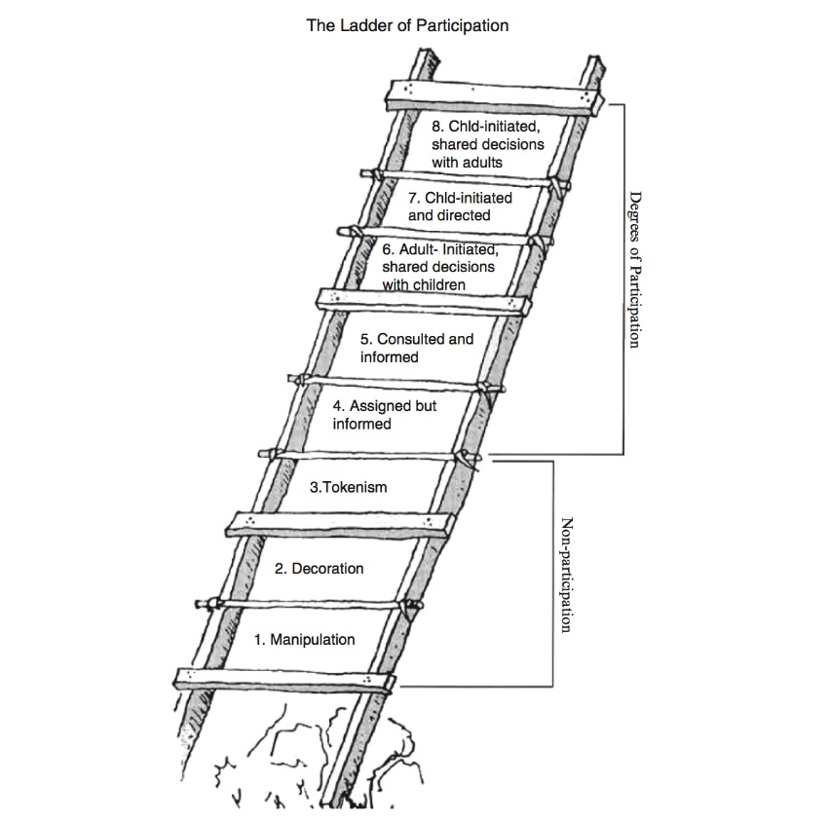

https://organizingengagement.org/wp-content/uploads/2019/07/Ladder-of-Childrens-Participation-Illustration-Roger-Hart.jpg
Allowing me to reflect that in the initial first few forum sessions, the group were at the manipulation and decoration stage of participating. As time has gone on, the group has built and established stronger relationships with themselves and us. I would say they have moved up the ladder and are at the assigned but informed stage. A key reflection here for me was asking myself that our CYPRO service sitting within the local authority can often come across decoration and tokenism when authoritive figures/elected members turn up to events involving young people and give a brief opening speech, have a quick picture then leave without providing feedback to young people. I find circumstances like this incredibly frustrating leading to ethical dilemmas, it can be difficult to challenge this when these figures are often in positons who make decisions about Youth Service funding, however you want to speak out and advocate on behalf of young people.
It was interesting to see formal school settings when I went in to co-deliver Children’s and Young people’s Rights presentations to all year groups for PSE days. One thing that stood out to me was the young people continually calling me sir, despite me asking them to call be by my name. On a few occasions informing them of their rights often sparked some heated debates between them and their teachers. One teacher even commented “You need to earn your rights”, he appeared unimpressed when I replied, ‘no in the United Kingdom you are born with them’. We were also told by teachers that we don’t que with the young people, that staff and adults go straight to the front and get their food. Despite being starving I opted to que with the young people.
Overall, my placement has been an excellent opportunity to learn and develop my Youth Work practice further. It has presented me with ethical dilemmas and challenges that I feel I have been able to reflect on. I have learned far more than I knew regarding the UNCRC and the history of democracy and the right to vote and have your voice heard. I feel it’s been an excellent opportunity to really cut my teeth into the inclusive and empowering pillars of the Youth Work in Wales principles and purposes, whilst ensuring I remain true with the educative, participative and expressive elements. There were times I was thrown into the deep end which pushed me out of my comfort zone, I was anxious and nervous at the time but have since reflected on the positives and the confidence it has given me when presenting to groups.
As an action moving forward to further strengthen my development, I feel that I need to develop my planning and preparation side of delivering sessions and ensure that I am not taking on too much with regards to my time management.
Word count : 1067

References
Gibbs’ Reflective Cycle. Novemember 11th 1970. The University of Edinburgh. https://www.ed.ac.uk/reflection/reflectors-toolkit/reflecting-on-experience/gibbs-reflective-cycle (Accessed on June 20, 2023)

PRACTICE: RESOURCE: NAOMIE. https://youthworkcentral.tripod.com/naomie.htm Website title PRACTICE | RESOURCE | NAOMIE. (Accessed June 21, 2023).

Ladder of Children's Participation. November 05, 2019 Organizing Engagement https://organizingengagement.org/models/ladder-of-childrens-participation/ (Accessed June 21, 2023)

[Tuckman, B.W. (1965). 'Developmental Sequence in Small Groups,' Psychological Bulletin, 63(6). https://www.mindtools.com/abyj5fi/forming-storming-norming-and-performing (Accessed on June 19, 2023)

- Supervision recordings

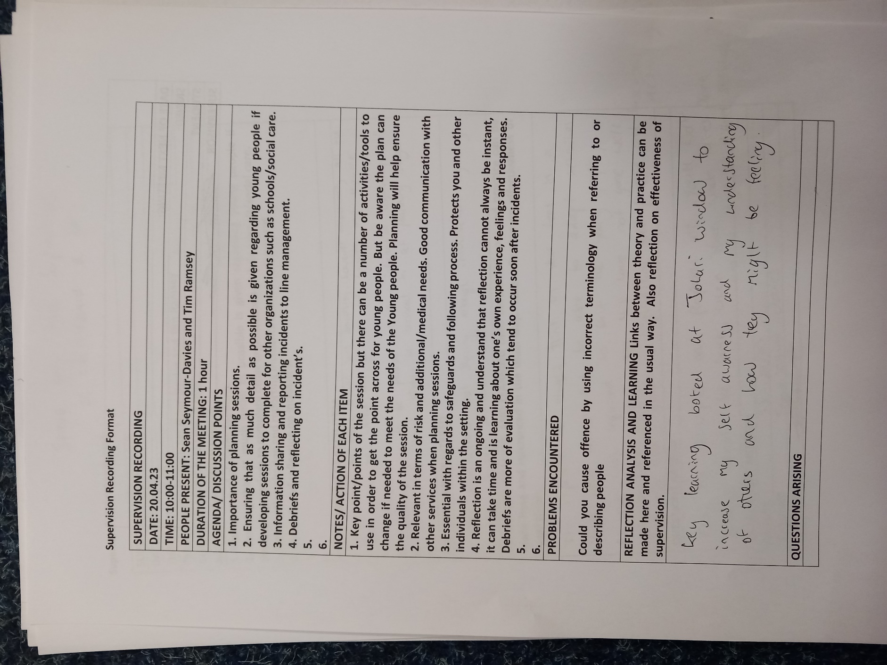

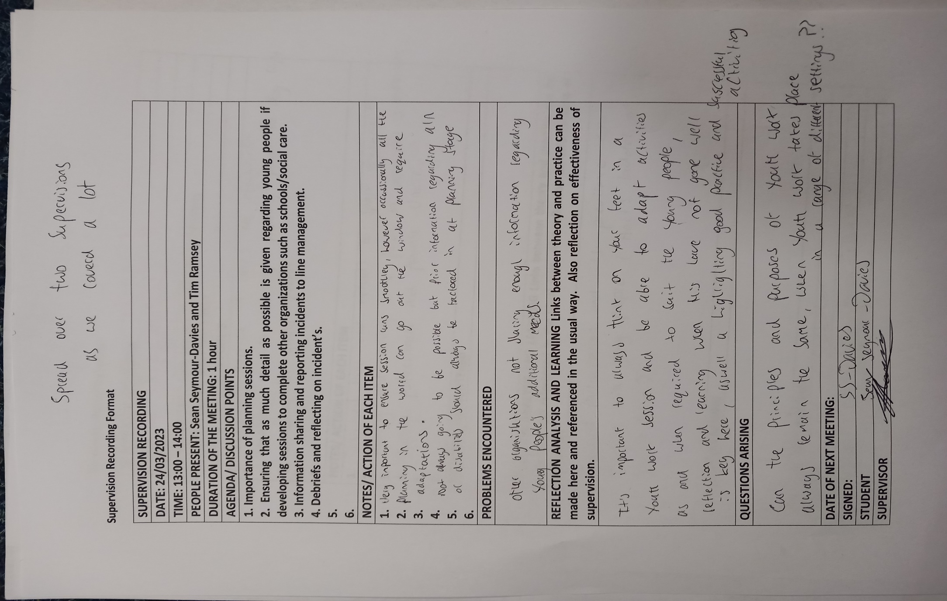

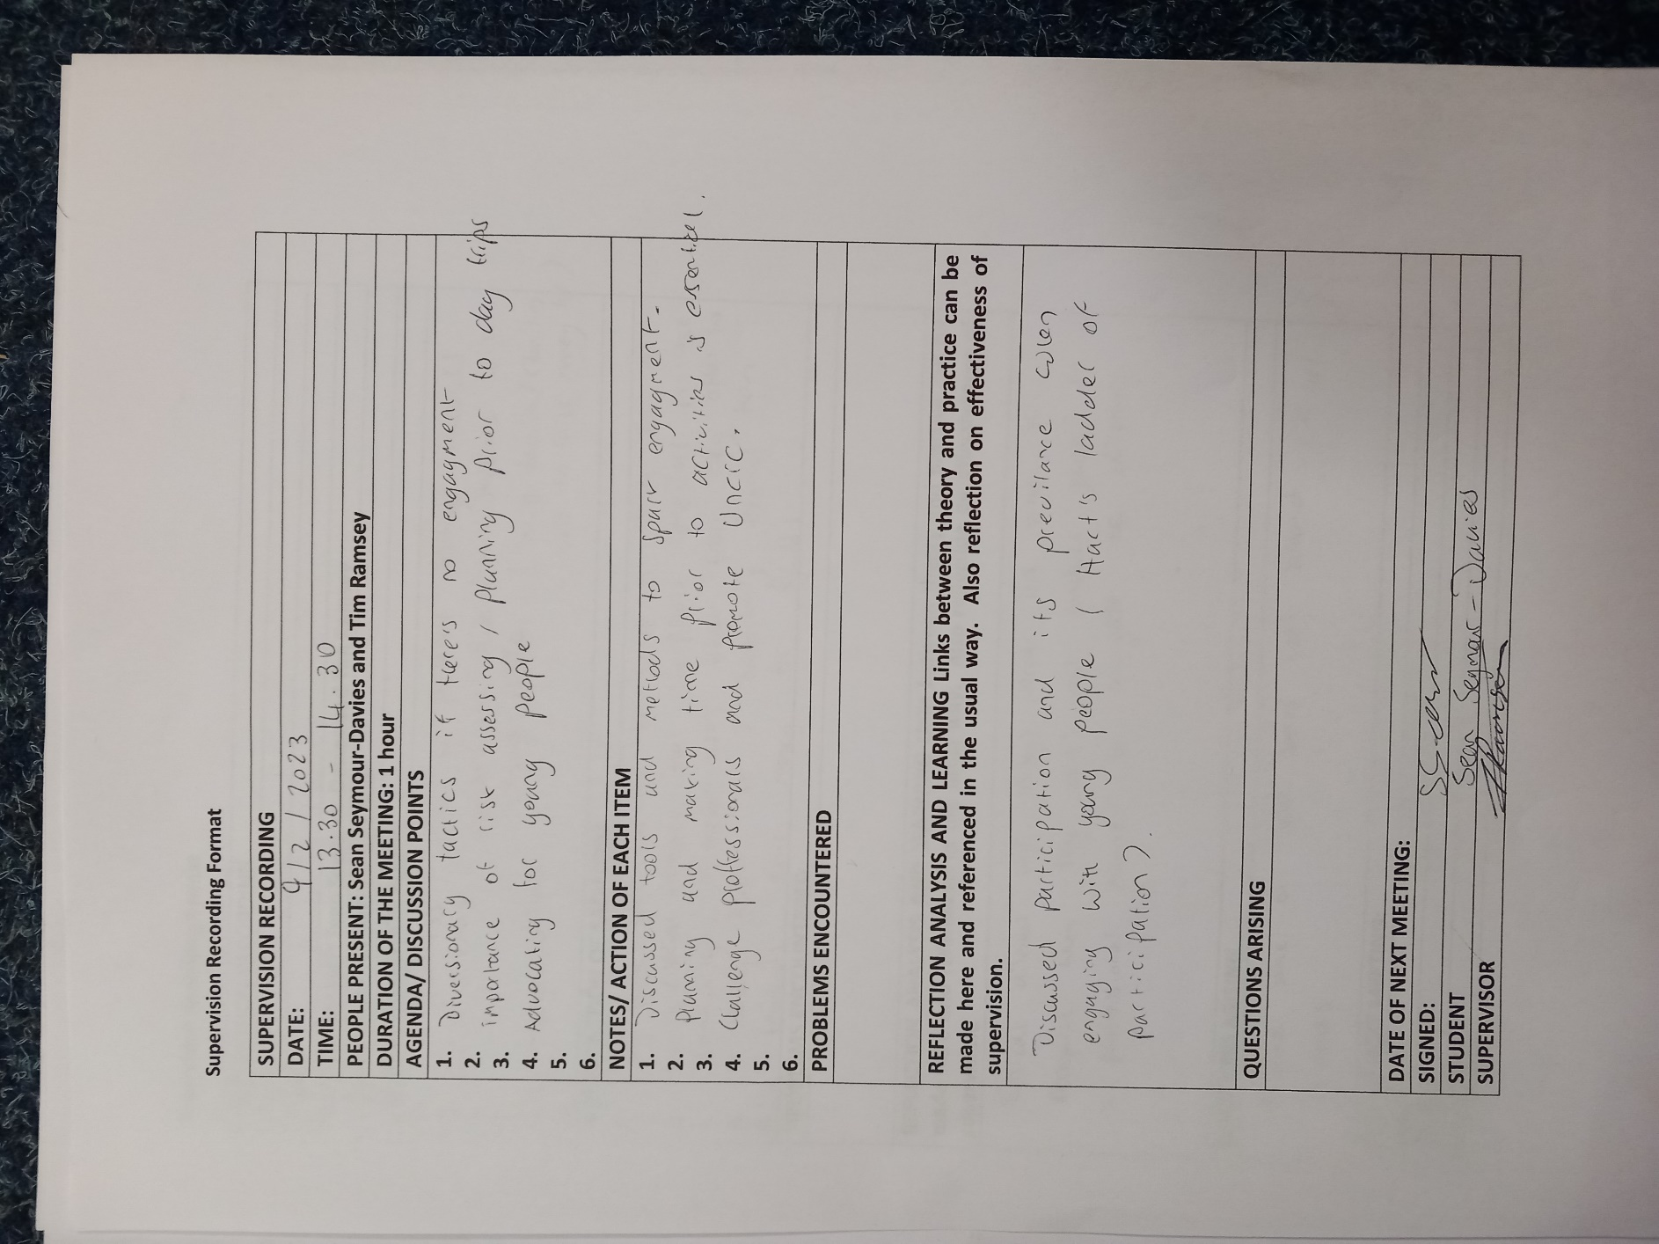

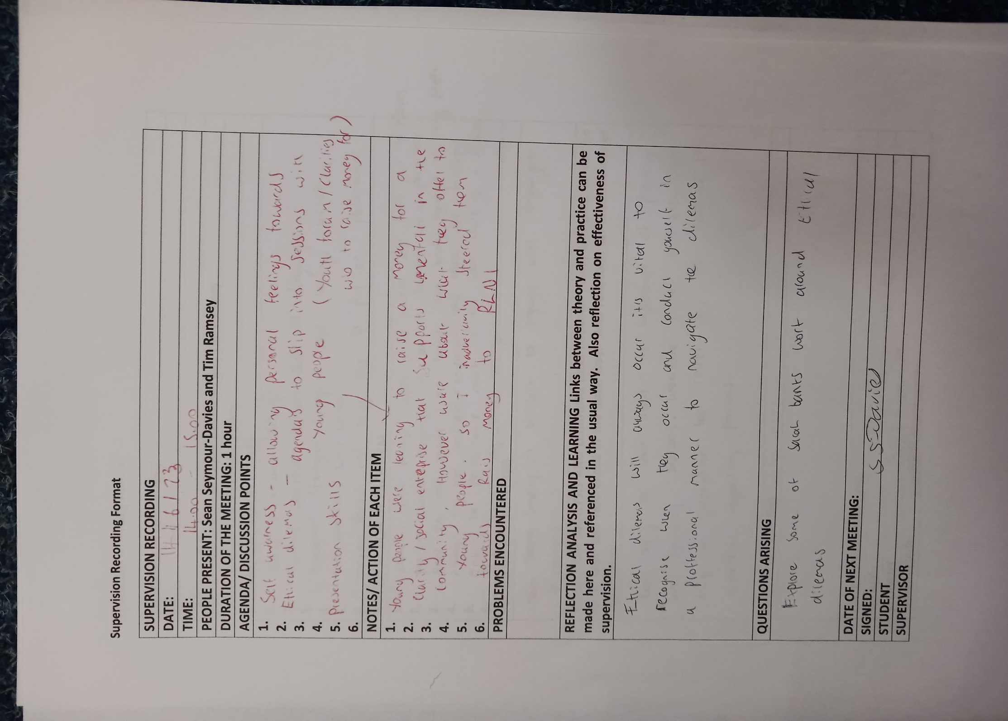
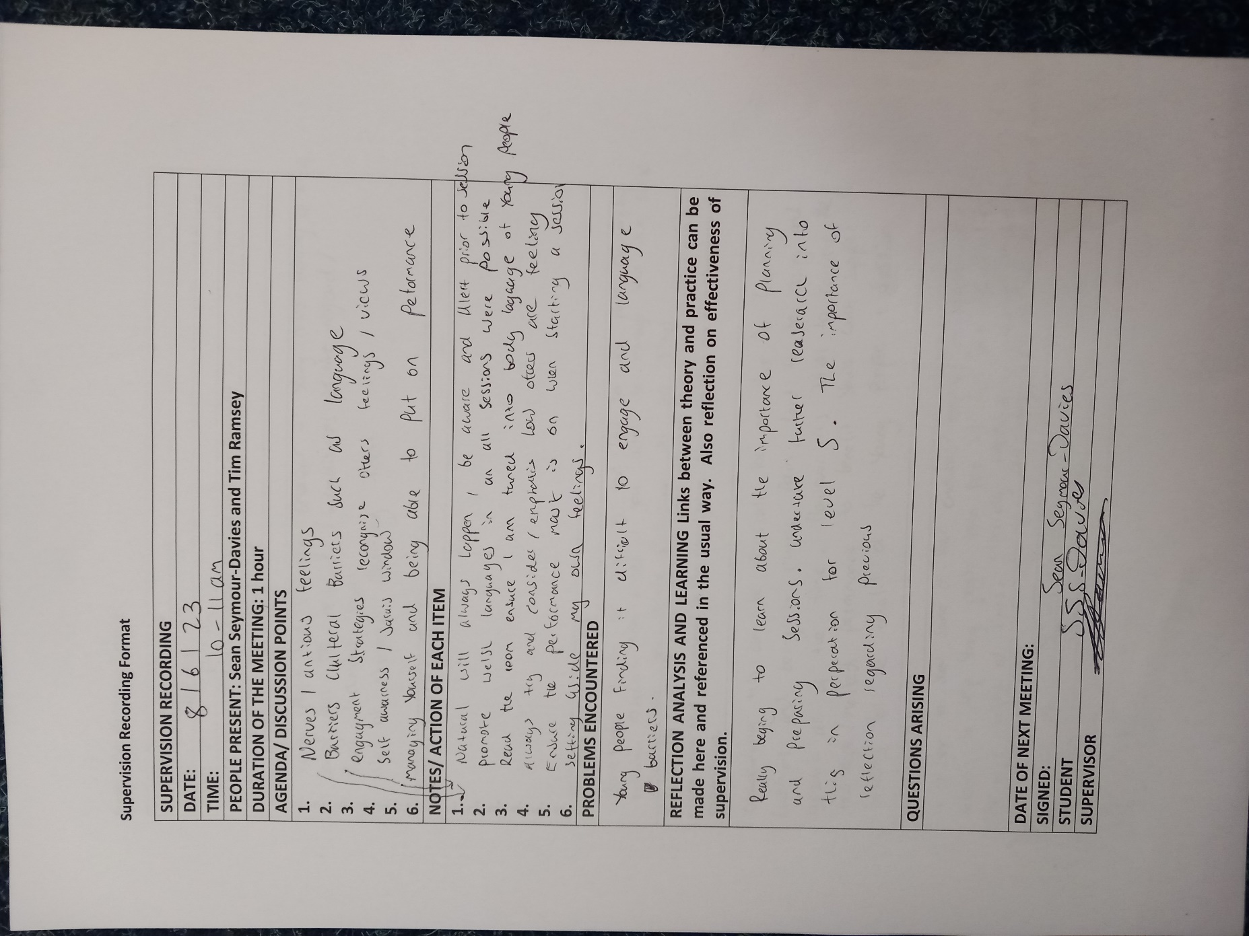

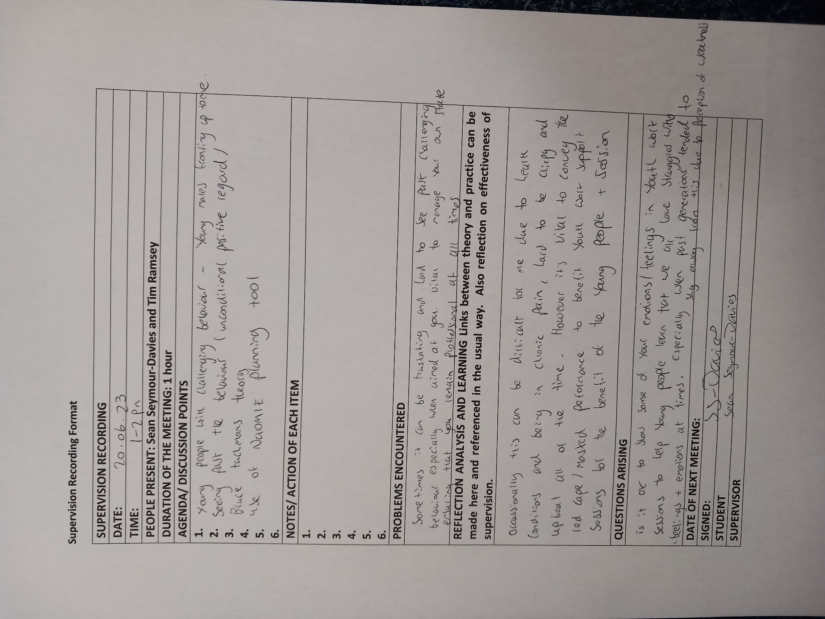

- Reflective recordings

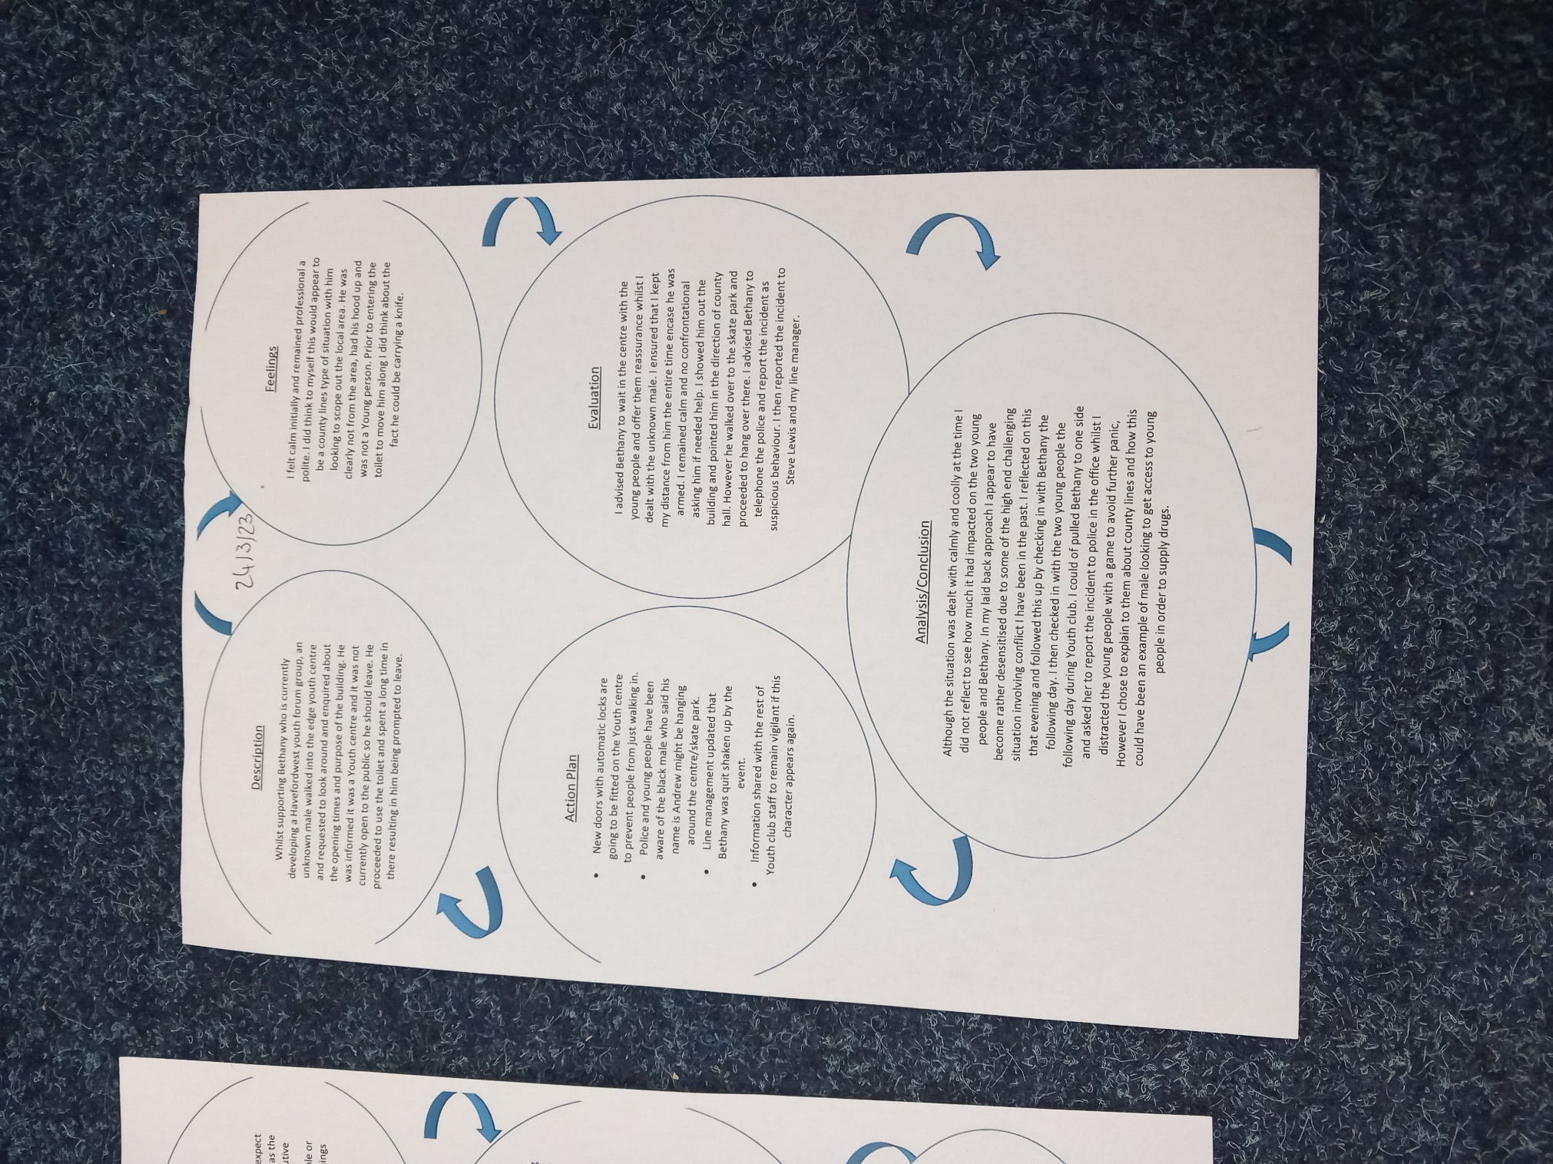

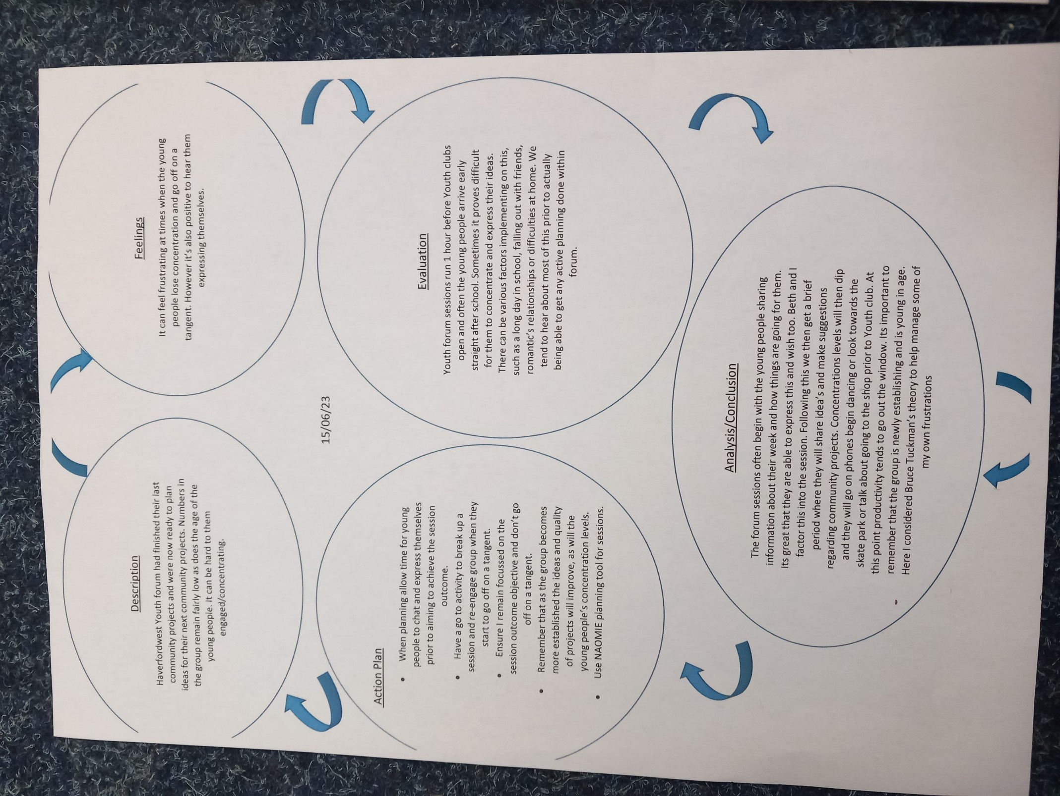

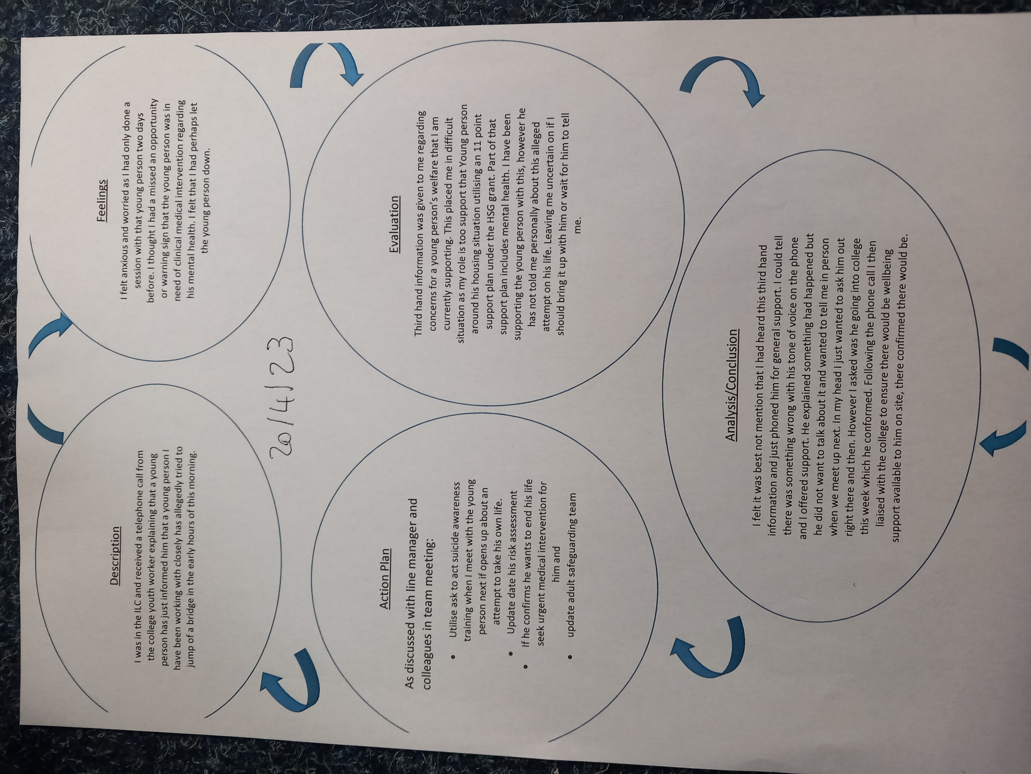

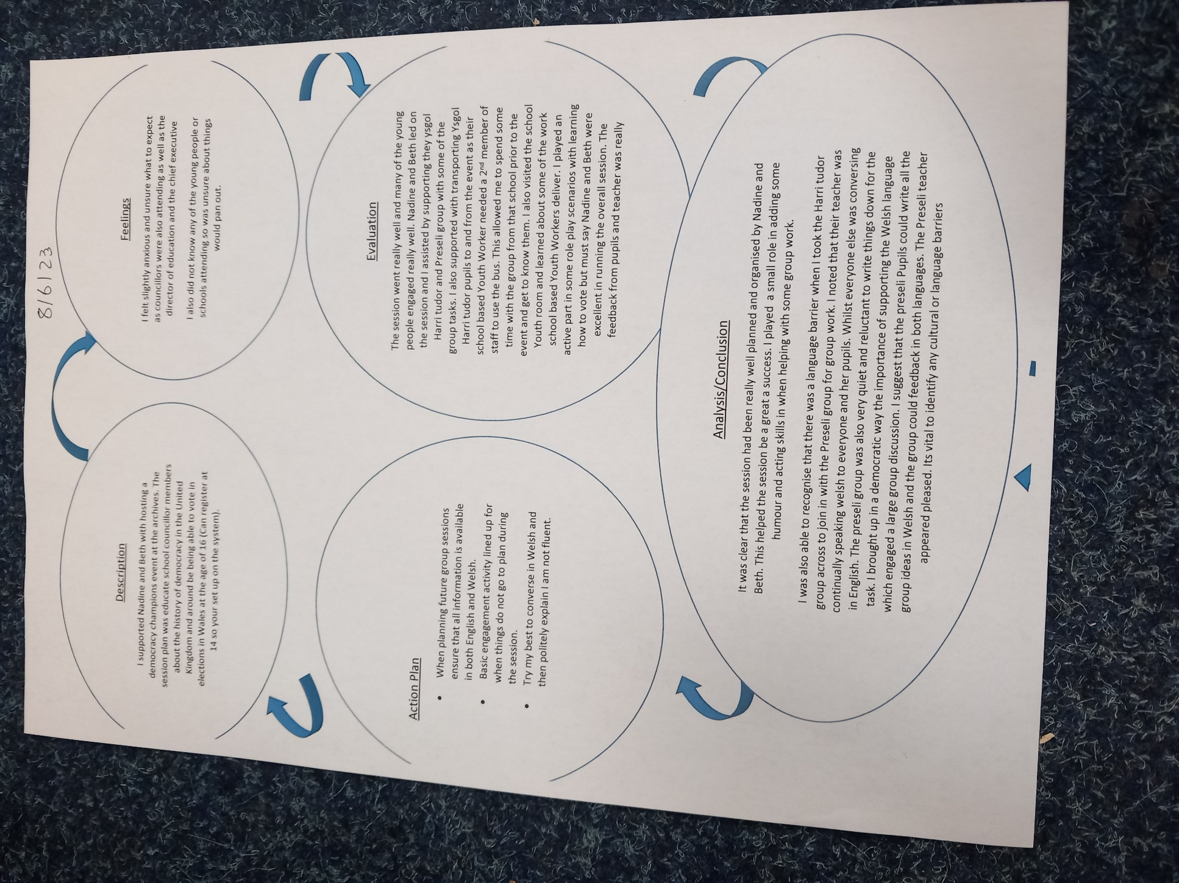

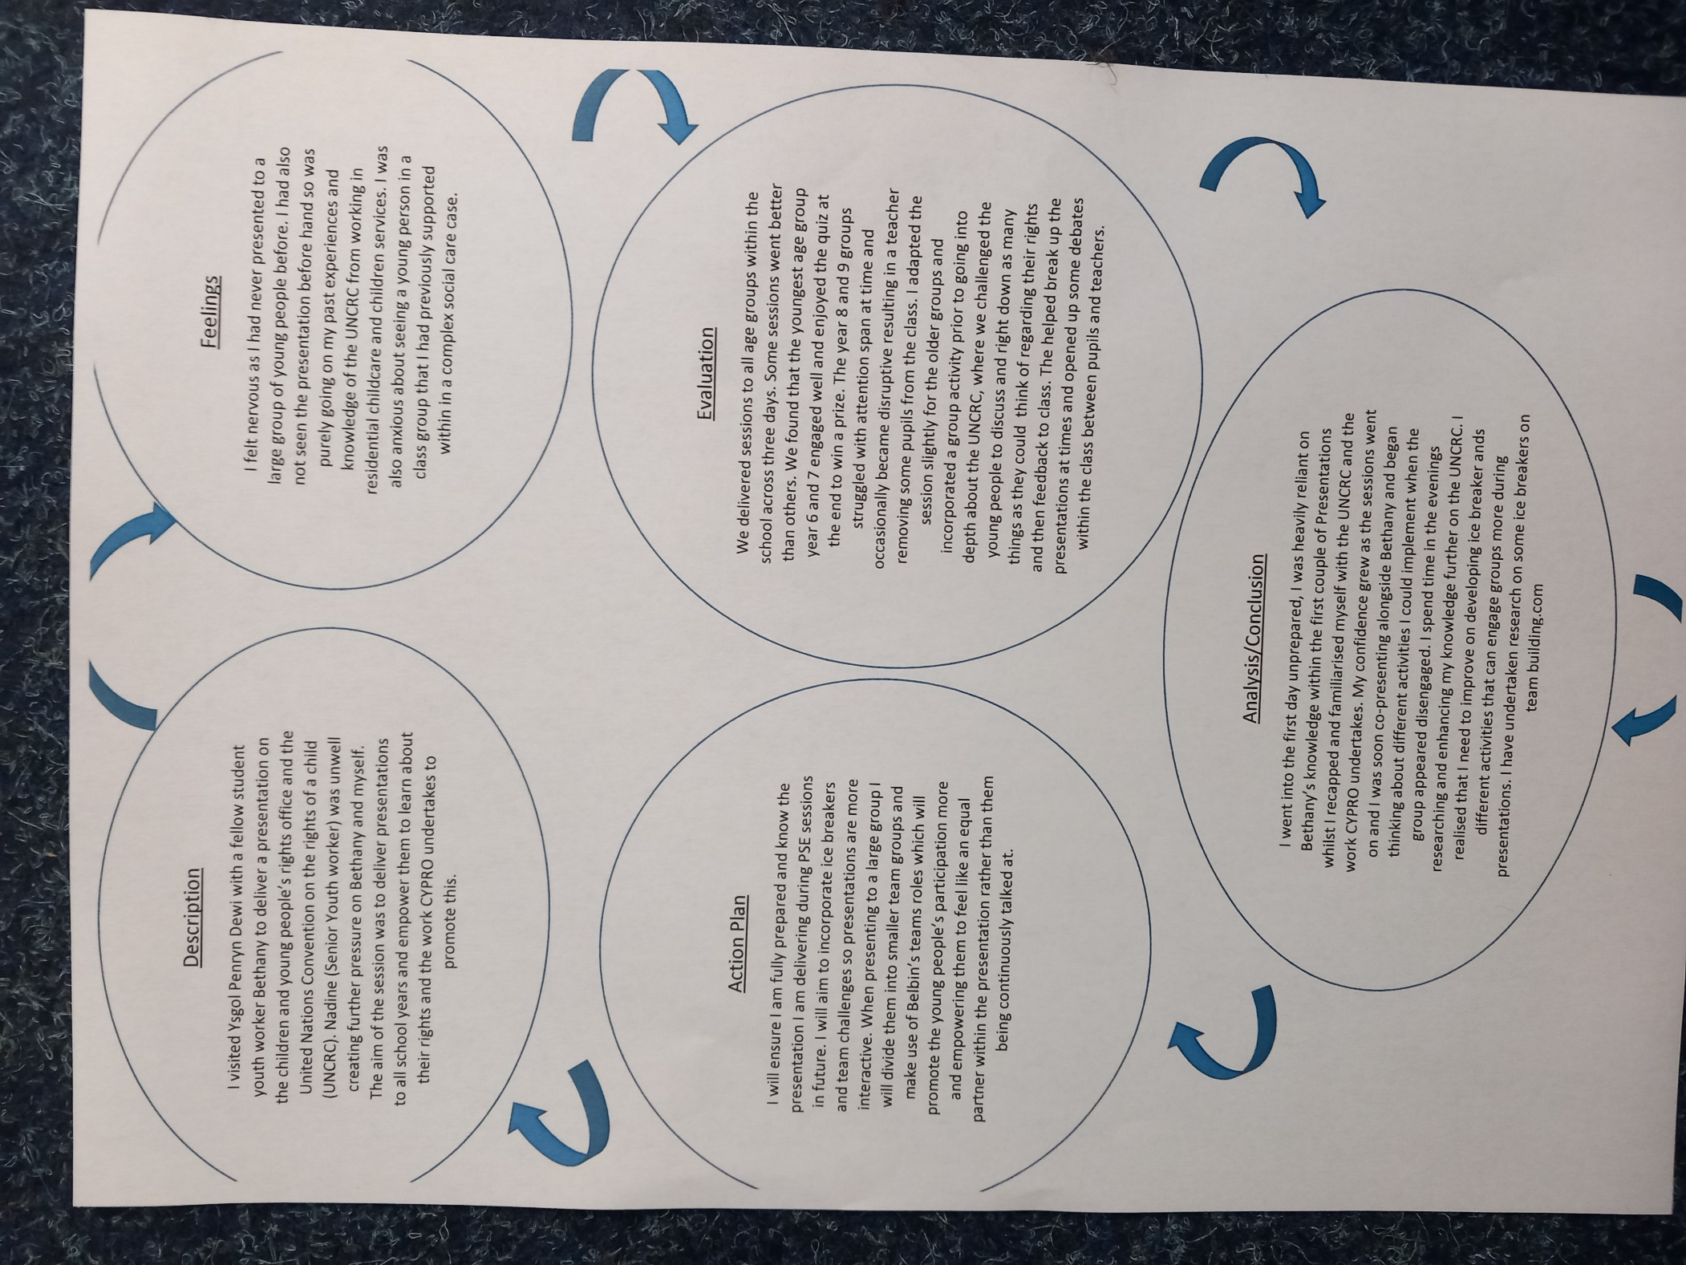

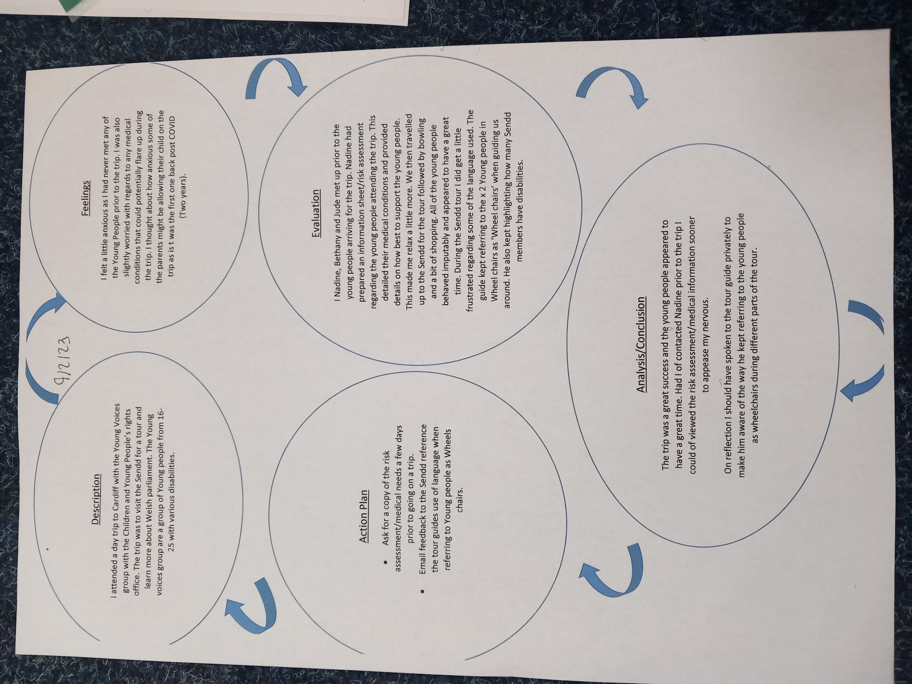

- Learning mentor final report

LEARNING MENTORS FINAL REPORT
The University would like to remind the Learning Mentor of the importance of their role in the assessment of the student. This role is fundamental in ensuring standards of practice of those working with young people in communities, and cannot be taken lightly.
To ensure the desired results are achieved, all those involved in the placement are required to understand and remain committed to the process of supervised practice. Issues of competence which might jeopardise a student’s ability to complete workplace/work based practice successfully should be identified and communicated to the visiting tutor or fieldwork coordinator as soon as possible.
After the student’s induction to the placement, the student will have drawn up a professional development plan balancing the needs of the student and the requirements of the programme. As Learning Mentor you will have carried out managerial supervision and an interim review of the placement. This document is the final report, and will include your final assessment of the standards achieved by the student on placement and an assessment of an observed piece of youth work practice.
Key areas of competence
When considering the level of competence of a student please refer to the marking criteria outlined below:
Grade Description Equivalent % marks towards HE qualification
A An exceptional trainee Youth worker who is a reflective practitioner; shows initiative and an ability to work independently for a sustained period; demonstrates thoroughness and commitment to all aspects of professional practice. 70%+
B An effective trainee youth worker who displays a degree of independence and commitment to further professional development. 60-69%
C A satisfactory trainee youth worker who has met the requirements appropriate for a professionally qualified Youth Worker and with further experience should develop into an effective youth worker. 50-59%
D A rather weak trainee youth worker with a basic level of knowledge or skill. May be very poorly organised with very limited understanding of important concepts. 40-49%
E/Fail A weak trainee youth worker who has been unable or unwilling to meet the required standard, may demonstrate inappropriate values or lack understanding or attention to detail.
Below 40%

LEARNING MENTOR’S FINAL REPORT (continued)
Work in accordance with the pillars of Youth Work in Wales: Principles and Purposes
A-Exceptional
70%+ B-Effective
60-69% C-Satisfactory
50-59% D-Rather weak
40-49% E-Weak
0-39%

Sean shows a high level of understanding regarding Youth Work in Wales: Principles and Purposes. Sean considers this when planning either group activities or individual plans with young people he is working with.

Facilitate the personal, social and educational development of young people
A-Exceptional
70%+ B-Effective
60-69% C-Satisfactory
50-59% D-Rather weak
40-49% E-Weak
0-39%

Sean was able to show that he has an understanding of learning through non-formal opportunities and ensures that there are some learning outcomes as part of the programme.

Sean is adaptable and able to change a planned session into a session that is more appropriate based on the needs of the young people. One session Sean was able to evidence this and deviating from the original plan to create a much better session for the young people who attended which resulted in much better outcomes. He had the ability to read the room and realise what we had originally planned would not be suitable for the group we had been asked to work with.

When developing or supporting youth forums you need an understanding of the young people’s level of social, personal and educational development needs. Sean shows he has an understanding of this and is able to deliver activities to promote social and educational development of young people.

Promote inclusion, equality and young people’s interests and wellbeing
A-Exceptional
70%+ B-Effective
60-69% C-Satisfactory
50-59% D-Rather weak
40-49% E-Weak
0-39%

From observing Sean during this placement you can see that the well-being of young people is always at the forefront of his planning and delivery. Sean has learnt about children and young people’s rights and gained an understanding of the importance of recognising diversity within the groups. I hope from this Sean will be able to support the development of the service that both echoes the young people’s needs whilst addressing any issues of equality.

Work with young people and others
A-Exceptional
70%+ B-Effective
60-69% C-Satisfactory
50-59% D-Rather weak
40-49% E-Weak
0-39%
Sean has only been with Pembrokeshire Youth for a short period of time and during this placement he has been able to build his relationship with others outside the Youth Homelessness Team. Sean utilises his skills well in order to build constructive relationships with both young people and staff.

LEARNING MENTOR’S FINAL REPORT (continued)
How has the student developed during the placement?
Sean has grown in confidence and knowledge during his placement. He has seen Youth Work from a different perspective which in turn has provided him with lots of opportunities out of the Youth Homelessness team. He has had the chance to develop his relationships with other members of staff and with a younger cohort of young people who voluntary engage with the work of the Children and Young People’s Rights Office.
Watching Sean grow as a practitioner has been a pleasure, he is a natural at developing relationships with young people and young people are very responsive to his approach.
What are your suggestions for further development? What would be your recommendations for the Student’s development during the Level 5 placement?
Sean needs to work on his time management skills, he takes on to much which could have become a barrier for completing his placement hours. I would recommend that Sean takes more of the lead in designing and delivering sessions for Level 5 placement. I believe working in different settings will help Sean have a clearer understanding of the wider service and develop a network of support in the team.
What is your feedback on observing the student’s planned piece of practice?
Sean’s observation was on a new developed sewing/repair group with in the ILC. Sean had worked with a young person who had expressed an interest in developing the group for other young people who were working with the Youth Homelessness Team. Sean was supporting the young person to develop this. The group is meeting on a monthly basis to sew and repair old clothing, which will then go onto a clothes rail for other young people to access.
Sean’s approach is very open and he is able to create an environment which young people feel safe. Everything was set up ready for the young people to participate and the young person was able to lead the session and teach others some basic sewing and repair skills. During the session there was some very open discussions and Sean was able to provide the young people with advice and guidance in an informal way. Sean’s communication skills with the young people is excellent, he treats them with respect and values their contribution to the session.
The planning of the session was well considered and effective which allows for the project to meet the aims and objectives.
This project is based on the voluntary engagement of the young people and will help them develop skills that are transferrable. This group is in the very early stages of development but it was clear to see the outcomes of the project will be positive for young people.
Has the student passed the placement? Please take into account your view of the student’s performance in each of the Key Aspects of Youth Work (Please circle clearly).
Yes, Pass
No, Fail
Provisional Grade: 64 %
Further Comments :
Sean’s practice is developing all of the time and his knowledge of youth work is expanding. Through completing the degree I’m sure Sean will develop the skills required to be an effective youth worker.

Signed Learning Mentor - N Farmer
Signed Student - S S-Davies
Date - 20/06/23

- Fieldwork Supervisors Report.

- Log of Placement Hours

Appendix 3: Placement Hours Monitoring Sheet
Student Name: Sean Seymour-Davies Level: 4
Learning Mentor: Placement Provider: Pembrokeshire County Council (Youth Service – Children’s and Young peoples rights office
Date | Planning Hours Completed | Learning Mentors Signature | Brief outline of Session/Experiences/Outcomes
14/11/22 | 2 |  | Met with Nadine and Beth (CYPRO) to plan placement hours and activities I could be included in with young people. Agreed that I would assist Beth with developing a new Haverfordwest Youth forum running out of Haverfordwest Youth Centre.
15/11/22 | 2 |  | Met with Nadine and Beth prior to the first Youth forum session to plan and discuss the objectives of developing a new Youth forum.
23/11/22 | 2 |  | Met with Nadine and Beth to plan PSE days coming up in Ysgol Penrin Dewi. Looked at the UNCRC presentation and spoke about some activities that could be put into the presentation to help promote engagement from the young people.
06/12/22 | 1 |  | Met with Beth prior to youth forum to plan the evening’s sessions. Local councilor attending to discuss a community project garden idea.
17/01/23 | 1 |  | Met with Beth to plan the evenings Youth forum session and objective. (Primary school leavers stationary kits to help with cost of living crisis.)
18/01/23 | 1 |  | Met with Nadine and Beth prior to a Youth Assembly meeting in the college to discuss what the Youth Assembly does and aims to achieve. Discussed idea for a consultation that captures the views of as many young people in Pembrokeshire with what they feel is the biggest issue for them requiring better levels of support from adults.
24/01/23 | 1 |  | Met with Beth to plan the evenings Youth forum session and objective. (Draft emails to primary schools about the stationary kit project for year 6 pupils about to transition into high school.
25/01/23 | 3 |  | Met with Nadine and Beth to help plan and risk access a residential trip to Cardiff with Young voices group forum
31/01/23 | 1 |  | Met with Beth to plan the evenings youth forum session.
03/02/23 | 2 |  | Met with Nadine, Suzanne and Beth to plan some activities for group of school students on a residential trip in Broad Haven to Incorporate some UNCRC training and discuss the benefits of creating a Youth Forum within in local communities.
07/02/23 | 1 |  | Met with Beth prior to Youth forum to plan the evenings session.
16/02/23 | 3 |  | Met with Nadine and Beth to discuss ideas and activities for an up and coming event (Celebration of children’s with foster care families.
21/02/23 | 1 |  | Met with Beth to plan the evenings Youth forum session.
05/03/23 | 1 |  | Met with Nadine to plan a school visit to engage pupils in having a say on matters that they feel affects their local community.
07/03/23 | 1 |  | Met with Beth prior to Youth forum to plan the evenings session.
14/03/23 | 2 |  | Assisted Beth with shopping and planning prior to our next Youth forum session that required the Young People to begin putting the stationary packs together for their project.
21/03/23 | 1 |  | Met with Beth Prior to Youth forum to plan the session.
28/03/23 | 2 |  | Met with Nadine and Beth to discuss plan for Youth forum and graffiti project alongside CWBR Youth Project.
18/04/23 | 1 |  | Met with Beth prior to Youth Forum that evening to plan the session.
25/04/23 | 2 |  | Met with Nadine and Beth to review placement hours so far, feedback and plan future sessions I could support them with.
26/04/23 | 1 |  | Met with Nadine and Beth prior a Pembrokeshire Youth bank meeting to plan the session.
27/04/23 | 2 |  | Met with Nadine and Beth to discuss and plan how I could assist them, the police, RLNI AND Tenby harbor with raising awareness about jumping/cold water swimming in hot weather.
02/05/23 | 1 |  | Met with Beth prior to the evenings Youth forum to plan the session.
03/05/23 | 2 |  | Met with Nadine and Beth prior to a Youth Bank meeting to discuss the new website design and ideas around applications and how its decided which Youth projects to fund.
09/05/23 | 1 |  | Met with Beth prior to Youth forum to plan that evenings session.
15/05/23 | 2 |  | Met with Beth to plan a trip into primary schools with Haverfordwest youth forum members to hand out the stationary kits to year 6 pupils about to transition into secondary schools.
17/05/23 | 1 |  | Met with Beth to plan a session with the junior safeguarding group.
23/05/23 | 2 |  | Met with Nadine and Beth to plan an upcoming Democracy champion’s event involving all secondary schools in Pembrokeshire and the local electorate service.
20/0523 | 1 |  | Met with Beth to plan my final session with Haverfordwest youth forum to reflect and say goodbye to the members.

Face to face hours Children and Young People’s rights office.

Date | Time | Activity
15/11/22 | 16:30 – 18:00  (1.5 hour) | Haverfordwest youth forum development, two young people present.
28/11/22 | 08:30 – 16:00  ( 7.5 ) | Children and young people rights office (UNCRC presentation and quiz). School PSE session year 6 and 7.
28/11/22 | 08:30 – 16:00  ( 7.5 ) | Children and young people rights office (UNCRC presentation and quiz). School PSE session year 8 and 9.
28/11/22 | 08:30 – 16:00  ( 7.5 ) | Children and young people rights office (UNCRC presentation and quiz). School PSE session year 10 and 11.
06/12/22 | 16:30 – 18:00  (1.5 hour) | Haverfordwest youth forum development, three young people present and met with local town consular regarding a community garden project.
17/01/23 | 16:30 – 18:00  (1.5 hour) | Haverfordwest youth forum development, three young people present. We began drafting an email to send out to schools regarding their pencil case/stationery set idea for year 6 pupils transisition9ong into secondary school
18/01/23 | 16:30 -18:00  (1.5 hour) | Youth assembly meeting.
24/01/23 | 16:30 – 18:00  (1.5 hour) | Haverfordwest youth forum development, three young people present. We began drafting an email to send out to schools regarding their pencil case/stationery set idea for year 6 pupils transisition9ong into secondary school
27/01/23 | 08:00 – 20:00  (12 hour) | Trip to Cardiff to visit the Senedd with the young voices group forum.
31/01/23 | 16:30 – 18:00  (1.5 hour) | Haverfordwest youth forum development, three young people present. We pricing up the items online for year 6 leavers
04/02/23 | 11:00 – 16:00  (5 hours) | UNCRC training at Broad Haven YHA for group of students looking at developing a Youth Forum.
07/02/23 | 16:30 – 18:00  (1.5 hour) | Haverfordwest youth forum development, three young people present. We pricing up the items online for year 6 leavers
18/02/23 | 10:30 – 16:30  ( 6 hours ) – 49.5 to date | Celebration of Children’s rights even with Foster Care Families.
21/02/23 | 16:30 – 18:00  (1.5 hour) | Haverfordwest youth forum development, three young people present. We pricing up the items online for year 6 leavers.
06/03/23 | 12:00 – 14:00  (2 hours) | I helped in Haverfordwest high school asking young people to fill out a ballet form consultation on what young people find to be the biggest issue for them in Pembrokeshire.
07/03/23 | 16:30 – 18:00  (1.5 hour) | Haverfordwest youth forum development, three young people present. We pricing up items for the pack by walking around local stationary shops.
14/03/23 | 16:30 – 18:00  (1.5 hour) | The items were bought so we began putting together the stationary kits ready to be donated to the pupils.
21/03/23 | 16:30 – 18:00  (1.5 hours) | Began putting together some of the stationary packs with the Haverfordwest youth forum.
28/03/23 | 16:30 – 20:00  (3.5 hours) | Supported the Youth forum members to participate in the CWBR Youth Graffiti Project.
18/04/23 | 16:30 – 18:00  (1.5 hour) | Hwest youth forum we put together the stationary kits for year 6 pupils moving up to secondary school
26/04/23 | 4pm-6pm  (2 hours) | Pembrokeshire Youth bank meeting, website designing with the young people.
28/04/23 | 9am – 5pm  (8 hours) | Supported CYPRO who delivering presentations to school year groups about peer pressure, alongside other agencies who were delivering presentations regarding water safety/tombstoning.
02/05/23 | 4:30 – 6pm  (1.5 hours) | Began planning ideas with Hwest youth forum for next project that can be funded by Youth bank.
03/05/23 | 4pm – 8pm  (4 hours)  Total – 86 hours | Pembrokeshire Youth bank meeting, website designing with the young people.
09/05/23 | 4:30pm – 6.pm  (1.5) | Haverfordwest youth forum, supported young people to attend local book shop to thank them for ordering supplies for the project and we had a picture outside the building.
16/05/23 | 2-6ppm  (4 hours) | Supported Hwest youth forum to visit primary schools and deliver the stationary kits to year 6 pupils. Then we returned to the youth centre to begin working on ideas for the next project.
17/05/23 | 4-6pm  (2 hours)  93.5 | Assisted a session with Pembrokeshire junior safeguarding group. Discussed ideas on raising awareness regarding sharing indecent images.
24/05/23 | 9-5pm  (8 hours) | Attended democracy champions event with CPRO and young people to celebrate and improve young peoples knowledge on democracy.
Total | 102.5 hours

