Using a Mediterranean shipwreck site, or type of archaeological assemblage, consider how this site or material can be interrogated to demonstrate maritime connectivity within (and possibly beyond) the Mediterranean region.
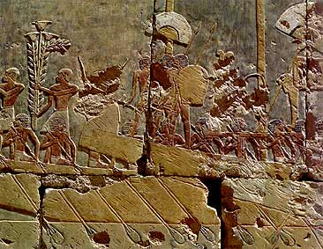
Hatshepsut’s mortuary temple at Deir el-Bahari is decorated with reliefs that have attracted scholarly attention as they represent Egypt’s connection with another area outside the Mediterranean, the Land of Punt. Throughout this essay I will endeavour to illustrate this connection by analysing the expedition to punt during Hatshepsut’s reign, accompanied with archaeological, and textual evidence from other areas.

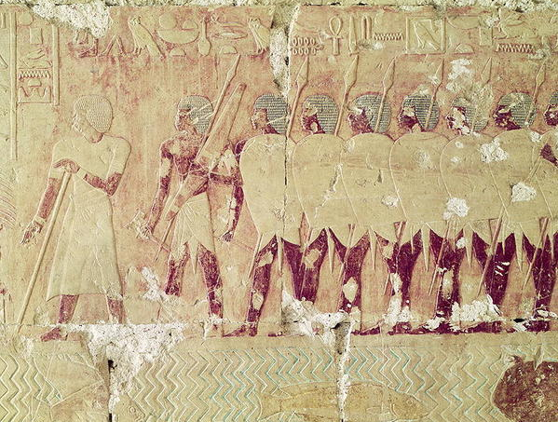
Queen Hatshepsut of the 18th Dynasty, c.1478 – 1458, believed that one way of expanding Egyptian influence “was to dispatch a fleet to “the God’s Land.”” (Creasman, 2014: 398), this feat would not only prove valuable on an economic scale but also on the political scale. Inscribed in the Queen’s temple at Deir el-Bahari is an announcement “that “a command was heard from the great throne, an oracle of the god (i.e., Amun-Re) himself, that the ways to Punt should be searched out, that the highways to the Myrrh terraces should be penetrated” (Breasted 2001b, p. 116, §285)” (Creasman, 2014: 398). Hatshepsut’s response to this command was to announce that she would send the military by land and sea to ‘the God’s land’ and although this would not be a conquest mission, it would display Hatshepsut’s ability to undertake such a venture, especially since “it was the first voyage so far afield for over three hundred years and before the Second Intermediate Period (I640-I532 B.C.)” (PHILLIPS, 1997: 429).
Figure 1: Sailors rowing to reach their destination. Relief, Deir el-Bahari, Thebes, Egypt. (Ib205.tripod.com, 2018)

The narrative of the reliefs start off with an image depicting sailors rowing in order to reach the land of punt, which can be seen in figure one. Other than this way of moving the vessel, at this time we can also observe two shapes that go upward out of view of this depiction of the punt relief, what this could possibly tell us is that other than rowing, the Egyptians employed masts at some point in their journey to keep the boat moving. Even if this relief does not tell us to whom the Egyptians are connecting to it does show that they are travelling in by ship in order to connect with another place, illustrating the maritime connectivity Egypt engaged in with Punt.
Figure 2: Soldiers ready to defend in case the people of Punt attack. Relief, Deir el-Bahari, Thebes, Egypt. (Www-bridgemaneducation-com.ezproxy.uwtsd.ac.uk, 2018)

If we move on to the next relief of this iconographical representation of Hatshepsut’s ordered expedition to Punt, we can see in figure two that the soldiers with spears and shields are in position to be ready for whatever greets them on the shores of Punt. What this could possibly tell us about this particular expedition is that relationship between Egypt and Punt wasn’t exactly concrete during this time, perhaps due to the fact that Egyptians had not been to this land in quite some time. We know that they had previous connections with the ‘Puntites’ from evidence that will be examined later.

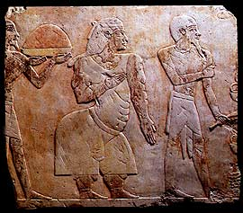
The third part of this narrative tale shows us one of the Chiefs of Punt, Parehu, and his wife coming to greet the travellers from Egypt. The text surrounding this relief, repeat this sense of plurality, that there was not just one Chief that ruled over all of Punt, but many different chiefs that held this responsibility, however only Parehu is known to us. This in a way illustrates Egypt’s connection with Punt, as they understand that hierarchical structure of the area. It is suggested by Kitchen (2009) that he was perhaps “the paramount chief along the sea-coast of Punt” (Kitchen, 2009: 5). As it is possible that this was the reason for this particular chief to greet the Egyptian sea men, he would also have been the facilitator for trade between these two regions. This would have been extremely important to the Egyptians as not only would it given them access to the products of Punt, but also the areas in which they were produced.
Figure 3: One of the Chiefs of Punt (far right), along with his wife behind him., greeting the Egyptian travellers. Relief, Deir el-Bahari, Thebes, Egypt. (Ib205.tripod.com, 2018)

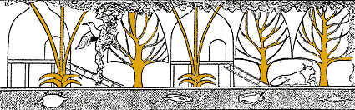
Next in the saga comes an interesting scene that shows us how the people of Punt lived, as it shows the structures in which they inhabited. What is displayed to us is that these ‘huts’, where elevated by stilts, perhaps suggesting that they were built this way in order to keep themselves safe from predators, or from what it looks like within the depiction that the water would sometimes come up right to the steps of the building. From the Egyptian use of iconography we can assume that because of the detail of this relief, in depicting the cultural aspects of the area, we can deduce that this was in fact extremely similar to the actual structures that would have been at Punt. We are able to do this as Egyptian Pharaohs took great pride in how far they could expand their kingdom, so they took great care to have the exactitudes of an area depicted accurately. So although from the reliefs we can only get the general gist of the events that occurred in Punt, it would seem that most of what was recorded were the “culturally significant highlights of the journey.” (Bochi, 2003: 55). This emphasises the connectivity between these two cultures, as the only way to know this information is to have been there, for whatever reason, trade or diplomacy or both.
Figure 4: Depicts of the ‘huts’ on punt, as well as the different trees and animals that inhabited the land. Relief, Deir el-Bahari, Thebes, Egypt. (Ib205.tripod.com, 2018)

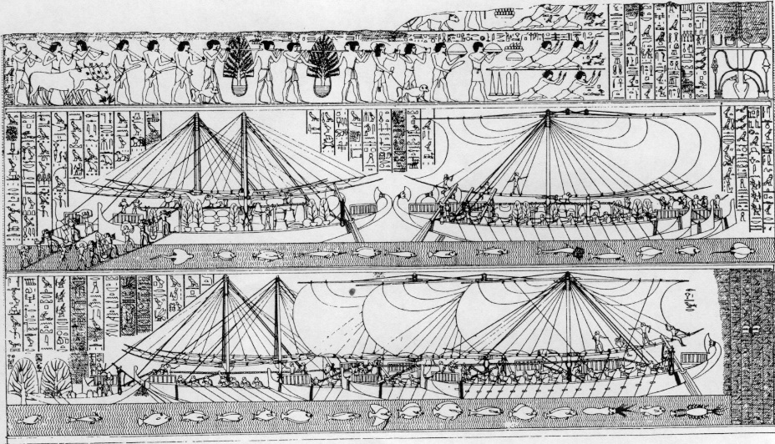
The fifth, and final image in the narrative shows us the loading process of the products acquired from punt. The loading process of the products can be seen in the middle section of Figure five, while the specific items can be deciphered from the top section of this relief. The animals traded to Egypt included “baboons, monkeys, hounds and cattle” (PHILLIPS, 1997: 430), as well as “giraffes, rhinos, ibexes, and domesticated donkeys, together with various kinds of birds” (PHILLIPS, 1997: 430). Also traded was leopard skin, ivory and gold. The trees procured included ebony, as well as other types of wood that were list, and date-palms. However, the most important of trees that were traded would have to be the incense trees that would be helpful towards temple rituals that were “central to the functioning of the Egyptian state and society at large” (Creasman, 2014: 396). It was from these aromatics, which were so essential to the running of the temple rituals, that “Punt gained its lasting fame as “the God’s Land”” (Creasman, 2014: 396). This relief also illustrates to us the “substantial nature of the Egyptian presence, and hence its importance to Egypt”, through the depiction of the five ships that were sent on this voyage, which so clearly have the sails that were suggested by analysing figure one. The depiction of the sails are also evidence that the Egyptians understood the mechanics of seafaring and perhaps had the ability to travel to other areas within the Mediterranean, as they were able to travel to Punt on the Red Sea with ease. Another image that helps with the reliability of this depiction of the expedition to punt would be the detailed fish illustrated below the ships, as explained before with the ‘huts’ depicted in figure four, the care that was taken to depict the variety of fish would suggest that these were actually seen by those that had undertaken the voyage. Again this highlights maritime connectivity, with the maritime aspect being the ships with sails, and the connectivity being the trade process occurring in the relief.
Figure 5: The loading of the trade items acquire from Punt. Relief, Deir el-Bahari, Thebes, Egypt. (Parkoffletter.com, 2018)

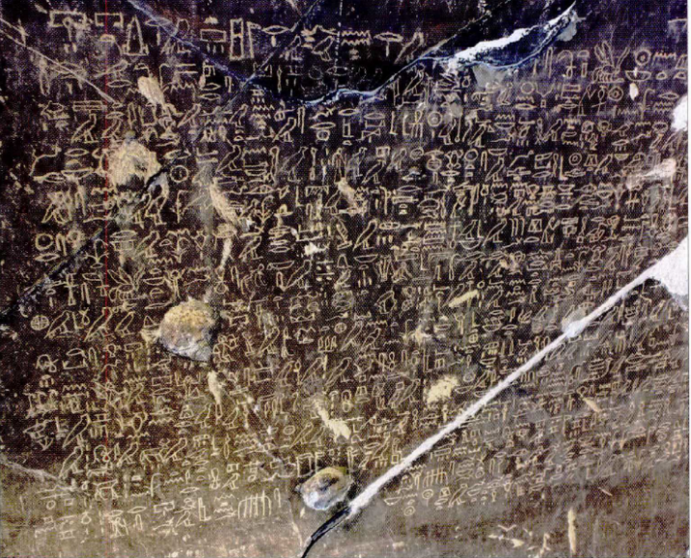
Hatshepsut’s mortuary temple reliefs are not the only evidence for connectivity between Egypt and Punt, as their connection has origins dating back to the fifth Dynasty. During the reign of the second king of the fifth dynasty, Sahure, “a large quantity of goods, including 80,000 measures of antyw, were brought to Egypt from Punt” (Creasman, 2014: 397), which is narrated to us from the Palermo stone which “preserves the earliest direct evidence of Egyptian knowledge of Punt at present (Strudwick 2005, p. 72)” (Creasman, 2014: 397). This could perhaps be textual evidence that corroborates with the depiction of a maritime expedition to Punt on the walls of the king’s causeway at Abusir. Fattovich tells us that from the time of the Old Kingdom Punt is recorded often in “Egyptian royal, private, religious and literary texts as a geographical region” (Fattovich, 2012: 2). Other textual evidence of connectivity with Punt would be the High official of Mentuhotep III’s, texts of the eleventh dynasty. The inscription left by Henu is one of the many inscriptions left by officials upon rocks in the quarries that were in the area “where the sacred bekhen stone was mined” (Bickerstaffe, 2017: 12). Henu’s inscription tells us of a journey to Punt, which starts off with the construction of the ships on the Nile that were “then dismantled and conveyed across the Eastern Desert to be reconstructed on the Red Sea coast” (Bickerstaffe, 2017: 16). The purpose of this voyage, Henu explains, is in order to bring back fresh myrrh for the king. Further evidence of the voyages to Punt before the time of Hatshepsut’s reign is illustrated in the archaeological record. This archaeological evidence comes from the site of a “Pharaonic Harbour of Mersa/Wadi Gawasis on the Red Sea” (Ward, 2012: 25) which comes in the form of cedar planks that were rotten with shipworm which provides us with the evidence that there were ancient Egyptians sailing on the Red Sea and perhaps going to and from Punt from around 2000 BC. Ward notifies us that the deposits of this area illustrate to us “that by the twelfth dynasty the Egyptians achieved regular success in launching expeditions”, which would have required lumber from the Mediterranean, illustrating other connections between Egypt and other areas of the Mediterranean. The lumber was used to build several types of ships that could be dissembled, and sailed on the Red Sea to Punt in order to bring back products that were essential for the daily running of religious institutions throughout Egypt. The measurements of the excavated timber and the dimensions that have been scaled from the Punt reliefs at Deir el-Bahari illustrate similarities between the reliefs and the finds at Gawasis.
Figure 6: “A close-up of the left-hand side of the Henu inscription taken in different light conditions, showing how well the text has survived in spite of damage to the rock surface.” (Bickerstaffe, 2017: 15)

Not only were there expeditions to Punt before the time of Hatshepsut, which illustrate the long standing connectivity between Egypt and the ‘Puntite’ tribes, there is also documentation of voyages that took place after her reign. Recorded in the Karnak Annals of Hatshepsut’s co-regent Thutmose III, are products that were received from Punt in regnal years 33 and 38. These products could possibly have been the result of trading expeditions undertaken by Egyptians to ‘the God’s land’, or could have also been the result of expeditions to Egypt undertaken by the people of Punt. Either way this is another way in which Egypt and the land of Punt’s maritime connectivity is illustrated to us.

In essence the very existence of the Punt reliefs at Queen Hatshepsut’s mortuary temple at Deir el-Bahari personify the maritime connectivity between Egypt and Punt in the 18th Dynasty. The first part of the colonnade starts off with introducing some form of maritime connectivity between Egypt and some other land through the depiction of Egyptian sailors rowing a boat. We move on to the landing party who are depicted with spears and shields, illustrating that they are unsure of what will greet them so they prepare themselves for the worse. This highlights that the connection between Punt had not been exercised for some time as the Egyptians did not know where they stood with the people of Punt. The third image treats us to a depiction of one of the chiefs of Punt, Parehu, and his wife, who greet the voyagers in hopes of beginning trade negotiations, and so this depiction exhibits the connectivity between the two regions, as for one the Egyptians understood the dynamics of the region, and the fact that the ‘Puntites’ were willing to trade with the Egyptians. This image perhaps only suggests to the fact of maritime connectivity through the fact that the Egyptians are in another land being greeted by the chief, however this is not so clear cut as it is possible to travel to Punt through use of a land route. Next we are shown another aspect of the culture of those that inhabit Punt, the fact that they live in structures that are supported on stilts. How this image highlights the connectivity between Egypt and Punt is clear, it shows us that someone has indeed been to this area of Punt, as Egyptians are either very abstract with their artistic representation of things, or they are exact in representing something as it is, or close enough to it. The last image of the relief embodies the concept of maritime connectivity, as it shows us the loading process of the products from Punt that are being traded to Egypt. Depicted to us on this particular relief is the ships that were sent to Punt, illuminating the maritime aspect, plus the fact that the Egyptians had the technical know-how when it came to seafaring, illustrating the possibility that they were able to go to other regions other than Punt, while the very fact that the Egyptians had travelled to ‘the God’s land’ exhibits the connectivity between Egypt and Punt. The evidence from before the time of Hatshepsut’s reign illustrate that the maritime connectivity between the two regions is a longstanding one, that can be backed up by both textual evidence but also material culture excavated from a pharaonic harbour on the Red Sea. Furthermore the maritime connectivity did not stop after the time of Hatshepsut but continued on after her reign, we know this from textual evidence from the Annals of Thutmose III at Karnak, which tell us of the continued trade relations between Egypt and Punt.

To conclude, the maritime connectivity between Egypt and Punt is clearly illustrated to us on the walls of Hatshepsut’s mortuary temple. This is evident from the illustration of the cultural and regional specifics that the Egyptians had observed during their expedition, as well as the depictions of the ships that had been sent on this voyage to ‘the God’s land’.

Bibliography
- Bickerstaffe, D. (2017). A Middle Kingdom Expedition to God's Land and Punt. Ancient Egypt.
- Bochi, P. (2003). Time in the Art of Ancient Egypt: From Ideological Concept to Visual Construct. KronoScope, 3(1), pp.51-82.
- Creasman, P. (2014). Hatshepsut and the Politics of Punt. African Archaeological Review, [online] 31(3), pp.395-405. Available at: https://link-springer-com.ezproxy.uwtsd.ac.uk/content/pdf/10.1007%2Fs10437-014-9160-9.pdf [Accessed 7 Mar. 2018].
- Davies, N. (1961). A Fragment of a Punt Scene. The Journal of Egyptian Archaeology, [online] 47, p.19. Available at: http://www.jstor.org/stable/3855862 [Accessed 7 Mar. 2018].
- Fattovich, R. (2012). Egypt’s trade with Punt: New discoveries on the Red Sea coast. British Museum Studies in Ancient Egypt and Sudan 18 (2012), pp.1-59.
- Kitchen, K. (2009). Ancient Polities and Interrelations along the Red Sea and its Western and Eastern Hinterlands. In: L. Blue, J. Copper, R. Thomas and J. Whitewright, ed., Connected Hinterlands: proceedings of Red Sea Project IV: held at the University of Southampton September 2008. Oxford: Archaeopress.
- Knapp, A. (1988). The History and Culture of Ancient Western Asia and Egypt. Belmont: Wadsworth Publishing Company.
- Millet, N. (1962). A Fragment of the Hatshepsut Punt Relief. Journal of the American Research Center in Egypt, [online] 1, p.55. Available at: http://www.jstor.org/stable/40000858 [Accessed 7 Mar. 2018].
- PHILLIPS, J. (1997). PUNT AND AKSUM: EGYPT AND THE HORN OF AFRICA. The Journal of African History, 38(3), pp.423-457.
- Ward, C. (2012). Sailing the Red Sea: Pharaonic Voyages to Punt and Min of the Desert. In: D. Agius, J. Cooper, A. Trakadas and C. Zazzaro, ed., Navigated spaces, connected places: proceedings of Red Sea Project V: held at the University of Exeter, 16-19 September 2010. Oxford: Archaeopress.
- Wendrich, W. ed., (2010). egyptian archaeology. Oxford: Wiley-Blackwell.

Picture Bibliography
- Www-bridgemaneducation-com.ezproxy.uwtsd.ac.uk. (2018). Bridgeman Education. [online] Available at: https://www-bridgemaneducation-com.ezproxy.uwtsd.ac.uk/en/asset/68329/summary [Accessed 8 Mar. 2018].
- Parkoffletter.com. (2018). Queen Hatshepsut of Egypt. [online] Available at: http://www.parkoffletter.com/queen-hatshepsut-of-egypt/ [Accessed 8 Mar. 2018].
- Ib205.tripod.com. (2018). Mortuary Temple of Hatshepsut. [online] Available at: http://ib205.tripod.com/hatshepsut_temple.html [Accessed 10 Mar. 2018].
- Bickerstaffe, D. (2017). A Middle Kingdom Expedition to God's Land and Punt. Ancient Egypt.

