

Student name: Khrystyna Yastremska
Student ID:2509328

Module name: Introduction to Health and Social Care
Module code: LCHS4003
Lecturer name: Oluwadamiola Tayo

Content page

Task1 ……………………………………………………………..3 page

Task2 ……………………………………………………………4-5page

References ……………………………………………………………6page
Challenges
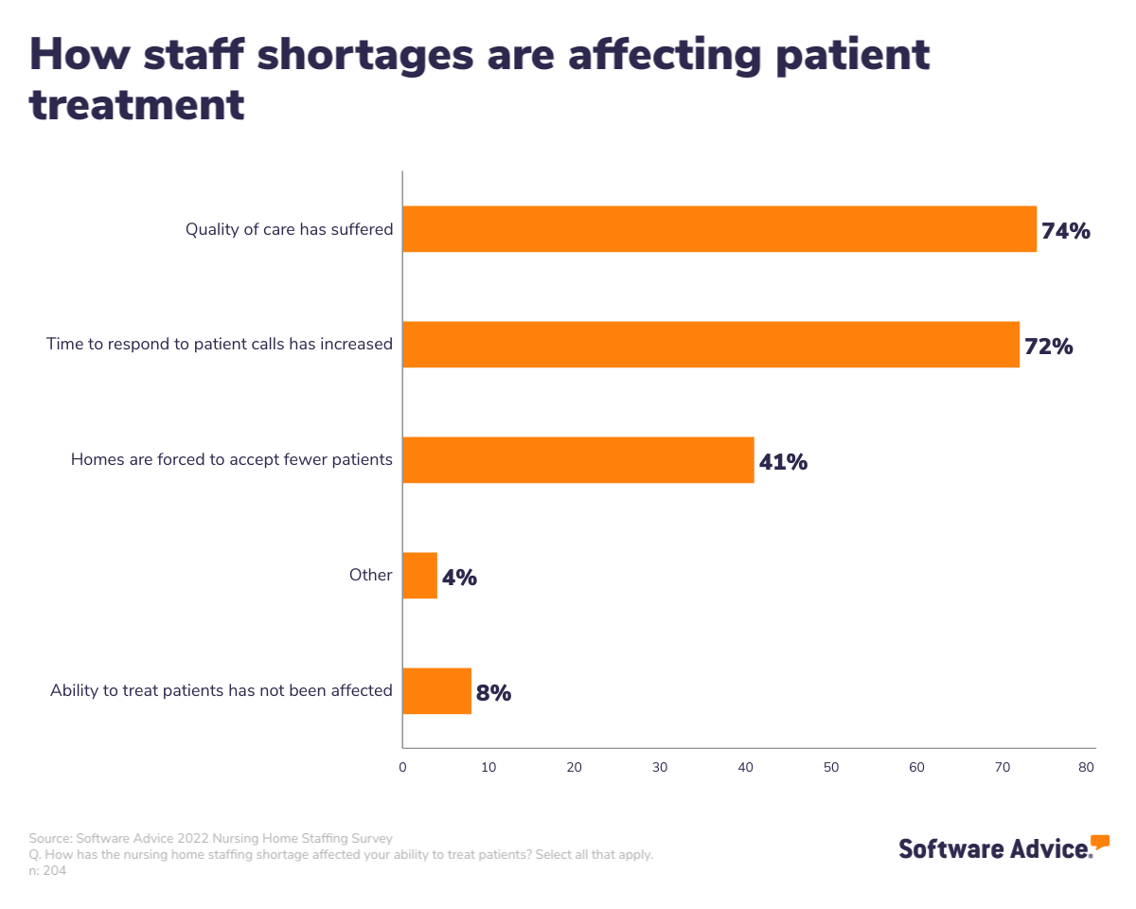
Figure 2: Sue Learner (2026). Carehome.co.uk.
Staffing Shortages: The residential care sector is experiencing a serious workforce crisis that has been caused by low wages and physical overwork which has resulted in high staff turnover. According to the NHS (2024), such shortages affect continuity of care. To be more stable, the sector should focus on professionalisation and mental health care and shift towards a more dignified, person-focused care approach that will attract and retain qualified and committed care professionals. Moreover, the use of agency personnel to staff these vacancies has a tendency of creating disparate care provision since temporary employees might not be aware of the unique medical history or emotional requirements of a resident. Constant underfunding also means that the care homes do not invest in up-to-date lifting equipment or ergonomic devices, something that adds to the physical burden on the already available workforce. These systemic financial barriers will need to be addressed when establishing a sustainable environment where caregivers feel important, which will eventually decrease the high turnover that is rocking the industry at the moment.
Infection Control and Health Risk: The residential houses are exposed to gross health hazards as a result of deteriorating infrastructure and lack of funds to purchase specialised health equipment’s (NHS, 2022). Homes may be closed down without proper means of infection control leading to the reduction of beds that are necessary by populations at risk (WHO, 2021). Moreover, the lack of appropriate ventilation systems in the old buildings can pose a great threat of spreading airborne diseases to the elderly citizens. Care homes are not able to comply with strict post-pandemic hygiene requirements without funding to upgrade to modern HEPA air philtres or touchless washrooms. Also, expensive Personal Protective Equipment (PPE) and other medical grade disinfectants frequently compel providers to redirect their budgets out of facility repairs. This forms a vicious circle that environmental degradation contributes to the increase in the rate of infection, which eventually jeopardises the legality and the financial feasibility of the home.
Current time Modern Operations in Residential Care
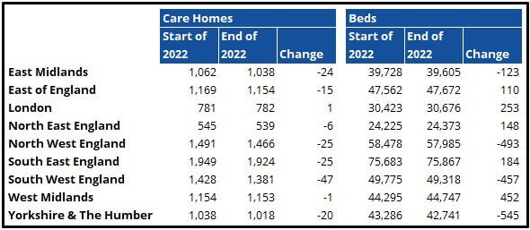
Figure 4: Sue Learner (2026). Carehome.co.uk.
The modern residential care homes place their services under a highly regulated structure, which is presided by the Care Quality Commission (CQC), in order to achieve high-quality services and establish safety. These services are beginning to work with local authorities and Integrated Care Boards (ICBs) to facilitate seamless operations between hospital and community settings yet some time NHS has experienced significant staff deficits (NHS, 2024). In line with local authority commissioning and NHS medical knowledge, contemporary care homes serve not as freestanding buildings but as critical centres within a larger, multidisciplinary health and social care environment (NHS, 2018). Moreover, it can be integrated to implement Enhanced Health in Care Homes (EHCH) frameworks, which will enable residents to have regular access to GP services and palliative care specialists. The alignment with ICB strategies will help the facility to manage the chronic conditions on-site and this aspect largely lowers the rate of emergency hospitalisation (NHS, 2018). Nonetheless, digital interoperability is critical to the success of these collaborative networks since the smooth exchange of patient records between social care providers and the NHS is the key to ensuring safety and clinical accuracy in medication administration.
Conclusion
The residential care homes have remained a segment of the UK social care fabric and this acts as a crucial safety net of the most vulnerable members of the society. These services have 24-hours support services to the persons with complex needs so that they can lead a dignified and safe life. Combining residential care with wider health care, as the NHS points out, is key to both alleviating pressure on hospitals and supporting long-term health. Although major issues in terms of financing and staffing remain, the WHO stresses that a Healthy care system is a pillar of universal health coverage. Finally, the trend toward person-centred care in the service continues to improve the quality of life of both residents and their families.

Introduction
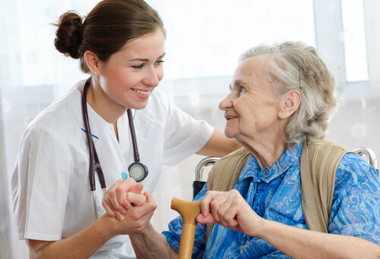
Figure 3: Viktor Berg (2025). Carehome.co.uk.
The residential care homes are regulated living conditions, whose aim is to offer the essential support to individuals that no longer can live independently. The NHS asserts that the majority of the population aged individuals, physically or learning impaired persons, and those with specific dementia needs are the majority users of the services (NHS, 2018). The World Health Organisation (WHO) identifies that these services are essential in protecting the identity and the safety of vulnerable communities by delivering long-term care in a professional and consistent manner that is aligned with the existing health standards and person-centred support paradigms (WHO, 2021). Moreover, the given professional assistance is frequently provided in form of the individualised care plans which consider the dignity and autonomy of a particular resident. Through these organised models, care homes will be able to efficiently track intricate health outcomes and offer specialised treatments within the premises.
History

Figure 4:Sarah Munson (2025). Carehome.co.uk.
In the UK, communal care has a solid historical foundation in the formalisation of informal community support and its implementation by the state. The biggest model of accommodating the vulnerable back in the day was the Victorian system of workhouses, which was grounded in institutional discipline, and not human well-being (NHS, 2022). However, a significant development occurred when the National Assistance Act 1948 was created that officially scrapped the existence of the Poor Law and introduced the contemporary use of local authorities in the residential provision of needy individuals. The policy in the UK social care was radically changed in the second half of the 20th century as the focus has been switched not to the large-scale, clinical institutions but to the so-called person-centred care.
Residential Care Service, Evolution, and Challenges
Task 2: Essay

Introduction to the Ambulance Service
An ambulance service is a vital first line service in the health sector that offers first aid and emergency care to individuals who are in need of such services (NHS, 2017). This essay looks at the way this service has developed into a sophisticated service as it is. This discussion indicates that the ambulance service is still at the heart of enhancing the quality of life and survival of patients during emergencies in the medical sector by evaluating its present role of operation and the issue that it experiences in the modern world.

Origins and Historical Context
The ambulance service traces its origins to the utilisation of primitive horse-drawn carriages in the 19th century, primarily on the battlefield to travel fast. The UK saw a radical change with the emergence of the NHS in 1948, and emergency transport was established as a free-at-the-point-of-use service (NHS, 2026). Over the next several decades, the service changed its mission from a bare-bones transport-only model to mobile clinical care. This shift was also necessitated by the improvement of medical technology and the professionalisation of the workforce, rather than mere drivers, into highly trained medical responders. The WHO identifies this development as an international standard for emergency medical systems, in which life-saving operations commence the instant a clinician comes into contact with the patient, rather than when the patient is brought to a hospital facility (WHO, 2018).

Critical Evaluation of Current Functioning
Ambulance services are now operating under modern triage, which includes the 999 and 111 emergency lines that prioritise calls according to clinical urgency, with life-threatening cases receiving first response. According to the NHS, paramedics have become skilled professionals who can handle complicated procedures and dispense of specialised medication on the spot (NHS, 2017). Nevertheless, the service has serious operational issues, the most important being response time and delays in handover to the emergency department. These delays are usually caused by hospital overcapacity, which prevents crews from being sent back to the community. According to the WHO, these systemic bottlenecks are a major concern for the current healthcare system because they directly affect the efficiency of emergency care and the capacity of staff to meet the growing needs of the ageing population with complex health issues (WHO, 2024).

Significance in Enhancing Quality of Life
The ambulance service has a transformative impact on patients' quality of life through critical acute care, which directly affects the immediate survival rate. Along with life-saving interventions, the service offers much-needed comfort to patients and families in the case of medical emergencies. The see-and-treat models and community-based treatment have increasingly become a component of the modern provision of paramedics. Whilst the NHS hails them as a fundamental element of avoiding unnecessary hospital admissions. This approach is tightly connected with the WHO aim of providing the proper care at the proper place, so patients could have an opportunity to obtain professional medical attention at the comfort of their houses (WHO, 2024). The ambulance service can significantly improve the general health and recovery rates of the various groups of people by reducing the stress of hospitalisation and providing professional clinical services.

Conclusion
In conclusion, the ambulance service has developed into a highly sophisticated clinical service, which is highly required in modern medical care unlike the very simplistic transport service. Despite high pressure on its operations, it also has the unparalleled capacity to deliver immediate life-saving interventions and community-based care. The additional evolution of the ambulance service is that as NHS keeps on evolving, the ambulance service is becoming part and parcel of the healthcare system. The WHO observes that the trend of professionalised, agile emergency services being taken is very essential to the health security in the long term and patient outcomes that are sustainable.
References
NHS (2017). NHS choices. Available at: https://www.england.nhs.uk/urgent-emergency-care/improving-ambulance-services/
NHS (2018). NHS choices. Available at: https://www.nhs.uk/social-care-and-support/
NHS (2022). NHS choices. Available at: https://www.nhs.uk/social-care-and-support/care-services-equipment-and-care-homes/care-homes/
NHS (2024). NHS choices. Available at: https://www.england.nhs.uk/community-health-services/ehch/
WHO (2021). World Health Organization. Available at: https://iris.who.int/
WHO (2024). Health workforce, World Health Organization. Available at: https://www.who.int/health-topics/health-workforce#tab=tab_3
NHS (2018). NHS choices. Available at: https://www.england.nhs.uk/statistics/statistical-work-areas/ambulance-quality-indicators/
NHS (2023). NHS choices. Available at: https://www.nhs.uk/nhs-services/urgent-and-emergency-care-services/when-to-call-999/
NHS (2026). NHS choices. Available at: https://www.england.nhs.uk/urgent-emergency-care/
WHO (2018). WHO Emergency Care System Framework, World Health Organisation. Available at: https://www.who.int/publications/i/item/who-emergency-care-system-framework
WHO (2024). Emergency care systems, World Health Organization. Available at: https://www.emro.who.int/cpi/publications/emergency-care-systems.html
Figure References:
Figure 1: Viktor Berg (2025). Carehome.co.uk. Available at: https://www.carehome.co.uk/advice/what-is-a-nursing-home
Figure 2: Sarah Munson (2025). Carehome.co.uk. Available at: https://www.carehome.co.uk/advice/a-history-of-care-homes
Figure 3: Sue Learner (2026). Carehome.co.uk. Available at: https://www.carehome.co.uk/advice/care-home-trends-2022-saw-numbers-of-uk-care-homes-decline
Figure 4: Sue Learner (2026). Carehome.co.uk. Available at: https://www.carehome.co.uk/advice/care-home-trends-2022-saw-numbers-of-uk-care-homes-decline

