Level Design and Development
Written Report
By Joseph Lee

Introduction
this report will be a thorough analysis and examination of the research process during the course of the conception and creation of the teams’ game project, called “CAVERN”. The report will cover an overview of the game’s general idea, its target audience, the design choices, ranging from stylistic choices to the theming, with justification for the decisions made, along with the role of a designer in the group, and how the research for that role was done. The report will also include the usage of Game Design Theory principles that were applied throughout the development and preparation for the Games’ creation.

Overview of The Game Idea

The game’s idea was to create a procedurally generated game that took the player from the top of a cave down to as far down as the player could go, collecting loot along the way, plans were made to involve other genres in the form of mechanics, or boss fights, like the edition of a souls-like boss at the end of the cave, and horror mechanics tied into other mechanics the game would have. The genre of the game was planned to be mainly that of a “Friendslop” game, which is a common slang term for a game that is made specifically for multiplayer experiences that benefit majorly from friends, and doesn’t offer services like “Matchmaking”, opting to imitate a more classic style of multiplayer, taking from “LM”, otherwise known as Local Multiplayer, though the difference between Local Multiplayer and a Friendslop game is that internet connections are needed, and aren’t restricted by distance, or a need to be in the same room using the same console.

Research Conducted

During the creation of the mood boards for items, the team researched several games, the research was conducted by discussing and brainstorming different games that included the items the team would make to be included in “CAVERN”, the games chosen to be researched were “Team Fortress 2” [1], by Valve, on Steam [2], “Fortnite” [3], by Epic Games, the “Super Mario Bros.” [4] franchise, by Nintendo, and “Subway Surfers” [5] , by co-developers “Kiloo” and “SYBO Games”.
In addition to the mood boards for Items, research was also conducted on the progression and game loop on a few games that were related to “CAVERN”, these games included “Peak” [6] , by Team PEAK, “Burgalin’ Gnomes” [7] , by Fobri, and “The House Always Wins” [8] , by Toxic Studio.
Below are the mood boards that were designed from the research;
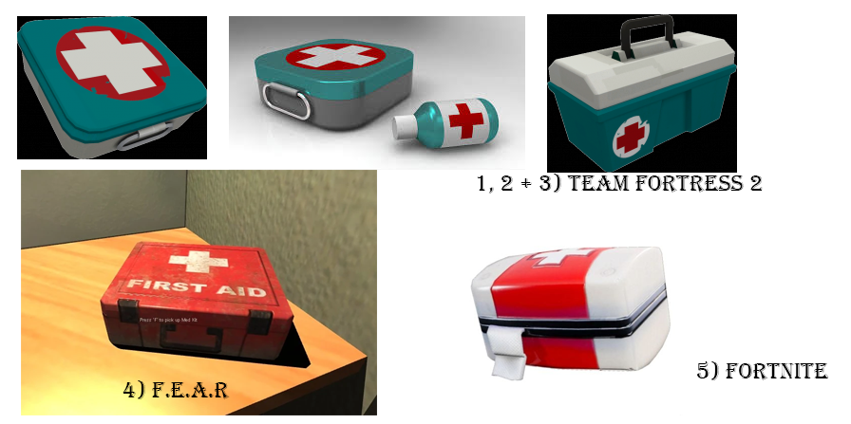
Figure 1, Medkit Mood Board
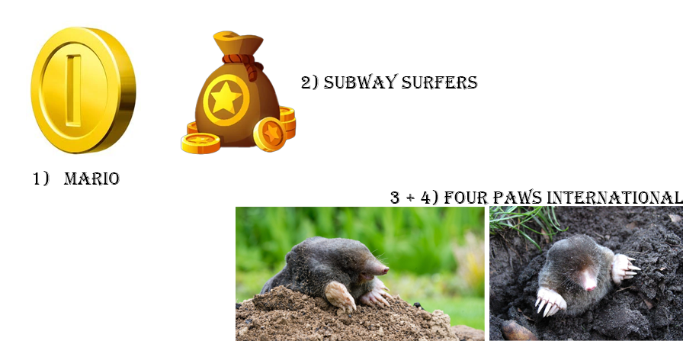
Figure 2, MoleCoin Mood Board

Target Audience

The game originally had the intended demographic of PEGI [9] 12, which allows for slightly graphic violence towards fantasy characters or non-realistic human-like characters. However, upon further reflection, the games’ demographic was shifted to 16+, even though the game would still fit well with PEGI [9] 12, the team decided that the game would most likely have an older audience, as was proven by the research conducted on games like Peak [6] , Burgalin’ Gnomes [7] , and The House Always Wins [8] . Under a PEGI [9] 16 rating, the game would be allowed to have a realistic depiction of violence, with extreme usage of bad language, tobacco, alcohol or illegal drugs. Though, the game was not planned to include any of these things.

Design/Theme Choices

The style of the game was chosen both from a mix of research and testing in Adobe Substance Painter [10] , the games’ style was inspired mostly by “Peak” [6] , but ended up resembling that of 2017 Fortnite [3], though that was accidental, the team decided to move forward with this style since it was aesthetically pleasing, and worked well with the genre of the game, since the game was going to be designed around having a more cartoonish, slightly angular design, for example, one of the NPCs that was also the first thing to have been designed with this in mind was the Mole, which turned out to look like this;
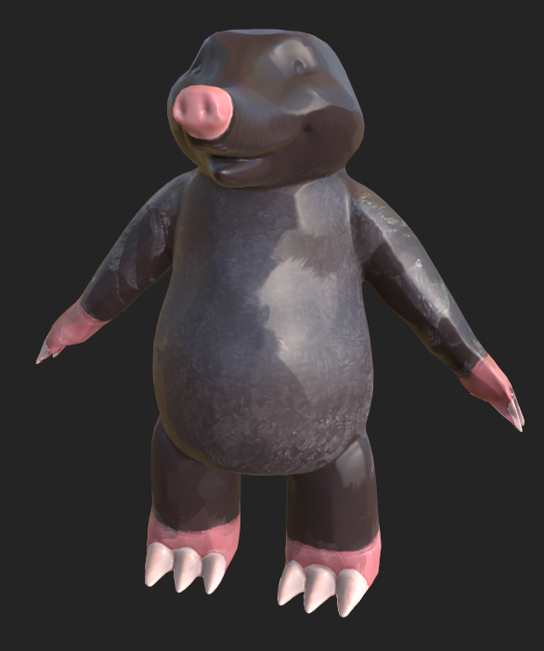
Figure 4, Mole

The stylisation of the game was made and handled by me, since the stylisation was discussed once it was shown to figure out if this was the direction that the team wanted to head in, after deciding that it was the direction the team wanted to head in, I handled the management of the models that would be created to make sure that they fit in line with the stylisation.
Prior to the conception of the stylisation of the game, concept art was created for the levels, I handled the concept art for the planned second layer of the caves, called the “Crystal Caves”, below is the concept art that was made.
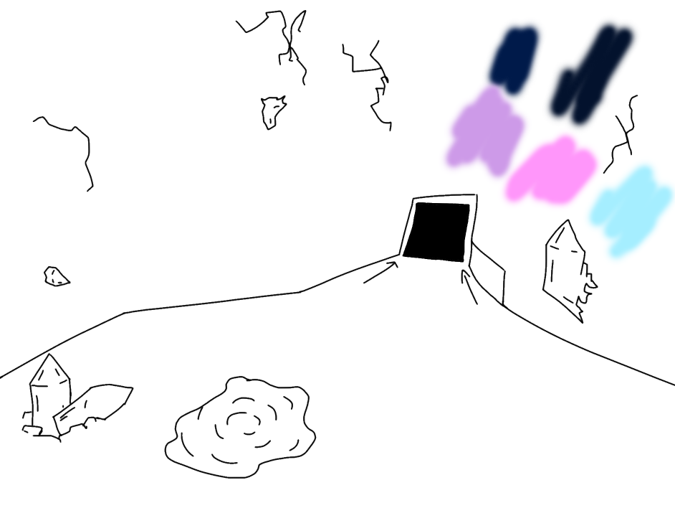
Figure 5, “Crystal Caves” Concept Art

Self-Directed Learning

Although some other team members did self-directed learning, like learning new softwares such as “ZBrush”[11], I personally stuck with what I previously knew, as I felt more comfortable with the softwares I know off by heart by now, using software like Adobe Photoshop [12], Adobe Substance Painter [10], and Maya [13]. And I felt confident and competent enough to complete my parts of the design aspects with just these softwares.

Game Design Theory Principles

The team came up with several level layouts for the game, my personal part in the level layouts was to handle the “Lobby” and the “Crystal Caves”, using research of level layouts from games like Call of Duty [22], and Battlefield [23] to get an idea for what a level layout looked like, I created a Layout and concept art for the Crystal Caves, while also making a layout but no concept art for the Lobby. Using Game Design Theory Principles for level layout to design wide areas for free movement, with obstacles in the way at some areas, the draft of a layout was made, as shown below;
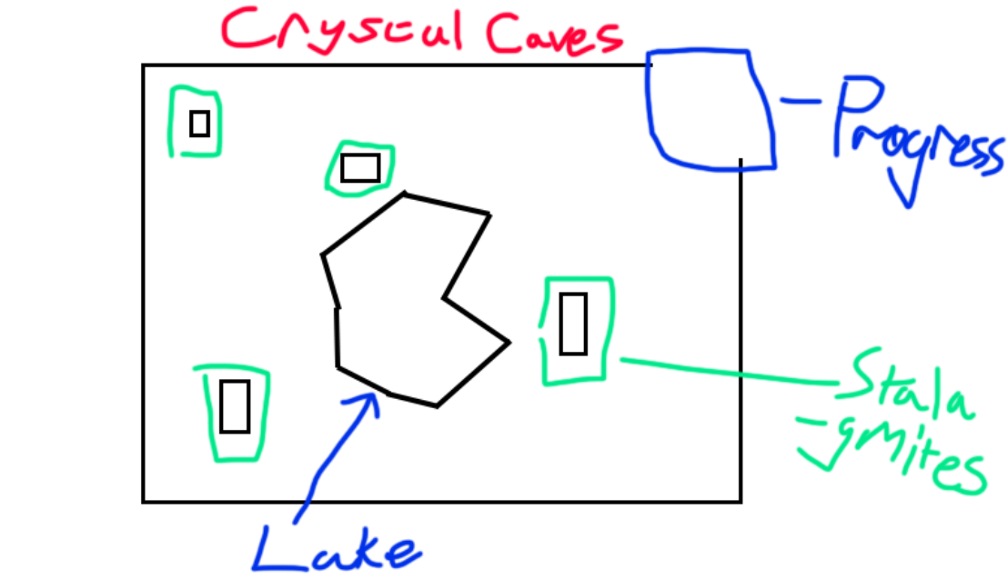
Figure 6, “Crystal Caves” Level Layout
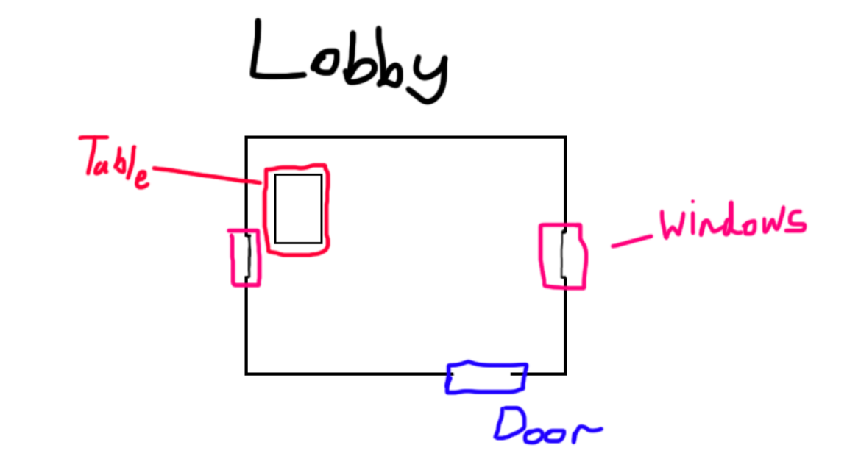
Figure 7, Lobby Layout

In figure 7, the layout was chosen to be more closed in, and designed to be more empty by myself, though this was decided against by the rest of the team, which later on would be filled with more things, as the lobby was a place the player would not spend a large amount of time in, and I felt that there shouldn’t be many things in a lobby most players would spend only a couple of minutes in at most.

However, for the rest of the Game Design Principles, they were regrettably left largely ignored, as the team felt that we had a good idea of where we wanted the game to go, and as such, felt that the team didn’t need to consider much about the other game design principles, other than the mechanics of the game.
The game features several mechanics, ranging from a stamina system to allow for sprinting, an oxygen meter that would deplete more rapidly as the player descended into the cave, alongside toxic gas that would deplete the oxygen meter quicker, there were enemy AI planned though this was most likely only going to be used for the souls-like boss at the end of the game. And, tied to the oxygen mechanic, would be a hallucination mechanic, where any player who had depleted enough oxygen would begin to experience auditory and visual hallucinations, such as seeing enemies that aren’t there, or hearing those same enemies, which were going to be just to make the player feel paranoid. Fully depleting the oxygen meter would both cause hallucinations and also result in the player dying.

Reflection and Evaluation

Upon reflection, this project, and more specifically, my involvement in this project could’ve been better, in future some things that could be improved upon is that, First of all, more research could be done in the beginning stages for more games to ensure that there is the most variety in both the beginning information available and could positively impact the game by providing the team with a wider range of inspiration to draw from and to help bring new ideas into development. In Addition, another thing that could improve the Design process would have been to take more of the Game Design Theory Principles into consideration, as this would allow for a better designed game that would be more enjoyable for players, and would follow more conventional means, since the game design principles are professionally tested and proven to be successful, going against these or just not including them in general takes away from the finished game as it doesn’t follow essential guidelines that should always be used in any form of game design and development. The team also faced difficulties with procedural generation, and thus, wasn’t able to get procedural generation done by the end of the games’ creation, this was unfortunate, but an expected outcome, as after doing further research afterwards into procedural generation, I feel like that would have taken too much time from the development, and would have brought down the rest of the projects’ quality because of that.
Finally, the mix of genres in the game feels like it brings down the experience of the game, as a mix of that many genres, while possible to do, for a beginning project makes the game feel like it doesn’t know which direction it wants to go in, as it isn’t committed to any specific game style or genre.

Bibliography
[1] Valve, “Team Fortress 2”, Steam, Available: https://store.steampowered.com/app/440/Team_Fortress_2/, Accessed: 06/03/2026
[2] Valve, “Steam”, Available: https://store.steampowered.com/ Accessed: 06/03/2026
[3] Epic Games, “Fortnite”, Available: https://www.fortnite.com Accessed: 06/03/2026
[4] Nintendo, “Super Mario Bros.” Available: https://www.nintendo.com/us/store/products/super-mario-bros-wonder-nintendo-switch-2-edition-plus-meetup-in-bellabel-park-switch-2/ Accessed: 07/03/2026
[5] Kiloo & CYBO Games, “Subway Surfers”, Google Play Store, Available: https://play.google.com/store/apps/details?id=com.kiloo.subwaysurf&hl=en_US&pli=1 Accessed: 07/03/2026
[6] Team PEAK, “Peak”, Steam, Available: https://store.steampowered.com/app/3527290/PEAK/ Accessed: 07/03/2026
[7] Fobri, “Burglin’ Gnomes”, Steam, Available: https://store.steampowered.com/app/3844970/Burglin_Gnomes/ Accessed: 08/03/2026
[8] Team Toxic, “The House Always Wins”, Steam, Available: https://store.steampowered.com/app/3412160/The_House_Always_Wins/ Accessed: 08/03/2026
[9] Pan European Game Information, PEGI, Available: https://pegi.info/page/pegi-age-ratings Accessed: 09/03/2026
[10] Adobe, “Substance Painter”, Adobe, Available: https://www.adobe.com/products/substance3d/apps/painter.html, Accessed: 09/03/2026
[11] Maxon, “ZBrush”, Maxon, Available: https://www.maxon.net/en/zbrush Accessed: 10/03/2026
[12] Adobe, “Photoshop”, Adobe, Available: https://www.adobe.com/products/photoshop.html Accessed: 10/03/2026
[13] Autodesk, “Maya”, Autodesk, Available: https://www.autodesk.com/products/maya/overview Accessed: 11/03/2026

